*Original Research Article*

Investigation of The Ewald Effect: Reversible shrinkage of Oil and aldehyde tanned Collagen

ABSTRACT

|  |
| --- |
| This study investigates the Ewald effect in chamois and glutaraldehyde (GTA) tanned leathers, aiming to understand why aldehyde- and oil-tanned leathers exhibit relaxation after thermal shrinkage—a phenomenon not observed in other tannages. Leather samples were subjected to thermal treatment by submerging them in hot water (10°C above their shrinkage temperature) for durations ranging from 30 to 120 seconds, followed by rapid cooling in water maintained at 25–30°C. The results revealed that chamois and GTA leathers consistently recovered approximately 70% of their original area after relaxation, even after multiple cycles of heating and cooling. In contrast, vegetable-tanned leather remained permanently collapsed, showing no signs of recovery. Differential Scanning Calorimetry (DSC) was employed to analyze the thermal behavior of the leathers, thermograms displayed no secondary peaks or exothermic signals in cooling and reheating phases, suggesting the absence of collagen re-registration during the relaxation process. This finding challenges the existing theory that collagen re-registration drives the recovery of leather structure after thermal shrinkage. Further analysis using Scanning Electron Microscopy (SEM) provided visual evidence of the structural changes. Chamois and GTA leathers regained an open, though disordered, fiber structure after rapid cooling in water, while vegetable-tanned leather retained a densely collapsed structure with no recovery. These results highlight the distinct thermal and mechanical behaviors of aldehyde- and oil-tanned leathers compared to other tannages. The study suggests that factors other than collagen re-registration, such as the interaction of tanning agents with the collagen matrix in the fibre structure, may play a critical role in the observed relaxation behavior. Conducted at the Institute for Creative Leather Technologies (ICLT), University of Northampton, from June 2023 to January 2024, this research provides new insights into the mechanisms underlying the Ewald effect and challenges conventional assumptions about collagen re-registration in chamois leather. |

*Keywords: Ewald effect, Collagen denaturation, Collagen renaturation, Hydrothermal stability, Collagen re- registration, Chamois leather.*

1. INTRODUCTION

Leather tanning, a process that transforms raw hides into durable material, has evolved over thousands of years (Thomson, 2019). Early civilizations discovered that rubbing fatty substances, such as animal fats and brains, into hides created waterproof leather (Merrill, 1926). Later, vegetable tanning, using tannins from plants, produced stiffer leather (Haslam, 1997; Ahmed et al., 2021). A major advancement came with chrome tanning, which replaced natural tannins with chromium salts, producing softer and more flexible leather (Gaidau, 2013). This transition to mineral tannages, such as chromium sulfate, was driven by their efficiency, cost-effectiveness, and strong physical properties (Sai Bhavya et al., 2019; Covington & Wise, 2020). Chrome tanning also shortened processing times and reduced chemical use (Leather International, 2019). Chromium tanning imparts high shrinkage temperatures, enhancing leather's heat resistance, making it ideal for applications like shoe manufacturing (Covington, 1997; Maina et al., 2019). It also performs well in machining processes like shaving, where higher heat is generated (Witt et al., 2021). The shrinkage temperature is now a key indicator of leather's strength and durability used to assess the tanning capacity of any chemical (Esteban et al., 2021). Overall, the evolution from plant tannins to mineral tannages has significantly improved leather's physical, mechanical, and hydrothermal properties

* 1. **Scientific Underpinnings of Hydrothermal Stability in Collagen**

Collagen, a key structural protein in the extracellular matrix, provides strength and support to connective tissues such as skin (Halper, 2021). Its hydrothermal stability, measured as the shrinkage temperature (Ts), reflects the temperature at which collagen fibers irreversibly contract under wet heating (Badea et al., 2012). According to Reich, 2007 The structural integrity of collagen is crucial for this stability Type I collagen consists of three polypeptide chains forming a right-handed triple helix, stabilized by the Gly-X-Y amino acid sequence, where proline and hydroxyproline residues (often in X and Y positions) enhance stability through interchain hydrogen bonds (Covington & Wise, 2020; Gustavson, 1956). Higher Ts values indicate greater thermal stability.

* 1. **Theories and Behaviors of Collagen Hydrothermal Stability Across Diverse Tannages**
     1. ***Link-Lock Theory of Collagen Stabilization.***

The Link-Lock Theory, proposed by Covington et al. (2008), offers a novel perspective on collagen hydrothermal stability. Unlike traditional models of cross linking proposed by Gustavson, 1956 focusing on single chemical species, this theory emphasizes a dual-step process of linking and locking. Linking involves chemical bonds (hydrogen, covalent, or ionic) between collagen and stabilizing agents, forming a matrix around collagen while locking further stabilizes this matrix by crosslinking reagents, increasing the energy required for structural breakdown and raising the shrinkage temperature (Ts). This combined process explains the high hydrothermal stability observed in chromium-tanned collagen, with Ts values up to 118°C (Covington et al., 2008; Covington, 2011). The theory also highlights the irreversible nature of collagen shrinkage, signifying permanent structural changes upon denaturation.

* + 1. ***Chromium Tannage.***

Chromium (III) sulfate is widely used in leather production due to its efficiency and high hydrothermal stability, achieving Ts values of ~118°C (Covington & Wise, 2020). The process involves covalent bonding between collagen carboxyl groups and chromium (III) ions, stabilized by sulfate ions and water molecules within the matrix. This creates a robust, irreversible structure resistant to high temperatures and humidity (Maina et al., 2019; Reich, 2007).

* + 1. ***Vegetable Tannage.***

Vegetable tannins, classified as hydrolyzable (e.g., chestnut, oak) or condensed (e.g., mimosa, quebracho), interact with collagen through hydrophobic and hydrogen bonding. Hydrolyzable tannins elevate Ts to 75-80°C, while condensed tannins achieve 80-85°C (Covington & Wise, 2020). The "gap" zone in collagen fibrils plays a critical role, providing space for tannin binding and complexation, enhancing stability and precipitation of collagen (Haslam, 1997; (Crozier et al. 1996).

* + 1. ***Glutaraldehyde Tannage.***

Glutaraldehyde crosslink with collagen where glutaraldehyde is polymerized, and the terminal hydroxy groups of the polymer are active and capable of reacting with amino groups, yielding a shrinkage temperature of 80 to 85°C (Covington, 1997). However, this shrinkage is reversible. Ewald (1919), Sharphouse, (1985), and Covington and Wise (2020) suggest that thermal denaturation in aldehyde tannages is reversible. This implies that when cooled rapidly, a shrunken piece of leather regains its shape to about 90%.

* + 1. ***Oil Tannage.***

Oil-tanned chamois leathers are known for exceptional water absorption flexibility and softness. They are widely used in garment and gloving, window, and car cleaning; they stand out for their high-water absorption (Balajyothi et al., 2008). The oil tanning mechanism is not fully understood. Still, Sharphouse, 1985 suggests it involves forming aldehydic compounds. It is a complex process involving tanning with aldehyde compounds formed in the oxidation of the unsaturated fats, fixing them to protein fibers, and forming a polymer matrix within the collagen structure (Covington,1997; Sharphouse, 1985). Oil tanning involves polymerizing unsaturated oils, such as cod liver oil, activated by heat. This reaction creates a polymer within the collagen structure matrix, altering the material sufficiently to resist biochemical attacks (Wang, H., Ma, Y., & Nian, Y. (2007). The system can be envisioned as a matrix of polymerized hydrocarbon chains. This matrix separates the collagen fibers, acting as a lubricant between the fibers, preventing them from sticking together. Unlike aldehydic tanning, there is uncertainty about any interaction 9 between the polymer and collagen because the tannage does not offer any hydrothermal stability change, meaning there is no collagen modification.

According to Covington (2018) The unique structure of oil-tanned leather gives rise to two notable properties. Firstly, it has a remarkable water-holding capacity, meeting a quality requirement of at least 800% of its weight. The oil matrix enables significant collagen hydration, transforming this hydrophobic tannage into highly hydrophilic leather. Secondly, the Ewald effect is observed: when exposed to hot water, the leather contracts, but upon cooling in cold water, it regains about 90% of its original area, this phenomenon is called the Ewald effect.

* 1. **Ewald Effect: Historical Overview.**

The **Ewald Effect** was first documented in 1919 by August Ewald in his paper *"Contributions to the Understanding of Collagen."* Ewald observed that formalin-treated mouse tendons, when heated in water, contracted at 87°C and shrank further at 93°C. However, upon cooling in cold water, the tendons rapidly expanded, recovering ~50% of their original length. This reversible behavior, likened to the tendon "coming alive," could be repeated multiple times. Ewald confirmed that this effect was specific to collagen, as a pure collagen tendons exhibited the same behavior, while non-collagenous tissues did not.

Later, Sharphouse (1985) noted the Ewald Effect in other aldehyde-tanned collagen, such as glutaraldehyde-treated leather, and Covington (1997) extended this observation to oil-tanned leathers like chamois. The phenomenon highlights the unique reversible thermal behavior of aldehyde and oil-tanned collagen, distinguishing them from other tannages.

* 1. **Statement of the Problem.**

Collagen experiences permanent changes when heated to its shrinkage temperature (Ts), leading to a breakdown in its structure (Reich, 2007). This irreversible shrinkage occurs in both natural and chemically treated collagen (Gustavson, 1956). Research by Sun et al. (2020) shows that high temperatures damage collagen's helical structure by breaking hydrogen bonds, which cannot be repaired. Similarly, Covington (1997) and Esteban et al. (2021) note that leather, a chemically modified form of collagen, also undergoes irreversible shrinkage when exposed to heat, making it difficult to restore its original form.

The Ewald effect, first identified by August Ewald in 1919 in formalin-tanned collagen, suggests that certain tannages, such as glutaraldehyde and oil-tanned leather, exhibit a degree of structural relaxation after shrinkage (Covington & Wise, 2020; Bienkiewicz, 1983; Sharphouse, 1983, 1985). Covington and Wise (2020) propose that in chamois leather, the oil matrix facilitates partial re-registration of collagen, allowing it to mimic its original structure. However, the mechanism responsible for reforming the broken hydrogen bonds remains unclear. This study aims to investigate the presence of the Ewald effect and explore the underlying mechanisms driving the observed relaxation in thermally shrunken leathers.

* 1. **Scope of the Study**

The study involved tannages expected to exhibit the Ewald effect, glutaraldehyde (GTA), and oil tannage together with tannages known for lacking the effect, such as chromium- and vegetable-tanned leather together with a pre-made chamois leather (Bought Chamois) acquired for comparative analysis. Shrinkage temperature was determined using Differential Scanning Calorimetry (DSC), while visual confirmation of the effect involved immersing samples in hot and cold water respectively and measuring sample dimensions. DSC findings were used to validate existing theories on collagen re-registration, Scanning Electron Microscopy (SEM) and Light Microscope provided fiber structural insights under varying heat treatments.

* 1. **Aim and Objectives**

The study aims to investigate and validate the mechanisms underlying the Ewald effect in chamois leathers, examining whether—and to what extent—thermally shrunk oil and glutaraldehyde-treated collagen can regain their original shape and structure after being cooled in water, a phenomenon known as collagen re-registration. The research will assess the validity of this phenomenon and explore the conditions under which it holds true or does not apply.

1. material and methods
   1. **Tanning Recipes and Procedures.**

The study employed Chromium (III), vegetable, glutaraldehyde, and oil tannages. For Chromium (III), vegetable, and glutaraldehyde tannages, the foundational tanning recipes were developed based on the methodology outlined by Leafe (1999), as detailed in Appendices I, II, and III. However, due to the lack of standardized recipes for oil tannage, the development of this process drew on insights from various studies, including those by Sharphouse (1983, 1985), Balajyothi et al. (2008), and Hongru et al. (2008). These sources provided essential guidance and methodologies for achieving complete oil tanning. The tanning process was carried out in steel drums (Type 14-400370/1/6, Dose Machinery GmbH, Germany).

* 1. **Examination of the shrinkage temperature by DSC.**

Differential Scanning Calorimetry (DSC) was employed to accurately measure the shrinkage temperature of leather, as highlighted by Onem et al. (2017). While the traditional boiling test is commonly used to determine shrinkage temperature, it has several limitations, including its dependency on heating rates and its unreliability for leathers with shrinkage temperatures exceeding 100 °C. In contrast, DSC provides a more comprehensive approach by monitoring collagen's phase transitions and denaturation processes (Onem et al., 2017). This technique measures changes in heat flow through the sample, offering a more precise and accurate determination of shrinkage temperature. DSC works by comparing a sample and a reference material under identical conditions, with their signals subtracted to analyze thermal behavior (Okamoto & Saeki, 2013). The process involves placing the sample in hermetically sealed aluminum pans within an enclosed chamber. By controlling the heating rate, DSC evaluates the sample's heat capacity by observing the temperature difference between the sample and the aluminum pans (Fathima, 2011). According to Carsote and Badea (2019) and Zeeman et al. (1999), the DSC curve obtained from the analysis serves as an indicator of collagen denaturation in leather. The endothermic peak in the curve corresponds to the thermal event that disrupts the bonds maintaining the collagen's triple helix structure.

The study utilized the Mettler Toledo DSC2 STARe system, supported by STARe Software Version 14.00 (Build 7458, Copyright © MettlerToledo AG 1993–2015). For chromium-tanned leathers, a standard 40 μL aluminum pan weighing approximately 49.42 milligrams was used, with sample weights ranging between 3 and 9 milligrams. The method began with an isothermal hold at 40 °C for 5 minutes, followed by dynamic heating from 40 to 125 °C at a rate of 5 K/min, and concluded with a final isothermal hold at 135.0 °C for 5 minutes. For other tannages, the initial temperature was set at 30 °C, while the heating and isothermal hold conditions remained consistent. The process started with sample preparation, which included vacuum soaking for one hour followed by overnight soaking. The prepared and weighed samples were sealed into aluminum pans and loaded into the machine alongside a reference pan. The resulting thermograms were analyzed to determine the shrinkage temperature.

**Figure 1. DSC Method for measuring Shrinkage Temperature of Wet blue.**

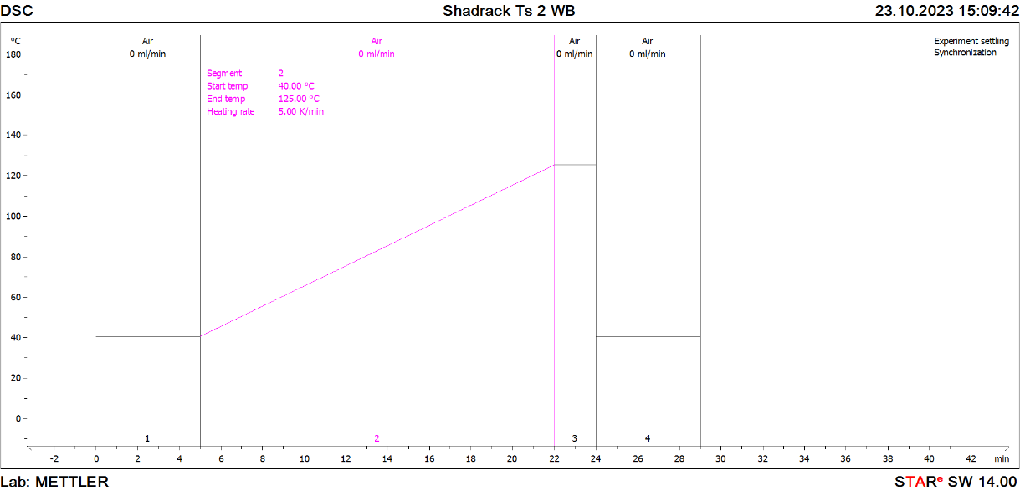

* 1. **Testing the** **Ewald Effect by DSC.**

The study employed the same Mettler Toledo DSC2 STARe system equipment, complemented by STARe Software Version 14.00 (Build 7458), Copyright © Mettler-Toledo AG 1993 - 2015. In testing the Ewald effect the method comprised cycles of heating and rapid cooling of samples: initiating with an isothermal hold at 30.0 °C for 5.00 minutes, followed by dynamic heating from 30.0 to temperature 10.0 °C higher than the shrinkage temperature of the tannage at a rate of 5.00 K/min. Subsequently, there was a rapid cooling back to 40.0 °C, succeeded by isothermal holds at 30.0 °C for 10.00 minutes and dynamic heating intervals from 30.0 to the same temperature at a 5.00 K/min rate. This cyclic procedure was systematically repeated several times.

**Figure 2. Methodology for Investigating the Ewald Effect on Tannery Produced Chamois Leather using DSC**

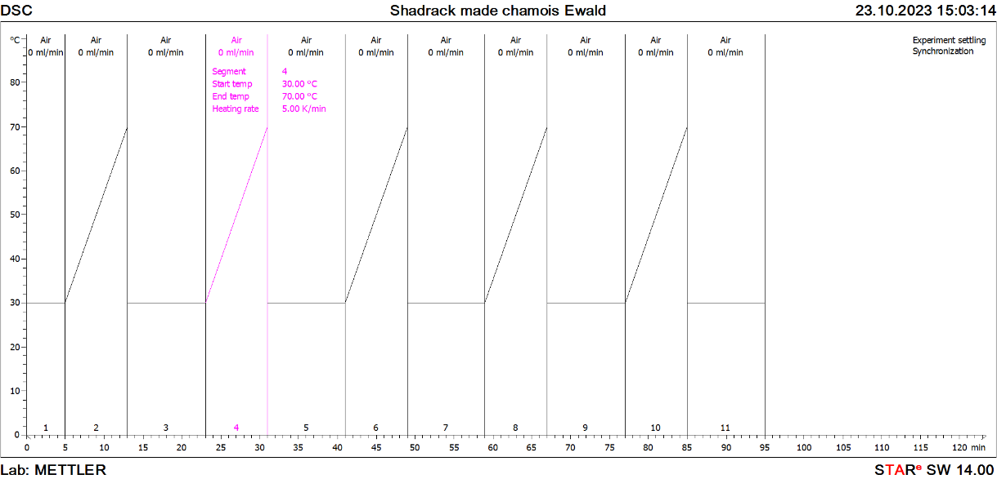

* 1. **Visual Evaluation of the Ewald Effect through Submerging Leathers in Hot water and Cooling with cold Water**.

50mm by 10mm pieces of leather from various tannages, were used for the study. The sampling incorporated two samples from each tannage category, including tannery-made Chamois, bought Chamois, vegetable-tanned leather, and glutaraldehyde-tanned leather. The study utilized laboratory equipment, including a hot plate, beakers, thermometer, and tongs. Samples were submerged in hot water maintained at a temperature set 10°C above the respective shrinkage temperature of each tannage, as determined by Differential Scanning Calorimetry (DSC), beginning with an immersion duration of 30 seconds. After immersion, sample dimensions were recorded before immediate transfer into cold water, maintained between 25-30°C. Subsequently, measurements of the samples' dimensions were taken after the completion of the cooling process approximately 10 minutes colling time. After the initial cooling process, the experiment was repeated two times to validate the repeatability of the Ewald effect. New leather samples were introduced into the experimental setup. These fresh samples were subjected to similar conditions with intentionally varied immersion durations in the heated water: 60, 90, and 120 seconds. This variation aimed to investigate the potential influence of varied heating durations on the observed Ewald effect. After immersion in both hot and cold water, the areas of the samples were calculated, and the average area loss and area recovery for each sample were determined for comparative analysis.

* 1. **Examination of the fiber structure in different heating phases by SEM.**

The study used Scanning Electron Microscopy (SEM) to analyze the fiber structure of leather samples from various tannages subjected to thermal treatments. A VEGA3 Tescan SEM, controlled by VEGA3 software (version 4.2.34.1), was employed. Samples were prepared by drying, cutting across the fibers, and coating with a 15-nanometer gold layer using a QUORUM Q150R ESPLUS coater before imaging

For thermally shrunk and cooled samples, pieces were immersed in hot water at 10°C above their shrinkage temperature (determined by DSC) and immediately cooled in cold water (25–30 °C) for two minutes. Exposure times in hot water varied (30, 60, 90, and 120 seconds). Thermally shrunk samples without cooling followed the same hot water immersion but were air-cooled naturally. Both sets underwent similar preparation steps before SEM imaging.

Special care was taken for pickled pelt and bought chamois due to their unique fiber structures. Samples were immersed in camphene overnight to preserve fiber arrangement, frozen for two hours, and air-dried for an hour to evaporate camphene. After preparation, samples were mounted on stubs, gold-coated, and imaged. Figures at various magnifications were captured and analyzed to evaluate fiber structures.

The study employed light optical microscopy to examine fiber structure in leather samples from different tannages subjected to thermal treatments. Using a LEICA M205 C microscope and Leica Application Suite Version 4.12.0, Thermally Shrunk leather pieces underwent two thermal protocols: rapid cooling in water and natural cooling. In the rapid cooling method, samples were immersed in hot water 10 degrees Celsius above their tannage-specific shrinkage temperature and then quickly cooled in cold water for two minutes, with exposure times varying between 30, 60, 90, and 120 seconds. The natural cooling protocol involved similar hot water immersion but allowed samples to cool naturally in air. Sample preparation included precise slicing of leather portions using a razor blade and mounting on glass slides with double-sided adhesive tape. Microscopic analysis was conducted at multiple magnifications to provide detailed structural insights into the thermal effects on leather fiber morphology.

1. results and discussion
   1. Shrinkage temperature by DSC.

**Figure 3. DSC Thermogram for GTA-Tanned Leather.**

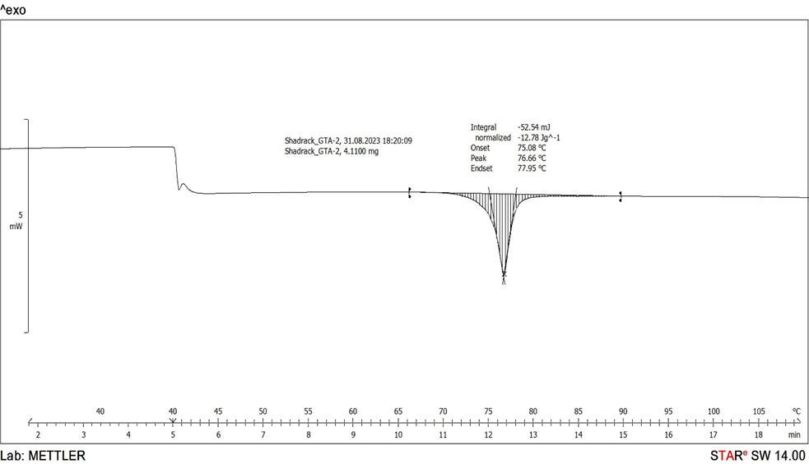

The DSC thermogram shown in Figure 3. reveals an endothermic peak, the beginning of which is often referred to as the onset temperature (Ti). This point, observed as the nearest inflection on the thermogram curve where the slope distinctly increases and diverges from the baseline, corresponds to the point where a tangent line drawn to the peak touches the thermogram curve (Esteban et al., 2021) signifies the initiation of collagen denaturation and marks the onset of leather shrinkage (Tang et al., 2003). It is an indicator of the denaturation process in collagen and is frequently utilized to estimate the temperature of denaturation (Ts) in leather (Chahine, 2000; Tang et al., 2003).

**Table 1. Shrinkage Temperatures Obtained from DSC Analysis.**

|  |  |  |  |  |
| --- | --- | --- | --- | --- |
| **Tannage** | **Ts1 (°C)** | **Ts2 (°C)** | **Average Ts (°C)** | **Standard  Deviation (SD)** |
| Made Chamois | 60.45 | 59.15 | 59.8 | 0.9 |
| Bought Chamois | 60.45 | 59.15 | 59.8 | 0.9 |
| Chromium III Tannage | 116.18 | 115.1 | 115.6 | 0.8 |
| Vegetable Tannage | 77.2 | 77.5 | 77.3 | 0.2 |
| Glutaraldehyde Tannage | 81.28 | 80.81 | 81.0 | 0.3 |

The DSC analysis confirms distinct shrinkage temperature profiles for different tannages, consistent with established tanning theories. Made and bought chamois leathers exhibit shrinkage temperatures around 59.8°C, aligning with native collagen, reinforcing the understanding that oil does not stabilize collagen thermally.

Chromium (III) tannage shows the highest thermal stability, with shrinkage temperatures averaging 115.6°C, attributed to covalent bonding and sulfate-assisted locking mechanisms. Vegetable tannage stabilizes collagen through hydrogen bonding, raising the shrinkage temperature to 77.3°C. Similarly, glutaraldehyde tannage, which forms covalent crosslinks with lysine and hydroxylysine residues, achieves an average shrinkage temperature of 81.0°C.

* 1. **Investigating the Ewald Effect by DSC.**

According to the literature, the oil matrix in oil-tanned leather is theorized to act as a supportive framework, resembling collagen and facilitating structural restoration when thermally shrunk chamois is cooled in water (Covington & Wise, 2020). Since collagen denaturation is characterized by an endothermic peak in DSC thermograms (Chahine, 2000) linked to the disruption of hydrogen bonds within the triple helix (Tang et al., 2003; Onem et al., 2017). Building on this, it was expected that if a collagen in oil-tanned leather can re-register, repeated heating and cooling cycles should regenerate these endothermic peaks, indicating reversible denaturation and structural restoration. Furthermore, Schön et al. (2017) emphasized that irreversible protein denaturation leads to aggregation (exothermic), while reversible denaturation allows collagen to regain its native conformation, which would be reflected by an exothermic DSC peak during re-registration.

**Figure 4. DSC Thermogram for Made Chamois Testing the Ewald Method: Involving repeated cycles of heating and cooling samples**

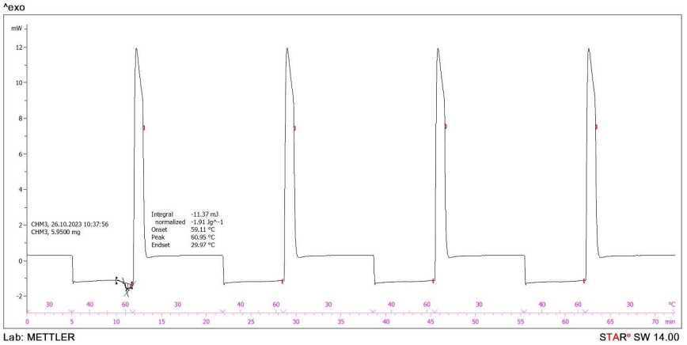

**Figure 5. DSC Thermogram for Vegetable tanned samples Testing the Ewald Method: Involving repeated cycles of heating and cooling.**

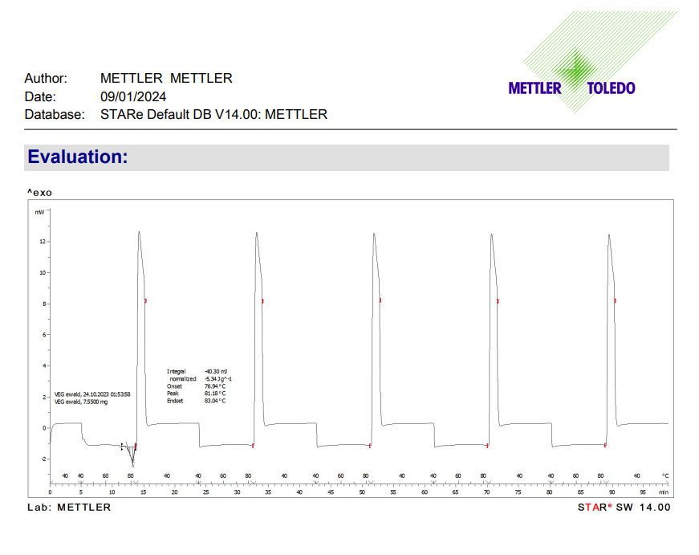

Figure (4) and (5) shows that the thermogram of tannery-made chamois and vegetable tanned leather lacking additional peaks after the initial shrinkage shown as endothermic peak in the thermogram, indicating no further collagen shrinkage phases. This pattern is consistent across all tannages studied.

Furthermore, the absence of exothermic peaks in the thermograms suggests no evidence of collagen re-registration, as would be expected in the Ewald effect. The thermograms of chromium- and vegetable-tanned leathers, which are not known to exhibit re-registration, closely resemble those of oil- and glutaraldehyde-tanned leathers, which were anticipated to demonstrate this effect. Analyses revealed that leathers processed with different tanning agents displayed similar thermograms, each featuring a single endothermic peak. This consistency strongly indicates that collagen in all tannages undergoes shrinkage without subsequent recovery. The uniform lack of additional peaks challenges the theoretical expectation of collagen structural recovery following denaturation.

* 1. **Visual observations of Ewald Effect by hot and cold-water test across various tannages: losing area during shrinkage and recovering of area after rapid cooling.**

The lack of reproducible shrinkage endothermic peaks in DSC thermograms suggests no Ewald effect. However, visual observations confirmed its presence in oil-tanned (bought and tannery-made chamois) and glutaraldehyde-tanned leathers. These leathers consistently regained about 70% of their initial area after shrinking, even across multiple cycles, showing a stable shrinkage and recovery pattern. This effect was absent in vegetable-tanned leather, regardless of variations in shrinking time (30–120 seconds).

**Table 2. Bought Chamois - Area Loss and Recovery Trends**

|  |  |  |  |  |  |  |
| --- | --- | --- | --- | --- | --- | --- |
| **Shrinking Time (sec)** | **Initial Area Loss (%)** | **Initial Area Recovery (%)** | **Second Shrinkage Area Loss (%)** | **Second Shrinkage Area Recovery (%)** | **Third Shrinkage Area Loss (%)** | **Third Shrinkage Area Recovery (%)** |
| 30 | 56±3 | 78±1 | 51±4 | 70±4 | 55±0 | 71±2 |
| 60 | 53±2 | 65±3 | 56±4 | 76±2 | 68±4 | 54±1 |
| 90 | 51±1 | 66±4 | 53±1 | 64±5 | 48±3 | 60±3 |
| 120 | 46±3 | 62±3 | 47±4 | 55±5 | 51±4 | 47±3 |

*All percentages are calculated from the original area.*

**Table 3: Made Chamois - Area Loss and Recovery Trends**

|  |  |  |  |  |  |  |
| --- | --- | --- | --- | --- | --- | --- |
| **Shrinking Time (sec)** | **Initial Area Loss (%)** | **Initial Area Recovery (%)** | **Second Shrinkage Area Loss (%)** | **Second Shrinkage Area Recovery (%)** | **Third Shrinkage Area Loss (%)** | **Third Shrinkage Area Recovery (%)** |
| 30 | 54±2 | 75±2 | 44±1 | 68±5 | 46±1 | 62±3 |
| 60 | 55±3 | 69±5 | 51±4 | 60±1 | 50±3 | 71±4 |
| 90 | 44±1 | 72±4 | 55±3 | 67±2 | 52±4 | 65±3 |
| 120 | 44±4 | 59±3 | 52±1 | 63±3 | 53±3 | 59±1 |

*All percentages are calculated from the original area.*

**Table 4. GTA - Area Loss and Recovery Trends**

|  |  |  |  |  |  |  |
| --- | --- | --- | --- | --- | --- | --- |
| **Shrinking Time (sec)** | **Initial Area Loss (%)** | **Initial Area Recovery (%)** | **Second Shrinkage Area Loss (%)** | **Second Shrinkage Area Recovery (%)** | **Third Shrinkage Area Loss (%)** | **Third Shrinkage Area Recovery (%)** |
| 30 | 69±1 | 81±0 | 42±2 | 68±5 | 46±3 | 59±4 |
| 60 | 61±1 | 82±5 | 71±5 | 67±5 | 59±4 | 70±2 |
| 90 | 52±4 | 76±2 | 43±3 | 62±5 | 50±2 | 63±4 |
| 120 | 28±4 | 38±0 | 29±2 | 33±2 | 28±1 | 30±3 |

*All percentages are calculated from the original area.*

**Table 5: VEG - Area Loss and Recovery Trends**

|  |  |  |
| --- | --- | --- |
| **Shrinking Time (sec)** | **Initial Area Loss (%)** | **Initial Area Recovery (%)** |
| 30 | 31±4 | 32±3 |
| 60 | 21±2 | 21±2 |
| 90 | 19±2 | 19±2 |
| 120 | 14±3 | 16±5 |

*All percentages are calculated from the original area.*

Tables (2), (3), and (4) reveal a consistent trend in oil- and aldehyde-tanned leathers, demonstrating recovery of the lost area after shrinkage, which confirms the Ewald effect. Both shrinkage and recovery rates decrease as exposure time increases, with minor exceptions, suggesting that factors enabling the Ewald effect diminish over time. For instance, GTA leather at 30-second intervals shows declining shrinkage rates (45%, 42%, 41%) and recovery rates (81%, 68%, 51%) across cycles. This pattern is consistent across bought chamois, made chamois, and GTA leather, with only slight deviations.

**Figure 6. The graph of percentage area loss after shrinkage of different tannages and in three shrinkage cycles and four different time durations percentages are calculated from the original area**

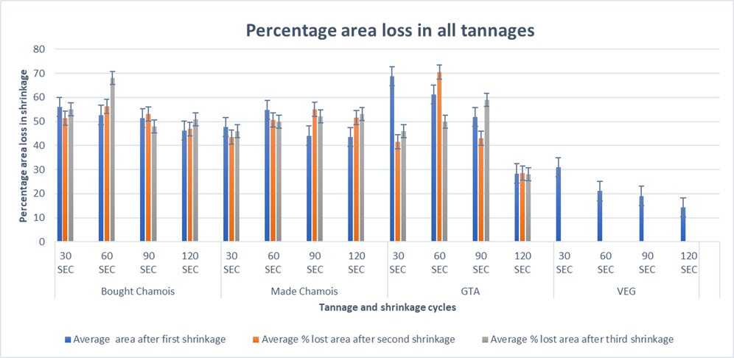

**Figure 7. The graph of percentage area recovered after cooling in the cold water of different tannages, and in three shrinkage cycles and four different time durations percentages are calculated from the original area**

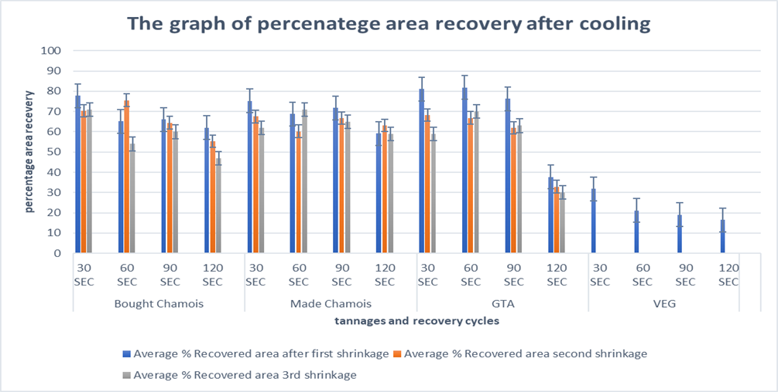

Figure 6 shows GTA tannage has a higher area loss rate than oil tannages, with area loss increasing as thermal exposure time rises across all tannages. This indicates prolonged heat weakens the fiber structure, leading to greater area loss. Vegetable tannage also shows increased shrinkage with longer exposure, suggesting more hydrogen bonds in triple helix structures break. Figure (7) reveals GTA tannage has a higher area recovery rate than oil-tanned leather, reflecting differences in their polymer matrices. Both GTA and oil tannages exhibit declining recovery rates with longer exposure, indicating greater destruction of Ewald effect forces. Vegetable tannage shows no area change during recovery, demonstrating resilience to thermal stress and the absence of the Ewald effect.

**Image 1. Shrinkage Patterns in different tannages: Hot Water Shrinkage with Rapid Cold-Water Cooling where a. Untreated Thermal Tannery Made Chamois b. Shrunk Tannery Chamois (Before Cooling) c. Recovered Tannery Chamois (Cooled in Cold Water) d. Untreated Bought Chamois e. Bought Chamois (Before Cooling) f. Recovered Bought Chamois (Cooled in Cold Water) g. Untreated Vegetable Tannage h. Vegetable Tannage Shrunk (Before Cooling) i. Vegetable Tannage Shrunk and Cooled in Cold Water**.

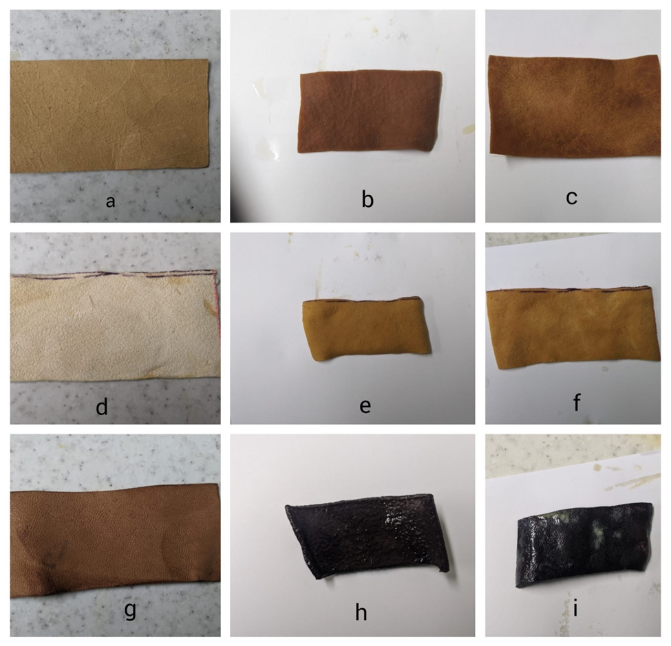

Image (1) demonstrates that bought and made chamois, which form a polymerized matrix, exhibit the Ewald effect, while vegetable tannages, lacking polymerization, show permanent shrinkage. Table (5) supports this, revealing permanent area loss in vegetable-tanned leather. Shorter exposure times, such as 30 seconds, resulted in 31% initial area loss and 32% recovery. As exposure increased to 60 and 90 seconds, area loss decreased to 21% and 19%, respectively, with corresponding recovery declines. At 120 seconds, area loss dropped significantly to 14%, with a 16% recovery rate, indicating increased shrinkage with prolonged exposure.

The methodologies employed confirmed the Ewald effect in oil and glutaraldehyde-tanned leathers. Area recovery is not solely due to collagen re-registration, suggesting fiber structure alterations beyond thermal collagen dynamics. Scanning Electron Microscopy (SEM) and light microscopy provided detailed insights into these structural changes. Based on Image (1) prolonged exposure leads to increased shrinkage and reduced recovery in oil and glutaraldehyde-tanned leathers, indicating that exposure time affect the forces of Ewald Effect.

* 1. **Analysis of Fiber Structure in Different Heating and Cooling Conditions Across Tannages Using SEM.**

***Image 2. SEM image of fiber structure where a. Thermal Untreated Tannery Made Chamois b. Shrunk Tannery Made Chamois (Before Cooling) c. Cooled Shrunk Tannery Chamois (Cooled in Cold Water) d. Thermal Untreated GTA e.*** ***Shrunk GTA (Before cooling) f.*** ***Cooled Shrunk GTA (Cooled in Cold Water) g. Thermally Untreated Vegetable Tannage h. Vegetable Tannage Shrunk (Before cooling) i. Vegetable Tannage Shrunk and Cooled in Cold Water. (30 seconds shrinkage time X250 magnification).***

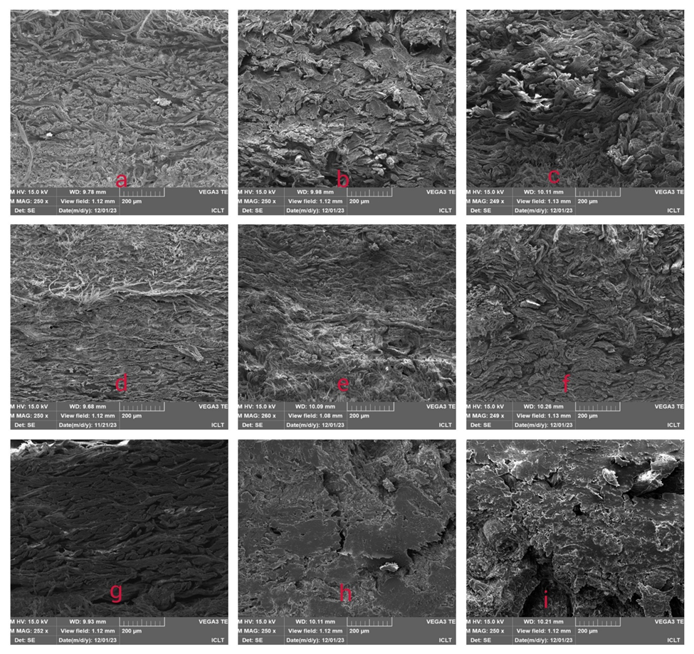

The analysis of fiber structures using SEM and light microscopy reveals distinct differences in the behavior of various tannages under thermal treatment. The untreated chamois (a) exhibits a well-defined, open fiber structure, characteristic of its inherent properties. However, when subjected to shrinkage without cooling (b), the fiber structure collapses, forming large bundles of fibers that stick together. In contrast, relaxation caused by cold water cooling (c) results in an open yet disordered fiber structure. This pattern is consistent in the Glutaldehyde Tannage see (d) (e) and (f) in image (2).

In the vegetable tannage series (g) (h) and (i) thermally untreated sample (g) displays an open fiber structure. However, both the shrunk without cooling (h) and shrunk with cold water cooling (i) samples maintain a collapsed fiber structure, suggesting that vegetable tannage lacks the reversal process observed in chamois and GTA. This distinction confirms the irreversible shrinkage for vegetable tannage under thermal treatment.

Further insights were gained at higher magnification (X1000) and shorter shrinkage times (30 seconds), as detailed in Appendix (H). Light microscopy confirmed that oil-tanned and glutaraldehyde-tanned leathers exhibit a reversal in fiber structure collapse upon immediate water cooling, whereas vegetable tannage shows a permanent collapse. Despite the clear observations, capturing these effects in images proved challenging, though the trends were evident.

1. Conclusion

Visual observations confirm the presence of the Ewald effect in oil and aldehyde tannages, with chamois and GTA leather able to regain nearly 70% of their initial area after relaxation through multiple shrinking cycles. Fiber structure analysis reveals that oil consistently envelops and penetrates chamois fibers across cooling phases and shrinkage durations, suggesting its lubricating properties help maintain the reversible nature of shrunk chamois. However, DSC results challenge the idea of collagen re-registration during area recovery, as denaturation appears permanent in all tannages, evidenced by the absence of subsequent peaks. This indicates that the Ewald effect is not driven by collagen re-registration but may involve other alterations in fiber structure rather than collagen.

Analysis using Differential Scanning Calorimetry (DSC) and Scanning Electron Microscopy (SEM) provides insights into the Ewald effect, DSC results rule out collagen re-registration theory as the mechanism behind area recovery in chamois and GTA leathers. SEM findings reveal differences in fiber structure between rapid water cooled and slow natural air-cooled samples, showing that rapid water cooling allows the fiber structure to revert to an open, although disordered configuration. These results challenge the existing theory of the Ewald effect, indicating that collagen re-registration is not the driving mechanism. This raises critical questions; Is area recovery linked to alterations in fiber structure rather than collagen re-registration? If so, what forces enable fibers to restore their original configuration?

Future research on the Ewald effect should investigate prolonged shrinkage times and elevated temperatures to evaluate their influence on chamois and aldehyde stability, as these extremes could test the strength of factors and forces driving the Ewald effect within the fiber structure. Employing DMA in TMA mode could also offer deeper insights into collagen re-registration during shrinkage and relaxation, further clarifying its mechanical and thermal behavior.

Ethical CONSIDERATION

The raw materials used in this study were ethically sourced to ensure compliance with ethical standards and sustainability. Pickled sheep skins were obtained from the ICLT tannery store, which works with reliable suppliers committed to ethical animal treatment and sustainable beamhouse practices.

Disclaimer (Artificial intelligence)

Author(s) hereby declare that NO generative AI technologies such as Large Language Models (ChatGPT, COPILOT, etc.) and text-to-image generators have been used during the writing or editing of this manuscript.

**REFERENCES**

Thomson, R.S. (2019). Tanning Man’s First Manufacturing Process? Transactions of the Newcomen Society, 53(1). Accessed 11 Jan. 2024.

Merrill, H.B., 1926. The chemistry of leather manufacture. Applying modern science to an ancient art. Journal of Chemical Education, 3(8), p.857.

Haslam, E. (1997). Vegetable tannage: where do the tannins go? JSLTC, 81(2), 45.

Ahmed, M.D., Maraz, K.M., & Khan, R.A. (2021). Prospects and Challenges of Chrome Tanning: Approach a Greener Technology in Leather Industry. Scientific Review, 7(3), 42-49.

Gaidau, C., 2013. Applicative chemistry of tanning metallic heterocomplexes. Bentham Science Publishers.

Sai Bhavya, K., Selvarani, A., V Samrot, A., Javad, M., Thevarkattil, P., & VVSS, A. (2019).

Covington, A.D., & Wise, W.R. (2020). Current trends in leather science. Journal of Leather Science and Engineering, 2, 1-9.

Leathermag.com. (2019). Why you shouldn’t worry about chromium - Leather International. Accessed 11 Jan. 2024.

Covington, A.D. (1997). Modern tanning chemistry. Chemical Society Reviews, 26(2), 111–111. doi:https://doi.org/10.1039/cs9972600111.

Maina, P., Ollengo, M.A., & Nthiga, E.W. (2019). Trends in leather processing: A Review.

Witt, T., Mondschein, A., Majschak, J.P., & Meyer, M. (2021). Heat development at the knife roller during leather shaving. Journal of Leather Science and Engineering, 3, 1-11.

Xu, Y. (2009). Thermal Stability of Collagen Triple Helix. Methods in Enzymology, 466, 211–232. doi:10.1016/s0076-6879(09)66009-2.

Esteban, B., Baquero, G., Cuadros, R., & Morera, J.M. (2021). Proposal and application of a new method to determine leather shrinkage temperature. Thermochimica Acta, 698, 178880. doi:https://doi.org/10.1016/j.tca.2021.178880.

Halper, J. (2021). Basic components of connective tissues and extracellular matrix: fibronectin, fibrinogen, laminin, elastin, fibrillins, fibulins, matrilins, tenascins and thrombospondins. In Progress in Heritable Soft Connective Tissue Diseases, 105-126.

Badea, E., Della Gatta, G., & Usacheva, T. (2012). Effects of temperature and relative humidity on fibrillar collagen in parchment: a micro differential scanning calorimetry (micro DSC) study. Polymer Degradation and Stability, 97(3), 346-353.

Reich, G. (2007). From Collagen to Leather - the Theoretical Background. Ludwigshafen: BASF. Routledge.

Gustavson, K. (1956). Chemistry and Reactivity of Collagen. New York: Academic Press.

Covington, A.D., Song, L., Suparno, O., Koon, H.E.C., & Collins, M.J. (2008). Link-Lock: An Explanation of the Chemical Stabilisation of Collagen. Journal of the Society of Leather Technologists and Chemists, 92, 1.

Covington, A. D. (2011). Prediction in Leather Processing: A Dark Art or a Clear Possibility? Procter Memorial Lecture. Journal of the Society of Leather Technologists and Chemists, 95, 231.

Haslam, E. (1988). Vegetable tannins - renaissance and reappraisal. JSLTC, 72(2), 45.

Crozier, A., Jaganath, I.B., & Clifford, M.N. (2006). Phenols, polyphenols and tannins: an overview. Plant Secondary Metabolites: Occurrence, Structure and Role in the Human Diet, 1, 1-25.

Ewald, A. (1919). Beiträge zur Kenntnis des Collagens. II. Hoppe-Seyler’s Zeitschrift für Physiologische Chemie, 105(3-4), 135–157. doi:https://doi.org/10.1515/bchm2.1919.105.3-4.135.

Leafe, M.K. (Ed.). (1999). Leather Technologists Pocket Book. Withernsea: The Society of Leather Technologists and Chemists.

Sharphouse, J.H. (1985). Theory and practice of modern chamois leather production. JSLTC, 69, 29.

Wang, H., Ma, Y., & Nian, Y. (2007). An Oil Tanning Process Accelerated by Oxidation with Sodium percarbonate. Journal of the Society of Leather Technologists and Chemists, 92(205).

Covington, A. D. (2018). Tanning Chemistry: The Science of Leather (2nd ed.). Royal Society of Chemistry.

Balajyothi, K., Sundar, V.J., Gnanamani, A., & Muralidharan, C. (2008). Bio-oxidation of oil-tanned leathers. Journal of the Society of Leather Technologists and Chemists, 92, 210-215.

Sun, M., Wei, X., Wang, H., Xu, C., Wei, B., Zhang, J., ... & Li, S. (2020). Structure restoration of thermally denatured collagen by ultrahigh pressure treatment. Food and Bioprocess Technology, 13, 367-378.

Sharphouse, J.H. (1983). Leather Technician’s Handbook. Rev. ed. Northampton: Leather Producers’ Association.

Bieńkiewicz, K. J. (1983). Physical chemistry of leather making. Krieger Pub. Co.

Hongru, W., Ma, Y., & Nian, Y. (Year). An Oil Tanning Process Accelerated by Oxidation with Sodium Percarbonate. Journal of the Society of Leather Technologists and Chemists, 92, 205.

Onem, E., Yorgancioglu, A., Karavana, H.A., & Yilmaz, O. (2017). Comparison of different tanning agents on the stabilization of collagen via differential scanning calorimetry. Journal of Thermal Analysis and Calorimetry, 129, 615-622.

Okamoto, Y. & Saeki, K. (2013). Phase transition of collagen and gelatin. Kolloid-Zeitschrift und Zeitschrift für Polymere, 194, pp. 124–135

FATHIMA, N.N. (2011, September). Hydration and Shrinkage Phenomena in Native and Crosslinked Collagen. Proc Indian Natn Sci Acad, 77(3), 283-294.

Carşote, C., & Badea, E. (2019). Micro differential scanning calorimetry and micro hot table method for quantifying deterioration of historical leather. Heritage Science, 7(1). doi:https://doi.org/10.1186/s40494-019-0292-8.

R Zeeman, PJ Dijkstra, P B van Wachem, MJA Van Luyn, M Hendriks, PT Cahalan and J Feijen, Biomaterials 20 (1999) 921

Chahine, C. (2000). Changes in hydrothermal stability of leather and parchment with deterioration: a DSC study. Thermochimica Acta, 365(1-2), 101-110.

Tang, H.R., Covington, A.D., & Hancock, R.A. (2003). Use of DSC to detect the heterogeneity of hydrothermal stability in the polyphenol-treated collagen matrix. Journal of Agricultural and Food Chemistry, 51(23), 6652-6656

Schön, A., Clarkson, B.R., Jaime, M. and Freire, E., 2017. Temperature stability of proteins: Analysis of irreversible denaturation using isothermal calorimetry. Proteins: Structure, Function, and Bioinformatics, 85(11), pp.2009-2016.

APPENDICES

Appendix A: CHROMIUM TANNING RECIPE



Appendix B: VEGETABLE TANNING RECIPE



Appendix C: glutatldehyde TANNING RECIPE



Appendix D: OIL TANNING RECIPE



Appendix E: DSC THEMOGRAM for shrinkage temperature

(a) Thermogram for chamois leather (b) Thermogram for chromium tanning (c) Thermogram for vegetable tanning (d) Thermogram for GTA tanning.

|  |  |
| --- | --- |
|  |  |
| (a) | (b) |
|  |  |
| (c) | (d) |

Appendix F: Ewald testing thermogram for Chamois leathers

(a)Bought chamois (b) Made chamois

|  |
| --- |
|  |
| (a) |
|  |
| (b) |

APPENDIX G: EWALD TESTING THERMOGRAM FOR GTA AND vegetable tanned leathers

(a) GTA tanned leather (b) Vegetable tanned leather

|  |
| --- |
|  |
| (a) |
|  |
| (b) |

\

Appendix H: SEM image of fiber structure.

(a) Untreated thermal tannery chamois (b) Shrunk tannery chamois (without cooling) (c) Shrunk tannery chamois (cooled in cold water) (d) Untreated gta e. gta (not cooled) (f) Shrunk gta (cooled in cold water) (g) Thermally untreated vegetable tannage (h) Vegetable tannage shrunk (not cooled) (i) Vegetable tannage shrunk and cooled in cold water. (30 seconds shrinkage time x1000 magnification).

