Original Research Article

Leveraging industry speaker into active learning opportunities to increase student engagement
1.

ABSTRACT

Industry guest speaker has been invited in many educational settings to share their real-world experience with students, yet there is little understanding on how it can be leveraged to increase student engagement. Student engagement is a concept receiving strong attention in higher education due to its association with a number of positive academic outcomes. The purpose of this research is to design active learning strategies into traditional guest lectures to make it more engaging. It hopes to address the research question on “How can industry speakers be leveraged to increase student engagement in higher education ?”. A total of 92 participants were surveyed at an undergraduate Year 1 Business Degree programme using quantitative research method where self-administered online survey was used to measure the learning activities designed in terms of engagement. The finding indicated that activities like Kahoot gamification and infographics when used correctly with lecturer support such as providing feedback and motivation can help in the overall engagement of the guest lecture that could provide a valuable educational experience. The results of this study provided important implications for educators seeking to enhance student engagement through industry guest speakers.
Keyword: Student engagement, Industry guest speaker, Active Learning, Infographics, Kahoot gamification

- INTRODUCTION

Traditional pedagogy in higher educational institutions often uses face to face lecture-based instruction especially in large class sizes. Lecture-based instruction method has a number of advantages such as able to convey a large factual information to large groups of students, support lecturer control, foster learning by listening which particularly benefit student with this learning style. However, goals like understanding, application and evaluation of ideas cannot be achieved in such passive learning environment [1]. Lecturers are therefore challenged to find ways to deliver concepts in new engaging ways, especially for large classes. A popular method that can bring insightful knowledge from industry practitioner to students is guest lectures [2]. It has been found that students who engage in such industry related activities develop problem solving, analytical skills, collaborative skills, communication skills and are more motivated to learn as compared to traditional lectures [3].
Jablon-Roberts & McCracken [4] stated that research based upon student considerations of using industry lecture in classroom setting has been especially sparse. From the authors knowledge there is also no detailed study done on how to make the industry guest lecture engaging to students especially in the Information System field. Several time guest lectures occur on an ad hoc basis without any detailed thoughts on how to make it more engaging. Lecturers spend considerable effort and time in recruiting, organizing for the industry guest speaker event but does it really enhance student learning experience? Do students find it engaging?
Often lecturer and guest speaker find it difficult to maintain student engagement especially during guest lecture delivery. Due to this, students sometimes become bored and engage in behavior such as playing with their laptop, mobile phones and talking among friends when the industry lecture is going on. Therefore, the traditional format of guest lecture impact towards student learning may not be so effective. Faced with such challenges often seen in educational institution prompted us to search a more effective method to deliver industry guest lecture which traditionally starts with a talk by the speaker and followed up with some time for questions from students. This method may explain why students find it boring and not impactful. As a way to address these issues, the author has thought of a way to incorporate some active learning strategies to make it more engaging. Gamson[5] in her experience with active learning found that it encourages complex thinking and increases student motivation when used. However, these kinds of approaches don’t happen automatically and in fact they need to be designed in a careful manner. It requires good integration of course curriculum with speaker content and a clear assessment of student’s needs [6]. Often it requires a good guest speaker who understands student’s needs and is able to engage and motivate students with their prepared content [7].
Taking this into mind, this research aims to fill the gap by providing guidance through addressing the two research questions.
RQ1: How to incorporate active learning activities in guest lecture to make it more engaging? RQ2: Do students perceive those active learning activities as engaging?

- LITERATURE REVIEW

The use of guest speakers in higher educational institutions is a well-accepted pedagogical practice [8]. Many parties such as guest speakers, faculty and students can benefit from incorporating industry guest lectures. Zuo et al. [9] conducted a review of 18 studies across 13 disciplines suggesting that having guest lectures enhances the learning outcome and leads to a mutually benefit relationship between the students, lecturer and speaker. It provides students with an understanding of how theory is being demonstrated in the real world hence better preparing them for their future careers. As for the industry partner, it can provide an indirect route for the company branding exercise and provide the company with access to potential graduates that may be their employee in the future. For the guest speaker, it is a potentially rewarding experience as it promotes a sense of giving back knowledge to the younger generations. For the lecturer utilizing guest speaker can be a great tool to make the class more interesting as it offers a new perspective based on the real world that is often neglected in regular classes.
Traditionally guest lectures are centered on the speaker who delivers a presentation and followed by a short question and answer session . Students are made passive learners in this process which contradicts the concept that learning is by nature an active endeavor and that different people learn in different ways. According to Kolb [10] students learn more when they are involved based on constructivist theory. Active learning is built on constructivist learning theory whereby activities are designed to engage students in their learning through answering questions, solving problems, teaching others and through group discussion [11]. In active learning there is a shift in the role of the lecturer and the students. Lecturers now become more of a facilitator that provides guidance and support to student learning [12] whereas the students take a more direct participants role of the learning process rather than being a passive receptor [13].
In many past reviews, active learning was found to be effective in undergraduate science, technology, engineering and math (STEM) course [14]. The IS Curriculum report in fact supports that active learning as a teaching mechanism to support four level of knowledge i.e., awareness, literacy, comprehension and application in IS undergraduate studies [15]. Due to the shift in the roles, many researchers found that active learning provides numerous benefits. It has been found to improve student retention and learning [16] and increase self-efficacy [17]. Active learning also leads to increases in examination performance and decreases in failure rates compared with traditional lectures [18]. Strategically designed active learning is also found to help in the development of life-long learning skills among graduate students [19].
Although it provides many benefits, the adoption of active learning is still low and lecturing is still the preferred mode of instruction among undergraduate STEM courses [20]. It was found that the most common barrier of adoption of active learning among lecturers are lack of preparation and insufficient time to complete the activities [21]. Some lecturers even feel unconvinced that it is worthwhile to spend so much effort to implement active learning and as many as 75% lecturers who have attempted some active learning strategies abandoned the practice altogether [22]. Students resistant to active learning are manifested in lack of engagement in activities, poor attendance and course performance [23]. Therefore, lecturers need to have well thought off strategies when implementing active learning with continuous reflection and practice over multiple subject offering. This is important to increase the level of student engagement which has been widely acknowledged as an important component in the field of education [24]. Student engagement is a broad and complex phenomenon grounded in psychological, social, and/or cultural perspectives [25]. Often student engagement can be measured as a desired outcome reflective of students through feeling and behavior about learning.
Mahatmya et al. [26] reported that student engagement exists as a predictor to quality of learning and students’ outcomes. It helps in improving student academic achievement and reduce dropout rates [27]. In short, students may perform better with a higher level of achievement if they are engaged in learning. A model used by us is the Fredricks, Blumenfeld, & Paris [28] suggest student engagement is a student-centered model which are based on factors such as behavior engagement, emotional engagement and cognitive engagement. Typology is useful because it encompasses different types of engagement that capture a range of student experiences. Using typology as a guide this study is conducted so that it could provide a better framework to measure the student engagement in reference to the active learning strategies implemented.

- Methodology

Introduction to the Business Information System is a subject offered to undergraduate Year1 Business students with the aim to instill an appreciation of how technology can be used to assist business particularly in creating an awareness of the importance of information to decision-making. One of the topics covered in the subject is Security and Privacy under which awareness of scams is taught to students. Lately scams have become the buzzword that we hear and read every day hence to create awareness about scams a guest speaker from the banking industry was invited to demonstrate real case studies to students. Industry guest speaker talk is a popular method that can bring relevance to classroom and to engage students. Students were required to actively get engaged in all the learning activities instead of just passively listening during the talk about scams.
This study is conducted to find out how industry guest speakers talk could be leveraged to get students active participation. A group of 92 undergraduate Year1 Business students within the age range of 19-21 years old were involved in this study. Learning activities such as question and answer sessions among industry guest speakers and students, gamification, team collaboration activities were used to encourage active learning among students. To assess students’ engagement in the learning activities a quantitative research method using self-administered online survey is employed. Three types of student engagement were taken note of, mainly their behavior, cognitive and emotion [29].
To stimulate student interactions during activity in active learning they were required to work in a small group of their own choice. They were also required to give an interesting and captivating name to their group. Students were divided into groups of four in a group for activities in gamification using Kahoot and another activity in creating Infographics as a team. Infographics are graphics representation of data and images. The lecturer observed students’ behavior during the Kahoot gamification and Infographics activities. Indicators like interaction within the team and participation in activities were taken into consideration.
Prior to the visit by an industry guest speaker the lecturer identified a suitable guest speaker and made sure students and the speakers were informed of the objectives of the scam talk and able to link to real world examples. The lecturer went through the presentation slides together with the speakers prior to the talk to ensure the relevancy to the subject. The guest speakers were also informed to speak enthusiastically and to engage students. In order to turn the guest visit to an active learning opportunities student were required to prepare a set of related questions to be answered by the speakers thus creating an interactive and engaging learning environment. The questions and answers session were held towards the end of the talk.
Students were tested on their active listening using Kahoot gamification and infographics activities after the talk. Gamification activities with new technologies included have been found to foster students’ engagement, enhance classroom dynamics, motivation and improve overall students’ learning experience [30]. It could be used to minimize distractions thus improving quality of teaching and learning as Kahoot provides timely feedback to students.
The lecturer used Kahoot, a digital game resource that includes a response system to construct quiz questions based on the information presented during the talk for the gamification activity. A total of eight questions from lower to higher order bloom taxonomy were tested. There were questions on remembering, recognition up to scenario-based analysis type. The game was played in a group to encourage collaboration and engagement among all students. Quiz questions were enhanced with images, and it was set in a way where the lecturer was able to control the pace of the game. The Kahoot game environment was designed with many interactive features including music, where students used mobile devices such as their smart phones, tablets and laptops to join the games and answer the questions. Groups were awarded points for answering questions correctly, and the timeliness of correct responses also impacts the points awarded. They could visualize their choice of response. Displaying the top groups’ score or the leaderboard on the screen motivates the other groups to get to the top of the leaderboard as shown in Figure 2.
Students often find the visits by the guest speakers and the gamification activities enjoyable however they do not necessarily find them challenging thus infographics activities were prepared to give an opportunity to get students to think constructively and work collaboratively. By doing infographic students use visual learning style, able to think critically, creatively, and innovatively.
Templates in Canva software were introduced to students during infographics activity. They were also allowed to choose any other design tools software of their choice. To assess the infographics design, rubrics are created with criteria to measure the content, organization, design creativity and innovation. Content should be compelling and convey useful or meaningful information to the reader. All required information should be in place with no errors in grammar, capitalization, punctuation, or spelling. Organization should be clear, consistent and be able to communicate the central issue or topic. Infographics should be overall pleasing to view with the right colour harmony. Images logically go with content. Creativity needs to be shown in the use of data tools and visuals.
The students need to understand the data and information shared during the industry guest speaker talk first, summarize it and then learn the techniques to create infographics. Once the students have learned how to design infographics and what their important criteria are, they will start to design their infographics together in a group. Working collaboratively in a group not only improves their interactions with peers but also their communication skills. Later their work was shared with the whole class and feedback was given based on the rubrics criteria set. Allowing students to construct the knowledge themselves through collaborative effort will not only make them learn better, but also be more engaged in the subject. Students get a chance to demonstrate their higher order thinking skills.
At the end of the industry guest speaker talk a self-administered online survey was conducted. Students were required to answer nine questions, a mix of open and close ended questions. The questions are designed in order to measure engagement based on behavioral, emotional and cognitive elements.

- Results Analysis

Kahoot game activity uses response time and correct answers in allocating points. Points are awarded to groups that have completed a particular quiz question. Groups that achieved the higher points will move up the ladder of achievement in the leaderboard. Total points will be recalculated when another question is answered, and the leaderboard will be updated with the new scores. Figure 3 shows the total points collected by each group which are only viewable by the lecturer. Based on the points, the top three groups will be shown on the podium of the leaderboard which is viewable by the students (Figure 2). Kahoot also gives the lecturer a hint on how groups performed in each question as shown in Figure 4 and the overall performance of the class in the quiz (Figure 1).

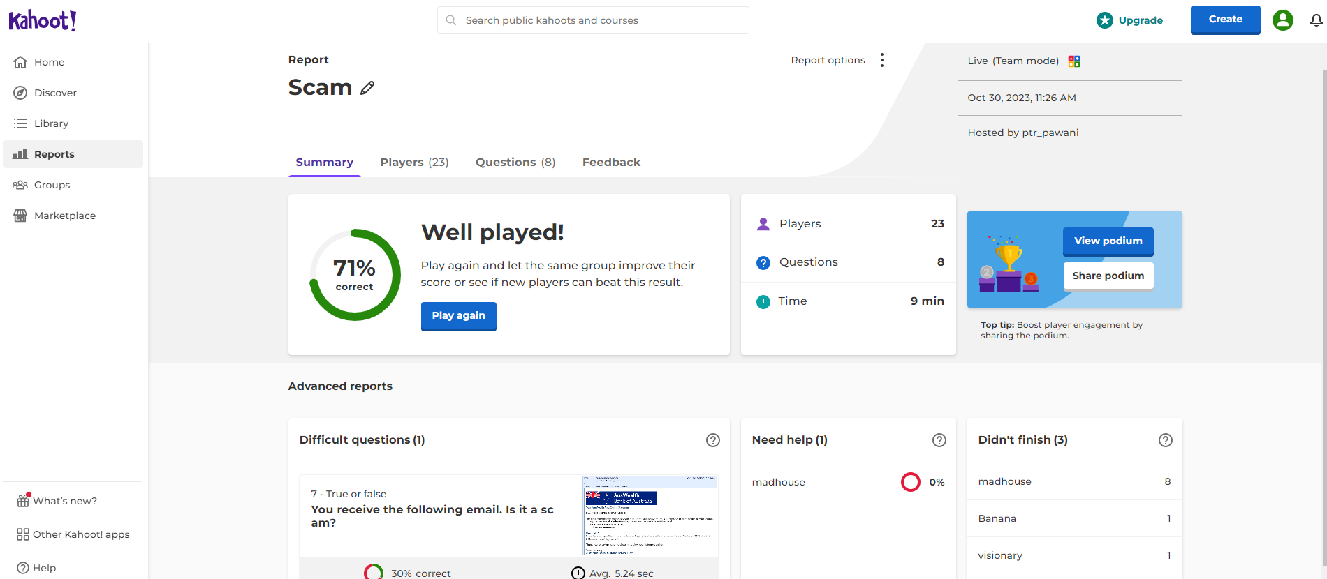
Figure 1. Overall performance
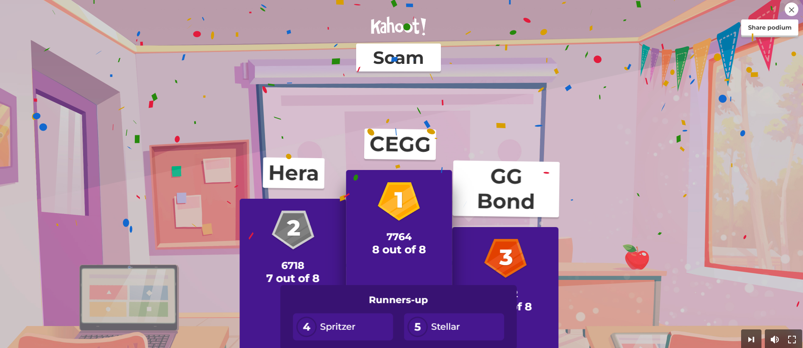
Figure 2. The podium of the leaderboard

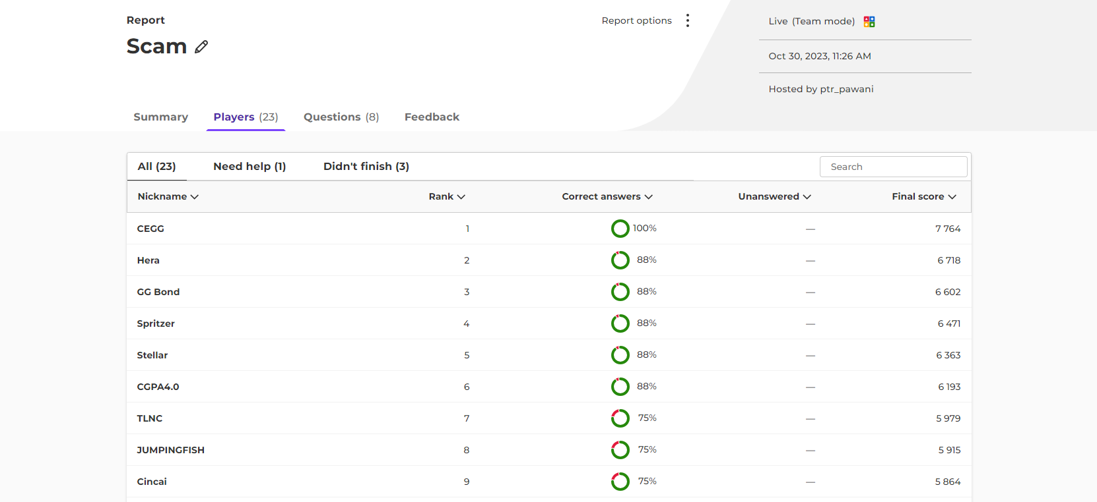
Figure 3. Ranking based on the total points collected by each group.
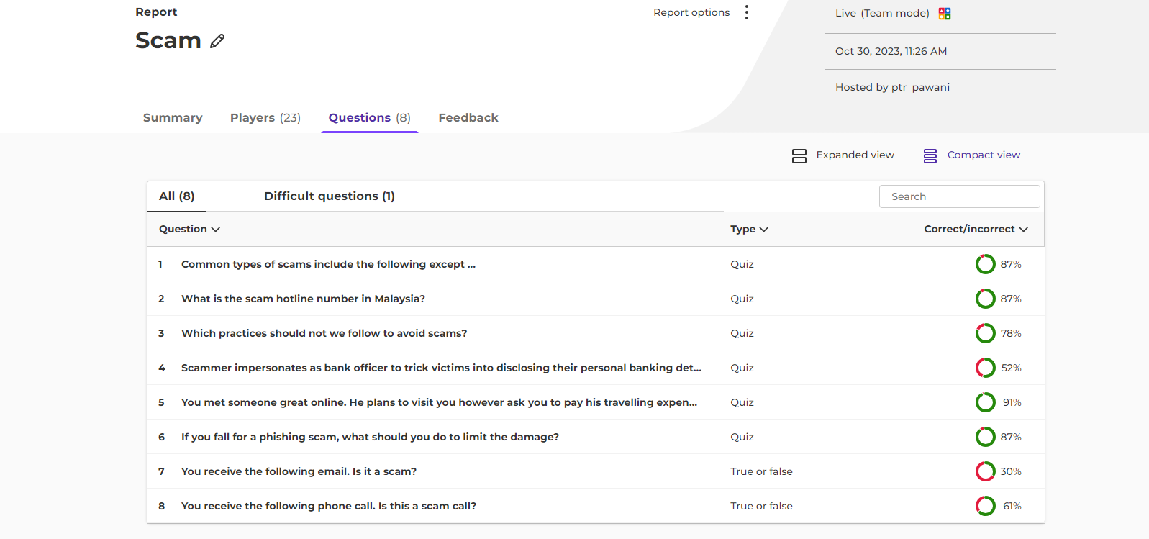
Figure 4. Performance of group based on the question.

Leader board and point system shows engagement from students. It creates competition with the use of leaderboards where groups can see how they rank against other groups, which positively affects student motivation to listen attentively to the talk and be more aware of the topic being presented. Winners got rewards sponsored by the industry guest speakers. Rewards gives motivation to students to listen attentively and be more engaged in future.
The summary of overall performance (Figure 1) gives an indication to the lecturer on how the students performed in the quiz. You can get information on the percentage of overall performance in the quiz by all the groups, average time taken to answer all questions, number of groups, groups that need help, difficult questions based on the score etc. A more detailed report of the performance of the class for each question can be seen in Figure 4. It is a great feedback report to the lecturer.
Infographics require higher order cognitive that needs deep conceptual understanding. Students worked collaboratively in a group and thought constructively by doing in-depth learning in the process of designing infographics. They learned graphic design, information filtering, synthetizing, and identifying essential concepts and relationships between them.
Higher-order learning assignments include situations in which students can experiment with product generation for real-world situations, reflect on the relationship between theory and practice, and receive specific feedback about their efforts. A rubric criteria was shared with students which main criteria include design, content, clarity and representation as shown in Table 1.
Table 1. Infographics Rubrics
 | 5 (Excellent) | 4 (Good) | 3 (Fair) | 2 (Needs improvement) | 1 (Poor)
Design  - Layout  - Color Scheme  - Fonts | - Layout is organized and uses consistent style  - Color scheme has visual appeal and works with content  - Fonts are legible and consistent | - Generally good layout  - Has minor inconsistency or one distracting element  - Color scheme clashes | - Layout could use improvement  - Two or more inconsistent elements  - Hard to read fonts  - Layout distracts from content | - Layout is disorganized, no obvious organization  - Layout distracts from content  - Color scheme is confusing | - No layout or scheme—just random elements, colors, and fonts
Content  - Terms, Facts  - Quantity of data  - Quality of data | - Appropriate terms, vocab, jargon defined and used  - More than enough data to make claims  - Data clearly demonstrate trend, claim, etc  - Data from good source | - One or two terms or jargon used incorrectly or without explanation  - Adequate amount of data  - Data demonstrate trend, claim, etc  - Data from good source | - Not enough terms, vocab, jargon  - Data is sparse  - Data might not demonstrate the trend or claim  - Data from good source | - Lacking in appropriate terminology  - Not enough facts or data  - Data is from poor or questionable source | - No real data or facts are present
Clarity  - Makes a claim  - Efficiency  - Makes clear impression | - Claim, main idea is obvious and easy to understand  - No unnecessary graphics or visuals  - Infographic makes a good initial impression | - Claim, main idea is understandable  - No unnecessary graphics or visuals | - Claim, main idea is made  - Some graphics or visuals are unneeded | - Infographic makes a poor initial impression  - Confusing | - Claim, main idea is missing
Representation  - Design complements content  - Careful choice of visuals  - Data visualization matches content and claim | - Design elements are clearly informed by content  - Visuals show connection to content and create a visual flow  - Visualizations fit the data and the claim | - Design elements are clearly informed by content  - Visualizations fit the data and the claim | - Visualizations fit the data and the claim | - Design and visuals are at odds with the content or claims being made | - Design elements and visuals convey a meaning contrary to the intent
Source: http://science-infographics.org/general-infographic-rubric/
Most groups were able to communicate a message with facts and figures shared during the talk. The storylines were mostly logical and consistent with appropriate title, visual, effective use of color, fonts, size and proportion. Some groups graphic designs were creative, and they used metaphors and relevant icons. Generally speaking, all infographics were good, however some of them were too lengthy. Some groups did well, some merely modified the template from Canva. Those poorly performed groups had some issues with team collaboration, missing figures, incomplete fact shown, no related icons and not able to identify colour harmony. Minority group had inconsistent fonts, spelling or grammatical error.
The key instrument in this study was an online survey questionnaire. The data from the online survey question was analyzed to investigate the engagement of students based on guest lecture talk and activities. Cronbach’s alpha coefficient is often used as indicator of an internal consistency and to estimate the reliability. A good Cronbach alpha scale usually should be more than 0.7 [31]. Cronbach's alpha was computed for the online survey instrument with Likert scale questions for this study. The alpha of the four items of Likert scale was 0.963. This result reflects a good reliability of the measure.
Non-parametric statistical analysis was performed to identify the existence of any relationships between the independent variables and the students’ responses. A Spearman's rho correlation compares the relationships between two variables, used for ordinal level data. The Spearman’s rho correlation test used in the analysis revealed that there is significant relationship as shown in Figure 5 and 6. Gamification and Topic Clarity/Learning were significantly correlated, r = 0.918, p < 0.01. At the significant level of 0.01, it can be concluded that there is a significant relationship between gamification activities and learning engagement. The results also indicated that the Collaboration and Topic Clarity/Learning were significantly correlated, r = 0.871, p < 0.01. At the significant level of 0.01, it can be concluded that there is a significant relationship between collaboration activities and learning engagement. An r-value between 0.1 and 0.3 signifies a small correlation, wherein a medium correlation is quantified with an r-value between 0.3 and 0.5. Lastly, a large correlation corresponds with an r-value of 0.5 or higher [32]. Based on the pair-wise combinations, a large or strong correlation is shown as in Figure 5 and 6.
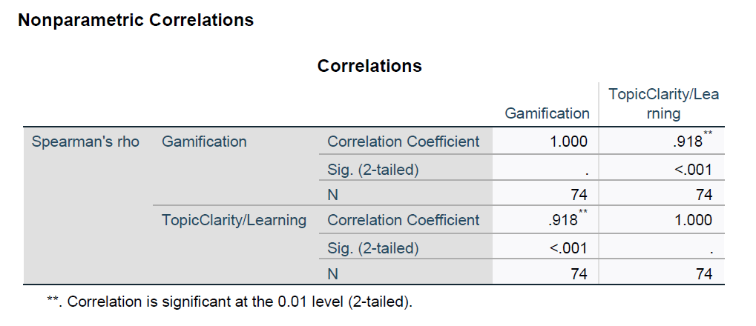
Figure 5. The correlation between gamification activities and learning engagement.

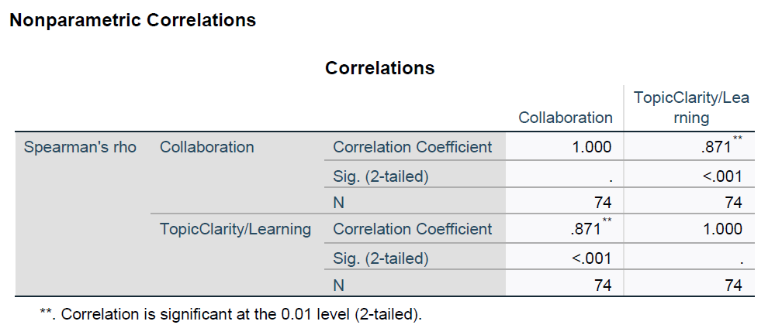
Figure 6. The correlation between collaboration activities and learning engagement.

- DISCUSSION

In order to address our first research questions, “How to incorporate active learning activities in guest lecture to make it more engaging?”, we would discuss the two main methods used. In each of these methods we would discuss on the supporting strategies lecturer can employ.

5.1 Kahoot gamification
We observed that Kahoot gamification provided a fun learning experience that contributed to useful classroom engagement dynamics. When students were discussing with their groups it provided an opportunity to enhance the students’ ability to retain the concept learned during the guest lecture. This finding supported the previous research that Kahoot helped in enhancing lecture-student engagement and provide a better constructive discussion with peers [33]. The Kahoot gamification that is provided after the one-hour guest lecture also allowed a timely break and provided a necessary avenue for reflection and discussion among the students on the content delivered.
As for the educator, providing reasoning towards the answer of the Kahoot gamification helped students in retaining the information gained. Prizes given based on the leaderboard to the top winner of the game provided extra motivation and engagement. We believed also by allowing students to enter the name of their choice into the Kahoot system provided anonymity which reduced the feeling among students that they will be judged for their answer. Furthermore, having funny names such as “Cincai” provided some element of fun into the whole learning process which helps in the student engagement.
As for the assessment activity in the Kahoot gamification we tested students on all levels in the Bloom Taxonomy. Bloom Taxonomy consists of six levels in which as you progress to the higher level, students need to have a more elevated amount of abstraction. Basically, the lower level requires students to recall, understanding of concept or terms whereas higher order requires students to interpret data and select of best conclusion. A question rated at the analysis level would require knowledge (facts), comprehension (understanding of facts), application (predicting outcomes), and analysis (inference). This is important as by having assessment following Bloom Taxonomy educator can provide engaging activities that challenge students to think critically.

5.2 Infographics
In order to develop deeper learning among students we found infographics to be a good active learning activity to be included. Infographics also match the learning style preference of Generation Z who majority of whom are visual learners and prefer less textual information in educational settings [34]. Infographics is able to provide an avenue for students to be an active creator of their own knowledge, immerse themselves in deeper learning as they need to think critically on what to be included using different forms of visualization. Students can learn how to critically analyze the content suitability and condense the information into a one-page template. This matches the research finding which confirmed that it helps in development of critical thinking, information literacy, research skills, creativity, communication and digital literacy [35,36]. Individuals prefer shorter as well as quicker forms of communication and this makes infographics a popular form of communication. Students found that graphic design was fun, and it is easy to remember when they are able to visualize their thinking.
To increase the value of infographics activity, it is important for instructor to redirect students to some examples of good infographics and infographics software tools before student embark in the design process. The rubrics should also be discussed with students so that they know how their design would be graded. Furthermore, to increase student engagement we suggest putting students in groups for this activity as it would help with their collaboration skills and provide better engagement. In collaboration activities, students are motivated to work together and learn. After reviewing all the infographics, it is important that instructor provides feedback, so students know what they have done well and need to improve in the future. Academic success should be measured not just in terms of what students can remember, but what students are able to do with their knowledge.
In order to answer our second research question which is “Does students perceive those active learning activities as engaging?”
To measure the engagement factor, we used the three factors which are behavioral engagement, emotional engagement and cognitive engagement. Behavioral engagement refers to the degree to which students are actively involved in learning activities. Indicators of behavioral engagement include time and effort spent participating in learning activities. From the survey it was found nearly 75% of the students find the activities provided many opportunities to exchange ideas with teammates which is included in the Kahoot and Infographics activity. This is most prevalent during Kahoot gamification whereby students need to discuss among their team members their answer. This is further supported by Chaiyo & Ranchana [37] which revealed that Kahoot enhances student interaction and activity, which helps in collaborative learning and increases student engagement in the learning process.
Cognitive engagement includes motivational aspects, much of the literature focuses on how students use active learning and higher-order thinking, absorption of learning. When measuring absorption of learning 73% found that Kahoot gamification activity and infographic has improved the student understanding of scam topic which show high absorption of learning. Overall, it can be concluded that the students generally have a high perception towards the integration of Kahoot and infographics into the guest lecture in terms of helping in understanding.
As for emotional engagement includes attitudes, interests, and values towards learning, peer bonding. From the survey it was found that more than 62% found game-based learning to be fun and engaging medium. When being asked which activity they liked the most or their favorite, 63.5% of them mention they liked the most the Kahoot gamification. This is because the Kahoot gamification provided a fun element into the whole guest lecture to make it more engaging. This corresponds with the research by Bicen where the researcher claimed that gamification has a significant impact on the perceived motivation and engagement [38]. This is further supported by Hitchens & Tulloch [39] that noted that gamification can be enjoyable and educationally beneficial for a majority of students. The game-based method is also able to motivate them to stay interested during the industry guest speaker as material presented would be tested. The direct feedback from Kahoot is also effective in helping students correct their mistakes in a fun manner.
The lowest in terms of favorite is infographics (12.2 %) although it helps the development of a set of important skills such as critical thinking, digital literacy, collaboration. The reason for this is students find this task time-consuming and something new which they have not done before so that created some negative perception towards it. However, we observed later students still find it a useful activity. This trend is observed in many higher educational institutions whereby the use of infographics is not very common [40]. Ray Chaudhury [41] in this research found student expressed some negative emotions about Infographic at the start of it but later they revealed positive attitudes to it. As for the second favorite or preferred technique that they find engaging is the guest lecture (24.3%). From the survey it was found that students liked this experience as the guest speaker talk was informative, spoke enthusiastically and honestly, and answered questions.
The results showed that 98.6% of respondents mentioned that they will recommend the talk and activities to their friends. This is because students have noticed a change in the guest lecture mechanism as some of them stated that, “Earlier the focus was only on the syllabus-based requirements about a concerned topic which was though informative but less interacting but now with gamification and collaboration the talk has become informative, more fun and engaging”.

- CONCLUSION

The beauty of inviting industry guest speakers into the classroom beneﬁts the students, faculty as well as the guest speakers. The primary beneﬁt for the students is that it enables the insights from industry essential for students to begin to understand how theory works in practice that promotes deeper learning among students. As for faculty it increases the opportunities for further collaboration between faculty and industry and for guest speakers they get personal satisfaction, and it is also good for employer branding.
Overall, the active learning activities with the industry guest speaker has improved the students’ knowledge on scams. It has also made the course more interesting as it provides students with an opportunity to interact with professionals and see how scams are being used in the real world. We identified two active learning methods that can make guest lectures more engaging which are using Kahoot gamification and infographics. Students like the fun element associated with Kahoot gamification and also Infographics has allowed students to build up many skills and overall made the whole learning experience more engaging. However, in order for both of these activities to be engaging and effective lecturers need to play an active role in the whole process guiding students by providing feedback and motivation. it is also important for lecturer to have a realistic expectation for the initial implementation and continuously refine their use of active learning in guest lecture through multiple course offering. With this persistent attitude among lecturers, it can be hoped that there would be an increase in the adoption of industry lecture with active learning in higher educational institutions.

- LIMITATIONS AND SUGGESTION

The conclusion of this study is limited due to the small sample size and short study period of time so it cannot be used as a generalizing finding for a larger population, furthermore it is limited to one class, and one subject only. Future research can use a larger survey sample size, a longer study period and integrating both quantitative and qualitative approaches such as interview and focus group. This will provide a more detailed understanding of student perception and deduce more precise and accurate findings that can be generalized to a larger population in various contexts. Another limitation is this study focuses on guest speakers that is face to face. It would be good to study the virtual guest speaker which is increasingly common especially after Covid pandemic. Additionally, it would be good to find-tune this research to measure the effect of active learning strategies implemented based on the different nationalities of the students which have different cultures. This study would be of value as many researchers pointed out that understanding culture has an effect on how students learn [42,43].

Disclaimer (Artificial intelligence)
Option 1:
Author(s) hereby declare that NO generative AI technologies such as Large Language Models (ChatGPT, COPILOT, etc.) and text-to-image generators have been used during the writing or editing of this manuscript.
Option 2:
Author(s) hereby declare that generative AI technologies such as Large Language Models, etc. have been used during the writing or editing of manuscripts. This explanation will include the name, version, model, and source of the generative AI technology and as well as all input prompts provided to the generative AI technology

Details of the AI usage are given below:
1.
2.
3.

References
- Jenkins A. Active learning in structured lectures: Gibbs G, Jenkins A, editors. Teaching large classes in higher education. London: Kogan Page. 1994 : p. 123-135.
- Li L, Guo R. A student-centered guest lecturing: A constructivism approach to promote student engagement. Journal of Instructional Pedagogies. 2015 ; 15(1)
- Hmelo-Silver CE. Problem-based learning: What and how do students learn? Educational Psychology Review. 2004;16(3):235-266.
- Jablon-Roberts, S., & McCracken, A. Undergraduate student perceptions of industry guest speakers in the college classroom. Journal of the Scholarship of Teaching and Learning.2022; 22(3) : 76-88. https://doi.org/10.14434/josotl.v22i3.32317
- Gamson, Z. Urgings and Cautions in Student-Centered Teaching. Innovative Higher Education.1996
- Kamoun, F., & Selim, S. A framework towards assessing the merits of inviting IT professionals to the classroom. Journal of Information Technology Education. 2007 : 81–103.
- Lee, K., & Joung, H. An examination of students’ perceptions for guest speakers in hospitality and tourism programs. Journal of Teaching in Travel & Tourism. 2017; 17(4) : 300-312. https://doi.org/10.1080/15313220.2017.1361888
- Jablon-Roberts S, McCracken A . Undergraduate student perceptions of industry guest speakers in the college classroom. J Sch Teach Learn. 2022; 22(3):89-105.
- Zou, P., Sun, W., Hallowell, S. G., Luo, Y., Lee, C., & Ge, L. Use of guest speakers in nursing education: An integrative review of multidisciplinary literature. Advances in Medical Education and Practice. 2019: 175-189. https://doi.org/10.2147/AMEP.S196456
- Kolb, D. A. Experiential learning: Experience as the source of learning and development. Englewood Cliffs, NJ:1984. Prentice Hall.
- Prince, M., & Felder, R. The many faces of inductive teaching and learning. Journal of College Science Teaching. 2007;36(5): 14-20.
- Ishii, K. Active learning and teacher training: Lesson study and professional learning communities. Scientia in Education. 2017
- Eugene, C. How to teach at the university level through an active learning approach? Consequences for teaching basic electrical measurements. Measurement. 2006; 39(10) : 936-946.
- Freeman, S., Eddy, S. L., McDonough, M., Smith, M. K., Okoroafor, N., Jordt, H., & Wenderoth, M. P. Active learning increases student performance in science, engineering, and mathematics. Proceedings of the National Academy of Sciences. 2014; 111(23): 8410–8415. https://doi.org/10.1073/pnas.1319030111
- Australasian Conference on Information Systems. Active Learning in IS Education: Choosing Effective Strategies for Teaching Large Classes in Higher Education. In Proceedings of the 10th Australasian Conference on Information Systems. 1999
- Chi, M. T., & Wylie, R. The ICAP framework: Linking cognitive engagement to active learning outcomes. Educational Psychologist.2014;49(4):219–243. https://doi.org/10.1080/00461520.2014.965823
- Stump, G. S., Husman, J., & Corby, M. Engineering students' intelligence beliefs and learning. Journal of Engineering Education. 2014; 103(3): 369–387. https://doi.org/10.1002/jee.20051
18.Freeman, S., Eddy, S. L., McDonough, M., Smith, M. K., Okoroafor, N., Jordt, H., & Wenderoth, M. P.
Active learning increases student performance in science, engineering, and mathematics. Proceedings
of the National Academy of Sciences. 2014; 111(23): 8410–8415.
https://doi.org/10.1073/pnas.1319030111
19.D’Silva, I. Active learning. Journal of Education Administration and Policy Studies. 2010; 2(6) : 77-82.
- Stains, M., Harshman, J., Barker, M., Chasteen, S., Cole, R., DeChenne-Peters, S., Young, A. M. Anatomy of STEM teaching in North American universities. Science. 2018:1468–1470. https://doi.org/10.1126/science.aap8892
21.Finelli, C. J., Daly, S. R., & Richardson, K. M. Bridging the research-to-practice gap: Designing an
institutional change plan using local evidence. Journal of Engineering Education. 2014; 103(2): 331–
361.
22.Froyd, J. E., Borrego, M., Cutler, S., Henderson, C., & Prince, M. J. Estimates of use of research-based instructional strategies in core electrical or computer engineering courses. IEEE Transactions on Education. 2013; 56(4): 393–399. https://doi.org/10.1109/TE.2013.2244602
23.Winkler, I., & Rybnikova, I. Student resistance in the classroom—Functional-instrumentalist, critical-emancipatory and critical functional conceptualizations. Higher Education Quarterly. 2019; 73(4): 521–538. https://doi.org/10.1111/hequ.12219
24.Haw, L. H., Sharif, S. B., & Han, C. G. K. Predictors of student engagement in science learning: The role of science laboratory learning environment and science learning motivation. Asia Pacific Journal of Educators and Education. 2022; 37(2) : 225–245. https://doi.org/10.21315/apjee2022.37.2.11
25.Wimpenny, K., & Savin-Baden, M. Alienation, agency, and authenticity: A synthesis of the literature on student engagement. Teaching in Higher Education. 2013 ; 18(3) :311–326. https://doi.org/10.1080/13562517.2012.725223
26.Mahatmya D, Lohman BJ, Matjasko JL, Farb AF. Predictors and pathways to civic involvement in emerging adulthood: Neighborhood, family, and school influences. J Youth Adolescence. 2012
27.Lei, H., Cui, Y., & Zhou, W. Relationships between student engagement and academic achievement: A meta-analysis. Social Behavior and Personality: An International Journal. 2018; 46 : 517–528.
28.Fredricks, J., Blumenfeld, P., & Paris, A. School engagement: Potential of the concept, state of the evidence. Review of Educational Research. 2004 ; 74(1) : 59–109. https://doi.org/10.3102/00346543074001059
29.Schindler, L. A., Burkholder, G. J., Morad, O. A., & Marsh, C. Computer-based technology and student engagement: A critical review of the literature. International Journal of Educational Technology in Higher Education. 2017; 14(1). https://doi.org/10.1186/s41239-017-0063-0
30.Licorish, S. A., Owen, H. E., Daniel, B., & George, J. L. Students’ perception of Kahoot!'s influence on teaching and learning. Research and Practice in Technology Enhanced Learning. 2018 ;13(1). https://doi.org/10.1186/s41039-018-0078-8
31.Devellis, R. F. Scale development: Theory and applications. Sage Publications, Inc. 2016
32.Benesty, J., Chen, J., Huang, Y., Cohen, I., & Springerlink (Online Service). Noise reduction in speech processing. 2009. Springer Berlin Heidelberg.
33.Plump, C. M., & LaRosa, J. Using Kahoot! in the classroom to create engagement and active learning: A game-based technology solution for eLearning novices. Management Teaching Review. 2017; 2(2) :151–158.
34.Jaleniauskiene, E., & Kasperiuniene, J. Infographics in higher education: A scoping review. E-Learning and Digital Media. 2022; 20(2) : 191–206. https://doi.org/10.1177/20427530221107774
35.Alqudah, D., Bidin, A. B., & Hussin, M. A. H. B. M. The impact of educational infographic on students’ interaction and perception in Jordanian Higher Education: Experimental Study. International Journal of Instruction. 2019 ; 12(4) : 669–688.
36.Kibar, P. N., & Akkoyunlu, B. Fostering and assessing infographic design for learning: The development of infographic design criteria. Journal of Visual Literacy. 2017; 36(1) : 20–40.
37.Chaiyo, Y., & Ranchana, N. The Effect of Kahoot, Quizizz and Google Forms on the Student's Perception in the Classroom Response System. In Proceedings of the International Conference on Digital Art, Media and Technology. 2017: 178-182.
38.Bicen, H., & Kocakoyun, S. Perceptions of students for gamification approach: Kahoot as a case study. International Journal of Emerging Technologies in Learning. 2018 ;13(2) : 72–93.
39.Hitchens, M., & Tulloch, R. A gamification design for the classroom. Interactive Technology and Smart Education. 2018; 15(1) : 28–45.
40.Alyahya, D. M. Infographics as a learning tool in higher education: The design process and perception of an instructional designer. International Journal of Learning, Teaching and Educational Research. 2019;18(1): 1–15.
41.Ray Chaudhury, S. Encouraging undergraduate students to ‘self-learn’ digital marketing using infographics: An exploratory study. Innovations in Education and Teaching International. 2021; 58(2): 207–218.
42.Kim, K. J., & Bonk, C. J. Cross-cultural comparisons of online collaboration. Journal of Computer-mediated Communication. 2002; 8(1).
43.Teng, L. Y. W. Collaborating and communicating online: A cross-bordered intercultural project between Taiwan and the US. Journal of Intercultural Communication. 2007.

