**Design and implementation of the cloud platform system of the picking robot**

**Abstract**

This paper designed picking robot data processing system based on the cloud technology, the system has the following functions: the user can view the current picking robot in the location of the orchard, environmental temperature and humidity, real-time orchard images and other environment information, and picking robot status and data such as robotic arm motion, picking robot working time and the current temperature, depth camera real-time image and picking recognition rate data. At the same time, the data of the picking robot device is interacted, collected and stored, and the data is exchanged with the cloud through MQTT Internet of Things communication protocol, and stored in the form of device log. Secondly, the system administrator on the application layer can manage all registered users and log off users; manage all the hardware equipment of picking robot such as mechanical arm, chassis car, add, delete and check the relevant data of picking robot; and open all the collected data in the database to the front end in JSON format.

**Key words:** picking robot; cloud platform; cloud collaboration; OTA

1. System requirements analysis

1.1 System functional requirements analysis

The main parts of the system are the picking robot, the cloud, and the data interaction between the picking robot and the cloud. The main functional requirements are as follows:

(1) Data collection of the picking robot. The data acquisition module is divided into orchard environment data acquisition and data acquisition of the picking robot sends the depth camera image, GPS sensor, mechanical arm pose data, equipment power and other information to the cloud platform through 5G module. Because the orchard environment is located in a remote area and the coverage of most orchard base stations is not high, it is very important to choose a transmission mode with wide coverage, low power consumption and low cost transmission mode. In this system, the data collected by the orchard environment parameters with various environment sensors and the orchard environment monitoring are communicated through the BC260Y gateway through NB-IoT (Narrowband Internet of Things, narrowband Internet of Things technology).

(2) Communication between the picking robot and the cloud platform. Picking robot and cloud platform need to define communication specification, due to different picking robot equipment structure and data interface, inevitably cause the exchange of data between the system is not standard, so need to design specific data exchange specification to realize the robot and cloud service platform docking, to solve the whole picking robot system compatibility and real-time dynamic matching. By defining the data interface of the picking robot top IC and the cloud platform based on the message type based on MQTT, different data formats are converted to realize the communication between the heterogeneous picking robot and the cloud platform.

(3) Cloud data storage and resource sharing. When the picking robot is performing the task, the collected data information can be stored persistently through the cloud platform, which can be used and shared by other robots. NFS (Network File System) service deployment enables the sharing of perceptual data, environmental information, task requirements, etc., enabling multiple robots to coordinate and cooperate on performing tasks to complete the work more efficiently. The sharing of data resources can make tasks more flexible and adaptable.

(4) Computing task separation of the picking robot. Based on the characteristics of distribution calculation, and the intelligent picking in the process of intensive computing and complex processing of fruit target detection and target positioning requires the deep learning algorithm migration to the cloud, reduce the equipment industrial control machine calculation, will the picking robot equipment data acquisition preprocessing deep learning algorithm execution and the results of the processing and preservation process in the picking robot and the cloud for reasonable division. In addition, the deployment of deep learning framework in the cloud, which can share data sets for multiple users. Secondly, because the cloud is scalable, it is convenient to do model training and development functions on the cloud platform.

(5) Cloud visualization interface development. The most important part of the client is the visual interface, which is also the most intuitive function for users to understand the whole system. The visual interface mainly includes the user login interface module, the historical data query and display interface module, and the real-time data monitoring interface module. The user or the administrator sends a request through the browser. After the server receives the request, the server-side program then queries the database to obtain the corresponding data, and then returns the data to the front-end page after background processing. The system administrator can enter the background management interface to configure the user information, device information and collection point data; after logging in the system, the user can modify the personal information, view the personal device, and view the collection point data by screening the device information.

1.2 Non-functional requirements analysis

A system requires stable and efficient operation. In addition to completing the functional requirements, it also needs to meet certain non-functional features. It mainly includes the following aspects:

(1) Generality

In the picking robot cloud platform, different software or hardware structures make there is no unified standard for the development of the system. Especially, in the data definition and transmission of picking robot data, defining the standard data format and data structure can reduce the repeated definition of data and improve the versatility of the system. In picking robot cloud platform system, using the same software application architecture for different types of equipment technology development and control, the system will ali cloud as picking robot cloud platform system development tools, used in the cloud platform picking robot monitoring and control, to improve the versatility of the cloud platform system.

(2) Scalability

Picking robot cloud platform according to different usage scenarios need to add new functions, such as different varieties picking target and orchard environment factors, at the same time may need to change the picking robot ontology mechanism or to add new picking robot application in the cloud platform, so the system scalability is particularly important, to make the system is easy to update and maintenance.

(3) Reusability

The picking robot cloud platform should enable the modules or components to be reused to reduce unnecessary development, and the components can be effectively connected through the MQTT message communication mechanism. For example, the GPS positioning module, environment sensing module, depth camera hardware module and deep learning algorithm of the picking robot are reusable, which provides the scalability and reuse of the cloud platform of the designed picking robot for different robots.

2. Picking robot and cloud communication mechanism

Based on the point-to-point uncoupled message model of ROS, the target detection module can be deployed in the cloud in the form of Docker file, and the cloud can conduct data interaction with the picking robot device through ROS to complete the service tasks. However, the communication mechanism based on ROS is only suitable for the information interaction between the internal nodes in the ROS system, and is closely related to the conditions such as the network environment and requires multiple configurations, which seriously affects the application of the picking robot on the network in the actual orchard scene. To solve this problem, this system cites the MQTT _ bridge tool based on MQTT protocol to extend the communication mechanism of ROS, MQTT is a lightweight messaging protocol specially suitable for the communication of IoT devices under low bandwidth, high latency or unreliable network conditions. Through MQTT _ bridge, the communication message type of ROS is converted to a format suitable for Internet message transmission, so that the picking robot can communicate with the cloud platform through the Internet, while retaining the message mechanism of ROS in the device end of the picking robot, reducing the changes to the internal structure of ROS.

The background management and control system of the picking robot is usually developed by different languages, such as Java and python. In order to achieve the loose coupling between the end of the picking robot, the language and platform can be irrelevant. MQTT _ bridge can not only realize the control of the picking robot on the cloud platform, but also transmit the data collected by the picking robot, such as image data and robotic arm state, according to the MQTT message transmission protocol. At the same time, the environmental sensor data and equipment positioning information in the orchard can be uploaded. In general, MQTT _ bridge implements the vast majority of the message data in the ROS system, and can fully provide the message content defined by the picking robot itself.

ROS analysis by the previous chapter 2.4.2 provides a distributed system architecture, but in its distributed communication architecture design, ROS is a centralized management structure, refers to each node needs to be deployed for a Master management node registration, and each node also need to maintain DNS and other network information. In the ROS environment, more people operate under the same LAN, which greatly limits the application scenario of the picking robot. At the same time, the loose-coupling architecture based on ROS enables us to migrate the computing to the cloud and provides the conditions for the combination of the picking robot and the cloud platform. Therefore, after making full use of the advantages of the loose coupling system architecture of ROS to move the computing-intensive resources to the cloud, we will focus on solving the problem of information transmission between the picking robot and the cloud through the Internet.

The system adopts the method of message conversion, continue to use the ROS in the communication architecture and message format, implement the ROS message package module within the cloud platform, the ROS message can be transmitted, while keeping the message release and subscription, so that the ROS message mechanism can continue to be used after Internet transmission, and the operation of the corresponding node can be triggered by the retained message mechanism. Figure 2 shows the message conversion model.

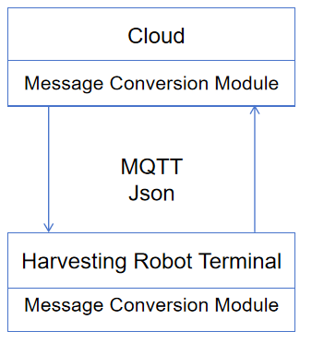

Fig 2 System message transformation model

First picking robot in the task of real-time requirements, so the system using MQTT protocol as a "cloud-end" message conversion protocol, then picking robot with ROS message transmission mode has the characteristics of diversity, the system adopts the Internet commonly used message format JSON as transmission object, it is independent of the programming language of lightweight convenient data transmission format, cross-platform, easy to read and write, the bandwidth is small. So the JSON is suitable for the conversion transmission of the ROS messages.

In the process of realizing MQTT _ bridge, the picking robot device end is first configured, and the MQTT client library is installed under the industrial controller Ubuntu system. Later, the MQTT client needs to be configured to connect to the MQTT Broker. In this process, we need to obtain the MQTT connection parameters, such as usemame, passwd, mqttHostUrl, port and other information in Broker, to ensure that the MQTT client can subscribe to the corresponding topic topics and publish a message to the corresponding topic. MQTT _ bridge interface for the configuration of the picking robot is shown in Figure 3.

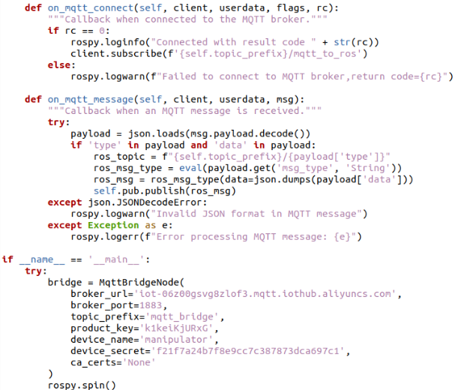

Fig 3 Configuration of MQTT_Bridge on the picking robot

MQTT _ bridge also needs to be the conversion between ROS messages and the corresponding operations and JSON messages. Therefore, in MQTT _ bridge also needs to define the corresponding communication protocol to including the ROS key information types of the picking robot. Some of the message content release and subscription code are shown as shown in Figure 4.

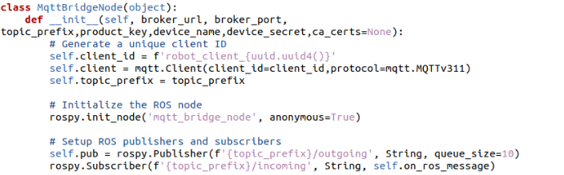

Fig 4 Publication and Subscription of ROS Message Contents in MQTT Bridge

Next, the MQTT server is configured in the cloud, and MQTT Broker is deployed as the cloud MQTT bridge. The system adopts the cloud server ECS and deploys the MQTT server in the cloud server, responsible for processing the data forwarded from MQTT _ bridge. The code of the specific implementation process is shown in Figure 5. By building MQTT server can subscribe to the theme from the picking robot topics, and the received data stored in OSS Broker, so that the subsequent data for data classification and data analysis, finally provide REST API or other forms of interface, for other systems or applications to access the data, in the cloud client visualization to show the user data.

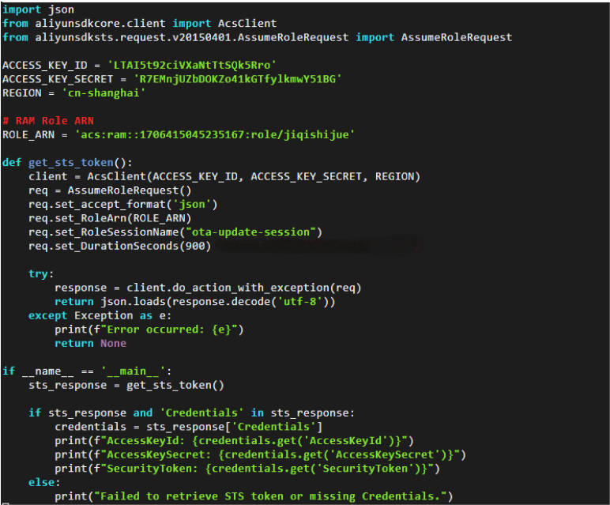

Fig 5 Publication and Subscription of Cloud Message Contents in MQTT Bridge

The system in the picking robot ROS, target detection function module through Docker package for mirror and deployed to the cloud platform at the same time will be based on MQTT _ bridge will the cloud function module in the form of mirror package deployment, when the picking robot request service, the cloud platform will automatically pull the corresponding function module service, and also the URL address and port back to the picking robot end. In this way, the picking robot can establish an MQTT _ bridge connection with the cloud platform to realize the interaction between the picking robot and the cloud platform. The communication structure of the picking robot and the cloud platform in the system is shown in Figure 6.

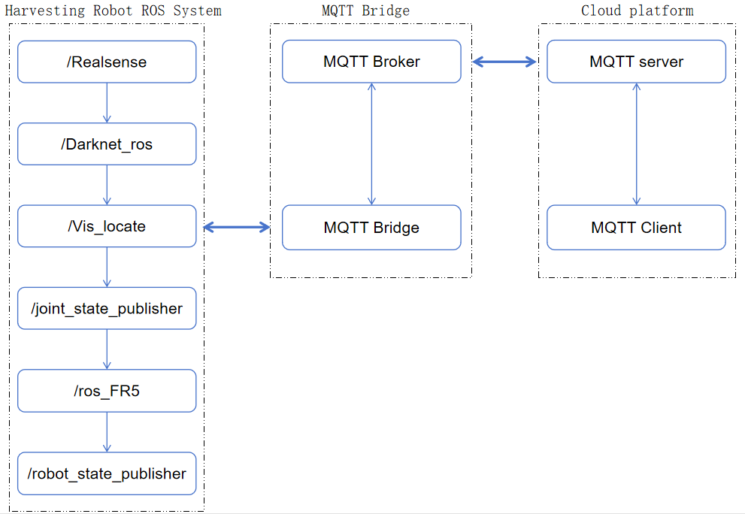

Fig 6 Communication structure between the picking robot and the cloud

In the process of picking robot and cloud platform communication, both through the MQTT bridge information transfer, realize the loose coupling connection, MQTT bridge will respectively in the picking robot and the cloud MQTT _ bridge connection, then will send the message after processing, make only need to middleware centralized development, reduce the change of both. The picking robot and the cloud subscribe to the corresponding messages in the MQTT bridge, that is, the messages sent by the picking robot can be forwarded to the MQTT server in the cloud. The cloud also sends the corresponding messages to the picking robot in the same way. In these ways, the message mechanism of retaining ROS can maximize the full use of MQTT _ bridge function to ensure the transmission efficiency of the message.

3. Cloud collaboration of the picking robot

For picking robot computing intensive tasks, picking robot can reduce the calculation pressure through the cloud, the target detection is an important part of intelligent grasping, picking robot computing ability requires higher task, so the task of reasonable migration to the cloud computing is an important aspect of the whole picking robot system, through the previous related technology and research results, elaborate synergy between picking robot and the cloud system capture task design and implementation.

3.1 Analysis of cloud collaborative process of picking robot

In the traditional picking robot to realize intelligent capture system, usually in the picking robot local end configuration fixed target detection and positioning capture module, the same algorithm in the operation and the local processing, however, under the system based on "picking robot-the cloud", picking the robot in the process of data processing of each nodes (data acquisition preprocessing, target detection algorithm execution process, results of processing and preservation, mechanical arm capture, etc.) in the picking robot and the cloud reasonable division is to migrate to the cloud to solve the problem. The specific workflow is shown in Figure 7. The left picture is the end of the picking robot, and the right picture is the cloud.

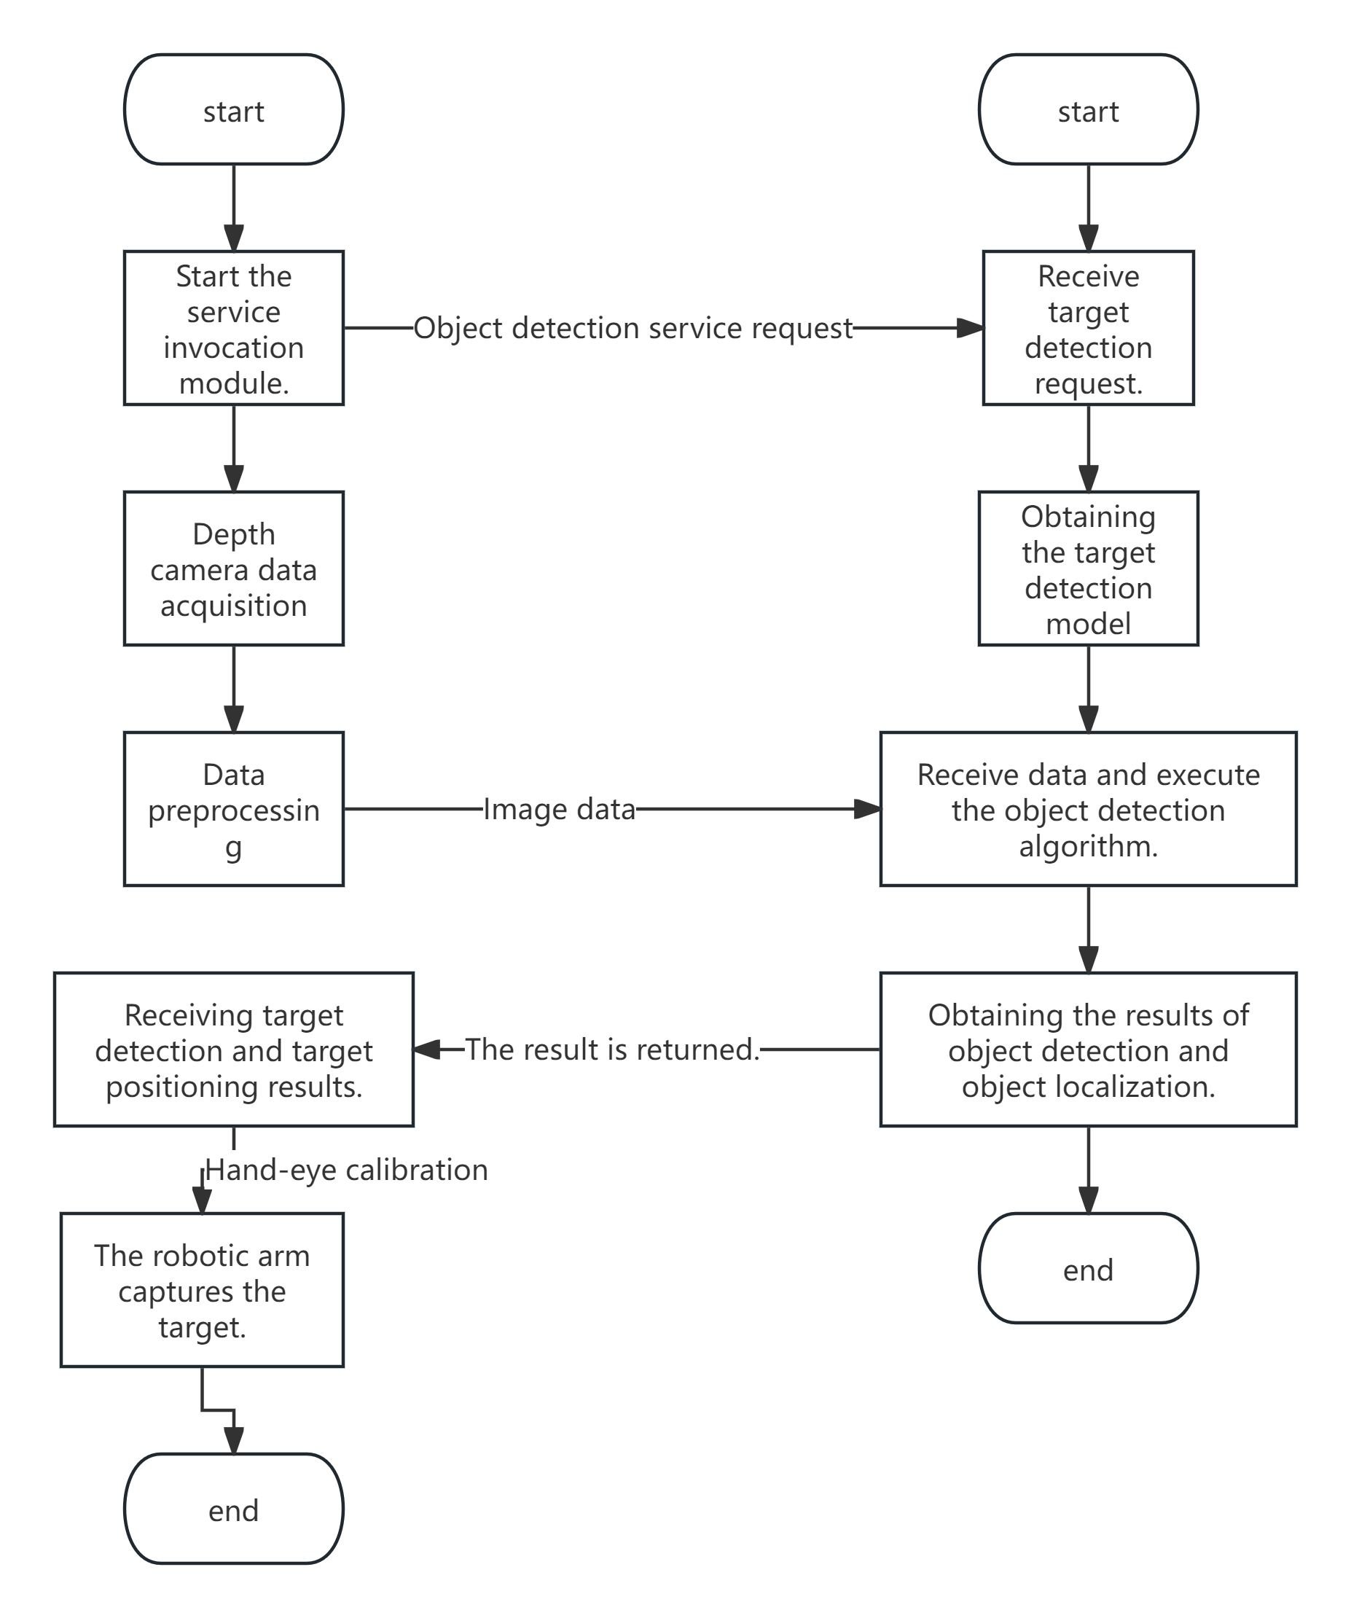

Fig 7 Flow chart of the cloud collaborative system of picking robots

3.2 Distributed cloud collaborative architecture

According to the previous section, the cloud collaboration of the picking robot is carried out in a distributed architecture, which analyzes the picking robot end and the cloud respectively. First of all, the picking robot end needs to carry out the message conversion module, which needs to realize a call mechanism for the service request of the target detection algorithm module, and use the cloud application service through the call mechanism. The call mechanism follows Docker Remote API, can request cloud resources, and can transmit the data information of the picking robot based on MQTT _ bridge. The structure of the picking robot end is shown in Figure Figure 8.

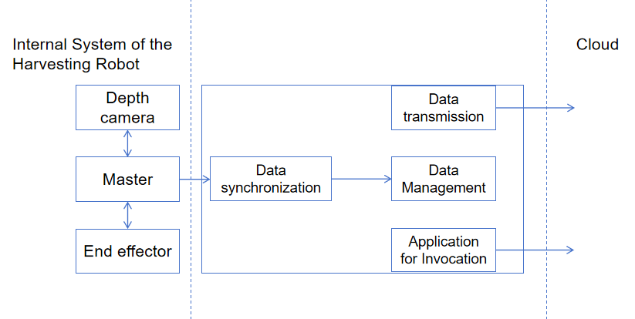

Fig 8 End structure of the picking robot

Picking robot the execution process as shown in figure 9, picking robot grasping tasks, service application module for the cloud service, when successful data transmission module establish data transmission channel with the cloud, and then synchronous data transmission to the cloud processing, algorithm after the results back to the picking robot other use module.

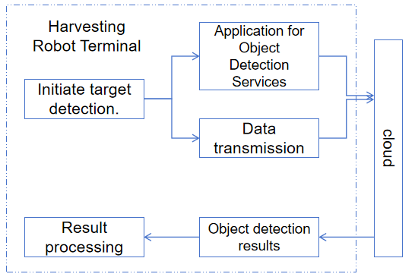

Fig 9 Picking robot end execution module

The cloud is mainly used to receive service applications sent from the picking robot end, and the Docker instance-based resource management module through resource allocation. The cloud service structure is shown in Figure 10.

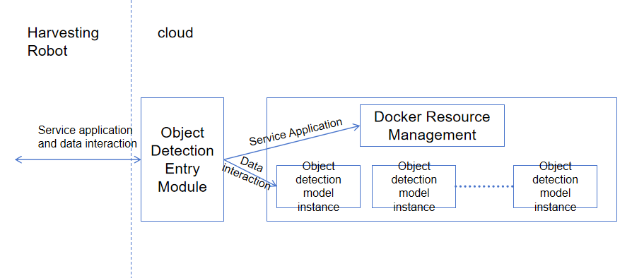

Fig 10 Cloud service structure

Through the distributed structure, the picking robot can better cooperate with the cloud, make use the high computing power and storage capacity of cloud computing, and realize the parallel processing of multiple tasks at the same time, and significantly improve the operation efficiency.

3.3 Realization of cloud collaborative system for picking robot

The first two sections mainly introduce the process analysis of cloud collaboration and the distributed architecture. This section explains the implementation of the cloud collaboration system of the picking robot. By deploying services and processing modules related to target detection on the device end and the cloud, the picking robot can request the target detection service in the cloud, so as to realize cloud collaboration.

The starting point of cloud collaboration is that the picking robot and the cloud jointly complete target detection and positioning capture. Based on the distributed architecture and implementation process, the cloud collaborative system architecture diagram is proposed in Figure 11.

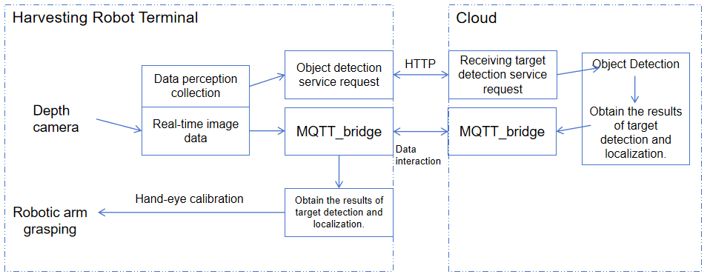

Fig 11 Cloud Collaboration System Architecture Diagram

The depth camera collects real-time image data through data sensing and sends these data to the target detection service request module. Subsequently, data interaction via MQTT _ bridge to transfer the data to the target detection module in the cloud. After receiving the target detection service request, the cloud conducts the target detection and returns the results. Finally, the robotic arm is grasped according to the target detection and positioning results.

Picking robot cloud in the process of collaborative target detection, need to pick the robot itself open data acquisition module, at the same time by the cloud collaborative target detection service, picking robot ontology is passive execution, in order to realize the picking robot actively apply for call target detection service, first picking robot service can apply to the cloud for target detection service, then can according to different picking scenarios automatically call different target detection algorithm model. Based on the above requirements, this system has designed the Request_object_detection module.

The Request_object_detection module contains four main nodes, each with its own specific function, and the node diagram is shown in Figure 12.

1. The target detection request interface of the picking robot is used to resolve the local target detection task request. When the task request is received, the request type and its corresponding sensor parameters (such as camera resolution, frame rate, etc.) are recorded to record the target detection status using the flag bit request _ Req, and the information is released to the relevant nodes.
2. The sensor control node can activate the corresponding function node depth camera according to the type of the sensor message parameters received, to ensure that the depth camera is running normally and start publishing image data.
3. The cloud service request node receives the data obtained from the target detection request interface of the picking robot itself, and sends the target detection request parameters and the data parameters of the picking robot to the cloud.
4. The data transmission node uses MQTT _ bridge middleware for data conversion to convert the ROS message data (such as image data) of the picking robot ontology into MQTT protocol format for easy transmission to the cloud. At the same time, it is responsible for receiving the target detection results (such as the detected object category, location and other information) from the cloud.

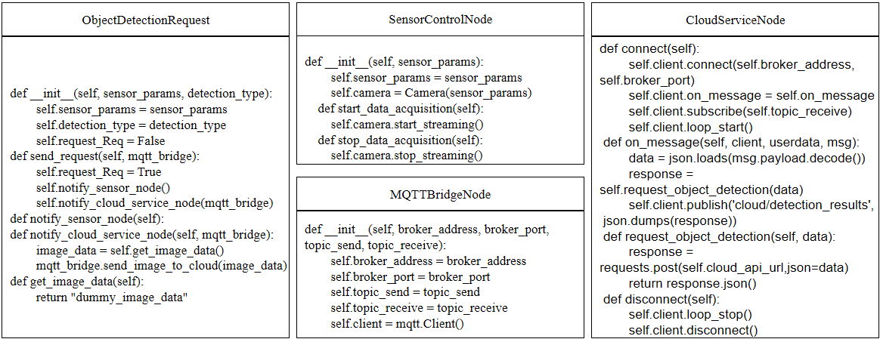

Fig 12 Request_object_detection module node graph

By realizing the corresponding functional package at the end of the picking robot, the picking robot itself can send requests to the cloud when receiving the task, so as to realize the process of target detection service application. Completed the part of the picking robot body of the picking robot. The design of this node does not change the structure of the robot body and the use of other functions, but just split and designs the functional node distributed through ROS.

4 Cloud OTA update deployment

The picking robot is widely used in orchards to realize automatic and precise fruit picking, which means the challenge of diversification and complexity. For example, in different picking scenarios, the dense canopy and uneven fruit distribution require a high-precision target detection algorithm to accurately identify the mature fruit; or the fruit color change is not significant to identify the correct maturity. Traditional picking robots mainly rely on the way of manual upgrade software, and the deployment algorithm is relatively fixed, which is difficult to quickly adapt to new needs or environmental changes. Therefore, the technology of deploying OTA (Over-The-Air) updates to picking robots through the cloud is the key to solving this problem. OTA update deployment is the process of safely and effectively distributing software or firmware updates from a remote server to the device side through wireless network technology.

4.1 Remote upgrade system workflow

The workflow of remote upgrade of the picking robot designed by this system starts from uploading the corresponding update function package to the cloud, and feedback the results of the upgrade from the picking robot to the cloud. The specific workflow is shown in Figure 13.

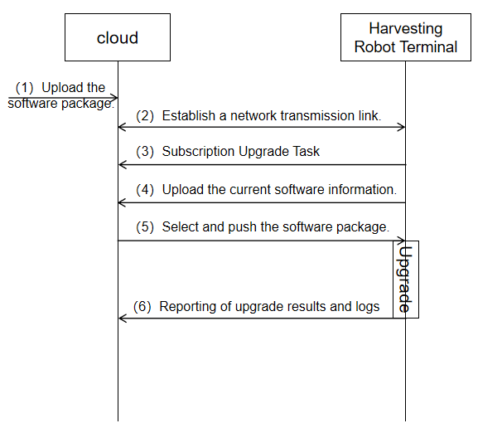

Fig 13 Workflow Diagram of the OTA System

4.2 Communication protocol design of the remote upgrade system

The information transmission between the cloud server and the picking robot is realized by wireless network technology. After the security link is established, the information sent by the cloud to the picking robot is called downstream data, while the information transmitted from the picking robot to the cloud is called uplink data. In the remote OTA upgrade system designed in this paper, the downlink data based on MQTT protocol mainly refers to the push upgrade task, while the uplink data includes reporting the upgrade information and the upgrade log. In order to ensure the consistency of information interaction, it is stipulated that the upstream and downstream data should uniformly adopt the JSON format. The specific upstream and downstream data information is shown in Figure 14.

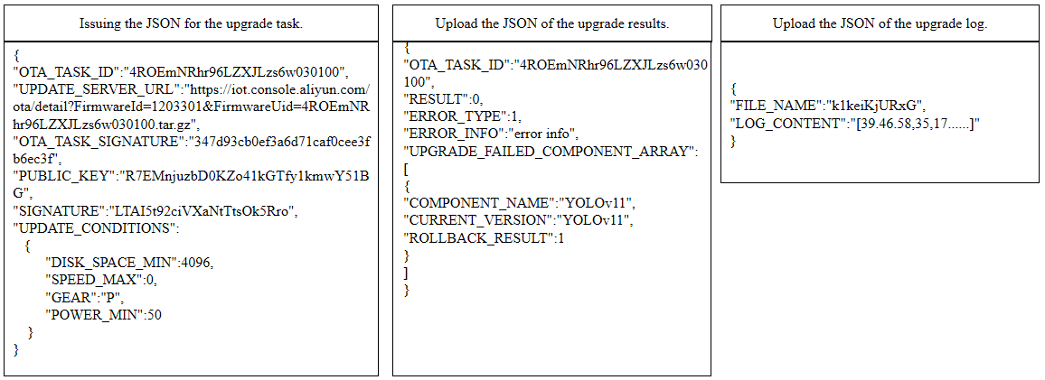

Fig 14 JSON Format for Upstream and Downstream Data Information

Topic and data format of OTA upgrade message, including OTA module version reported by devices, cloud platform push upgrade package information, device report upgrade progress and device request to obtain the latest upgrade package information, release and subscription Topic information are shown in Table 1.

**Tab 1 Topic format for OTA upgrade messages**

|  |  |
| --- | --- |
| function | Topic class |
| Device reports the OTA module version | /ota/device/inform/${productKey}/${deviceName} |
| Cloud platform push OTA upgrade package | /ota/device/upgrade/${productKey}/${deviceName} |
| Equipment to report the upgrade progress | /ota/device/progress/${productKey}/${deviceName} |
| Device requests the OTA upgrade package | /sys/${productKey}/${deviceName}/thing/ota/firmware/get |
| The cloud platform responds to the request | /sys/${productKey}/${deviceName}/thing/ota/firmware/get_reply |

4.3 Remote upgrade system functions and implementation

Remote upgrade is mainly used to solve the problem of reducing the detection accuracy reduction due to the fixed and single detection software version of the target detection algorithm deployed by the picking robot in the complex orchard scenario. In order to maintain the efficiency of the picking robot and adapt to the changing environmental conditions, the system publishes the dynamically adjusted equipment parameters and configuration files to the picking robot in the form of the whole software package. The specific functions and implementation are as follows:

In order to increase the working time of the picking robot, accelerate the picking process and prevent the fruit drop due to the delay of picking, the picking work at night is of great significance to the improvement of agricultural production efficiency. Various factors, such as night lighting conditions, ambient temperature, humidity changes and image transmission process, may interfere with the recognition of the visual system, making the target image suffer from different degrees of noise influence. These factors will not only affect the recognition accuracy and positioning accuracy of the visual detection system, but also seriously affect the efficiency of picking, making night picking a challenging task.

The apple dataset taken in the night environment in the cloud storage OSS Bucket was called, and the data set was sent to the deep learning algorithm model YOLOv8 (Chapter 3.7) deployed in the cloud for training. The trained network model was named YOLO-model. The fruit target identification results are shown in Figure 15 below.

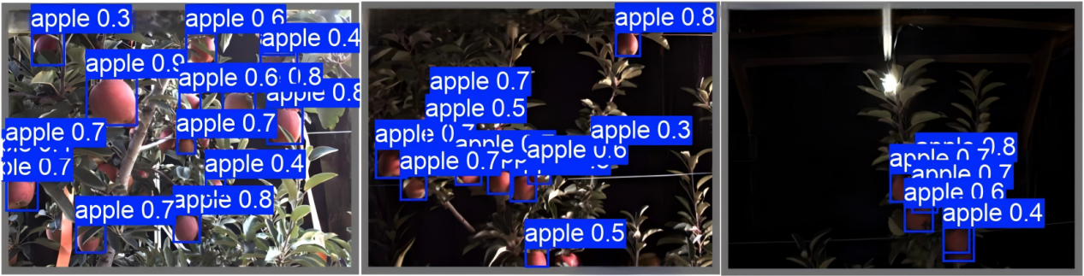

|  |  |  |  |  |
| --- | --- | --- | --- | --- |
| Train the network model |  |  |  |  |
| YOLO-model | 0.874 | 0.909 | 0.937 | 0.891 |

Fig 15 Target recognition in the dark environment

Combined with the identification results presented above, the accuracy, recall rate and average accuracy of the YOLO-model model in the test set were 87.4%, 90.9% and 93.7%, respectively, which showed high accuracy for the identification of night occlusion and poor lighting.

The implementation of the trained network model in the cloud in the form of a software package needs to export the trained network model, then create a software package directory structure, then the network model is packaged into a software package, and finally uploaded to the cloud in the form of the software package. The code of the realization part is shown in Figure 16 below.

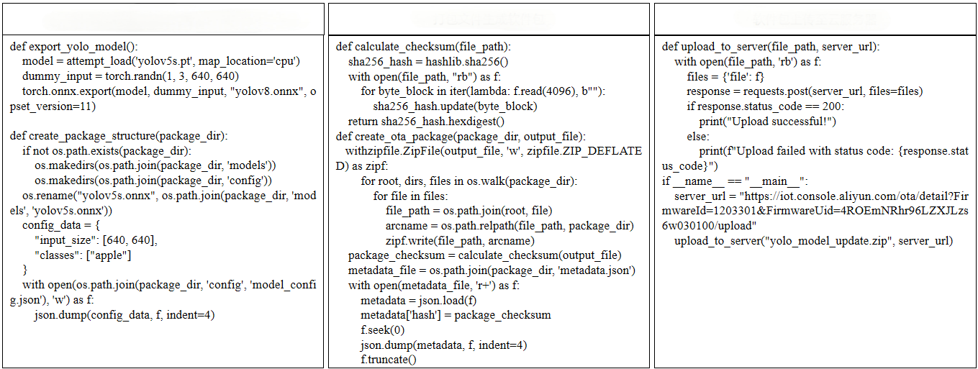

Fig 16 Diagram of the ECS node for uploading a software package

In order to enable the picking robot to receive and process the OTA update package sent from the cloud server, it is also necessary to deploy the communication module at the picking robot end. Its main function is to interact with OTA signaling and upgrade package with the cloud server based on MQTT, HTTPS and protocols. After starting the remote upgrade system, the picking robot will obtain the IP address of the cloud server from the configuration file, and establish a two-way MQTT connection with the cloud. During the remote upgrade, the picking robot end and the cloud need to complete the OTA upgrade signaling interaction, including the picking robot reporting the current visual recognition version information, the cloud issuing upgrade tasks, and the picking robot reporting the upgrade results and upgrade log. The node diagram of the picking robot is shown in Figure 17.

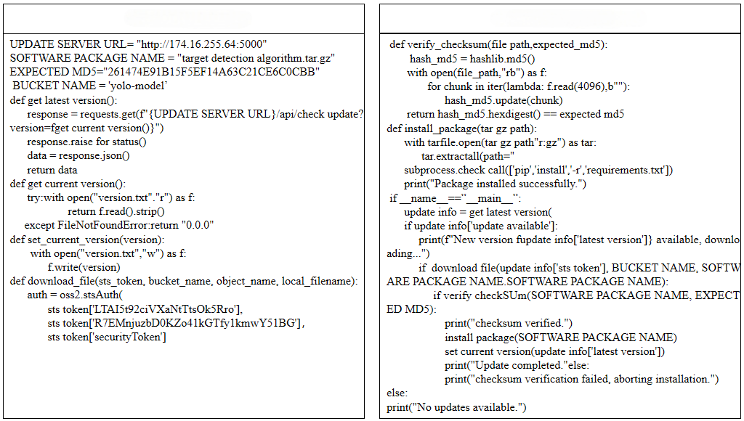

Fig 17 Node diagram of the picking robot module

In the previous sections, the workflow and the implementation of key functions of the remote upgrade system are introduced, which fully proves that the remote upgrade is advanced and practical compared with the traditional picking robot software upgrade.

5 Conclusion

From the research of the picking robot cloud platform system, the requirements of the cloud platform are analyzed from the functional requirements of the core functions of the system, including data collection, cloud communication, data storage and resource sharing, computing task separation and visual interface development. In terms of communication, through the combination of MQTT protocol and ROS message model, the efficient loose-coupled communication mechanism between the picking robot and the cloud is realized, which solves the problem of information transmission in different network environments. Later, this paper introduces the cloud collaborative workflow of the picking robot under the distributed architecture, and shows how to migrate the compute-intensive tasks such as target detection to the cloud, so as to reduce the computing burden on the device side and improve the operation efficiency and flexibility of the whole system. At the same time, the remote OTA update deployment scheme is also discussed, allowing the picking robot to keep the software up to date in the complex orchard environment to adapt to different picking needs.

reference

[1]Kumar B ,Verma A ,Verma P .A multivariate transformer-based monitor-analyze-plan-execute (MAPE) autoscaling framework for dynamic resource allocation in cloud environment[J].Computing,2025,107(3):69-69.

[2]Kamatera: Canadian Startups Can Leverage Cloud Technology for Growth and Innovation[J].M2 Presswire,2025,

[3]Wu W ,Shi H .Pairing-Free Searchable Encryption for Enhancing Security Against Frequency Analysis Attacks[J].Electronics,2025,14(3):552-552.

[4]Tamizhselvi P S ,Muthuswamy V .Enhancing TCP Variants to Estimate Dynamic Bandwidth in Mobile Cloud[J].Wireless Personal Communications,2025,(prepublish):1-31.

[5]Ali I ,Gupta A ,Kulshrestha S , et al.Optimizing multi-cloud architecture by employing an innovative workflow management model[J].International Journal of System Assurance Engineering and Management,2025,(prepublish):1-11.

[6]Choudhury T ,Rajpurohit J ,Kotecha K , et al.Intelligent Robotic Process Automation: Development, Vulnerability and Applications[M].IGI Global:2025-01-16. DOI:10.4018/979-8-3693-4365-4.

[7]Accounting and Financial Accounting in Florida Set for Expansion with Cloud Technology Integration[J].M2 Presswire,2025,

[8]Amin A ,Chimba D ,Hasan K .Integrating AI and edge computing for advanced safety at railroad grade crossings[J].Journal of Rail Transport Planning & Management,2025,33100501-100501.

[9]Yang T .The Role of Cloud Computing Platform in Civic Education Resource Sharing in Colleges and Universities[J].Applied Mathematics and Nonlinear Sciences,2025,10(1):

[10]Larikova T ,Ivankov P ,Novichenko L , et al.Possibilities of integrating artificial intelligence technologies into the system of accounting and analytical support to public sector entitie[J].Eastern-European Journal of Enterprise Technologies,2024,6(13):88-97.

[11]Mood E S ,Rouhbakhsh A ,Souri A .Evolutionary recurrent neural network based on equilibrium optimization method for cloud-edge resource management in internet of things[J].Neural Computing and Applications,2024,37(6):1-13.

[12]Viettel High Tech Inks Contract with High Cloud Technologies for 5G deployment in the Middle East[J].Telecomworldwire,2024,

[13]Zhang Y .Efficient Storage and Access Management System for Network Databases Driven by Cloud Computing Technology[J].Academic Journal of Engineering and Technology Science,2024,7(6):

[14]Azar S A ,Gupta K S ,Bataineh A B K , et al.Smart Education and Sustainable Learning Environments in Smart Cities[M].IGI Global:2024-12-20. DOI:10.4018/979-8-3693-7723-9.

[15]Mahalle N P .Bridging Academia and Industry Through Cloud Integration in Education[M].IGI Global:2024-12-20. DOI:10.4018/979-8-3693-6705-6.

[16]Xue Z .The Application and Challenges of Cloud Computing in Financial Services[J].Financial Engineering and Risk Management,2024,7(6):

[17]MLCOMMONS UNVEILS RESULTS FOR MLPERF TRAINING V4.1[J].Productivity Software,2024,37(12):

[18]Calkoen R F ,Luijendijk P A ,Vos K , et al.Enabling coastal analytics at planetary scale[J].Environmental Modelling and Software,2025,183106257-106257.

[19]Şahin C .Applications of Point Cloud Technology[M].IntechOpen:2024-11-20. DOI:10.5772/INTECHOPEN.1001660.

[20]Kapil G ,Kumar N ,Mourya K A , et al.Securing big healthcare data using attribute and honey-based encryption in cloud environment[J].The Journal of Supercomputing,2024,81(1):181-181.