***Original Research Article***

**FINITE ELEMENT MODELLING OF TRANSIENT SEEPAGE AND SEDIMENT TRANSPORT IN DIAPHRAGM WALLS FOR COASTAL PROTECTION WORKS IN THE NIGER DELTA.**

**ABSTRACT**

In this research, a two-dimensional analysis of transient seepage and sediment transport in diaphragm walls for coastal protection projects was conducted using the finite element method. One of the key factors influencing the stability of diaphragm walls in coastal protection works is transient seepage and sediment transport (flow boundary conditions). The reduction of passive soil resistance due to seepage and sediment movement can lead to stability issues through piping and scour effects. A representative soil profile from the Niger Delta region was subjected to transient seepage (long-term steady-state seepage with a gradual drawdown over a 24-hour period) and modeled using the finite element method with the Geostudio 2018R2V9.1 (SEEP/W) software. The movement of sediments (soil particles) through advective processes (water alone) was simulated and monitored based on the seepage flow velocities. Calculations were performed to determine the velocities of sediment transport and the total distances traveled due to seepage forces for each case study. The finite element solutions employed the Galerkin’s weighted residual method along with Lagrange isoparametric triangular or quadrilateral elements. Results from the seepage and sediment transport analyses indicated significantly higher rates of water and particle transport for diaphragm walls embedded in sandy layers compared to those in clay or in a sand-clay mixture. Thus, it is advisable to incorporate seepage and sediment transport considerations in the analysis and design of diaphragm walls for coastal protection in the Niger Delta region.

**Keywords:** Finite Element, Modelling, Transient Seepage, Sediment Transport, Geostudio, Diaphragm Walls, Coastal Protection, Niger Delta

**1. INTRODUCTION**

The increase in the construction of coastal structures along the shoreline of the Niger Delta region is driven by the high offshore requirements from the oil and gas industries and cargo transportation via waterways. Most coastal structures are supported by deep foundations and diaphragm walls for shoreline protection or serving as quay walls. Diaphragm walls are flexible or embedded retaining walls that rely significantly, if not entirely, on the earth's passive thrusts below the excavation level and the resistance forces provided by the support systems (Simpson & Powrie, 2001). The challenging coastal environmental conditions, such as turbulent tidal waves (which involve repeated fluctuations in water levels, currents, and wave impacts), often result in saturated or unsaturated soil conditions accompanied by time-dependent flow and fluctuating pore-water pressures along shorelines. Geotechnical engineering issues predominantly arise from the presence of groundwater movement or seepage within earth structures or soil (Marandi et al., 2012). Water flows through a particulate medium due to an energy imbalance, meaning that water moves from areas of high energy levels to those of lower energy levels (Fethi, 2000). A key issue leading to the failure of coastal structures is the seepage through and/or beneath these structures, which is caused by differences in water levels between the upstream and downstream sides (El-Jumaily & Al-Bakry, 2013). Seepage refers to the movement of water under gravitational forces through a permeable medium. The soil's flow rate is influenced by factors such as the density/viscosity of the liquid (water), degree of saturation, void ratio, porosity, and particle size distribution or gradation (Harr, 1990). Seepage can lead to sediment transport via surface erosion or scour, which reduces the embedment depth of the wall, resulting in a decrease in passive resistance force and an increase in the active forces acting on the wall. Simulating seepage and sediment transport through soils (taking into account both saturated and unsaturated conditions) allows for the calculation of fluxes, pore-water pressure distributions, and water velocity/pathways (for sediment migration), which are essential for an in-depth engineering analysis and design of diaphragm walls along shorelines. The alarming frequency of failures in coastal structures due to seepage and sediment transport issues associated with diaphragm walls is a significant challenge in the Niger Delta region, affecting adjacent quay apron stacking areas and disrupting offshore production and cargo transportation. Therefore, transient seepage and sediment transport in diaphragm walls for coastal protection works and dam bodies remain pressing geotechnical challenges that researchers continue to explore. Aslan & Temel (2022) utilized the finite element method to examine steady-state seepage in the dam body and foundation, considering isotropic and anisotropic materials based on Galerkin’s approach, and also assessed the impact of horizontal drainage length and cut-off walls. Richart & Schmertmann (1957) analyzed the stability of vertical sheet pile walls in cohesionless soil affected by steady-state seepage flow in terms of the rotation around the anchor attachment. Veiskarami & Zanj (2014) modeled the stability of sheet pile walls under seepage flow using slip lines (the method of stress characteristics) and the finite element method. Fredlund et al. (1987) developed a finite element model for transient seepage in saturated-unsaturated soil systems known as TRASEE and applied it to solve example problems in dam bodies while comparing the obtained results with those from other methods. El-Jumaily & Al-Bakry (2013) examined seepage through and beneath hydraulic structures using finite volume methods (FVM). (El-Jumaily & Al-Bakry, 2013). Kheiri et al. (2020) calculated seepage under embankment dams, earth systems, and environments using the finite element-based SEEP/W software and verified the accuracy of the results against physical modeling outcomes. Seepage leads to the movement of sediment through surface erosion or scour, which diminishes the depth of wall embedment, thereby decreasing the passive resistance force and increasing the active forces acting on the wall. Simulating seepage and sediment transport through soils (in both saturated and unsaturated states) allows for calculating fluxes, pore-water pressure distributions, and water velocities/pathways (the movement of sediments) that are essential for thorough engineering analysis and the design of diaphragm walls along shorelines. The significant failure rates of coastal structures due to seepage and sediment transport issues associated with diaphragm walls have emerged as a critical concern in the Niger Delta region, impacting adjacent quay apron stacking areas and causing interruptions in offshore production and cargo transportation. Consequently, transient seepage and sediment transport in diaphragm walls for coastal protection and dam bodies remain pressing geotechnical challenges that numerous researchers are currently examining.

Aslan & Temel (2022) employed the finite element method to analyze steady-state seepage in the dam body and foundation, considering both isotropic and anisotropic materials based on Galerkin’s approach, assessing the impacts of horizontal drainage length and cutoff walls as well. Richart & Schmertmann (1957) investigated the influence of steady-state seepage flow on the stability of vertical sheet pile walls in cohesionless soil, focusing on the rotation about the anchor attachment. Veiskarami, & Zanj (2014) modeled the stability of sheet pile walls subjected to seepage flow using slip lines (stress characteristics method) and finite element methods. Fredlund et al. (1987) created a transient seepage model for saturated-unsaturated soil systems named TRASEE, which was applied to solve example problems in dam bodies, comparing the outcomes with results obtained using other methods. El-Jumaily & Al-Bakry (2013) examined seepage through and beneath hydraulic structures using finite volume methods (FVM). El Molla (2019) sought to ascertain the total seepage discharge and velocities through homogeneous earth dams equipped with vertical sheet piles founded on impervious substratum. Kheiri et al. (2020) assessed seepage beneath embankment dams, earth systems, and environmental conditions utilizing the finite element-based SEEP/W software, comparing the precision of these outcomes with those from physical modeling Zhou & Li (2024) performed a series of tests on seepage flow through homogeneous and anisotropic soils, contrasting the results with the finite element method. Jotisankasa & Tepparnich (2015) computed seepage and pore pressure behavior by applying the soil water characteristic curve (SWCC) and permeability functions derived from laboratory tests on undisturbed samples in 1-D finite element analysis (SEEP/W).

Thorough engineering assessments must be conducted to quantify seepage and sediment transport during the analysis and design stages prior to the construction of diaphragm walls for coastal protection projects. The key variable (dependent variable) calculated in a finite element analysis of a seepage issue is the pressure head at each nodal point in the finite element mesh (Alicia & Leonard, 2006). Given the complex stratigraphy (multi-layer saturated/unsaturated soils) involving transient flow and varying boundary conditions, analytical solutions such as graphical flow nets are unfeasible; thus, high-powered numerical methods are necessary to provide the solutions required. Due to ongoing fluctuations in water levels along the coast, the volumetric water content and hydraulic conductivity functions for transient flow conditions yield the realistic pore-water pressure distributions essential for the analysis and design of diaphragm walls in coastal protection efforts. The determination of realistic pore-water pressure distributions (under unsteady-state conditions) through effective stress analysis and particle tracking (sediment transport by advection processes) resulting from variations in water levels is most effectively managed using the finite element method (Department of the Army, 1995). The finite element method is highly effective for solving differential equations that lack a closed-form or analytical solution (Anderson et al., 2015). For instance, the application of Galerkins weighted residual finite element method was adopted in solving non-linear Saint-Venant equations that have no closed form solutions for flood predictions which gave improved solution over finite difference 6-points method (Nwaogazie, 1985a, 1985b; 1986, 1992). This study took into account saturated and unsaturated soil conditions, utilizing the finite element method to analyze transient seepage and sediment transport through the soils.

**2.METHODOLOGY**

**2.1 Study Area**

The area of the research is the Niger Delta region in the southern part of Nigeria bordering with the Atlantic Ocean, Figure 1. In Niger Delta, diaphragm walls are used for shoreline protections such as in Nigerian Ports Authority berths (4, 5, 6, 9,10,11 and 12), West African Container Terminal berths (7 and 8) in Federal lighter Terminal and Federal Ocean Terminal Onne Rivers State and Nigerian Port Authority Warri in Delta State. The sites as shown in the Goggle map are located in Onne in Eleme local government area of Rivers state Nigeria. They are accessible through the Federal Ocean Terminal junction and also through Ogu creek and Bonny River at the back side. Total area of the site in the Federal Lighter Terminal (FLT) is 26,250 sqm comprising berth 1-3 and 131,250 sqm comprising of berth 1-15 in the Federal Ocean Terminal (FOT) of the Nigerian Ports Authority (NPA) Onne. Berths 1-3 in FLT and Berths 1- 11 in the FOT lie along the Ogu creek side while Berth 12-15 in FOT lie along the Bonny River side. The sites are approximately 10 km from the Atlantic coast with the Federal Ocean Terminal actually located in an inlet, where tidal currents play a major role in water flow. The areas investigated falls within the tertiary Niger Delta which occurs at the south-central sedimentary basin of Nigeria bordering the Atlantic Ocean with latitude of 4º41’13.79” N and longitude of **7**º09’16.80” E.

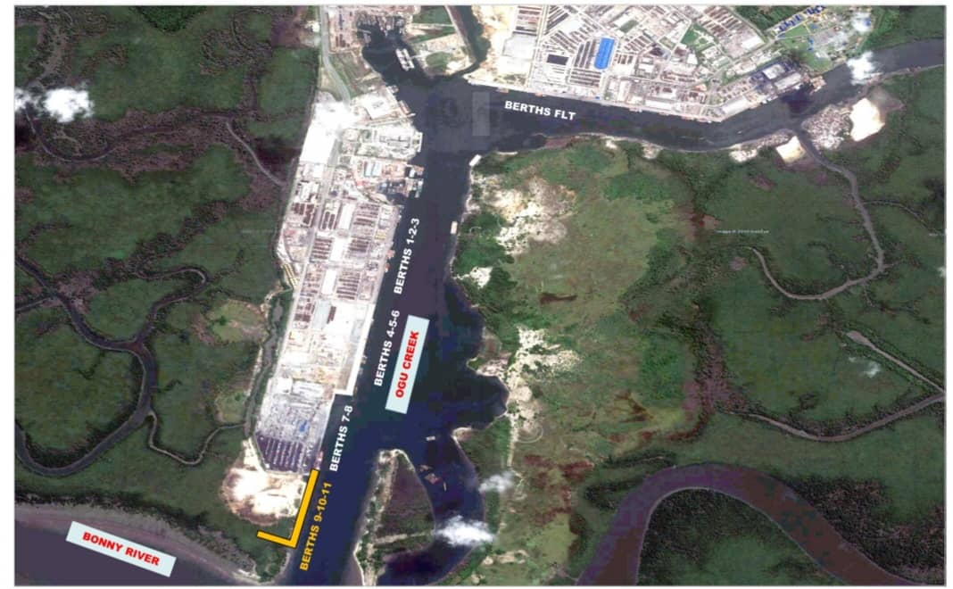

**Figure 1. Goggle maps of Onne study area**

**2.2 Sources of Data**

Seepage and sediment transport analyses using finite element methods require acquisition of relevant data/information such as levels, geotechnical subsoil conditions and meteomarine data which serve as input data. Relevant data used were obtained from standard codes of practice, authorities and reputable sources. Laboratory tests results on representative samples taken from these areas from Dutch Cone penetrometer tests (CPT) to refusal depths and various geotechnical boreholes to depth of 40 metres below existing ground level (Standard Penetration Tests) showed similar lithology (subsoil and groundwater conditions) which have been classified into 3 categories. All the tests were executed in accordance and compliance with the specifications contained in BS 1377-2 [18].

**2.2.1 Geotechnical Soil Stratigraphy, Properties and Boundary Conditions Data for SEEP/W Modelling.**

Table 1 shows the soil stratigraphy for the 3-Case study with a probe depth of 40m, as used for SEEP/W Modelling.

**Table 1. Soil Stratigraphy for SEEP/W Modelling**

|  |  |  |  |  |  |  |  |  |  |
| --- | --- | --- | --- | --- | --- | --- | --- | --- | --- |
| **Strata Unit** | **Case Study 1** | | | **Case Study 2** | | | **Case Study 3** | | |
|  | Description | Top level  (m) | Bottom level  (m) | Description | Top level  (m) | Bottom level  (m) | Description | Top level  (m) | Bottom level  (m) |
| Unit 1 | Hydraulic fill | +0.00 | -3.00 | Hydraulic fill | +0.00 | -1.50 | Hydraulic fill | +0.00 | -1.50 |
| Unit 2 | Hydraulic fill | -3.00 | -15.00 | Hydraulic fill | -1.50 | -10.00 | Hydraulic fill | -1.50 | -10.00 |
| Unit 3 | LSS to MDS | -15.00 | -19.00 | LSS to LS | -10.00 | -24.00 | LSS to LS | -10.00 | -24.00 |
| Unit 4 | Soft to Firm Clay | -19.00 | -24.00 | Firm to Stiff Clay | -24.00 | -40.00 | MDS to DS | -24.00 | -40.00 |
| Unit 5 | MDS to DS | -24.00 | -40.00 |  |  |  |  |  |  |

*Hydraulic fill: Loose Silty Sand to Loose Sand, LSS: Loose Silty Sand, MDS: Medium Dense Sand, DS: Dense Sand

Preliminary dredging level of existing unit 1 and 2 (very soft to dark grey organic peaty Clay) to depth of -15m for case study 1, unit 1 and 2 to a depth of 10m for both case study 2 and 3 were assumed completed. Sandfill taken from riverbed with no selection likely in very loose state once discharged has been placed to +0.00m. The fill materials are granular (non-cohesive) soil materials with the same property as the loose silty sand and are allowed for compaction with the fill compaction requirements. This material is described as hydraulic fill. Table 2 shows the geotechnical properties of the soil as used in the SEEP/W modelling.

**Table 2. Geotechnical Properties of Soil for SEEP/W Modelling**

|  |  |  |  |  |  |  |  |
| --- | --- | --- | --- | --- | --- | --- | --- |
| **Parameter** | **Name/**  **Symbol** | **Unit** | **Hydraulic fill** | **LSS to MDS** | **Soft to Firm Clay** | **MDS to DS** | **Firm to Stiff Clay** |
| Hydraulic | Model | - | Saturated/  Unsaturated | Saturated/  Unsaturated | Saturated/  Saturated | Saturated/  unsaturated | Saturated/  unsaturated |
| Horizontal Conductivity | Kx | m/day | 0.60 | 0.60 | 8.64E-02 | 0.60 | 0.15 |
| Vertical Conductivity | Ky | m/day | 0.60 | 0.60 | 1.7E-05 | 0.60 | 0.15 |
| Saturated Water Content | ϴs | - | 0.41 | 0.41 | 0.65 | 0.41 | 0.55 |
| Compressibility | av | /KPa | 1.0E-6 | 1.0E-6 | 4.24E-4 | 1.0E-6 | 4.24E-4 |
| Residual Water Content | ϴr | - | 5.0E-5 | 5.0E-5 | 6.0E-6 | 1.0E-6 | 1.042E-5 |

The boundary conditions used for SEEP/W modelling and analysis, are as reported in Table 3.

**Table 3. Boundary Conditions (BC) for SEEP/W modelling.**

|  |  |  |  |
| --- | --- | --- | --- |
| **Boundary Condition** | **Long Term Steady State** | | **Transient** |
| Name | Upstream | Downstream | Slow drawdown |
| Type | Hydraulic | Hydraulic | Hydraulic |
| Kind | Water total head | Water total head | Water total head |
| Constant | 38.5m | 38m | Not applicable |
| Function | Not applicable | Not applicable | (0hr,38m) and 24hrs,35.4m) |

**2.2.2 Waves, Current, Seismic Input, Levels, Ground Water Conditions**

The site is about 10 km from the Atlantic Coast and for this reason no natural waves and the only water level oscillation is due to movement of vessels (ships). The wave height is considered to be 500 mm. The Federal Ocean Terminal is located in an inlet hence tidal currents play major roles in water flow. Ebb current velocity can be considered equal to 1.5 knots (0.75 m/sec). Information on Tide levels at Onne Port are similar to Bonny town and are stated in Table 4 as obtained from Tidal predictions for Nigerian ports and River Channels (Nigerian Navy, 2023).

**Table 4. Tidal Level for SEEP/W modelling.**

|  |  |  |  |
| --- | --- | --- | --- |
| Description* | Tide Level (m) | Description* | Tide Level(m) |
| HAT | +2.70 | MSL | +1.50 |
| MHWS | +2.30 | LAT | +0.10 |
| MHWN | +1.90 |  |  |

*HAT: Highest Astronomical Tide, MHWS Mean High Water Springs, MHWN: Mean High Water Neaps, MSL: Mean Sea Level, LAT: Lowest Astronomical Tide

No seismic design is applicable to diaphragm walls design in the Niger Delta region hence, pseudo-static ground movement not considered in the analysis. Finally, the existing ground water level at the site from geotechnical reports is 1.5 m below existing ground level. Properties of the diaphragm wall as used in the analysis are:

Top level = + 0.00 m Elastic Modulus, E = 20E6 KPa

Toe level = - 30.00 m Unit bulk weight, γ = 25 kN/m3

Length, L = 30 m Area, A = 2.2 m2/m

Thickness of wall =1100 mm Net width of wall = 2000 mm

Moment of Inertia, I = 3.24 m4/m

**2.3 Transient State Seepage**

A flow is transient because of change in boundary conditions with time and ability of the soil to release (pumpage) or store water (recharge) or change in volumetric water content. In a transient (unsteady) state flow condition, the following requirements apply:

1. soil deformation occurs (associated with volume change);
2. the pore water pressure changes with time and the rate of flow also changes (varying pressure head and varying flux rate with time):
3. saturated-unsaturated soil conditions applied;
4. flow is assumed to be turbulent (not uniform over the entire area perpendicular to the flow);
5. under seepage (confined flow) and seepage through (unconfined flow) are fully handled;
6. time steps are required; and
7. need to start from known initial condition.

In transient flow, water is either stored in or discharged from the medium. For discharge (extraction such as a case of water drawdown), flow that exits = flow that enters – flow discharged during a time interval. Also, for storage (injection such as a case of water filling), flow that exits = flow that enters + flow stored during a time interval (Fredlund et al., 1987).

**2.3.1 2-D Transient State Seepage Formulations**

The general mass balance equation for transient flow in unsaturated soil according to Richards states that the sum of the rates of change of flow in x, y, and z directions plus the external applied flux is equal to the rate of change of the volumetric water content with respect to time (Jotisankasa & Tepparnich, 2015).

Mathematically expressed as:

$\frac{d}{dx}(Kx\frac{dh}{dx}$) + $\frac{d}{dy}(Ky\frac{dh}{dy} )+\frac{d}{dz}(Kz\frac{dh}{dz}$) + Q = $\frac{dθ}{dt}$ (1)

In terms of Specific yield, Equation 1 is rewritten as:

$\frac{d}{dx}(Kx\frac{dh}{dx}$) + $\frac{d}{dy}(Ky\frac{dh}{dy} )+\frac{d}{dz}(Kz\frac{dh}{dz}$) + Q = S $\frac{dh}{dt}$ (2)

Where:

h = total head, Kx, Ky and Kz = the hydraulic conductivities in x, y and z directions

Q = the applied boundary flux or source term (injection or extraction), t = time

ϴ = the volumetric water content and S = Specific yield.

By Galerkin’s Weighted Residual Method (GWRM), the errors or residual/difference between the approximate solution and the true solution is orthogonal to the functions used in the approximation i.e., equal to zero as assumed by (Zienkiewicz & Taylor, 2000; Nwaogazie, 2008). Applying GWRM and integration by parts (Green’s theorem), the following transformation results:

$ʃʃ_{R}\sum_{i=1}^{n}{\left[Kxxb\frac{{dN}_{i}^{T}}{∂X}\frac{∂Nj}{∂x}+Kyyb \frac{{dN}_{i}^{T}}{∂y}\frac{∂Nj}{∂y}\right]}h_{j}∂x∂y-ʃʃ_{R}SN_{i}^{T}N_{j}∂x∂y\frac{∂h}{∂t}+ʃʃ_{R}QN_{i}^{T}∂x∂y - ʃ_{L}N_{i}^{T}\left(Kxxb\frac{∂h}{∂x}L_{x}+Kyyb\frac{∂h}{∂y}L_{y}\right)∂L=0$ (3)

The above equation is expressed in matrix form as:

[A] [h] + [M $]\left[\frac{dh}{dt}\right]-$ [p] = 0

This can be rewritten in simplified form as:

∆t [A] [h] + [M]{h1} = ∆t [P] + [M]{h0}

The Transient Finite element 2-D equation for Seep/W by Geo-Slope International (2015) is written as:

∆t [K] + [M]{H1} = ∆t [Q1] + [M]{H0} (4)

H1 = new unknown or head at each time step

H0 = initial condition at the start of the time step

Q1 = boundary condition at the end of the time step

[M] = mass matrix (it has volume or area and slope. Mw)

In Seep/w, only groundwater flow due to pressure and gravity-driven gradients is considered as default physical processes (Geo-Slope International, 2015).

**2.4 Method of Data Analysis**

This was carried out using the finite element software Geostudio 2018R2V9.1(SEEP/W). The point coordinates for the general geometry include (-30,0), (35,0), (-0.55,10), (0.55,10), (-30,16), (-0.55,16), (0.55,16), (36,16), (-30,24), (-0.55,21), (0.55,21), (35,21), (-30,24), (-0.55,33), (-30,37), (-0.55,37), (0.55,37), (35,37), (-30,40), (-0.55,40),(-0.55,40), (0.55,40), (35,40), (-30,28), (-0.55,28), (-30,26), (-0.55,26) and (35,40).

**2.4.1 Seepage Analysis (SEEP/W).**

**2.4.1.1 Long -Term Steady State Seepage Analysis (Initial Seepage condition).**

The following were the key components for finite element long-term seepage analysis solutions:

1. Input data as given in Tables 1 and 2 used and the entire domain discretized into 493 elements having an approximate global element size of 2.4 m. The dredging depth at the seaside is -10 m.
2. Boundary conditions as in Table 3 was implemented and the solution obtained.

**2.4.1.2Transient State Seepage Analysis (Slow drawdown Seepage condition).**

The following were the key components for finite element transient seepage analysis solutions:

1. The model for the long-term steady state cloned, initial pore water pressure was obtained from it and duration of a day, 15-time steps with an exponential initial increment size of 0.05 days was used. Input data as in long-term condition was also used.
2. Boundary conditions as in Table 3 used in adopting the spline data point function and the solution was obtained.
   * 1. **Sediment Transport Analysis**

i. The same model for transient state seepage analysis with slow drawdown was used.

ii Solute particles were introduced closer to the under tip of the diaphragm wall and downstream boundary to determine the solute particles velocity and total travelled distance due to seepage forces. A number of particles can be introduced arbitrarily to the flow system at any given position either by expressing its x & y coordinates or assigning directly. Particles are assumed to move in the direction of the water flow with the same speed as the water flows. The new positions of the particles are computed according to the average linear/ actual velocity of the groundwater. The SEEP/W transient seepage models for case study 1 at 0 and 24 hours are as shown in Figures 2 and 3.

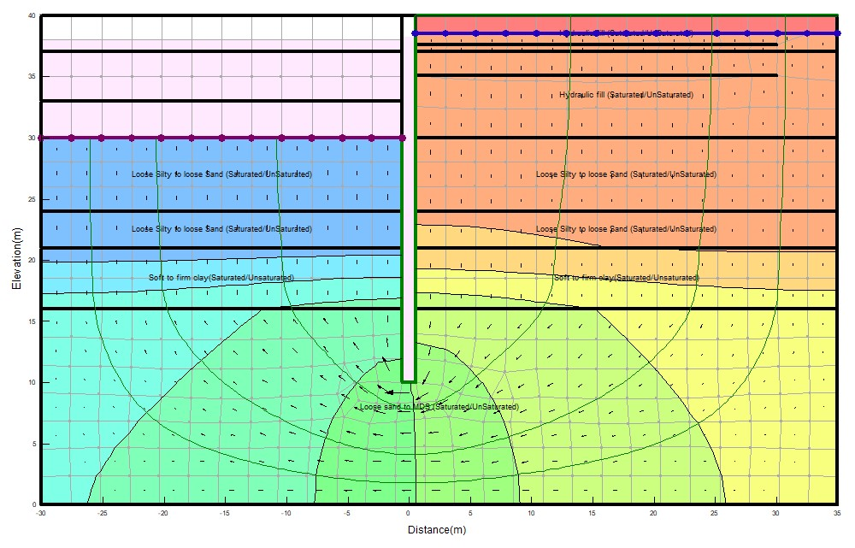

**Figure 2. Case study 1 Seep/w Transient model @ dredge depth of -10 m and 0 hr**

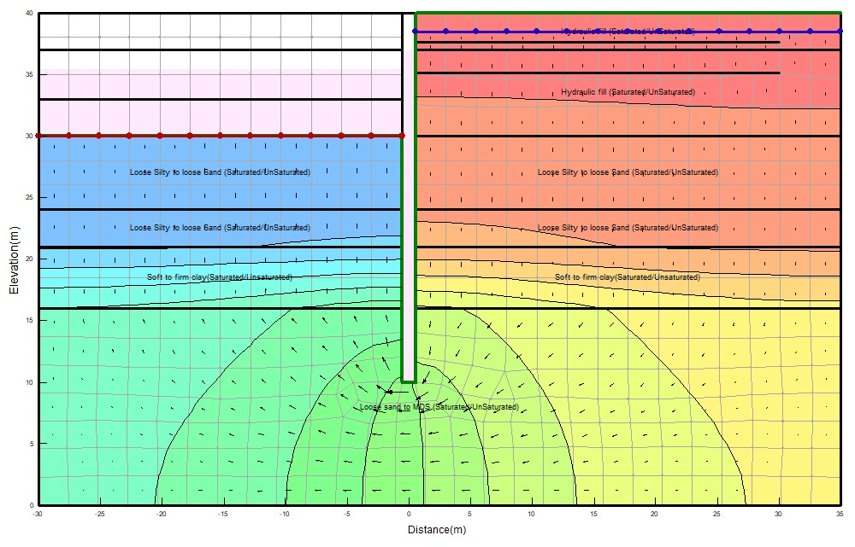 **Figure 3. Case study 1 Seep/w Transient model @ dredge depth of -10 m and 24hr****s**

**3. RESULTS AND DISCUSSION**

**3.1 Results**

**3.1.1 Seepage Analysis Results**

From the transient seepage analysis with 15-time step for 24 hours, the following results as presented in Table 5 were recorded per metre length. Considering the time of zero hour and 24 hours, Case 1 has (0hr, 4.042E-5m3/s) and (24hrs, 2.49E-4 m3/s), Case 2 has (0hr, 2.39E-5 m3/s) and (24hrs, 1.43E-4 m3/s), Case 3 has (0hr, 6.63E-5 m3/s) and (24hr, 4.11 E-04m3/s).

Graphical display of the variations in water fluxes with time under the diaphragm wall for the 3-case study is represented in Figure 4**.** Gradients are computed at Gauss integration points and averaged to the nodes for contouring. It is a function of element size and geometry. The resultant gradient of ix and iy gives the XY- gradient; if it approaches zero, then the effective stress is zero. Hence, it must be less than 1 as developed by Casagrande for flow nets having upward flow. The element with the highest exit gradient is important because it shows the area or element with the lowest factor of safety.

**Table 5. Transient water rates (Seepage) under diaphragm wall for the different Case study.**

|  |  |  |  |
| --- | --- | --- | --- |
| **Time**  **(hr)** | **Case Study 1**  **(Water rate m3/s)** | **Case study 2**  **(Water rate m3/s)** | **Case study 3**  **(Water rate m3/s)** |
| 0.00 | 4.04E-05 | 2.39E-05 | 6.63E-05 |
| 1.20 | 4.94E-05 | 2.73E-05 | 8.35E-05 |
| 2.45 | 6.03E-05 | 3.24E-05 | 1.01E-04 |
| 3.75 | 7.16E-05 | 3.84E-05 | 1.20E-04 |
| 5.10 | 8.35E-05 | 4.51E-05 | 1.40E-04 |
| 6.50 | 9.57E-05 | 5.22E-05 | 1.60E-04 |
| 7.95 | 1.08E-04 | 5.97E-05 | 1.81E-04 |
| 9.47 | 1.22E-04 | 6.75E-05 | 2.02E-04 |
| 11.05 | 1.36E-04 | 7.57E-05 | 2.25E-04 |
| 12.68 | 1.50E-04 | 8.42E-05 | 2.49E-04 |
| 14.40 | 1.65E-04 | 9.31E-05 | 2.77E-04 |
| 16.17 | 1.80E-04 | 1.02E-04 | 2.99E-04 |
| 18.02 | 1.97E-04 | 1.12E-04 | 3.25E-04 |
| 19.93 | 2.13E-04 | 1.22E-04 | 3.53E-04 |
| 21.93 | 2.31E-04 | 1.32E-04 | 3.81E-04 |
| 24.00 | 2.49E-04 | 1.43E-04 | 4.11E-04 |

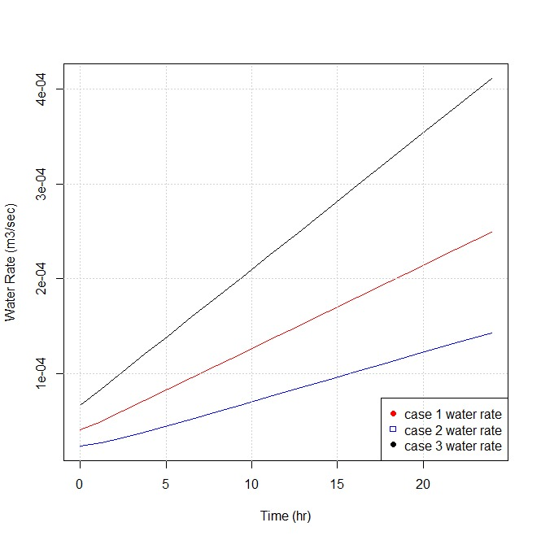

**Figure 4. Variations in water fluxes with time under the diaphragm wall for the different Case studies.**

Water XY-gradients versus time at the downstream cross section for 3-case study presented in Table 6. Also, graphical display of the variations in XY-gradients with time at the downstream level for the 3-case study are shown in Figure 5**.**

The distribution of pore water pressure (KPa) along the entire length of the diaphragm wall for the transient seepage analysis considering zero hour and 24hr given in Table 7 for the three-case studies.

**Table 6. Transient water XY- gradient on the downstream level for the different Case studies.**

|  |  |  |  |
| --- | --- | --- | --- |
| **Time**  **(hr)** | **Case study 1**  **(Water XY gradient)** | **Case study 2**  **(Water XY gradient)** | **Case study 3**  **(Water XY gradient)** |
| 0.00 | 0.043382177 | 0.025708974 | 0.071220605 |
| 1.20 | 0.067203646 | 0.056308565 | 0.089995839 |
| 2.45 | 0.080996444 | 0.074755587 | 0.10928527 |
| 3.75 | 0.093622484 | 0.088351424 | 0.12934574 |
| 5.10 | 0.10639661 | 0.099455479 | 0.15017777 |
| 6.50 | 0.1195738 | 0.10926903 | 0.17178135 |
| 7.95 | 0.13320681 | 0.11847025 | 0.19415649 |
| 9.47 | 0.14746346 | 0.12754421 | 0.21756037 |
| 11.05 | 0.16234612 | 0.13670713 | 0.241993 |
| 12.68 | 0.17769862 | 0.14599006 | 0.26719718 |
| 14.40 | 0.19383439 | 0.15565203 | 0.29368729 |
| 16.17 | 0.21044012 | 0.1655451 | 0.32094895 |
| 18.02 | 0.22782914 | 0.17587752 | 0.34949654 |
| 19.93 | 0.2458448 | 0.18656793 | 0.37907288 |
| 21.93 | 0.26464374 | 0.19771562 | 0.40993514 |
| 24.00 | 0.28406932 | 0.20923107 | 0.44182614 |

.

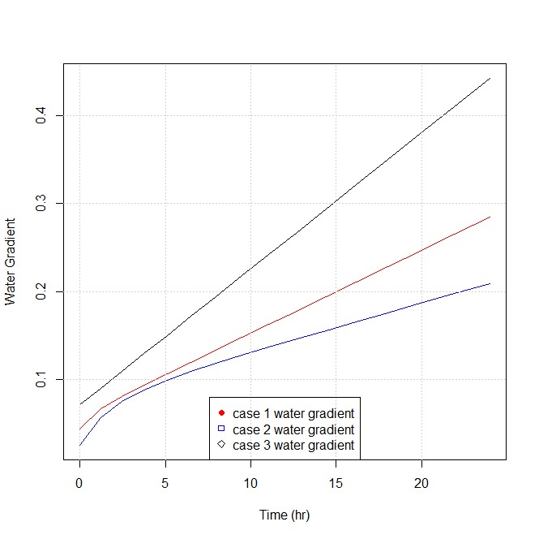

**Figure 5. Variations in water horizontal and vertical XY-gradients with time at downstream level for different Case studies.**

**Table 7. Distribution of pore water pressure with depth at 0hr and 24hr for the different Case studies.**

|  |  |  |  |  |  |  |
| --- | --- | --- | --- | --- | --- | --- |
| **Depth (m)** | **Case Study 1** | | **Case Study 2** | | **Case Study 3** | |
|  | Pore- water pressure at 0sec  (KPa) | Pore-water pressure at 1day  (Kpa) | Pore-water at 0sec  (KPa) | Pore-water at 1day  (KPa) | Pore-water at 0sec  (KPa) | Pore-water at 1day  (KPa) |
| 10 | 282.632 | 270.536 | 282.874 | 272.709 | 282.624 | 270.271 |
| 12 | 262.913 | 252.273 | 263.63471 | 257.201 | 263.120 | 253.348 |
| 14 | 243.050 | 233.112 | 244.05833 | 239.659 | 243.380 | 234.959 |
| 16 | 223.144 | 213.693 | 224.41648 | 221.717 | 223.584 | 216.223 |
| 18.5 | 198.800 | 192.715 | 199.51222 | 197.264 | 198.796 | 192.536 |
| 21 | 174.432 | 171.562 | 174.59213 | 172.717 | 173.980 | 168.677 |
| 24 | 144.538 | 142.199 | 144.67545 | 143.187 | 144.179 | 139.908 |
| 26 | 124.605 | 122.6058 | 124.7259 | 123.470 | 124.302 | 120.673 |
| 28 | 104.670 | 103.003 | 104.77352 | 103.737 | 104.420 | 101.407 |
| 30 | 84.734 | 83.392 | 84.819028 | 83.991 | 84.535 | 82.118 |
| 32.565 | 59.166 | 58.233 | 59.225166 | 58.655 | 59.028 | 57.354 |
| 35.13 | 33.600 | 33.067 | 33.629631 | 33.308 | 33.518 | 32.572 |
| 37 | 14.953 | 14.719 | 14.968762 | 14.826 | 14.919 | 14.499 |
| 37.63 | 8.673 | 8.537 | 8.6818905 | 8.599 | 8.653 | 8.410 |
| 38.5 | 0 | 0 | 0 | 0 | 0 | 0 |
| 40 | -15 | -15 | -15 | -15 | -15 | -15 |

**3.1.2 Sediment Transport Results**

A particle’s velocity is determined given the computed water flux and the saturated volumetric water content of the soil. Particle tracking or sediment transport under the diaphragm wall and exit from downstream involving the total distance travelled and average speed for the different case study at dredge depth of 10m presented in Table 8.

**Table 8. Particle tracking records under the diaphragm wall and at downstream exit for the different Case study.**

|  |  |  |  |  |  |  |
| --- | --- | --- | --- | --- | --- | --- |
| **Description** | **Case Study 1** | | **Case Study 2** | | **Case Study 3** | |
|  | Under the wall | Exit from down-stream | Under the wall | Exit from down-stream | Under the wall | Exit from down-stream |
| Total distance travelled (m) | 4.46 | 1.31 | 2.39 | 1.16 | 6.25 | 2.22 |
| Average speed (m/s) | 5.16E-5 | 1.52E-5 | 2.76E-5 | 1.35E-5 | 7.23E-5 | 2.56E-5 |

**3.2 Discussion**

**3.2.1 Seepage Analysis**

i). From the transient water rates (Seepage) under the diaphragm wall as presented in Table 6, Case study 1 (diaphragm wall in sand-clay-sand) showed water rate at 0hr of 4.04E-05 m3/s/m and 2.49E-04 m3/s/m at 24hr. From 0hr to 24hr, the flow rate under the diaphragm wall in this stratigraphy increased by 2.08E-04 m3/s/m due to the slow drawdown of the water level. Also, Case study 2 (diaphragm wall in sand – firm clay) showed water rate at 0hr of 2.39E-05 m3/s/m and 1.428E-04 m3/s/m at 24hr. From 0hr to 24hr, the flow rate under the diaphragm wall in this stratigraphy increased by 1.189E-04 m3/s/m due to the slow drawdown of the water level. For Case study 3, (diaphragm wall in sand – sand) showed water rate at 0hr of 6.63E-05 m3/s/m and 4.111E-04 m3/s/m at 24hr. From 0hr to 24hr, the flow rate under the diaphragm wall in this stratigraphy increased by 3.45E-04 m3/s/m due to the slow drawdown of the water level. Therefore, transient water flow rate for a 3-case study increases as the water drawdown to the lowest depth of slow drawdown of 35.4m with higher rates at the starting point 0hr to 6.5hr and gradually decreases to 24hr. The maximum transient seepage rate occurred for the 3-case study at the end of 24hrs with case study 3 (diaphragm wall fully embedded in different sand layers) having the greatest transient seepage rate as 4.111E-04 m3/s/m. The lowest transient water flow rate for the 3-case study is for case 2 (diaphragm wall embedded through sand to firm clay stratum) with a value of 1.43E-04 m3/s. These results are in agreement with literature as groundwater flowrate is very high in sand layers than in clay layers [3,5].

ii) Transient x-y gradient on the downstream level for the 3-case study increases as the water drawdown to the lowest depth of slow drawdown of 35.4m (at 24hr). The maximum transient x-y gradient occurred for the 3-case study at the end of 24hrs with case study 3 (diaphragm wall fully embedded in different sand layers) having the greatest transient x-y gradient as 0.442. The lowest transient x-y gradient for the 3-case study is for case 2 (diaphragm wall embedded through sand to firm clay stratum with a value of 0. 209.These results are in agreement with literature as groundwater flowrate increases, the rate of sediment transport on the downstream faces increases and this is more pronounced in contractive soils (sand layers) as the hydraulic exit gradient is greater than the critical hydraulic gradient (Anderson et al., 2015).

**3.2.2 Sediment Transport Analysis Results**

i). From the particle tracking records under the diaphragm wall as presented in Table 8, Case study 1 (diaphragm wall in sand-clay-sand) showed an average speed of 5.16E-5 m/s with a total travelled distance of 4.46m from the initial assigned point. Also, Case study 2 showed an average speed of 2.76E-5 m/s with a total travelled distance of 2.39m from the initial assigned point and Case study 3 showed an average speed of 7.23E-5 m/s with a total travelled distance of 6.25m from the initial assigned point. The greatest average particle speed (7.23E-05m/s) was encountered for case study 3 at the end of 24 hours under the diaphragm wall. This conformed with the greatest value of seepage rate also obtained for case study 3. Hence, Seepage rate or flow rate enhances sediment transportation.

ii). From the particle tracking records exit from downstream, Case study 1 (diaphragm wall in sand-clay-sand) showed an average speed of 1.526E-5 m/s with a total travelled distance of 1.31m from the initial assigned point. Also, Case study 2 showed an average speed of 1.35E-5 m/s with a total travelled distance of 1.16 m from the initial assigned point and Case study 3 showed an average speed of 2.56E-5 m/s with a total travelled distance of 2.22 m from the initial assigned point. The greatest average particle speed (2.56E-05 m/s) was encountered for case study 3 at the end of 24hrs at exit from downstream. Therefore, particle/sediment movement or transportation in a flexible retaining wall is more pronounced at the tip(under) the diaphragm wall as shown in the results of the 3-case study and the greatest values obtained for diaphragm walls embedded in sand layer.

**4. CONCLUSION AND RECOMMENDATION**

**4.1 Conclusion**

The following concluding remarks are made based on the results obtained:

1. Transient state seepage analysis has shown the realistic distributions of pore water pressures and fluxes due to changes in volumetric water content and hydraulic conductivity functions. Hence, transient state seepage, not steady state should be adopted in the analysis/design of diaphragm walls for coastal protection works.
2. Due to high seepage and sediment transportation rates in sand layer, the depth of embedment of diaphragm walls for coastal protection works in sand layer must be increased to accommodate sediment transport resulting from scour actions leading to reduction in passive resistance in sand.
3. For diaphragm wall embedded in sand, surface pavement of the backfill or drains introduction on the wall with filters reduces seepage/sediment transport problems affecting wall stability.

**4.2 Recommendation**

Seepage and sediment transport must be considered in the analysis/design of diaphragm wall for coastal protection works in the Niger Delta and obtained flow conditions/pore-water pressures distributions used for further stability analysis (uncoupled or coupled analysis).

Disclaimer (Artificial intelligence)

Option 1:

Author(s) hereby declare that NO generative AI technologies such as Large Language Models (ChatGPT, COPILOT, etc.) and text-to-image generators have been used during the writing or editing of this manuscript.

**REFERENCES**

Alicia, M.W. & Leonard, R.G. (2006). Comparison of four numerical models for stimulating seepage from salt marsh sediments. Estuarine and Coastal Science Association journal, Vol 69, Pp 427-437.

Anderson, M.P., Woessner, W.W. and Hunt, R.J. (2015). Applied Groundwater Modeling: Simulation of Flow and Advective Transport. 2nd Edition, Academic Press, Cambridge, 535-564.

Aslan, Timuçin Alp & Temel, Beytullah (2022). Finite Element Analysis of the Seepage Problem in the Dam Body and Foundation Based on the Galerkin’s Approach. Article in European Mechanical Science, 6(2): 143-151 https://doi.org/10.26701/ems.1024266

British Standards Institutions: BS 1377-2 (2022), Methods of Test for Soils for Civil Engineering Purposes, Part 2: Classification Tests and Determination of Geotechnical Properties. Available at: https://www.en-standard.eu › bs-1377-2-2022-methods-...

Department of the Army (1995). Geotechnical Analysis by the Finite Element Method, Engineering Technical Letter (ETL), U.S Army Corps of Engineer, Washing. Available at: <https://apps.dtic.mil/sti/tr/pdf/ADA403367.pdf>

El-Jumaily, K.K., & Al-Bakry, J.M.H. (2013). Seepage Analysis Through and Under Hydraulic Structures Applying Finite Volume Method *Engineering and Technology Journal, Vol. 31 Part(A), No 9, 1719-1731.*

El Molla, Doaa A. (2019). Seepage through homogeneous earth dams provided with a vertical sheet pile and formed on impervious foundation. *Ain Shams Engineering journal.* Pp 529-539.

Fethi, A. (2000). Applied Analyses in geotechnics, 1st Edition, T.J international Ltd publishers, Padstow Cornwall.

Fredlund, D.G., Lam, L., & Barbour, S.L. (1987). Transient seepage model for saturated-unsaturated soil systems- a geotechnical engineering approach. *Canadian Geotechnical Journal*, Vol 24, Pp 565-580.

Geo-Slope International (2015). Seepage Modelling with SEEP/W – An Engineering Methodology. Calgary, Alberta Canada.

Harr, M.E. (1990). Groundwater and Seepage. Dover Publications, Inc; New York.

Jotisankasa, A. & Tepparnich, J. (2015). Seepage and Pore Water Pressure Behavior. Proc. International Conference on Geotechnical Engineering.

Kheiri, G., Javdanian, H. & Shams, R. (2020). A numerical modelling study on the seepage under embankment dams. *Modelling Earth Systems and Environment journal*, Vol 6, Pp 1075-1087. DOI: 10.1007/s40808-020-00742-9

Marandi, S.M., Firoozjani, Y.R., & Safapour.P. (2012). Solving Seepage Problems in Soils using Element Free Galerkin’s Methods. Advanced Materials Research, Vols 472-475, Pp 1717-1728. DOI: [**https://doi.org/10.4028/www.scientific.net/AMR.472-475.1717**](https://doi.org/10.4028/www.scientific.net/AMR.472-475.1717)

Nigerian Navy, (2023). Tidal Predictions for Nigerian Ports and River Channels. Hydrographer of the Nigerian Navy.

**Nwaogazie, I.L. (1985a). “WICFEM – A Fortran Program for Solutions of Saint-Venant Streamflow Equations”, Adv. Eng. Software, Vol. 7 (4), pp. 182 – 198**

**Nwaogazie, I.L. (1985b). “Approximate River Flood Forecasting Model Based on Galerkian Finite Elements, part 1”, Int. Journ. Dev. Tech., Vol 3 (1), pp. 35** **– 48 (1985).**

**Nwaogazie, I.L (1986). “Approximate River Flood Forecasting Model Based on Galerkian Finite Elements, part 1”, Int. Journ. Dev. Tech., Vol 3 (1), pp. 35** **– 48.**

**Nwaogazie, I.L (1992). “River Mass Transport Linear-Quadratic Finite Element Model (RIMTRA)”, Environmental Software, Vol. 7, pp. 103 – 121.**

Nwaogazie, I.L. (2008). Finite Element Modelling of Engineering Systems (with Emphasis in Water Resources), 2nd Edition University of Port Harcourt Press Plc, Port Harcourt, pp.452.

Richart, F.E., & Schmertmann, J.H. (1957) The Effects of Seepage on the Stability of Sea Wall. *Coastal Engineering Proceedings*, *1*(6), 48. <https://doi.org/10.9753/icce.v6.48>

Simpson, B., & Powrie, W. (2001). Embedded Retaining Walls: Theory, Practice and Understanding. Perspective lecture of the 15th International Conference on Soil Mechanics and Geotechnical Engineering. Available at: https://www.issmge.org/uploads/publications/1/30/2001_04_0006.pdf

Veiskarami, M., & Zanj, A. (2014). Stability of sheet pile walls subjected to seepage flow by slips line and finite element. Geotechnique, 64. No 10, 759-755. Available at: http://dx.doi.org/10.1680/geot.14.P.020

Zhou, Guan & Li, Xue (2024). Geotechnical Aspects of Underground Construction in Soft Ground. The Editor(s), ISBN 978-1-032-53812-9 Open Access: www.taylorfrancis.com.

Zienkiewicz, O.C., & Taylor, R.L. (2000). The Finite Element Methods. 5th Edition, Butterworth – Heinemann Pulisher UK.