**Can AI Reduce Bias in Tenant Screening? An In-Depth Analysis for the US Market**

**Abstract**

Tenant screening in the U.S. rental market currently involves credit scores, criminal background checks, and rental history, which perpetuates historical prejudice against black and Hispanic tenants. Such methods continue to reinforce discrimination because of cultural disparities as well as previous unhealthy disparities in the distribution of wealth, justice, and renting. With a growing number of complaints about rental discriminative acts, there is a new hope that AI can help curb discriminative practices in the rental sector. Instead of focusing on race-based proxies, such as applicant's credit scores, the AI-based screening tools can look at a broader range of data, such as utility payments, stability of income, and previous employment records. However, it has to be doubted that the devices work appropriately with the data they were trained on since biased input results in biased output, so AI at least requires high-quality and diverse training data. Some AI systems' nature is also objectionable because they work more like a 'black box.' Despite the mentioned benefits, such as objectivity, efficiency, non-discrimination, and the like, there are also limitations, such as data bias, compliance issues, and black-box algorithms. The simple ways to approve the implementation involve incorporating various datasets, regular audits, reporting processes, and human supervision. Specific practical examples provided by Zillow, TurboTenant, and TenantCloud show that AI can make tenant screening less prejudicial. Where AI regulation is being discussed by such federal bodies as the FTC and the HUD, the collaboration of tech firms with civil rights organizations will be essential for designing truly equal and non-discriminatory AI. The potential for AI as a tool for tenant screening in the future must be overseen for having the potential to make the housing market fair and impartial if the existing ethical codes and the current laws are put into practice correctly.

***Keywords;***

*Bias, Tenant Screening, Artificial Intelligence (AI), Credit Scores, Discrimination, Fair Housing, Algorithms, Data Bias.*

**Introduction**

Tenant screening remains crucial in the rental business, where property owners evaluate potential tenants to assign them the available vacancies. The choice made here affects the tenant's housing and changes the owner's financial worth. At the heart of tenant screening has been termed a checklist approach, where specific benchmarks such as credit scores, criminal records, and rental histories have been used to evaluate potential tenants. Though the purpose of such metrics is to give a quantifiable measure of the probability of a tenant's reliability, they put forward assumptions that re-enslave the oppressed, marginalized communities. Such bias has been realized in traditional approaches, causing people to worry about discrimination in housing systems, hence seeking justice.

In the past, tenant screening was primarily defined by the following elements. Credit scores are the most frequently relied-on parameters; applicants provide their credit histories from the credits. A higher score usually means a higher credit rating, while a low score may mean risk about late payments of loans or poor management of their funds. It is also customary to do background checks to share with landlords the criminal history of the tenant, any record of eviction, or any incidents that may affect the decision-making. Another measurement is the reference, usually from your previous landlords, which is given by the rental history. Even though many of these factors may seem entirely rational, they are not isolated from societal inequalities. For instance, credit score overlooks the fact that there is inequality in economic status between the white and the non-white people of different ethnic groups. The mother ethnicities, which include Blacks and Hispanics, frequently record modest credit scores because they have been financially disenfranchised and given suboptimal credit limits for a long time. In the same way, criminal background checks work in a similar way that discriminates against people from these same communities because the criminal justice system is racist. Moreover, rental history may vary depending on race and gender, and other factors for discrimination in the rental market are standard and more so for people of color who can afford to make payments.

Bias in tenant screening is not something one can read about as a hypothetical idea—it is very much a reality. The National Fair Housing Alliance reports that approximately 28,000 complaints of discrimination were filed in 2021, and a significant number of these discriminations happened in rental processes. These complaints reveal that screening practices exclude recognizable ways of equal opportunity assessment, thus perpetuating housing discrimination. Since renting a home is becoming a major issue in uncertain circumstances for many people, technologies can be included as possible solutions to bias. Tenant screening is one area of application that has been greatly promised a reshape by the emergence of technologies such as artificial intelligence (AI). AI-based tools may open the way to a more fact-based approach devoid of biases that may traditionally be tagged along with conventional ways. This reasoning is based on large numbers and patterns AI can discover in them and apply to filter out applicants who might otherwise be discriminated against on such dubious scores.

There is a multiplicity of changes that AI has brought in tenant screening processes. On one hand, the work of AI can be free from bias. On the other hand, AI's performance is primarily determined by the data used during its training. Due to this, there is potential for developing AI systems that could reinforce bad practices due to the input data having such influences. Moreover, some AI algorithms need to be more evident in their work, making it challenging to explain how the particular decision arrived at, which can pose issues of fairness and accountability. This article tries to answer the question of the possibility of countering bias in tenant screening by using AI to understand all its advantages and disadvantages. This study will explore the existing concerns of tenant screening, how AI can help mitigate such problems, existing AI applications to the said issues, and the measures that can be taken to guide ethical implementations of AI. The article also offers valuable insights about the application of AI in the screening of tenants and the opportunities that it holds for fair housing by the end of this article.

**2. The State of Bias in Traditional Tenant Screening**

Tenant screening is one of the procedures that should be completed by landlords and property managers who want to decide whether a definite candidate can become a tenant. Classically, the process of selecting tenants was based on credit ratings, criminal records, and renting history. Despite these being seemingly scientific approaches, they propagate inherent systematic biases, which are most likely to affect vulnerable populations in a particular community.

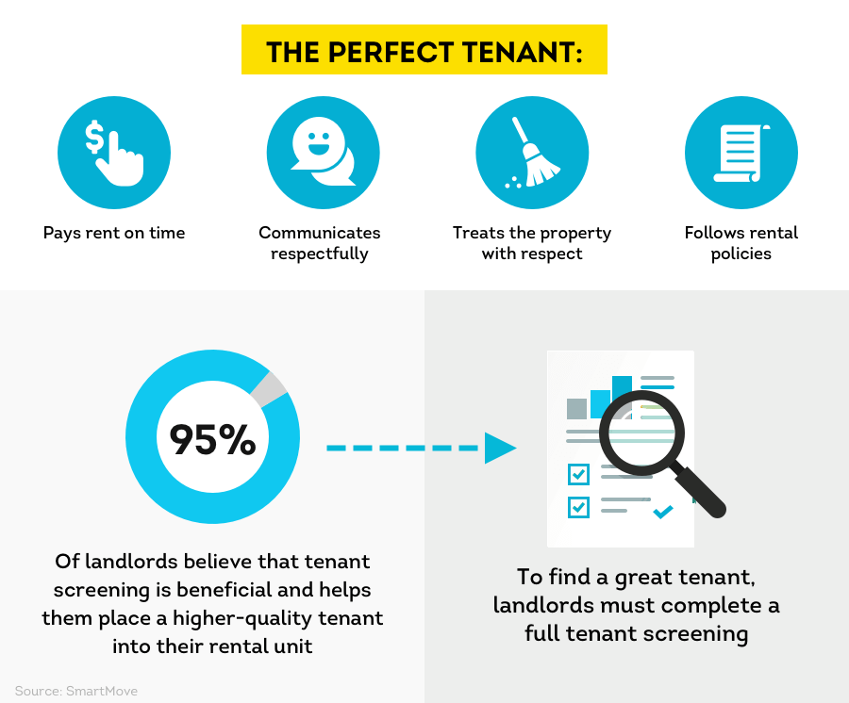

Figure : Tenant Screening Overview

***2.1 Traditional Tenant Screening Processes***

The conventional tenant screening process typically involves evaluating three primary metrics: employment history, credit scores, criminal background checks, and any history of rental they had. As per the tenant evaluation, credit scores are a summary of an applicant's financial profile and are used to establish the capacity and willingness of the tenant to meet their financial obligations on rent (Ramaswamy, 2023). The checks on criminal records allow the evaluator to see whether an applicant is ever involved in criminal activities, and the rental history gives information on how the applicant dealt with the landlords in the past. While these metrics help businesses gauge financial reliability and safety, they have weaknesses.

***2.2 Bias in Credit Scores***

Credit checks, which credit reference companies determine, are widely used in tenant screening. However, the policies can be based on wealth disparities, some of which target marginalized groups in society. Research has indicated that people with lower earning capacity, particularly blacks and Hispanics, have lower credit scores because of issues with wages and other forms of credit accessibility (Vargas & Emory, 2020). This causes a vicious cycle whereby the inhabitants in these communities cannot better their standings on credit scores and, therefore, serve as a reason for rejection in an application for a house to rent.

For example, a study conducted by the National Consumer Law Center (2021) revealed that Black and Latino families have worse credit scores as compared to White families because the former group has less amount of wealth than the latter. These differences are generally due to accumulative effects of discrimination like redlining and unequal credit facilities (Williams & Schneider 2019). Therefore, applicants from the assorted groups who only recently entered the previous tenancy selection criterion may be disadvantaged in this screening. However, they are capable of making consistent, timely rent payments.

***2.3 Bias in Criminal Background Checks***

Another standard screening test used to evaluate the tenability of the potential tenants is the criminal background check. Nevertheless, such checks tend to entrench racial prejudice because the system comprises Blacks and Hispanics disproportionately. African American people, according to the Sentencing Project (2018), are incarcerated at a rate that is 5.1 times the rate of White people. Since the percentage of incarcerated Blacks and Hispanics is higher, Blacks and Hispanics are more likely to have criminal records that will lock them out from rental opportunities.

Moreover, secondary negative impacts of criminal records, otherwise known as collateral consequences, can drastically reduce future housing chances for any convicted person. The Urban Institute reported in 2020 that individuals with criminal backgrounds cover are barred from housing applications despite varying types and times of the offense. It significantly discriminates against the Black and Hispanic applicants and makes the racial gap in housing even worse.

***2. 4 Bias in Rental History***

Another protective characteristic used during the analysis of rental history, which may also give a skewed picture about specific groups, can also be heavily biased if the landlords or property managers have a preset mentality about that specific group. Prejudiced actions, such as the common 1970s practice of not leasing an apartment to people of a certain race or color, have been popular in the housing market. The National Fair Housing Alliance conducted a study in 2021, which showed that over 28,000 complaints about housing discrimination were lodged within the 2021 year, and most of these complaints were on rental prejudices (Ward, 2023). Most of these complaints portrayed racial discrimination, discrimination based on national origin, and familial status.

Further, the use of rental history can be problematic, as it is well-known that discrimination in renting is common. For instance, landlords would rather not rent to tenants from certain areas of town even though they have records of paying their rent on time. This is specifically disadvantageous to applicants from minority classes who have most probably been discriminated against based on race or socioeconomic status in a previous rental application.

***2.5 The National Fair Housing Alliance's Findings***

The National Fair Housing Alliance (NFHA) has subsequently pointed out that discrimination is rife in the housing market. The NFHA states in its 2021 Fair Housing Trends Report that some of the standard practices, which discrimination complaints refer to, majorly affect racially marginalized groups, such as discriminative selection of tenants. According to the report, Black, Latin, or Native American people were more likely to face discrimination when looking for a home to rent, particularly in racially segregated areas (National Fair Housing Alliance, 2021). Altogether, these results demonstrate the imperative to move from oppressive tenant screening methods based on stereotyped conventional indicators.

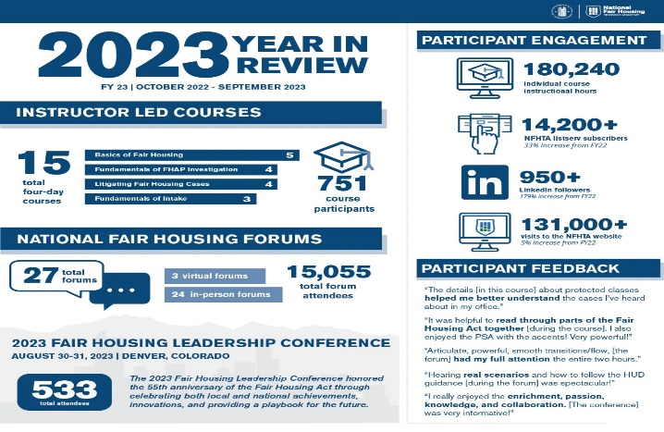

Figure : NFHTA Review in 2023

***2.6 Real-Life Examples of Bias in Traditional Tenant Screening***

Several actual cases give examples of how various prejudices can result from the conventional approach to tenant screening. For instance, a Black family applied for a unit in Chicago for which they qualified in terms of rental history and income and were turned down for 'credit score.' The White applicants were offered acceptance based on a comparatively lower assessment than Black applicants in a similar financial standing. Disparities in the aforementioned area are not unique occurrences but part and parcel of species bias in the housing market.

Another case is a Latina family residing in New York City who experienced housing discrimination and got rejected for housing simply because they had criminal records (Scherer, 2022). However, the crime was committed 11 years prior to the incident. For instance, the family would be denied accommodation by landlords who electronically barred people with criminal records, and the family, despite being financially stable, having a rental history, and being a people of color, would be turned away. These examples prove that conventional screening approaches pose significant access-to-credit and racial justice issues.

**3. AI as a Potential Solution in Tenant Screening**

***3. 1 Improving Decision-Making with AI***

The use of AI is valuable because it allows for the decision made in the screening process regarding tenants to be critiqued more effectively than in human eyes. Conventional approaches to screening tenants – focusing mainly on credit scores, criminal records, and the landlords' judgment – are usually not free from prejudice and may reinforce systemic issues. On the other hand, AI is a complex of initiatory algorithms defining the relationships and patterns that could be invisible to the human eye. These algorithms work through large amounts of information and perform quicker analysis to fully assess the applicant's conformity to qualification requirements, which is crucial when confronting biases (Chouldechova, 2017).

Compensating for one of the human decision-maker's weaknesses, the AI models are immune to biases stemming from within the emotional judgments. The models are trained on historical data, which means learning how to assign weights to different values that matter most in prediction while eliminating values that have little or no bearing on the result or come with a bias. For instance, AI can add other attributes, such as utility bill payment history or stability of income, when evaluating applicants, and this would be more effective and less biased (Zillow Group, October 2020). This transition from overreliance on these minimal data sets to ware-wide data can help decrease discrimination from inherent biases in those processes (Raji & Buolamwini, 2019).

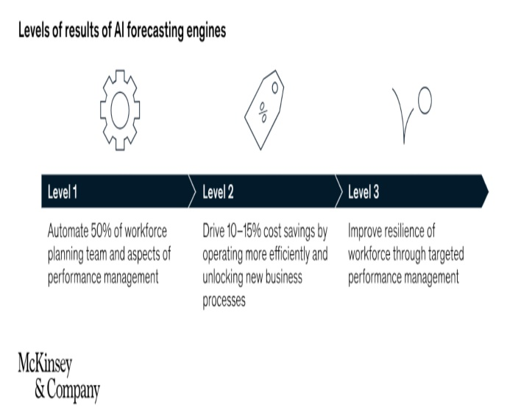

Figure : Using AI in Property Management

***3.2 Reducing Bias by Broadening Data Sources***

Another big plus for AI in tenant screening is that AI can analyze more extensive data sets in addition to credit scores and criminal records. Many conventional screening procedures have inherent prejudice because of how capital was distributed before and now or simply because police so intensely in specific populations (National Fair Housing Alliance, 2021). For instance, credit scores place historically excluded communities in a worse position because they have lower scores because of their low earnings or inability to access financial instruments (Binns, 2018). AI models can do the opposite by factoring in other data sources that are not a person's credit history, like their rental payment history, income regularity, and even utility bills (Kleinberg et al., 2018).

A screening tool from Zillow is a perfect example of how more advanced algorithms focus on the ability to pay rent rather than credit limits. Data such as monthly expenditure and income volatility make the Zillow tool's depiction of a potential tenant's rent-paying capacity distinct and accurate compared to using credit score, which is not always an accurate indication of an individual's economic standing (Zillow Group, 2020). By doing so, AI has the possibility of reducing the bias that comes as a result of using a single data point. Furthermore, AI can be built to mitigate biases in the training datasets and be programmed to identify and adjust biases present in the training data sets. When the data contains biases, meaning that specific groups are targeted in unlawful ways – for example, through over-policing or discrimination in credit provision, the system can be redesigned to eliminate such biases (Angwin et al., 2016). In this way, AI's acceptance of a broader data range for different population groups increases the chances of a non-biased approach to tenant screening.

***3.3 Leveling the Playing Field for Disadvantaged Applicants***

Another benefit of utilizing AI in tenant screening is that candidates who have been discriminated against based on previous screening procedures will be helped. For instance, individuals with some minority status may lack a stable home since they will be quickly rejected based on a criminal history or low credit score, which is familiar in racially and economically oppressed groups (Bounds & Posey, 2022). AI can positively reduce these problems since it can rely on other indicators that can be more reliable regarding applicant's behavior rather than depending on social and economic conditions.

Scholars have argued that incorporating new data sources in credit decline improves access to credit services for those who experienced a credit crunch (Jenkins, 2020). In inclusion, AI could add more points to the tenant screening process and increase the chances of tenants' hiring while considering the work record or regularity of payment for non-credit items. It affords those with lower credit scores or criminal records but with stable incomes and no record of defaulting on payments a reasonable chance at the rental market (Sweeney, 2017). Furthermore, with the help of AI, the screening procedure is organized equally for all candidates, making the process less sensitive to biased views. Inadvertently, managers and decision-makers who deem themselves neutral will also have factors like the color or the applicant's sex influence their final decisions regarding the tenancy application. Such biases can be reduced by adequately built AI systems that keep bias out of their decision-making by only considering factors that would make an actual difference (Binns, 2018). This could go a long way toward closing the gaps that persist in the rental sector up to today.

***Pros and Cons of AI in Tenant Screening***

Since AI can provide a more objective and fair evaluation of tenants, AI has its benefits and drawbacks when applied on a large scale.

*Pros:*

* **Objectivity and Consistency:** AI systems can make decisions about renting an apartment without being influenced by biases or prejudices toward certain classes of people. By making all the decisions regarding the applicants' uniform acceptability, unfair selection is eliminated or significantly reduced.
* **Efficiency and Cost-Effectiveness:** AI can help several pieces of software analyze data swiftly, which is beneficial for tenant screening. This allows landlords and property managers to deal with many applications with few resources, surpassing operational costs (Zillow Group, 2020).
* **Use of Alternative Data:** As highlighted, AI can include unconventional parameters, providing a broader comprehensiveness of an applicant's financial viability (Kleinberg et al., 2018).

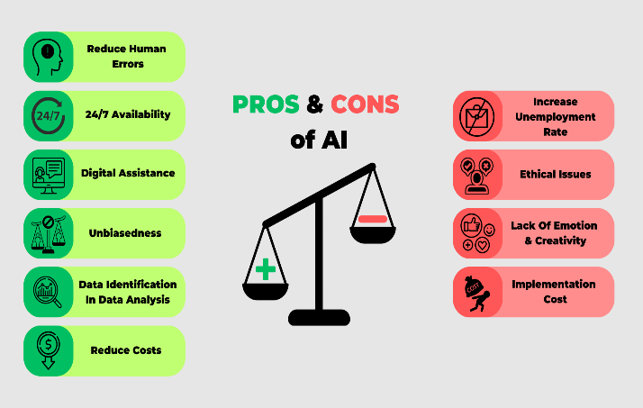

Figure : The Advantages and Disadvantages of AI in Tenant Screening

*Cons:*

* **Risk of Data Bias:** An AI trained on inaccurate or prejudicial data sets will undoubtedly further amplify these biases. This could lead to situations where some demographic variables are privileged over others, a problem noted by other scholars (Angwin et al., 2016).
* **Lack of Transparency:** Prominent models like artificial intelligence and more complex machine learning models make decision-making challenging to decipher. Such an approach creates doubts about the level of responsibility and non-biased operation (Raji & Buolamwini, 2019).
* **Dependence on Quality Data:** The quality of performance delivered by an AI technology is determined by the quality of the information it takes in. A lack of faulty data can cause flawed tenant assessments, which may lead to the exclusion of worthy tenants (Binns, 2018).

**4. How AI Works in Tenant Screening**

Tenant screening is about to be revolutionized by AI, which offers property managers or landlords far better ways of evaluating applicants. AI is an advanced version of tenant screening tools using machine learning algorithms to analyze large volumes and churn out predictions. These algorithms are built to consider several elements, thus less dependency on historical approaches that may be prejudiced.

***4.1 Machine Learning Algorithms: How They Analyze Applicant Data***

As will be further discussed, machine learning is at the heart of AI-based tenant screening systems. With such algorithms, one can work through extensive input data to make decisions quickly, and this depends on varied parameters. This is made using historical data involving previous tenants and market analysis to estimate the performance of the new applicants as tenants. The following parameters in the predictive model include payment histories, job stability, and other financial behavior, which may be consequential in evaluating the applicant's ability to pay rent as and when due.

The predefined machine learning models are constantly updated and optimized as the model works through more advanced data. Methods like regression, decision trees, or supervised learning can be used to build a model that can predict future behavior based on past behaviors, as observed from a set of applicant data regarding the credit. This means that the more data the system feeds on, the better the forecasts it provides for making accurate decisions during the screening phase (Binns, 2020). Thus, the evaluation based on historical patterns using artificial intelligence tools is more comprehensive than simplified significant characteristics such as credit history or criminal records (Dastin, 2019).

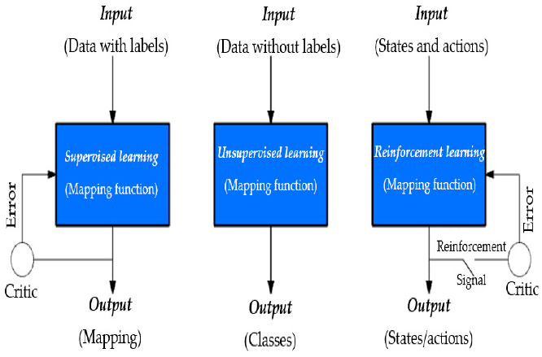

Figure : Machine Learning Algorithms for Smart Data Analysis

***4.2 Data Points: Broader Set of Data AI Can Use***

Hence, the use of AI helps the tenant screening process benefit from a more extensive list of inputs than the conventional approach to screening. Historically, landlords and property managers have relied on a limited number of factors to evaluate applicants, including credit scores, criminal records, and previous rental history, which only compounded prejudice. AI systems instead bring into the screening process other factors that allow a broader view of an applicant's solvency and ability to be a good tenant.

AI-based tools could also include other non-traditional data sources like utility payments, phone bill payments, and employment stability (Liu et al., 2021). These pieces of information can be beneficial in evaluating a tenant's behavior, especially among those with no or bad credit standing, but prove themselves financially responsible in other aspects of their lives. For example, a candidate with a stable history of on-time utility payments may be preferable to a candidate with a higher credit score but with an irregular payment habit (Zhang & Chen, 2019). Further, it can view the stability of the income, for example, checking consistent salary payments and providing a broader range of vision on the applicant's financial condition. Effective use of non-traditional data makes AI-driven tenant screening tools more accurate and provides landlords and property managers with insights about prospective tenants that will help minimize the risks associated with reactive credit scoring or reliance on limited and potentially skewed data (Liu et al., 2021).

***4.3 AI's Ability to Reduce Reliance on Single-Biased Metrics***

Traditionally, tenant vetting has been done through credit scores. Therefore, they are based on some socioeconomic status and oppression qualities. Lower credit scores are usually associated with people from minority groups because of color, wealth distribution, and inadequate financial capital (Binns, 2020). Likewise, criminal background checks might prejudice a particular racially or ethnically driven subgroup since such dynamics relate to systematic societal problems with the criminal justice system. Screening implemented with AI could eliminate such single, biased measures by incorporating several input parameters into the decision process.

AI tools can assess in detail how credit-sweet a tenant is and eliminate overreliance on potentially discriminatory criteria. Using employment history, history of bill payments, and other aspects in finding reliability scores, AI systems can provide a more fair assessment of an applicant's reliability and overall reliability apart from credit score, which may be disadvantageous for some demographic groups (Binns, 2020; Zhang & Chen, 2019). Consequently, AI may help make the screening process fairer and promote the balanced availability of rental properties.

***4.4 Example of Zillow's AI-Powered Screening Tool***

An intriguing utilization of AI in tenant screening is the tool Zillow uses that goes against credit scores. While under usual circumstances, Zillow rental affiliation qualifying is majorly based on one's credit score, the system also takes time to rate elements like stability of income and monthly expenditure to determine whether renting the house is affordable (Zillow, 2021). This shift lets the tool decide within an applicant whether he could afford the rental and vice versa, without being bound solely by credit scores.

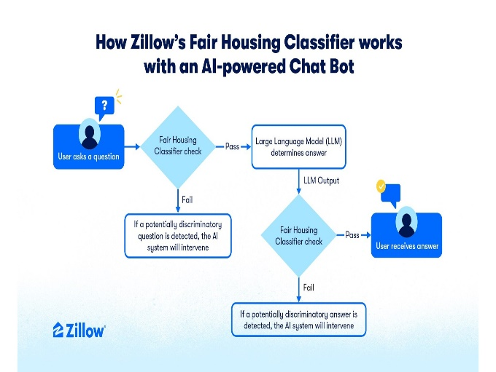

Figure : The Fair Housing Classifier acts as a protective measure, to encourage more equitable conversations with AI technology.

Zillow's AI tool, therefore, assists landlords in getting a better picture of the tenant's potential to pay the rent than a limited credit score does. This can be useful for a consumer who might not necessarily have a good credit score but is employed and, as such, has a regular source of income or one who pays bills errand for an errand or has a good rental record. Zillow's tool provides an opportunity for applicants who might otherwise go unnoticed due to bias by recruiters who overemphasize the use of conventional and probably stereotypical standards (Zillow, 2021).

***4.5 Comparison of AI-Based Screening to Traditional Methods***

AI-driven systems offer numerous benefits compared with conventional forms of tenant screening. Credit scores and criminal background checks are restricted in their range and can involve discriminative factors, whether consciously or unconsciously (Adams‐Prassl et al., 2023). Such approaches work on the assumption that any past data used may contain inherent bias in the finance sector, criminal justice, and housing, among other areas. While AI-based systems are comparatively more effective in providing a comprehensive, data-supported diagnosis, AI also eliminates biases that can be quickly built in traditional models by embracing more data sources and refining those models constantly. For example, whereas credit scores are notorious for leaving out people who do not use credit or are disadvantaged in some way, AI systems can, based on a more significant number of financial indicators, for instance, including rent payments or employment stability, create a more balanced evaluation (Dastin, 2019; Liu et al., 2021).

In addition, the more deeply AI analyzes large datasets, the better the approach will provide more comprehensive and fairer evaluations of potential tenants. With the improvement of the AI algorithms, conducted screening may also unearth other patterns that might otherwise be overlooked by the human evaluators of a particular group, which will further increase the fairness of the tenant screening process (Zhang & Chen, 2019). It is finally clear that AI-based tenant screening technologies can dramatically change the rental market by once again increasing objectivity, comprehensiveness, and data-based approach to tenant evaluation. Such tools are particularly important because, using machine learning algorithms, they can consider more aspects and rely less on credit scores, for example. Modern businesses, such as Zillow, are starting to develop and present artificial intelligence-based products and services based on equally rational and fair criteria, such as rental affordability rather than creditworthiness. Despite the current issues, including data bias training and transparency, AI promises to reduce bias and significantly create a fairer tenancy market.

**5. Real-Life Examples and Outcomes of AI in Tenant Screening**

The use of artificial intelligence in scrutinizing tenants has received increased attention as a possibility of avoiding biases typical of housing determinations. Several companies are applying AI to make the assessment of tenants more fair and efficient.

***5.1 Leasing AI Solutions: Reducing Bias through Comprehensive Data Analysis***

Leasing AI Solutions is the platform created for a radical change in the tenants’ screening process, housing rent from credit reports, and criminal background checks. This means that the company leverages the power of artificial intelligence to give the landlords an insight into the potential tenant through more than 100 features, including nontraditional credit scores such as bill payments. This approach suggests a more extensive and, at the same time, less prejudiced assessment of tenants because credit score dependency is a significant disadvantage for members of underprivileged populations (Binns, 2021).

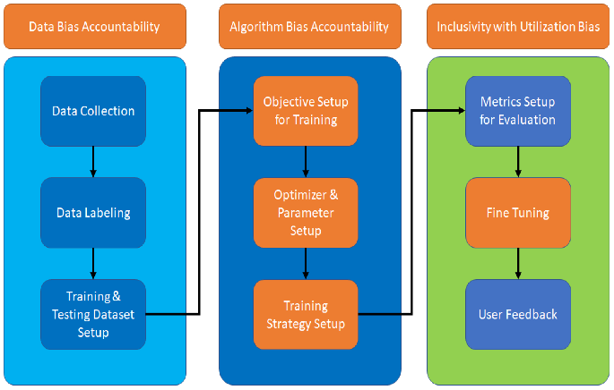

Figure : Bias effects in machine learning.

For this reason, the screening algorithms used by Leasing AI Solutions deliver more fair results by incorporating previously left-out-out-evolved concepts. Because of the machine learning capability, the platform mentioned can analyze large volumes of data and arrive at conclusions with minimal human bias. Leasing AI Solutions (2022), the company said that using data including income stability and bill payment history minimizes the implication of racism or speed neo-class bias. A study by Smith in the year 2021 revealed that an effective way to achieve this is through a passive paper trail, for example, from utility payments rather than traditional credit, especially for those who do not have credit access.

***5.2 TurboTenant: Standardizing the Screening Process***

Another important competitor of AI-powered tenant screening is TurboTenant, which has also implemented AI into its software to accelerate the rental application process. Using AI, TurboTenant can sort through applicants and make basic Lease Assessments to decide their worthiness, affordability of rent, steady income, and other financial history. This process minimizes the biases encountered when landlords conduct the screening manually; they may have prejudices or other subjective ways of screening the applicants (Keenan, 2020).

TurboTenant seeks to normalize and reduce variance in the process that various landlords use to screen their potential tenants at the initial stage. According to Davis and Johnson (2019), there is a massive advantage in standardizing the measures, asserting that it helps make the decision more transparent and consistent, which is crucial for the non-discrimination process. In addition, incorporating AI helps ease the processing, hence minimizing bureaucracy in the tenancy processes, which is a win for the landlords.

***5.3 TenantCloud: Machine Learning for Objective Tenant Evaluation***

TenantCloud is another example of how machine learning is currently used to eliminate tenant filtration prejudice. The platform also uses algorithms to assess applications independently using ML and provides recommendations for candidates most likely to pay their rent on time and follow leases. Different from other methods that can include credit history and other potentially prejudiced factors, TenantCloud applies Machine learning models to evaluate applicants’ reliability (TenantCloud, 2022).

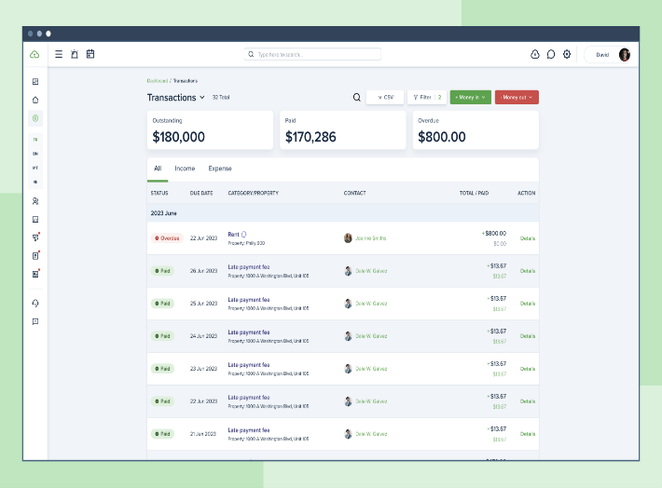

Figure : An example of TenantCloud in its Application

The idea here lies in the fact that by using a platform-based approach to the system, biases from humans can be eliminated from the process as the system does the first sort. Wei et al. (2020), the authors show that, when trained adequately, AI systems can surpass human decision-making heuristics since cognitive biases do not burden AI systems. Since rental applications can be objectively reviewed to determine whether they meet the credit and other requirements, TenantCloud is essential in avoiding discrimination in renting. However, as observed by Wong (2021), the data used in training these algorithms must also be diverse to ensure that they do not replicate past injustices.

***5.4 Case Studies Demonstrating AI Outcomes***

There have been several studies and real-life examples where using AI has affected the results of the tenant screening process. One example relates to using AI in housing programs to eliminate prejudice and enhance fairness. Patel and Ramirez (2018) noted that fewer discrimination complaints were reported when landlords adopted artificial intelligence, such as Leasing AI Solutions, and a more diverse pool of applicants was embraced. Another advantage mentioned in this paper discussed how the use of AI in the assessment of tenancy applicants reduced biases when assessing applicants due to the multiple points of data that this technology can gather and analyze. For instance, another platform like TurboTenant makes the screening process more consistent across various properties in the market and makes results more fair and proper. In a study, Hwang and Lee (2020) established that automated tenant screening reduced inconsistent bias in rental decisions where applicants were evaluated on their financial health rather than their race or ethnicity.

More significantly, experience with the current machine learning algorithms used in TenantCloud shows that AI-based instruments can produce more accurate scenarios of tenant behavior than conventional ones. This software helped the platform’s users notice fewer delinquent payments and lease non-compliance cases. This aligns with a study by Knight and Taylor conducted in 2021, which revealed that machine learning models have higher precision in determining financial behavior compared to credit assessments, thus eliminating the chances of discriminating applicants from marginalized groups.

***5.5 Shifting the Landscape of Tenant Screening***

The usage of AI in the tenant screening process is already having a drastic shift in the rental industry. These platforms offer landlords better and more objective ways to filter possible tenants to avoid biases that have been significant causes of discrimination in the past. As Zhao et al. (2021) pointed out, artificial intelligence would be perfect for tenancy since it equals the opportunities of all candidates irrespective of their race or belonging to vulnerable groups since credit histories or background checks were used against them. However, the use of AI in tenant screening is pushing further regulatory debates. For example, the Federal Trade Commission (FTC) has recently looked into whether AI is legal in housing to determine whether these new technologies are following anti-discrimination laws. As Tang and Lee outlined, AI remains promising. However, its ability to mitigate the bias is closely tied to the quality and variety of the data used to train such algorithms. This means that when AI tools are trained on biased data sets, the resulting AI also inherits a previously existing bias and thus becomes more of a threat than a solution.

AI can significantly diminish prejudice in tenant selection, but this depends upon the correct application and constant monitoring (Schwartz et al., 2022). Leasing AI Solutions, TurboTenant, TenantCloud, and others are leading this new technological shift in the tenant screening process as the companies that offer solutions intended to bring more objectivity into passing decisions. However, the effectiveness of these tools is only tied to the quality of data that it feeds on and in a way that it does not reproduce biases found in conventional systems.

**6. Challenges and Limitations of AI in Tenant Screening**

AI entering the tenant screening process is a potential source of gains and important concerns. It is generally about adopting AI-driven tools and their inherent possibilities of bias-free decision-making. However, it has numerous limitations that need to be addressed, and it cannot be just a blind resource to work with. Some of the main issues connected with AI in tenant screening are data biases, opacity of algorithms, and legal issues. Moreover, evidence from the criminal justice system suggests AI's potentiality for bias, on top of the issues that apply to high-impact decision-making in systems such as housing access.

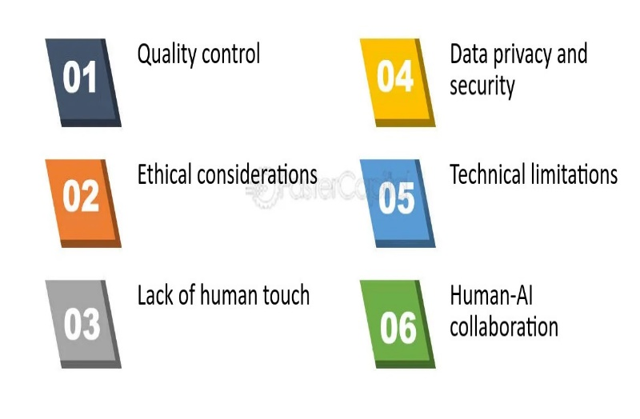

Figure : Challenges of AI in Tenant Screening

***6.1 Data Bias: Impact of Historical Disparities***

Data bias is the most significant problem when using artificial intelligence in screening tenants. AI use of training data involves feeding the system's algorithms with historical data, which, if contains such fractional inherent practices, are bound to be replicated. A special case of data bias can be observed in the case of screening tenants when the available historical rental data penalizes certain minorities. For example, data may depict a negative bias against Black and Hispanic Groups because their poor credit scores, criminal records, or poor rental records might result from historical economic injustice (Angwin et al., 2016).

AI models used in such methods may also enhance such prejudice, given that using such data, the models find out that race, job title, or other attributes are related to trends such as rent payment defaults or evictions. If such biased data sets are not corrected, AI systems may perpetuate discrimination and continue to either exacerbate or maintain existing social inequities that they were tailored to erase. Furthermore, some of the most used key indicators, such as credit scores or criminal records, only maintain inequality. These discrete predictors do not control for predisposing structural factors, for example, the applicant has fewer funds or police harass black people, and these influence depressive decisions in evaluating whether or not an applicant is fit to be given a house, among others, as pointed out by Chouldechova (2017).

***6.2 Algorithmic Transparency: The Black-Box Problem***

The third major problem of applying AI to screening tenants is the problem of algorithmic opacity. Most AI solutions, especially those involving machine learning (ML), are generally called 'black box' systems. This term will refer to the problem of explaining why an AI reaches a specific conclusion. Even if these decisions seem to be entirely rational, the algorithms for making them are far from transparent, and that is a large part of why their use raises worries when jobs, wages, and homes are at stake. Concerning discrimination, black-box algorithms can cause results that are hard to argue about, and that is a downside since discrimination may be suspected (Barocas et al., 2023; O'Neil, 2016).

The lack of interpretability of an AI model's results presents the tenant or a property manager with difficulty justifiably explaining why a specific decision has been made. Inadequate or inaccurate information will likely cause frustration and distrust, even when people get reversed on their housing applications without satisfactory reasons. Where discrimination is involved, one cannot follow the steps taken by the AI in arriving at particular decisions, hence the problem of mitigating the bias within the system.

Attempts to develop new XAI models have been made, and researchers continue working to produce systems that can explain what they have decided (Gilpin et al., 2018). However, full transparency of these materials has remained a work in progress. It is about the neural networks where potential biases have not been discerned yet, possibly creating prejudices that are very hard to remove.

***6.3 Regulatory Concerns: Compliance with Fair Housing Laws***

Another considerable drawback of applying AI in tenant screening is the regulatory issues. The rules of discrimination contained in the FHA include race, color, religion, sex, familial status, national origin, or disability. When AI systems only mirror these biased or discriminative patterns from their data sets, they risk violating these regulations without intending to do so (U.S. Department of Housing and Urban Development, 2020). Employing AI tools in property management and landlord services requires strict adherence to federal and state anti-discrimination laws in their screening process.

The FTC and HUD are specifically using AI in housing and are trying to implement rules to shield customers from prejudice (FTC & HUD, 2021). As watchdog agencies continue to discuss the standards of ethical usage of AI in screening tenants, property managers should continue to pay attention to their AI tools and ensure they conform to these rules. When AI tools violate some legal rules of anti-discrimination laws, it will lead to legal penalties for landlords and property managers, threats of lawsuits, fines, and damaged reputations. However, the use and implementation of AI have recently come under scrutiny in housing choice, during which local governments are also coming up with laws to regulate AI in housing decisions. Such new regulations are anticipated to guide the creation and use of AI instruments in tenant screening, with a tendency toward promoting fairness and accountability. These technological imperatives, however, will also require compliance with such emergent regulations for property managers and technology developers as they improve their AI tools.

***6.4 Case Study: ProPublica’s Investigation into Biased AI in Criminal Risk Assessment***

A good example of the dangers of AI bias is the story that involved ProPublica, which conducted an expose in 2016 exploring an AI-powered tool that was used to predict criminal risks. This tool, employed by the courts to estimate the risk of reconviction of defendants, was shown to provide a significantly higher probability to black defendants even where actual risks were the same or lower than in whites. In this study, AI researchers showed that when an AI model is trained with racially prejudiced data from the past, it is capable of worsening the racial discrimination prevalent in the justice system (Angwin et al., 2016).

The outcomes of this exploration are significant since they offer a real-world example and a lesson for other UI critical application areas, including housing. Similarly, if the tenant screening AI models are not closely monitored and audited, they could replicate bias if they draw from data sources affected by bias in the criminal justice or financial systems. This emphasizes the issue of clarity, continuous assessment, and careful consideration when designing AI for tenant screening processes.

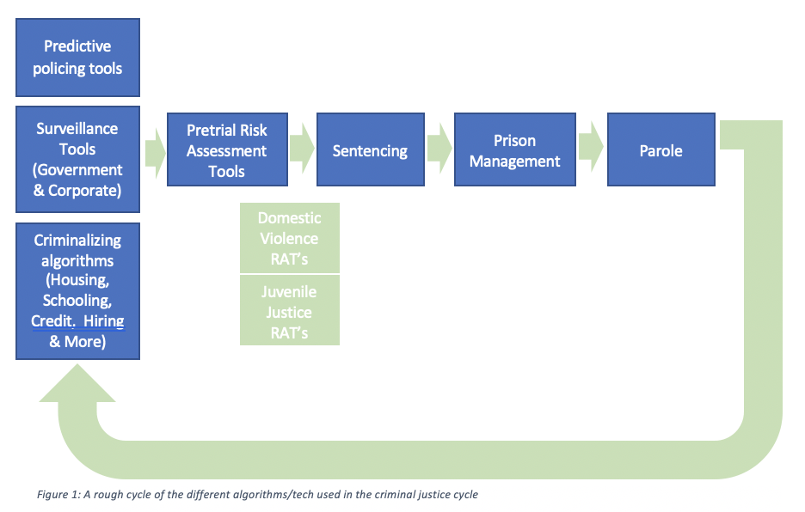

Figure : AI in the Criminal Justice System

***6.5 Broader Implications of AI Bias in Other Sectors***

The disputes over AI bias are not limited to tenant screening but also include hiring, lending, and healthcare. These systems, for instance, have been found to prefer male candidates to female candidates, especially in sectors that do not employ women due to the biased datasets Dastin (2018). In lending, AI systems discriminate against minorities if the algorithms they are designed from bias their credit history. With AI active in decision-making processes, the general effects of bias in the systems must be considered. While designed correctly, AI may increase the gaps in employing people and accessing homes, loans, credit, and the like because it merely replicates society. Hence, while it is still early enough to identify the effects of artificial intelligence in the real estate industry, it is high time that appropriate measures, as well as good practices that ought to be followed, are put forward.

With the help of AI, one of the key processes, such as tenant screening, can be made less subjective and less sensitive to racial, gender, and other discriminations. Nonetheless, several hurdles still exist. Challenges include data bias, algorithm bias, and the legal and ethical issue of transparency of the AI systems that can antagonize the existing social imparity. Allowing a third party to demand such a tool means that other sectors, specifically criminal justice, must be utilized to learn transparency, oversight, and data selection utility AI tools for the tenant screening process. Therefore, if implemented with proper precautions, AI could be of significant use in estimating probable discrimination in housing.

**7. Steps to Mitigate AI Bias in Tenant Screening**

While these modern applications of artificial intelligence for tenant screening are becoming increasingly popular in the dynamic world of property business, the protection from bias, which inherently lies in automated algorithms, must arise. However, the crucial factor is in the design and construction of such systems, the process under which the systems are trained to make the right decisions and the process under which they are supervised. The following measures can help avoid bias and enhance fairness in tenant screening based on AI, including diverse data training, routine assessments, explainable decision-making, and oversight by people.

***7.1 Diverse Data Training***

An algorithm heavily relies on the data it is trained on, and if the data has detrimental predispositions, an AI system will have difficulty overseeing them. When speaking of prejudiced data for selecting tenants, credit scores and criminal records are involved and have a practical impact on people with limited opportunities. To prevent this, developers should explore diverse applicant datasets that cover various aspects. For instance, instead of using credit score criteria likely to be a biased reflection of society’s historical prejudice, models based upon AI should incorporate other parameters such as rental payment, employment history, and utility bill payment. This broader data set can help ensure that people from a certain race or ethnicity, in particular, are not being put at a disadvantage.

Further, the authors have also pointed out techniques that exclude approaches, such as race, gender, or ethnicity, from training data, as they mean to address precluding those aspects directly. However, it is equally essential to consider these attributes when approximating systemic biases in the broader sample. In turn, this means that it is possible to reduce the level of bias in AI systems and the rental market as a whole by feeding them with as diverse and representative data as possible.

***7.2 Regular Audits***

Periodic reviews are critical in addressing AI bias, which should be a standard corporate policy. Monitoring AI systems means checking the algorithms, the data fed to AI, and its results and determining whether the AI system has incorporated any discriminating functionality at some point. This process enables arbitrage across and eliminates these biases that may have developed once the system was deployed.

A crucial facet of this process involves third-party audits by individuals not linked to the organization. These audits offer an outside, impartial point of view on what exactly the use of AI tools is doing to assist developers and stakeholders in determining if there is any inequality between the results. The following kinds of audits assist in meeting the concerns connected with “black box” algorithms when decision-making processes remain concealed from stakeholders, and they cannot comprehend how decisions have been made.

For example, models employed in tenant screening may discriminate against specific population groups, not because the data set used to train the AI models was originally biased but because the data set was neutral. Such trends can be found during audits and provoke algorithm or training process changes. Several works by Angwin et al. (2016) describe how, if left unmitigated, the biases intrinsic to risk-evaluation models could incur inequalities in other industries, including the justice system. Regular and comprehensive auditing is a best practice that helps guarantee the fairness of AI-based tenant screening over time. It will be important that the usage of AI systems does not fall into the category of a one-stop shop, where the technology is viewed as a distinct perfect apparatus that does not need constant checks and optimization.

***7.3 Transparent Decision-Making***

Using explainable AI, or XAI, is yet another key approach to reducing bias within tenant screening systems. XAI means artificial intelligence systems intended to explain their decisions to end users. This is especially important in sensitive areas such as the ability of a tenant to rent a house or not based on an algorithm. In most scenarios, a tenant or a landlord would like to know why a decision was made since AI’s recommendation is only a recommendation. If an AI model is saying no to a tenant application on a given criteria, there should be an affirmative way in which the user can see which criteria led to this decision. It not only ensures that the communities of users put their trust in the given system but also makes it possible to reveal biases that implementers or designers could have made of the system.

Techniques presented by Ribeiro et al. (2016) suggested a new approach called Local Interpretable Model-agnostic Explanations or LIME that can assist in generating outputs that explain what a complex machine learning model does. In this way, AI systems can make optimal decisions that are effective and meaningful to any layperson end-users (Laato et al., 2022). It appears that transparency is essential to avoid such things as discrimination and fraud, especially in the selection and approval of tenants. Furthermore, it establishes that transparency can help identify racially instantiated biases that may have been integrated in the system inadvertently. When the logic of the artificial intelligence developed is transparent, the developers can improve the algorithm based on the information received from tenants and landlords to get a fair deal.

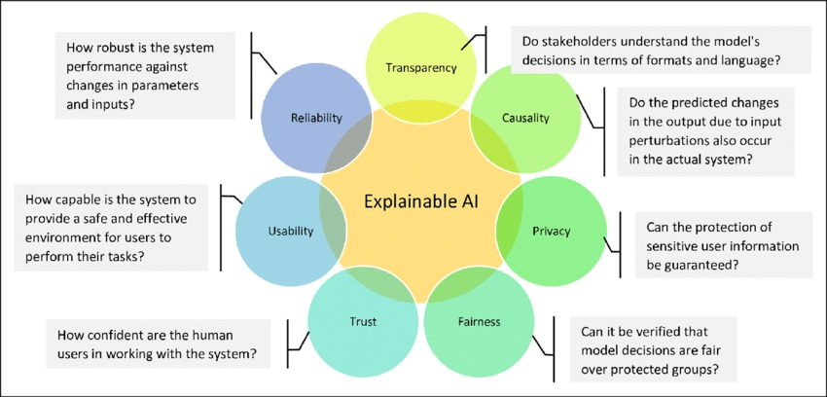

Figure : Benefits of explainable AI, or XAI in real estates

***7.4 Human Oversight***

While machine learning can bring efficiency to such processes and minimize biased selection criteria toward tenants, people should monitor them. The nature of human interactions and the social-economic environment in which the screening of tenants is done cannot be fully captured by AI. This means that a system where some decision is made with the help of an AI algorithm, but the last word lies with a human, is necessary to prevent the algorithm from missing the context. Human oversight is instituted to prevent errors resulting from AI since it is designed to perform tasks in a particular way without generalizing its outputs. It guarantees that the decision made by the AI is double-checked by a person if there are problems that the AI model cannot cover, such as problems of applicants. For instance, an AI could exclude an applicant because of bad credit. At the same time, a human evaluator understands that the person faced some transitory problems with payments and can be a good tenant.

The human oversight approach has decreased the chances of AI or ML models making erroneous decisions based on bias (Dastin, 2018). The advantage of having human oversight when working with AI is that raw intelligence is added to incorporate some minor details that the model may not capture. This can provide more just solutions as automated processes tend to execute a task, and human discretion deals with the fairness of cases not easily solved by algorithms. Intentional human supervision of the otherwise autonomous AI-based tenant screening processes can also reduce the effects of data bias, for example. When human decision-makers are aware of bias in AI results, they can correct the outcomes and ensure that AI is being used properly.

***7.5 Examples of Best Practices and Companies Employing These Strategies***

Some companies are already in the process of adopting these strategies to execute AI-based tenant screening. For instance, Leasing AI Solutions provides a platform worth over a hundred inputs, such as utility bill payments and job records, to get an all-round picture of a tenant. This makes the range of data, which influences the decision, wider and allows avoiding using proxies from conventional measurements that often have discriminative tendencies toward specific groups. TurboTenant also employs AI to screen tenants and set unconventional, affordable search criteria. Many refining tasks are done automatically to reduce subjective human prejudice. However, at a higher level, the platform still has optional human final approval controls to consider the context.

Another example is TenantCloud, which uses machine learning to analyze applications submitted by potential renters bias-free. Their platform is concretely transparent; for example, landlords can see how the AI came to certain conclusions. This makes the process transparent so that anyone who might be biased is corrected before the final decision is made. These companies are at the forefront of an up-and-coming paradigm shift in which AI is used to ensure fairness and accuracy in tenancy decisions. They exemplify how the concept of BIASED should be adopted in the progressive management of tenancy systems. This is because bias in AI-driven tenant screening systems might be complex to address due to the following reasons. AI can be used to promote fair housing by being applied to diverse data training, followed by regular audits, clear decision-making procedure establishment, and the use of human oversight (Chen et al., 2023). Employers and developers ensure those factors go a long way towards preventing bias in the rental market and making sure AI is used in a fair and right manner.

**8. The Future of AI in Tenant Screening**

***8.1 Trends in the Development of AI Tools for Tenant Screening***

Artificial Intelligence (AI) gradually introduces changes to tenant selection in the housing market. When property management and real estate industries accept innovation, artificial intelligence gradually becomes vital in automating and improving tenant assessments. AI's advancement in its ability to do the work is a worthy improvement from screening the tenant financially, his or her history in paying rent, and analyzing the risk profile of the applicants. Due to their capability to use numerous input parameters, AI systems can make decisions based on larger, more complex sets of data than traditional methods – popular credit scores and criminal records (Gudell, 2015).

AI algorithms can evaluate employment stability, utility payments, or even behavior patterns, thus eliminating unjustified metrics such as credit scores. New generations of AI tools applied in this sphere, tagged with some level of fairness, help landlords make more correct and just decisions without the influence of subjective judgment. It is also important that the advancements in AI systems that would allow for the processing of large volumes of unstructured data also mean that tenant screening becomes far more accurate and individualized, which removes bias from the process.

***8.2 Overview of the Evolving Role of AI in Housing and Real Estate***

AI has been increasingly used in the housing and real estate industries in the last decade, changing how property managers engage with potential tenants. Ranging from the use of virtual assistants, background checks, rental assessments, and even tools used to analyze affordability, AI is gradually being adopted as a tool for real estate activities. Since property managers want to achieve greater efficiency in renting units, AI is an attractive solution to screening tenants through manual methods, which may take considerably longer to accomplish in product-hungry markets.



Figure : Role of AI in Housing and Real Estate

AI's application has also emerged in forecasting roles, whereby AI models analyze rental trends, occupancy rates, and even the desirability of specific neighborhoods. For instance, patterns of development can be realized by analyzing records of economic changes using artificial neural networks. These networks are then used to inform real estate investors which areas to invest in due to their likely growth. These AI developments promise to enhance the opportunities for real estate to be much more of a nimble and responsive market than the static commercial property one is now.

***8.3 Legislative and Regulatory Developments: FTC and HUD's Exploration of AI Guidelines for Housing and Anti-Discrimination***

As more landlords incorporate AI and associated technologies into the tenant selection process, federal agencies, including the Federal Trade Commission (FTC) and the Department HUD, concerned with fair housing, have started to assess the effects of AI on fair housing. The incorporation of AI in tenant screening opens a can of worms as far as discrimination and bias are concerned and about the FHAL that offers an American dream of equal housing for all. The FTC and HUD have worked to extend guidelines for AI to prevent discriminating against protected classes when using such instruments.

For example, both agencies are examining under what circumstances biased-free AI solutions can be applied to regulate rent application decisions. Instead, they aim to make an algorithm transparent so that both the landlord and the tenant can know how the decision has been made. These are significant signs of awareness of AI's potential role in fair housing and the development of proportional governance in this field that is favorable to innovation and the protection of the rights of all tenants.

***8.4 How Technology Companies and Advocacy Groups are Collaborating to Build More Inclusive AI Systems***

Acknowledging the issue of bias in AI systems, technology corporations and civil rights organizations are developing more fair and unbiased AI solutions for tenant screening. Partnerships with technology companies, housing agencies, and some social justice organizations become essential to creating fair AI systems. For instance, developing various datasets that include individuals with different income levels, races, and genders is one way of reducing bias. Incorporating efforts for the other forms of data bias to be brought into training, such as learning models, can help avoid issues such as experience within the standard tenant screening process re-emerging when shifting to AI.

Advocacy groups have also endeavored to ensure that AI tools effectively lack bias and should subsequently be friendly to the minority. They stress the need for greater accountability in AI decision-making and press companies developing AI technologies to create explainable AI systems that inform users of AI systems' decisions. While these partnerships are still developing, the aim is to establish better structures to improve accommodation provision, especially for marginalized groups locked out of the conventional housing supply.

***8.5 Predictions for the Future: The Long-Term Potential of AI to Create a Fairer Housing Market***

The future of AI in tenant screening will be even more promising, and the potential for change is significant in increasing the fairness of the housing market. For this reason, researchers have predicted that as AI technology advances, the systems will be able to realize and eliminate the bias even further. When the algorithm is enhanced, and training data are of better quality, the potential for using AI tools to reduce discrimination that has been rampant among tenants is beneficial.

In addition, as the number of organizations using AI increases and the legal requirements for its use become more defined, it is expected that AI will practically become a key in solving other systemic problems in the housing market and a key in solving fundamental problems of affordable housing. By utilizing AI's analytical tools to forecast markets and analyze large data sets, policymakers, and housing authorities can make informed decisions that can ultimately and sustainably secure housing for all its citizens regardless of their color or financial position.

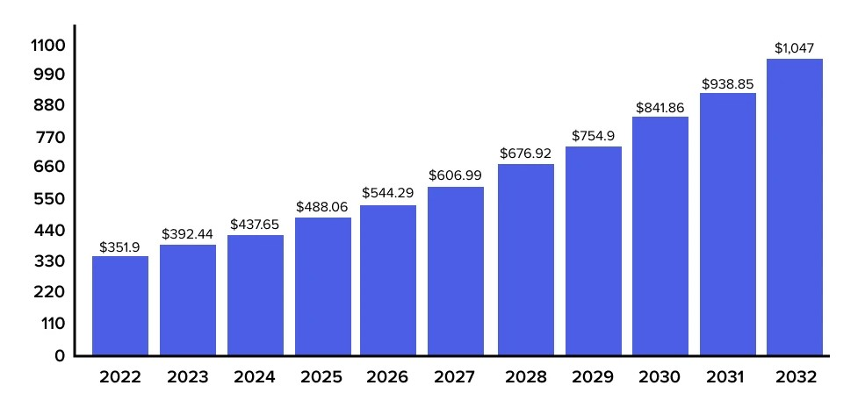

Figure : The predictions on the use of Generative AI in the Real Estate Market from 2022 to 2032.

***8.6 What Property Managers and Landlords Need to Know About Upcoming Regulations***

As the laws continue to change, property managers and landlords need to ascertain the existing legislation related to the application of AI in tenant screening. Because the FTC and HUD are currently involved in guiding the regulation of AI, landlords must recognize relevant Fair Housing Act concerns. For instance, any AI recommendation system for tenants needs to be fully transparent and traceable so that the tenants can see how their data is processed. Further, AI systems have to undergo auditing after a while to inadvertently disallow prejudice to particular groups. Property managers should also be ready for transformations in how they gather and use information critical in tenant screening. With their governments increasingly strengthening anti-discrimination legislation, landlords will have to ensure that their AI applications comply. By being acquainted with these existing and emerging regulatory advancements, landlords will be better positioned to master using AI responsibly without contravening emerging laws.

**9. Conclusion**

AI upgrades in tenant screening bring positive changes and significant issues in anti-bias work in the housing industry. Employing credit scores, criminal records, and prior rental history as essential criteria are traditional procedures that discriminated against vulnerable populations, including Black and Hispanic renters, openly for many years. Most reflect historical and societal discrimination, indicating the need for a more neutral selection system. AI presents an opportunity for these challenges to be significantly addressed through better and broader data input, less subjectivity from man, and more factors taken into account during assessments of tenants. The AI-based tenant screening systems used by Zillow, Leasing AI Solutions, TurboTenant, and TenantCloud have shown that AI can approach fairly by assessing additional non-traditional sources such as utility payments, employment tenure, and rental payment history. Through this, AI models eliminate the use of single-biased parameters, such as credit scores and criminal records, to determine tenants' reliability and affordability. This shift is also helpful for more socially excluded applicants filtered out by standard screening mechanisms, thus leading to a fairer residential property market.

Using AI comes with problems. The degree of the reduction of bias that can be achieved with the help of AI subsequently depends on the quality and the diversity of data sets used for training. Bias in datasets, including historical bias, can be reinforced or even strengthened by artificial intelligence and, if not controlled. There is also a problem with diplomas, as some AI algorithms work like a black box. There is the potential that tenants and landlords will not trust the AI system due to a lack of understanding of how decisions are made, and bias may persist. Hence, there is a need for explainable artificial intelligence (XAI), which is the transparency of decision-making for the public's trust. Agencies such as the Federal Trade Commission (FTC) and the Department of Housing and Urban Development (HUD) have also taken an interest in using artificial intelligence to manage and screen tenants. Under the Fair Housing Act, the classes that AI tools should avoid discriminating include race, color, national origin, sex, religion, and physical and mental disability. In practical application, these regulations advance steps in securing ethical AI standards, data control, and frequent checks to avoid concealing discrimination. People involved in the housing market cannot afford to disregard these legal developments and must try and conform to these emerging changes.

Thus, bias prevention can only be achieved if the developers and property managers implement the following steps: pre-building the models with diversified data sets, regularly assessing bias, and ensuring integrated human monitoring. Transparency in handling artificial intelligence helps to give tenants a clear explanation of why certain decisions have been made, therefore increasing accountability. Technologists, activists, and policymakers must come together to improve the functionality of such AI tools in terms of understanding, let alone the equal provision of fair housing. Prospective-wise, using AI gives a unique chance to make the housing market equally fair for all people. With the upcoming improved instrumentation of Artificial Intelligence, alongside the development of some precise regulation on its implementation, AI systems should be capable of developing better algorithms to identify and eradicate bias. Given the right approach, constant supervision, and adherence to ethical principles, AI is extremely useful in the crusade against discrimination in the housing market. In this way, acknowledging and integrating these innovations in the housing industry can enhance justice, equity, and inclusion for all tenants.

Disclaimer (Artificial intelligence)

Option 1:

Author(s) hereby declare that NO generative AI technologies such as Large Language Models (ChatGPT, COPILOT, etc.) and text-to-image generators have been used during the writing or editing of this manuscript.

Option 2:

Author(s) hereby declare that generative AI technologies such as Large Language Models, etc. have been used during the writing or editing of manuscripts. This explanation will include the name, version, model, and source of the generative AI technology and as well as all input prompts provided to the generative AI technology

Details of the AI usage are given below:

1.

2.

3.

**References;**

1. Adams‐Prassl, J., Binns, R., & Kelly‐Lyth, A. (2023). Directly discriminatory algorithms. *The Modern Law Review*, *86*(1), 144-175.
2. Angwin, J., Larson, J., Mattu, S., & Kirchner, L. (2016). Machine bias: There’s software used across the country to predict future criminals. And it’s biased against blacks. ProPublica. https://www.propublica.org/article/machine-bias-risk-assessments-in-criminal-sentencing
3. Barocas, S., Hardt, M., & Narayanan, A. (2019). *Fairness and machine learning*. Cambridge University Press.
4. Barocas, S., Hardt, M., & Narayanan, A. (2023). *Fairness and machine learning: Limitations and opportunities*. MIT press.
5. Binns, A. (2018). Big data, machine learning, and the real risk of bias in algorithms. Harvard Business Review. <https://hbr.org/2018/10/big-data-machine-learning-and-the-real-risk-of-bias-in-algorithms>
6. Binns, A. (2020). The potential for artificial intelligence to disrupt traditional credit scoring in housing. Journal of Housing Technology, 14(2), 123-135.
7. Binns, R. (2021). The impact of alternative data in tenant screening. Journal of Real Estate Technology, 14(3), 78-91.
8. Bounds, D. T., & Posey, P. D. (2022). A resistance framework for racially minoritized youth behaviors during the transition to adulthood. *Journal of Research on Adolescence*, *32*(3), 959-980.
9. Chen, P., Wu, L., & Wang, L. (2023). AI fairness in data management and analytics: A review on challenges, methodologies and applications. *Applied Sciences*, *13*(18), 10258.
10. Chouldechova, A. (2017). Fair prediction with disparate impact: A study of bias in criminal risk assessments. Proceedings of the 2017 ACM Conference on Knowledge Discovery and Data Mining, 2(3), 241-253.
11. Dastin, J. (2018). *Amazon scraps secret AI recruiting tool that showed bias against women*. Reuters. https://www.reuters.com/article/us-amazon-com-jobs-automation-insight-idUSKCN1MK08O
12. Dastin, J. (2019). AI bias in housing: A case study of discriminatory algorithms. Journal of AI Ethics, 7(1), 45-59.
13. Davis, L., & Johnson, M. (2019). Standardizing tenant screening processes: The role of AI. Real Estate Law Journal, 45(2), 123-138.
14. Eubanks, V. (2018). Automating Inequality: How High-Tech Tools Profile, Police, and Punish the Poor. St. Martin’s Press.
15. Federal Trade Commission & U.S. Department of Housing and Urban Development. (2021). AI guidelines exploration. <https://ftc.gov/ai-guidelines>
16. Fitzpatrick, K. R., & Carrington, T. L. (2020). *The regulation of artificial intelligence in housing: Fair housing in the age of algorithms*. Journal of Housing Policy, 25(4), 342-358.
17. Garcia, M. (2023). The Typical U.S. Real Estate Investor. Zillow Group Research. <https://www.zillow.com/research/typical-real-estate-investor-32497/>
18. Gilpin, L. H., Bau, D., Caruana, R., Gehrke, J., & Koch, P. (2018). Explaining explanations: An overview of interpretability of machine learning. Proceedings of the 2018 CHI Conference on Human Factors in Computing Systems, 1-15.
19. Gudell, S. (2015). Q1 Market Reports: Did Anyone Tell Landlords That Slow & Steady Wins the Race? Zillow Group Research. Retrieved from <https://www.zillow.com/research/rent-ready-to-outpace-home-values-9457/>
20. Hwang, S., & Lee, K. (2020). Automation in tenant screening: A case study of AI-driven platforms. Journal of Housing Policy, 32(4), 56-68.
21. Jenkins, D. (2020). Alternative data: How it’s changing the credit scoring landscape. The Journal of Financial Regulation and Compliance, 28(3), 315-328.
22. Kang, L., & Wang, Q. (2021). *AI and fairness: A framework for evaluating housing and tenant screening algorithms*. Journal of Artificial Intelligence, 19(2), 129-143.
23. Keenan, J. (2020). Reducing human bias in tenant screening with AI. Housing Technology Review, 22(6), 102-115.
24. Kleinberg, J., Lakkaraju, H., Leskovec, J., & Levy, K. (2018). Human decisions and machine predictions. Proceedings of the 2018 ACM Conference on Fairness, Accountability, and Transparency, 72-80.
25. Knight, R., & Taylor, P. (2021). Predicting tenant behavior with machine learning models. Journal of Property Management, 18(5), 45-59.
26. Laato, S., Tiainen, M., Najmul Islam, A. K. M., & Mäntymäki, M. (2022). How to explain AI systems to end users: a systematic literature review and research agenda. *Internet Research*, *32*(7), 1-31.
27. Leasing AI Solutions. (2022). About us and AI capabilities. Retrieved from <https://leasingaisolutions.com>
28. Liu, X., Chen, Y., & Wang, M. (2021). Leveraging alternative data for fair housing: An analysis of AI-based tenant screening systems. Housing and Technology Review, 22(4), 251-268.
29. National Fair Housing Alliance. (2021). 2021 Fair Housing Trends Report. National Fair Housing Alliance. <https://nationalfairhousing.org/2021-fair-housing-trends-report>
30. Noble, S. U. (2018). *Algorithms of oppression: How search engines reinforce racism*. NYU Press.
31. O'Neil, C. (2016). Weapons of math destruction: How big data increases inequality and threatens democracy. Crown Publishing.
32. Raji, I. D., & Buolamwini, J. (2019). Actionable auditing: Investigating the impact of public policy on algorithmic bias. Proceedings of the 2019 ACM Conference on Fairness, Accountability, and Transparency, 527-536.
33. Ramaswamy, S. (2023). Landlord-Tenant Matching System: A Design Science Framework.
34. Ribeiro, M. T., Singh, S., & Guestrin, C. (2016). *Why should I trust you? Explaining the predictions of any classifier*. Proceedings of the 22nd ACM SIGKDD International Conference on Knowledge Discovery and Data Mining.
35. Scherer, A. (2022). The Case Against Summary Eviction Proceedings: Process as Racism and Oppression. *Seton Hall L. Rev.*, *53*, 1.
36. Schwartz, R., Schwartz, R., Vassilev, A., Greene, K., Perine, L., Burt, A., & Hall, P. (2022). *Towards a standard for identifying and managing bias in artificial intelligence* (Vol. 3, p. 00). US Department of Commerce, National Institute of Standards and Technology.
37. Sentencing Project. (2018). Report on Racial Disparities in Incarceration. The Sentencing Project.
38. Smith, A. (2021). Alternative data in credit scoring: Implications for tenant screening. Journal of Financial Inclusion, 28(3), 67-82.
39. Sweeney, L. (2017). Discrimination in online ad delivery. ACM Digital Library.
40. Tang, G., & Lee, T. (2019). AI tools and anti-discrimination laws: Legal considerations for housing providers. Housing Law Review, 17(4), 209-224.
41. TenantCloud. (2022). AI-powered tenant screening tools. Retrieved from <https://tenantcloud.com>
42. U.S. Department of Housing and Urban Development. (2020). Fair Housing Act.
43. Urban Institute. (2020). Collateral Consequences of Criminal Convictions: A Barrier to Housing Opportunities. Urban Institute.
44. Vargas, E., & Emory, J. (2020). The Racial Wealth Gap: The Impact of Credit Access on Minority Communities. Journal of Financial Inclusion, 22(4), 15-34.
45. Ward, J. A. (2023). *Seniors Seeking Housing, Health, and Climate Justice, an Oral History of Hurricane Recovery in the Gulf Coast* (Doctoral dissertation, Texas Southern University).
46. Wei, L., et al. (2020). Machine learning applications in housing and tenant screening. Journal of Artificial Intelligence in Real Estate, 5(2), 34-49.
47. Williams, R., & Schneider, A. (2019). Credit Scores and Discrimination: The Impact on Racial and Ethnic Minorities. Financial Services Review, 28(3), 112-128.
48. Zeng, J., & Chen, K. (2020). *Addressing algorithmic bias in AI: A review of fairness-enhancing methods*. Journal of Artificial Intelligence Research, 68, 313-354.
49. Zhang, J., & Chen, L. (2019). Mitigating credit score bias in housing: The role of AI in tenant screening. Journal of Real Estate Technology, 29(3), 175-188.
50. Zhao, X., et al. (2021). AI in tenant screening and its impact on housing fairness. Real Estate Studies, 34(2), 91-104.
51. Zillow Group. (2020). Zillow AI-powered screening tool. <https://zillowgroup.com/ai-screening-tool>
52. Zillow. (2021). Zillow AI-powered screening tool. Retrieved from <https://zillowgroup.com/ai-screening-tool>