**Effect of biofertilizers based on mycorrhizal fungi (*Rhizophagus intraradices*) and aquatic ferns (*Azolla filiculoïdes*) on agromorphological parameters of chilli pepper (*Capsicum chinense* L.) grown on Distric plinthic ferralsol** **in Daloa, Côte d'Ivoire**

**ABSTRACT**

The main aim of the study is to use mycorrhizal fungi (*Rhizophages intraradices*) and water fern (*Azolla filiculoïdes*) as biofertilizers to improve chilli productivity in an organic farming concept.

The experiment was carried out at the Jean Lorougnon University experimental farm in Daloa in 2023

The methodology consisted in setting up a two-repetition randomized Fisher block design with five treatments (*Rhizophages intraradices, Azolla filiculoïdes, Rhizophages intraradices-Azolla filiculoïdes* combination and a control), in which 12 seedlings were transplanted. At transplanting, biofertilizers were applied as background fertilizer, compared with an unfertilized control, at a rate of 150g/pack of crushed *Rhizophages intraradices*; 50g/pack of fresh, well-crushed *Azolla filiculoïdes* 50g/pack of a mixture of *Rhizophages intraradices* and *Azolla filiculoïdes* and 1.5g of NPK in an 8 cm radius around the pepper plant. Growth and production parameters assessed included: collar diameter, number of leaves, plant height, leaf width and length, number of flowers, fruits and mass at harvest. The data obtained were subjected to an analysis of variance with Statistica 7.1 software at the 5% threshold.

The results clearly showed that the different treatments had a significant effect on all the growth and production parameters of the pepper plants at the 5% threshold. However, it should be noted that *Azolla filiculoïdes* had the greatest effect on agromorphological parameters, followed by *Rhizophages intraradices*, the *Rhizophages intraradices-Azolla filiculoïdes* combination and, finally, NPK in descending order.

In Conclusion, the aquatic fern, *Azolla filiculoïdes*, appears to be the best biofertilizer likely to improve growth and development in the BIG SUN pepper plant, compared with the mycorrhizal fungus (*Rhizophages intraradices*). It could be an alternative for improving the fertility of agricultural soils.

**Key words**: Biofertilizers, BIG SUN pepper, growth and development, agricultural

1. **INTRODUCTION**

Agriculture is essential to today's society, and must also provide nutrition for the world's population. Chillies are one of the world's most widely grown vegetable crops. Chillies are a vegetable crop of great interest both in terms of production and consumption. They come in many shapes and sizes, but all belong to the *Capsicum* genus. They are cultivated or grow wild in Mexico, the United States, South America, the Caribbean, Africa, India, China and Southeast Asia. Data from the FAO (2015) show that chilli production worldwide is evolving from year to year, with an estimated 78% increase in the decade 2003-2013. However, climate change and soil impoverishment are impacting on the profitability of pepper production. The genetic improvement of chilli plants and the use of inputs are involved in the search for answers to the challenges of chilli production. In addition, organic fertilizers and mineral fertilizers (NPK) have shown numerous advantages for soil fertilization. Among organic fertilizers, mycorrhizal fungi (*Rhizophagus intraradices*) and aquatic fern (*Azolla filiculoides*) can be considered as a solution to limit the impact of environmental shocks caused by the synthetic plant protection products currently in use. In addition, it is universally recognized that mycorrhizal fungi (*Rhizophagus intraradices*) contribute effectively to the establishment and maintenance of plants under highly constraining ecological conditions (Tacon *and al*., 2008). Some plants cannot grow without being associated with mycorrhizal fungi (*Rhizophagus intraradices*). Mycelial hyphae explore a large volume of soil, enabling colonized plants to obtain the water and nutrients they need to function and grow (Nelson, 2009). Thus, the study of mycorrhizal fungi is important not only because of the direct role they play in tree performance, but also because of their contribution to ecosystem functioning. The composition and functioning of mycorrhizae-plant associations has been studied mainly under controlled conditions with isolated plants (Barea, 2013). *Azolla filiculoides* is a small aquatic fern (Groga *and al.,* 2018), that forms a hereditary symbiosis with *Anabaena azollae*, a diazotrophic cyanobacterium capable of utilizing nitrogen (N2). This association is characterized by high productivity of nitrogenous substances and a high protein content. The proteins confer fertilizing and food qualities on *Azolla filiculoides*, which have been recognized and empirically exploited for many centuries in China and Vietnam (FAO, 1978). Mineral fertilizers (NPK) are substances of mineral origin, produced by the chemical industry, or by the exploitation of natural phosphate and potash deposits. A distinction is made between straight fertilizers, which contain just one nutrient, and compound fertilizers, which may contain two or three. The advantage of these mineral fertilizers lies in their ease of application by spreading, and their value for money. Despite the widespread use of fertilizers in agriculture, particularly for soil fertilization, pepper production remains low in Côte d'Ivoire. What's more, the use of chemical fertilizers is partly responsible for the destruction of soil microfauna, soil pollution and groundwater pollution (Mulaji, 2011). For this reason, it has become imperative to take action to improve pepper production while preserving the environment in a sustainable way. The aim of this study is to use mycorrhizal fungi (*Rhizophagus intraradices*) and Azolla aquatic ferns (*Azolla filiculoides*) as biofertilizers to improve chilli production in the wild. To this end, the effects of mycorrhizal fungi (*Rhizophagus intraradices*), aquatic fern (*Azolla filiculoides*), the *Rhizophagus intraradices-RI* and *Azolla filiculoides-AF (RI-AF)* association and NPK on vegetative growth, pepper plant development and production will be evaluated.

1. **MATERIAL AND METHODS**
   1. **Study site**

The study was carried out at the Jean Lorougnon University experimental farm in Daloa (***Figure 1***) in 2023. The site is characterized by a highly heterogeneous fallow vegetation cover of more than 10 years under a complex Distric plinthic ferralsol soil cover, presenting good agricultural aptitudes for all crop types (Zro *and al.,* 2016). The climate is bimodal, with two rainy and two dry seasons (N'guessan *and al.,* 2014). Average rainfall reaches 1,200 mm/year and the average annual temperature is around 25.6°C for a relative air humidity of 70% (N'guessan *and al.,* 2014).

Carte, N’Ganzoua k René 2023

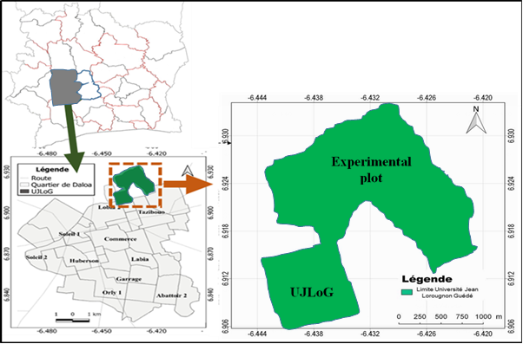

**Fig. 1: Location of the UJLoG experimental plot**

**2.2. Plant material**

Seeds of the pepper (Capsicum chinense) named BIG SUN or SENT BON were used as planting material (***Figure 2***). The choice of this variety was guided by local seed availability and its agronomic characteristics (vigorous plants 70 to 95 cm high, early 90 days after transplanting, attractive fruit shape and color, very fragrant, potential production of 15t/ha (Technisem, 2023).



Photo, N’Ganzoua k René 2023

**Fig. 2 : BIG SUN pepper**

**2.3. Biofertilizers and mineral fertilizers**

The biofertilizers used are composed of mycorrhizal fungi (*Rhizophagus intraradices*) and water fern (*Azolla filiculoides*). The Mycorrhizal fungi grow in Daloa's forests, while aquatic ferns colonize our ponds. These biofertilizers were chosen for their local availability and their ability to improve soil nutrient potential by providing plants with physically assimilable nutrients for growth, development and production. They were sampled, air-dried and ground to powder using a Restch ZM 300 grinder.

The mineral fertilizer used was NPK formula 15-15-15. It was chosen for its immediate beneficial effect on food crop productivity, as recognized by farmers (*Figure 3*).

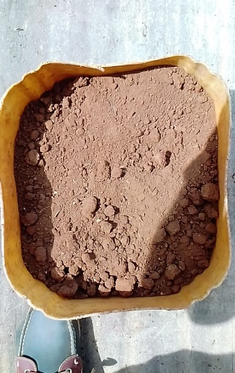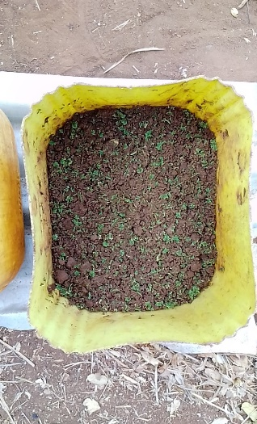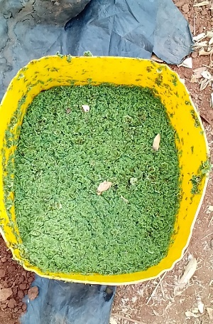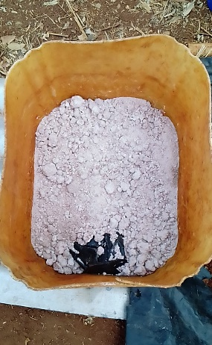

**A**

**B**

**C**

**D**

**Fig. 3: Biofertilizers and NPK**

A = Mycorrhizal fungi (*Rhizophagus intraradices*); B =  *Water fern (Azolla filiculoides)*;

C = *Rhizophagus intraradices* - *Azolla filiculoides*; D = fertilizer NPK

**2.4. Setting up the nursery**

The BIG SUN chilli seeds were placed in nursery trays made of flexible plastic with 36 narrow conical cells, 7.5 cm in diameter and 7 cm deep, filled with potting soil. Sowing was carried out by lightly pressing the chilli seeds one by one into each alveolus containing moistened potting soil. After sowing, the trays were placed under cover with reasonable spacing between them. Regular watering by misting was carried out every day to ensure seed germination and seedling emergence. Vigorous seedlings were obtained 33 days after sowing, and were transplanted directly onto the prepared plot.

**2.5. Site preparation and experimental set-up**

After clearing a 200 m2 (20 m x 10 m) plot of fallow land over 10 years old with a machete and clearing it of plant debris, the entire fallow was ploughed and weeded with a daba, before staking out the boundaries of microplots arranged in randomized complete blocks of two replicates separated by a 1.5 m aisle. In each repetition, five (05) microplots or ridges measuring 2 m x 0.5 m and spaced 1 m apart are distributed. In each ridge, 12 bunches, spaced 0.5 m apart, were planted with pepper seedlings. At transplanting, dried bio-fertilizers, single or mixed, were applied as ground fertilizer at a rate of 150g of crushed *Rhizophagus intraradices* per planting; 50g of well-dried, well-crushed *Azolla filiculoides* per planting; 50g of well-dried mixture in the proportions 50% *Rhizophagus intraradices* and 50% *Azolla filiculoides* per planting; and finally 1.5g NPK in an 8 cm radius around the pepper plant. All these applications are compared with a control without fertilizer, according to the experimentalset-up below (*Figure 4*).

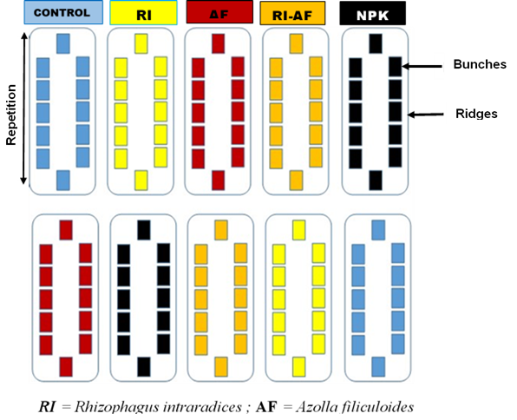

**Fig. 4 : Expérimental set-up**

**2.6. Data collection and analysis**

After transplanting, vegetative and developmental parameters were measured or determined, including collar diameter, number of leaves, plant height, leaf width and length, number of flowers, number and mass of fruits. Fruits were weighed at harvest, three months after transplanting. Data processing was carried out using Statistica 7.1 single-factor classification software for statistical data analysis. The analysis focused on plant growth parameters and plant production parameters. The Newman-Keuls Test was used to classify the different treatments into homogeneous groups, when a significant difference was observed at the 5% threshold.

**3. RESULTS AND DISCUSSION**

**3.1. Results**

**3.1.1. Effect of treatments on chilli plant growth parameters** :

The various agro-morphological parameters measured during chilli plant growth are presented in Table 1. Overall, growth parameters were affected by the different treatments applied. Explicitly, it shows that :

- the number of leaves (NuL) of chilli plants varied between treatments. Statistical analysis revealed a significant difference in leaf number between treatments (P < 0.05). In all five treatments, Azolla filiculoides favoured the emission of several leaves on chilli plants compared with the other treatments (25.82±7.53 cm). In addition, chilli plants that received no treatment (Control) had more leaves than the Rhizophagus intraradices, NPK and RI-AF treatments. However, the Rhizophagus intraradices and NPK treatments showed a moderate increase in the number of leaves on chilli plants (11.48±4.98 cm and 14.26±10.46 cm). As for the RI-AF treatment, it does not have an effective effect on the fruiting of pepper plant leaves (9.22±2.57 cm),

-As for the height of pepper plants (HeP), the results showed that the action of the different treatments was more or less appreciated on the height growth of pepper plants. However, the effect of Azolla filiculoides on the height of chilli plants (18.73±5.25 cm) is quite remarkable. Contrary to the increase in the number of leaves, NPK has a positive effect on the height growth of chillies after Azolla filiculoides,

- Regarding the diameter at the collar (DiC) of chilli plants, each treatment significantly increased the width growth of chilli plants (P < 0.05). Statistical analysis shows that the Azolla filiculoides treatment had a greater effect on pepper plant circumference than the other treatments (5.79 ± 0.93 cm). The other treatments, i.e. Control, Rhizophagus intraradices, RI-AF and NPK, had approximately the same effect on pepper plant circumference,

- As for leaf width (LeW), overall leaf enlargement ranged from 1.79 ± 1.18 cm to 6.28 ± 1.45 cm. Table I shows that the Azolla filiculoides treatment had the greatest effect on leaf widening in chilli plants. After the Azolla filiculoides treatment, the NPK treatment resulted in significant leaf enlargement. The Control, Rhizophagus intraradices and Rhizophagus intraradices-Azolla filiculoides treatments all resulted in leaf enlargement in the same way. However, the statistical data indicate that the Rhizophagus intraradices-Azolla filiculoides combination does not effectively promote leaf enlargement (1.79 ± 1.18 cm),

-leaf length (LeL) was affected by the various treatments applied. Apart from the Rhizophagus intraradices-Azolla filiculoides combination, the separate use of organic fertilizers (Rhizophagus intraradices and Azolla filiculoides) resulted in good leaf elongation. The use of NPK mineral fertilizer also promotes leaf length growth.

T**able 1: Mean values for vegetative parameters of pepper plants according to treatments**

|  |  |  |  |  |  |
| --- | --- | --- | --- | --- | --- |
| **Treatments** | **Vegetative parameters** | | | | |
| **NuL** | **HeP (cm)** | **DiC (mm)** | **LeW (cm)** | **LeL (cm)** |
| Control | 18.1±5.82b | 10.614±3.61a | 3.03±0.87a | 2.97±1.48a | 5.10±2.33a |
| *Rhizophagus int.* | 11.48±4.98ab | 10.88±4.43a | 3.11±1.41a | 2.87±2.01a | 5.09±3.38a |
| *Azolla fili.* | 25.82±7.53c | 18.73±5.25c | 5.79±0.93b | 6.28±1.45c | 9.92±2.49c |
| RI-AF | 9.22±2.57a | 7.73±2.72a | 2.36±0.73a | 1.79±1.18a | 3.33±2.13a |
| NPK | 14.26±10.46ab | 13.52±5.97a | 3.49±1.78a | 3.47±2.40a | 5.82±3.68a |
| *F* | 9.18494 | 20.63867 | 11.79156 | 9.14499 | 7.27906 |
| *P* | 0.000016 | 0.000042 | 0.000001 | 0.000017 | 0.000131 |

*Means in a column followed by the same letter are not significantly different at the 5% level (Newman-Keuls test). NuL= Number of leaves; HeP = Plant height; DiC = Plant collar diameter; LeL = Leaf length; LeW = Leaf width; Rhizophagus int. = Rhizophagus intraradices ; Azolla fili. = Azolla filiculoides ; RI-AF = Rhizophagus intraradices - Azolla filiculoides combination.*

**3.1.2. Effects of treatments on chilli development parameters**

The production parameters developed by the pepper plant and affected by the treatments are shown in Table 2. On analysis, it shows a significant difference in the number of flowers (Nufl), fruits (Nufr) and fruit mass, varying according to treatment at the 5% threshold of the Newman-Keuls test (P < 0.001). More explicitly, the results showed that :

- The average number of flowers (Nufl) opened on pepper plants was significantly (P < 0.05) affected by the different treatments. Rhizophagus intraradices-Azolla filiculoides association treatment shows the lowest number of flowers (2.52±3.02), while the highest value is recorded for Azolla filiculoides plants (17.03±12.09);

- the average number of fruits (Nufr) ranged from 0.7±0.97 to 8.2±5.08. Pepper plants treated with NPK fertilizer produced fewer fruits (0.7±0.97), while those treated with Azolla filiculoides had the best fruiting (8.2±5.08);

- for the average fruit mass of chilli plants according to treatment, the table shows that the different treatments had a highly significant effect on fruit weight (P = 0.0000). It can be seen that the average weight affected by the Azolla filiculoides treatment was the highest (33.60±22.66 g), the Rhizophagus intraradices treatments, the RI-AF association and the Control had intermediate fruit weights, while the NPK treatment showed the lowest average weight (1.78±2.40 g).

**Table 2: Average values for pepper plant production parameters according to treatments**

|  |  |  |  |
| --- | --- | --- | --- |
| **Treatments** | **Production parameters** | | |
| **Nufl** | **Nufr** | **Mass (g)** |
| Control | 7.63±6.43a | 2±1.27a | 5.80±4.17a |
| *Rhizophagus int.* | 6.43±7.61a | 2.1±2.77a | 6.66±8.04a |
| *Azolla fili.* | 17.03±12.09c | 8.2±5.08c | 33.60±22.66c |
| RI-AF | 2.52±3.02a | 0.95±1.14a | 2.44±1.71a |
| NPK | 5.35±6.46a | 0.7±0.97a | 1.78±2.40a |
| *F* | 5.10654 | 12.77071 | 14.69388 |
| *P* | 0.001767 | 0.000001 | 0.000000 |

## *Means in a column followed by the same letter are not significantly different at the 5% level (Newman-Keuls test).*

## *Nufl : Number of flowers ; Nufr : Numberof fruits ; mass : Fruit weight ; Rhizophagus int. = Rhizophagus intraradices ; Azolla fili. = Azolla filiculoides ; RI-AF = Rhizophagus intraradices - Azolla filiculoides combination.*

**3.2. Discussion**

The different treatments on the growth parameters of chilli plants were evaluated. Results showed that leaf number, plant height, collar diameter, leaf width and leaf length varied significantly between treatments. Taking all fertilizers into account, *Azolla filiculoïdes* was the best fertilizer compared with the control, *Rhizophagus intraradices* (RI), NPK and the RI-AF combination. The use of *Azolla filiculoïdes* in the growing medium significantly increased the growth of pepper plants. These results concur with those of Groga *and al.* (2018), who reported that *Azolla filiculoïdes* fertilizers increased plant height and crown diameter. According to Brasset et al (2005), Azolla filiculoides contains a significant quantity of nitrogen and phosphorus elements, which enable it to nourish the plant and thus ensure its growth and development, directly impacting the foliage and productivity of growing plants. *Azolla filiculoides* is home to cyanobacteria of the genus *Anabaena,* which fix nitrogen in the form of nitrate NO3- and transform it into assimilable nitrogen in the form of ammonium NH4+ for the plant (Layzell, 1990). In addition, *Azolla filiculoides* releases minerals gradually, which can ensure that they are available when the plant actually needs them. Nutrients made sufficiently available over time in the soil are efficiently utilized by crop plants Ojetave *and al.* (2011). Also, William (2003), reveals that an excess of nitrogen stimulates increased growth of the aerial part of the plant.

The effects of the treatments on change in the number of leaves, plant collar diameter, plant height growth, leaf width and leaf length growth of pepper plants reveal that the two biological fertilizers (*Rhizophagus intraradices* and *Azolla filiculoides*) used separately had an effect on the growth of pepper plants. These results corroborate those of Zaoui & Brun (2011), who also show that biological fertilizers can increase the efficiency of soil fertility and hence plant growth. According to the work of Hamza (2014), mycorrhizae, by associating with plant roots, facilitate better root development, enabling plants to feed better. Studies by Cardenas (2010) show that plants inoculated with mycorrhizal fungi (Rhizophagus intraradices) are more efficient in utilizing soil nutrients, and thus in plant growth. However, the mycorrhizal fungus-Azolla combination is not beneficial to the growth of chilli plants. This could be explained by the fact that the combination of the two fertilizers inhibits their action. The results obtained in this study are in line with those of Perrin (1985), who showed that the single use of mycorrhizal fungi (*Rhizophagus intraradices*) has an advantage in improving soil fertility and the absorbent surface of the root system, enabling the plant to feed. But when mycorrhizal fungi are combined with another type of fertilizer in a real environment, these advantages disappear (Souna *and al.,* 2010). The good growth of chilli plants observed in the control treatment could be explained by the fact that the soil in the experiment is chemically rich in minerals, which favours good plant growth. According to Schafer (1999), the soil contains elements that are chemically available to the crop in question.

In terms of production parameters, the biofertilizers aquatic fern (*Azolla filiculoides)* and mycorrhizal fungi (*Rhizophagus intraradices*) applied to chilli plants boosted yield more than NPK, RI-AF and Control. The average number of fruits in chilli plants treated with *Azolla filiculoides* was higher than in the other treatments. The same biofertilizer (*Azolla filiculoides*) also enabled chilli plants to have the highest fruit weight. These results are in line with those of Fondio *and al.* (2013), who showed that the application of *Azolla filiculoides* biofertilizers to chilli respectively resulted in a higher number of fruits. This high yield could be justified by the nitrogen supplied in organic form by the *Azolla filiculoides* treatment. Moreover, according to the work of Thomas *and al.* (2004) and Kitabala *and al.*(2016) nitrogen fertilization affects all the parameters contributing to good yield.

The low productivity obtained with NPK treatment could be explained by the rapid release of these fertilizing elements (nitrogen, phosphorus and potassium) into the soil and their immediate availability to the plant. Mineral fertilizer is used to rapidly correct nutrient deficiencies according to the plant's needs and stage of development. However, the rapid mineralization of this treatment leads to the infiltration of minerals into the lower soil horizons, making them inaccessible to roots. Our claims are supported by Giller et al, (2002) and Alvarez (2005), who assert that mineral fertilizers alone cannot maintain long-term soil productivity due to leaching and degradation of soil properties. In addition, the low productivity of NPK mineral fertilizer is also due to the nature of the compound fertilizer (Sarma and al., 2022) and also to the dose applied, which is insufficient during the active phase of chilli fruiting for maximum green chilli production (Kanhaiya and al., 2022). Furthermore, the structure of the unamended soil could be at the root of nitrogen volatilization due to environmental conditions (Bouamara & Zerkak, 2016). This would result in a loss of nitrogen and consequently its negative effect on production.

. Control plants gave satisfactory yields after those fertilized with organic fertilizers (*Rhizophagus intraradices* and *Azolla filiculoides*). This result could be justified by the very structure of the pepper plant. Obiagwu & Odiaka (1995) and Guohua *and al.* (2001) have shown that chillies have indeterminate vegetative growth and a superficial root system with few tap roots. As long as the root zone contains a good water regime and the necessary nutrients in sufficient quantity, it continues to flower, fruit and thus give increasingly high yields.

**4. CONCLUSION**

The study of the effect of biofertilizers, in the case of mycorrhizal fungi (*Rhizophagus intraradices*), and *Azolla filiculoïdes* on the production of chilli pepper (Capsicum chinense) is part of the drive to sustainably improve the productivity of food and vegetable crops through environmentally-friendly practices. The results of the study showed that *Azolla filiculoïdes* promotes good vegetative plant growth, notably in terms of collar diameter, plant height, leaf length, leaf width and leaf number, compared with other fertilizers and control plants. This effect was also observed for production parameters. However, when biofertilizers are combined, the study showed that under certain conditions their effects are limited or even inhibited. Under experimental conditions, the use of *Azolla filiculoïdes* as an organic amendment provided a source of nutrients necessary for the growth and development of chilli plants. It could be an alternative for improving crops and agricultural soil fertility.

**DISCLAIMER (Artificial intelligence)**

Les auteurs déclarent par la présente qu'aucune technologie d'intelligence artificielle générative telle que les grands modèles de langage (ChatGPT, COPILOT, etc.) et les générateurs texte-image n'a été utilisée pendant la rédaction de ce manuscrit.

# REFERENCES

Alvarez R. (2005). A review of nitrogen fertilizer and conservation tillage effects on soil organic carbon storage. Soil Use and Management, 21, 38-52

Barea J.M. (2013). Vesicular-arbuscular mycorrhizae as modifiers of soil fertility. Advances in soil Sciences, 15,1-40

Bouamara K & Zerkak H. (2016).Effect of compost on the evolution of water retention at field capacity of two soil types (clayey and sandy). Master's thesis by Université A. MIRA - Bejaia, Algeria. 50 p with 14 pages appendices.

Brasset T. and Couturier C. (2005). Management and valorization of wood-fired boiler ash. ADEME, 3.

Cardenas R.E. 2010. Does mycorrhization promote access to complex forms of nitrogen? Study on the nutrition of umbrella pine (Pinus pinea). National Center for Scientific Research. François Rabelais University of Tour. 72p.

Dabin B., Leneuf N. and Riou G. (1960). Soil map of Côte d'Ivoire at 1-2,000,000, Institute of Tropical Education and Research, Adiopodoumé (Côte d'Ivoire), ORSTOM, 39p.

FAO (1978). The multiplication of Azolla and its use in agriculture. Soil Bulletin 41, FAO, ROME, Italy, 68p.

FAO (2015). Joint FAO/WHO Food Standards Programme, Codex Committee on Spices and Culinary Herbs, Second Session Proposals for New Work Goa, India, 41p.

Fondio L., Djidji H. A, N'gbesso F.P.M. and Kone D. (2013). Evaluation of nine varieties of tomato (Solanum Lycopersicum L.) in relation to bacterial wilt and productivity in southern Côte d'Ivoire. International Journal of Biological and Chemical Science, 7(3),1078-1086

Giller K.E., Cadisch G. and Palm C. (2002). The NorthSouth divide: Organic wastes or resources of nutrient management. Agronomy 22, 703-709

Groga N., Akedrin T.N., Dro B., Kouadio K.P.F, Akafou D.S., Kouadio Y.J. and Allassane O. (2018). Contribution of biotechnologies to food security: case of organic biofertilizer (Anbaena-Azollae symbiosis, Azolla filiculoides) on the fertilization and development of Oryza sativa (CB-one rice) in Côte d’Ivoire. International Journal of Innovation and Applied Studies, 23, 1155-1165

Guohua X., Wolf S. and Kafkafi U. (2001). Effect of varying nitrogen form and concentration during growing season on sweet pepper flowering and fruit yield. Journal of Plant Nutrition, 24 (7), 1099-1116

Hamza N. (2014). Application of arbuscular mycorrhizae in market gardening: case of watermelon (Citrullus lanatus). Ferhat Abbas Sétif University, 1, 83 p.

Kanhaiya S., Tirunima P., Shankar L.Y., Shashi S.Y. and Nivedita S. (2022). Effect of NPK Levels with Biofertilizers on Growth and Yield of Chilli (*Capsicum annum* L.) in Alluvial Soil of Gwalior, Madhya Pradesh. *International Journal of Plant & Soil Science34(22): 1337-1342*

Kitabala M.A., Tshala U.J, Kalenda M.A, Tshijika I.M. and Mufind K.M. (2016). Effects of different doses of compost on the production and profitability of tomato (Lycopersicon esculentum Mill) in the city of Kolwezi, Lualaba Province, DR Congo. Journal of applied Biosciences, 102, 9669-9679

Layzell D.B. (1990). N2 fixation NO3- reduction and NH4+ assimilation, In: Plant physiology, biochemistry and molecular biology. D.T. Denis and D.H. Teurpin (Eds), Longman scientific & Technical, Singapore, 389-413,

Mulaji K .C. (2011). Use of household bio-waste composts to improve the fertility of acid soils in the province of Kinshasa (Democratic Republic of Congo). Doctoral thesis, University of Liège - Gembloux Agro-Bio Tech, 220.

N’guessan A.H., N’Guessan K.F., Kouassi K.P, Kouamé N.N and. N’Guessan P.W, (2014). Population dynamics of the cocoa stem borer, Eulophonotusmyrmeleon. Felder (Lepidoptera: Cossidae) in the Haut-Sassandra region in Ivory Coast, 9p.

Nelson C.E. (2009). The water relations of vesicular arbuscular mycorrhizal systems. In Safir G. R., ed: Ecophysiology of VA Mycorrhizal Plants, Bocaraton, CRC Press, 41p.

Obiagwu C.J. and Odiaka N.I. (1995).Fertilizer schedule for yield of fresh fluted pumpkin (Telfairia occidentalis) grown in lower Benue river basin of Nigeria. International Journal of Agricultural Science. 65 (2),98-101

Ojetayo A.E., Olaniyi J.O, Akanbi W.B. and Olabiyi T.I. (2011). Effect of fertilizer types on nutritional quality of two cabbage varieties before and after storage. Journal of Applied Soil Ecology, 44, 101-115,

Perrin R. (1985). The ability of mycorrhizae to protect plants against diseases. Panacea or chimera? Annales des sciences forestières, 42 (4), 453-470

Sarma UJ, Baruah JP, Suhrawardy J, Narzary BD, Chakravarty M.( 2004). Effect of various NPK levels on yield and capsaicin content in direct seeded chilli (*Capsicum* *annuum*). Indian J Hill Farming;17(1/2):15-8.

Schafer J.L (1999). Improvement of the Macabo cropping system, Xanthosoma sagittifolium (L) Schott, in Bamiléké country (West Cameroon). Cahier Agriculture 8 (1), 9-20,

Souna F., Chafi A., Chakroune K., Himri1., Bouakka M. and Hakkou A. (2010). Effect of mycorrhization and compost on the growth and protection of date palm (Phoenix dactylifera L.) against Bayoud disease. American-Eurasian Journal of Sustainable agriculture, 4 (2), 260-267

Tacon F., Garbaye J. and Carr. G. (2008).The use of mycorrhizas in tropical forests. In Tress and mycorrhiza, Proceedings of the Asian Seminan, 13-17 April 2008 Kuala Lumpus, Ed. F. S. Ngp, 15-32

Technisem, (2020). Tropicasem, Big Sun pepper. Best choice of variety for export. https://tropicasem.sn/wp-content/uploads/2020/09/BIG-SUN-CR-FR.pdf, accessed October 2023.

Thomas C.D., Cameron A. and Grenn R.E. 2004. Extinction risk from climate e change. Nature, 427 (6970),145-148

William G. (2003). Plant physiology. Edition De Boeck University, rue des minimes 39, B-1000 Brussels, 110-115

Zaoui E. and Brun G. (2011). Fertilization efficiency: a new challenge for modern agriculture. Professional journal of fruit and vegetable sectors; Agriculture of the Maghreb, 139p.

Zro FGB, Guéi AM, Nangah YK, Soro D & Bakayoko S. (2016). Statistical approach to the analysis of the variability and fertility of vegetable soils of Daloa (Côte d’Ivoire). African Journal of Soil Science, 4 (4), 328-338.