Original Research Article
Soil Property Mapping Using Geo-Statistical Techniques: A Case Study of Muzaffarpur District of Bihar
ABSTRACT
Crop production is governed by three factors, viz., soil, inputs and climatic condition. Climatic conditions are beyond human control whereas soil and other inputs can be altered to enhance crop production. An understanding of soil properties is required for sustainable management of soil to reduce soil erosion and enhance soil health and fertility level.The variability of soil properties is needed for agricultural productivity, food safety and environmental modelling. The present study was conducted in soils of Muzaffarpur district in Bihar, India to understand the soil properties mapping using geostatistical Techniques.Soil pH, electrical conductivity (EC), organic carbon(OC), sulphur (S) and zinc (Zn)were measured. Spatial maps of soil properties were prepared using the semivariogram model through kriging techniques.The nugget-sill ratio for pH ranged between 0.25- 0.75, indicating a moderate level of spatial dependence among the variables. For soil properties such as EC, OC, S, and Zn, the nugget-sill ratio was greater than 0.75, indicating a weak level of spatial dependence for these variables. The cross-validation results illustrated the smoothing effect of the spatial prediction. The maps developed by kriging were observed to be superior to assuming mean of observed value for any un-sampled location. These maps may help farmers to adopt need based variable rate of fertilizer application thus optimizing resource utilization.The present study suggests that the geostatistical model can directly reveal the spatial variability of soils.

Key words: Geostatistics, spatial variability, Variogram, Kriging, cross-validation
- INTRODUCTION

Crop production is governed by three factors, viz., soil, inputs and climatic condition. Climatic conditions are beyond human control whereas soil and other inputs can be altered to enhance crop production. The quality of soil and its inherent characteristics in a field helps to determine whether the field is ready for planting a crop or not. An understanding of soil properties is required for sustainable management of soil to reduce soil erosion and enhance soil health and fertility level (Thapa and Yila, 2012; Zhao et al., 2013). Management practices affect the direction and degree of changes in soil properties. The elements of irrigation, fertilization, and soil formation (e.g, soil parent materials) are responsible for spatial variability in soil properties (Davatgar et al., 2012).
If field areas are uniformly managed, there is chance of over application of inputs to high nutrient content areas, and lack input applications to low nutrient content areas with [Abd-Elmabod et al., 2010], thus leading to soil degradation. It will be possible to control the detrimental effects on agricultural production by using specialised soil management practises once the spatial variation of soil nutrients is understood. (Ge et al., 2007). There have been many studies documenting the important role of spatial variability in soil properties for determining the site-specific agricultural management strategies. Farmers and researchers know that crop yields are not uniform across their fields as some locations consistently produce higher or lower yields than the field average. Hence information on spatial variability of soil properties is vital for improving soil management and crop productivity. The spatial distribution of soil properties is considered a fundamental input of any sustainable agricultural planning (Aboelsoud and Abdelrahman, 2017). It also helps in saving effort, time, and cost for any cultivation process. Behera et al., 2015 studied spatial variability of soil properties in various soils under diverse management systems worldwide.
Precision agriculture is one of the most important recent advances for sustainable agricultural development (Far and Rezaei-Moghaddam, 2018). It includes judicious use of crop inputs. Its advantages include improved crop yield or quality, more effective management of agricultural inputs, and increased environmental sustainability (better air, water and soil quality). Knowledge of soil variation has a critical role in achieving the objectives of precision agriculture. Thus, it requires quantitative characterization of variation in soil properties at local level. Availability of accurate and continuous spatial data is important for informed decision making which is difficult and entails an expensive process. Thus, geostatistics play an important role in spatial soil analyses by highlighting variations between different parts of a study area. There have been man studies that preferred geostatistics methods (Kriging) over others (Zhang et al., 2013, Yeneneh et al. 2022, Tagore et al., 2023).
Geostatistics is a branch of statistics that focuses on the analysis and interpretation of data with a geographic component (Webster and Oliver 2007, Nielsen and Wendroth 2003). Geostatistical estimation predicts soil characteristics at un-sampled locations by taking into account the spatial correlation between sampled and estimated points, which reduces associated costs and estimation error. [Saito et al., 2005]. The accuracy of such predictions, however, depends on the quality of information on the soil and crops. Hence, geostatistics help in achieving the target of sustainable agriculture by providing valuable information about soil properties. This information contributes to delineate soil management zones in a region by knowing what, when, where, and how much farming inputs will maintain soil productivity along with minimizing costs as well as decreasing the environmental impact (Shaddad 2018, Bogunovic et al., 2017; Shukla et al., 2017; Abd-Elmabod et al., 2019). Relevant and detailed geo-information is a prerequisite for successful management of natural resources in many applied environmental and geosciences.This study uses both standardand geostatistical methods to determine the spatial relationship between soil nutrients in agricultural potential regions for site-specific soil management practices and predict the soil properties for un-sampled locations. It focusses on the geographical allocation of topsoil properties such as soil pH, electrical conductivity (EC), organic carbon (OC), sulphur (S) and zinc (Zn),
- MATERIALS AND METHODS
2.1 Study area
Muzaffarpur is the one of the districts of North Bihar. It is divided in 16 blocks. Agriculture is the main economic occupation of the district. The area is part of the productive Indo-Genetic Plains and has a comparatively high farming intensity. It comes under the agro-ecological Zone-1 of the state i.e. North-West Alluvial plains zone and is noted for its fertile alluvial soil. soil type is heavy textured sandy loam to clayey, and the climate ranges from dry to moist sub-humid. Muzaffarpur is located at ${25}^{0}{54}^{'}$-${26}^{0}{23}^{'}$N and ${84}^{0}{53}^{'}$-${85}^{0}{45}^{'}$E. Important rivers including as the Bagmati, BurhiGandak, Gandak, and Lakhandei river flow through the Muzaffarpur district. It results in a very fertile land (Alluvial soil). Even three crops are being harvested annually by the farmers.
2.2 Soil Sampling and analysis

A total of 1405 geo-referenced soil samples (Figure1) were collected from various farmers’ field in the study area under All India Coordinated Research Project (AICRP) on Micronutrients running in the department of Soil Science in (Dr. Rajendra Prasad Central Agricultural University (RPCAU), Pusa. The coordinates (latitude and longitude) of data samples were originally in degree decimal (unprotected geographic coordinate system). For analysis, it was converted to Universal Transverse Mercator (UTM) coordinate system with coordinates (Northing and Easting) given in meters.
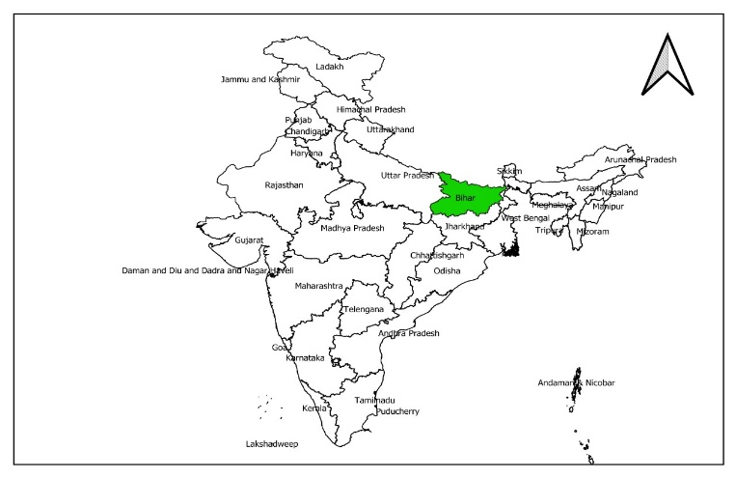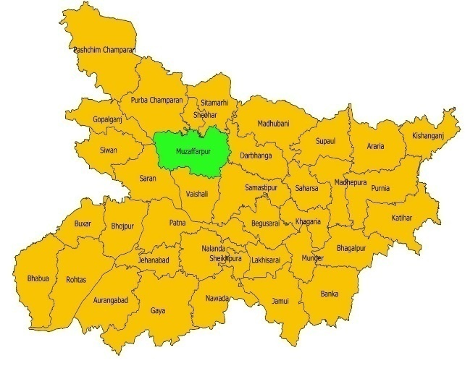
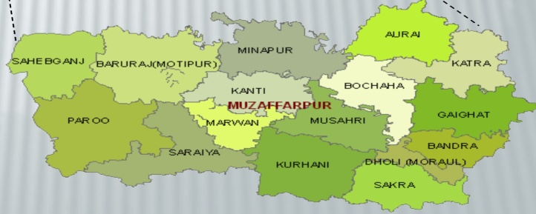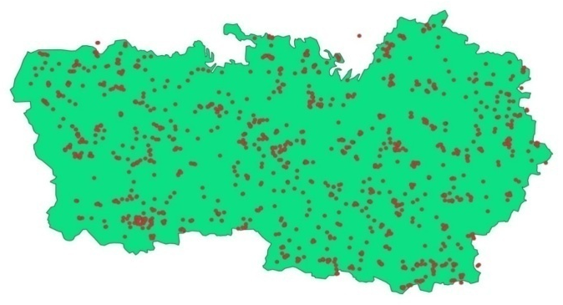
Figure 1: Location and sampling points map of the study area
All the soil samples collected from surface soil (0-15 cm) were allowed to air dry in the shade for a few days, then crushed with a wooden roller and sieved through a sieve of 2 mm size. The processed soil samples were then tested for physical and chemical properties. Potential of hydrogen (pH) was tested by potentiometry with the ratio of 1:2.5 between soil and distilled water. Electrical conductivity(EC) content of the soil samples was determined by conductivity bridge method (Richards 1954). Organic carbon content of the soil samples was determined by the Walkley and Black (1934) wet oxidation method as described by Jackson (1956).Determining the Available Sulphate Content in Soil Samples Using Spectrophotometry (Nair et al., 2020). DTPA (Diethylene triamine penta-acetic acid) extracting solution (0.005 M DTPA + 0.1 M TEA + 0.01M CaCl2 buffered at pH 7.3) in the soil to solution ratio of 1:2 agitated for two hours extraction of available micronutrient cations (Zn) (Lindsay and Novell1978, Sharma et al., 2011) was done. Using an Atomic Absorption Spectrophotometer, the accessible micronutrients in the clear aliquot were determined (Perkin Elmer A Analyst 2009).
  - Statistical Analysis

Exploratory Statistical Analysis
To explain the distribution of the soil properties datasets, statistical measures like mean, Standard deviation, Coefficient of Variation, skewness, and kurtosis were generated for the variables under consideration. To evaluate the variability of the various data sets, the coefficient of variation was applied. The ratio of the third moment about the mean and the third power of the standard deviation is used to express skewness, and the ratio of the fourth moment about the mean and the fourth power of the standard deviation is used to express kurtosis. The asymmetry of a random variable's probability distribution is measured by its skewness. Values of skewness between -1 and +1 indicate a normal distribution. To reduce variance, non-normal data were modified. The altered data were then used to recalculate normality tests, as the asymmetry in the data distribution has a significant impact on the geo-statistical analysis (Fu et al., 2010).
Geo-statistical analysis
The geostatistical analyst of ArcGIS v9.1 software package has been used for modelling the semivariogram and producing the interpolation map using kriging techniques. Toanalyze the spatial correlations among the obtained data points, a semivariogram was calculated.To evaluate soil parameters and their relationship to relief variables and land use features, geostatistical approaches were used.Spatial inconsistency is estimated as a semivariogram which portrays the mean square variability between the two neighbouring sample locations of distance h as shown.
$γ\left(h\right)$=$\frac{1}{2N\left(h\right)}\sum_{i=i}^{N\left(h\right)}{{\left[z\left(x_{i}+h\right)-z\left(x_{i}\right)\right]}^{2}}$
Where$γ\left(h\right)$: magnitude of the lag distance between the two samples locations, N(h) is the number of data pairs within a given class of distance and direction; z is the measured variable at location x_{i}, i = 1, 2 …...
The experimental semivariogram was calculated using all sets of point pairs that were separated by lag h. The variogram describes the spatial correlation of a spatial varying property. variograms have been constructed to assess the degree of spatial continuity of soil characteristics among data points and to estimate a range of spatial dependency for each parameter. In a highly spatially correlated variable, the semi variogram increase from low values near origin to the larger values as h increases. Information obtained through variograms have been used further to calculate sample weighted factors for spatial interpolation by kriging procedure (Isaaks and Srivastava 1989). The soil variable was thought to be strongly spatially dependent or strongly distributed in patches if the ratio was less than 25%; moderately spatially dependent if it was between 26 and 75 %; weakly spatially dependent if it was more than 75 %; and non-spatially correlated if it was % or the slope of the semivariogram was close to zero (pure nugget).The four models applied to the variogram include linear, spherical, gaussian and exponential.
- Linear model
$γ\left(h\right)$= $C_{0}$ + C(h/R)
- Spherical model
$γ\left(h\right)$=$\left\{\begin{aligned}C_{0} h=0 \\ C_{0}+C\left\{\frac{3}{2}\frac{h}{R}-\frac{1}{2}{\left(\frac{h}{R}\right)}^{3}\right\}0<h≤R \\ C_{0}+C h>R \end{aligned}\right.$
- Gaussian model
$γ\left(h\right)$=$\left\{\begin{aligned}C_{0} h=0 \\ C_{0}+C\left\{1-exp\left\{-3{(\frac{h}{R})}^{2}\right\}\right\} h≠0 \\ \end{aligned}\right.$
- Exponential model
$γ\left(h\right)$=$\left\{\begin{aligned}C_{0} h=0 \\ C_{0}+C\left\{1-\exp\left\{\frac{-3h}{R}\right\}\right\} h≠0 \\ \end{aligned}\right.$
where, $γ\left(h\right)=$ theoretical semivariogram $C_{0}$ = Nugget C = Partrial sill $C_{0}+C$=Sill
The variables that define the spatial structure of a soil property are the ratio $C_{0}$/($C_{0}$+C) and the range. The range determines how closely the soil property values are connected with one another, and the $C_{0}$/($C_{0}$+C) relation indicates the fraction in the dependent zone (Parfitt et al.,2009). After being reviewed, the soil data variogram models were utilised to create maps using standard kriging interpolation (Ayoubiet al., 2007).Kriging is a method that uses the initial set of data values and the structural characteristics of the semi-variogram to provide optimum, unbiased estimates of regionalised variables at unsampled locations(Shit et al., 2016).Kriging process is calculated by the following equation.
Z ($x_{0})=\sum_{i=1}^{N}{{}_{i}Z(x_{i})}$
Where $Z(x_{0}$) is the predicted value at position $x_{i}$, $Z(x_{i}$) the known value at sampling site $x_{i}$, ${}_{i}$the weighting coefficient of the measured site and N is the number of sites within the neighborhood searched for the interpolation.
For spatial interpolation of soil attributes, ordinary kriging was chosen as the preferred method since it was more trustworthy than the other interpolation techniques based on the mean squared error, which contrasts the observed values with the anticipated ones. A further benefit of standard kriging is that it reduces the impact of outliers (Triantafiliset al., 2001).The soil nutrient maps were evaluated through cross-validation approach. The accuracy of spatial interpolation or predictive models is critical as it determines the quality of interpolated values. Among three evaluation indices used in this study, mean absolute error (MAE), and mean squared error (MSE) measure the accuracy of prediction, whereas goodness of prediction (G) measures the effectiveness of prediction. The MAE is a measure of the sum of the residuals (e.g., predicted minus observed)
MAE$=\frac{1}{N}\sum_{i=1}^{N}{\left|Z\left(X_{i}\right)-(x_{i})\right|}$
Where, z(x) is the predicted value at location i
MSE=$\frac{1}{N}{\sum_{i=1}^{N}{\left[z\left(X_{i}\right)-z(x_{i})\right]}}^{2}$
G = $\left[1-\frac{\sum_{i=1}^{N}{{\left\{z\left(x_{1}\right)-z(x_{1)}\right\}}^{2}}}{\sum_{i=1}^{N}{{\left\{z\left(x_{1}\right)-z\right\}}^{2}}}\right]×10$0
G measure gives an indication of how effective a prediction might be relative to that which could have been derived from using sample mean alone (Schloeder et al. 2001).

- Results and discussion
Descriptive statistics of soil properties
The descriptive characteristics of soil properties were represented in Table 1. Soil pH value ranged from 6.8-10.30, with a mean 8.36 and CV is 6.37. The spatial distribution of electric conductivity (EC) in the study area has the mean value 0.36 ${dsm}^{-1}$and ranges from 0.09-1.72 ${dsm}^{-1}$where EC< 4 indicates that soil is free from salinity. EC is highest (1.72${dsm}^{-1}$) at the Gaurahiya village in Kurhani block.

Table1:Descriptive statistical analysis of soil properties
Soil parameters  (unit) | Minimum | Maximum | Mean | Standard  Deviation | CV | Kurtosis | Skewness
pH | 6.80 | 10.30 | 8.36 | 0.53 | 6.37 | 0.45 | -0.10
EC (${dsm}^{-1}$) | 0.09 | 1.72 | 0.36 | 0.20 | 55.56 | 9.64 | 2.57
OC (%) | 0.06 | 1.10 | 0.38 | 0.13 | 33.97 | 2.93 | 1.04
S (ppm) | 3.50 | 41.90 | 16.94 | 6.52 | 38.47 | 1.13 | 1.02
Zn (ppm) | 0.06 | 7.48 | 1.76 | 1.38 | 78.44 | 1.21 | 1.29

Organic carbon varies from 0.06 to 1.10%, with a mean 0.38%. The maximum value (1.10%) obtained at Mohabbat village in parooblock. Organic carbon (OC) is observed to have moderate variability across the study area with CV of 33.97%. the Sulphur concentration at sampled locations. The range of sulphur varies from 3.50 to 41.90ppm with an average concentration of 16.94ppm. It exhibited very high variability (38.47%) across the study area.The Zinc concentration at sampled locations. The range of Zn varies from 0.06 to 7.48ppm with an average concentration of 1.76ppm. It exhibited very high variability (78.44%) across the study area.
Correlation analysis
Correlation studies among different soil parameters are given in Table 2. EC and Zn are observed to be significantly and positively correlated with soil pH whereas OC and Sare observed to be significantly and negative correlated. Zn is observed to be significantly and positively correlated with electrical conductivity (EC) while OC is observed to be negative correlated with electrical conductivity(EC). S is positively correlated with electrical conductivity (EC). S is observed to be significantly and positive correlated with OC while Zn is observed to be negative correlated with organic carbon (OC). Zn is observed to be significantly and positive correlated with sulphur(S).
Table 2: Pearson’s correlation coefficients for soil parameters
Variables | pH | EC | OC | S | Zn
Ph | 1
EC | 0.146** | 1
OC | -0.067* | -0.048 | 1
S | -0.081** | 0.048 | 0.158** | 1
Zn | 0.076** | 0.114** | -0.005 | 0.181** | 1
Note: ** p < 0.01; * p<0.05
Table 3: Geostatistical parameters for fitted variogram for soil parameters
Soil parameter | Fitted Model | Nugget  ($C_{0})$ | Sill  $$(C_{0}+C_{1})$$ | Range | Nugget/sill | Spatial dependence | $$R^{2}$$
pH | Spherical | 0.146 | 0.272 | 10.631 | 0.535 | Moderate | 0.71
EC (${dsm}^{-1}$) | Spherical | 0.034 | 0.039 | 36.424 | 0.864 | Weak | 0.63
OC (%) | Spherical | 0.015 | 0.016 | 34.713 | 0.919 | Weak | 0.58
S (ppm) | Spherical | 81.441 | 102.986 | 4.393 | 0.791 | Weak | 0.58
Zn (ppm) | Spherical | 2.175 | 2.420 | 26.36 | 0.898 | Weak | 0.59

Geostatistical analysis
The autocorrelation function results showed variation in the spatial variation of soil properties. Fig.2(a) presents the variogram and fitted model for soil pH. It shows spatial correlation to a greater distance i.e. up to 10.631km. The nugget sill ratio for soil pH is observed to be approximately 53% thus indicating a moderate spatial dependence (Table 3) in the study area. 71% of the variation in ( $R^{2}$) data points are captured by the fitted model thus indicating a good fit.Fig.2(b) presents the variogram and fitted model for electrical conductivity. Electrical conductivity exhibited spatial dependence distance, the range being 36.424 km as shown in Table 3 The nugget sill ratio for EC is observed to be approximately 86.4% thus indicating a weak spatial dependence in the study area. The goodness of fit statistic is observed to be 63%. Fig.2(c) presents the variogram and fitted model for organic carbon. Organic carbon exhibited spatial dependence up 34.713 kms (Table 3). The nugget-sill ratio for OC is observed to be approximately 91% thus indicating a weak spatial dependence in the study area. The goodness of fit statistic is observed to be 58%.Fig.2(d)presents the variogram and fitted model for soil available sulphur. It showed spatial dependence up to 4.393 kms. The nugget sill ratio for soil pH is observed to be approximately 79 % thus indicating a weak spatial dependence (Table 3) in the study area. 58% of the variation in data points is captured by the fitted model thus indicating a good fit.Fig.2(e) presents the variogram and fitted model for soil available Zn. It showed spatial dependence up to 26.36 kms. The nugget sill ratio for soil pH is observed to be approximately 89 % thus indicating a weak spatial dependence (Table 3) in the study area. 59%of the variation in data points is captured by the fitted model thus indicating a goodfit.

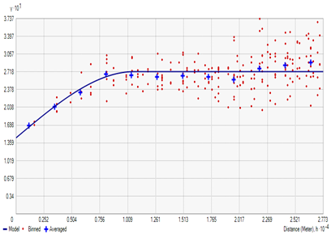  Fig.2(a) Variograms with fitted model for pH | 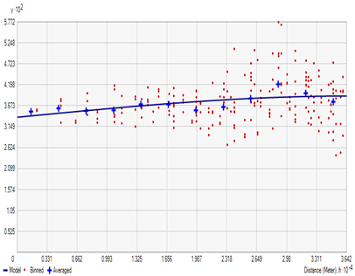  Fig.2(b) Variograms with fitted model for EC
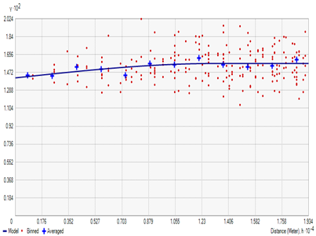  Fig.2(c) Variograms with fitted model for OC | 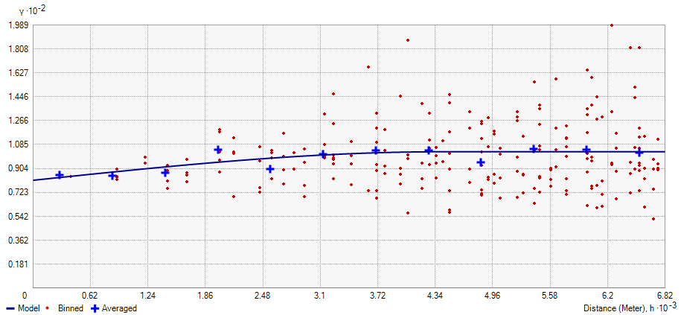  Fig.2(d) Variograms with fitted model for S
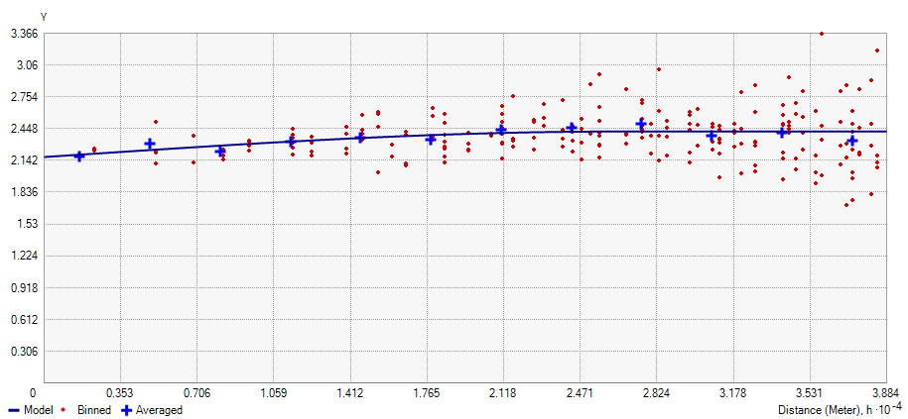
Fig.2(e) Variograms with fitted model for Zn

Spatial Interpolation of Soil Properties
Spatial interpolation of soil properties:

Spatial distribution map and prediction varianceof soil properties like soil pH, OC, EC, S and Zn using ordinary kringing (OK) interpolation methods. The blue dots in spatial distribution map fig.3(a) and predicted variance map fig.3(b) represent the sample locations from where the measurements on soil parameters have been included in the study. The map shows the value of soil pH within a range of 6.80 to 10.30 in Muzaffarpur district. The green-coloured patchy distribution in spatial distribution map shows highest pH while red coloured shows lowest pH.The predicted variance fig.3(b) seemto be low acrossthe whole region thus suggesting a good prediction.From the fig.3(c) of the spatial distribution map of electric conductivity it is revealed that there are small patchy of green coloured shows higher salinity only selected area in western part of Muzaffarpur while major portion of study area don’t have salinity. The blue colour patches in prediction variance map fig.3(d) shows low variance only around the sample location. It is observed to be relatively high at other un-sampled location indicated by colour red.
From the fig.3(e) of the spatial distribution map of organic carbon it is revealed that there are small patchy of green coloured shows higher organic carbon in study area. while major portion of study area have low organic carbon indicated red coloured patches. The prediction variance map fig.3(f) shows low variance only around the sample location indicated by colour blue. It is observed to be relatively high at other un-sampled location indicated by colour red.
From the fig.3(g) of the spatial distribution map of Sulphur it is revealed that there are small patchy of red coloured area shows higher Sulphur in study area. While major portion of study area have low Sulphur indicated green coloured patches. The prediction variance map fig 3(h) shows low to medium variance only around the sample location indicated by colour blue and yellow. It is observed to be relatively high at other un-sampled location indicated by colour red.
From the fig.3(i) of the spatial distribution map of zinc it is revealed that the lot variation is present in the study area. High to low zinc content area is present in the study area. High zinc content is shown by green color while the low zinc content is shown by red color. The prediction variance map fig.3(j) shows low variance only around the sample location indicated by colour blue. It is observed to be relatively high at other un-sampled location indicated by colour red.
Cross-validation
The cross-validation procedure created for testing the semivariogram model tests the OK method at each sample position by neighbouring samples after evaluating approximations with actual values. Present analysis also reports that most of soil properties had low MAE (Table 4), for soil parameters a good indicator of accurate prediction. MSE is also low for all parameter. All of the soil parameters have G values greater than 0 (Table 4), which suggests that using semi variogram parameters for spatial prediction is preferable than assuming the mean of the observed value as the value of the parameter for un-sampled locations.
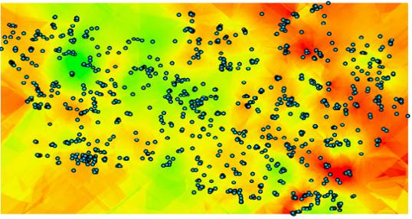  HighLow  Fig 3(a)Spatial distribution map of pH | 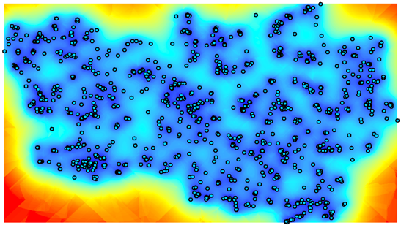  HighLow  Fig 3(b)Prediction variance of pH
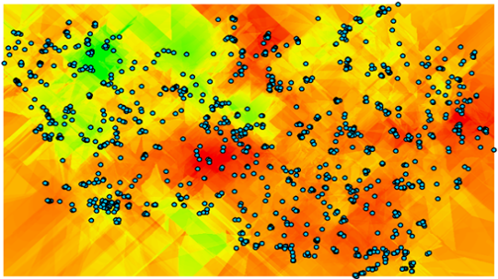  HighLow  Fig 3(c)Spatial distribution map of EC | 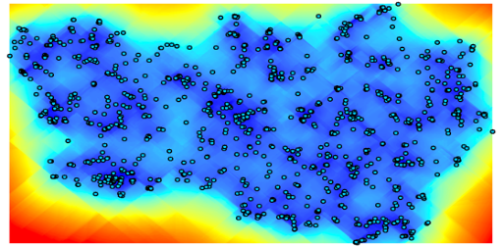  Highlow  Fig 3(d)Prediction variance of EC
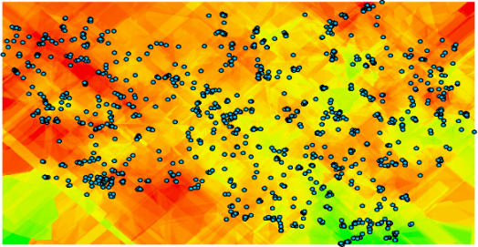  High Low  Fig 3(e)Spatial distribution map of OC | 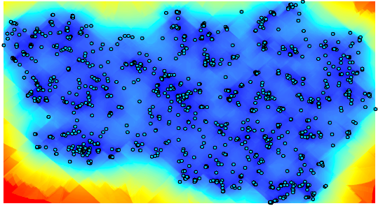  HighLow  Fig 3(f)Prediction variance of OC
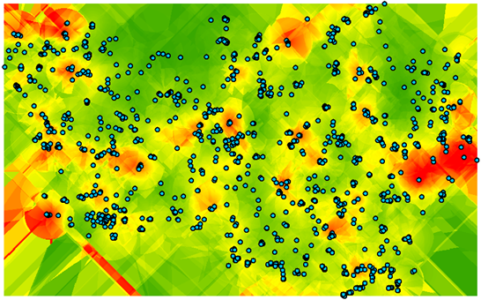  HighLow  Fig 3(g)Spatial distribution map of S | 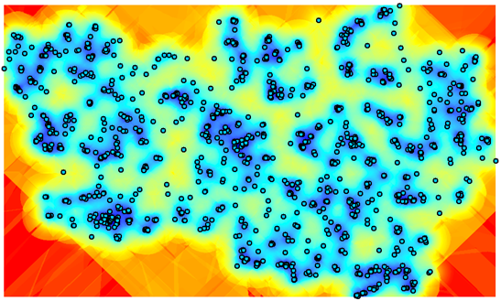  HighLow  Fig 3(h)Prediction variance of S
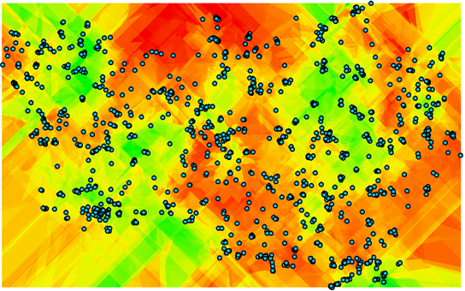  HighLow  Fig 3(i)Spatial distribution map of Zn | 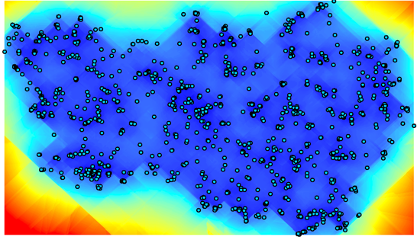  HighLow  Fig 3(j)Prediction variance of Zn

Table 4: Evaluation performance of kriging map of soil parameters through cross-validation

Soil parameter | Mean absolute error | Mean square error | Goodness of prediction (%)
pH | 0.23 | 0.16 | 11.29
EC (${dsm}^{-1}$) | 0.41 | 0.03 | 12.14
OC (%) | 0.94 | 0.01 | 12.35
S (ppm) | 3.44 | 93.51 | 8.92
Zn (ppm) | 0.81 | 2.13 | 11.21

Conclusion
Understanding geographical distribution and precise mapping of soil properties at large scale are very important for soil conservation and environmental modeling. Geographical models were fitted for five soil properties namely soil pH, EC, OC, S and Zn. Semivariogram models for each soil property were identiﬁed using a cross-validation approach. Cross-validation of semivariogram techniques derived through OK portrayed that spatial extrapolation of soil properties was more accurate than assuming the mean of the observed values at any unmeasured location. Finally, five prediction maps were developed using best ﬁt semivariogram models with OK. The outcomes of the present work were valuables by depicting the effect of poor management practices on soil quality parameters. The preponderance of soil properties represented a moderate spatial dependency at short distances in the soil. Finally, the result derived in this study may help farmers.

REFERENCE
- Abd-Elmabod SK, Ali RR, Anaya-Romero M, de la Rosa D (2010) Evaluating soil contamination risks by using MicroLEIS DSS in El-Fayoum Province, Egypt. In2010 2nd International Conference on Chemical, Biological and Environmental Engineering (pp. 1-5). IEEE.
- Abd-Elmabod SK, Fitch AC, Zhang Z, Ali RR, Jones L (2019) Rapid urbanisation threatens fertile agricultural land and soil carbon in the Nile delta. Journal of environmental management 252:109668.
- Aboelsoud HM, AbdelRahman MA (2017) Rapid field technique for soil salinity appraisal in north Nile delta using EM38 through some empirical relations. Int. J. Plant Soil Sci (5):1-9.
- Ayoubi SH, Zamani SM, Khormali F (2007) Spatial variability of some soil properties for site specific farming in northern Iran. International Journal of Plant Production 1(2):225-36.
- Behera SK, Shukla AK (2015) Spatial distribution of surface soil acidity, electrical conductivity, soil organic carbon content and exchangeable potassium, calcium and magnesium in some cropped acid soils of India. Land Degradation & Development (1):71-9.
- Bremner JM, (1996) Nitrogen –total, in: D.L. Sparks (Ed.), Methods of Soil Analysis –Part 3 -Chemical Methods, Soil Science Society of America, American Society of Agronomy, Madison, Wisconsin, USA, pp. 1085–1121.
- Bogunovic I, Pereira P, Brevik EC (2017) Spatial distribution of soil chemical properties in an organic farm in Croatia. Science of the total environment 584:535-45.
- Davatgar N, Neishabouri MR, Sepaskhah AR (2012) Delineation of sitespecific nutrient management zones for a paddy cultivated area based on soil fertility using fuzzy clustering. Geoderma 173:111-8.
- ESRI. (2005) ArcGIS version, 9.1. Redland, USA: The complete Geographic Information Systems, Environmental Systems Research Institute, Inc.
- Far ST, Rezaei-Moghaddam K (2018) Impacts of the precision agricultural technologies in Iran: An analysis experts' perception & their determinants. Information processing in agriculture 5(1):173-84.
- Fu W, Tunney H, Zhang C (2010) Spatial variation of soil nutrients in a dairy farm and its implications for site-specific fertilizer application. Soil and Tillage Research 106(2):185-93.
- Ge F, Zhang J, Su Z, Nie X (2010) Response of changes in soil nutrients to soil erosion on a purple soil of cultivated sloping land. Acta Ecologica Sinica 27(2):459-63.
- Isaaks EH, Srivastava RM (1989) An introduction to applied geostatistics, Oxford University Press, New York, p 500.
- Jackson, M(1958) Soil chemical analysis prentice Hall. Inc, Englewood Cliffs, NJ, 498,183-204.
- Lindsay WL, Norvell W (1978) Development of a DTPA soil test for zinc, iron, manganese, and copper. Soil science society of America journal42(3):421-8.
- Nair R, Jain C, Gakkhar N (2020) Spectrophotometric Determination of Available Sulphate Content in Soil Samples of Jaipur District.
- Nielsen DR, Wendroth O (2003) Spatial and temporal statistics: sampling field soils and their vegetation. Catena Verlag.
- Parfitt JM, Timm LC, Pauletto EA, Sousa RO, Castilhos DD, Ávila CL, Reckziegel NL (2009) Spatial variability of the chemical, physical and biological properties in lowland cultivated with irrigated rice. Revista Brasileira de Ciência do Solo 33:819-30.
- Richards LA, editor (1954) Diagnosis and improvement of saline and alkali soils (No. 60). US Government Printing Office.

- Saito H, McKenna SA, Zimmerman DA, Coburn TC (2005) Geostatistical interpolation of object counts collected from multiple strips transects: Ordinary kriging versus finite domain kriging. Stochastic Environmental Research and Risk Assessment 71-85.
- Schloeder CA, Zimmerman NE, Jacobs MJ (2001) Comparison of methods for interpolating soil properties using limited data. Soil science society of America journal 65(2):470-479.
- Shaddad SM (2018) Geostatistics and proximal soil sensing for sustainable agriculture. Sustainability of Agricultural Environment in Egypt: Part I: Soil-Water-Food Nexus 255-71.
- Sharma P, Shukla MK, Mexal JG (2011) Spatial variability of soil properties in agricultural fields of Southern New Mexico. Soil Science:176(6):288-302.
- Shit PK, Bhunia GS, Maiti R (2016) Spatial analysis of soil properties using GIS based geostatistics models. Modeling Earth Systems and Environment: 2:1-6.
- Shukla AK, Sinha NK, Tiwari PK, Prakash C, Behera SK, Lenka NK, Singh VK, Dwivedi BS, Majumdar K, Kumar A, Srivastava PC (2017) Spatial distribution and management zones for sulphur and micronutrients in Shiwalik Himalayan region of India. Land Degradation & Development (3):959-69.
- Subbiah BV, G.L. Asija (1956) A rapid procedure for the determination of the availablenitrogen in the soil, Curr. Sci. 25, 259–260.
- Tagore GS, Sethy SK, Kulhare PS, Sharma GD (2023) Characterization of spatial Variability of micro nutrients in soils: Classical Vs. Geo-Statistical Approach. Communications in Soil Science and Plant Analysis 54(4):472-87.
- Thapa GB, Yila OM (2012) Farmers' land management practices and status of agricultural land in the Jos Plateau, Nigeria. Land Degradation & Development 23(3):263-77.
- Triantafilis J, Odeh IO, McBratney AB (2001) Five geostatistical models to predict soil salinity from electromagnetic induction data across irrigated cotton. Soil Science Society of America Journal 65(3):869-78.
- Webster R, Oliver MA (2007) Geostatistics for environmental scientists. John Wiley & Sons.
- Yeneneh N, Elias and Feyisa GL (2022) Assessment of the spatial variability of selected soil chemical properties using geostatistical analysis in the north-western highlands of Ethiopia. Acta Agriculturae Scandinavica, Section B — Soil & Plant Science, 72(1): 1009-1019, DOI: 10.1080/09064710.2022.2142658
- Zhang SW, Shen CY, Chen XY, Ye HC, Huang YF, Shuang LA (2013) Spatial interpolation of soil texture using compositional kriging and regression kriging with consideration of the characteristics of compositional data and environment variables. Journal of Integrative Agriculture 12(9):1673-83.
- Zhao G, Mu X, Wen Z, Wang F, Gao P (2013) Soil erosion, conservation, and eco-environment changes in the Loess Plateau of China. Land Degradation & Development 24(5):499-510.

