ASSESSMENT OF THE LEVEL OF DIRECT HEALTH FACILITY FUNDING AWARENESS AND TRAINING AMONG STAFF OF PRIMARY HEALTH CARE FACILITIES IN PLATEAU STATE

Abstract
The study carried out an assessment of the level of direct health facility funding awareness and training among staff of primary health care facilities in Plateau State. Pragmatism research philosophy and descriptive cross-sectional design were used. The population of the study comprised of a total of 974 healthcare centres in Plateau State, out of which 851 are primary health care centres comprising of 1702 administrators and 25,111 staff. The sample of this study was drawn from the population of the study using Krejcie and Morgan technique. A sample of 642 was obtained based on 265 administrators and 377 staff. The study established that most of the primary healthcare created awareness about the direct health facility funding initiative among their staff. Interactive sessions were held in most of the facilities to educate staff about the direct health facility funding initiative, its components, principles and application. Experts in direct health facility funding administration were enlisted by the government and other stakeholders to train principal administrative and financial officers of primary healthcare facilities in Plateau State on how to implement the programme in various primary healthcare centres in Plateau State. The trainings were mainly carried out through workshop and seminars. It is recommended that more training should be provided to administrators of primary health facilities so as to equip them adequately on direct health facility funding administration. This will in turn improve the effectiveness of the direct health facility funding programme in primary healthcare facilities.
Keywords: Awareness, Direct Health Facility Funding and Primary Health Care Centres

1.1 Introduction
Lack of consumer awareness and participation, poor human resource management, lack of fair and sustainable health care financing, inadequate laboratory facilities, the Nigerian state's neo-liberal economic policies, low pay and motivation, a lack of basic infrastructure and equipment, unequal and unjust economic and political relations between Nigeria and the developed world, widespread corruption, very low government spending on health, high out-of-pocket expenditure on health, and the absence of an integrated system for disease prevention, surveillance, and treatment are some of the major factors that affect the health system's overall contribution to Nigeria’s economic growth and advancement (Ibe, 2023). The availability of the PHC's basic health services, particularly in rural regions, may serve as a barometer for gauging a nation's level of health development. Since 1975, Nigeria's national development plans have placed a strong emphasis on providing basic health services to the majority of the population. Despite this, as evidenced by inadequate coordination, disjointed services, a shortage of resources (including supplies and pharmaceuticals), failing infrastructure, unequal resource distribution, and restricted access to care, the nation's healthcare system is still deficient. In summary, patients' medical and non-medical demands are not met by the Nigerian healthcare system (Oyekale, 2017).
Nigeria's goal to rank among the top 20 economies globally by 2030—a goal that is rapidly approaching—may be directly related to the country's efforts to strengthen its human capital in the health sector. The life expectancy of Nigerians has decreased due to the country's failing healthcare system. Any nation's main driver of growth and development is acknowledged to be the health sector. Notwithstanding the health sector's commendable inputs to economic expansion, Nigeria's healthcare system has witnessed a number of upheavals that have adversely undone the advancements made at different points in time. With some of Africa's worst poverty-related health indices, poverty is pervasive and on the rise in Nigeria.
Direct facility financing changes how money is received, managed, and reported for the provision of healthcare services by health institutions and their larger provider and community networks (Barroy & Coulibaly, 2021). The strategy positions healthcare institutions as independent management organizations that can directly accept a variety of funding sources and independently oversee them to satisfy the needs of recipients. Successful implementation of direct facility financing increases responsibility, fosters an environment where facilities are more likely to react favorably to financial rewards, and helps health facilities run more efficiently and fairly.
According to Katshin and Kutzin (2017), direct facility finance is guided by three principles: facility autonomy, which allows facilities to decide how best to use finances in order to provide the best possible services; output-based payments, wherein resources are distributed to facilities according to service outputs as opposed to rigid line items or inputs; and sound facility financial management, in which facilities have the systems and capacity to carry out appropriate financial management, accounting and reporting practices. Direct facility financing is not to be considered a single project or scheme but rather a collection of qualities and behaviors that can assist the advancement of universal health coverage (UHC) and boost national health systems.
2.1 Literature Review
Waweru (2023) asserts that the DHFF may increase the amount of funds accessible at medical facilities for health items. According to this survey, Health Basket monies (HBFs) are the biggest source of funding, making up an average of 52% of all monies allocated to healthcare facilities. More than 90% of all health commodity expenditures at healthcare facilities are accounted for by HSBF, insurance funds (such as the National Health Insurance Funds (NHIF) and the Improved Community Health Funds (iCHF) reimbursements), user fees, and the Drug Revolving Fund, a central government funding source for health commodities. Nonetheless, user fees have increased by around three times over the last two fiscal years, making them a substantial source of income. The reported rise in out-of-pocket expenses may be related to Tanzania's and other developing nations' diminishing health development aid. This necessitates coordinated measures to provide financial security by lowering household health care costs in the direction of universal health coverage.
Tsofa and Goodman (2021) observed that careful administration and supervision are necessary to boost accountability, increase spending efficiency, and track how spending affects health. According to guidelines created by the Tanzanian government, at least 50% of complementary funds—that is, money received at the facility level from user fees and insurance funds (NHIF, iCHF)—should be used to buy medical supplies.
According to a report by Smoke (2023), health institutions often spend 20% of their available health budget on health commodities, as opposed to the minimum 50% that is recommended by guidelines. Considering the poor compliance with cost-sharing guidelines, more research is necessary to determine if the guidelines' provisions are enough or whether the rules do not take into account other health facility priorities. The implementation of health financing reform mechanisms is hampered by the absence of a well-tailored governance structure, according to a recent study conducted in Tanzania by McCollum and Otiso (2021). Among the obstacles noted were a lack of openness and a lack of strong accountability for the money received by healthcare providers. Analyzing the trends by health service level reveals similar patterns. While financing for health centers and dispensaries varies, it is continuously rising at the hospital level.
The results of Mulaka and Bugakile's (2022) study suggest that DHFF may be able to increase the amount of funds available for health items at medical centers. According to this survey, Health Basket monies (HBFs) are the biggest source of funding, making up an average of 52% of all monies allocated to healthcare facilities. More than 90% of all health commodity expenditures at healthcare facilities are accounted for by HSBF, insurance funds (such as the National Health Insurance Funds (NHIF) and the Improved Community Health Funds (iCHF) reimbursements), user fees, and the Drug Revolving Fund, a central government funding source for health commodities. Yet, user fees have increased by around three times over the last two fiscal years, making them a substantial source of income. One step toward achieving universal health coverage is reducing an excessive dependence on out-of-pocket funding. The reported rise in out-of-pocket expenses may be related to Tanzania's and other developing nations' diminishing health development aid (Alsop, 2022). This necessitates coordinated measures to provide financial security by lowering household health care costs in the direction of universal health coverage.
3.1 Research Methodology
The study adopted the pragmatism research philosophy and descriptive cross-sectional design. The population for this study therefore was made up of staff and management of primary health care facilities in centres in Plateau State. There are a total of 974 healthcare centres in Plateau State, out of which 851 are primary health care centres with a population of 1702 administrators (chairmen and secretaries) and 25,111 staff. The sample of this study was drawn from the population of the study using Krejcie and Morgan technique. This provided a sample of 265 administrators and 377 staff giving a total sample size of 642 respondents.
The samples for the study were selected through stratified random sampling. The researcher first stratified the population into service providers and administrators. The researcher then employed the simple random sampling technique, specifically the ballot system in drawing the sample size of administrators and staff. Through the ballot system, a sample of 265 administrators and 377 staff were selected, giving a total sample size of 642 respondents. The researcher’s choice of the stratified random sampling technique is to accord each individual in the population has an equal chance of being included in the sample. Data was collected using interviews and questionnaires.
4.1 Data Analysis and Discussions
The data analysis and discussions of findings are encompassed in this section as guided by the qualitative and quantitative data collected for the study.
4.2 Data Analysis
The analysis of data was based on qualitative and quantitative analyses. The various sub statements /questions based on the research question and underlying objective guided the analysis of data.
4.2.1 Qualitative Analysis
The qualitative analysis was aimed at providing answers to the following research question:
What is the level of Direct Health Facility Funding Awareness and Training among Staff of Primary Healthcare Facilities in Plateau State?
The study sought to examine the extent to which awareness and training provided to staff of primary healthcare facilities in Plateau on direct health facility funding management. To answer this question, the qualitative data obtained from the stakeholders were analyzed using thematic analysis. The analysis involved identifying and discussing relevant themes based on the codes generated. Two major themes were identified, namely: provision of awareness and provision of training

4.2.1.1 Provision of Awareness
The thematic analysis of the interview conducted with the respondents from primary healthcare facilities in Plateau State revealed that 90% of the respondents interviewed mentioned the theme of awareness provision and perceived a significant level of awareness provision on direct health facility funding to primary healthcare staff and management in Plateau State. To further buttress this assertion, respondent number one who was interviewed on 25th of October, 2024 has this to say:
“The management of primary healthcare facilities has done much to educate and create awareness among primary healthcare staff on direct health facility funding”
To corroborate this response, one of the management staff at the primary health facility in Plateau State who was interviewed on 25th of October, 2024 has this to say:
“we took our time to educate all the administrative staff and other staff of the facility on the nature of direct health facility funding, its functionalities, principles and application and this has help to make the adaptation of DHFF easier into the primary healthcare facilities”.
Another principal officer of one of the primary healthcare facility who was interviewed on the 26th of October, 2024 made the following submissions:
“when DHFF was introduced to our facility, we organised seminars and workshops to educate our staff on how the programme functions. This helped to improve the standard of implementation and smooth takeover of DHFF in our facility”.
4.2.1.2 Provision of Training
One of the themes that emerged from the thematic analysis of research question one is training. Over 65% of the respondents stated that several training programmes were provided to educate the staff of primary health facilities on the Direct Health Facility Funding programme. To buttress this point, one of the principals of the primary healthcare facilities who was interviewed on the 26th October, 2024 has this to say:
“when DHFF was introduced, the government sent experts to train principal administrative and financial officers on how to implement the programme in various primary healthcare centres in Plateau State”.
To further buttress this point, a principal officer in one of the primary healthcare facilities who was interviewed on 26th of October, 2024 has this to say:
“seminars and workshops were organised to train the staff of the primary healthcare facilities on DHFF and how the programme can be implemented in the healthcare facility”.
Another principal officer of one of the primary healthcare facility who was interviewed on the 26th of October, 2024 corroborated this account by asserting that:
“when the direct health facility funding was introduced to our facility, the first one month was dedicated to awareness and training programme on how to properly propagate the funding programme and ensure effective implementation and take-off in the health facility.”.
To further buttress this point, a principal officer in one of the health facilities who was interviewed on the 26th of October, 2024 made the following postulations:
“training was a key aspect of the introduction of the Direct Health Facility Funding programme because it was relatively new to the staff of the facility at the time of the introduction. Awareness and familiarization programmes were carried out for all the staff while the principal staff involved like the administrative and financial staff were subjected to intense training programmes for almost four weeks to ensure that they have proper knowledge and understanding of how they programme functions and how it should be properly implemented and integrated into the primary healthcare facility management process”.
However, another respondent who was interviewed on 26th of October, 2024 made the following assertions:
“Though awareness campaign and training were carried out in all the primary healthcare facilities in Plateau State, the duration of the training was too short and therefore inadequate for the DHFF programme to be properly implemented in the in the primary healthcare facilities in Plateau State”
4.3 Quantitative Analysis
The quantitative analysis was based on descriptive analysis which was informed by the following research question:
What is the level of Direct Health Facility Funding Awareness and Training among Staff of Primary Healthcare Facilities in Plateau State?
Q1: Are you aware of the Basic Health Care Funding (Direct Health Facility Funding (DHFF) initiative?
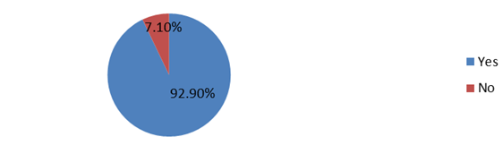
Figure 1: Awareness of Direct Health Facility Funding Initiatives among staff of Primary Healthcare Facilities in Plateau State
Figure 1 shows the responses obtained from the respondents on awareness of Direct Health Facility Funding Initiatives among staff of Primary Healthcare Facilities in Plateau State. 92.9% agreed that they are aware of the Direct Health Facility Funding initiative while 7.1% said they are not aware of such initiative.
Q2: If yes, how did you first learn about Basic Health Care Funding?
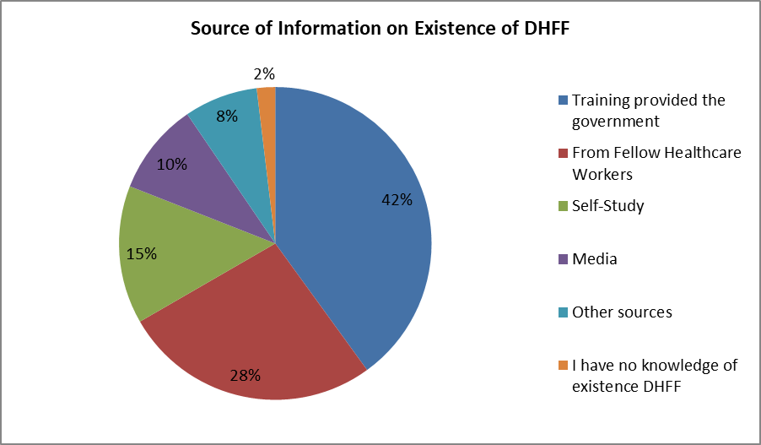
Figure 2: Source of Information about DHFF among Primary Healthcare Facility Staff in Plateau State.
Figure 2 shows the responses of the respondents on the sources of information on the existence of Direct Healthcare Facility Funding. 42% of the respondents said they learnt about direct healthcare facility funding through training provided by the government, 28% of the respondents said they learnt about direct healthcare facility funding through fellow healthcare workers, 15% said they learnt about it through self-study, 10% said they learnt about it through the media, 8% said they learnt about the existence of direct healthcare facility funding through other sources while 2% of the respondents said they had no knowledge of the existence of direct healthcare facility funding.
Q.3 Have you received training on Basic Healthcare Facility Funding and how to utilise funds at the facility?
The respondents were asked if they have received training on basis healthcare facility funding and how to utilize the funds at their facility. The responses were analyzed and presented in Figure 3.
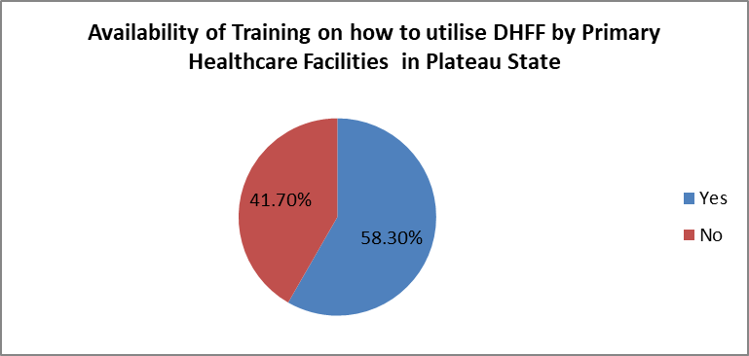
Figure 3: Availability of Training on how to utilise DHFF by Primary Healthcare Facilities in Plateau State
Figure 3 shows the responses collected on the availability of training on how to utilise direct health facility funding by the primary healthcare centres in Plateau State. 58.3% of the respondents agreed that training was organised for staff of the primary healthcare facilities in Plateau State on how to utilise the direct facility funding initiative while 41.70% disagreed
Q.4: How will you rate the adequacy of training received?
The respondents were asked how they will rate the adequacy of training received. The responses obtained were analyzed and documented in Figure 4.
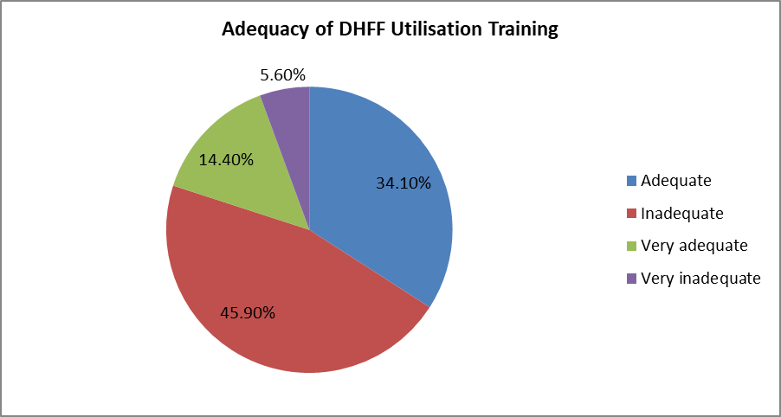
Figure 4: Adequacy of Training Received
Figure 4 shows the responses of the respondents on the adequacy of Direct Health Facility Funding Training given to staff and management of primary healthcare facilities in Plateau State. From the analysis of data, 14.4% of the respondents said the training they received on DHFF is very adequate, 34.1% of the respondents said it is adequate, 45.9% of the respondents said it is inadequate while 5.6% said it is very inadequate.
4.3 Discussions of Findings
Research question one sought to investigate the level of Direct Health Facility Funding Awareness and Training among Staff of Primary Healthcare Facilities in Plateau State. The purpose of this research question was to examine the extent to which awareness and training provided to staff of primary healthcare facilities in Plateau on direct health facility funding management. To answer this question, both quantitative and qualitative data were analysed. From the thematic analysis of qualitative data collected through interview, it was discovered that most of the primary healthcare created awareness about the DHFF initiative among their staff. Interactive sessions were held in most of the facilities to educate staff about the DHFF initiative, its components, principles and application. This finding is in agreement with the findings of Brinkerhoff and Bossert (2021) who discovered that the direct health facility funding received warmth welcome from almost all the facilities it was introduced thereby leading to widespread awareness about the programme in the facilities.

Similarly, on the issue of training, the stakeholders in some of the primary healthcare facilities in Plateau State reported that experts in DHFF were enlisted by the government and other stakeholders to train principal administrative and financial officers of primary healthcare facilities in Plateau State on how to implement the programme in various primary healthcare centres in Plateau State. These training were mainly carried out through workshop and seminars. However, majority of the respondents interviewed lamented that the duration of the training was too short and therefore inadequate for the DHFF programme to be properly implemented in the primary healthcare facilities in Plateau State. This finding is in conformity with the findings Rifkin and Alma (2018) who discovered that training programmes majorly in forms of workshops and seminars were carried out to train staff of the primary healthcare facilities on how the DHFF programme functions and how it should be implemented in the facilities.

Furthermore, from the results of the quantitative analysis, majority of the respondents (92.9%) reported a high level of awareness on the Direct Health Facility Funding programme and outlined their major source of awareness to include training programmes, colleagues, self-study and the media. This finding is in tandem with the findings of Okpora (2020) who discovered a high level of awareness on the existence of DHFF among facilities’ staff.

Similarly, the results of the quantitative analysis revealed that only 58.3% of the respondents have received training on the Direct Health Facility Funding programme. Also, 45.9% of respondents rated the training they received on DHFF as inadequate. This figure reveals that the number of staff that have received training on DHFF initiative is barely above average. This finding is in consonance with the findings of Maluka and Hurtiq (2021) who discovered that training given to staff of the primary healthcare facilities is inadequate to ensure effective implementation of the DHFF programme in the primary healthcare facilities.
5.1 Conclusion and Recommendations
Most of the primary healthcare created awareness about the DHFF initiative among their staff. Interactive sessions were held in most of the facilities to educate staff about the DHFF initiative, its components, principles and application. Experts in DHFF administration were enlisted by the government and other stakeholders to train principal administrative and financial officers of primary healthcare facilities in Plateau State on how to implement the programme in various primary healthcare centres in Plateau State.

The trainings were mainly carried out through workshop and seminars. However, the duration of the training was too short and therefore inadequate for the Direct Health Facility Funding programme to be properly implemented in most of the primary healthcare facilities in Plateau State. It is recommended that more training should be provided to administrators of primary health facilities as this will equip them adequately on Direct Health Facility Funding Administration. This will lead to improvements in the effectiveness of the Direct Health Facility Funding programme in primary healthcare facilities.

Disclaimer (Artificial intelligence)
Option 1:
Author(s) hereby declare that NO generative AI technologies such as Large Language Models (ChatGPT, COPILOT, etc.) and text-to-image generators have been used during the writing or editing of this manuscript.
Option 2:
Author(s) hereby declare that generative AI technologies such as Large Language Models, etc. have been used during the writing or editing of manuscripts. This explanation will include the name, version, model, and source of the generative AI technology and as well as all input prompts provided to the generative AI technology
Details of the AI usage are given below:
1.
2.
3.

REFERENCES
- Alsop, M. A. (2022). Strengthening the informed consent process in international health research through community engagement: the KEMRI-Welcome trust research programmen experience. PLoS Medicine. 8(9), 116-156
- Barroy, R. A. & Coulibaly, O. A. (2021). Direct health facility financing in Tanzania. Process evaluation: Phone Survey. International Journal Health Policy Management, 2(1):15-26.
- Ibe, K. C. (2023). Establishing a sustainable ward health system in Nigeria: are key implementers well informed? Journal of Community Medical Health Education 2(7), 164.-170.
- Katshin, W. M. & Kutzin, J. M. (2017). High-quality health systems in the Sustainable Development Goals era: time for a revolution. Lancet Global Health Journal, 2(3), 20-30.
- Maluka, M. A. & Hurtiq, T. W. (2021). Does pay-for-performance improve the quality of health care? Annals of International Medical Research, 2(4):265–72.
- McCollum, R. G. & Otiso, P. W. (2021). Misunderstandings and ambiguities in strategic purchasing in low-and middle-income countries. International Journal of Health Planning and Management, 5(5):100-121.
- Mulaka, M. A. & Bugakile, G. A. (2022). Financing incidence analysis of household out-of- pocket spending for healthcare in Nigeria. International Journal of Health Planning Management, 2(2):174–185.
- Okpora, W. A. (2020). Conceptual Framework for comparing Healthcare politics and Policy. New York: Wesley Press
- Oyekale, A. W. (2017). Barriers to and facilitators of implementing complex workplace dietary interventions: Process evaluation results of a cluster controlled trial. BMC Health Service Research, 5(7), 100-121.

- Rifkin, B. A. & Alma, T. R. (2018). Performance-Based Financing to Strengthen the Health System in Benin: Challenging the Mainstream Approach”. International Journal of Health Policy Management 7(2), 111-120.
- Tsofa, G. S. & Goodman, J. H. (2021). Primary health care is the first step to building strong families, stable communities and productive nations. https://www.usaid.gov/global-health/health-systems-innovation/health- systems/primary-health-care.
- Smoke, H. A. (2023). Quality of primary healthcare in developing countries: recent experiences & future directions. International Journal of Quality Healthcare, 2(2):131–139,
- Waweru, V. B. (2023). Does performance-based financing increase value for money in low- and middle- income countries? A systematic review. Health Economic Review 2(2),110-120.

