**Isolation and Characterisation of Docosanoic Acid, Quercetin, and Vitexin from (*Dennettia tripetala* Bak. f.) Root and Stem Bark and Their *In Vivo* Anti-inflammatory and Analgesic Activities**

**Abstract**

*Dennettia tripetala* Baker f. (Annonaceae) is widely used in African traditional medicine for managing diabetes, inflammation, pain, and other ailments due to its diverse phytochemical composition. This study aimed to isolate and characterize bioactive compounds from the root and stem bark of *D. tripetala* and evaluate their anti-inflammatory and analgesic properties through *in vivo* models. The plant materials were extracted using 70% aqueous methanol, and the extracts were partitioned into n-hexane, dichloromethane, ethyl acetate, and n-butanol fractions. Compounds were isolated through open-column chromatography and thin layer chromatography and characterized using 1H NMR, 13C NMR, and FTIR spectroscopy. Ethical approval was obtained from the University of Uyo Health Research Ethics Committee for animal studies. Anti-inflammatory activity was evaluated using egg albumin and xylene-induced oedema models, while analgesic activity was assessed using formalin-induced paw licking and hot plate tests, respectively. Data were analyzed using one-way ANOVA, with significance level set at p<0.05.  The dichloromethane and ethyl acetate fractions exhibited the highest anti-inflammatory activity, with the root extract at 447 mg/kg significantly inhibiting egg albumin-induced oedema by 81% at 5 hours, compared to 77% for aspirin. In the xylene-induced oedema model, the root extract at 670 mg/kg achieved 76% inhibition, comparable to the standard drug. Analgesic effects were most pronounced in the formalin test, where the root extract reduced paw licking duration by 85% in the late phase. Isolated compounds, including quercetin, vitexin, and docosanoic - nonacosyl ester acid were carried out using spectroscopic methods. These findings validate the traditional use of *D. tripetala* and highlight its potential as a source of natural therapeutic agents.

**Keywords**: *Dennettia tripetala,* anti-inflammatory, analgesic, phytochemical properties, isolation and characterization.

**Introduction**

All over the world, there is a growing demand for medicinal plants. Beyond treating diseases, people are increasingly turning to these plants as natural alternatives to synthetic drugs, which may pose health risks due to their numerous side effects. Most plants are used in our everyday cooking as herbs, spices, seasonings, teas, enemas, and preservatives and sometimes as insecticides. Studies have been carried out to verify the efficacy of some medicinal plants in the prevention and treatment of diseases (Soforowa *et al*., 2013; Adesina and Johnny, 2021).

*Dennettia tripetala* is utilized in traditional medicine in Africa for the treatment of various ailments including inflammation and pains, diabetes and cancer. This broad bioactivity has been reported to be due to the diverse group of phytoconstituents in the plant including annonaceous acetogenins, as well as huge deposits of flavonoids and alkaloids (Enema, *et al*., 2024).

Reports have shown that there is an increasing trend of chronic diseases like cancer, inflammations and pains and growing resistance to conventional pharmaceuticals like nonsteroidal anti-inflammatory drugs (NSAIDs) and opioids as well as the side effects often associated with conventional treatments, this emphasizes the urgent need for novel therapeutic agents derived from natural sources (Eseyin *et al*., 2017; Tsai *et al*., 2019; Pahwa *et al*., 2021).

This study focused on isolating and identifying bioactive compounds from the root and stem bark of *D. tripetala* and assessing the anti-inflammatory and pain-relieving effects of the various extracts and fractions using *in vivo* models.

**Materials and Methods**

**Plant Collection and Identification**

The stem bark and root of *D. tripetala* were collected from Itak Ikot Akap village in Ikono Local Government Area, Akwa Ibom State, Nigeria. The plant was identified by Dr. Imeh Imoh Johnny of the Department of Pharmacognosy and Natural Medicine, Faculty of Pharmacy, University of Uyo, Uyo and authenticated by Prof. Mrs. M.E Bassey of the Department of Botany and Ecological Studies, Faculty of Biological Sciences, University of Uyo, Uyo and a voucher specimen deposited in the herbarium. The voucher number UUPH A2(i) was assigned.

**Extraction and Partitioning**

The stem bark and root of *D. tripetala* were air-dried and coarsely powdered with a hammer mill. About 3 kg of each of the powdered plant materials were extracted in 70% aqueous methanol. The extract was dried, weighed, and stored in a refrigerator. The dried extracts were then partitioned using various solvents including n-hexane, dichloromethane, ethyl acetate, and n-butanol, aqueous, respectively to obtain the respective fractions after drying.

**Acute Toxicity Testing (LD50)**

An Acute toxicity study was done using the method of Lorke (1983) with slight modifications. Mice were randomized and divided into groups of three mice per group. The animals were starved of food 24 hours before the experiment. The aqueous methanol extract was administered intraperitoneally (IP) in a dose range of 100-3000 mg/kg body weights.

**Egg Albumin-Induced Oedema**

In this model, albino mice of either sex were randomized and divided into five groups of five animals each. Group one animals were pretreated with distilled water (10 mL/kg), groups 2 to 4 were pretreated with 224 mg/kg, 447 mg/kg and 670 mg/kg for the root and 324 mg/kg, 648 mg/kg and 972 mg/kg for the stem bark extract, respectively, thirty (30) minutes before the induction of edema with fresh egg albumin while group five animals received the standard drug acetylsalicylic acid (ASA 100 mg/kg). The linear circumference of the injected paws was assessed with vernier calipers before and at thirty-minute intervals for 5 hours following the administration of egg albumin (Okokon *et al.,* 2008).

**Formalin-Induced Paw Licking in Mice**

The procedure followed was similar to that previously described by Hunskaar and Hole (1987) and Nwafor and Okwuasaba (2003). Twenty microliters (20 µL) of 2.5% formalin solution (0.9% formaldehyde) was made up in phosphate buffer solution (PBS concentration: NaCI, 137 mM; KCI, 2.7 mM and phosphate buffer, 10 mM) and injected into the undersurface of the right hind paw subcutaneously. The time that the animals spent licking the injected paw was taken as a measure of pain with the first phase of response at 5 minutes and second phase (15-30 minutes) after formalin injection. Thirty minutes before the challenge with buffered formalin, albino mice were randomly divided into five groups of 5 animals in each group. Animals in group 1 were pretreated with distilled water (10 ml/kg), groups 2-4 extract (224 - 972 mg/kg, IP), and group 5 ASA (100 mg/k, IP). The fractions were also evaluated at a dose of 447 - 648 mg/kg with sodium carbonate as control.

**Thermally-Induced Pain in Mice**

The effect of the extract on the hot plate was investigated in adult mice. The procedure was basically similar to the one earlier described by Vaz *et al*. (1996). Adult mice were put into a glass beaker of 50cm diameter and placed on a hot plate that was kept at 45 ± 1 °C. The time(s) between being placed on the hot plate and licking the paws were recorded. Animals were grouped as described above and pretreated the same 30 minutes prior to being placed on the hot plate.

**Xylene-Induced Ear Oedema**

Male and female albino mice were randomly divided into six groups of six animals in each group. Two (2) drops of xylene topically applied to the inner surface portion of the right ear and allowed for 15 minutes was used to induce Inflammation (Mbagwu *et al*., 2007). Group 1 received distilled water (10 ml/kg; ip), animals in groups 2-4 were made to receive 30-90 mg/kg of extract intraperitoneally, group 5 animals received dexamethasone and group 6 received extract plus dexamethasone (4 mg/kg, ip) 30 minutes before induction of inflammation. The animals were sacrificed using chloroform anesthesia and their left and right ears cut off. The difference in weights indicated the degree of xylene-induced oedema (Tjolsen *et al*., 1992). The fractions were assessed at a dose of 447 - 648 mg/kg with sodium carbonate as control.

**Isolation of AZ**

About 26 g of the dichloromethane extract from the root was subjected to open-column chromatography. Silica gel (60–200 mesh) was used as the stationary phase, while a solvent gradient starting from 100% n-hexane to mixtures with dichloromethane, ethyl acetate, and methanol was used as the mobile phase. This resulted in the collection of 116 fractions from the first column. Each fraction was analyzed using Thin Layer Chromatography (TLC) with solvent systems such as n-hexane and dichloromethane in ratios of 1:9, 3:7, 2:8, and 50:50. Fractions with similar TLC profiles was bulked into 44Q (2724 mg), A30 (1968 mg), 84D (478 mg), and 93B (1102 mg).

Further purification of A30 (1968 mg) was conducted using open-column chromatography with a similar gradient of n-hexane, dichloromethane, and ethyl acetate. TLC analysis of subfractions resulted in bulking into A1(320 mg), A2 (546 mg), A3 (418 mg), A4 (288 mg), and A5 (244 mg), respectively due to similar TLC profiles. Sample A2 (546 mg) was further subjected to open-column chromatography. The fractions were bulked into A2X (164 mg), A2Y (163 mg), A2Q (87 mg), and A2M (52 mg), respectively. Sample A2Y (163 mg) was further purified using preparative TLC. Two bands were scraped and labelled as A100 (69 mg) and AZ (9 mg). The fractions were analyzed using TLC with various solvent systems, namely: different ratios of n-hexane and dichloromethane (1:9, 3:7, 2:8, 50:50), 100% dichloromethane, and dichloromethane with ethyl acetate (9:1 and 7:2). A single spot consistently appeared on the TLC plate, confirming purity. AZ was weighed, and its final weight was recorded as 9 mg.

### **Isolation of B40**

Bulked fraction 93B (1102 mg), obtained from the initial 116 fractions was further subjected to purification through open-column chromatography. The elution began with 100% n-hexane and progressed to dichloromethane, ethyl acetate, and methanol in varying proportions. TLC analysis of the collected subfractions indicated the presence of distinct groups, which were bulked into AQ (310 mg), B1(286 mg), and B20 (372 mg), respectively based on their chemical profiles. The B1 (286 mg) fraction was then subjected to preparative TLC using 100% dichloromethane as the solvent system. The dried sample was dissolved, spotted on preparative TLC plates, and developed in a TLC tank. Two bands were scraped; B40 (17 mg) and B12 (174 mg), respectively. Consistent TLC results under various solvent systems (e.g., n-hexane and dichloromethane in ratios 1:9, 3:7, 2:8, and 50:50) confirmed the purity of B40. The weight of the compound was recorded as 17 mg.

**Isolation of OX2**

Sample B20 (322 mg) another subfraction of 93B was further purified using preparative TLC with 100% dichloromethane as the solvent system. The dried B20 sample was dissolved, applied to the preparative TLC plate, and developed in the TLC tank. After visualization under UV light, three distinct bands were identified and scraped into separate beakers: OX2 (15 mg), O1 (208 mg), and O2 (66 mg), respectively. Different solvent systems including n-hexane and dichloromethane in ratios like 1:9, 3:7, 2:8, and 50:50, as well as dichloromethane and ethyl acetate in ratios such as 9:1 and 7:2 were used in analyzing fraction OX2. This analysis confirmed the presence of a single spot, indicating purity. OX2 was then weighed, with a final weight of 15 mg.

**Results and Discussion**

**Yield of Extract and Fractions**

The total yield of extracts was 102 g for the stem bark methanol extract and 138 g for the root extract of *D. tripetala.* The yield of fractions and percentage yield are presented in Table 1. The dichloromethane fraction of the stem bark had the most yield and was closely followed by the aqueous fraction of the root extract. The n-hexane fraction of the root and stem bark extracts had the least yield when compared with other fractions, respectively.

**Table 1: Yield of Fractions**

|  |  |  |  |  |
| --- | --- | --- | --- | --- |
| **Fractions** | **Root (g)** | **Percentage Yield (%)** | **Stem bark (g)** | **Percentage Yield (%)** |
| n-hexane | 13.2 | 10.0 | 9.7 | 10.0 |
| Dichloromethane | 26.2 | 19.0 | 22.5 | 22.0 |
| Ethyl acetate | 18.0 | 13.0 | 14.0 | 14.0 |
| n-butanol | 13.4 | 10.0 | 17.3 | 17.0 |
| Aqueous | 28.1 | 20.0 | 19.8 | 19.0 |

**Egg Albumin Anti-inflammatory Study of EPFR and EPFS**

The results of the egg albumin anti-inflammatory effects are displayed in Table 2. The result showed that the root extract at 447 mg/kg (the median) dose had more activity when compared to other doses tested. This was closely followed by the high dose of the root extract at 670 mg/kg. The result showed that the inhibition of egg albumin-induced oedema was not dose-dependent.

**Table 2: Egg albumin anti-inflammatory analysis of EPFR and EPFS**

|  |  |  |  |  |  |  |  |
| --- | --- | --- | --- | --- | --- | --- | --- |
|  | **Mean oedema volume (ml) at different hours** | | | | | | |
| **Treatment (mg/kg)** | **0h** | **0.5h** | **1h** | **2h** | **3h** | **4h** | **5h** |
| N. Saline 10 | 2.236 ± 0.110ns | 1.596 ± 0.058* | 1.138 ± 0.076ns | 0.990 ± 0.055ns | 0.854 ± 0.028ns | 0.756 ± 0.036ns | 0.674 ± 0.013ns |
| ASA 100 | 2.12 ± 0.072ns | 1.172 ± 0.045* | 0.786 ± 0.044* | 0.506 ± 0.051* | 0.438 ± 0.041* | 0.292 ± 0.023* | 0.172 ± 0.048* |
| EPFR 224 | 2.152 ± 0.082ns | 1.048 ± 0.089* | 0.932 ± 0.051ns | 0.814 ± 0.041ns | 0.704 ± 0.015* | 0.32 ±  0.050* | 0.198 ± 0.047* |
| EPFR 447 | 2.274 ± 0.010ns | 0.876 ± 0.102* | 0.588 ± 0.011* | 0.436 ± 0.095* | 0.32 ± 0.032* | 0.21 ±  0.019* | 0.126 ± 0.037* |
| EPFR 670 | 2.146 ± 0.051ns | 1.012 ± 0.071* | 0.704 ± 0.096* | 0.474 ± 0.059* | 0.314 ± 0.037* | 0.228 ± 0.039* | 0.138 ± 0.026* |
| EPFS 324 | 2.266 ± 0.044ns | 1.228 ± 0.010* | 0.712 ± 0.039* | 0.552 ± 0.037* | 0.428 ± 0.031* | 0.308 ± 0.049* | 0.186 ± 0.043* |
| EPFS 648 | 2.152 ± 0.036ns | 1.092 ± 0.047* | 0.816 ± 0.044* | 0.572 ± 0.039* | 0.434 ± 0.041* | 0.336 ± 0.018* | 0.248 ± 0.034* |
| EPFS 972 | 2.296 ± 0.066ns | 1.102 ± 0. 041* | 0.882 ± 0.038ns | 0.708 ± 0.028* | 0.576 ± 0.038* | 0.392 ± 0.030* | 0.256 ± 0.213* |

Where;

ASA - Aspirin

EPFR - *D. tripetala* root extract

EPFS - *D. tripetala* stem bark extract

**Formalin induced Paw Edema of EPFS and EPFR**

Table 3 shows the result of the formalin-induced paw oedema in mice. Like that of the egg albumin-induced oedema in mice, the result also showed that the median dose of the root extract of *D. tripetala* had the most activity at most time intervals followed by the high dose at 670 mg/kg.

**Table 3: Effects of EPFS and EPFR on formalin induced paw oedema**

|  |  |  |  |  |  |  |
| --- | --- | --- | --- | --- | --- | --- |
|  | **Time (min)** | | | | | |
| **Treatment (mg/kg)** | **5min** | **10min** | **15min** | **20min** | **25min** | **30min** |
| Saline 10 | 22.2 ± 1.281ns | 13.2 ± 1.594ns | 8.2 ± 0.583ns | 7.2 ± 1.594ns | 5.2 ± 1.393ns | 5.2 ± 0.663ns |
| ASA 100 | 11.6 ± 0.748* | 6.6 ± 1.166ns | 3.8 ± 0.583* | 2.2 ± 0.8ns | 1.8 ± 0.489ns | 1.2 ± 0.583* |
| EPFS 324 | 12.2 ± 3.087* | 12.6 ± 0.812ns | 6.4 ± 0.872ns | 4 ± 0.834ns | 4.6 ± 0.937ns | 2.8 ± 0.860ns |
| EPFS 648 | 15.0 ± 1.949* | 12.2 ± 0.374ns | 4.2 ± 1.356ns | 4.6 ± 1.029ns | 2.6 ± 0.678ns | 2.6 ± 0.812ns |
| EPFS 972 | 14.0 ± 1.581* | 4.2 ± 0.734* | 4.4 ± 2.227* | 2.2 ± 0.663ns | 2.4 ± 0.871ns | 1.2 ± 0.583* |
| EPFR 224 | 12.0 ± 1.581* | 5.0 ± 1.761* | 3.0 ± 0.547* | 2.0 ± 0.837ns | 2 ± 0.774ns | 1.4 ± 0.748* |
| EPFR 447 | 10.4 ± 0.60* | 4.0 ± 0.775* | 2.0 ± 0.447* | 0.6 ± 0.40* | 0.6 ± 0.244ns | 0.8 ± 0.489* |
| EPFR 671 | 8.2 ± 0.860* | 1.8 ± 0.969* | 2.2 ± 0.8* | 1.0 ± 0.548* | 0.2 ± 0.2ns | 0.6 ± 0.245* |

**Hot Plate Analgesia Comparison of EPFS and EPFR**

The hot plate analgesia result is also displayed in Table 4. The result showed that the median dose was the most active dose followed by the high dose at 670 mg/kg. When compared to the stem bark extract, the root had more activity. This result also shows that the activity is not dose-dependent which may be attributed to the pharmacokinetics properties of the extracts.

**Table 4: Hot plate analgesia comparison of extracts (EPFS and EPFR)**

|  |  |
| --- | --- |
| **Treatment (mg/kg)** | **Time (s)** |
| Saline 10 | 13.17 ± 2.522* |
| ASA 100 | 29.00 ± 0.365* |
| EPFS 324 | 23.83 ± 1.046* |
| EPFS 648 | 25.33 ± 1.406* |
| EPFS 972 | 26.5 ± 1.176* |
| EPFR 224 | 27.67 ± 0.615* |
| EPFR 447 | 29.33 ± 0.333* |
| EPFR 670 | 29.00 ± 0.516* |

**Hot Plate Analgesia Comparison of Fractions of EPFR**

The result of the hot plate analgesia comparisons of the fractions in Table 5 also showed that the DCM fraction had the most activity and was closely followed by the ethyl acetate fraction and with the n-butanol fraction low dose showing the least activity.

**Table 5: Hot plate analgesia comparison of fractions of EPFR**

|  |  |
| --- | --- |
| **Treatment (mg/kg)** | **Time (s)** |
| Saline (10 | 13.17 ± 2.522* |
| ASA (100 | 29.00 ± 0.365* |
| EPFR NH 224 | 25.17 ± 0.601* |
| EPFR NH 447 | 26.17 ± 0.601* |
| EPFR NH 671 | 27.50 ± 0.428* |
| EPFR DCM 224 | 28.67 ± 0.333* |
| EPFR DC M 447 | 29.00 ± 0.365* |
| EPFR DCM 671 | 29.83 ± 0.167* |
| EPFR ETH 224 | 27.83 ± 0.543* |
| EPFR ETH 447 | 27.67 ± 0.667* |
| EPFR ETH 671 | 28.00 ± 0.447* |
| EPFR nBT 224 | 22.00 ± 0.183* |
| EPFR nBT 447 | 24.00 ± 1.183* |
| EPFR nBT 671 | 24.67 ± 1.256* |
| EPFR AQ 224 | 25.50 ± 0.671* |
| EPFR AQ 447 | 24.83 ± 1.327* |
| EPFR AQ 671 | 25.33 ± 1.330* |

**Xylene-induced Edema Inhibition of EPFS and EPFR**

Table 6 shows that the xylene-induced oedema inhibition also showed that the root extract was more active at various doses than the stem bark extract.

**Table 6: Xylene anti-inflammatory edema inhibition of**

**EPFS and EPFR**

|  |  |  |
| --- | --- | --- |
| **Xylene anti-inflammatory oedema inhibition** | | |
| **Treatment (mg/kg)** | **% oedema degree** | **% oedema inhibition** |
| ASA 100 | 8.89 ± 1.4396* | 77 |
| EPFS 324 | 16.3 ± 3.413* | 58 |
| EPFS 648 | 11.88 ± 2.457* | 69 |
| EPFS 972 | 10.25 ± 1.892* | 73 |
| EPFR 224 | 12.81 ± 3.355* | 67 |
| EPFR 447 | 9.928 ± 1.733* | 74 |
| EPFR 670 | 9.144 ± 1.807* | 76 |

**Xylene-induced Anti-inflammatory Inhibition of Fractions EPFR**

The fractions of the stem bark and root bark extract were also compared in Table 7. The result revealed that the dichloromethane fraction had the most activity followed by the ETH fraction.

**Table 7: Xylene anti-inflammatory oedema inhibition of fractions EPFR**

|  |  |  |
| --- | --- | --- |
| **Xylene anti-inflammatory oedema inhibition** | | |
| **Treatment (mg/kg)** | **% oedema degree** | **% oedema inhibition** |
| ASA 100 | 8.89 ± 1.483* | 77 |
| NH 224 | 32 ± 4.231ns | 18 |
| NH 447 | 22.12 ± 5.51 ns | 43 |
| NH 670 | 22.25 ± 3.478 ns | 43 |
| DCM 224 | 10.14 ± 1.235* | 74 |
| DCM 447 | 10.53 ± 2.628* | 73 |
| DCM 670 | 14.02 ± 3.021* | 64 |
| ETH 224 | 23.51 ± 7.705 ns | 17 |
| ETH 447 | 16.97 ± 2.302* | 56 |
| ETH 670 | 18.29 ± 5.434* | 53 |
| nBT 224 | 38.22 ± 6.271 ns | 2 |
| nBT 447 | 34.38 ± 2.421 ns | 12 |
| nBT 670 | 14.89 ± 2.292* | 61 |
| AQ 224 | 27.2 ± 6.594 ns | 30 |
| AQ 447 | 18.71 ± 2.945* | 51 |
| AQ 670 | 29.48 ± 5.59 ns | 25 |

Where;

NH - n-hexane fraction

DCM - dichloromethane fraction

ETH - Ethyl acetate fraction

nBT - n-butanol fraction

AQ - Aqueous fraction

**1H NMR Analysis of Sample AZ**

Table 8 and Figure 1, reveal the 1H NMR spectrum peaks of sample AZ corresponding to CH₂ groups near oxygen (3.98 ppm) and carbonyl (2.22 ppm) groups, along with signals for a long alkyl chain (1.54, 1.18 ppm) and terminal methyl groups (0.81 ppm), suggesting the presence of ester linkages and a fatty acid-like structure.

**Table 8: 1H NMR spectra information of sample AZ**

|  |  |  |  |  |  |
| --- | --- | --- | --- | --- | --- |
| **Peak (δ ppm)** | **Multiplicity (J, Hz)** | **Number of Protons (Sample AZ)** | **Literature Peaks (NCBI, 2024)** | **Functional Group/Assignment** | **Significant Peaks for Identification** |
| 3.98 | t (J = 6.7 Hz) | 2H | 3.9–4.0 t | -CH₂ next to oxygen (R-CH₂-O) | Yes, indicates CH₂ near oxygen |
| 2.22 | t (J = 7.5 Hz) | 2H | 2.2–2.3 t | -CH₂ next to carbonyl (R-CH₂-C=O) | Yes, indicates CH₂ near carbonyl |
| 1.54 | p (J = 6.8 Hz) | 5H | 1.5–1.6 p | Methylene groups (-CH₂-) | No, general alkyl chain peaks |
| 1.18 | m | 88H | 1.1–1.2 m | Long alkyl chain (-CH₂-) | No, indicates long alkyl chain |
| 0.81 | t (J = 6.8 Hz) | 6H | 0.8–0.9 t | Terminal methyl (-CH₃) | No, typical methyl group signal |

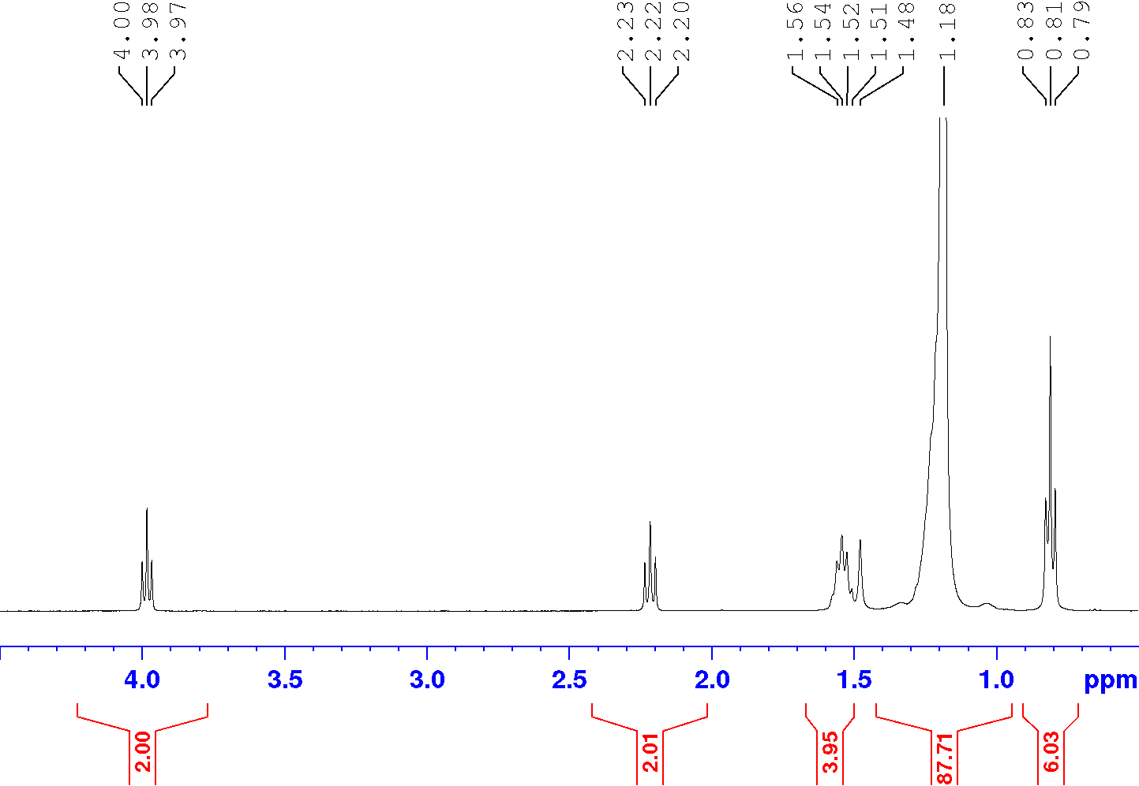

**Figure 1: 1H NMR spectra of AZ**

**13C NMR Analysis of Sample AZ**

Figure 2 and Table 9 show that the 13C NMR spectrum displays a strong carbonyl signal at 174.0 ppm, confirming an ester or carboxyl group, along with peaks for CH₂ groups attached to oxygen (64.4 ppm) and carbonyl (34.4 ppm), and several signals from long alkyl chains (29.7–14.1 ppm), further supporting an esterified long-chain fatty structure.

**Table 9: 13C NMR spectra data for sample AZ**

|  |  |  |  |  |
| --- | --- | --- | --- | --- |
| **Peak (δ ppm)** | **Sample AZ** | **Literature Peaks (NCBI, 2024)** | **Functional Group/Assignment** | **Significant Peaks for Identification** |
| 174.03 | Present | 170–175 | Carbonyl group (C=O, ester or acid) | Yes, indicates ester/carboxyl group |
| 64.41 | Present | 60–65 | -CH₂ next to oxygen (R-CH₂-O) | Yes, confirms CH₂ near oxygen |
| 34.44 | Present | 34–35 | -CH₂ near carbonyl group | Yes, confirms CH₂ next to C=O |
| 31.94 | Present | 31–32 | Alkyl chain (-CH₂-) | No, part of long alkyl chain |
| 29.71–29.18 | Present (multiple peaks) | 29–30 | Long alkyl chain (-CH₂-) | No, typical alkyl chain signals |
| 28.67 | Present | 28–29 | Alkyl chain (-CH₂-) | No, typical alkyl chain signals |
| 25.96 | Present | 25–26 | Alkyl chain (-CH₂-) | No, typical alkyl chain signals |
| 25.05 | Present | 24–25 | Alkyl chain (-CH₂-) | No, typical alkyl chain signals |
| 22.7 | Present | 22–23 | Terminal methyl (-CH₃) | No, typical methyl group |
| 14.12 | Present | 14–15 | Terminal methyl (-CH₃) | No, typical methyl group |

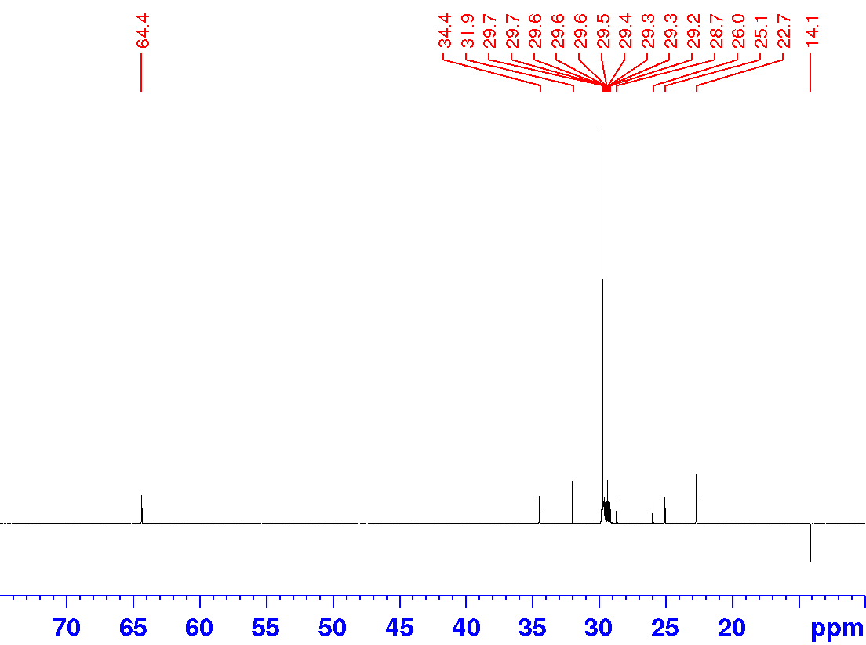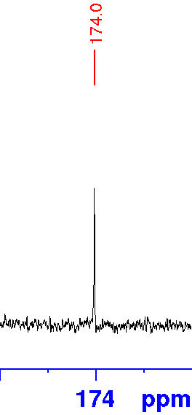

**Figure 2: 13C NMR spectra of AZ**

**FTIR Analysis of Sample AZ**

The FTIR spectrum of sample AZ is presented in Figure 3 and Table 10 showing the functional groups. A sharp C=O stretch at 1736 cm⁻¹ (confirming ester carbonyl groups), and a C-O stretch at 1048 cm⁻¹, consistent with ester or ether linkages, pointing to ester functionalities and possible hydroxyl groups in the structure.

**Table 10: FTIR spectra data for sample AZ**

|  |  |  |  |  |
| --- | --- | --- | --- | --- |
| **Peak (cm⁻¹)** | **Sample AZ** | **Literature Peaks (NCBI, 2024)** | **Functional Group/Assignment** | **Significant Peaks for Identification** |
| 1736 | Present | 1720–1750 | C=O stretch (Carbonyl in esters) | Yes, confirms ester carbonyl (C=O) group |
| 1457 | Present | 1450–1470 | CH₂ bending (Alkyl chains) | No, typical CH₂ bending |
| 1048 | Present | 1050–1150 | C-O stretch (Alcohols, ethers, esters) | Yes, confirms C-O bond in esters or ethers |



**Figure 3: FTIR spectra of AZ**

Combined analysis of ¹H NMR, ¹³C NMR, and FTIR spectra identifies the compound as an ester of a long-chain fatty acid. Characteristic spectral features, including signals for a long alkyl chain and ester carbonyl (C=O) groups, confirm its saturated nature. ¹H NMR integrals suggest the presence of approximately 48 methylene (-CH₂-) units, two terminal methyl groups, and a carbonyl group, corresponding to a molecular formula of C₅₁H₁₀₂O₂. The data indicate that the compound is likely docosanoic acid ester (nonacosyl ester), known for its applications in cosmetics and pharmaceuticals, as well as its anti-inflammatory and antioxidant properties.



**Figure 4: Chemical structure of sample AZ (Docosanoic acid, nonacosyl ester)**

**1H NMR Analysis of Sample B40**

The 1H NMR spectrum of sample B40 shows signals for several hydroxyl (O-H) groups between δ 9.3 and 12.5 ppm, indicating the presence of multiple hydroxyl groups in the structure. The aromatic protons, which are part of an aromatic ring, are seen between δ 6.19 and 7.68 ppm. These signals confirm that the compound has both hydroxyl groups and a benzene ring, consistent with the structure of quercetin. The signals are presented in Table 11.

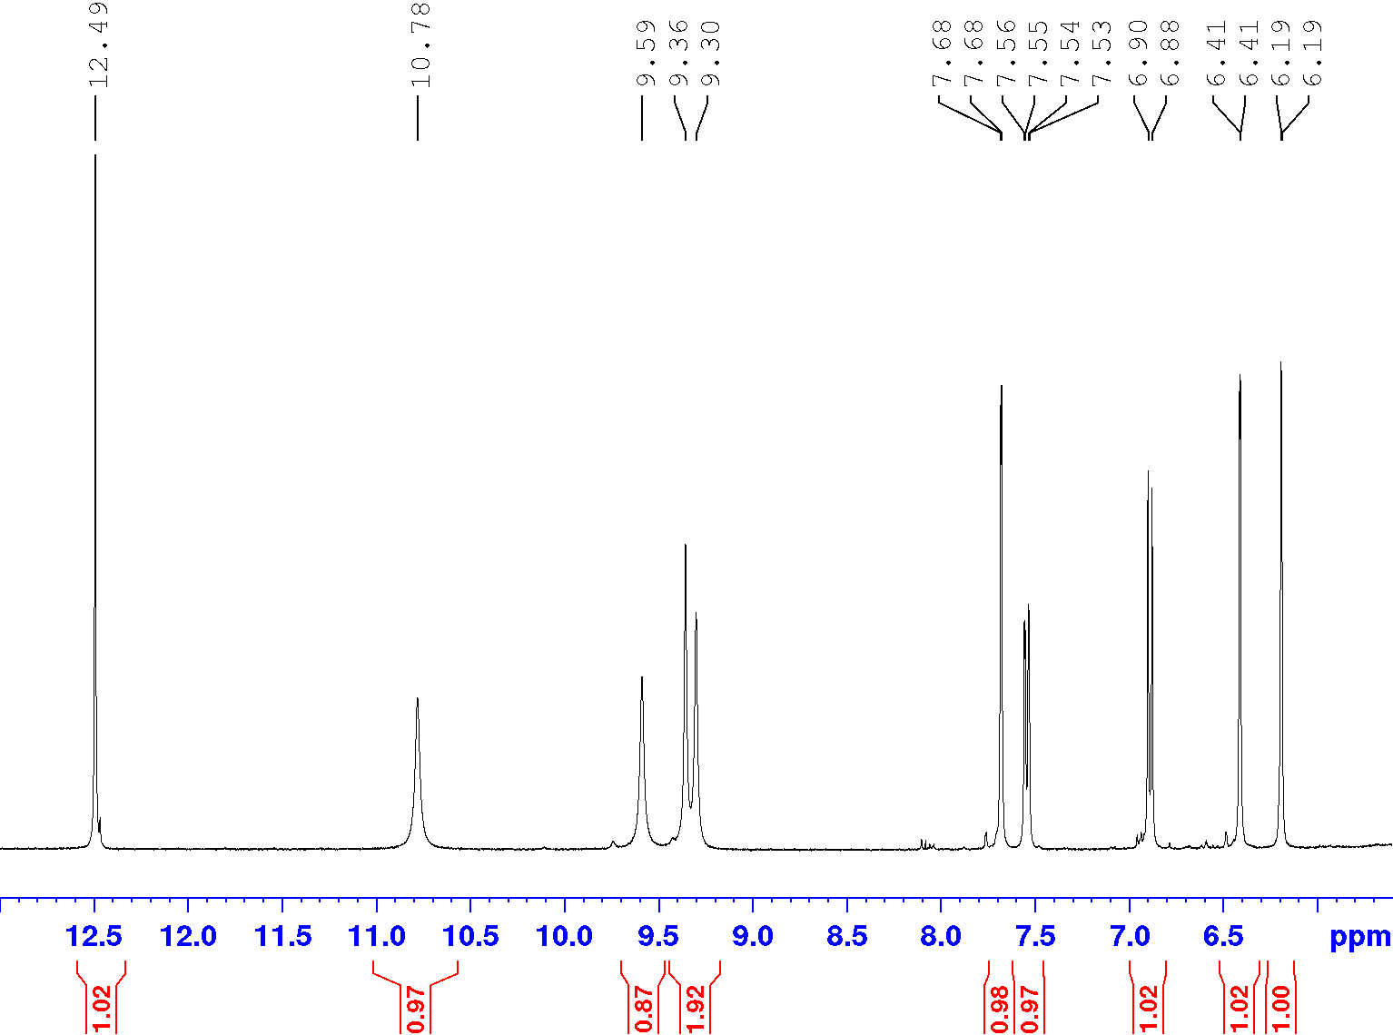

**Figure 5: 1H NMR spectra of B40**

**Table 11: Data from 1H NMR spectra of sample B40**

|  |  |  |  |  |  |
| --- | --- | --- | --- | --- | --- |
| **Peak (δ ppm)** | **Multiplicity** | **Number of Protons (Sample B40)** | **Literature Peaks (Wishart *et al*., 2008)** | **Functional Group/Assignment** | **Significant Peaks for Identification** |
| 12.5 | s | -OH | 12.5 s | Hydroxyl proton (-OH) | Yes, confirms hydroxyl group |
| 10.8 | b | -OH | 10.5–11.0 b | Hydroxyl proton (-OH) | Yes, confirms hydroxyl group |
| 9.6 | b | -OH | 9.5–9.7 b | Hydroxyl proton (-OH) | Yes, confirms hydroxyl group |
| 9.4 | b | -OH | 9.3–9.5 b | Hydroxyl proton (-OH) | Yes, confirms hydroxyl group |
| 9.3 | b | -OH | 9.2–9.4 b | Hydroxyl proton (-OH) | Yes, confirms hydroxyl group |
| 7.68 | d (J = 2 Hz) | 1H | 7.6–7.7 d | Aromatic proton (C-H) | Yes, confirms aromatic ring |
| 7.54 | dd (J = 8.5, 2 Hz) | 1H | 7.5–7.6 dd | Aromatic proton (C-H) | Yes, confirms aromatic ring |
| 6.89 | d (J = 8.5 Hz) | 1H | 6.8–7.0 d | Aromatic proton (C-H) | Yes, confirms aromatic ring |
| 6.41 | d (J = 1.8 Hz) | 1H | 6.3–6.5 d | Aromatic proton (C-H) | Yes, confirms aromatic ring |
| 6.19 | d (J = 1.8 Hz) | 1H | 6.1–6.2 d | Aromatic proton (C-H) | Yes, confirms aromatic ring |

**13C NMR Analysis of Sample B40**

The 13C NMR spectrum of sample B40 shows a key signal at δ 175.9 ppm, indicating the presence of a carbonyl (C=O) group. Other peaks between δ 93.0 and 164.1 ppm correspond to carbons in an aromatic ring, including those attached to hydroxyl groups. This data confirms that the compound contains both a carbonyl group and a hydroxyl-substituted benzene ring, which is characteristic of quercetin.

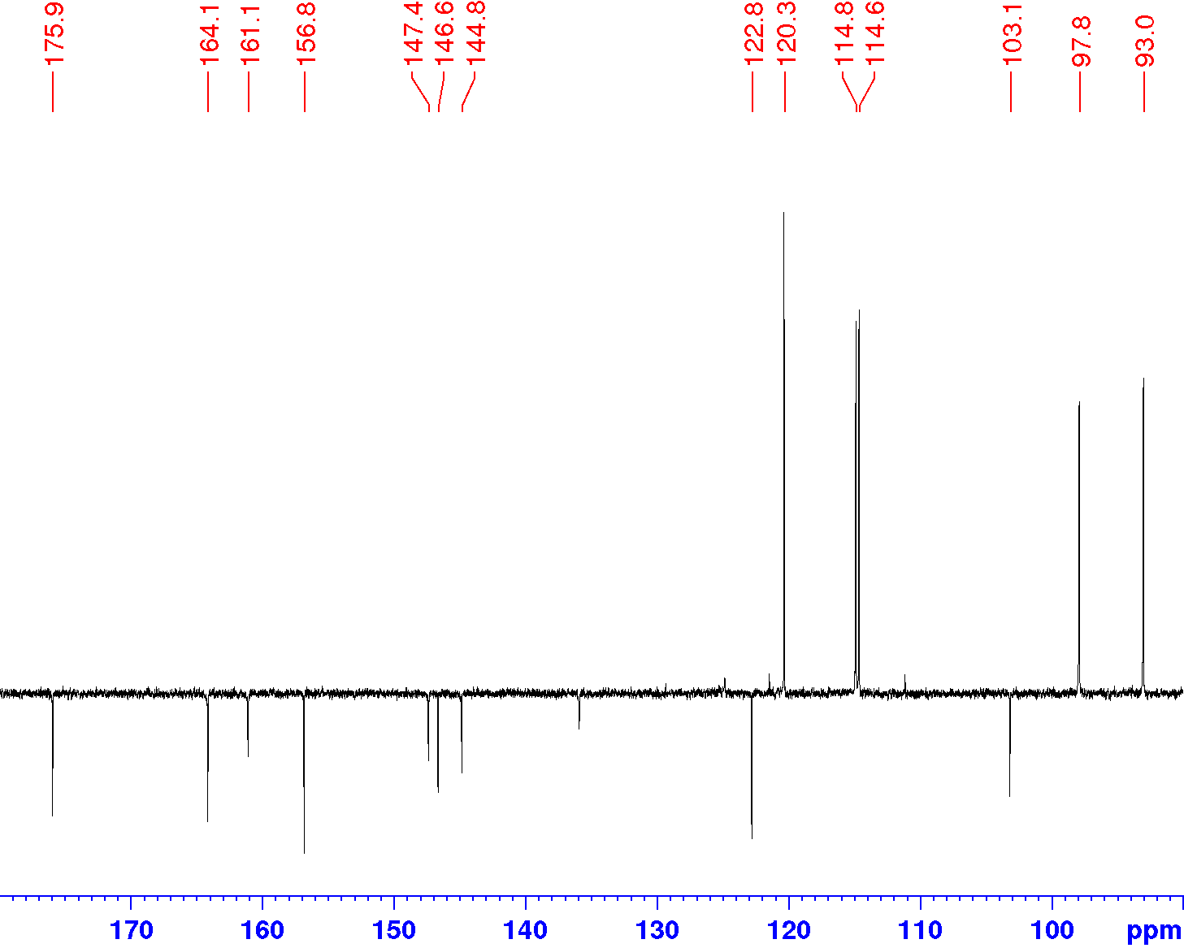

**Figure 6: 13C NMR spectra of B40**

**Table 12: Data from the 13C NMR spectra of sample B40**

|  |  |  |  |  |
| --- | --- | --- | --- | --- |
| **Peak (δ ppm)** | **Sample B40** | **Literature Peaks (Wishart *et al*., 2008)** | **Functional Group/Assignment** | **Significant Peaks for Identification** |
| 175.9 | Present | 175–176 | Carbonyl group (C=O) | Yes, confirms carbonyl group (C=O) |
| 164.1 | Present | 163–165 | Aromatic C attached to O (C-OH) | Yes, confirms hydroxyl group on ring |
| 161.1 | Present | 160–162 | Aromatic C attached to O (C-OH) | Yes, confirms hydroxyl group on ring |
| 156.8 | Present | 156–158 | Aromatic C attached to O (C-OH) | Yes, confirms hydroxyl group on ring |
| 147.3 | Present | 146–148 | Aromatic C in ring system | No, general aromatic signal |
| 146.6 | Present | 145–147 | Aromatic C in ring system | No, general aromatic signal |
| 144.8 | Present | 144–146 | Aromatic C in ring system | No, general aromatic signal |
| 136 | Present | 135–137 | Aromatic C in ring system | No, general aromatic signal |
| 122.7 | Present | 122–124 | Aromatic C in ring system | No, general aromatic signal |
| 120.3 | Present | 119–121 | Aromatic C in ring system | No, general aromatic signal |
| 114.8 | Present | 113–115 | Aromatic C in ring system | No, general aromatic signal |
| 114.6 | Present | 113–115 | Aromatic C in ring system | No, general aromatic signal |
| 103.1 | Present | 102–104 | Aromatic C in ring system | No, general aromatic signal |
| 97.8 | Present | 97–99 | Aromatic C in ring system | No, general aromatic signal |
| 93 | Present | 92–94 | Aromatic C in ring system | No, general aromatic signal |

**FTIR Analysis of Sample B40**

The FTIR spectrum data of sample B40 shown in Table 13 reveals important functional groups. A broad O-H stretch at 3243 cm⁻¹ confirms the presence of hydroxyl groups, while a sharp C=O stretch at 1662 cm⁻¹ indicates a carbonyl group. Additional peaks at 1047 cm⁻¹ (C-O stretch) and 721 cm⁻¹ (aromatic C-H bend) confirm the presence of alcohol or phenol groups and an aromatic ring. These features align with the structure of quercetin.



**Figure 7: FTIR spectra of B40**

**Table 13: FTIR data from the FTIR spectra of sample B40**

|  |  |  |  |  |
| --- | --- | --- | --- | --- |
| **Peak (cm⁻¹)** | **Sample B40** | **Literature Peaks (Wishart *et al*., 2008)** | **Functional Group/Assignment** | **Significant Peaks for Identification** |
| 3243 | Present | 3200–3500 | O-H stretch (Hydroxyl group) | Yes, confirms hydroxyl group |
| 1731 | Present | 1660–1690 | C=O stretch (Carbonyl group) | Yes, confirms carbonyl group |
| 1457 | Present | 1440–1460 | CH₂ bend | No, typical alkyl bending |
| 1047 | Present | 1000–1100 | C-O stretch (Alcohol or phenol) | Yes, confirms hydroxyl groups |
| 721 | Present | 700–800 | Aromatic C-H bend | Yes, confirms aromatic structure |

Based on the combined analysis of the 1H NMR, 13C NMR, and FTIR spectra, the compound was identified as quercetin. The 1H NMR spectrum reveals signals for multiple hydroxyl (O-H) groups and aromatic protons, confirming the presence of a hydroxyl-substituted benzene ring. The 13C NMR spectrum shows a key carbonyl (C=O) signal at δ 175.9 ppm and additional aromatic carbon signals, further supporting the presence of hydroxyl groups on an aromatic ring. The FTIR data complements these findings, with a broad O-H stretch at 3243 cm⁻¹, a C=O stretch at 1662 cm⁻¹, and a C-O stretch at 1047 cm⁻¹, confirming the hydroxyl and carbonyl groups. Together, these results conclusively identify the compound as quercetin. This was also previously reported in the leaf and seed of *D. tripetala* (Aderogba *et al*., 2012).



**Figure 8: Chemical structure of sample B40 (Quercetin)**

**1H NMR Analysis of Sample OX2**

1H NMR spectrum of sample OX2 shows signals for multiple hydroxyl (O-H) protons between δ 13.18 and 4.6 ppm, along with aromatic protons at δ 8.03–6.28 ppm, confirming the presence of both hydroxyl groups and an aromatic ring. Additional signals in the 3.85–3.24 ppm range indicate protons from a glycoside sugar unit as shown in shown in Table 14.

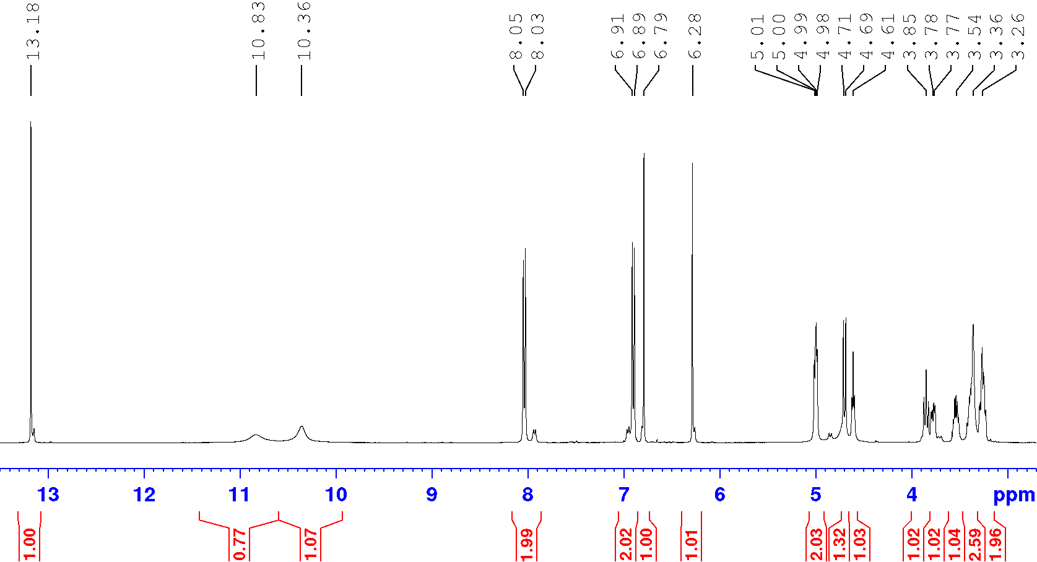

**Figure 9:  1H NMR spectra of OX2**

**Table 14: 1H NMR spectra data of sample 0X2**

|  |  |  |  |  |  |
| --- | --- | --- | --- | --- | --- |
| **Peak (δ ppm)** | **Multiplicity** | **Number of Protons (Sample OX2)** | **Literature Peaks (Costa *et al*., 2020)** | **Functional Group/Assignment** | **Significant Peaks for Identification** |
| 13.18 | s | -OH | 13.0–13.2 s | Hydroxyl proton (-OH) | Yes, confirms hydroxyl group |
| 10.82 | b | -OH | 10.8–10.9 b | Hydroxyl proton (-OH) | Yes, confirms hydroxyl group |
| 10.35 | b | -OH | 10.3–10.4 b | Hydroxyl proton (-OH) | Yes, confirms hydroxyl group |
| 8.03 | d (J = 8.8 Hz) | 2H | 8.0–8.1 d | Aromatic protons (C-H in ring) | Yes, confirms aromatic ring protons |
| 6.9 | d (J = 8.8 Hz) | 2H | 6.9–7.0 d | Aromatic protons (C-H in ring) | Yes, confirms aromatic ring protons |
| 6.79 | s | 1H | 6.7–6.8 s | Aromatic proton (C-H in ring) | Yes, confirms aromatic ring protons |
| 6.28 | s | 1H | 6.2–6.3 s | Aromatic proton (C-H in ring) | Yes, confirms aromatic ring protons |
| 5.01 | d | -OH | 5.0–5.1 d | Hydroxyl proton (-OH) | Yes, confirms hydroxyl group |
| 4.99 | d | -OH | 4.9–5.0 d | Hydroxyl proton (-OH) | Yes, confirms hydroxyl group |
| 4.7 | d (J = 9.3 Hz) | 1H | 4.6–4.7 d | Hydroxyl proton (-OH) | Yes, confirms hydroxyl group |
| 4.6 | t (J = 5.7 Hz) | -OH | 4.5–4.6 t | Hydroxyl proton (-OH) | Yes, confirms hydroxyl group |
| 3.85 | t (J = 9.3 Hz) | 1H | 3.8–3.9 t | Sugar protons (-CH) in glycoside | Yes, confirms sugar unit |
| 3.77 | m | 1H | 3.7–3.8 m | Sugar protons (-CH) in glycoside | Yes, confirms sugar unit |
| 3.54 | m | 1H | 3.5–3.6 m | Sugar protons (-CH) in glycoside | Yes, confirms sugar unit |
| 3.39 | m | 1H | 3.3–3.4 m | Sugar protons (-CH) in glycoside | Yes, confirms sugar unit |
| 3.27 | m | 1H | 3.2–3.3 m | Sugar protons (-CH) in glycoside | Yes, confirms sugar unit |
| 3.24 | m | 1H | 3.2–3.3 m | Sugar protons (-CH) in glycoside | Yes, confirms sugar unit |

**13C NMR Analysis of Sample OX2**

Table 15 shows the data from the 13C NMR spectrum of sample OX2. The 13C NMR spectrum reveals a carbonyl (C=O) peak at δ 182.6 ppm, along with aromatic carbons between δ 163.0 and 98.6 ppm. Several peaks between δ 82.1 and 61.8 ppm correspond to carbons in the glycoside unit, confirming the structure of vitexin. The C=O stretch at 182.6 ppm is slightly high for vitexin

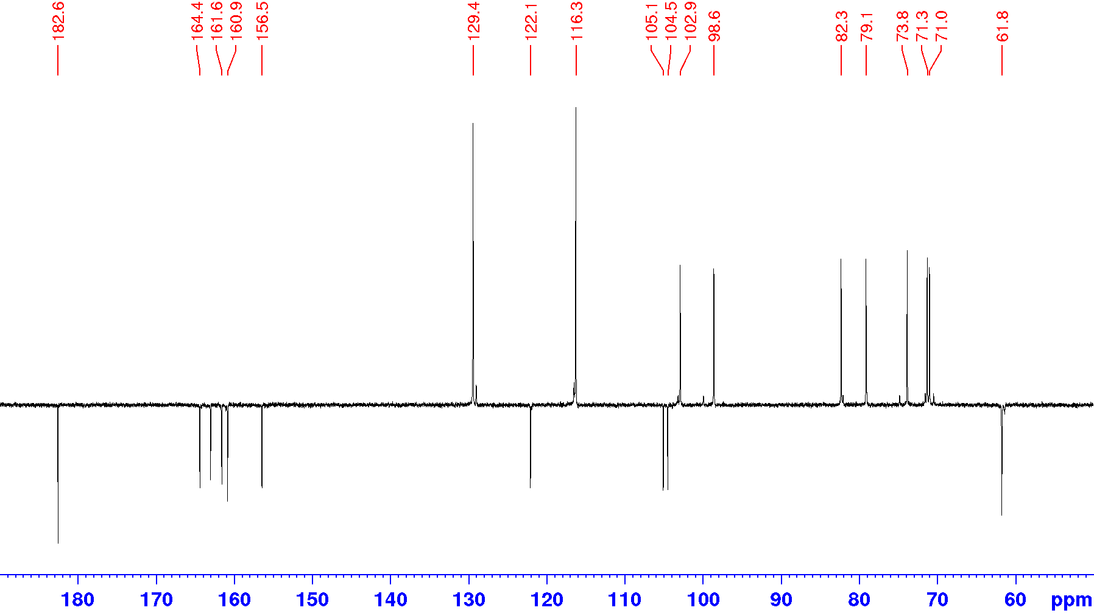

**Figure 10: 13C NMR spectra of OX2**

**Table 15: Data from the 13C NMR spectra of sample OX2**

|  |  |  |  |  |
| --- | --- | --- | --- | --- |
| **Peak (δ ppm)** | **Sample OX2** | **Literature Peaks (Costa *et al*., 2020)** | **Functional Group/Assignment** | **Significant Peaks for Identification** |
| 182.6 | Present | 180–183 | Carbonyl group (C=O) | Yes, confirms carbonyl group |
| 163 | Present | 162–164 | Aromatic carbon attached to O-H | Yes, confirms hydroxyl group |
| 161.6 | Present | 160–162 | Aromatic carbon attached to O-H | Yes, confirms hydroxyl group |
| 160.8 | Present | 159–161 | Aromatic carbon attached to O-H | Yes, confirms hydroxyl group |
| 156.6 | Present | 155–157 | Aromatic carbon | No, general aromatic carbon signal |
| 129.4 | Present | 128–130 | Aromatic carbon | No, general aromatic carbon signal |
| 122.1 | Present | 121–123 | Aromatic carbon | No, general aromatic carbon signal |
| 116.3 | Present | 115–117 | Aromatic carbon | No, general aromatic carbon signal |
| 105.1 | Present | 104–106 | Aromatic carbon | No, general aromatic carbon signal |
| 104.5 | Present | 104–106 | Aromatic carbon | No, general aromatic carbon signal |
| 102.9 | Present | 102–104 | Aromatic carbon | No, general aromatic carbon signal |
| 98.6 | Present | 97–99 | Aromatic carbon | No, general aromatic carbon signal |
| 82.1 | Present | 81–83 | Sugar carbon (glycoside unit) | Yes, confirms glycoside unit |
| 79.1 | Present | 78–80 | Sugar carbon (glycoside unit) | Yes, confirms glycoside unit |
| 73.9 | Present | 73–75 | Sugar carbon (glycoside unit) | Yes, confirms glycoside unit |
| 71.3 – 71.1 | Present | 71–72 | Sugar carbon (glycoside unit) | Yes, confirms glycoside unit |
| 61.8 | Present | 60–62 | Sugar carbon (glycoside unit) | Yes, confirms glycoside unit |

**FTIR Analysis of Sample OX2**

The results of the FTIR data of sample OX2 are displayed in Table 16. The FTIR spectrum displays characteristic peaks, including an O-H stretch at 3216 cm⁻¹, a C=O stretch at 1650 cm⁻¹, and C-O stretches at 1061 cm⁻¹, confirming the presence of hydroxyl groups, a carbonyl group, and aromatic structure in vitexin.



**Figure 11: FTIR spectra of OX2**

**Table 16: Data from the FTIR spectrum of sample OX2**

|  |  |  |  |  |
| --- | --- | --- | --- | --- |
| **Peak (cm⁻¹)** | **Sample OX2** | **Literature Peaks (Costa *et al*., 2020)** | **Functional Group/Assignment** | **Significant Peaks for Identification** |
| 3216 | Present | 3200–3500 | O-H stretch (Hydroxyl group) | Yes, confirms hydroxyl group |
| 1731 | Present | 1650–1680 | C=O stretch (Carbonyl group) | Yes, confirms carbonyl group |
| 1457 | Present | 1450–1460 | CH₂ bend | No, typical alkyl bending |
| 1061 | Present | 1050–1150 | C-O stretch (Alcohol or phenol) | Yes, confirms C-O bond in hydroxyl group |
| 970 | Present | 960–980 | =C-H bend | No, general unsaturation signal |
| 831 | Present | 820–840 | Aromatic C-H bend | Yes, confirms aromatic structure |

Based on the combined 1H NMR, 13C NMR, and FTIR spectral data, the compound OX2 was identified as vitexin. The 1H NMR spectrum reveals multiple hydroxyl protons and signals corresponding to a glycoside unit and aromatic protons, confirming the structure. The 13C NMR data shows a key carbonyl signal (δ 182.6 ppm) and signals consistent with both aromatic carbons and sugar carbons, indicating the glycoside structure. The FTIR spectrum further supports these findings with characteristic O-H, C=O, and aromatic C-H stretches. This was also previously reported in the leaf of *D. tripetala* (Aderogba et al., 2012).



**Figure 12: Chemical structure of sample OX2 (Vitexin)**

**Discussion**

The root and stem bark of *D. tripetala* and their various fractions demonstrated strong anti-inflammatory and analgesic activities comparable to that of the standard compound Aspirin used in the study. Quercetin is a well-known flavonoid with significant anti-inflammatory, analgesic, and antioxidant properties. It has been shown to inhibit the production of inflammatory cytokines and enzymes, making it a potential therapeutic agent for various inflammatory conditions (Boots *et al*., 2008). Previous studies have isolated quercetin from *Dennettia tripetala* and demonstrated its potent antioxidant activity (Ugheighele *et al*., 2022). Vitexin, another flavonoid, has been recognized for its anti-inflammatory and antioxidant effects. It works by inhibiting the production of pro-inflammatory cytokines and reducing oxidative stress (Zhang *et al*., 2017). The presence of vitexin in *Dennettia tripetala* adds to the plant’s medicinal value, supporting its traditional use in treating inflammatory conditions.

Docosanoic acid, a long-chain fatty acid, has been studied for its anti-inflammatory properties. It can modulate inflammatory responses and has been shown to reduce the production of pro-inflammatory cytokines (Kumar *et al*., 2018). Its presence in *D. tripetala* supports the plant’s traditional use in treating inflammatory ailments. *D. tripetala* has been extensively studied for its medicinal properties. Previous research has highlighted its rich phytochemical composition, including alkaloids, tannins, saponins, flavonoids, terpenoids, steroids, and cardiac glycosides (Iseghohi, 2015). These compounds contribute to the plant’s broad spectrum of biological activities, such as antioxidant, anti-inflammatory, analgesic, antimicrobial, and cytotoxic properties (Okunlola *et al*., 2021).

The methanol extract and its fractions of *D. tripetala* have demonstrated significant antioxidant activity, with high concentrations of phenolics and flavonoids contributing to their potency (Dennis-Eboh, *et al*., 2021). The dichloromethane and ethyl acetate fractions, in particular, have shown potent free radical scavenging activity, supporting their use in managing oxidative stress-related diseases (Ugheighele *et al*., 2022). These findings align with previous studies and highlight the plant’s role in traditional medicine for treating inflammatory, analgesic, and oxidative stress-related conditions.

**Conclusion**

This study expands the phytochemical profile of *Dennettia tripetala* by identifying vitexin and docosanoic acid, previously unreported in the plant. It reinforces the plant’s anti-inflammatory potential by linking these compounds to its traditional medicinal use. Additionally, it highlights the potent anti-inflammatory activity of its dichloromethane and ethyl acetate fractions, supporting their therapeutic relevance in managing oxidative stress-related diseases.

The research also confirmed that the root and stem bark of *D. tripetala* is rich in bioactive compounds with significant medicinal properties like flavonoids, alkaloids and esters. The research successfully isolated and characterised quercetin, vitexin, rutin, and docosanoic acid, nonacosyl ester which have reported significant anti-inflammatory, analgesic, and antioxidant effects. These findings provide robust scientific support for the traditional medicinal use of *D. tripetala* as an anti-inflammatory agent in African traditional medicine.

**Ethical Approval**

Permission and approval for animal studies were obtained from the College of Health Sciences Animal Ethics Committee, University of Uyo.

**Disclaimer (Artificial intelligence)**

Author(s) hereby declare that NO generative AI technologies such as Large Language Models (ChatGPT, COPILOT, etc.) and text-to-image generators have been used during the writing or editing of this manuscript.

**References**

1. Sofowora, A., Ogunbodede, E. and Onayade, A. (2013). The role and place of medicinal plants in the strategies for disease prevention. *African Journal of Traditional, Complementary and Alternative Medicines*, 6(5): 210–229.
2. Adesina, S. K. and Johnny, I. I. (2021). Plants in Herbal Medicine; Their Traditional Uses, Chemistry and Biology. *Book Publishers International, London*. 785pp.
3. Enema, O. J., Umoh, U. F. and Johnny, I. I. (2024): Phytochemical profile and *in vitro* antioxidant evaluation of the root of *Dennettia tripetala* BAK. F. (Annonaceae). *IOSR Journal of Pharmacy (IOSRPHR)*. 14(6): 4-16.
4. Eseyin, O. A, Akaninyene, D., Thomas, P. S., Attih, E., Essien, E., Johnson, E. C., Zubaid, A. S. M., Ahmad, A., Afzal, S. and Ukeme, A. (2017). Phytochemical analysis and antioxidant activity of the seed of *Telfairia occidentalis* Hook (Cucurbitaceae). *Natural Product Research,* 32(4): 1478-1494.
5. Tsai, D. H., Riediker, M., Berchet, A., Paccaud, F., Waeber, G., Vollenweider, P., and Bochud, M. (2019). Effects of short- and long-term exposures to particulate matter on inflammatory marker levels in the general population. *Environmental Science and Pollution Research International*, 26(19): 19697-19704.
6. Pahwa, R., Amandeep, G., Pankaj, B. and Jialal, I. (2021). Chronic inflammation. *StatPearls Publishing*. https://www.ncbi.nlm.nih.gov/books/NBK493173/ (Retrieved on August 2021).
7. Lorke, D. (1983). A new approach to tropical acute toxicity testing. *Archives of Toxicology*, 53(1): 275-287.
8. Okokon, J. E., Antia, B. S. and Umoh, E. E. (2008). Analgesic and anti-inflammatory activities of *Hippocratea africana*. international journal of pharmacology, 4(17): 51–55.
9. Hunskaar, S. and Hole, K. (1987). The formalin test in mice: dissociation between inflammatory and non-inflammatory pain. *Pain*,30, 103-114.
10. Nwafor, P. A. and Okwuasaba, F. K. (2003). Anti-nociceptive and anti-inflammatory effects of methanolic extract of *Asparagus pubescens* roots in rodents. *Journal of Ethnobiology and Ethnomedicine*. 84: 125 – 129.
11. Vaz, Z. R., Cechinel, V., Yunes, R. A. and Calixto, JB (1996). Antinociceptive action of 2-(-4bromobenzoyl)-3-methy-4-6- dimethoxybenzofuran, a novel xanthoxyline derivative of chemical and thermal models of nociception in mice. *Journal of Pharmacology and Experimental Therapeutics*, 278: 304 – 312.
12. Mbagwu, H. O. C., Anene, R. A. and Adeyemi O. O. (2007). Analgesic, antipyretic and anti-inflammatory properties of *Mezoneuron benthamianum* Baill Caesalpiniaceae. *Nigerian Quarterly Journal of Hospital Medicine*, 17(3): 35 – 41.
13. Tjolsen, A., Berge, O. G., Hunskaar, S., Rosland, J. H. and Hole, K. (1992). The formalin test: an evaluation of the method. *Pain*, 51: 5 – 17.
14. Boots, A. W., Haenen, G. R. and Bast, A. (2008). Health effects of quercetin: From antioxidant to nutraceutical. *European Journal of Pharmacology*, 585(2-3), 325-337.
15. Zhang, Y., Liu, Y., Wang, T. and Wang, X. (2017). Vitexin protects against oxidative stress and apoptosis in H9c2 cardiomyocytes via the PI3K/Akt signaling pathway. *Molecular Medicine Reports*, 16(2), 2053-2060.
16. Kumar, N., Goel, N. and Pandey, V. N. (2018). Anti-inflammatory and antioxidant properties of docosanoic acid in experimental models. *Journal of Ethnopharmacology*, 214, 1-8.
17. Iseghohi, S. O. (2015). A review of the uses and medicinal properties of *Dennettia tripetala* (Pepperfruit). *National Library of Medicine*, 3(4): 104-111.
18. Okunlola, B. M., Adebiyi, Y. H., Odey, B. O., Alawode, R. A., Lawal, A., Okunlola, B. M., Ibrahim, J. and Berinyuy, E. B. (2021). *Dennettia tripetala* (Pepper Fruit), a review of its ethno-medicinal use, phyto-constituents, and biological properties. *GSC Advanced Research and Reviews*, 6(3), 35-43.
19. Dennis-Eboh, U., Achuba, F. I. and George, B. O. (2021). Evaluation of the phytochemical and antioxidant properties of cold, hot water, and wine extracts produced from *Ficus capensis* leaf. *Tropical Journal of Phytochemistry and Pharmaceutical Sciences, 2*(2), 47-54.
20. Aderogba, M., Akinkunmi, E. O. and Mabusela, W. (2012). Antioxidant and Antimicrobial Activities of Flavonoid Glycosides from Dennettia Tripetala G. Baker Leaf Extract. *Nigerian Journal of Natural Products and Medicine*, 15(1): 49-51.
21. Ugheighele, S., Imafidon, K., Choudhary, M., Ahmed, S. and Okoro, E. (2022). Isolation of Quercetin and Avicularin from *Dennettia tripetala* (G. Baker) Seeds, and Evaluation of the Oxidative Stress Management Capacity and Cytotoxic Activities of Its Acetone Extract and Fractions*. Chemistry Africa*. 5(3): 413-415.