Original Research Article

**Association of Trichloroacetic Acid Peeling with Photobiomodulation in the Treatment of Photoaging of the Hands: A Randomized, Controlled, Double-Blind Clinical Trial**

**ABSTRACT**

|  |
| --- |
| **Aims:** To **c**ompare the photorejuvenating effects of 20% trichloroacetic acid (TCA) peeling applied alone and the effects of associating 20% TCA peeling with red LED photobiomodulation (PBM) on the treatment of the back of the hands (660 nm; 100 mW; 5 J/cm²)  **Study design:** Randomized, controlled, double-blind clinical trial.  **Place and Duration of Study:** Department of Medicine-Biophotonic, Universidade Nove de Julho, Campus Vergueiro, São Paulo, Brazil, between July 2020 and September 2021.  **Methodology:** Forty-four participants were randomized into two groups. The experimental group underwent three sessions of 20% TCA peeling combined with PBM, while the control group received three sessions of 20% TCA peeling with simulated PBM. Treatments were administered monthly, with evaluations conducted biweekly. Assessment of photoaging characteristics, including fine and deep wrinkles, dyschromia, and global appearance, was performed using standardized photographs analyzed by two independent plastic surgeons. Pain and participant satisfaction were assessed using a visual analog scale and a 5-point Likert scale.  **Results:** After three sessions, the experimental group demonstrated significant improvement in fine wrinkles, deep wrinkles, and pain levels, as well as in dyschromia and global o  after two sessions. Both groups showed high satisfaction.  **Conclusion:** This study supports the beneficial role of PBM as an adjunct to 20% TCA peeling in hand photoaging treatment. |

*Keywords: Photoaging; Photodamage; Chemical peeling; Photobiomodulation; Phototherapy; Skin rejuvenation; Hand rejuvenation;* Low-Level Laser Therapy (LLLT)*;* Light Emitting Diode (LED)*.*

**1. INTRODUCTION**

The skin, comprising the epidermis and dermis, functions as a protective barrier while influencing aesthetics and psychosocial behavior [1-3]. Skin aging results from intrinsic factors, such as cellular senescence, and extrinsic factors like UV radiation, pollution, and smoking, with photoaging being the primary cause of premature aging [4-6]. UV exposure accelerates aging by inducing wrinkles, pigmentation changes, and elasticity loss, particularly in fair-skinned individuals [4, 7]. Intrinsic aging leads to fine wrinkles and dermal thinning, whereas prolonged sun exposure exacerbates deep wrinkles and sagging [4, 5]. These changes typically appear around 30 and are more evident in lighter skin tones [8, 9]. Consequently, non-invasive hand rejuvenation has gained popularity as part of a holistic aesthetic approach [10].

Understanding photoaging pathogenesis is crucial for effective treatments. Chronic UV exposure degrades the dermal extracellular matrix, primarily affecting collagen types I and III [11-13]. UVA penetrates deeper than UVB and is the main cause of photodamage, inducing oxidative stress, mitochondrial damage, and transcription factor activation (NF-Kappa-B, AP-1) that degrade collagen [14-17].

Hands, second only to the face in exposure, show pronounced aging signs, including solar lentigines, seborrheic keratoses, wrinkles, skin laxity, and volume loss from subcutaneous fat depletion [10, 18-22]. Hand rejuvenation aims to restore youthful characteristics by improving epidermal tone, increasing dermal collagen, and replenishing volume [10]. Treatments include topical agents (tretinoin, vitamin C), intense pulsed light (IPL), photodynamic therapy (PDT), lasers, and chemical peels. Chemical peeling is a cost-effective treatment for pigmentation changes, fine wrinkles, and superficial scars, often chosen based on patient preference, cost, and clinical recommendations [10, 23-27].

Peeling involves controlled exfoliation via caustic agents that induce epidermal keratolysis, keratocoagulation, and protein denaturation [25]. Keratolysis enhances texture and pigment uniformity, while keratocoagulation and protein denaturation stimulate cytokine and chemokine release, promoting collagen and elastin synthesis, keratinocyte regeneration, and dermal restructuring [28].

The depth of exfoliation depends on the agent and technique. Superficial peels affect the epidermis, improving texture and lightening skin. Medium-depth peels target the epidermis and papillary dermis, enhancing epidermal and superficial dermal characteristics. Deep peels address deep wrinkles and acne scars [24, 27, 28].

Trichloroacetic acid (TCA) peels effectively treat photodamage, actinic keratoses, solar lentigines, fine wrinkles, and superficial acne scars [26-29]. TCA, derived from acetic acid and chlorine, requires no neutralization. Exfoliation depth varies with concentration (10%-35%), with 20% commonly used for hand rejuvenation. This concentration induces mild epidermal whitening, ensuring superficial exfoliation with minimal systemic toxicity and fewer side effects [25-27, 29].

Adverse effects correlate with peel depth. Superficial exfoliation requires approximately four days of recovery, with mild erythema and peeling. Procedure-related discomfort is typically mild (5/10 pain scale), with itching, burning, and stinging sensations. If discomfort exceeds 6/10, the procedure should be halted. Severe complications, such as ocular injury, infection, and scarring, are rare with proper preparation and aftercare [28, 30, 31].

Light-based therapies date back to antiquity, but photobiomodulation (PBM) gained prominence with the advent of standardized light-emitting diodes (LEDs) [32, 33]. Initially thought to require collimated light (lasers), PBM is now recognized as equally effective with non-collimated LED sources [33, 34]. LEDs are compact, energy-efficient, and superior to incandescent bulbs [34].

PBM employs low-intensity light to promote tissue repair, reduce inflammation, and provide analgesia by stimulating intracellular chromophores. Cytochrome C oxidase (CCO) in mitochondria absorbs red and near-infrared light, playing a central role in PBM [35]. Treatment efficacy depends on light penetration, influenced by wavelength and tissue optics [36, 37].

Studies indicate that 660nm red light at 3-5 J/cm² enhances tissue repair, particularly during the inflammatory phase [38-40]. PBM mechanisms include redox modulation, nitric oxide release, and reactive oxygen species (ROS) generation, all critical for cell signaling, collagen synthesis, and regeneration [41-43]. Low ROS levels induce mitohormesis, benefiting cellular function, while excessive ROS can be detrimental [44].

Unlike other light-based therapies, PBM does not produce thermal effects. Instead, it modulates inflammation and immunity to promote tissue repair without causing cytotoxicity. PBM is applied in wound healing, skin rejuvenation, and inflammatory and circulatory disorder treatments [36]. Despite ongoing research, PBM effectively addresses chronic pain, tendinopathies, nerve regeneration, lymphedema, and skin rejuvenation [47, 48].

Combining chemical peeling and PBM is expected to accelerate repair, reduce inflammation, and optimize skin rejuvenation, particularly for hands, a key site of photoaging. This study explores PBM’s adjunctive role with chemical peeling in photoaging treatment, contributing to a broader understanding of their combined benefits. As demand for minimally invasive rejuvenation increases, a holistic approach incorporating hand treatment is essential.

Among minimally invasive hand rejuvenation techniques, chemical peeling remains a cost-effective alternative to specialized equipment-dependent methods. It effectively treats pigmentation changes, fine and deep wrinkles, incipient lesions, and actinic melanosis due to photodamage with fewer complications.

Similarly, PBM with LED is an affordable, minimally invasive alternative to lasers [49]. Beyond aesthetic enhancement, LED therapy aids in inflammation control, immune modulation, analgesia, and cellular repair—key factors in mitigating tissue damage caused by chemical peeling. By interacting with exfoliation, PBM can safely accelerate skin rejuvenation. However, controlled studies on the combined effects of PBM and chemical peeling are scarce in the literature. Investigating these two complementary, low-cost therapies may optimize treatments for photoaging, advancing the field of minimally invasive skin rejuvenation.

**2. material and methods**

This study is a randomized, controlled, single-center, double-blind clinical trial (blinding applied to both participants and evaluators). It was conducted in compliance with the Declaration of Helsinki and the protocol was prepared following the SPIRIT (Standard Protocol Items: Recommendations for Interventional Trials) checklist. The research was approved by the Research Ethics Committee of Universidade Nove de Julho, with its complete protocol registered on the ClinicalTrials.gov PRS (Protocol Registration and Results System) platform for public access (Supplementary material, Appendix E). The details of the methods is available in the Supplementary Material. The study flowchart is shown below (Fig 1).

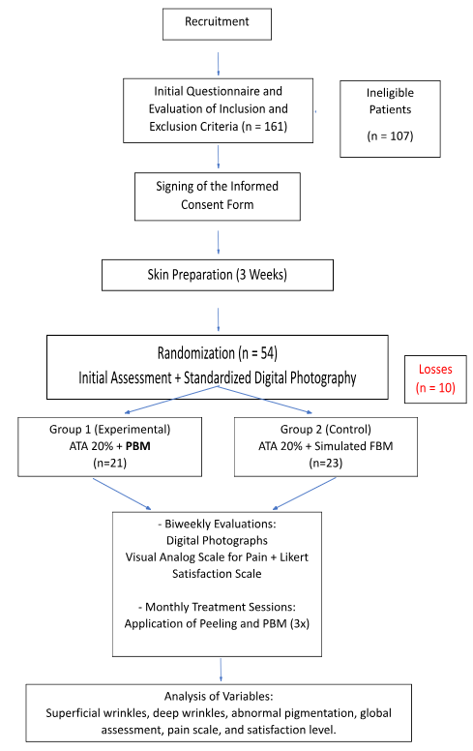

**Fig. 1. Study flowchart.** PBM**:** Photobiomodulation. TCA 20%: 20% Trichloroacetic Acid (solution).

**3. results and discussion**

In interpreting the results, it is important to emphasize the timing of the analyses. The intervals recorded in the inferential graphs were assessed biweekly.

Evaluations of photoaging characteristics—fine wrinkles, deep wrinkles, abnormal pigmentation, and overall assessment—as well as participant satisfaction levels, were consistently collected prior to subsequent treatment sessions. Conversely, the visual analog scale (VAS) for pain was administered immediately after the application of the 20% TCA and PBM or the simulated treatments. Treatment sessions are denoted as TIME 1, TIME 3, and TIME 5. At the remaining time points, evaluations consisted only of standardized digital photographs and questionnaires.

**3.1 Superficial Wrinkles**

Although the confidence intervals between groups overlap, a trend toward a reduction in superficial wrinkles was observed in the experimental group receiving red LED photobiomodulation (PBM) compared to the control group undergoing simulated PBM. Statistical significance was confirmed at TIME 6 (15 days after the third session), as shown in Figure 2.

Another noteworthy observation from the graphical analysis is the progressive improvement in fine wrinkles following each treatment session. This trend was apparent in both groups, further substantiating the efficacy of the 20% trichloroacetic acid (TCA) solution for treating photoaging on the dorsal surface of the hands.

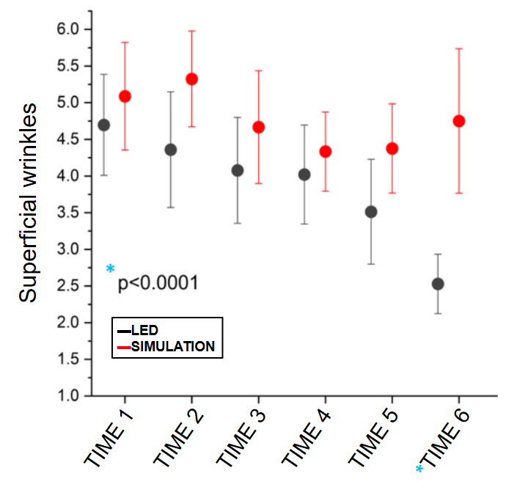

**Fig. 2. Means and confidence intervals in the assessment of superficial wrinkles.**

*LED versus simulation: * P < 0.0001; Mean values ± Standard error of means.*

### 3.2 Deep Wrinkles

Similar to the trends observed for fine wrinkles, a reduction in deep wrinkles was noted in the experimental group receiving red LED photobiomodulation (PBM). Statistical significance was achieved at TIME 6 (15 days after the third session), as shown in Figure 8, where the confidence intervals between the groups do not overlap.

A progressive improvement in deep wrinkles was also observed following each treatment session in both groups. This consistent trend further supports the efficacy of the 20% trichloroacetic acid (TCA) solution for addressing photoaging on the dorsal surface of the hands.

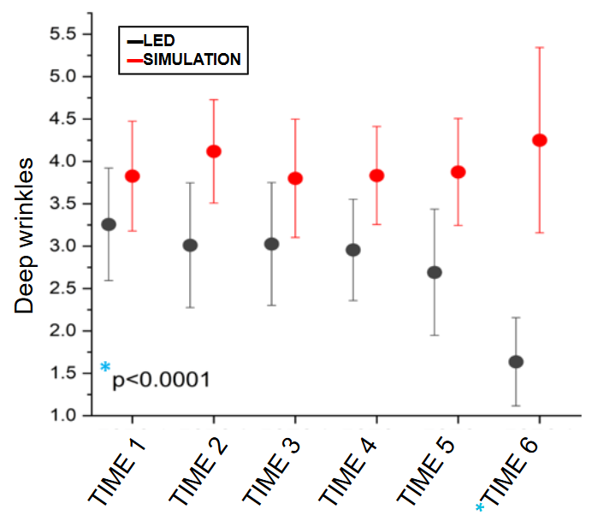

**Fig. 3. Means and confidence intervals in the assessment of deep wrinkles.**

*LED versus simulation: * P < 0.0001; Mean values ± Standard error of means.*

**3.3 Abnormal Pigmentation**

Inferential analyses of the observed confidence intervals indicate a reduction in abnormal pigmentation or dyschromias in the group treated with 660nm red LED photobiomodulation (PBM) compared to the placebo group. Statistical significance was achieved earlier in this parameter, beginning 30 days after the second treatment session (TIME 5), and persisted after the third session (TIME 6), as demonstrated in the graph where the intervals no longer overlap.

Additionally, the graphical analysis suggests a progressive improvement in dyschromias within both groups following each treatment session. This trend underscores the benefits of the 20% trichloroacetic acid (TCA) solution in addressing photoaging on the dorsal hands, particularly between the second and third sessions.

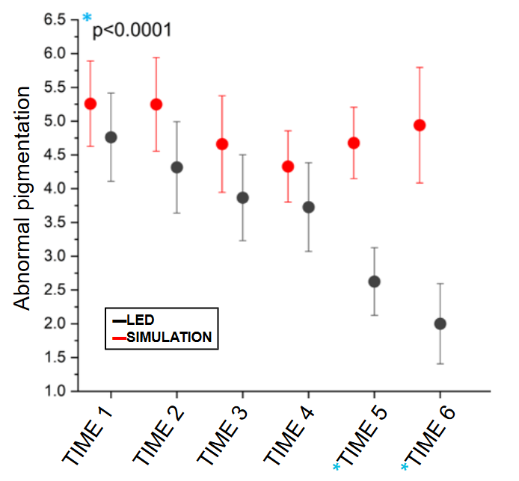

**Fig. 4. Means and confidence intervals in the assessment of abnormal pigmentation.**

*LED versus simulation: * P < 0.0001; Mean values ± Standard error of means.*

**3.4 Global Evaluation**

Unlike the other variables, the global evaluation of the dorsal hands in the photobiomodulation (PBM) group did not demonstrate a trend of improvement until 30 days after the second treatment session (TIME 5). At this point, a significant divergence in the confidence intervals between the experimental and control groups was observed, with no further overlap, indicating statistical improvement in this variable.

Within the experimental group itself, a downward trend in scores was also noted starting at TIME 5, prior to the third application of the 20% trichloroacetic acid (TCA) solution, as compared to the previous evaluation (TIME 4). This suggests a progressive improvement in the global evaluation after 30 days of the second session, pointing to a synergistic effect of the two therapies. Notably, this trend was not observed in the control group.

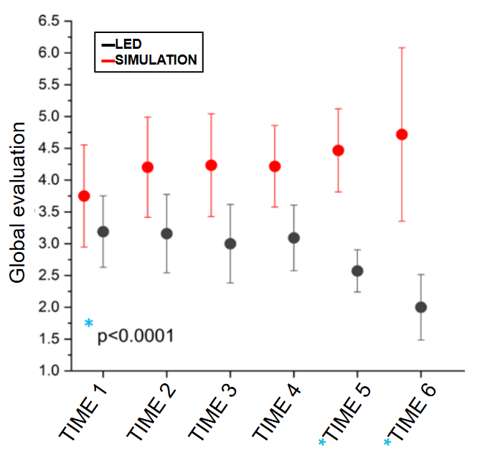

**Fig. 5. Means and confidence intervals in the assessment of global evaluation.**

*LED versus simulation: * P < 0.0001; Mean values ± Standard error of means.*

### 3.5 Visual Analog Scale (VAS) for Pain

The Visual Analog Scale (VAS) (Table 1) has been employed since the 1920s to measure intangible quantities such as pain, quality of life, and anxiety [55]. Assessing the subjective experience of pain remains a significant challenge in healthcare, and despite its limitations, the VAS is a validated primary outcome measure for pain intensity [51].

In this study, participants utilized the VAS to assess pain intensity throughout the course of the research during consultation visits. On treatment session days, the VAS was completed immediately after the application of either real or simulated photobiomodulation.

On the VAS, a score of 0 represents the total absence of pain, while a score of 10 corresponds to the worst pain ever experienced by the participant.

Analysis of confidence intervals reveals that they were largely overlapping, indicating no statistically significant difference in pain levels between participants undergoing photobiomodulation and those receiving simulated irradiation, except at **Timepoint 7**. Despite this, a consistent trend of lower pain levels was observed in the experimental group, particularly immediately after treatments (**Timepoints 1, 3, and 5**) (Fig 4).

The statistically significant difference noted at **Timepoint 7**, assessed 30 days after the third treatment session, may suggest enhanced tissue repair and improved integrity of free nerve endings responsible for skin pain sensitivity in the group receiving red LED (660nm) photobiomodulation (Fig 4).

**Table 1:** Visual Analog Scale for Pain

|  |  |  |  |  |  |  |  |  |  |  |
| --- | --- | --- | --- | --- | --- | --- | --- | --- | --- | --- |
| MILD | | | MODERATE | | | | | SEVERE | | |
| 0 | 1 | 2 | 3 | 4 | 5 | 6 | 7 | 8 | 9 | 10 |
| **VISUAL ANALOG SCALE FOR PAIN** | | | | | | | | | | |

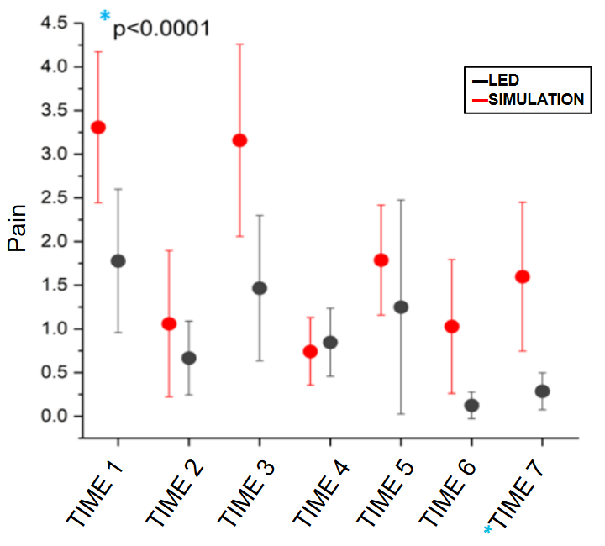

**Fig. 6. Means and confidence intervals in the assessment of pain.**

*LED versus simulation: * P < 0.0001; Mean values ± Standard error of means.*

### 3.6 Satisfaction Scale

During the biweekly medical consultations, participants were also asked about their satisfaction with the treatment outcomes achieved up to that point.

The participants responded to a questionnaire based on a modified **5-point Likert scale** [52] developed by the author, which evaluated their satisfaction with the results obtained.

The Likert scale ranged from:

● **1:** Very dissatisfied

● **2:** Dissatisfied

● **3:** Neutral

● **4:** Satisfied

● **5:** Very satisfied

This evaluation provided insight into the subjective perception of the treatment's effectiveness from the participants' perspective and complemented the objective clinical outcomes.

It is noted that all confidence intervals overlap, and there is no statistical difference between the experimental group and the control group (Fig 7). However, a rising trend is observed graphically within each group, indicating a significant improvement in the satisfaction level of all participants throughout the treatment, regardless of their allocation group.

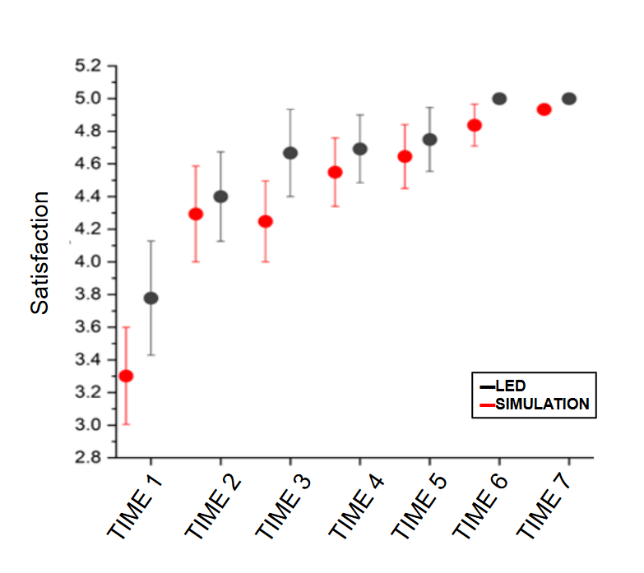

**Fig. 7. Means and confidence intervals in the assessment of pain.**

It is important to emphasize that neither group showed any degree of dissatisfaction during the study, and from the first session onward, both groups demonstrated a significant level of satisfaction with the procedures performed for photoaging treatment. The representative photo of before and after treatment with 20% TCA peeling and photobiomodulation is shown below (Fig 8).

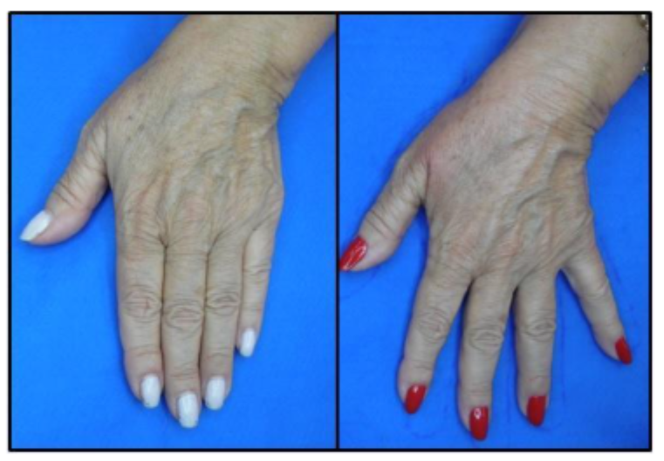

**Fig. 8. Representative photo of before and after treatment with 20% TCA peeling and photobiomodulation.**

*An improvement is observed, primarily in the dyschromia and fine wrinkles, according to the evaluation of both independent specialists.*

For a better understanding of the key results obtained by the experimental group in comparison to the control group, the following flowchart was created (Fig 9).

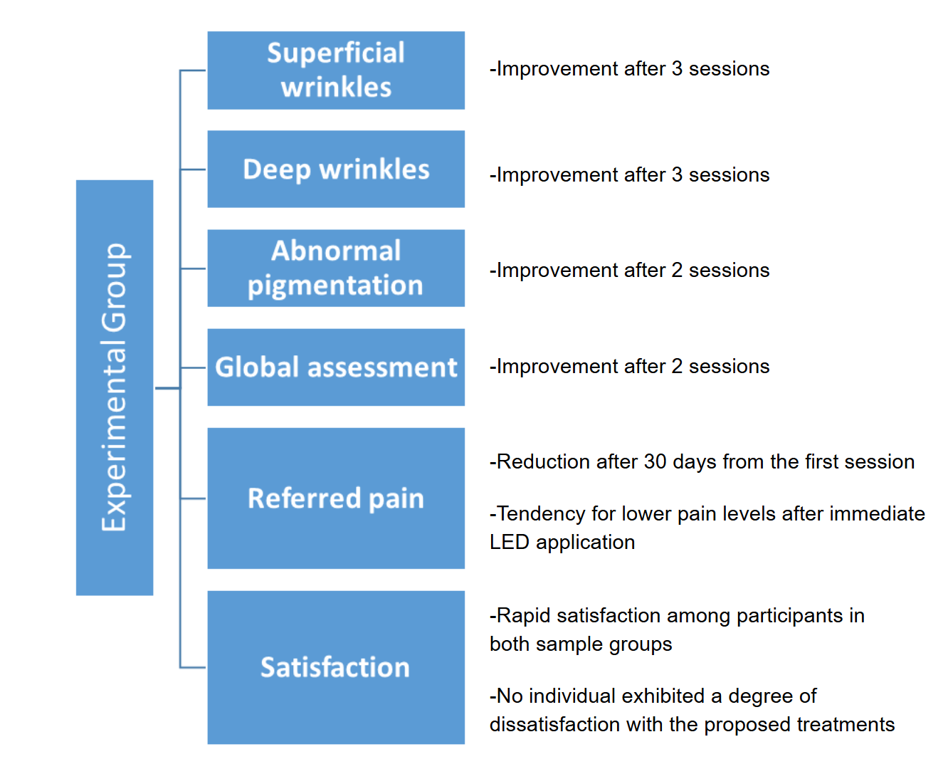

**Fig. 9. Flowchart of results obtained by the experimental group compared to the control group.**

**3.4 Discussion**

Photoaging results from prolonged and repeated skin exposure to ultraviolet solar radiation, being considered the primary extrinsic factor causing photodamage [4, 5]. Understanding its pathogenesis is crucial for developing accessible and effective treatments. However, this process remains not fully elucidated [2, 53].

Based on available knowledge, both 20% TCA peeling and 660nm LED photobiomodulation are minimally invasive, low-cost techniques that can be used to halt this cycle by targeting the skin’s primary layers (dermis and epidermis) [24-27], and acting directly on fibroblasts whose function of synthesizing collagen, elastin, and extracellular matrix components is effectively regulated by irradiation [54, 55].

Additionally, 660nm photobiomodulation is also applied for inflammatory control, immunomodulation, analgesia, and cellular restoration [56]. It is important to emphasize that early application during the inflammatory phase of tissue repair with energy transfer of 3-5 J/cm² is essential for maximizing the benefits of the technology, considered the most critical factor [38-40].

All these characteristics were considered and respected in the study, alongside thehuman skin's physiological repair time of 15-30 days, which varies depending on individual conditions and the extent of injury [57]. It is crucial to note that 20% TCA peeling induces epidermal keratolysis, keratocoagulation, and denaturation of dermal and epidermal proteins. Moreover, each session increases the substance’s permeation, resulting in more tissue aggression, leading to higher production of pro-inflammatory chemokines that delay the healing process. However, there is also an increase in collagen and elastin production in the dermal layer and uniform dispersion of pigment in the epidermis [28].

Based on the findings, it is evident that all study variables related to photoaging characteristics (superficial wrinkles, deep wrinkles, abnormal pigmentation, and global evaluation) showed significant improvement with the combination of 20% TCA peeling and 660nm LED photobiomodulation after 15 days of the third treatment. Furthermore, variables related to dyschromia (abnormal pigmentation) and global evaluation (melanosis, keratosis, telangiectasia, etc.) showed statistically significant improvement in the experimental group even before the third session, occurring 30 days after the second combined treatment session.

Thus, it can be inferred that the 660nm LED irradiation may influence key cells in the inflammatory phase, such as fibroblasts, enhancing and favorably regulating the tissue repair process. Even after the multiple aggressions induced by 20% TCA, the photobiomodulation appears to accelerate the dermal and epidermal cellular renewal process, increasing collagen and elastin production, as well as reducing inflammatory chemokines compared to the control group, key factors in improving superficial wrinkles observed 15 days after the third treatment session.

In contrast, the granules responsible for abnormal skin pigmentation, dyschromia, and melanosis are located in the upper layers of the epidermis [57]. This explains the more immediate effects of the treatments, with statistically significant improvement occurring by the end of the second session.

Additionally, analysis of the confidence intervals reveals a tendency for improvement in photoaging characteristics within each sample group, confirming the benefit of the standard therapy (20% TCA) in isolation. However, in the control group’s graphs, a worsening trend in the analyzed variables was observed during TIME 6, 15 days after the third session. This deterioration likely indicates a delay in the tissue repair process due to the successive injuries induced, without the modulating benefit of the LED treatment.

Although the literature shows a reduction in pain complaints with the use of 660nm LED photobiomodulation [56, 58], the confidence intervals found in this study were overlapped, and it was concluded that there was no statistical difference in pain levels reported between the groups until TIME 7. However, a consistent trend of reduced pain complaints was observed in the experimental group, especially during TIMES 1, 3, and 5 (treatment days). In contrast, the confidence intervals obtained in TIME 7, 30 days after the third treatment session, demonstrated a statistically significant difference in the reduction of pain levels reported by participants in the experimental group compared to the control group. This result possibly reflects a faster tissue repair process and regeneration of free nerve endings responsible for skin pain sensations. It is notable that pain levels remained low even after the protein denaturation caused by the successive TCA 20% applications, which was not observed in the control group with the simulation.

For participant satisfaction evaluation, an important study variable, a 5-point Likert scale was used, answered biweekly. In the analysis, all confidence intervals were overlapped, with no statistical difference between the experimental and control groups. However, an upward trend was observed in the graph of each group, highlighting a consistent improvement in satisfaction levels among all participants throughout the treatment period, regardless of their group allocation.

It is worth noting that neither group showed any dissatisfaction (satisfaction index <3) throughout the study. From the first session, both groups demonstrated a satisfactory level regarding the results achieved with the applied procedures. The progressive and rapid improvement in satisfaction levels likely reflected the better adherence of participants to the study in both groups and could result in the commercial success of the developed treatments.

Although this clinical trial included both genders, all participants were female, demonstrating their greater concern with health in a holistic manner. It is noteworthy that participants frequently expressed their gratitude, as in addition to the variables analyzed, they praised the texture, hydration, and radiance acquired on the back of their hands. These are certainly characteristics that should be further evaluated in future studies.

Another descriptive characteristic of the sample that stands out is the balance between the education levels of the participants (basic and technical education: 19; higher education: 23), highlighting the need for the treatment of hand photoaging to be accessible and widely available, as all social groups have similar aspirations and deserve to pursue their well-being. Thus, a great benefit is suggested from the association of photobiomodulation with a 660nm LED wavelength as an adjunct to the conventional TCA 20% therapy for hand photoaging. This benefit occurs progressively throughout the therapy.

**4. Conclusion**

The results demonstrate the effectiveness of the combination of TCA 20% peeling with 660nm LED photobiomodulation for treating the main characteristics of photoaging compared to the control group with only TCA 20% application. Photobiomodulation was applied with red LED immediately after peeling, acting early during the inflammatory phase of tissue repair with an energy density of 5J/cm² transferred to the target tissue.

The improvement in superficial wrinkles, the main outcome of the study, was achieved 15 days after the third treatment session, which also marked the improvement in deep wrinkles. For dyschromias and global evaluation of the back of the hands (keratoses, melanoses, telangiectasias), the secondary outcomes analyzed, the superiority of the experimental group over the control group occurred more rapidly, within 30 days after the second session of the treatments. Pain levels reported by participants in the experimental group showed improvement only after 30 days of the third session of the associations.

In conclusion, all participants exhibited a high level of satisfaction throughout the study, suggesting strong acceptance of adjunctive photobiomodulation with TCA 20% peeling for the treatment of hand photoaging, with the benefits evident by the second session of this combination.

DEFINITIONS, ACRONYMS, ABBREVIATIONS

AP-1 – Activator protein 1

ATP – Adenosine triphosphat

CCO – Cytochrome C oxidase

DNA – Deoxyribonucleic acid

ICF – Informed Consent Form

IPL – Intense pulsed light

LASER – Light amplification by stimulated emission of radiation

LED – Light Emitting Diode

MMP – Metalloproteinase

PBM – Photobiomodulation

PDT – Photodynamic therapy

ROS – Reactive oxygen species

SPIRIT – Standard Protocol Items: Recommendations for Interventional Trials

TCA – trichloroacetic acid

TCA – Trichloroacetic acid

TGF-β – Transforming growth factor-beta

UV – Ultraviolet radiation

**Consent**

All authors declare that ‘written informed consent was obtained from the patient (or other approved parties) for publication of this case report and accompanying images. A copy of the written consent is available for review by the Editorial office/Chief Editor/Editorial Board members of this journal.

**Ethical approval**

All authors hereby declare that all experiments have been examined and approved by the appropriate ethics committee and have therefore been performed in accordance with the ethical standards laid down in the 1964 Declaration of Helsinki.

**DISCLAIMER (ARTIFICIAL INTELLIGENCE)**

The authors hereby declare that generative AI technologies, such as Large Language Models, have been utilized during the writing and editing of this manuscript. The details of the AI usage are as follows:

AI Technology Name: ChatGPT

Version: GPT-4

Model: Large Language Model (LLM)

Source: OpenAI

Input Prompts Provided:

* Request for translation of text.
* Request to reduce the word count while maintaining the meaning and scientific accuracy of the text.

These prompts were provided throughout the manuscript revision and editing process.

**References**

1. de Szalay S, Wertz PW. Protective Barriers Provided by the Epidermis. Int J Mol Sci. 2023 Feb 5;24(4):3145. doi: 10.3390/ijms24043145. PMID: 36834554; PMCID: PMC9961209.

2. Zhang S, Duan E. Fighting against Skin Aging: The Way from Bench to Bedside. CELL TRANSPLANTATION. 2018;27(5):729-38. doi: 10.1177/0963689717725755. PubMed PMID: WOS:000438559600001.

3. Shin JW, Kwon SH, Choi JY, Na JI, Huh CH, Choi HR, Park KC. Molecular Mechanisms of Dermal Aging and Antiaging Approaches. Int J Mol Sci. 2019 Apr 29;20(9):2126. doi: 10.3390/ijms20092126. PMID: 31036793; PMCID: PMC6540032.

4. Huertas A, Schmelzer C, Hoehenwarter W, Heyroth F, Heinz A. Molecular-level insights into aging processes of skin elastin. BIOCHIMIE. 2016;128:163-73. doi: 10.1016/j.biochi.2016.08.010. PubMed PMID: WOS:000385327700020.

5. Krutmann J, Bouloc A, Sore G, Bernard B, Passeron T. The skin aging exposome. JOURNAL OF DERMATOLOGICAL SCIENCE. 2017;85(3):152-61. doi: 10.1016/j.jdermsci.2016.09.015. PubMed PMID: WOS:000399861200001.

6. Poljšak B, Dahmane RG, Godić A. Intrinsic skin aging: the role of oxidative stress. Acta Dermatovenerol Alp Pannonica Adriat. 2012;21(2):33-6.

7. Gilchrest BA. Photoaging. J Invest Dermatol. 2013 Jul 1;133(E1):E2-6. doi: 10.1038/skinbio.2013.176. PMID: 23820721.

8. Green A, Hughes M, McBride P, Fourtanier A. Factors Associated with Premature Skin Aging (Photoaging) before the Age of 55: A Population-Based Study. DERMATOLOGY. 2011;222(1):74-80. doi: 10.1159/000322623. PubMed PMID: WOS:000287470100015.

9. Goh SH. The treatment of visible signs of senescence: the Asian experience. Br J Dermatol. 1990 Apr;122 Suppl 35:105-9. doi: 10.1111/j.1365-2133.1990.tb16134.x. PMID: 2337528.

10. Butterwick K, Sadick N. Hand Rejuvenation Using a Combination Approach. DERMATOLOGIC SURGERY. 2016;42(5):S108-S18. doi: 10.1097/DSS.0000000000000687. PubMed PMID: WOS:000375433900007.

11. Liu H, Dong J, Du R, Gao Y, Zhao P. Collagen study advances for photoaging skin. Photodermatol Photoimmunol Photomed. 2024 Jan;40(1):e12931. doi: 10.1111/phpp.12931. Epub 2023 Nov 27. PMID: 38009842.

12. Theocharis A, Skandalis S, Gialeli C, Karamanos N. Extracellular matrix structure. ADVANCED DRUG DELIVERY REVIEWS. 2016;97:4-27. doi: 10.1016/j.addr.2015.11.001. PubMed PMID: WOS:000370906200002.

13. Shin JW, Kwon SH, Choi JY, Na JI, Huh CH, Choi HR, Park KC. Molecular Mechanisms of Dermal Aging and Antiaging Approaches. Int J Mol Sci. 2019 Apr 29;20(9):2126. doi: 10.3390/ijms20092126. PMID: 31036793; PMCID: PMC6540032.

14. Panich U, Sittithumcharee G, Rathviboon N, Jirawatnotai S. Ultraviolet Radiation-Induced Skin Aging: The Role of DNA Damage and Oxidative Stress in Epidermal Stem Cell Damage Mediated Skin Aging. STEM CELLS INTERNATIONAL. 2016;2016. doi: 10.1155/2016/7370642. PubMed PMID: WOS:000375309700001.

15. Sreedhar A, Aguilera-Aguirre L, Singh KK. Mitochondria in skin health, aging, and disease. Cell Death Dis. 2020 Jun 9;11(6):444. doi: 10.1038/s41419-020-2649-z. PMID: 32518230; PMCID: PMC7283348.

16. Gromkowska-Kępka KJ, Puścion-Jakubik A, Markiewicz-Żukowska R, Socha K. The impact of ultraviolet radiation on skin photoaging - review of in vitro studies. J Cosmet Dermatol. 2021 Nov;20(11):3427-3431. doi: 10.1111/jocd.14033. Epub 2021 Mar 13. PMID: 33655657; PMCID: PMC8597149.

17. Poon F, Kang S, Chien A. Mechanisms and treatments of photoaging. PHOTODERMATOLOGY PHOTOIMMUNOLOGY & PHOTOMEDICINE. 2015;31(2):65-74. doi: 10.1111/phpp.12145. PubMed PMID: WOS:000351470000003.

18. Bains R, Thorpe H, Southern S. Hand aging: Patients' opinions. PLASTIC AND RECONSTRUCTIVE SURGERY. 2006;117(7):2212-8. doi: 10.1097/01.prs.0000218712.66333.97. PubMed PMID: WOS:000238431500016.

19. Wendt J. Distal, dorsal superior extremity plasty. PLASTIC AND RECONSTRUCTIVE SURGERY. 2000;106(1):210-3. PubMed PMID: WOS:000087824600040.

20. Butterwick K. Rejuvenation of the aging hand. DERMATOLOGIC CLINICS. 2005;23(3):515-+. doi: 10.1016/j.det.2005.04.007. PubMed PMID: WOS:000231248900012.

21. Zhou J, Xie Y, Wang W, Herrler T, Hang R, Zhao P, et al. Hand Rejuvenation by Targeted Volume Restoration of the Dorsal Fat Compartments. AESTHETIC SURGERY JOURNAL. 2018;38(1):92-100. doi: 10.1093/asj/sjx091. PubMed PMID: WOS:000424146300021.

22. Conlon C, Abu-Ghname A, Davis M, Ali K, Winocour S, Eisemann M, et al. Fat Grafting for Hand Rejuvenation. SEMINARS IN PLASTIC SURGERY. 2020;34(1):47-52. doi: 10.1055/s-0039-1700960. PubMed PMID: WOS:000514932100010.

23. Fabi S, Goldman M. Hand Rejuvenation: A Review and Our Experience. DERMATOLOGIC SURGERY. 2012;38(7):1112-27. doi: 10.1111/j.1524-4725.2011.02291.x. PubMed PMID: WOS:000305941500002.

24. Castillo D, Keri J. Chemical peels in the treatment of acne: patient selection and perspectives. CLINICAL COSMETIC AND INVESTIGATIONAL DERMATOLOGY. 2018;11:365-72. doi: 10.2147/CCID.S137788. PubMed PMID: WOS:000439194200002.

25. VMF Y, TMH B, R M. Peelings químicos : revisão e aplicação prática. Surg Cosmet Dermatol. 2013;5(1).

26. P R, O R, L R, L F, JV S. Peeling de ácido tricloroacético no tratamento de melanoses actínicas no dorso das mãos: estudo comparativo e randomizado entre dois veículos. 2015;7(4):294–7.

27. Wambier C, Lee K, Soon S, Sterling J, Rullan P, Landau M, et al. Advanced chemical peels: Phenol-croton oil peel. JOURNAL OF THE AMERICAN ACADEMY OF DERMATOLOGY. 2019;81(2):327-36. doi: 10.1016/j.jaad.2018.11.060. PubMed PMID: WOS:000475303900018.

28. T S, J L, Z R. A Practical Approach to Chemical Peels: A Review of Fundamentals and Step-by-step Algorithmic Protocol for Treatment. J Clin Aesthet Dermatol. 2018;11(8):21.

29. E B. Peelings químicos corporais. In: Tratado de cirurgia dermatológica, cosmiatria e laser da Sociedade Brasileira de Dermatologia2012.

30. Costa I, Damasceno P, Costa M, Gomes K. Review in peeling complications. JOURNAL OF COSMETIC DERMATOLOGY. 2017;16(3):319-26. doi: 10.1111/jocd.12329. PubMed PMID: WOS:000408902400004.

31. Costa IMC, Damasceno PS, Costa MC, Gomes KGP. Review in peeling complications. J Cosmet Dermatol. 2017 Sep;16(3):319-326. doi: 10.1111/jocd.12329. Epub 2017 Mar 27. PMID: 28349655.

32. Kim J, Kim N, Tian Y, Lee A. Light-emitting Diodes at 830 and 850 nm Inhibit Melanin Synthesis In vitro. ACTA DERMATO-VENEREOLOGICA. 2012;92(6):675-80. doi: 10.2340/00015555-1319. PubMed PMID: WOS:000310828300031.

33. Noé C, Pelletier-Aouizerate M, Cartier H. [LED lights in dermatology]. Annales de Dermatologie et de Vénéréologie (Ann Dermatol Venereol). 2017;144(4):301-14. doi: 10.1016/j.annder.2016.10.009.

34. E M, G L, M S, B S, J. T. The simulating effect of low power laser rays on biological systems. Laser Review. 1968;1:3.

35. Avci P, Gupta A, Sadasivam M, Vecchio D, Pam Z, Pam N, et al. Low-Level Laser (Light) Therapy (LLLT) in Skin: Stimulating, Healing, Restoring. Seminars in Cutaneous Medicine and Surgery. 2013;32(1):41-52. PubMed PMID: WOS:000317529400008.

36. Mokoena D, Sundar S, Kumar D, Houreld N, Abrahamse H. Role of photobiomodulation on the activation of the Smad pathway via TGF-β in wound healing. JOURNAL OF PHOTOCHEMISTRY AND PHOTOBIOLOGY B-BIOLOGY. 2018;189:138-44. doi: 10.1016/j.jphotobiol.2018.10.011. PubMed PMID: WOS:000454374800017.

37. Hamblin MR. Mechanisms and applications of the anti-inflammatory effects of photobiomodulation. AIMS Biophysics. 2017;4(3). doi: 10.3934/biophy.2017.3.337.

38. Mosca RC, Ong AA, Albasha O, Bass K, Arany P. Photobiomodulation Therapy for Wound Care: A Potent, Noninvasive, Photoceutical Approach. Advances in Skin & Wound Care. 2019;32(4):157-67. doi: 10.1097/01.ASW.0000553600.97572.d2. PubMed PMID: WOS:000463196600003.

39. Santana C, Silva D, de Souza A, Jacinto M, Bussadori S, Mesquita-Ferrari R, et al. Effect of Laser Therapy on Immune Cells Infiltrate After Excisional Wounds in Diabetic Rats. LASERS IN SURGERY AND MEDICINE. 2016;48(1):45-51. doi: 10.1002/lsm.22445. PubMed PMID: WOS:000371505600006.

40. Alvarenga M, de Oliveira S, Francisco A, da Silva F, Sousa M, Nobre M. Effect of Low-Level Laser Therapy on Pain and Perineal Healing After Episiotomy: A Triple-Blind Randomized Controlled Trial. LASERS IN SURGERY AND MEDICINE. 2017;49(2):181-8. doi: 10.1002/lsm.22559. PubMed PMID: WOS:000396997200005.

41. Wang X, Ti

an F, Soni S, Gonzalez-Lima F, Liu H. Interplay between up-regulation of cytochrome-c-oxidase and hemoglobin oxygenation induced by near-infrared laser. SCIENTIFIC REPORTS. 2016;6. doi: 10.1038/srep30540. PubMed PMID: WOS:000380661300001.

42. de Freitas L, Hamblin M. Proposed Mechanisms of Photobiomodulation or Low-Level Light Therapy. IEEE JOURNAL OF SELECTED TOPICS IN QUANTUM ELECTRONICS. 2016;22(3). doi: 10.1109/JSTQE.2016.2561201. PubMed PMID: WOS:000378533700001.

43. Holmström K, Finkel T. Cellular mechanisms and physiological consequences of redox-dependent signalling. NATURE REVIEWS MOLECULAR CELL BIOLOGY. 2014;15(6):411-21. doi: 10.1038/nrm3801. PubMed PMID: WOS:000337245500012.

44. Ristow M, Schmeisser S. Extending life span by increasing oxidative stress. FREE RADICAL BIOLOGY AND MEDICINE. 2011;51(2):327-36. doi: 10.1016/j.freeradbiomed.2011.05.010. PubMed PMID: WOS:000292352500009.

45. Anders JJ, Lanzafame RJ, Arany PR. Low-Level Light/Laser Therapy Versus Photobiomodulation Therapy. Photomedicine and Laser Surgery. 2015;33(4):183-4. doi: 10.1089/pho.2015.9848. PubMed PMID: WOS:000352341300001.

46. Houreld N, Abrahamse H. Low-Intensity Laser Irradiation Stimulates Wound Healing in Diabetic Wounded Fibroblast Cells (WS1). DIABETES TECHNOLOGY & THERAPEUTICS. 2010;12(12):971-8. doi: 10.1089/dia.2010.0039. PubMed PMID: WOS:000284943500006.

47. Avci P, Gupta A, Sadasivam M, Vecchio D, Pam Z, Pam N, et al. Low-Level Laser (Light) Therapy (LLLT) in Skin: Stimulating, Healing, Restoring. SEMINARS IN CUTANEOUS MEDICINE AND SURGERY. 2013;32(1):41-52. PubMed PMID: WOS:000317529400008.

48. Weiss R, McDaniel D, Geronemus R, Weiss M, Beasley K, Munavalli G, et al. Clinical experience with light-emitting diode (LED) photomodulation. DERMATOLOGIC SURGERY. 2005;31(9):1199-205. PubMed PMID: WOS:000233129900006.

49. Chen H, He J, Lanzafame R, Stadler I, El Hamidi H, Liu H, et al. Quantum dot light emitting devices for photomedical applications. JOURNAL OF THE SOCIETY FOR INFORMATION DISPLAY. 2017;25(3):177-84. doi: 10.1002/jsid.543. PubMed PMID: WOS:000401719000005.

50. Freyd M. The graphic rating scale. JOURNAL OF EDUCATIONAL PSYCHOLOGY. 1923;14:83-102. PubMed PMID: WOS:000202766000006.

51. Heller GZ, Manuguerra M, Chow R. How to analyze the Visual Analogue Scale: Myths, truths and clinical relevance. Scandinavian Journal of Pain. 2016;13:67-75. doi: 10.1016/j.sjpain.2016.06.012.

52. Prabhu K, Cleghorn M, Elnahas A, Tse A, Maeda A, Quereshy F, et al. Is quality important to our patients? The relationship between surgical outcomes and patient satisfaction. BMJ QUALITY & SAFETY. 2018;27(1):48-52. doi: 10.1136/bmjqs-2017-007071. PubMed PMID: WOS:000418324600008.

53. Naylor E, Watson R, Sherratt M. Molecular aspects of skin ageing. MATURITAS. 2011;69(3):249-56. doi: 10.1016/j.maturitas.2011.04.011. PubMed PMID: WOS:000292492700009.

54. Jere S, Houreld N, Abrahamse H. Photobiomodulation at 660 nm stimulates proliferation and migration of diabetic wounded cells via the expression of epidermal growth factor and the JAK/STAT pathway. JOURNAL OF PHOTOCHEMISTRY AND PHOTOBIOLOGY B-BIOLOGY. 2018;179:74-83. doi: 10.1016/j.jphotobiol.2017.12.026. PubMed PMID: WOS:000426233200010.

55. S A, N H, H A. Laser Irradiation Alters the Expression Profile of Genes Involved in the Extracellular Matrix. International Journal of Photoenergy. 2014.

56. Chung H, Dai T, Sharma S, Huang Y, Carroll J, Hamblin M. The Nuts and Bolts of Low-level Laser (Light) Therapy. ANNALS OF BIOMEDICAL ENGINEERING. 2012;40(2):516-33. doi: 10.1007/s10439-011-0454-7. PubMed PMID: WOS:000300485100019.

57. Arda O, Göksügür N, Tüzün Y. Basic histological structure and functions of facial skin. CLINICS IN DERMATOLOGY. 2014;32(1):3-13. doi: 10.1016/j.clindermatol.2013.05.021. PubMed PMID: WOS:000328656700002.

58. Chow R, Johnson M, Lopes-Martins R, Bjordal J. Efficacy of low-level laser therapy in the management of neck pain: a systematic review and meta-analysis of randomised placebo or active-treatment controlled trials. LANCET. 2009;374(9705):1897-908. doi: 10.1016/S0140-6736(09)61522-1. PubMed PMID: WOS:000272646900023.