Replacement of a High-Fat Diet with a Standard Chow Diet Reduces Daytime Food Intake in Obese Mice and Normalizes Fat Accumulation and Metabolic Parameters

.
ABSTRACT

Introduction: The consumption of ultra-processed foods rich in fat has contributed to the global rise in obesity and other metabolic disorders, including excess adipose tissue accumulation and Non-Alcoholic Fatty Liver Disease (NAFLD). Although physical exercise and dietary education are first-line treatments for weight loss, restrictive diets are often used to accelerate weight reduction. However, these diets are generally unsustainable in the long term and frequently lead to weight regain.
Aims: To evaluate the effects of replacing a high-fat diet with a standard chow diet (ad libitum) on food intake, fat accumulation, glycemic homeostasis, and non-alcoholic fatty liver disease.
Methodology: Animals were divided into two groups: one fed a high-fat diet and the other a standard diet for 8 weeks. Then, half of the animals on the high-fat diet had their food replaced with a standard diet. Body weight was measured weekly. After an additional 7 weeks, food intake was assessed, and glucose and insulin tolerance tests were performed. The animals were euthanized 8 weeks after the dietary intervention, and liver tissue was collected for histological analysis.
Results: The high-fat diet induced obesity and metabolic changes, including hyperglycemia, insulin resistance, dyslipidemia, and hepatic steatosis. Replacing it with a standard diet, even without influencing total caloric intake, reduced daytime food intake and successfully restored body weight, normalized blood glucose and lipid profiles, and improved hepatic steatosis.
Conclusion: Switching to a standard chow diet, even without reducing total caloric intake, decreased daytime food intake, restored body weight, normalized blood glucose and lipid profiles, and improved hepatic steatosis in mice.

Keywords: obesity; high-fat diet; diet therapy; NAFLD; weight loss; food intake; glycemic homeostasis.

1. INTRODUCTION

The consumption of ultra-processed foods, rich in sugars and fats, has contributed to the increase in obesity worldwide ^{(1,2,3,4)}. At this rate, it is estimated that by 2035, more than 50% of the global population will be obese ⁽⁵⁾, representing a significant public health problem, because excess adipose tissue is associated with the development of various Non-Communicable Chronic Diseases (NCDs), such as hypertension, Type 2 Diabetes Mellitus (DM2), and Non-Alcoholic Fatty Liver Disease (NAFLD), the leading cause of chronic liver disease globally ^{(1,4,6)}.
The liver is an organ that operates in a highly coordinated and dynamic manner to regulate the metabolism of macronutrients according to hormonal, neural, and dietary stimuli ⁽⁷⁾. However, in obesity, an inflammatory state occurs, leading to metabolic changes that contribute to NAFLD, such as the stimulation of de novo lipogenesis due to hyperinsulinemia, increased uptake of free fatty acids from adipose tissue lipolysis due to insulin resistance, and mitochondrial dysfunction, along with increased oxidative stress ^{(6,8)}.
Various strategies are being employed to combat obesity and comorbidities such as NAFLD. These include adopting healthier lifestyle habits, engaging in physical exercise, dietary reeducation, and more drastic measures like pharmacological treatment and bariatric surgery ^{(9,10)}. Highly restrictive diets are also commonly adopted as a strategy for achieving a quick solution to obesity; however, they are generally unsustainable in the long term, often being followed by weight regain ⁽¹¹⁾.
Some diets, such as the hypocaloric Mediterranean diet, are well-accepted in the treatment of NAFLD, as are certain foods like coffee and the modulation of the microbiota ⁽¹²⁾. In this context, high-quality diets could reduce NAFLD cases. Therefore, the improvement in the nutritional composition of diets—moving from a high-fat diet to a normocaloric, balanced diet in macronutrients—raises the question of its potential in treating obesity and its comorbidities, like NAFLD. In this sense, we aimed to evaluate the effects of replacing a high-fat diet (HFD) with a standard chow diet (CD) on food intake, fat accumulation, glycemic homeostasis, and non-alcoholic fatty liver disease (NAFLD) in mice.

2. material and methods

2.1 Animals

All experiments were approved by the university’s Ethics Committee on Animal Use (CEUA – State University of Western Paraná - UNIOESTE, Protocol No. 22-20). Male C57BL/6 mice at 6 weeks of age (average weight of 20 g) were housed in polypropylene boxes (30 x 20 x 13 cm, 2-3 animals per box) under controlled temperature (23± 2 ºC) and lighting conditions (12-hour light/dark cycle). All animals underwent a 2-week acclimatization period, during which they received a standard chow diet and water ad libitum.
During data collection and analysis, animals were randomized to ensure investigator blinding.

2.2 Obesity Induction and Diet Composition

After the acclimatization period, the animals were randomly divided into two groups. The control group (CTL, n=9) received a standard chow diet (Supralab, Brazil; 70% carbohydrates, 20% proteins, 10% lipids; 3.8 kcal/g) throughout the experiment. The high-fat diet group (HFD, n=26) received a high-fat diet for 8 weeks to induce obesity. The high-fat diet was prepared at the Laboratory of Endocrine Physiology and Metabolism (LAFEM – UNIOESTE) and consisted of 50% ground standard chow diet, 14.8% casein, 4% soybean oil, and 31.2% lard (36.7% carbohydrates, 25.4% proteins, 37.9% lipids; 6.23 kcal/g).

2.3 Dietary Intervention
After inducing obesity in the HFD group, a dietary intervention was conducted with half of the animals from this group, replacing the high-fat diet with a standard chow diet. This group, referred to as the high-fat diet-standard chow diet group (HFD-CD, n = 13), continued on the standard chow diet for an additional 8 weeks.

2.4 Food Intake Assessment

In the 7th week after the dietary intervention, the animals were individually housed, and food intake was recorded by subtracting the amount of feed offered from its residue every 12 hours for three days. The results are presented as the average consumption, expressed in kcal.

2.5 Intraperitoneal Glucose Tolerance Test (ipGTT)

The intraperitoneal glucose tolerance test (ipGTT) was conducted 7 weeks after the dietary intervention. The animals underwent an 8-hour fast, and blood was collected from a tail snip for fasting glycemia measurement (time 0) using a glucose meter and test strips (Accu-Chek® Active, Roche, Brazil). Subsequently, the animals received an intraperitoneal injection of glucose at a concentration of 2 g/kg body weight, and glycemia was measured at 15, 30, 60, 90, and 120 minutes after administration.

2.6 Insulin Tolerance Test (ITT)

After a 2-hour fast, blood was collected from the tail for fasting glycemia measurement (time 0) using a glucose meter and test strips (Accu-Chek® Active, Roche, Brazil). Regular insulin (0.75 IU/kg) was administered intraperitoneally, and glycemia was measured again at 3, 6, 9, 12, 15, 18, and 21 minutes post-injection. At the end of the test, the animals received 100 μl of 50% glucose to prevent hypoglycemia and were monitored for one hour.

2.7 Euthanasia

After 8 weeks of dietary intervention, the mice were weighed, anesthetized with xylazine (9 mg/kg) (Anasedan®, Vetbrands, Brazil), and ketamine (90 mg/kg) (Dopalen®, Vetbrands, Brazil). Once the cutaneous reflex was absent, the naso-anal length was measured, and the animals were decapitated. Blood was collected, transferred to Eppendorf tubes, centrifuged (12,600 g, 10 minutes, 4 °C), and the plasma was stored at -80 °C for triglyceride (TG) and cholesterol (COL) measurement using commercial colorimetric kits (Bioclin, Quibasa, Brazil). Subsequently, a laparotomy was performed to extract and weigh the retroperitoneal and perigonadal white adipose tissue and the liver.

2.8 Insulin Resistance

Insulin resistance was calculated using the TyG index, which is associated with fasting glucose and TG under fasting conditions. It was calculated using the formula: Ln(fasting TG [mg/dL] x fasting plasma glucose [mg/dL])/2 (ref) ⁽¹³⁾.

2.9 Liver Histology

A fragment of the left hepatic lobe was collected from each animal, in a cross-section from the center towards the organ's margin. Samples were fixed in Carson's formalin solution (10% of 37% formaldehyde by weight, 1.5% methanol, and 88.5% PBS, pH 7.4) for 24 hours, then washed in running water, dehydrated in increasing concentrations of alcohol, clarified in xylene, embedded, and included in Paraplast® (Sigma Co., St. Louis, MO). Seven-micrometer-thick slices were cut using a manual rotary microtome (Olympus 4060) equipped with a steel knife. Sections were stained with hematoxylin and eosin (HE) for hepatic steatosis analysis ⁽¹⁴⁾. Images were analyzed under an optical microscope (Olympus BX61) equipped with a digital camera (Olympus DP71) and DP Controller 3.2.1.276 software.

2.10 Data Analysis and Statistics

Data are presented as means ± standard errors of the mean (SEM). The Shapiro-Wilk test was used for normality analysis. Parametric data were analyzed using unpaired Student's t-test or one-way ANOVA. Non-parametric data were analyzed using the Mann-Whitney test or Kruskal-Wallis test. The significance level was set at p < 0.05, and analyses were performed using GraphPad Prism version 8.0 (GraphPad Software ©).

3. results

3.1 Eight-Week Dietary Intervention Reduces Body Weight in Obese Mice Fed a High-Fat Diet

After eight weeks on a high-fat diet, the HFD’s group body weight gain was approximately 2.5 times higher than that of the CTL group (Fig. 1A), confirming obesity. In the tenth week (Fig. 1B), the animals in the HFD group were divided into two groups: HFD, which continued the high-fat diet, and HFD-CD, which switched to a standard chow diet for an additional eight weeks. Figure 1B shows the weight progression of obese animals on a high-fat or standard chow diet. Notably, within two weeks after returning to the standard chow diet, the HFD-CD group’s body weight was statistically similar to that of the CTL group (Fig. 1B). The CTL group maintained a relatively stable body weight over the eight weeks, while the HFD group continued to gain weight throughout the experiment. However, the HFD-CD group exhibited a significant reduction in body weight after the dietary intervention (Fig. 1C).
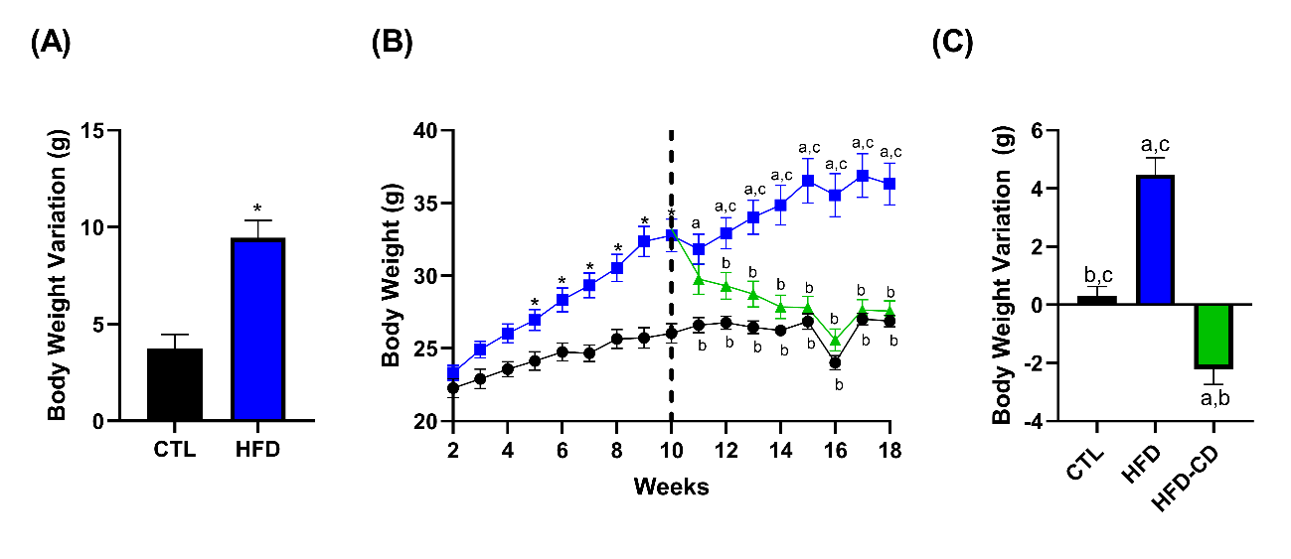

Fig. 1. Effects of standard and high-fat diets on body weight in mice. (A) Body weight variation during obesity induction. (B) Body weight progression in mice fed a standard chow diet or high-fat diet. (C) Body weight variation after dietary intervention. Data presented as mean ± SEM. Different letters represent statistical differences between groups: a (CTL, n=9), b (HFD, n=13), and c (HFD-CD, n=13), with p < 0.05 as the significance criterion.

3.2 Eight-Week Dietary Intervention Modestly Improves Glucose Tolerance in Obese Mice on a High-Fat Diet

Following glucose administration during the ipGTT, all three groups exhibited similar glycemic peaks, with plasma glucose concentration decreasing after 30 minutes. However, at 60, 90, and 120 minutes, the blood glucose levels of the HFD-CD group and the CTL group were similar, while those of the HFD group remained higher (Fig. 2A). Analysis of the area under the glycemic curve during the ipGTT revealed that the HFD-CD group showed a slight improvement in glucose tolerance, statistically similar to the CTL group (Fig. 2B).
During the ipITT, the area under the glycemic curve was similar between the groups (Fig. 2D). However, in the representative curve of the test (Fig. 2C), it is noted that the blood glucose of the HFD group remained higher than that of the CTL group until 12 minutes, while the HFD-CD group’s blood glucose remained intermediate between the CTL and HFD groups. Fifteen minutes after insulin administration, plasma glucose levels in all three groups were similar until the end of the test (Fig. 2C).

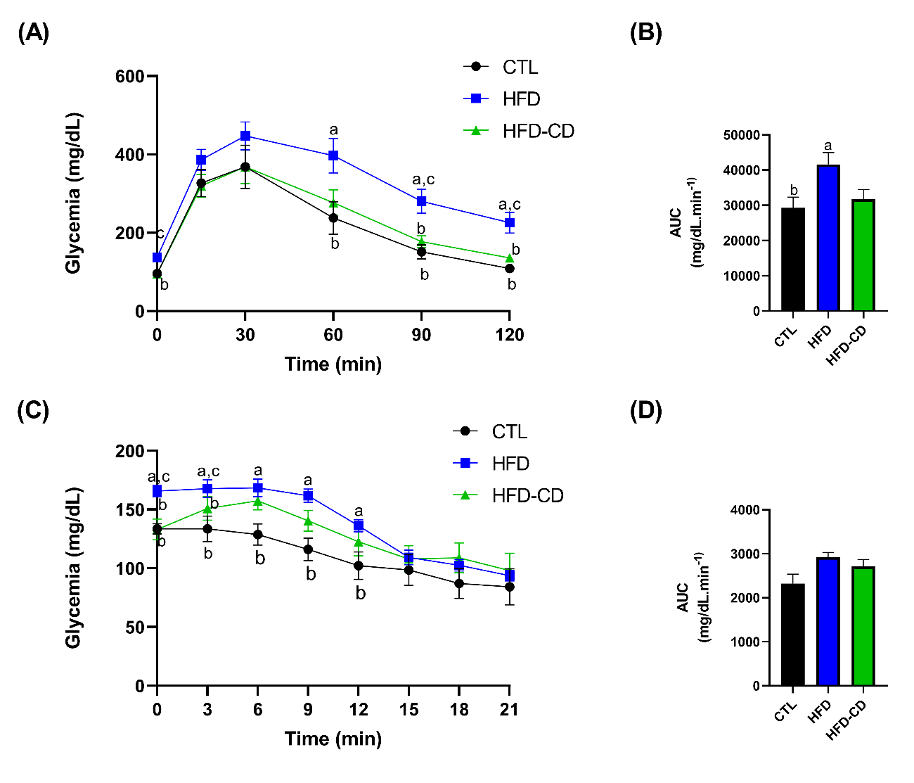
Fig. 2. Effect of dietary intervention on blood glucose during the glucose and insulin tolerance tests in obese mice. Blood glucose curve during intraperitoneal glucose administration (A) and insulin administration (C), and area under the curve for blood glucose during ipGTT (B) and ipITT (D). Data presented as mean ± SEM. Different letters represent statistical differences between groups: a (CTL, n=9), b (HFD, n=13), and c (HFD-CD, n=13), with p < 0.05 as the significance criterion.

3.3 The Food Intake of Obese Mice on a High-Fat Diet is Similar to That of Lean Mice During the Nighttime and Higher During the Daytime

Food intake during the nighttime (19:00 to 07:00 h) (Fig. 3A) and over a 24-hour period (Fig. 3B) was similar across all three groups. However, the daytime food intake (from 7:00 to 19:00h) of the HFD group was significantly higher compared to both the CTL and HFD-CD groups (Fig. 3C).
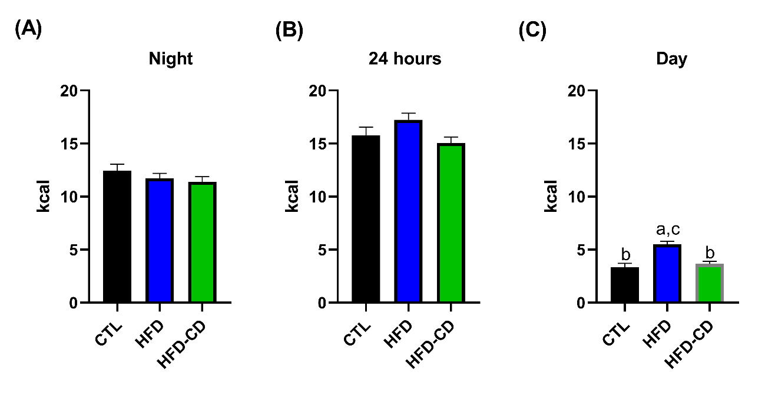
Fig. 3. Comparison of food intake in animals on a high-fat or standard diet in three distinct periods. (A) Nighttime calorie consumption (7:00 PM to 07:00 AM). (B) Caloric intake over a 24-hour period. (C) Daytime calorie consumption (07:00 AM to 7:00 PM). Data presented in kcal as the mean ± SEM of food intake over 3 days. Different letters represent statistical differences between groups: a (CTL, n=9), b (HFD, n=13), and c (HFD-CD, n=13), with p < 0.05 as the significance criterion.

3.4 Eight-Week Dietary Intervention Normalizes Fat Stores and Biochemical Parameters in Obese Mice on a High-Fat Diet

Table 1 shows that body weight, perigonadal and retroperitoneal fat weight, fasting blood glucose, plasma triglycerides, cholesterol, and TyG index were significantly higher in the HFD group compared to the CTL group. Notably, after eight weeks of dietary intervention, all analyzed parameters in the HFD-CD group were statistically lower than those in the HFD group and were similar to those in the CTL group (Table 1).

Table 1. Biometric and Plasma Parameters Analyzed Eight Weeks After Dietary Intervention
 | CTL | HFD | HFD-CD
Body Weight (g) | 26,89 ± 0,39 ^{b} | 36,3 ± 1,43 ^{a,c} | 27,57 ± 0,7 ^{b}
Perigonadal Fat  (mg/g de PC) | 10,49 ± 0,63 ^{b} | 49,33 ± 3,20 ^{a,c} | 14,06 ± 1,71 ^{b}
Retroperitoneal Fat (mg/g de PC) | 1,24 ± 0,30 ^{b} | 11,68 ± 1,97 ^{a,c} | 2,43 ± 0,59 ^{b}
Fasted Glycemia (mg/dL) | 95,67 ± 5,90 ^{b} | 137,2 ± 9,37 ^{a,c} | 95,05 ± 3,14 ^{b}
Fed Glycemia (mg/dL) | 123,4 ± 1,67 | 135,2 ± 4,78 ^{c} | 118,6 ± 3,78 ^{b}
Plasma COL (mg/dL) | 75,4 ± 4,46 ^{b} | 127,8 ± 13,03 ^{a,c} | 70,85 ± 7,56 ^{b}
Plasma TG (mg/dL) | 53,34 ± 5,44 ^{b} | 85,17 ± 7,50 ^{a,c} | 57,38 ± 4,72 ^{b}
TyG Index | 4,22 ± 0,10 ^{b} | 4,72 ± 0,06 ^{a,c} | 4,28 ± 0,04 ^{b}
Data presented as mean ± SEM. Different letters represent statistical differences between groups: a (CTL), b (HFD), and c (HFD-CD). Body weight, perigonadal fat, retroperitoneal fat, fed blood glucose: One-way ANOVA (CTL n=9; HFD n=13; HFD-CD n=13). Fasting blood glucose: Kruskall-Wallis (CTL n=9; HFD n=13; HFD-CD n=13). Plasma cholesterol (Plasma COL): One-way ANOVA (CTL n=5; HFD n=7; HFD-CD n=6). Plasma triglyceride (Plasma TG) and TyG index: Kruskall-Wallis (CTL n=5; HFD n=7; HFD-CD n=6). A significance criterion of p < 0.05 was adopted.

3.5 Hepatic Histology Shows Improvement in Hepatic Steatosis After Eight Weeks of Dietary Intervention in Obese Mice on a High-Fat Diet

Photomicrographs of the liver (Fig. 4E), stained with H&E, were used to quantify macrovesicular and microvesicular steatosis based on the percentage of the affected area (Fig. 4A and B).
For macrovesicular steatosis, all areas assessed in HFD animals were classified as Score 2. Dietary intervention in the HFD-CD group led to slight improvement, with 20% of areas classified as Score 1. In contrast, CTL animals presented macrovesicular steatosis with Score 1 in 75% of the assessed areas (Fig. 4A).
Regarding microvesicular steatosis, 20% of the areas assessed in HFD animals were classified as Score 2, while 80% were Score 1. After dietary intervention, the HFD-CD group showed 80% of the assessed areas as Score 1 and 20% as Score 0, similar to the CTL group, which had 75% in Score 1 and 25% in Score 0 (Fig. 4B).
Therefore, all three groups showed signs of NAFLD; however, the HFD group had the highest score on a scale of 0 to 9, with an average of 4.6. Dietary intervention was able to reverse the disease’s progression, and thus, the CTL and HFD-CD groups presented similar values (Fig. 4C). The most advanced stage of the disease in the HFD group was marked by the presence of more inflammatory foci per field (Fig. 4D).

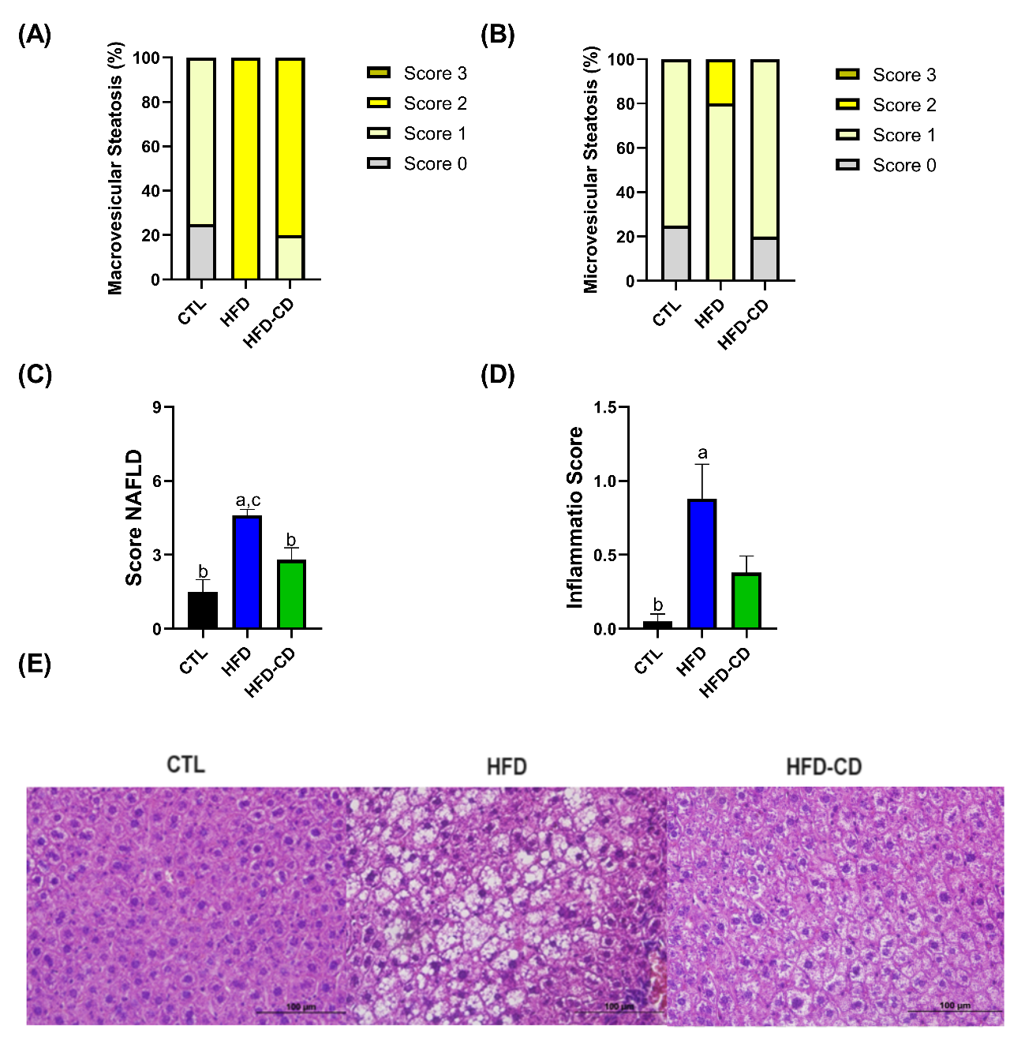
Fig. 4. Effects of dietary intervention on hepatic steatosis in obese mice fed a high-fat diet. (A) Percentage of liver areas with macrovesicular steatosis. (B) Percentage of liver areas with microvesicular steatosis. (C) Scoring scale for NAFLD. (D) Inflammatory foci per field. Photomicrograph of the liver stained with Hematoxylin and Eosin, magnification of 400x. Different letters represent statistical differences between groups: a (CTL n=4), b (HFD n=5), and c (HFD-CD n=5), with p < 0.05 as the significance criterion.

4. DISCUSSION

Obesity has reached pandemic proportions, with a high-fat diet combined with a sedentary lifestyle proving critical elements in explaining this population-wide weight gain. Contemporary diets, which are highly palatable and rich in fats and simple carbohydrates, contribute to hypothalamic injuries, resulting in an imbalance between caloric intake and energy expenditure. The longer a subject consumes such a diet, the greater the imbalance and increased food intake, leading to a vicious cycle of excessive weight gain, accompanied by various comorbidities¹⁵. A high-fat diet contributes to hypothalamic inflammation even before body weight gain occurs ¹⁶, and caloric restriction, while capable of reversing obesity, leaves the NPY/AgRP axis in a heightened state without promoting changes in the POMC/CART axis, which could explain the challenges in maintaining long-term weight loss ^{(17,18)}.
This study observed that administering a high-fat diet for 8 weeks effectively induced obesity and associated metabolic changes, such as hyperglycemia, glucose intolerance, dyslipidemia, and hepatic steatosis. The use of a high-fat diet is a well-established model for inducing obesity in the literature ^{(6,19)}, though these models vary significantly in diet lipid percentage. Notably, many studies use high-fat diets composed of 60% fat, which is not representative of the typical western human diet, with around 35% fat ⁽²⁰⁾. This study adopted a diet with 37.9% lipids, very similar to the composition of the human diet.
In addition to the nutritional composition of diets, their chemical composition also influences metabolic responses. The literature shows that a high-fat diet with the addition of palm oil does not induce liver insulin resistance ⁽²¹⁾, whereas the addition of corn oil, lard, and coconut oil impairs hepatic metabolism ⁽¹⁹⁾. Treating animals with a 37.9% fat diet containing lard and soybean oil resulted in hepatic changes, including increased areas of steatosis and inflammation (Fig. 4).
After 8 weeks on a high-fat diet, 50% of the animals from the HFD group were switched to a standard chow diet, forming the HFD-CD group. After 8 weeks of diet replacement, body weight, fat stores, blood glucose, and plasma TG and cholesterol levels became similar to those of the control animals. Additionally, glycemic homeostasis and hepatic steatosis were partially normalized in the HFD-CD group compared to the HFD group. It is important to note that despite the dietary intervention in the HFD-CD group, the animals were not subjected to caloric restriction, as feed was offered ad libitum. Despite unrestricted access to food, all three groups had the same total caloric intake; however, although the HFD-CD group lost weight, while the HFD group continued to gain weight until euthanasia. A similar observation was made in the study by Hatzidis et al. ⁽²²⁾, in which obesity was induced with a high-fat diet for 9 weeks , followed by dietary intervention in one group by switching from a high-fat diet to a standard chow diet for 4 weeks. It was observed that both the animals consuming a high-fat diet and those fed a standard chow diet had the same caloric intake, despite the weight loss in the dietary intervention group and the maintenance of obesity in the animals fed a high-fat diet.
Additionally, although the total food intake was the same, the HFD-CD and CTL animals consumed approximately 15 kcal/day, while HFD animals consumed around 17 kcal/day. According to Guo et al. ⁽⁸⁾, significant differences in body weight can be maintained with very small differences in food intake, requiring less than 1 kcal/day more to maintain a higher weight. Moreover, animals subjected to a high-fat diet show lower total energy expenditure due to a decrease in voluntary physical activity ^{(8, 22)} and hypothalamic inflammation, which impairs thermogenesis ⁽²³⁾ and may stimulate hedonic eating behavior. Interestingly, in this study, despite similar food intake during the night and over 24 hours (Fig 3A and B) among the three groups, HFD-CD and CTL animals ate less during the daytime compared to HFD animals (Fig 3C), which could explain the reduction in body weight and fat accumulation, and consequently, improvements in other evaluated parameters. Similar results were observed in HFD mice undergoing vertical gastrectomy (article submitted for publication).
Several studies suggest that consuming high-fat diets at certain times of the day can accentuate body weight gain. The timing of food intake is related to the synchronization of various organs involved in nutrient digestion, absorption, and metabolism, such as the stomach, intestine, and pancreas ⁽²⁴⁾. Animal studies indicate that the timing of food intake influences the synchronization of circadian rhythm genes, which is crucial for weight gain, fat mobilization, and body weight reduction ⁽²⁴⁾. Mice submitted to knockout of clock genes, such as the nuclear receptor Rev-erbα, present increased adiposity and hyperglycemia associated with insulin resistance, highlighting the importance of clock gene expression in the development of obesity ⁽²⁵⁾. Moreover, the expression of the clock gene BMAL1 in the Neotomodon alstoni mouse also modulates obesity development, an effect that is also dependent on sexual hormones ^{(26).}
Evidence obtained from animal studies shows that eating at inappropriate times is closely related to the development of obesity ⁽²⁷⁾. Mice subjected to a high-fat diet during the day, their resting period, showed greater weight gain despite having a similar total food intake to the control group ^{(27, 28)}. In this sense, interventions that modify food intake timing can prevent the development of obesity and its comorbidities.
Moreover, high-fat diets are known to alter eating behavior through changes in the expression of genes that regulate circadian rhythm in the hypothalamus, liver, and adipose tissue. This effect has been associated with changes in insulin, leptin, glucose, and free fatty acid levels ⁽²⁹⁾. These data suggest that high-fat diets could alter food consumption patterns during the light/dark cycle through changes in genes that regulate circadian rhythm. In this study, dietary intervention in the HFD-CD group appeared to regulate daytime food consumption, reducing intake and contributing to the observed reduction in body weight.
The body weight loss in the HFD-CD group was accompanied by a significant reduction in both perigonadal and retroperitoneal fat stores, consistent with various experiments involving dietary changes after a period of high-fat diet-induced obesity ^{(22, 28, 29)}.
Interestingly, although traditional therapy for obesity recommends caloric restriction and physical exercise, Hatzidis et al. ⁽²²⁾ observed that mice switched from a high-fat diet to a standard chow diet became as lean as control animals even without exercise. Moreover, voluntary wheel running did not result in additional weight loss, reinforcing the idea that maintaining food intake aligned with to circadian rhythms is crucial in weight gain.
Prolonged consumption of a high-fat diet leads to hyperglycemia and insulin resistance ⁽³²⁾. In this study, animals in the HFD-CD group showed a reduction in blood glucose at certain points in the glucose curve (Fig. 2A), with no significant differences in the ipITT (Fig. 2D). However, insulin sensitivity, as inferred through the TyG Index, showed that dietary intervention improved insulin sensitivity in HFD-CD animals, partly due to weight loss, considering that, in the obese state, macrophages infiltrate target organs and produce inflammatory cytokines that negatively affect insulin signaling and increase chronic inflammation ⁽⁶⁾.
Data also showed that after 8 weeks on a high-fat diet, mice had an increase in hepatic area with steatosis and inflammatory foci, an effect that was mitigated after 8 weeks of returning to a standard chow diet. This effect was similar to that found by Baiges-Gaya et al. ⁽³¹⁾, who observed that switching from a high-fat and carbohydrate-rich diet to a standard chow diet was effective in reducing lobular inflammation and ballooning of hepatic cells, typical changes in NAFLD. Siersbæk et al. ⁽⁷⁾ also showed that this reversal occurs at both macroscopic and genomic levels. It has also been demonstrated that variations in the expression of circadian rhythm genes are directly related to the development of hepatic steatosis and the development of NAFLD ⁽³²⁾. These findings suggest that dietary intervention with a standard chow diet may modulate the expression of genes that regulate circadian rhythm, leading to normalization of food consumption during the daytime and acting, at least in part, to reduce hepatic steatosis levels.
This study has some limitations, as it did not evaluate other factors that may influence weight gain and, consequently, the development of NAFLD, such as energy expenditure and spontaneous movement, which could be explored in future research. Additionally, metabolic responses in mice do not perfectly mimic human metabolism, especially in terms of circadian eating patterns and dietary adaptation. However, the results are considered valid since the focus was on assessing the effect of the diet.

4. Conclusion

In conclusion, replacing a high-fat diet with a normocaloric, balanced diet significantly reduces daytime food intake in animals, resulting in the normalization of body weight, fat stores, and plasma lipid profile. It also improves glycemic homeostasis and attenuates hepatic steatosis in mice made obese by a high-fat diet.

Ethical approval

All authors hereby declare that the "Principles of laboratory animal care" (NIH publication No. 85-23, revised 1985) were followed, as along with specific national laws where applicable. All experiments were reviewed and approved by the appropriate ethics committee.
This research received financial support from FAPESP (thematic process nº 21/04664-7) and CAPES (nº88887.676056/2022-00).

Disclaimer (Artificial intelligence)
Author(s) hereby declare that NO generative AI technologies such as Large Language Models (ChatGPT, COPILOT, etc.) and text-to-image generators have been used during the writing or editing of this manuscript.

References

1. Brasil. Ministério Da Saúde. Guia alimentar para a população brasileira. 2nd ed. Brasília, Df: Ministério Da Saúde; 2014.
2. Fisberg M, Maximino P, Kain J, Kovalskys I. Obesogenic environment – intervention opportunities. Jornal de Pediatria. 2016 May;92(3):S30–9.
3. Maija Kallioinen, Sabrina Ionata Granheim, World Health Organization. Regional Office For The Western Pacific. Overweight and obesity in the Western Pacific Region : an equity perspective. Manila, Philippines: World Health Organization, Western Pacific Region; 2017.
4. Nilson EAF, Andrade R da CS, Brito DA de, Michele Lessa de O. Custos Atribuíveis a obesidade, Hipertensão E Diabetes No Sistema Único De Saúde, Brasil, 2018. Revista Panamericana De Salud Pública [Internet]. 2020 Apr 10;44(32):1
5 World Obesity Federation. World obesity atlas 2023 [Internet]. 2023.
6 Li H, Meng Y, He S, Tan X, Zhang Y, Zhang X, et al. Macrophages, Chronic Inflammation, and Insulin Resistance. Cells. 2022 Sep 26;11(19):3001.
7. Siersbæk M, Varticovski L, Yang S, Baek S, Nielsen R, Mandrup S, et al. High fat diet-induced changes of mouse hepatic transcription and enhancer activity can be reversed by subsequent weight loss. Scientific Reports [Internet]. 2017 Jan 10 [cited 2021 May 28];7.
8. Guo X, Yin X, Liu Z, Wang J. Non-Alcoholic Fatty Liver Disease (NAFLD) Pathogenesis and Natural Products for Prevention and Treatment. International Journal of Molecular Sciences [Internet]. 2022 Jan 1 [cited 2023 May 6];23(24):15489.
9. Melby C, Paris H, Foright R, Peth J. Attenuating the Biologic Drive for Weight Regain Following Weight Loss: Must What Goes Down Always Go Back Up? Nutrients. 2017 May 6;9(5):468.
10. Cohen R, Pechy F, Petry T, Correa JL, Caravatto PP, Tzanno-Martins C. Bariatric and metabolic surgery and microvascular complications of type 2diabetes mellitus. Jornal Brasileiro de Nefrologia. 2015;37(3).
11. Tahreem A, Rakha A, Rabail R, Nazir A, Socol CT, Maerescu CM, et al. Fad Diets: Facts and Fiction. Frontiers in Nutrition [Internet]. 2022 Jul 5;9(9).
12. Montemayor S, García S, Margalida Monserrat-Mesquida, Tur JA, Bouzas C. Dietary Patterns, Foods, and Nutrients to Ameliorate Non-Alcoholic Fatty Liver Disease: A Scoping Review. Nutrients. 2023 Sep 14;15(18):3987–7.
13. Guerrero-Romero F, Villalobos-Molina R, Jiménez-Flores JR, Simental-Mendia LE, Méndez-Cruz R, Murguía-Romero M, et al. Fasting Triglycerides and Glucose Index as a Diagnostic Test for Insulin Resistance in Young Adults. Archives of Medical Research. 2016 Jul;47(5):382–7.
14. Liang W, Menke AL, Driessen A, Koek GH, Lindeman JH, Stoop R, et al. Establishment of a General NAFLD Scoring System for Rodent Models and Comparison to Human Liver Pathology. Sookoian SC, editor. PLoS ONE. 2014 Dec 23;9(12):e115922.
15. Mendes NF, Velloso LA. Perivascular macrophages in high-fat diet-induced hypothalamic inflammation. Journal of Neuroinflammation. 2022 Jun 9;19(1).
16. Jais A, Brüning JC. Hypothalamic inflammation in obesity and metabolic disease. Journal of Clinical Investigation. 2017 Jan 3;127(1):24–32.
17. Liu X, Jin Z, Summers S, Derous D, Li M, Li B, et al. Calorie restriction and calorie dilution have different impacts on body fat, metabolism, behavior, and hypothalamic gene expression. Cell Reports [Internet]. 2022 May 17 [cited 2022 Dec 9];39(7):110835.
18. De Souza CT, Araujo EP, Bordin S, Ashimine R, Zollner RL, Boschero AC, et al. Consumption of a Fat-Rich Diet Activates a Proinflammatory Response and Induces Insulin Resistance in the Hypothalamus. Endocrinology. 2005 Oct;146(10):4192–9.
19.Kleinert M, Clemmensen C, Hofmann SM, Moore MC, Renner S, Woods SC, et al. Animal models of obesity and diabetes mellitus. Nature Reviews Endocrinology [Internet]. 2018 Mar 1;14(3):140–62.
20. Stott NL, Marino JS. High Fat Rodent Models of Type 2 Diabetes: From Rodent to Human. Nutrients. 2020 Nov 27;12(12):3650.
21. Janneke de Wilde, Smit EF, Mohren R, Boekschoten MV, Philip de Groot, van, et al. An 8-Week High-Fat Diet Induces Obesity and Insulin Resistance with Small Changes in the Muscle Transcriptome of C57BL/6J Mice. Lifestyle genomics. 2009 Jan 1;2(6):280–91.
22. Hatzidis A, Hicks JA, Gelineau RR, Arruda N l, De Pina IM, O’Connell KE, et al. Removal of a high-fat diet, but not voluntary exercise, reverses obesity and diabetic-like symptoms in male C57BL/6J mice. HORMONES. 2017 May 12;16(1).
23. Arruda AP, Milanski M, Coope A, Torsoni AS, Ropelle E, Carvalho DP, et al. Low-Grade Hypothalamic Inflammation Leads to Defective Thermogenesis, Insulin Resistance, and Impaired Insulin Secretion. Endocrinology. 2011 Jan 25;152(4):1314–26.
24. Lopez-Minguez J, Gómez-Abellán P, Garaulet M. Timing of Breakfast, Lunch, and Dinner. Effects on Obesity and Metabolic Risk. Nutrients [Internet]. 2019 Nov 1;11(11):2624.
25. Delezie J, Dumont S, Dardente H, Oudart H, Gréchez-Cassiau A, Klosen P, Teboul M, Delaunay F, Pévet P, Challet E. The nuclear receptor REV-ERBα is required for the daily balance of carbohydrate and lipid metabolism. FASEB J. 2012 Aug;26(8):3321-35
26. Pérez-Mendoza M, Rivera-Zavala JB, Rodríguez-Guadarrama AH, Montoya-Gomez LM, Carmona-Castro A, Díaz-Muñoz M, Miranda-Anaya M. Daily cycle in hepatic lipid metabolism in obese mice, Neotomodon alstoni: Sex differences. Chronobiol Int. 2018 May;35(5):643-657
27. Arble DM, Bass J, Laposky AD, Vitaterna MH, Turek FW. Circadian Timing of Food Intake Contributes to Weight Gain. Obesity. 2009 Sep 3;17(11):2100–2.
28. Sherman H, Genzer Y, Cohen R, Chapnik N, Madar Z, Froy O. Timed high‐fat diet resets circadian metabolism and prevents obesity. The FASEB Journal. 2012 May 16;26(8):3493–502.
29. Kohsaka A, Laposky AD, Ramsey KM, Estrada C, Joshu C, Kobayashi Y, et al. High-Fat Diet Disrupts Behavioral and Molecular Circadian Rhythms in Mice. Cell Metabolism. 2007 Nov;6(5):414–21.
30. Parekh PI, Petro AE, Tiller JM, Feinglos MN, Surwit RS. Reversal of diet-induced obesity and diabetes in C57BL/6J mice. Metabolism. 1998 Sep;47(9):1089–96.
31. Baiges-Gayà G, Elisabet Rodríguez-Tomàs, Castañé H, Jiménez-Franco A, Núria Amigó, Camps J, et al. Combining Dietary Intervention with Metformin Treatment Enhances Non-Alcoholic Steatohepatitis Remission in Mice Fed a High-Fat High-Sucrose Diet. Biomolecules. 2022 Nov 30;12(12):1787–7.
32. Velázquez KT, Enos RT, Bader JE, Sougiannis AT, Carson MS, Chatzistamou I, et al. Prolonged high-fat-diet feeding promotes non-alcoholic fatty liver disease and alters gut microbiota in mice. World Journal of Hepatology [Internet]. 2019 Aug 27;11(8):619–37.

