Case report

Multidisciplinary Surgical Management of Coexisting Frontoethmoidal Mucocele and Meningioma: A Case Report

.
ABSTRACT

Aims: This study aims to review the multidisciplinary surgical approach to managing frontal sinus mucoceles associated with meningiomas, emphasizing the importance of collaboration between maxillofacial surgery and neurosurgery. The objective is to assess optimal strategies for lesion removal, sinus reconstruction, and postoperative care to reduce complications and improve patient outcomes.
Study Design: This is a retrospective literature review analyzing documented cases of coexisting frontal sinus mucoceles and meningiomas, along with their surgical management and outcomes.
Place and Duration of Study: Relevant studies from multiple medical institutions and surgical case reports published in peer-reviewed journals between 1979 and 2024 were included.
Methodology: Data were collected from published case studies and reviews on patients diagnosed with both frontal sinus mucoceles and meningiomas. The analysis focused on surgical techniques, the involvement of different medical specialties, and postoperative results. Special attention was given to procedures such as frontal sinus cranialization, sinus drainage restoration, and prevention of mucocele recurrence.
Results: The coexistence of frontal sinus mucoceles and meningiomas presents significant surgical challenges, requiring a coordinated effort between maxillofacial and neurosurgical teams. Studies indicate that the obstruction of the frontal sinus ostium by a meningioma often predisposes patients to secondary mucocele formation. Advanced reconstruction techniques, such as cranialization and frontal recess obliteration, significantly reduce recurrence rates and postoperative complications. The integration of endoscopic and open surgical approaches has demonstrated favorable outcomes, minimizing morbidity and enhancing functional recovery.
Conclusion: A multidisciplinary surgical approach is essential for successfully managing frontal sinus mucoceles associated with meningiomas. Proper lesion removal, sinus reconstruction, and long-term follow-up can prevent recurrence and ensure optimal patient outcomes. Further research and case studies are needed to refine treatment strategies and improve surgical planning in these complex cases.
decrease medical as well as financial burden, hence improving the management of cirrhotic patients. These predictors, however, need further work to validate reliability.

Keywords: Frontal sinus mucocele, meningioma, multidisciplinary surgery

1. INTRODUCTION
Frontoethmoidal mucoceles and meningiomas are distinct clinical conditions that, when coexisting, may present significant surgical and therapeutic challenges. Mucoceles, benign cystic lesions, typically arise due to obstruction of the frontal sinus ostium, leading to the accumulation of mucus and subsequent progressive expansion of the sinus cavity. Clinical manifestations include headache, proptosis, and, in advanced cases, invasion of the orbital and intracranial structures (Magboul et al., 2023). If untreated, these lesions can lead to severe complications such as bone erosion, cerebrospinal fluid fistulas, and recurrent infections (Takeuchi et al., 2015).
On the other hand, meningiomas are generally benign tumors originating from arachnoid cells in the meninges. They represent the most common intracranial neoplasm in adults, although they are mostly asymptomatic until they reach a size sufficient to cause compression of brain structures (Janković et al., 2023). While most meningiomas occur intracranially, there are reports of extracranial cases, such as in the frontal sinus, a rare location that may result in symptoms like persistent headache and visual disturbances (Adeloye, 1979). Furthermore, the simultaneous presence of a meningioma and a frontal sinus mucocele is extremely rare but has been documented in the medical literature (Serry et al., 2004).
When these two pathologies coexist, the therapeutic approach becomes challenging, requiring multidisciplinary surgical management. The obstruction of the frontal sinus ostium by a meningioma may predispose to the development of secondary mucoceles, exacerbating the clinical condition and demanding complex intervention involving both maxillofacial surgeons and neurosurgeons (Moniakis et al., 2024). Coordination between these specialties is crucial to ensure that both the sinus pathology and intracranial involvement are effectively treated, reducing the risk of postoperative complications and restoring normal anatomy and function (Dennis et al., 2023).
Frontal sinus reconstruction after the removal of both a mucocele and a meningioma must be performed with great care to avoid mucocele recurrence and minimize the risk of infection. Studies suggest that advanced techniques, such as frontal sinus cranialization and obliteration of the frontal recesses, play a critical role in reducing postoperative complications (Talamonti et al., 2024). Additionally, the restoration of adequate sinus drainage after mucocele removal is crucial in preventing recurrence and ensuring successful recovery (Palladino et al., 2024).
The literature emphasizes that integration among specialties is essential in such cases. The treatment of complex mucoceles with orbital or intracranial involvement, associated with meningiomas, requires meticulous surgical planning, which should involve complete lesion removal and proper reconstruction of affected structures (Jannelli et al., 2023). Skull base meningioma resection, in turn, is a delicate task that requires the preservation of surrounding structures, and the prevention of complications related to nasofrontal duct obstruction and mucocele recurrence (Priambodo & Sidabutar, 2024).
This article reviews the multidisciplinary surgical approach to managing frontal sinus mucoceles associated with meningiomas, highlighting the importance of collaboration between maxillofacial surgery and neurosurgery specialties. The development of integrated treatment strategies has demonstrated favorable outcomes in the literature, reducing complication rates and improving clinical outcomes in patients with complex pathologies involving the paranasal sinuses and skull base (Mezouri et al., 2014).

2. Presentation of case

A 59-year-old female patient was referred to the neurosurgery outpatient clinic due to a progressive frontal expansile lesion with a three-year evolution. The patient reported gradual enlargement of a frontal mass associated with symptoms such as anosmia (loss of smell) and constant nasal discharge. A brain MRI revealed chronic pansinusitis, along with a globular expansile lesion predominantly occupying the frontal sinus. Additionally, an extra-axial lesion closely associated with the crista galli, highly suspected to be an olfactory groove meningioma, was identified. Based on these findings, a surgical approach was indicated to resect both lesions.
The surgical procedure was performed with the patient in a supine position, with the head in a neutral position, fixed with the Mayfield device. A bicoronal incision was made, with the skin flap moved to the frontal region, exposing the tumor. A perilesional frontal craniectomy was then performed, during which a mixed lesion with solid characteristics and thick, whitish mucus was removed. Following this, an expanded craniotomy was performed to access the olfactory groove meningioma, with total resection of the meningeal lesion.
For the closure of the bony defect resulting from the resection of the frontal lesion, an abdominal fat graft was harvested and placed over the defect. The bony contour was restored by placing a titanium mesh, fixed with 1.5 mm screws. The flap was repositioned and sutured with 3-0 nylon sutures.
Histopathological examination confirmed the tumor lesion as a mucocele. The patient was kept under observation in the Intensive Care Unit (ICU) for 5 days and then transferred to the ward for an additional 3 days. Postoperative follow-up was performed at 7, 15, 30, 60, and 120-day intervals. During follow-up, a facial CT scan revealed the presence of an exostosis on the right supraorbital ridge. Due to this finding, surgical removal of the exostosis under general anesthesia was indicated.
The exostosis removal procedure was performed with the patient in a supine position. The access to the lesion was made through a supraorbital approach. A skin incision was made over the right supraorbital ridge, following the natural line of the lower eyelid crease to preserve the aesthetic appearance. Dissection was performed to expose the subcutaneous layers, with careful separation of the orbicularis oculi muscle and the periosteum of the orbital arch. Using an ultrasonic saw, the exostosis was removed, being cautious to avoid injury to adjacent structures such as the supraorbital nerve and the major facial nerve branches. After complete removal of the lesion, the layers were closed with 6-0 nylon sutures, ensuring the integrity of the region and a good cosmetic result. The patient was discharged the following day.
Postoperative follow-up continued with visits at 7, 15, 30, and 60 days, without evidence of recurrence of the lesions or changes in visual acuity and ocular motility. The patient, however, reported persistent anosmia, which had been noted before the first surgical approach. This symptom was attributed to tumor invasion in the olfactory nerve region, compromising olfactory function.

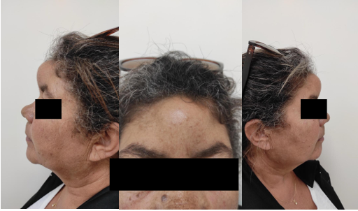
Image 1 - Preoperative Photos
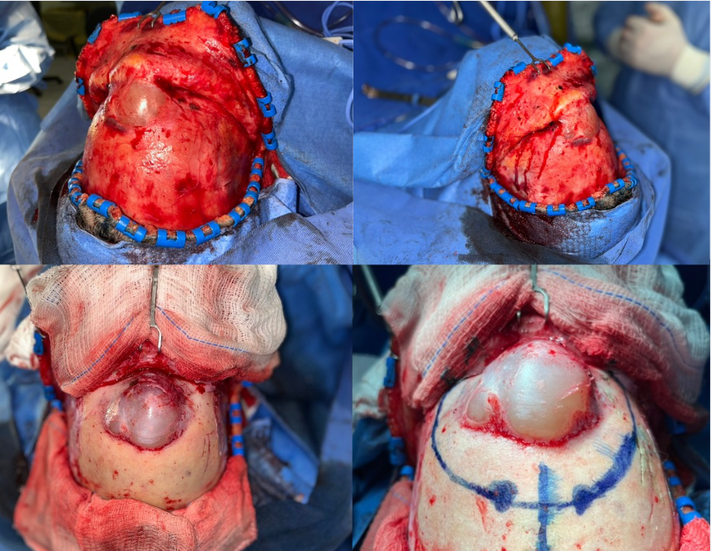
Image 2 - Frontoethmoidal Mucocele
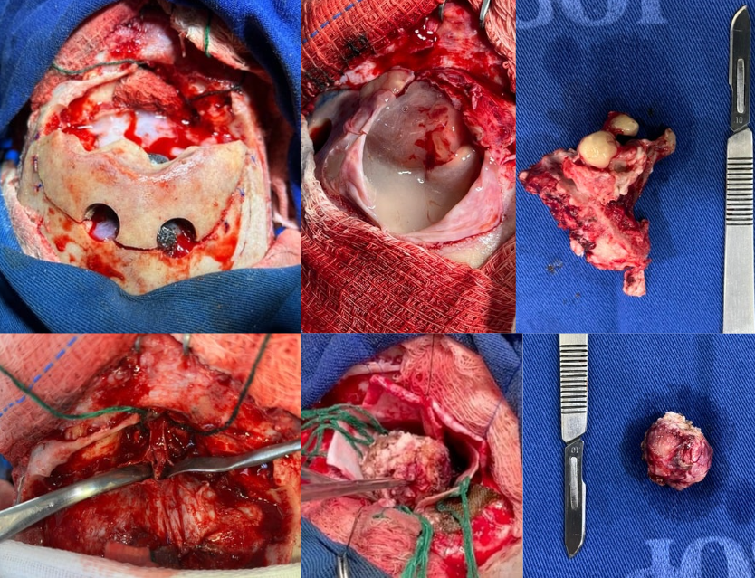
Image 3 - removal of mucocele and meningioma
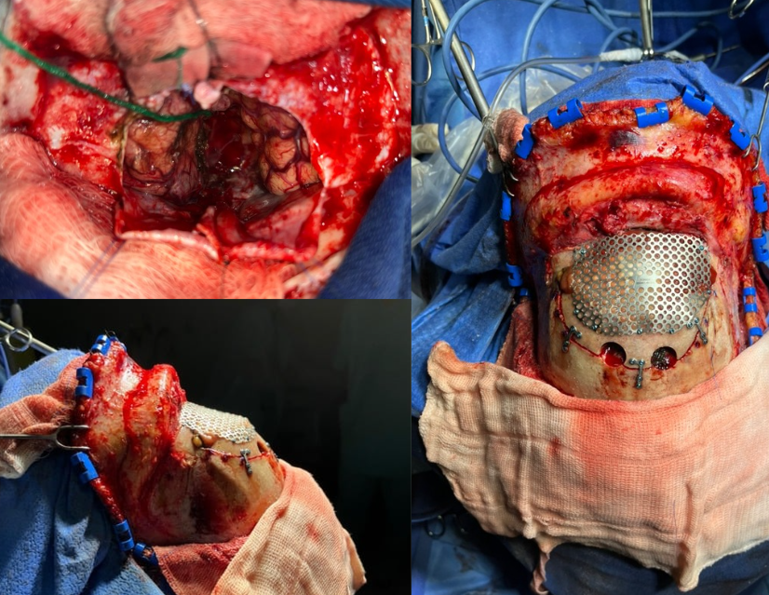
Image 4 - reconstruction with titanium mesh, plates and screws
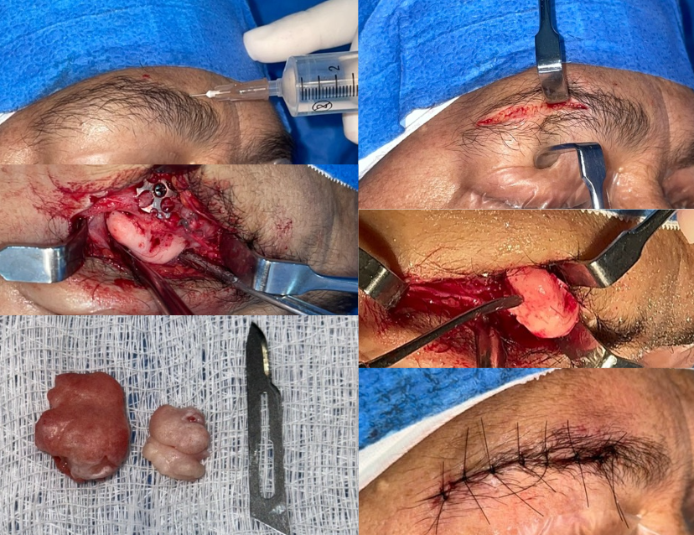
Image 5 - bone callus removal
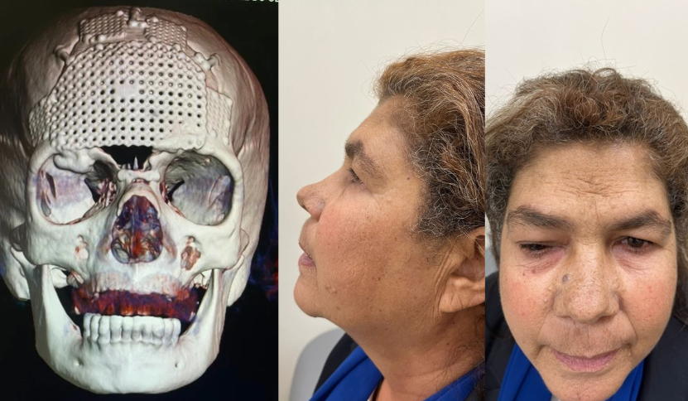
Image 6 - postoperative
3. discussion

The coexistence of a frontoethmoidal mucocele and meningioma is a rare but challenging condition that requires careful and multidisciplinary surgical management. Although the exact prevalence of this combination is unknown, the literature suggests that intracranial meningiomas represent approximately 36% of primary brain tumors, with extremely rare cases of involvement in the frontal sinus (Ostrom et al., 2020). Mucoceles, on the other hand, are more common in the frontal and ethmoidal sinuses, comprising about 65% of paranasal lesions diagnosed in adults (Magboul et al., 2023). This mixed condition can be attributed to factors such as secondary obstruction caused by the tumor or chronic inflammatory changes promoting the development of mucoceles (Campos et al., 2024).
The presented case highlights the need for a collaborative approach involving specialties such as neurosurgery, maxillofacial surgery, and otolaryngology, along with advanced diagnostic resources, to ensure optimal patient outcomes.
Although benign, mucoceles have the potential to cause significant destruction of adjacent structures due to their progressive expansion, bone erosion, and possible orbital or intracranial involvement. Studies such as those by Roncone (2020) highlight that frontal mucoceles are often associated with chronic obstruction of the sinus ostium, whether due to trauma, previous surgery, or chronic inflammation. In this study, 44.9% of mucoceles showed intraorbital or intracranial extensions, highlighting the severity of structural involvement. Additionally, CT scans were used to identify bone erosion, while MRI helped differentiate mucoceles from other lesions, reinforcing the need for a comprehensive diagnostic approach to plan treatment. When associated with meningiomas, as reported by Swain & Dubey (2023), there is evidence that the intracranial tumor may cause secondary obstruction, exacerbating symptoms and increasing the complexity of treatment.
Skull base meningiomas, especially those in the olfactory groove, can invade adjacent structures and coexist with other pathologies, as demonstrated in the reported case. The literature suggests that this relationship can be both causal and coincidental, given the rarity of this association (Wanyoike & Magoha, 2022).
In addition to the anatomical severity, there are important pathophysiological considerations. Obstruction of the nasofrontal duct, often attributed to the presence of the meningioma, can lead to mucus stagnation and subsequent mucocele formation. Studies suggest that this obstruction also contributes to increased local intracranial pressure, which may worsen clinical symptoms and accelerate lesion expansion (Tsitouridis et al., 2007).
Accurate diagnosis is essential for surgical planning and should include CT and MRI. Specific examples include identifying bone erosions and remodellings in CT, which often show a homogeneous expansile mass in the paranasal sinuses. MRI can highlight important differentiations such as hypointensity on T1 and hyperintensity on T2 for mucoceles and reveal the boundaries of meningiomas.
This case exemplifies the importance of multidisciplinary treatment and the need for a staged surgical approach to achieve successful outcomes in complex cases involving both intracranial and paranasal pathology. Collaboration between neurosurgery, maxillofacial surgery, and otolaryngology specialists is essential in ensuring the appropriate removal of lesions, minimizing the risk of recurrence, and addressing the anatomical consequences of combined lesions. Studies emphasize the significance of careful reconstruction and preservation of functional anatomy after tumor removal, particularly in challenging cases with concurrent sinus and brain involvement (Singh et al., 2019).

4. Conclusion

This case report highlights the importance of a multidisciplinary approach to the concurrent management of frontoethmoidal mucoceles and meningiomas. Proper preoperative imaging, careful surgical planning, and collaboration between specialties such as neurosurgery and maxillofacial surgery are essential to achieving favorable outcomes. The successful resection of both lesions and the patient's recovery without significant complications underscore the importance of a coordinated treatment strategy. This case contributes to the growing body of literature on the management of these complex, rare conditions and reinforces the need for further research into optimal treatment protocols and long-term outcomes.

Consent

All authors declare that ‘written informed consent was obtained from the patient (or other approved parties) for publication of this case report and accompanying images. A copy of the written consent is available for review by the Editorial office/Chief Editor/Editorial Board members of this journal.

Disclaimer (Artificial intelligence)
Option 1:
Author(s) hereby declare that NO generative AI technologies such as Large Language Models (ChatGPT, COPILOT, etc.) and text-to-image generators have been used during the writing or editing of this manuscript.
Option 2:
Author(s) hereby declare that generative AI technologies such as Large Language Models, etc. have been used during the writing or editing of manuscripts. This explanation will include the name, version, model, and source of the generative AI technology and as well as all input prompts provided to the generative AI technology
Details of the AI usage are given below:
1.
2.
3.

References

1. Adeloye, A. (1979). Co-existing meningioma and mucocele of the frontal sinus. The Journal of Laryngology and Otology, 93(11), 1121–1125.
2. Arias Marzan, F., de Lucas Carmona, G., Alvarez Florez, M., & Febles Garcia, P. (2010). Primary extracranial meningioma of the paranasal sinuses. Acta Otorhinolaryngologica Espanola, 61(3), 238–240.
3. Campos, L. T., Costa, M. L. da, Sousa, J. de A., & Melucci, B. H. (2024). Frontoethmoidal mucocele: case reports and literature review. Health Archives of the Journal, 5(3).
4. Chowdhury, R., Aldajani, A., Almhanedi, H., Al Majid, D., Tewfik, M. A., & Himdi, L. (2024). Paranasal sinus mucoceles with intraorbital and intracranial involvement: A case series analysis and surgical outcomes assessment. Annals of Otology, Rhinology & Laryngology.
5. Dennis, S. K., Steele, T. O., Gill, A. S., Hwang, J. C., Sarhadi, K. S., Cheema, K. S., Aulakh, S. S., Wilson, M. D., & Strong, E. B. (2023). Treatment outcomes with conservative management of frontal sinus outflow tract fractures. Otolaryngology–Head and Neck Surgery: Official Journal of the American Academy of Otolaryngology-Head and Neck Surgery, 169(6), 1455–1461.
6. Janković, D., Ahmetspahić, A., Splavski, B., Schmidt, L., Rotim, K., Tomasović, S., & Arnautović, K. (2023). Clinical and surgical characteristics of posterior fossa tumors in adults - Single-center experience of surgical management. Croatian Clinical Acta, 62(3), 502–509.
7. Jannelli, G., Calvanese, F., Jouanneau, E., & Jacquesson, T. (2023). Frontal trans-sinusal approach: How do I do it? Acta Neurochirurgica, 165(10), 2963–2968.
8. Magboul, N. A., Alzubaidi, A. A., Abumsmar, L. A., Alzarei, A., Al-Ahmari, M., & Alshehri, M. A. (2023). Mucocele of the paranasal sinuses: Retrospective analysis of a series of eight cases. Cureus, 15(7), e41986.
9. Mezouri, I., Bellefqih, S., Chenna, H., El Kacemi, H., Kebdani, T., & Benjaafar, N. (2014). Meningioma of the maxillary sinus: Report of a case with review of the literature. The Pan African Medical Journal, 18, 137.
10. Moniakis, A., Malli, A., Smponias, V., & Kasapas, K. (2024). Delayed post-traumatic frontal mucocele occurrence: A case report. Cureus, 16(8), e67108.
11. Naik, D., Aten, K., Lopez, D., & Patel, J. (2023). A real headache: Intracranial extension and epidural abscess as a complication of chronic mucocele. Cureus, 15(12).
12. Palladino, T. C., Law, W. H., Herfort, O. P., & Seo, S. S. (2024). Frontal sinus mucopyocele presenting as a subcutaneous subcutaneous head mass in a patient with chronic sinusitis. Rhode Island Medical Journal (2013), 107(9), 10–14.
13. Priambodo, R., & Sidabutar, R. (2024). AB090. A rare case report: Spheno-orbital meningioma with dural involvement. Chinese Clinical Oncology, 13(Suppl 1), AB090.
14. Rastin, M. S., & Rasouly, N. (2023). Giant ectopic mucocele presenting as a mass in the nasal region with intracranial extension, a case report. Radiology Case Reports, 18(1), 156-158.
15. Roncone, D.P. (2020). Frontoethmoidal mucocele presenting with ocular manifestations. Clinical and Experimental Optometry, 103(5), 610–617
16. Serry, P., Rombaux, P., Ledeghen, S., Collet, S., Eloy, P., Hamoir, M., & Bertrand, B. (2004). Extracranial sinonasal tract meningioma: A case report. Acta Oto-Rhino-Laryngologica Belgica, 58(4), 151–155.
17. Swain, S. K., & Dubey, D. (2023). Paranasal sinus mucoceles: A narrative review. Hamdan Medical Journal, 16(2), 69-73
18. Takeuchi, S., Tanikawa, R., Katsuno, M., Tsuboi, T., Noda, K., Oda, J., Miyata, S., Ota, N., & Kamiyama, H. (2015) . An effective method of frontal sinus reconstruction after bifrontal craniotomy: Experience with 103 patients. World Neurosurgery, 83(6), 907–911.
19. Talamonti, G., Fragale, M., Carrassi, E., Meccariello, G., Pozza, A., & Canzi, G. (2024). Surgical treatment of complex craniofacial fractures. World Neurosurgery, 183, e462–e469.
20. Tsitouridis, I., Michaelides, M., Bintoudi, A., & Kyriakou, V. (2007). Frontoethmoidal mucoceles: CT and MRI evaluation. The Journal of Neuroradiology, 20(5), 586-596.

