**Genetic Purity Assessment of Maize Hybrid (*Zea mays* L.) and its Parental Lines Employing SSR Markers**

**Abstract**

The success of hybrid seed production is determined by the genetic purity of parental lines. Hence, genetic purity testing of parental lines and hybrid is essential to verify any deviation from genuineness of the genotypes during multiplication and seed production programme. In order to check the genetic purity of parental lines of recently released maize hybrid MAH 15-84, an investigation was carried out to identify an ideal SSR marker for confirmation of hybridity of maize hybrid and its parental lines. The maize hybrid MAH 15-84 and the parents MAI-19-117 (female) and MAI-19-20 (male) were subjected to genetic purity testing employing twenty-one SSRs to identify the polymorphic marker to distinguish parental lines and hybridity confirmation. Among twenty-one primers, five primers namely umc1152, bnlg1371, bnlg1043, umc2071 and bnlg107 showed polymorphism between the parental lines and rest of primers exhibited monomorphic banding pattern. The unique banding pattern of these five primers revealed the presence of the PCR amplified products present in the female as well as the male parent, indicating the true hybridity.

**Key words:** Maize hybrid, SSR markers and Genetic purity

**Introduction:**

Maize, scientifically known as *Zea mays* L., is a member of the Poaceae family, with a diploid chromosome of 2n = 20. It holds a significant stature among cereal crops globally, closely trailing rice and wheat in both production and consumption. Originating in Central America, it is hailed as the "Miracle crop" or the "Queen of cereals" for its remarkable genetic yield potential. It is one of the most versatile emerging crops having wider adaptability due to its C4 plant status making it essential in sustainable agricultural practices (Kumar and Jhariya, 2013). With approximately 9.9 % protein, 4 % oil and 70 % starch, maize serves as a vital source of nutrients including vitamins A and E, riboflavin and nicotinic acid addressing the dietary requirements of a growing population (Gami *et al.,* 2018). Beyond its role as a staple food crop, maize exhibits versatility across various domains, including feed, fodder, industrial raw materials and biofuel production. This diverse range of applications has led to its designation as a "4F crop" (Food, Feed, Fuel and Fodder).

Globally, maize stands out as a leading cereal crop, cultivated on an area of 201 million hectares with a production of 1162 million tonnes and productivity of 5.75 tonnes per hectare (Anon, 2021). In India, maize ranks third position among cereals with a production of 33.73 million tonnes from an area of 9.95 million hectares and productivity of 3.38 t / hectare. Andhra Pradesh, Karnataka, Maharashtra, Rajasthan and Bihar together account for about 2/3rd of the total maize production in India (Anon, 2022). Among all states, Karnataka holds first place in maize production with 1.68 million hectares of area. This is about 17.0% of India's total area under cultivation, producing around 5.18 million tonnes which is 16.45% of all India production with a yield of 3092 kg / hectare (Anon, 2020).

Maintaining genetic purity is crucial, as mere one per cent impurity in hybrid seeds can lead to a substantial yield reduction of about 135 kg per hectare, underscoring the necessity of providing farmers with genetically pure seeds to preserve heterotic expression. The inadequacy of traditional morphological traits for purity testing necessitates the adoption of efficient techniques to uphold genetic integrity thereby ensuring superior seed quality and reducing production costs for the farming community (Liu and Wang, 2000).

Ensuring genetic purity of seeds entails employing a spectrum of methods, from traditional grow out tests (GOT) to cutting-edge sequencing techniques. Conventional morphological examination, deemed insufficient, costly and time-intensive, has prompted the adoption of advanced methods like protein, isozyme and DNA marker-based testing, with SSRs and SNPs emerging as especially crucial for hybrid purity assessment and genetic profiling (Jhansi *et al.,* 2015). DNA-based molecular markers, particularly SSRs or microsatellites, offer swift and precise testing using seed or plant tissue samples, owing to their locus-specific, PCR-based, co-dominant and highly polymorphic nature. These markers facilitate rapid and clear assessment of genetic purity by identifying parental polymorphism, thus ensuring efficient hybridity confirmation and seed quality (Farhad, 2017).

## Material and Methods:

MAH 15-84, a single cross high yielding hybrid suitable for cultivation under rainfed areas of Southern Karnataka obtained from crossing of female parent MAI-19-117 and male parent MAI-19-20 was subjected to finger printing. Primer pairs of twenty-one SSR markers were screened to identify the polymorphic marker to distinguish the parental lines. The primers used in the study along with their sequences are listed in Table 1.

### Genomic DNA extraction

Leaf samples of 18-21 days old seedlings of hybrid and their parental lines for DNA isolation were collected and sample was prepared for DNA isolation by surface sterilization with 70 % ethanol. The DNA was extracted from the leaves using the modified CTAB method of Hoisington *et al.* (1994). The extracted DNA was dissolved in 1× TAE buffer and stored at -200C.

**DNA Purification**

DNA purification involved treating the sample with RNAase (8 µl, 10 mg/ml) at 37°C for 30 minutes followed by proteinase K (2 µl, 100 µg/ml) for 15 minutes. An equal volume of phenol: chloroform: iso-amyl alcohol (25:24:1) was added, mixed by inversion and centrifuged at 12,000 rpm for 10 minutes. The supernatant was transferred mixed with chloroform: iso-amyl alcohol (24:1) and centrifuged again. DNA was spooled, pelleted at 14,000 rpm for 15 minutes, washed with 70% ethanol, air-dried and resuspended in TE buffer (100-200 µl).

**DNA Quantification**

DNA quality and quantity were checked using a 0.8% agarose gel. Agarose was dissolved in 1X TAE buffer mixed with ethidium bromide and poured into a tray to solidify. DNA samples and a Lambda DNA marker were loaded and electrophoresis was run at 50 V for 2-3 hours. The gel was visualized under UV and DNA quantity was estimated by comparing band intensity to the marker (Shete *et al.,* 2023).

### PCR Analysis

PCR analysis of maize hybrid and its parental lines was carried out using twenty-one SSR primer pairs. The volume of the reaction mixture was 20 µL, consisting of 50 ng/µL concentration of 2.0 µL of template DNA, ampliqon PCR mix of 2x concentration of 3.0 µL, 2.0 µL each of forward and reverse primers and 10.5 µL of sterile water.

#### **Table 1. List of primers with their nucleotide sequences**

|  |  |  |  |  |  |  |  |
| --- | --- | --- | --- | --- | --- | --- | --- |
| **Sl. No.** | **Primer** | **Nucleotide sequence (5'- 3 ')** | | **Sl. No.** | **Primer** | **Nucleotide sequence (5'- 3 ')** | |
| 1 | umc1139 | F | TTTGTAATATGGCGCTCGAAAACT | 12 | umc1419 | F | CTCATCACAACTAGCGCCACTCTA |
| R | GAAGACGCCTCCAAGATGGATAC | R | ATAGTGCAGAGGTCATCGTGGC |
| 2 | umc1152 | F | CCGAAGATAACCAAACAATAATAGTAGG | 13 | umc2084 | F | ATCGCGACGAGTTAATTCAAACAT |
| R | ACTGTACGCCTCCCCTTCTC | R | TACGATGTCTTCAGTGTGACACCA |
| 3 | phi126 | F | [TCCTGCTTATTGCTTTCGTCAT](https://www.maizegdb.org/data_center/primer?id=130895) | 14 | umc2310 | F | ACAACAGAAGAGGACGAGAGGAAG |
| R | GAGCTTGCATATTTCTTGTGGACA | R | GTCGCTTCTTCCTGAGCTTGAG |
| 4 | bnlg1371 | F | TTGCCGATAAGAACCAAACA | 15 | mmc0063 | F | ACACCCCTATCCAACATAAAT |
| R | ACGACCGGTGTGGTTACATT | R | TGCAAAATTAATTGATACATAG |
| 5 | bnlg1327 | F | TCTCTCTCGCGTGTGTGC | 16 | bnlg1200 | F | CGTCCTCGTTGTTATTCCGT |
| R | TGGGTCTCCTTCTCCGTCTA | R | GTTCCCTCTCTCCCTCCCTC |
| 6 | umc1085 | F | TACTGTGATGTGGCGGTGCT | 17 | umc2311 | F | GAGGCGCTATCACTGTCACAAC |
| R | GCCACCTCTCACAGGTCTCAC | R | CAGACTGGGTACCCTCATGCTT |
| 7 | umc1884 | F | TAGGAGCAGTATGAGAGGGCACTT | 18 | umc2071 | F | ACTGATGGTGTTCTTGGGTGTTTT |
| R | CTTTTTCTAGCGATCATTCTCCCA | R | ATACACGCAGTTACCCGAAGGTT |
| 8 | bnlg1043 | F | TTTGCTCTAAGGTCCCCATG | 19 | bnlg107 | F | GCAACTAGAAGTAGATGGCTTGTTATGG |
| R | CATACCCACATCCCGGATAA | R | CAACAACAAGTGGCTGGCTAGGGTGAA |
| 9 | phi117 | F | ATCGGATCGGCTGCCGTCAAA | 20 | umc1041 | F | CATTTCTTAGCACAACGCTGGTAAC |
| R | AGACACGACGGTGTGTCCATC | R | GCCACTGTGATTTCCCTTGTGT |
| 10 | bnlg1252 | F | GATTTTGCTTGAAGCCGAAG | 21 | umc1240 | F | GCAGCAGGTATTGGAAGTCGTAGT |
| R | GCTTTGCAGCACTGTCGTAG | R | CTGGTCCCTCAGGAAATCCAT |
| 11 | bnlg149 | F | CATCCTCCAAAAGCACTACGT |  | | | |
| R | CAGCTGTCCGACACTTATTCTGTA |

PCR amplification was carried out in the Applied Biosystems thermal cycler which consisted of initial denaturation at 95°C for 4 min followed by 35 cycles consisting of denaturation at 94°C for 0.35 min, 0.45 min at respective annealing temperature of primer, extension at 72°C for 1 min. Final extension was at 72 °C for 8 min. These steps were followed by infinite time at 4°C for holding. The PCR product was loaded on 3 % agarose gel in 1X TAE buffer stained with 5 μl ethidium bromide. Amplicons were separated in an electrophoresis unit at 90 V for three hours using 1X TAE buffer. The gel was visualized under UV transillumination and captured in a gel documentation system (BioRad). The amplified PCR products for hybrid and parental lines were scored manually by using 100 bp ladder loaded alongside as reference.

##### Results and discussion:

The SSR primer umc1152 amplified a specific allele of size 220 bp for female parent (MAI-19-117) and 200 bp for male parent (MAI-19-20), whereas the hybrid (MAH 15-84) exhibited both 220 bp and 200 bp amplified products (Fig. 1). The SSR primer bnlg1371 produced a distinct amplified product of 250 bp corresponding to female parent and 180 bp corresponding to male parent, while the hybrid showed both 250 bp and 180 bp PCR amplified products on agarose gel (Fig. 1). Thus, presence of both female and male parent alleles confirmed the crossing and hybridity between two parents.

Similarly, the SSR primers umc2071 and bnlg107 showed the distinct PCR amplified products of 225 bp and 300 bp, respectively for female parent (MAI-19-117) and amplified products of 190 bp and 220 bp for male parent (MAI-19-20), respectively. The hybrid MAH 15-84 showed the presence of both male and female specific amplified products for these primer sets (Fig. 2).

The primer bnlg1043 scored 180 bp size amplified product for female parental line (MAI-19-117) and amplified product of 160 bp for male parental line (MAI-19-20). While, the hybrid showed presence of both female and male specific PCR amplified products (Fig. 3). These findings confirmed the heterozygous nature of single cross maize hybrid (MAH 15-84) by scoring polymorphic and unique DNA bands from the parental lines, indicating the true hybridity.

The primers umc1139, phi126, bnlg1327, umc1085, umc1884, phi117, bnlg1252, bnlg149, umc1419, umc2310, umc0063, bnlg1200, umc2311, umc1041 and umc1240 showed monomorphic banding pattern. Which means, in both parents (female-MAI-19-117 and male- MAI-19-20) and their hybrid offspring exhibited same band length at a specific SSR locus, indicating monomorphism. This locus was non-informative for hybridity testing, necessitating the use of additional polymorphic SSR markers for accurate hybrid confirmation.

On the other hand, the primer umc2084 amplified a specific allele of size 120 bp in the male parent (MAI-19-20) which was also present in the hybrid (MAH 15-84). This confirms the inheritance of the male parent's allele in the hybrid, supporting its hybridity. This finding is useful for confirming the hybrid status of MAH 15-84, as it demonstrates the inheritance of a parental allele. It also highlights the utility of the umc2084 primer for distinguishing genetic contributions from the male parent in hybridity testing.

The SSR markers which generated distinct PCR amplified products in both female and male parental lines are too valuable in genetic purity testing. Hence, the SSR markers umc1152, bnlg1371, bnlg1043, umc2071 and bnlg107 identified in this study could be used effectively to establish the distinctness, identity and purity of hybrids and their parental lines during various stages of seed production programme. The utility of SSR markers for hybridity and seed genetic purity analysis of maize was demonstrated earlier by several workers (Cholastova *et al.,* 2011; Malik, *et al.,* 2020; Desai *et al*., 2022, Neelothpala, 2022).

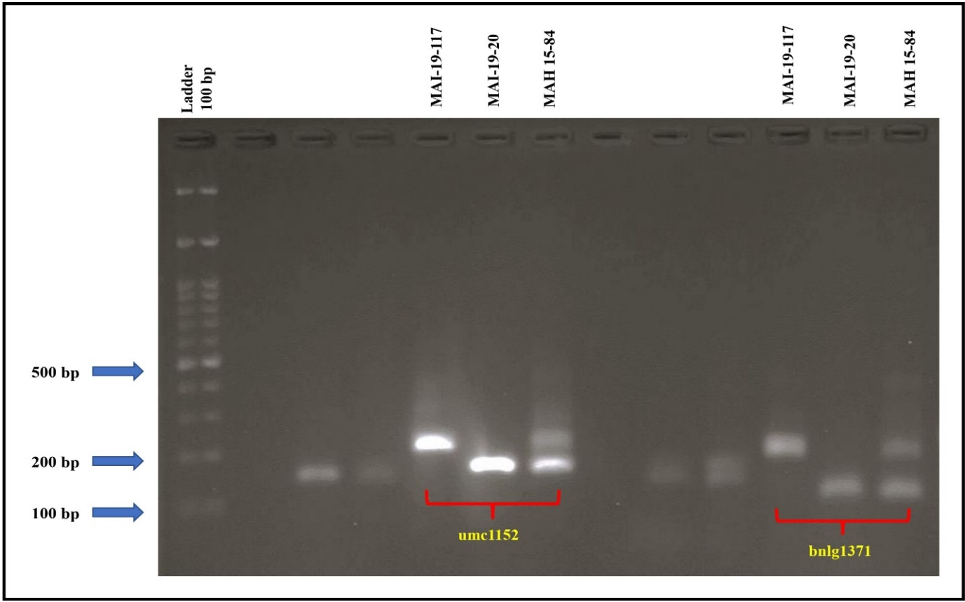

**Fig. 1. Gel picture showing the banding pattern to confirm hybridity of maize hybrid MAH 15-84 with SSR markers umc1152 and bnlg1371**

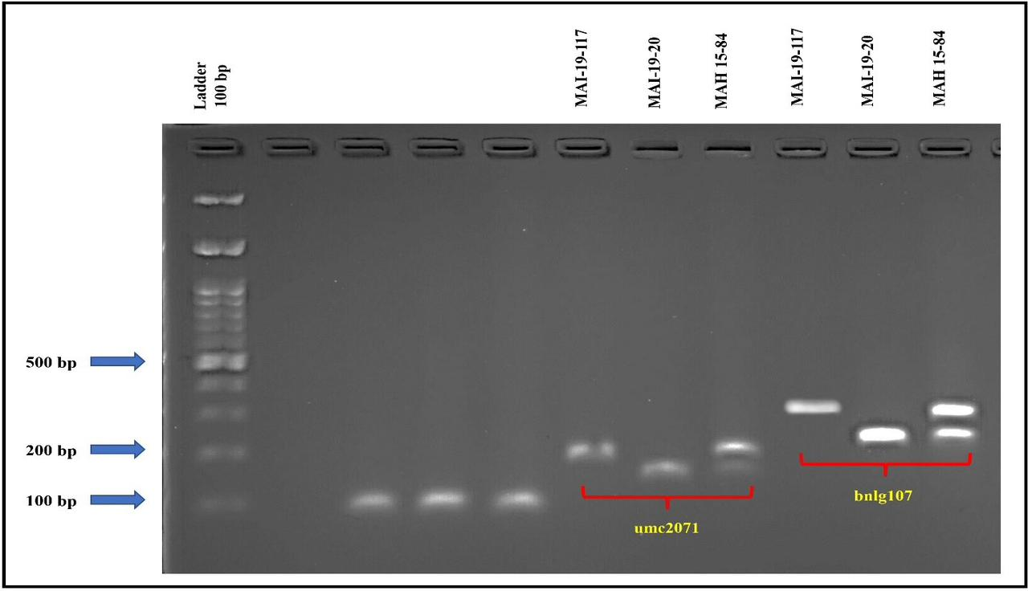

**Fig. 2. Gel picture showing the banding pattern to confirm hybridity of maize hybrid MAH 15-84 with SSR markers umc2071 and bnlg107**

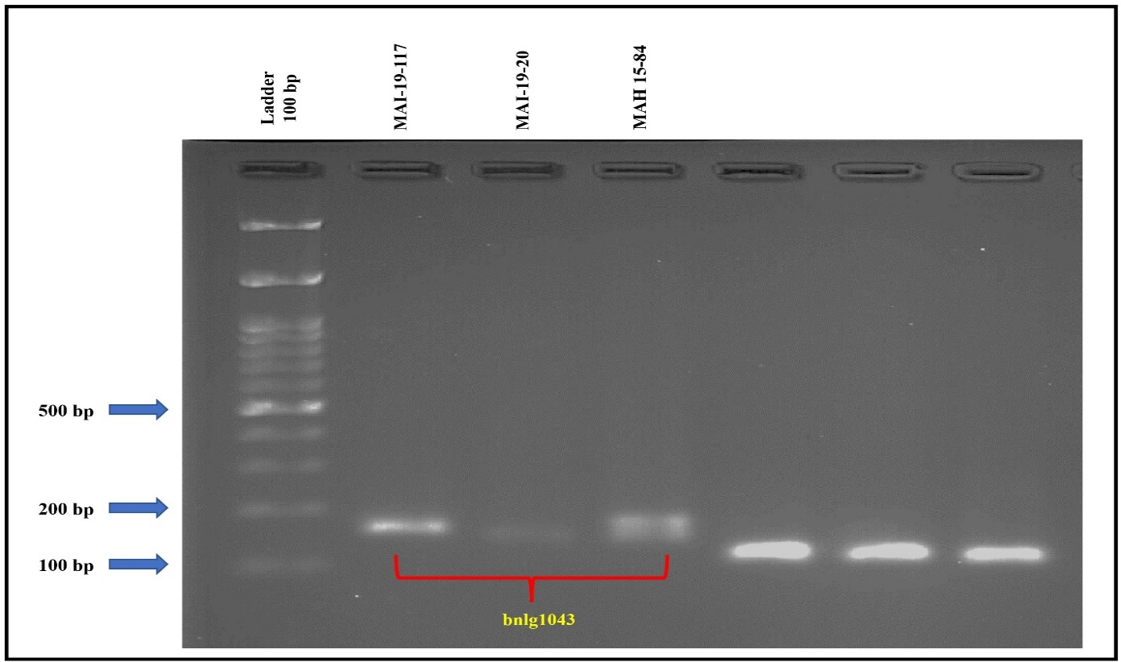

**Fig. 3. Gel picture showing the banding pattern to confirm hybridity of maize hybrid MAH 15-84 with SSR marker bnlg1043**

**Conclusion:**

The maize hybrid MAH 15-84 and the parents MAI-19-117 (female) and MAI-19-20 (male) were subjected to genetic purity testing employing twenty-one SSRs to identify the polymorphic marker to distinguish parental lines and hybridity confirmation. Among twenty-one primers, five primers namely umc1152, bnlg1371, bnlg1043, umc2071 and bnlg107 showed polymorphism between the parental lines and rest of primers exhibited monomorphic banding pattern. Hence, these five markers could be potentially used in hybridity confirmation of maize hybrid MAH 15-84 and in genetic purity testing.

**Acknowledgement:**

The authors are greatly thankful to Department of Seed Science & Technology and AICRP on Pigeonpea, ZARS, University of Agricultural Sciences, GKVK, Bengaluru for providing laboratory facilities and financial support to carry out the research work.

Disclaimer (Artificial intelligence)

Option 1:

Author(s) hereby declare that NO generative AI technologies such as Large Language Models (ChatGPT, COPILOT, etc.) and text-to-image generators have been used during the writing or editing of this manuscript.

I declare that, NO generative AI technologies are use in this research article as of my knowledge

Option 2:

Author(s) hereby declare that generative AI technologies such as Large Language Models, etc. have been used during the writing or editing of manuscripts. This explanation will include the name, version, model, and source of the generative AI technology and as well as all input prompts provided to the generative AI technology

Details of the AI usage are given below:

1.

2.

3.

## References:

Anonymous, 2020, Maize vision 2022 a knowledge report. FICCI New Delhi, pp. 1-77.

Anonymous, 2021, FAO Stat. FAO, Rome. http://www.fao.org/faostat.

Anonymous, 2022, Ministry of agriculture and farmers welfare. Department of agriculture and farmers welfare. Directorate of economics and statistics. Annual Report at a Glance. [www.agricoop.nic.in](http://www.agricoop.nic.in).

Cholastova T, Soldanova M, Pokorny, R. Random amplified polymorphic DNA (RAPD) and simple sequence repeat (SSR) marker efficacy for maize hybrid identification. Afr. J. Biotechnol. 2011; **10**(24): 4794-4801.

Desai SP, Lohithaswa HC, Ravikumar RL, Rao AM. 2022, SSR Marker Assay-based selection of parents for the development of multiparent segregating population in maize (*Zea mays* L.). Mysore J. Agric. Sci. 2022; **56**(1): 327-334.

Farhad G. Advances in genetic purity testing. Seed world, 2017; **5**: 30-33

Gami RA, Chauhan RM, Patel MS, Patel JA, Solanki SD. Line×Tester analysis for kernel yield and component traits in maize (*Zea mays* L.). Res. Crops, 2018; **19** (3): 465-471.

Hoisington D, Khirallah M, Gonzalez-de-leon D. Laboratory Protocols: CIMMYT Applied Molecular Genetics Laboratory. 2nd Edition. 1994. CIMMYT, Mexico.

Jhansi G, Surender M, Aparna S, Sunitha B. DNA finger printing of maize hybrids and development of molecular ID’s using SSR markers. Res. J. Agril. Sci. 2015; **6**(1): 43-47.

Kumar D, Jhariya AN. Nutritional, medicinal and economical importance of corn: A mini review. Res. J. Pharm Sci. 2013; **2**(7): 1-6.

Liu L. Wang Y. Identification of maize seed purity based on electrophoresis. Seed World. 2000; **21**: 11-28.

Malik N. Kumar D. Babu BK. Analysis of genetic divergence and population structure through microsatellite markers in normal and quality protein maize genotypes from NW Himalayan region of India. Vegetos, 2020; **33**(1): 194-202.

Neelothpala M. Genetic purity assessment of maize hybrids using morphological and microsatellite markers. Ph. D. Thesis, PJTS Agril. Univ. 2022. Hyderabad, Telangana, India.

Shete GS, Nikam SD, Surbhaiyya SD, Jadhav MP. Thakare TN. Analysis of genetic diversity in maize (Zea mays L.) variety using SSR Markers. Int. J. Plant Soil Sci*.* 2023; **35**(15):205-212.