Original Research Article

Characterization and evaluation of the biological activities of ulvan extracted from Ulva lactuca with a focus on the antiviral activity against herpes simplex virus type 1

.
ABSTRACT

Aims: Physicochemical characterization and evaluation of the cytotoxic, antioxidant, antibacterial and antiviral activities of the ulvan polysaccharide, extracted from Ulva lactuca, with emphasis on its action against herpesvirus type 1 (HSV-1).
Study design: The study followed an experimental design focusing on the bioactive properties of ulvan, involving tests against the HSV-1 virus, in addition to the evaluation of its cytotoxic, antioxidant and antibacterial properties.
Place and Duration of Study: This research was conducted at the Laboratory of Biochemistry and Molecular Biology of Microorganisms and Plants (BIOMIC) in conjunction with the Center for Research in Biodiversity and Biotechnology (BIOTEC), located at the Federal University of Delta do Parnaíba, state of Piauí, Brazil.
Methodology: Ulvan was obtained from the macroalgae Ulva lactuca collected on Coqueiro beach, in the city of Luis Correia, state of Piauí. The polysaccharide was characterized and evaluated for its biological activities. The antioxidant capacity was evaluated by the ABTS (2,2'-azinobis(3-ethylbenzenethiazoline-6-sulfonic acid)) radical scavenging assay, the cytotoxicity was evaluated by the MTT (3-(4,5-dimethylthiazol-2-yl)-2,5-diphenyltetrazolium bromide) test, and the antibacterial activity was evaluated by the minimum inhibitory concentration (MIC) technique. The percentage of HSV-1 inhibition was verified by titrations of the pretreatment assays of cells (PTC) and viral particles (PTV) with ulvan. The atomic force microscopy (AFM) technique was used to observe possible changes that ulvan could cause in the structure of HSV-1, in addition to verifying the dimensions of the particles between the control and the viral treatment with ulvan.
Results: Ulvan did not show antibacterial activity against the tested strains. However, it showed ABTS radical scavenging and reducing activity, in addition to low cytotoxicity with CC⁵⁰ above 8,805 µg/mL and viral inhibition percentages of 65% and 88%. Through AFM images, a decrease in HSV-1 particles was observed after treatment with ulvan, which decreased from 150 nm to 79 nm, indicating that there was possible damage to the viral envelope.
Conclusion: This study provided valuable information into the biological activities of ulvan, providing unique insights into the mechanism of action of the polysaccharide against HSV-1. These results help advance knowledge on the use of marine polysaccharides as biomaterials, while contributing to new advances in the discovery of antiviral materials.

Keywords: Ulva lactuca; ulvan; sulfated polysaccharide; antioxidant; cytotoxicity; antibacterial; antiviral; herpesvirus

1. INTRODUCTION

Herpes simplex virus type 1 (HSV-1) infection is a cosmopolitan disease, affecting approximately 67% of the world's population, corresponding to 3.75 billion individuals aged ≥ 49 years (Pliego-Cortés et al., 2022). Commercially available antivirals used in the therapy of several viruses have some disadvantages, such as side effects due to their toxicity and the rapid selection of viral strains resistant to treatment (Paula et al., 2018). Such is the case of the resistance of the HSV-1 virus to acyclovir, which is the drug used as the gold standard for its treatment (Schalkwijk et al., 2022). Sulfated polysaccharides open new promising pharmacological perspectives for the development of antiviral drugs, since studies indicate that antiviral activity represents one of the most relevant biological functions of these molecules (Lu et al., 2021). Marine organisms, especially algae, are rich sources of sulfated polysaccharides, which have unique structures and demonstrate virucidal effects against several types of viruses (Lu et al., 2021). In the literature, it is possible to confirm the existence of several sulfated polysaccharides found in algae being used as antiviral bioactive agents, including fucoidans (Sun et al., 2020), carrageenans (Boulho et al., 2017), exopolysaccharides (Hasui et al., 1995), agarans (Duarte et al., 2004) and ulvans (Hardouin et al., 2004; Lopes et al., 2017). Some studies carried out with ulvans have already demonstrated significant activity against HSV-1, as demonstrated by Lopes et al (2017), who observed a 50% decrease in HSV-1 plaque-forming units using ulvan and attributed the antiviral action to the high degree of sulfation of the molecules. In addition to its activity against HSV-1, ulvan may also have activity against other types of viruses. As demonstrated by stude of Chiu et al. (2011), where they observed that ulvan can block the adsorption and entry of Japanese encephalitis virus (JEV) into VERO cells. In a more recent study, Chi et al. (2020a) evaluated the antiviral activity of ulvan against vesicular stomatitis virus (VSV) and observed that the fractions with higher molecular weight showed antiviral activity, inhibiting infection and replication of the virus. In another study, Binsuwaidan et al. (2024) showed that ulvan may also have activity against severe acute respiratory syndrome coronavirus 2 (SARS-CoV-2) through virucidal activity, inhibition of viral replication, and interference with viral adsorption.This polysaccharide, found in green macroalgae of the phylum Chlorophyta, is one of the most complex sulfated polysaccharides in existence. This biopolymer has a complex and branched conformation, does not have an exact structure or simple repeating unit, and does not have long chains of the same sugar (Tziveleka et al., 2019). The structure of these heteropolysaccharides, which are polyanionic, is most commonly composed of α- and β-(1,4)-linked monosaccharides (rhamnose, xylose, glucuronic acid, and iduronic acid) with characteristic repeating disaccharide units (Kidgell et al., 2019). The main repeating disaccharide in ulvan is actually two types of aldobiuronic acid called ulvanobiuronic acids type A3s (Fig. 1a) and B3s (Fig. 1b). Ulvanobiuronic acid type A3s, one of the most common disaccharide units, consists of β-D-glucuronic acid (1,4)-linked to α L-rhamnose 3-sulfate, whereas in type B3s α-L-iduronic acid (a C-5 epimer of glucuronic acid) is (1,4)-linked to α-L-rhamnose 3-sulfate (Lahaye et al., 1998a). In some cases, the uronic acids are replaced by xylose or sulfated xylose residues. In this situation, the disaccharides are called ulvanobioses and symbolized as U3s (ulvanobiose 3-sulfate) (Fig. 1c) and U2'S,3S (ulvanobiose 2',3-disulfate) (Fig. 1d) (Lahaye et al., 1998a; Lahaye et al., 1998b; Robic et al., 2009).
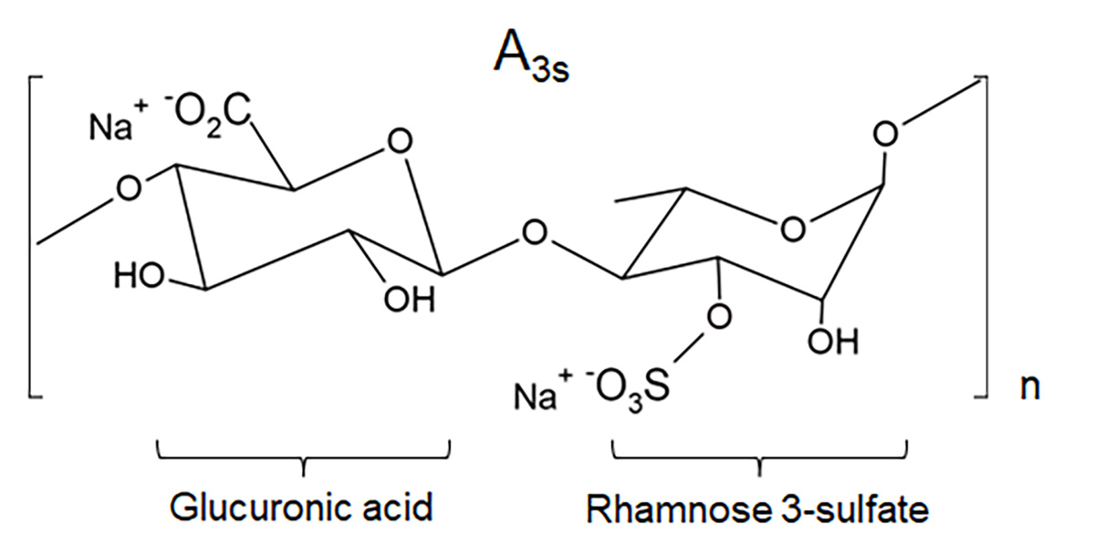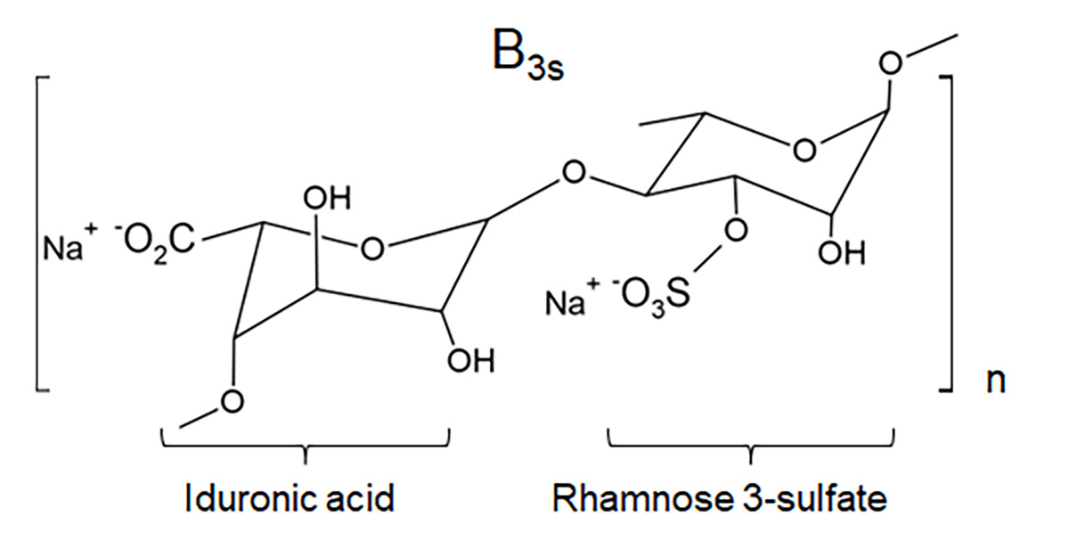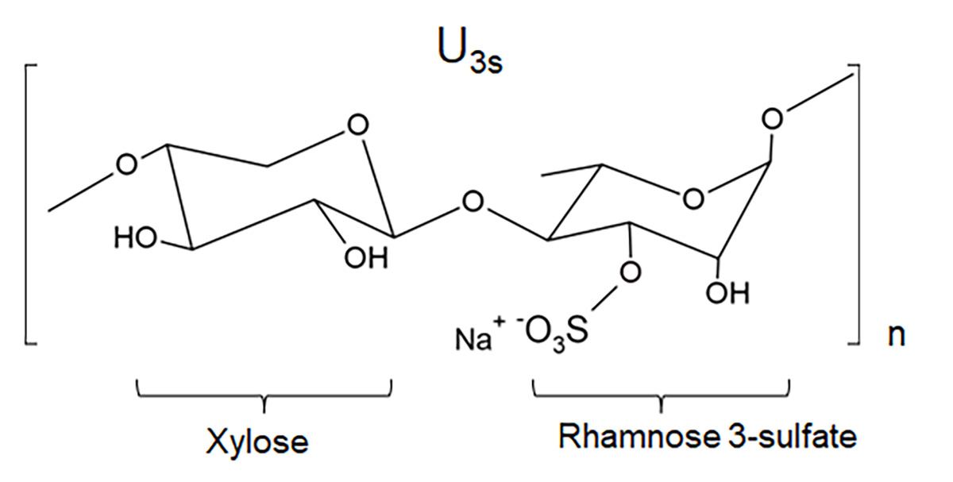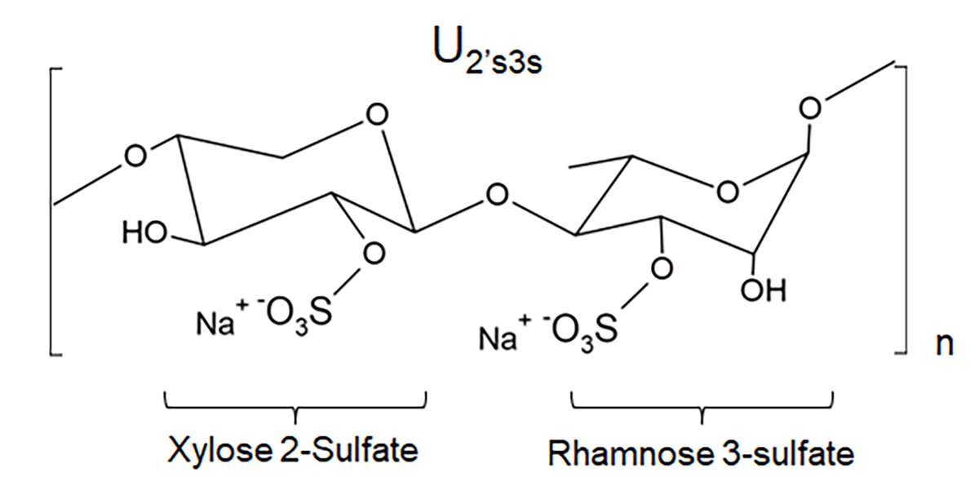
(b)
(a)
(d)
(c)

Fig. 1. Description and organization of the main repeated disaccharides in ulvan, the ulvanobiuronic acids types A3S and B3S and the ulvanobioses U3S and U2’S,3S. A3S.
(a) A3S ulvanobyronic acids with glucuronic acid linked to rhamnose 3-sulfate; (b) B3S ulvanobyronic acids with iduronic acid in place of glucuronic acid, also linked to rhamnose 3-sulfate; (c) U3S ulvanobinoses composed of rhamnose 3-sulfate linked to xylose, (d) xylose may have a sulfate group, as present in U2′s,3s.

These unique structural features of ulvan, together with its wide range of biological activities, including antiviral, antioxidant, and antibacterial, have attracted significant attention to for this molecule (Binsuwaidan et al., 2023; Maray et al., 2023). Furthermore, its tunable physical and chemical properties reinforce its potential as a material for various therapeutic applications (Tziveleka et al., 2019). Although previous research has demonstrated the extensive antiviral activity of ulvan, few studies have also focused on analyzing the effects that the polysaccharide can cause on the structure of viral particles. Thus, in the present study, ulvan obtained from Ulva lactuca was characterized and evaluated for its cytotoxic, antioxidant, antibacterial and antiviral activities, with a focus on the activity of ulvan on HSV-1 particles.

2. methodology

2.1 Collection of raw materia

The algae was collected at Coqueiro beach, located in the municipality of Luis Correia, coast of Piauí - Brazil (2°54'18.00'' S 41°34'27.00” W) during low tide (0.1 m). The species identified as U. lactuca was registered under no. 6800 in the Herbarium of the Parnaíba Delta – (HDELTA). The algae were washed, dried, ground and stored for later extraction.

2.2 Aqueous Extraction of Ulvan

The aqueous extraction and purification method of ulvan was performed according to Rodrigues et al. (2010) with some modifications. Initially, the raw material was suspended in distilled water at a dilution of 1:10 (m/v), at 80°C under constant stirring for 2 hours. After filtration and removal of residues, the polysaccharides present in the filtrate were precipitated with pure ethanol in a ratio of 1:2, and kept for 24 hours under refrigeration. Then, the material was centrifuged and the precipitate washed twice with ethanol and twice with acetone in a ratio of 1:2 (Fig. 2). Finally, the samples were dried in a hot air flow to obtain the pure polysaccharides and the yield was calculated.

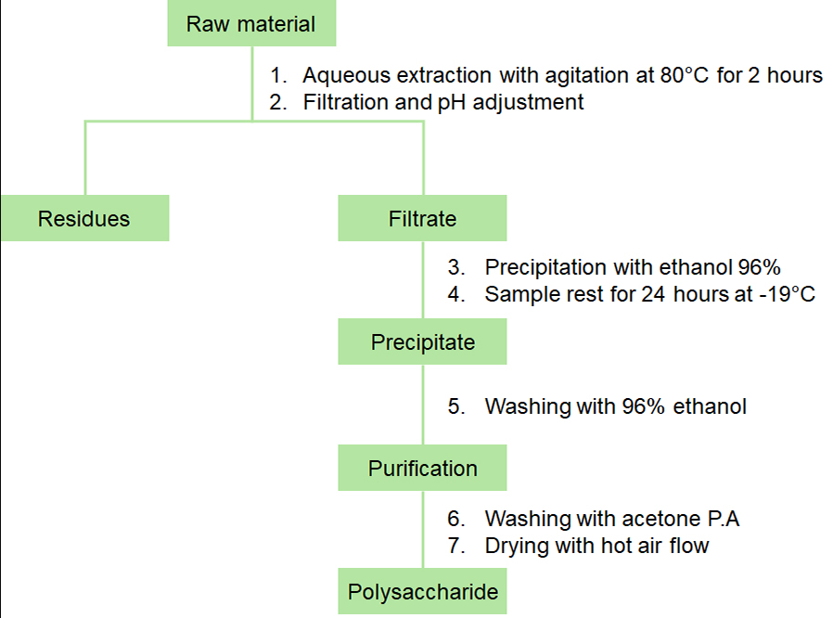

Fig. 2. Flowchart of aqueous extraction of ulvan obtained from the alga U. lactuca.

2.3 Protein content

The concentration of soluble proteins in the samples was determined by the Bradford methodology (1976). Aqueous solutions of the polysaccharide were prepared and mixed with the Bradford reagent. The absorbances of the samples were measured at 595 nm and the protein concentration was calculated based on the absorbance data of the calibration curve generated, using bovine serum albumin as the standard protein.

2.4 Zeta Potential

In the present study, zeta potential measurements were performed on the Malvern Zetasizer Nano ZS90 instrument. For each analysis, samples were diluted in ultrapure water at a ratio of 1:10. Samples were analyzed in triplicate at 25 °C.

2.5 Elemental analysis of Carbon, Hydrogen, Nitrogen and Sulfur.

Elemental analysis of carbon, hydrogen, nitrogen and sulfur of the polysaccharide was performed using the Elementary Analyzer - Perkin Elmer 2400 series II in CHNS mode, with a thermal conductivity detector.

2.6 Determination of Molar Mass by Gel Permeation Chromatography (GPC).

The molar mass distribution was determined by gel permeation chromatography in a Shimadzu LC-20AD equipment coupled to a refractive index detector (RID-10A). Origin software, version 9.65, was used for data processing. A polysep linear column, 300 x 7.8 mm, with sodium nitrate (aq) 0.1 mol/L as eluent was used. The measurement was made at 30°C, with a flow rate of 1 mL/min and the injected volume of the sample was 50 µL. Using the following curve:

$$Log M=14,52278-1,16825 x Ve$$

2.7 Fourier transform infrared vibrational absorption spectroscopy (FTIR).

The characterization of the ulvan produced was performed by FT-IR using the Attenuated Total Reflection (ATR) technique, with a wavelength range of 4000 to 500 cm⁻¹. The equipment model used was the Nicolet model iS5 - iD7 from Thermo Fisher Scientific, in absorbance module.

2.8 Antioxidant activity

The antioxidant potential assay of ulvan was performed by capturing the ABTS•⁺ radical in a 96-well microplate according to the methodology of Torres et al. (2017), with some modifications in the solvent solution. The ABTS solution (7 mM) reacted with potassium persulfate (140 mM) to form the ABTS•⁺ cationic radical for 16 h at room temperature. After the reaction, it was diluted in ultrapure water to an absorbance between 0.8-1 at 734 nm. Trolox was used as a standard. All samples were diluted in water and the absorbance was measured after 20 min of reaction in the dark. The results were processed in GraphPad Prism 8.0.1 software. The values ​​were also expressed by the Inhibition Percentage (IP) according to Gião et al. (2007), according to the equation below:

$$PI=\left(\frac{Abs ABTS·^{+}-Abs sample}{Abs ABTS·^{+}}\right)×100$$

2.9 Cell and virus culture

Cytotoxicity and antiviral activity assays were performed using VERO cells (ATCC CCL81). The cells were maintained in Dulbecco's MEM medium (DMEM) supplemented with 5% fetal bovine serum (FBS), penicillin/streptomycin, and amphotericin at 37°C in 5% CO². The virus propagated in the VERO cell line was the HSV-1 EK strain. After virus titration, the viral stock was distributed into sterile tubes, which were stored at -80°C until use. Viral production and purification were performed as previously described by Campos and Kroon (1993), obtaining a titer of 1.0 x 10⁷pfu/mL.

2.10 Cytotoxicity assay

Cytotoxicity analysis was performed as described by Mosmann (1986) using the MTT method. VERO cells were seeded in 96-well plates at an initial density of 5 × 10⁵ cells per well. After this step, the cells were incubated for 4 h at 37 °C in 5% CO². Different concentrations of ulvan ranging from 13,000 µg/mL to 101 µg/mL were added to the culture medium and incubation was continued for 72 h. MTT solution at a concentration of 0.5 mg/mL was added to the wells and then incubated again for 4 h. Excess MTT was removed from each well and dimethyl sulfoxide (DMSO) was used to dissolve the formazan crystals. Optical density (OD) was measured using an ELISA plate reader (BioSystems model ELx800) at a wavelength of 540 nm. Cytotoxicity was expressed as 50% cytotoxic concentration (CC⁵⁰), which was the concentration that reduced cell viability by 50%. Data were processed using GraphPad Prism 8.0.1 software.

2.11 Antibacterial activity

To evaluate the antibacterial activity of ulvan, the minimum inhibitory concentration (MIC) technique was used, following the guidelines of the Clinical Laboratory Standards Institute – CLSI (CLSI. 2018). The bacterial strains chosen for the test were Staphylococcus aureus ATCC 29213, Enterococcus faecalis ATCC 29212, Pseudomonas aeruginosa ATCC 27853, Escherichia coli ATCC 25922. The microorganisms were cultured on nutrient agar in a bacteriological incubator at 35 ± 2 ºC under aerobic conditions for 24 hours. After the incubation period, the bacteria were diluted in 0.85% (w/v) sodium chloride (NaCl) solution. The McFarland scale was adjusted using a Shimadzu UV1800 spectrophotometer at a wavelength of 625 nm, with an OD according to the McFarland scale 0.5 (1–2 × 10⁸ CFU/mL), for the test, bacterial suspensions were prepared at a concentration of 5 × 10⁵ CFU/mL. The serial dilution method was employed, using a 96-well plate (Sousa et al., 2024). The bacteria were exposed to treatment with an ulvan solution, which was previously autoclaved at 1 atm and a temperature of 121ºC for 15 minutes. The concentrations of the assay dilutions ranged from 1000 to 31.35 µg/mL. To ensure the effectiveness of the test, sample sterility control, medium sterility control, and growth control were performed.

2.12 Antiviral trials

Ulvan was tested for its activity against HSV-1. All experiments were performed on VERO cells seeded in 6-well plates at a density of 5 X 10⁵ cells/mL. In the viral control (CV), cells were infected with HSV-1 using MOI 1. To determine the percentage viral inhibition of ulvan, viral titrations were performed (Baer et al., 2014).

2.12.1 Evaluation of antiviral activity with pretreatment of cells with Ulvan (PTC).

The antiviral activity of ulvan was evaluated using VERO cells (5x10⁵ cells/mL), which were pretreated with polysaccharide (PTC) at 1000 µg/mL for 30 minutes. After this period, the cells were infected with HSV-1 and underwent an adsorption process for 60 minutes. After this time, DMEM medium with 2% FBS was added, and the plate was incubated for 48 hours at 37 °C and 5% CO². Finally, the supernatant of the plates was collected for viral titration.

2.12.2 Evaluation of ulvan activity on viral particle (PTV)

To evaluate the antiviral activity of ulvan directly on the viral particle (PTV), a viral suspension of HSV-1 was incubated with an ulvan solution at a concentration of 1000 µg/mL. The suspension was left under interaction for 30 minutes. After this period, this suspension was used to infect VERO cells (5x10⁵ cells/mL), and after one hour of adsorption, DMEM medium with 2% FBS was added, and the plate was incubated for 48 hours at 37 °C and 5% CO². Subsequently, the supernatant of the plates was collected for viral titration.

2.13 Morphostructural analysis by atomic force microscopy (AFM)

For AFM analysis, three different solutions were prepared at a concentration of 1000ug/mL; the ulvan control solution (CP), virus control solution (CV) and the virus treatment solution with ulvan (PTV). Only the PTV solution was left to stand for 30 minutes before being filtered. At the end of the preparation of the solutions, all were filtered with 0.45µL diameter filters and subsequently a 10 µL aliquot was deposited under each mica slide. The mica was left at room temperature to dry. Then, two washes with water were performed, followed by drying at room temperature, before analysis in the equipment. AFM images were obtained in a TT-AFM equipment (AFM Workshop - USA) using the intermittent contact mode with a TED PELLA tip (TAP300-G10) at an amplitude frequency of 289 kHz. Images were processed using Gwyddion 2.60 software and particle size data were processed using GraphPad Prism 8.0.1 software.

2.14 Statistical analysis

Statistical analysis of the experiments was performed using GraphPad Prism 8.0.1 software. The results obtained were evaluated by ANOVA with Tukey's post-test and by one-way analysis of variance. With different levels of significance varying in each experiment (P < 0.01, P < 0.05 and P < 0.001) and measurements between the control and treated groups. All assays were performed in triplicates (n = 3).

3. results and discussion

In the present study, we characterized and performed the biological evaluation of ulvan extracted from the macroalgae U. lactuca. The polysaccharide yield after aqueous extraction was 13% (Table 1), higher than that recorded in some studies, such as the study by Hernández-Garibay et al. (2010), carried out with algae of the same genus, which obtained a yield of 7.72%. The yield of algal polysaccharides can be influenced by factors such as collection period, morphology, habitat, stage and extraction method (Vandanjon et al. 2023).

Table 1. Physicochemical characterizations performed with ulvan obtained from the aqueous extraction of the U. lactuca algae.

Characterizations | Results
Yield | 13%
Proteins | 0,11 µg/mL
Zeta Potential | - 25.7 mV
Elementary Analysis of NHSC | N = 4.3%; H = 5.5%; S = 5.0% and C = 26.0%
Molar mass | M_{Pk} = 8.63 x 10⁵ ; Mn = 1.16 x 10⁴; Mw = 9.46 x 10⁵; IPD = 8.13 x 10¹
*Mpk = Peak Molar Mass
*Mn = Number average molecular weight
*Mw = Weighted average molecular weight
*IPD = Polydispersity index

When determining the protein content of ulvan, the value found was 0.11 µg/mL (Table 1), corresponding to approximately 0.1%. This small amount found in the sample can demonstrate the efficiency of the extraction method in relation to the purity of the sample. Kidgell et al. (2019) observed variations in protein content between species of the genus Ulva ssp, with U. lactuca presenting 0% and Ulva reticulata 9.4%, demonstrating that both the extraction method and the species of algae can influence the protein content. In the elemental analysis (Table 1), ulvan showed contents of 26% carbon, 5.5% hydrogen, 4.3% nitrogen and 5% sulfur, values ​​similar to those found by Glasson et al. (2017) in other algae species such as Ulva ohnoi. Variations in these values ​​can be attributed to differences in environmental conditions and also to the extraction processes (Madany et al., 2021). In the surface charge analysis, ulvan presented a charge of -25.7 mV (Table 1), demonstrating that the polysaccharide is anionic and stable (Dominguez-Martinez et al. 2016), which is important for its interaction in colloidal solutions (Ahmed et al. 2016; Guidara et al. 2019). In the GPC analysis of ulvan, a monomodal polydisperse profile was observed, with an elution volume peak close to 7.36 mL at its apex and a small shoulder close to 9.58 mL (Fig. 3), average molecular weight (Mw) of 9.46 x 10⁵ and low polydispersity (IPD) of 8.13 x 10¹ with peak molar mass (Mpk) of 8.63 x 10⁵ and numerical molar mass of 1.16 x 10⁴ (Table 1). These values ​​are similar to those found in other studies carried out with U. lactuca, and indicate that the molecular weight of the polysaccharide may be linked to the extraction conditions (Wahlstrom et al. 2020).

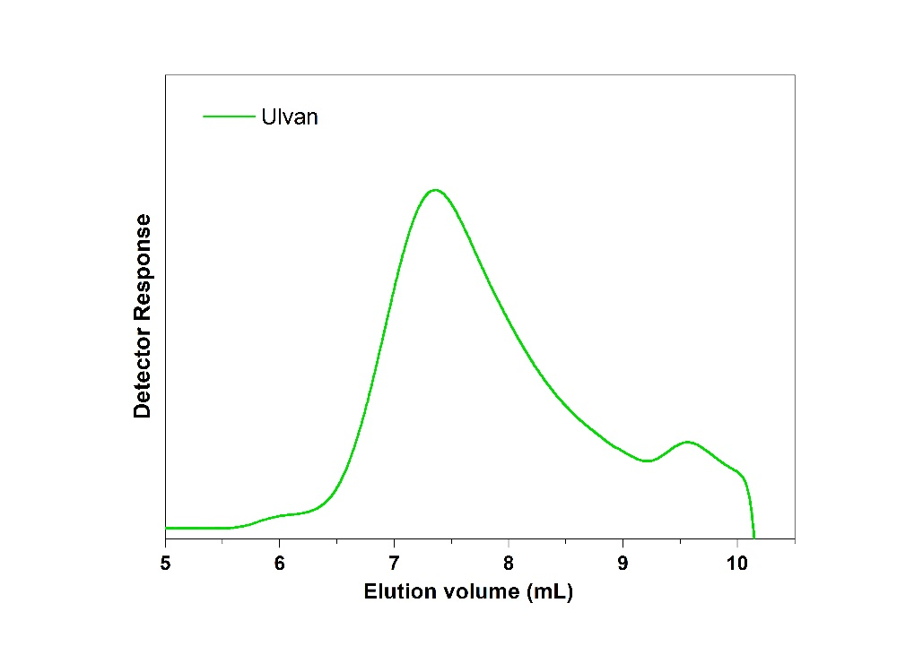

Fig. 3. Chromatographic profile of the ulvan, obtained through Gel Permeation Chromatography analysis (GPC).

The FTIR results provided information about the main chemical bonds and functional groups present in the ulvan molecule (Fig. 4). Analyzing the spectrum (Fig. 4), it is possible to observe bands in the region of 3360 cm-1, characteristic of the O-H stretching, and in the region of 2931 cm-1, of the C-H stretching (Barakat et al. 2022). The bands in the regions of 1025 cm-1 and 978 cm-1 involve the vibration of the C-O, C-O-C and C-O-H bonds, these bands being associated with the glycosidic units (Chi et al. 2020a). The bands in the region of 1617 cm-1 and 1420 cm-1 refer to the stretching of the COO group, characteristic of uronic acid, one of the constituents of ulvan (Chi et al. 2020a). A band at 1215 cm-1 is attributed to the CH deformation of the methyl group present in carbohydrate structures and to the asymmetric stretching vibration S = O related to the occurrence of the sulfate ester characteristic of ulvan (Chi et al. 2020a; Madany et al. 2021). The presence of sulfate groups is also evidenced by the bands at 845 cm-1 and 788 cm-1 associated with the respective vibrations of the C-O-S bonds in the rhamnose molecule (Chi et al. 2020b). Corroborating with Madany et al. (2021) who found values ​​of 844 cm-1 and 786.1 cm-1, related to the stretching vibrations of the sulfate ester group.
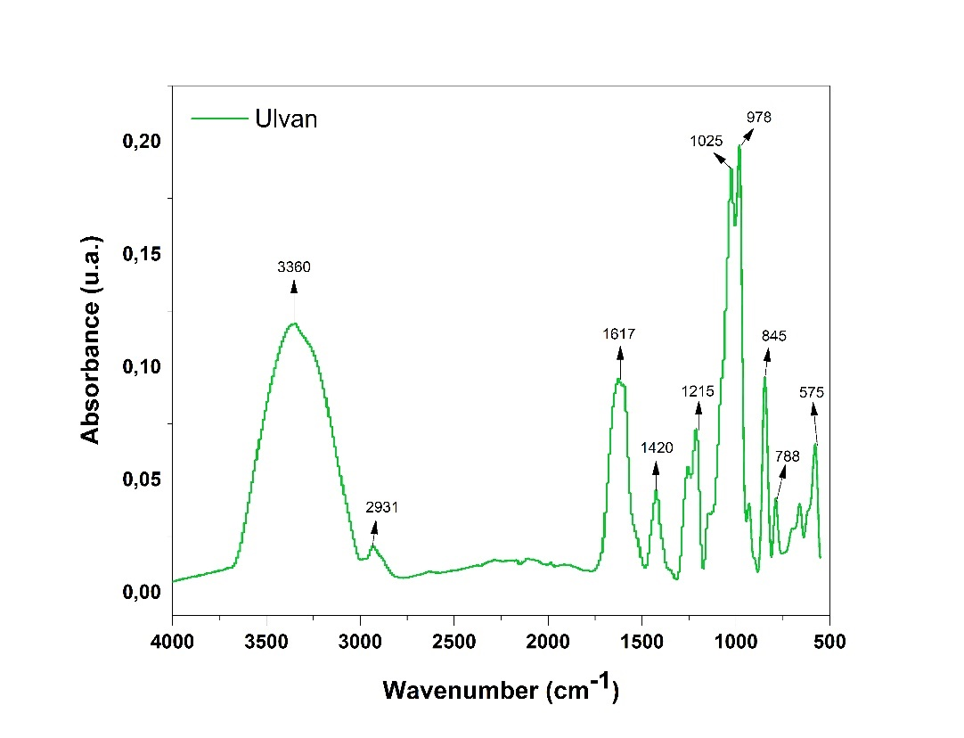
Fig. 4. FTIR spectrum of the ulvan sample, showing absorption peaks in the range 4000 to 500 cm-1.

After the physicochemical characterization of ulvan, the biological activities of the material were also investigated. Regarding antioxidant activity, ulvan was effective with an EC⁵⁰ of 332.0 µg/ml, although its action was not equivalent to that exhibited by the Trolox standard, which presented an EC⁵⁰ of 0.09 µg/ml (Table 2). In the graph (Fig. 5), it is possible to observe an abrupt drop in antioxidant activity, this reduction can be justified by the decrease in ulvan concentration, which went from 83 µg/ml to 41 µg/ml. The antioxidant potential of green algae polysaccharides can be attributed to the arabinogalactan domain present in these molecules (Zhong et al. 2019). The structural characteristics of these polimer, such as molecular weight, monosaccharide composition, degree and position of sulfation, also have a significant impact on antioxidant activity. However, it is still unclear how these characteristics influence activity (Nigam et al. 2021).
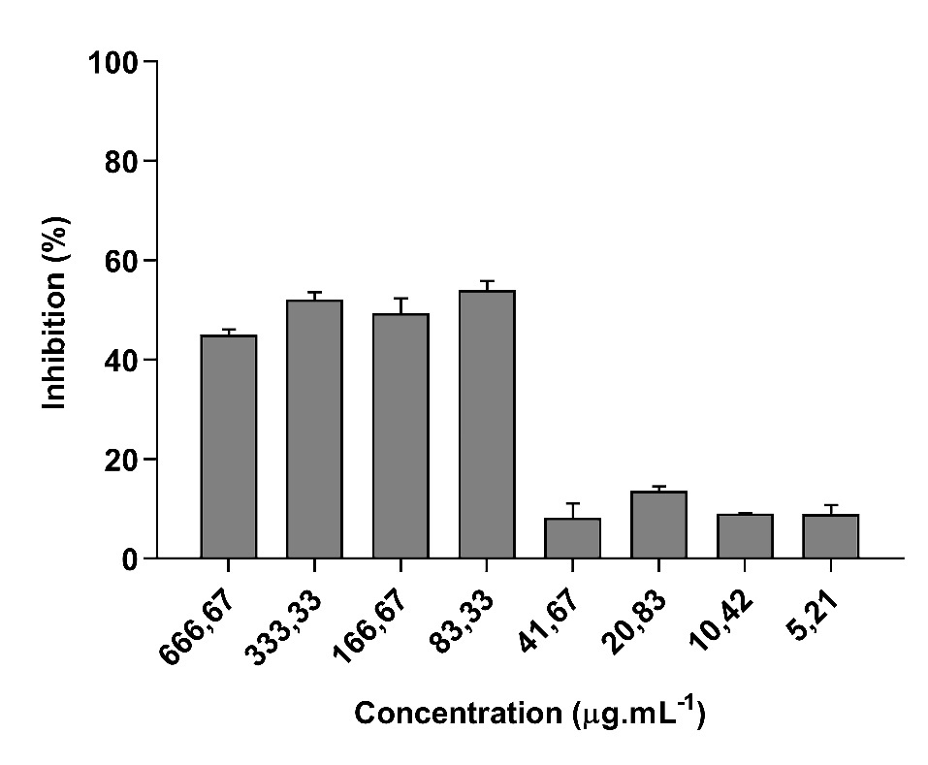
Fig. 5. ABTS radical scavenging effect of ulvan at different concentrations (666.67µl/mL to 5.21µl/mL).
The experiments were performed in triplicate (n=3) and the ANOVA and Tukey tests were used as post-test, with results considered statistically significant when P<0.01 was observed.

Table 2. EC⁵⁰ results of the antioxidant activity of ulvan and Trolox (standard used) against the ABTS radical.

Samples | EC⁵⁰ μg/mL
Ulvan | 332.0 ± 42.90
Trolox | 0.09 ± 0.07
*EC⁵⁰ = effective concentration causing 50% of the maximum effect. Values ​​expressed as mean and standard deviation.

When evaluating cell viability, it was observed that even after 72 hours of exposure of VERO cells to the polysaccharide, ulvan still showed low cytotoxicity, with a CC⁵⁰ greater than 8,805 µg/mL (Fig. 6). This finding corroborates some studies, which also showed low toxicity of ulvan (Binsuwaidan et al., 2023; Srisai et al., 2020). Such as that of Srisai et al., (2020), where the polysaccharide presented a CC⁵⁰ greater than 5,000 µg/mL. Thus, the fact that ulvan presents low cytotoxicity, even at high concentrations, makes this molecule promising for use in several biotechnological applications.

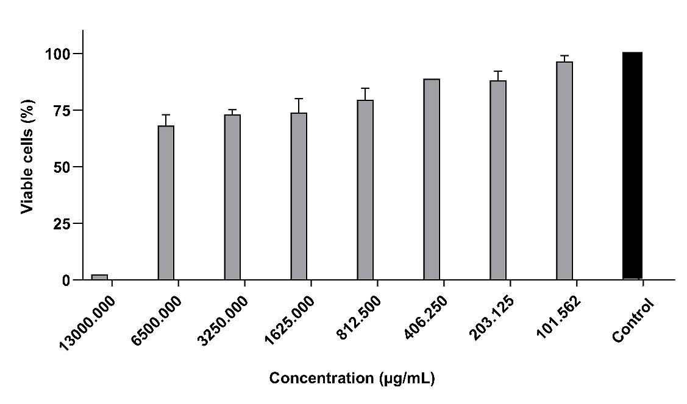

Fig. 6. Cell viability of the VERO cell line exposed to different concentrations of ulvan (13,000 µg/mL to 101 µg/mL) for 72 hours.
Analysis performed by ANOVA followed by Tukey's post-test, with results considered statistically significant at P < 0.05. The tests were performed in triplicate (n=3).

Antibacterial tests performed with ulvan did not reveal activity against any of the strains (S. aureus, E. faecalis, P. aeruginosa and E. coli), even at the highest concentration tested (1000 µg/mL). The results found by Ibrahim et al (2022) showed the absence of antibacterial activity of ulvan against E. faecalis, S. aureus and Listeria monocytogenes. In the same study, ulvan inhibited the growth of P. aeruginosa and gram-negative E. coli, however, at considerably higher concentrations of 25,000 µg/mL and 6,250 µg/mL, respectively. In another study, carried out by Maray et al. (2023) observed that ulvan was unable to inhibit S. aureus even at higher concentrations, but showed inhibitory activity against E. faecalis and P. aeruginosa. This difference in results may occur because the biochemical and structural characteristics of ulvan may allow ulvans extracted from similar forms and algae of the same species to still present structural differences, which may or may not be sensitive to high temperatures (Kidgell et al. 2019; Ibrahim et al. 2022).

In the evaluation of ulvan activity against HSV-1 (Fig. 7), a significant reduction in the viral titer was observed in the PTC assay, with a titer of 2.8x10⁶ PFU/mL, showing approximately 65% ​​reduction in HSV-1 activity by ulvan, while in the CV the titer was 8.1x10⁶ PFU/mL. In the PTV assay, the viral titer obtained was 9.1x10⁵ PFU/mL, corresponding to 88.7% viral inhibition (Fig. 7). This PTV result shows a possible direct action of ulvan on the virus, suggesting virucidal activity. To evaluate the possible direct activity of ulvan on HSV-1, morphostructural analyses of HSV-1 particles and ulvan were performed by the AFM technique (Fig. 8).

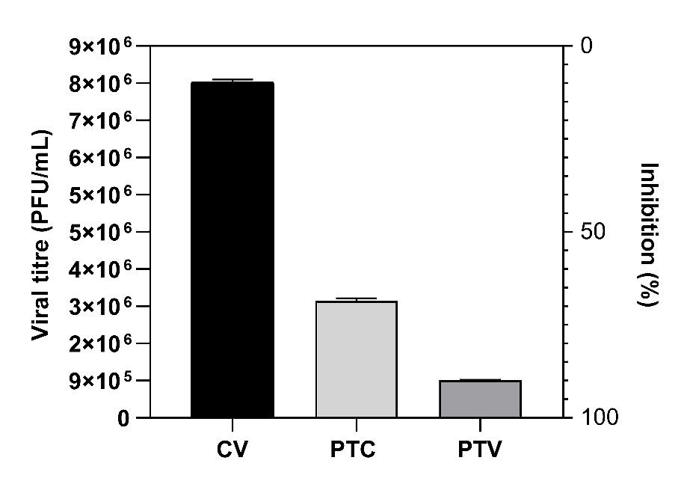
Fig. 7. Plaque forming unit count (PFU/mL) and percentage of viral inhibition, obtained in cell pretreatment (PTC) and viral pretreatment (PTV), at a concentration of 1000 µg/mL for 30 minutes vs viral control (CV).
Data analysis was performed by one-way ANOVA. Results were considered statistically significant at P < 0.001 when compared to the virus control. Assays were performed in triplicate (n=3).

AFM analysis revealed that pure ulvan (CP) has a relatively flat surface with little roughness (Fig. 8a). In Fig. 8b, it is possible to observe that the images of HSV-1 particles (CV) without ulvan treatment do not present as much roughness as in CP. Furthermore, the CV particles presented spherical shapes with calculated average diameters of around 150 nm (Table 3). In the images of HSV-1 after treatment with ulvan (PTV), a greater irregularity was observed in the HSV-1 particles (Fig. 8c), and a reduction in the average size of the virus, which went from 150 nm to 79 nm (Table 3).

Table 3. Comparison of viral particle size between viral control (control) and viral treatment with ulvan (treated).

Group | Size average (nm) | Mean standard error | Confidence Interval - CI 95%
Control | 150.7 | 20.04 | 105.4 – 196.0
Treated | 79.35 | 8.85 | 59.32 – 99.38

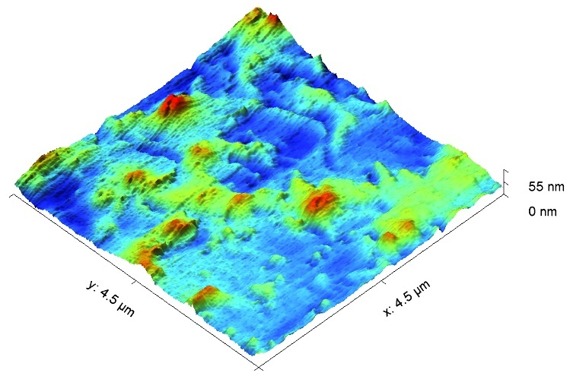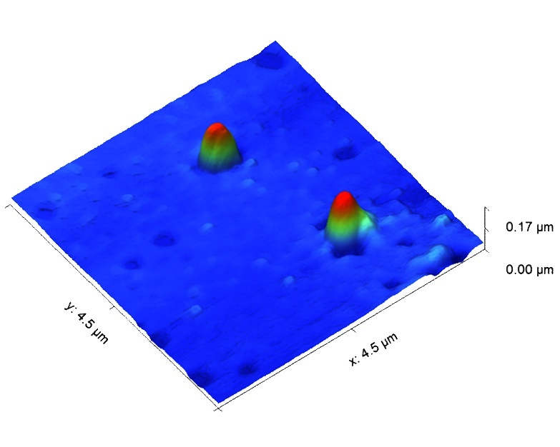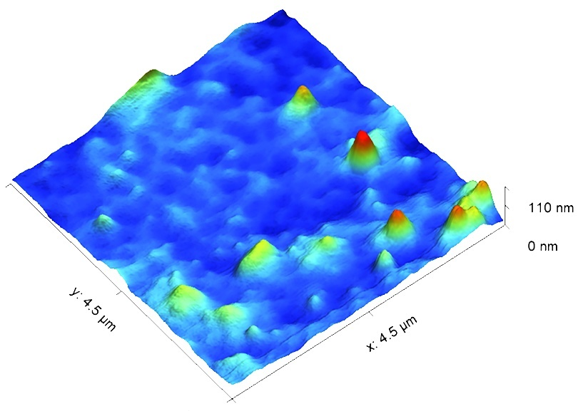
(c)
(b)
(a)

Fig. 8. AFM images of ulvan morphostructure and HSV-1 particles before and after treatment.
(a) Topographic image of ulvan without the presence of virus; (b) image of control of HSV-1 particles without treatment; (c) image of HSV-1 after treatment with ulvan.

Results from previous studies on HSV-1 morphology demonstrated viral particles with sizes ranging from 127 to 150 nm (Wu et al., 2011) and 160 nm (Kämmer et al., 2016), values ​​that correspond to the size of intact virus without any treatment. The reduction in the size of HSV-1 presented in this study suggests that ulvan can directly modify the viral structure and, eventually, inhibit its ability to infect. According to some evidence, sulfated polysaccharides from marine algae probably block viral infection by inhibiting one or more stages of the virus multiplication cycle. They may interfere with the adsorption process, either by interacting with virions or by interacting with virus receptors in host cells, with specific mechanisms dependent on the polysaccharide structure (Wang et al. 2012; Wei et al. 2022). Furthermore, the structure, molecular weight and degree of sulfation of ulvan are significant factors that influence its antiviral activity. These factors can affect the way the polysaccharide interacts with both virions and viral receptors present in host cells (Chiu et al. 2011; Chi et al. (2020a); Shefer et al. 2021; Shefer et al., 2022). Furthermore, due to its structural similarity to mammalian glycosaminoglycans (GAGs), together with its low toxicity, ulvan could be useful in the topical treatment of lesions caused by HSV-1, preventing viral proliferation in tissues (Sulastri et al., 2021). It can also be used as an adjuvant in antiviral therapies, alone or in combination with other agents.
4. CONCLUSION

Ulvan extracted from the macroalgae U. lactuca showed significant antioxidant activity against ABTS radicals. The compound did not show antibacterial activity against the strains tested (Staphylococcus aureus, Enterococcus faecalis, Pseudomonas aeruginosa and Escherichia coli). However, it showed anti-HSV-1 activity with low toxicity to VERO cells. AFM analysis demonstrated a possible direct action of ulvan on the viral envelope of HSV-1, with a decrease in the average particle size after treatment with the polysaccharide. Thus, ulvan can be considered a potentially valuable ingredient for the development of biotechnological products. It may be a promising alternative for the treatment of HSV-1 and an option in cases of viral resistance to conventional treatments or as an adjuvant treatment. The limitation found in the development of the present study was the lack of a more detailed analysis of how the interaction of ulvan with viral particles occurs. Therefore, we suggest that additional studies be performed to understand the molecular mechanisms involved in the interaction between ulvan and viruses and to explore its potential therapeutic applications.

Disclaimer (Artificial intelligence)
Author(s) hereby declare that no generative AI technologies such as Large Language Models (ChatGPT, COPILOT, etc.) and text-to-image generators have been used during the writing or editing of this manuscript.

REFERENCES

[1] Pliego-Cortés, H., Hardouin, K., Bedoux, G., Marty, C., Cérantola, S., Freile-Pelegrín, Y., et al. (2022). Sulfated Polysaccharides from Seaweed Strandings as Renewable Source for Potential Antivirals against Herpes simplex Virus 1. Mar Drugs, 20(02), 116. http://dx.doi.org/10.3390/md20020116

[2] Paula, R.C.M., Paula, H.C.M., Pessoa, J.P.A. (2018). Polysaccharides from Brazilian biodiversity. Press University of the Federal University of Ceará (UFC), Fortaleza.

[3] Schalkwijk, H.H., Snoeck, R., Andrei, G. (2022). Acyclovir resistance in herpes simplex viruses: prevalence and therapeutic alternatives. Biochem Pharmacol, 206, 115322. http://dx.doi.org/10.1016/j.bcp.2022.115322

[4] Lu, W., Yang, Z., Chen, J., Wang, D., Zhang, Y. (2021). Recent advances in antiviral activities and potential mechanisms of sulfated polysaccharides. Carbohydr Polym, 272, 118526. http://dx.doi.org/10.1016/j.carbpol.2021.118526

[5] Sun, Q.L., Li, Y., Ni, L.Q., Li, Y.X., Cui, Y.S., Jiang, S.L., et al. (2020). Structural characterization and antiviral activity of two fucoidans from the brown algae Sargassum henslowianum. Carbohydr Polym, 229, 115487. http://dx.doi.org/10.1016/j.carbpol.2019.115487

[6] Boulho, R., Marty, C., Freile-Pelegrín, Y., Robledo, D., Bourgougnon, N., Bedoux, G. (2017). Antiherpetic (HSV-1) activity of carrageenans from the red seaweed Solieria chordalis (Rhodophyta, Gigartinales) extracted by microwave-assisted extraction (MAE). J Appl Phycol, 29, 2219-2228. https://doi.org/10.1007/s10811-017-1192-5

[7] Hasui, M., Matsuda, M., Okutani, K., Shigeta, S. (1995). In vitro antiviral activities of sulfated polysaccharides from a marine microalga (Cochlodinium polykrikoides) against human immunodeficiency virus and other enveloped viruses. Int J Biol Macromol, 17, 293-297. http://dx.doi.org/10.1016/0141-8130(95)98157-t

[8] Duarte, M.E.R., Cauduro, J.P., Noseda, D.G., Noseda, M.D., Gonçalves, A.G., Pujol, C.A., et al. (2004). The structure of the agaran sulfate from Acanthophora spicifera (Rhodomelaceae, Ceramiales) and its antiviral activity. Relation between structure and antiviral activity in agarans. Carbohydr Res, 339, 335-347. http://dx.doi.org/10.1016/j.carres.2003.09.028

[9] Hardouin, K., Bedoux, G., Burlot, A.S., Donnay-Moreno, C., Bergé, J.P., Nyvall-Collén, P., Bourgougnon, N. (2016). Enzyme-assisted extraction (EAE) for the production of antiviral and antioxidant extracts from the green seaweed Ulva armoricana (Ulvales, Ulvophyceae). Algal Res, 16, 233-239. http://dx.doi.org/10.1016/j.algal.2016.03.013

[10] Lopes, N., Ray, S., Espada, S.F., Bomfim, W.A., Ray, B., Faccin-Galhardi, L.C., et al. (2017). Green seaweed Enteromorpha compressa ( Chlorophyta , Ulvaceae ) derived sulphated polysaccharides inhibit herpes simplex virus. Int J Biol Macromol, 102, 605-612. http://dx.doi.org/10.1016/j.ijbiomac.2017.04.043
[11] Chiu, Y.H., Chan, Y.L., Li, T.L., Wu, C.J. (2011). Inhibition of Japanese Encephalitis Virus Infection by the Sulfated Polysaccharide Extracts from Ulva lactuca. Mar Biotechnol, 14, 468-478. http://dx.doi.org/10.1007/s10126-011-9428-x

[12] Chi, Y., Zhang, M., Wang, X., Fu, X., Guan, H., Wang, P. (2020a). Ulvan lyase assisted structural characterization of ulvan from Ulva pertusa and its antiviral activity against vesicular stomatitis virus. Int J Biol Macromol, 157, 75-82. http://dx.doi.org/10.1016/j.ijbiomac.2020.04.187

[13] Binsuwaidan, R., El-Masry, T.A., El-Sheekh, M., Seadawy, M.G., Makhlof, M.E.M., Aboukhatwa, S.M., et al. (2023). Prospective Antiviral Effect of Ulva lactuca Aqueous Extract against COVID-19 Infection. Mar Drugs, 22(1), 30. http://dx.doi.org/10.3390/md22010030

[14] Tziveleka, L.A., Ioannou, E., Roussis, V. (2019). Ulvan, a bioactive marine sulphated polysaccharide as a key constituent of hybrid biomaterials: a review. Carbohydr Polym, 218, 355-370. http://dx.doi.org/10.1016/j.carbpol.2019.04.074

[15] Kidgell, J.T., Magnusson, M., Nys, R., Glasson, C.R.K. (2019). Ulvan: a systematic review of extraction, composition and function. Algal Res, 39, 101422. http://dx.doi.org/10.1016/j.algal.2019.101422

[16] Lahaye, M. (1998a). NMR spectroscopic characterisation of oligosaccharides from two Ulva rigida ulvan samples (Ulvales, Chlorophyta) degraded by a lyase. Carbohydr Res, 314, 1-12. http://dx.doi.org/10.1016/s0008-6215(98)00293-6

[17] Lahaye, M., Inizan, F., Vigoureux, J. (1998b). NMR analysis of the chemical structure of ulvan and of ulvan-boron complex formation. Carbohydr Polym, 36, 239-249. http://dx.doi.org/10.1016/s0144-8617(98)00026-5

[18] Robic, A., Rondeau-Mouro, C., Sassi, J.F., Lerat, Y., Lahaye, M. (2009). Structure and interactions of ulvan in the cell wall of the marine green algae Ulva rotundata (Ulvales, Chlorophyceae). Carbohydr Polym, 77, 206-216. http://dx.doi.org/10.1016/j.carbpol.2008.12.023

[19] Maray, S.O., Abdel-Kareem, M.S.M., Mabrouk, M.E.M., El-Halmouch, Y., Makhlof, M.E.M. (2023). In Vitro Assessment of Antiviral, Antimicrobial, Antioxidant and Anticancer Activities of Ulvan Extracted from the Green Seaweed Ulva lactuca. Thalassas: An International Journal of Marine Sciences, 39, 779-790. http://dx.doi.org/10.1007/s41208-023-00584-z

[20] Rodrigues, J.A.G., Araujo, I.W.F., Paula, G.A., Bessa, E.F., Lima, T.B., Benevides, N.M.B. (2010). Isolamento, fracionamento e atividade anticoagulante de iota-carragenanas da Solieria filiformis. Ciência Rural, 40, 2310-2316. http://dx.doi.org/10.1590/s0103-84782010001100010

[21] Bradford, M.M. (1976). A rapid and sensitive method for the quantitation of microgram quantities of protein utilizing the principle of protein-dye binding. Analytical Biochemical, 72, 248-254. http://dx.doi.org/10.1016/0003-2697(76)90527-3

[22] Torres, P.B., Pires, J.S., Chow, F., Santos, D. (2017). Ensaio do potencial antioxidante de extratos de algas através do sequestro do ABTS•+ em microplaca. Instituto de Biociências Universidade de São Paulo, 1,1-4. http://dx.doi.org/10.13140/RG.2.2.10672.87041

[23] Campos, M.A., Kroon, E.G. (1993). Critical period of irreversible block of VACV replication, Review. Microbiology. 24,104-110.

[24] Mosmann, T. (1983). Rapid colorimetric assay for cellular growth and survival: application to proliferation and cytotoxicity assays. J Immunol Methods, 65, 55-63 http://dx.doi.org/10.1016/0022-1759(83)90303-4

[25] Baer, A., Kehn-Hall, K. (2014). Viral Concentration Determination Through Plaque Assays: using traditional and novel overlay systems. Immunology and Infection, 93, 52-65. http://dx.doi.org/10.3791/52065

[26] Hernández-Garibay, E., Zertuche-González, J.A., Pacheco-Ruíz, I. (2010). Isolation and chemical characterization of algal polysaccharides from the green seaweed Ulva clathrata (Roth) C. Agardh. J Appl Phycol, 23, 537-542. http://dx.doi.org/10.1007/s10811-010-9629-0

[27] Vandanjon, L., Burlot, A.S., Zamanileha, E.F., Douzenel, P., Ravelonandro, P.H., Bourgougnon, N., Bedoux, G. (2023). The Use of FTIR Spectroscopy as a Tool for the Seasonal Variation Analysis and for the Quality Control of Polysaccharides from Seaweeds. Mar Drugs, 21(9), 482. http://dx.doi.org/10.3390/md21090482

[28] Glasson, C.R.K., Sims, I.M., Carnachan, S.M., Nys, R., Magnusson, M. (2017). A cascading biorefinery process targeting sulfated polysaccharides (ulvan) from Ulva ohnoi. Algal Res, 27, 383-391. http://dx.doi.org/10.1016/j.algal.2017.07.001

[29] Madany, M.A., Abdel-Kareem, M.S., Al-Oufy, A.K., Haroun, M., Sheweita, S.A. (2021). The biopolymer ulvan from Ulva fasciata: extraction towards nanofibers fabrication. Int J Biol Macromol, 177, 401-412. http://dx.doi.org/10.1016/j.ijbiomac.2021.02.047

[30] Dominguez-Martinez, B.M., Martínez-Flores, H.E., Berrios, J.J., Otoni, C.G., Wood, D.F., Velazquez, G. (2016). Physical Characterization of Biodegradable Films Based on Chitosan, Polyvinyl Alcohol and Opuntia Mucilage. J Polym Environ, 25, 683-691. http://dx.doi.org/10.1007/s10924-016-0851-y

[31] Ahmed, T., Aljaeid, B. (2016). Preparation, characterization, and potential application of chitosan, chitosan derivatives, and chitosan metal nanoparticles in pharmaceutical drug delivery. Drug Des, Dev Ther, 10, 483-507. http://dx.doi.org/10.2147/dddt.s99651

[32] Guidara, M., Yaich, H., Richel, A., Blecker, C., Boufi, S., Attia, H., et al. (2019). Effects of extraction procedures and plasticizer concentration on the optical, thermal, structural and antioxidant properties of novel ulvan films. Int J Biol Macromol, 135, 647-658. http://dx.doi.org/10.1016/j.ijbiomac.2019.05.196

[33] Wahlström, N., Nylander, F., Malmhäll-Bah, E., SJövold, K., Edlund, U., Westman, G., et al. (2020). Composition and structure of cell wall ulvans recovered from Ulva spp. along the Swedish west coast. Carbohydr Polym, 233, 115852. http://dx.doi.org/10.1016/j.carbpol.2020.115852.

[34] Barakat, K.M., Ismail, M.M., Hassayeb, H.E.A.E., Sersy, N.A.E., Elshobary, M.E. (2022). Chemical characterization and biological activities of ulvan extracted from Ulva fasciata (Chlorophyta). Rendiconti Lincei. Scienze Fisiche e Naturali, 33, 829-841. http://dx.doi.org/10.1007/s12210-022-01103-7

[35] Chi, Y., Li, H., Wang, P., Du, C., Ye, H., Zuo, S., et al. (2020b). Structural characterization of ulvan extracted from Ulva clathrata assisted by an ulvan lyas, Carbohydr Polym, 229, 115497. http://dx.doi.org/10.1016/j.carbpol.2019.115497

[36] Zhong, Q., Wei, B., Wang, S., Ke, S., Chen, J., Zhang, H., et al. (2019). The Antioxidant Activity of Polysaccharides Derived from Marine Organisms: an overview. Mar Drugs, 17(12), 674. http://dx.doi.org/10.3390/md17120674

[37] Nigam, S., Singh, R., Bhardwaj, S.K., Sami, R., Nikolova, M.P., Chavali, M., et al. (2021). Perspective on the Therapeutic Applications of Algal Polysaccharides. J Polym Environ, 30, 785-809. http://dx.doi.org/10.1007/s10924-021-02231-1

[38] Srisai, P., Pekkoh, J., Tragoolpua, Y. (2020). Anti-herpes simplex virus effect of algal polysaccharide extract from Ulva reticulata. Division Of Microbiology, Department Of Biology, Faculty Of Science, Chiang Mai University, Thailand, 1, 671-680.

[39] Ibrahim, M.I.A., Amer, M.S., Ibrahim, H.A.H., Zaghloul, E.H. (2022). Considerable Production of Ulvan from Ulva lactuca with Special Emphasis on Its Antimicrobial and Anti-fouling Properties. Appl Biochem Biotechnol, 194, 3097-3118. http://dx.doi.org/10.1007/s12010-022-03867-y

[40] Wu, N., Kong, Y., Zu, Y., Fu, Y., Liu, Z., Meng, R., et al. (2011). Activity investigation of pinostrobin towards herpes simplex virus-1 as determined by atomic force microscopy. Phytomedicine, 18, 110-118. http://dx.doi.org/10.1016/j.phymed.2010.07.001

[41] Kämmer, E., Götz, I., Bocklitz, T., Stöckel, S., Dellith, A., Cialla-May, D., et al. (2016). Single particle analysis of herpes simplex virus: comparing the dimensions of one and the same virions via atomic force and scanning electron microscopy. Anal Bioanal Chem, 408, 4035-4041. http://dx.doi.org/10.1007/s00216-016-9492-1

[42] Wang, W., Wang, S.X., Guan, H.S. (2012). The Antiviral Activities and Mechanisms of Marine Polysaccharides: an overview. Mar Drugs 10, 2795-2816. http://dx.doi.org/10.3390/md10122795

[43] Wei, Q., Fu, G., Wang, K., Yang, Q., Zhao, J., Wang, Y., et al. (2022). Advances in Research on Antiviral Activities of Sulfated Polysaccharides from Seaweeds. Pharmaceuticals, 15, 581. http://dx.doi.org/10.3390/ph15050581

[44] Shefer, S., Robin, A., Chemodanov, A., Lebendiker, M., Bostwick, R., Rasmussen, L., et al. (2021). Fighting SARS-CoV-2 with green seaweed Ulva sp. extract: extraction protocol predetermines crude ulvan extract anti-sars-cov-2 inhibition properties in in vitro vero-e6 cells assay. Peerj, 9,1-24. http://dx.doi.org/10.7717/peerj.12398

[45] Shefer, S., Lebendiker, M., Finkelshtein, A., Chamovitz, D.A., Golberg, A. (2022). Ulvan crude extract’s chemical and biophysical profile and its effect as a biostimulant on Arabidopsis thaliana. Algal Res, 62, 102609. http://dx.doi.org/10.1016/j.algal.2021.102609

[46] Sulastri, E., Lesmana, L., Zubair, M.S., Elamin, K.M., Wathoni, N. (2021). A Comprehensive Review on Ulvan Based Hydrogel and Its Biomedical Applications. Chem Pharm Bull, 69, 432-443. http://dx.doi.org/10.1248/cpb.c20-00763

