Exploring the biodiversity of turkey tail mushroom “*Trametes* sp.” from their natural habitat and its characterization

**Abstract** :

*Trametes versicolor* a high value medicinal mushroom recognized for its diverse bioactive and therapeutic industry. The versatile nature of this tropica l mushroom with their wider adaptability makes it very unique. A survey was conducted in southern regions of Kerala (Thiruvananthapuram, Kollam, and Alappuzha) during November to January, 2022-2023 for the collection of the native *Trametes* sp. from their habitat. The survey identified five distinct species of Trametes. These mushrooms occurred in gregarious nature on lignicolous substrates,. The mushrooms exhibited fan-shaped pilei with wavy margins and were sessile attached to the substrate. The upper surface displayed concentric brown zonations, while the undersurface was porous. The native *Trametes* sp. had creamish-white pilei with brown concentric zones, ranging in size from 6 to 13 cm. Pure cultures of the native Trametes species were developed using the standard tissue culture technique on Potato Dextrose Agar (PDA) medium. The mycelial growth of these native isolates was either fluffy or sparse, with growth completion from 7 to 16 days in Petri plates(9 cm). The rapid/fast-growing isolate I4 was molecularly characterized as Trametes sp. For comparative study, a standard culture of Trametes versicolor (DMRO-211) obtained from ICAR-DMR, Solan, were also used. Physiological studies were conducted to identify suitable media, temperature, and pH conditions for the mycelia under *in vitro* conditions. The growth of both the native isolate (I4) and *T. versicolor* was comparatively faster in Malt Extract Agar (MEA) medium and slower in Czapek Dox Agar (CDA) medium. The optimum temperature for mycelial growth was found to be in the range of 25°C to 30°C. Near-neutral and neutral pH levels (5.5-6.5) favored rapid mycelial growth in both isolates.

*Keywords: Trametes, mycelial growth, medium, fluffy, sparse*

INTRODUCTION

The cultivation of mushrooms in India commenced a few decades ago. Although significant progress has been made, the Indian mushroom industry has yet to achieve its full potential. Historically, mushrooms in India were predominantly viewed as a food source. Within the food sector, only a limited variety of mushrooms—such as button, oyster, paddy straw, and milky mushrooms—have been commercialized and widely consumed. India's diverse agro-ecological conditions, abundant agricultural waste, and readily available workforce make it an ideal environment for cultivating a wider range of mushrooms [1]. This realization prompted the exploration of various other mushrooms that could contribute to overall well-being. Consequently, medicinal mushrooms such as *Ganoderma lucidum* (Reishi mushroom) have been cultivated in various laboratories across India [2,3,4]. The initiative to promote the cultivation of medicinal mushrooms is gaining significance in the country.

*Trametes versicolor* is one of the most potent and the best-studied medicinal mushroom [5]. *T. versicolor*, commonly known as the turkey tail mushroom due to its vibrant, fan-shaped appearance, is a widely recognized species of fungi that plays a crucial role in both traditional and contemporary medicine. These mushrooms occur on logs, stumps or dead trunks of hardwoods species. The fruiting bodies are fan-shaped or shelf-like pileus, with a thin, leathery and velvety upper surface with concentric bands of brown-black and white colours [6]. Beyond its ecological importance, *Trametes versicolor* has emerged as a key player in the medicinal and food industries due to its remarkable array of bioactive compounds and therapeutic properties. From thousands of years, the turkey tail mushroom (Trametes versicolor) has been utilized for medicinal purposes in Japan and China. Two immunologically active fractions extracted from this species are PSK (a protein-bound polysaccharide) and PSP (a polysaccharide peptide). High molecular-weight fractions from the mycelium, particularly polysaccharide Krestin (PSK), have been the subject of human clinical trials and have been approved as a drug by national healthcare authorities in Japan. PSK has demonstrated anticancer activity in breast, colorectal, and gastrointestinal cancers [7,8]. Proteoglycans have been identified as the principal components responsible for the anticancer activity of *Trametes* sp. [9,10,11]. *T. versicolor*, commonly is not generally used as a culinary mushroom because of its tough and leathery texture. However, it is becoming increasingly popular in the functional and nutritional food industry, where it is used in supplements, teas, and powdered extracts for its potential health benefits. These products cater to the growing demand for natural health-promoting foods and nutraceuticals [12 ]. Additionally, these mushrooms can be effectively used for bioremediation, enzyme production, aesthetic purposes, and spent mushroom substrate utilization. To diversify the Indian mushroom industry, global exploratory efforts are underway to cultivate *T. versicolor*. To check the suitability of Trametes cultivation under our tropical condition’s *in vitro* studies for optimum media, temperature and pH for its growth was attempted.

2. material and methods

**2.1 Survey and collection of the native *Trametes* spp.**

The survey was conducted in 5 different locations of three districts (Thiruvananthapuram, Kollam and Pathanamthitta) under AEU 1 and 2 of Kerala from November 2023-January, 2024. The locations were selected from each AEU which were geographically separated *viz.,* AEU 1 – Kulathupuzha (Kollam district), Dhanuvachapuram, Vellayani, Amaravila (Trivandrum dist.) and AEU 2- Mylapra (Pathanamthitta dist.). From the above locations, sample of *Trametes* sp. were collected and characterized.

**2.2 Morphological Characterization of the native *Trametes* spp. in their natural habitat and isolation**

The collected mushrooms were studied for their natural habitats and morphological characters of pileus and stipe. The native mushrooms were isolated using the standard tissue culture technique in PDA media. The mushrooms were washed / wiped free of the soil particles. The pileus was surface sterilized with 80% alcohol and was split into two equal halves. A piece of tissue from the junction of stipe and pileus (fertile) were placed on PDA media plated Peri plates. The inoculated petri dishes were incubated at room temperature (26+-2oC) for 3 days. The cultures were made pure by the hyphal tip method and maintained on PDA slants for further studies ( Plate 1 and2).

**2.3. Cultural and molecular characterization of native *Trametes* sp**.

The cultural characterization of the native *Trametes* sp. cultures was done on by growth in PDA media. The mycelial bits of 3mm size were placed at the centre of the PDA medium poured petri plate and incubated at room temp (26 +- 2oC). The radial growth of mycelium (cm), nature of mycelial growth and days taken to complete full growth in petri dish (days) were studied in potato dextrose agar medium (PDA). On the basis of the above observations, the best isolate was selected for molecular characterization.

**2.4. Molecular characterization**

**2.4.1. Extraction of DNA**

DNA isolation of the isolate was done using NucleoSpin ® Plant II Kit (Macherey-Nagel). About 100 mg of the tissue/mycelium was homogenized using liquid nitrogen and the powdered tissue was transferred to a microcentrifuge tube. Four hundred microlitres of PL1 buffer was added and vortexed for 1 minute. Ten microlitres of RNase A solution was added and mixed by inverting the tubes. The homogenate was incubated at 65°C for 10 minutes. The lysate was transferred to a Nucleospin filter and centrifuged at 11000 x g for 2 minutes. The flow through liquid was collected and the filter was discarded. Four hundred and fifty microlitres of buffer PC was supplemented and mixed properly. The solution was transferred to a Nucleospin Plant II column and centrifuged for 1 minute. Further, the flow through liquid is discarded. Four hundred microlitre buffer PW1 was added to the column, centrifuged at 11000 x g for 1 minute and again, flow though liquid was discarded. Then, 700 µl of PW2 was added, centrifuged at 11000 x g and flow through liquid discarded. Finally, 200 µl of PW2 was added and centrifuged at 11000 x g for 2 minutes to dry the silica membrane. The column was transferred to a fresh 1.7 ml tube and 50 µl of buffer PE was added and incubated at 65°C for 5 minutes. A final centrifugation of the column was done at 11000 x g for 1 minute to elute the DNA. The eluted DNA was stored at 4°C. The quality of the isolated DNA was checked and confirmed using agarose gel electrophoresis.

**2.4.2. PCR analysis using LSU primer**

The entire region of rDNA of *Trametes* isolate was dome using the LSU primers. PCR amplification reactions were carried out in a 20 µl reaction volume which contained 1X Phire PCR buffer (contains 1.5 mM MgCl2), 0.2mM each dNTPs (dATP, dGTP, dCTP and dTTP), 1 µl DNA, 0.2 µl Phire Hotstart II DNA polymerase enzyme, 0.1 mg/ml BSA and 3% DMSO, 0.5M Betaine, 5pM of forward and reverse primers. The forward primer- LROR (5ʹ-ACCCGCTGAACTTAAGC-3ʹ) and reverse primer LR5 (5ʹ-TCCTGAGGGAAACTTCG-3ʹ) were used to amplify the DNA in GeneAmp 9700 PCR Thermal cycler. The PCR products were checked in 1.2% agarose gels prepared in 0.5X TBE buffer containing 0.5 µg/ml ethidium bromide. Gel electrophoresis was performed for 1-2 hours using 1 µl of 6X loading dye mixed with 5 µl of PCR products immersed in 1X TBE electrophoresis buffer . The gels were visualized in a UV transilluminator (Genei) and the image was captured under UV light using Bio-Rad Gel documentation system. DNA sequencing was performed using the same listed primers in DNA analyser (Applied Biosystems).

**2.4.3. Phylogenetic analysis**

The nucleotide sequences obtained after sequencing were first correctly trimmed using *Bioedit* software and aligned using *Clustal W* in MEGA X software. The aligned sequenced were corrected and analyzed to provide pairwise percentage sequence divergence. The data obtained from the sequence alignment were used to plot a Maximum Parsimony tree diagram in MEGA X software with 1000 bootstrap replications.

**2.4.4.** **Evaluation of different media for the growth of T*rametes* spp.**

The growth characters of the native isolate *Trametes* spp. and *T. versicolor* in different media *viz*., Potato dextrose agar (PDA), Malt extract agar (MEA), Peptone potato dextrose agar (PPDA), Czapek dox agar (CDA) and Potato malt agar (PMA) were assessed. The experiment was laid out in Completely Randomized Design (CRD) with five treatments and four replications. The standard procedures were used for media preparation and were sterilized at 121°C for 15-20 min (15 psi pressure). Five-millimeter mycelial disc of seven-day old mushroom culture was transferred aseptically to the centre of the respective media plated on Petri dish. The inoculated dishes were incubated at room temperature (27⁰C ± 2⁰C). The nature of mycelial growth, radial mycelial growth (cm) and time taken to full growth of mycelia (days) were recorded. The observations of mycelial growth were documented on 3-, 5- and 7-days after inoculation.

**2.4.5 Standardization of effective temperature for growth of *Trametes* spp*.***

Similarly, the growth of the native isolate- *Trametes* sp. and *T. versicolor* at different temperatures *viz.*, 15oC, 20oC, 25oC, 30oC and 35oC were assessed. The experiment was laid out in Completely Randomised Design (CRD) with four replications. The effective media from 2.4.1 was prepared and were sterilized at 121 °C (15 psi) for 15-20 min. Five-millimeter mycelial disc of seven-day old mushroom culture was transferred aseptically to the centre of the respective media plated on Petri dish. The inoculated dishes were incubated at respective temperatures. The characteristics of the mycelial growth along with days taken to complete growth in Petri dish were recorded at 3, 5 and 7 days interval respectively.

**2.4.6. Standardization of effective pH for the growth of *Trametes sp.***

The - native isolates *Trametes* sp. and *T.versicolor* (DMRO211) were tested for their growth characters at different pH  *viz*., 4.5, 5, 5.5, 6, 6.5, 7, 7.5 and 8 respectively. The most effective media from 2.4.1was used at different pH ranges. The experiment was laid out in Completely Randomised Design (CRD). The effective media from 2.4.5 was prepared and the pH was adjusted. The media was sterilized at 121°C (15psi) for 15-20 min. Five mm discs of actively growing cultures were cut and placed in the centre of the Petri-dishes with media at different pH ranges and recorded at 3,5 and 7days interval and kept at most suitable temperature from 2.4.5.

3. results and discussion

3.1 Survey for the collection of native *Trametes* sp.

From the survey conducted in different parts of Kerala *viz*., Thiruvananthapuram, Kollam and Pathanamthitta (AEU 1 and 2) districts, 5 different samples of *Trametes* mushroom (three from Thiruvananthapuram, one from Kollam and one from Pathanamthitta) were collected. The mushrooms were identified based on the basic characters of *Trametes sp*. such as presence of fan shaped fruiting body with striations, close concentric zonation, slightly hairy surface with a wavy outer margin and porous under surface. The collected mushroom samples were observed on dead hardwoods and occurred in clusters.

**3.2 Morphological Characterization of the native *Trametes* sp. in their natural habitat and isolation**

The natural habitat of these mushrooms were mainly the wooden stumps and occurred in clusters. Similar studies indicate T*rametes* spp. to be common on dead wood prevalent with centrally-attached circular fans and found in abundance in Western Ghats region of India [13]. The isolates had typical characters of the bracket fungi with close concentric zonation’s and fan-shaped pileus with a wavy outer margin. The mushroom obtained in the survey were found to be sessile. The pileus diameter roughly ranged from 6-13 cm. The wider pileus was observed in the mushrooms from Amaravila (Thiruvananthapuram) and Mylapra (Pathanamthitta). The pileus had alternate creamish white and brown concentric zones (plate: 2). Cui and Christi [14]revealed the morphological characteristics of fruiting body of *T. versicolor* and described it as semicircular sporocarp having thin and, tough wavy margin with a diameter of 3 –5 cm young brackets, occurring in tiers, spread along branches. The upper surface is velvety and attractively marked with concentric zones of varying colors of brown, yellow, gray, greenish, or black which coincides with the native *Trametes* sp. isolate [14]. The mushrooms were identified and confirmed as *Trametes* sp. according to its habitat and morphological characters.

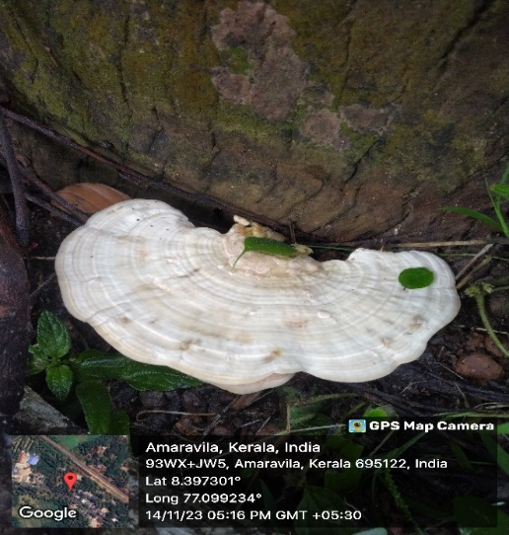

**Plate 2: Native *Trametes* sp.**

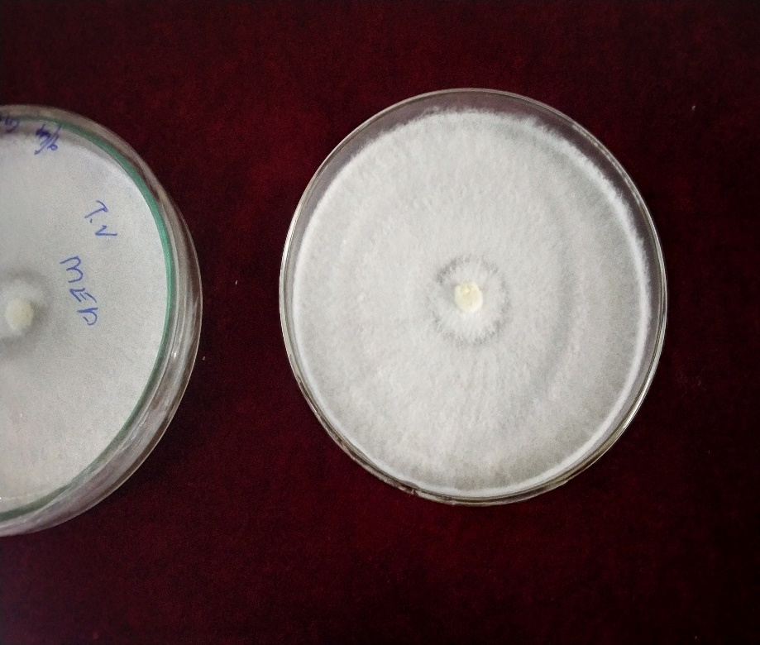

**Plate 1: Culture of *Trametes versicolor* (DMRO 211)**

**3.3 Cultural and molecular characterization of native *Trametes* sp.**

Five isolates were obtained from survey, which were isolated and designated as I1, I2, I3, I4 and I5.The isolates on the PDA had white fluffy mycelial growth with thick strands emerging towards the edges. The isolates took 6-9 days for complete growth in Petri dish (9cm) in PDA medium. The mycelial growth was observed to be comparatively faster in I4 isolate and least growth was observed in I2 isolate. So, I4 isolate was selected as the best isolate and molecularly characterized for further confirmation.

The sequences were deposited in NCBI GenBank data and obtained. GenBank Accession number (PV012560). The phylogenetic analysis using LSU primers revealed that the phylogenetic relationship of native *Trametes* sp. and *Trametes versicolor*. Maximum parsimonious tree was constructed with 1000 bootstrap replications in MEGA X software and revealed that the native *Trametes* sp. and *Trametes versicolor* were belonging to the same clade (Plate 3).

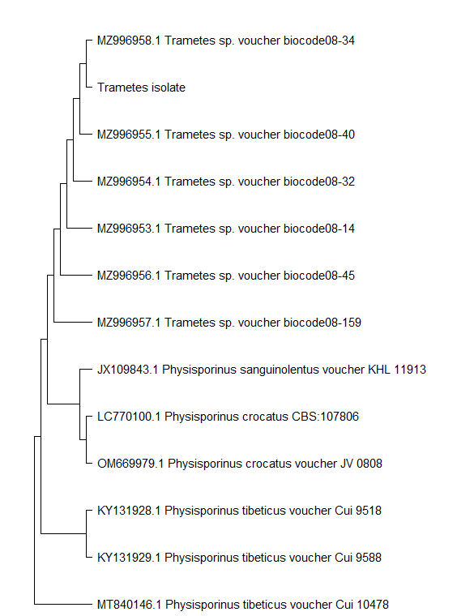

**Plate 3: Single gene phylogenetic tree generated from maximum parsimony analysis based on pairwise alignment of LSU primer (LROR and LR5)**

**3.4 Physiological studies**

**3.4.1 Evaluation of different media for the growth of T*rametes* sp.**

Among the different media tested to evaluate the growth of the mushroom, Malt extract agar (MEA) was found to the best media for *T.* *versicolor* followed by peptone potato dextrose agar medium(PPDA) and least growth was in Czapek dox agar medium(CDA) after 7days after inoculation (DAI). Cottony nature of mycelial growth was observed in MEA, PDA, PMA and the mycelium had fluffy growth in PPDA medium. Sparse growth was observed in CDA medium (Plate 4). The highest growth rate was observed on MEA (18.00 mm/day) and lowest in CDA (9.00 mm/day) (Table 1). Native *Trametes* isolate also shows MEA as best media for cultural growth. Fluffy nature of mycelial growth was observed in MEA, PDA, PPDA and PMA and sparse growth in CDA (plate 5). The highest growth rate was observed on MEA (18.00 mm/day) and lowest in CDA (11.13 mm/day) (Table 1). Comparative studies revealed MEA (malt extract agar) as the best media for the growth of *T. versicolor* and native *Trametes* sp. The results were in accordance with the findings of Jo et al. [15] who reported that the mycelial densities of *T.* *versicolor* were favourable in MEA, but poor in Czapek Dox, Leonian, Hennerberg, Lily and Hoppkins media. Likewise, Czapex Dox and glucose peptone media were least suitable for mycelial growth of *T. versicolor* [16]. Both *T.versicolor and native Trametes* sp*.* had cottony mycelial growth in MEA, PDA and PMA; sparse growth in CDA. Nature of mycelial growth of *T.* *versicolor* and native *Trametes* sp. in PPDA mediawere observed as cottony or fluffy, respectively. Most cultures of *Trametes* *versicolor* showed cottony nature of mycelium with high mycelial density [17]. Similarly, mycelial colonies of *T. versicolor* have abundant aerial hyphae and were off-white, showing high density and velvety texture [18].

**Table 1. Characteristics of mycelial growth of *Trametes versicolor* and native *Trametes* isolate in different media**

|  |  |  |  |  |  |  |
| --- | --- | --- | --- | --- | --- | --- |
| Media | Nature of mycelial growth | | Rate of mycelial growth(cm) | | Days taken for complete growth | |
|  | T.*versicolor* | I4 | T.*versicolor* | I4 | T.*versicolor* | I4 |
| Potato dextrose agar (PDA) | Cottony | Fluffy | 1.50 | 1.27 | 6 | 7 |
| Malt extract agar (MEA) | cottony | Fluffy | 1.80 | 1.80 | 5 | 5 |
| Peptone potato dextrose agar (PPDA) | Fluffy | Fluffy | 1.50 | 1.50 | 6 | 6 |
| Czapek dox agar (CDA) | Sparse | Sparse | 1.13 | 0.90 | 8 | 10 |
| Potato malt agar (PMA) | Cottony | Fluffy | 1.27 | 1.00 | 7 | 9 |

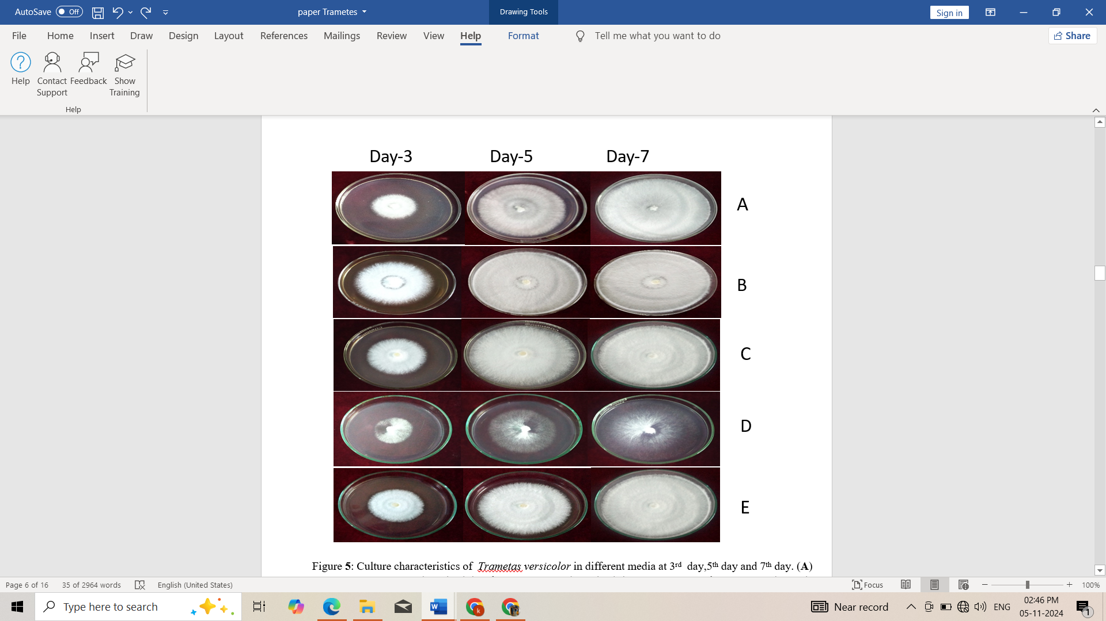

**Plate 4.** Mycelial growth of *T. versicolor* in different media at 3,5and 7 DAI. (**A**) Potato Dextrose Agar (PDA), (**B**)Malt Extract Agar (MEA), (**C**)Peptone potato dextrose agar(PPDA), (**D**)Czapek Dox Agar(CDA)and (**E**)Potato Malt Agar

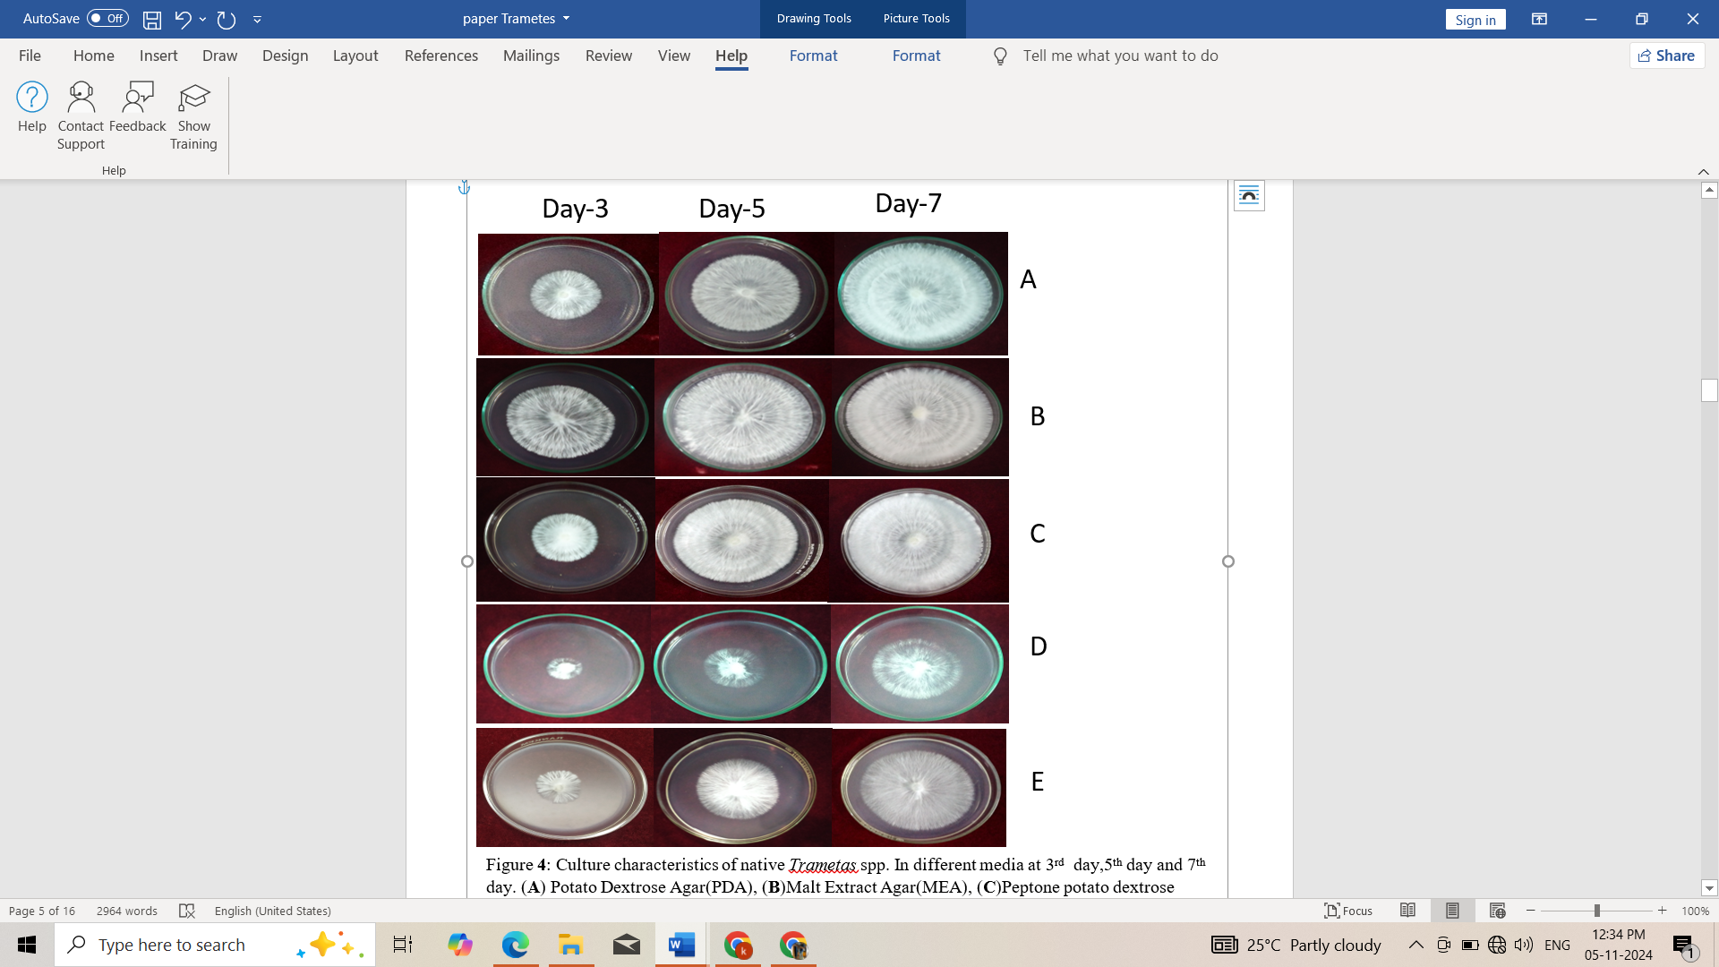

**Plate 5.** Mycelial growth of native *Trametes* sp. in different media at 3,5, and 7DAI. **A**) Potato Dextrose Agar (PDA), (**B**) Malt Extract Agar (MEA), (**C**)Peptone potato dextrose agar (PPDA), (**D**)Czapek Dox Agar (CDA)and (**E**)Potato Malt Agar

**3.4.2 Standardization of effective temperature for growth of *Trametes sp..***

Temperature plays a vital role in enzyme activity, mycelial growth, primordial formation and Mature fruiting body. The optimal growth temperature for mycelial growth varies according to species. Temperatures ranging from 25oC-30oC were found to be suitable for the mycelial growth of *T.* *versicolor* and native *Trametes* *sp*. The mycelial growth of *T*. *versicolor* was suppressed rapidly at temperatures above 30oC and below 20oC. Highest growth rate was observed at 30°C (18 mm/day) and lowest growth rate at 15°C (7.5mm /day) (plate 7). The mycelial growth of native *Trametes* sp. was completely inhibited at 15°C and 35°C. Highest growth rate of native *Trametes* sp. was observed at 30°C (15mm /day) and lowest growth rate at 20°C (8.1mm /day) (Table 2)(Plate 6 ).

Certain mushroom species are adapted to colder climates and are prevalent in temperate regions, while others thrive in warmer tropical climates [19]. The ligninolytic enzymes- laccase enable their producers to penetrate growth substrate and to earn easy access to the available nutrients [20]. *T. versicolor* was able to grow and produce enzyme laccase at temperatures ranging from 25°C-35°C, but grew poorly above 30°C and below 20°C. The optimal temperature for the mycelium growth of *T. versicolor* was observed at 30oC followed by 25oC [19].

**Table 2. Mycelial growth of *T. versicolor* and native *Trametes* spp. at different temperature**

|  |  |  |  |  |  |  |  |  |  |
| --- | --- | --- | --- | --- | --- | --- | --- | --- | --- |
| Temperature | | Nature of mycelial growth | | | Rate of mycelial growth(cm/day) | | | Days taken for complete growth | |
|  | T.*versicolor* | | I4 | T.*versicolor* | | I4 | T.*versicolor* | | I4 |
| 15°C | Cottony | | Nil | 0.75 | | 0.00 | 12 | | No growth |
| 20°C | Cottony | | Fluffy | 0.90 | | 0.81 | 10 | | 11 |
| 25 °C | Cottony | | Fluffy | 1.50 | | 1.27 | 6 | | 7 |
| 30°C | Cottony | | Fluffy | 1.80 | | 1.50 | 5 | | 6 |
| 35°C | Cottony | | Nil | 1.28 | | 0.00 | 7 | | No growth |

**Plate 6.** Culture characteristics of *Trametes versicolor* at different temperature at 3rd day,5th day and 7th day. (**A**)15°C (**B**)20°C (**C**)25°C , (**D**)30°C and (**E**)35°C

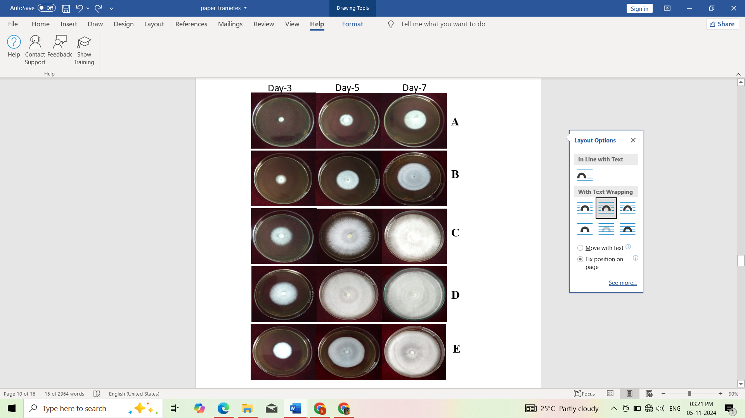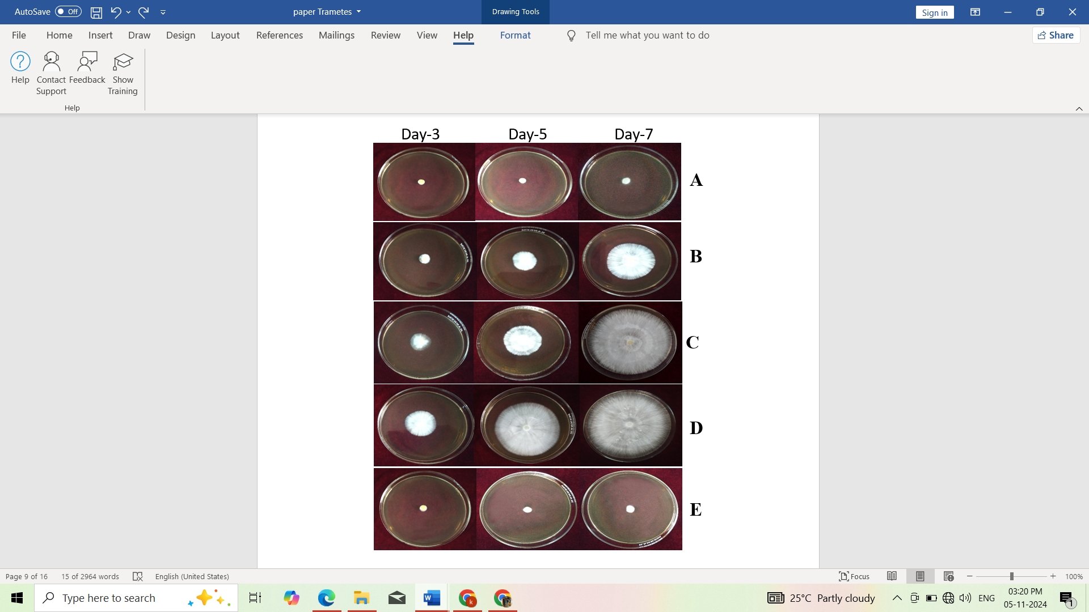

**Plate 7.** Mycelial growth of native *Trametes* sp*.* at different temperature 3,5 and 7 DAI (**A**)15°C (**B**)20°C (**C**)25°C, (**D**)30°C and (**E**)35°C

**3.4.3 Standardization of effective pH for the growth of *Trametes* sp.**

pH is one of the most vital physical factors affecting both the mycelial growth and production of extracellular enzymes by fungal strains. The characteristics of mycelial growth were studied for both native *Trametes* sp. and *T. versicolor* at different pH. Favourable mycelial growth was obtained within the pH range of 5-6 for *T*. *versicolor* and 5.5-6.5 for native *Trametes* *sp.* The nature of mycelial growth was cottony in *T. versicolor* while fluffy nature was observed for native *Trametes* *sp*. The rate of mycelial growth was inapt below the pH of 4 and above 8 (Table 3). The optimum pH range for the growth of *T. versicolor* were previously recorded as 5.0-5.8 [21]. Concurrently, the mycelial growth of *T. versicolor* was found to be optimum at a pH range of 4-6 [15]*.* The results from the present study suggest that optimum pH for of *T.* *versicolor* was 5-6.

**Table 3. Mycelial growth of *Trametes versicolor* and native *Trametes* spp. at different Ph**

|  |  |  |  |  |  |  |
| --- | --- | --- | --- | --- | --- | --- |
| pH | Nature of mycelial growth | | Rate of mycelial growth (cm/day) | | Days taken for complete growth | |
|  | T.*versicolor* | I4 | T.*versicolor* | I4 | *T. versicolor* | I4 |
| 4.5 | Cottony | Fluffy | 1.50 | 1.12 | 6 | 8 |
| 5.0 | Cottony | Fluffy | 1.50 | 1.27 | 6 | 7 |
| 5.5 | Cottony | Fluffy | 1.80 | 1.50 | 5 | 6 |
| 6.0 | Cottony | Fluffy | 1.80 | 1.50 | 5 | 6 |
| 6.5 | Cottony | Fluffy | 1.50 | 1.50 | 6 | 6 |
| 7.0 | Cottony | Fluffy | 1.50 | 1.27 | 6 | 7 |
| 7.5 | Cottony | Fluffy | 1.50 | 1.27 | 6 | 7 |
| 8.0 | Cottony | Fluffy | 1.50 | 1.27 | 6 | 7 |

**Conclusion**

The study commenced by Survey of AEU of Kerala with the collective purpose of understanding the prevalence of medicinal mushroom- *Trametes versicolor* and identifying the suitable climatic conditions. Throughout the study, the different Trametes species collected showed variable differences in growth at varying temperatures. Even though the food industry is reigned by *Pleurotus* and *Agaricus* mushroom, the other edible mushrooms such as *Auricularia, Trametes*, *Cordyceps*, *Hericium* and so on, have influenced the population to try new mushrooms to embark on healthy pace. Despite the constant negligence faced by Turkey tail mushrooms in the food industry due to less attractive morphology and flavour, the scientist has quite bright and immense hope in putting *Trametes* as the new face of healthy food. As a matter of fact, for the growth of *Trametes* sp., widely depends on pH and specific temperature ranges for growth under *in vitro* conditions. Further, parallel researches are undeniably required for its potential at *in vivo* conditions, in order to take up the mushroom on commercial basis.

**DISCLAIMER (ARTIFICIAL INTELLIGENCE)**

Author(s) hereby declare that NO generative AI technologies such as Large Language Models (ChatGPT, COPILOT, etc) and text-to-image generators have been used during writing or editing of this manuscript.

**References**

1. Ahlawat, O. P., & Tewari, R. P. (2007). *Cultivation technology of paddy straw mushroom (Volvariella volvacea)* (Vol. 36). India: National Research Centre for Mushroom.

2. Rai, R. D. (2003). Pradesh, India. *Fungal Biotechnology in Agricultural, Food, and Environmental Applications*, 382.

3. Veena, S. S., & Pandey, M. (2011). Paddy straw as a substrate for the cultivation of Lingzhi or Reishi medicinal mushroom*, Ganoderma lucidum* (W. Curt.: Fr.) P. Karst. in India. *International Journal of Medicinal Mushrooms*, *13*(4).

4. Mishra, J., Rajput, R., Singh, K., Puri, S., Goyal, M., Bansal, A., & Misra, K. (2018). Antibacterial natural peptide fractions from Indian *Ganoderma lucidum*. *International Journal of Peptide Research and Therapeutics*, *24*, 543-554.

5. Stamets, P. 2000. Growing gourmet and medicinal mushrooms. (3 rd Ed.). Ten Speed Press, Berkeley, California, 574p

6. Chen, Y., Yao, F., Ming, K., Wang, D., Hu, Y., and Liu, J. 2016. Polysaccharides from traditional Chinese medicines: extraction, purification, modification, and biological activity. Mol. 21(12): 1705.

7. Blagodatski, A., Yatsunskaya, M., Mikhailova, V., Tiasto, V., Kagansky, A., & Katanaev, V. L. (2018). Medicinal mushrooms as an attractive new source of natural compounds for future cancer therapy. *Oncotarget*, *9*(49), 29259.

8. Kiyama, R. (2017). Estrogenic terpenes and terpenoids: Pathways, functions and applications. *European Journal of Pharmacology*, *815*, 405-415.

9. Li, S., Tang, B., Liu, Y., Chen, A., Tang, W., & Wei, S. (2016). High-level production and characterization of laccase from a newly isolated fungus *Trametes* sp. LS-10C. *Biocatalysis and Agricultural Biotechnology*, *8*, 278-285.

10. Sun, H., Meng, X., Han, J., Zhang, Z., Wang, B., Bai, X., & Zhang, X. (2013). Anti-cancer activity of DHA on gastric cancer—an in vitro and in vivo study. *Tumor Biology*, *34*, 3791-3800.

11. Zhao, X., Ma, S., Liu, N., Liu, J., & Wang, W. (2015). A polysaccharide from *Trametes robiniophila* inhibits human osteosarcoma xenograft tumor growth *in vivo*. *Carbohydrate Polymers*, *124*, 157-163.

12. Córdoba M, K. A., & Ríos H, A. (2012). Biotechnological applications and potential uses of the mushroom *Trametes versicolor*. *Vitae*, *19*(1), 70-76.

13. Veena, S. S., & Pandey, M. (2012). Physiological and cultivation requirements of *Trametes versicolor*, a medicinal mushroom to diversify Indian mushroom industry. *Indian Journal of Agricultural Sciences*, *82*(8), 672.

14. Cui, J., & Chisti, Y. (2003). Polysaccharopeptides of *Coriolus versicolor*: physiological activity, uses, and production. *Biotechnology advances*, *21*(2), 109-122.

15. Jo, W. S., Kang, M. J., Choi, S. Y., Yoo, Y. B., Seok, S. J., & Jung, H. Y. (2010). Culture conditions for mycelial growth of *Coriolus versicolor*. *Mycobiology*, *38*(3), 195-202.

16. Shim, S. M., Oh, Y. H., Lee, K. R., Kim, S. H., Im, K. H., Kim, J. W., ... & Lee, T. S. (2005). The characteristics of cultural conditions for the mycelial growth of M*acrolepiota procera*. *Mycobiology*, *33*(1), 15-18.

17. Le, V. V. (2021). Successful Rescue of Wild *Trametes versicolor* Strains Using Sawdust and Rice Husk-based Substrate. *Pakistan Journal of Biological Sciences: PJBS*, *24*(3), 374-382.

18. Guerrero, D. G., Martínez, V. E., & de la Torre Almaráz, R. (2011). Cultivation of *Trametes versicolor* in Mexico. *Micologia Aplicada International*, *23*(2), 55-58.

19. Fabros, J. A., Lazo, M. K. M., Magpantay, J. E. S., Abon, M. D., Dulay, R. M. R., Kalaw, S. P., & Reyes, R. G. (2023). The effect of nutritional and physical factors on the growth of *Trametes versicolor* (L.) Lloyd and its mycochemical and cytotoxic properties. *Studies in Fungi*, *8*(1).

20. Šnajdr, J., & Baldrian, P. (2007). Temperature affects the production, activity and stability of ligninolytic enzymes in *Pleurotus ostreatus* and *Trametes versicolor*. *Folia Microbiologica*, *52*(5), 498-502.

21. Park, Y. D., Whang, W. K., Huh, J. D., Kim, S. H., &amp; Park, W. M. (1989). Comparisons of physiological characteristics in *Coriolus versicolor* intraspecific strains. The Korean Journal of Mycology, 17(1), 7-13.