# Evaluating Millet Straw as an Alternative Substrate for *Calocybe indica* Cultivation: A Comparative Study with Paddy Straw

ABSTRACT

This study aims to explore the use of pearl millet straw as an alternative substrate for cultivating milky white mushroom (*Calocybe indica*) for evaluating its effectiveness in terms of yield, growth parameters, and biological efficiency. Five different treatment combination were tested *viz.*, T1 (100% paddy straw), T2 (25% pearl millet straw + 75% paddy straw), T3 (50% pearl millet straw + 50% paddy straw), T4 (75% pearl millet straw + 25% paddy straw), and T5 (100% pearl millet straw). Among all treatments, T1 recorded 24.07 days for spawn running in bags, 11.95 days for pin head formation and average number of 42.32 fruiting bodies per bed, fruit body weight (67.07g). Followed by the treatment (T2) recorded 25.12 days for spawn run, 13.82 days for pin head formation and average number of 24.72 fruiting bodies per bed, fruit body weight (43.62g) compared to T3, T4 and T5. Biological efficiency was highest in T1 (76.33%) followed by T2 (56.52%) and T3 (55.07%). The results highlighted the potential ability to use pearl millet straw (25 %) in combination with paddy straw (75 %) to get better yields on par with paddy straw alone in mushroom farming by utilizing locally available agricultural wastes.

**Keywords: *Calocybe indica*, paddy straw, pearl millet straw, spawning, yield and biological efficiency.**

**Introduction**

*Calocybe indica*, commonly referred to as milky white mushrooms, is a species of edible fungus native to India. Recognized for its robust, fleshy, and umbrella-like shape, these mushrooms are primarily white in color, which gives rise to their name, "milky white." Notable for their resilience, they are suitable for cultivation in hot and humid climates (Purkayastha and Chandra, 1974). Milky white mushrooms are celebrated for their simple and cost effective cultivation methods, along with the ability to grow year around. They are essential agricultural product in many regions of India and other tropical countries (Krishnamoorthy and Bala, 2015). Traditionally consumed in the Indian state of West Bengal, these mushrooms have found their way into commercial cultivation since the mid-1990s. *Calocybe indica* was earlier described in 1974 by botanist A.S. Krishnamoorthy in Kolkata, India, following its first cultivation in Tamil Nadu Agricultural University. Over time, it has gained significance due to its economic potential and nutritional benefits (Purkayastha and Chandra, 1974; Krishnamoorthy and Bala, 2015). Milky white mushrooms are noted for their tender, chewy texture and mild, radish-like aroma, making them a popular ingredient in culinary practices. These mushrooms have long been associated with traditional Indian medicine, with historical records indicating their use both as food and for their potential medicinal properties (Kumar *et al*., 2017; Singh & Pathak, 2018).

Milky white mushrooms can be cultivated on various lignocellulosic wastes such as paddy straw, millet straw, coir pith, wood shavings, and banana trash, which serve as nutrient rich substrates. These agricultural wastes are rich in lignocellulosic components, complex and resistant to biodegradation, yet can be broken down by the mushroom mycelium during cultivation. This process provides a valuable opportunity for utilizing agricultural waste in an ecofriendly manner while simultaneously mitigating environmental pollution (Chakraborty *et al*., 2016). Furthermore, this method of mushroom cultivation generates additional income for farmers with minimal investment (Biswas and Singh, 2009). The cultivation process of *Calocybe indica* involves a straightforward approach with minimal infrastructural requirements. The optimal environmental conditions for spawning and growing milky white mushrooms include temperatures of 30-35°C, humidity levels of 85-90%, and adequate ventilation. The entire cultivation cycle spans approximately 56-60 days, making it a relatively fast-growing crop that can be harvested multiple times throughout the year (Navathe *et al*., 2014).

The commercial cultivation of milky white mushrooms has grown rapidly in Southern India, particularly in states such as Tamil Nadu, Andhra Pradesh, and Karnataka, where the climate and agricultural practices are favorable for their growth. The successful commercialization of *Calocybe indica* provides farmers with an additional income source and offers an innovative solution for reducing agricultural waste. Furthermore, widespread adoption of mushroom cultivation could help the farmers to use lignocellulosic wastes to use efficiently and generating an additional income by mushroom growers. (Vijaykumar *et al*., 2014; Chakraborty *et al*., 2016; Patel & Trivedi, 2016).

The current study aims to explore the use of new agro waste materials like pearl millet straw for cultivating milky white mushrooms, advancing the understanding of this valuable fungal species and its contribution to sustainable agriculture and waste management.

Material and Methods

**Raw Material Selection**

Agro waste includes paddy (*Oryza sativa*) straw and pearl millet (*Pennisetum glaucum*) straw which are abundant and serve as the substrate for mushroom growth. Cocopeat for casing material purchased from local market. Red soil for casing collected from garden (Fig. 1).

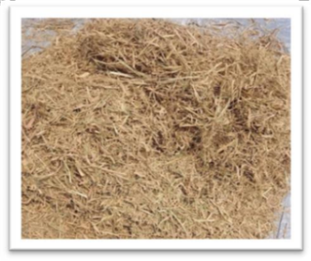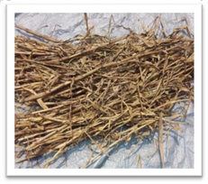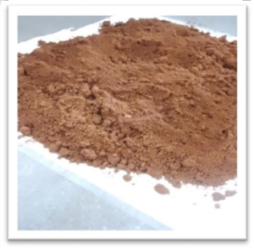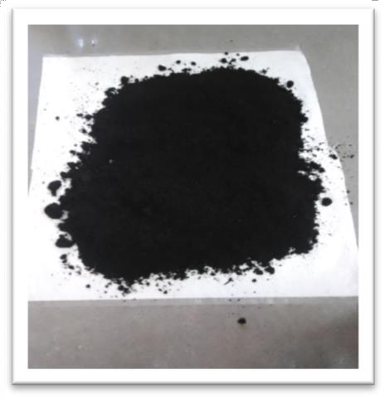

**a. Paddy straw**

**b. Millet straw**

**c. Red soil**

**d. Cocopeat**

**Figure 1: Raw materials used for mushroom production**

**Spawn and Substrate Preparation**

Spawn preparation was done by using the standard method described by Krishnamoorthy (2003). Pure culture of *Calocybe indica* was aseptical placed on Potato dextrose agar medium (PDA) in Petri plates and placed in the incubator at 28± 2˚C for one week. After one week, the mycelium spreads across the agar, which is then used to inoculate sterilized sorghum grains for spawn production (Subbaiah & Balan, 2015). The growth of the spawn was confirmed by the thick white mycelium, as shown in Fig. 2.

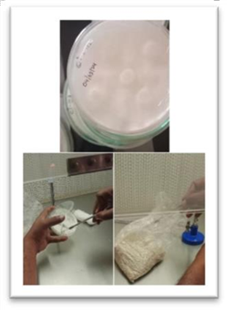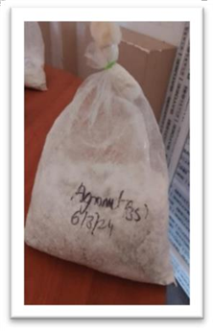

**Figure 2. Preparation of master culture and Spawn from mother culture**

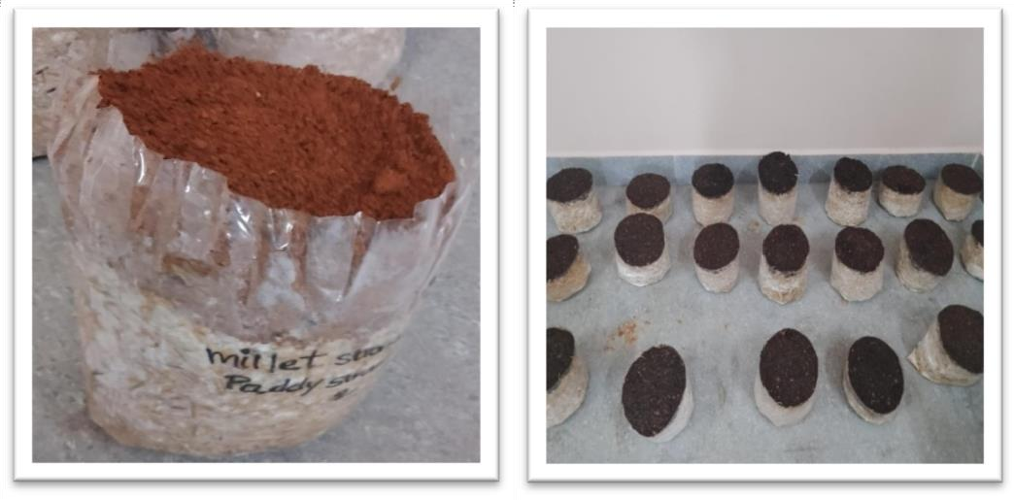

**Figure 3. Casing with red Soil and Cocopeat**

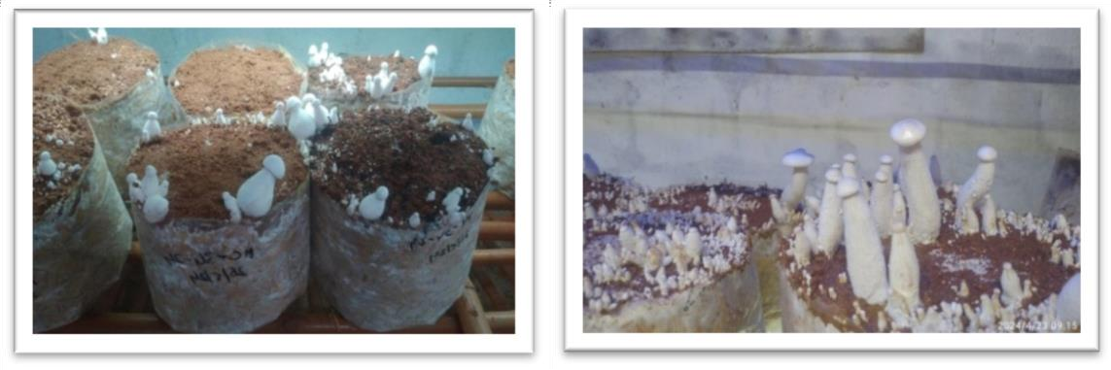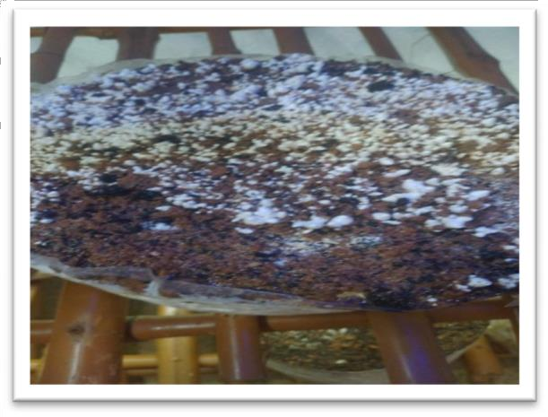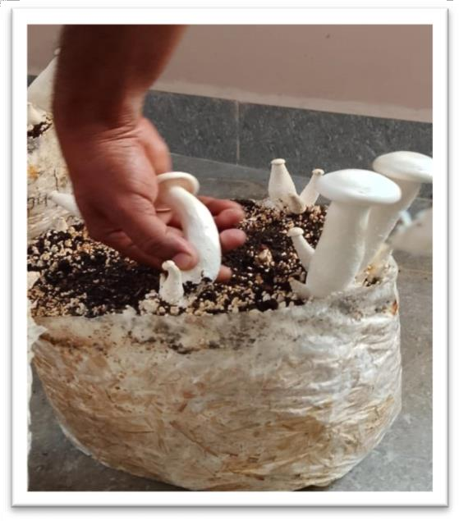

**Figure 4: Growth of *Calocybe indica* (milky mushroom) on different treatment combinations of paddy and pearl millet straw**.

The substrates used for milky white mushroom cultivation are paddy straw and pearl millet straw were chopped into 2 to 3-inch pieces and soaked in water containing carbendazim (75 ppm) and formalin (500 ppm) for 24 hours and excess water was drained out for 2-3 hrs. A moisture content of about 60 percent was maintained. Spawning was done @ 4 % by wet weight of the prepared substrate. Cultivation was done in high density polyethylene bags 25 x 14 inches with 100 gauge and 2.0 kg size of beds were maintained. Casing mixture was prepared by using cocopeat and red soil (1:2) and the casing material was sterilized at 65oC for 4 hrs. (Tandon and Sharma., 2006). The experiment was laid out as a completely randomized design with five replications and five treatments viz., T1 (Paddy straw 100%), T2 (75 % Paddy straw + 25 % Millet straw) T3 (50 % Paddy straw + 50 % Millet straw), T4 (25 % paddy straw + 75 % Millet straw) and T5 (100 % Millet straw). Biological efficiency (BE) of mushroom on the fresh weight basis was calculated by using the formula given by Chang and Miles (1989).

$$BE \left(\%\right)=\frac{Fresh weight of mushrooms}{Dry weight of the substrate}X100$$

**Spawn Running and Casing Application:**

Spawn running refers to the incubation phase, where the inoculated substrate is placed in a dark room with temperatures maintained between 28-32 °C and humidity levels of 85-90% (Table 1). After spawn running, the bags are opened, and a pasteurized casing material (cocopeat and red soil) is applied over the substrate. After 18-21 days, when the beds were fully colonized with mycelium, the 2.0 kg mushroom bag was cut into two halves exactly in the center. The surface was applied with casing soil to a thickness of 1.5 to 2.0 cm over the spawn run substrate (Fig 3&4). The beds were uniformly and regularly sprayed with water to keep the surface of substrate moist. Within one week the pin head becomes mushroom fruit body and mature mushrooms were harvested. Observation like number of days for spawn run, days for pin head formation, average number of fruiting bodies, number of pin heads, average fruit body weight (gm), stipe length (cm), width of fruiting body (cm) and biological efficiency (BE) was calculated (Bhiswanath *et al*., 2016).

**Statistical Analysis:**

The data obtained from the yield and growth parameters are analyzed statistically using a Completely Randomized Design (CRD) with one-way ANOVA. Coefficients of variation, standard errors, and coefficients of dispersion are calculated to measure variability and precision in the results Gomez and Gomez (1984).

**Table 1. Climatic conditions for mushroom cultivation**

|  |  |
| --- | --- |
| **Spawn run** |  |
| Temperature (°C) | 25-30 |
| CO2 concentration (ppm) | 5000-8000 |
| Relative humidity (%) | 80-85 |
| **Cropping** |  |
| Temperature (°C) | 28-34 |
| CO2 concentration (ppm) | 600-800 |
| Light requirement duration (hours) | 8-10 |
| Relative humidity (%) | 80-90 |
| Fresh air exchange | Once in a day  (5-10 min. exchange) |

Results and Discussion

### **Spawn Running**

Among different treatments, T1 (Paddy straw 100%) recorded fast mycelial growth in 24.07 days in bags, followed by T2 (75 % Paddy straw + 25 % Millet straw) with 25.12 days. T3 (50 % Paddy straw + 50 % Millet straw) and T5 (100 % Millet straw) required 27.21 days, while T4 (25 % paddy straw + 75 % Millet straw) took the longest at 26.17 days (Figure 5). Mycelium colonization was better in the samples containing only paddy straw compared to other treatments. This study was also supported by the fining of Pani (2012) and Bokaria et al., (2014) where they used different substrate and casing materials for cultivation of *C.indica* that affect spawn run and colonization period in the substrate. The yield potential on maize stalks could be improved when it was used in combination with paddy straw.

**Fig 5. Effect of millet straw in different treatment combinations on number of days for spawn run and pin head formation of *Calocybe indica***

### **Pin Head Formation:**

### T1 (Paddy straw 100%) took the shortest time period of 11.95 days for pin head formation, followed by T3 (50 % Paddy straw + 50 % Millet straw) at 13.82 days (Fig 5). T2 (75 % Paddy straw + 25 % Millet straw) and T4 took (25 % paddy straw + 75 % Millet straw)15.04 and 15.24 days, respectively, while T5 (100 % Millet straw) had the lowest pin head formation at 16.69 days. Sandeep *et al*., (2018) recorded less number of days (27 days) for pin head formation with wheat straw alone and 32 days for paddy straw (100 % paddy straw) and 33 days for wheat and paddy straw (1:1).

**Number of Fruiting Bodies in the Harvest:**

The highest number of fruiting bodies were observed in T1 (Paddy straw 100%), with an average of 42.32 fruiting bodies per bed (2.0 kg) followed by T2 (75 % Paddy straw + 25 % Millet straw) which recorded 24.72 fruiting bodies, and T3 (50 % Paddy straw + 50 % Millet straw) had 21.63 fruiting bodies. The lowest number of fruiting bodies (18.54) were recorded in T4 (25 % paddy straw + 75 % Millet straw) and T5 (100 % Millet straw) (Figure 6). Biswanath *et al.,* (2016) recorded highest number of fruiting bodies (23 number of fruiting bodies) in the treatment with paddy straw substrate encased with spent mushroom compost where 16 fruiting bodies were harvested in paddy straw and maize stalk combination, 12 in paddy straw and saw dust (1:1 v/v), 10 in paddy straw and saw dust (1:2 v/v), 7 in maize stalk and 4 in bamboo leaves.

**Fig 6. Effect of millet straw in different treatment combinations on average number of fruiting bodies of *Calocybe indica***

**Fruiting Body Weight:**

The highest average fruiting body weight (67.07g) was recorded in T1 (Paddy straw 100%) followed by T2 (75 % Paddy straw + 25 % Millet straw) which recorded 43.62 gm and T3 (50 % Paddy straw + 50 % Millet straw) (42.18gm). The lowest weight was observed in T5 (100 % Millet straw) (37.29 gm) (Figure 7). Bishwanath *et al.* (2016)recorded sporophore size grown on different substrates and observed that the size was significantly higher in paddy straw followed by the substrate combination of paddy straw and maize stalk, paddy straw and saw dust, maize stalk and bamboo leaves, minimum size observed in bamboo leaves. They also recorded maximum diameter of stalk in paddy straw (3.2 cm) followed by the combination of paddy straw and maize stalk (2.7 cm), maize stalk (2.2 cm).

**Stipe Length and pileus breadth:**

Treatment (T1) containing 100% paddy straw recorded the longest stipe length (9.94 cm), followed by T2 (9.32 cm) containing 75 % paddy straw and 25 % millet straw and T3 (8.90 cm) containing (50% paddy straw and 50% millet straw). The shortest stipe length was recorded in T5 (6.49 cm) where 100 % millet straw was used (Figure 8). Similarly, the pileus breadth of the fruiting bodies was largest in T1 (4.33 cm), followed by T2, T3, and T4 which recorded 3.91, 3.71, 3.87 and 2.78 cm respectively. These findings align with previous research on *Calocybe indica* (Bokaria et al., 2014) where they recorded maximum pileus breadth (7 cm) and stipe length (8 cm) in mushrooms grown in paddy straw compared to maize stalks and sorghum stalks.

**Fig 7. Effect of millet straw in different treatment combinations on average fruit body weight (gm) of *Calocybe indica***

**Fig 8. Effect of millet straw in different treatment combinations on stipe length and width of fruiting body of *Calocybe indica***

**Yield per 2.0 kg Bag:**

The average yield ranged from 0.23–0.50 g per 2.0 kg bag, with T1 (100% paddy straw) recorded the highest yield of 0.50 g/bag, followed by T2 (75 % paddy straw and 25 % millet straw) which recorded 0.37 g/bag and T3 (50 % paddy straw and 50 % millet straw) recorded 0.36 g/bag) (Figure 9). The lowest yield (0.23g/bag) was recorded in T5 (100 % millet straw). Among the different substrate combinations, paddy straw recorded highest yields. Next to the paddy straw alone, the combination of paddy straw (75 % with millet stalk (25 %) recorded better yields compared to T3, T4 and T5 combinations where 50 % and 75 % millet straw and 100 % millet straw supplied respectively. This study was supported by the experiment of Amin *et al*., 2010 and they used different substrates for cultivation of *C. indica* to see the effect of substrates on yield and biological efficiency. Niranjan and shyama sundar (2020) cultivated *Calocybe indica* on ten different lignocellulosic substrates *viz*., paddy straw, maize stalk, maize cob, wheat straw, green gram stalk, groundnut shell, coir pith, mustard stalk, sugarcane baggase and niger stick.

**Yield per 100 kg Dry Straw:**

Mushroom yield per 100 kg of dry straw ranged from 11.57–24.81 kg. T1 produced the highest yield of 24.81 kg/100 kg dry straw, followed by T2 (18.37 kg), T3 (17.90 kg), and T4 (13.45 kg). The lowest yield was recorded in T5 (11.57 kg). Amin et al., 2010 used different substrates for cultivation of milky mushrooms to see the effect of substrates on yield and biological efficiency. Shanmugaraj and Biswas (2024) recorded maximum yields for *Agaricus bisporus* with 1:1 ratio of paddy straw and maize stalks with a spawn run period of 20.33 days, pinhead formation at 15.33 days, and sporophore production of 92 per 8 kg compost bag. They also revealed that the compost made solely from maize stalks resulted in the lowest yield (643.33 g per 8 kg bag) and biological efficiency (8.04%).

**Fig 9. Effect of millet straw in different treatment combinations on average yield (g) per 2.0 k.g bag**

**Fig 10. Effect of millet straw in different treatment combinations on Biological efficiency of *Calocybe indica*.**

**Biological Efficiency:**

Maximum biological efficiency (BE) of 76.33 % was recorded in T1 (100 % paddy straw) followed by T2 (75 % paddy straw and 25 % millet straw) which recorded 56.52%of biological efficiency and T3 (55.07%) where 50 % paddy straw and 50 % millet straw. The lowest BE was recorded in T5 (35.59%) with 100 % millet straw (Fig. 10). The trend confirms the significant impact of substrate materials on biological efficiency, with paddy straw showing superior performance (Pani (2012) and (Bokaria *et al*., (2014). The results indicate that paddy straw is the most effective substrate for cultivating *Calocybe indica*, as it led to the highest yield and biological efficiency. The inclusion of millet straw in varying combinations reduced these parameters, although it still supported good mushroom growth. These findings are in line with previous studies that highlight the importance of substrate selection in optimizing mushroom production. The findings of the present study are comparable with those of previous studies using *C. indica* (Krishnamoorthy and Muthusamy, 1997 and Eswaran & Thomas, 2003). Rice straw was the best substrate, followed by wheat straw. Therefore, cellulose rich organic substrates are suitable for cultivating mushrooms. The reason for low biological efficiency on millet straw may be attributed to unavailability of necessary cellulosic compound in required amounts for fruiting body formation. Paddy straw was the best suitable substrate in respect of spawn run period, pinhead formation time, average weight of fruit body and biological efficiency. Proportionate amounts of lignin, cellulose and hemicellulose in paddy straw might have played the crucial role in performance of the mushroom study. Superiority of paddy straw as compared to many other substrates such as maize stalks, sorghum stalks, sugarcane bagasse, ground nut haulms, soybean hay, black gram hay, sunflower stalk, cotton waste, sesamum stalk and coir pith for cultivation of *C. indica* has been reported by many workers (Yadav 2006; Chaubey *et al*., 2010; Pani 2012; Saranya *et al*., 2011). Niranjan and Shyama sundar (2020) cultivated *Calocybe indica* on ten different lignocellulosic substrates and highest biological efficiency (BE) was recorded from wheat straw (86.8 %) with 1302 g mushroom /1500 g dry substrate followed by paddy straw (74.2 %). Early spawn run, pinhead initiation and 1st harvest was observed in wheat straw (17.5 d, 24.3d and 35.9 d) as compared to paddy straw. Delayed 1st harvest was recorded in coir pith (51.1d) followed by groundnut shell (49.6 d). The morphology and number of mushroom harvested from wheat straw was maximum that directly influenced the yield per bag. Highest pileus diameter, stipe length and stipe diameter was observed in mushroom harvested from wheat straw (116.0 mm, 175.2 mm, 73.7 mm) which was statistically at par with that of paddy straw. But, paddy straw substrate can be recommended for production of milky mushroom instead of wheat straw because of its unavailability in the state of Odisha.

Conclusion

Pearl millet straw when used in combination with paddy straw, exhibited promising potential ability for cultivating *Calocybe indica* (milky white mushroom). Even though, paddy straw alone yielded the higher yields, but the inclusion of pearl millet straw (especially in treatments like T2, with 75% paddy straw and 25% millet straw) compared to other treatments. This study highlights the importance of utilizing millet straw as an effective and eco-friendly option, particularly in regions where millet is abundantly available, providing an additional resource for mushroom production.

Disclaimer (Artificial intelligence)

Author(s) hereby declare that NO generative AI technologies such as Large Language Models (ChatGPT, COPILOT, etc.) and text-to-image generators have been used during the writing or editing of this manuscript.

**References**

Amin, R., Khair, A., Alam, N. and Lee, T.S. (2010). Effect of different substrates and casing materials on the growth and yield of *Calocybe indica*. *Mycobiology*. 38: 97-101.

Bishwanath Chakraborty, Usha Chakraborty, Shibu Barman, Somnath Roy. (2016). Effect of different substrates and casing materials on growth and yield of Calocybe indica (P&C) in North Bengal, India. *Journal of Applied and Natural Science*, 8(2): 683-690.

Biswas, S., and Singh, N. P. (2009). Evaluation of alternative substrates for milky mushroom. *Journal of Mycology and Plant Pathology*. 39(2):355.

Bokaria, K., Balsundram, S.K., Bhattarai, I. and Kaphle, K. (2014). Commercial production of Milky Mushroom (*Calocybe indica*). *Journal of Agricultural Science and Soil Sciences.* 2: 032-037.

Chakraborty, B., Chakraborty, U., Barman, S., & Roy, S. (2016). Effect of different substrates and casing materials on growth and yield of *Calocybe indica* (P&C) in North Bengal, India. *Journal of Applied and Natural Science*. 8(2): 683-690.

Chang, S. T., & Miles, P. G. (1989). Edible mushrooms and their cultivation (pp. 345-pp).

Chaubey, A., Dehariya, P. and Vyas, D. (2010). Yield performance of *Calocybe indica* on conventional and non-conventional substrates. *Journal of Mycology and Plant Pathology.* 40: 176-178.

Eswaran A, Thomas S. (2003). Effect of various substrates and additives on sporophores yield of *Calocybe indica* and *Pleurotus* species. *Indian Journal of Mushroom*. 21:8–10.

Gomez, k. A., & Gomez, A. A. (1984). Statistical procedures for agricultural research, 2nd edn. John Wiley and Sons, New York, pp 680.

Krishnamoorthy A. S. and Bala V (2015). [A Comprehensive Review of Tropical Milky White Mushroom (*Calocybe indica* P&C)](https://www.ncbi.nlm.nih.gov/pmc/articles/PMC4630423).  *Mycobiology*. 43 (3): 184–94.

Krishnamoorthy, A. S. (2003). Commercial prospects of milky mushroom (*Calocybe indica*) in the tropical plains of India. Current vistas in mushroom biology and production. Solan (HP): *Mushroom Society of India*, 131-5.

Krishnamoorthy, A.S. and M. Muthusamy. (1997). Yield performance of *Calocybe indica* (P&C) on different substrates. *Mushroom Res.* 6(1): 29-32.

Kumar, S., Sharma, V. P., Shirur, M., & Kamal, S. (2017). Status of Milky mushroom in India-a review. *Mushroom Research*. 26(1).

Navathe, S., P.G. Borkar and J.J. Kadam. (2014). Cultivation of *Calocybe indica* (P & C) in Konkan region of Maharashtra. *Indian World Journal of Agricultural Research.* 2: 187-191.

Niranjan Chinara and Shyama Sundar Mahapatra. (2020). Evaluation of Different Substrates for Production of Milky Mushroom (*Calocybe indica* P&C) in Odisha. *International Journal of Current Microbiology and Applied Science.* 9(6): 3195-3200.

Pani, B.K. (2012). Sporophore production of milky mushroom (*Calocybe indica*) as influenced by depth and time of casing. *International Journal of Advanced Biological Research*. 2(1):168-170.

Patel, P., & Trivedi, R. (2016). Yield performance of *Calocybe indica* on different agricultural substrate. *International Research Journal of Engineering, IT and Scientific Research*. 2(3): 66-71.

Purkayastha R. P and Chandra A. (1974). New species of edible mushroom from India. *Transactions of the British Mycological Society*. 62 (2): 415–18.

Sandeep Kumar Suman, Mithilesh Kumar and Dayaram. 2018. Evaluation of Substrate on Production of *Calocybe indica* (Milky white mushroom) under Bihar Condition. *International Journal of Current Microbiology and Applied Science.* 7: 3694-3699.

Saranya V, Madhanraj P and Panneerselvam A. (2011). Cultivation, Composting, Biochemical and Molecular Characterization of *Calocybe indica* (C and A). *Asian Journal of Pharmaceutical research.* 1(3): 55-57.

Shanmugaraj, C., and M.K. Biswas. (2024). Evaluation of Different Substrates in Composting for Cultivation of *Agaricus bisporus* under agro ecological conditions of West Bengal. *Journal of Advances in Biology & Biotechnology*. 27 (9):199-207.

Singh, S. K., & Pathak, R. (2018). Cultivation, Conservation and Medicinal Significance of Macrofungi. In Fungi and their Role in Sustainable Development: *Current Perspectives* (3-22). Springer, Singapore.

Subbiah, K. A., & Balan, V. (2015). A Comprehensive Review of Tropical Milky White Mushroom (*Calocybe indica* P&C). *Mycobiology*. 43(3):184–194.

Tandon, G., & Sharma, V. P. (2006). Yield performance of *Calocybe indica* on various substrates and supplements. *Mushroom Research*, 15(1): 33-35.

Vijaykumar, G., John, P., & Ganesh, K. (2014). Selection of different substrates for the cultivation of milky mushroom (*Calocybe indica* P & C). *Indian Journal of Traditional Knowledge*. 13:434-436.

Yadav, R.S. (2006). Use of vermi products in the production of milky mushroom *Calocybe indica*, M.Sc. Thesis, submitted to University of Agricultural Sciences, Dharwad-580 005 India.