Study of hematobiochemical, immune status and oxidative parameters in Ross AP strain broiler birds based on supplementation of Moringa oleifera and indigenous cow urine distillate in drinking water

Abstract
This experiment was conducted to compare the efficacy of native Munga plant (M. oleifera) methanolic leaves extract, indigenous cow (Kosali) urine distillate (CUD) and their combination on hematobiochemical status, immune status and oxidative parameters of Ross AP strain broiler birds (during April-May) using day-old broiler chicks (n = 150) with 30 birds in each group, were reared for 42 days. The day-old chicks were divided into 5 treatment groups, each with 3 replicates of 10 birds. The treatment groups were as follows: Group C (Control) consisted of a basal diet without any feed additives, group S (Standard) consisted of a basal diet with Enradin as an antibiotic @ 0.025% in feed, group T1 consisted of M. oleifera @ 1g/L in drinking water (0.1%) + basal feed, group T2 consisted of Cow urine distillate @ 10ml/L in drinking water (1%) + basal feed, and group T3 consisted of a combination of M. oleifera @ 1g/L (0.1%) and cow urine distillate @ 10ml/L in drinking water (1%) + basal feed. In the haematological study groups T1, T2 and T3 showed significantly (P<0.05, <0.01) higher levels of Hb, PCV, TEC and TLC as compared to the control group at the end of the 6th week. In the biochemical study, Group T₁, T₂ and T₃ showed a significantly (P<0.01 and <0.001) higher blood glucose level (mg/dl) as compared to the Control group. Groups T₁, T₂ and T₃ showed significant (P<0.05 and <0.01) reduction in levels of AST, creatinine and uric acid (T₁) as compared to the control group. Also, there was an increase in Total protein and globulin (T₁) as compared to the control group. In the case of Ca and P, the T₁ and T₃ groups showed a significant increase (P<0.05 and <0.01) as compared to the control group. At the end of the 6th week of the experiment, the antioxidant status of birds was measured in blood. For this study lipid peroxidation in red blood cell (RBC) hemolysate and reduced glutathione (GSH) concentration in RBC suspension were estimated. The birds of group T₁, T₂ and T₃ showed significantly (P<0.01 and <0.001) lowered MDA level, higher mean reduced GSH and increased GPx levels as compared to the control group. Also, there was a significantly (P<0.05, <0.01 and <0.001) higher glutathione peroxidase (GPx) level in the birds of T₁, T₂ and T₃ groups. On the 28th and 35th days, the humoral immunity test was showing significantly (P<0.01 and <0.001) improvement in birds of groups T₁, T₂ and T₃. The Cell-mediated immune status was determined by DTH (direct type hypersensitivity reaction) test on birds’ skin and resulted that the T₁, T₂ and T₃ groups showed a significantly positive response at both pre-and post-sensitization (6, 12, 24 and 48hr).
Keywords: Moringa oleifera, methanolic leaf extract, growth, haemato-biochemical, immunological, oxidative stress.
INTRODUCTION
In poultry, antioxidants are vital for nutritional and production purpose. In broilers, antioxidant deficiency causes disorders such as stunted development, weakness, ruffled feathers, blindness, xerophthalmia (Hill et al., 1961), encephalomalacia, exudative diathesis for vitamin E, polyneuritis, curled toe paralysis, perosis, and impaired selenium dietary utilisation (Swain, 1996). Antioxidant and antibacterial activity have been reported in a variety of plant and animal-derived compounds and lower the risk of diseases including cancer, stroke, and cardiovascular disease (Chanda & Dave, 2009). The leaves of the moringa tree are recommended for use as leaf meals in both animal and poultry feeds. The purposes of the study was to see how this leaf extract affected the hematobiochemical, immunological, and oxidative parameters of Ross AP strain broiler chicks. Luqman et al., (2012) discovered that polyphenols, tannins, anthocyanin, glycosides, and thiocarbamates, which eliminate free radicals, activate antioxidant enzymes, and block oxidases were responsible for M. oleifera leaf extract and fruit's antioxidant action. As evidenced by the scavenging of superoxide and DPPH radicals, cow urine and its distillate reduced free radicals and the fresh cow urine was more active than its distillation reported by Jarald et al., 2008. According to ancient literature, the distillate of cow urine was primarily employed, and the distillate was discovered to have antioxidant properties (Krishnamurthi et al., 2004). For the above-mentioned activities, we compared methanolic leaf extract of M. oleifera (T₁) and fresh cow urine distillate (T₂) and their combination (T₃) in our current investigation.
MATERIALS AND METHODS
Study site:
The current study was carried out at the College of Veterinary Science and Animal Husbandry, DSVCKV, Durg, Chhattisgarh, poultry shed of Department of veterinary pharmacology and toxicology. On broiler chickens, the study was conducted using a completely randomised design. For 42 days, 150 broiler chicks (Ross AP strain) were raised.
Preparation of extract and distillate:
Freshly gathered leaves were dried in shade at typical room temperature and powdered by utilizing a mixer grinder. The leaf powder was then extracted by the Soxhlet apparatus with methanolamo. For the investigation of the growth-promoting effect, haemato-biochemical, oxidative stress, immunological parameters. M. oleifera methanolic leaf extract (MLE) was supplemented to the broiler birds through drinking water. Then the urine was distilled or refined by using the simple distillation apparatus. At least 2L of cow urine distillate (CUD) was collected in a sterile glass bottle for further use.
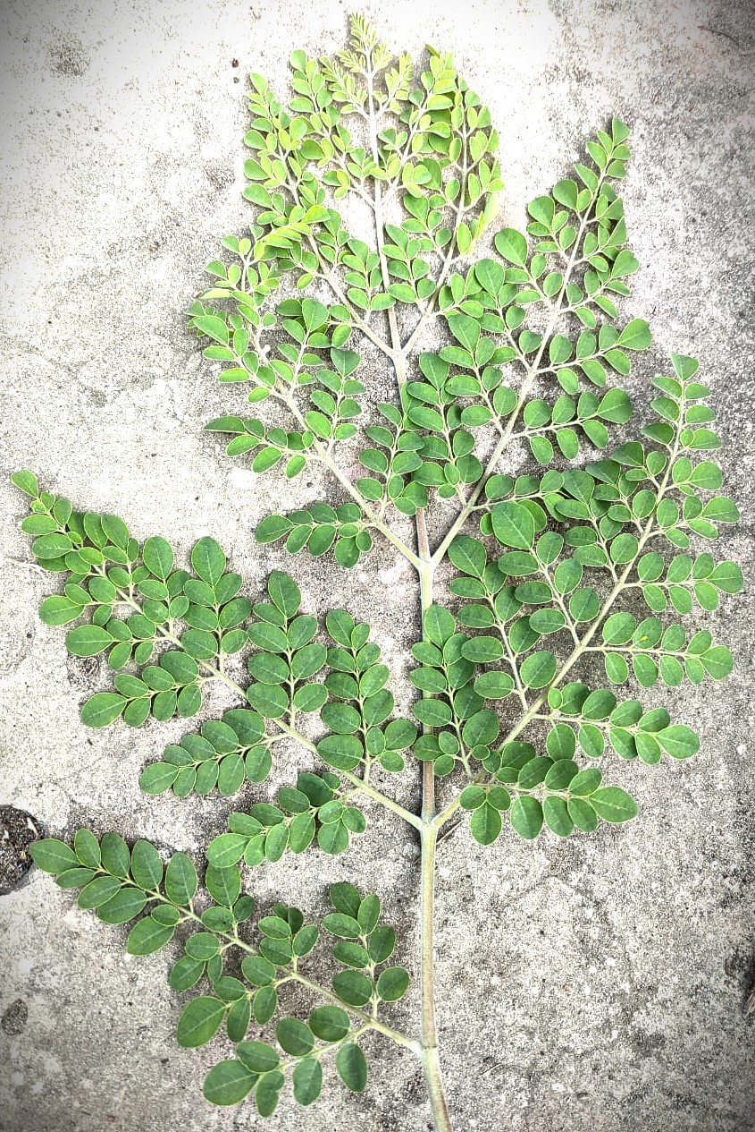 | 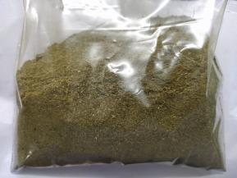 | 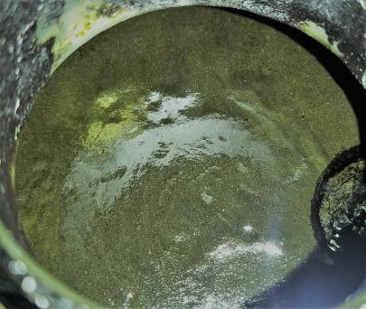 | 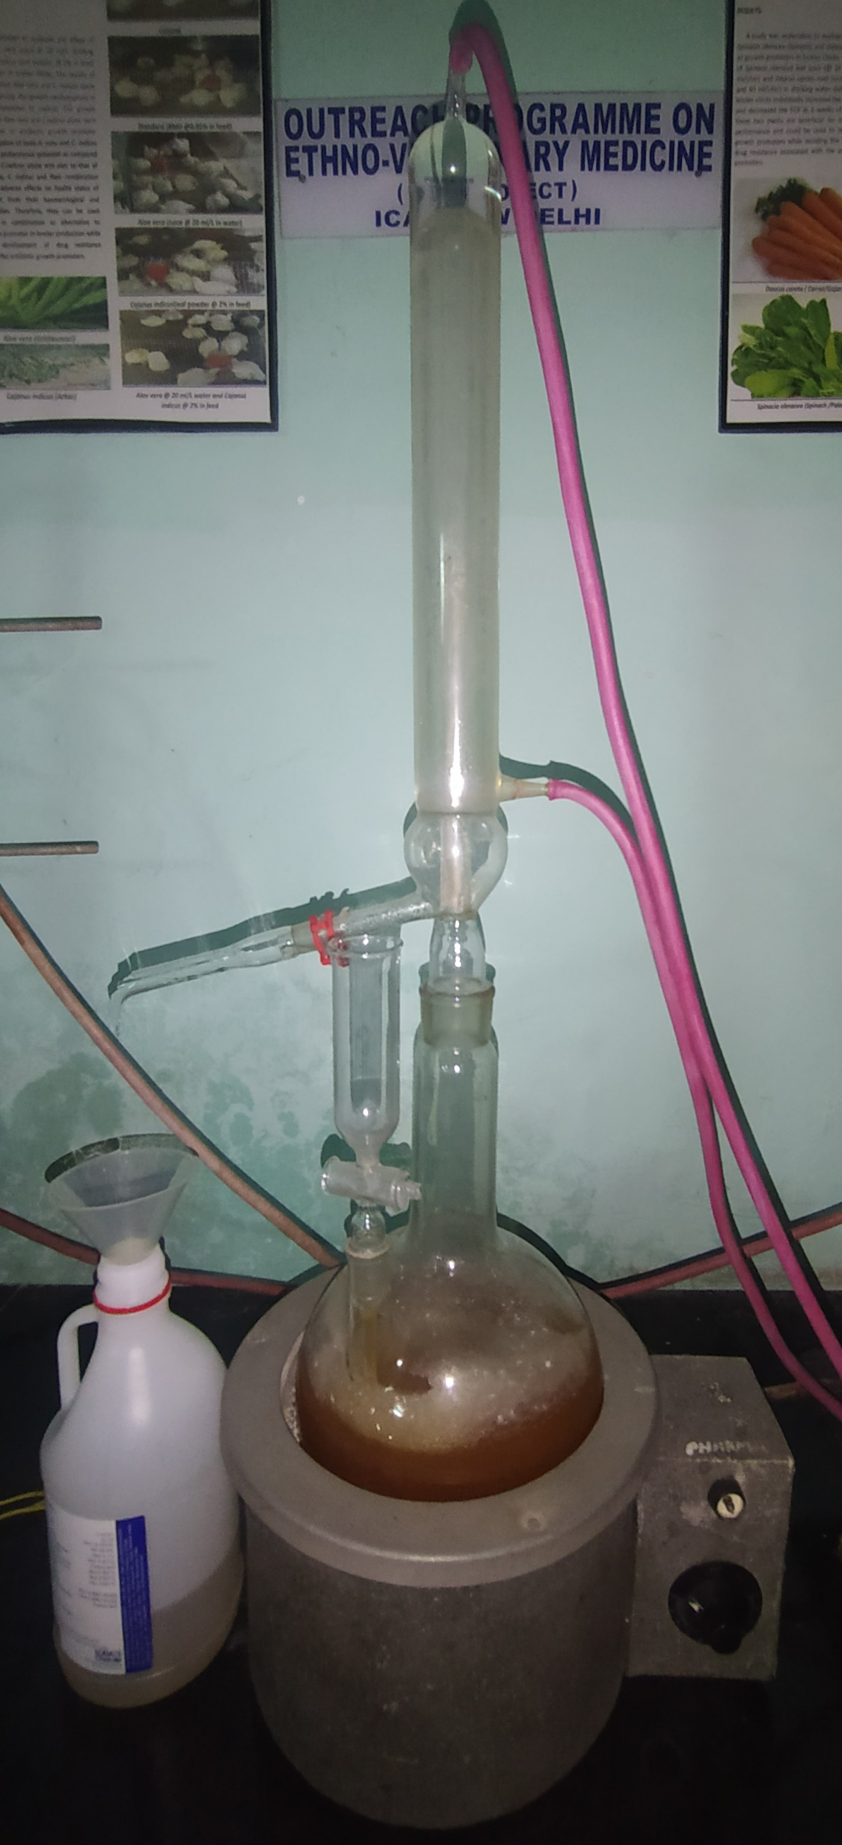
pic 1: M oleifera leaf | pic 2: M oleifera leaf powder | pic 3: M oleifera methanolic leaf extract | pic 4: Cow urine distillate
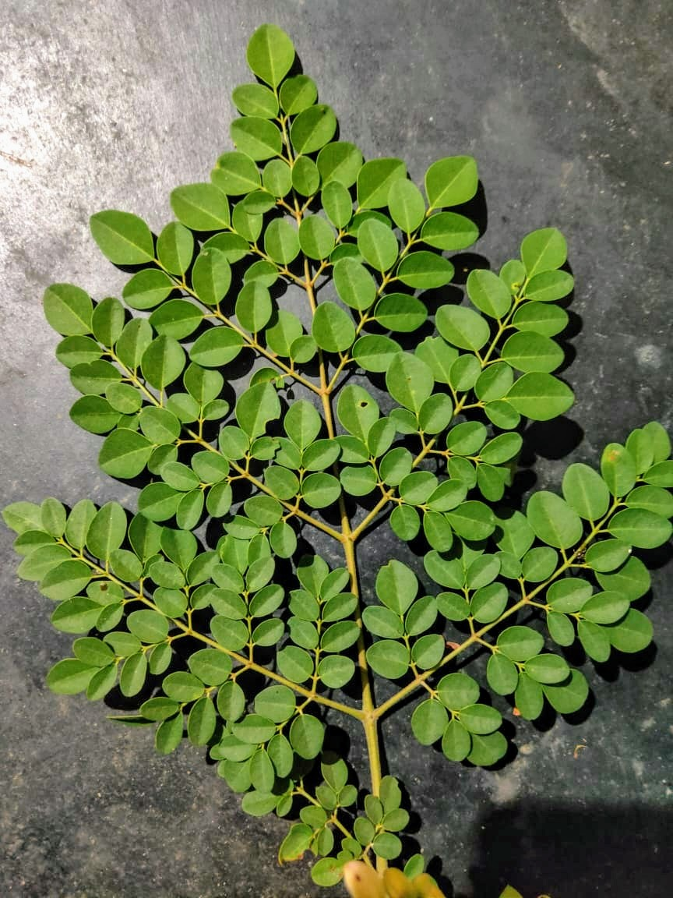 | 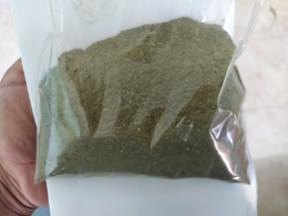 | 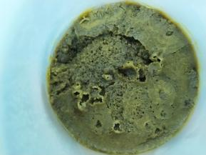 | 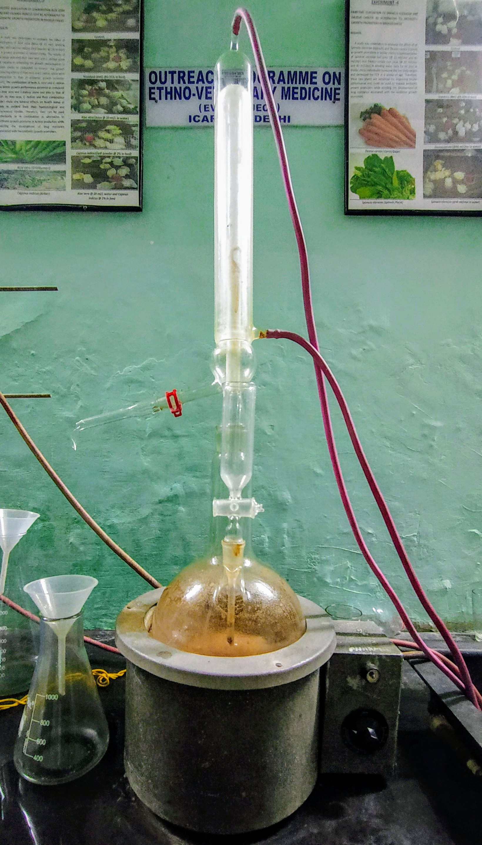
pic 5: M oleifera leaf | pic 6: M oleifera leaf powder | pic 7: M oleifera methanolic leaf extract | pic 8: CUD preparation

Experimental design:
The day-old chicks were split into five groups, each with three replicates of ten birds. The following were the treatment groups: Group C (Control) had a basal diet without any feed additives, group S (Standard) had a basal diet with Enradin as an antibiotic @ 0.025% in feed, group T₁ had M. oleifera @1g/L in drinking water (0.1%) + basal feed, group T₂ had Cow urine distillate @10ml/L in drinking water (1%) + basal feed and group T₃ had a combination of the above. The following study design was used to investigate the effects of M. oleifera methanolic leaf extract, indigenous cow urine distillate and their combination on the immunological status of experimental birds. Experimental design for hematobiochemical, oxidative and immunological studies (cell-mediated and humoral immune response) in broiler birds were performed in the remaining 30 birds. For the study of cell-mediated immunity and Humoral immune response the birds (n=30) were divided into 5 groups (C, S, T₁, T₂, T₃) containing 10 birds each separately and maintained for 42 days.
List 1-Experimental design for hematobiochemical, oxidative and immunological studies in broiler birds
Particulars | Groups
Particulars | C  (Control) | S  (Standard) | Treatment
Particulars | C  (Control) | S  (Standard) | T1 | T2 | T3
Total birds | 6 | 6 | 6 | 6 | 6
Replicate | 3 | 3 | 3 | 3 | 3
 | 2 | 2 | 2 | 2 | 2
Basal feed | + | + | + | + | +
Enradin (0.025%) | - | 0.25mg/kg feed | - | - | -
Methanolic leaf extract of Moringa oleifera in water (0.1%) | - | - | 1g/L | - | 1g/L
Cow urine distillates in water (1%) | - | - | - | 10ml | 10ml

Serum biochemical study:
On the 42nd day of the experiment, blood was collected from the jugular vein of six birds from each group (two birds from each replicate) in non-heparinized and clean test tubes. The serum was separated using standard methods and stored at -20°C for future use. Blood glucose, total protein, albumin, globulin, A: G, creatinine, uric acid, ALT, AST, calcium and phosphorus were measured in these samples using a semi-automated analyser and the manufacturer’s diagnostic kits and methodology.
Serum haematological study:
Blood samples were taken from 6 birds in each group at day 42 of age and placed in EDTA vials. The counts of RBCs, WBCs and DLCs were assessed using a hemacytometer and Natt-Herrick solution. PCV% and haemoglobin (Hb) levels were calculated using microhematocrit and cyanmethemoglobin techniques (Kececi et al., 1998).
Blood antioxidant study:
Antioxidant activity in hemolysate of the experimental birds were estimated by using the method described by Placer et al. (1966) for MDA level, GSH conc in RBC suspension, method described by Prins and Loos (1969) was followed.
Immunological study:
Humoral immunity and cell-mediated immunity are two adaptive immune responses that allow the animal body to protect itself against harmful agents such as bacteria, viruses, and poisons in a targeted manner.
Cell-mediated immunity: with slight modification of DTH hypersensitivity (Huynh and Chubb, 1987), subcutaneously with 100 μl DNFB (2000 μg) 2,4-dinitro-1-fluorobenzene (DNFB) produced hypersensitivity in 24th day old two broiler birds, following 14 days of the first application, the birds were challenged by applying 100 μl DNFB (50 μg) dye to the same areas. The degree of hypersensitivity was measured by the vernier callipers at 0, 6, 12, 24, and 48 hours after application. Increase in skin thickness (mm) = (Tt −T0) R−(Tt −T0) L. Where Tt = thickness at t, T0 = thickness at 0 h, R = right side, L = left side and t = time.
Humoral immunity: following the method described by Thaxton et al. (1974). Sheep blood was collected in an equal volume of Alsever’s solution and allowed to settle for a week. After centrifugation, the sheep RBCs were obtained and washed three times in normal saline solution (NSS), and a 7 % SRBC suspension was prepared. For immunisation, 1ml of this suspension was injected intravenously into six birds (two from each replicate) in each group (on day 32). Blood samples were taken from those birds 10 days after the SRBC injection. The blood sample was allowed to clot at 37°C for a few hours before being refrigerated, which resulted in serum extraction and storage at -20°C for future use. 2 ml of blood was drawn from a sheep and placed in a test tube containing Alsever's solution. The blood was washed in phosphate-buffered saline (PBS) and centrifuged at 3000 rpm for 5 minutes. This process was repeated until a clear supernatant was obtained. The packed red blood cells (RBC) were resuspended in a measured volume of PBS solution to create a 0.5% RBC suspension (Beard, 1989). The antigen titre for the HI test was determined using the standard HA technique with the LaSota ND vaccine as the antigen (Alexander and Senne, 2003). To inactivate the complement fractions, serum was thawed and warmed in a water bath. The micro-haemagglutination inhibition test was used to evaluate the serum antibody products in response to immunisation. The reciprocal of the highest dilution of the LaSota ND antigen causing 100% agglutination of an equal volume of standardised RBCs were used to calculate the antigen's HA titre. Hemagglutination inhibition tests were performed using a 4HA unit antigen dilution. The HI titers were expressed as log² values and the reciprocal of the highest dilutions of the sera at which 100% RBC HI occurred. On days 28 and 35, the HI test was used to assess the antibody titers of the experimental birds.
Statistical analysis:
A completely randomised design (CRD) was used for statistical analysis and data were analysed using analysis of variance (ANOVA) (Snedecor and Cochran, 1987) and Duncan's multiple range test with probability P<0.05 (Duncan, 1955) for significant differences between treatments. IBM SPSS was used for the statistical analysis (23.0).
RESULT AND DISCUSSION
Serum biochemical parameters:
The effects of M. oleifera and indigenous cow urine distillate on experimental treatments (T₁, T₂ and T₃) compared to the control group on hematological and serum biochemical parameters are summarized in Table 1 & 2. albumin and ALT levels were not significantly affected in T₁, T₂ and T₃ groups (P>0.05). When in T₁, T₂ and T₃ group broilers were showing their protein, albumin, globulin, A: G, ALT, AST, Creatinine, Uric acid, Calcium and Phosphorus levels increased significantly (P>0.05) compared to the control group. However, increase blood glucose concentration indicates the extract containing various carbohydrates (Tesfay et al., 2011) including fructose (12.99 mg/g), glucose (14.51 mg/g), raffinose (8.91 mg/g), sucrose (42.14 mg/g). According to Melesse et al. (2013) the inclusion of moringa leaf meal in Koekoek chicken diets caused significant changes in most serum biochemical parameters, .

Table: 1, Biochemical parameters in broiler birds (n=6) (Mean ± SE)
Parameters | C | S | T1 | T2 | T3
Glucose (mg/dl) | 155.83±3.12ª | 170.40±3.55^{b}* | 191.95±6.60^{c}** | 178.20±5.34^{b,c}** | 184.45±3.11^{c}**
Total protein (g/dl) | 3.86±0.10ª | 4.30±0.31ª | 5.16±0.17^{b}** | 4.18±0.32ª | 4.44±0.26^{a,b}
Albumin (g/dl) | 2.30±0.10ª | 2.28±0.32ª | 2.09±0.23ª | 2.05±0.24ª | 2.14±0.16ª
Globulin (g/dl) | 1.55±0.09ª | 2.01±0.14ª | 3.08±0.33^{b}** | 2.13±0.18ª | 2.30±0.34ª*
A: G | 1.52±0.13^{b} | 1.17±0.17^{a,b} | 0.74±0.13ª* | 0.99±0.14^{a,b} | 1.15±0.34^{a,b}
ALT (IU/L) | 5.31±0.14ª | 5.06±0.21ª | 4.45±0.34 ª | 4.79±0.48ª | 4.77±0.36ª
AST (IU/L) | 234.83±4.80^{b} | 215.34±10.20^{a,b} | 201.26±4.75ª** | 211.98±9.53ª* | 205.66±3.78ª**
Creatinine (mg/dl) | 3.66±0.16^{b} | 3.02±0.35ª* | 2.42±0.13ª** | 2.54±0.17ª** | 2.46±0.15ª**
Uric acid (mg/dl) | 6.06±0.28ª | 5.49±0.51ª | 4.85±0.40ª* | 5.34±0.40ª | 5.01±0.34ª
Calcium (mg/dl) | 7.80±0.49ª | 8.05±0.25^{a,b} | 8.90±0.24^{b,c}* | 8.11±0.18 ^{a,b,c} | 9.03±0.24^{c}**
Phosphorus (mg/dl) | 4.32±0.42^{a,b} | 4.61±0.13^{a,b} | 4.67±0.14^{a,b} | 4.16±0.41ª | 5.17±0.17^{b}*
Means having different superscripts at a particular period of treatment differs significantly (P<0.05)
*- Significant (P<0.05), **- Highly significant at P<0.01and <0.001

Parameters in haematology:
Table 2 shows the impact of administered M. oleifera leaf extract and CUD in drinking water on blood parameters in broilers. MCV, MCH, MCHC and heterophils % did not differ significantly among treatments. Hb, PCV %, TEC (10⁶/mm³), TLC (10³/mm³), Monocytes %, Eosinophils %, Basophils %, Lymphocytes % etc. This might be due to the presence of minerals and vitamins in CUD and the extract phytochemical ingredients. These components are well-known haemopoietic factors, which have a direct impact on blood formation in the bone marrow (Sembulingam K & Sembulingam P, 2010). Ajugwo et al., (2017) reported that the extract of M. oleifera leaves affected haematological parameters in Wistar rats with Phenylhydrazine-induced anaemia, resulting in a significant increase (p<0.05) in mean values of haemoglobin concentration and RBC count in treatment groups. When compared to the control group, these parameters were significantly higher in extract-treated animals. The effect on hemopoietic organs may explain the increased total erythrocyte count, haemoglobin content, and packed cell volume. Plant extract containing vitamins such as vit E, vit B₁₂, vit B₅, vit B₉, and vit B₇ are required for proper haemopoietic organ development and erythropoiesis. Moyo et al., 2011 reported that M. oleifera leaves highly contain vit A, C, E and folic acid (Saini et al, 2016). According to Stohs and Hartman et al., (2015) Niaziridin, a component found in M. oleifera, has been shown to increase the absorption of certain vitamins, minerals, and other micronutrients in the host's gastrointestinal system. Both biochemical and haematological parameters are often linked to one's health condition and are useful in diagnosing one’s health.

Table: 2, Haematological parameters in broiler birds (n=6) (Mean ± SE)
Parameters | C | S | T1 | T2 | T3
Hb (g/dl) | 9.77±0.09ª | 10.22±0.22ª | 12.92±0.73^{b}** | 10.73±0.32ª | 13.45±0.67^{b}**
PCV (%) | 27.00±0.36ª | 28.33±0.49ª | 32.00±0.86^{b}** | 28.67±0.95ª | 33.50±1.06^{b}**
TEC (10⁶/mm³) | 2.25±0.03ª | 2.45±0.04^{b}** | 2.75±0.03^{c}** | 2.65±0.03^{c}** | 2.94±0.05^{d}**
MCV (fl) | 120.16±2.84ª | 115.85±2.59ª | 116.28±3.22ª | 108.19±4.31ª* | 114.15±5.17ª
MCH (pg) | 43.43±0.40^{a,b} | 41.77±1.03^{a,b} | 47.01±2.90^{b} | 40.52±1.50ª | 45.74±2.41^{a,b}
MCHC (g/dl) | 36.21±0.67ª | 36.16±1.32ª | 40.76±3.28ª | 37.76±2.22ª | 40.54±3.05ª
TLC (10³/mm³) | 22.75±0.20ª | 23.48±0.27ª | 25.02±0.44^{b}** | 25.08±0.28^{b}** | 25.97±0.40^{b}**
Heterophils (%) | 29.35±0.69ª | 30.40±0.79ª | 30.10±0.68ª | 29.30±0.79ª | 29.47±0.77ª
Monocytes (%) | 2.56±0.05ª | 2.85±0.07^{b}** | 3.04±0.04^{c}** | 3.01±0.03^{c}** | 3.00±0.03^{c}**
Eosinophils (%) | 0.60±0.01^{b} | 0.58±0.01^{a,b} | 0.56±0.01ª* | 0.55±0.01ª** | 0.55±0.01ª**
Basophils (%) | 1.32±0.06ª | 1.23±0.01ª | 1.57±0.03^{b}** | 1.49±0.05^{b}** | 1.24±0.01ª
Lymphocytes (%) | 58.62±0.81ª | 60.87±1.11^{a,b} | 63.88±0.92^{c}** | 63.05±0.71^{b,c}** | 62.97±0.44^{b,c}**
Means having different superscripts at a particular period of treatment differs significantly (P<0.05)
*- Significant (P<0.05), **- Highly significant at P<0.01and <0.001

Antioxidant parametes:
Oxidative stress (MDA level) and antioxidant status (GSH & GPx) of 6 birds from each group were red on the 35th day of the experiment, blood samples were collected from 6 birds of each group (two birds from each replicate) in Ephendroph tubes containing anticoagulant (acid citrate dextrose) @1.5ml/10ml blood. These tubes were centrifuged at 3000 rpm for 15 min at 4°C and then the plasma and buffy coats were removed. The erythrocyte pellet was washed three times in phosphate buffer saline (PBS 50 mosmole/L). The concentration of MDA was measured by the method of Placer et al., (1966), using thiobarbituric acid reactive substances by the MDA-TBA method. The MDA level was significantly lower in T1, T2 & T3 groups as compared to the control group. The reduced glutathione assay results of the present study showed a significant increase in GSH levels in hemolysate of both Moringa and CUD and their combined treated experimental groups (Table 1) on 35th days and it is following the results of Gosavi et al. (2011) who observed a significant reduction in MDA values in gomutra ark treated group of rats as compared to control. Also, the level of GPx was significantly increased in all the treatment groups as compared to the control group. Similar to the present findings, Lavania et al. (2011) stated that cow urine reduced TBARS levels of liver and plasma in all experimental groups of rats in a dose-dependent manner. Similar to the present findings, Sushma et al., (2021) found significantly lower MDA levels in both hemolysate and tissue homogenate of Ongole and Sahiwal CUD treated experimental group’s birds after 42 days and M. oleifera leaves Extract groups (T5 and T6) were significantly (P > 0.05) higher in antioxidant capacity with 0.86 mmol/l (AbouSekken, 2015). Krishnamurthi et al., (2004) reported the existence of volatile fatty acids in cow urine, which may act as antioxidants, in a study. The number of volatile fatty acids in the redistillate of cow urine was reported to be around 1500 mg/dl. Also, Jarald et al., (2008) reported that cow urine and its distillate reduced free radicals such as superoxide and DPPH (2,2-diphenyl-1-picrylhydrazyl) radicals, also fresh cow urine was found to be more active than its distillation. Interestingly, as per a study by Fakurazi et al., (2008) has been found to restore the activity of Glutathione in M. oleifera treated rat group.

Table: 3. Antioxidant parameters (Mean ± SE)
Parameters | C | S | T1 | T2 | T3
LPO (nmole/ml) | 8.84±0.97c | 8.02±0.48b,c | 6.63±0.24a,b** | 7.72±0.34a,b,c | 6.27±0.34a**
GSH (M/g Hb) | 0.15±0.01a | 0.16±0.01a | 0.28±0.01c** | 0.23±0.01b** | 0.26±0.01c**
GSHPx (units/ml) | 145.57±7.48a | 191.57±6.30b** | 228.12±5.13c** | 197.24±3.83b** | 230.64±11.55c**
LPO=Lipid peroxidation, GSHPx=Glutathione peroxidase, GSH= Reduced Glutathione
Means having different superscripts at a particular period of treatment differs significantly (P<0.05).
*- Significant (P<0.05), **- Highly significant at (P<0.01) and (P<0.001).

Lipid peroxidase (LPO) (nmole/ml): The concentrations of lipid peroxidase (LPO) (nmole/ml) in the hemolysate of birds from the T1 (MLE) and T3 (MLE+CUD) groups were significantly (P<0.01) lower than in the control group (Fig: 1).
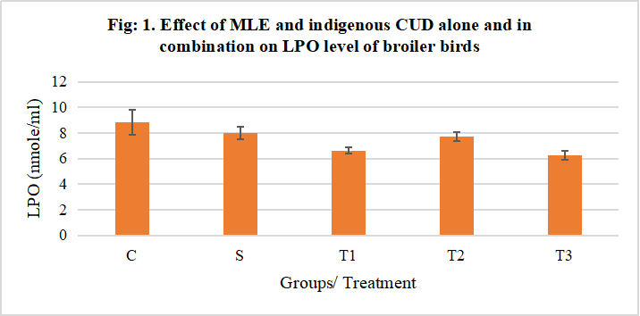
Reduced glutathione (M/g Hb): The concentrations of GSH (M/g Hb) in the hemolysate of birds from the T1 (MLE), T2 (CUD) and T3 (MLE+CUD) groups were significantly (P< 0.01) higher than in the control group (Fig: 2).
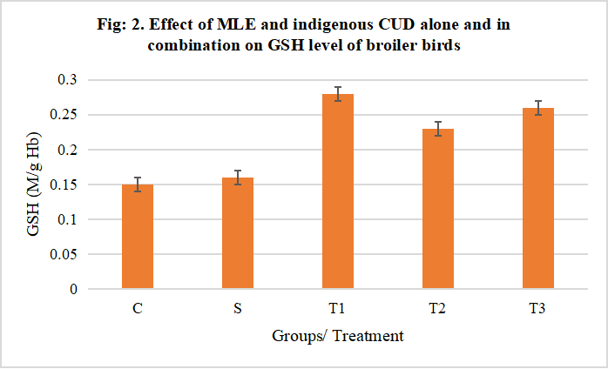
Glutathione peroxidase (GSH-Px) (units/ml): The concentrations of glutathione peroxidase (GSHP-x) (units/ml) in the hemolysate of birds from the S, T1 (MLE), T2 (CUD) and T3 (MLE+CUD) groups were significantly (P< 0.01) higher than in the control group (Fig: 3).

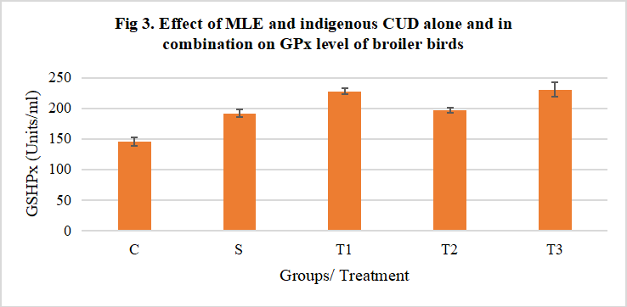
Immunological studies:
Humoral immunity:
The HA titration aimed to determine the viability or the potency of the vaccine used. The endpoint of the titre was determined as the pair of wells where haemagglutination was observed and 4 HA unit titre obtained. Then, the haemagglutination inhibition technique was used and the stock antigen was diluted according to the 4HA unit. The log₂ value of the micro hemagglutination inhibition (HI) titres of the induced birds of all groups against SRBC is depicted in Table. 4 and illustrated in Fig 4. A random sampling of birds for maternal baseline antibody titre level gave a mean value of log2.
When compared to the control group, the antibody titre values of the experimental birds after Newcastle disease vaccinations at 28th and 35th days were considerably (P<0.05 and <0.01) higher in the S (Standard), T2 (MLE), T1 (CUD), and T3 (MLE+CUD) groups. Immune responses were generated by administering NDV La-Sota on the 28th day, with antibody titre values being highest in birds treated with MLE+CUD. On the other hand, the birds in the T1 and T3 groups generated the highest antibody titres on the 35th day of treatment. The fact that all treatment groups evoked significantly higher (P<0.05) HI titers among vaccinated birds than the control group confirms this observation. The goal of the HA titration was to determine the vaccine's viability or potency. The pair of wells where haemagglutination was seen and a 4 HA unit titre was acquired served as the titre's endpoint. The stock antigen was then diluted according to the 4HA unit using the haemagglutination inhibition procedure. Table 4 shows the log2 value of the micro hemagglutination inhibition (HI) titres of the induced birds of all groups against SRBC, as shown in Fig 4. The mean value of log2 was obtained from a random sampling of birds for maternal baseline antibody titre levels.
Table 4: Effect of dietary supplementation of Moringa oleifera methanolic leaf extract (MLE) and indigenous cow urine distillate (CUD) and combination of both on the humoral immune status of broiler birds (n=6)
Humoral immune status in broiler birds (n=6) (Mean ± SE)
Parameters | C | S | T1 | T2 | T3
28th day | 3.00±0.26ª | 4.67±0.33^{b}** | 6.17±0.40^{c}** | 5.67±0.33^{b,c}** | 6.17±0.40^{c}**
35th day | 3.33±0.21ª | 4.50±0.43^{b}* | 6.17±0.40^{c}** | 5.83±0.31^{c}** | 6.00±0.36^{c}**
Means having different superscripts at a particular period of treatment differs significantly (P<0.05)
*- Significant (P<0.05), **- Highly significant at (P<0.01) and (P<0.001)

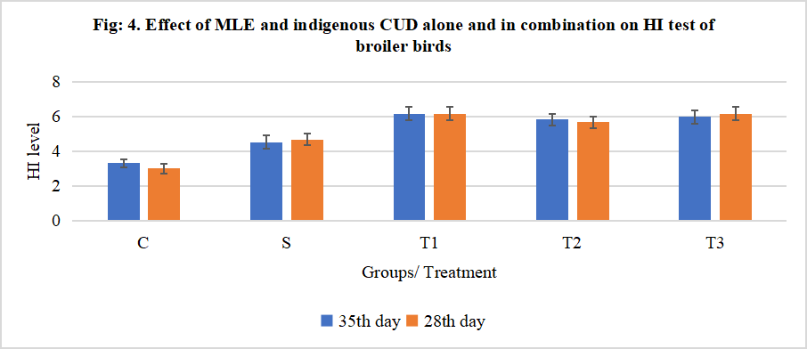
Cell-mediated immunity (CMI)
The effect of MLE and CUD administration alone and in combination on the Cell-mediated immune response was evaluated employing delayed-type hypersensitivity reaction using DNFB and the skin thickness of abdomen region at 6, 12, 24, and 48 hrs after challenge with DNFB in different groups were measured using Vernier callipers is presented in Table 5 and shown in Fig 5.
Pre-sensitization:
A significant (P<0.01) increase in the skin thickness was recorded at 6, 12, 24, and 48 hrs after DNFB-challenge at 24th day (pre-sensitization) in the birds from T1 (MLE), T2 (CUD) and T3 (MLE+CUD) groups as compared to the control group.
Post-sensitization:
The MLE and MLE+CUD groups revealed significantly (P<0.05 and 0.01) increased skin thickness at 6 and 12 hrs after post-challenge at 38th day (post-sensitization). However, at 24 and 48 hrs after DNFB post-challenge it was significantly (P<0.05 and 0.01) decreased in the birds from the CUD group as compared to the control group.
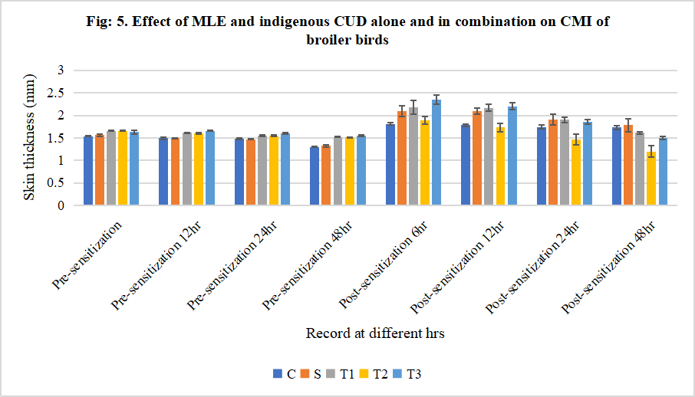

Cell-mediated immune response was evaluated by measuring the skin thickness of reactive skin lesion after application of 2,4-Dinitro-fluorobenzene (DNFB) at 6, 12, 24 and 48 hrs. The skin thickness in the birds of T1, T2 and groups were higher than the control (C) group at 6, 12, 24, and 48 hrs sensitization as shown in table 5. Skin thickness increases were higher in the T1 and T3 groups at 6 and 12 hrs, and in the T2 group only at 24 and 48 hours post sensitization, compared to the control group. In the current study, we found that supplementing MLE, CUD, and MLE+CUD in feed resulted in the highest CMI response among the different groups. In a study by Gosavi et al., (2011) antibody titres against sheep RBC increased considerably in the Gomutra ark group compared to the control group. Cow urine possesses immunomodulatory properties, as evidenced by this study. Also, Ambwani et al., (2006) found that cow urine enhances both cellular and humoral immune responses. Cow urine distillate (CUD) immune-potentiating effect on humoral and cell-mediated immune responses has been studied by Ganguly, (2006) with NDV virus vaccination, he found an increase in HI antibody titer against NDV. He claimed that CUD has immunomodulatory properties and its usage as an immunomodulating drug at the appropriate dose level may be recommended. One of its numerous properties is bioenhancing (Garg and Chauhan, 2003). Cow urine distillate is a bioenhancer that improves the efficacy of antibacterial, antifungal, and anticancer medications (Chawla, 2010). M. oleifera methanolic leaf extract significantly increased ND HI titre and total and differential leukocyte counts in the treated and unvaccinated Group I birds compared to the treated and vaccinated Group II birds, suggesting that it could be used as an immune-booster treatment against ND in non-vaccinated birds, according to Nnabuike and Olu (2012).

Table: 5. Effect of dietary supplementation of MLE and indigenous CUD and combination of both on the humoral immune status of broiler birds (n=6)
Skin thickness After DTH (Mean ± SE)
Time | C | S | T1 | T2 | T3
Pre-sensitization 6hr | 1.54±0.01ª | 1.56±0.02ª | 1.66±0.01^{b}** | 1.66±0.01^{b}** | 1.63±0.04^{b}**
Pre-sensitization 12hr | 1.49±0.02ª | 1.49±0.01ª | 1.61±0.01^{b}** | 1.60±0.01^{b}** | 1.66±0.01^{c}**
Pre-sensitization 24hr | 1.48±0.01ª | 1.47±0.01ª | 1.55±0.01^{b}** | 1.55±0.01^{b}** | 1.60±0.01^{c}**
Pre-sensitization 48hr | 1.30±0.01ª | 1.32±0.03ª | 1.52±0.01^{b}** | 1.51±0.01^{b}** | 1.55±0.01^{b}**
Post-sensitization 6hr | 1.81±0.03ª | 2.09±0.12^{a,b,c} | 2.18±0.15^{b,c}* | 1.89±0.09^{a,b} | 2.35±0.11^{c}**
Post-sensitization 12hr | 1.78±0.03ª | 2.09±0.07^{b}** | 2.17±0.07^{b}** | 1.73±0.10ª | 2.20±0.08^{b}**

CONCLUSION
Therefore, it can be concluded that M. oleifera extract and CUD can be added in drinking water to get best result in terms of reducing oxidative stress, improve immune system hemato-biochemical profiles on broilers chicken. The effect of oral administration of M. oleifera leaf extract irrespective of the dose tends to increase blood parameters such as WBC, RBC, Hb and PCV in broiler birds. This possibly could be the case in humans, hence justifying its use in traditional medicine practice. Decreased oxidative stress and improved antioxidant activity was noticed in all treatment groups which resulted in increased growth performance and higher feed efficiency in broilers given CUD (10ml/litre of water) of native cow (Kosali) breed. The improved antioxidant status and overall growth performance of T-4 (CUD from HF crossbred cows) compared to control was impressive.
CONFLICT OF INTEREST: None.

REFERENCES:
- AbouSekken MS. Performance, immune response and carcass quality of broilers fed low protein diets contained either Moringa oleifera leaves meal or its extract. J. Am. Sci. 2015 Aug 5;11(6):153-64.
- Ajugwo, A. O., Mounbegna, P. E., Kemajou, T. S., & Ofokansi, V. C. 2017. Effects of Moringa oleifera leaves extract on haematological parameters of phenylhydrazine anaemia induced wistar rats. Int J Pub Health Safe, 2(4), 139.
- Alexander, D.J. and Senne, D.A., 2003. Newcastle disease. Diseases of poultry, 11(1), pp.64-87.
- Ambwani, S., Ambwani, T., Singhal, L., & Chauhan, R. S. (2006). Immunomodulatory effects of Cow urine on dimethoate induced immunotoxicity in avian Lymphocytes. International Journal of Cow Science, 2(1), 45-48.
- Beard, C.W., 1989. Serologic procedures. A laboratory manual for the isolation and identification of avian pathogens. The American Association of Avian Pathologists. 3rd ed. Ames (Io): Kendall/Hunt Publishing Co, pp.192-193.
- Chanda, S., & Dave, R. (2009). In vitro models for antioxidant activity evaluation and some medicinal plants possessing antioxidant properties: An overview. African Journal of Microbiology Research, 3, 981–996.
- Chawla, P. C. 2010. Resorine A novel CSIR drug curtails TB treatment. CSIR news, 60, 52-54.
- Duncan, D. B. (1955). Multiple range and multiple F tests. Biometrics, 11(1), 1-42.
- Fakurazi, S., Hairuszah, I. and Nanthini, U., 2008. Moringa oleifera Lam prevents acetaminophen induced liver injury through restoration of glutathione level. Food and chemical toxicology, 46(8), pp.2611-2615.
- Ganguly, S. (2006). Cow urine distillate is regarded as promising immunomodulatory supplement for broiler diet: A Review. Biochemistry, 283, 67.
- Garg, N., & Chauhan, R. S. 2003. Cow therapy as an alternative to antibiotics. In Indian Science Congress (pp. 3-7).
- Gosavi, D. D., Sachdev, D., & Salwe, K. 2011. Immunomodulatory and antioxidant effect of gomutra ark in rats. J Mahatma Gandhi Inst Med Sci, 16, 37-41.
- Hill, F. W., Scott, M. L., Norris, L. C., & Hetjser, G. F. 1961. Reinvestigation of the vitamin A requirements of laying and breeding hens and their progeny. Poultry Science, 40(5), 1245-1254.
- Huynh, V. and Chubb, R.C., 1987. The induction of delayed type hypersensitivity to dinitrochlorobenzene in the chicken. Avian pathology, 16(3), pp.383-393.
- Jarald, E., Edwin, S., Tiwari, V., Garg, R., & Toppo, E. 2008. Antioxidant and antimicrobial activities of cow urine. Global journal of pharmacology, 2(2), 20-22.
- Kaur, R. G. 2010. Cow urine distillate as bioenhancer. J Ayurveda Integr Med, 1, 240-1.
- Kececi, T., Oguz, H., Kurtoglu, V. and Demet, O., 1998. Effects of polyvinylpolypyrrolidone, synthetic zeolite and bentonite on serum biochemical and haematological characters of broiler chickens during aflatoxicosis. British Poultry Science, 39(3), pp.452-458.
- Kececi, T., Oguz, H., Kurtoglu, V., & Demet, O. 1998. Effects of polyvinylpolypyrrolidone, synthetic zeolite and bentonite on serum biochemical and haematological characters of broiler chickens during aflatoxicosis. British Poultry Science, 39(3), 452-458.
- Krishnamurthi, K., Dutta, D., Sivanesan, S. D., & Chakrabarti, T. 2004. Protective effect of distillate and redistillate of cow's urine in human polymorphonuclear leukocytes challenged with established genotoxic chemicals. Biomedical and Environmental Sciences, 17(3), 247-256.
- Lavania, M., Dalal, J., Cheema, S., Nautiyal, C. S., & Lal, B. 2011. In vitro study of lipid peroxidation and free radical scavenging activity of cow urine. European Food Research and Technology, 232(4), 703-711.
- Luqman, S., Srivastava, S., Kumar, R., Maurya, A. K., & Chanda, D. 2012. Experimental assessment of Moringa oleifera leaf and fruit for its antistress, antioxidant, and scavenging potential using in vitro and in vivo assays. Evidence-Based Complementary and Alternative Medicine.
- Melesse, A., Getye, Y., Berihun, K. and Banerjee, S., 2013. Effect of feeding graded levels of Moringa stenopetala leaf meal on growth performance, carcass traits and some serum biochemical parameters of Koekoek chickens. Livestock Science, 157(2-3), pp.498-505.
- Moyo, B., Masika, P. J., Hugo, A., & Muchenje, V. 2011. Nutritional characterization of Moringa (Moringa oleifera Lam.) leaves. African Journal of Biotechnology, 10(60), 12925-12933.
- Nnabuike D, Olu SS. Effects of Moringa oleifera methanolic leaf extract on the morbidity and mortality of chickens experimentally infected with Newcastle disease virus (Kudu 113) strain. Journal of Medicinal Plants Research. 2012 Jul 18;6(27):4443-9.
- Placer, Z. A., Cushman, L. L., & Johnson, B. C. 1966. Estimation of product of lipid peroxidation (malonyl dialdehyde) in biochemical systems. Analytical biochemistry, 16(2), 359-364.
- Prins, H.K. and Loos, J.A., 1969. Glutathione. In Biochemical methods in red cell genetics (pp. 115-137). Academic Press New York.
- Saini, R. K., Manoj, P., Shetty, N. P., Srinivasan, K., & Giridhar, P. 2016. Relative bioavailability of folate from the traditional food plant Moringa oleifera L. as evaluated in a rat model. Journal of food science and technology, 53(1), 511-520.
- Sembulingam, K., & Sembulingam, P. 2010. Essentials of medical physiology. (5th edtn). Jaypee Brothers Medical Limited, India.
- Snedecor, G. W., & Cochran, W. G. (1987). Statistical Methods, 17th (Edn).
- Stohs, S. J., & Hartman, M. J. 2015. Review of the safety and efficacy of Moringa oleifera. Phytotherapy Research, 29(6), 796-804.
- Sushma, A., Eswara Prasad, P., Padmaja, K., Adilaxmamma, K., & Jayasri, K. (2021). Effect of native and crossbreed cow urine distillate on haemato-biochemical profile of broilers.
- Swain, B. K. 1996. Influence of Certain Nutrients and Their Interactions on the Performance and Immune Response of Broilers (Doctoral dissertation, IVRI).
- Tesfay, S. Z., Bertling, I., Odindo, A. O., Workneh, T. S., & Mathaba, N. (2011). Levels of anti-oxidants in different parts of moringa (Moringa oleifera) seedling. African Journal of Agricultural Research, 6(22), 5123-5132.
- Thaxton, J.P., Tung, H.T. and Hamilton, P.B., 1974. Immunosuppression in chickens by aflatoxin. Poultry science, 53(2), pp.721-725.

