**EXPLORING VEGETABLE ECOSYSTEM FOR PARASITOIDS OF LEPIDOPTERAN PESTS AND HOST SUITABILITY OF PREDOMINANT PARASITOID IN KERALA, INDIA**

ABSTRACT

|  |
| --- |
| **Aims:** Biological control plays an important role in reducing reliance on synthetic pesticides, gives a sustainable alternative that minimizes environmental and health risks. By utilizing natural enemies—such as predators, parasitoids, and pathogens—biological control helps manage pest populations effectively while preserving beneficial insects and maintaining ecological balance.In this studydocumentation of larval parasitoids of lepidopteran pests in vegetable crops from Kerala and finding out host suitability of predominant larval parasitoid for the purpose of mass production.  **Study design:** Completely Randomized Design for laboratory experiment  **Place and Duration of Study:** College of Agriculture, Vellayani, between November 2023 and July 2024.  **Methodology:** A periodic survey was conducted in selected agricultural fields of Kerala to collect lepidopteran pests. The collected larvae were kept in laboratory condition, to observe parasitization, highly polyphagous parasitoid obtained was designated as the predominant one. For the assessment of suitable host for the mass production the two natural hosts from the survey and *Corcyra cephalonica* and *Galleria mellonella* was reared in the laboratory condition and and assessed for preference by the predominant parasitoid.  **Results:** *Bracon hebetor* Say was identified as the predominant parasitoid in the vegetable ecosystem, which was identified by experts and confirming a parasitization rate of about 61.8%.*Chalcids ,Cotesia* and *Bracon brevicornis* were other parasitoids emerged. The cucumber moth and cotton leaf roller were the major hosts, exhibiting parasitization rates of 60-90%. *G. mellonella* was found to be the most effective host other than *C.cephalonica* and the natural hosts, supporting high fecundity, a short life cycle, and a substantial number of emerging parasitoids  **Conclusion:** There is a considerable amount of natural parasitation in the vegetable ecosystem and predominantly by the braconoid parasitoid, *B.hebetor*. It can be successfully mass produced using *G. mellonella*. |

***Keywords****:* Biological control, Parasitoids, *Bracon hebator,* mass production, *Galleria mellonella*

**1.INTRODUCTION**

The majority of India's agriculture follows a subsistence model, which faces numerous biotic and abiotic challenges. Pest activity has significantly increased in recent years, affecting agricultural output. With around 4.5 million hectares planted to vegetable production, India produces about 75 million tonnes of vegetables a year, second only to China in the world. However, insect pests reduce production by over 40%, resulting in significant losses. In India, there are 152 species of lepidopteran pests that harm vegetable crops. These pests are divided into several groups according how they feed namely stem borer, cutworms, fruit borers, pod borers, leaf miners, defoliators and leaf feeders [1].

The history of managing pests begins with the early days of farming. The most common approach to controlling different arthropod pests is still the use of chemical treatments [2].The benefits of chemical intervention include high effectiveness, quick action, affordability, accessibility and the opportunity for people to use these chemicals on their own. However, with the release of the book “Silent Spring”, the negative effects of pesticides on the environment and human health have dominated public discourse [3]. Pesticides have a fatal effect on the targeted insects or pests [18] about 98% of insecticides and 95% of herbicides are sprinkled on crops that reach their targeted and non-targeted species, water, soil, and air [19].When chemical pesticides are used excessively, pest resistance often develops, which eventually reduces their effectiveness. On the other hand, by utilising natural ecological interactions, biological control methods reduce the likelihood that pests to become resistant [4].

Biological control implemented through conservation and temporary augmentation of natural enemy is found to be more effective [5]. Biological control is one of the most important ecosystem services that arthropods provide, especially in cities where synthetic chemicals have major impacts on the environment and human health[16]. Harmful organisms in agriculture are today suppressed by biological agents everywhere around the world, but the intensity and manner of their use and pertaining legislation, which both enables the use of natural enemies and restricts it, differ considerably among regions[17] Even though there is an abundance in natural enemies in vegetable ecosystem, there has been a lack of systemic studies to document these beneficial organisms which limits their use in integrated pests management. As per reports, biocontrol involving parasitoids was found to be 66% successful [6]. The use of parasitoid groups which include egg, larval and pupal parasitoids in biological control initiatives has a lot of promise [7]. Non-selective pesticide use can have detrimental effects on pest population dynamics by reducing natural enemy populations, which can result in the emergence of secondary pests and a notable incidence of pest resurgence [8].

Considering the foregoing, a detailed study was carried out with the objective of documentation of larval parasitoids of lepidopteran pests in vegetable crops from Kerala and finding out host suitability of predominant larval parasitoid for the purpose of mass production.

**2.MATERIALS AND METHODS**

**2.1. Field survey and sampling of lepidopteran larvae**

During the year 2023–24, a survey was carried out in the farmers fields in several districts of Kerala. The survey was conducted periodically across major vegetable groups, including solanaceous, cruciferous, cucurbitaceous, malvaceous and leguminous plants. Caterpillars were collected from the field and then reared individually on their natural food under room temperature. Regular observations were made to monitor the emergence of any parasitoids from the collected pests. The parasitized samples were also collected from the field and brought to laboratory for observations.

Table1. Sampling sites and crops sampled

|  |  |  |
| --- | --- | --- |
| Districts | Geographic Information of farmers field | Crops |
| Thiruvanathapuram | Lat 8.564373 º  Long76.849472 º  Lat 8.6818 º  Long77.1022 º  Lat 8.2728 º  Long 76.5957 º  Lat 8.564373 º  Long76.849472 º | Snake gourd, Bhindi, Bittergourd  Amaranthus, Bhindi, Ash gourd, Brinjal  Brinjal, Cowpea, Snake gourd, Pumpkin  Snake gourd, Cowpea, Ash gourd, Brinjal |
| Kollam | Lat 8.9561º  Long 76.906863º  Lat 8.9389 º  Long 76.692413 º  Lat 8.965073 º  Long 76.688011 º  Lat 9.131487 º  Long 76.631343 º  Lat 8.9561 º  Long 76.906863 º | Bitter gourd, Snake gourd  Brinjal, Bhindi, Cowpea  Cabbage, Cauliflower, Bitter gourd  Snake gourd, Cowpea, Ash gourd, Brinjal  Amaranthus, Cowpea |
| Pathanamthitta | Lat 9.234521 º  Long 76.84 º | Snake gourd, Ash gourd, Bitter gourd, pumpkin |
| Alappuzha | Lat 9.654634 º  Long 76.30348 º  Lat 9.668769 º  Long 76.316871 º  Lat 9.676661 º  Long 76.301673 º | Snake gourd, Bitter gourd  Snake gourd, Bitter gourd, Cowpea  Snake gourd, Bitter gourd, Cowpea,Bhindi |
| Kottayam | Lat 9.558439 º  Long 76.596514 º  Lat 9.54985 º  Long 76.635315 º  Lat 9.686048 º  Long 76.636001 º  Lat 9.686065 º  Long 76.636017 º  Lat 12.075768 º  Long 75.276485 º | Snake gourd, Ash gourd, Bitter gourd, pumpkin  Snake gourd, Bitter gourd  Snake gourd, Bitter gourd, Cowpea,Bhindi  Snake gourd, Bitter gourd, Cowpea  Snake gourd, Bitter gourd,Cowpea |
| Ernankulam | Lat 9.976556 º  Long 76.32119 º  Lat 10.111664 º  Long 76.28878 º  Lat 10.156774 º  Long 76.264117 º | Bhindi, Cowpea  Snake gourd, Bitter gourd, Cowpea  Amaranthus, Chilli, Cowpea |
| Malappuram | Lat 11.284144 º  Long 76.279146 º  Lat 11.287592 º  Long 76.296766 º  Lat 11.2740 º  Long76.3115 º  Lat 11.2441 º  Long 76.3000 º | Snake gourd, Bitter gourd, Cowpea, Bhindi, Brinjal  Snake gourd, Bitter gourd,Cowpea  Amaranthus  Cowpea,Bittergourd |
| Kozhikode | Lat 11.497177 º  Long 75.695532 º  Lat 11.514781 º  Long 75.707699 º | Amaranthus, Chilli, Cowpea  Snake gourd, Bitter gourd, Cowpea, Bhindi, Brinjal |

The emerged parasitoids were preserved in 70% alcohol. The parasitoid that was obtained from maximum number of host larvae was designated as the predominant parasitoid from vegetable ecosystem.

**2.1 Identification of Parasitoid**

An experiment was conducted for identification of suitable hosts for mass production of predominant parasitoid under laboratory conditions. For this purpose, greater wax moth *Galleria mellonella* L. and rice moth *Corcyra cephalonica* Stainton were reared in laboratory. Two predominant hosts from the field, the cucumber moth *(Diaphania indica* Saunders) and the cotton leaf roller (*Sylepta derogata* Fabricius), were collected from the field and reared under laboratory conditions.

**2.2 Rearing of Host species**

**2.2.1 Rearing of Greater wax moth, *G. mellonella***

Wax moth larvae were introduced into a semi-synthetic diet in plastic containers with wire mesh. These containers were maintained at room temperature. Once pupation occurred, pupae were transferred to a separate container for adult emergence. Newly emerged adults were placed in a container with cotton soaked in 50% honey solution, and folded paper strips were provided for egg laying. The collected eggs were placed on a semi-synthetic medium in a new container to rear the larvae. Routine cleaning, transferring and media replenishment were done as needed. Fully grown fifth instar larvae were then collected for the experiment.

Composition of semi synthetic diet for wax moth larva were wheat flour (200 g), corn flour (400 g),wheat bran (200 g),milk powder (100 g) , yeast (100 g ), glycerol ( 250 mL) ,honey (250 mL).The wheat flour, corn flour, wheat bran and milk powder were weighed accurately and mixed thoroughly in a clean container, to which honey and glycerol were added and mixed homogenously so as to obtain ball break consistency and added yeast.

**2.2.2 Rearing of Rice moth, *C. cephalonica***

To promote the growth of C. cephalonica, insects were reared in medium-sized plastic basins using a standardized medium (Singh, 1995). The medium included sterilized broken sorghum grains (750 g), yeast (1.5 g), groundnut powder (30 g), streptomycin sulphate 0.1% (15 mL), and sulfur powder (3.0 g), all thoroughly mixed. Corcyra eggs (0.15 cc) were evenly spread on this medium, covered with muslin cloth, and labelled with the inoculation date. Moth emergence began around day 40. The moths were collected and transferred to an oviposition chamber, fed with w50% honey and vitamin E solution. Eggs were collected daily, separated from scales, and used to rear larvae for experiments.

**2.2.3 Rearing of Cucumber moth, *D.indica***

The late instar larvae collected from the farmer’s field were reared separately in clean containers. These containers were cleaned daily and the larvae were fed with the cucumber leaves till pupation. Also the eggs were used for the further multiplication of the test insect and used in the experiment.

**2.2.4 Rearing of Cotton leaf roller, *S.derogata***

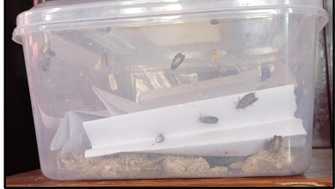Late-instar larvae collected from farmers' fields were reared individually in sanitized containers, which were cleaned daily. The larvae were fed with bhindi leaves until they pupated. The eggs produced were then used to further propagate the test insect population for use in the experiment.

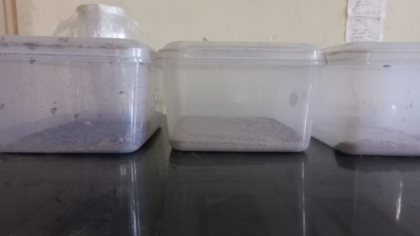

Fig 2: Rearing set up of *G.mellonella*

Fig 1: Rearing set up of *C.cephalonica*

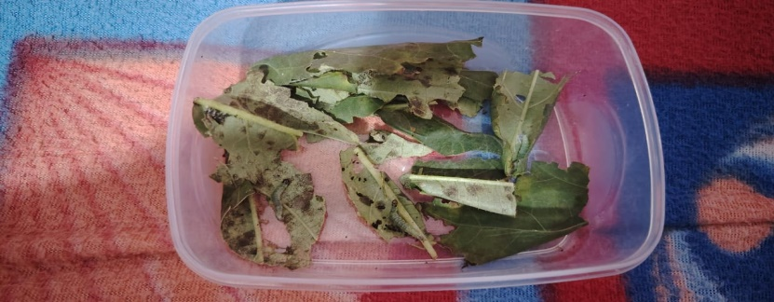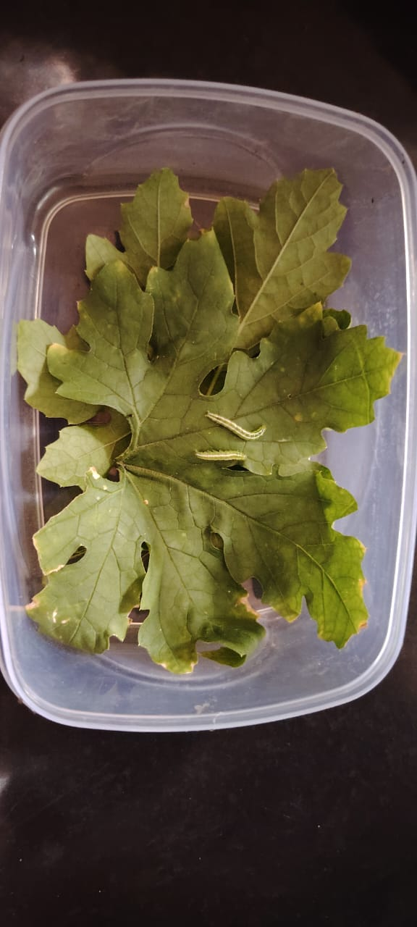

Fig 4: Rearing set up of *S.derogata*

Fig 3: Rearing set up of *D.indica*

**2.3 Experimental Design for host suitability**

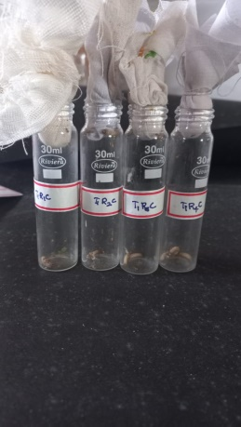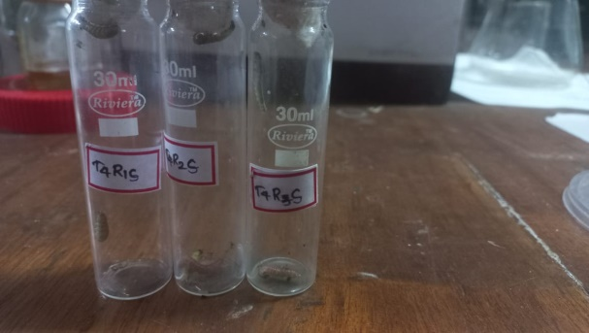The experiment was conducted using larvae reared under a Completely Randomized Design (CRD) setup, with four treatments and four replications each. In each replication, three larvae and ten parasitoids were introduced into glass vials. Parasitization rates were closely monitored, with specific observations on host mortality at different hours and the number of emerging parasitoids recorded for each treatment. These measures were critical for assessing the effectiveness of each treatment in influencing parasitoid emergence and host mortality, providing data essential for understanding the interaction dynamics in this controlled setting.

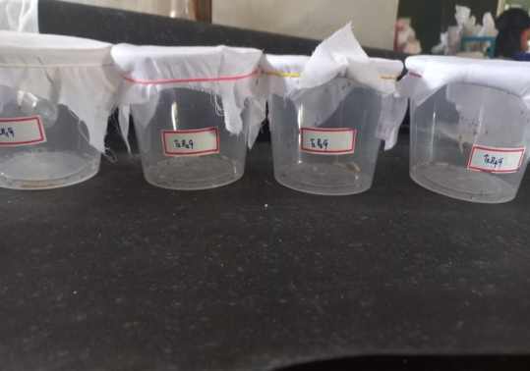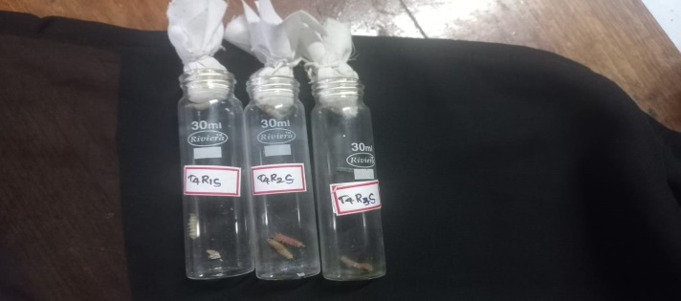

Fig 5: Experimental set up in the laboratory

**3. RESULT AND DISCUSSION**

Parasitoids were the predominant natural enemies attacking the lepidopteran pests in the vegetables. Parasitism observed from larvae collected from field is listed below regarding the respective parasitoids.

Table 2. Location, host and parasitism exhibited by parasitoid 1

|  |  |  |  |  |
| --- | --- | --- | --- | --- |
| Sl.No | Districts | Geographical Location | Host | Parasitism |
|  | Thiruvanathapuram | Lat 8.564373°  Long76.849472° | Snakegourd semilooper, *Anadevidia peponis* | 75% |
|  | Kollam | Lat 8.9561º  Long 76.906863º  Lat 8.9389°  Long 76.692413°  Lat 8.965073°  Long 76.688011°  Lat 9.131487°  Long 76.631343° | Cucumber moth, *Diaphania indica*  Snakegourd semilooper, *Anadevidia peponis*  Cotton leaf roller, *Sylepta derogata*  Cucumber moth, *Diaphania indica* | 80%  0  65%  50% |
|  | Pathnamthitta | Lat 9.234521°  Long 76.845609° | Cucumber moth, *Diaphania indica* | 85% |
|  | Ernankulam | Lat 9.976556°  Long 76.32119°  Lat 10.111664°  Long 76.28878°  Lat 10.156774°  Long 76.264117° | Cucumber moth, *Diaphania indica*  Pod borer, *Maruca vitrata*  Cotton leaf roller, *Sylepta derogata* | 86.55%  10%  75% |
|  | Alappuzha | Lat 9.654634°  Long 76.30348°  Lat 9.668769°  Long 76.316871°  Lat 9.676661°  Long 76.301673° | Snakegourd semilooper, *Anadevidia peponis*  Cotton leaf roller, *Sylepta derogata*  Cucumber moth, *Diaphania indica* | 0  20%  75% |

Table 3. Location, host and parasitism exhibited by parasitoid 2

|  |  |  |  |  |
| --- | --- | --- | --- | --- |
| Sl.No | Districts | Geographical Location | Host | Parasitism |
| 1 | Thiruvanathapuram | Lat 8.6818  Long77.1022 | Snakegourd semilooper, Anadevidia peponis | 40% |

Table 4. Location, host and parasitism exhibited by parasitoid 3

|  |  |  |  |  |
| --- | --- | --- | --- | --- |
| Sl.No | Districts | Geographical Location | Host | Parasitism |
| 1 | Thiruvanathapuram | Lat 8.2728  Long 76.5957  Lat 8.564373  Long76.849472 | Cucumber moth, *Diaphania indica*  Cucumber moth, *Diaphania indica* | 60%  0 |
| 2 | Kozhikode | Lat 11.497177  Long 75.695532  Lat 11.514781  Long 75.707699 | Cucumber moth, *Diaphania indica*  Cucumber moth, *Diaphania indica* | 40%  20% |

Table 5. Location, host and parasitism exhibited by parasitoid 4

|  |  |  |  |  |
| --- | --- | --- | --- | --- |
| Sl.No | Districts | Geographical Location | Host | Parasitism |
| 1 | Kottayam | Lat 9.558439  Long 76.596514  Lat 9.54985  Long 76.635315 | Cucumber moth, *Diaphania indica*  Snakegourd semilooper, *Anadevidia peponis* | 25%  10% |
| 2 | Malappuram | Lat 11.284144  Long 76.279146 | Snakegourd semilooper, *Anadevidia peponis* | 10% |
| 3 | Kollam | Lat 8.9561  Long 76.906863 | Snakegourd semilooper, *Anadevidia peponis* | 15% |

**3.1 Predominant Parasitoids Identified**

The parasitoid Species 1 were identified with the help of experts as *Bracon hebator* Say with approximately 61.28% of parasitisation. In the present study *Bracon brevicornis* (Species 4)*,Chalicids* (Species 2) and *Cotesia* (Species 3)were the other parasitoids reported. These findings align with a survey conducted in Coimbatore on vegetables where presence of braconoid parasitoids was found to be predominant[10]. [20] reported *B. hebetor*, is an important potential biocontrol agent of a wide range of lepidopteran insect species.Natural occurrences of *B. brevicornis*, *B. greeni*, *B. lefroyi*, *Chelonus* spp., *B*. *hebator* were documented by several workers[11][12]. The cucumber moth and cotton leaf roller were the primary natural hosts, with parasitization rates ranging from 60-90%.

**3.1 Host Suitability Evaluation for Mass Rearing**

For mass production of parasitoid, individual host is the entire larval food[13].Result obtained in the present study assures that mass production of host had significant effect on the mass production of the parasitoids.*G* . mellonella proved to be a suitable host under laboratory conditions, as B. hebetor exhibited significantly higher fecundity when reared on the greater wax moth (20.553) compared to C. cephalonica (15.277) (Table 6). On the other hand, it is found that progeny production was less in the natural hosts.The adult longevity was longer when reared on the *G. mellonella* (25.33 days) than any other hosts. This is in accordance with the results of [9] who had reported that the host affect the biology of *B. hebator* and *G. mellonela* was considered the most suitable host for this parasitoid. According to the results [14] adult emergence was greater in the 5th instar larva of *G*. *mellonella* than in the other hosts and the third instar larva of *G. mellonella* was found to be the best host for the oviposition and development of *B. hebetor.* When egg laying capacity, sex ratio and adult longevity of *B. hebetor* was studied[15] combined use of *G. mellonella* larvae and honey had significant increase on reproductive capacity and longevity of B. hebetor.The study also agreed with [21] that there was a significant difference in the period of development from egg to adult of the parasite when reared on host *G. mellonella* and other hosts.

Table 6. Evaluation of host suitability of predominant parasitoid

|  |  |  |  |  |  |  |
| --- | --- | --- | --- | --- | --- | --- |
| Treatment | Percent parasitization | No of eggs laid per host | No of cocoons per host | No of adult parasitoids emerged per host | No of days for egg –adult emergence | Adult longevity (days) |
| *Corcyra cephalonica* | 2.667 ab | 15.277 b | 14.777b | 13.170b | 8.667 | 19.333 b |
| *Galleria mellonella* | 3.000 a | 20.553 a | 20.553a | 18.663a | 5.667 | 25.333 a |
| *Diaphania indica* | 2.000 bc | 9.833 c | 9.167c | 8.833 c | 13.000 | 9.333 c |
| *Sylepta derogata* | 1.333 c | 5.333 d | 4.333d | 4.167d | 16.667 | 8.667 c |
| SE(m)± | 0.236 | 0.447 | 0.588 | 0.582 | 0.707 | 0.441 |
| CD(0.05)value | 0.769 | 1.458 | 1.916 | 1.898 | 2.306 | 1.438 |
| CV(%) | 18.144 | 6.075 | 9.013 | 8.315 | 11.134 | 4.875 |

**4.CONCLUSION**

In conclusion, *B. hebetor* was identified as the predominant parasitoid, achieving a natural parasitization rate of 61%. *D.indica* was more susceptible to parasitation in field which was followed by *S.derogata* ranging from 60-90%.For mass production of this parasitoid, *G. mellonella* proved to be the most suitable host, as it supported higher fecundity, adult emergence, and longevity of *B. hebetor* compared to other hosts used in the experiment.

Disclaimer (Artificial intelligence)

Author(s) hereby declare that generative AI technologies such as Large Language Models, etc. have been used during the writing or editing of manuscripts. This explanation will include the name, version, model, and source of the generative AI technology and as well as all input prompts provided to the generative AI technology

Details of the AI usage are given below:

1.ChatGpt

2.

3.

**Reference**

1. Maish SC. Lepidopterous pests, biology and its effect on vegetable crops. *J.* *Entomol. Zool. Stud*. 2019; 7(4):593-7.
2. Graves JB, Leonard BR, Ottea JA. Chemical approaches to managing arthropod pests. InHandbook of pest management. CRC Press. 1999 Jul 9; 471-508.
3. Carson R. Silent Spring Fawcett Publications. Greenwich. 1962;1-55.
4. Khulbe A, Batra P. Insect-Pests and Diseases in Greenhouse Cultivation and Their Biological Control. InProtected Cultivation. Apple Academic Press. 2024 Feb 6; 217-254.
5. Sharma S, Shera PS, Kaur R, Sangha KS. Evaluation of augmentative biological control strategy against major borer insect pests of sugarcane—a large-scale field appraisal. *Egypt. J.* *Biol. Pest Control*. 2020 Dec; 30:1-0.
6. Halder J, Rai AB, Dey D, Singh B. Abundance of important parasitoids in the vegetable ecosystem and their prospects in integrated pest management. *J. Entomol. Zool. Stud*. 2018; 6(4):762-9.
7. Pinto CP. Parasitoid wasps as biological control agents: A review. *J. Entomol. Zool*. 2020; 8:967-71.
8. Gallo DO, Nakano S, Silveira-Neto RPL, Carvalho GC, Baptista E, Berti-Filho JRP, Parra SB, Alves JD, Vendramin LJ, Marchini JRS, Lopes C, Omoto. Handbook of Agricultural Entomology. Piracicaba, Fealq. 2002; 649.
9. Farag NA, Ismail IA, Elbehery HH, Abdel-Rahman RS, Abdel-Raheem MA. Life table of *Bracon hebetor* Say.(Hymenoptera: Braconidae) reared on different hosts. *Int. J. Chemtech Res.* 2015; 8(9):123-30.
10. Thanavendan G, Jeyarani S. Parasitic Potential of some Braconid Parasitoids against Okra Fruit Borers. *Madras. Agri. J*. 2012 Oct; 99:1.
11. Jagmohan. 2001. Natural enemies of insect pests recorded from Punjab. Biocontrol Contributed paper. Punjab Agric.Univ. Ludhiana. 2001;1.
12. Mani M, Krishnamoorthy A, Gopalakrishnan C. Biological control of lepidopterous pests of Horticultural crops in India. *Ann. Rev. Agric. Res*. 2005; 26: 39-49.
13. Herren P, Hesketh H, Meyling NV, Dunn AM. Environment–host–parasite interactions in mass-reared insects. *Trends in Parasitology*. 2023 Jul 1;39(7):588-602.
14. Aswini R, Nelson SJ, Chitra N, Alagar M, Kumar SM, Elumalai D. Influence of five lepidopteran host insects on the fecundity and development of a larval parasitoid *Bracon* *hebetor* Say. *J. Eco-friendly Agric*. 2024 Jan 19;19(1):104-8.
15. Aamer N, Hegazi E, Khafagi W. Reproductive capacity, sex ratio and longevity of the parasitoid, Bracon hebetor (Say) parasitizing the wax moth larvae, Galleria mellonella (L.). *Egypt. J.* *Biol. Pest Control*. 2015;25(2):433.
16. Lowe EC, Latty T, Webb CE, Whitehouse ME, Saunders ME. Engaging urban stakeholders in the sustainable management of arthropod pests. *J. Pest Sci*. 2019 Jun (1);92:987-1002.
17. Garcia FR, Ovruski SM, Suárez L, Cancino J, Liburd OE. Biological control of tephritid fruit flies in the Americas and Hawaii: A review of the use of parasitoids and predators*. Insects*. 2020 Sep 25;11(10):662.
18. Christopher FC, Kumar PS, Christopher FJ, Joshiba GJ, Madhesh P. Recent advancements in rapid analysis of pesticides using nano biosensors: a present and future perspective*. J*. *cleaner production*. 2020 Oct 1;269:122356.
19. Delon OBC .Pesticides handling practices by vegetable growers along the accra-tema motorway .Doctoral dissertation, department of development and environmental studies, Wisconsin International University College. 2019
20. Abou El-Ela AS, Dessoky ES, Masry S, Arshad A, Munawar A, Qamer S, Abdelkhalek A, Behiry SI, Kordy A. Plasticity in life features, parasitism and super-parasitism behavior of Bracon hebetor, an important natural enemy of Galleria mellonella and other lepidopteran host species. *Saudi J. Biol. Sci*. 2021 Jun 1;28(6):3351-61.
21. Munshid RJ, Al-Gerrawy AJ, Hanawi MJ. The effect of host species on the development of immature stages and biological aspects of the larval parasitoid, Bracon hebetor Say [Hymenoptera: Braconidae] adults. *J. Entomoll Research*. 2021;45(suppl):827-32.

.