**Analyzing Haller Cells through Cone Beam CT: Investigating Associations with Orbital Floor Dehiscence and Sinusitis**

**Abstract**

**Aims**: This study aims to analyze Haller cells (infraorbital ethmoid cells) using cone beam computed tomography (CBCT) to determine their association with orbital floor dehiscence and sinusitis.

**Place and Duration of Study**: A retrospective study was conducted at the Department of Oral Medicine and Radiology, Government Dental College, Chh. Sambhajinagar, from May 2024 to July 2024.

**Methodology**: The number of ethical approval issued by the institutional committee is ECR/684/Inst/ MH/2014/RR-21. CBCT images from 150 patients were acquired using the Carestream CS 9300 machine and analyzed with TROPHY DICOM 3D Imaging Dental software (Version 6.4.0.4). The evaluation focused on coronal sections with a slice thickness of 0.899 mm. Data was recorded in Microsoft Excel (2007/2013). Descriptive and frequency analyses were performed using SPSS version 21.0. The Shapiro-Wilk test was used to check if the data followed a normal distribution. Chi-square tests were used to analyze associations, and a p-value of <0.05 was considered statistically significant.

**Results**: The study included 150 participants, aged 16–62 years, with a mean age of 29.7 ± 9.16 years. Of the participants, 60% were female (90) and 40% were male (60). Haller cells were present in 42% and absent in 58%. The most common shapes of Haller cells were oval (28%), round (9.3%), irregular (2.7%), and triangular (1.3%). Sizes included large (5.3%), medium (20%), and small (14.7%). Bilateral presence was seen in 8%, unilateral in 34%, and absent in 58%. Maxillary sinusitis was present in 16.7% of participants with Haller cells, and orbital floor dehiscence was observed in 3.3%. Significant associations were found between Haller cells and maxillary sinusitis (Chi-square = 41.429, p < 0.001) and orbital floor dehiscence (Chi-square = 7.143, p = 0.012).

**Conclusion**: The study found a significant relationship between Haller cells and maxillary sinusitis and orbital floor dehiscence, highlighting the importance of identifying Haller cells in CBCT evaluations.

**Keywords**: CBCT, Haller cells, Sinusitis, Orbital Floor Dehiscence

**Introduction**

Haller cells are a type of anatomical variation found in the paranasal sinuses. These cells, specifically infraorbital ethmoid cells, are often discovered by accident during imaging and are not always carefully examined for their potential role in causing blockages or inflammation of the ethmoidal infundibulum, a passage in the sinuses. The term "Haller cells" is named after the anatomist Albert Von Haller, who first identified the air space in the orbital floor, which is part of the ethmoidal region, back in 1765 (1,2,3,4,5,6). These cells are typically considered to be an extension of the ethmoidal sinuses, which are a group of sinuses located in the region of the nose, into the orbital floor or the upper portion of the maxillary sinus. Haller cells are located medially (toward the midline of the face) to the infraorbital canal and laterally (toward the side of the face) to the nasolacrimal duct. These cells are sometimes referred to as orbito-ethmoidal cells or maxillo-ethmoidal cells because of their location and connection to the orbital and maxillary areas. It is important to note that the posterior extension of these ethmoidal cells is quite rare, and it should be clearly distinguished from the lateral extension of the posterior portion of the middle meatus, a part of the nasal cavity (2,3,5,6,7).

When Haller cells become larger, they can exert pressure on the maxillary sinus infundibulum, which is a small passage in the maxillary sinus. This pressure may block the normal flow of mucus, which is essential for clearing the sinuses. The blockage of this mucus flow can disrupt the normal transport and drainage of fluids, leading to the accumulation of fluid within the sinuses. This buildup creates an ideal environment for bacterial growth, which can contribute to the development of infections and other issues related to the maxillary sinuses (2,5). The position of Haller cells can also affect the natural flow of mucus, making it more difficult for the sinuses to drain properly. This disruption can lead to recurrent maxillary sinusitis, an ongoing condition where the maxillary sinuses become inflamed and infected (3,11,12). In some studies, there has been a notable connection between larger Haller cells, specifically those greater than 3 mm in size, and the occurrence of orbital floor dehiscence, a condition where there is a thinning or opening of the bone that forms the floor of the orbit. However, despite these findings, there is still no clear or conclusive information on the exact relationship between the size of Haller cells and orbital floor dehiscence (3,7).Given these considerations, the purpose of our study is to evaluate the prevalence of Haller cells using cone beam computed tomography (CBCT), an advanced imaging technique that provides detailed 3D images of the facial structures. We aim to assess how frequently these cells occur in the general population and to explore any possible connections between the presence of Haller cells and conditions such as maxillary sinusitis and orbital floor dehiscence.

**Materials and Methods**

A retrospective study was designed to analyze 150 CBCT scans of patients who visited the Department of Oral Medicine and Radiology for conditions such as temporomandibular joint disorders, orthodontic evaluation, dental implants, and other maxillo-facial indications. Only scans that displayed the complete maxilla, from the alveolar bone to the orbit, were included. Patients aged 16 years and older were eligible for inclusion. Scans with artifacts or unclear visualization of the area of interest were excluded. Since no radiographic scans were taken specifically for this study, informed consent was not required.The CBCT scans were acquired using a Carestream CS 9300 machine and evaluated with TROPHY DICOM 3D Imaging Dental Software (Version 6.4.0.4 CS 3D Imaging Software). The acquisition parameters included 8 mA (current), 85 kVp (voltage), 11.30 s (exposure time), 300 µm (voxel size), a 17 x 13.5 cm field of view (FOV), and a slice thickness of 0.3 mm. The software provided three-dimensional data to evaluate Haller cells using cone beam computed tomography, focusing on their associations with orbital floor dehiscence and sinusitis.All scans were reviewed by two observers: the principal investigator (a) and an experienced Oral and Maxillofacial Radiologist (b) with a minimum of 20 years of expertise in evaluating CBCT scans. The coronal view was specifically examined for the presence of Haller cells. Both observers evaluated all sections for parameters such as age, gender, presence of Haller cells (including site, size, and number), maxillary sinusitis, and orbital floor dehiscence. The data was recorded in a Microsoft Excel sheet. The institutional ethical committee approved the study.

**Statistical Analysis**

Data obtained will be coded and entered in Microsoft Excel 2007/2013.

Descriptive and Frequency analysis will be done by using Statistical Product and Service Solution (SPSS) (v.21.0) software. Data normality will be checked by using Shapiro – Wilk test. Confidence interval is set at 95% and probability of alpha error (level of significance) set at 5%, Power of the study set at 80%.Frequency and percentage distribution of different variables will be performed. Chi-square test of proportion and association will be performed for significance within parameters. Non-parametric tests will be performed wherever required. P value of <0.05 will be considered statistically significant at 95% confidence intervals.

**Parameters Measured**

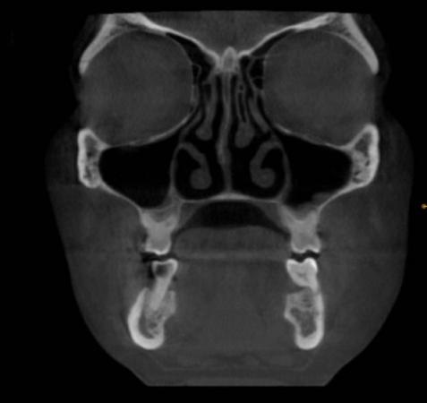

Fig. 1. Coronal cone beam CT shows the absence of Haller cells.

Haller cells are air-filled cavities located medially on the orbital floor. They are enclosed by the ethmoidal capsule, distinguishing them from the infra-orbital recess of the maxillary sinus. Haller cells can vary in size and shape, be present unilaterally or bilaterally, and appear as single or multiple entities. Observations were made in the coronal section of CBCT scans, with a slice thickness of 800 µm. Fig 2 shows the maximum medio-lateral dimensions of the Haller cells were measured and categorized by size as small (<2 mm), medium (2–4 mm), or large (>4 mm).

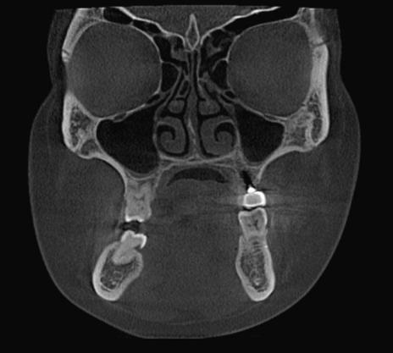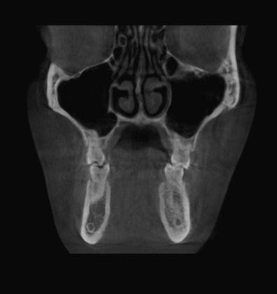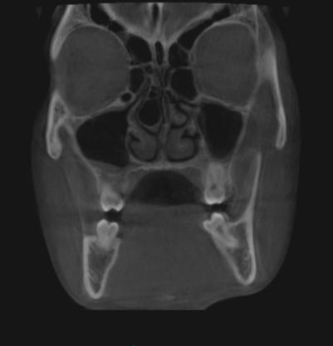

**Fig 2**. Coronal cone beam CT shows different shapes of Haller cells, (a) Small (b) Medium (c) Large

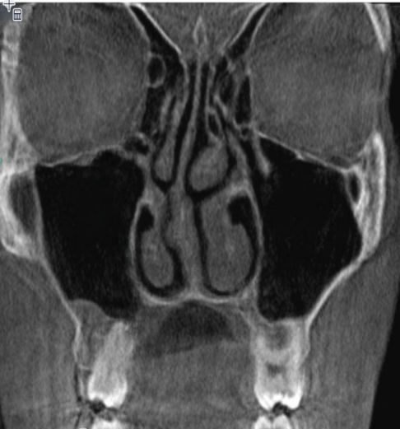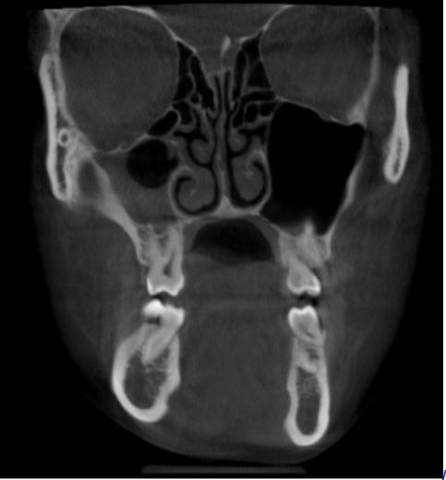

**Fig.3.** Haller cells present with maxillary sinusitis. **Fig.4.** Haller cells present with orbital floor dehiscence.

**Results**

The study included 150 participants, aged between 16 and 62 years, covering a broad range of adult age groups. The mean age of the participants was 29.7 years. Females constituted a larger portion of the sample, accounting for 60% .

**Fig 5.** Pie chart depicts distribution of the study participants according to Gender.

The **minimum age** observed in the sample is **16 years**, representing the youngest participant, while the **maximum age** is **62 years**, indicating the oldest individual in the dataset. The **mean (average) age** of the participants is calculated as **29.70 years**, which suggests that the overall study population tends to be relatively young. Furthermore, the **standard deviation** is **9.16 years**, which reflects the extent of variation or dispersion in the ages of the participants around the mean value.(Table no.1)

|  |  |  |  |  |  |
| --- | --- | --- | --- | --- | --- |
|  | N | Minimum | Maximum | Mean | Std. Deviation |
| **Age (in years)** | 150 | 16.00 | 62.00 | 29.70 | 9.16 |

**Table 1**: Descriptive statistics of Age (in years) in different groups

A total of 87 patients, representing the majority, did not exhibit Haller cells. In contrast, 63 patients were found to have Haller cells, comprising a smaller portion of the study population (Fig. 6).

**Fig.6** Frequency distribution of the study participants according to presence or absence of Haller cells

The chart (Fig. 7) shows that the majority of observations revealed the absence of Haller cells in 87 scans. Among the cases with Haller cells, oval-shaped cells were the most commonly observed, unilateral occurrences were more frequent, and medium-sized cells were the most prevalent.

**Fig. 7.** Frequency distribution of the study participants according to Shape, Sites and Size of Haller cells

The table no 2. suggests that **most individuals in the study did not develop maxillary sinusitis**, regardless of whether they had Haller cells or not. However, **16.7% of the cases had maxillary sinusitis**, which could indicate a potential relationship between the presence of Haller cells and the development of sinusitis.

|  |  |  |  |
| --- | --- | --- | --- |
| **Haller cells present with maxillary sinusitis** | | Frequency | Percent |
|  | No | 125 | 83.3 |
| Yes | 25 | 16.7 |
| Total | 150 | 100.0 |

**Table 2.** Frequency distribution of the study participants according to Haller cells present with maxillary sinusitis

The chi-square test was used to analyze the association, with a chi-square value of 41.429.

The p-value is 0.001, which is marked as statistically significant (p < 0.05) and highly significant (p < 0.01).There is a statistically significant association between the presence of Haller cells and the occurrence of maxillary sinusitis. Specifically, individuals with Haller cells are more likely to have maxillary sinusitis compared to those without.When Haller cells are present, 38 cases were recorded without maxillary sinusitis, and 25 cases were associated with maxillary sinusitis.(Table no.3)

|  |  |  |  |  |  |  |  |
| --- | --- | --- | --- | --- | --- | --- | --- |
|  | | **Haller cells present with maxillary sinusitis** | | **Total** | **Chi-square value** | **p value** | **Interpretation** |
| **No** | **Yes** |
| **Haller cells** | **Absent** | **87** | **0** | **87** | **41.429** | **0.001\*** | **Significant** |
| **Present** | **38** | **25** | **63** |
| **Total** | | **125** | **25** | **150** |

**Table 3**.Association between presence or absence of Haller cells and maxillary sinusitis.

|  |  |  |  |
| --- | --- | --- | --- |
| **Haller cells present with orbital floor dehiscence** | | Frequency | Percent |
|  | No | 145 | 96.7 |
| Yes | 5 | 3.3 |
| Total | 150 | 100.0 |

Out of the **150 people studied**, **145 individuals (96.7%) did not have orbital floor dehiscence**. This means that the vast majority of the people in this study did not show any gaps or defects in the orbital floor.Only **5 people (3.3%) had orbital floor dehiscence**, meaning they had a defect or thinning in the bone that separates the orbit from the maxillary sinus.(Table no.4)

**Table 4:** Frequency distribution of the study participants according to Haller cells present with orbital floor dehiscence

**Among 63 patients** **5 of them** had orbital floor dehiscence. The **Chi-square test value** is **7.143**, and the **p-value is 0.012** (which is less than 0.05), meaning the result is statistically significant.(Table no.5)

|  |  |  |  |  |  |  |  |
| --- | --- | --- | --- | --- | --- | --- | --- |
|  | | **Haller cells present with orbital floor dehiscence** | | **Total** | **Chi-square value** | **p value** | **Interpretation** |
| **No** | **Yes** |
| **Haller cells** | **Absent** | **87** | **0** | **87** | **7.143** | **0.012\*** | **Significant** |
| **Present** | **58** | **5** | **63** |
| **Total** | | **145** | **5** | **150** |

**Table 5**. Association between presence or absence of Haller cells and orbital floor dehiscence

**Discussion:**

Haller cells have been connected to symptoms like orofacial pain, sinusitis, nasal blockage, trouble breathing through the nose, headaches, chronic cough, and even issues like mucoceles (cystic lesions filled with mucus and lined by a special kind of tissue) [9]. Bolger et al. reported that the prevalence of Haller’s cells was equal in individuals with and without sinus disease, as observed in various studies(16).Whereas in our study out of 150 scans 63 patient present with Haller cells which is fairly high at around 42%. The youngest individual in the sample is **16 years old**. The oldest individual in the sample is **62 years old with** average age of the participants is **29.70 years**.Previous studies have shown a wide range of prevalence, from 2% to 70.3%. For example, Mathew et al. found a prevalence of 60%, and Khojastepour et al. found 68%, which is similar to our results. CBCT is a more advanced imaging method with a slice thickness of 899 µm, making it capable of detecting small and delicate bone structures like Haller cells, even those smaller than 1 mm [2]. The high percentage of Haller cells found in our study emphasizes CBCT's ability to detect these variations. This result is statistically significant (p < 0.05) and agrees with many earlier studies (2–4, 13).In our study, we looked at factors like age, gender, location, number, size, and shape of Haller cells. We found that younger individuals were more likely to have Haller cells than older ones. Unilateral Haller cells (34%), medium-sized cells (20%), and oval-shaped cells (28%) were the most common types. Interestingly, there was no significant difference in the prevalence of Haller cells based on gender, which matches the findings of Raina et al. [7].Sivasli et al. and Kim HJ et al. support this observation (17,18). However, other studies have identified Haller cells as a significant etiological factor in maxillary sinusitis, particularly when their size exceeds 6 mm, leading to considerable narrowing of the maxillary infundibulum (19,20).Haller cells were seen in 16.6% of cases with maxillary sinusitis and in 3.3% of cases with orbital floor dehiscence. Moshfeghi et al. also noted the presence of Haller cells alongside orbital floor dehiscence [3]. Identifying Haller cells is especially important for rhinologists when other issues aren’t clear during physical exams or endoscopies.Management of Haller cells can involve conservative treatments or surgical intervention. If Haller cells are believed to contribute to maxillary sinusitis, medical treatment is usually the first choice. However, if this doesn’t work, surgical options like functional endoscopic sinus surgery or lateral rhinotomy might be needed to relieve symptoms [2, 12, 13].The connection between Haller cells and maxillary sinus issues suggests a need for further research with larger sample sizes and stronger study designs, such as long-term studies.

**Conclusion**:

This study found a link between the presence and size of Haller cells and maxillary sinus issues. CBCT imaging, which allows for 3D evaluation, was shown to be an effective tool for spotting Haller cells. A significant relationship (p < 0.05) was found between Haller cells, maxillary sinusitis, and orbital floor dehiscence.

**Ethical Approval:**

The institutional ethical committee approved the study. The number of ethical approval issued by the institutional committee is ECR/684/Inst/ MH/2014/RR-21.

**Disclaimer (Artificial intelligence)**

Option 1:

Author(s) hereby declare that NO generative AI technologies such as Large Language Models (ChatGPT, COPILOT, etc.) and text-to-image generators have been used during the writing or editing of this manuscript.

Option 2:

Author(s) hereby declare that generative AI technologies such as Large Language Models, etc. have been used during the writing or editing of manuscripts. This explanation will include the name, version, model, and source of the generative AI technology and as well as all input prompts provided to the generative AI technology

Details of the AI usage are given below:

1.

2.

3.

**REFERENCES:**

1. Caversaccio M, Boschung U, Mudry A. Historical review of Haller's cells. **Ann Anat.** 2011 May;193(3):185-90. doi:10.1016/j.aanat.2011.02.006.
2. Kamdi P, Nimma V, Ramchandani A, Ramaswami E, Gogri A, Umarji H. Evaluation of Haller cell on CBCT and its association with maxillary sinus pathologies. **J Indian Academy Oral Med Radiology.** 2018;30(1):41-5. doi:10.4103/jiaomr.jiaomr_22_18.
3. Moshfeghi M, Dehini H, Ghazizadeh Ahsaie M. Cone Beam CT Analysis of Haller Cells: Prevalence and Relationship with Orbital Floor Dehiscence. **Int J Dent.** 2023 Jan 31;2023:5200152. doi:10.1155/2023/5200152.
4. Mathew R, Omami G, Hand A, Fellows D, Lurie A. Cone beam CT analysis of Haller cells: prevalence and clinical significance. **Dentomaxillofacial Radiol.** 2013;42(9):20130055. doi:10.1259/dmfr.20130055.
5. Ahmad M, Khurana N, Jaberi J, Sampair C, Kuba RK. Prevalence of infraorbital ethmoid (Haller’s) cells on panoramic radiographs. **Oral Surg Oral Med Oral Pathol Oral Radiol Endod.** 2006 May;101(5):658-61. doi:10.1016/j.tripleo.2005.08.035.
6. Yesilova E, Bayrakdar IS. The appearance of the infraorbital canal and infraorbital ethmoid (Haller’s) cells on panoramic radiography of edentulous patients. **Biomed Res Int.** 2018 Jul 8;2018:1293124. doi:10.1155/2018/1293124.
7. Wanamaker HH. Role of Haller’s cell in headache and sinus disease: a case report. **Otolaryngol Head Neck Surg.** 1996 Feb;114(2):324-7. doi:10.1016/S0194-59989670196-1.
8. Sandhu R, Kheur MG, Lakha TA, Supriya M, Valentini P, Le B. Anatomic variations of the osteomeatal complex and its relationship to patency of the maxillary ostium: a retrospective evaluation of cone-beam computed tomography and its implications for sinus augmentation. **J Indian Prosthodont Soc.** 2020;20(4):371-7. doi:10.4103/jips.jips_113_20.
9. Shetty S, Sura A, Ahmed F, Al-Bayati S, Shakeel SK, Gandhiraj V. Haller’s cells: a brief review. **Balkan Mil Med Rev.** 2015;18. doi:10.5455/bmmr.190880.
10. Dhanasekaran B, Priya K, Srinivasan R, Paventhan K, Somu P, Navin N, Ramya C. Prevalence of Haller cells: a retrospective observational study at a tertiary health care centre. **MedPulse Int J ENT.** 2019;12:24-8. doi:10.26611/10161224.
11. Lerdlum S, Vachiranubhap B. Prevalence of anatomic variation demonstrated on screening sinus computed tomography and clinical correlation. **J Med Assoc Thai.** 2005;88(4):S110-5.
12. Leunig A. Anatomic variations of the sinuses: multiplanar CT analysis in 641 patients. **Laryngorhinootologie.** 2008 Jul;87(7):482-9.
13. Yesilova E, Bayrakdar IS. The appearance of the infraorbital canal and infraorbital ethmoid (Haller’s) cells on panoramic radiography of edentulous patients. **Biomed Res Int.** 2018 Jul 8;2018:1293124. doi:10.1155/2018/1293124.
14. Maillet M, Bowles WR, McClanahan SL, John MT, Ahmad M. Cone-beam computed tomography evaluation of maxillary sinusitis. **J Endod.** 2011 Jun;37(6):753-7. doi:10.1016/j.joen.2011.02.032.
15. Ghosh D, Baruah D, Goswami S, Basu S. Lateral rhinotomy for a large, infected Haller cell causing proptosis. **Philipp J Otolaryngol Head Neck Surg.** 2018;30(1):4. doi:10.32412/pjohns.v30i1.389.
16. Bolger WE, Butzin CA, Parsons DS. Paranasal sinus bony anatomic variations and mucosal abnormalities: CT analysis for endoscopic sinus surgery. Laryngoscope. 1991 Jan;101(1 Pt 1):56-64. doi: 10.1288/00005537-199101000-00010. PMID: 1984551.
17. Sivasli E, Sirikçi A, Bayazýt YA, Gümüsburun E, Erbagci H, Bayram M, Kanlýkama M. Anatomic variations of the paranasal sinus area in pediatric patients with chronic sinusitis. Surg Radiol Anat. 2003 Feb;24(6):400-5. doi: 10.1007/s00276-002-0074-x. Epub 2002 Dec 18. PMID: 12652368.
18. Kim HJ, Jung Cho M, Lee JW, Tae Kim Y, Kahng H, Sung Kim H, Hahm KH. The relationship between anatomic variations of paranasal sinuses and chronic sinusitis in children. Acta Otolaryngol. 2006 Oct;126(10):1067-72. doi: 10.1080/00016480600606681. PMID: 16923712.
19. Stackpole SA, Edelstein DR. The anatomic relevance of the Haller cell in sinusitis. Am J Rhinol. 1997 May-Jun;11(3):219-23. doi: 10.2500/105065897781751910. PMID: 9209594.
20. Sebrechts H, Vlaminck S, Casselman J. Orbital edema resulting from Haller's cell pathology: 3 case reports and review of literature. Acta Otorhinolaryngol Belg. 2000;54(1):39-43. PMID: 10719592.