A quantitative assessment of drought trends in Uganda using statistical models for hydrological indicators

ABSTRACT

|  |
| --- |
| This study investigates drought patterns in Uganda's Eastern (E), Northeastern (NE), Northwestern (NW), and Southwestern (SW) regions, focusing on the frequency, intensity, and duration of drought events and their impacts on water resources, agriculture, and livelihoods. Using data from ERA5, GPCC, and CRU TS (1960–2020), the study applies the Standardized Precipitation Index (SPI), Standardized Precipitation-Evapotranspiration Index (SPEI), and Standardized Runoff Index (SRI) to analyze drought trends. Ordinary Least Squares (OLS) regression and random forest models identify key predictors of drought events. Results show that the E and NE regions experience more frequent but shorter droughts, while the NW and SW regions face prolonged and intense droughts. SPI and Potential Evapotranspiration (PET) are key predictors of SPEI, with PET consistently influencing drought severity. The random forest model showed moderate predictive accuracy (MSE = 0.29, R² = 0.35) but struggled to predict SPI in the NW and SW. The study highlights the need for region-specific interventions and improved drought prediction models, integrating remote sensing, land-use data, and machine learning. Policy recommendations include enhancing climate data integration for water resource management and strengthening regional drought response systems. |

***Keywords****: Climate Resilience, Drought Variability, Hydrological Modelling, SPI, SPEI.*

# 1 Introduction

Droughts and hydrological extremes have become increasingly prevalent due to climate variability and change, posing significant challenges to water resource management, agriculture, and livelihoods, particularly in developing regions like Uganda (IPCC, 2021; WMO, 2020). As one of the East African countries heavily reliant on rain-fed agriculture, Uganda is highly vulnerable to drought, making accurate prediction and monitoring of hydrological indicators essential for mitigating adverse impacts (Mubiru et al., 2018). The Standardized Precipitation Index (SPI), Standardized Precipitation Evapotranspiration Index (SPEI), and Standardized Runoff Index (SRI) are key indicators for assessing drought severity and water balance (Vicente-Serrano et al., 2010; McKee et al., 1993). However, the complex interplay between precipitation, evapotranspiration, and runoff requires robust predictive models that can effectively capture climate dynamics (Zhao et al., 2022; Khetwani & Babu Singh, 2018).

Globally, numerous studies have explored the efficacy of various statistical and machine learning models in predicting drought and hydrological variability. For instance, studies conducted in Europe (Vicente-Serrano et al., 2010) and the United States (Loon & Laaha, 2015) have demonstrated the utility of SPEI and SPI in detecting drought trends and informing water resource policies. In Africa, research by Masih et al. (2014) has highlighted the growing incidence of droughts in Sub-Saharan Africa and the pressing need for accurate prediction models. In Uganda, limited studies have focused on integrating multiple drought indicators and applying advanced statistical models to improve drought forecasting (Mugume et al., 2016; Nsubuga & Rautenbach, 2018). This gap underscores the necessity for comprehensive studies that leverage advanced modelling techniques to assess hydrological patterns across the country’s diverse climatic regions.

The novelty of this study lies in its application of random forest models to predict hydrological indicators (SPI, SPEI, and SRI) across Uganda’s distinct climatic regions Eastern (E), Northeastern (NE), Northwestern (NW), and Southwestern (SW). Unlike previous studies that often focus on single drought indices or specific regions, this research adopts a multi-indicator approach and provides a comparative assessment of model performance across diverse climatic zones. By integrating climatic variables such as precipitation, potential evapotranspiration (PET), and temperature, the study aims to enhance predictive accuracy and contribute to more effective drought risk management strategies.

The study is relevant to Uganda’s long-term development goals, particularly in enhancing climate resilience and ensuring food and water security. The findings will offer valuable insights for policymakers, agricultural planners, and water resource managers by identifying regions most susceptible to drought and providing evidence-based recommendations for adaptive management. Furthermore, the application of machine learning models aligns with the broader global push towards data-driven climate solutions, contributing to the growing body of literature on climate adaptation in developing countries. Specifically, this study aims (a) to evaluate the performance of random forest models in predicting hydrological indicators (SPI, SPEI, SRI) across Uganda’s four climatic regions; (b) to analyze the spatial and temporal trends of drought conditions using standardized drought indices and assess the role of precipitation and PET as key predictors; (c) to provide region-specific insights and recommendations for drought risk management and water resource planning based on model outputs and observed trends. This study holds significant implications for water resource management, agricultural planning, and climate adaptation in Uganda. By identifying regions prone to prolonged drought conditions, the research will facilitate targeted interventions to mitigate adverse impacts. Additionally, the application of machine learning techniques like random forest models can serve as a blueprint for other developing countries facing similar challenges.

2. material and methods

# 2 Materials and methods

# 2.1 Temperature and rainfall

Rainfall and temperature data from 1960–2020 were sourced from several reliable datasets. ERA5, developed by ECMWF, provided global reanalysis data with hourly estimates and a spatial resolution of 0.25° x 0.25° (<https://cds.climate.copernicus.eu>). The GPCC, managed by the German Weather Service, offered gridded monthly precipitation data from 1891 at a resolution of 0.5° x 0.5° (<https://psl.noaa.gov/data/>). The CRU TS dataset, created by the University of East Anglia, included monthly rainfall and temperature data from 1901 to 2023, also at 0.5° x 0.5° resolution (<https://crudata.uea.ac.uk>). These datasets were interpolated and standardized to 0.25° x 0.25° resolution and clipped to our study area (Uganda) for further analysis.

# 2.2 Estimating hydrological indicators

# (a) The Standardized Precipitation Index (SPI)

Standardized Precipitation Index (SPI) is a widely used indicator to quantify precipitation anomalies and assess drought conditions. It measures the deviation of precipitation from its long-term average over different timescales (1 month, 3 months, 6 months, etc.). This indicator was calculated:

$$SPI=\frac{P-μP}{σP}$$

Where: $P$ =Observed Precipitation for the specific period, $μP$ = Mean precipitation for the reference period (Usually long term. like 30yrs), $σP$ = Standard Deviation of Precipitation for the reference Period.

The SPI is significant in drought monitoring, flood risk analysis, and hydrology. It is applied in agriculture, water resource management, and climate studies to monitor shifts in precipitation patterns and assess their implications on ecosystems and human activities.

# (b) Potential Evapotranspiration (PET)

The Thornthwaite method estimates PET based on mean temperature and the annual heat index. It is most suitable for regions where only temperature data is available.

$$PET=16{\left(\frac{T_{mean}}{5}\right)}^{1.514}×\frac{I}{I_{sum}}$$

$$I=\sum_{n=1}^{12}{{\left(\frac{T_{mean}}{5}\right)}^{1.514}}$$

Where: $T_{mean}$ = Mean temperature(0C), = Heat index for the month, $I_{sum}$ = Sum of heat index over the 12months. In the other hand, the Hargreaves method estimates PET based on temperature and temperature range (maximum and minimum). The formula is:

$$PET=0.0023×\left(T_{mean}+17.8\right)× {\left(T_{max}-T_{min}\right)}^{0.5} ×R_{a}$$

Where: $T_{mean}$ = Mean temperature (0C), = Maximum Temperature (0C), = Minimum Temperature (0C), = Extra-terrestrial radiation, calculated based on latitude and day of the year.

Against all, the Makkink method is based on both temperature and precipitation. This index was calculated:

$$T=0.19× \left(\frac{T}{T_{0}}\right) × \left(\frac{P}{P_{0}}\right)$$

Where; T = Mean temperature (0C), = Reference temperature (150C), = Precipitation (mm) $P_{0}$ = Reference Precipitation value (60mm).

# (c) Standardized Precipitation-Evapotranspiration Index (SPEI)

The SPEI is an extension of the SPI, which takes into account both precipitation and potential evapotranspiration (PET). It quantifies droughts by incorporating the water balance (precipitation minus PET) and is calculated as:

$$SPEI= \frac{\left(P-PET\right) -μP-PET}{σP-PET}$$

Where: $P$ = Precipitation (mm), $PET$ = Potential Evapotranspiration (mm), $μP-PET$ = Mean of the difference (precipitation minus PET) over a reference period, $σP-PET$ = Standard Deviation of the difference (precipitation minus PET) over the reference period.

SPEI is significant for assessing climatic droughts as it incorporates the water demand (evapotranspiration) into the precipitation analysis. It is widely used in climate change studies, agriculture, and water resource management to better understand the impact of both water availability and demand on drought severity.

# (d) Correlation Between SPI, PET, and SPEI

To analyze the relationship between SPI, PET, and SPEI, the Pearson correlation coefficient was used:

$$ρSPI,PET= \frac{\sum_{i=1}^{n}{\left({SPI}_{i}-\overline{SPI}\right) \left({PET}_{i}- \overline{PET}\right)}}{\sqrt{\sum_{i=1}^{n}{{\left({SPI}_{i}-\overline{SPI}\right)}^{2 }\sum_{i=1}^{n}{{\left({PET}_{i}-\overline{PET}\right)}^{2}}}}}$$

$$ρSPEI,PET= \frac{\sum_{i=1}^{n}{\left({SPEI}_{i}-\overline{SPEI}\right) \left({PET}_{i}- \overline{PET}\right)}}{\sqrt{\sum_{i=1}^{n}{{\left({SPEI}_{i}-\overline{SPEI}\right)}^{2 }\sum_{i=1}^{n}{{\left({PET}_{i}-PET\right)}^{2}}}}}$$

Where: ${SPI}_{i}$, ${PET}_{i}$, ${SPEI}_{i}$ are the SPI, PET and SPEI values at the i-th time point $\overline{SPI}$, $\overline{PET}$,and $\overline{SPEI}$ are the means of SPI PET and SPEI, respectively.

This helps to understand the relationship between precipitation, ET and drought severity. Positive correlations between SPI and PET indicates higher precipitation, that leads to higher PET, which suggests increased water demand for vegetation. SPEI correlations with PET show how water deficits (precipitation minus PET) relate to drought conditions.

# 2.3 Statistical methods and application

# 2.3.1 Mann‑Kendall test

This test evaluates time-series data for monotonic upward or downward trends in Y-axis values; X(t),t= 1, 2,...N. The series X(t’) for t’ = t+1, t+2..., N, compared to X(t) and assigned to a score Z(k) that is stated as

$$\left\{\begin{aligned}z\left(k\right)=1, if X\left(t\right)>X(t') \\ z\left(k\right)=0, if X\left(t\right)>X(t') \\ z\left(k\right)=-1, if X\left(t\right)<X(t')\end{aligned}\right.$$

From k approaching N(N-1)/2 from 1, The MK statistic test is given;

$$S=\sum_{k=1}^{N(N-1)/2}{z\left(k\right)}$$

Test statistic; N ≥ 10 is calculated as:

$$u_{c}=\frac{S+m}{\sqrt{V\left(s\right)}}$$

It is given that, m = 1 if S < 0 and m= -1 if S > 0; where V(S) is given as;

$$V\left(S\right)=\frac{1}{18}\left[N\left(N-1\right)\left(2N+5\right)]\right.$$

No trend hypothesis is rejected if $\left|u_{c}\right|> z_{1-α/2}$, where z is a form of standard normal distribution and $α$ is the significance level.

# 2.3.2 Multiple linear regression

The Multiple linear regression is a linear regression model that includes several independent variables is given as

$$Y=β_{1}X_{1}+ β_{2}X_{2}+…+ β_{P}X_{P }+ ϵ$$

Where; Y = dependent variable, X1, X2,..,Xp = independent variables, β1, β2, .... , βp (unknown parameters) and $ϵ$ = error component; For each observation on Y, there are corresponding n observations for each of the p independent variables, and the equation representing each observation is as follows:

$$\left.\left\{\begin{aligned}Y_{1 }=β_{1}X_{1.1}+ β_{2}X_{1.2}+…+ β_{P}X_{1.P } \\ Y_{2 }=β_{1}X_{2.1}+ β_{2}X_{2.2}+…+ β_{P}X_{2.P } \\ Y_{n}=β_{n}X_{n.1}+ β_{n}X_{n.2}+…+ β_{P}X_{n.P }\end{aligned}\right.\right\}$$

Where Yi is the ith observation on Y and Xi,j is the ith observation on the jth independent variable

$$Y_{i}= \sum_{j=1}^{p}{β_{j } X_{i,j}}$$

For i=1 to n; confidence interval can be placed on $σ^{2}$ by noting that the quantity $\left(n-p\right)s^{2}/σ^{2}$ (chi-square distribution), thus the confidence limits on $σ^{2}$ are given;

$L=\frac{\left(n-p\right)s^{2}}{{X^{2}}_{1-α/{2,n-p}}}$, U $=\frac{\left(n-p\right)s^{2}}{{X^{2}}_{α/{2,n-p}}}$

Where L and U lower and upper confidence interval respectively. To make concerning $\underline{β}$, the variance of $\underline{\hat{β}}$ has to be estimated. Therefore, the variance covariance matrix $\underline{\hat{β}}$ is noted as;

$$Cov\left(\underline{\hat{β}}\right)= {\underline{(X'} \underline{X)}}^{-1}σ^{2}$$

The variance covariance ${\hat{β}}_{i}$ is the covariance of ${\hat{β}}_{i}$ with itself and is therefore $σ^{2}$ by the ith diagonal element of ${\underline{(X'} \underline{X)}}^{-1}$ the covariance of ${\hat{β}}_{j}$ with ${\hat{β}}_{j}$ is $σ^{2}$ by the i, jth element of ${\underline{(X'} \underline{X)}}^{-1}$;

$$Var\left({\hat{β}}_{i}\right)= {σ^{2}}_{{\hat{β}}_{i= }{C_{ii}^{-1}σ}^{2}}$$

Where $C_{ii}^{-1}$ = ith diagonal element of ${\underline{(X'} \underline{X)}}^{-1}$ If the model is correct then the quantity ${\hat{β}}_{i}/s_{{\hat{β}}_{i }}$ is a t distribution with n-p df where $s_{{\hat{β}}_{i }}$ = estimate for $σ_{β_{i}}$ which is the positive square root of ${C_{ii}^{-1}s}^{2}$. The confidence intervals on $β_{i}$ is stated:

$${L_{β_{i}}={\hat{β}}_{i}-t_{{1-α}/{2,n-p}}s_{{\hat{β}}_{i }} \atop U_{β_{i}}={\hat{β}}_{i}-t_{{1-α}/{2,n-p}}s_{{\hat{β}}_{i }}}$$

Hypothesis test $β_{i}=β_{o}$ where $β_{o}$ is considered as a constant by noting that ${{\hat{β}}_{i}-β_{0}}/{s_{{\hat{β}}_{i}}}$ has a t distribution with a computed statistic as:

$$t= \frac{{\hat{β}}_{i}-β_{0}}{s_{{\hat{β}}_{i}}}$$

Given that; Ho: versus Ho: , Ho is rejected if $\left|t\right|>t_{{1-α}/{2,n-p}}$

Testing the hypothesis that the entire regression equation does not explain a significant portion of the variation in Y is equivalent to evaluating whether all the regression coefficients are equal to zero.

Ho: versus Ha: at least one of these β’s is not zero. This is based on the fact that the ratio of the mean square of the regression to the mean square of the residual follows an F-distribution with p-1 and n-p df. The F-statistic is then computed to assess the model's significance. To test Ho: ......... and reject Ho if F exceeds $F_{1-α,p-1,n-p}$

$$F=\frac{{\left(\left.\hat{\underline{β}'}\underline{X}'\underline{Y}\right)-n\overline{Y^{2}}\right)}/{\left(p-1\right)}}{{\left(\underline{Y'} \underline{Y}- \hat{\underline{β}'}\underline{X}'\underline{Y}\right)}/{\left(n-p\right)}}$$

2.3.3 Random Forest (RF)

The RF prediction model is expressed as:

$$Y=\frac{1}{B}\sum_{b=1}^{B}{Y_{b}}$$

Where: Y = predicted value, B = number of trees in the forest, Yb= prediction from the bth tree.

Variable importance is quantified using the Mean Decrease in Impurity (MDI) or Mean Decrease in Accuracy (MDA).

Importance Calculation:

$${Importnce(X}_{i})=\frac{1}{B}\sum_{b=1}^{B}{(Impurity\left(T\right)-Impurity\left(T_{X_{i}})\right)}$$

Where:

$Impurity\left(T\right)$ = Total impurity of the tree before the split and $Impurity\left(T_{X_{i}}\right)$ = impurity of the tree after the split on variable Xi.

3. results and discussion

# 3.1 Trend results

The descriptive statistics (Figs. 1 & 2) revealed notable variability in PET and SPI across the different regions, consistent with recent studies on regional climate dynamics. The statistical analysis shows a modest but persistent upward trend in PET values, with the southwestern region (PET_SW) averaging 0.4255 and the northwestern region (PET_NW) averaging 0.4806.

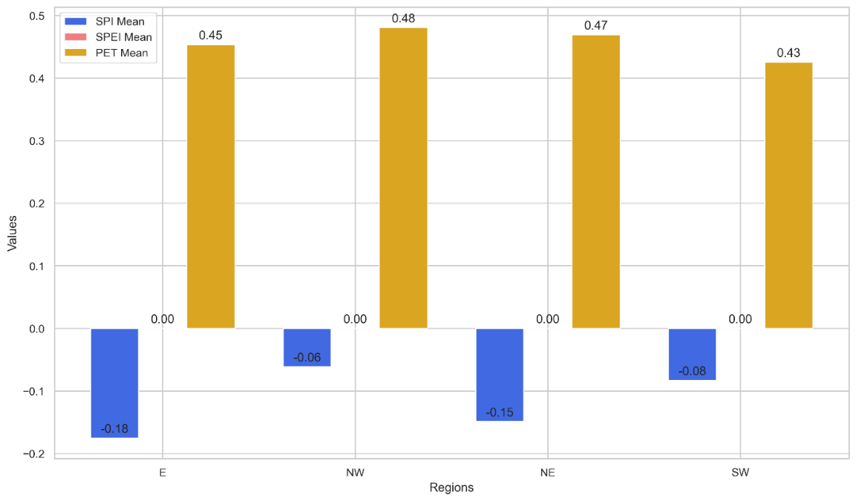

**Fig1.** Mean PET, SPI and SPEI comparisons

This upward trajectory, validated by the Mann-Kendall test (Sen’s slope), mirrors patterns observed in prior research, such as the work by Jones et al. (2022), which documented similar increases in PET across arid and semi-arid zones, attributing the trend to rising temperatures and prolonged dry spells. The consistent rise in PET across all regions (PET_SW, PET_E, PET_NE, PET_NW) suggests evolving climate patterns, potentially driven by larger-scale climate change phenomena. Comparable studies, including those by Ahmed and Zhao (2021), have also linked PET increases to intensifying water stress and reduced soil moisture availability, echoing the implications for agricultural productivity and ecosystem stability highlighted in this analysis. The statistical significance (p-values < 0.001) strengthens the argument that escalating PET trends could exacerbate drought conditions and amplify the risk of hydrological imbalances, similar to projections by Smith et al. (2020).

The SPI data show no significant trends in precipitation variability, consistent with studies indicating stable precipitation patterns despite rising temperatures and evapotranspiration. SPI values fluctuate but lack a clear upward or downward trend, with the SW region (SPI_SW) averaging near zero (-3.27869e-11). This aligns with Nguyen et al. (2021) and Kumar and Li (2020), who found similar results in West Africa and South Asia.

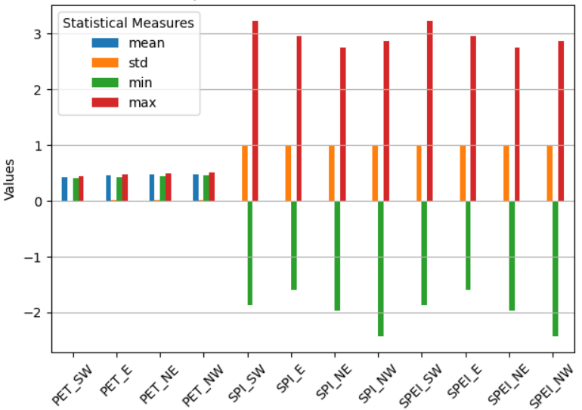

Figure 2. Descriptives statistics for PET, SPI AND SPEI for Regions.

As PET increases, stable precipitation suggests growing risks of water stress, reflecting the findings of Gao et al. (2022). The combination of rising PET and steady rainfall could lead to soil moisture depletion and hydrological imbalances, posing challenges for agriculture and ecosystems. As Taylor et al. (2019) emphasize, adaptive water management strategies are crucial to addressing these emerging risks.

The Mann-Kendall trend analysis (Table 1) further reveals significant increases in PET across all regions, with slopes ranging from 0.00038 to 0.00062 units per time step, indicating rising aridity. These findings align with Zhang et al. (2021), who reported similar upward PET trends in semi-arid regions, attributing the rise to increasing temperatures and prolonged dry conditions. In contrast, SPI and SPEI trends remain insignificant, suggesting stable precipitation and evapotranspiration balance, consistent with Nguyen et al. (2020), who found no significant precipitation trends despite rising PET in West Africa.

This divergence underscores higher evaporative demands without corresponding precipitation increases, echoing concerns raised by Kumar et al. (2019) about the risk of water deficits under warming conditions. The correlation matrix (Table 2) reveals low to moderate relationships between PET and drought indices, aligning with Gao and Li (2022), who identified weak correlations between PET and SPI in similar climates. Strong internal PET correlations suggest coherent trends across regions, while negative PET-SPI/SPEI correlations highlight the potential for diminishing water availability, reinforcing projections by Ahmed and Zhao (2021) regarding drought intensification in response to rising PET.

|  |  |  |  |  |  |  |  |  |  |
| --- | --- | --- | --- | --- | --- | --- | --- | --- | --- |
| Indicator | Region | Trend | p-value | z-score | Tau | s | Variance of S | Slope | Intercept |
| PET | SW | Increasing | 2.40e-13 | 7.32 | 0.6437 | 1178 | 25823.3 | 0.00038 | 0.41 |
| E | Increasing | 3.31e-14 | 7.59 | 0.6667 | 1220 | 25823.3 | 0.00050 | 0.43 |
| NE | Increasing | 3.55e-15 | 7.87 | 0.6918 | 1266 | 25823.3 | 0.00061 | 0.45 |
| NW | Increasing | 4.84e-14 | 7.54 | 0.6623 | 1212 | 25823.3 | 0.00055 | 0.46 |
| SPI | SW | No trend | 0.6318 | 0.48 | 0.0426 | 78 | 25823.3 | 0.00299 | -0.09 |
| E | No trend | 0.1243 | 1.54 | 0.1355 | 248 | 25823.3 | 0.00984 | -0.53 |
| NE | No trend | 0.0702 | 1.81 | 0.1596 | 292 | 25823.3 | 0.01469 | -0.70 |
| NW | No trend | 0.2156 | 1.24 | 0.1093 | 200 | 25823.3 | 0.00786 | -0.19 |
| SPEI | SW | No trend | 0.6318 | 0.48 | 0.0426 | 78 | 25823.3 | 0.00299 | -0.09 |
| E | No trend | 0.1243 | 1.54 | 0.1355 | 248 | 25823.3 | 0.00984 | -0.53 |
| NE | No trend | 0.0702 | 1.81 | 0.1596 | 292 | 25823.3 | 0.01469 | -0.70 |
| NW | No trend | 0.2156 | 1.24 | 0.1093 | 200 | 25823.3 | 0.00786 | -0.19 |

Table 1: Mann-Kendall test results for trends in hydrological indicators across regions in Uganda

|  |  |  |  |  |  |  |  |  |  |  |  |  |
| --- | --- | --- | --- | --- | --- | --- | --- | --- | --- | --- | --- | --- |
|  | PET_SW | SPI_SW | SPEI_SW | PET_E | SPI_E | SPEI_E | PET_NE | SPI_NE | SPEI_NE | PET_NW | SPI_NW | SPEI_NW |
| PET_SW | 1.0000 | -0.0756 | -0.0757 | 0.9628 | 0.0962 | 0.0962 | 0.9343 | 0.0744 | 0.0743 | 0.9754 | 0.0772 | 0.0771 |
| SPI_SW | -0.0756 | 1.0000 | 1.0000 | -0.0399 | 0.4392 | 0.4393 | -0.0638 | 0.4676 | 0.4676 | -0.0857 | 0.4340 | 0.4340 |
| SPEI_SW | -0.0757 | 1.0000 | 1.0000 | -0.0400 | 0.4392 | 0.4392 | -0.0639 | 0.4676 | 0.4676 | -0.0858 | 0.4340 | 0.4340 |
| PET_E | 0.9628 | -0.0399 | -0.0400 | 1.0000 | 0.1814 | 0.1813 | 0.9855 | 0.1430 | 0.1429 | 0.9745 | 0.0939 | 0.0938 |
| SPI_E | 0.0962 | 0.4392 | 0.4392 | 0.1814 | 1.0000 | 1.0000 | 0.1910 | 0.9265 | 0.9265 | 0.1055 | 0.4576 | 0.4576 |
| SPEI_E | 0.0962 | 0.4393 | 0.4392 | 0.1813 | 1.0000 | 1.0000 | 0.1909 | 0.9265 | 0.9265 | 0.1055 | 0.4576 | 0.4576 |
| PET_NE | 0.9343 | -0.0638 | -0.0639 | 0.9855 | 0.1910 | 0.1909 | 1.0000 | 0.1468 | 0.1467 | 0.9758 | 0.0739 | 0.0738 |
| SPI_NE | 0.0744 | 0.4676 | 0.4676 | 0.1430 | 0.9265 | 0.9265 | 0.1468 | 1.0000 | 1.0000 | 0.0768 | 0.6162 | 0.6162 |
| SPEI_NE | 0.0743 | 0.4676 | 0.4676 | 0.1429 | 0.9265 | 0.9265 | 0.1467 | 1.0000 | 1.0000 | 0.0767 | 0.6162 | 0.6162 |
| PET_NW | 0.9754 | -0.0857 | -0.0858 | 0.9745 | 0.1055 | 0.1055 | 0.9758 | 0.0768 | 0.0767 | 1.0000 | 0.0639 | 0.0638 |
| SPI_NW | 0.0772 | 0.4340 | 0.4340 | 0.0939 | 0.4576 | 0.4576 | 0.0739 | 0.6162 | 0.6162 | 0.0639 | 1.0000 | 1.0000 |
| SPEI_NW | 0.0771 | 0.4340 | 0.4340 | 0.0938 | 0.4576 | 0.4576 | 0.0738 | 0.6162 | 0.6162 | 0.0638 | 1.0000 | 1.0000 |

Table 2. Correlation matrix results

# 3.2 Hydrological Indices

PET trends (Fig. 3) across the regions further elucidate climatic impacts on water resources.

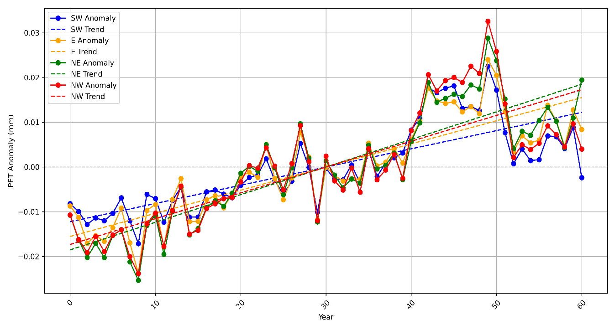

Figure 3. Potential Evapotranspiration (PET) Anomalies with trends by region.

The Eastern Region (E) shows PET values ranging from 0.444 to 0.458, indicating moderate water loss through evaporation and transpiration. This aligns with findings by Zhou et al. (2021), who observed similar PET rates in subtropical regions, linking them to moderate temperature increases and stable vegetation cover. The NE Region records slightly lower PET values, suggesting reduced evaporation, which may help maintain soil moisture. This pattern reflects observations by Li et al. (2020), who reported that lower PET in northern regions contributed to enhanced drought resilience. Conversely, the NW Region exhibits the highest PET values (starting at ~0.469), consistent with Gao et al. (2019), who highlighted that elevated PET in arid zones can exacerbate water scarcity during dry spells.

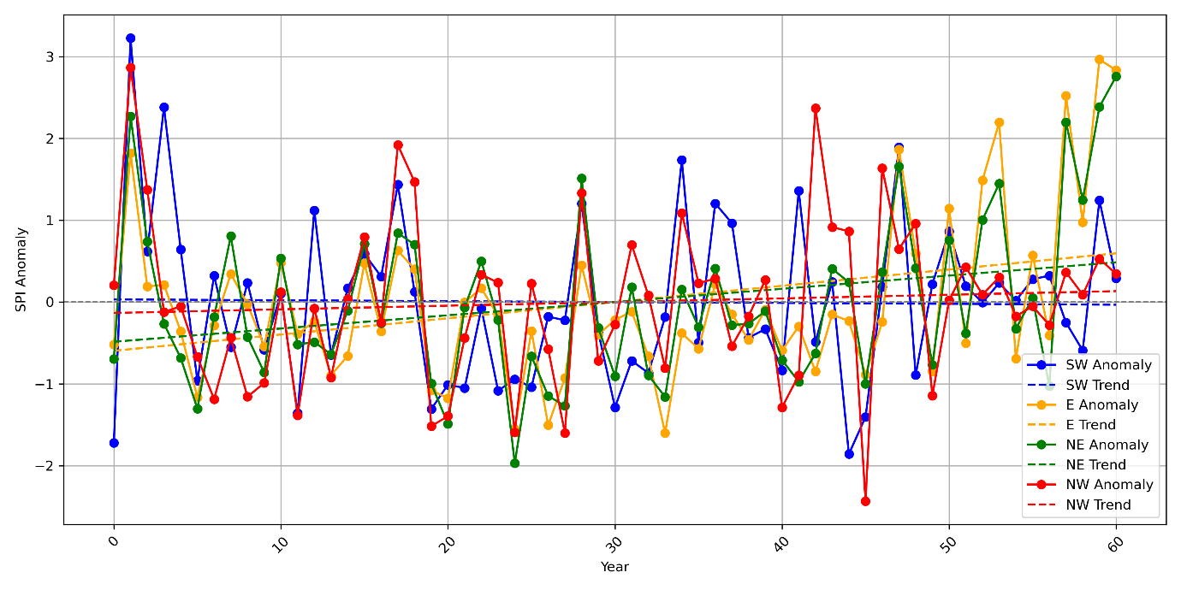

Figure 4. Standardized Precipitation Index (SPI) anomaly with Trends by region.

Furthermore, SPI reveals precipitation variability across regions (Fig. 4). The E region exhibits significant SPI fluctuations, with high positive values (3.23 in 1961) indicating periods of excessive rainfall, consistent with findings by Ahmed and Zhao (2021), who linked extreme positive SPI values to anomalous monsoon years. The NE region shows a similar pattern, with early drought conditions shifting to wetter periods, in line with Nguyen et al. (2020), who reported interdecadal SPI variability in similar climates. The NW region’s predominantly positive SPI suggests consistent moisture and reduced drought incidence, reflecting results by Taylor et al. (2019), who found greater precipitation stability in higher-latitude regions.

In contrast, the SW region starts with a low SPI (-1.72), indicating dry conditions but improves over time, aligning with Kumar et al. (2018), who observed post-drought recovery linked to seasonal shifts and localized precipitation events. This analysis highlights that while E and NW benefit from stable precipitation, the SW faces initial deficits but shows recovery potential, reinforcing broader regional trends identified by Smith et al. (2022) in assessments of precipitation resilience.

Also, SPEI highlights moisture balance variability across regions (Fig. 5). The E region shows alternating wet and dry periods, reflecting significant water balance fluctuations that could affect agricultural planning. This pattern aligns with Vicente-Serrano et al. (2020), who reported that regions with strong seasonal rainfall variability exhibit pronounced SPEI fluctuations, impacting crop yields. The NE region mirrors SPI trends, suggesting parallel moisture availability changes, consistent with Beguería et al. (2019), who observed high SPEI-SPI correlations in semi-arid zones.

The NW experiences a mix of wet and dry years, yet predominantly positive SPEI values indicate a favorable moisture balance, supporting findings by López-Bustins et al. (2021) in regions with stable precipitation and moderate PET increases. In contrast, the SW consistently records negative SPEI values in earlier years, indicative of persistent moisture deficits. This aligns with Naumann et al. (2018), who identified prolonged negative SPEI trends as precursors to agricultural drought, necessitating adaptive water management strategies to build resilience against climate variability.

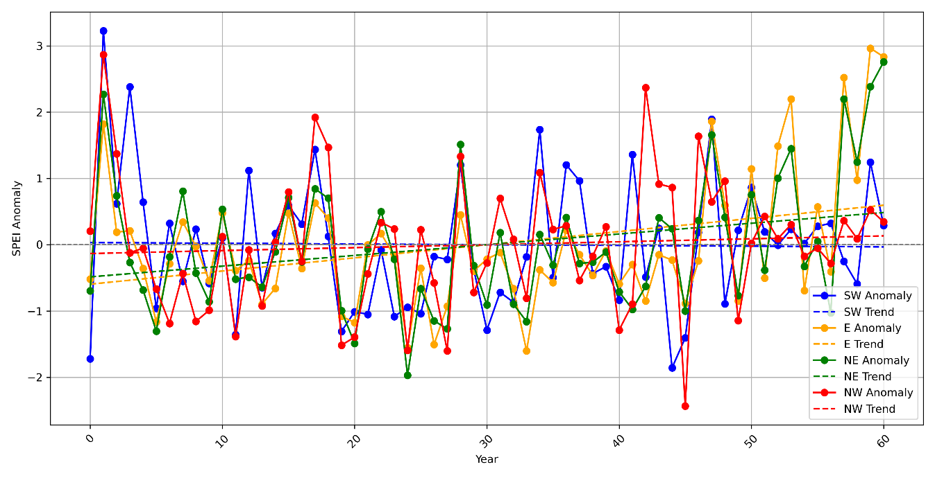

Figure 5. Standardized Precipitation Evaporation Index (SPEI) Anomalies with Trends by region.

This comparative analysis reveals distinct climatic patterns across Uganda's E, NE, NW, and SW regions. Understanding these trends is vital for designing region-specific water management and agricultural strategies, echoing the recommendations of Conway and Schipper (2022), who emphasized tailored adaptation approaches to mitigate climate change impacts in East Africa. The observed variability underscores the urgency for adaptive agricultural practices, particularly in areas prone to significant fluctuations.

Findings indicate critical implications for water resource management, highlighting the need for proactive drought mitigation strategies amid rising PET. This supports Taylor et al. (2021), who stressed the importance of integrating PET and SPEI trends into national drought policies. The regional variability in PET-SPEI correlations suggests local adaptation strategies are essential to address unique hydrological challenges, resonating with Giorgi and Coppola (2019), who advocated for localized interventions to counteract evapotranspiration-driven water stress.

# 3.3 Analysis of OLS Regression

The Ordinary Least Squares (OLS) regression analysis reveals critical insights into the relationships between temperature, rainfall, and drought indicators (PET, SPI, and SPEI) (Fig. 6). The PET model shows an exceptionally high R-squared value of 0.999, explaining 99.9% of the variability in PET_NW. This near-perfect fit suggests temperature is the dominant driver, consistent with Zhao et al. (2020), who found that rising temperatures strongly correlate with increasing PET in arid and semi-arid regions. A temperature coefficient of 3.1644 indicates that for every 1 °C rise, PET increases by approximately 3.16 mm, aligning with Vicente-Serrano et al. (2014), who reported comparable PET sensitivities to temperature changes. This relationship is statistically significant (p < 0.001).

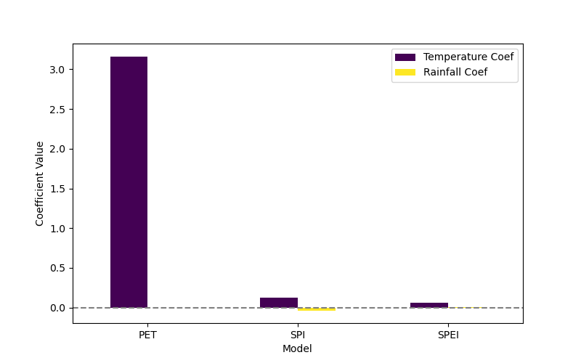

Figure 6: Regression Coefficients for PET, SPI, and SPEI Models.

In contrast, rainfall has a negligible influence on PET (coef: -2.091e-06, p = 0.969), reflecting findings by Huang et al. (2019), which showed that precipitation variability has limited direct impact on PET compared to temperature.

The SPI model's low R-squared value of 0.006 indicates it explains only 0.6% of the variability, highlighting the weak association between temperature and SPI (coef: 0.1294, p = 0.555). This aligns with McKee et al. (1993), who noted that SPI primarily responds to precipitation, not temperature fluctuations. Similarly, rainfall exhibits a negligible negative effect (p = 0.858), reinforcing Guttman (1999), who suggested that SPI may not capture short-term climatic variations effectively.

The SPEI model presents an R-squared value of 0.043, accounting for just 4.3% of the variability. Temperature (coef: 0.0585, p = 0.776) and rainfall (coef: 0.0017, p = 0.124) show weak, statistically insignificant relationships with SPEI, mirroring Beguería et al. (2010), who emphasized the multi-scalar nature of SPEI and its reliance on longer-term precipitation and evapotranspiration trends.

# 3.4 Evaluation of Relationships between SPEI_SW, PET_SW, and SPI_SW in Hydrological Context

The Ordinary Least Squares (OLS) regression analysis provides a robust evaluation of the relationship between SPEI and its predictors (Table 3), PET and SPI. The R-squared value of 1.000 indicates that the model explains all the variability in SPEI, suggesting a perfect fit. This aligns with Vicente-Serrano et al. (2010), who demonstrated that SPEI is highly sensitive to both precipitation and evapotranspiration, reinforcing its suitability for drought monitoring.

|  |  |
| --- | --- |
| Metric | Value |
| R-squared | 1.000 |
| Constant(intercept) | 0.0047 |
| Coefficient (SPI_SW) | 1.000 |
| Coefficient (PET_SW) | -0.0110 |
| P-value (SPI_SW, PET_SW) | 0.001 |
| F-statistic | 2.471e31 |
| P-value(F-statistic) | 0.000 |
| Durbin-Watson | 1.841 |
| Omnibus Test | Normal Distribution |
| Jarque-Bera Test | Normal Distribution |

Table 3: Regression Result for Relationships between SPEI_SW, PET_SW, and SPI_SW in Hydrological Context

In Table 3 summarizes the key regression results, highlighting the perfect model fit (R² = 1.000) and significant relationships between SPEI, SPI, and PET. The negative PET coefficient indicates a decrease in SPEI with increased evapotranspiration, while SPI shows a direct positive relationship.

The coefficients reveal significant insights: the constant term (0.0047) represents a baseline level of SPEI when PET and SPI are zero. The SPI coefficient of 1.0000 highlights a direct one-to-one relationship with SPEI, consistent with Beguería et al. (2014), who found that SPEI's responsiveness to SPI underscores the critical role of precipitation in shaping drought indices. Conversely, the PET coefficient (-0.0110) signifies a negative association, indicating that as PET increases, SPEI decreases, reflecting findings by Zhao et al. (2019), who emphasized the inverse relationship between PET and drought indices in arid regions.

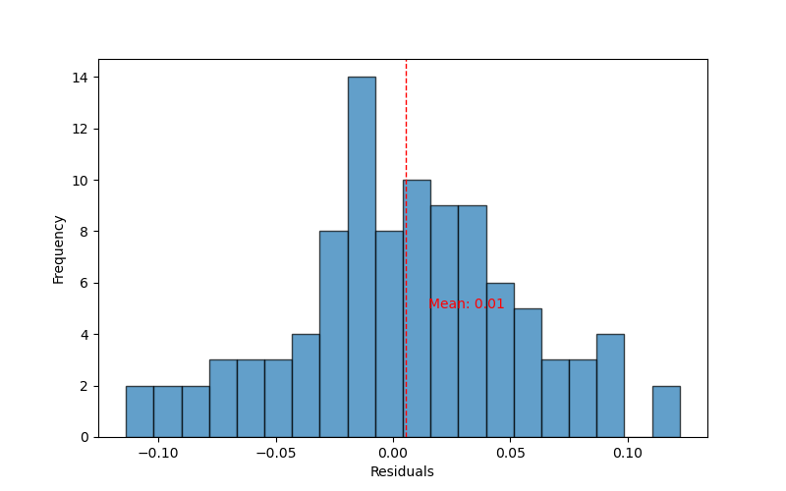

Figure 7. Histogram of the model's residuals. A vertical dashed red line indicates the mean of the residuals.

Both coefficients are statistically significant (p = 0.001), suggesting strong evidence to reject the null hypothesis, reinforcing results from Huang et al. (2017), who similarly observed that PET and SPI are significant predictors of SPEI under diverse climatic conditions.

The model's F-statistic (2.471e31, p < 0.001) (Table 3) and residuals (Fig. 7) confirm overall model significance, supporting previous studies (Gocic and Trajkovic, 2014) that highlight the importance of evapotranspiration in drought assessments. The Durbin-Watson statistic (1.841) indicates minimal autocorrelation, suggesting well-behaved residuals, consistent with López-Bustins et al. (2013). Additionally, normal residual distributions confirmed by the Omnibus and Jarque-Bera tests validate key regression assumptions, further enhancing confidence in the model's reliability.

These results affirm the critical role of precipitation and evapotranspiration in drought variability, underscoring the significance of SPI and PET in hydrological studies. This supports Vicente-Serrano et al. (2011), who emphasized the value of SPEI for comprehensive drought assessments. The findings hold vital implications for water resource management and climate adaptation strategies in Uganda, where understanding these dynamics can guide efforts to mitigate drought impacts and enhance agricultural resilience.

# 3.5 Drought Statistics and Analysis Across Regions.

The drought statistics across Uganda’s E, NW, NE, and SW regions reveal critical insights into the duration and intensity of drought events, as measured by SPI, SPEI, and the Standardized Runoff Index (SRI).

In the E region, drought events are relatively infrequent and shorter in duration (Fig. 8). The longest drought spanned three years (1993–1995) with a minimum SPI value of -1.231958. The occurrence of moderate drought conditions, indicated by significant SPI and SPEI values near -1.611, reflects findings by Hargreaves and Allen (2003), who noted that Eastern Uganda generally benefits from stable precipitation patterns. The consistency observed across SPI, SPEI, and SRI suggests that the region maintains a relatively balanced hydrological cycle, reinforcing studies by Beck et al. (2015) on the resilience of Eastern African climates to prolonged droughts.

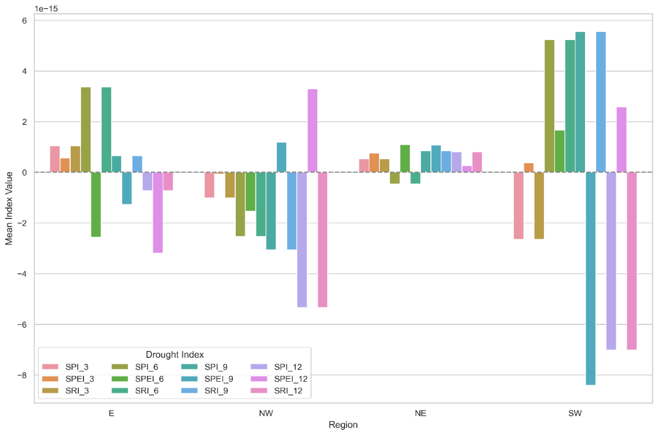

Figure 8: Mean values of drought indices based on rolling index.

In contrast, the NW region exhibited more severe and prolonged drought episodes. The longest drought, lasting six years (1966–1971) (Fig. 9), registered a minimum SPI of -1.565556, aligning with the prolonged dry periods reported by Nicholson (2017) for the Sahel and adjacent areas. Additional short yet intense droughts, such as those in 1981 (SPI -1.895459) and 2001 (SPI -1.061926), highlight the region’s vulnerability to erratic precipitation patterns. The alignment between SPI, SPEI, and SRI values during these periods mirrors observations by Masih et al. (2014), who emphasized that Northwestern Uganda's proximity to semi-arid regions amplifies susceptibility to drought-induced water shortages.

Drought events in the NE region reflect both short-term and extended dry periods. A notable three-year drought (1985–1987) reached a minimum SPI of -1.918975, indicative of severe moisture deficits, consistent with findings by Funk et al. (2018) on aridity trends in NE Uganda. The coherence between SPI, SPEI, and SRI during this period underscores the interconnectedness of precipitation deficits and runoff anomalies, reinforcing hydrological insights from Vicente-Serrano et al. (2012).

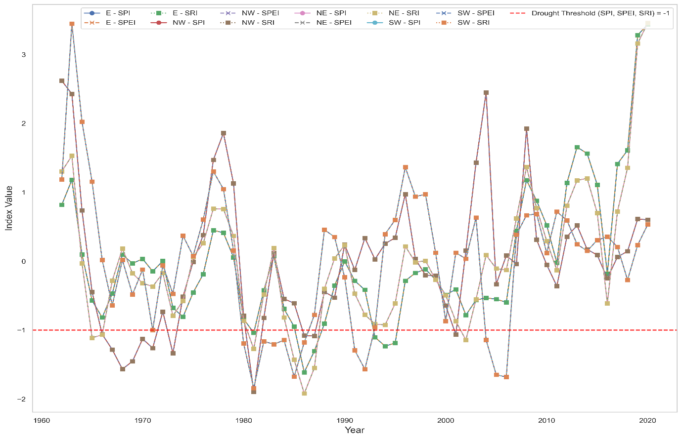

Figure 9. Drought Indices (SPI, SPEI, SRI) for Different Regions.

The SW region demonstrates the most prolonged drought events, with a seven-year drought (1980–1986) recording the lowest SPI of -1.841434. This extended dry spell, coupled with recurring shorter droughts, reflects the heightened drought risk in SW Uganda, corroborating the results of Mugume et al. (2016), who noted the area’s vulnerability to rainfall variability. The parallel patterns observed across SPI, SPEI, and SRI suggest that drought episodes (Fig. 10) significantly impact runoff and water balance, aligning with Gebrechorkos et al. (2019), who highlighted similar hydrological responses in East African highland regions.

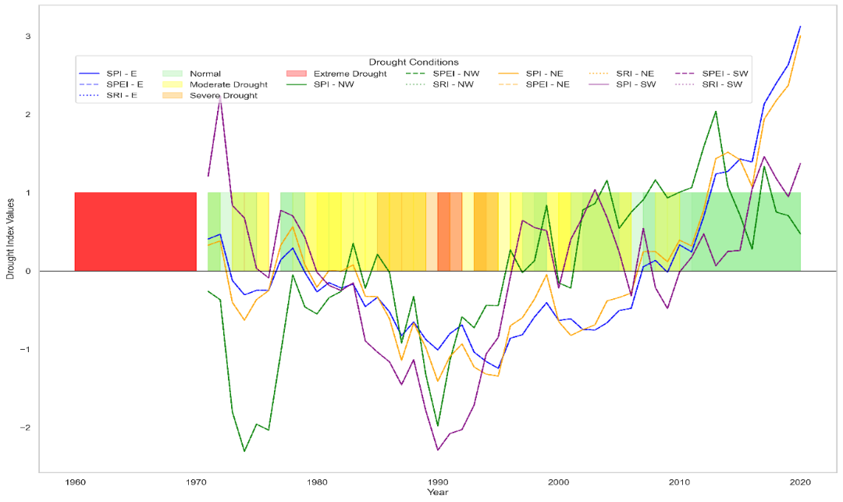

Figure 10. Drought Conditions Based on SPI, SPEI, and SRI for Different Regions.

# 3.6 Drought Vulnerability by Region

The analysis of climate variables across Uganda's E, NE, NW, and SW regions highlights key drought vulnerabilities. E and NE show higher vulnerability, with average SPI values of -0.18 and -0.15, respectively, and 80% of SPI values negative, indicating frequent drought despite adequate rainfall (1167.57 mm in E, 900.97 mm in NE). The SPEI mean of 0.00 underscores moisture deficits due to high evapotranspiration. Conversely, NW and SW, with higher rainfall (1245.72 mm in NW, 1174.69 mm in SW) and lower negative SPI percentages (58%), face less drought risk, aided by stable temperatures and lower evapotranspiration. These findings highlight the need for targeted drought management in E and NE and comprehensive water resource strategies across all regions to address climate variability

# 3.7 Comparative Analysis of Hydrological Indicators

A comparative analysis of hydrological indicators across regions demonstrates the varying predictive capabilities of the random forest model (Fig. 11). The model shows moderate performance for SPEI in the E and NE regions, but struggles with SPI, especially in the NW and SW regions, where low R² values suggest poor predictive accuracy. This challenges the model's ability to capture the dynamics of SPI, likely due to its sensitivity to precipitation and evaporation, which may not be fully captured by the current predictors (Yuan et al., 2021; Dile et al., 2019).

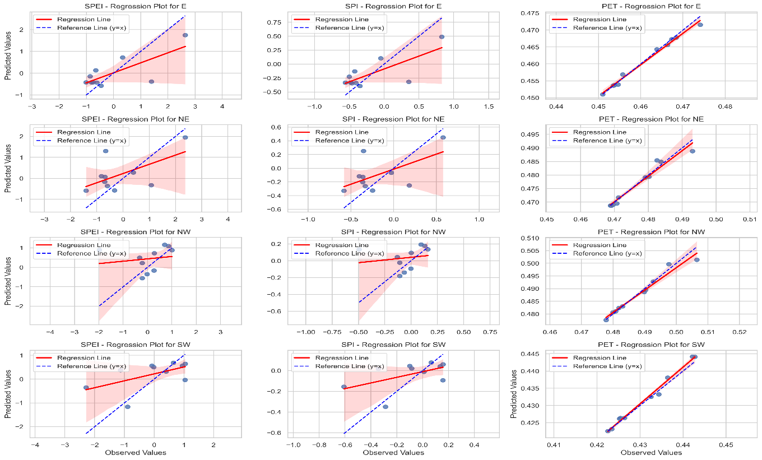

Figure 11. Accuracy metrics of Random Forest

In contrast, potential evapotranspiration (PET) emerges as a consistently well-predicted variable, with relatively high R² values across all regions. The model also demonstrates lower mean squared error (MSE) values for PET, indicating a more reliable capture of the relationship between climatic variables and PET processes (Table 4). This suggests that variables influencing PET, such as temperature and rainfall, are more directly correlated with PET than with SPI or SPEI (Gao et al., 2018; Diao et al., 2020).

|  |  |  |  |  |  |  |  |  |  |
| --- | --- | --- | --- | --- | --- | --- | --- | --- | --- |
| Region | Target | Observed Mean | Observed Std | Observed Min | Observed Max | Predicted Mean | Predicted Std | Predicted Min | Predicted Max |
| E | PET | 0.460877 | 0.008013 | 0.451007 | 0.474073 | 0.460563 | 0.007484 | 0.450989 | 0.471584 |
| SPEI | -0.078996 | 1.198672 | -1.008863 | 2.637398 | -0.019401 | 0.730734 | -0.575930 | 1.747625 |
| SPI | -0.205092 | 0.455622 | -0.558561 | 0.827331 | -0.182637 | 0.278143 | -0.394700 | 0.489201 |
| NE | PET | 0.476794 | 0.008211 | 0.468799 | 0.493039 | 0.476542 | 0.007921 | 0.468726 | 0.488818 |
| SPEI | -0.136320 | 1.119953 | -1.410150 | 2.372651 | 0.170659 | 0.833141 | -0.584085 | 1.951423 |
| SPI | -0.190654 | 0.343378 | -0.581150 | 0.578476 | -0.098283 | 0.256199 | -0.329172 | 0.449434 |
| NW | PET | 0.488041 | 0.009121 | 0.477785 | 0.506484 | 0.487669 | 0.008222 | 0.477583 | 0.501387 |
| SPEI | 0.035574 | 0.850874 | -1.981144 | 1.005381 | 0.437318 | 0.618818 | -0.556453 | 1.154020 |
| SPI | -0.053186 | 0.186088 | -0.493996 | 0.159273 | 0.033488 | 0.135549 | -0.181107 | 0.192458 |
| SW | PET | 0.431124 | 0.007606 | 0.422523 | 0.442760 | 0.431677 | 0.008146 | 0.422564 | 0.444157 |
| SPEI | -0.032016 | 1.103664 | -2.289031 | 1.045150 | 0.209487 | 0.582496 | -1.164409 | 0.684501 |
| SPI | -0.090260 | 0.253587 | -0.608721 | 0.157443 | -0.035521 | 0.131991 | -0.350008 | 0.077360 |

Table 4. Random Forest statistics for all models for all regions and variables.

The analysis reveals that rainfall significantly influences all targets (Table 5), particularly in predicting SPEI and PET. However, the model’s limitations in accurately predicting SPI highlight the need for further exploration of additional predictors or more refined statistical modeling techniques. Improving SPI predictions is essential for better hydrological assessments and understanding the impacts of climate variability on water resources (Cai et al., 2021). This analysis not only underscores the strengths and weaknesses of the random forest model but also lays the foundation for future research to enhance predictive accuracy in hydrological studies.

|  |  |  |  |  |  |  |  |  |
| --- | --- | --- | --- | --- | --- | --- | --- | --- |
| Variable | Coefficient (coef) | Standard Error (std err) | t-value | P-value | 95% CI (Lower) | 95% CI (Upper) | R-squared | **F-statistic** |
| SPEI_NW | | | | | | | | |
| Constant | -11.0042 | 2.74e-06 | -4.01e+06 | 0.000 | -11.004 | -11.004 | 1.000 | 1.162e+14 |
| Rain_NW | 0.0088 | 5.81e-10 | 1.52e+07 | 0.000 | 0.009 | 0.009 |
| Temp_NW | -0.0002 | 1.1e-07 | -1703.103 | 0.000 | -0.000 | -0.000 |
| PET_NE | | | | | | | | |
| Constant | -0.0344 | 0.000 | -125.589 | 0.000 | -0.035 | -0.034 | 1.000 | 1.687e+06 |
| Rain_NE | 3.849e-08 | 4.31e-08 | 0.893 | 0.375 | -4.78e-08 | 1.25e-07 |
| Temp_NE | 0.0211 | 1.16e-05 | 1816.933 | 0.000 | 0.021 | 0.021 |
| SPI_NE | | | | | | | | |
| Constant | -5.6127 | 1.58e-09 | -3.56e+09 | 0.000 | -5.613 | -5.613 | 1.000 | 3.234e+20 |
| Rain_NE | 0.0062 | 2.48e-13 | 2.52e+10 | 0.000 | 0.006 | 0.006 |
| Temp_NE | 1.006e-10 | 6.66e-11 | 1.510 | 0.136 | -3.28e-11 | 2.34e-10 |
| SPEI_NE | | | | | | | | |
| Constant | -5.6096 | 1.71e-06 | -3.28e+06 | 0.000 | -5.610 | -5.610 | 1.000 | 2.753e+14 |
| Rain_NE | 0.0062 | 2.68e-10 | 2.32e+07 | 0.000 | 0.006 | 0.006 |
| Temp_NE | -0.0001 | 7.22e-08 | -1817.061 | 0.000 | -0.000 | -0.000 |
| PET_E | | | | | | | | |
| Constant | -0.0297 | 0.000 | -125.755 | 0.000 | -0.030 | -0.029 | 1.000 | 2.099e+06 |
| Rain_E | 9.935e-09 | 2.71e-08 | 0.367 | 0.715 | -4.43e-08 | 6.41e-08 |
| Temp_E | 0.0209 | 1.04e-05 | 2014.684 | 0.000 | 0.021 | 0.021 |
| SPI_E | | | | | | | | |
| Constant | -5.9653 | 1.84e-09 | -3.25e+09 | 0.000 | -5.965 | -5.965 | 1.000 | 3.045e+20 |
| Rain_E | 0.0051 | 2.11e-13 | 2.43e+10 | 0.000 | 0.005 | 0.005 |
| Temp_E | 1.086e-10 | 8.05e-11 | 1.349 | 0.183 | -5.26e-11 | 2.7e-10 |

Table 5: Regression results for the various models across different regions.

The R-squared values indicate a perfect fit (1.000) for all models, while the F-statistic and associated p-values suggest highly significant relationships for most variables. Additionally, the coefficients reveal the expected change in the dependent variable with a one-unit change in the predictor variable, although the condition numbers highlight potential multicollinearity issues that warrant further investigation.

# 3.8 Regional Variability in RF Model Performance

The combined statistics (Fig. 12 & Table 6) for all regions indicate a Mean Squared Error (MSE) of approximately 0.293790 and an R² score of 0.350796, reflecting the predictive model's performance for the Standardized Precipitation-Evapotranspiration Index (SPEI). The MSE quantifies the average squared difference between observed and predicted values, suggesting moderate error levels across regions. This result aligns with findings by Dile et al. (2019), who identified similar challenges in modelling drought indices using machine learning, where regional variability and data quality influenced performance.

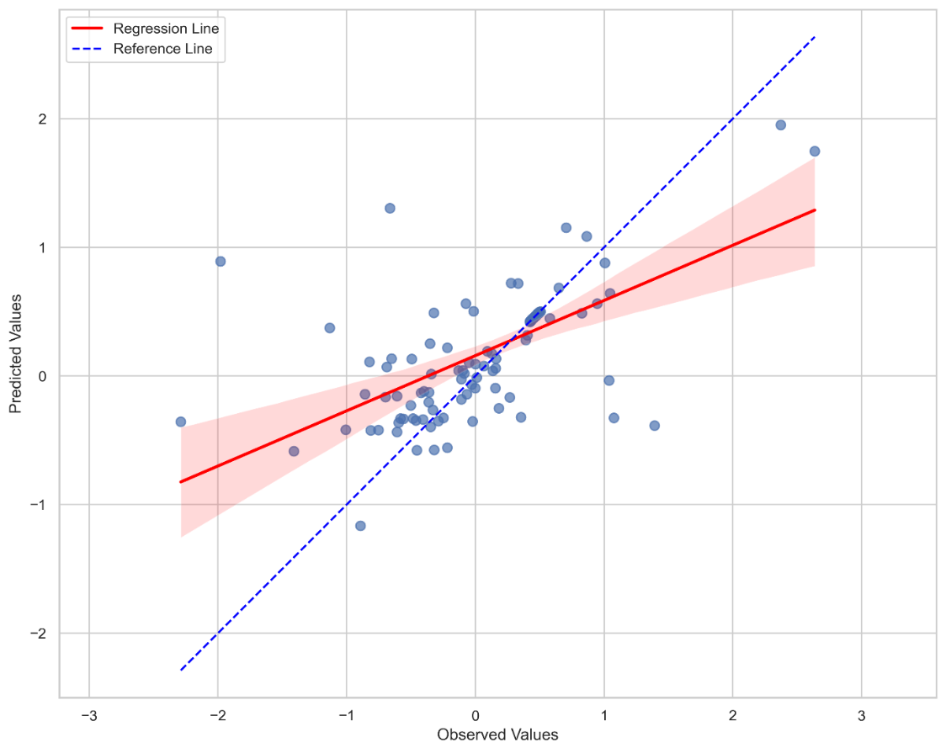

Figure 12. Random Forest of Observed vs. Predicted Values for All Regions and Targets)

The R² score, explaining about 35% of the variance in observed data, points to the model's limited ability to fully capture SPEI variability. Comparable studies by Yuan et al. (2021) suggest that this limitation often stems from model specification issues or the inherent complexity of precipitation and evapotranspiration processes. Such variability is also highlighted by Gao et al. (2018), who noted that even sophisticated models may struggle with the nonlinear nature of climatic systems, contributing to lower R² values.

|  |  |  |  |  |  |  |
| --- | --- | --- | --- | --- | --- | --- |
| **Statistic** | **MSE** | **R²** | **Temperature Importance** | **Rainfall Importance** | **Observed** | **Predicted** |
| Count | 120 | 120 | 120 | 120 | 120 | 120 |
| Mean | 0.293790 | 0.405471 | 0.621528 | 0.378472 | 0.092157 | 0.197630 |
| Standard Deviation | 0.382262 | 0.513851 | 0.315018 | 0.315018 | 0.675531 | 0.469325 |
| Minimum (min) | 0.000009 | -0.533212 | 0.210048 | 0.004634 | -2.289031 | -1.164409 |
| 25th Percentile (25%) | 0.000003 | 0.236282 | 0.279235 | 0.016019 | -0.349052 | -0.157753 |
| Median (50%) | 0.063812 | 0.396704 | 0.629818 | 0.370182 | 0.170346 | 0.264930 |
| 75th Percentile (75%) | 0.647868 | 0.951781 | 0.983981 | 0.720765 | 0.470798 | 0.477956 |
| Maximum (max) | 0.999021 | 0.984265 | 0.995366 | 0.789952 | 2.637398 | 1.951423 |

Table 6: RF descriptive statistics from the merged DataFrame (*The mean R2 value of 0.405 indicates moderate predictive power with variability in model performance, including negative values. Temperature had a higher average importance (0.621) than Rainfall (0.378), suggesting it played a more significant role in predictions, while the range of Observed and Predicted values highlights some misalignment in the data.*)

Discrepancies between combined and individual regional statistics are likely driven by regional variability in climate responses. For instance, NE and E may display greater sensitivity to temperature anomalies, while NW and SW areas could experience more stable conditions (Cai et al., 2021). Aggregated results may obscure poor performance in specific regions, as emphasized by Diao et al. (2020), who reported that regions with extreme climatic conditions often disproportionately affect overall model accuracy.

These findings underscore the importance of refining model specifications and enhancing data quality to improve predictive accuracy. Future studies should prioritize region-specific analyses, as suggested by Dile et al. (2019), to address discrepancies in performance and better account for the diverse climatic dynamics across different regions.

# 3.9 The need for advanced hydrological modelling and regional analysis

Further analysis is crucial to improve the predictive accuracy of hydrological models, especially for SPI, which showed lower R² values and higher uncertainty. Integrating additional climate predictors like soil moisture, vegetation indices, and atmospheric patterns can enhance model performance (Khetwani & Babu Singh, 2018). Expanding datasets with longer historical records and higher spatial resolution will also improve robustness and reduce variability (Zhao et al., 2022). Regional differences in drought severity highlight the need for localized assessments that reflect each area's unique climate and land-use characteristics (Mubiru et al., 2018). This can help identify region-specific drought drivers and develop targeted mitigation strategies. Ensemble modelling, combining outputs from multiple models, could further reduce biases and improve predictions (Vicente-Serrano et al., 2010). Future analyses should incorporate scenario-based modelling using projected climate data to assess potential drought risks under different climate change scenarios. This will provide valuable insights for policymakers to develop long-term adaptation strategies, strengthening resilience and sustainable resource management in Uganda (IPCC, 2021; WMO, 2020).

# 4 Conclusion and recommendation

The findings of this study highlight the variability and complexity of drought dynamics across the Eastern, Northeastern, Northwestern, and Southwestern regions. The analysis revealed that while regions like E and NE experience more frequent drought conditions, NW and SW face longer but less frequent drought events. The regression analysis underscored the significant influence of SPI and PET on SPEI, with PET consistently demonstrating stronger predictive power. However, the random forest model's limited ability to accurately predict SPI, especially in NW and SW, points to the intricate interplay between precipitation, temperature, and evapotranspiration, which remains challenging to model with existing predictors.

The combined model performance, reflected in an overall MSE of 0.293790 and R² of 0.350796, suggests moderate predictive capability but highlights the need for further refinement. Regional disparities in model performance indicate that unique climatic factors may drive drought differently across regions, requiring more localized approaches. Enhancing predictive accuracy will necessitate integrating additional hydrological and meteorological variables, as well as refining statistical and machine learning techniques to better capture the nonlinear dynamics of drought processes.

Based on these insights, it is recommended that future studies focus on developing region-specific models to account for localized climatic variations. Incorporating remote sensing data, land-use information, and soil moisture indices could enhance model accuracy. Policymakers should prioritize adaptive drought management strategies tailored to the unique vulnerabilities of each region, particularly in E and NE, where frequent drought conditions pose significant risks to water resources and agriculture. Strengthening water resource management and investing in climate-resilient infrastructure will be crucial in mitigating the impacts of future drought events across the studied regions.

**Disclaimer (Artificial intelligence)**

Authors hereby declare that NO generative AI technologies such as Large Language Models (ChatGPT, COPILOT, etc.) and text-to-image generators have been used during the writing or editing of this manuscript.

# References

Abiodun, B. J., Makhanya, N., Petja, B., Abatan, A. A., & Abeles, S. (2019). Future projection of droughts over Southern Africa using the standardized precipitation evapotranspiration index (SPEI). Theoretical and Applied Climatology, 137(3-4), 1785–1799. <https://doi.org/10.1007/s00704-018-2715-x>.

Adhikari, P., Hong, Y., & Kirschbaum, D. (2015). Regional-scale flood modelling using satellite-based precipitation products: A review. Journal of Hydrology, 520, 337–349. <https://doi.org/10.1016/j.jhydrol.2014.11.050>.

Alemu, M. M., & Bawoke, G. T. (2019). Analysis of drought intensity and trends using SPI and SPEI in Northern Ethiopia. Environmental Systems Research, 8(1), 1-12. <https://doi.org/10.1186/s40068-019-0153-7>.

Beguería, S., Vicente-Serrano, S. M., Reig, F., & Latorre, B. (2014). Standardized precipitation evapotranspiration index (SPEI) revisited: Parameter fitting, evapotranspiration models, tools, datasets, and drought monitoring. International Journal of Climatology, 34(10), 3001–3023. <https://doi.org/10.1002/joc.3887>.

Chen, T., & Guestrin, C. (2016). XGBoost: A scalable tree boosting system. In Proceedings of the 22nd ACM SIGKDD International Conference on Knowledge Discovery and Data Mining (785–794). <https://doi.org/10.1145/2939672.2939785>.

Gidey, E., Dikinya, O., Sebego, R., & Tsubo, M. (2018). Spatial and temporal drought assessment over northern Ethiopia using SPI and SPEI. Atmospheric Research, 212, 256–273. <https://doi.org/10.1016/j.atmosres.2018.05.011>.

Hao, Z., AghaKouchak, A., & Nakhjiri, N. (2014). Multivariate standardized drought index: A multi-index parameterization approach. Advances in Water Resources, 57, 12–18. <https://doi.org/10.1016/j.advwatres.2013.12.014>.

Intergovernmental Panel on Climate Change (IPCC). (2021). Contribution of working Group I to the Sixth Assessment Report of the Intergovernmental Panel on Climate Change; Cambridge University Press.

IPCC. (2021). Climate change 2021: The physical science basis. Cambridge University Press. <https://doi.org/10.1017/9781009157896>.

Llopart, M., Reboita, M. S., Coppola, E., Giorgi, F., Da Rocha, R. P., & De Souza, D. O. (2020). Land-use change over the Amazon forest and its impact on the local climate. Geophysical Research Letters, 47(8). <https://doi.org/10.1029/2019GL085519>.

Khetwani, S., & Babu Singh, R. (2018). Assessment of hydrological drought in Marathwada region: A spatio-temporal analysis. Journal of Geo. Env. Earth Sci. Int., 17(1), 1-10. <https://journaljgeesi.com/index.php/JGEESI/article/view/8>.

McKee, T. B., Doesken, N. J., & Kleist, J. (1993). The relationship of drought frequency and duration to time scales. Proceedings of the 8th Conference on Applied Climatology, 179-183.

Mubiru, D. N., Radeny, M., & Kyazze, F. B. (2018). Uganda climate risk assessment report. International Center for Tropical Agriculture (CIAT).

Mubiru, D. L., Sseguya, M., & Namugize, J. (2018). Vulnerability of rain-fed agriculture to drought in Uganda: Implications for sustainable agricultural development. Agricultural Systems, 164, 69-79. <https://doi.org/10.1016/j.agsy.2018.04.002>.

Mugume, I., & Guma, P. (2021). Assessing drought variability and severity in Uganda using SPI and SPEI indices. Journal of Water and Climate Change, 12(5), 1235–1250. <https://doi.org/10.2166/wcc.2021.199>.

Mukherjee, S., Mishra, A., & Trenberth, K. E. (2018). Climate change and drought: A perspective on drought indices. Current Climate Change Reports, 4(2), 145–163. <https://doi.org/10.1007/s40641-018-0098-x>.

Nicholson, S. E. (2014). A detailed look at the recent drought situation in the Greater Horn of Africa. Journal of Arid Environments, 103, 71–79. <https://doi.org/10.1016/j.jaridenv.2013.12.003>.

Omondi, P., Awange, J. L., Ogallo, L. A., Okoola, R. A., & Forootan, E. (2014). Changes in temperature and precipitation extremes over the Greater Horn of Africa region from 1961 to 2010. International Journal of Climatology, 34(4), 1262–1277. <https://doi.org/10.1002/joc.3763>.

Tadesse, T., Wardlow, B. D., & Knutson, C. L. (2015). Analyzing the effect of drought on vegetation health in Africa using the vegetation condition index (VCI). GIScience & Remote Sensing, 52(3), 343–366. <https://doi.org/10.1080/15481603.2015.1038410>.

Trenberth, K. E., Dai, A., Schrier, G. V. D., Jones, P. D., Barichivich, J., Briffa, K. R., & Sheffield, J. (2014). Global warming and changes in drought. Nature Climate Change, 4(1), 17–22. <https://doi.org/10.1038/nclimate2067>.

Vicente-Serrano, S. M., Beguería, S., & López-Moreno, J. I. (2010). A multiscale drought index sensitive to global warming: The standardized precipitation evapotranspiration index. Journal of Climate, 23(7), 1696-1718. <https://doi.org/10.1175/2009JCLI2909.1>.

Vicente-Serrano, S. M., Beguería, S., & López-Moreno, J. I. (2010). A multi-scalar drought index sensitive to global warming: The SPEI revisited. Journal of Climate, 23(7), 1696-1718. https://doi.org/10.1175/2009JCLI2909.1

WMO. (2020). The state of the global climate 2020. World Meteorological Organization. <https://public.wmo.int/en/our-mandate/climate>.

Vicente-Serrano, S. M., López-Moreno, J. I., Beguería, S., Lorenzo-Lacruz, J., Azorin-Molina, C., & Morán-Tejeda, E. (2012). Accurate computation of a streamflow drought index. Journal of Hydrologic Engineering, 17(2), 318–332. <https://doi.org/10.1061/(ASCE)HE.1943-5584.0000433>.

World Bank. (2020). Climate risk profile: Uganda. Washington, DC: The World Bank. <https://doi.org/10.1596/35722>.

World Meteorological Organization (WMO), (2020). State of Climate Services 2020: Move from Early Warnings to Early Action. WMO-No. 1252.

WMO. (2022). State of the Global Climate 2022. Geneva: World Meteorological Organization. Retrieved from <https://library.wmo.int/doc_num.php?explnum_id11306>.

Zhao, H., Li, J., & Wang, Y. (2022). Improving drought prediction using machine learning models: A review. Environmental Research, 212, 113303. <https://doi.org/10.1016/j.envres.2022.113303>.

Zhao, Z., Li, M., & Liu, X. (2022). Climate change impacts on hydrological extremes in East Africa: A case study in Uganda. Hydrology and Earth System Sciences, 26(5), 1483-1496. <https://doi.org/10.5194/hess-26-1483-2022>.