**Unveiling the Power of Epigenetics in Seed Dormancy and Germination**

**Abstract**

Germination is the process by which a seed absorbs water and begins to grow, eventually emerging as a seedling. Seed dormancy and germination are crucial stages in the life cycle of a plant, determining its ability to survive and reproduce. These processes are influenced by a complex interplay of genetic, hormonal, and environmental factors. Recent advances in the field of epigenetics have revealed that changes in gene expression associated with these processes are not solely driven by genetic alterations, but are also regulated by epigenetic modifications. These modifications, including DNA methylation, histone modifications, and small RNA pathways, play pivotal roles in regulating seed dormancy, germination, and post-germination growth. This paper highlights the latest findings in the role of epigenetic regulation in seed dormancy and germination, exploring the mechanisms involved and the potential for leveraging epigenetic knowledge for crop improvement and sustainable agriculture. Additionally, we will highlight the potential of manipulating epigenetic modifications to improve seed quality and crop yield.

***Keywords:*** Seed dormancy, seed germination, epigenetics, DNA methylation, mechanisms and sustainable agriculture.

1. **Introduction**

Seed dormancy and germination are critical stages in the life cycle of plants, determining their ability to survive in fluctuating environmental conditions. Seed dormancy is a crucial adaptive mechanism in plants, allowing seeds to remain viable during unfavorable conditions (Vaschetto, 2024). Dormant seeds are in a state of metabolic inactivity, which prevents premature germination and ensures that seeds only begin to grow when environmental conditions are optimal (Luján-Soto and Dinkova, 2021; Wang et al., 2024). This ensures that seeds avoid germinating during droughts, extreme temperatures, or the winter months, which could damage them.

Germination, on the other hand, marks the transition from dormancy to active growth. It involves a series of molecular and physiological changes, including the breakdown of stored reserves, water uptake, and the activation of growth-promoting hormones like gibberellins (GA). The precise regulation of both processes is vital for plant survival and successful reproduction (Luján-Soto and Dinkova, 2021; Sato and Köhler, 2022; Wang et al., 2024; Chandra et al. 2024).

Traditionally, genetic factors have been studied to explain seed dormancy, but epigenetic regulation is now recognized as a key player in these processes. Epigenetics refers to the modifications of DNA and histones that affect gene expression without altering the underlying genetic sequence (Sato and Köhler, 2022; Wang et al., 2024). These epigenetic changes can be stable and heritable, and importantly, they can be influenced by environmental cues.

1. **Importance of Seed Dormancy and Germination**

Seed dormancy and germination are two critical processes in the life cycle of plants, and understanding how they work is fundamental for agriculture, ecology, and conservation. Seed dormancy ensures that seeds only germinate under favorable conditions, protecting them from environmental stressors. Germination, on the other hand, marks the transition from dormancy to active growth, allowing a seed to develop into a new plant.

* 1. **Seed Dormancy**

Seed dormancy is a state in which a viable seed does not germinate, even when environmental conditions (such as temperature, light, and moisture) are favourable (An and Lin, 2011; Buijs et al., 2020). This dormancy is an adaptive mechanism that allows seeds to survive adverse conditions until the environment is more suitable for growth.

* 1. **Types of Seed Dormancy:**
* **Physiological Dormancy (PD):** In this type of dormancy, the embryo is capable of germination, but it is inhibited by internal physiological factors. These include the presence of growth-inhibiting hormones like abscisic acid (ABA) or the absence of growth-promoting hormones like gibberellins (GA) (An and Lin, 2011; Buijs et al., 2020). Physiological dormancy can be broken by environmental cues, such as changes in temperature, light, or moisture.

***Shallow Dormancy:*** Requires minimal cues to break dormancy.

***Deep Dormancy:*** Requires more prolonged exposure to specific conditions (e.g., cold stratification).

* **Morphological Dormancy (MD):** In morphological dormancy, the seed embryo is underdeveloped at the time of seed dispersal. These seeds cannot germinate until the embryo matures further, which typically happens after the seed is exposed to specific environmental conditions.
* **Physical Dormancy (PY):** In physical dormancy, the seed's coat is impermeable to water and gases, which prevents the seed from germinating. Scarification (the physical breaking of the seed coat) or exposure to environmental factors like fire or freezing may be required to break the dormancy (An and Lin, 2011; Buijs et al., 2020).
* **Chemical Dormancy (CD):** Chemical dormancy occurs due to the presence of inhibitory chemicals in the seed, which prevent germination. These inhibitors can be broken down by environmental cues like temperature fluctuations or leaching by water.
  1. **Germination**

Germination is the process by which a seed absorbs water and begins to grow, eventually emerging as a seedling. This is a critical step for the continuation of the plant life cycle (An and Lin, 2011; Buijs et al., 2020).

* 1. **Stages of Germination:**
* **Imbibition (Water Uptake):** The first step in germination is the absorption of water by the seed, known as imbibition. The seed swells as water enters, activating enzymes that start breaking down stored food reserves within the seed. This phase is essential for rehydrating the seed's tissues and kick-starting metabolic processes.
* **Activation of Metabolism:** Once the seed has absorbed enough water, it begins metabolic activity. Stored nutrients (like starches, proteins, and lipids) are broken down into simpler molecules like sugars and amino acids, which provide energy for the growing seedling.
* **Radicle Emergence:** The radicle (the embryonic root) is the first structure to emerge from the seed. It grows downward into the soil to anchor the seed and start absorbing water and nutrients from the surrounding environment.
* **Plumule Emergence:** The plumule (the embryonic shoot) grows upwards, emerging from the seed. This shoot will eventually develop into the stem and leaves of the plant. The cotyledons (seed leaves) may also begin to unfold at this stage, providing initial nourishment to the growing plant.
* **Seedling Development:** The seedling continues to grow, developing its root system further and beginning to photosynthesize once true leaves emerge. This marks the transition from seedling to juvenile plant, capable of independent growth.

1. **Factors Affecting Seed Dormancy and Germination**

Several factors influence whether a seed will remain dormant or begin the germination process. These factors are both internal (seed-related) and external (environmental) (Fig. 1).

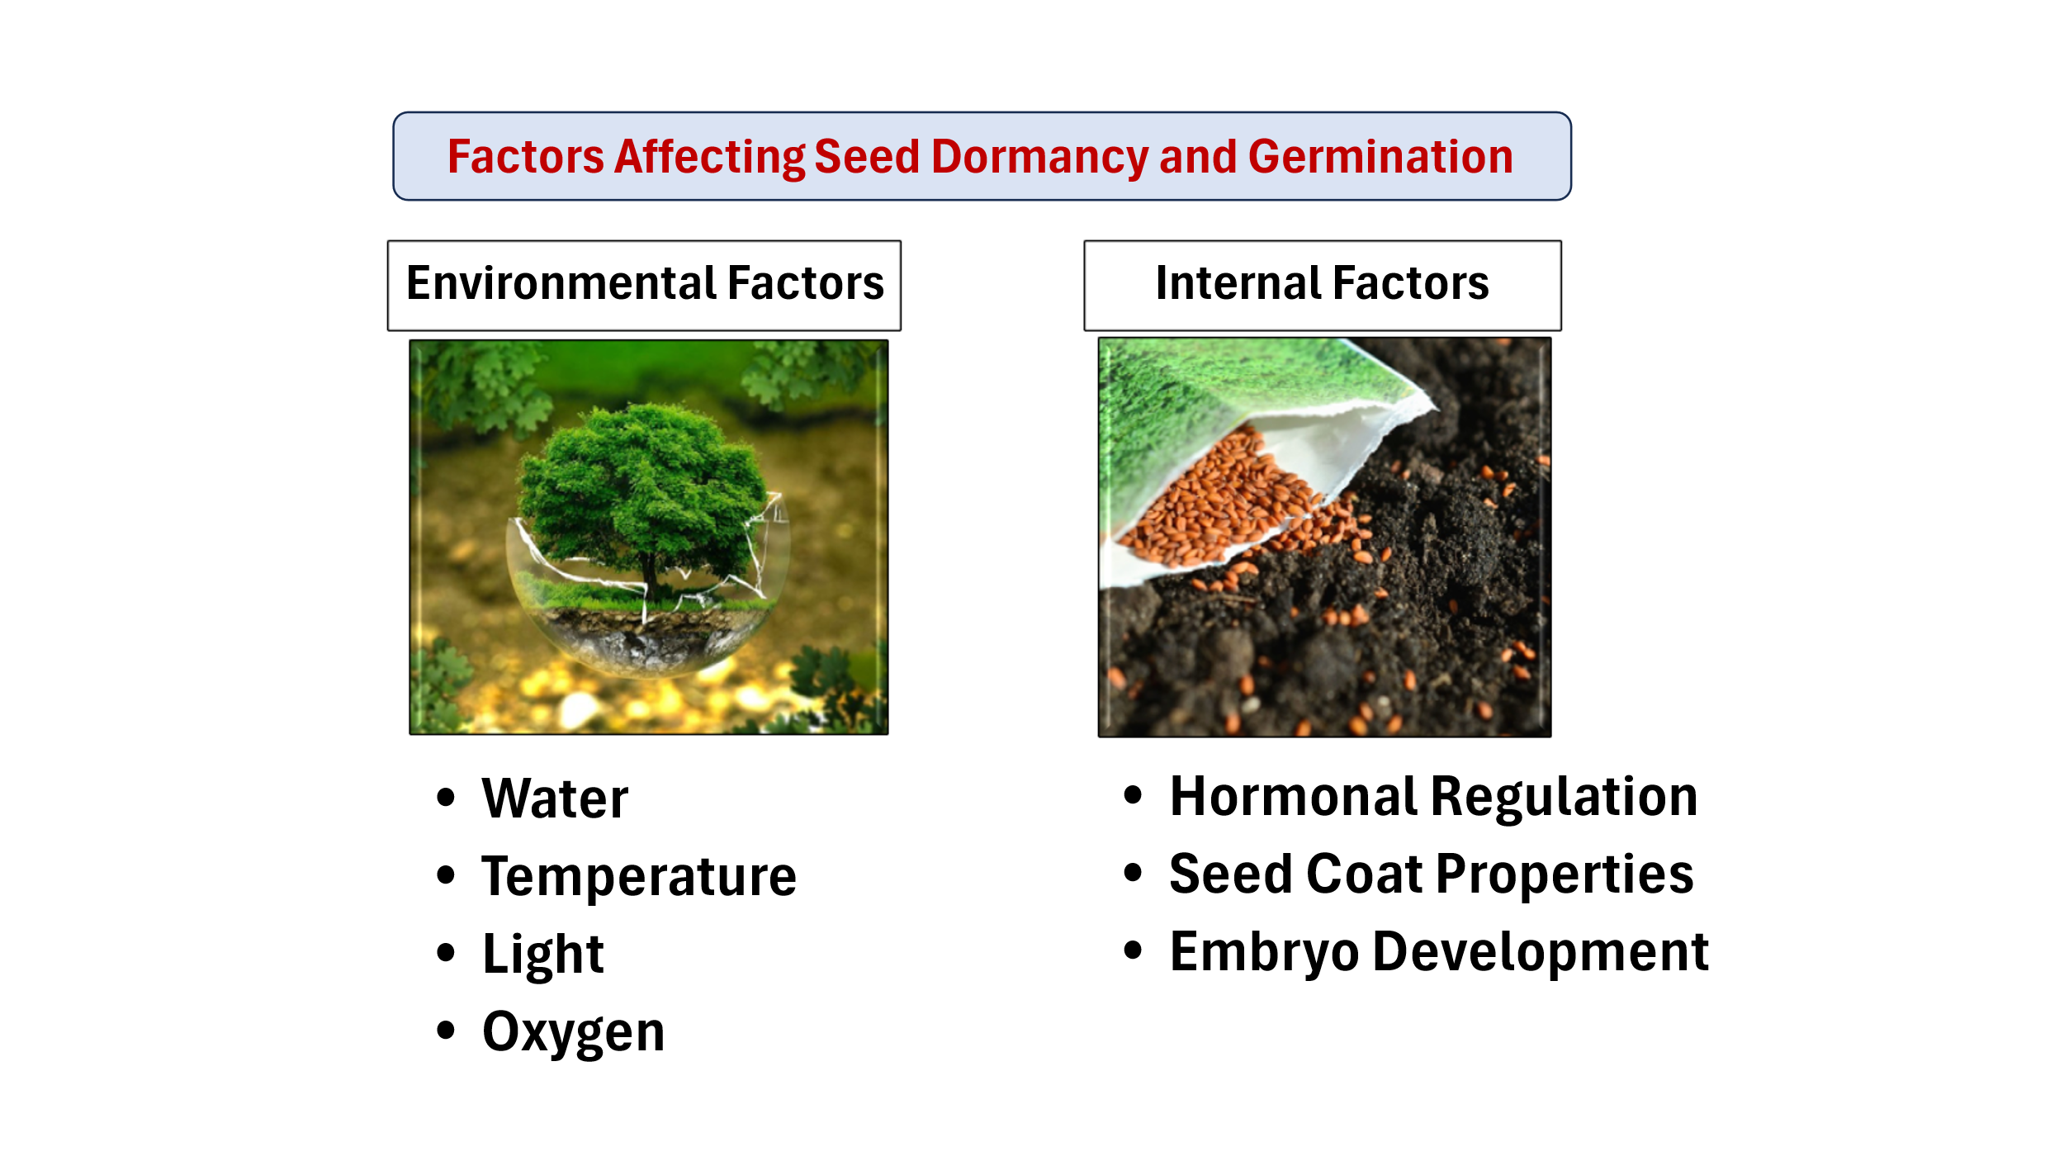

**Fig. 1: Factors Affecting Seed Dormancy and Germination**

* 1. **Environmental Factors:**
* **Water:** Water is essential for germination. Seeds require a certain level of moisture to absorb and activate the metabolic processes required for germination. Lack of water (drought) or excess water (waterlogging) can prevent germination.
* **Temperature:** Temperature affects the rate of germination and the metabolic activity of the seed. Some seeds require specific temperature ranges to break dormancy and begin germination. For example, cold-stratified seeds need exposure to cold temperatures to break dormancy, while others may need warmer conditions.
* **Light:** Light can be either necessary or inhibitory for germination, depending on the species. Some seeds require light to break dormancy (light-sensitive seeds), while others prefer darkness to germinate. Light acts as a signal for photoblastic seeds to begin germination.
* **Oxygen:** Oxygen is required for cellular respiration, a process that provides energy to the seed during germination. Poorly aerated or waterlogged soils can hinder oxygen availability and thus delay or prevent germination.
  1. **Internal Factors:**
* **Hormonal Regulation:** Hormones play a crucial role in regulating seed dormancy and germination. Abscisic acid (ABA) typically inhibits germination by maintaining dormancy, while gibberellins (GA) promote germination by stimulating the breakdown of stored food in the seed and the elongation of tissues. The balance between these hormones is key to the timing of germination.
* **Seed Coat Properties:** The seed coat protects the seed from environmental stresses and pathogens, but it can also contribute to dormancy. Some seed coats are impermeable to water and gases, requiring mechanical or environmental means (e.g., scarification or freezing) to allow water and oxygen to enter and trigger germination.
* **Embryo Development:** In seeds exhibiting morphological dormancy, the embryo may be underdeveloped at dispersal. The seed may need to undergo further maturation before germination can take place, often influenced by environmental conditions like temperature.

1. **Breaking Seed Dormancy and Inducing Germination**

For many seeds, dormancy must be broken before germination can occur. Various treatments can help break dormancy, depending on the type of dormancy.

* **Stratification:** Some seeds, especially those from temperate regions, require a period of cold temperatures (stratification) to break dormancy. This simulates winter conditions and signals to the seed that it is time to germinate when conditions warm up.
* **Scarification:** Some seeds have hard seed coats that must be mechanically broken (scarification) to allow water to penetrate the seed. This can be done by rubbing the seed against a rough surface, using chemicals, or by natural means like passing through the digestive tract of an animal.
* **Light Exposure:** Light is required for some seeds to break dormancy, especially those that are photoblastic. The exposure to certain wavelengths of light can signal the seed to begin the germination process.
* **Temperature Fluctuations:** Some seeds need to experience a specific temperature range or fluctuating temperatures (e.g., hot days followed by cold nights) to break dormancy and stimulate germination.

Seed dormancy and germination are vital processes for plant survival and reproduction. Dormancy ensures that seeds do not germinate under unfavorable conditions, while germination marks the transition to growth when the environment is suitable. Understanding these processes allows for better management in agriculture, conservation, and plant ecology. Environmental factors like water, temperature, light, and oxygen play crucial roles in determining when and how seeds break dormancy and begin germination.

1. **The Power of Epigenetics in Seed Dormancy and Germination**

Epigenetics refers to changes in gene expression or cellular phenotype that do not involve changes to the underlying DNA sequence. These changes can be influenced by environmental factors and can be heritable, meaning they can be passed down through generations without altering the genetic code itself. In the context of **seed dormancy and germination**, epigenetic mechanisms play a critical role in regulating the processes that determine whether a seed remains dormant or germinates (fig. 2). Understanding epigenetics in these processes opens new possibilities for improving agricultural practices, plant breeding, and conservation efforts.

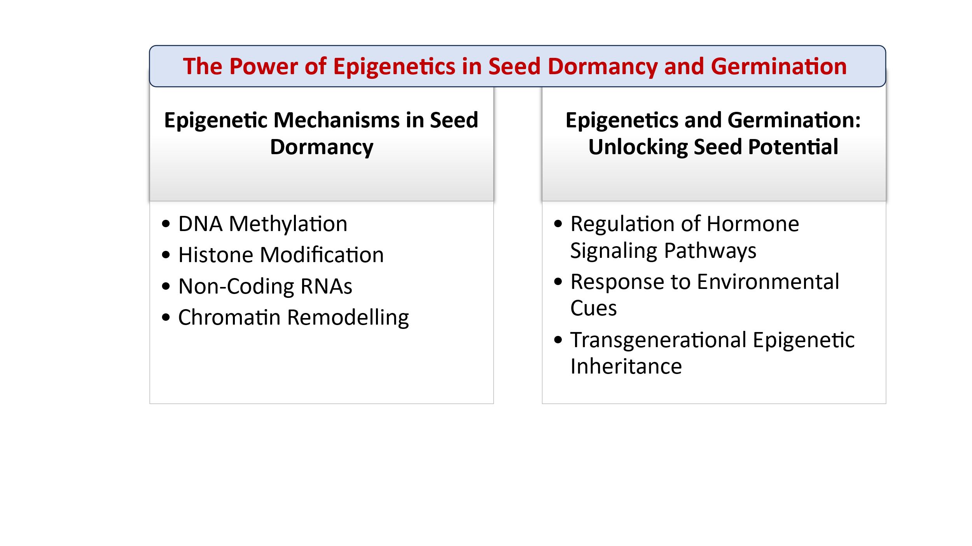

**Fig. 2: The Power of Epigenetics in Seed Dormancy and Germination**

* 1. **Epigenetic Mechanisms in Seed Dormancy**

Seed dormancy is a state in which viable seeds do not germinate despite favorable conditions. This is an adaptive mechanism to prevent premature germination and ensure the survival of the plant in changing environmental conditions (Kamthan et al., 2015; Bartels et al., 2018; Song et al., 2019; Hou et al., 2019; Jiang et al., 2021). Epigenetic regulation helps control seed dormancy by altering the expression of genes involved in the dormancy process without changing the DNA sequence itself. Key epigenetic mechanisms that influence seed dormancy include:

* **DNA Methylation:** DNA methylation is the addition of a methyl group (-CH3) to the DNA molecule, typically at cytosine bases in plants (An et al., 2017; Bouyer et al., 2017). This modification can silence genes involved in dormancy or germination, effectively "turning off" the expression of these genes (Niederhuth et al., 2016; Gomez-Cabellos et al., 2022). In seeds, specific methylation patterns can prevent premature germination and maintain dormancy under adverse conditions (Bartels et al., 2018). For instance, methylation of key genes in the gibberellin biosynthesis pathway can inhibit germination and maintain dormancy.
* **Histone Modification:** Histones are proteins around which DNA is wrapped, and their chemical modification (such as acetylation or methylation) can influence gene expression (Berger, 2007; Lepiniec et al., 2018). Histone modifications can regulate the expression of genes involved in seed dormancy by either promoting or suppressing their activity (Tanaka et al., 2008; Lebedeva et al., 2017; Nonogaki, 2019). For example, certain histone modifications are associated with genes that control the response to environmental cues like temperature and light, which are critical for breaking dormancy.
* **Non-Coding RNAs:** Non-coding RNAs, including microRNAs and small interfering RNAs (siRNAs), play an important role in regulating seed dormancy (Rodrigues et al., 2017; Tamiru et al., 2018; Sarkar Das et al., 2018). These RNA molecules can target and silence specific genes that are involved in processes like germination and dormancy (Kamthan et al., 2015; Song et al., 2019; Hou et al., 2019; Jiang et al., 2021). They act as fine-tuners of gene expression in response to environmental changes (Das et al., 2015). For example, microRNAs have been implicated in the regulation of abscisic acid (ABA) signaling pathways, which are central to maintaining dormancy in seeds.
* **Chromatin Remodelling:** Chromatin structure, which is influenced by epigenetic modifications, can either promote or inhibit the transcription of genes related to dormancy and germination (van Zanten et al., 2012; Zha et al., 2020; Footitt et al., 2020). When the chromatin is tightly packed (heterochromatin), gene expression is often silenced (Han et al., 2012; Sang et al., 2012; Archacki et al., 2013). When it is loosely packed (euchromatin), genes are more accessible for transcription (Dekkers et al., 2016; Carter et al., 2018). Chromatin remodelling can alter the accessibility of genes involved in seed dormancy, enabling the seed to "decide" when to germinate.
  1. **Epigenetics and Germination: Unlocking Seed Potential**

Germination is the process by which a seed breaks dormancy and begins to grow into a seedling. The decision to germinate involves a series of complex molecular events that are influenced by both genetic and epigenetic factors. Epigenetics plays a crucial role in controlling these processes, particularly in response to environmental cues such as temperature, light, and water availability. Key epigenetic mechanisms in seed germination include:

* **Regulation of Hormone Signaling Pathways:** Hormones like **abscisic acid (ABA)** and **gibberellins (GA)** play central roles in regulating seed dormancy and germination. ABA generally maintains seed dormancy, while GA promotes germination. Epigenetic modifications can influence the expression of genes involved in the biosynthesis and signaling of these hormones. For example, DNA methylation or histone modification of genes in the ABA and GA pathways can determine whether a seed remains dormant or breaks dormancy to germinate. Epigenetic regulation of these pathways allows seeds to "sense" environmental signals and adjust their dormancy or germination status accordingly.
* **Response to Environmental Cues:** Environmental factors like light, temperature, and water availability are important triggers for breaking seed dormancy. Epigenetic mechanisms allow seeds to "remember" previous environmental experiences and adjust their response in future generations. For instance, if a seed experiences a period of cold (stratification), epigenetic changes may activate or silence genes that respond to temperature, enabling the seed to germinate when temperatures become more favorable. This "memory" is often mediated through changes in histone modifications or DNA methylation patterns.
* **Transgenerational Epigenetic Inheritance:** Epigenetic modifications can be passed from one generation to the next, meaning that seeds may "inherit" epigenetic changes that influence dormancy and germination. This transgenerational epigenetic inheritance enables plants to adapt more rapidly to changing environmental conditions. For example, seeds from plants grown in drought-prone conditions might exhibit epigenetic changes that make them more responsive to water availability, potentially improving germination success in drought conditions.

1. **Environmental Factors Influencing Epigenetic Regulation in Seeds**

Environmental factors are critical in determining whether seeds remain dormant or begin to germinate. Temperature, light, moisture, and other environmental signals can cause changes in epigenetic marks, allowing seeds to respond to their surroundings in an adaptive manner.

* 1. **Temperature: Epigenetic Memory and Dormancy Release**

Temperature fluctuations are perhaps the most well-studied environmental cue influencing seed dormancy. Low-temperature treatments, such as stratification, can trigger epigenetic changes that release dormancy and promote germination. This is especially critical in temperate climates where seeds need to remain dormant during winter and only germinate when spring arrives.

Research has shown that cold temperatures can lead to specific DNA demethylation and histone modifications that alter the expression of dormancy-related genes. Such epigenetic changes act as a form of "epigenetic memory," enabling seeds to "remember" the cold exposure and subsequently overcome dormancy once the weather warms.

* 1. **Light: Photoperiod and Germination Control**

Light is another key environmental factor in seed germination, especially in species that require light to break dormancy. Light can trigger changes in epigenetic marks, particularly in genes involved in light perception and photoreceptor pathways.

For instance, the phytochrome signaling pathway, which responds to light signals, can activate histone modifications that promote the expression of genes involved in germination. In this way, light not only acts as a signaling molecule but also alters chromatin structure to enable the seed to respond appropriately.

1. **Implications of Epigenetics in Agriculture and Plant Breeding**

Understanding the role of epigenetics in seed dormancy and germination has significant implications for agriculture and plant breeding. By manipulating epigenetic mechanisms, it may be possible to:

* **Improve Crop Germination Rates:** Epigenetic modifications could be used to optimize germination in crops, ensuring that seeds germinate under the right conditions. For instance, understanding how epigenetic changes control seed dormancy could lead to the development of crops that germinate more uniformly, even under challenging environmental conditions.
* **Develop Drought-Resistant Plants:** Epigenetic modifications can help plants "remember" past environmental stresses, such as drought, and adapt more efficiently to future stressors. By enhancing epigenetic memory, it may be possible to breed crops that are more resilient to water scarcity, improving crop yields in dry regions.
* **Enhance Seed Preservation:** Epigenetic changes also influence seed longevity and vigor. By understanding the epigenetic changes that occur during seed storage, scientists could improve seed preservation techniques, ensuring better germination rates and seedling growth after long periods of storage.
* **Precision Plant Breeding:** Epigenetics offers an additional layer of regulation that can be exploited for precise breeding of plants with desirable traits. For example, breeders could use epigenetic markers to select plants that are better adapted to specific environmental conditions, such as temperature extremes or nutrient-poor soils.

1. **Challenges and Future Directions**

While the power of epigenetics in seed dormancy and germination holds great promise, there are still challenges to overcome:

* **Complexity of Epigenetic Regulation:** Epigenetic regulation is highly complex and context-dependent, with many genes and environmental factors involved. Understanding the full range of epigenetic mechanisms that control dormancy and germination remains an ongoing challenge.
* **Epigenetic Stability:** Epigenetic changes can be reversible and may be influenced by the environment. This means that the epigenetic "memory" of past environmental conditions may not always be stable across generations, making it difficult to predict how seeds will respond in different environments.
* **Species-Specific Mechanisms**: While epigenetic mechanisms are beginning to be understood in model organisms like *Arabidopsis*, there is a need to expand research to crop species of agricultural importance, as different species may exhibit unique epigenetic regulation patterns.
* **Gene-Environment Interactions**: Further research is needed to understand how epigenetic modifications interact with genetic factors and environmental cues to control seed dormancy and germination.
* **Ethical Considerations:** Manipulating epigenetic mechanisms in plants raises ethical questions regarding the long-term consequences of altering natural processes. While epigenetic modifications offer exciting opportunities for crop improvement, their potential impact on ecosystems and biodiversity must be carefully considered.

1. **Conclusion**

Epigenetics plays a powerful and dynamic role in regulating seed dormancy and germination. By influencing the expression of key genes involved in these processes, epigenetic mechanisms help seeds adapt to environmental conditions and "decide" when to germinate. This knowledge has profound implications for agriculture, plant breeding, and conservation, offering new strategies for improving crop resilience, optimizing germination, and enhancing seed preservation. As our understanding of epigenetics continues to grow, it will undoubtedly open new doors for more sustainable and efficient agricultural practices.

**Disclaimer (Artificial intelligence)**

Option 1:

Author(s) hereby declare that NO generative AI technologies such as Large Language Models (ChatGPT, COPILOT, etc.) and text-to-image generators have been used during the writing or editing of this manuscript.

Option 2:

Author(s) hereby declare that generative AI technologies such as Large Language Models, etc. have been used during the writing or editing of manuscripts. This explanation will include the name, version, model, and source of the generative AI technology and as well as all input prompts provided to the generative AI technology

Details of the AI usage are given below:

1.

2.

3.

**References**

1. Allen, R. S., Li, J., Stahle, M. I., Dubroué, A., Gubler, F., & Millar, A. A. (2007). Genetic analysis reveals functional redundancy and the major target genes of the Arabidopsis miR159 family. *Proceedings of the National Academy of Sciences*, *104*(41), 16371-16376.
2. An, Y. Q. C., Goettel, W., Han, Q., Bartels, A., Liu, Z., & Xiao, W. (2017). Dynamic changes of genome-wide DNA methylation during soybean seed development. *Scientific Reports*, *7*(1), 12263.
3. An, Y. Q., & Lin, L. (2011). Transcriptional regulatory programs underlying barley germination and regulatory functions of gibberellin and abscisic acid. BMC plant biology, 11, 1-24.
4. Archacki, R., Buszewicz, D., Sarnowski, T. J., Sarnowska, E., Rolicka, A. T., Tohge, T., ... & Jerzmanowski, A. (2013). BRAHMA ATPase of the SWI/SNF chromatin remodeling complex acts as a positive regulator of gibberellin-mediated responses in Arabidopsis. *PloS one*, *8*(3), e58588.
5. Bartels, A., Han, Q., Nair, P., Stacey, L., Gaynier, H., Mosley, M., ... & Xiao, W. (2018). Dynamic DNA methylation in plant growth and development. *International journal of molecular sciences*, *19*(7), 2144.
6. Berger, S. L. (2007). The complex language of chromatin regulation during transcription. *Nature*, *447*(7143), 407-412.
7. Bouyer, D., Kramdi, A., Kassam, M., Heese, M., Schnittger, A., Roudier, F., & Colot, V. (2017). DNA methylation dynamics during early plant life. *Genome biology*, *18*, 1-12.
8. Buijs, G., Vogelzang, A., Nijveen, H., & Bentsink, L. (2020). Dormancy cycling: translation‐related transcripts are the main difference between dormant and non‐dormant seeds in the field. The Plant Journal, 102(2), 327-339.
9. Carter, B., Bishop, B., Ho, K. K., Huang, R., Jia, W., Zhang, H., ... & Ogas, J. (2018). The chromatin remodelers PKL and PIE1 act in an epigenetic pathway that determines H3K27me3 homeostasis in Arabidopsis. *The Plant Cell*, *30*(6), 1337-1352.
10. Das, S. S., Karmakar, P., Nandi, A. K., & Sanan-Mishra, N. (2015). Small RNA mediated regulation of seed germination. *Frontiers in Plant Science*, *6*, 828.
11. Dekkers, B. J., He, H., Hanson, J., Willems, L. A., Jamar, D. C., Cueff, G., ... & Bentsink, L. (2016). The Arabidopsis DELAY OF GERMINATION 1 gene affects ABSCISIC ACID INSENSITIVE 5 (ABI 5) expression and genetically interacts with ABI 3 during Arabidopsis seed development. *The Plant Journal*, *85*(4), 451-465.
12. Footitt, S., Walley, P. G., Lynn, J. R., Hambidge, A. J., Penfield, S., & Finch‐Savage, W. E. (2020). Trait analysis reveals DOG1 determines initial depth of seed dormancy, but not changes during dormancy cycling that result in seedling emergence timing. *New Phytologist*, *225*(5), 2035-2047.
13. Gomez-Cabellos, S., Toorop, P. E., Cañal, M. J., Iannetta, P. P., Fernández-Pascual, E., Pritchard, H. W., & Visscher, A. M. (2022). Global DNA methylation and cellular 5-methylcytosine and H4 acetylated patterns in primary and secondary dormant seeds of Capsella bursa-pastoris (L.) Medik.(shepherd’s purse). *Protoplasma*, 1-20.
14. Han, S. K., Sang, Y., Rodrigues, A., BIOL425 F2010, Wu, M. F., Rodriguez, P. L., & Wagner, D. (2012). The SWI2/SNF2 chromatin remodeling ATPase BRAHMA represses abscisic acid responses in the absence of the stress stimulus in Arabidopsis. *The Plant Cell*, *24*(12), 4892-4906.
15. Hou, J., Lu, D., Mason, A. S., Li, B., Xiao, M., An, S., & Fu, D. (2019). Non-coding RNAs and transposable elements in plant genomes: emergence, regulatory mechanisms and roles in plant development and stress responses. *Planta*, *250*, 23-40.
16. Jiang, A., Guo, Z., Pan, J., Yang, Y., Zhuang, Y., Zuo, D., ... & Li, L. (2021). The PIF1-miR408-PLANTACYANIN repression cascade regulates light-dependent seed germination. *The Plant Cell*, *33*(5), 1506-1529.
17. Kamthan, A., Chaudhuri, A., Kamthan, M., & Datta, A. (2015). Small RNAs in plants: recent development and application for crop improvement. *Frontiers in plant science*, *6*, 208.
18. Lebedeva, M. A., Tvorogova, V. E., & Tikhodeyev, O. N. (2017). Epigenetic mechanisms and their role in plant development. *Russian Journal of Genetics*, *53*, 1057-1071.
19. Lepiniec, L., Devic, M., Roscoe, T. J., Bouyer, D., Zhou, D. X., Boulard, C., ... & Dubreucq, B. (2018). Molecular and epigenetic regulations and functions of the LAFL transcriptional regulators that control seed development. *Plant reproduction*, *31*, 291-307.
20. Luján-Soto, E., & Dinkova, T. (2021). Time to Wake Up: Epigenetic and Small-RNA-Mediated Regulation during Seed Germination. Plants, 10, 236.
21. Niederhuth, C. E., Bewick, A. J., Ji, L., Alabady, M. S., Kim, K. D., Li, Q., ... & Schmitz, R. J. (2016). Widespread natural variation of DNA methylation within angiosperms. *Genome biology*, *17*, 1-19.
22. Nonogaki, H. (2019). Seed germination and dormancy: The classic story, new puzzles, and evolution. *Journal of Integrative Plant Biology*, *61*(5), 541-563.
23. Rodrigues, A. S., & Miguel, C. M. (2017). The pivotal role of small non-coding RNAs in the regulation of seed development. *Plant Cell Reports*, *36*(5), 653-667.
24. Sang, Y., Silva‐Ortega, C. O., Wu, S., Yamaguchi, N., Wu, M. F., Pfluger, J., ... & Wagner, D. (2012). Mutations in two non‐canonical Arabidopsis SWI2/SNF2 chromatin remodeling ATPases cause embryogenesis and stem cell maintenance defects. *The plant journal*, *72*(6), 1000-1014.
25. Sarkar Das, S., Yadav, S., Singh, A., Gautam, V., Sarkar, A. K., Nandi, A. K., ... & Sanan-Mishra, N. (2018). Expression dynamics of miRNAs and their targets in seed germination conditions reveals miRNA-ta-siRNA crosstalk as regulator of seed germination. *Scientific reports*, *8*(1), 1233.
26. Sato, H., & Köhler, C. (2022). Genomic imprinting regulates establishment and release of seed dormancy. Current Opinion in Plant Biology, 69, 102264.
27. Song, X., Li, Y., Cao, X., & Qi, Y. (2019). MicroRNAs and their regulatory roles in plant–environment interactions. *Annual review of plant biology*, *70*(1), 489-525.
28. Tamiru, M., Hardcastle, T. J., & Lewsey, M. G. (2018). Regulation of genome‐wide DNA methylation by mobile small RNAs. *New Phytologist*, *217*(2), 540-546.
29. Tanaka, M., Kikuchi, A., & Kamada, H. (2008). The Arabidopsis histone deacetylases HDA6 and HDA19 contribute to the repression of embryonic properties after germination. *Plant physiology*, *146*(1), 149-161.
30. van Zanten, M., Carles, A., Li, Y., & Soppe, W. J. (2012). Control and consequences of chromatin compaction during seed maturation in Arabidopsis thaliana. *Plant signaling & behavior*, *7*(3), 338-341.
31. Wang, Y., Sun, X., Peng, J., Li, F., Ali, F., & Wang, Z. (2024). Regulation of seed germination: ROS, epigenetic, and hormonal aspects. Journal of Advanced Research.
32. Zha, P., Liu, S., Li, Y., Ma, T., Yang, L., Jing, Y., & Lin, R. (2020). The evening complex and the chromatin-remodeling factor PICKLE coordinately control seed dormancy by directly repressing DOG1 in Arabidopsis. *Plant Communications*, *1*(2).
33. Chandra, R. J., Masilamani, P., Suthakar, B., Rajkumar, P., Sivakumar, S. D., & Manonmani, V. (2024). Seed Dormancy and After-ripening Mechanisms in Seed Germination: A Comprehensive Review. International Journal of Plant & Soil Science, 36(10), 68-92.
34. Vaschetto, L. M. (2024). Seed Dormancy and Germination as Models for Understanding Epigenetic Programming. In *Epigenetics in Crop Improvement: Safeguarding Food Security in an Ever-Changing Climate* (pp. 99-107). Cham: Springer Nature Switzerland.