**Isolation and Identification of Mycoflora from Fruits and Vegetables in Chitradurga Local Market, Karnataka, India**

.

ABSTRACT

|  |
| --- |
| **Aim:** This study aimed to isolate and identify the mycoflora associated with fruits and vegetables from local markets in Chitradurga, Karnataka, India, to assess fungal diversity, determine potential post-harvest pathogens, and evaluate their impact on food quality and safety.  **Study design:** The study will be conducted in various local markets of Chitradurga, Karnataka, India, where fruits and vegetables are commonly sold, and further research work done in the laboratory.  **Methodology:** infected fruits and vegetables were collected from local markets in Chitradurga, surface-sterilized, and inoculated onto Potato Dextrose Agar (PDA) for fungal isolation. The isolated fungi were identified based on morphological characteristics and microscopic examination.  **Results:** In this study, 43 fungal pathogens from 7 different genera were isolated from 23 fruit and vegetable samples, collected from the local Chitradurga market. The fungal isolates were identified at the species level based on the morphological characteristics of fungal colonies or hyphae, spore features, and reproductive structures. *Aspergillus spp., Rhizopus spp., Mucor spp., Colletotrichum spp., Alternaria spp., Fusarium spp.,* and *Penicillium spp***.** Were found to be major disease-causing organisms in fruits and vegetables in the local market of Chitradurga.  **Conclusion:** The study revealed diverse mycoflora associated with fruits and vegetables in Chitradurga local markets, identifying potential spoilage and pathogenic fungi. Effective post-harvest management strategies are essential to minimize fungal contamination and ensure food safety. |

***Keywords****: Local market, Mycoflora, Spoilage, Fruits and Vegetables.*

1. INTRODUCTION

Fruits and vegetables are essential components of a balanced diet, providing vital nutrients, micronutrients, vitamins, and dietary fibre **(Abakari *et al*., 2018).** However, post-harvest diseases significantly impact their availability, accounting for 35–55% of total production losses worldwide. These losses vary across geo-economic regions and affect both the quantity and quality of produce. In particular, mycotoxin contamination poses serious food safety concerns, making post-harvest spoilage a major issue in agricultural production and food security **(Aulakh and Regmi, 2013).**

India is the second-largest producer of fruits and vegetables globally, following China. Despite this, substantial losses occur at various stages, including field production, handling, storage, and transportation, resulting in significant economic setbacks for farmers **(Chukwuka *et al*., 2010; Barth *et al*., 2013).** Fruits and vegetables provide ideal conditions for microbial growth due to their high moisture content and frequent exposure to soil, dust, water, and handling during post-harvest processes. Compared to vegetables, fruits are more perishable because they retain active metabolism during storage (Singh, 2007). Their high concentrations of sugars, minerals, vitamins, and amino acids, along with their low pH, create a favourable environment for the survival and proliferation of various parasitic and saprophytic fungi **(Droby, 2006).**

Among the microorganisms responsible for post-harvest losses, fungi play a dominant role in the spoilage of fruits and vegetables. Fungal contamination not only reduces consumer value but also leads to significant market losses. Several studies have reported post-harvest fungal spoilage across different fruit varieties. For instance, *Colletotrichum* species have been isolated from strawberries, while multiple studies have identified a diverse range of fungal species from various local fruits **(Akhter *et al*., 2009; Sharma *et al*., 2013)**. Research has documented the presence of 11 fungal species in strawberries **(Akhter *et al*., 2009)**, 12 fungal species from eight genera in various fruits **(El-Gali, 2016),** and 77 fungal isolates belonging to five different genera in local market produce **(Qureshi *et al*., 2020).** These findings highlight the widespread nature of fungal contamination in fruits and vegetables, reinforcing the need for further investigation.

Recent advancements in transportation and packaging techniques have enhanced the availability of fresh produce, increasing the consumption of minimally processed fruits, such as pre-cut, packaged, and dried fruits. However, these products are often not sterilized or are only lightly treated with heat, making them susceptible to microbial spoilage. Since minimally processed fruits are consumed without further treatment, it is crucial to study their associated microbiota to assess the risk of fungal contamination and potential spoilage **(Watanable *et al*., 2011).**

Post-harvest diseases cause significant losses, destroying 10-30% of the total fruit and vegetable yield, with losses exceeding 30% in developing countries. The quality of fruits and vegetables is influenced by post-harvest handling, packaging, transportation, and storage, which can lead to decay and microbial activity due to physiological changes. Their low pH, high moisture content, and rich nutrient composition make them highly susceptible to pathogenic fungi, which can render them unfit for consumption by producing mycotoxins. Arah et al. highlighted that handling practices such as sorting, grading, packaging, storage, and transportation play a crucial role in maintaining quality and extending shelf life. **(Zakawa *et al*.,2019)**

Fungi thrive in acidic environments, and the naturally low pH of fruits and vegetables inhibits bacterial growth, allowing fungal species to dominate and cause deterioration. Various studies have reported the contamination of different fruit types by a wide range of fungal species, emphasizing the need for comprehensive research in this area **(Gracia-Jimenez *et al*., 1994; Tournas and Katsondas, 2005; Tournas and Memon, 2009).**In view of the foregoing, there is a need to isolate and identify microbes associated with fruit and vegetable spoilage with the view to proffering suitable solutions for controlling them before reaching the final consumers, to safeguard human health. Given these challenges, the present study aims to isolate, identify, and investigate fungi associated with the spoilage of economically important fruits and vegetables collected from the local market in Chitradurga.

1. material and methods

2.1Study Area

The area of investigation of Chitradurga, one of the central districts of Karnataka, is situated approximately between the longitudes of 76°01' and 77°01' east and the latitudes of 13°34' and 15°02' north of the Equator(**Fig.1**). The district has a generally dry climate, with temperatures ranging from 17°C in winter to 41°C in summer. The average annual rainfall is 487 mm, with a recorded maximum of 459.30 mm. The soil types found in the region include red sandy, deep black, red loamy, mixed red and black, and medium black soils.

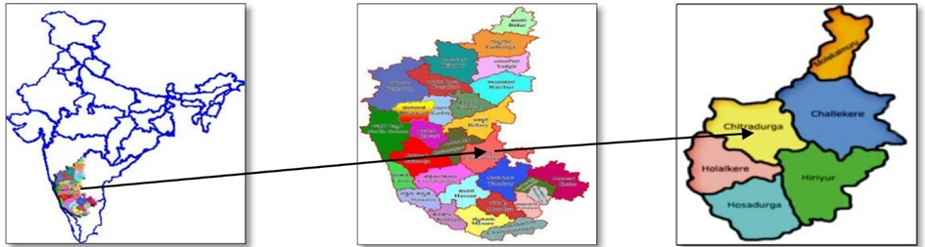The sampling site is the Chitradurga fruit and vegetable market(**Fig.2**), next to the private bus stand. This market is the main hub of Chitradurga for fruits and vegetables, primarily sourced from various areas including Challakere, Hosadurga, Holalkere, and Hiriyuru, as well as from surrounding villages.

**Figure 1: Location of the Study Area**

**2.2 Sample Collection**

During the survey, twenty-three fungi-infected fruits and vegetables(**Fig.3 and 4**), were collected from the Chitradurga market(**Fig.2**). The samples were brought to the laboratory in separate sterilized polythene bags**(Alexopoulos, 1961; Malik,1996).**. The collected infected samples of fruits and vegetables are listed as follows, Fruits include; Grapes (*Vitis vinifera*), Lemon (*Citrus limon*) Lime (*Citrus aurantiifolia*), Apple (*Malus domestica*), Pomegranate (*Punica granatum*), Sapota (*Manilkara zapota*), Banana (*Musa paradisiaca*), Mango (*Mangifera indica*)*,* Orange (*Citrus sinensis*).

The sampled vegetables include; Carrot (*Daucus carota*), Brinjal (*Solanum melongena*), Capsicum (*Capsicum sp.*), Tomato (*Solanum lycopersicum*), Chilli (*Capsicum annum*), Ladies finger(*Abelmoschus esculentus* L.), Bitter gourd (*Momordica charantia*), Cucumber (*Cucumis sativus*), Onion (*Allium cepa*), Pumpkin (*Cucurbita maxima*), Potato (*Solanum tuberosum*), Beans (*Phaseolus vulgaris* L.), Ridge gourd (*Luffa acuntangula*), Radish (*Raphanus sativus*).

**2.3 Media preparation**

The media used for the isolation and culturing of fungi such as Potato dextrose agar (PDA), is used for the growth of fungi. Commercially available potato dextrose agar was used as medium and prepared by adding 39 g of Potato Dextrose Agar to 1000 ml of distilled water. The media was then autoclaved for 30 minutes at 1210c.

**2.4 Isolation of fungi**

The infected fruits and vegetables were sliced into small segments (3 mm in diameter) using a sterilized blade. Surface sterilization of the samples was performed by treating them with 2% sodium hypochlorite (NaOCl) for 3 minutes, followed by five washes with sterile distilled water. The samples were then inoculated onto sterilized potato dextrose agar (PDA) plates using sterile forceps and incubated at 28°C for 5-7 days. After incubation, the plates were examined for fungal growth and pure fungal cultures were obtained using the single spore method(**Choi.et al.,1999**).

**2.5 Identification of fungi**

The fungal growths that appeared were primarily identified using cultural and morphological features(**Table 1**). The fungi isolates were identified by staining with Lactophenol cotton blue (**Mc Lean and Lvimey 1965**). It allows for the identification of various fungal structures such as the presence or absence of rhizoids, hyphae, spores as well as other additional structures under a binocular microscope **(Barnett and Hunter,1987**).

3. results and discussion

In this study, 43 fungal pathogens from 7 different genera were isolated from a total of 23 fruit and vegetable samples **(Fig.3 & 4)**, collected from the local market of Chitradurga market(**Fig.2**). The fungal isolates were identified at the species level based on the morphological characteristics of fungal colonies or hyphae, spore features, and reproductive structures (**Table 1**). Among these *Aspergillus spp., Rhizopus spp., Mucor spp., Colletotrichum spp., Alternaria spp., Fusarium spp.,* and *Penicillium spp.* **(Fig.5).** Were found to be major disease-causing organisms in fruits and vegetables.

A total of 19 fungal pathogens **(Table 2)**, from 6 different genera were isolated from 9 samples of decaying fruits(**Fig.3**). Among these fungal isolates, *Aspergillus spp.* had the highest incidence, with the two species, *Aspergillus niger,* and *Aspergillus flavus*, being more prevalent than any other fungal pathogens isolated in this study. The *Aspergillus spp.* was isolated from grapes, lime, apple, pomegranate, sapota, banana, mango, and orange. Hence the genus *Aspergillus spp.* was the predominating fungi in the fruits. *Rhizopus spp.* was the second most prevalent disease-causing fungi in fruits, isolated from grapes, bananas, and oranges. *Colletotrichum spp*. was the third most prevalent, isolated from pomegranates, bananas, and mangoes. *Mucor spp*. was the fourth highest disease-causing fungi in fruits and isolated from apples and sapota. The remaining two fungal pathogens were *Alternaria spp.* and *Penicillium spp*. *Alternaria spp.* was isolated from lime, and *Penicillium spp*. was isolated from lemon **(Table 4 and Fig.6),** whichwere the common fungi found as the predominant fungal pathogens with rotten fruits.

In vegetables, a total of 24 fungal pathogens **(Table 3)**, belonging to 7 different genera were isolated from 14 samples of decaying vegetables **(Fig.4)** and were identified, among these fungal isolates, *Aspergillus spp.* was the highest disease-causing fungi in vegetables, and the fungal genera represented by *Aspergillus niger, Aspergillus fumigatus, and Aspergillus flavus* were more prevalent than any other fungal pathogens isolated in this study. The *Aspergillus spp.* was isolated from tomato, capsicum, ladies' finger, onion, pumpkin, and ridge gourd. Hence *Aspergillus spp. was* the predominating fungi in vegetables. *Mucor spp.* was the second highest disease-causing in vegetables, the *Mucor spp.* isolated from brinjal, chilli, potato, and cucumber. This was followed by *Rhizopus spp.* was also disease-causing fungi in vegetables, the *Rhizopus spp.* was isolated from brinjal, capsicum, bitter gourd, and radish. *Colletotrichum spp.* was the fourth most prevalent disease-causing fungi in this study, isolated from capsicum, chilli, and cucumber. The remaining three fungal pathogens were, *Fusarium spp*. isolated from tomatoes and beans, *Alternaria spp*. isolated from potatoes and *Penicillium spp*. isolated from carrots. **(Table 5 and Fig.7).**

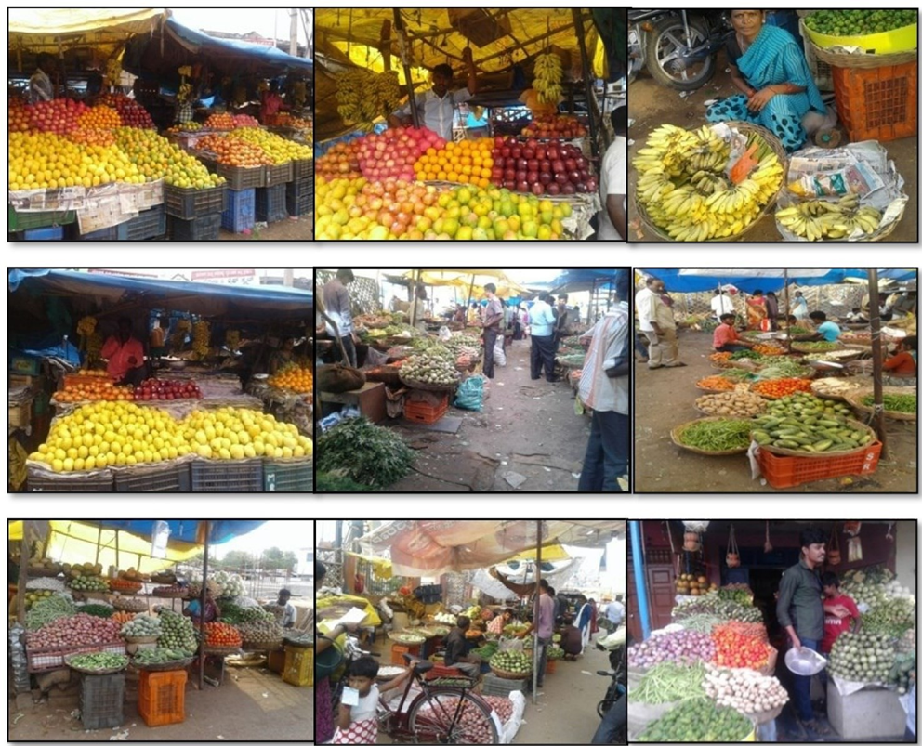

**Figure-2:Fruit and vegetable market of Chitradurga (Sampling Site)**

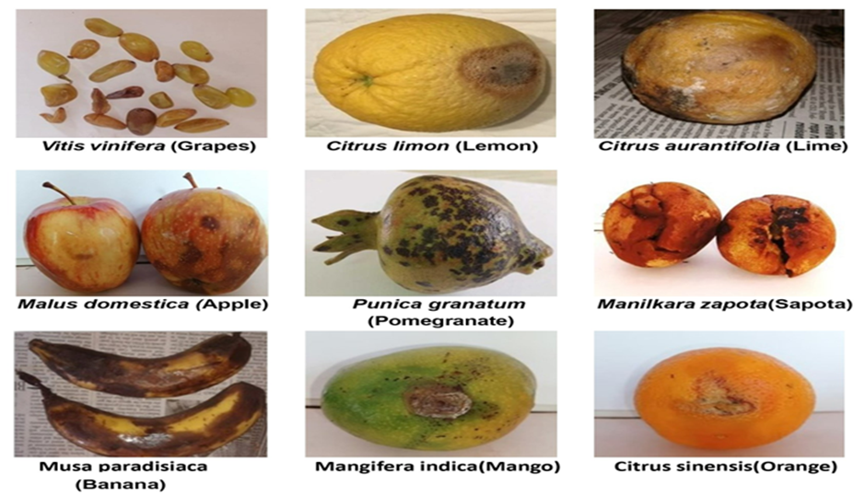**Table 1: Cultural, and Morphological Characteristics for Identification of Fungi**

|  |  |  |
| --- | --- | --- |
| **Isolate** | **Cultural Characteristics** | **Morphological Characteristics** |
| *Aspergillus niger* | Black colour fluffy growth with white edges | Large conidial, head dark brown becoming radiate and split to columns |
| *Aspergillus flavus* | Green powdered colony. Reverse goldish to red-brown | Conidiophores are hyaline and appear rough |
| *Aspergillus fumigatus* | Grey, green fluffy growth, or bluish-green. | Vesicle pyriform, uniseriate, Clavate, vesicle, thick-walled, Smooth,  conidia globose to sub-globose, echinulate |
| *Rhizopus spp.* | White cotton candy dense growth.  Reverse white | Rhizoids well developed at the point on the stolon and unbranched sporangiophore |
| *Mucor spp.* | White cotton candy fluffy appearance | Branched sporangiophores and rhizoids absent |
| *Colletotrichum spp.* | Colonies varied in the appearance of their culture ranging from fibrous, compact, and cottony colonies. The colour of colonies ranged between whitish to greyish, pinkish, and greyish-  green. | Morphologically, it is characterized by oblong, sometimes slightly constricted, micro-guttate conidia and simple obovoid to ellipsoidal appressoria. |
| *Alternaria spp.* | Flat white growth | Erect conidiophores, septate hyphae with cylindrical conidia. |
| *Fusarium spp.* | Rapidly growing woolly to cottony lemon and yellow. | Multicellular distinctive sickle-shaped macroconidia. |
| *Penicillium spp.* | Green colony. Reverse usually white, but maybe red or brown | The presence of conidiophores & appeared as in chains.  Bears flask-shaped phialides |

**Figure 3:Fruits affected by fungal pathogens.**

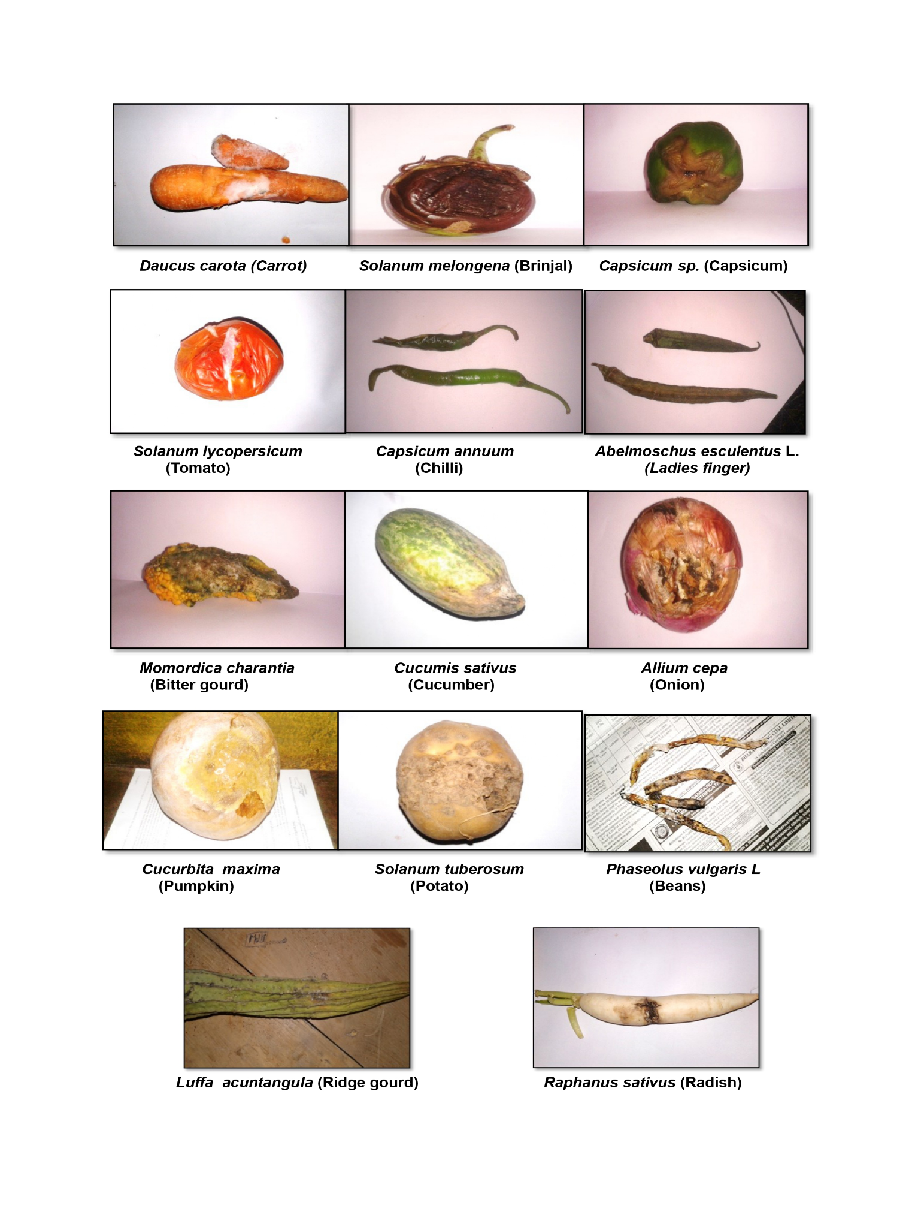

**Figure 4: Vegetables affected by fungal pathogens.**

**Table 2: The fungal pathogens isolated from infected fruit samples**

|  |  |  |
| --- | --- | --- |
| **Fruits** | **Scientific Name** | **Fungal pathogens** |
| Grapes | *Vitis vinifera* | *Aspergillus niger, Rhizopus spp.* |
| Lemon | *Citrus limon* | *Penicillium spp.* |
| Lime | *Citrus aurantiifolia* | *Aspergillus niger, Alternaria spp.* |
| Apple | *Malus domestica* | *Aspergillus niger, Mucor spp.* |
| Pomegranate | *Punica granatum* | *Aspergillus niger., Colletotrichum spp.* |
| Sapota | *Manilkara zapota* | *Aspergillus niger, Mucor spp.* |
| Banana | *Musa paradisiaca* | *Aspergillus flavus, Rhizopus spp., Colletotrichum spp.* |
| Mango | *Mangifera indica* | *Aspergillus niger, Colletotrichum spp.* |
| Orange | *Citrus sinensis* | *Aspergillus niger, Aspergillus flavus,*  *Rhizopus spp.* |

**Table 3: The fungal pathogens isolated from infected vegetable samples**

|  |  |  |
| --- | --- | --- |
| **Vegetables** | **Scientific Name** | **Fungal pathogens** |
| Carrot | *Daucus carota* | *Penicillium spp.*, *Mucor spp.* |
| Brinjal | *Solanum melongena* | *Rhizopus spp., Mucor spp.* |
| Capsicum | *Capsicum sp.* | *Rhizopus spp., Aspergillus niger*,  *Colletotrichum spp.* |
| Tomato | *Solanum lycopersicum* | *Aspergillus niger, Aspergillus fumigatus, Fusarium spp.* |
| Chilli | *Capsicum annum* | *Mucor spp.*, *Colletotrichum spp.* |
| Ladies finger | *Abelmoschus esculentus* L. | *Aspergillus niger* |
| Bitter gourd | *Momordica charantia* | *Rhizopus spp.* |
| Cucumber | *Cucumis sativus* | *Mucor spp., Colletotrichum spp.* |
| Onion | *Allium cepa* | *Aspergillus niger, Aspergillus fumigatus* |
| Pumpkin | *Cucurbita maxima* | *Aspergillus flavus* |
| Potato | *Solanum tuberosum* | *Mucor spp., Alternaria spp.* |
| Beans | *Phaseolus vulgaris* L*.* | *Fusarium spp.* |
| Ridge gourd | *Luffa acuntangula* | *Aspergillus niger* |
| Radish | *Raphanus sativus* | *Rhizopus spp.* |

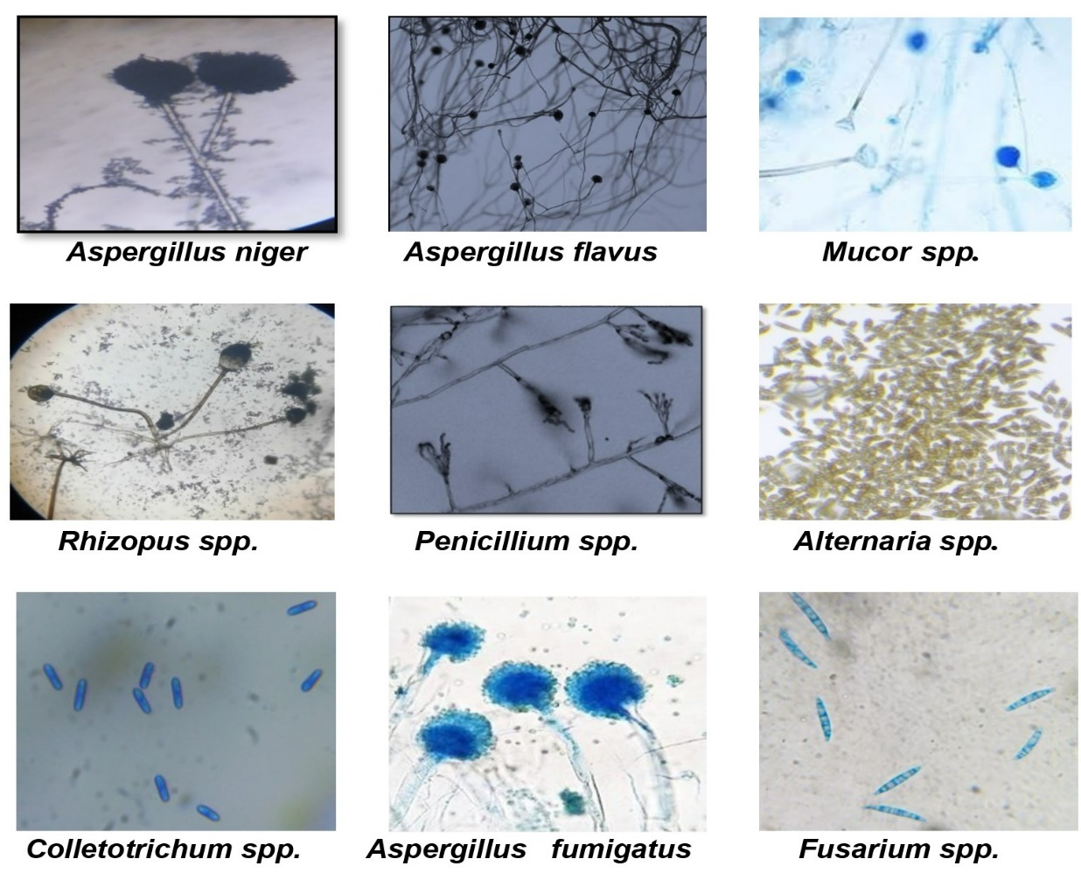**Figure 5: Microphotographs of some isolated fungi from infected fruits and vegetables**

**Table 4: Occurrence of fungi on infected fruits**

|  |  |  |  |  |  |  |  |  |  |  |
| --- | --- | --- | --- | --- | --- | --- | --- | --- | --- | --- |
| **Sl.No** | **Pathogens** | **Fruits** | | | | | | | | |
| **S1** | **S2** | **S3** | **S4** | **S5** | **S6** | **S7** | **S8** | **S9** |
| 1. | ***Aspergillus. niger*** | **+** | **-** | **+** | **+** | **+** | **+** | **-** | **+** | **+** |
| 2. | ***Aspergillus. flavus*** | **-** | **-** | **-** | **-** | **-** | **-** | **+** | **-** | **+** |
| 3. | ***Rhizopus spp.*** | **+** | **-** | **-** | **-** | **-** | **-** | **+** | **-** | **+** |
| 4. | ***Colletotrichum spp.*** | **-** | **-** | **-** | **-** | **+** | **-** | **+** | **+** | **-** |
| 5. | ***Mucor spp.*** | **-** | **-** | **-** | **+** | **-** | **+** | **-** | **-** | **-** |
| 6. | ***Penicillium* spp.** | **-** | **+** | **-** | **-** | **-** | **-** | **-** | **-** | **-** |
| 7. | ***Alternaria spp.*** | **-** | **-** | **+** | **-** | **-** | **-** | **-** | **-** | **-** |

**“+” =Presence of fungi, “-”= Absence of fungi.**

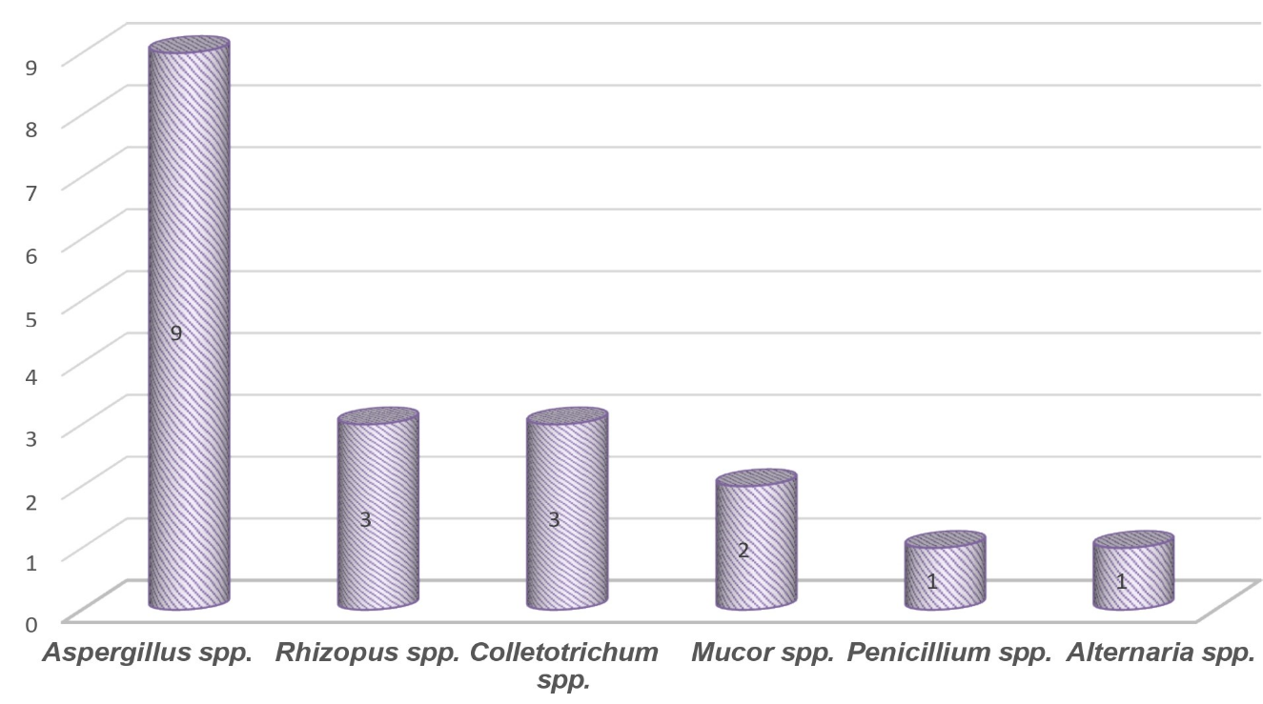**S1-Grapes, S2-Lemon, S3-Lime, S4-Apple, S5-Pomegranate, S6-Sapota, S7-Banana, S8-Mango, S9-Orange**

**Figure 6: Prevalence of fungal species present in infected fruits**

**Table 5: Occurrence of fungi on infected vegetables**

|  |  |  |  |  |  |  |  |  |  |  |  |  |  |  |  |
| --- | --- | --- | --- | --- | --- | --- | --- | --- | --- | --- | --- | --- | --- | --- | --- |
| **Sl. No** | **Pathogens** | **Vegetables** | | | | | | | | | | | | | |
| **S**  **1** | **S**  **2** | **S**  **3** | **S**  **4** | **S**  **5** | **S**  **6** | **S**  **7** | **S**  **8** | **S**  **9** | **S**  **10** | **S**  **11** | **S**  **12** | **S**  **13** | **S**  **14** |
| **1** | ***Aspergillus Niger*** | **-** | **-** | **+** | **+** | **-** | **+** | **-** | **-** | **+** | **-** | **-** | **-** | **+** | **-** |
| **2** | ***Aspergillus fumigatus*** | **-** | **-** | **-** | **+** | **-** | **-** | **-** | **-** | **+** | **-** | **-** | **-** | **-** | **-** |
| **3** | ***Aspergillus flavus*** | **-** | **-** | **-** | **-** | **-** | **-** | **-** | **-** | **-** | **+** | **-** | **-** | **-** | **-** |
| **4** | ***Mucor spp.*** | **+** | **+** | **-** | **-** | **+** | **-** | **-** | **+** | **-** | **+** | **-** | **-** | **-** | **-** |
| **5** | ***Rhizopus spp.*** | **-** | **+** | **+** | **-** | **-** | **-** | **+** | **-** | **-** | **-** | **-** | **-** | **-** | **+** |
| **6** | ***Colletotrichum spp.*** | **-** | **-** | **+** | **-** | **+** | **-** | **-** | **+** | **-** | **-** | **-** | **-** | **-** | **-** |
| **7** | ***Fusarium spp.*** | **-** | **-** | **-** | **+** | **-** | **-** | **-** | **-** | **-** | **-** | **-** | **+** | **-** | **-** |
| **8** | ***Penicillium spp.*** | **+** | **-** | **-** | **-** | **-** | **-** | **-** | **-** | **-** | **-** | **-** | **-** | **-** | **-** |
| **9** | ***Alternaria spp.*** | **-** | **-** | **-** | **-** | **-** | **-** | **-** | **-** | **-** | **-** | **+** | **-** | **-** | **-** |

**“+” =Presence of fungi, “-”= Absence of fungi.**

**S1-Carrot, S2-Brinjal, S3-Capsicum, S4-Tomato, S5-Chilli, S6-Ladies finger, S7-Bitter gourd, S8-Cucumber, S9-Onion, S10-Pumpkin, S11-Potato, S12-Beans,**

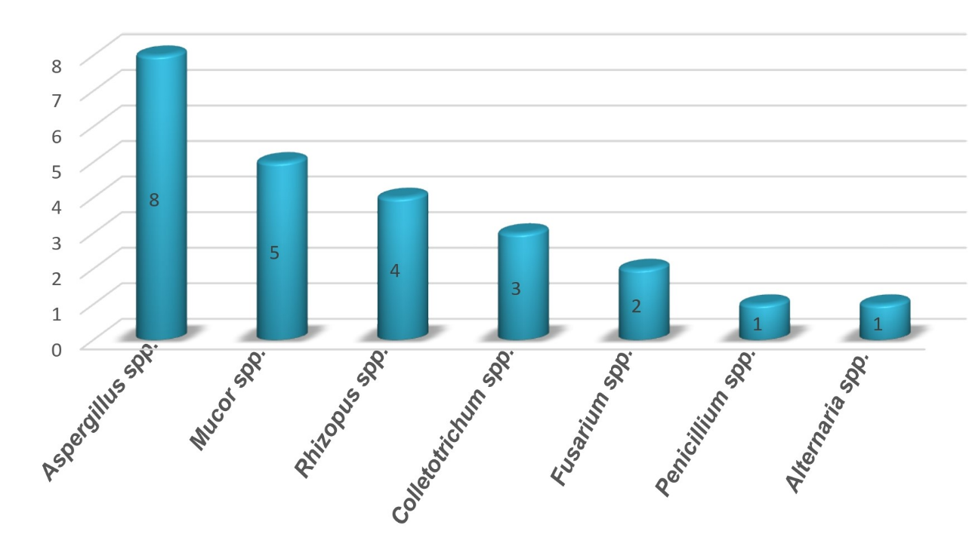**S13-Ridge gourd, S14- Radish.**

**Figure 7: Prevalence of fungal species present in infected Vegetables**

**Discussion**

The present investigation revealed that fungal infection is mainly due to injury during storage and handling. Edible fruits and vegetables are vulnerable to fungal attacks during transportation, storage, and marketing. This study focuses on fungal diseases affecting fruits and vegetables under storage and marketing conditions at the Chitradurga market. Weather conditions, particularly humidity and temperature, influence the incidence of these diseases both qualitatively and quantitatively. Therefore, an attempt was made to correlate the prevailing humidity and temperature conditions with the incidence of spoilage organisms. The high rate of fungal isolation from fruits indicates that fungi are responsible for the post-harvest deterioration of some edible fruits and vegetables in the Chitradurga market. The isolation and distribution of fungi in spoilt fruits and vegetables in the Chitradurga market is a novel discovery that exposed an array of fungi that are pathogenic to man and animals.

A total of 43 fungal pathogens belonging to 7 different genera were isolated from 23 selected fruits and vegetables, collected from the local market of Chitradurga. The isolated fungal pathogens were identified by their cultural and morphological characteristics as presented in **Table 1**. In some cases, the fungi colonies were stained by Lactophenol cotton blue **(Mc Lean and Lvimey, 1965)** and observed under a compound microscope, the morphological identification of fungal culture colonies or hyphae, the characteristics of the spores and reproductive structures **(Barnett and Hunter, 1987).** The findings of this study showed that *Aspergillus flavus, Aspergillus niger, Aspergillus fumigatus, Rhizopus spp., Mucor spp., Penicillium spp., Alternaria spp.,* and *Fusarium spp.* Were found to be major disease-causing organisms in fruits and vegetables.

**Table 2** illustrates the isolation of 19 fungal pathogens from 9 different fruits, representing 6 distinct genera. *Aspergillus spp.* was the most prevalent pathogen, causing disease in fruits such as grapes, lime, apples, pomegranate, sapota, mango, and oranges. These findings align with reports on post-harvest fungal pathogens in fruits during market storage **(Bhale, 2011).** *Rhizopus spp.* ranked as the second most common pathogen, affecting grapes, bananas, and oranges. *Colletotrichum spp.* was the third most frequently isolated fungus, found in pomegranates, bananas, and mangoes. *Mucor spp*. ranked fourth, with isolates from apples and sapota. *Alternaria spp.* was found only in lime, while *Penicillium spp*. was isolated from lemons.

**Table 3** shows that 24 fungal pathogens from 7 different genera were isolated from 14 decaying vegetable samples. Among these, *Aspergillus spp.* was identified as the most prevalent disease-causing fungus, affecting vegetables such as tomato, capsicum, ladies finger, onion, pumpkin, and ridge gourd, indicating its dominance among fungal pathogens in vegetables, *Mucor spp.* was the second highest disease-causing in vegetables, and it was isolated from brinjal, chilli, potato, and cucumber. This was followed by *Rhizopus spp.* was also disease-causing fungi in vegetables, and it was isolated from brinjal, capsicum, bitter gourd, and radish. *Colletotrichum spp.* was the fourth most prevalent disease-causing fungi in this study, isolated from capsicum, chilli, and cucumber. The remaining three fungal pathogens were, *Fusarium spp*. isolated from tomatoes and beans, *Alternaria spp*. isolated from potatoes and *Penicillium spp*. isolated from carrots.

Similar results on post-harvest fungi on storage fruits and vegetables were reported by many investigators. **(Sharma*, et al.* 1998, Cherian 2005, Ghurde*, et al.,* 2010 and Yusuf *et al*., 2021).**

The susceptibility of fruits and vegetables to fungal contamination can be attributed to their soft peel, which makes them more prone to physical damage and easier for fungi to penetrate. The presence and absence of specific fungi on different fruits and vegetables could be due to variations in their sugar content, pH, and water content. Since fungi-infected fruits and vegetables can infect others, it is essential to discard contaminated produce immediately to prevent further spread. Washing fruits and vegetables can help reduce microbial load, but if not consumed immediately after washing, they should be properly dried to prevent fungal growth due to moisture.

Certain fungal genera identified in this study, such as *Aspergillus, Penicillium,* and *Alternaria*, are pathogenic and produce mycotoxins. These fungi can grow on fruits and vegetables at room temperature and pose significant health risks to humans and animals. Fungal spoilage diminishes the hygiene and marketable quality of fruits and vegetables and causes substantial economic losses. Therefore, it is crucial to develop strategies to minimize the spoilage of fruits and vegetables.

4. Conclusion

The present study was carried out to isolate and characterize the fungi associated with fruits and vegetables in the local market of Chitradurga. Fruits and vegetables showed a significant occurrence of various fungi, due to high relative humidity and favorable conditions. Therefore, there is a need to keep the fruits and vegetables in a good place of storage condition for proper care to get rid of the attack of various pathogenic fungi which can lead to various human illnesses. Care should also be taken to consume the fruits and vegetables with proper scientific knowledge by knowing the pathogenic fungi that may contaminate and thereby spoil the fruits and vegetables. This study aids in identifying and estimating the abundance of surface fungi on fruits and vegetables in the local market of Chitradurga, with an emphasis on future preservation methods. A suggestive approach should be implemented to educate local people on scientifically sound preservation methods to maintain the quality of fruits and vegetables. Future work could involve molecular characterization of the fungi, estimation of the extent of pathogenesis, and development of control measures to ensure safe consumption and address the socio-economic impacts in this region.

Disclaimer (Artificial intelligence)

Option 1:

Author(s) hereby declare that NO generative AI technologies such as Large Language Models (ChatGPT, COPILOT, etc.) and text-to-image generators have been used during the writing or editing of this manuscript.

Option 2:

Author(s) hereby declare that generative AI technologies such as Large Language Models, etc. have been used during the writing or editing of manuscripts. This explanation will include the name, version, model, and source of the generative AI technology and as well as all input prompts provided to the generative AI technology

Details of the AI usage are given below:

1.

2.

3.

References

1. Abakari, G., S. J. Cobbina and E. Yeleliere (2018). Microbial quality of ready-to-eat vegetable salads vended in the central business district of Tamale, Ghana*. Int. J. Food. Contam*. 5(1): 3.
2. Ahmed Rashed Al-Najada, Mohammed Saad Al-Suabey.(2014) Isolation and classification of fungi associated with spoilage of post-harvest mango (*Mangifera indica* L.) in Saudi Arabia.Vol.8 (7):685-688.
3. Akhter MS, Alam S, Islam MS, Lee MW. (2009). Identification of the fungal pathogen that causes strawberry anthracnose in Bangladesh and evaluation of in vitro fungicide activity. *Microbiology* 37(2), 77- 81. <https://doi.org/10.4489/MYCO.2009.37.2.077>
4. Akinmusire, O.O.(2011). Fungal Species Associated with the Spoilage of Some Edible Fruits in Maiduguri Northern Eastern Nigeria.Vol. 5(1): 157-161.
5. Alexopoulos. C.J,(1961). Introductory Mycology, *John Wiley and Sons, Inc., New York* pp: 229-230.
6. Aulakh, J., & Regmi, A. (2013). Post-harvest food losses estimation-development of consistent methodology, 2050, 1–34.
7. Barnett, H.L., and Hunter, B.B.(1987).Illustrated Genera of Imperfect Fungi. 4th Edition, *Macnuilian Publishing Co., New York*. 320 pp.
8. Barth, M.; Hankison, T.R.; Zhuang, H. and Breidt, F. (2009). Microbiological spoilage of fruits and vegetables. In: Sperber W.H, Doyle M.P, editors. Compendium of the Microbiological Spoilage of Foods and Beverages, Food Microbiology and Food Safety New York: C Springer Science Business Media, LLC; 2009. 135–183.
9. Benkee Thiyam, G.D. Sharma. (2013). Isolation and Identification of Fungi Associated with Local Fruits of Barak Valley, Assam.Vol. 8(2):319-322.
10. Bhale. U.N(2011).Survey of market storage diseases of some important fruits of Osmannabad District (M. S.) India.Vol.1 (2): 88 – 91.
11. Borse K. N. (2016).Survey of Post-Harvest Fungal Diseases of Fruits and Vegetables from Dhule District of Maharashtra.Vol.1:114-118.
12. Cherian, TT.(2005).Post-harvest fungal diseases of some fruits of Kerala. B.F.Rodrigues, H.N.Gour, D.J.Bhat & N.kamat eds. *Advances in fungal diversity and host-pathogen interactions*. Goa University, Goa., PP-26-36.
13. Choi, Y. W., Hyde, K. D., & Ho, W. H. (1999). Single Spore Isolation of Fungi. Fungal Diversity, 3, 29-38.
14. Chukwuka KS, Okonko IO, Adekunle AA. 2010. Microbial ecology of organisms causing pawpaw (Carica papaya L.) fruit decay in Oyo State, Nigeria. *American-Eurasian Journal of Toxicological Sciences.* 2(1), 43-50.
15. Droby, S. (2006). Improving quality and safety of fresh fruits and vegetables after harvest by the use of biocontrol agents and natural materials*. Acta Hortic.,* 709: 45–51.
16. El-Gali ZI. 2016. Isolation and Identification of Fungi Associated with Fruits Sold in Local Markets. *International Journal of Research Studies in Biosciences* 4(11), 61-64. <http://dx.doi.org/10.20431/2455-4316.0402001>
17. Garcia-Jimenez, J., T. M. Velazquez, C. Jorda, and A. Alfaro-Garcia. 1994. Acremonium species as the causal agent of muskmelon collapse in Spain. *Plant Dis*. 78:416–419.
18. Ghurde MU and Pachkhede AU. (2010). The market and storage diseases of fruits from Amravati (Maharashtra) India. *Bionanofrontier.* 3(2):325 - 327.
19. Malik, B.S.,(1996), A Laboratory Manual of Veterinary Microbiology, Part III. Pathogenic Bacteriology and Mycology, 4th Ed.,pp:137-146.
20. Mc Lean Rc and Lvimey cook WR.(1965).Plant science formulae. *Macmillan & Co.Ltd, New Delhi.*
21. Qureshi, I. A., Lal, S., Sapna, P. K., Ujjan, J. A., Parkash, O., & Kanhar, N. A. (2020). Fungi associated with spoiled fruits vended in local market. *International Journal of Biosciences,* 16(1), 244-50. <http://dx.doi.org/10.12692/ijb/16.1.244-250>
22. Sharma G, Kumar N, Weir BS, Hyde KD, Shenoy BD. (2013). The ApMat marker can resolve Colletotrichum species: a case study with Mangifera indica. *Fungal Diversity* 61(1), 117-38.
23. Sharma, N, and Alam, M, Mashkoor.,(1998) Post-harvest diseases of horticulture perishables, *International Book Distributing Co Lucknow.*
24. Tournas, V. H., and E. Katsoudas. (2005). Mould and yeast flora in fresh berries, grapes and citrus fruits. *Int. J. Food Microbiol*. 105:11–17.
25. Tournas, V. H., and S. U. Memon.(2009). Internal contamination and spoilage of harvested apples by patulin-producing and other toxigenic fungi. *Int. J. Food Microbiol*. 133:206–209.
26. Watanabe, M., Tsutsumi, F., Konuma, R., Lee, K. I., Kawarada, K., Sugita-Konishi, Y., and Hara-Kudo, Y. (2011). Quantitative analysis of mycoflora on commercial domestic fruits in Japan. *Journal of Food Protection*, 74(9), 1488-1499.
27. Yusuf *et al*., (2021). The Efficacy of Plant Extracts on the Control of Post-harvest Loss of Tomato. *INOSR Applied Sciences*, 7(1): 86-95.
28. Zakawa *et al*.,(2019). Isolation and control of fungal rot pathogen of tomato fruit using aqueous leaf extracts of *Azadirachta indica* in Mubi, Adamawa State. *Research Journal of Plant Pathology*. Volume 2, issue 1, number 09: 1-5.
29. Zakawa *et al*.,(2020). Anti-fungal activities of aqueous leaf extracts of *Moringa oleifera* lam. on *Mangifera indica* l. post-harvest fruit-rot pathogens from some markets in Yola North, Adamawa State. *World Journal of Pharmaceutical Research.* 9(6): 1675-1687.