**Assessment of current sanitary quality of market garden products in the Yopougon municipality**

**ABSTRACT**

**Aims :** Inadequate agricultural practices and poor hygiene among vegetable growers increase the risk of food contamination, compromising public health and degrading natural resources. This study evaluates the impact of different cleaning treatments (sodium bicarbonate, sodium hypochlorite, and their combination) on microbial contamination and the presence of heavy metals in vegetables (lettuce, tomatoes, cucumbers, peppers).

**Methodolgy:** Samples of vegetables from various production sites in Yopougon Municipality were treated with sodium bicarbonate, sodium hypochlorite, or a combination of both. Each vegetable was subjected to microbiological characterization. The levels of Aerobic Mesophilic Germs, Staphylococcus aureus, Bacillus cereus, yeast and mold, Enterobacteria, Escherichia coli and Salmonella contamination and the presence of heavy metals (Lead (Pb), Cadmium (Cd), Mercury (Hg), Arsenic (As), Nickel (Ni), Copper (Cu) and Zinc (Zn)) were measured using standard procedures.

**Results:** Microbiological analyzes revealed bacteriological contamination of all Raw-Consumed Vegetables tested. Microbial counts remain below normative thresholds for most samples. Each treatment has a specific role to play in disinfecting raw vegetables: sodium bicarbonate in frozen water reduces the microbial load and eliminates pesticide residues, while giving vegetables a crisp, shiny appearance. Sodium hypochlorite in tap water effectively destroys any remaining pathogens. Their combination maximizes the reduction of microbial contaminants, optimizing disinfection, while revealing results that meet the AFNOR standard (1996) microbiological quality for vegetables consumed raw. Analysis of lettuce, tomato, cucumber and bell pepper samples revealed the presence of various heavy metals, some of which require special attention to ensure consumer safety. However, the risk quotient (RQ) shows that the heavy metal content of each vegetable has an RQ of less than 1, indicating a low risk to the consumer.

**Conclusion:** This study showed that the combination of both treatments proved most effective in reducing microbial contamination, highlighting the importance of improving hygiene practices to ensure the safety of fresh produce.

*Keywords: Health quality, Vegetables, Microbial load, Yopougon.*

1. **INTRODUCTION**

Urban and peri-urban market gardening plays a crucial role in West African economic development, supporting urban dynamics and ensuring rapid supply of fresh produce. This agriculture is multifunctional and specializes in perishable products to meet growing urban market demands (Weidner et al., 2019). In Côte d'Ivoire, this activity is mainly carried out by vulnerable groups living in the peri-urban areas of major cities, where it is a key source of income (Kouakou, 2020). In Abidjan, green spaces and lowlands are used for growing vegetables (Assy et al., 2024).

This production ensures a supply of fresh vegetables for urban populations. It also provides essential vitamins and micronutrients, especially for vulnerable groups, contributing to the prevention of diseases such as cancer, obesity, and cardiovascular diseases (Noopur et al., 2023). The sanitary quality of these market garden products is crucial for consumer health, socio-economic, and environmental sustainability, however, inadequate agricultural practices, like the excessive use of pesticides and irrigation with contaminated water, lead to risks of chemical, organic, and microbiological pollution (Tarnagda et al., 2017).

Urban agriculture in Côte d'Ivoire faces significant challenges related to contamination and health risks. In Abidjan, most vegetable farmers are unaware of contamination risks from their practices, with limited attention to health risk prevention (Coulibaly et al., 2023). Studies have revealed significant contamination of soil, water, and vegetables with heavy metals, often exceeding safety norms. Research in periurban areas of Abidjan found toxic levels of lead (>8 mg/kg) in plant organs, with soil lead content ranging from 35.5 to 39.8 mg/kg (Guety et al., 2017). Studies have shown that irrigation water often contains fecal contaminants and pathogens, posing health risks to consumers (Douti et al., 2021).

These findings highlight the urgent need for improved agricultural practices and awareness to mitigate environmental and health risks in urban agriculture.

The present study aims to evaluate the sanitary quality of market garden products in the Yopougon municipality. Specifically, it seeks to enumerate pathogenic microorganisms and determine the levels of heavy metals in cucumbers, tomatoes, peppers, and lettuce produced by the Yopougon market gardeners and to Treat of vegetables from various production sites in Yopougon Municipality with sodium bicarbonate, sodium hypochlorite, or a combination of both.

1. **MATERIALS AND METHODS**
   1. **Study Site**

The study was conducted in the autonomous district of Abidjan, specifically in the Yopougon municipality, located between the Banco forest and the Ebrié lagoon, west of the Abidjan North geographic zone, slightly off-center. The municipality's geographical coordinates are 5°20'56" North and 4°00'42" West. It has a population of 1,571,065 inhabitants, with a density of 9,568 inhabitants/km², and covers an area of 16,420 hectares (164.2 km²). Its altitude ranges from 40 to 132 meters above sea level.

* 1. **Study Material**

The study focused on samples of lettuce (*Lactuca sativa*), tomatoes (*Lycopersicon esculentum*), cucumbers (*Cucumis sativus*), and peppers (*Capsicum frutescens*), collected from three major vegetable farming areas in Yopougon: Adiopodoumé (Km 17), Niangon Adjamé (Lièvre-Rouge), and Niangon Attié (Attiesso). The sample collection period spanned from October 2023 to August 2024.

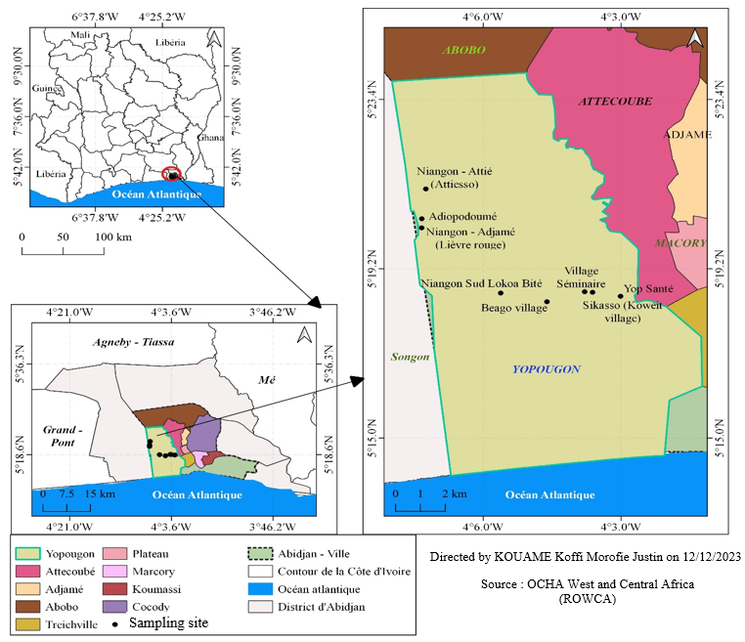

Fig.1. Location of Vegetable Production Areas in the Yopougon Municipality

Sampling sites :

|  |
| --- |
| *Niangon Adjamé (Lièvre-Rouge)*  *Niangon Attié (Attiesso)*  *Adiopodoumé (Km 17)* |

**Fig. 2. Photographs of Vegetables**  
A: Peppers (*Capsicum annuum*); B: Lettuce (*Lactuca sativa*); C: Cucumbers (*Cucumis sativus*); D: Tomatoes (*Solanum lycopersicum*).All products are collected aseptically at the production sites in BIOHAZARD weighing bags, using sterile, single-use latex gloves.

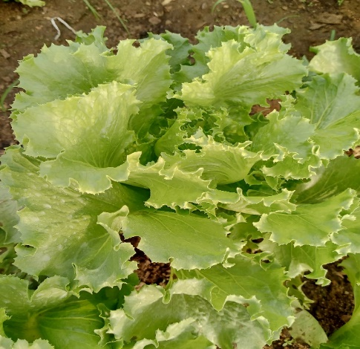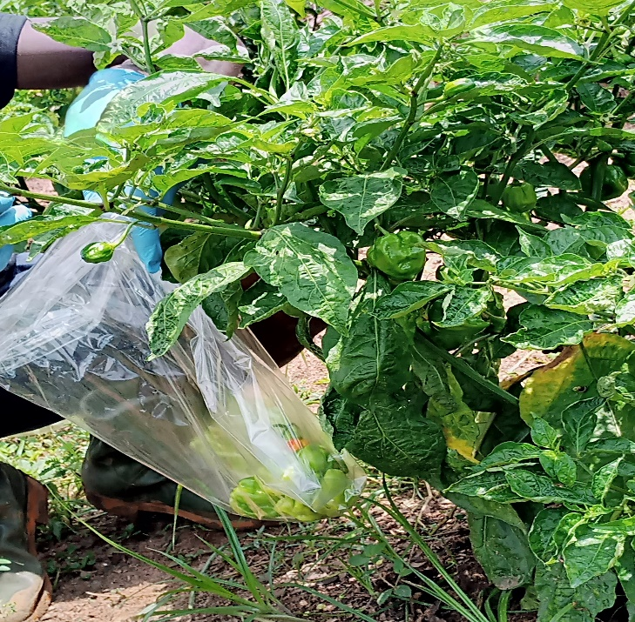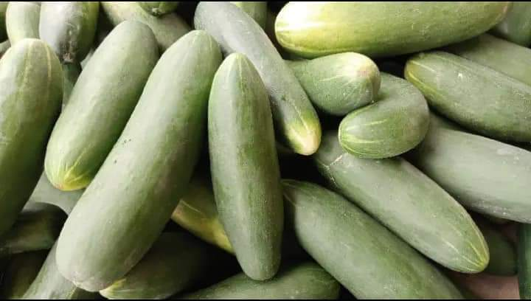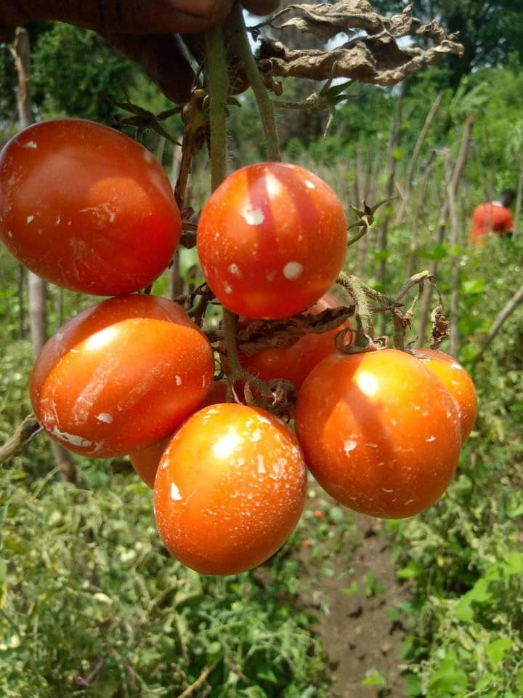

**A**

**B**

**C**

**D**

* 1. **Selection of Sites and Market Garden Products**

The studied production areas include Adiopodoumé (Km 17), Niangon Attié (Attiesso), and Niangon Adjamé (Lièvre Rouge), which are the main sources of fresh market garden products for Yopougon and its surroundings. Located in lowlands within an urbanized environment, these areas are bordered by factories and are supplied by wastewater and runoff, with solid waste in proximity. These sites were selected for their accessibility and the availability of producers willing to participate in the study.

The selected market garden products (pepper, tomato, lettuce, and cucumber) were chosen for their nutritional importance and their potential consumption without cooking.

The four seasons (major rainy season, major dry season, minor rainy season, minor dry season) were chosen due to their impact on the intensification of vegetable cultivation. During the major rainy season, natural irrigation encourages increased use of pesticides and fertilizers, while wastewater runoff, flooding, and waste site filling can spread contaminants, compromising the sanitary and microbiological quality of the products. In the major dry season, market gardeners rely on ponds or wells to irrigate crops. This period is crucial for evaluating health risks associated with vegetable production in Yopougon.

* 1. **Sampling Collection**

For sampling, three production areas (Adiopodoumé, Niangon Adjamé, and Niangon Attié) were selected, with five production sites in each area. In each site, plots managed by producers were selected for sampling. A total of 500 g of each vegetable (tomatoes, cucumbers, peppers, lettuce), freshly harvested from each plot, were randomly collected, placed in sterile BIOHAZARD plastic bags from Fisher Scientific, and handled with sterile latex gloves from the Synguard brand. Three samples were taken per season over an eleven-month period from October 2023 to August 2024, covering:

* October-November: Minor Rainy Season (MRS)
* December-March: Major Dry Season (MDS)
* April-June: Major Rainy Season (MRS)
* July-August: Minor Dry Season (MDS)

For each season, 144 samples (lettuce, tomatoes, cucumbers, peppers) were collected from the production sites, totaling 576 samples from all sites. Labeled samples were placed in a cooler with dry ice and transported to the microbiology and food biotechnology laboratories, as well as the central laboratory at Nangui Abrogoua University for analysis.

* 1. **Treatment of Products Before Analysis**

Three treatments were applied to the analyzed vegetables: soaking in water with 1% sodium hypochlorite, in water with 1% sodium bicarbonate, and in a mixture of both. Each vegetable was then rinsed and prepared for analysis. These treatments aim to effectively reduce microbial and chemical contamination thanks to the complementary properties of both agents, which are safe for human consumption and easily accessible. Sodium bicarbonate, a safe alkaline cleaner, is effective against microorganisms and pesticide residues. Sodium hypochlorite, an affordable and widely available disinfectant, eliminates a wide range of pathogens due to its strong oxidizing power, ensuring the safety of fresh vegetables.

* 1. **Microbiological Analyses**
     1. **Preparation of Mother Suspensions and Decimal Dilutions**

To prepare mother suspensions of the samples, 25 g of each vegetable were aseptically cut and mixed with 225 mL of sterile Buffered Peptone Water (BPW). From each mother suspension, five successive decimal dilutions were made. For the first dilution, 1 mL of the mother suspension was aseptically added to 9 mL of sterile BPW in a test tube, creating a 10⁻¹ dilution. Then, 1 mL of this 10⁻¹ suspension was transferred to 9 mL of sterile BPW to obtain a 10⁻² dilution. This procedure was repeated to achieve a 10⁻⁵ dilution, following the NF EN ISO 6887-V08-010-6 (2013) standard.

* + 1. **Enumeration and Detection of Germs**

Analyses were performed at the food microbiology and biotechnology laboratory of Nangui Abrogoua University to detect the presence of various microorganisms indicating contamination. The evaluated bacteriological parameters included

* + - 1. **Aerobic Mesophilic Germs**

For the enumeration of aerobic mesophilic germs (AMG), Plate Count Agar (PCA) was used. Inoculation was done by incorporating 1 mL of each selected decimal dilution into a Petri dish, to which 12 to 15 mL of melted PCA agar maintained at 45°C was added. The mixture was manually homogenized and then left to cool at room temperature to solidify. A second layer of 4 to 5 mL of agar was poured to limit contamination. The inoculated plates were incubated at 30°C for 72 hours. After incubation, colonies in plates containing 30 to 300 colonies were counted, in accordance with ISO 4833-1:2013.

* + - 1. **Staphylococcus aureus Enumeration**

The medium used for the detection and enumeration of *Staphylococcus aureus* was Stap-Rapid Agar. Inoculation was done by spreading 0.1 mL of the mother suspension and decimal dilutions onto the surface of the pre-poured and solidified agar in a Petri dish. Incubation was at 30°C for 24 hours. Presumptive colonies of *Staphylococcus aureus* were shiny black, entire, convex, surrounded by clear zones extending into the opaque medium, shiny black without a clearly defined clear zone, or dark gray. Presumptive colonies in plates containing 15 to 150 colonies were counted.

* + - 1. **Bacillus cereus Germs (Spores)**

Before enumeration, the mother solution or decimal dilutions were placed in a water bath at 80°C for 10 minutes, then immediately cooled to destroy vegetative forms. The medium used for the detection and enumeration of *Bacillus cereus* was Bacillus cereus Selective Agar. Inoculation of 0.1 mL of the mother solution or decimal dilutions was performed by spreading on the surface of cooled agar in Petri dishes. Incubation was at 37°C for 48 hours. Presumptive colonies were pink, surrounded by a clear opaque halo, or yellow without an opaque halo. Presumptive colonies in plates containing 15 to 150 colonies were counted following NF EN ISO 7932:2004.

* + - 1. **Yeast and Mold Enumeration**

For yeast and mold enumeration, Sabouraud Agar with chloramphenicol (Fluka, Biochemica 89579, Sigma-Aldrich Chemie GmbH, India) was used. Inoculation of 0.1 mL of the mother solution and selected decimal dilutions was performed by spreading on the surface of the agar, poured and cooled in Petri dishes. Plates were incubated at 37°C for 3 to 5 days. Colony counting was done according to AFNOR standard, NF ISO 21527-2 (2008), counting colonies in plates containing 15 to 150 colonies.

* + - 1. **Enterobacteria Enumeration (ISO 21528-1)**

Enterobacteria enumeration was performed on VRBG agar (Violet Red Bile Glucose). Inoculation in the mass was performed by adding 1 mL of inoculum into sterile Petri dishes. Then, 12 to 15 mL of VRBG agar at 45°C was poured into the dishes containing the inoculum, and the mixture was gently stirred for homogenization. After solidification, a second layer of 4 mL of the same medium was added. Plates were incubated at 37°C for 24 hours, and characteristic red colonies of Enterobacteria were counted in plates containing 15 to 150 colonies.

* + - 1. **Escherichia coli Enumeration**

RAPID' E. coli agar was used for the detection and enumeration of *Escherichia coli* (Standard NF ISO 16140:2003). Inoculation was performed by adding 1 mL of inoculum into sterile Petri dishes, followed by pouring 12 to 15 mL of agar at 45°C. The mixture was gently stirred for homogenization. After solidification, a second layer of 4 mL of the same medium was poured. Incubation was at 37°C for 24 hours. Presumptive colonies of *E. coli* appeared purple to pink. Presumptive colonies in plates containing 15 to 150 colonies were counted.

* + - 1. **Salmonella Detection (NF ISO 6579-1:2017)**

*Salmonella* isolation involved multiple steps. It began with pre-enrichment in a non-selective medium, followed by enrichment in a selective medium, and culture on selective agar.

* *Pre-enrichment and Enrichment*: For pre-enrichment, 25 g of substrate were homogenized in 225 mL of sterile Peptone Water in a sterile jar. Incubation was at 37°C for 24 hours. For selective enrichment, 1 mL of the pre-enriched culture was inoculated into 10 mL of sterile Rappaport Vassiliadis broth. Incubation was at 37°C for 24 hours.
* *Selective Agar Culture*: The medium used for *Salmonella* isolation was Salmonella-Shigella Agar (Oxoid). Each enrichment culture was streaked onto Salmonella-Shigella (SS) agar. Incubation was at 37°C for 24 hours. Presumptive colonies on SS agar were colorless, transparent, with or without a black center.
  1. **Expression of Enumeration Results**

After counting the colonies, the results were expressed in colony-forming units (CFU) per gram using the formula below:

$$N (CFU/g) =\frac{∑C}{V. \left(n1+0,1 n2\right). d}x 10$$

**N**: Number of CFU per gram or milliliter of the initial product;  
**ΣC**: Sum of the colonies counted on all selected plates from successive dilutions;  
**V**: Volume of the inoculum applied to each plate (in mL);  
**n₁**: Number of plates selected at the first considered dilution;  
**n₂**: Number of plates selected at the second considered dilution;  
**d**: Dilution factor corresponding to the first selected dilution.

* 1. **Standards and Threshold Limits for Bacteriological Quality in Raw Vegetables**

The bacteriological quality standards defined by the AFNOR standard (1996) for vegetables are summarized in the following table:

**Table 1. Microbiological Quality Standards for Raw-Consumed Vegetables**

|  |  |  |  |
| --- | --- | --- | --- |
| **Germes** | **Microbial Load Limit (CFU/g)** | **Reference/ Source** | **Reference Methods for Analysis** |
| **Aerobic Mesophilic Germs(30°C)**  **Coliforms (37°C)**  **Molds and Yeasts (30ºC)**  ***Staphylococcus aureus* (37°)**  **Escherichia. Coli**  **Salmonella**  **Bacillus cereus**  **Enterobacteria** | **< 10⁵**  **≤ 10²**  **≤ 10³**  **≤ 10²**  **0**  **0**  **≤ 10²**  **≤ 10³** | (CE) n° 2073/2005  OMS, 2007 ;AFNOR 1996  OMS, 2006  AFNOR 1996  (CE) n° 2073/2005  (CE) n° 2073/2005  (CE) n° 2073/2005  AFNOR 1996 | NF V08-051 ; ISO 4833, 2003  NF ISO 4832  NF ISO 21527 2 (2008)  ISO 6888-3  ISO 6579,2002  ISO 7932 : 2004  ISO 21528-1  NF ISO 16140 : 2003 |

* 1. **Physicochemical Analyses**
     1. **Heavy Metal Quantification**

The multi-element content was determined using the method described by Mununga et al. (2023). This is a sample digestion method carried out as follows: a 0.5 g sample was weighed into a porcelain crucible and placed in a muffle furnace at 650°C for 5 hours. After cooling, 5 mL of nitric acid (1 mol/L) was added to the obtained ash and then evaporated to dryness on a sand bath. To the residue, 5 mL of 0.1 mol/L hydrochloric acid was added, and the mixture was returned to the furnace at 400°C for 30 minutes. The final residue was recovered with 10 mL of 1 mol/L hydrochloric acid and transferred into a 50 mL flask. The crucible was rinsed twice with 10 mL of hydrochloric acid. The flask was then filled to 50 mL with 0.1 mol/L hydrochloric acid.

The element content was obtained by flame atomic absorption spectrophotometry using air-acetylene (Varian AA 20, Sydney, Australia). The heavy metals most often considered toxic to humans are lead, mercury, arsenic, and cadmium, which were the ones investigated. Others, such as copper, zinc, and chromium, although necessary for the body in small amounts, can become toxic at higher doses. The values are expressed in mg/L. Conversion to µg/g or mg/kg is done using the following calculation:

$$Teneur =\frac{Ce-Cb}{m}x V$$

* Ce​: Concentration of the sample in mg/L
* Cb​: Concentration of the blank in mg/L
* V: Volume of the solution obtained in mL (50 mL)
* m: Sample mass (0.5 g)
  + 1. **Food Risk Characterization**

Food risk characterization allows for the estimation, through calculation, of the health risks faced by a population exposed to a specific type of pollution, whether anthropogenic or natural (INERIS, 2007). It expresses the expected risk based on the exposures.

* + - 1. **Risk Quotient (HQ)**

The calculation of the Risk Quotient (HQ) is obtained using the following formula :

$$HQ=\frac{Cplante​}{RfD×BW}$$

* **Cplante**: metal concentration in the plant (mg/kg)
* **RfD**: oral reference dose (mg/kg/day)
* **BW**: average body weight

If HQ ≥ 1, it indicates a potential health risk. This approach assesses risks without the need for food consumption data.

* + - 1. **Standards and Threshold Limits for Heavy Metals in Raw Vegetables**

**Table 2. Physicochemical quality standards for heavy metals in fresh vegetables**

|  |  |  |  |
| --- | --- | --- | --- |
| Parameters (mg/kg) | Maximum Limit Criterion | Reference/Source | Reference Methods for Analysis |
| Lead (Pb)  Cadmium (Cd)  Mercury (Hg)  Arsenic (As)  **Nickel (Ni)**  Copper (Cu)  **Zinc (Zn)** | 0,1  0,2  0,5  0,2  0,2  5,0  50 | CE N 1881/2006  CE N 1881/2006  CE N 1881/2006  CE N 1881/2006  CE N 1881/2006  CE N 1881/2006  CE N 1881/2006 | CE N 333/2007  CE N 1881/2006  CE N 333/2007  CE N 333/2007  CE N 333/2007  CE N 333/2007  CE N 333/2007 |

* 1. **Statistical Analysis**

The software XL STAT version 2020, ANOVA with Duncan's post-hoc test, 5% significance level, was used. This software allowed for the calculation of means and standard deviations for the physicochemical and microbiological parameters. It also enabled the comparison of means for the physicochemical and microbiological parameters of the samples and determined whether the differences observed in the means of these parameters were significant at the 5% threshold.

1. **RESULTS AND DISCUSSION**

The microbial loads and physicochemical parameters presented in this study concern the vegetable products subjected to different treatments, as described in the Methods section.

* 1. **Average Microbial Loads in Vegetables and Fruits**

Table 3 summarizes the average microbial loads in lettuce, tomatoes, cucumbers, and peppers.

Bacteriological analyses highlight high levels of microbial contamination in vegetable products, despite the various treatments applied. The results reveal the presence of mesophilic aerobic bacteria, *Bacillus cereus*, and enterobacteria in all samples, regardless of the type of treatment. The highest microbial loads are observed with a 1% sodium bicarbonate solution for 10 minutes, followed by sodium hypochlorite (1%) for 5 minutes. However, the combination of both solutions at 1% for 5 minutes produces the best results in reducing these loads, indicating an interesting potential for this combination in vegetable disinfection. Each treatment, however, has a specific role in the disinfection of raw vegetables: sodium bicarbonate in frozen water reduces microbial load and removes pesticide residues, while giving the vegetables a crisp and shiny appearance (Massimi et al., 2023). Sodium hypochlorite in tap water effectively destroys remaining pathogens (Popov et al., 2024). Their combination maximizes the reduction of microbial contaminants, thereby optimizing disinfection (García-Robles et al., 2017). This result aligns with the work of Pezzuto et al.(2016), demonstrating the effectiveness of combined treatments in reducing microbial loads on fresh produce.

The average counts of mesophilic aerobic bacteria in lettuce (3.2 ± 0.2) x 10⁵ CFU/g and cucumbers (2.1 ± 0.9) x 10⁵ CFU/g, treated with sodium bicarbonate, exceed the AFNOR standard from 1996. In contrast, with sodium hypochlorite alone, the counts remain below normative thresholds for most samples, although a slight increase is observed, particularly for lettuce (6.23 ± 0.5) x 10⁴ CFU/g and cucumbers (7.67 ± 0.9) x 10⁴ CFU/g. The mesophilic aerobic bacteria counts comply with standards when the combination of the two solutions is used for 5 minutes. Sodium bicarbonate mainly acts by dislodging contaminants and removing some residues, but it does not have sufficient action against microorganisms. Sodium hypochlorite effectively disinfects surfaces, but its efficacy can be limited without a pretreatment. Their combination maximizes these effects, first cleaning surfaces before disinfecting, providing a complete disinfection of fresh vegetables (Banach et al., 2017). These results echo the conclusions of Petri et al. (2015), suggesting that antimicrobial effectiveness is enhanced when disinfectants are combined rather than used individually.

The average counts of *Escherichia coli*, *Staphylococcus aureus*, and enterobacteria in lettuce treated with bicarbonate alone also exceed normative thresholds, with particularly high values: *Escherichia coli* (1.4 ± 0.3) x 10² CFU/g, *Staphylococcus aureus* (9.8 ± 0.2) x 10² CFU/g, and enterobacteria (2.5 ± 0.3) x 10⁵ CFU/g. In tomatoes and cucumbers, contamination by *Bacillus cereus* and enterobacteria also exceeds standards for bicarbonate treatments, with particularly high loads for *Bacillus cereus*, at (9.8 ± 0.1) x 10² CFU/g in tomatoes and (9.9 ± 0.3) x 10² CFU/g in cucumbers, as well as for enterobacteria: (8.1 ± 0.3) x 10³ CFU/g in tomatoes and (1.6 ± 0.2) x 10³ CFU/g in cucumbers. High levels of *Escherichia coli*, *Staphylococcus aureus*, *Bacillus cereus*, and enterobacteria in vegetables can lead to severe food poisoning, acute gastrointestinal infections, severe diarrhea, and, in extreme cases, sepsis syndromes that can result in organ failure and death. These pathogens, when exceeding standards, pose a direct risk to public health (Mir et al., 2018).

Furthermore, the study reports the absence of yeasts, molds, and *Staphylococcus aureus* in tomatoes, cucumbers, and peppers, as well as a total absence of *Salmonella* in all analyzed products. These results are in line with observations by Sy et al. (2005), confirming that some disinfectants are more effective against molds and *Salmonella* than against sporulated bacteria like *Bacillus cereus*.

Table 3. Average microbial loads in vegetable products

|  |  |  |  |  |  |  |
| --- | --- | --- | --- | --- | --- | --- |
|  | | **Average Microbial Loads of the Four Horticultural Products** | | | | |
| Produits | Traitements | AMB **(CFU/g)** | **E. coli (CFU/g)** | **S. aureus (CFU/g)** | **B. cereus (CFU/g)** | Enterobacteria **(CFU/g)** |
| Lettuce | NaClO | (6,2±0,5)104b | (7,9±0,7)101b | (7,7±0,1)102a | (2,1±0,0)101b | (2,3±0,1)104b |
| NaHCO3 | (3,2±0,2)105a | (1,4±0,3)102a | (9,8±0,2)102a | (5,6±0,1)101a | (2,5±0,3)105a |
| NaClO+ NaHCO3 | (5,1±0,3)103c | (6±0,0)100c | (7,3±0,6)101b | (9±0,0)100c | (7,3±0,1)102c |
| Tomatoes | NaClO | (1,7±0,3)104b | ND | ND | (7,3±0,6)102b | (3,7±0,1)103b |
| NaHCO3 | (3,1±0,0)104a | (6±0,0)100a | ND | (9,8±0,1)102a | (8,1±0,3)103a |
| NaClO+ NaHCO3 | (6,5±0,0)103c | ND | ND | (9,9±0,3)101c | (1±0,0)103c |
| Cucumbers | NaClO | (7,6±0,9)104b | ND | ND | (8,8±0,2)102a | (2,1±0,4)102b |
| NaHCO3 | (2,1±0,9)105a | (1,2±0,2)102a | ND | (9,9±0,3)102a | (1,6±0,2)103a |
| NaClO+ NaHCO3 | (2,3±0,5)103c | ND | ND | (8,6±0,5)101b | (1,1±0,1)101c |
| Peppers | NaClO | (9,4±0,4)102b | ND | ND | (1,25±0,0)102b | (2,3±0,2)102b |
| NaHCO3 | (3±0,1)103a | (4,4±0,0)101a | ND | (8,2±0,1)102a | (3,9±0,1)102a |
| NaClO+ NaHCO3 | (1,8±0,1)102c | ND | ND | (4,1±0,3)101c | (1,3±0,0)102c |
| **Microbial Load Limit (CFU/g)** | | **< 10⁵** | ***0*** | **≤ 10²** | **≤ 10²** | **≤ 10³** |

*The values in the table are means ± standard deviation of three trials for each parameter. Values with identical letters in the exponent are not statistically different at p > 0.05.*

*Key: AMB : mesophilic aerobic microorganisms ; E. coli : Escherichia coli****;*** *S. aureus : Staphylococcus aureus ; B. cereus : Bacillus cereus ; CFU/g: Colony Forming Units per gram*

* 1. **Heavy metal content in the analyzed vegetables and fruits**

The analysis of lettuce, tomato, cucumber, and pepper samples reveals the presence of various heavy metals, some of which require particular attention to ensure consumer safety. The observed levels suggest an accumulation linked to the characteristics of the soils in which these vegetables are grown. The distribution of metals varies according to the plant species, confirming the conclusions of several scientific studies in this field. According to research by (Mashuk & Alam, 2020); Hamid et al., 2016), contamination of vegetables by heavy metals is primarily due to soil pollution from wastewater, industrial emissions, and the excessive use of fertilizers and pesticides. Even at low concentrations, these metals can lead to neurological disorders, kidney diseases, and increase cancer risk. Their accumulation in plant tissues varies depending on the cultivated species.

In lettuce samples, copper (Cu) is the dominant metal, with average concentrations of 0.0795 ± 0.005 mg/kg. The presence of this metal, although moderate, indicates a probable bioaccumulation in agricultural soils, in line with the findings of Dahlawi et al. (2023), who study accumulation of heavy metals – Cadmium (Cd), Lead (Pb), Zinc (Zn), Copper (Cu) and Manganese (Mn) in root, stem and leaves of mustard (Brassica juncea L.) grown on loamy coastal soil . The lead (Pb) content in lettuce, measured at 0.0214 ± 0.001 mg/kg, remains below regulatory thresholds, thus limiting the risks to consumers despite the toxicity of Pb.

Tomatoes are characterized by significant concentrations of nickel (Ni) and copper, with average values of 0.0821 ± 0.001 mg/kg for Ni and 0.0787 ± 0.003 mg/kg for Cu. These results are consistent with those of Roccotiello et al. (2022), indicating that tomatoes are often sensitive to nickel accumulation due to their absorption capacity. The levels of lead (0.0115 mg/kg) and cadmium (Cd) (0.0111 mg/kg) are low and below the EU standards, reducing health risks, although continuous monitoring is recommended to assess the evolution of these levels.

The lead content in cucumbers (0.0314 ± 0.008 mg/kg) remains below regulatory limits, ensuring safety for consumers. The absence of Hg and As also confirms low contamination of these elements in this crop, further enhancing food safety.

Finally, pepper samples show notable concentrations of zinc (Zn) (0.0461 ± 0.007 mg/kg), while cadmium, measured at 0.0175 ± 0.001 mg/kg, remains below permitted thresholds. This result aligns with Ugulu et al. (2021), who observed similar zinc levels in peppers from agricultural areas.

Moreover, the absence of mercury (Hg) and arsenic (As) in all samples is an encouraging result, as noted by Hwang et al. (2017), who warn of the severe effects of these metals when present in food. These observations are also consistent with the conclusions of Blagojević et al. (2016), which show that these contaminants are rarely detected in conventional crops.

In conclusion, this study demonstrates varying accumulation of heavy metals depending on the type of vegetable, linked to the characteristics of the cultivation soils. Although the measured levels remain within established safety limits, the bioaccumulation of certain metals, such as copper, in agricultural crops could pose a long-term risk to consumers. The results underscore the importance of monitoring heavy metal levels in agricultural soils to prevent their accumulation in crops intended for human consumption.

Fig.3. Heavy metal content in vegetable products

Maximum limits tolerated according to EU Regulation No. 1881/2006: Pb = 0.1 mg/kg; Cd = 0.2 mg/kg; As = 0.2 mg/kg; Ni = 0.2 mg/kg; Cu = 5.0 mg/kg; Zn = 50 mg/kg.

* 1. **Risk Quotient Estimation**

The Risk Quotient (HQ) analysis shows that each vegetable individually (lettuce, tomato, cucumber, pepper) has an HQ lower than 1, indicating a low risk for consumers. For example, the highest cadmium concentrations are found in peppers (0.292 mg/kg) and lettuce (0.247 mg/kg), while lead reaches 0.174 mg/kg in cucumbers and 0.119 mg/kg in lettuce. Arsenic shows a stable concentration of 0.167 mg/kg in both peppers and lettuce. Although none of these vegetables pose a significant danger individually, their regular consumption in combination could lead to a cumulative risk.

Thus, even though the Risk Quotient (HQ) analysis indicates an immediate low risk for each vegetable when considered separately, the cumulative risk becomes concerning due to the accumulation of heavy metals like cadmium, lead, and arsenic. Chronic exposure, even at low doses, can cause severe damage to vital organs, particularly in vulnerable populations such as children and pregnant women. Recent data highlight the importance of long-term monitoring of this contamination (Rahim et al., 2024; Hassan et al., 2024).

Fig.4. Estimation of the Heavy Metal Risk Quotient in Vegetable Products

If HQ ≥ 1, it indicates a potential health risk.

1. **Conclusion**

This study revealed significant microbiological contamination of vegetables in Yopougon, highlighting the presence of aerobic bacteria, *Bacillus cereus*, and *Escherichia coli*, which indicates inadequate agricultural practices and a high health risk for consumers. Although the levels of heavy metals, such as lead and cadmium, partially comply with current standards, their persistence remains a public health concern.

Disinfection treatments combining sodium bicarbonate and sodium hypochlorite demonstrated notable effectiveness in significantly reducing microbial loads. However, a thorough analysis of chemical residues should be conducted to further enhance the safety of vegetable products.

In conclusion, this study represents a significant step forward in understanding the health risks associated with urban vegetable farming and paves the way for the development of strategies aimed at ensuring sustainable and safe food security for the population.

**DISCLAIMER (ARTIFICIAL INTELLIGENCE)**

Author(s) hereby declare that NO generative AI technologies such as Large Language Models (ChatGPT, COPILOT, etc.) and text-to-image generators have been used during the writing or editing of this manuscript.

**References**

**Assy, H. C., Dan, G. C., Yapi, D. Y. A., & Don, O. R. A. (2024).** Identification and characterization of market garden crops grown near landfills in abidjan district. Archives of Current Research International, 24(2), 1-11.

**Banach, J. L., Van Bokhorst-van de Veen, H., Van Overbeek, L. S., Van der Zouwen, P. S., Van der Fels-Klerx, H. J., & Groot, M. N. (2017).** The efficacy of chemical sanitizers on the reduction of Salmonella Typhimurium and Escherichia coli affected by bacterial cell history and water quality. Food Control, 81, 137-146.

**Blagojević, S. M., Blagojević, S. N., & Begović, B. M. (2016).** Lead, mercury and arsenic content in spices: Black, white and green pepper, black cumin and ginger. Facta Universitatis, Series: Physics, Chemistry and Technology, 13(3), 191-202.

**Coulibaly, A. E., Pakora, G. A., Ako, A. A. B., & Djaman, J. A. (2023).** Survey of the Use of Phytosanitary Products in Vegetable Crops in the District of Abidjan, Côte d ‘Ivore. European Scientific Journal, ESJ, 19(12), 114.

**Dahlawi, S., Sadiq, M., Sabir, M., Farooqi, Z. U. R., Qadir, A. A., & Faraj, T. K. (2023).** Differential response of Brassica cultivars to potentially toxic elements and their distribution in different plant parts irrigated with metal-contaminated water. Sustainability, 15(3), 1966.

**Douti, N. B., Amuah, E. E. Y., Abanyie, S. K., & Amanin-Ennin, P. (2021).** Irrigation water quality and its impact on the physicochemical and microbiological contamination of vegetables produced from market gardening: a case of the Vea Irrigation Dam, UER, Ghana. Journal of Water and Health, 19(2), 203-215.

**García-Robles, J. M., Medina-Rodríguez, L. J., Mercado-Ruiz, J. N., & Báez-Sañudo, R. (2017).** Evaluación de desinfectantes para el control de microorganismos en frutas y verduras. Revista Iberoamericana de Tecnología Postcosecha, 18(1), 9-22.

**Guety, T., Bi, E. B. B., Jeanne, B. D. A., & Kone, B. (2017).** Metallic trace elements (MTE) in soils and plant organs of some crop in periurban of Abidjan (Ivory Coast). Advances in Agricultural Science. 5(4), 13-31

**Hamid, A., Riaz, H., Akhtar, S., & Ahmad, S. R. (2016).** Heavy metal contamination in vegetables, soil and water and potential health risk assessment. Am Eurasian J Agric Environ Sci, 16, 786-794.

**Hassan, J., Rajib, M. M. R., Khan, M. N. E. A., Khandaker, S., Zubayer, M., Ashab, K. R., & Awual, M. R. (2024).** Assessment of heavy metals accumulation by vegetables irrigated with different stages of textile wastewater for evaluation of food and health risk. Journal of Environmental Management, 353, 120206.

**Hwang, I. M., Choi, J. Y., Nho, E. Y., Dang, Y. M., Jamila, N., Khan, N., & Kim, K. S. (2017).** Determination of essential and toxic elements in vegetables from South Korea. Analytical letters, 50(4), 663-681.

**ISO 16140-2:2016**. Microbiology of the food chain - Method validation - Part 2: Protocol for the validation of alternative (proprietary) methods against a reference method.

**ISO 2017.** International Organization of Standardization 6579:2017 Microbiology of the Food ChainHorizontalMethod for the Detection, Enumeration and Serotyping of Salmonella—Part 1: Detection of Salmonella spp. Published in Switzerland.

**ISO 21527-2:2008.** Microbiology of foodstuffs - Horizontal method for the enumeration of yeasts and moulds - Part 2: Colony counting technique in products with a water activity less than or equal to 0.95.

**ISO 21528-1.** Microbiology of the food chain — Horizontal method for the detection and enumeration of Enterobacteriaceae — Part 1: Detection of Enterobacteriaceae International Organization For Standardization, Geneva, Switzerland 2017; 1-17

**ISO 4833-1:2013**. Microbiology of the Food Chain—Horizontal Method for the Enumeration of Microorganisms—Part 1: Colony Count at 30 ◦C by the Pour Plate Technique. International Organization for Standardization: Geneva, Switzerland, 2013.

**ISO 7932:2004**. Microbiology of food and animal feeding stuffs - Horizontal method for the enumeration of presumptive Bacillus cereus – Colony count technique at 30 degrees C.

**Kouakou, P. A. (2020).** Determinants of productivity, economic profitability and social impact of market gardening in the district of Boundiali, in north of Cote d’Ivoire. Moroccan Journal of agricultural and veterinary sciences. 8(1): 93-102

**Mashuk, H. A., & Alam, M. S. (2020).** Heavy Metal Contamination in Vegetables from Industrial Wastewater and Risk Assessment: A Review. Agriculturists, 18, 140-156.

**Massimi, M., Radócz, L., & Kabashi, B. (2023).** The Response of Chlorophyll Content and Ionic Composition in Tomato and Pepper Seedlings to Foliar Nutrition in Growing Chambers. Agronomy, 13(9), 2234.

**Mir, S. A., Shah, M. A., Mir, M. M., Dar, B. N., Greiner, R., & Roohinejad, S. (2018).** Microbiological contamination of ready-to-eat vegetable salads in developing countries and potential solutions in the supply chain to control microbial pathogens. Food Control, 85, 235-244.

**Mununga Katebe, F., Raulier, P., Colinet, G., Ngoy Shutcha, M., Mpundu Mubemba, M., & Jijakli, M. H. (2023).** Assessment of heavy metal pollution of agricultural soil, irrigation water, and vegetables in and nearby the cupriferous city of Lubumbashi,(Democratic Republic of the Congo). Agronomy, 13(2), 357.

**NF EN ISO 6887-V08-010-6.** Food Microbiology-Preparation of samples, stock suspension and decimal dilutions for examination microbiological - Part 6 : Specific rules for the preparation of samples collected at the primary production stage. 2013;5.

**Noopur, K., Chauhan, J. K., Kumar, L., Chandegara, A. K., & Panwar, S. S. (2023).** Vegetables for food and nutritional security: A review. Indian Res. J. Ext. Edu, 23(4), 21-27.

**Petri, E., Rodríguez, M., & García, S. (2015).** Evaluation of combined disinfection methods for reducing Escherichia coli O157: H7 population on fresh-cut vegetables. International Journal of Environmental Research and Public Health, 12(8), 8678-8690.

**Pezzuto, A., Belluco, S., Losasso, C., Patuzzi, I., Bordin, P., Piovesana, A., & Ricci, A. (2016).** Effectiveness of washing procedures in reducing Salmonella enterica and Listeria monocytogenes on a raw leafy green vegetable (Eruca vesicaria). Frontiers in microbiology, 7, 1663.

**Popov, M., Tamindžija, D., Kuzmanović, A., Kragulj, I. M., Molnar, J. J., Simetić, T., & Agbaba, J. (2024).** Removal of selected bacterial strains from raw water by disinfection with sodium hypochlorite. In 45. Međunarodna konferencija" Vodovod i kanalizacija'24"-zbornik radova (No. Izvorišta i priprema vode za piće, pp. 189-196).

**Rahim, N., Noor, A., Kanwal, A., Tahir, M. M., & Yaqub, A. (2024).** Assessment of heavy metal contamination in leafy vegetables: implications for public health and regulatory measures. Environmental Monitoring and Assessment, 196(8), 684.

**Roccotiello, E., Nicosia, E., Pierdonà, L., Marescotti, P., Ciardiello, M. A., Giangrieco, I., & Mariotti, M. (2022).** Tomato (Solanum lycopersicum L.) accumulation and allergenicity in response to nickel stress. Scientific Reports, 12(1), 5432.

**Tarnagda, B., Tankoano, A., Tapsoba, F., Pane, B. S., Hissein, O. A., Djbrine, A. O., & Savadogo, A. (2017).** Assessment of agricultural practices of leafy vegetables: the case of the use of pesticides and chemical inputs on market gardening sites in Ouagadougou, Burkina Faso. Journal of Applied Biosciences, 117, 11658-11668.

**Ugulu, I., Akhter, P., Khan, Z. I., Akhtar, M., & Ahmad, K. (2021).** Trace metal accumulation in pepper (Capsicum annuum L.) grown using organic fertilizers and health risk assessment from consumption. Food Research International, 140, 109992.

**Weidner, T., Yang, A., & Hamm, M. W. (2019).** Consolidating the current knowledge on urban agriculture in productive urban food systems: Learnings, gaps and outlook. Journal of Cleaner Production, 209, 1637-1655.