***Original Research Article***

**Process Optimization for the development of Little millet** *(Panicum sumatrense* **) based Functional Greek yoghurt enriched with Whey Protein Concentrates and its influence on sensory attributes**

**Abstract:**

Greek yoghurt is a popular fermented dairy product recognized for its high protein content and creamy texture. This study aimed to develop functional Greek yoghurt enriched with whey protein concentrate (WPC) and little millet (*Panicum sumatrense*) to enhance its nutritional and sensory properties. Fresh cow milk was pasteurized at 90°C for 5 minutes, cooled to 45°C, and inoculated with freeze-dried DVS starter culture (Streptococcus thermophilus and Lactobacillus bulgaricus) at 0.10, 0.20, and 0.30%, followed by incubation at 45°C for 4 hours. The yoghurt was de-wheyed overnight and blended with different concentrations of WPC (2, 3, and 5%) and little millet (3, 5, and 7%). Sensory evaluation using a 9-point hedonic scale revealed that the formulation containing 5% WPC and 7% little millet achieved the highest scores for color, texture, flavor, and overall acceptability. Statistical analysis confirmed a significant improvement in sensory attributes (p<0.05). The results indicate that WPC enhances mouthfeel and texture, while little millet contributes to flavor and nutritional value. This study suggests that incorporating these functional ingredients can improve Greek yoghurt’s quality, making it a potential commercial product for health-conscious consumers.

Key words: Greek yoghurt, Little millet, Whey protein concentrates and Sensory attributes

**Introduction:**

India is the largest milk producer with 230.58 million tonnes in 2022-23 (BAHS,2023). About 46% of the milk produced is sold to consumers in rural regions or consumed by the producers. Out of total milk production 7% of milk is converted into fermented dairy products. Fermented milk products were initially developed by nomadic Asian cattle breeders. These products are manufactured by following the fermentation of milk by a specific group of microorganisms, which lowers the pH and in each successive coagulation of milk proteins along with the microorganism which remains active as long as they do not experience heat treatment. Fermented milk products are well-known for their superior nutritional and health related properties including prevention of gastrointestinal infections, reduction of blood cholesterol levels and ant-mutagenic effects. In India, fermented products such as Dahi (curd), Mishti Doi (sweetened curd), Shrikhand, Lassi and Chhach or Mohi (buttermilk) (Dewan and Tamang, 2007).

The yoghurt is an excellent source of vital nutrients such as Protein, Calcium, Vitamin A. The folic acid in yoghurt and other other fermented dairy products gains more popularity. High protein yoghurts are consumed worldwide, with diversity in composition and denominations, depending on the place of origin. These strained yoghurts are best known as Greek-style yoghurts are characterised by protein content usually around 9% to 10%. Their creamy texture and their natural, nutritive and low-fat attributes have made them very popular in the past few years (Ramakrishna *et al*. 2024).

Little millet (*Panicum sumatrense*) is one of the important minor millets grown extensively in the tropics and a staple food for the low-income groups in some countries of the world. It is grown widely in India, Pakistan, Sri Lanka and Western Myanmar. By any nutritional parameter little millets are miles ahead of rice and wheat in terms of their mineral content compared to rice and wheat (Kundgol *et al.,* 2014). Little millet is comparable with other cereals such as rice and wheat as a source of protein, fat, carbohydrates and crude fibre apart from minerals, vitamins and is also rich source of antioxidants .Little millet has nutrient profile of carbohydrate (67.00 %), protein (7.7 %), fat (4.7 %), crude fibre (7.6 %), minerals (1.5 %) with 341 k cal of energy. Little millet comprises of lysine 110 mg/ g of N, tryptophan 60mg/ g of N, phenyl alanine 330 mg/ g of N, methionine 180 mg/ g of N, cystine 90 mg/ g of N, threonine 190 mg/ g of N, leusine 760mg/ g of N, isoleusine 370mg/ g of N, valine 350mg/ g of N (ICAR, Indian farming, 2016).Little Millet grains are highly nutritious with good quality protein, rich in minerals, dietary fiber, phyto- chemicals and vitamins. Photochemical help in slowing digestion process and this helps in controlling blood sugar level in condition of diabetes, bringing down cholesterol level by eliminating excess fat from Liver. If consumed regularly, it could help in overcoming mal nutrition, degenerative diseases and premature aging at bay (Mal and Tripathi, 2016).

A functional ingredient is a bioactive component that can be incorporated into multiple food manufacturing processes. It can come from a variety of sources, such as inorganic raw materials, microorganisms, aquatic sources, and other natural sources. Food processing waste is one of the sources of bioactive chemicals that help the food sector financially. Customers are commencing to gravitate towards functional foods more since they provide extra health advantages over traditional diets. Functional enhancement raises the nutritional value and market value of dairy products. One of the main and abundant functional by-products of the dairy industry, whey has several health advantages. Dried whey containing more than 25% protein is referred to as whey protein concentrate. The protein level of Whey Protein Concentrate, which varies from 25 to 90 percent, determines its chemical composition. Whey protein concentrate is an essential functional element that is necessary for human nutrition since it contains vital amino acids. It is one of the most well-liked and advantageous protein supplements that is simple to include into a diet, and it also have significant nutritional value. (Harinivenugopal *et al*., 2020).

Whey proteins have a higher concentration of key amino acids, including lysine, tryptophan, isoleucine, threonine, and others, which accounts for their higher nutritional value. The higher protein efficiency ratio (PER) of whey proteins (3.2) compared to casein (2.6) can be attributed to the higher concentration of sulfur-containing amino acids (cysteine and methionine) found in whey proteins. Whey proteins have a higher biological value (104) than casein (77). Blood pressure-raising angiotensin converting enzyme (ACE) inhibitory peptides have been found in beta-lactoglobulin and alpha-lactalbumin in whey proteins. Both its ability to lower cholesterol and raise glutathione levels is a sign that whey proteins have immune-boosting qualities. (Kumar *et al*., 2018).

This study aimed to optimize the formulation of functional Greek yoghurt enriched with WPC and little millet and evaluate its impact on sensory attributes.

**Materials and Method**

A completely randomized design (CRD) was used to evaluate the effects of three independent variables: whey protein concentrate (WPC) at concentrations of 2%, 3%, and 5%, little millet at 3%, 5%, and 7%, and starter culture at 0.10%, 0.20%, and 0.30%. Fresh cow milk (4.5% fat, 9.0% SNF) was sourced from the Student Experimental Dairy Plant, Dairy Science College, Hebbal, Bengaluru. Whey protein concentrate (WPC) was obtained from Nutrilac, DKSH India Pvt Ltd, while freeze-dried direct vat set (DVS) yoghurt culture containing *Streptococcus thermophilus* and *Lactobacillus bulgaricus* was procured from Delvo DSL Pvt Ltd, Netherlands. Locally sourced little millet was ground into fine flour before use.

The yoghurt preparation process involved pasteurizing fresh cow milk at 90°C for 5 minutes, cooling it to 45°C, and inoculating it with DVS starter culture at varying concentrations. The mixture was incubated at 45°C for 4 hours, after which it was de-wheyed using cloth bag filtration and left overnight at 4°C to obtain Greek yoghurt. Different concentrations of WPC and little millet were blended into the Greek yoghurt, which was then packaged in 100 mL PET cups and stored at 7±1°C. Sensory evaluation was conducted by a trained panel of 10 judges, who assessed color, appearance, texture, flavor, and overall acceptability using a 9-point hedonic scale. Statistical analysis was performed using R software (version 4.0.3), with significance determined at p<0.05.

Fresh cow milk

(Fat-4.5 % & SNF- 9.0 %)

Heat treatment (90 ̊C/no hold) 

Cooling to 45 ̊C

Addition of Whey Protein Concentrate (2%, 3% and **5%**)

Addition of 0.1, 0.20, and **0.30**% freeze dried DVS culture at 1:1

(*Streptococcus thermophilus* and *Lactobacillus bulgaricus*)

Incubation (45°C/ 4h) 

De-wheying (cloth bag filtration at 4°C/overnight)

Addition of Little Millet (3, 5and **7%**)

Blending and Packaging in PET cups(100ml)

Cooling and storage (7±1°C)

**Flow chart 1. Study protocol**

**Results & discussion**

The sensory evaluation results (Table 1) indicate that the incorporation of whey protein concentrate (WPC) significantly improved the color, texture, flavor, and overall acceptability of Greek yoghurt. Among the different WPC concentrations (2%, 3%, and 5%), the 5% WPC sample achieved the highest scores across all sensory attributes, with scores of 8.50 for color and appearance, 8.25 for texture, 8.00 for flavor, and 8.50 for overall acceptability. The control sample (without WPC) had noticeably lower scores, particularly for texture (7.13) and flavor (7.14), indicating a weaker gel formation.

The positive impact of WPC on yoghurt texture and mouthfeel aligns with findings by Brodzaiak et al. (2020), who reported that WPC enhances emulsification, gelling, and water-binding capacity, leading to improved consistency and smoothness in dairy products. The results suggest that higher WPC levels enhance creaminess and palatability, making Greek yoghurt more appealing to consumers. However, beyond 5%, excessive protein incorporation might lead to an undesirably thick texture.

**Table 1: Effect of WPC as Functional ingredient on the sensory attributes of Greek yoghurt.**

|  |  |  |  |  |
| --- | --- | --- | --- | --- |
| **Functional ingredient-WPC (%)** | **Colour and appearance** | **Body and texture** | **Flavour** | **Overall**  **acceptability** |
| Control | 8.00c | 7.13c | 7.14b | 7.33c |
| 2 | 7.33b | 7.53b | 7.87ab | 7.73b |
| 3 | 8.00bc | 7.75ab | 7.50c | 8.00c |
| **5** | **8.50a** | **8.25a** | **8.00a** | **8.50a** |
| CD *(P=0.05*) | 0.60 | 0.47 | 0.54 | 0.55 |

**Figure 1: Effect of WPC as Functional ingredient on the sensory attributes of Greek yoghurt.**

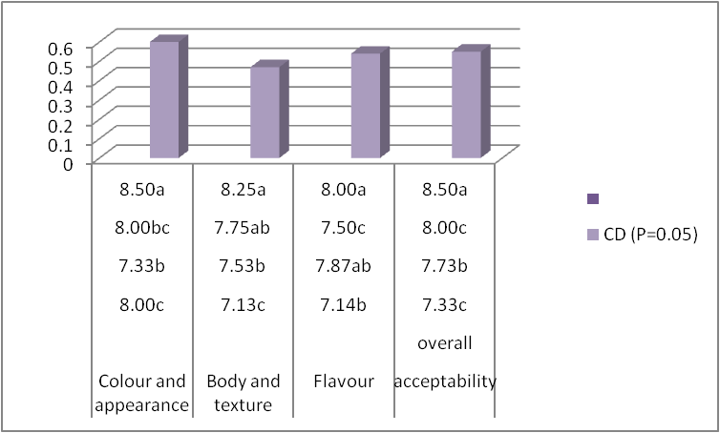

**Note:**

All the values are average of three trials

Similar superscripts indicate non - significance at the corresponding critical difference

Sensory analysis – 9-point hedonic scale

The sensory acceptance reflecting the effect of WPC is correlated in table 1 and figure1.The control sample's mean colour and appearance score was 7.17 8.00, compared to 7.33, 8.00, and 8.50 for treated samples that contained 2, 3 and 5 percent of WPC respectively. The functional Greek yoghurt with 5 percent WPC had a maximum score of 8.50, 8.25 , 8.00 and 8.50 for Colour and appearance, Body & texture, flavor and overall acceptability respectively. Statistical analysis indicated that WPC had a significant effect on the overall acceptability of functional Greek yoghurt. The result is complimenting with the work conducted by Brodzaiak *et al*. 2020 who emphasized that WPC ad positive influence on the product that possess excellent functional properties with respect to emulsifying, gelling and water binding capabilities that enhances the sensory acceptance of Greek yoghurt.

The addition of little millet also played a significant role in enhancing sensory properties, particularly flavor and texture (Table 2). The highest-rated formulation contained 7% little millet, which achieved scores of 8.50 for color and appearance, 8.55 for texture, 8.09 for flavor, and 8.50 for overall acceptability. Compared to the control sample (which had lower scores, especially for texture at 7.00 and flavor at 7.25), the little millet-enriched samples exhibited superior mouthfeel and a slightly nutty flavor.

Comparing these findings with previous studies, Sandy et al. (2009) observed that little millet enhances moisture retention and imparts a characteristic nutty taste, which contributes to better flavor perception. Lower millet concentrations (3%) resulted in weaker flavor perception, while excessive millet incorporation (above 7%) led to slight graininess, which could negatively affect consumer acceptance.

Overall, the results confirm that combining WPC (5%) and little millet (7%) leads to the most desirable functional Greek yoghurt formulation, balancing texture, taste, and overall acceptability while leveraging the nutritional benefits of both ingredients.

**Table 2: Effect of Little Millet as Functional ingredient on the sensory attributes of Greek yoghurt.**

|  |  |  |  |  |
| --- | --- | --- | --- | --- |
| **Functional ingredient-Little Millet (%)** | **Colour and appearance** | **Body and texture** | **Flavour** | **Overall**  **acceptability** |
| Control | 8.00c | 7.00c | 7.25b | 7.45c |
| 3 | 7.00b | 7.35b | 7.05ab | 7.70b |
| 5 | 8.02bc | 7.55ab | 7.50c | 8.05c |
| **7** | **8.50a** | **8.55a** | **8.09a** | **8.50a** |
| CD *(P=0.05*) | 0.60 | 0.47 | 0.54 | 0.55 |

**Figure 2: Effect of Little Millet as Functional ingredient on the sensory characteristics of Greek yoghurt.**

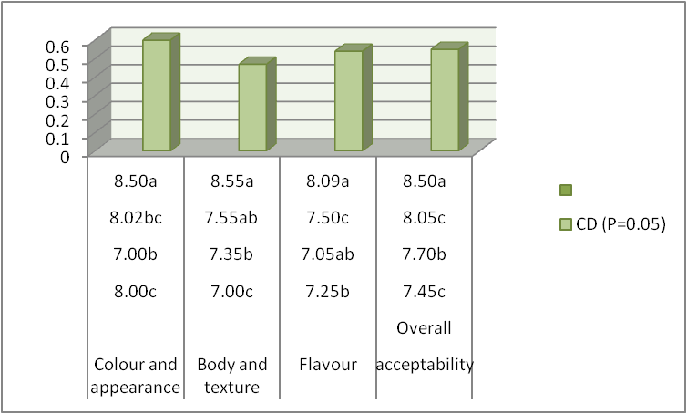

**Note:**

All the values are average of three trials

Similar superscripts indicate non - significance at the corresponding critical difference

Sensory analysis – 9-point hedonic scale

The sensory attributes relevant to the effect of little millet is correlated in table 2 and figure 2.The control sample's mean colour and appearance score was 8.00, 7.00, 7.25 and 7.45 compared to treated samples that contained 3, 5 and 7 percent of little millet respectively. The functional Greek yoghurt with 7 percent little had a maximum score of 8.50, 8.55, 8.09 and 8.50 for Colour and appearance, Body & texture, flavor and overall acceptability respectively. Statistical analysis indicated that little millet had a significant effect on the overall acceptability of functional Greek yoghurt. The result is in accordance with research study conducted by Sandy *et al* 2009 who insisted that little millet improvised the sensory attribute of the product due to its fibre content which binds the moisture content and gives good acceptability and mouth feel.

**Conclusion:**

This study successfully developed a functional Greek yoghurt enriched with whey protein concentrate (WPC) and little millet, optimizing its nutritional value and sensory attributes. The incorporation of 5% WPC and 7% little millet significantly improved the texture, mouthfeel, and overall acceptability of the yoghurt. WPC enhanced creaminess, protein content, and structural integrity, while little millet contributed to dietary fiber, antioxidants, and a pleasant nutty flavor. Sensory evaluation confirmed that this optimized formulation achieved higher consumer acceptability compared to control samples, with statistical analysis indicating a significant improvement in color, texture, flavor, and overall liking (p<0.05).

Comparative analysis with previous studies demonstrated that WPC enhances emulsification, gelling, and water-binding properties, contributing to a smoother consistency, while little millet improves moisture retention and adds nutritional value. However, exceeding 7% little millet led to graininess, which could negatively affect consumer preference. The findings highlight the potential for commercialization of functional Greek yoghurt with high protein, improved texture, and enhanced health benefits, catering to the growing demand for functional dairy products. Future studies can explore shelf-life stability, microbiological properties, and consumer acceptance in a larger market, ensuring the product's feasibility for large-scale production and marketing.

Ethical approval and consent

The study adhered to food safety and ethical guidelines for dairy product development. All sensory panel members participated voluntarily, and informed consent was obtained before the evaluation.

**Disclaimer (Artificial intelligence)**

Option 1:

Author(s) hereby declare that NO generative AI technologies such as Large Language Models (ChatGPT, COPILOT, etc.) and text-to-image generators have been used during the writing or editing of this manuscript.

Option 2:

Author(s) hereby declare that generative AI technologies such as Large Language Models, etc. have been used during the writing or editing of manuscripts. This explanation will include the name, version, model, and source of the generative AI technology and as well as all input prompts provided to the generative AI technology

Details of the AI usage are given below:

1.

2.

3.

**References:**

Brodzaiak A, Krol J, Barlowska J, Teter A, Florek M. Changes in the physico-chemical parameters of yoghurts with added whey protein in relation to the starter bacteria strains and storage time. *J Anim.* 2020;10(8):1350-1355.

Dewan S, Tamang JP. Dominant lactic acid bacteria and their technological properties isolated from Himalayan ethnic fermented milk products. *Antonie Van Leeuwenhoek.* 2007;92(3):343-352.

Dey S, Saxena A, Kumar Y, Maity T, Tarafdar A. Understanding the antinutritional factors and bioactive compounds of kodo millet (*Paspalum scrobiculatum*) and little millet (*Panicum sumatrense*). *J Food Qual.* 2022;2022(1):1578448.

Harinivenugopal, Jayaprakasha HM, Arunkumar H. Influence of Whey Protein Concentrate (WPC) – A functional ingredient on rheological attributes of foxtail millet-based RTE food. *Int J Creative Res Thoughts.* 2020;8(6):4186-4192.

Johnson M, Deshpande S, Vetriventhan M, Upadhyaya HD, Wallace JG. Genome-wide population structure analyses of three minor millets: kodo millet, little millet, and proso millet. *Plant Genome.* 2019;12(3):190021.

Kanhed MI, Harinivenugopal, Arunkumar H, Manjunatha H, BG S. Formulation of WPC-enriched ready-to-serve yoghurt smoothie. *Int Res J Modern Eng Technol Sci.* 2023;5(5):2582-5208.

Kumar R, Chauhan S, Shinde G, Subramanyan V, Nandanasabapathi S. Whey proteins: A potential ingredient for the food industry – A review. *Asian J Dairy Food Res.* 2018;37(4):283-290.

Mal P, Tripathi P. Millets – The nutridense potent ethno-medical grasses – A review. *World J Pharm Res.* 2016;5(2):495-520.

McKinley MC. The nutrition and health benefits of yoghurt. *Int J Dairy Technol.* 2005;58(1):1-1.

Ramakrishnan V, Harinivenugopal, Arunkumar H, Venkatesh M, Manjunath H, Pushpa BP. Effect of concentration of starter culture and incubation time on sensory attributes of RTE functional Greek yoghurt. *J Sci Res Rep.* 2024;30(7):340-345.

Raundal PU, Pawar PP, Musamade AM, Mahajan MS, Desale SB. Response of little millet varieties to different levels of fertilizers under rainfed condition. *A Peer-Reviewed Multi-Disciplinary Int J.* 2017;18.

Sandy KK, Asgar S, Manorama, Chaudary PL. Utilization of little millet flour for the preparation of dairy products. *Res J Sci Technol.* 2009;1(2):71-73.

Srilekha K, Kamalaja T, Uma Maheswari K, Neela Rani R. Nutritional composition of little millet flour. *Int Res J Pure Appl Chem.* 2019;20(4):1-4.

Vijay L, Karthikeyan N, Kumaresan G, Kathirvelan C. Sensory properties of functional Greek yoghurt incorporated with *Moringa oleifera* leaf powder. *Pharma Innov J.* 2022;11(4):251-254.

**ANNEXURE**

**DAIRY SCIENCE COLLEGE, KVAFSU, BENGALURU-24**

**DEPARTMENT OF DAIRY TECHNOLOGY**

**Score card for Sensory Evaluation Using 9-Point Hedonic Scale**

**Name of the Judge: Date:**

You are requested to assess the product in terms of general acceptability on a 9-point hedonic scale score system.

**score system:**

Like extremely 9

Like very much 8

Like moderately 7

Like slightly 6

Neither like nor dislike 5

Dislike slightly 4

Dislike moderately 3

Dislike very much 2

Dislike extremely 1

|  |  |  |  |  |  |  |
| --- | --- | --- | --- | --- | --- | --- |
| **Sensory Characteristics** | **Sample Code** | | | | | |
|  |  |  |  |  |  |
| Color and Appearance |  |  |  |  |  |  |
| Body and Texture |  |  |  |  |  |  |
| Flavour |  |  |  |  |  |  |
| Overall Acceptability |  |  |  |  |  |  |

**Comments: Signature**