**An Ethnopharmacological Review on The Antibacterial, Antifungal and Therapeutic Potentials of *Acorus Calamus* Linn**

**ABSTRACT**

*Acorus calamus* Linn. (Sweet Flag), a semiaquatic aromatic herb from the Araceae family, thrives in wetland and humid conditions, particularly in temperate and subtropical regions. Its rhizomes, used in traditional medicine, have been employed for centuries to treat ailments like swelling, constipation, fever and asthma. The plant's medicinal properties stem from its rich content of secondary metabolites, including glycosides, flavonoids, saponins, tannins, polyphenols and essential oils. These compounds contribute to its antibacterial, antifungal anti-inflammatory and antioxidant activities. Asarone is the chief bioactive compound responsible for its antifungal properties because it interferes with the fungal cell wall synthesis and metabolic processes. Recent studies have emphasized the potential of *Acorus calamus* essential oils as a natural remedy for microbial infections, offering promising alternatives to synthetic drugs. With a broad spectrum of therapeutic effects, the plant holds great promise in modern drug development, particularly in combating drug-resistant infections. Despite its therapeutic potential, concerns regarding toxicity have emerged. The plant contains β-asarone, which, at high doses, may cause hepatotoxicity, nephrotoxicity and neurotoxicity. Prolonged use could also lead to gastrointestinal issues and potential carcinogenic effects. Therefore, further research is critical to assess the safety profile of *Acorus calamus*, determine safe dosages, and explore its full medicinal potential while mitigating toxicity risks.

**Keywords:** Sweet flag, Traditional medicine, Secondary metabolites, Antibacterial activity, Drugs

**INTRODUCTION**

In recent years, research on natural products has increased all over the world, and showing large number of evidences for medicinal properties. These unique properties have been identified since ancient times. The World Health Organization (WHO) has estimated that nearly 80 per cent of the world’s population in developing countries meets their health needs through medicines from natural products. Secondary metabolites found in plant products are the primary source of medication utilised to treat human illnesses utilising cutting-edge scientific techniques. India stands eighth largest country in the world having rich plant diversity of over 46,000 species (Balakumbahan et al. 2010). Now-a-days, the interest in natural drugs started to increase because of the wide spread belief that green medicines are healthier than synthetic products. The annual growth of medicinal plants is increasing worldwide at the rate of 7–15 percent (Paarakh 2010). *Acorus calamus* Linn. commonly known as bach, calamus and sweet flag, is one the important medicinal plant belongs to family Araceae (Adoraceae). The family Araceae comprises of 110 genera and over 1800 species. The genus *Acorus* derived from word *Acoron* means pupil of the eye and the species *calamus* is derived from the Greek word *Calamos* which means reed (Chandra and Prasad 2017). It is a wetland perennial, semiaquatic and aromatic herb with creeping rhizomes. This rhizomatous and tuberous herb is commercially important in both peeled and unpeeled forms. All parts of Acorus are used in Ayurvedic and Unani systems of medicine, the extracts from rhizomes are the most important in the field of medicine and drugs. In *A. calamus*, asarone is the chief bioactive compound responsible for its antifungal properties (Li et al. 2017). It is used to heal illness, diseases and to address psychological concerns. In Ayurveda, it is reputed as a “rejuvenator” for the brain and nervous system (Sharma et al. 2020). *A. calamus* rhizome is effective against stomach-ache, flatulence and as a remedy for digestive disorders (Howes and Houghton 2003). Plant extractives could also protect the wood effectively at laboratory scale.

**Table 1: Vernacular names (**In India and abroad, plant is known by different names) (Divya et al. 2011)

|  |  |  |
| --- | --- | --- |
|  | Bengali | Bach |
|  | Ayurvedic | Vacha |
|  | Unani | Bacch |
|  | Gujarat | Vekhand |
|  | Marathi | Vekhand |
|  | Tamil | Vasambu |
|  | Telugu | Vasa |
|  | Kannada | Baje |
|  | Malayalam | Vayambu |
|  | Sanskrit | Ugragandh, Jatila |
|  | Italy | Plant of venus |

**Distribution**

The plant occurs in wild on the bank of ponds, rivers and in damp marshy places. It is found in the northern temperate and sub-tropical regions of Asia, North America and Europe. The herb prefers marshy, clayey loam soil for better growth. It is widely distributed in Sikkim, marshy tracts of Kashmir, Manipur and Naga hills. The regular cultivation is occur in Koratagere taluk in Karnataka.

**Morphology**

*A. calamus* is a tall, perennial and aromatic herb with creeping rhizomes. The cylinderical rhizomes are upto 2.5 cm thick, purplish-brown to light brown (externally) and whitish (internally) in colour. The leaves are simple, long and sword-shape arises from the horizontal rhizomes which spread out below the surface of the soil. Flowers are small, densely packed and greenish brown in colour. Flowering occurs from early to late summer depending upon the climatic and edaphic conditions. Usually, plants predominately growing in water produce flowers (Garneau et al. 2008).

f**ig.1:** *Acorus calamus* Linn.

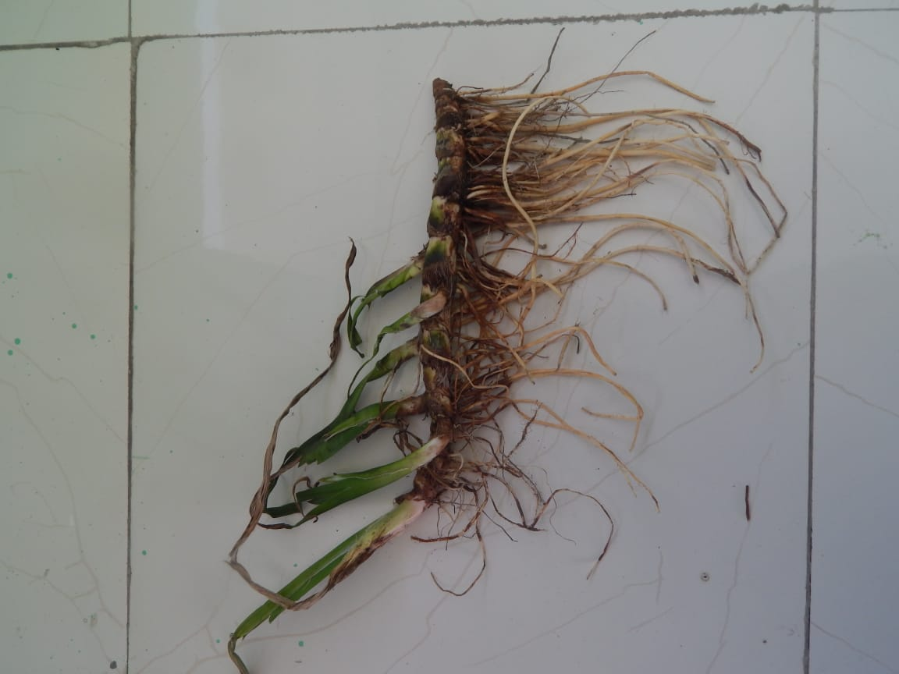

Flowering and fruiting occur in the month of July. In India, it grows in marshy and humid conditions. The roots are 1 cm thick, spread within the soil having distinct nodes and internodes.

**Propagation**

*Acorus calamus* Linn. is widely distributed in wild or cultivated lands of Himalayas up to 1800 m altitudes. The plant can be grown well in clayey loam, sandy loam and light alluvial soils of river banks. It propagated through rhizomes, which is kept preserved in soil and constantly moistens. Sprouted rhizome are cut into small pieces and planted at a spacing of 30 × 30 cm in the month of July-August. The best time for planting is the second fornight of June (Balakumbahan et al. 2010).

**Harvesting**

The collection and harvesting of rhizomes occur in the winter seasons when plant has high percentage of stored material. During collection, the roots are removed from soil, washed, cut into small pieces and dried for few days for making proper powder. Traditionally, bach powder mixed with ghee to improve the intellect and speech development (Howes and Houghton 2003). It is also used for prevention and treatment of a wide range of diseases.

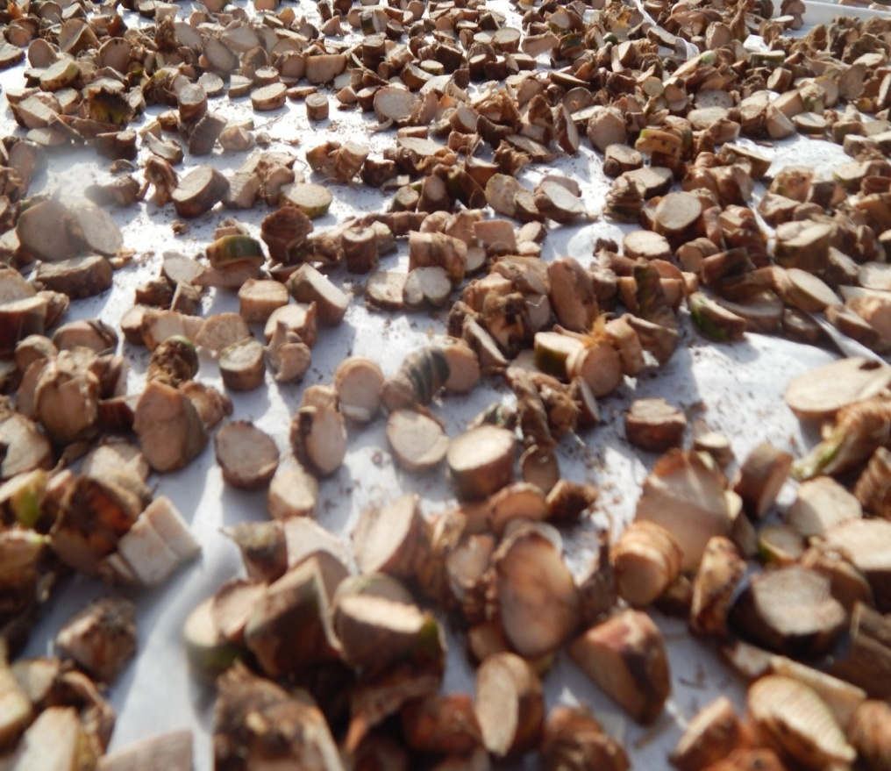

**Fig. 2:** Cutting and drying of rhizomes

**Chemical composition**

The rhizome and leaves of plant are rich in various phytochemical compounds, such as phenylpropanoids, sesquiterpenoids and monoterpenes. Among these, α-asarone, β-asarone, and eugenol are primarily found in the rhizome (Rai et al. 2023). The phytochemicals are consisting of gycosides, flavanoids, saponins, tannins, polyphenols and volatile oils (Afzal et al. 2022; Imam et al. 2013). Polyphenols include major tannins like gallic acid and ellagic acid (Reddy et al. 2011). All parts of the plant contain volatile oil having terpenoids, calamine, calamenol, calamenone, eugenol, camphene, pinene and acorafuran. A number of chemical constituents from the rhizomes, leaves and roots of the Acorus had been reported including *β*-asarone, *α*-asarone, camphene, P-cymene, camphor, terpinen-4-ol and acorone (Li et al. 2017). The percentage of chemical constituents in *Acorus calamus* depends on the plant part from which the oil is extracted (Raja et al. 2009). *Acorus calamus* contains yellow coloured aromatic volatile oil (Balakumbahan et al. 2010). The essential oil of rhizomes was extracted by hydrodistillation and analyzed by GC-MS. Liu et al. (2013) reported that the yield of *A. calamus* essential oil was 1.31 per cent and the density of oil was calculated to be 0.92 g/mL. GC-MS analysis of rhizome oil showed a total of 32 major components which accounts for 97.52 per cent of total compound present. The rhizomes of Acorus find its utilization extensively in Chinese, Indian as well as other cultures (Pandy et al. 2009). *β*-asarone shows anti-microbial properties (Loying et al. 2019; Venil and Raja 2009). The roots and rhizomes are used to treat mental disorders, such as insomnia, hysteria, epilepsy, diarrhoea and asthma. Liu et al. (2013) reported *α*-asarone (50.09%), (E)-methylisoeugenol (14.01%) and methyleugenol (8.59%) as the principal compounds in the essential oil of *Acorus calamus* rhizomes. The presence of various phytochemicals in this plant has been linked to several pharmacological effects, including acetylcholinesterase inhibition, memory enhancement, anticonvulsant activity, as well as antioxidant and anti-inflammatory properties (Devaki et al. 2016).

The leaves extract of *A.* *calamus* had showed anti-inflammatory activity (Hazra et al. 2007; Loying et al. 2019; Mukherjee 2007). The plant also showed various pharmacological activities such as analgesia, cardiovascular, anti-inflammatory, antibacterial and antifungal activity (Aqil and Ahmad 2007; Divya et al. 2011; Pulok et al. 2007). Huang et al. (2013) collected Acorus samples from China and demonstrated *β*-asarone (85.68%) as a major constituent compound in the essential oil. Balakumbahan et al. (2010) reported *β*-asarone as the major constituent in the leaves (27.4 to 45.5%) and acorenone as a dominant constituent in the rhizomes (20.86%) followed by isocalamendiol (12.75%). Tkachev et al. (2006) finds acorafuran, a new sequiterpenoid from *A. calamus* essential oil. *A. calamus* shows higher percentage of *β*-asarone (11%) followed by camphene (2.27%) as measured by Raja et al. (2009) and Singh et al. (2011). Other compounds that are identified in *A. calamus* were methyleugenol, geranylacetate, farnesene, acetic acid, camphor, linalool and linolenic acid (Bano et al. 2022).

**USES OF PLANT EXTRACT**

The plant is considered important from the pre historic times.All parts of Acorus are used in Ayurvedic and Unani systems of medicine, the extracts from rhizomes are the most important in the field of medicine and drugs (Rajput et al. 2014). The ancient peoples of China used the rhizome to cure swelling and constipation. In India, rhizome has been used to cure fever, asthma, and as a sedative. The tribal communities used it to treat cough, stomach ache and problems associated with digestive system (Divya et al. 2011; Khwairakpam et al. 2018). Small amounts of powder used to reduce stomach acidity and larger doses increase the acid production. It is also used in the conditions of hoarseness, flatulence dyspepsia and helminthiasis (Palani et al. 2010). Dhiman (2018) reported that plant extracts can also be used to inhibit the growth of fungi. In recent years, the harmful effects of chemicals have been seen on the environment as well as on the health of human beings. The ability of natural plant extracts to protect wood from decaying fungi and insects have given positive approach for developing new wood preservatives (Kartal et al. 2004). Preservative treatment is extremely effective method for extending the life of wood used in terrestrial and marine environment. Plants act as a reservoir for inexhaustible source of fungicides and pesticides. Being non-toxic to mammals and easily biodegrable than synthetic chemicals make them widely acceptable to the society (Onuorah 2000; Soni 1975; Gupta and Dev 1999). Plant extractives are natural compounds and are rich in bioactive compounds such as alkaloids, tannins, polyphenols etc. which are toxic to wood degrading organisms. Several scientists have reported that plant extracts are good source of fungitoxic substances (Barnes and Gerber 1955). Therefore, considerable efforts are made by researchers towards the development of ecofriendly drugs and preservatives.

The rhizomes of *Acorus calamus* are considered to possess anti-spasmodic, carminative and antihelmintic properties which are used for treatment of epilepsy, tumors and chronic diarrhea. Anonymous (1975) also listed it as an insecticide, antifungal agent and a fish poison. Zhang et al. (2016) laboratory studies indicated that *Acorus calamus* roots extracts is very effective for inhibiting cyanoobacteria. Gupta and Dev (1999) and Dhyani et al. (2005) have reported that plant extracts are good source of fungitoxic substances which provide resistance against fungi. The acetone, ethyl alcohol and methyl alcohol extract of neem leaves inhibit the growth of brown rot (*Poria menticola*) and white rot (*Polyporus versicolor*). Shafique et al. (2005) showed that aqueous extracts of allelopathic plants have considerable potential to control seed borne mycoflora.Dry and powdered rhizomes of *A. calamus* were extracted with dichloromethane as a solvent. It shows antifungal activity on PDA agar against *Alternaria spp*. (leaf spot), *Fusarium spp*. (wilt disease) and *Septoria spp*. (chrysanthemum leaf spot). The results indicated complete inhibition of all tested fungi at the concentration of 0.10 to 0.15 per cent (Mungkornasawakul et al. 2001). Manikandan et al. (2010) evaluated the ethanolic extracts of *A. calamus* for antibacterial activity against bacteria. The results showed that ethanolic extracts of rhizomes was active against all bacterial strains viz., *Bacillus subtilis, Stacphylococcus aureus, Escherichia coli* and *Proteus mirabilis*. The methanolic extract of *Acorus calamus* extract was found to be effective against *Alternaria solani* fungi (Singh et al. 2010).Panek et al. (2014) studied the effect of methanol extract of *A. calamus* rhizomes for its antimicrobial activities on various microorganism including bacteria and fungi. The results showed antifungal properties of extract against brown rot (*Coniophora puteana*) and white rot (*Trametes versicolor*) fungi. The crude extract of Acorus had shown inhibitory effects on *Fusarium oxysporum* (Rawal et al. 2015). Dhiman and Dutt (2018) studied the antifungal activity of *A. calamus* rhizomes extract on less durable wood species *i.e.,* *Pinus roxburghii*, *Celtis australis* and *Bombax ceiba*. The results showed average growth of Polyporus fungus (69.44%) on wooden samples at 2 per cent concentration of rhizome extract. Therefore, *A. calamus* extract could also be used as bio-preservative for non-durable wood species.

**Toxicity**

*Acorus calamus* (AC), while recognized for its medicinal properties, has raised concerns regarding its toxicity, particularly due to the presence of certain compounds like β-asarone. Studies have shown that prolonged or excessive use of plant may lead to adverse effects, including hepatotoxicity, nephrotoxicity and neurotoxicity. β-Asarone, a major constituent in the rhizome, has been implicated in cytotoxicity and genotoxicity, with some studies indicating potential carcinogenic effects at high doses. Additionally, the plant's use in large quantities or over extended periods may lead to gastrointestinal disturbances and liver damage. Despite these risks, *Acorus calamus* has also been explored for its antimicrobial properties, including its use in wood preservation, where its extracts have been employed to protect against microbial degradation. This dual nature of *Acorus calamus* offering both medicinal benefits and potential toxic effects, highlights the need for in-depth research into its safety profile. Sharma et al. (2022) studied the antibacterial effect of aqueous and methanolic extracts of *A. calamus* against various microorganisms, including *Bacillus subtilis* (MTCC 441), *Staphylococcus aureus* (MTCC 96), *Escherichia coli* (MTCC 443), *Proteus mirabilis* (MTCC 1429) and *Pseudomonas aeruginosa* (MTCC 424). The in vitro activity was assessed using the agar well diffusion method. The aqueous extract of Acorus calamus showed no antibacterial effect against the gram-negative bacteria *(E. coli, P. mirabilis,* and *P. aeruginosa*) and exhibited only moderate activity against the gram-positive bacteria (*B. subtilis* and *S. aureus*) at a high concentration (200 μL). On the other hand, the methanolic extract was effective against all the bacterial strains examined. Further studies are essential to establish safe dosage guidelines, identify the mechanisms underlying its toxicity, and explore its full therapeutic potential in treating various health conditions. Understanding both the benefits and risks of *Acorus calamus* will be crucial for its future application in both traditional and modern medicine.

**CONCLUSION**

*Acorus calamus* Linn. stands as a valuable plant in traditional medicine, with a wide array of pharmacological properties. The plant's rich phytochemical composition, including bioactive compounds like methyleugenol, α-asarone, β-asarone and linalool, highlights its potential in modern therapeutic applications. The essential oil from its rhizomes, particularly high in α-asarone and β-asarone, exhibits notable antibacterial, antifungal, anti-inflammatory and insecticidal properties. Given its promising biological properties, *Acorus calamus* holds considerable potential for the development of natural fungicides and insecticides, alongside its traditional medicinal uses. The wealth of ethnopharmacological knowledge about this plant paves the way for the creation of novel drugs from commonly found plants. Further research into its chemical constituents and pharmacological activities will be crucial in advancing its therapeutic applications in modern medicine.

**Disclaimer (Artificial intelligence)**

Option 1:

Author(s) hereby declare that NO generative AI technologies such as Large Language Models (ChatGPT, COPILOT, etc.) and text-to-image generators have been used during the writing or editing of this manuscript.

Option 2:

Author(s) hereby declare that generative AI technologies such as Large Language Models, etc. have been used during the writing or editing of manuscripts. This explanation will include the name, version, model, and source of the generative AI technology and as well as all input prompts provided to the generative AI technology

Details of the AI usage are given below:

1.

2.

3.

**REFERENCES**

Afzal S, Ayoub M and Raja W Y. A Review on Its Phytochemical and Pharmacological Profile. *Edible Plants in Health and Diseases,* 2022*,* **3**: 501-22.

Anonymous. Herbal Pharmacology in the People’s Republic of China, National Academy of Sciences, Washington DC. 1975, 265p.

Aqil F and Ahmad I. 2007. Antibacterial properties of traditionally used Indian medicinal plants. *Methods and Findings in Experimental and Clinical Pharmacology,* 2007, **29** (2): 79-92.

Balakumbahan R, Rajamani K and Kumanan K. “*Acorus calamus*: An overview." *Journal of Medicinal Plants* *Research,* 2010, **4**(25): 2740-45.

Bano H, Noor F, Bhat M A and Siddique M A. Distribution, Chemical Composition and Ethnomedicinal Appraisal of *Acorus calamus* L. an Endangered Medicinal Plant Species of Kashmir Valley, India. *Medicinal and Aromatic Plants of India,* 2022, **1**(8): 363-65.

Barnes R A and Gerber N N. The antifungal agent from Osage orange wood. *Journal of the American Chemical Society,* 1955*,* **77**(12): 3259-62.

Chandra D and Prasad K. Phytochemicals of *Acorus calamus* (Sweet flag). *Journal of Medicinal Plants Studies,* 2017, **5**(5): 277-

Devaki M, Nirupama R, Nirupama M and Yajurvedi H N. Protective effect of rhizome extracts of the herb, vacha (*Acorus calamus*) against oxidative damage: An in vivo and in vitro study. *Food Science and Human Wellness* 2016, **5**(2): 76-84.

Dhiman B. Biopreservation of *Pinus roxburghii* and *Bombax ceiba* Using Aqueous Extract of *Acorus calamus*. *International Biodeterioration and Biodegradation,* 2018, **25**: 16-20.

Dhiman B and Dutt B. Evaluation of *Acorus calamus* L. rhizome extract as a bio preservative against wood fungal decay. *Journal of Applied and Natural Science,* 2018, **10**: 37-40.

Dhyani S, Tripathi S and Jain V K. Neem leaves, a potential source for protection of hardwood against wood decaying fungus. *International Research Group on Wood Preservation,* 2005, **5**: 303-07.

Divya G, Gajalakshmi S, Mythili S and Sathiavelu A. Pharmacological activities of *Acorus calamus*: a review. *Asian Journal of Biochemical and Pharmaceutical Research,* 2011, **1**(4): 57-64.

Garneau F X, Collin G, Gagnon H, Bélanger A, Lavoie S, Savard N and Pichette A. Aromas from Quebec. I. Composition of the essential oil of the rhizomes of *Acorus calamus* L. *Journal of Essential Oil Research,* 2008,**20**(3):250-54.

Gupta A L and Dev I. Studies on the fungal toxicity of Sal (*Shorea robusta*) heartwood extractives. *Journal of the Timber Development Association of India,* 1999, **45**(2): 16-24.

Hazra R, Ray K and Guha D. Inhibitory role of *Acorus calamus* in ferric chloride-induced epileptogenesis in rat. *Human and Experimental Toxicology,* 2007, **26**(12): 947-53.

Howes M R and Houghton P J. Plants used in Chinese and Indian traditional medicine for improvement of memory and cognitive function. *Pharmacology Biochemistry and Behaviour,* 2003, **75**: 513-27.

Huang C, Li W G, Zhang X B, Wang L, Xu T L, Wu D and Li Y 2013. Alpha-asarone from Acorus gramineus alleviates epilepsy by modulating A-type GABA receptors. *Neuropharmacology* **65**: 1-11.

Imam H, Riaz Z, Azhar M, Sofi G and Hussain A. Sweet flag (*Acorus calamus* Linn.): An incredible medicinal herb. *International Journal of Green Pharmacy* (IJGP), 2013, **7(4)**: 145-48.

Kartal S N, Yoshimura T and Imamura Y. Decaying and termite resistance of boron-treated and chemically modified wood by in situ co-polymerization of allyl glycidyl ether (AGE) with methyl methacrylate (MMA). *International Biodeterioration and Biodegradation,* 2004, **53**(2): 111-17.

Khwairakpam A D, Damayenti Y D, Deka A, Monisha J, Roy N K, Padmavathi G and Kunnumakkara A B. *Acorus calamus*: a bio-reserve of medicinal values. *Journal of basic and clinical physiology and pharmacology,* 2018, **29(2)**: 107-22.

Li J, Zhao J, Wang W, Li L, Zhang L and Zhao X. New acorane-type sesquiterpene from *Acorus calamus* L. *Molecules,* 2017 **22**(4): 526-29.

Liu X C, Zhou L G, Liu Z L and Du S S. Identification of insecticidal constituents of the essential oil of *Acorus calamus* rhizomes against Liposcelis *bostrychophila Badonnel.* *Molecules,* 2013, **18**(5): 5684-96.

Loying R, Gogoi R, Sarma N, Borah A, Munda S, Pandey SK and Lal M. Chemical compositions, in-vitro antioxidant, anti-microbial, anti-inflammatory and cytotoxic activities of essential oil of *Acorus calamus* L. rhizome from North-East India. *Journal of Essential Oil Bearing Plant*s, 2019, **22**(5): 1299-12.

Manikandan S, Devi R S, Srikumar R, Thangaraj R, Ayyappan R and Jegadeesh R. In vitro antibacterial activity of aqueous and ethanolic extracts of *Acorus calamus.* *International Journal of Applied Biology and Pharmaceutical Technology,* 2010, **1**: 1072-75.

Mukherjee P K. Quality control of herbal drugs-An approach to evaluation of botanicals. 2nd ed. Business horizon, (Kolkata Pharmaceutical Publishers), 2007, pp. 618-94.

Mungkornasawakul P, Supyen D, Jatisatienr C and Jatisatienr A. Inhibitory effect of *Acorus calamus* L. extract on some plant pathogenic molds. *International Conference on Medicinal and Aromatic Plants*. Possibilities and Limitations of Medicinal and Aromatic Plant, 2001, **12:** 341-45.

Onuorah E O. Short communication:The wood preservative potential of heartwood extracts of *Milicia excels* and Erythrophleum suaveolens. *Bioresources Technology,* 2000, **75**: 171-73.

Paarakh P M. *Igella sativa* Linn.-Acomprehemnsive review. *Indian Journalof Natuiral Products and Resource,* 2010, **1**(4): 409-29.

Palani S, Raja S, Kumar R P, Parameswaran P and Kumar B S. Therapeutic efficacy of *Acorus calamus* on acetaminophen induced nephrotoxicity and oxidative stress in male albino rats. *Acta Pharmaceutica Sciencia,* 2010, **52**(1): 23-26.

Pandy V, Jose N and Subhash H. CNS activity of methanol and acetone extracts of *Acorus calamus* leaves in mice*. Journal of Pharmacology and Toxicology,* 2009, **4**(2): 79-86.

Panek M, Reinprecht L and Hulla T. Ten essential oils for beech wood protection-efficacy against wood-destroying fungi and moulds, and effect on wood discoloration. *BioResources,* 2014, **9:** 5588-03.

Pulok K M, Venkatesan K, Mainak M and Houghton P J. *Acorus calamus*: Scientific validation of ayurvedic tradition from natural resources. *Pharmaceutical Biology,* 2007, **45**(8): 651-66.

Rai A R, Joy T, Poojari M, Pai M M, Massand A and Murlimanju B V. Role of *Acorus calamus* in preventing depression, anxiety and oxidative stress in long-term socially isolated rats. *Veterinary World* 2023, **16**(8): 1755.

Raja A E, Vijayalakshmi M and Devalarao G. *Acorus calamus* Linn.: chemistry and biology. *Research Journal of Pharmacy and Technology,* 2009, **2**(2): 256-61.

Rajput S B, Tonge M B and Karuppayil S M. An overview on traditional uses and pharmacological profile of *Acorus calamus* Linn.(Sweet flag) and other Acorus species. *Phytomedicine,* 2014, **21**(3): 268-76.

Rawal P, Adhikari R S, Danu K and Tiwari A. Antifungal activity of *Acorus calamus* against *Fusarium oxysporum.* International *Journal of Current Microbiology and Applied Sciences,* 2015, **4**: 710-15.

Reddy A K, Joy J M and Kumar A. *Lannea coromandelica*: The researcher’s tree. *Journal of Pharmacy Research,* 2011, **4:** 577-79.

Shafique S, Shafique S and Javaid A. Fungiyoxicity of aqueous extracts of allelopathic plants againsts seed borne mycoflora of maize. *Mycopath,* 2005. **3**: 23-26.

Sharma V, Sharma R, Gautam D S, Kuca K, Nepovimova E and Martins N. Role of Vacha (*Acorus calamus* Linn.) in neurological and metabolic disorders: evidence from ethnopharmacology, phytochemistry, pharmacology and clinical study. *Journal of clinical medicine,* 2020, **9**(4): 1172-76.

Sharma P, Jain D K, Jain N K, Jain A, Bhadoria U P, Paliwal P et al. Anti-Parkinson’s Potential of *Acorus Calamus* Linn: A Review. *J Pharma Negative Results*, 2022, **13**(5): 2540-47.

Singh E, Sharma P K and Malviya R. Pharmacological properties and Ayurvedic value of Indian Buch Plant (*Acorus calamus*): A short review. *Advan Biol Res,* 2011, **5**: 145-54.

Singh S, Srivastava R and Choudhary S. Antifungal and HPLC analyais of the crude extracts of *Acorus calamus, Tinospora cordifolia* and *Celestrus paniculatus*. *Journal of Agricultural Technology,* 2010, **6**: 149-58.

Soni P L. The chemistry of extractives of *Dalbergia sissoo*, Partl, The occurrence of 3,5-Dihydroxy-trans-stilbene in the heartwood. *Journal of the Indian Academy of Wood Science,*1975, **6**(2): 57-68.

Tkachev A V, Gurev A M and Yusubov M S. Acorafuran a new sesquiterpenoid from *Acorus calamus* essential oil. *Chemistry of Natural Compdounds,* 2006,**42**(6): 696-98.

Venil C K and Raja S S. Beta Asarone-an anti-microbial compound from Sweet flag (*Acorus calamus* Linn.). *Indian Forester,* 2009, **135**(1): 126-32.

Zhang S H, Zhang S Y and Li G. *Acorus calamus* root extracts to control harmful cyanobacteria blooms. *Ecological Engineering,* 2016,**14**: 95-01.