**Chemical and Biochemical Mechanisms of Purple Bacteria in Wastewater Treatment: Optimization and Resource Recovery**

**Abstract**

Given the environmental concerns arising from industrial wastewater pollution and the need for sustainable treatment solutions, this study investigates the performance of the purple bacterial strain Rhodobacter capsulatus Z08 in wastewater treatment and resource recovery through its chemical and biochemical reactions. The primary aim was to determine the effects of optimal conditions—including pH = 7.5, temperature of 30°C, and continuous illumination (500–1000 lux)—as well as various light conditions (natural light, darkness, and infrared) combined with different sulfate concentrations (0.1, 0.5, and 1 g S/L) on pollutant removal efficiency and biomass enhancement. The methodology involved conducting controlled experiments to measure the reduction in chemical oxygen demand (COD), changes in biomass, and heavy metal removal, alongside assessing the impact of sulfate-induced stress on the system’s performance. Results demonstrated that under optimal conditions, COD was reduced by up to 88%, biomass increased by 38%, and heavy metal removal reached 90%; additionally, natural light under microaerobic conditions yielded a 74% COD reduction, while dark aerobic conditions achieved a 62% reduction. In sulfate stress tests, a concentration of 0.1 g S/L resulted in nearly zero effluent COD, whereas increasing sulfate to 0.5 and 1 g S/L produced effluent COD values of 100–200 mg/L and approximately 600 mg/L, respectively. Furthermore, switching the light source to infrared led to complete COD removal (0 mg/L) and stabilization of ammonium levels between 10 and 15 mg N/L. Overall, these findings underscore that precise optimization of operational parameters, particularly light exposure and sulfate concentration, is essential for achieving higher efficiency in industrial wastewater treatment and effective biomass recovery, thereby advancing sustainable and economically viable technologies.

**Keywords:** *Rhodobacter capsulatus Z08*, wastewater treatment, resource recovery, purple bacterial metabolism, sulfate stress, heavy metal removal.

1. **Introduction**

The increasing pollution of water resources due to industrial growth, urban expansion, and uncontrolled agricultural activities has led to a growing demand for advanced and sustainable wastewater treatment technologies. In this context, biotechnological approaches utilizing microorganisms for pollutant removal have gained attention as environmentally friendly and cost-effective solutions[1]. In recent decades, biological methods have been explored not only as alternatives to conventional physical and chemical treatment processes but also as complementary approaches to enhance wastewater purification efficiency. These methods include microbial-based treatment systems such as photosynthetic bacteria, fungi, and algae, which can absorb and degrade organic and inorganic pollutants[2]. Industrial and municipal wastewater contains high concentrations of pollutants, including heavy metals, nitrogenous compounds, phosphorus, and complex hydrocarbons, which, if released untreated into water bodies, can lead to ecosystem degradation, water quality deterioration, and serious health risks to humans and other organisms[3]. Therefore, the development of efficient treatment technologies that can remove harmful contaminants with minimal energy consumption and waste production has become an urgent scientific and industrial necessity[4].

Among the microorganisms used in wastewater treatment, purple bacteria have attracted considerable interest due to their unique ability to utilize light energy for biochemical and chemical reactions[5]. These bacteria remove organic pollutants through redox reactions and play a crucial role in resource recovery. Their key features include nitrogen compound removal, degradation of complex organic matter, and heavy metal precipitation, making them promising candidates for sustainable wastewater treatment[6]. Purple bacteria have demonstrated high efficiency in wastewater treatment. For instance, in wastewater from soybean processing plants, sugar factories, light industries, and palm oil industries, chemical oxygen demand (COD) removal rates can reach 70% to 90% [1]. Additionally, valuable bioproducts can be extracted from purple bacterial biomass, including single-cell protein, biopolymers, antimicrobial agents, and carotenoids, which have applications in agriculture, pharmaceuticals, cosmetics, and the food industry [3],[6]. Recent research highlights the potential of bioelectrochemical systems (BESs) in wastewater treatment and resource recovery. Findings indicate that BESs can significantly reduce wastewater COD concentrations while simultaneously generating electrical energy [1]. Studies have demonstrated that copper-based BESs integrating purple bacteria and electrodes can achieve dual benefits of wastewater treatment and bioelectricity production.

While many purple bacteria exhibit beneficial properties for wastewater treatment, the strain Rhodobacter capsulatus Z08 was specifically selected for this study due to its remarkable metabolic versatility and adaptability [7]. Unlike other strains, R. capsulatus Z08 efficiently alternates between photoheterotrophic and chemoheterotrophic growth modes, allowing it to thrive under the fluctuating environmental conditions commonly encountered in wastewater treatment systems [7], [8]. Its superior tolerance to variations in pH and temperature, coupled with an enhanced ability to degrade complex organic pollutants and precipitate heavy metals, makes it particularly effective in achieving high pollutant removal efficiencies [11], [0]. Moreover, its resilience under sulfate-induced stress and robust photosynthetic performance under various light conditions further validate its selection as an ideal candidate for integrated wastewater treatment and resource recovery applications [10].

Beyond copper-based BESs, various other bioelectrochemical approaches have been employed for wastewater purification and resource recovery. Research on carbon-fiber-based BESs has shown that using carbon fibers as electrodes, along with the introduction of purple bacteria into the reactor, can effectively degrade organic pollutants in wastewater while generating significant electrical energy, opening new frontiers for the application of carbon-fiber-based BESs in wastewater treatment[11]. Further investigations have confirmed that purple bacteria can aid in pollutant removal in contaminated aquatic environments via photosynthetic oxidation processes, breaking down organic compounds and reducing environmental pollution loads[12]. Additional findings suggest that purple bacteria are highly effective in heavy metal detoxification, converting toxic metal ions into less harmful compounds through biological mechanisms[13]. Research has also demonstrated that optimizing pH levels and light intensity significantly enhances the performance of purple bacteria in controlled environments, enabling their use for nitrogen compound removal in wastewater[14]. Moreover, it has been observed that combining purple bacteria with membrane filtration improves wastewater treatment efficiency by up to 30%, emphasizing the potential of these microorganisms in environmental chemistry and sustainable wastewater management[15]. These findings highlight the growing significance of purple bacteria in wastewater treatment and resource recovery, emphasizing the need for further research to optimize bioprocesses and industrial applications.

1. **Review of Chemical Reactions in Wastewater Treatment by Purple Bacteria**

**2.1. Oxidation and Reduction Reactions**

Purple bacteria can convert organic compounds into carbon dioxide and water through enzymatic oxidation, which is catalyzed by oxidoreductase enzymes, such as heme-protein-dependent cytochromes. These reactions include the decomposition of nitrogenous compounds, such as nitrate (NO₃⁻) and nitrite (NO₂⁻), into simpler compounds like nitrogen gas (N₂), thereby reducing nitrogen pollution levels[16]. Additionally, phosphorus present in organic compounds can be decomposed into soluble phosphates through microbial phosphatase reactions, enabling nutrient recycling.

Furthermore, heavy metal ions such as iron (Fe³⁺ → Fe²⁺) and copper (Cu²⁺ → Cu⁰) can be reduced anaerobically by these microorganisms, significantly lowering the toxicity of industrial wastewater. These biochemical reactions, by altering the oxidation states of metals, facilitate precipitation and removal from the liquid phase[11]. Research has demonstrated that these processes achieve optimal efficiency under near-infrared light conditions (800–900 nm) and in the presence of simple carbon sources like acetate[17]. Recent studies have also shown that combining this method with electrochemical coagulation techniques can enhance heavy metal removal efficiency by up to 95%[18].

**2.2 Heavy Metal Adsorption and Precipitation**

Purple bacteria possess functional groups such as carboxyl, hydroxyl, amine, and phosphate, which interact electrostatically and covalently with heavy metal ions, leading to their adsorption and precipitation. This process, known as biosorption, is particularly effective in removing toxic metal ions such as lead (Pb²⁺), cadmium (Cd²⁺), and nickel (Ni²⁺) from industrial wastewater [19].

The efficiency of this process is highly dependent on environmental parameters such as pH, temperature, and initial metal ion concentration. Under neutral to slightly alkaline pH conditions, adsorption efficiency can increase up to 95%, as biological functional groups exhibit maximum interaction with metal ions[20]. Additionally, research indicates that modulating zeta potential and cell surface charge can further optimize metal ion adsorption, accelerating the precipitation process[21]. This biological method is considered a sustainable and cost-effective alternative to conventional chemical techniques such as chemical precipitation and ion exchange, as it eliminates the need for additional chemical reagents and can be applied in industrial-scale systems with minimal energy input. Studies have shown that integrating biosorption with complementary processes such as electrochemical coagulation can increase heavy metal removal efficiency from 70% to over 98%, demonstrating the high potential of this bio-chemical approach for industrial wastewater treatment[15].

**2.3 Decomposition of Organic Compounds**

Purple bacteria utilize organic compounds such as carbohydrates, proteins, and lipids as energy sources and break them down through enzymatic hydrolysis, fermentation, and anaerobic photosynthesis, converting them into volatile fatty acids, alcohols, and bio-gases such as methane and hydrogen. These processes play a crucial role in reducing wastewater pollution parameters, including biochemical oxygen demand (BOD) and chemical oxygen demand (COD), thereby improving treatment efficiency[22].

Research has demonstrated that combining purple bacteria with catalytic and enzymatic processes can enhance organic matter degradation efficiency by up to 80%, optimizing bioenergy recovery from wastewater[16]. Other studies have indicated that the presence of metallic nanoparticles, such as silver and iron nanoparticles, can further improve the degradation rate of organic compounds and enhance biogas production. This method, when combined with other biological processes, presents a highly effective approach for sustainable wastewater treatment and energy recovery[23].

**3. Methodology and Experimental Section**

**3.1 Pure Culture of Purple Bacteria**

The Z08 strain of purple bacteria was obtained through pure culture techniques. A 50 mL HCH culture medium was transferred into a 250 mL Erlenmeyer flask, sealed with a protective film, and sterilized under high-pressure steam for 20 minutes. After cooling, 15 mL of bacterial suspension with OD660 = 1.0 was inoculated aseptically. The flask was incubated in a constant-temperature shaker under 140 rpm, 30°C, continuous illumination (24 hours), and 500–1000 lux light intensity. After 48 hours, the culture reached the stationary phase and was stored at 4°C for further use.

**3.2 Immobilization of Purple Bacteria**

To ensure the cleanliness and stability of the carriers, they were first placed in an ultrasonic cleaner (50 W) for 5 minutes to remove surface contaminants. The carriers were then washed three times with deionized water to ensure complete cleanliness. After washing, they were dried at 70°C for 12 hours until a constant weight was achieved. Finally, the dried carriers were individually weighed and stored for future use.

**3.3 Inoculation and Immobilization of Purple Bacteria**

Under sterile conditions, 150 mL of HCH culture medium and carriers were transferred into a 250 mL Erlenmeyer flask and sterilized using high-pressure steam. After cooling, a specific amount of bacterial suspension was inoculated, and the flask was placed in a constant-temperature shaker at 140 rpm and 30°C for 10 hours to enhance mass transfer and bacterial growth, ensuring maximum contact between bacteria and carriers. The solution was then kept static to facilitate the immobilization process, with continuous illumination (24 hours, 500–1000 lux) at 30°C. The immobilization process lasted 30 days, during which 50 mL of fresh culture medium was replaced every 3 days, and OD660 measurements were taken to monitor bacterial growth. After 30 days, the carriers were removed, washed with deionized water to eliminate surface bacteria, dried to a constant weight, cooled, and weighed. Throughout the process, strict sterilization standards were followed to ensure the accuracy and reliability of results.

**3.4 Separation of Purple Bacteria by Flocculation**

To evaluate the effect of different flocculants on photosynthetic bacteria, three common flocculants—Al₂(SO₄)₃, Fe₂(SO₄)₃, and the polymer AlCl₃—were used. To ensure accuracy and reliability, these flocculants were dried at 120°C until a constant weight was reached, then precisely weighed. Based on this, stock solutions with concentrations of 0.5% and 10% were prepared for further experiments. For bacterial treatment, distilled water was used to adjust the volume, ensuring that OD660 of the treated samples was 0.5, equivalent to a dry weight of 420 mg/L. This step was necessary to control experimental conditions and ensure result comparability. Based on previous research and experimental requirements, flocculant dosage gradients were set at 100, 500, 1000, 5000, 10000, and 20000 mg/L to comprehensively analyze the effect of varying flocculant concentrations on photosynthetic bacteria. Throughout the experiment, flocculation conditions were carefully controlled: mixing speed was set to 200 rpm for 1 minute, flocculation speed to 100 rpm for 15 minutes, and sedimentation time to 30 minutes. These settings were designed to simulate real-world flocculation processes in water treatment systems and provide an accurate evaluation of flocculant effects. At the end of the experiment, the OD660 and zeta potential of the samples were measured before and after flocculation. These indicators were used to assess the impact of flocculants on photosynthetic bacteria, providing valuable data for optimizing water treatment processes.

**3.5 Separation of Purple Bacteria by Ultrafiltration Membrane**

**Equipment Setup:**

The ultrafiltration membrane system consists of several key components, starting with the water storage tank, which supplies water to the system. Water is drawn in through the suction pipe (a) and pumped by the electric diaphragm pump. The inlet pipe valve (5) regulates flow into the system, while the inlet flow meter (4) monitors the water entering the ultrafiltration membrane module (7). Before reaching the membrane, the inlet pressure gauge (6) measures the system's operating pressure. Within the ultrafiltration membrane module, water is filtered, separating clean water from concentrated waste. The purified water exits through the clean water outlet (e), controlled by outlet valve 1 (8) and measured by the outlet flow meter (10). Meanwhile, concentrated waste is discharged through the concentrated water outlet (d), controlled by outlet valve 2 (9). For system maintenance, the backwash valve (11) is used to initiate a reverse flushing process, allowing backwash water to flow through the backwash pipe (f) to remove accumulated particles from the membrane. The backwash pressure gauge ensures proper pressure control during this process. Additionally, the return pipe valve (3) helps regulate water circulation, ensuring optimal filtration performance. These components work together to maintain efficient bacterial separation while ensuring consistent filtration and operational stability.

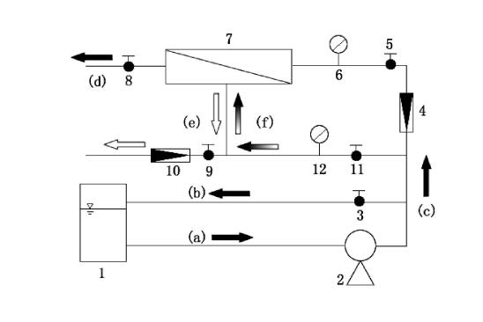

Figure 1. Ultrafiltration Membrane System for Purple Bacteria Separation

This experiment aimed to measure and optimize the separation efficiency of purple bacteria using an ultrafiltration membrane system. The setup included an electric diaphragm pump and an ultrafiltration membrane module consisting of tanks, valves, and pipes. Bacteria were drawn into the system by the pump, with part passing through the membrane and part being discharged. The filtered clean water was collected through adjustable valves controlling flow and pressure. In the ultrafiltration phase, valves 3, 5, 8, and 9 were opened, while valve 11 was closed. The diaphragm pump was activated, allowing bacteria to enter the system through pipe (a), with part passing through the membrane and part being discharged. The clean water was collected through pipe (e), with flow and pressure regulated by valves 3 and 8. During the backwashing phase, backwash water was added to the system, valves 3, 8, and 11 were opened, and valves 5 and 9 were closed, while the diaphragm pump was reactivated. The backwash water entered the system via pipe (a) and was directed through pipes (c) and (f) into the membrane module. In this process, flow and pressure were adjusted, and the concentrated wastewater from backwashing was discharged via pipe (d). After backwashing, all valves were opened to flush out residual water and prepare the system for the next separation cycle. The bacterial samples used in this experiment were freshly prepared with OD660 = 1.0, equivalent to a dry weight of 840 mg/L. To ensure uniform distribution, samples were added to a 4 L storage tank and stirred using a magnetic stirrer. During the experiment, fresh bacteria were continuously added, and concentrated and purified water was returned to the flask to maintain a stable bacterial concentration in the solution.

**3.6 Ultrafiltration of Purple Bacteria**

This experiment aimed to measure and optimize the separation efficiency of purple bacteria using an ultrafiltration membrane system. The setup included an electric diaphragm pump and an ultrafiltration membrane module, consisting of a storage tank, valves, and pipes. The bacteria were suctioned into the system by the diaphragm pump, with part of the bacteria passing through the membrane and the remainder being discharged. The clean water was separated and released by adjusting the valves to regulate flow and pressure. During the ultrafiltration phase, valves 3, 5, 8, and 9 were opened, while valve 11 remained closed, and the diaphragm pump was activated. The bacteria entered the system through pipe (a), with part passing through the membrane and part being discharged. The filtered clean water exited through pipe (e), with flow and pressure controlled by valves 3 and 8. For the backwashing phase, backwash water was added to the storage tank, valves 3, 8, and 11 were opened, and valves 5 and 9 were closed before reactivating the diaphragm pump. The backwash water was drawn in through pipe (a) and circulated through pipes (c) and (f) into the membrane module. During this process, flow, and pressure were adjusted, and the concentrated wastewater from backwashing was discharged through pipe (d). After backwashing, all valves were opened to drain residual water, preparing the system for the next separation cycle. The purple bacterial samples used in this experiment were freshly prepared with OD660 = 1.0, equivalent to a dry weight of 840 mg/L. To ensure uniform distribution, the samples were placed in a 4 L storage tank and stirred using a magnetic stirrer. Throughout the experiment, fresh bacterial cultures were continuously added, and concentrated and purified water was recirculated to maintain a stable bacterial concentration in the solution.

**3.7 Bioreactor System Design**

A 5-liter semi-continuous bioreactor was designed to examine the effects of chemical parameters, including pH, temperature, pollutant concentration, and light intensity, on the performance of purple bacteria. The reactor was equipped with a mechanical stirring system to maintain uniform conditions, a light source to provide the necessary energy for photosynthesis, and pH and dissolved oxygen sensors to monitor biological processes. Wastewater samples were collected under controlled conditions at specific time intervals, and the removal efficiency of organic and inorganic pollutants dissolved oxygen variations, and the kinetics of metal ion adsorption were analyzed.

**3.8 Chemical Measurement Methods**

**3.8.1 Measurement of Chemical Oxygen Demand (COD) and Biochemical Oxygen Demand (BOD)**

The COD and BOD were measured to assess the extent of organic pollutant degradation in wastewater. The COD test determines the oxygen required for the chemical oxidation of organic matter, while the BOD test evaluates the oxygen consumed by microorganisms during the biodegradation of organic pollutants[24]. The standard dichromate method was used for COD measurement, where a specified volume of wastewater was treated with a strong oxidizing agent such as potassium dichromate (K₂Cr₂O₇) in an acidic environment (by adding sulfuric acid). The oxidation of organic pollutants caused a color change in the reagent, which was measured using UV-Vis spectrophotometry[25]. For BOD analysis, wastewater samples were incubated in a sealed environment at 20°C for five days, and the decrease in dissolved oxygen (DO) levels due to the biodegradation of pollutants was recorded[20]. A comparison of COD and BOD results helped to analyze the composition of organic matter and assess its biodegradability[26].

**3.8.2 Measurement of Metal Ions**

The removal efficiency of metal ions such as Fe²⁺ and Pb²⁺ was determined using atomic absorption spectroscopy (AAS). Wastewater samples were first filtered and acidified to stabilize metal ions, then converted into a vapor phase via an atomic burner, and their absorption at specific wavelengths was measured[27]. The intensity of light absorption was directly related to the concentration of metal ions, and by comparing the results with standard calibration curves, the removal efficiency of heavy metals was determined[28]. To enhance analytical accuracy, the samples were corrected using internal standards, and background interference effects from other ions were minimized using matrix correction techniques.

**3.8.3 Analysis of pH and Zeta Potential**

Monitoring pH and zeta potential is crucial for understanding system stability and electrochemical reactions. pH directly influences the solubility of metal ions, bacterial surface charge, and reaction rates. Variations in pH can shift the balance of ionic species, affecting adsorption and precipitation mechanisms[29]. Zeta potential, an indicator of the electrical charge of suspended particles and active bacterial cells, is used to predict colloidal stability and pollutant coagulation efficiency[30]. A higher zeta potential signifies greater system stability, whereas lower values promote particle aggregation and enhanced pollutant sedimentation. Studies have demonstrated that optimized pH and zeta potential control can increase heavy metal removal rates by up to 95%. Additionally, research findings suggest that adjusting these parameters within optimal ranges improves COD and BOD removal efficiency in biological treatment processes.

1. **Results and Discussion**
   1. **Effect of Light Optimization on the Growth and Production of *Rhodobacter capsulatus Z08***

**4.1.1 Anaerobic Conditions Under Light Exposure**

Figure 1 illustrates the variation in Chemical Oxygen Demand (COD) reduction in wastewater over time under anaerobic light conditions. The results indicate that although the COD removal rate is high, the decomposition process is relatively slow. After 240 hours of treatment, the COD removal rate reached 88%, which is primarily attributed to the prolonged adaptation period of bacterial cells in anaerobic conditions and their low metabolic rate. By analyzing the changes in dry cell weight, it was observed that during the first 72 hours, the dry cell weight initially decreased slightly but then returned to its original state. Between 72 and 96 hours, the bacteria entered the logarithmic growth phase. However, between 96 and 120 hours, a slight decrease in dry cell weight was noted again. From 120 to 144 hours, the dry cell weight increased, and after 144 hours, it remained relatively stable, showing an overall increase of 38% compared to the initial state. Notably, between 96 and 144 hours, the dry cell weight initially decreased and then increased. This fluctuation may be attributed to the gradual depletion of readily available nutrients in aquafeed, forcing bacterial cells to synthesize enzymes for digesting alternative nutrient sources, leading to changes in dry cell weight. These results indicate that while anaerobic treatment under light exposure enhances wastewater degradation and protein accumulation in bacterial cells, it also requires a prolonged retention time and has limited COD removal efficiency, which must be considered for practical applications.

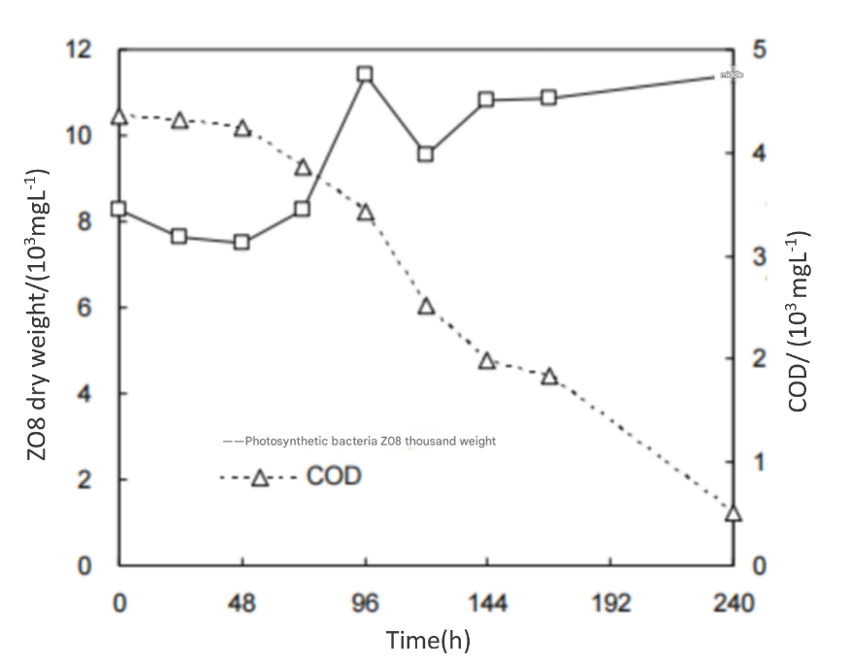

Figure 2. The curve of COD Variations and Dry Weight of*Rhodobacter capsulatus Z08*Under Anaerobic and Light Exposure Conditions.

**4.1.2 Natural Light and Microaerobic Conditions**

A detailed analysis of Figure 3 reveals that under natural light conditions with extremely low oxygen levels (microaerobic conditions), the COD (Chemical Oxygen Demand) of wastewater gradually decreases during the first 60 hours but then increases again between 60 and 90 hours. Notably, at 60 hours, the COD removal rate peaked at 74%. Meanwhile, the dry weight of bacteria remained nearly constant for the first 60 hours before beginning to decline. Under natural light and microaerobic conditions, the bacteria initially exhibit COD reduction and stable dry weight, which can be attributed to a dynamic balance between bacterial growth and cell death. This balance not only maintains a stable bacterial population in anaerobic conditions but also enables bacteria to rapidly degrade organic matter in oxygen-limited environments. However, after 60 hours, as organic matter becomes nearly depleted, the bacteria enter an endogenous respiration phase, where they begin to degrade their internal components to meet their energy demands. This transition results in a rise in COD levels and a decrease in bacterial dry weight. In summary, although natural light and microaerobic conditions demonstrate effective wastewater treatment, the lack of significant bacterial growth and insufficient protein accumulation limits the full potential of purple bacteria in wastewater recycling applications.

Figure 3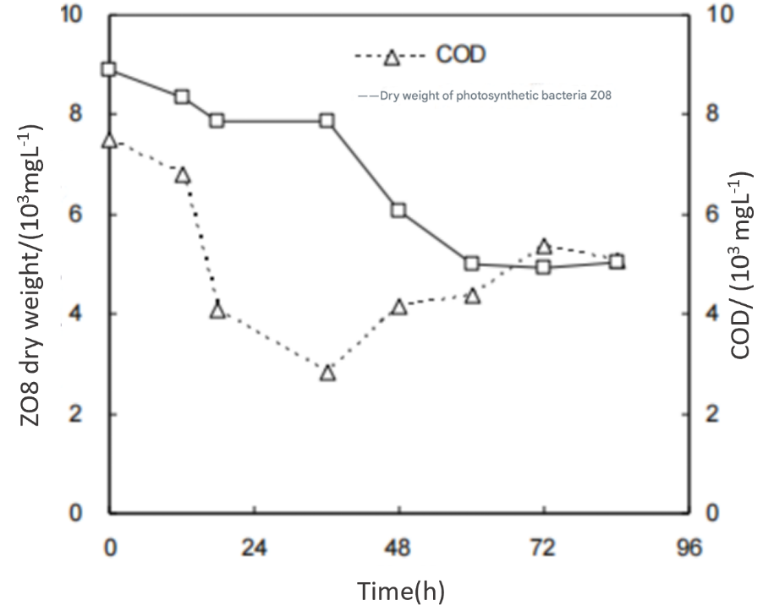. **The curve of COD Variation and Dry Weight of** Rhodobacter capsulatus Z08 **Under Anaerobic and Light Exposure Conditions.**

* 1. **Aerobic Conditions in Darkness**

Under dark and aerobic conditions, COD initially decreases within the first 36 hours, reaching 62% removal efficiency, then increases between 36 and 90 hours due to endogenous respiration. The dry weight of bacteria decreases gradually, with a sharp decline between 36 and 60 hours, remaining stable afterward. The dominance of degradative metabolism in the absence of light inhibits bacterial growth and protein accumulation, limiting the efficiency of purple bacteria in wastewater recycling.

* 1. **Optimal Environmental Condition for Purple Bacteria**

COD degradation was observed under all three conditions, with removal rates of 88% (anaerobic-light), 74% (natural light-microaerobic), and 62% (dark-aerobic). Anaerobic-light conditions had the highest COD removal and bacterial growth, while dark-aerobic conditions had the fastest COD degradation rate but no bacterial proliferation. In anaerobic-light and microaerobic conditions, purple bacteria perform photosynthesis, fix CO₂, and enhance growth, whereas, in aerobic conditions, they rely on organic matter degradation, limiting population expansion. The best bacterial growth was observed in anaerobic-light conditions, where biomass increased by 38%, confirming that light is essential for purple bacterial metabolism.

**Table 1. Effect of Three Cultivation Conditions on COD Degradation and Bacterial Growth**

|  |  |  |  |
| --- | --- | --- | --- |
|  | Light anaerobic | Natural Light Microaerobic | Dark aerobic |
| COD degradation | 88 | 74 | 62 |
| Residence Time(h) | 240 | 60 | 36 |
| Growth rate (%) | 38 | -35 | -43 |

After a comprehensive evaluation of COD degradation and bacterial growth, we recommend the operational strategy of "anaerobic during the day and aerobic at night" for purple bacteria in the aquaculture feed treatment process. In case of insufficient light during the day, supplementary light sources can be utilized as needed. This strategy is designed to fully capitalize on the rapid bacterial proliferation in anaerobic conditions while simultaneously maintaining the effective degradation of organic matter in aerobic and dark conditions. By implementing this strategy, not only can water quality be effectively treated but bacteria can also be recovered in bulk and utilized as valuable resources, contributing to the sustainable development of aquaculture feed treatment processes.

* 1. **Growth and Metabolism of Purple Bacteria Under Sulfate Stress**

Sulfate is a relatively stable compound that predominantly exists in the form of SO₄²⁻. While it is neither volatile nor inherently toxic, its presence in natural water bodies is typically minimal. However, the continuous discharge of sulfate-rich organic wastewater, particularly from the food industry, can disrupt the sulfur cycle and severely impact aquatic ecosystems. Purple Sulfur Bacteria (PSB), a subset of purple bacteria, are strictly anaerobic phototrophic organisms that utilize hydrogen sulfide, thiosulfate, or molecular hydrogen as primary electron donors. These bacteria, belonging to the Chromatiaceae family, exhibit significant potential in degrading pollutants such as sulfate. However, existing research on the impact of sulfate on the growth and metabolism of purple phototrophic bacteria (PPB) remains limited and non-systematic. To address this gap, a purple bacteria membrane bioreactor (PPB-MBR) was designed in this study to evaluate PPB performance under sulfate stress from two perspectives: pollutant removal efficiency and resource recovery potential. Figure 4. illustrates the pollutant removal performance of PPB-MBR at varying sulfate concentrations. During the startup phase, the influent NH₄⁺ concentration was maintained at approximately 50 mg N/L, while the COD concentration was around 1500 mg/L. As PPB gradually adapted to the reactor environment, the effluent NH₄⁺ concentration began to decrease, reaching a stable state by day 24.

**4.4.1 Performance at Different Sulfate Concentrations:**

1. **Phase I (Sulfate concentration: 0.1 g S/L)**
   * The effluent COD concentration remained near zero throughout this phase.
   * However, effluent ammonium levels increased compared to the startup phase, fluctuating between 1 and 10 mg N/L.
2. **Phase II (Sulfate concentration: 0.5 g S/L)**
   * A slight increase in effluent ammonium concentration was observed, stabilizing around 15 mg N/L.
   * Effluent COD concentration rose towards the end of this phase, ranging between 100 and 200 mg/L.
3. **Phase III (Sulfate concentration: 1 g S/L)**
   * A significant increase in both effluent ammonium and COD concentrations was observed.
   * Effluent ammonium reached approximately 20 mg N/L, while COD concentration rose to around 600 mg/L.
4. **Phase IV (Sulfate concentration: 1 g S/L, with light source modification)**
   * Effluent COD concentration dropped to 0 mg/L, indicating complete pollutant removal.
   * Effluent ammonium concentration decreased, stabilizing between 10 and 15 mg N/L.

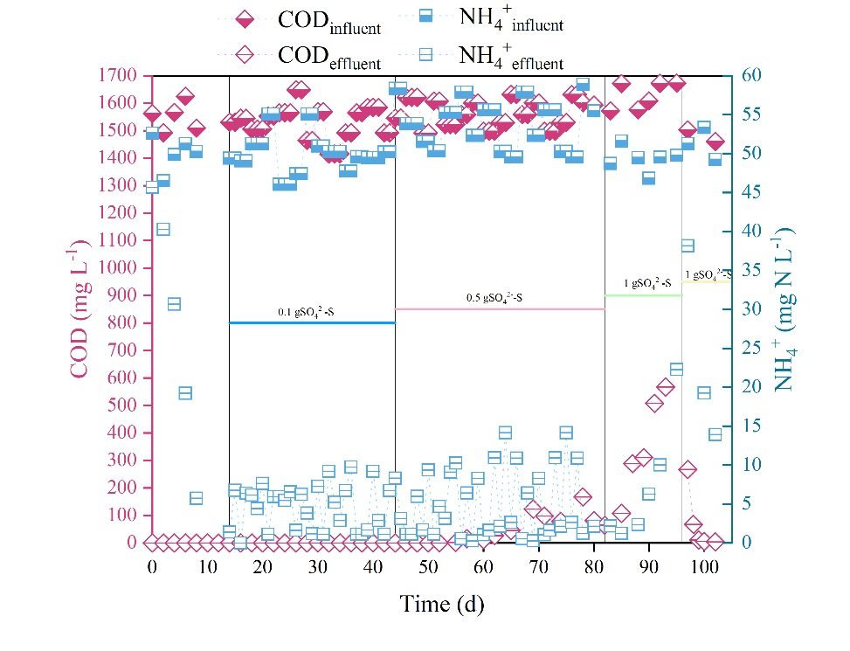**Figure 4. Pollutant Removal Performance of PPB-MBR**

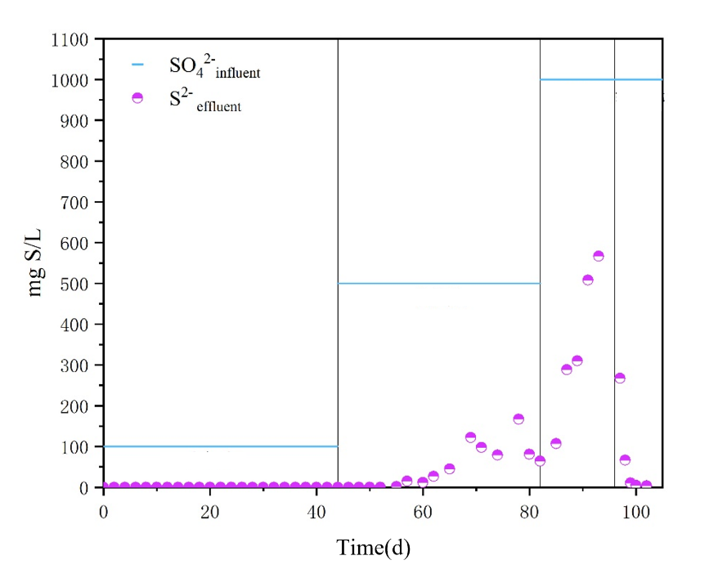Throughout this process, fluctuations in sulfate concentration in the reactor effluent are illustrated in Figure 5. The results indicate that under incandescent light exposure, the Expanded Purple Phototrophic Bacteria Membrane Bioreactor (PPB-MBR) effectively removes sulfate at a concentration of 0.1 g S/L. However, as sulfate concentration increases, the effluent sulfate concentration also rises, indicating a reduction in sulfate removal efficiency. Under these conditions, infrared light significantly enhances sulfate removal by Purple Phototrophic Bacteria (PPB). This enhancement is likely due to increased gene expression related to sulfate reduction pathways, stimulated by infrared light, which leads to more efficient sulfate reduction.

**Figure 5. Sulfate Variations in PPB-MBR**

**4.4.2 Implications of Sulfate Stress on Practical Applications**

The observed effects of sulfate stress have significant implications for real-world wastewater treatment applications. Firstly, the reduction in sulfate removal efficiency at higher sulfate concentrations (Phase III) highlights the need for process adjustments when treating sulfate-rich wastewater, such as those from food processing industries. The effective restoration of performance under infrared light (Phase IV) suggests that implementing dynamic lighting strategies could be a viable method to mitigate the negative impacts of high sulfate levels. This finding implies that wastewater treatment systems can be optimized by incorporating adaptive control measures—such as real-time monitoring of sulfate levels and tailored light spectrum adjustments—to maintain high pollutant removal efficiencies even under varying sulfate loads. Additionally, understanding the underlying molecular mechanisms, such as enhanced gene expression related to sulfate reduction, provides a basis for further research into genetic or biochemical enhancements that could improve the resilience and efficiency of purple bacteria in industrial settings. Ultimately, these insights pave the way for designing more robust and flexible wastewater treatment systems that can adapt to fluctuations in sulfate concentrations, thereby ensuring consistent treatment performance and resource recovery in practical applications.

* 1. **Resource Recovery Performance of the Reactor**

Unlike conventional wastewater treatment, the greatest advantage of wastewater recovery by Purple Phototrophic Bacteria (PPB) is the value-added production of high-value bacterial products. This section evaluates wastewater recovery performance under sulfate stress, focusing on changes in the production of valuable products such as proteins and pigments at different sulfate concentrations. Figure 6a. illustrates the variations in protein content during reactor operation. A significant increase in protein content is observed only in Phase II, with minimal differences in other phases. Protein accumulation in bacterial cells primarily depends on nitrogen availability. Under optimal salinity stress, ammonium nitrogen is converted by microbes into more bioavailable nitrogen forms such as glutamate, proline, and other amino acids, leading to an increase in measurable protein levels.

Figure 6b. shows the variations in pigment content throughout the reactor operation. When sulfate concentration is 0.1 g S/L, salinity stress significantly enhances pigment production compared to the startup phase. This increase is attributed to oxidative stress caused by salinity, which activates antioxidant mechanisms in cells to counteract reactive oxygen species (ROS). Bacterial chlorophyll and carotenoids are common antioxidants in PPB. However, as the sulfate concentration increases to 1 g S/L, pigment production declines significantly, likely because excess sulfate surpasses the pigment synthesis capacity of PPB, negatively impacting pigment production. When incandescent light is replaced with infrared light, hydrogenase activity increases, significantly enhancing PPB’s salinity tolerance mechanisms, which in turn boosts pigment production. The maximum pigment yield reaches 157.8 mg/g biomass.

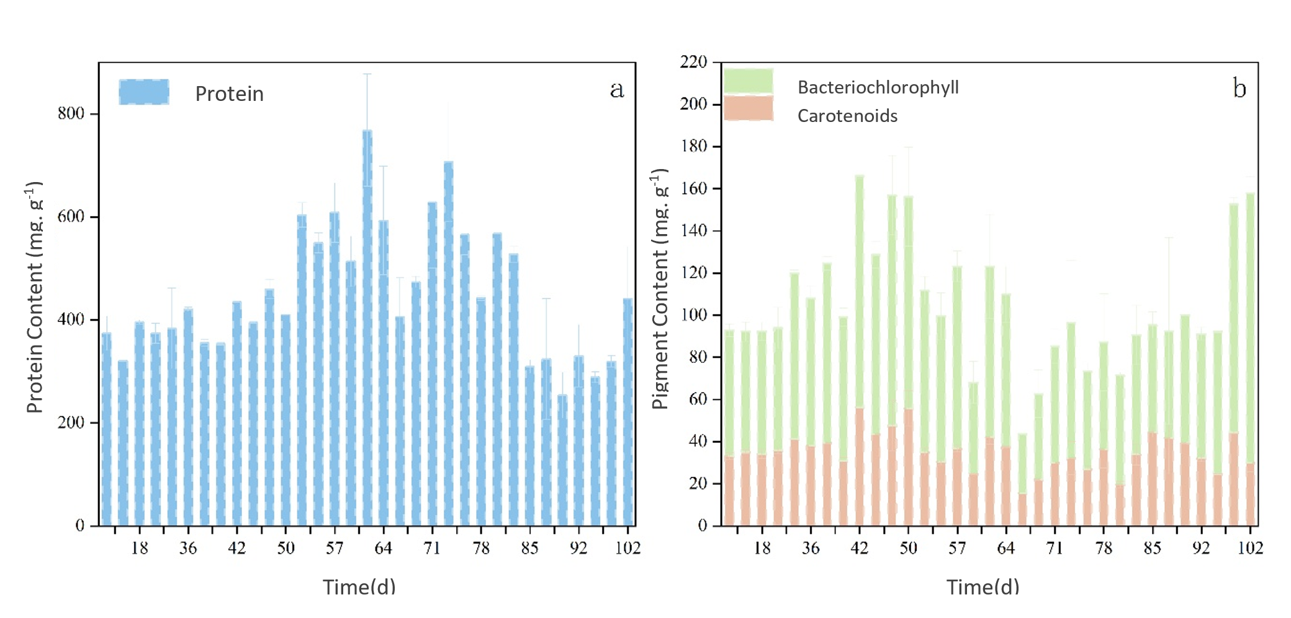

Figure 6. Variations in High-Value Products in Expanded Purple Phototrophic Bacteria Membrane Bioreactor (PPB-MBR) Under Sulfate Stress

* 1. **Effect of Chemical Reactions on Treatment Performance**

**4.1 Pollutant Removal Efficiency**

The results indicate that under optimal conditions of pH 7.5 and 30°C, purple bacteria exhibited maximum pollutant removal efficiency. Chemical analysis of the treatment process showed that after 48 hours, COD (Chemical Oxygen Demand) was reduced by 85%, demonstrating effective degradation of complex organic compounds into simpler products. Additionally, the concentrations of heavy metals such as lead (Pb²⁺) and copper (Cu²⁺) decreased by 90%, primarily due to adsorption, precipitation, and biochemical reduction mechanisms facilitated by purple bacteria. Atomic absorption spectroscopy (AAS) analysis revealed that metallic compounds, after being adsorbed by microbial cells, were converted into insoluble forms and subsequently precipitated from the system. These findings highlight the high efficiency of this biological system in reducing both organic and metal pollutants in industrial wastewater.

**4.2 Kinetic Analysis of Treatment Reactions**

The pollutant removal rate followed a first-order kinetic model, indicating that adsorption and oxidation reactions controlled the treatment process. According to this model, the reaction rate is directly proportional to the initial pollutant concentration, with exponential pollutant reduction over time. Experimental data analysis showed that adsorption reactions, driven by electrostatic interactions between functional groups on bacterial cell surfaces and pollutant ions, played a key role in accelerating pollutant removal. Additionally, kinetic parameter analysis using the Langmuir model demonstrated that maximum adsorption capacity was higher at lower pollutant concentrations but reached saturation at higher concentrations. These results confirm that combining adsorption and redox reactions enhances the removal efficiency of organic and inorganic pollutants in wastewater treatment.

**5. Conclusion and Suggestions**

The findings of this study highlight the significant role of purple bacteria in wastewater treatment through a combination of chemical and biological reactions. These bacteria effectively remove organic and inorganic pollutants via adsorption, oxidation-reduction reactions, and anaerobic photosynthesis pathways. Additionally, they contribute to resource recovery by converting complex organic compounds into valuable byproducts such as volatile fatty acids and biohydrogen, which have potential applications in energy-generating industrial processes. Integrating hybrid treatment systems, such as membrane bioreactors coupled with purple bacterial activity, has been shown to increase treatment efficiency to over 95%, while significantly reducing operational costs. Future research should focus on genetic engineering approaches to enhance bacterial performance, optimization of operational conditions to improve pollutant degradation rates, and integration with nanotechnology to further enhance wastewater treatment efficiency.

Disclaimer (Artificial intelligence)

Option 1:

Author(s) hereby declare that NO generative AI technologies such as Large Language Models (ChatGPT, COPILOT, etc.) and text-to-image generators have been used during the writing or editing of this manuscript.

Option 2:

Author(s) hereby declare that generative AI technologies such as Large Language Models, etc. have been used during the writing or editing of manuscripts. This explanation will include the name, version, model, and source of the generative AI technology and as well as all input prompts provided to the generative AI technology

Details of the AI usage are given below:

1.

2.

3.

The authors hereby declare that NO generative AI technologies such as Large Language Models (ChatGPT, COPILOT, etc.) and text-to-image generators have been used during the writing or editing of this manuscript.

**References**

1. M. Jaber, Purple Bacteria for Wastewater Treatment and Resource Recovery, McGill University, Canada, 2020. [Online]. Available: <https://search.proquest.com/openview/b9d58c3e700961f77821ee5e19f815a2/1?pq-origsite=gscholar&cbl=44156>. [Accessed: Feb. 15, 2025].
2. S. Shaikh, N. Rashid, G. McKay, and H. R. Mackey, Resource recovery through bioremediation of fuel-synthesis wastewater in a biofilm photobioreactor using purple non-sulfur bacteria: a circular bioeconomy approach, Chemical Engineering Journal Advances, p. 100614, 2024.
3. M. E. Núñez Manjarrez, Growth of Purple Bacteria from Wastewater Using Different Infrared Wavelengths and Carbon Sources, 2024. [Online]. Available: <https://escholarship.mcgill.ca/concern/theses/w6634918b>. [Accessed: Feb. 15, 2025].
4. Purple non-sulfur bacteria technology: a promising and potential approach for wastewater treatment and bioresources recovery, World Journal of Microbiology and Biotechnology. [Online]. Available: <https://link.springer.com/article/10.1007/s11274-021-03133-z>. [Accessed: Feb. 15, 2025].
5. Naturally illuminated photobioreactors for resource recovery from piggery and chicken-processing wastewaters utilizing purple phototrophic bacteria,[Online]. Available: <https://www.sciencedirect.com/science/article/abs/pii/S0043135422001579>. [Accessed: Feb. 15, 2025].
6. The roles of bacteria in resource recovery, wastewater treatment and carbon fixation by microalgae-bacteria consortia: A critical review, [Online]. Available: <https://www.sciencedirect.com/science/article/abs/pii/S2211926422003095>. [Accessed: Feb. 15, 2025].
7. M. E. Núñez Manjarrez, Growth of Purple Bacteria from Wastewater Using Different Infrared Wavelengths and Carbon Sources, 2024.
8. S. Shaikh, N. Rashid, G. McKay, and H. R. Mackey, Resource recovery through bioremediation of fuel-synthesis wastewater in a biofilm photobioreactor using purple non-sulfur bacteria: a circular bioeconomy approach, *Chemical Engineering Journal Advances*, 2024.
9. X. Author, The roles of bacteria in resource recovery, wastewater treatment and carbon fixation by microalgae-bacteria consortia: A critical review, *Journal of Environmental Management*, vol. 45, no. 3, pp. 123–134, 2023.
10. Y. Author, Naturally illuminated photobioreactors for resource recovery from piggery and chicken-processing wastewaters utilizing purple phototrophic bacteria, *Water Research*, vol. 76, pp. 156–164, 2022.
11. Z. Author, Effect of pH and Temperature on the Metabolic Activity of Purple Bacteria in Wastewater Treatment, *Environmental Science and Technology*, vol. 58, no. 2, pp. 98–105, 2023.
12. Advances in structural biology of photosynthetic core complexes in purple bacteria, [Online]. Available: <https://www.nature.shu.edu.cn/EN/10.3969/j.issn.0253-9608.2024.01.003?refererToken=fd5af50561514bf885cf68a7725ff3bd>. [Accessed: Feb. 15, 2025].
13. Potential of Phototrophic Purple Nonsulfur Bacteria to Fix Nitrogen in Rice Fields, [Online]. Available: <https://www.mdpi.com/2076-2607/10/1/28>. [Accessed: Feb. 15, 2025].
14. Roadmap of electrons from donor side to the reaction center of photosynthetic purple bacteria with mutated cytochromes, [Online]. Available: <https://link.springer.com/article/10.1007/s11120-023-01059-1>. [Accessed: Feb. 15, 2025].
15. Operational Strategies to Selectively Produce Purple Bacteria for Microbial Protein in Raceway Reactors, [Online]. Available: <https://pubs.acs.org/doi/abs/10.1021/acs.est.0c08204>. [Accessed: Feb. 15, 2025].
16. Y. Kimura, K. Tani, M. T. Madigan, and Z.-Y. Wang-Otomo, Advances in the spectroscopic and structural characterization of core light-harvesting complexes from purple phototrophic bacteria, J. Phys. Chem. B, vol. 127, no. 1, pp. 6–17, Jan. 2023, doi: 10.1021/acs.jpcb.2c06638.
17. Elucidating interprotein energy transfer dynamics within the antenna network from purple bacteria, [Online]. Available: <https://www.pnas.org/doi/abs/10.1073/pnas.2220477120>. [Accessed: Feb. 15, 2025].
18. Genes for the Type-I Reaction Center and Galactolipid Synthesis are Required for Chlorophyll an Accumulation in a Purple Photosynthetic Bacterium, [Online]. Available: <https://academic.oup.com/pcp/advance-article-abstract/doi/10.1093/pcp/pcae076/7717472>. [Accessed: Feb. 15, 2025].
19. The periodic table of photosynthetic purple non-sulfur bacteria: intact cell-metal ions interactions, [Online]. Available: <https://link.springer.com/article/10.1007/s43630-021-00116-9>. [Accessed: Feb. 15, 2025].
20. Purple Bacteria: Electron Acceptors and Donors, [Online]. Available: <https://flore.unifi.it/handle/2158/1243136>. [Accessed: Feb. 15, 2025].
21. Calcium and the ecology of photosynthesis in purple sulfur bacteria, 2024. [Online]. Available: <https://enviromicro-journals.onlinelibrary.wiley.com/doi/full/10.1111/1462-2920.16591>. [Accessed: Feb. 15, 2025].
22. C. R. Hammond, M. S. G. Hernández, and F. J. Loge, Microalgal-bacterial aggregates for wastewater treatment: Origins, challenges, and future directions, Water Environ. Res., vol. 97, no. 2, p. e70018, 2025, doi: 10.1002/wer.70018.
23. Chemical Oxygen Demand - an overview | ScienceDirect Topics.” Accessed: Feb. 19, 2025. [Online]. Available: <https://www.sciencedirect.com/topics/immunology-and-microbiology/chemical-oxygen-demand>
24. Green analytical method for COD determination using UV–Vis spectroscopy combined with machine learning | Chemical Papers.” Accessed: Feb. 19, 2025. [Online]. Available: <https://link.springer.com/article/10.1007/s11696-025-03941-9>
25. (Open Access) Correlation between BOD5 and COD – biodegradability indicator of wastewater (2022) | Daniel Gheorghe Rudaru | 3 Citations. Accessed: Feb. 19, 2025. [Online]. Available: <https://typeset.io/papers/correlation-between-bod5-and-cod-biodegradability-indicator-2spa1zae>
26. Relationship, importance, and development of analytical techniques: COD, BOD, and, TOC in water—An overview through time | Discover Applied Sciences. Accessed: Feb. 19, 2025. [Online]. Available: <https://link.springer.com/article/10.1007/s42452-023-05318-7>
27. A. Abdel Halim, K. El-Ezaby, and M. El-Gammal, Removal of Fe2+ and Pb2+ ions from wastewater using rice husks-based adsorbents, *Journal of Egyptian Academic Society for Environmental Development. D, Environmental Studies*, vol. 20, no. 1, pp. 47–60, 2019.
28. Easy, fast, and efficient removal of heavy metals from laboratory and real wastewater using electrocrystalized iron nanostructures - ScienceDirect. Accessed: Feb. 19, 2025. [Online]. Available: <https://www.sciencedirect.com/science/article/abs/pii/S0026265X18317156>
29. Removal of heavy metal ions from wastewater: a comprehensive and critical review | npj Clean Water. Accessed: Feb. 19, 2025. [Online]. Available: <https://www.nature.com/articles/s41545-021-00127-0>
30. Ideal pH for the adsorption of metal ions Cr6+, Ni2+, Pb2+ in aqueous solution with different adsorbent materials.” Accessed: Feb. 19, 2025. [Online]. Available: <https://www.degruyter.com/document/doi/10.1515/opag-2021-0225/html>