***Original Research Article***

**FINITE ELEMENT STRESS-BASED STABILITY ANALYSIS OF DIAPHRAGM WALLS FOR COASTAL PROTECTION AT ONNE, RIVERS STATE IN THE NIGER DELTA.**

**ABSTRACT**

The aim of the research is to model the stability of diaphragm walls subjected to seepage and sediment transport using finite element method for different soil conditions in the Niger Delta. Most coastal structures are supported by deep foundations and diaphragm walls for coastal protections or serving as quay walls. Diaphragm walls serve the dual purpose of coastal protection and berthing of vessels. Transient seepage/sediment transport (flow boundary conditions) and stress-deformations (stress boundary conditions) are the major controlling factors influencing the stability of diaphragm walls in coastal protection works. In this study, a two-dimensional uncoupled transient seepage and stress- deformation analyses were carried out to determine the stability of the diaphragm wall in different soil stratigraphy in Onne, Niger Delta region using the finite element stress-based method. The finite element solutions are based on the Galerkin’s weighted residual method and the use of Lagrange isoparametric triangular or quadrilateral elements representative soil stratigraphy along the coastline of Onne in the Niger Delta region were subjected to different stress and flow conditions modeled using a finite element method-based product Geostudio 2018R2V9.1. Uniform surcharge loads of 40, 60, 80, 100 and 120KPa were applied to the different case studies at varying dredge depths of 10, 16 and 19m under transient seepage conditions. Stability factors for critical slip surfaces and local stability factor of each slice for both shallow and deep-seated failure modes of the diaphragm wall were determined. The results obtained showed that diaphragm walls embedded in Stiff to firm clay offered better resistance than those in sand or sand with clay intercalations for both shallow (10m) and deep-seated slip surface (19m) failure modes due to transient seepage effects. The results also showed that the stability of diaphragm wall in coastal protection is strongly dependent on the depth of embedment as the stability factors in the case studies for all time steps decrease with increase in the dredging depth. The results further showed that stability factors reduce with increase in surcharge loads application for the case studies. The solutions obtained were in agreement with literature. Therefore, it is recommended to incorporate uncoupled/coupled transient seepage and stress-deformation analyses (finite element stress -based method) in the stability analysis and design of diaphragm walls for coastal protection works in the Niger Delta region.

**Keywords:** Finite Element, Stress-deformation, Transient Seepage, Sediment Transport, Stability Analysis, Geostudio, Diaphragm Walls, Coastal Protection, Niger Delta

**1. INTRODUCTION**

The activities of the oil/gas industries and transshipment of freight through waterways have increased the construction of coastal structures and ports along the shoreline of the Niger Delta region. Most coastal structures are founded on deep foundations with diaphragm walls for shoreline protections (quay walls). Diaphragm walls are embedded retaining walls that depend to a great extent or wholly on the earth passive resistance below dredge level and support systems (Simpson & Powrie, 2001). The weak soils (Recent deposits) are along the coastline with high phreatic level, presence of compressible organic clays, peat and hydraulic fills exert large initial stresses (Reijers, 2011). The adverse coastal environmental conditions with repeated variation in water levels, currents, and wave impacts, results in saturated or unsaturated soil conditions with time-dependent flow and pore-water pressure fluctuations along shorelines. Transient seepage/sediment transport and externally applied loads/lateral earth pressures are the major controlling factors in the stability of diaphragm wall for coastal protection works in the Niger Delta. Simulation of seepage and sediments transport through soils (both saturated and unsaturated conditions) results in the computation of fluxes, pore-water pressures distributions and water velocity/pathway (migration of sediments) that are used as hydraulic boundary conditions in the stress deformation analysis, through which internal stresses distribution needed for detailed engineering stability analysis and design of diaphragm walls along the shorelines computed (Anderson, et al., 2015). Water flows through a particulate medium due to an energy imbalance, meaning that water moves from areas of high energy level to those of lower energy levels (Fethi, 2000). The soil's flow rate is influenced by factors such as the density/viscosity of the liquid (water), degree of saturation, void ratio, porosity, and particle size distribution or gradation (Harr, 1990). The alarming rates of failure of coastal protection works due to stability problems of diaphragm walls have been a major problem in the Niger Delta region affecting adjoining quay apron stacking areas and disruption of offshore productions/cargo transportation. For these reasons, stability analysis of diaphragm walls continues to be major geotechnical problems and are being investigated by many researchers.

Veiskarami & Zanj (2014) modeled the stability of sheet pile walls subjected to seepage flow by slip lines (method of stress characteristics) and finite elements method. Richart & Schmertmann (2011) investigated the effect of steady state seepage flow and the stability of vertical sheet pile walls were considered in a cohesionless soil and stability evaluated in terms of the rotation about the anchor attachment. Suraya et al. (2019) studied the stability of diaphragm wall for deep excavation by using Plaxis 2D to determine the factors affecting stability. Czajewska (2014) conducted a numerical analysis of a 36m deep diaphragm wall using Geo5 and internal stresses and displacements were compared. Ou et al. (2019) used closed form solution based on the principle of minimum potential energy to compute lateral displacement and internal force in diaphragm walls. Ahmad et al. (2020) developed a mathematical model to analyze steady state seepage through the dam and evaluated the upstream and downstream slopes stability using the traditional limit equilibrium methods (Bishop, Janbu, Morgenstern-Price and Ordinary). Saminu et al. (2023) Utilized the Finite element method of Geostudio SEEP/W and Slope/W softwares to analyze seepage and stability of Saura-Keffi earth dam in Nasarawa state, Nigeria. Sundaravel & Goudappa (2024) conducted comparative of numerical modeling and analysis using ABAQUS and PLAXIS on the behaviour of earth retaining structures and slopes. Kheiri et al. (2020) calculated seepage under embankment dams, earth systems, and environments using the finite element-based SEEP/W software and verified the accuracy of the results against physical modeling outcomes.

Past research works on numerical modelling of stability of diaphragm walls have been based on load-deformation patterns considering only stress boundary conditions (such as externally applied loads and lateral earth pressures) based on limit equilibrium methods and other finite element methods without putting into cognizance, transient seepage and sediment transports. Detailed engineering evaluations must be carried out to determine the transient seepage and stress-deformations conditions during the analysis and design phase before the construction of diaphragm wall for coastal protection works. The dependent variable solved for in a finite element solution of a seepage problem is the pressure head and of a load deformation problem is the displacements (deformations) at each nodal point in the finite element mesh (Department of the Army, 1995; Geo-Slope International Ltd, 2013, 2015). For such complex stratigraphy (multi-layer saturated/unsaturated soils) with transient flow having varying boundary conditions and different stage construction processes involving incremental loading, analytical and general limit equilibrium methods (GLE) solutions are not possible rather high-power numerical methods (finite element stress-based method) provide the needed solutions. The finite element stress-based method captures the localized shear stress concentration, local factor of safety, soil-structure interaction problems and possible convergence problems with the general equilibrium methods (GeoStudio, 2022). Finite element method is very useful in finding solutions to differential equations that have no close form or analytical solutions (Zienkiewicz & Taylor, 2000); Nwaogazie, 2008). For instance, the application of Galerkin’s weighted residual finite element method was adopted to develop an environmental software used to model River mass transport using linear-quadratic model (Nwaogazie, 1992).

This study specifically addressed this gap by taking into account transient seepage in saturated and unsaturated soil conditions and results used as boundary conditions in the computation of the stresses needed for finite element stress- based stability analysis of diaphragm walls in coastal protection works. The aim of the research is to model the stability of diaphragm walls subjected to seepage and sediment transport using finite element method for different soil conditions in the Niger Delta. The three major objectives are to:

1. obtain relevant data/information such as levels, meteo-marine data, structural material’s properties/specifications, geotechnical subsoil conditions and loads which serve as analysis/design inputs;
2. evaluate overall soil - diaphragm walls interactions including all support systems and loadings at different staged construction using Geostudio software SIGMA/W ; and
3. model the overall stability of diaphragm wall using finite element stress-based method (SLOPE/W).

**2.** **METHODOLOGY**

**2.1 Study Area**

The area of the research is the Niger Delta region in the southern part of Nigeria bordering with the Atlantic Ocean, Figure 1. In Niger Delta region, diaphragm walls are used for shoreline protections such as in Nigerian Ports Authority berths (4, 5, 6, 9,10,11 and 12), West African Container Terminal berths (7 and 8) in Federal lighter Terminal and Federal Ocean Terminal Onne Rivers State and Nigerian Port Authority Warri in Delta State. The sites as shown in the Google map are located in Onne, Eleme local government area of Rivers state Nigeria. They are accessible through the Federal Ocean Terminal junction and also through Ogu creek and Bonny River at the back side. Total area of the site in the Federal Lighter Terminal (FLT) is 26,250sqm comprising of berth 1-3 and 131,250sqm comprising of berth 1-15 in the Federal Ocean Terminal (FOT) of the Nigerian Ports Authority (NPA) Onne. Berths 1-3 in FLT and Berths 1- 11 in the FOT lie along the Ogu creek side while Berth 12-15 in FOT lie along the Bonny River side. The sites are approximately 10km from the Atlantic coast with the Federal Ocean Terminal actually located in an inlet, where tidal currents play a major role in water flow. The areas investigated falls within the tertiary Niger Delta which occurs at the south-central sedimentary basin of Nigeria bordering the Atlantic Ocean with latitude of 4º41’13.79” N and longitude of **7**º09’16.80” E.

.

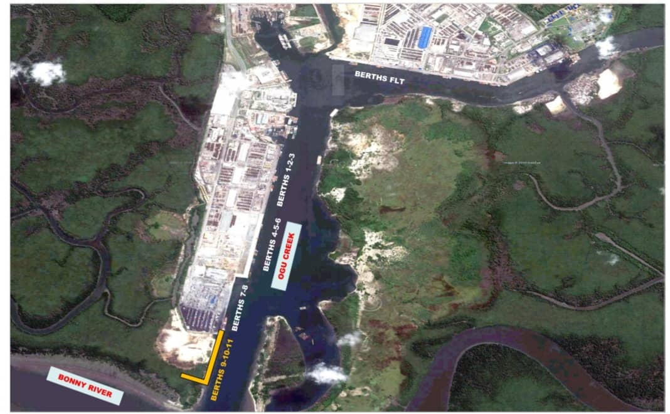

**Figure 1. Google maps of Onne study area**

**2.2 Sources of Data**

Relevant data used were obtained from standard codes of practice, authorities and reputable sources. Laboratory tests results on representative samples from these areas on Dutch Cone penetrometer tests (CPT) to refusal depths and various geotechnical boreholes to depth of 40 metres below existing ground level and Standard Penetration Tests (SPT) were obtained from reputable sources. These results showed similar lithology (subsoil and groundwater conditions) which have been classified into 3 categories. All the tests were executed in accordance and compliance with the specifications contained in BS 1377-2 (British Standards Institution, 2022).

**2.2.1 Geotechnical Soil Stratigraphy and Properties for Geostudio Modelling.**

Table 1 shows the soil stratigraphy for the 3-Case study with a probe depth of 40m, as used for Geostudio Modelling.

**Table 1. Soil Stratigraphy for Geostudio Modelling**

|  |  |  |  |  |  |  |  |  |  |
| --- | --- | --- | --- | --- | --- | --- | --- | --- | --- |
| **Strata Unit** | **Case Study 1** | | | **Case Study 2** | | | **Case Study 3** | | |
|  | Description | Top level  (m) | Bottom level  (m) | Description | Top level  (m) | Bottom level  (m) | Description | Top level  (m) | Bottom level  (m) |
| Unit 1 | Hydraulic fill | +0.00 | -3.00 | Hydraulic fill | +0.00 | -1.50 | Hydraulic fill | +0.00 | -1.50 |
| Unit 2 | Hydraulic fill | -3.00 | -15.00 | Hydraulic fill | -1.50 | -10.00 | Hydraulic fill | -1.50 | -10.00 |
| Unit 3 | LSS to MDS | -15.00 | -19.00 | LSS to LS | -10.00 | -24.00 | LSS to LS | -10.00 | -24.00 |
| Unit 4 | Soft to Firm Clay | -19.00 | -24.00 | Firm to Stiff Clay | -24.00 | -40.00 | MDS to DS | -24.00 | -40.00 |
| Unit 5 | MDS to DS | -24.00 | -40.00 |  |  |  |  |  |  |

*Hydraulic fill: Loose Silty Sand to Loose Sand, LSS: Loose Silty Sand, MDS: Medium Dense Sand, DS: Dense Sand

Preliminary dredging level of existing unit 1 and 2 (very soft to dark grey organic peaty Clay) to depth of -15m for case study 1, unit 1 and 2 to a depth of 10m for both case study 2 and 3 were assumed completed. Sandfill taken from riverbed with no selection likely in very loose state once discharged has been placed to +0.00m. The fill materials are granular (non-cohesive) soil materials with the same property as the loose silty sand and are allowed for compaction with the fill compaction requirements. This material is described as hydraulic fill. Table 2 shows the geotechnical properties of the soil as used in the Geostudio modelling**.**

**Table 2. Geotechnical Properties of Soil for Geostudio Modelling (SEEP/W-Seepage and SIGMA/W- Load-deformation).**

|  |  |  |  |  |  |  |  |
| --- | --- | --- | --- | --- | --- | --- | --- |
| **Parameter** | **Name/**  **Symbol** | **Unit** | **Hydraulic fill** | **LSS to MDS** | **Soft to Firm Clay** | **MDS to DS** | **Firm to Stiff Clay** |
| Material Model | Model | - | Mohr-Coulomb | Mohr –Coulomb | Mohr –Coulomb | Mohr –Coulomb | Mohr –Coulomb |
| Soil Unit Weight | γ | KN/M3 | 18.5 | 18.5 | 13.0 | 18.5 | 19.0 |
| Horizontal Conductivity | Kx | m/day | 0.60 | 0.60 | 8.64E-02 | 0.60 | 0.15 |
| Vertical Conductivity | Ky | m/day | 0.60 | 0.60 | 1.7E-05 | 0.60 | 0.15 |
| Saturated Water Content | ϴs | - | 0.41 | 0.41 | 0.65 | 0.41 | 0.55 |
| Compressibility | av | /KPa | 1.0E-6 | 1.0E-6 | 4.24E-4 | 1.0E-6 | 4.24E-4 |
| Residual Water Content | ϴr | - | 5.0E-5 | 5.0E-5 | 6.0E-6 | 1.0E-6 | 1.042E-5 |
| Young’s modulus | E | KN/M2 | 6.0E+04 | 6.0E+04 | 500.00 | 6.0E+04 | 1.2E+04 |
| Poisson’s ratio | Ѵ | - | 0.35 | 0.35 | 0.33 | 0.35 | 0.34 |
| Angle of soil shearing resistance | Ø | O | 30.00 | 30.00 | 0 | 30.00 | 28.00 |
| Cohesion | C | KN/M2 | 0 | 0 | 21 | 0 | 10.00 |

**2.2.2 Boundary Conditions for Geostudio Modelling.**

The boundary conditions used for SEEP/Wand SIGMA/W modelling, are as reported in Tables 3 and 4.

**Table 3. Boundary Conditions (BC) for SEEP/W modelling.**

|  |  |  |  |
| --- | --- | --- | --- |
| **Boundary Condition** | **Long Term Steady State** | | **Transient** |
| Name | Upstream | Downstream | Slow drawdown |
| Type | Hydraulic | Hydraulic | Hydraulic |
| Kind | Water total head | Water total head | Water total head |
| Constant | 38.5m | 38m | Not applicable |
| Function | Not applicable | Not applicable | (0hr,38m) and 24hrs,35.4m) |

**Table 4. Boundary Conditions (BC) for SIGMA/W modelling.**

|  |  |  |  |  |  |
| --- | --- | --- | --- | --- | --- |
| **Boundary Condition** | **Insitu Stress Condition** | | **Load deformation** | | |
| Name | Fixed X | Fixed X/Y | Lateral Unload | Uplift stress | Surcharge Load |
| Type | Stress/Strain | Stress/Strain | Stress/Strain | Stress/Strain | Stress/Strain |
| Kind | X-Displacement | X/Y Displacement | Hydrostatic Pressure | X-Y Stress | Normal/Tan. Stress |
| Constant | 0m | 0m | Unit wt./m Depth | X and Y Stress | Normal  (60KPa,80Kpa,100Kpa and 120KPa) |

**2.2.3 Properties of Anchor and Diaphragm Walls for Geostudio Modelling.**

The properties of the tie rods (Anchor system) as used in the load-deformation and finite element stress-based method are given in Table 5.

**Table 5. Properties of the Anchor for SIGMA modelling.**

|  |  |  |  |
| --- | --- | --- | --- |
| **Parameter** | **Name** | **Value** | **Unit** |
| Type of behaviour | Material type | Elastic | KN |
| Anchor spacing | Ls | 2.50 | m |
| Pre- axial force |  | -100 | KN |
| Area | M2 | 0.006 | M2 |
| Diameter |  | 0.0875 | m |
| Youngs modulus | E | 2.10E6 | KPa |

Properties of the diaphragm wall as used in the analysis are:

Top level = + 0.00 m Elastic Modulus, E = 20E6 KPa

Toe level = - 30.00 m Unit bulk weight, γ = 25 kN/m3

Length, L = 30 m Area, A = 2.2 m2/m

Thickness of wall =1100 mm Net width of wall = 2000 mm

Moment of Inertia, I = 3.24 m4/m Allow for both Tension and Compression

**2.2.2 Waves, Current, Seismic Input, Levels and Ground Water Conditions**

Information on Tide levels at Onne Port are similar to Bonny town and are stated in Table 6 as obtained from Tidal predictions for Nigerian ports and River Channels (Nigerian Navy, 2023).

**Table 6. Tidal Level for Geostudio modelling.**

|  |  |  |  |
| --- | --- | --- | --- |
| Description* | Tide Level (m) | Description* | Tide Level(m) |
| HAT | +2.70 | MSL | +1.50 |
| MHWS | +2.30 | LAT | +0.10 |
| MHWN | +1.90 |  |  |

*HAT: Highest Astronomical Tide, MHWS Mean High Water Springs, MHWN: Mean High Water Neaps, MSL: Mean Sea Level, LAT: Lowest Astronomical Tide

No seismic design is applicable to diaphragm walls design in the Niger Delta region hence, pseudo-static ground movement was not considered in the analysis. Finally, the existing ground water level at the site from geotechnical reports is 1.5m below existing ground level.

**2.3 Method of Data Analysis**

The general geometry of the soil regions, diaphragm wall, support systems and initial ground water level were modeled using Geostudio 2018R2V9.1 software. The point coordinates for the general geometry were (-30,0), (35,0), (-0.55,10), (0.55,10), (-30,16), (-0.55,16), (0.55,16), (36,16), (-30,24), (-0.55,21), (0.55,21), (35,21), (-30,24), (-0.55,33), (-30,37), (-0.55,37), (0.55,37), (35,37), (-30,40), (-0.55,40),(-0.55,40), (0.55,40), (35,40), (-30,28), (-0.55,28), (-30,26), (-0.55,26) and (35,40).

**2.3.1 Finite Element Stress-Based Analysis (SIGMA/W STRESS)**

The following were the key components for finite element stress-based analysis solutions:

1. Geometry and Meshing: Input data as given in Tables 1- 5 used and the entire discretized domain into 493 elements having an approximate global element size of 2.4m. The initial dredging depth at the seaside is -10m. Transient state seepage solutions considering slow water drawdown for duration of a day, 15-time steps with an exponential initial increment size of 0.05 days and spline data point function boundary conditions were obtained. Insitu stress state conditions and load deformation (incremental loading considering different stage construction stages) and solutions obtained. The stage construction considered are insitu state of stress condition (stage 1), install diaphragm wall and excavate top 3m (stage2), install upper anchors (stage 3), excavate another 4m (stage 4), install lower anchor (stage 5), Dredge last 3m, 6m or 9m for dredging depths of 10m, 16m and 19m respectively (stage 6) and Apply Surcharge loads of 40KPa,60KPa, 80KPa, 100KPa and 120KPa (stage 7).
2. The model for Stage 7 cloned, initial stress conditions obtained from it and pore water pressure conditions obtained from the transient seepage analysis considering all time steps. Entry & exit slip surface considered. Minimum slip surface depth of 0.1m and 30 number of slices used.
3. Material definitions: Elastic-plastic model (Mohr-Coulomb) material model used and basic unit weight, cohesion and angle of internal friction supplied and assigned.
4. Boundary conditions: The stresses from the parent analysis (Stage 7) used as initial stresses conditions for this analysis hence the boundary conditions of the parent analysis used and no new boundary conditions specified in the finite element stress- based analysis and solutions were obtained.

**2.3.1.1 Shallow Slip Failure Mode**

The following were the key components for shallow slip failure mode of a finite element stress-based analysis solutions:

i. Initial dredge depth of 10m considered for shallow slip failure;

ii. The entry and exit considered as range at the ground surface level of the landside and a single point at the dredge depth of 10m respectively; and

iii. Passive wedge exists from the depth of 10m to the tip of the diaphragm wall (30m). The passive resistance from these passive earth pressures computed and modeled with a line load (constant X-force) or pile shear force acting at the depth of 10m as a boundary condition (constant X-force boundary condition).

**2.3.1.2 Deep-Seated Failure Mode**

For the deep-seated failure mode, the following were key components considered.

i. The slip surface passes below the diaphragm wall;

ii. No inclusion of the resistance force due to the passive wedge in the computations of the factor of Safety; and

iii. The slip surface entry and exit considered a range indicated at the ground surface level of the landside and at the downstream line on the sea side respectively. The slip surface therefore starts from the upstream line level through the tip of the diaphragm wall to the downstream line level.

**3. RESULTS AND DISCUSSION**

**3.1 Results**

**3.1.1 Stability Analysis and Transient Seepage Results**

The results of the stability factors for all time steps considering the distribution of pore water pressure from 0 hr to 24 hr computed for surcharge loads of 40, 60, 80, 100 and 120kpa and dredging depths of 10, 16 and 19m, for the critical slip surfaces versus time (hrs) for the 3-case study shown in Tables 8 – 10 on the Appendix. Variations of stability factors for each critical slip surface with time (hrs) for dredging depths of 10, 16 and 19m for all time steps for the critical slip surfaces for the 3-case study displayed in Figures 2 – 4 and transient seepage analysis results displayed in Figure 5.

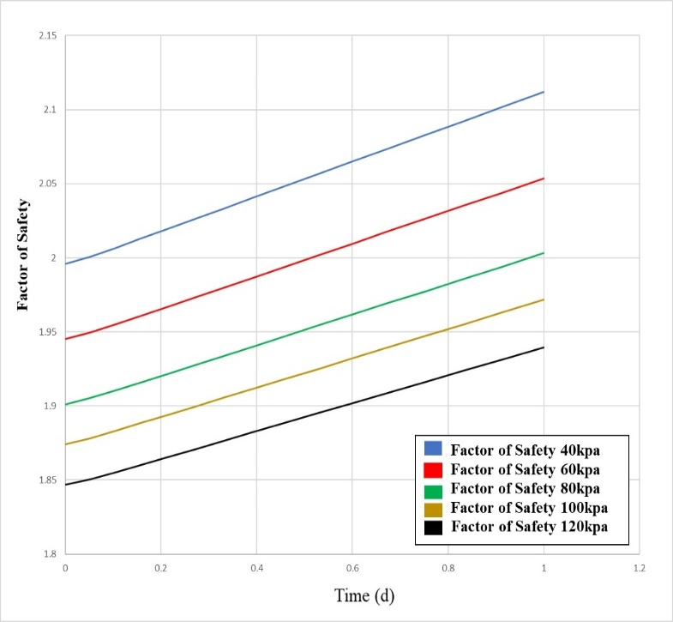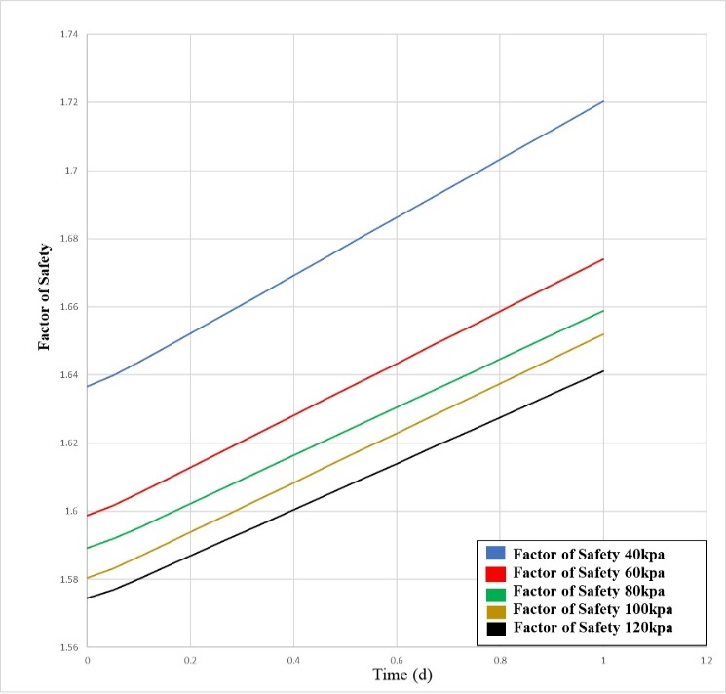**Figure 2. Factors of safety versus Time for Case study 1 at dredge depth of 16m and 19m with different surcharge load applications.**

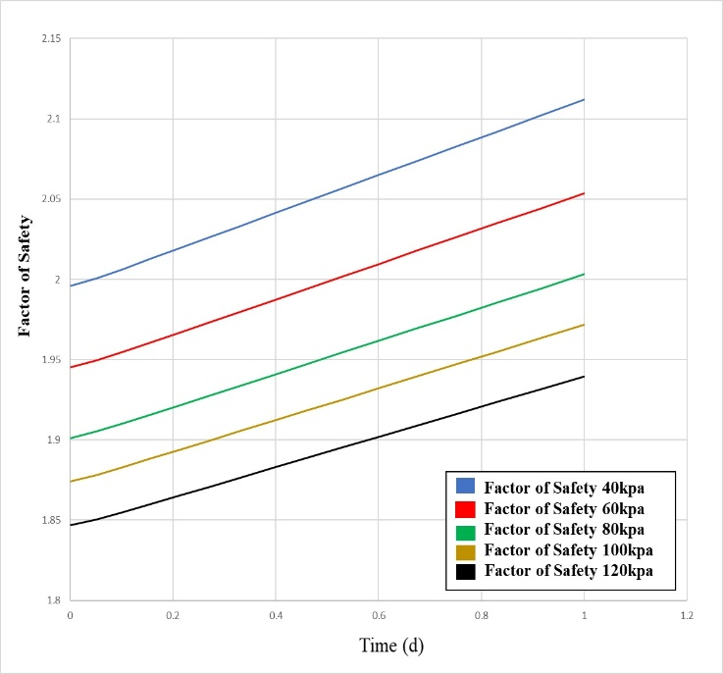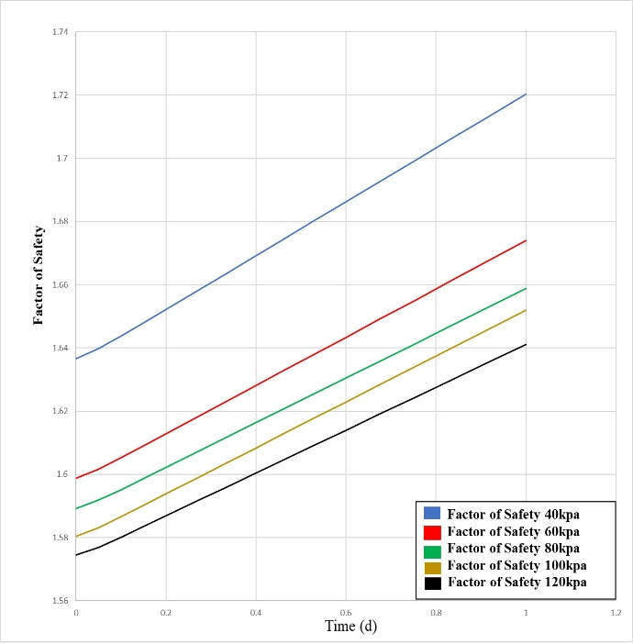

**Figure 3. Factors of safety versus Time for Case study 2 at dredge depth of 16m and 19m with different surcharge load applications.**

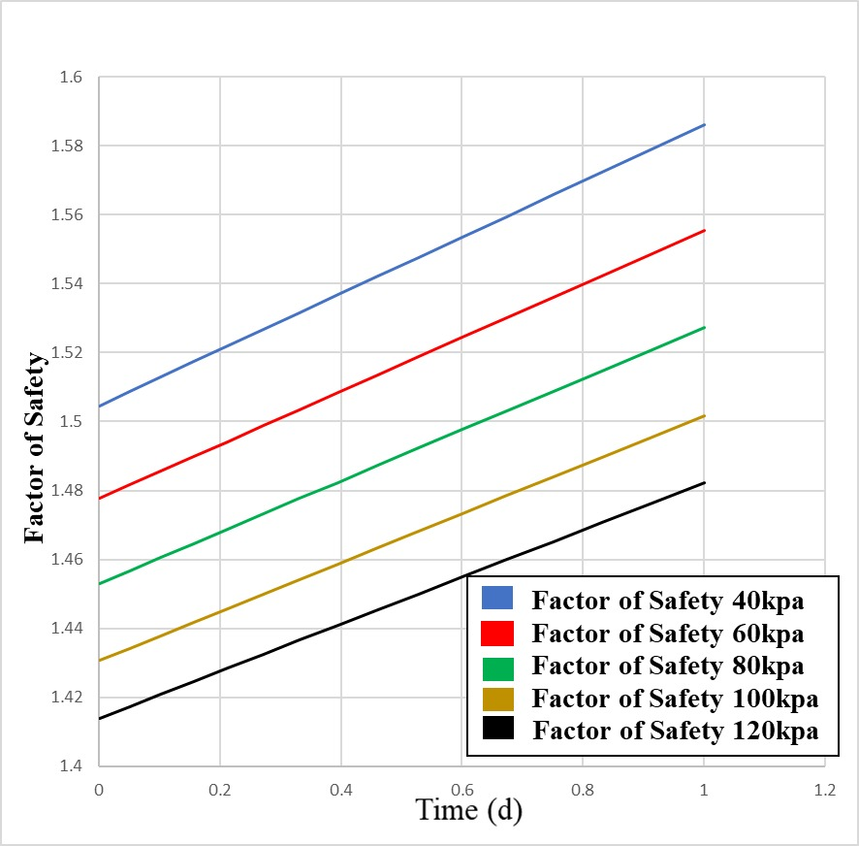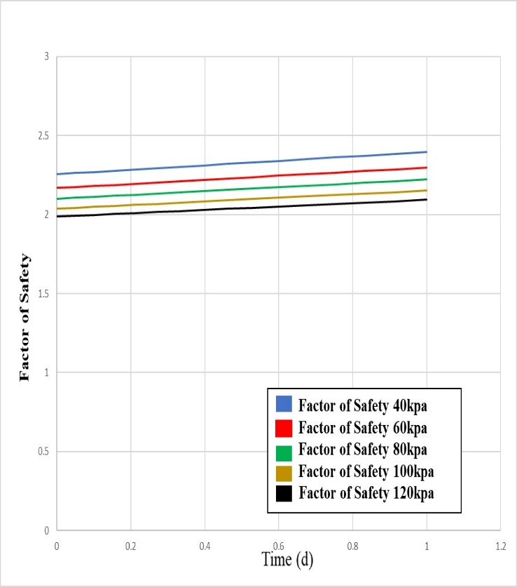 **Figure 4. Factors of safety versus Time for Case study 3 at dredge depth of 16m and 19m with different surcharge load applications.**

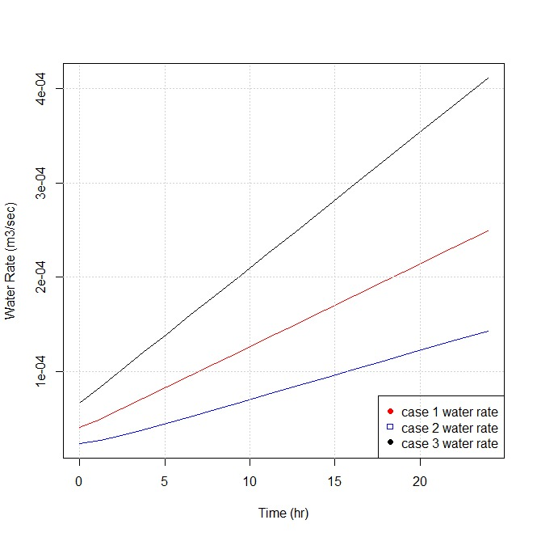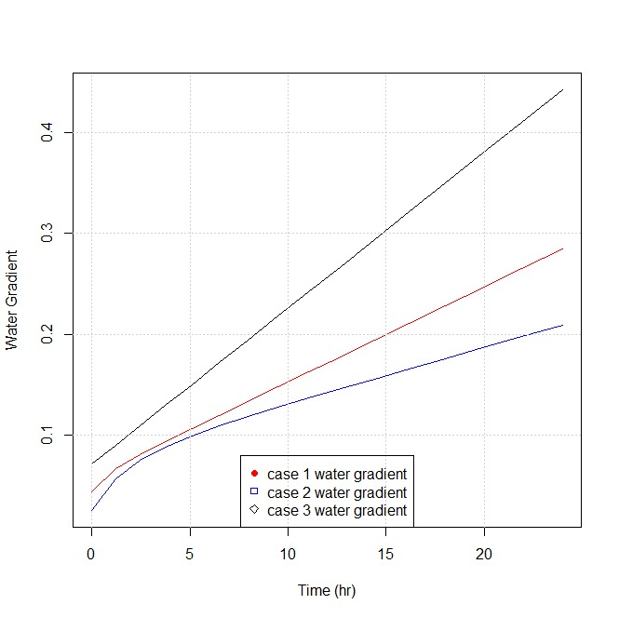

**Figure 5. Transient Seepage variation with time under the diaphragm wall and water horizontal and vertical XY-gradients with time at downstream level for different Case studies.**

Sediment transport results by advection processes under the diaphragm wall and the downstream exit for the case studies are as recorded in Table 7.

**Table 7. Particle tracking records under the diaphragm wall and at downstream exit for the different Case study.**

|  |  |  |  |  |  |  |
| --- | --- | --- | --- | --- | --- | --- |
| **Description** | **Case Study 1** | | **Case Study 2** | | **Case Study 3** | |
|  | Under the wall | Exit from down-stream | Under the wall | Exit from down-stream | Under the wall | Exit from down-stream |
| Total distance travelled (m) | 4.46 | 1.31 | 2.39 | 1.16 | 6.25 | 2.22 |
| Average speed (m/s) | 5.16E-5 | 1.52E-5 | 2.76E-5 | 1.35E-5 | 7.23E-5 | 2.56E-5 |

The SIGMA/W Stress- based finite element stability results for shallow and deep-seated failure modes on application of 60KPa surcharge load at depths of 10 and 19m, respectively for Case study 3 displayed in Figures 5 - 6.

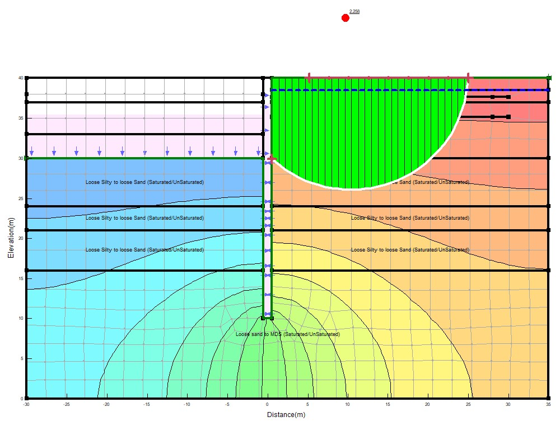

**Figure 5. Case study 3 Sigma/w stress-based finite element stability result for depth of Shallow failure mode (10m) and 60kpa surcharge load application.**

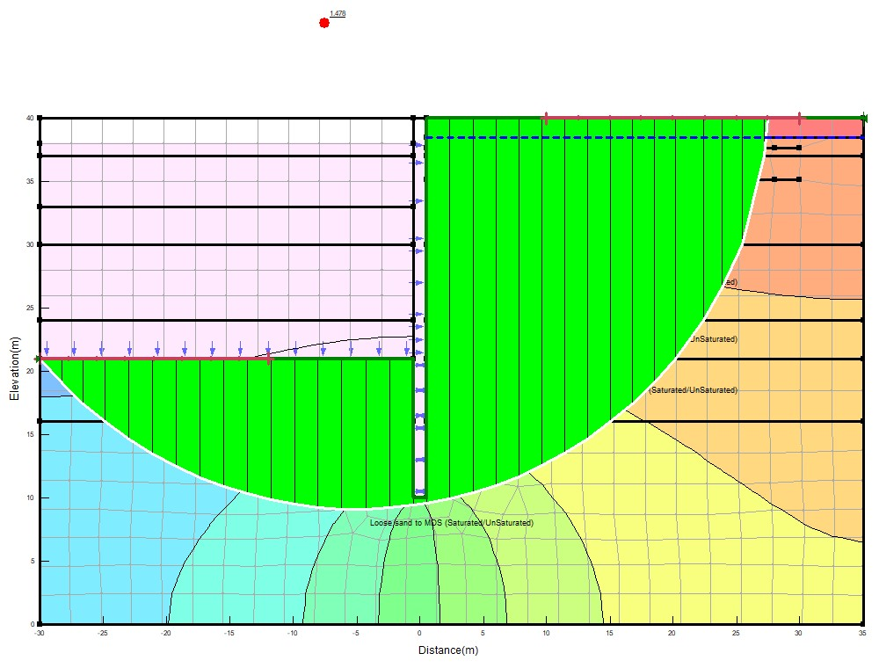

**Figure 6. Case study 3 Sigma/w stress - based finite element stability result for depth of Deep-Seated failure mode (19m) and 60kpa surcharge load application.**

**3.2 Discussion**

The stability of diaphragm wall for coastal protection works based on the results of the finite element stress-based analysis were influenced by the dredge depths, surcharge loads and seepage/sediment transport as discussed below.

**3.2.1 Shallow Slip Surface Failure Mode (10m Dredge Depth).**

i). For Case study 1 at dredge depth of 10m at 0day, factors of safety of 2.75 and 1.645 obtained for 40 and 120kpa surcharge loads applications. Also, case study 2 at same 10m dredge depth at 0 day, factors of safety of 3.00 and 1.737 obtained for 40 and 120kpa surcharge loads applications, respectively and finally, for Case study 3 factors of safety of 2.34 and 1.781, respectively. Here, the stability factors for the 3 Case studies decrease with increase in surcharge load application.

**3.2.2 Deep- Seated Slip Surface Failure Mode (19m Dredge Depth).**

i). For Case study 1 at dredge depth of 19m at 0day, factors of safety of 1.64 and 1.57 were obtained for 40 and 120KPa surcharge loads applications. Also, for case study 2 at same 19m dredge depth at 0 day, factors of safety of 1.65 and 1.55 were obtained for 40 and 120kpa surcharge loads applications respectively. Finally, for Case study 3 factors of safety of 1.50 and 1.41 respectively were obtained with same surcharge loads application. Therefore, on application of 40 to 120KPa surcharge loads at dredge depth of 19m, Case 2 (diaphragm wall embedded in firm to stiff clay through loose to dense sand) showed highest values of the stability factor for surcharge loads between 40 to 60KPa. Also.in the deep-seated slip surface failure mode, the stability factors for the 3-Case studies decrease with increase surcharge load application. Therefore, for the 3 Case studies, the stability factor decreases with increasing depth of dredging which is in agreement with literature (Simpson & Powrie, 2001; Fethi, 2000; Richart & Schmertmann, 2011; Suraya et al., 2019).

**3.2.3 Transient Seepage.**

i). Transient water flow rate for a 3-case study increases as the water drawdown to the lowest depth of slow drawdown of 35.4m with higher rates at the starting point 0 hr to 6.5hr and gradually decreases to 24hr. The maximum transient seepage rate occurred for the 3-case study at the end of 24 hours with case study 3 (diaphragm wall fully embedded in different sand layers) having the greatest transient seepage rate as 4.111E-04 m3/s/m. The lowest transient water flow rate for the 3-case study is for case 2 (diaphragm wall embedded through sand to firm clay stratum) with a value of 1.43E-04 m3/s. These results are in agreement with literature as groundwater flowrate is very high in sand layers than in clay layers (Fethi, 2000; Harr, 1990).

ii. The maximum transient x-y gradient occurred for the 3-case study at the end of 24 hours with case study 3 (diaphragm wall fully embedded in different sand layers) having the greatest transient x-y gradient as 0.442. The lowest transient x-y gradient for the 3-case study is for case 2 (diaphragm wall embedded through sand to firm clay stratum with a value of 0. 209.

**3.2.4 Sediment Transport.**

i). The greatest average particle speed (7.23E-05m/s) was encountered for case study 3 at the end of 24 hours under the diaphragm wall. This conformed with the greatest value of seepage rate also obtained for case study 3. Hence, Seepage rate or flow rate enhances sediment transportation.

ii). The greatest average particle speed (2.56E-05 m/s) was encountered for case study 3 at the end of 24 hours at exit from downstream. Therefore, particle/sediment movement or transportation in a flexible retaining wall is more pronounced at the tip(under) the diaphragm wall as shown in the results of the 3-case study and the greatest values obtained for diaphragm walls embedded in sand layer.

**4. CONCLUSION AND RECOMMENDATION**

**4.1 Conclusion**

The following conclusions are made based on the results obtained:

1. The stability of Diaphragm wall has been shown to be dependent on the depth of embedment of the wall. Therefore, for Diaphragm wall for coastal protection works in Niger Delta with surcharge loads between 40kpa to 120kpa, the depth of embedment should be thoroughly evaluated using finite element stress-based stability analysis that will take care of seepage/sediment transport problems and excessive lateral pressures exerted on the wall.
2. Dredging must be monitored closely in diaphragm wall coastal protection works as such increases the disturbing moment and reduces resisting moments on the wall.
3. The results obtained showed that diaphragm walls embedded in Stiff to firm clay offered better resistance than those in sand or sand with clay intercalations for both shallow (10m) and deep-seated slip surface (19m) failure modes. Due to high seepage rates in sand, the depth of embedment must be increased to accommodate sediment transport resulting from scour actions leading to reduction in passive resistance in sand. Generally, for all the 3-Case study, the stability factor decreases with increasing depth of dredging.

**4.2 Recommendation**

For stability analysis of diaphragm wall for coastal protection works in the Niger Delta, coupled or uncoupled transient seepage/sediment transport and load deformation analyses should be considered. This will provide the realistic distributions of pore water pressures, fluxes (due changes in volumetric water content and hydraulic conductivity functions) and internal stresses (due to incremental load applications).

Disclaimer (Artificial intelligence)

Option 1:

Author(s) hereby declare that NO generative AI technologies such as Large Language Models (ChatGPT, COPILOT, etc.) and text-to-image generators have been used during the writing or editing of this manuscript.

**REFERENCES**

Anderson, M.P., Woessner, W.W. and Hunt, R.J. (2015) Applied Groundwater Modeling: Simulation of Flow and Advective Transport. 2nd Edition. Available at https://shop.elsevier.com/books/applied-groundwater-modeling/anderson/978-0-08-091638-5

Ahmad, I.M., Haitham, A.H., & Zeyad, S.K. (2020). Numerical Model of Seepage and Slope Stability for Horan Dam H4 in Iraq. 2nd International Scientific Conference of Engineering Sciences (ISCES). Vol 1076. DOI: 10.1088/1757-899X/1076/1/012089

British Standards Institutions: BS 1377-2 (2022), Methods of Test for Soils for Civil Engineering Purposes, Part 2: Classification Tests and Determination of Geotechnical Properties. Available at: https://www.en-standard.eu › bs-1377-2-2022-methods-...

Czajewska, M.M. (2014). Numerical analysis of a 36m deep diaphragm wall. Geotechnical Aspects of Underground Construction in Soft Ground-Korean Geotechnical Society, ISBN 978-1-138-02700-8. Available at: https://www.issmge.org/uploads/publications/6/20/2014_041.pdf

Department of the Army (1995). Geotechnical Analysis by the Finite Element Method, Engineering Technical Letter (ETL), U.S Army Corps of Engineer, Washington. Available at: https://apps.dtic.mil/sti/tr/pdf/ADA403367.pdf

Fethi, A. (2000). Applied Analyses in geotechnics, 1st Edition, T.J international Ltd publishers, Padstow Cornwall. https://www.routledge.com/Applied-Analyses-in-Geotechnics/Azizi/p/book/9780419253501?srsltid=AfmBOorQW7cSe5TYZC2AOg8UishQ3g3nTRQWPRC1JtQiPF5ub8vfYn_l

Geo-Slope International Ltd (2015) Seepage Modelling with SEEP/W – An Engineering Methodology. Avilable at: https://ottegroup.com/wp-content/uploads/2021/02/seep-modeling-June2015.pdf

GeoSlope International Ltd (2013) Stress-Deformation Modelling with SIGMA/W. [Brochure]. Calgary, Alberta Canada. Available at: https://www.slideshare.net/slideshow/sigma-modeling/137465786

GeoStudio (2022) Stability Modelling with Geostudio. Available at: https://files.seequent.com/PDFs/Geostudio-Stability%20Modeling-Oct2022.pdf.

Harr, M.E. (1990). Groundwater and Seepage. Dover Publications, Inc; New York. Available at: https://istasazeh-co.com/wp-content/uploads/2022/10/Groundwater-and-Seepage-Harr-1990.pdf

Kheiri, G., Javdanian, H. & Shams, R. (2020). A numerical modelling study on the seepage under embankment dams. *Modelling Earth Systems and Environment journal*, Vol 6, Pp 1075-1087. DOI: 10.1007/s40808-020-00742-9

Nigerian Navy, (2023). Tidal Predictions for Nigerian Ports and River Channels. Hydrographer of the Nigerian Navy. Available at: https://nnho.ng/NoticeToMariners/NNP1.pdf

Nwaogazie, I.L. (1992). River Mass Transport Linear-Quadratic Finite Element Model (RIMTRA). Environmental Software., Vol.7. pp.103-121. DOI: <https://doi.org/10.1016/0266-9838(92)90032-Y>

Nwaogazie, I.L. (2008). Finite Element Modelling of Engineering Systems, 2nd Edition University of Port Harcourt Press Plc, Port Harcourt. **Available at:**[**https://selar.co/nn3727**](https://selar.co/nn3727)

Ou, Q., Zhang, L., Zhao, M., and Wang, Y. (2019). Lateral Displacement and Internal Force in Diaphragm Walls Based on Principle of Minimum Potential Energy. *International Journal of Geotechnics, American Society of Engineers.* ISSN 1532-3641. Available at: https://ascelibrary.com/doi/10.1061/%28ASCE%29GM.1943-5622.0001415

Reijers, T.A. (2011). Stratigraphy and sedimentology of Niger Delta. Geologos, pp 133 – 162. Available at: <http://www.geologos.com.pl/pdf/Geologos_17_3_Reijers.pdf>

Richart, F.E., & Schmertmann, J.H. (2011) The Effects of Seepage on the Stability of Sea Wall. Department of Civil Engineering, University of Florida. Available at: <https://icce-ojs-tamu.tdl.org/icce/article/view/2057/1729>

Saminu, A., Friday, E., & Uwemedimo, N.W. (2023). Finite Element Method of Seepage and Stability Analysis of Saura-Keffi Earth Dam. Malaysian Journal of Civil Engineering. Vol. 35. DOI: 10.11113/mjce.v35.19591

Simpson, B., & Powrie, W. (2001). Embedded Retaining Walls: Theory, Practice and Understanding. Perspective lecture of the 15th International Conference on Soil Mechanics and Geotechnical Engineering. Available at: <https://www.issmge.org/uploads/publications/1/30/2001_04_0006.pdf>

Sundaravel, V., & Goudappa, R.D. (2024). Finite Element Analysis of Reinforced Earth Retaining Structures: Material Models and Performance Assessment. Indian Geotechnical Journal. Vol. 54. DOI: 10.1007/s40098-023-00839-9

Suraya, S., Hamzah, M.H., Taib, M.A., Ramli, A.B., & Hasbollah, A.D. (2019). The stability of Diaphragm wall for deep excavation. International Journal of Advanced Trends in Computer, Science and Engineering (IJATCSE), Vol 8, No 1.6, 2019. Available Online at https://doi.org/10.30534/ijatcse/2019/4581.62019

Veiskarami, M., & Zanj, A. (2014). Stability of sheet pile walls subjected to seepage flow by slips line and finite element. Geotechnique, 64. No 10, 759-755. Available at: http://dx.doi.org/10.1680/geot.14.P.020

Zienkiewicz, O.C., & Taylor, R.L. (2000). The Finite Element Methods. 5th Edition, Butterworth – Heinemann Pulisher UK. Available at: https://www.amazon.com/Finite-Element-Method-Fifth-Ser/dp/0750650494

**APPENDIX**

**Table 8. Stability Factor versus Time for Case study 1 at dredge depth of 10m and different surcharge loads application.**

|  |  |  |  |  |  |
| --- | --- | --- | --- | --- | --- |
|  | 40KPa | 60KPa | 80KPa | 100KPa | 120KPa |
| Time (d) | Factor of Safety | Factor of Safety | Factor of Safety | Factor of Safety | Factor of Safety |
| 0 | 2.7533267 | 2.0506527 | 1.7667936 | 1.5350627 | 1.3446406 |
| 0.05 | 2.7541371 | 2.0511831 | 1.767206 | 1.5355207 | 1.3450179 |
| 0.10208333 | 2.7553729 | 2.0519922 | 1.7678348 | 1.5362176 | 1.3455922 |
| 0.15625 | 2.7567832 | 2.0529154 | 1.7685525 | 1.5370124 | 1.3462471 |
| 0.2125 | 2.7582816 | 2.0538963 | 1.7693149 | 1.5378565 | 1.3469427 |
| 0.27083333 | 2.7598437 | 2.0549189 | 1.7701098 | 1.5387365 | 1.3476678 |
| 0.33125 | 2.7614635 | 2.0559793 | 1.7709341 | 1.5396491 | 1.3484197 |
| 0.39444444 | 2.7631583 | 2.0570888 | 1.7717965 | 1.5406038 | 1.3492064 |
| 0.46041667 | 2.7649277 | 2.0582471 | 1.7726969 | 1.5416005 | 1.3500277 |
| 0.52847222 | 2.7667529 | 2.059442 | 1.7736257 | 1.5426287 | 1.350875 |
| 0.6 | 2.7686713 | 2.0606978 | 1.7746019 | 1.5437094 | 1.3517655 |
| 0.67361111 | 2.7706455 | 2.0619902 | 1.7756065 | 1.5448216 | 1.3526819 |
| 0.75069444 | 2.7727129 | 2.0633436 | 1.7766585 | 1.5459862 | 1.3536416 |
| 0.83055556 | 2.7748548 | 2.0647458 | 1.7777484 | 1.5471928 | 1.3546358 |
| 0.91388889 | 2.7770898 | 2.0662089 | 1.7788857 | 1.5484519 | 1.3556732 |
| 1 | 2.7793993 | 2.0677208 | 1.7800609 | 1.5497529 | 1.3567453 |

**Table 9. Stability Factor versus Time for Case study 2 at dredge depth of 10m and different surcharge loads application.**

|  |  |  |  |  |  |
| --- | --- | --- | --- | --- | --- |
|  | 40kPa | 60kPa | 80kPa | 100kPa | 120kPa |
| Time (d) | Factor of Safety | Factor of Safety | Factor of Safety | Factor of Safety | Factor of Safety |
| 0 | 3.0017815 | 2.436743 | 2.1115797 | 1.8962098 | 1.7365891 |
| 0.05 | 3.0020214 | 2.4369195 | 2.1117198 | 1.8963246 | 1.7366854 |
| 0.10208333 | 3.0025413 | 2.437302 | 2.1120234 | 1.8965735 | 1.736894 |
| 0.15625 | 3.0033067 | 2.4378651 | 2.1124703 | 1.8969399 | 1.7372011 |
| 0.2125 | 3.0042684 | 2.4385726 | 2.1130318 | 1.8974003 | 1.7375869 |
| 0.27083333 | 3.0053822 | 2.439392 | 2.1136821 | 1.8979335 | 1.7380337 |
| 0.33125 | 3.0066134 | 2.4402978 | 2.114401 | 1.8985229 | 1.7385277 |
| 0.39444444 | 3.0079523 | 2.4412828 | 2.1151828 | 1.8991638 | 1.7390648 |
| 0.46041667 | 3.0093823 | 2.4423349 | 2.1160177 | 1.8998484 | 1.7396385 |
| 0.52847222 | 3.010877 | 2.4434346 | 2.1168905 | 1.9005639 | 1.7402382 |
| 0.6 | 3.01246 | 2.4445992 | 2.1178148 | 1.9013217 | 1.7408732 |
| 0.67361111 | 3.0140958 | 2.4458027 | 2.1187699 | 1.9021048 | 1.7415295 |
| 0.75069444 | 3.0158128 | 2.4470659 | 2.1197724 | 1.9029267 | 1.7422184 |
| 0.83055556 | 3.0175939 | 2.4483762 | 2.1208124 | 1.9037793 | 1.7429329 |
| 0.91388889 | 3.0194535 | 2.4497443 | 2.1218982 | 1.9046696 | 1.743679 |
| 1 | 3.0213758 | 2.4511586 | 2.1230206 | 1.9055898 | 1.7444502 |

**Table 10. Stability Factor versus Time for Case study 3 at dredge depth of 10m and different surcharge loads application.**

|  |  |  |  |  |  |
| --- | --- | --- | --- | --- | --- |
|  | 40kPa | 60kPa | 80kPa | 100kPa | 120kPa |
| Time (d) | Factor of Safety | Factor of Safety | Factor of Safety | Factor of Safety | Factor of Safety |
| 0 | 2.3355022 | 2.2275901 | 2.1412642 | 1.9910102 | 1.7817293 |
| 0.05 | 2.3372258 | 2.2291163 | 2.1426341 | 1.9922575 | 1.7827657 |
| 0.10208333 | 2.3390313 | 2.230715 | 2.144069 | 1.9935638 | 1.7838513 |
| 0.15625 | 2.340909 | 2.2323777 | 2.1455613 | 1.9949224 | 1.7849802 |
| 0.2125 | 2.3428589 | 2.2341043 | 2.1471111 | 1.9963333 | 1.7861526 |
| 0.27083333 | 2.344881 | 2.2358949 | 2.1487182 | 1.9977964 | 1.7873685 |
| 0.33125 | 2.3469754 | 2.2377494 | 2.1503827 | 1.9993118 | 1.7886277 |
| 0.39444444 | 2.349166 | 2.2396892 | 2.1521238 | 2.0008968 | 1.7899448 |
| 0.46041667 | 2.351453 | 2.2417143 | 2.1539414 | 2.0025515 | 1.7913199 |
| 0.52847222 | 2.3538121 | 2.2438033 | 2.1558164 | 2.0042585 | 1.7927383 |
| 0.6 | 2.3562916 | 2.2459989 | 2.157787 | 2.0060525 | 1.7942292 |
| 0.67361111 | 2.3588434 | 2.2482584 | 2.1598151 | 2.0078989 | 1.7957634 |
| 0.75069444 | 2.3615155 | 2.2506245 | 2.1619388 | 2.0098323 | 1.79737 |
| 0.83055556 | 2.3642839 | 2.2530759 | 2.164139 | 2.0118353 | 1.7990346 |
| 0.91388889 | 2.3671726 | 2.2556339 | 2.166435 | 2.0139255 | 1.8007714 |
| 1 | 2.3701577 | 2.2582771 | 2.1688074 | 2.0160853 | 1.8025662 |