**DRIVERS OF AGRICULTURAL LAND USE IN THE TERAI REGION OF NEPAL: A CASE OF CHITWAN DISTRICT****,** **NEPAL**

**Abstract**

Population growth and rapid urbanization have led to agricultural land use change in the Terai region of Nepal. Both underutilization and intensification of agricultural land are common phenomena in Terai districts like Chitwan. It is important to examine the factors determining the agricultural land use intensity to develop a location and context-specific agricultural land use policy. However, due to lack of evidence-based research, land use policies in Nepal became impractical. This study used both qualitative and quantitative survey design to assess the drivers of agricultural land intensification of Terai region of Nepal. Chitwan district of Nepal was purposively selected for this study. The stratified random sampling method was used to select 384 households from the six municipalities of Chitwan. Statistical analysis was conducted using R Studio version 4.3.3. A binary logistic regression model was used, where cropping frequency, a dependent variable, of more than two per year indicated higher intensification. Two and less than two cropping frequencies were considered as low agricultural land intensification. Among different predictor variables, increased access to groundwater and canal irrigation sources, fewer land parcels, reduced home to land distance, medium family size, and land operated by the household, either owned, and owned and leased, were found to significantly influence higher cropping frequency. Key informant surveys and focus group discussions with stakeholders were used to explore the causes of low cropping frequency and land leasing practices. Policy recommendations include promoting land leasing, improving sustained irrigation sources, and land consolidation. The findings provide valuable insights for developing and implementing local-level context-specific agricultural land use plans.

**Key words:** Cropping frequency, irrigation sources, agriculture land use intensity

**INTRODUCTION**

The livelihood of agrarian countries like Nepal is directly linked to the productive land, as it is the basis of agricultural activities and production. Nepal has undergone a significant change in land use including agricultural land (Devkota et al., 2023). Mostly agricultural land is being converted to urban built-up (Timilsina et al., 2025). Based on geographical settings, factors determining land use change vary (Devkota et al., 2023). The hilly areas in Nepal have witnessed significant land abandonment, and parts of the Terai region have experienced land intensification, while others remain underutilized (Ojha et al., 2017). Research shows that urbanization is the major cause of land use change, and land fragmentation has led to lower land use intensification (Nuissl & Siedentop, 2021). Farmers' shift to non-farm business is a common phenomenon due to increased urbanization. Thus, employment in agriculture has dropped to approximately 60% in the fiscal year 2020/21 from about 82.2 % in the fiscal year 2001/02 (CBS, 2021; CBS, 2006).

In Nepal, land classification failed to address haphazard urbanization and land fragmentation, resulting in the loss of agricultural land (Upreti et al., 2017; Paudel et al., 2014). To address this issue, the Government of Nepal introduced the National Land Use Policy 2012, which revised land classification and envisioned strategies for land use. Following this, the Land Use Act 2019 was enacted, mandating local governments to classify land before land transactions (GoN, 2019; National Urban Policy, 2007). These policy reforms impacted both household-level and community-level (Paudel & Saito, 2015), which should be explored further for context and location-specific policy formulation and amendment.

One of the key drivers of agricultural land use change is urbanization (Rimal et al., 2017; Zhang et al., 2014). Urban expansion is driven by infrastructure expansion and other urban amenities (Saqib et. al., 2024). In recent decades, Chitwan district has become the hub for in-migrants, particularly from hilly regions due to infrastructure development such as hospitals, educational institutions, and medical colleges and industries. Migration has an adverse effect on farming, causing labor shortages ([Hussain et al., 2016](https://www.sciencedirect.com/science/article/pii/S0143622818310427#bib42)). Labor availability and family size are important socioeconomic drivers of farmland abandonment (Xu et al., 2019; Zhang et al., 2014)**.**  In addition, out-migration has also impacted Terai land use change (Maharjan et al., 2020).

The conversion of agricultural land to built-up area is prominent; however, the impact on change in the agricultural land use is yet to be explored in the rapidly urbanizing districts of Nepal, like Chitwan. The district has the highest in-migration rate next to capital city Kathmandu among districts of Bagmati province in Nepal. Considered as one of the fastest urbanizing districts, Chitwan has a positive population growth rate and infrastructure development (CBS, 2021). However, limited research has been done in Chitwan, particularly in the context of agricultural land use. The findings provide insights for local-level agricultural land use planning in response to rapid urbanization trends along with other socio-economic and environmental settings. The study helps policymakers in contributing to sustainable development, maintaining agricultural productivity with a balanced urban expansion. Trying to fill the critical research gap in local land use planning, this study offers a framework to integrate urban and rural land management in the context of the Terai region of Nepal.

**METHODOLOGY**

**Research design, study area, population, sampling strategy, and data collection**

This research used a mix-methods approach to analyze the data. Based on quantitative data, both descriptive and inferential statistics were used to generalize the findings of the study. Whereas qualitative data were used to gain insight into the land use change in the study area.

Chitwan District is situated in the southwestern part of Bagmati Province, Nepal. It lies in the Terai region, which is characterized by flat and fertile land. The district covers an area of approximately 2,218 square kilometers and ranges in elevation from about 150 meters to 815 meters above sea level. Chitwan has a tropical to subtropical climate, with hot summers, mild winters, and a monsoon season from June to September (District Profile Chitwan, 2072).

Chitwan district was purposely selected for this study as most parts of it lie in the Terai region. It is also known for its infrastructural development, agricultural prominence, commercial hub, and rapid urbanization (Malla & Karki, 2016). The population growth rate of Chitwan is 2.07%, the highest among districts in Bagmati Province next to Bhaktapaur, whereas the population density is 198 persons per square kilometer (CBS, 2021). Out of the total land area of Chitwan, 40.60% is occupied by Chitwan National Park, 38.75 % is plain area, and 20.65% is hilly area (District Profile Chitwan, 2072).

The municipalities selected for the study include Rapti, Khairahani, Ratnanagar, Kalika, Bharatpur, and Madi, except Icchhakamana, as it is relatively hilly, rugged, and underdeveloped compared to other municipalities. Core city areas of municipalities that are urbanized were excluded in the study for survey purposes.

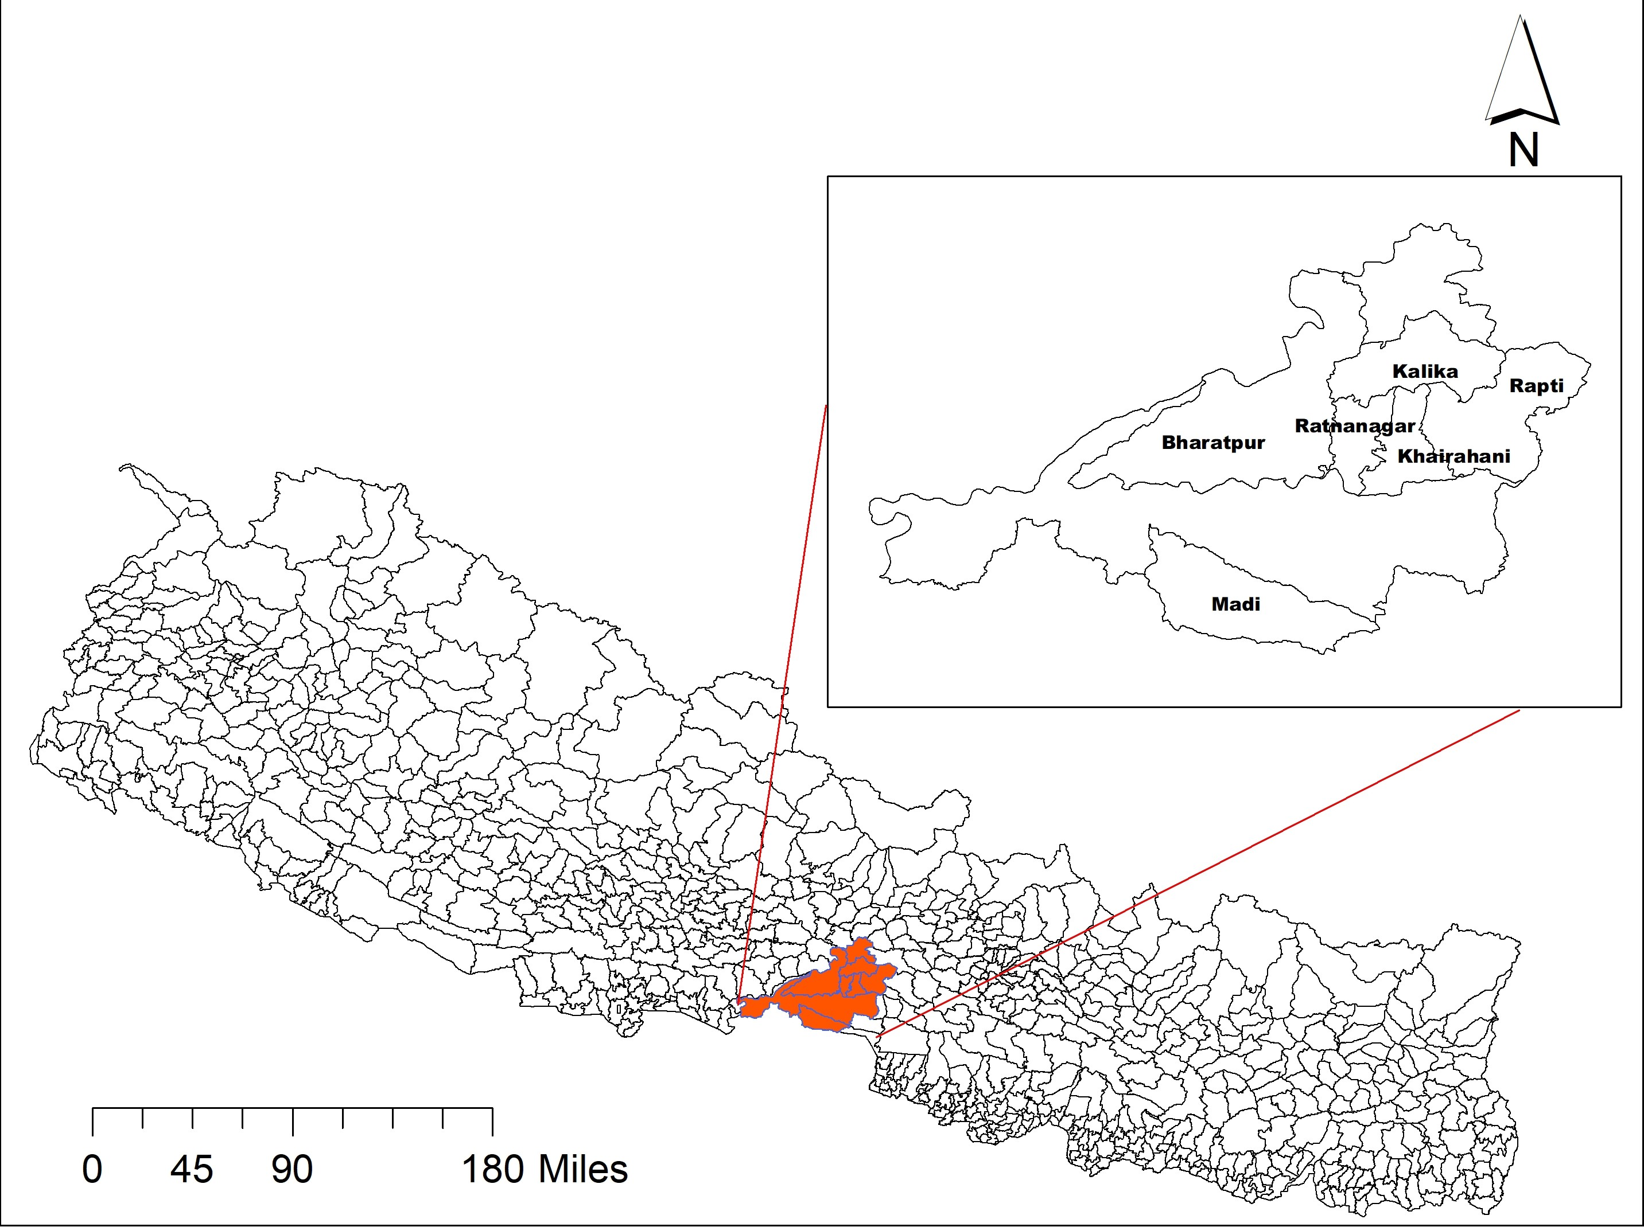

**Figure 1: Study area with municipalities under study**

Both primary and secondary sources of data were used for this study. Household surveys, Focus Group Discussions (FGDs), Key Informants Interviews (KIIs), and field observation were primary sources of data. Secondary data sources were reports from governmental organizations mainly the Central Bureau of Statistics (CBS), scientific articles, and reports.

The study population consisted of farming households from six municipalities. Farmers lists from each municipality served as the sampling frame. Samples from each municipality were developed as a stratum. Based on the sampling frame provided by municipalities, stratified random sampling was used to select the household for the survey.

Household numbers of each municipality were used to calculate the sample size. Central Bureau of Statistics (CBS) reports and municipality profiles were used to find household numbers, which were considered as the study population.To determine the sample size for each municipality, assuming homogeneity within the sample, the following formula for calculating the sample size for a finite population was used as given by Kothari (2004). $$n=\frac{N.Z^{2}.p.(1-p)}{{E². \left(N-1\right)+Z^{2}.p.(1-p)}^{ }}$$

Where n is the sample size, N is the population size of the study. Z is the Z-score (e.g., 1.96 for a 95% confidence level), p is the estimated proportion of the population (e.g., 0.5 for maximum variability). E is the margin of error (e.g., 0.05 for 5%). By using these values in the formula, the required sample size for household survey was calculated for each municipality. By summing the sample size of all municipalities, the total sample size became approximately 384.

A survey in 384 households and FGDs in 12 locations were carried out, with two from each municipality under study. Land leasing practice, and causes of low cropping frequency were the main topics of discussion for FGD. A FGD of 5 to 10 people were purposively selected including community leaders, farmers group leaders, Agriculture Knowledge Centre extension professionals, agro-vet owner, municipality extension agents, and the Prime Minister Agriculture Modernization Project (PM-AMP) extension professionals. The selection criteria were based on participants’ engagement in agricultural development work, knowledge and experience in observing agricultural land use over different time periods.

Information on the overall change on agricultural land use, land leasing model, cropping frequency, its trends and causes, development of market centers and its effect, access to irrigation sources, wildlife effect on land use, off-farm income, and migration status were collected for qualitative analysis. All these components were taken into consideration for in-depth analysis. Key informant interviews (KIIs) were conducted to collect information from a wide range of people, including community leaders, extension professionals, senior citizens, and local residents who have firsthand knowledge about agricultural activities. Field observation was also employed as a method of data collection to observe the land use pattern of the study sites. Ngalim and Edgar (2022) also used similar methodology to analyze the determinants of land use change.

**Determinants of agricultural land intensification**

Agricultural land use intensity refers to how frequently farmland is cultivated (Boserup, 1965). The cropping frequency was used to explore the intensity of land use (Boserup 1965; Jiang et al. 2013; Khatiwada et al., 2017). The number of times crops were cultivated in the same piece of land in 2020 was considered as cropping frequency in this study.

Throughout the survey, we observed limited instances of single cropping cycle and identified very few households with four cropping frequencies. Therefore, in our study, we categorized cropping frequency into only two groups: less than or equal to two crops was considered as low cropping frequency, whereas more than two crops within a calendar year were considered as high cropping frequency.

Statistical analysis was conducted using R Studio version 4.3.3. We used a binary logistic regression to understand the drivers of cropping frequency. Cropping frequency was used as a dependent variable and the following independent variables were taken:

Logit (P(cropping frequency=1))=β0+ β 1(Agexpyears) + β2 (Familyno) + β3 (hometomarketdistance) + β4 (homelanddistance)+…….. +β11 (Landoperation) where P (cropping frequency=1) represents the probability of high cropping frequency.

**Table 1: Name of predictor variables**

|  |  |
| --- | --- |
| **Variables** | **Definition** |
| Years of experiences | Farming experience in years |
| Primary occupation | Primary occupations of households heads have been categorized as agriculture, remittance, job, business, and wages ( agriculture as a reference category) |
| Household size | Small (Mean family no.- s.d), medium (Mean) and large (Mean+s.d) |
| Sources of Irrigation | Ground water, Canal, and Rainfed (Rainfed as reference category) |
| Livestock holding | Rearing of livestock, yes or no (yes-reference category) |
| Non-farm income | Non-farm income source, yes or no (reference category) |
| Land ownership | Land ownership has been categorized as own land, others land and having both-own land and other’s land (own land as reference category) |
| Home to land distance | Home to land distance in kilometer |
| Parcel number | Number of land parcels owned by the households |
| Market distance | Home to market distance in kilometer |
| Migrants in house | Household members migrate or not (yes, reference category) |

**RESULTS AND DISCUSSIONS**

The majority of the respondents (65.10%) were engaged in agriculture, 11.46% of the respondents were found to be engaged in wage-based occupation, whereas 8.33% were engaged in jobs, 8.1% engaged in business, and 7% were engaged in abroad employment, as depicted in Figure 2. Jobs include service in government and non-government organizations; wage include skilled and unskilled labor, and business includes service, trade, construction, electricity, accommodation, and food service.

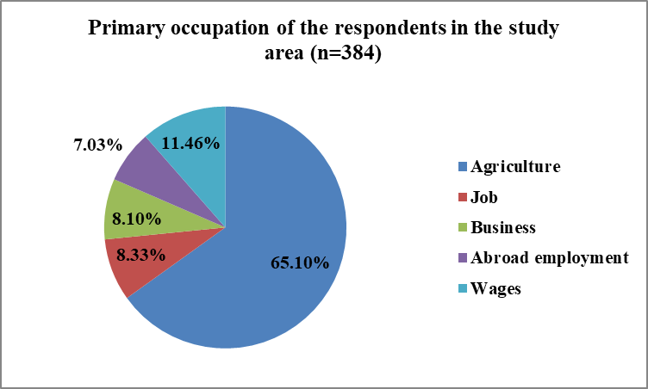

**Figure 2: Primary occupation of the respondents in the study area**

About 57 % of people in Nepal engaged in agriculture, whereas it is 47.4% in Chitwan. In Bharatpur Municipality of Chitwan district, it is 40.3%, followed by 60.9, 53.1, 39.4, 56.5, and 77.5% in Rapti, Kalika, Ratnanagar, Khairahani, and Madi, respectively (CBS, 2021). As this research basically focused on agricultural households, this could be the reason for the high percentage of people engaged in agriculture.

The standard deviation (1.73) and mean (4.47) were used to categorize the size of the households. A household is categorized as small if it has fewer than 3 members (< mean-SD), large with more than 6 members (> mean + SD) and medium for household size range from 3 to 6. CBS (2021) reported that the average household size of Chitwan is 4.01, where Bharatpur, Rapti, Kalika, Ratnanagar, Khairahani, and Madi municipalities have, 3.82, 4.38, 4.26, 4.01, 4.11, and 3.78, respectively. The average household size (4.47) in the study is more or less similar to the national average (4.38), and the average household size of an agricultural farm family was 4.71 (CBS, 2021).

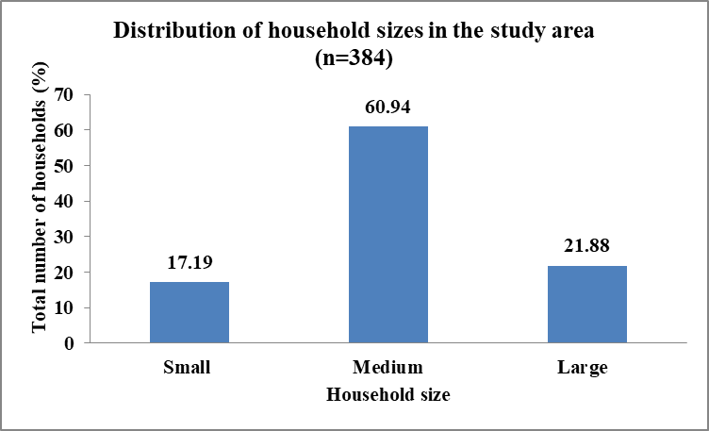

**Figure 3: Distribution of the household sizes in the study area**

Another predictor variable is irrigation sources. Figure 4 shows the distribution of major irrigation sources in the study area. Groundwater sources (50.3%) were the most common for irrigation, followed by canal (28.6%), and rainfed (21.1%).

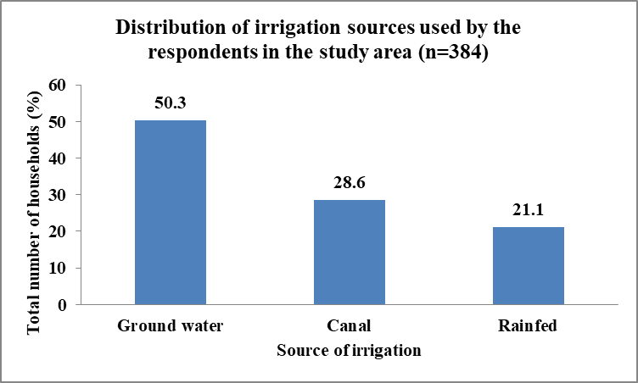

**Figure 4: Distribution of irrigation sources used by the respondents in the study area**

Figure 5 shows that 56.5% of the respondents cultivate on their own land, whereas nearly 35 % of the respondents use both their own and others’ land for cultivation, and about 9% of the respondents cultivate on others land.

**Figure 5: Status of land ownership among the households in the study area**

Table 2 shows the distribution of respondent households based on livestock holdings, non-farm income, and migrants at home. The majority of the respondents had livestock (68%) and non-farm income (67%). It is reported that about 26% of Nepalese farmers depend on off-farm activities (CBS, 2021). Further, our study revealed that 23.7% of households had migrants in their homes.

**Table 2: Description of the predictor’s categorical variables**

|  |  |  |
| --- | --- | --- |
| **Livestock holding** | **Frequency** | **Percentage (%)** |
| Yes | 262 | 68.22 |
| No | 122 | 31.78 |
| **Non-farm income** |  |  |
| Yes | 257 | 67 |
| No | 127 | 33 |
| **Migrants in house** |  |  |
| Yes | 91 | 23.7 |
| No | 293 | 76.3 |

As depicted in Table 3, the mean years of experience in farming of the respondent is nearly 31%, with a standard deviation of 17.10, indicating a wide range of farming experiences. The data showed that, on average, farmers were 11.7 kilometers away from the main market center.

**Table 3: Description of the predictors continuous variables (n=384)**

|  |  |  |
| --- | --- | --- |
| **Category** | **Mean** | **Standard deviation** |
| Years of farming experience | 30.90 | 17.10 |
| Home to market distance | 11.70 | 11.66 |
| Parcel number | 2.23 | 0.96 |
| Home to land distance | 0.68 | 0.75 |

The mean value of parcel number shows that most of the farmers owned more than two parcels. Likewise, the average distance from home to land is 0.68 kilometers. However, the high standard deviation suggests that some farmers lived significantly farther from their farmland.

**Table 4. Factors influencing the cropping intensity adopted by farming households (Results from logistic regression)**

|  |  |  |  |  |
| --- | --- | --- | --- | --- |
| **Categories** | **Coefficient** | **Std. Error** | **Z- value** | **P- value** |
| (Intercept) | 2.69 | 0.72 | -3.77 | <0.001**\*\*\*** |
| Agriculture experience years | 0.01 | 0.008 | 1.641 | 0.100 |
| Familyno_category(medium) | 1.38 | 0.42 | 3.288 | 0.001 **\*\*\*** |
| Familyno_category (large) | 0.59 | 0.51 | 1.152 | 0.249 |
| Home to market distance | -0.0006 | 0.01 | -0.066 | 0.947 |
| Home to land distance | -0.39 | 0.15 | -2.547 | 0.010 **\*** |
| Parcel number | -0.57 | 0.16 | -3.649 | <0.001**\*\*\*** |
| Primary occupation- job | 0.03 | 0.55 | 0.057 | 0.954 |
| Primary occupation- business | 0.34 | 0.53 | 0.634 | 0.526 |
| Primary occupation-abroad employment | 0.63 | 0.61 | 1.021 | 0.307 |
| Primary occupation-wages | -0.19 | 0.46 | -0.420 | 0.674 |
| Livestock- no | 0.07 | 0.30 | 0.234 | 0.815 |
| Migrants in house- yes | -0.14 | 0.34 | -0.405 | 0.685 |
| Non-farm income- no | 0.49 | 0.28 | 1.76 | 0.078 |
| Irrigation source- groundwater | 2.26 | 0.39 | 5.73 | <0.001**\*\*\*** |
| Irrigation source- canal | 1.62 | 0.43 | 3.797 | <0.001**\*\*\*** |
| Land operation- other’s | 0.98 | 0.46 | 2.140 | 0.032 **\*** |
| Land operation- both | 1.05 | 0.32 | 3.290 | 0.001 *** |

Significant codes:  ‘***’ .001 ‘**’ .01 ‘*’ .05

McFadden's pseudo R-squared was used to evaluate the model's goodness of fit. A moderate fit is suggested by the model's 0.21 value, which shows that it accounts for about 21% of the variation in the dependent variable. Seven categorical and four continuous independent variables were retained by the model. In addition, area under the curve (AUC) is found to be 0.79, indicating a good model fit with high predictive accuracy. We further tested for multicollinearity among independent variables using the Variance Inflation Factor (VIF). The VIF for all variables under study was below 5. It indicated that the model was free from multicollinearity.

High cropping frequency is significantly influenced by the size of the household, home to land distance, parcel number, irrigation source, and land operation. Farming experience and livestock holding of the households positively associated with high cropping frequency. In contrast, home to market distance, home to land distance, migration in household and number of parcel land are negatively associated with the high cropping frequency.

Although farming experiences have a positive association, the effect is not significant on higher cropping frequency. The result depicts that about 60% of the respondents in the study area belong to the medium-sized category with an average of four household members. The medium sized families are more likely to have higher cropping frequency compared to households with smaller families. Though large family size has a positive relation its effect is not significant for higher cropping frequency. This implies that increasing the number of family sizes would not increase the cropping frequency significantly, which may be due to the availability of diverse income sources in larger family size.

Similarly, the study shows that the respondent households’ occupation has no significant effect on cropping frequency. Distance from home to farmland has a significant negative effect on higher cropping frequency (p=0.01). As the distance increases, farmers have to spend much time, which may increase the unwillingness to cultivate crops more frequently, thereby reducing the cropping frequency and ultimately productivity. Land that is far away from home results in low cropping intensity. Due to the longer distance from home logistical difficulty causes farmers to decrease cropping frequency (Khatiwada et al., 2017). Similarly, home to market centre distance also plays a role in agriculture intensification, as Pingali et al. (1987) suggest an increase in agriculture intensification with the decrease in market distance. However, the study did not find a significant effect, which may be attributed to differences in urban city settings across locations. This study is in contrast with Khatiwada et al. (2017) as they report a significant negative impact of home to market distance with cropping intensity in Nepal.

The number of land parcels has a significantly negative impact on higher cropping frequency in the study. This finding is similar to findings by Shuhao (2005) and Jha et al. (2005) that state a greater number of land parcels increases the travel time between fields and requires more inputs such as labor and machinery for both agricultural land preparation and harvesting periods. In Nepal, land fragmentation often stems from traditional inheritance practices, where parental properties are divided equally among sons (Sapkota, 2004). Similarly, Khadka (2021) and Rahman and Rahman (2009) concluded that land fragmentation reduces productivity and efficiency. Overall the increase in production cost leads to fragmented land fallow and unmanaged (Valtiala et. al, 2023). In addition, land fragmentation limits the ability to grow profitable crops on large farms and forces small plots to cultivate less profitable crops (Ntihinyurwa et al., 2019). Furthermore, fragmented and smaller landholdings, limits the capacity for farm expansion and intensification (Urfels et al., 2023).

It is considered a significant barrier to agricultural mechanization, resulting in inefficiencies in production and incurring substantial costs to mitigate its effects, particularly in countries like Nepal (Niroula & Thapa, 2007; Niroula & Thapa, 2005). Small and fragmented plots are often left fallow or poorly managed, reducing overall agricultural productivity. Furthermore, without coordinated land pooling or consolidation efforts, as pointed out by Sharma (2018), farmers face challenges to maximize the use of their land.

Furthermore, livestock holding is not a strong predictor of cropping frequency. Similarly, migrants in the house also had a non-significant effect in the study area, a result similar to Khatiwada et al. (2017). Besides, families with higher non-farm income might have higher cropping frequency, as the p-value is just above the standard 0.05 threshold; so, it is considered marginal. A study by Ango et al. (2014) reported similar results. Regarding land ownership, respondents owning both their own land and others’ land has a significant effect on higher cropping frequency (p=0.001), indicating that households engaged in this type of land operation are more likely to crop frequently. The increasing extent of the complex system of land ownership, land and political instabilities also acted as drivers of farmland underutilization in Nepal (Chaudhary et al., 2020).

The study shows that irrigation sources such as groundwater and canals can increase the likelihood of higher cropping frequency. Malla and Karki (2016) and Nepal and Thapa (2009) also pointed out ground water is the major source of livelihood for Terai people. This indicates the households with access to ground water irrigation sources are more likely to have higher cropping frequency. Canal irrigation also showed a positive effect on higher cropping frequency (p<0.001). Similar to groundwater, access to the canal significantly increases the likelihood of higher cropping frequency, though its effect is comparatively smaller than that of groundwater.

According to the Agricultural Census (2021/22), over 70% of agricultural holdings in Chitwan use irrigation, with the main sources of Narayani Lift Irrigation System, Rapti River and several others such as the Kayar, Pampha, Lothar River systems (CBS, 2021). Additionally, deep and shallow tube wells are introduced in government subsidy programs, because of which successful cultivation of maize, paddy, mustard, and off-season crops are being cultivated. Availability of group water is the major factor in agricultural intensification, as it can be used whenever required (Raut et al., 2011; Nepal & Thapa, 2009).

To explore agricultural intensification, we conducted focused group discussions with the farmers, agriculture extension agents, and local community leaders. Based on FGDs, it was found that the introduction of commercial banana farming in Eastern Chitwan, particularly the northern part of Ratnanagar, Khairahani, Rapti and Kalika Municipalities has intensified land use. Increased availability of irrigation facilities in the previously underutilized land has increased the cropping frequency. Over the last 20 years, there has been considerable improvement in different sources of irrigation infrastructure, including construction of new canals, deep borings and pump-set irrigation. Through the initiative of the East Rapti irrigation project, the old irrigation system has been renovated (Adhikari, 2002).

KIIs and FGDs were also used to explore the factors that limit the frequency of cultivation. The causal flow diagram of low cropping intensity in Figure 6 shows different factors that limit the frequency of crop cultivation. Limited access to reliable irrigation sources, land fragmentation, and migration are the key causes of low cropping intensity. Additionally, long distance to market, competing non-farm income sources were found to be discouraging factors for higher cropping frequency. Moreover, land ownership patterns, land leasing, and engagement in non-farm activities tend to have lower cropping intensity. To increase the cropping frequency and agricultural intensification, those elements need to be considered, which were perceived as a barrier based on both quantitative and qualitative analysis in our study.

Key Informant Interviews (KIIs) with farmers of Khairahani and Ratnanagar, along with field observation revealed that government regulation, people awareness and their voices have led to the displacement of about 30 brick kilns, occupying about 200 ha of land reverting back to cropland in Eastern Chitwan. Field observation revealed that the increase in land area of spring rice, winter maize, and polyhouse culture for vegetable farming is now evident in numerous places in Chitwan, indicating the commercialization of agriculture.

One of the key factors of agricultural land use change is land tenure security threat, making it difficult for the government to plan and implement sustainable land use policies (Nepal & Marasini, 2018). Lack of clarity on land use policy leads to weak implementation, affecting food security, sustained food supply, and economic stability (FAO, 2020). However, the recent reform in land tenure security rights has resolved the land tenure security of landowner to some extent.

Marginal land cropping frequency was found to be lower as it is less fertile and low in productivity (Edrisi & Abhilash, 2016; Lal, 1991; FAO, 1976). Food security has faced significant challenges due to barren and marginal lands in Nepal that are not in use for farming (Timilsina et al., 2019). It is widely recognized that farmers often engaged in more intensive cultivation on higher quality land because of the potential for greater benefits (Haiguang & Xiubin, 2011). Political transition and federalism-led institutional development has established new urban centers (Devkota et al., 2023), leaving land underutilized. The trend of out migration is creating a labor shortage which is one of the major reasons for decreasing cropping intensity (Khatiwada et al., 2017).

To overcome the constraints of working on small farms, households are increasingly supplement farming with non-farm jobs (Sharma et al., 2020). In addition to farming, off-farm income, particularly remittance, had a profound impact on agricultural land use. As younger generations migrate for better economic opportunities, agricultural labor shortages have increased (Bhandari, 2019; Hussain et al., 2016; Paudel et al., 2014). According to the fourth Nepal Living Standard Survey (2022/23), 76.8% of households in Nepal received remittances. Remittance has changed consumption behavior and investment in non-farm businesses (Chapagai et al., 2023; Bhandari, 2019). Although migration is considered as one of the major reasons for agricultural land use change, our study showed that there is no significant impact of migration on cropping intensity, which is in line with Maharjan et al. (2020).

Land adjacent to Chitwan National Park (CNP) and community forest being left temporary fallow due to wildlife encroachment (Timilsina et al*.,* 2022). Wild-life induced crop loss is one of the crucial reasons for low cropping frequency near CNP and its buffer zone. Farmlands near CNP and community forest are particularly vulnerable to wildlife damage (Khatri et al., 2024; Timilsina, et al., 2019; Gillingham & Lee, 2003). Animals such as rhinoceros, wild boar, deer, elephants, and cheetal cause major damage to crops (Bhusal et al., 2024; Nyirenda et al., 2018; Hua et al., 2016). Wildlife interference has reduced farmers’ willingness to cultivate multiple seasons leading to underutilization of land (Wangchuk et al., 2023; Dahal et al., 2020). Furthermore, a notable shift in farming to non-farm activities has been documented in recent years (Chhetri et al., 2023; Sugden et al., 2022). As a result, many farmers relocate to safer areas or shift to lower-risk crops, significantly limiting agricultural productivity in these regions.

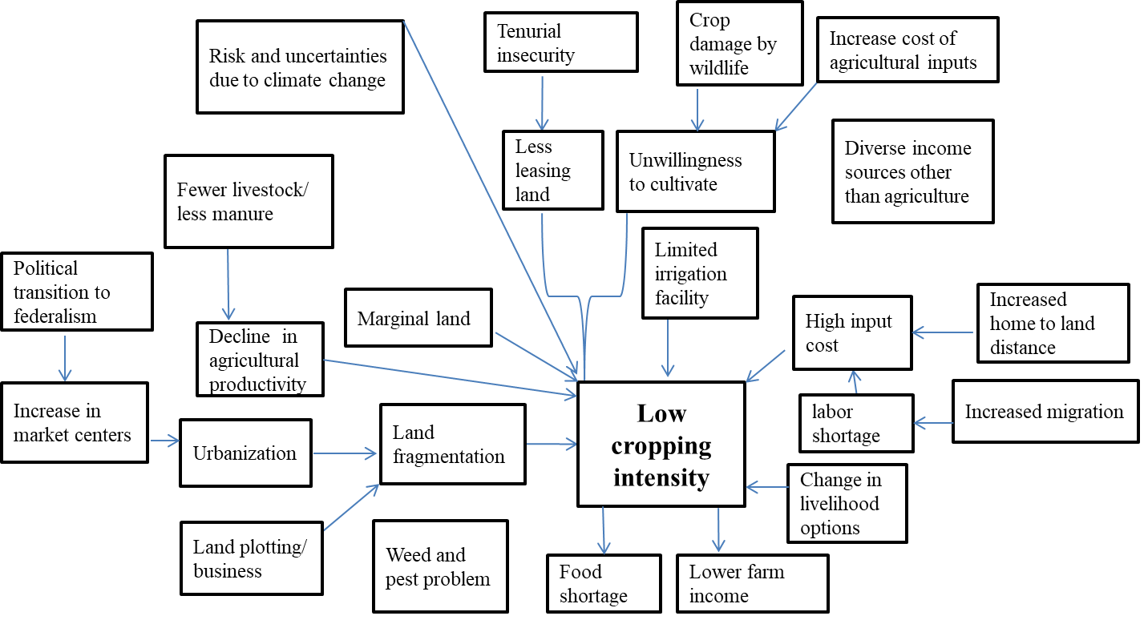

Source: (Developed by authors based on FDG and KII, 2021)

**Figure 6: Causal diagram of low cropping intensity showing a visual representation of how different factors are interconnected resulting in low land use intensity.**

**Land leasing dynamics in the study area**

The practice of land leasing was found more prevalent in the study area (Figure 5). The major driving factors for land leasing practice in the study area may be a result of the better transportation system, indicating commercialization of agriculture. As farmers have easy access to markets and resources, particularly in Bharatpur, Ratnanagar, and Khairahani due to the developed road network, has encouraged land leasing. A pilot study of Chitwan documented that 66% of land holdings are self-owned in Chitwan, while 30% consist of both self-owned and others’ land (CBS, 2019). The four different land leasing models depicted in Figure 7 was developed based on the FGDs and KII with the respondents in the study area trying to explore the factors driving land leasing in Chitwan, which outlined the major prevailing leasing systems. Moreover, these models investigate the financial implications of the new sharecropping practices, particularly how agricultural input costs, such as fertilizers, pesticides, tillage, and irrigation, are shared.

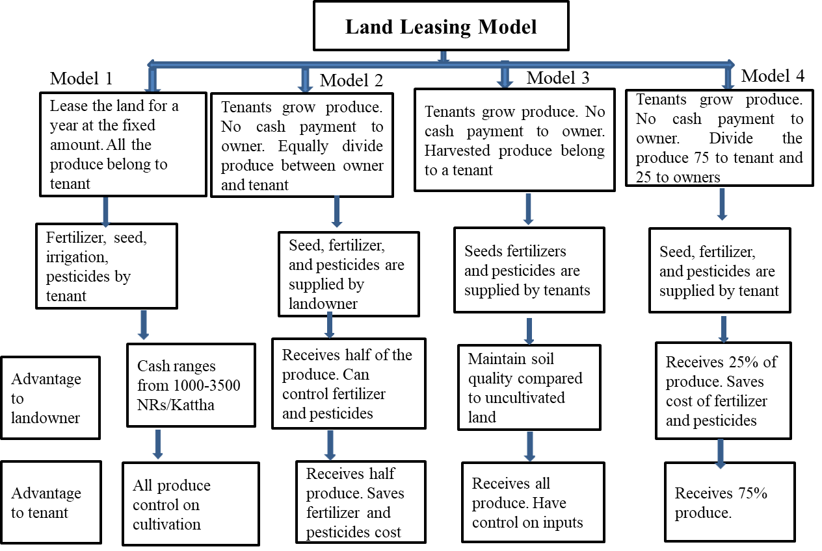

Source: (Developed by authors based on FGD and KII, 2021)

**Figure 7: Land leasing dynamics of Chitwan district based on FGD and KII**

Among the four conditions of land leasing for agricultural practices, the most common include a land leasing agreement on paying in cash to the landowner (Model 1). In this model, tenants are responsible for providing all necessary inputs. FGDs and KIIs found that the rate for one Kattha (0.012ha) leasing ranges from 1000 to 3500 NRs depending upon the fertility of soil, accessibility of irrigation, and road. As per the CBS (2021) report, the most popular rental practice in Chitwan is a fixed monetary payment, accounting for 73% of leases, whereas only 5.4 % is leased with sharecropping.

The next is equal crop sharing (Model 2) between tenants and landowners. However, this practice is in a decreasing trend due to the high cost of agricultural inputs, labor, and low profitability. The third one is, harvested produce belonging to tenants (Model 3) and in Model 4, tenants get 75% and land owners get only 25% share of the produce. As depicted in model 2 and 4, the harvested produce is shared between the tenants and the land owners according to the agreed terms that can vary in different situations and time. According to the National Sample Census of Agriculture (2021/22), a total of 28,531 hectares of land is leased for farming under various agreements. Out of this, 41.7 % of the land is leased under a produce sharing agreement, while 30.4 % is leased with cash payment.

Several factors drive a change in land leasing practices. The risk of losing control over land under formal agreement of land tenancy has been a key barrier to landowners’ reluctance to be on farms (Community Self-Reliance Centre, 2024), though recent land rights has eased the issue to some extent. In addition, the increasing cost of inputs as compared to the return from the farm poses a risk among landowners to keep engaged in farming (Dhakal & Khanal, 2018). Financial risks are faced by both owners and tenants, where owners ask for more share of the harvest and payments, and tenants have to manage the inputs effectively to benefit from the farm.

**CONCLUSION**

Agricultural land use intensification in Terai area is driven by access to perennial sources of irrigation, land leasing practices, family size, while home-to-farm distance and land fragmentation contributes to reducing cropping frequency. Urbanization, labor shortages, and wildlife-induced damage contribute to land underutilization. Shifting sharecropping practices place greater financial risks on tenants due to land tenure uncertainties and rising input costs.

People engaged in off-farm employment opportunities, high cost of agricultural inputs, low livestock rearing trend were also found discouraging factors for agricultural land use intensification. Policy interventions should prioritize irrigation expansion, land consolidation, and strategies to address wildlife damage to crop and labor shortages to sustain agricultural productivity. Access to infrastructure, mainly roads, should be improved to make both land and market accessible. It is recommended to develop local context-specific land tenure policy that will encourage both tenants and land owners to optimize land use and secure long-term land contract. Researches on effective crop protection measures from-wild life is recommended to increase land use intensity. Further research should also focus on how peri-urban region like Chitwan land can be used sustainably.

Disclaimer (Artificial intelligence)

Author(s) hereby declare that NO generative AI technologies such as Large Language Models (ChatGPT, COPILOT, etc.) and text-to-image generators have been used during the writing or editing of this manuscript.

**REFERENCES**

Adhikari, K. R. (2002). Diagnosis of the East Rapti river basin of Nepal. In integrated water-resources management in a river-basin context: Institutional strategies for improving the productivity of agricultural water management. Proceedings of the regional workshop, Malang, Indonesia, January 15-19, 2002, Colombo, Srilanka, International Water Management Institute.

Ango, A. K., Ibrahim, S. A., Yakubu, A. A., & Usman, T. (2014). Determination of socio-economic factors influencing youth rural-urban migration in Sokoto State, Nigeria. *Journal of Human Ecology*, *45*(3), 223-231.

Bhandari, P. (2019). Rural households' allocation of remittance income in agriculture in Nepal. *Global Journal of Agricultural and Allied Sciences*, *1*(1), 1-10. <https://doi.org/10.35251/gjaas.2019.001>

Bhushal, G., Wolde, B., & Lal, P. (2024). Human-wildlife conflict and the likelihood of reporting losses in Nepal. *Trees, Forests and People*, *15*, 100512.

Boserup, E. (1965). 1965: The conditions of agricultural growth: the economics of agrarian change under population pressure. London: Allen and Unwin. *P. BOYD, J.*, *124*, 1982. <https://doi.org/10.4324/9781315070360>

CBS. (2006). Agriculture Monograph. Central Bureau of Statistics. Government of Nepal. P8.

CBS. (2019). Pilot Agriculture Integrated Survey 2019, Chitwan. Central Bureau of Statistics.  Government of Nepal.

CBS. (2021). National Report**.** National Population and Housing Census 2021. National Statistics Office. Government of Nepal. <https://censusnepal.cbs.gov.np>.

Chapagai, S. D., & Ghimire, K. P. (2023). Unraveling the Effect of Remittance on Nepal's Agricultural GDP. *Economic Review of Nepal, 6*(1), 16-26. https://doi.org/10.3126/ern.v6i1.67968

Chaudhary, S., Wang, Y., Dixit, A. M., Khanal, N. R., Xu, P., Fu, B., ... & Li, M. (2020). A synopsis of farmland abandonment and its driving factors in Nepal. *Land*, *9* (3), 84. <https://doi.org/10.3390/land9030084>

Chhetri, R., Yokying, P., Smith, A., Van Den Hoek, J., Hurni, K., Saksena, S., & Fox, J. (2023). Forest, agriculture, and migration: contemplating the future of forestry and agriculture in the middle-hills of Nepal. *The Journal of Peasant Studies*, *50*(1), 411-433. <https://doi.org/10.1080/03066150.2021.1978983>

Community Self-Reliance Centre. (2024). Land tenure security in Nepal: A discussion paper for ADB. Asian NGO coalition for Agrarian Reform and Rural Development (ANGOC). Paper prepared for the project mainstreaming land rights in the Asian Development Bank with the financial support of fair Finance Philippines (FFPh) through the initiatives for dialogue & empowerment through alternative legal services, Inc. (IDEALS).

Dahal, G. R., Pandit, B. H., & Shah, R. (2020). Abandoned agricultural land and its reutilization by adoption of agroforestry: A case study from Kaski and Parbat Districts of Nepal. *Journal of Forest and Livelihood, 19* (1), 1-16.

Devkota, P., Dhakal, S., Shrestha, S., & Shrestha, U. B. (2023). Land use land cover changes in the major cities of Nepal from 1990 to 2020. *Environmental and Sustainability Indicators*, *17*, 100227.

Dhakal B.N, & Khanal, N.R. (2018). *The Geographical Journal of Nepal,11*, 95-112, 2018 Central Department of Geography, Tribhuvan University, Kathmandu, Nepal.

District Profile Chitwan. (2072). Government of Nepal Ministry of Agriculture & Livestock Development Planning & Development Cooperation Coordination Division Statistics and Analysis Section Singhdurbar, Kathmandu, Nepal.

Edrisi, S. A., & Abhilash, P. C. (2016). Exploring marginal and degraded lands for biomass and bioenergy production: An Indian scenario. *Renewable and Sustainable Energy Reviews*, *54*, 1537-1551. <https://doi.org/10.1016/j.rser.2015.10.050>

FAO. (1976). A framework for land evaluation. Food and Agriculture Organization of the United Nations Rome. http://www.fao.org/3/x5310e/x5310e00.htm

FAO. (2020). Impact of COVID-19 on agricultural and food systems in Nepal. United Nations Food and Agriculture Organization. Retrieved from FAO.org. https://doi.org/10.5814/j.issn.1674-764x.2020.01.009

Gillingham, S., & Lee, P. C. (2003). People and protected areas: a study of local perceptions of wildlife crop-damage conflict in an area bordering the Selous Game Reserve, Tanzania. *Oryx*, *37*(3), 316-325. doi:10.1017/ S0030605303000577

GoN. (2023). National report: National Sample census of Agriculture 2021/22. Office of the prime minister and council of ministers, National statistics office, Kathmandu, Nepal.

Government of Nepal. (2019). Land Use Act 2019. Government of Nepal. Kathmandu, Nepal. Available online: https://molcpa.gov.np/department/page/555 (accessed on 2 January 2025).

Haiguang, H., & Xiubin, L. (2011). Agricultural land use intensity and its determinants in ecologically-vulnerable areas in North China: A case study of Taipusi County, Inner Mongolia Autonomous Region. *Journal of Resources and Ecology, 2*(2), 117-125. https://doi.org/10.3969/j.issn.1674-764x.2011.02.003

Hua, X., Yan, J., Li, H., He, W., & Li, X. (2016). Wildlife damage and cultivated land abandonment: Findings from the mountainous areas of Chongqing, China. *Crop Protection, 84,* 141–149. doi:10.1016/j.cropro.2016.03.005

Hussain, A., Rasul, G., Mahapatra, B., & Tuladhar, S. (2016). Household food security in the face of climate change in the Hindu-Kush Himalayan region. *Food Security, 8*, 921-937.<https://doi.org/10.1007/s12571-016-0607-5>

Jha, R., Nagarajan, H. K., & Prasanna, S. (2005). Land fragmentation and its implications for productivity: evidence from Southern India. ASARC Working Paper 2005/01, Australia South Asia Research Centre, RSPAS, Division of Economics, Australian National University, Canberra, ACT 0200, Australia

Jiang, L., Deng, X., & Seto, K. C. (2013). The impact of urban expansion on agricultural land use intensity in China. *Land Use Policy, 35*, 33-39. <https://doi.org/10.1016/j.landusepol.2013.04.011>

Khadka, S., Gyawali, B. R., Shrestha, T. B., Cristan, R., Antonious, G., & Poudel, H. P. (2021). Exploring relationships among land ownership, landscape diversity, and ecological productivity in Kentucky. *Land Use Policy*, *111*, 105723. <https://doi.org/10.1016/j.landusepol.2021.105723>

Khatiwada, S. P., Zhang, J., Su, Y., Paudel, B., & Deng, W. (2017). Agricultural land use intensity and determinants in different agro ecological regions in Central Nepal Himalaya. *Land Cover Change and its Eco-Environmental Responses in Nepal; Li, A., Deng, W., Zhao, W., Eds*, 281-305.

Khatri, D., Paudel, D., Poudyal, B. H., Khatri, S., Poudel, D. P., & Marquardt, K. (2024). Examining socio‐ecological transitions and new human–wildlife relations in farming landscapes of the Nepal Himalaya. *Journal of Agrarian Change, 24*(4), e12594. <https://doi.org/10.1111/joac.12594>

Kothari. (2004). Research methodology: Methods and techniques, Second Revised Editions; New Age International (P) Limited, Publishers 4835/24, Ansari Road, Daryaganj, New Delhi-110002.

Lal, R. (1991). Tillage and agricultural sustainability. *Soil and Tillage Research, 20*(2-4), 133-146. https:// [doi.org/10.1016/0167-1987(91)90036-W](http://doi.org/10.1016/0167-1987(91)90036-W)

Maharjan, A., Kochhar, I., Chitale, V. S., Hussain, A., & Gioli, G. (2020). Understanding rural outmigration and agricultural land use change in the Gandaki Basin, Nepal. *Applied Geography, 124,* 102278.<https://doi.org/10.1016/j.apgeog.2020.102278>

Malla, R., & Karki, K. (2016). Groundwater environment in Chitwan, Nepal. In Groundwater Environment in Asian Cities (pp. 47-75). Butterworth-Heinemann. DOI: [10.1016/B978-0-12-803166-7.00004-0](http://dx.doi.org/10.1016/B978-0-12-803166-7.00004-0)

MLRM. (2012). Nepal Land Use Policy 2012. Ministry of Land Reform and Management (MLRM), Kathmandu, Nepal.

National Urban Policy. (2007). Government of Nepal: Kathmandu, Nepal, 2007. Available online: https://www.moud.gov.np/storage/listies/May2023/national-urban-policy-2007-compressed.pdf (accessed on 12 January 2025).

Nepal H., & Marasini, A. (2018). Status of land tenure security in Nepal. *Geoinformatics 17*: 22-29.

Nepal, R., & Thapa, G. B. (2009). Determinants of agricultural commercialization and mechanization in the hinterland of a city in Nepal. *Applied Geography, 29*(3), 377-389. <https://doi.org/10.1016/j.apgeog.2008.12.002>

Ngalim, R. N. M., & Edgar, D. (2022). Analyses and determinants of land use-land cover dynamics in Dimako Sub-Division, East Region of Cameroon. *Asian Journal of Environment & Ecology*, *18*(1), 1–16. https://doi.org/10.9734/ajee/2022/v18i130301

Niroula, G. S., & Thapa, G. B. (2005). Impacts and causes of land fragmentation, and lessons learned from land consolidation in South Asia. *Land Use Policy*, *22*(4), 358-372. <https://doi.org/10.1016/j.landusepol.2004.10.001>

Niroula, G. S., & Thapa, G. B. (2007). Impacts of land fragmentation on input use, crop yield and production efficiency in the mountains of Nepal. *Land Degradation & Development, 18*(3), 237-248. https://doi.org/10.1002/ldr.771

Ntihinyurwa, P. D., de Vries, W. T., Chigbu, U. E., & Dukwiyimpuhwe, P. A. (2019). The positive impacts of farm land fragmentation in Rwanda. *Land Use Policy*, *81*, 565-581.

Nuissl, H., & Siedentop, S. (2021). Urbanization and land use change. In: Weith, T., Barkmann, T., Gaasch, N., Rogga, S., Strauß, C., Zscheischler, J. (eds) Sustainable land management in a European Context. *Human-Environment Interactions*, vol 8. Springer, Cham. https://doi.org/10.1007/978-3-030-50841-8_5.

Nyirenda, V. R., Nkhata, B. A., Tembo, O., & Siamundele, S. (2018). Elephant crop damage: Subsistence farmers’ social vulnerability, livelihood sustainability and elephant conservation. *Sustainability, 10* (10), 3572

Ojha, H. R., Shrestha, K. K., Subedi, Y. R., Shah, R., Nuberg, I., Heyojoo, B., ... & McManus, P. (2017). Agricultural land underutilization in the hills of Nepal: Investigating socio-environmental pathways of change. *Journal of Rural Studies*, *53*, 156-172. https://doi.org/10.1016/j.jrurstud.2017.05.012

Paudel, B., Pandit, J., & Reed, B. (2014). Fragmentation and conversion of agriculture land in Nepal and Land Use Policy 2012. The Munich Personal RePEc Archive, MPRA Paper No. 58880, https://mpra.ub.uni-muenchen.de/58880/

Paudel, D. B., & Saito, K. (2015). Impact of implementation of current land reform policy in Nepal. *The Japanese Journal of Rural Economics*, *17*, 35-39.

Paudel, K. P., Tamang, S., & Shrestha, K. K (2014). Transforming land and livelihood: Analysis of agricultural land abandonment in the Mid Hills of Nepal. *Journal of forest and Livelihood*, *12*(1), 9-9.

Pingali, P. L., Bigot, Y., & Binswanger, H. P. (1987). Agricultural mechanization and the evolution of farming systems in sub-Saharan Africa. ISBN (Hardback): 978-0-8018-3502-5

Rahman, S., & Rahman, M. (2009). Impact of land fragmentation and resource ownership on productivity and efficiency: The case of rice producers in Bangladesh. *Land Use Policy*, *26*(1), 95-103. <https://doi.org/10.1016/j.landusepol.2008.01.003>[Get rights and content](https://s100.copyright.com/AppDispatchServlet?publisherName=ELS&contentID=S0264837708000185&orderBeanReset=true)

Raut, N., Sitaula, B. K., Vatn, A., & Paudel, G. S. (2011). Determinants of adoption and extent of agricultural intensification in the central mid-hills of Nepal. *Journal of Sustainable Development*, *4*(4), 47. doi:10.5539/jsd.v4n4p47

Rimal, B., Zhang, L., Keshtkar, H., Wang, N., & Lin, Y. (2017). Monitoring and modeling of spatiotemporal urban expansion and land-use/land-cover change using integrated Markov chain cellular automata model. ISPRS *International Journal of Geo-Information*, *6*(9), 288.doi.org/10.3390/ijgi6090288

Sapkota, K. (2004). Gender perspectives on peri-urban agriculture in Nepal. UA-Magazine, 2004: 38-39.

Saqib, S. E., Kaleem, M., Yaseen, M., Yang, S. H., & Visetnoi, S. (2024). From green fields to housing societies: Unraveling the mysteries behind agricultural land conversion in Pakistan. *Land Use Policy, 144*, 107256.https://doi.org/10.1016/j.landusepol.2024.107256

Sharma, G. P. (2018). Innovative Agricultural Technologies in South Asia. SAARC Agriculture Centre, Dhaka, Bangladesh, 174p, 110.

Sharma, G. P., Pandit, R., White, B., & Polyakov, M. (2020). The income diversification strategies of smallholders in the hills of Nepal. *Development Policy Review*, *38*(6), 804-825.

Shuhao, T. (2005). Land fragmentation and rice production: A case study of small farms in Jiangxi Province, PR China. Wageningen University and Research. Wageningen University and Research ProQuest dissertations & theses, 2005. 30680249.

Sugden, F., Nigussie, L., Debevec, L., & Nijbroek, R. (2022). Migration, environmental change and agrarian transition in upland regions: Learning from Ethiopia, Kenya and Nepal. *The Journal of Peasant Studies*, *49*(5), 1101-1131. https://doi.org/10.1080/03066150.2021.1894552

Timilsina, R. H., Ojha, G. P., Nepali, P. B., & Tiwari, U. (2019). Agriculture land use in Nepal: prospects and impacts on food security. *Journal of Agriculture and Forestry University, 3*, 1-9.

Timilsina, R. H., Ojha, G. P., Nepali, P. B., & Tiwari, U. (2022). Contribution of marginal land and indigenous crops on food security: A case of eastern Chitwan, Nepal. *Journal of Agriculture and Forestry University*, 187-195.

Timilsina R.H., Ojha G.P., Nepali P.B., Tiwari, U. (2025). Landscapes in transition: A study of agricultural land use change in inner Terai of Nepal. *International Journal of Social Science and Management 12* (1): 46-59. DOI 10.3126/ijssm.v12i1.73583.

Upreti, B. R., Breu, T., & Ghale, Y. (2017). New challenges in land use in Nepal: Reflections on the booming real-estate sector in Chitwan and Kathmandu Valley. *Scottish Geographical Journal, 133*(1), 69-82. doi/full/10.1080/14702541.2017.1279680

Urfels, A., Mausch, K., Harris, D., McDonald, A. J., Kishore, A., van Halsema, G., ... & Krupnik, T. J. (2023). Farm size limits agriculture's poverty reduction potential in Eastern India even with irrigation-led intensification. *Agricultural Systems, 207*, 103618. https://doi.org/10.1016/j.agsy.2023.103618

Valtiala, J., Niskanen, O., Torvinen, M., Riekkinen, K., & Suokannas, A. (2023). The relationship between agricultural land parcel size and cultivation costs. *Land Use Policy, 131*, 106728.<https://doi.org/10.1016/j.landusepol.2023.106728>

Wangchuk, S., Bond, J., Thwaites, R., & Finlayson, M. (2023). Exploring human–wildlife conflict and implications for food self-sufficiency in Bhutan. *Sustainability, 15*(5), 4175

Xu, D., Deng, X., Huang, K., Liu, Y., Yong, Z., & Liu, S. (2019). Relationships between labor migration and cropland abandonment in rural China from the perspective of village types. *Land Use Policy, 88*, 104164.

Zhang, Y., Li, X., & Song, W. (2014). Determinants of cropland abandonment at the parcel, household and village levels in mountain areas of China: A multi-level analysis. *Land Use Policy, 41*, 186-192. <https://doi.org/10.1016/j.landusepol.2014.05.011>