Identification of areas influencing vulnerability to sedimentation in the bacon reservoir in south-eastern Côte d'Ivoire:A mapping approach.

ABSTRACT
Soil erosion and sediment transport are causes of reservoir storage capacity loss. This study addresses the issue of access to clean water in the Akoupé Bacon area of Côte d'Ivoire. The watershed of the study area accommodates a reservoir constructed to provide water supply to the populations of Bacon, Akoupé, and soon the municipality of Affery. In recent years, the water reservoir has been experiencing eutrophication and sedimentation phenomena.
These problems lead to a reduction in the water reservoir's storage capacity. The objective of this study is to map the vulnerability of the Akoupé-Bacon reservoir to sedimentation. The methodological approach is based on the development of a Geographic Information System (GIS) that integrates multi-source data (soil erodibility, rainfall erosivity, topographic slope, land use, and slope exposure) to establish a map of vulnerability to water erosion using an additive combination. Three vulnerability classes were distinguished: highly vulnerable areas (55.92%), moderately vulnerable areas (43.18%), and areas with low vulnerability, which are almost non-existent in the region (0.89%).
Thus, the moderately and highly vulnerable areas represent 99.1% of the region's total area. This map of reservoir sensitivity to sedimentation demonstrates that the Akoupé Bacon region is highly exposed to soil losses and, consequently, significant sedimentation in the reservoir.

Keywords: vulnerability, water erosion, GIS, Côte d'Ivoire, water reservoir.

1. INTRODUCTION

Soil erosion is an unavoidable natural phenomenon that becomes a serious environmental and economic problem when accelerated by human activities (Del Mar López and al, 1998). Demographic pressure and the extension of cultivation through various human activities such as farming practices, forestry, grazing, road and building construction, combined with the amplifying effects of climate change, lead to the exposure of land, and therefore to its degradation by water erosion (Vezena and Bonn, 2006; Boudhar and al., 2007). The impact of this erosion is mainly reflected in soil loss, sedimentation and a reduction in the storage capacity of surrounding reservoirs and watercourses. Sedimentation can also lead to the development of aquatic vegetation and pollution of the water body. This is the case of the Bacon dam in south-eastern Côte d'Ivoire. This hydraulic structure is at the heart of a drinking water distribution link covering the needs of the municipality and its surrounding area.
Over the past two decades, strong demographic growth and the expansion of the town have resulted in the banks of this reservoir being occupied, either for housing or for crop development. As a result, this previously isolated lake is now surrounded by urban areas. According to Kemka and al (2004), this situation in an urban environment predisposes the functioning of lakes to fairly frequent disturbances, making them vulnerable to human activity. Recent studies by Kouassi and al (2021) have shown that Lake Bacon is facing a siltation problem linked to these urban dynamics.
The aim of this study is to identify areas that are easily subject to erosion in the catchment area of the Bacon reservoir, so that measures can be taken to protect the reservoir from excessive sedimentation. It adopts a methodological approach based on GIS mapping, using multi-criteria analysis with weighting of factors integrating response to erosion sensitivity, such as soil erodibility, topographical slope, rainfall erosivity and land use.
According to Aké and al (2012), the map obtained is an essential tool in the fight against erosion and silting of the surrounding watercourses. It provides an overview of the areas at risk and pinpoints the sectors that require priority action with a view to the sustainable management of soils and watercourses.

2. MATERIAL AND METHODS
2.1 Presentation of the study area
The study area is located in the south-east of Côte d'Ivoire. It is approximately 146 km from the city of Abidjan and is bounded to the north-east by the department of Akoupé and to the south-west by the department of Affery.
From a hydrographic point of view, the Bacon reservoir sub-basin belongs to the Agneby basin (Fig.1). It has a surface area of ​​3.47 km² (347 Ha), and is located between Latitudes 6°20'0 and 6°22'39 N and Longitudes 3°54'10 and 3°55'30 W. Inside this basin a water reservoir has been built which measures approximately 1.6 km (Kouassi et al, 2021). This reservoir, commissioned in 1975 and which serves as a water intake for SODECI to supply drinking water to the commune of Bacon and Akoupé, is supplied by two seasonal tributaries.
Geologically, like all of eastern Côte d'Ivoire, the upper Agnéby basin which contains the study area is based on Precambrian formations, linked to the Birrimian stage, having undergone only slight metamorphism (Girard and al., 1971).
The vegetation in the basin is made up of dense rainforest (evergreen and semi-deciduous), cleared forest, swamp forest and very rarely savannah (Avenard et al.1971).
The population of the commune of Bacon, together with that of Akoupé, is estimated at 79,065, according to thegeneralcensus of the population and habitats (RGPH, 2021). Their economic activities are based on food crops (cassava, maize, yams, rainfed rice) and cash crops (sweet bananas, coffee, cocoa, oil palm and rubber trees), some of which are grown in the off-season and require irrigation (lowland rice, sweet bananas, aubergines and tomatoes).
The main soil units found in the catchment area are reworked and slightly indurated ferralitic soils and podzolic soils with gley (A. PERRAUD and P. de la SOUCHÈRE, 1971).

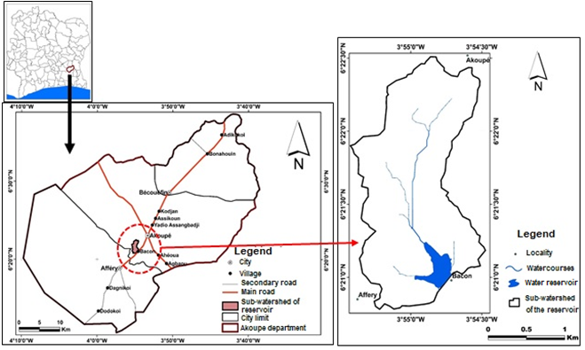
Fig.1. Map of the study area

2.2 Matériel
The material used in this study consisted of several data sets.
- Cartographic data

The data consists of a Shuttle Radar Topography Mission (SRTM) Digital Terrain Model (DTM) with 30m resolution, which can be accessed free of charge via the https://earthexplorer.usgs.gov/ website. It was used to determine the relief of the catchment area; pedological data obtained mainly from the 1/500,000 pedological sketch of Côte d'Ivoire (A. Perraud and P. DE LA Souchere, 1971); Landsat_8 OLI_TIRS satellite data from 07/01/2020 of scene 196-056 downloaded from the website: glovis.usgs.gov. This image was used to produce the land use map.
- Meteorological data
They consist mainly of monthly climate data (2002 to 2020) taken from the Climatic Research Unit (CRU) database and downloaded from the CRU website (www.cru.uea.ac.uk). These data have been used and validated by a number of authors, including Koua and al. (2014).
These multi-source data were processed using computer tools equipped with several software packages, calculation programs, graph construction, mapping and image processing. ENVI 4.5 software was used to process Landsat 8 satellite images to produce the land use map and ArcGIS 10.5 was used to produce and combine thematic maps using a GIS to produce the final map.

2.3 Method for assessing the vulnerability of reservoirs to sedimentation
Assessing the vulnerability of reservoirs to sedimentation involves evaluating the risks of erosion in the immediate and distant environment of reservoirs. In fact, water erosion caused by a combination of several factors accentuates soil degradation and causes serious and costly damage to hydraulic infrastructures. Sedimentation in dams is a recurrent example. Numerous models exist to assess the risks of erosion: Wischmeier and Smith (1958); De Jong and Riezebos (1997); Quinton (1997); Bou kheir and al. (2001) etc. This work is based on the classical factors of Wischmeier and Smith, (1958) used by Bou kheir and al, (2001) and which have been adapted to the specific conditions of the study region.

2.3.1 Identification of factors

The factors selected for the study region are: soil erodibility (K), topography (P), slope exposure (EP), land use (OC) and rainfall erosion (R). The risk of each factor is estimated using the multi-criteria analysis of Saaty (1977) in order to draw up maps of the reservoir's vulnerability to sedimentation.

Soil erodibility factor(Texture and structure) (K)

The concept of erodibility reflects a soil's susceptibility to erosion in relation to its intrinsic properties (Roose, 1994). Resistance to water erosion is lower for shallow soils than for deep soils (Ryan, 1982). This factor was established on the basis of the soil map of the region drawn up by A. Perraud and De La Souchere (1971).For better use, it has been subdivided into different resistance classes to which different scores have been assigned based on the work of Boughalem and al, (2012).

Slope factor (P)
When the slope is steep enough to allow water to run off, the land is vulnerable to water erosion (Bou kheir and al., 2001). The slope map generated from the digital elevation model (DEM) was reclassified on the basis of the Mayer (1995) classification. This classification has been used by several authors, including N'go (2000), Kouadio and al (2007), N'dri and al (2008) and Aké end al (2012). It differentiates between the following slope classes (Table 1)

Table 1 : Slope class according to Mayer (1995)
Slope interval (%) | Slope class
0 à 5 % | Gentle slope
5 à 15 % | Medium slope
15 à 50 % | Steep slope
> 50 % | Very steep slope

Erosivity of rain (E)
Aggressiveness can be characterised by its height, energy and intensity. In the study area, the high annual rainfall observed (mean annual rainfall = 1276.45 mm - Akoupé synoptic station, over the period 2002-2020) is likely to favour strong erosion. However, with only one rainfall station, it is impossible to spatialise rainfall erosion. It has therefore been assumed to be uniform across the zone. Given its importance in this process, it has been given a score of 4.

Land use(OC)
The land cover map was produced from the Landsat OLI image using supervised maximum likelihood classification (ENVI 5.4 software). This method is widely used and considered to be the most effective for producing land cover maps (Bonn and Rochon, 1992). The information gathered was then compared with the field data and the confusion matrix. Five classes were identified: 1) Dense forest; 2) Degraded forest; 3) Crops; 4) Habitats; 5) Bare soil, then coded from 1 to 4, according to their capacity to protect the soil from erosion (Table 2).

Slopeexposure (EP)
Slope exposure is a factor in erosion, as the direction of the slopes indicates the direction of water flow (Bou Kheir and al, 2001). This factor isderivedfrom the slopemap.

Table 2.Classification of erosion vulnerability factors, their erosive impacts and
the scores assigned to them.
Factors | Classes | Erosive Impact | Score
Soilerodibility (K) (Boughalem et al., 2012) | Podzolicsoils at Gley | Resistant | 1
Soilerodibility (K) (Boughalem et al., 2012) | Lightly indurated reworked ferralitic soils | Medium  resistant | 2
Slopes (P) %  (N'go, 2000 ; Kouadio et al., 2007, N'dri et al., 2008) | 0-5 | Low | 1
 | 5 - 15 | Medium | 2
 | 15 - 41 | Strong | 4
Erosivity of rain(E) | Averageannualrainfall=1276.45 mm | Strong | 4
Land use (OS)  (Aké et al., 2012) | Dense forest | Low | 1
Land use (OS)  (Aké et al., 2012) | Degradedforest | Medium | 2
Land use (OS)  (Aké et al., 2012) | Cropmosaic | strong | 3
Land use (OS)  (Aké et al., 2012) | Habitats / baresoil | Very Strong | 4
Slopeexposure (EP)  (BouKheir et al. ,2008). | North | Low | 1
Slopeexposure (EP)  (BouKheir et al. ,2008). | Nord East | Low | 1
Slopeexposure (EP)  (BouKheir et al. ,2008). | East | Medium | 2
Slopeexposure (EP)  (BouKheir et al. ,2008). | South East | Medium | 2
Slopeexposure (EP)  (BouKheir et al. ,2008). | South | Strong | 3
Slopeexposure (EP)  (BouKheir et al. ,2008). | South west | Strong | 3
Slopeexposure (EP)  (BouKheir et al. ,2008). | west | Very Strong | 4
Slopeexposure (EP)  (BouKheir et al. ,2008). | North west | veryStrong | 4

2.3.2 Weighting of factors using Saaty's multi-criteria analysis
The Analytical Hierarchy Process (AHP) pairwise comparison method developed by Saaty (1977) and used by Morjani (2002); Eba and al. (2013); Eba and al. (2016); Deh and al. (2017) and several other authors was exploited.
This involves comparing the relative importance of all the factors taken in pairs to configure a reciprocal square matrix. This comparison is based on a 9-level numerical scale (Saaty, 1977) for pairwise comparison. When two parameters have the same importance in the phenomenon under study, the Saaty scale gives these two parameters the value of ‘1’. However, if one parameter is more important than the other, then it takes a higher value between 1 and 10 and the other the inverse of this value. This method produces standardised weighting coefficients whose sum is equal to ‘1’. The weights assigned to the factors are judgements based on a good knowledge of the terrain and an understanding of the importance of the factors in the erosion process. It is necessary to calculate a consistency ratio (CR) to indicate the reliability of the judgements in the matrix calculated. To show that the matrix is consistent, the value of (CR) must be less than 0.1 (10%).
The matrix obtained is summarised in Table 3.

Table 3.Matrix resulting from the comparison of various parameters (Original matrix)
 | P | EP | E | OC | K
P | 1 | 3 | 2 | 3 | 2
EP | 1/3 | 1 | 3 | 1/5 | 1/3
E | 1/2 | 1/3 | 1 | 1/3 | 3
OC | 1/3 | 5 | 3 | 1 | 4
K | 1/2 | 3 | 1/3 | 1/4 | 1
∑ai | 2.67 | 12.33 | 9.33 | 4.78 | 10.33

This square matrix resulting from the prioritisation was used to carry out the combinations for determining the weights. With ∑ai equal to the sum of the parameters per column.
Once all the combinations have been made, the eigenvector (Vp) (Equation 1) and the weighting coefficient (Cp) (Equation 2) can be deduced.
The weight of an element expresses its importance in relation to another (Saaty, 1980). It corresponds to the intensity of its impact in the study of the vulnerability of the water resource.
Indeed, all the formulas and equations that will be used in this methodology come from Saaty, (1977).
Vp corresponds to the eigenvector of each element compared. It is determined as follows:

𝑉𝑝 = ^{𝑘}√𝑤1𝑋 … … …. . 𝑋𝑤𝑘 (1)

Determining these weights involves calculating the weighting coefficient for each element. This coefficient iscalculatedusing the followingformula:

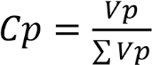 (2)

The sum of the Cp of all the Factors in a square matrix must be equal to 1 (one). A high Cp will tend to increase the vulnerability of the reservoir, while a low Cp will reduce this vulnerability..

Consistency of judgements
The Consistency Ratio (CR) is used as a reference for judging the consistency of the matrix. If the value of the ratio is less than 10%, then the judgements are consistent; if not, they may require some revision. The ratio is equal to the ratio of the coherence index (CI) to the random index (RA) and is given by equation 3 below:
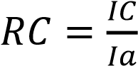 (3)

With 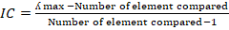 (4)

IC is the coherence index, IA the random index and λmax, the maximum eigenvalue.
If RC ≤ 10, then the matrix is coherent;
If RC > 10% then the matrix is inconsistent and will need to be revised.
The values of the random index ‘Ia’ are given as a function of the number of parameters being compared. The value is 1.12 (Table 4).

Table 4. Random Index (RI) values of a matrix of the same dimension (Saaty; 1980)
Number of variables | 2 | 3 | 4 | 5 | 6 | 7 | 8 | 9 | 10 | 11
AI | 0 | 0.58 | 0.9 | 1.12 | 1.24 | 1.32 | 1.41 | 1.45 | 1.49 | 1.51

Once we know the Random Index (RI), we need to determine the Consistency Index (CI). The steps are as follows:
Step 1: normalise the original matrix by dividing each element in a column by the sum of that column;
Step 2: average each row to determine the eigenvector;
Step 3: multiply each column of the matrix by its corresponding priority vector to determine the overall priority;
Step 4: divide each global priority by its corresponding priority vector to determine the rational priority;
Step 5: determine the average of the rational priorities (λ max): (5)
Step 6: calculate the Consistency Index (CI) (6)
Finally, the Consistency Ratio is calculated using the following formula: (7)
It is 5.7%, so CR ˂ 10%. Consequently, the judgements attributed are good. Table 5 summarises the results obtained from the various calculations.

Table 5. Summary of results obtained
 | P | EP | E | OC | K | λmax | IC | RC | Vp | Cp
P | 0.35 | 0.30 | 0.20 | 0.94 | 0.23 | 5.23 | 0.057 | 5.7% | 2.05 | 0.35
EP | 0.12 | 0.10 | 0.30 | 0.06 | 0.04 | 5.23 | 0.057 | 5.7% | 0.58 | 0.10
E | 0.18 | 0.12 | 0.35 | 0.12 | 1.06 | 5.23 | 0.057 | 5.7% | 0.70 | 0.12
OC | 0.12 | 0.50 | 1.06 | 0.31 | 0.45 | 5.23 | 0.057 | 5.7% | 0.66 | 0.11
K | 0.18 | 0.30 | 0.03 | 0.08 | 0.11 | 5.23 | 0.057 | 5.7% | 1.82 | 0.31

2.3.3Determining the areas likely to cause sedimentation in the reservoir
This stage involves cross-referencing the various factors. It was carried out by combining the different layers in a GIS. The approach chosen is that of the operational approach of the single synthesis criterion of Roy (1985).
The vulnerability index is calculated using the following equation:
Is = P*0.35+EP*0.10+E*0. 35+OC*0.31+K*0.11 (8)
For each parameter, the weight is multiplied by the corresponding score.

3. RESULTS AND DISCUSSION
3.1 Results

3.1.1Mapping the erosive impact of different factors

Soil erodibility map
The map of soil erodibility classes to water erosion shows two (2) zones (Fig 2)
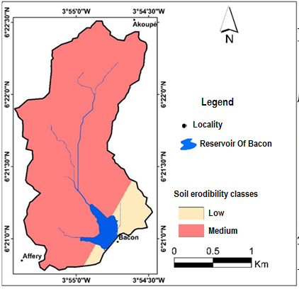
Fig. 2. Map of soil erodibility classes

- Areas of low erodibility: these are found mainly on podzolic to gley soils in the south and south-east of the Basin. They cover 8.86% of the area studied;
- medium erodibility zones: these cover 91.14% of the study area. They are located in the north and centre and are represented by slightly indurated reworked ferralitic soils. These formations, under the influence of heavy rainfall, are subject to intense weathering.

Map of the topographical slope parameter
Three (3) zones are identified on the slope class map (Fig3) :

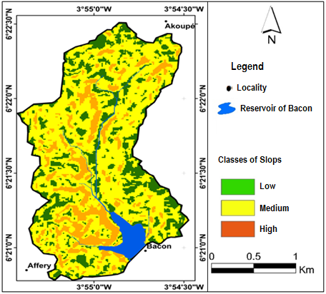
.-E LA Souchere P. Yoder D. C., , Fig.3. Map of slope classes

- low-slope areas (0 to 5%): these cover 23.67% of the region and involve the flat terrain found mainly
throughout the area;
- medium-slope areas (5 to 15%): these account for 61.22% of the study area. The risk of erosion
remains relatively low;
- Steeply sloping areas (15-22%): these cover 15.10% of the study area. The risk of erosionis
relatively high.

Land use parameter map
The map obtained shows four (4) classes (Fig 4):
- the weak class: this represents 18.92% of the sub-basin and concerns dense forest.
The dense vegetation cover reduces soil loss to almost nothing;
- medium class: this covers 36.78% of the sub-basin. It contains degraded forest, with less dense plant
cover than the previous class ;
- the high class represents 13.21% of the region. It is made up of crop/fallow and forest/crop mosaics.
- The very high vulnerability class covers 31.06% of the region. It is made up of dwellings and bare soil. This class reflects the extent of environmental degradation that exposes soils to bad weather. Indeed, in the absence of the canopy of trees which acts as a buffer against raindrops, these surfaces are generally exposed to the action of the latter and run-off.

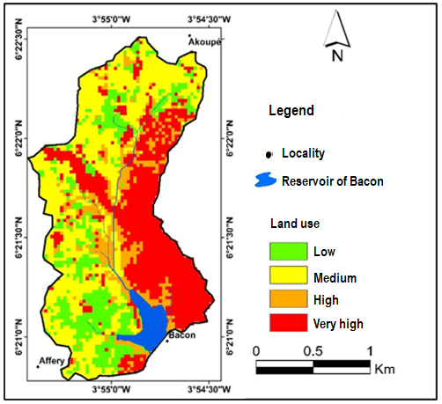
Fig. 4. Map of land use classes

Map of slopeexposure
According to Figure 5, the West, South-West, North and North-West exposures are at high and very high risk, aggravating the deterioration of the land. The surface area occupied by these exposures is 1.84 km², representing 55.42% of the total surface area of the sub-catchment.
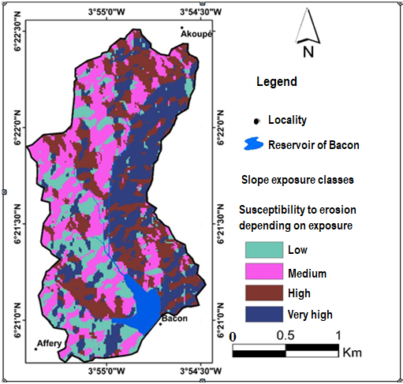
Fig. 5.Map of slope exposure classes

3.2 Map of vulnerability to sedimentation of the Acoupé-Bacon reservoir
The integration of the environmental and climatic variables of the Bacon reservoir basin into the GIS made it possible to draw up a map of the indices of zones favouring vulnerability to sedimentation of the Akoupé-Bacon reservoir (Fig.6).
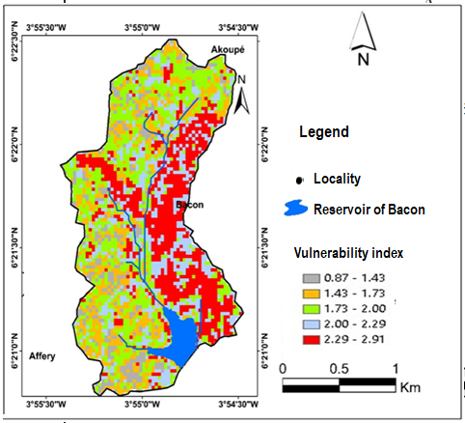
Fig. 6. Index map of areas vulnerable to sedimentation in the Akoupé
reservoir to sedimentation

These indices were then reclassified into three (3) classes of vulnerability (Fig 7):
- Areas with little (or low) influence on vulnerability to sedimentation: these are practically non-existent in the region (0.89%); they are essentially made up of watercourses which cannot themselves be a source of vulnerability;
- Areas with a moderate (or medium) influence on vulnerability to sedimentation: these account for more than half (43.18%) of the sub-basin. These areas have relatively low to mediumslopes (between 5 and 15%) and are generally covered by degraded forest and cultivated areas, as well as residential areas not far from the reservoir (Fig. 8).

- Areas highly vulnerable to sedimentation. These cover 55.92% of the region. These areas are associated with the high population density in the vicinity of the reservoir, which has resulted in exposed soil due to the creation of residential areas.

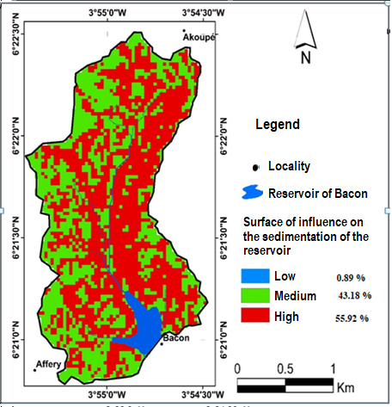

Fig.7. Map of areas of influence on sedimentation vulnerability
of the Akoupé-Bacon reservoir

Fig. 8. Medium erosion surfaces not far from the Bacon water reservoir

3.2 Discussion
The map of areas influencing sedimentation vulnerability reveals three classes: a low class (0.89%), a medium class (43.18%), and a high class (55.92%). Thus, in the sub-basin, the medium and high vulnerability classes account for 99.1% of the areaIn the Adiaké region, Eblin and al. (2017) and in Bonoua, Aké et al. (2012) also identified these three vulnerability classes, although the vulnerability was mainly concentrated between high and medium levels (99.9% and 71%).
This situation results from high population growth and intensified agriculture, which further expose the basin’s soils to this hazard. Other studies using the same methodology have yielded similar results (FAO, 2000; Herbreteau and al., 2003; Abdelbaki and al., 2009; Ducommun, 2011). Mudslides caused by water erosion have numerous significant impacts on human activities, the most notable being soil degradation and costly damage to hydraulic infrastructure due to the silting of water bodies.
The effects of erosion are generally well observed in southern localities where populations are densely clustered (Hauhouot, 2004). According to Roose (1977), under the influence of demographic pressure and the expansion of export crops, the fallow period granted to soil in West Africa has significantly decreased. Consequently, erosion risks have considerably increased in some high-density areas. Indeed, pressure on the natural environment not only strips the soil but also removes any barriers that might prevent the onset of water erosion processes. Also, for Bawa (2024), erosion which results in sedimentation in the reservoirs takes place under the control of hydrological dynamics and following the configuration of the morphology of the basin
In the Akoupé department, cocoa, coffee, and rubber cultivation alone have led to the loss of nearly 650.89 hectares of forest (agricultural areas used in lessthantenyears in the Akoupédepartment) (DRMARA, 2015-2016). Thus, the development of subsistence farming and the establishment of numerous residential sites have contributed to exposing the region’s soils, making them vulnerable to erosion.Vegetative cover is particularly effective at reducing erosion because it dissipates the energy of raindrops, slows water runoff on the soil surface, and maintains good surface porosity, preventing crust formation (Roose, 1996). However, the study area shows a trend toward anthropization, as revealed by the land-use map, where highly vulnerable areas account for 31.06% of the basin. These areas consist of residential zones and bare soils. This classification reflects the extent of environmental degradation that exposes soils to the elements. Without the canopy of trees acting as a cushion for raindrops, these surfaces are generally exposed to rain and runoff. This situation directly increases surface runoff, likely intensifying soil erosion, which will eventually lead to sedimentation in the reservoir. According to F. Fournier (1967), in the absence of vegetative cover, the characteristics of surface horizons play a crucial role in triggering and developing erosion, particularly soil structural stability and permeability.
Additionally, low and medium slopes represent 84.89% of the total area, with medium slopes dominating (61.22%). This trend does not necessarily justify the medium and high sedimentation vulnerability but aligns perfectly with the dominance of the high vulnerability class. According to Pautrot (2012), surface water runoff follows gravitational laws and moves downhill.
To refine these results, it would be necessary to update certain data (pedology), improve the combinatorial methods implemented, and incorporate additional parameters (spatial variability of rainfall erosivity, soil infiltration capacity, etc.) (Aké and al., 2012). However, the sedimentation vulnerability map developed for the surroundings of the Bacon water reservoir serves as a valuable document.
It would also be essential to consider the concept of a protection perimeter, which can also accommodate initial anti-erosion and anti-sedimentation measures. Within this zone, any activity likely to alter soil structure and exacerbate erosion should be prohibited. This area should also include bank and slope management. Abdelbaki and al. (2009) recommend revegetating the slopes of banks and the tops of structures. Bouchetata and al. (2006) suggest using plant species with strong rooting systems and high ground cover capacity, as these improve water infiltration into the soil and dissipate runoff energy, reducing its transport capacity.
Despite these challenges, protection perimeters remain an important tool for territorial planning and better water resource management.

Conclusion
Soil erosion and sediment transport are major causes of the loss of reservoir storage capacity. Under demographic pressure, forested areas, which occupy the steepest slopes, are gradually converted into farmland and no longer fulfill their environmental role in soil protection. Erosion becomes severe, and reservoirs are increasingly silted.
This study used GIS technology incorporating multi-source data (soil erodibility, rainfall erosivity, topographic slope, land use, and slope aspect) to map zones influencing sedimentation vulnerability in the Akoupé Bacon water reservoir. The resulting map identifies three distinct vulnerability classes: low vulnerability zones, which are almost non-existent (0.89%); medium vulnerability zones (43.18%); and high vulnerability zones, which account for 55.92% of the basin.
Validated through fieldwork, this map is a valuable tool for easily identifying areas sensitive to water erosion, which may significantly contribute to sediment deposition in the Bacon reservoir. This map serves as an essential resource for territorial planning and improving water resource management.

DISCLAIMER (ARTIFICIAL INTELLIGENCE)
Author(s) herebydeclarethat NO generative AI technologies such as Large LanguageModels (ChatGPT, COPILOT, etc.) and text-to-image generators have been usedduring the writing or editing of thismanuscript
.
COMPETING INTERESTS
Authors have declaredthat no competinginterestsexist.

REFERENCES

Abdelbaki, A., Abdelbaki, C., Ouldache, E & H. Semmar. (2009). Implementation of a geographic information system for the development of an anti-erosion protection development plan. Casduunder the Oued Bouguedfinewatershed, Chlef province, Algeria. Nature and TechnologyReview, No. 1, Pp 24 – 32
Ake G. É., Kouadio B. H., Adja M. G., Ettien J.-B., Effebi K. R. &Biemi J. (2012). Mapping of multifactorialvulnerability to water erosion of soils in the Bonoua region (South-East of Côte d'Ivoire)", Physio-Géo [Online], Volume 6 | 2012, Online since 06 April 2012 ; URL: http://physio-geo.revues.org/2285 ; DOI : https://doi.org/10.4000/physio-geo.2285
Avenard JM, Eldin M, Girad G, Sircoulon J, Touchebeuf P, Guillaumet JL, & al. (1971). Le Milieu Naturelde la Cote d’Ivoire. ORSTOM: Paris France.
Bawa D. (2024 Morphology of the Aléhéridè dam basin and sedimentation (Central Togo). Geographical Space and Moroccan Society Review N°85, May 2024. P.4-60.
https://doi.org/10.34874/lMIST.PRSM/EGSM/48509
Bonn F. & Rochon G. (1992) - Summary of remotesensing, principle and method. Ed. Presses de l'Université du Québec, AUPELF-UREF, vol. 1, 485 p.
Bouchetata A., Bouchetata T. (2006). Proposals for the development of the sub-watershed of the Fergoug wadi (Algeria) weakened by episodes of drought and subject to water erosion. Drought 2006, 17 (3), pp 415-424.

Boudhar, A., Duchemin, B., Hanich, L., Chaponnière, A., Maisongrande, P., Boulet, G., & al. (2007). Analysis of the dynamics of snow-covered surfaces in the Moroccan High Atlas using SPOT-VEGETATION data. Drought 18 (4): 278-88. ( Lack of DOI)
Boughalem M., Mazour M. &Zaagane M. (2012). Use of GIS for the development of the Isserwatershed (North-West Algeria). Erosion control, rehabilitation of tropical soils and protection againstexceptionalrainfall, IRD Editions Marseille, p.79 – 90 ( Lack of DOI)
Bou kheir R., M.-C. Girard, A. Shaban, M. Khawlie, G. Faour, & T. Darwich (2001). Contribution of remotesensing to the modeling of water erosion of soils in the coastalregion of Lebanon”, RemoteSensing, vol. 2, no. 2, 79-90. ( Lack of DOI)
Deh S. K., Kouame K. J., Eba A. L., Edoukou D. J., Kpan A. &Jourda J. P., (2017). Contribution of Geographic Information Systems in Protection Zones Delineationaround a Surface Water Resource in AdzopeRegion (Southeast of Côte d’Ivoire). Journal of Environmental Protection, Vol 8, pp 1652 -1673. DOI:10.4236/jep.2017.813102
Del Mar Lopez, T., Mitchel Aide, T., &Scatena, F. N. (1998). The effect of land use on soilerosion in the Guadiana watershed in Puerto Rico. Caribbean Journal of Science, 34: 298–307.
De Jong S. M., &Riezebos H. T. (1997). SEMMED:adistributedapproach to soilerosionmodelling, Remotesensing. Vol 96, Pp 199-204
-DRMARA (2015-2016). Annual report of the RegionalDirectorate of the Ministry of Agriculture and Animal Resources of Adzopé on food and perennialcrops. 22 pages.
Ducommun C. (2011). Knowing the sensitivity of soils to erosion to improve water quality. Syndicat Mixte des Marais de la Vie, du Ligneron et du Jaunay. SAGE du bassin de la Vie et du Jaunay. Sheet No. 25 July-August 2011. 2 p.

Eba A. E. L., Kouame K. J., Jourda J.P., Saley M. B., AKE G. E., Deh S. K. & al. (2013):Demarcation of Surface Water Protection Perimeters by Using GIS: Case of Gagnoa Reservoir in West Central of Côte d'Ivoire. International Journal of Scientific & Engineering Research, Vol.4, Issue 4, pp.1311-1320.ISSN 2229-5518. ( Lack of DOI)
Eba A. E., Kouame K. J., Deh S., Anoh K. A., Balliet R., Toure M. & al. (2016):Assessment of the vulnerability to pollution of surface water intended for the supply of drinking water to a metropolis. Case of the Aghein Lagoon in Abidjan, (Southern Côte d'Ivoire). European Scientific Journal, Vol 12, pp. 1857- 7431. https://doi.org/10.19044/esj.2016.v12n36p306
Eblin S. G., Yao A. B., Anoh K. A. & Soro N. (2017). Mapping multifactorialvulnerability to soil water erosionrisks in the Adiakéregion, coastalsouth-east of Côte d'Ivoire, Rev. Ivoir. Sci. Technol, Vol.30, Pp.197-216. ( Lack of DOI)
El Morjani Z. (2002), Design of a spatiallyreferenced information system for environmentalmanagement; application to the selection of potential sites for the storage of household and industrialwaste in a semi-aridregion (Sousse, Morocco), Doctoral thesis of the University of Geneva, Switzerland, Terre et Environnement, Vol. XLII, 300 p
FAO (Food and Agriculture Organization of the United Nations) (2000), "Global Assessment of SoilDegradation (GLASOD)”. FAO, Rome,
Fournier F. (1967) - The factors of soilerosion by water;research on soil conservation in Africa and Madagascar. AfricanSoils, vol. XII, n° 1, p. 6-51. ( Lack of DOI)
Girard G. Sircoulon J. and Touchebeuf P. (1971). The natural environment of Côte d’Ivoire, Hydrology. ORSTOM Paris Memoirs No. 50, 359 p. ( Lack of DOI)

Hauhouot C (2004). Anthropogenic pressures on naturalenvironments in southeastern Ivory Coast. Geo-Eco-Trop, Vol. 28, N° 1-2 Pp69 – 82 ( Lack of DOI)
Herbreteau V., Boucheta B., Commagnac L., Lee A., &Chery P. (2003) Assessment of the sensitivity to erosion of wine-growing areas. Influence of cultivation practices (example of Fronsadais). SYMPOSCIENCE:Environmental Risk Assessment for Sustainable Management of Spaces-IALE France, Cemagref, Parc national des Écrins, Pp31 – 38.
Koua, T.J.J., Jourda, J.P., Kouame, K.J., Anoh, K.A., N’Dri, W.K.C., Lazar, G. & al. (2014) Effectiveness of Soil and Water Assessment Tool Model to Simulate Water Flow in a Large Agricultural ComplexWatershed: Case of Buyo Lake Basin, West of Côte d’Ivoire. Environmental Engineering and Management Journal, Vol 13, Pp 1735-1742. https://doi.org/10.30638/eemj.2014.193
Kemka,N., Njine, T., ZébazéTogouet, S. H., Niyitegeka, D., Nola, M., Monkiedje, A., & al. (2004). Phytoplankton of the municipal lake of Yaoundé (Cameroon):Ecological succession and structure of populations. Journal of Water Science, 17(3), 301–316. https://doi.org/10.7202/705535a
Kouassi, B.A.T., Komoe, K., & Coulibaly, N. S. (2021). Specific composition and diversity of microalgaefrom the Bacon reservoir, southern Côte d’Ivoire. Journal of Animal & Plant Sciences Vol.48 (3): 8712-8721 https://doi.org/10.35759/JAnmPlSci.v48-3.28
Kouadio B.H., Kouamé K.F., Saley M.B., Biémi, J., & Ibrahima, T. (2007). Climateinsecurity and geohazards in Côte d’Ivoire:study of the risk of soil water erosion in the semi-mountainousregion of Man (Western Côte d’Ivoire). Drought, vol. 18, no. 1, pp. 29-37.
Mayer, L. (1990). Introduction to quantitative geomorphology. Ed. PRENTICE HALL, Englewood Cliffs (New Jersey), 380 p. DOI: 10.4236/ajps.2015.618279
N'Dri B.E., N'GO Y.A., Kadio H.N., Ouattara A., Touré B. &Biémi, J. (2008). Effect of soilslope and cover on runoff and rate soillossfromexperimental plots in the area of ​​Attécoubé. European Journal of Scientific Research, vol. 21, n° 3, pp. 459-470.
N'go, Y.A. (2000). Study of soilerosion in the Buyoregion:analysis of factors and riskassessmentattempt by remotesensing and GIS. 3rd cycle thesis, University of Abobo Adjamé, 155 p.
Pautrot C. (2012). Soilerosion and degradation. Memoirs of the National Academy of Metz, 203 – 221.
Perraud, A. & DE LA Souchere P. (1971). Soil sketch of Côte d'Ivoire at a scale of 1/500000. South-WestSheet. ORSTOM, Adiopodoumé Center, (1971)
Quinton J. N. (1997). Reducingpredictiveuncertainty in model simulations:acomparison of twomethodsusing the EuropeanSoil Erosion Model (EUROSEM). Catena. Vol 30, No. 2, Pp 101-117
RGHP-CI .(2021). General Census of Housing and Population of Côte d’Ivoire
Overallresults p.37
Roose E. (1977). Erosion and runoff in West Africa: Twenty years of measurements in smallexperimental plots. O.R.S.T.O.M. Paris, No. 78; PP. 1-108;
Roose E. (1996). Currentdynamics of a gravellyferralliticsoilfrom granite under cultivation and underSudanianshrub savannah in northern Côte d’Ivoire: Korhogo. ORSTROM
Roose, E., (1994.b). Introduction to GCES. FAO Pedological Bulletin, Rome; 70; 420 p.
Roy B. (1985). Multicriteriadecision-makingmethodology. Paris, Economica, XXII, 423 p.

Ryan J. (1982). - A perspective on soilerosion and conservation in Lebanon. Publication of the American University of Beirut, n° 69, p. 15-38.
Saaty, T. L. (1980). The AnalyticHierarchyProcess: Planning, Priority setting, Resource allocation, McGraw-Hill, New York, 19 p.
Saaty T. L. (1977). A scalingmethod for priorities in hierarchical structures. J.Math. Psychology, Vol 15, Pp 234-281.
Vezena, K., & Bonn, F. (2006). Modeling and analysis of the spatio-temporaldynamics of society relations – erosion and diffuse pollution in agricultural environments – case study in Vietnam and Quebec; Nature-Society interaction, analysis and models. UMR6554 LETG, La Baule, 6p.
Wischmeïer, W. H., & Smith D. D. (1978). PredictingRainfall Erosion losses, Agriculture Handbook no. 57, US Department of Agriculture. Washington DC. USA., 58p

