A Phenological Study of *Butea pellita* Hook.f. ex Prain, An Endemic and Critically Endangered Shrub of the Kumaun Himalayas

.

ABSTRACT

|  |
| --- |
| **Background:** *Butea pellita* Hook.f. ex Prain, a critically endangered and endemic shrub of Uttarakhand, India, lacks documented phenological records crucial for its conservation.  **Aim:** This study investigates the phenological patterns of *B. pellita* to provide insights into its seasonal life cycle and regeneration strategies.  **Methodology:** Field observations over two years (2022 & 2023) in Patwadangar village (29.33°N, 79.43°E) recorded key life cycle events, including vegetative growth, flowering, fruiting, and dormancy.  **Results:** *B. pellita* exhibited a nine-month growth cycle, with shoot emergence in April, peak flowering in June-July, and seed maturation by November. Pollination was primarily facilitated by bees and butterflies, while natural regeneration relied on rootstock proliferation.  **Conclusion:** The study highlights significant challenges for conservation, including low seed viability and poor germination rates. These findings provide crucial insights for undertaking conservation strategies, and emphasizing the need for targeted interventions to ensure the long-term survival of this species in its natural habitat. |

***Keywords****:* *Butea pellita, Phenology, Conservation, Pollination, Germination*

1. INTRODUCTION

Due to climate change and unpredictable weather patterns, understanding the life cycles of plants is becoming increasingly important, particularly for rare and endangered species. Phenomenology, the study of the seasonal occurrence of life-cycle events in living organisms, provides essential insights into how plants respond to environmental changes (Moza and Bhatnagar, 2005). These cyclical biological events, including seed germination, vegetative development, flowering, fruiting, and seed maturation, are typically represented by phenograms, which provide visual documentation of temporal patterns in plant development.

*Butea pellita* Hook.f. ex Prain (syn. *Meizotropis pellita*), commonly known as Patwa, is a rare and endemic shrub of the Fabaceae family. As per, The IUCN Red List of Threatened Species (2022), *B. pellita* is categorized as Critically Endangered under criteria B1ab (ii, iii, v) +2ab (ii, iii, v). The categorization is based on its severely restricted distribution, with an extent of occurrence and area of occupancy less than 10 km², presence in a single location, and projected continuing decline in habitat quality due to fire-related threats (Chauhan, 2022).

The significance of *B. pellita* extends beyond its conservation status owing to its valuable phytochemical properties. The species contains diverse bioactive constituents, like alcohols, aldehydes, carboxylic acids, and aromatic compounds (Rani *et al.,* 2016). Leaf extracts of the plant exhibit significant antimicrobial activity against various pathogenic bacteria (Singh *et al.,* 2017), while the essential oil extracted from leaves shows promising antioxidant properties with potential pharmaceutical applications (Kerketta *et al.,* 2014). Additionally, Jadhav and Jadhav (2021) reported the use of grafted *B. pellita* fibers in managing oil spillage across different oil fractions.

Phenological studies are fundamental for understanding plant-environment interactions and ecological relationships in natural ecosystems (Khawas and Mishra, 2020). Despite the critically endangered status and ecological and pharmaceutical significance of *B. pellita*, its phenophases have not yet been documented. Conservation of a species is difficult in absence of such phenological records hence, the present study establishes a vital reference point.

2. methodology

**2.1 Study site** **& Climate:**

The study was conducted in Patwadangar, a village about 12 km from Nainital, Uttarakhand, India, at 29.33°N latitude and 79.43°E longitude, with an average elevation of 1,530 meters above sea level. The region has a temperate climate, with summer temperatures ranging from 17°C to 28°C, and winter temperatures varying from -3°C to 15°C, including snowfall between December and February.

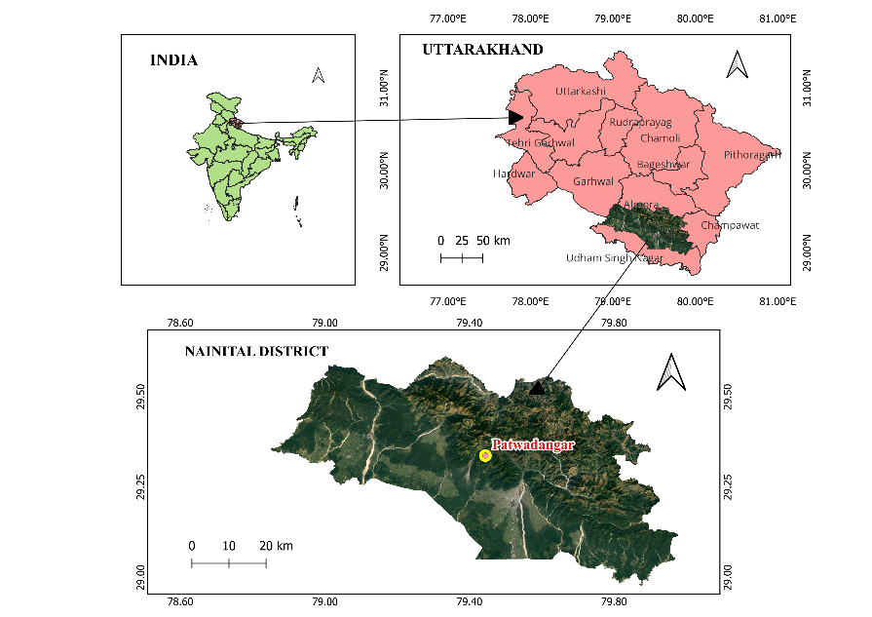

Fig. 1. Map of the Study Area

**2.2 Experimental design-** A two-year observational study (2022 & 2023) was undertaken to document the phenological patterns of *B. pellita*, focusing on key developmental stages, including vegetative phase, inflorescence emergence, flowering, fruit development, seed maturation, and dormancy. Each stage was systematically documented through photographic records for detailed visual representation of seasonal transitions and growth dynamics. A voucher specimen (Accession No. 1629) was authenticated and deposited at the Botanical Survey of India, Northern Regional Centre, Dehradun (BSD). To represent the cyclical nature of phenology, a hexagonal model was used, with each vertex depicting a key phenophase and its gradual transition, ensuring a comprehensive visualization of seasonal dynamics.

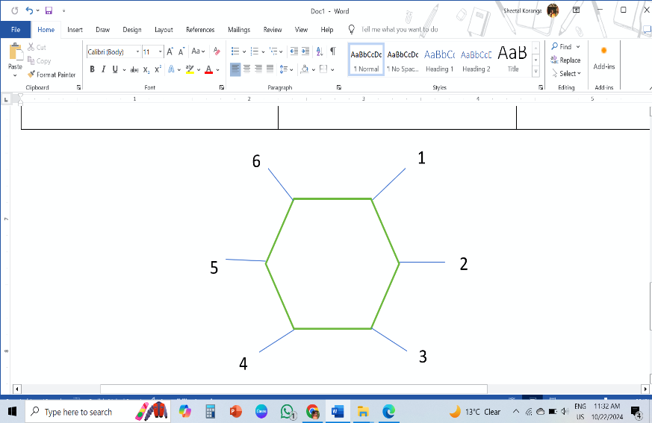

Fig. 2. Schematic representation of phenophases: 1- Shoot emergence and vegetative growth 2- Inflorescence development 3- Flowering 4- Fruit formation 5- Seed maturation 6- Dormancy

3. results and discussion

Seasonal variations play a crucial role in plant development. In temperate regions and northern latitudes, plants rely on cues such as photoperiod, vernalization, and growing degree days (GDD) to align the flowering and other growth activities with the favorable environmental conditions (Wright *et al.,* 2019).

*B. pellita* is characterized by a stout, woody perennial rootstock that develops multiple erect shoots. The mature shoots reach heights of 220-225 cm with diameters of approximately 1.9 cm. The stems exhibit distinct ribbing and carry substantial pith, contributing to the plant's structural integrity. Leaves are broad and oval shaped measuring 45-75 cm in length (Tewari,1998). The root system demonstrates extensive branching with deep-penetrating taproots and lateral spread, indicating effective soil binding properties suitable for slope stabilization (Pandey *et al.,* 2015).

The phenological progression of *B. pellita* illustrates the seasonal life cycle patterns from vegetative growth to reproductive phases and dormancy, essential for understanding its ecological adaptations. Fig 3&4 presents comprehensive phenological calendar and photographic documentation of critical stages of phenological transitions of *B. pellita* from initial vegetative emergence in April to complete dormancy in December, providing an essential visual record.

**Fig 3. Phenological calendar of *B. pellita* showing major developmental stages**

|  |  |  |  |  |  |  |
| --- | --- | --- | --- | --- | --- | --- |
| Growth phase |  |  |  |  |  |  |
| Time period | April-May | Late May | June-July | August | October-November | December |
| Key characteristics | Shoot emergence, leaf development | Formation of floral primordia | Anthesis, pollinator activity | Pod development | Seed ripening, pod dehiscence | Complete plant senescence |

The annual growth cycle initiates in April with shoot emergence from the perennial rootstock. Vegetative development intensifies through the first week of May, characterized by robust shoot elongation and leaf expansion. This timing coincides with increasing temperatures and photoperiod in the region. Reproductive phase begins with inflorescence emergence in late May, followed by flowering from June through July. Flowers, measuring 1.3-2.5 cm in length, are arranged in fascicles of 3-5 within erect terminal and axillary racemes (Tewari, 1998 and Singh *et al.,* 2013). The corolla displays distinctive bright red wings, while the keel exhibits a base-to-tip color gradient from orange to red.

During the study, it was observed thatpollination occurs predominantly through anemophily and entomophily. Principal pollinators include various species of bees (Hymenoptera) and butterflies (Lepidoptera), with peak visitation observed during morning hours. These pollinator interactions are crucial for successful fruit development (Kubov *et al.,* 2024).

Fruit formation initiates in early August, marked by the development of immature pods. Each pod contains a single seed, which reaches maturity by November. The seeds are characterized by their large size and recalcitrant nature, enclosed within a leathery seed coat. These seed characteristics significantly influence seed viability and germination success rates. The dormancy phase follows a sequential pattern, starting with the leaf perforation, which typically occurs first followed by the senescence of inflorescence and then the stems and roots. Leaf puncturing begins in September, with the drying of the entire inflorescence taking approximately 32-45 days. By October, the leaves dry out and shed off coinciding with the maturation of seeds. After shedding its seeds, the plant becomes completely dormant by the end of December.

The complete life cycle of *B. pellita* spans approximately nine months, with natural regeneration occurring primarily through rootstock proliferation rather than seed germination. This reproductive strategy ensures local persistence, but it may restrict genetic diversity and limit population expansion. Additionally, the low seed viability and poor germination rates present significant challenges for the conservation of this species. Addressing these challenges will be crucial for effective conservation strategies, highlighting the need for targeted efforts to support the species' regeneration and long-term survival.

**Fig 4. Photographic documentation of phenological transitions in *B. pellita* across two consecutive years (2022&23)**

|  |  |  |
| --- | --- | --- |
| A | B | C |
| D | E | F |
| G | H | I |

**A.** Young shoot emergence (**April**) **B.** Inflorescence development (**May**) **C.** Peak flowering phase (**June**) **D.** Active pollination phase (**July**) **E.** Early fruiting phase-Immature pod development (**August**) **F.** Beginning of senescence (**September**) **G.** Progressive leaf perforation (**October**) **H.** Seed pods on defoliated stems (**November**) **I.** Mature seeds- coated and decoated

4. Conclusion

The study presents the phenological profile of *B. pellita,* in its natural habitat. The profile can serve as a guide for protective measures to ensure the survival and reproduction of the species. Continuous monitoring of phenophases will be essential to promote the sustainability of this unique shrub.

**Disclaimer (Artificial intelligence)**

Option 1:

Author(s) hereby declare that NO generative AI technologies such as Large Language Models (ChatGPT, COPILOT, etc.) and text-to-image generators have been used during the writing or editing of this manuscript.

References

1. Chauhan, H.K. (2022). *Meizotropis pellita*. The IUCN Red List of Threatened Species.<https://dx.doi.org/10.2305/IUCN.UK.2022.RLTS.T216171980A216253140.en>. Accessed on 26 October 2024.
2. IUCN. (2022). The IUCN Red List of Threatened Species. Version 2022-2. Retrieved from [www.iucnredlist.org](http://www.iucnredlist.org) (Accessed: December 8, 2022).
3. Jadhav, A.C., & Jadhav, N.C. (2021). Graft copolymerization of methyl methacrylate on *Meizotropis pellita* fibres and their applications in oil absorbency. Iranian Polymer Journal, 30(1), 9-24. <https://doi.org/10.1007/s13726-020-00871-1>
4. Kerketta, A., Sirohi, V., & Nailwal, R.K. (2014). Antioxidant activity of *Meizotropis pellita*: A critically endangered and endemic plant of the Himalayan region. Indian Journal of Scientific Research, 4(1), 140-144.
5. Khawas, S.K., & Mishra, P.K. (2020). Phenological study of a medicinally important plant *Leonotis nepetifolia* in Jharia Coal Field. European Journal of Medicinal Plants, 31(10), 14-19.
6. Kubov, M., Fleischer, P. Sr., Tomes, J., Mukarram, M., Janík, R., Turyasingura, B., Fleischer, P. Jr., & Schieber, B. (2024). Differential responses of Bilberry (*Vaccinium myrtillus*) phenology and density to a changing environment: A study from Western Carpathians. Plants, 13(17), 2406.
7. Moza, M.K., & Bhatnagar, A.K. (2005). Phenology and climate change. Current Science, 89(2), 243-244.
8. Pandey, V., Daudi, P., & Gupta, B.P. (2015). Development and standardization of nursery techniques for *Meizotropis pellita*: A critically endangered plant of the Himalayan region. International Journal of Advance Research, 3(12), 1688-1692.
9. Rani, N., Sharma, S., & Sharma, M. (2016). Phytochemical analysis of *Meizotropis pellita* by FTIR and UV-VIS spectrophotometer. Indian Journal of Science and Technology, 9(31), 1-4.
10. Singh, L., Nailwal, T., & Tewari, L. (2013). An *in vitro* approach for the conservation of *Meizotropis pellita*: An endangered and endemic plant. American Journal of Plant Sciences, 4, 1233-1240. <https://doi.org/10.4236/ajps.2013.46151>
11. Singh, M.K., Mishra, P., Sharma, R., & Nailwal, T.K. (2017). Antimicrobial potential of wild and micropropagated *Meizotropis pellita*—an endemic and endangered plant of Kumaun Himalayas. International Journal of Advance Research in Science and Engineering, 6(3), 106-111.
12. Tewari, L.M. (1998). A threatened, endangered, endemic plant: Patwa. Current Science, 75(6), 544.
13. Wright, S.J., Calderon, O., & Muller-Landau, H.C. (2019). A phenology model for tropical species that flower multiple times each year. Ecological Research, 34(1), 20–29.