**A MATHEMATICAL MODEL FOR DECIDING OPTIMAL ORDERING POLICY FOR FIXED LIFETIME INVENTORIES WITH EXPECTED INSURANCE COSTS**

**ABSTRACT**

Managing inventory-related risks is crucial for companies dealing with fixed lifetime inventories. Previous researches have focused on the study of inventory management and risk management. However, there are no adequate study in the literature that combines these two critical aspects in the mamagement of fixed liftetime inventories. We developed a stochastic optimization problem and minimized the expected total costs. The aim of the study is to examine decisions as regards when to place order or not for the probabilistic fixed lifetime inventory model with expected insurance costs. We computed the expected ordering costs, expected holding costs, expected shortage costs, expected outdate costs and expected insurance costs. These expected costs were applied to obtain the expected total costs for the inventory system. We also determined the optimal ordering policy for the probabilistic fixed lifetime inventory model with expected insurance cost. A numerical application demonstrates the effectiveness of the proposed model in reducing the expected total costs. The results highlight the usefulness of integrating insurance costs into inventory management for fixed lifetime inventory products.

*Keywords : Fixed lifetime, inventory model, risk management, setup cost ,expected insurance costs, expected total costs, optimal ordering policies,*

**1 Introduction**

Effective inventory management is a crucial component of business success, as it enables organizations to optimize stock levels, reduce costs, prevent product shortages or surpluses, and ensure operational efficiency.Inventory management is particularly challenging due to the fixed lifetimes of these products Enagbonma et al. (2015). Some examples of these products in real life includespharmaceutical products, whole blood, chemicals and electronics, The integration of probabilistic inventory models with expected insurance costs is particularly valuable in these industries, as it mitigates risks, optimizes inventory levels, minimizes expected total costs, and improves service levels and cost savings. In the work given in Ramos (2017), the author considered premium to be the payment made by a company to an insurer to purchase insurance coverage for their inventory. This payment is typically made periodically, such as monthly or annually, and is used to fund the insurer's operations and pay claims. The importance of managing fixed lifetime inventory products cannot be overemphasized. For instance, in the pharmaceutical industry, inventory management is critical to ensuring that life-saving medications are available when needed, while also minimizing waste and reducing costs Dubey et al. (2022). Similarly, in the electronics industry, inventory management is crucial to ensuring that components and finished goods are available to meet customer demand, while also minimizing obsolescence and reducing costs Hugo et al. (2016). Despite the importance of inventory management in these industries, there are several challenges that companies face Hermit (2020).One of the primary challenges is the uncertainty in demand and lifetime of date-sensitive products. This uncertainty can lead to stockouts, overstocking, and waste, which can have significant financial and operational implications. Another challenge is the complexity of inventory management decisions, which require balancing competing objectives such as minimizing costs, maximizing service levels, and reducing risk. By incorporating insurance costs into the inventory management decision-making process, companies can reduce market risk, credit risk, operational risk, and liquidity risk, so as to optimize inventory levels, and improve service levels. This can lead to significant financial and operational benefits, including reduced costs, improved customer satisfaction, and increased competitiveness.

**2 Literature Review**

Zhongyi et al. (2022) investigated the mitigation strategies employed by a risk-averse firm to counter the threat of supply chain disruption. The firm's primary objective is to minimize losses resulting from disruptions by adjusting its ordering decisions and purchasing business interruption (BI) insurance. The authors explored the firm's joint ordering and insurance decisions in two distinct insurance market settings: perfectly competitive and imperfectly competitive. Their findings indicate that BI insurance effectively reduces losses caused by supply chain disruptions and eliminates the impact of the firm's risk-averse attitude. In a perfectly competitive insurance market, the firm always purchases full insurance coverage.

Heinrich et al. (2022) created an agent-based simulation model to investigate the impact of risk model homogeneity on the catastrophe insurance and reinsurance industry. The model replicates the dynamics of insurance firms, including premium collection, capital management, and risk hedging. They used the model to examine the effects of relying on a limited number of certified risk models, as required by the European regulatory framework Solvency II. They observe that this approach increases the risk of non-payment and default, while reducing industry-wide profits. The presence of the reinsurance industry was found to mitigate this issue, but not eliminate it entirely.

Panham et al. (2024) introduced a novel pricing model for delivery insurance in the Latin American food delivery sector. They aimed to mitigate the high costs associated with insurance premiums. To achieve this, they conducted a comprehensive analysis to estimate the probability of losses based on various factors, including delivery routes, transportation modes, and driver profiles.. A substantial dataset was collected and utilized to construct a comprehensive risk profile, which facilitated risk classification.

The world economy is increasingly exposed to multiple risks and unpredictable circumstances (Alam et al., 2022). The relationship between insurance and risk management has become a critical area of focus. The author proposed that insurance and risk management involves the quantification of financial impacts of events, providing stakeholders with essential insights. They emphasize that insurance and risk management form an organized structure offering a structured approach to mitigating risks. This structure encompasses various risk modeling techniques, including market risk, credit risk, operational risk, and liquidity risk They also highlight the fundamental methods of risk management, including avoidance, retention, sharing, transferring, and loss reduction.

Livingston (2024) evaluated concept of prorata which is the allocation of amounts in proportion to each recipient's share or benefit. In a financial context, this method ensures that distributions, such as dividends, are allocated proportionally to each investor's stake in the business. In contrast, a flat rate represents a fixed fee or price, unaffected by usage or quantity. This concept is commonly observed in telecommunications, where service providers charge a uniform fee for unlimited services, regardless of actual usage. However, the distinction between pro rata and flat rate has significant implications for budgeting and planning. Pro rata services can result in variable costs from one month to another, making budgeting more challenging. Conversely, flat rate services provide consistent charges, facilitating more predictable budget planning. The author highlights that prorata approaches charges are calculated based on usage, whereas flat rates typically involve a one-time fee, unaffected by frequency or volume of usage. For instance, telecommunications providers may offer pro rata plans, where charges are linked to data consumption, or flat rate plans, where a specified cost applies regardless of data usage.

However, Enabongma et al. (2015) addressed the problem of determining optimal ordering policies for a probabilistic fixed lifetime inventory model with a continuous demand rate. In the course of their work, they proposed a probabilistic fixed lifetime inventory model and derived the necessary condition for minimizing the expected total cost. They examined decisions regarding when to order or not, under specific conditions. They successfully bridged the gap between theoretical results and practical requirements for computational results by computing the ordering cost, expected holding cost, expected shortage cost, and expected outdates cost, and applied these computations to determine the expected cost for the fixed lifetime inventory system.

Izevbizua and Emunefe (2021) examined some of the challenges associated with fixed lifetime inventory management, such as the outdating of products. The author opined that the outdated product could bring about economic losses for inventory managers and can also have detrimental negative consequences on public healthcare. To address this issue, they developed a useful lifetime-based model aimed at minimizing the number of items that outdate from a fixed lifetime inventory. The model utilizes the number of useful life periods remaining in an order as the basis for placing new orders, it is also unique due to its flexibility, allowing inventory managers to adjust the required number of useful items left before placing a new order in response to changing demand patterns. This adaptive approach enables inventory managers to optimize their ordering decisions and reduce the likelihood of outdating.

Enagbonma and Eraikhuemen (2011) developed a model to determine optimal ordering policies for inventory with a fixed lifetime, considering discrete demand scenarios. Their research identified ordering decisions that account for inventory perishability and recommended the First-In-First-Out (FIFO) issuing policy to minimize expected obsolescence. To optimize stock management, they suggested implementing the FIFO policy by ensuring consumers are exposed to products of similar age, thereby reducing waste.

Boxma et al. (2024) opined that perishable inventory systems have significant societal relevance, as they are critical in various industries, such as healthcare, food, and pharmaceuticals. The authors, they evaluated the probabilistic analysis of perishable inventory systems over time, with the goal of developing a deeper understanding of these complex systems. Their proposed approach offers a valuable tool for practitioners to evaluate and optimize their inventory management strategies, ultimately reducing waste and improving efficiency.

Notably, Alejo-Reyes et al. 2023 examines some challenges that emanates from retail management figuring out how many products to order from suppliers. This involves considering many factors that affect how much profit a store can make, such as making sure products are good quality, getting discounts when ordering large quantities, how the price of a product affects how many people will buy it. By looking at these factors, the authors created a guide for retailers to make the best decisions about ordering products and making the most money. Using a nonlinear maximization problem. This helped them find the best combination of suppliers and order quantities to make the most profit.

In the available literatures, a good number of researchers that have worked on probabilistic fixed lifetime inventory models has not examined the usefulness of incorporating expected insurance costs into their models. Presently, there are no adequate or sufficient study on models in the literature that integrates expected insurance costs with probabilistic fixed lifetime inventory models.

The aim of this paper is to develop a probabilistic fixed lifetime inventory model with expected insurance costs. The objectives of the paper seek to minimize the expected total inventory costs and to determine the optimal ordering policies for the probabilistic fixed lifetime inventory modelwith expected insurance costs.

**3 Methodology**

The mathematical model is developed under the following assumptions. Time is divided into discrete period. The length of a period is arbitrary or fixed. Demands in successive periods are independent and identically distributed random variable with known distribution. The issuing policy is First in First out (FIFO). The insurance cost is fixed.

The sequence of event with each period is as follows: (i) any order is placed and order arrives immediately. (ii)demand for the period is filled. (iii) any unit that has reached the age m and has not been used is outdated and must be disposed of.

The following mathematical model were used in developing the model

A = setup cost

r = replenishment cost

Q = ordered quantity on expected ordered quantity

h = holding cost rate

v = inventory level at the start of each period

f(t) = probability density function (pdf) of the uniform distribution

s = shortage cost

w = wastage on estimated outdate quantity

b = flat rate also known as fixed insurance cost regardless of inventory level

$λ=$ mean demand

D(t) = demand in period t

E [D(t)] = $λ$

E[TCA(v)] = Expected total relevant cost function for the period with setup cost

E[TC(v)] = Expected total relevant cost function for the period without setup cost

IP = inventory position

m = fixed lifetime

The model relies on the probability of an item being sold within a specific period. The probability is estimated using the parameter (p) which represents the likelihood of an item’s sale reoccurring within that period is given by Omosigho (2002) as

$p= \frac{λ}{v}$ (1)

Let Q denote the expected order quantity, representing the average number of units ordered at the end of period t and received at the beginning of period t + 1, given by the same expression in Omosigho (2002)

$Q=E\left[Q\left(t\right)\right]= \frac{λ}{(1- {\left(1- \frac{λ}{v}\right)}^{m}}$ (2)

Let W represent the expected number of u nits that expire or become obsolete at the end of period t also from Omosigho (2002) given by

$W=E\left[W\left(t\right)\right]=Q{\left[1-\frac{⅄}{v}\right]}^{m}$ (3)

The probability of an item is not being sold in one period is 1 – P, which also represents the probability of an item becoming outdated, assuming independent transactions within the period.

In particular outdate decreases with increasing m, since 1 – P < 1. Applying equation (2) in equation (3) gives;

$W= \frac{⅄{(1-\frac{⅄}{v})}^{m}}{1-{(1-\frac{⅄}{v})}^{m}}$ (4)

As conjectured by Nahmias (1982)

Where D (t) is demand in period t,

Expected demand in period t = E[D(t)] = ⅄ (5)

Expected ordering cost = r (v -IP) = rQ (6)

Expected holding cost = $h\int_{0}^{v}{\left(v-t\right)f\left(t\right)dt}$ (7)

The probability of running out of stock is given by

$P_{out }= \int_{0}^{∞}{f\left(t\right)dt}$ = 1 - $\int_{0}^{v}{f(t)dt }$ (8)

Shortage quantity is given by

s = $\int_{v}^{∞}{\left(t-v\right)f\left(t\right)dt}$ (9)

Expected shortage cost = s $\int_{v}^{∞}{\left(t-v\right)f\left(t\right)dt}$ = s [⅄- $\int_{0}^{v}{t f\left(t\right)dt}-v P_{out }]$ (10)

Applying (9) in (10) yields

Expected shortage cost = s [⅄- $\int_{0}^{v}{t f\left(t\right)dt}-v(1-\int_{0}^{v}{f(t)dt}) ]$ (11)

Expected wastage or outdate cost = w $\int_{0}^{v}{\left(v-t\right)f\left(t\right)dt}$ (12)

Expected insurance cost = b $\int_{0}^{v}{\left(v-t\right)f\left(t\right)dt}$ (13)

Applying equations (6), (7), (8), (9), (10), (11), (12) and (13) yields the models given by

Model 1 with setup cost given by

E[TC $A$ (v)] = $A+rQ+h\int_{0}^{v}{\left(v-t\right)f\left(t\right)dt+s\int_{v}^{∞}{\left(t-v\right)f\left(t\right)dt+w\int_{0}^{v}{\left(v-t\right)f\left(t\right)dt}}}+b\int_{0}^{v}{\left(v-t\right)f\left(t\right)dt}$ (14)

and

Model 2 without setup cost given by

E[TC(v)] = $rQ+h\int_{0}^{v}{\left(v-t\right)f\left(t\right)dt+s\int_{v}^{∞}{\left(t-v\right)f\left(t\right)dt+w\int_{0}^{v}{\left(v-t\right)f\left(t\right)dt}}}+b\int_{0}^{v}{\left(v-t\right)f\left(t\right)dt}$ (15)

The necessary condition of optimality is given by Taha(2017) as

$E\left[TCA\left(v-1\right)\right]≥E[TCA\left(v\right)]$ (16)

$E\left[TCA\left(v-1\right)\right]$ = $A+r(v-IP-1)+h\int_{0}^{v-1}{\left(v-1-t\right)f\left(t\right)dt+s\int_{v-1}^{∞}{\left(t-v-1\right)f\left(t\right)dt+w\int_{0}^{v-1}{\left(v-1-t\right)f\left(t\right)dt}}}+b\int_{0}^{v-1}{\left(v-1-t\right)f\left(t\right)dt}$ (17)

It follows to

$E\left[TCA\left(v-1\right)\right]$ = $A+r(v-IP-1)+h\int_{0}^{v-1}{\left(v-1-t\right)f\left(t\right)dt+s\int_{v-1}^{∞}{\left(t-v-1\right)f\left(t\right)dt+w\int_{0}^{v-1}{\left(v-1-t\right)f\left(t\right)dt}}}+b\int_{0}^{v-1}{\left(v-1-t\right)f\left(t\right)dt}$– r - $h\int_{0}^{v-1}{f\left(t\right)dt+ s\int_{v-1}^{∞}{f\left(t\right)dt- w\int_{0}^{v-1}{f\left(t\right)dt}}}-b\int_{0}^{v-1}{f\left(t\right)dt}$ (18)

$E\left[TCA\left(v-1\right)\right]$ = $E[TCA\left(v\right)]$– r - $h\int_{0}^{v-1}{f\left(t\right)d+s\int_{v-1}^{∞}{f\left(t\right)dt-w\int_{0}^{v-1}{f\left(t\right)dt}}}-b\int_{0}^{v-1}{f\left(t\right)dt}$ (19)

Since $P_{out}=1- \int_{0}^{v-1}{f\left(t\right)dt}$

$E\left[TCA\left(v-1\right)\right]$ = $E[TCA\left(v\right)]$– r - $h\int_{0}^{v-1}{f\left(t\right)d+s(1-\int_{v-1}^{∞}{f\left(t\right)dt)-w\int_{0}^{v-1}{f\left(t\right)dt}}}-b\int_{0}^{v-1}{f\left(t\right)dt}$ (20)

$E\left[TCA\left(v-1\right)\right]$ = $E[TCA\left(v\right)]$– r - $h\int_{0}^{v-1}{f\left(t\right)dt+s-s\int_{v-1}^{∞}{f\left(t\right)dt-w\int_{0}^{v-1}{f\left(t\right)dt}}}-b\int_{0}^{v-l}{f\left(t\right)dt}$ (21)

$E\left[TCA\left(v-1\right)\right]$ = $E\left[TCA\left(v\right)\right]+s$– r - $h\int_{0}^{v-1}{f\left(t\right)dt-s\int_{v-1}^{∞}{f\left(t\right)dt-w\int_{0}^{v-1}{f\left(t\right)dt}}}-b\int_{0}^{v-l}{f\left(t\right)dt}$ (22)

$E\left[TCA\left(v-1\right)\right]$ = $E[TCA\left(v\right)]$ + s – r - $(h+s+w+b)\int_{0}^{v-l}{f\left(t\right)dt}$ (23)

- s – r - $\left(h+s+w+b\right) P\left[t≤v-1\right]≥0$ (24)

Hence

s – r - $\left(h+s+w+b\right) P\left[t≤v-1\right]≥0$ (25)

s – r $≥\left(h+s+w+b\right) P\left[t≤v-1\right]$ (26)

or

$\left(h+s+w+b\right) P\left[t≤v-1\right] ≤ s – r$ (27)

Hence,

$P\left[t≤v-1\right] ≤\frac{ s – r }{h+s+w+b}$ (28)

The optimum value of v* must satisfy

$P\left[t≤v^{*}-1\right] ≤\frac{ s – r }{h+s+w+b}≤P\left[t≤v^{*}\right]$ (29)

The condition is also sufficient since the expected total cost function is convex

The ordered and outdate quantities are computed using (2) and (4) for (say) m = 4, and demand rate ⅄ = 25, v = 27, 28, 29,…,41 the results are given in tables 1 these quantities are applied in the expected cost function.

**Table 1:** Expected Ordered and Outdate Quantities when m = 4, ⅄ = 25

|  |  |  |  |
| --- | --- | --- | --- |
| **Inventory level (v)** | **Expected Ordered Quantity** | **Inventory Position** | **Expected Outdate Quantity** |
| 27 | 25.0008 | 1.9992 | 0.0008 |
| 28 | 25.0033 | 2.9967 | 0.0033 |
| 29 | 25.0091 | 3.9909 | 0.0091 |
| 30 | 25.0193 | 4.9807 | 0.0193 |
| 31 | 25.0351 | 5.9649 | 0.0351 |
| 32 | 25.0574 | 6.9426 | 0.0574 |
| 33 | 25.0866 | 7.9134 | 0.0866 |
| 34 | 25.1233 | 8.8767 | 0.1233 |
| 35 | 25.1677 | 9.8323 | 0.1677 |
| 36 | 25.2198 | 10.7802 | 0.2198 |
| 37 | 25.2797 | 11.7203 | 0.2797 |
| 38 | 25.3472 | 12.6528 | 0.3472 |
| 39 | 25.4221 | 13.5779 | 0.4221 |
| 40 | 25.5044 | 14.4956 | 0.5044 |
| 41 | 25.5936 | 15.4064 | 0.5936 |

Applying the probability density function ( p d f ) of continuous demand uniform distribution within the interval [0, v ], given in (30) to the model given by (14) we obtain the results given in Tables 2 using the indicated inventory levels for v = 27, 28,29,30,31,…, 41, and inventory parameters m = 4, ⅄ = 25, r = 110, s = 140 , h = 15, b = 5 and values of outdates and ordered quantities given in table 1

$f\left(t\right)=\left\{\begin{aligned}\frac{1}{v} , 0≤t ≤v \\ 0elsewhere \end{aligned}\right.$ (30)

To generate result mathematically, we have,

E[TC $A$ (v)] = $A+rQ+h\int_{0}^{v}{\left(v-t\right)f\left(t\right)dt+s\int_{v}^{∞}{\left(t-v\right)f\left(t\right)dt+w\int_{0}^{v}{\left(v-t\right)f\left(t\right)dt}}}+b\int_{0}^{vl}{\left(v-t\right)f\left(t\right)dt}$ (31)

E[TC $A$ (v)] = $A+rQ+h\int_{0}^{v}{\left(v-t\right)\frac{1}{v}dt+s\int_{v}^{∞}{\left(t-v\right)\frac{1}{v}dt+w\int_{0}^{v}{\left(v-t\right)\frac{1}{v}dt}}}+b\int_{0}^{v}{\left(v-t\right)\frac{1}{v}dt}$ (32)

E[TC $A$ (v)] = $A+rQ+\frac{h}{v}\int_{0}^{v}{\left(v-t\right)+} S \left[⅄- \int_{0}^{v}{t f\left(t\right)dt}-v \left(1-\int_{0}^{v}{\frac{1}{v}dt}\right)\right]+ \frac{w}{v}\int_{0}^{v}{\left(v-t\right)f\left(t\right)dt}+\frac{b}{v}\int_{0}^{v}{\left(v-t\right)dt}$ (33)

Setup cost A = 1000

Ordering cost rQ = (110)(25.0008) =2750.088

Expected holding cost = $\frac{15}{27}$ [$\int_{0}^{27}{\left(27-t\right)dt= \frac{15}{27}\left[{27}^{2}-\frac{{27}^{2}}{2}\right]=202.5}$

Expected shortage cost = $140[25-\frac{1}{27}\int_{0}^{27}{t dt}-27\left(1-\frac{1}{27}\int_{0}^{27}{dt}\right)]$

= 140 [25 - $\frac{1}{27}\left[{27}^{2}-\frac{{27}^{2}}{2}\right]-27(1- \frac{1}{27}$. 27) = 1610

Expected outdate cost= $\frac{0.0008}{27}\left[{27}^{2}-\frac{{27}^{2}}{2}\right]=0.0108$

Expected Insurance cost = $\frac{5}{27}\left[{27}^{2}-\frac{{27}^{2}}{2}\right]=67.5$

Applying these expected costs into the model given by equation (14) we have,

E[TCA(27)] = 1000 + 2750.088 + $202.5$ + 1610 + 0.0108+ 67.5 = 5630.093

Following the procedure, other values of the expected costs for the fixed lifetime inventory system obtained for v = 28, 29, . . . , 400 using computer programme are depicted in table 2

**Table 2: Expected Inventory Costs**

|  |  |  |  |  |  |  |  |  |
| --- | --- | --- | --- | --- | --- | --- | --- | --- |
| **Inventory Level (v)** | **Setup Cost** | **Expected Ordering Costs** | **Expected Holding Costs** | **Expected Shortage Costs** | **Expected Outdate Costs** | **Expected Insurance Costs** | **E[TCA(v)]** | **E[TC(v)]** |
| 27 | 1000 | 2750.083 | 202.5 | 1610 | 0.0108 | 67.5 | 5630.093 | 4630.093 |
| 28 | 1000 | 2750.362 | 210 | 1540 | 0.0461 | 70 | 5570.409 | 4570.409 |
| 29 | 1000 | 2750.996 | 217.5 | 1470 | 0.1313 | 72.5 | 5511.127 | 4511.127 |
| 30 | 1000 | 2752.124 | 225 | 1400 | 0.2896 | 75 | 5452.413 | 4452.413 |
| 31 | 1000 | 2753.865 | 232.5 | 1330 | 0.5446 | 77.5 | 5394.409 | 4394.409 |
| 32 | 1000 | 2756.311 | 240 | 1260 | 0.918 | 80 | 5337.229 | 4337.229 |
| 33 | 1000 | 2759.531 | 247.5 | 1190 | 1.4297 | 82.5 | 5280.961 | 4280.961 |
| 34 | 1000 | 2763.568 | 255 | 1120 | 2.0969 | 85 | 5225.665 | 4225.665 |
| 35 | 1000 | 2768.449 | 262.5 | 1050 | 2.935 | 87.5 | 5171.384 | 4171.384 |
| 36 | 1000 | 2774.182 | 270 | 980 | 3.9571 | 90 | 5118.139 | 4118.139 |
| 37 | 1000 | 2780.767 | 277.5 | 910 | 5.1744 | 92.5 | 5065.941 | 4065.941 |
| 38 | 1000 | 2788.191 | 285 | 840 | 6.5966 | 95 | 5014.788 | 4014.788 |
| 39 | 1000 | 2796.436 | 292.5 | 770 | 8.2319 | 97.5 | 4964.668 | 3964.668 |
| 40 | 1000 | 2805.48 | 300 | 700 | 10.0872 | 100 | 4915.567 | 3915.567 |
| 41 | 1000 | 2815.293 | 307.5 | 630 | 12.1683 | 102.5 | 4867.462 | 3867.462 |
| $$⋮$$ | $$⋮$$ | $$⋮$$ | $$⋮$$ | $$⋮$$ | $$⋮$$ | $$⋮$$ | $$⋮$$ | $$⋮$$ |
| 400 | 1000 | 12086.6474 | 3000 | -24500 | 16975.7226 | 1000 | 9562.3701 | 8562.3701 |

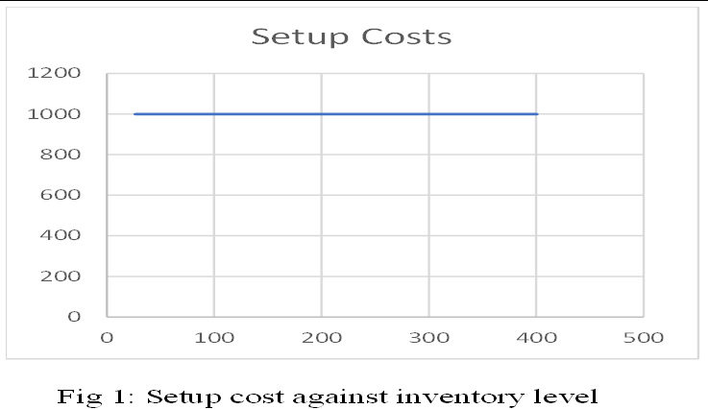

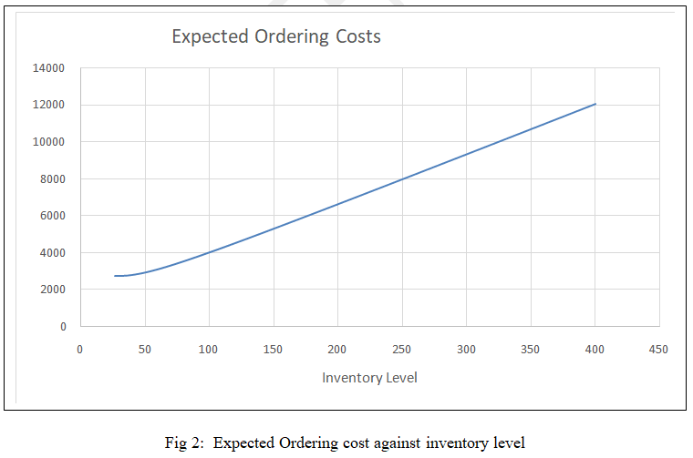

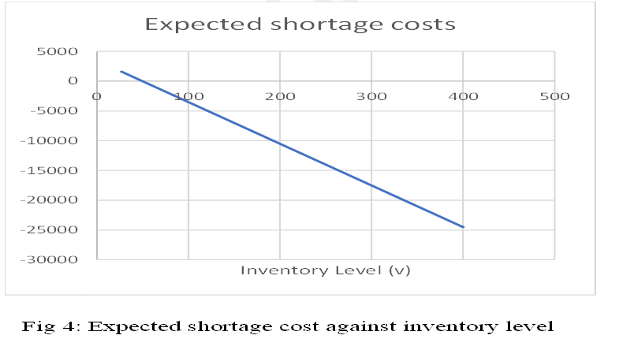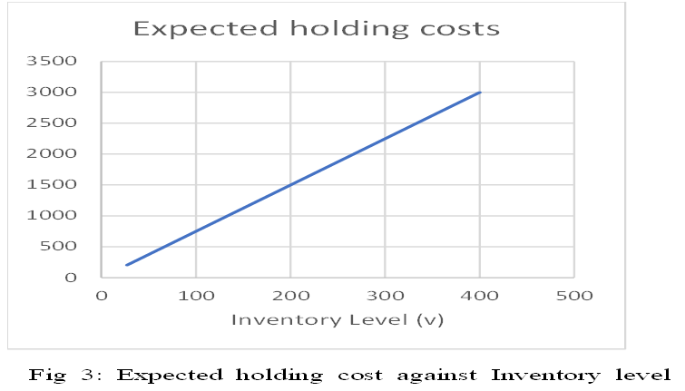

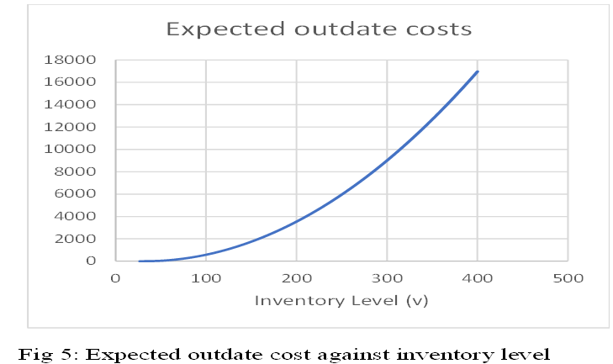

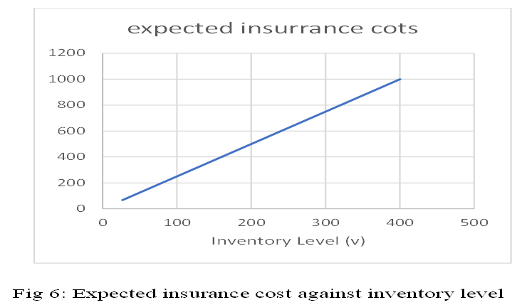

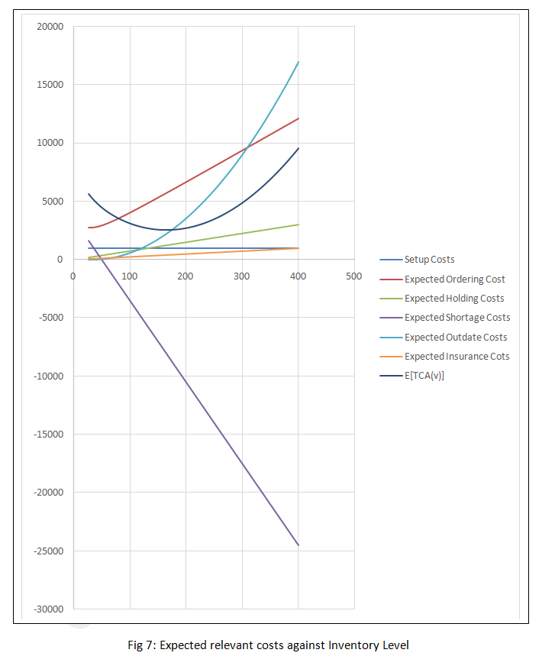**4.1 The z-Z Ordering Policy For The Inventory System With Fixed lifetime**

Assuming IP, the amount on hand before an order is placed, the number of quantity to be is answered under these conditions

1. IP $<$ z
2. z ≤ IP ≤ Z
3. 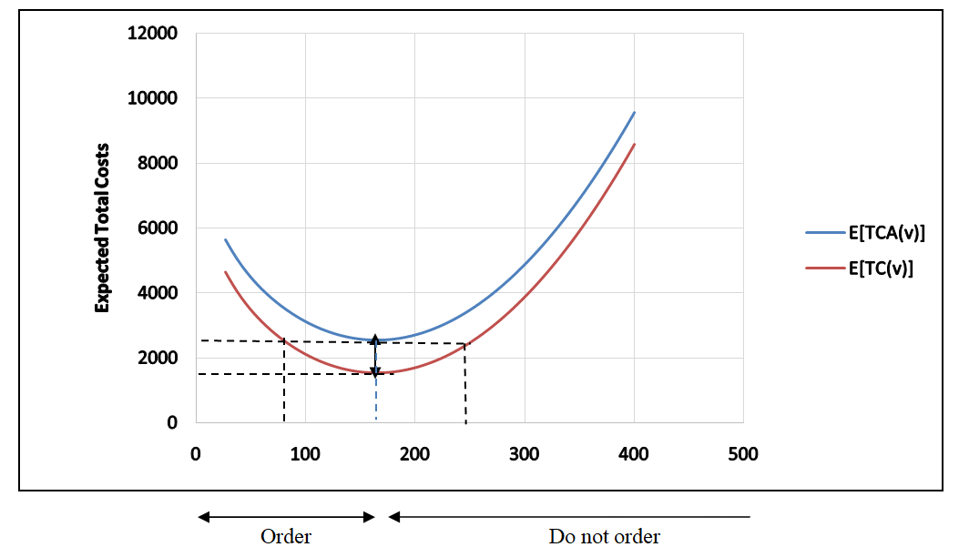IP $>$ Z

Fig 8: (z - Z) Optimal Ordering Policy

When the symbol z and Z are defined in fig 8 the value of Z is equal to $v^{*}$ while the value of z is determined from

E[TC(z)] = E[TCA(Z)] = A + E[TC(Z)] (34)

Such that z $<$ Z

**Case 1 (IP $<$ z)**

Because IP is already on hand, its equivalent cost is given by E[TC(IP)]. If any additional amount

v -IP(v>IP) is ordered, the corresponding cost given as E[TCA (v)] , which includes the setup cost K. from above see fig 8 , we have:

$\begin{matrix}min \\ v>IP\end{matrix}E\left[TCA\left(V\right)\right]=E[TCA\left(Z\right)<E[TC\left(IP\right)]$ (35)

This means that the optimal inventory levels reach v* = Z and the amount ordered equals Z-IP

**Case 2 ( z ≤ IP ≤ Z)**

From the data above, we have

E{TC(IP)} ≤ $\begin{matrix}min \\ v>IP\end{matrix}$ E[TCA(V)] = E[TCA(Z)] (36)

Thus, it is not beneficial to order in this case and V* = IP.

**Case 3 (IP $>$ Z)**

From the data above, we have v $>$ IP

E[TC(IP)] $<$ E[TCA(V)] (37)

The condition shows that, as in condition (2), it is not beneficial to place an order- that is v* = IP. The optimal inventory policy, frequently referred to as the z - Z policy, is summarized as:

If IP < z, order Z-IP

If IP ≥ z, do not order

The optimality of the z-Z policy is guaranteed because the associated cost function is convex

**4.2 Discussion Of Results**

We were able to determine the expected total relevant costs by applying the results givenin table 2 with setup cost ( A = 1000), mean demand (⅄= 25), product lifetime of (m=4) with inventory parameters shortage cost (s = 140), replenishment cost ( r = 110 ) , holding cost)( h = 15 ) and insurance cost (b = 5 ). We achieved this by considering various values of inventory levels ranging from 27 to 400. Also, a graphical illustration of the results given in table 2 are presented in figures 1-8. in particular, figure 1 indicates that a proprtional setup cost exists regardless of the inventory levels, This is likely due to the fact that higher inventory levels require no additional setup cost for production or purchase. figures 2, 3, 5 and 6 repectively indicates that a postive directional relationship exist between (a) expected ordering cost and inventory levels.This is likely due to the fact that higher inventory levels require more frequent orders, resulting in higher ordering costs.(b) expected holding cost and inventory levels.This indicates that as the inventory level increases, the expected holding cost also increases. This is likely due to the fact that higher inventory levels require more storage space, handling, and maintenance, resulting in higher holding costs. (c) expected outdate cost and inventory levels. This suggests that as the inventory level increases, the expected outdate cost also increases. This is likely due to the fact that higher inventory levels increase the likelihood of inventory becoming outdated or obsolete.(d) expected insurance costs and inventory levels. This implies that as the inventory level increases, the expected insurance cost also increases. This is due to the fact that higher inventory levels typically require more insurance coverage, resulting in higher premiums. However, figure 4 indicates that a negative relationship between between expected shortage cost and inventory levels. This indicates that as the inventory level increases, the expected shortage cost decreases. This is likely due to the fact that higher inventory levels reduce the likelihood of stockouts and shortages. Figure 7 indicaties the interaction between the relevant expected inventory costs and the expected total inventory cosst. Figure 8 indicates the graphical illustration of the ordering policy for this type of model.

**5 Conclusion**

We have developed a probabilistic fixed lifetime inventory model with expected insurance costs. The expected ordering costs expected holding costs, expected shortage costs, expected outdates costs and expected insurance costs, were computed to determine the expected total cost for the fixed lifetime inventory system. We have also determinedan optimal ordering policyfor this type of probabilistic fixed lifetime inventory model. We recommend adopting a First-In-First-Out (FIFO) optimal issuing policy for managing stock items with fixed lifetimes. By prioritizing the issuance of older items, the FIFO policy minimizes expected outdates, thereby reducing waste and optimizing inventory management. The optimal ordering policy derived from the model shows that if IP < z it is safe to order Z – IP*,* conversely*,* if IP ≥ z, no ordering is required. The results of this study demonstrate the accuracy and consistency of the model, highlighting its potential as a decision-making tool for businesses seeking to optimize their risk management strategies and inventory models. By leveraging this model, businesses can better understand the impact of insurance premiums on their expected total costs and make informed decisions about their risk management strategies. Incorporating expected lead time into this type of model could be suggested for future studies

**Competing Interest**

Author has declared that there is no competing interests exist

**Disclaimer (Artificial intelligence)**

Author(s) hereby declare that NO generative AI technologies such as Large Language Models (ChatGPT, COPILOT, etc.) and text-to-image generators have been used during the writing or editing of this manuscript.

**References**

Alam, F., Ilahi, M., and Siddiqui, T. 2022. Insurance & Risk Management. *Journal of Business and Management.* 24(3): 39-46

Alejo-Reyes, A.; Mendoza, A.; Cuevas, E.; Alcaraz-Rivera, M. A., (2023) Mathematical Model For An Inventory Management And Order Quantity Allocation Problem With Nonlinear Quantity Discounts And Nonlinear Price-Dependent Demand. *Axioms*, 12, 547

Boxma, O., Perry, D., And Stadje, W. (2024) Perishable Inventories With Random Input: A Unifying Survey With Extensions. *Annals of Operations Research*. 332:1069–1105

Dubey, M. Vishwakarma, H. Nisha, P. (2022) Review Article on Pharmaceutical Inventory Models, *Journal of Drug Delivery and Therapeutics*. 12(5-S):230-235

Enagbonma, O., Ataha, J. and. Muhammed, U. (2015) An Optimal Ordering Policy for a Probabilistic Fixed Lifetime Inventory Model with Continuous Demand Rate. *British Journal of Mathematics & Computer Science* 11(6): 1-14.

Enagbonma. O and Eraikhuemen I. B. (2011) Optimal Ordering Policies for the Inventory System With Fixed Lifetime. *Australian Journal of Basic and Applied Sciences*, 5(12): 3343-3348

Heinrich, T., Sabuco, J. & Farmer, J.D (2022) A simulation of the insurance industry: the problem of risk model homogeneity. *J Econ Interact Coord* 17: 535–576

Hemrit, W. (2022) Does insurance demand react to economic policy uncertainty and geopolitical risk? Evidence from Saudi Arabia. *The Geneva Papers on Risk and Insurance - Issues and Practice*. 47:460–492

Hugo, G., Fettermann, D., Tortorella, G., and Testoni, M., (2016). Inventory management: a case study in a small enterprise of the electronics sector. *ProduçãoemFoco.* 06. 66-74.

Izevbizua, O And Emunefe, O. J. (2021) The Flexibility Of The Useful Lifetime Based Fixed Life Inventory Model. *Abacus (Mathematics Science Series)* 48(2): 57 – 62

Livingston, T. 2024. Pro Rate vs Flat Rate: A Comprehensive Guide To Financial Terms. *Blue Notary*.

Nahmias, S. (1982) Perishable Inventory Theory: A review”. Operation Research, 30(4): 680 -708

Omosigho SE. (2002) Determination of outdate and shortage quantities in the inventory problem with fixed lifetime*. International Journal Computer Mathematics*. 79(11):1169-1177.

Ramos, P. L. (2017) Premium calculation in insurance activity, *Journal of Statistics and Management Systems,* 20(1): 39-65

Panham, D.S., Louzada, F. & Ramos, P.L. (2024) Reducing delivery insurance costs through risk score model for food delivery company*. Scientific Reports 14, 10994.*

Taha, H. A. (2017) Operations Research. Prentice – Hall of Indian Private Limited, New Delhi.

Zhongyi L., Mengyu L., Ying L., Xin Z., (2022) A joint strategy based on ordering and insurance for mitigating the effects of supply chain disruption on risk-averse firms. International *Journal of Production Economics*. 244