**Comparative Study of Two Hypofractionated**

**Palliative Radiotherapy Schedules-24Gy in 4**

## Fractions vs 30Gy in 10 Fractions in Stage IVA and IVB Squamous Cell Carcinoma of Head-Neck Region

**Abstract:**

Palliative radiotherapy relieves distressing symptoms and helps to manage localized tumor growth when curative treatment is not possible. The study aims to determine that a palliative regimen of 24 Gy in 4 fractions in 4 weeks, once weekly fractionation can achieve a similar response to another palliative radiation therapy of 30 Gy in 10 fractions in 2 weeks regarding symptom and tumor control in locally advanced head-neck cancers with manageable toxicities. This quasi-experimental study was done at the National Institute of Cancer Research and Hospital (NICRH), Dhaka. Sixty newly diagnosed patients of HNSCC (except the cases of the nasopharynx, salivary glands, and paranasal sinus malignancies) presented with stage IVA and IVB were included in two arms. The most common age in both arms was 51-60, with 46.7% in Arm A and 50% in Arm B. On the other hand, most of the participants were in the Taka 15000-24999 income group. 8.3% participants were diabetic 2(6.7%) in Arm A vs 3(10%) in Arm B. According to TNM staging, IVB constituted just above half 16(53.3%) in Arm A, and 15(50%) in Arm B. Before RT, there was no skin toxicity in any participant. After completing RT, there was 13(43.3%) skin toxicity in Arm A and 19(63.3%) in Arm B. This resolved with time, and at the end of the 6th week following RT, it was only 2 (6.7%) in Arm A and 3(10%) in Arm B. The palliative hypofractionated radiotherapy regimen of 24 Gy in 4 fractions administered once weekly, as observed in this study, exhibits similar effectiveness in terms of symptom management, tumor control, and minimal adverse effects when compared to the conventional 30 Gy delivered in 10 fractions.

**Keywords: hypofractionated, palliative, management, radiotherapy, symptom.**

**Introduction:**

Head and neck cancer” (HNC) encompasses malignancies affecting the upper aerodigestive tract which includes the lips, oral cavity, oropharynx, larynx, hypopharynx, nasopharynx, sino-nasal cavities, and salivary glands [1]. The predominant type in this category is head and neck squamous cell carcinoma (HNSCC), which accounts for over 90% of cases. Less frequent types comprise the salivary glands' adenocarcinoma, adenosquamous carcinoma, mucoepidermoid carcinoma, and pleomorphic adenoma [2].

According to GLOBOCAN 2020, HNSCC is the seventh most common cancer globally, accounting for an estimated 890,000 new cases (roughly 4.5% of all cancer diagnoses around the world) and 450,000 deaths per year (approximately 4.6% of global cancer deaths). (GLOBOCAN, 2020). The incidence of HNSCC continues to rise and is anticipated to increase by 30% (that is, 1.08 million new cases annually) by 2030. In the United States, head and neck cancer accounts for more than three percent of malignancies, with approximately 66,000 cases annually and 15,000 deaths per year. The incidence of HNSCC continues to rise and is anticipated to increase by 30% (that is, 1.08 million new cases annually) by 2030. In the United States, head and neck cancer accounts for more than three percent of malignancies, with approximately 66,000 cases annually and 15,000 deaths per year [3]. Overall, around 57.5% of head and neck cancer (HNC) cases are concentrated in Asia. Particularly India, registers a significant HNC burden, with 205,325 new cases reported annually, resulting in 122,834 associated deaths [4].

Comprehensive cancer statistics are lacking in Bangladesh, but fragmented information is available from international organizations, journals, and local institutes [5]. According to GLOBOCAN 2020, the incidence of lip and oral cavity cancer in Bangladesh was 13,985, encompassing both sexes and all age groups. This ranked as the second most common cancer type in Bangladesh, following esophageal cancer. The hypopharynx had the 7th highest incidence with 7,476 cases, the larynx ranked 9th with 5,270 cases, and the oropharynx accounted for 3,852 cases. In terms of mortality, the lip and oral cavity accounted for 8,137 deaths ranking third, the larynx ranked 8th with 3,219 deaths and the hypopharynx ranked 9th with 3,151 deaths [6].

The Cancer Registry Report-2018-2020 of the National Institute of Cancer Research and Hospital (NICRH) shows that 35,773 cancer patients were newly diagnosed at the NICRH outpatient department. Out of these, 3,282 had head and neck cancer. Cheek and buccal mucosa cancer was the ninth most common type of cancer among the top ten cancers [5].

Globally, HNSCC is more common in men than in women, with a male-to-female

ratio of approximately 2:1. In the developing world, especially in the Indian subcontinent, the incidence of HNSCC is growing with increasing consumption of tobacco (smoked or smokeless), alcohol, and areca nut (betel nut). Alcohol and tobacco have a synergistic effect on developing HNSCC. In developed nations, HPV-related HNSCC surpasses tobacco- and alcohol-related disease. Nasopharyngeal carcinoma is prevalent in southern China. Research has established the significant involvement of the Epstein–Barr virus (EBV) as the primary causative factor in the development of nasopharyngeal carcinoma [7].

Advanced TNM stages are, in general, associated with worse survival. Nevertheless, curative treatment is possible in advanced head and neck cancer, if disease extent, general condition, and performance status are favourable for definitive chemoradiotherapy or surgery followed by concurrent chemoradiotherapy [8,9]. Radiation therapy (RT) plays a key role in curative-intent treatments as well as palliative treatment for head and neck squamous cell carcinoma. Its use is indicated as a sole therapy in the early stage or in combination with surgery or concurrent chemotherapy in advanced stages [10].

The palliative hypofractionated treatment regimens include 30-32Gy in 5-8 fractions, 24 Gy in 3 fractions, 20-25 Gy in 5 fractions 30 Gy in 10 fractions, Quad Shot regimen, Christie regimen, 0,7,21 regimen. [11]. The most commonly used palliative schedules are 20 Gy in 5 daily fractions over 1 week and 30 Gy in 10 fractions over 2 weeks [12].

The purpose of the current study was to determine that a palliative regimen of 24 Gy in 4 fractions in 4 weeks, once weekly fractionation can achieve a similar response to another palliative radiation therapy of 30 Gy in 10 fractions in 2 weeks regarding symptom and tumor control in locally advanced head-neck cancers with manageable toxicities.

**Methods:**

This quasi-experimental study was done at the National Institute of Cancer Research and Hospital (NICRH), Dhaka. Sixty newly diagnosed patients of HNSCC (except the cases of the nasopharynx, salivary glands, and paranasal sinus malignancies) presented with stage IVA and IVB were included in two arms. The sample was collected by purposive sampling technique.

Histologically and radiologically proven moderately advanced (IVA) or very advanced (IVB) locoregional squamous cell carcinoma patients of head and neck who were not fit for curative treatment (due to fungating growth, inoperable disease, distressing symptoms, poor performance status, or significant co-morbidity) are included whereas, patients with age *<*18 years or *>*72 years, ECOG performance status more than 3, evidence of synchronous, multiple malignancies or recurrent cases, previously treated with chemotherapy and radiotherapy to head and neck region, Nasopharynx, PNS, or Salivary gland tumor, pregnancy, Other major vital organ dysfunction are excluded from this clinical study. A pre-tested semi-structured questionnaire. This Questionnaire was designed based on objectives and contained relevant questions and variables. Data were collected by face-to-face interviews ensuring the privacy and confidentiality of the participants.

* **Arm-A**

Total Dose- 24 Gy

Dose per fraction- 6 Gy

Number of fractions - 4

Number of fractions per week - 1

Duration – 21 days (Day 1, 8, 15 & 22).

* **Arm-B**

Total Dose- 30 Gy

Dose per fraction- 3 Gy

Number of fractions - 10

Number of fractions per week - 5

Duration – 10 days.

Statistical analysis was done according to the study’s objective by using SPSS software version 27.0 for Windows (IBM SPSS Statistics for Windows, version 27.0, Armonk, NY: IBM Corp.) and graphs, and diagrams by Google Sheets. The analysis was done using an independent t-test for continuous variables a chi-square test and Fisher’s exact test for categorical variables. All reported *p*-values were two-sided, and a value less than or equal to 0.05 was regarded as significant.

Ensuring informed consent was of paramount importance. Every participant received comprehensive information about the study’s purpose, procedures, potential risks, and benefits. It was imperative that participants willingly and knowingly consented to their involvement and had the opportunity to ask questions before agreeing to participate.

**Result:**

**Table 1: Distribution of the patients according to sociodemographic characteristics (n=60)**

Table 1 shows the distribution of the patients according to sociodemographic characteristics. Among the participants. The most common age in both arms was 51-60, with 46.7% in Arm A and 50% in Arm B. On the other hand, most of the participants were in the Taka 15000-24999 income group. This group belonged to Arm A 13 (43.3%) and Arm B 16 (53.3%) participants. In the income range, tk *<* 15000 Arm A constituted 12(40%) and Arm B constituted 9(30%).

**Age in years** Arm-A Arm-B

*p*-value

No. % No. %

|  |  |  |  |  |
| --- | --- | --- | --- | --- |
| ≤ 40 | 5 | 16.7 | 3 | 10.0 |
| 41-50 | 5 | 16.7 | 7 | 23.3 |
| 51-60 | 14 | 46.7 | 15 | 50.0 |
| 61-72 | 6 | 20.0 | 5 | 16.7 |

0.8532ns

|  |  |  |
| --- | --- | --- |
| **Income** |  |  |
| <15000 | 12 40 | 9 30 |
| 15000-24999 | 13 43.3 | 16 53.3 |
| 25,000-34,999 | 4 13.3 | 3 10 |
| >35,000 | 1 3.3 | 2 6.6 |

**Figure 1: Distribution of the study population by risk comorbidities (n=60)**

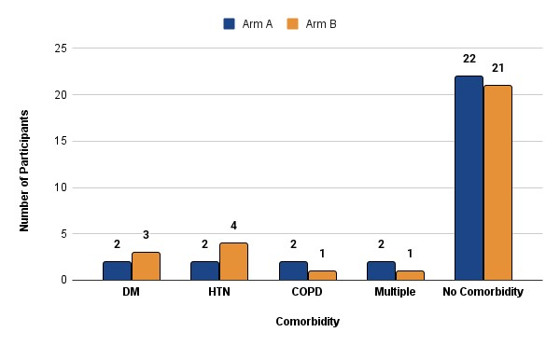

Figure 1 illustrates distribution of the study population by risk comorbidities. It is evident that, 5 (8.3%) participants were diabetic 2(6.7%) in Arm A vs 3(10%) in Arm B, 6(10%) population was hypertensive 2(6.7%) in Arm A vs 4(13.3%) in Arm B, Chronic obstructive pulmonary disease (COPD) in 3(5%) participants, 2(6.7%) in Arm A vs 1(3.3%) in Arm B, and 3(5%) participants had multiple commodities.

**Figure 2: Distribution of the study population by symptom at presentation (n=60)**

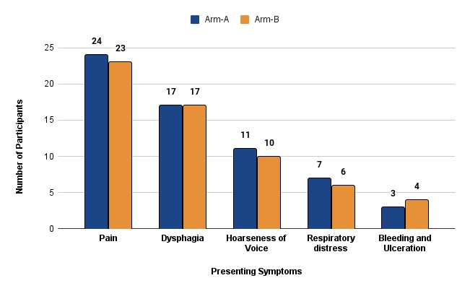

Figure 2 evaluates the distribution of the study population by symptom at presentation. We found a spectrum of presenting complaints with varying degrees. We found that 47(78.3%) of participants had pain of different severity. In Arm A it was 24(80%) and in Arm B it was 23(76.7%). In terms of dysphagia, we found 34(56.7%) of participants presented with dysphagia, followed by hoarseness of voice at 31(51.7%), distress at 13(21.7%), and bleeding and ulceration at 7(11.7%).

**Table 2: Distribution of the patients according to TNM staging (n=60):**

Table 2 resembles the distribution of the patients according to TNM staging. the TNM stage grouping of the participants in both Arms. IVB constituted just above half 16(53.3%) in Arm A, and 15(50%) in Arm B.

TNM Stage Arm-A Arm-B

*p*-value

No. % No. %

stageIVA 14 46.70 15 50.00

0.796ns

|  |  |  |  |  |
| --- | --- | --- | --- | --- |
| stageIVB | 16 | 53.30 | 15 | 50.00 |

**Figure 3:** **Distribution of the study population by treatment response (n=60)**

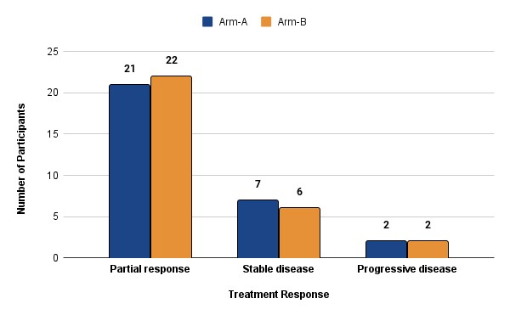

Figure 3 shows the distribution of the study population by treatment response. It is found that, partial response is 43(71.7%0 in Arm A 21(70%), Arm B 22(73.3%), stable disease is 13(21.7%), in Arm A 7(23%) and Arm B 6(20%) and unfortunately 2(6.7%) of each Arm had progressive disease. In our study, there was no complete response.

**Table 3: Distribution of study population according to symptomatic response status (n=60)**

The table 3 shows relief from distressing symptoms at the end of RT. The responses were measured more than 75%, 50-75%, and less than 75% scoring system. In terms of pain (n=47), dysphagia (n=34), hoarseness of voice (n=21), and respiratory distress

(n=13). In both of the arms, there is no significant difference

Distribution of study population according to pain status

|  |  |  |  |
| --- | --- | --- | --- |
| Pain | Arm-A | Arm-B | *p*-value |
|  | No. % | No. % |  |

|  |  |  |  |  |
| --- | --- | --- | --- | --- |
| none | 6 | 20.00 | 7 | 23.30 |
| mild | 9 | 30.00 | 8 | 26.70 |
| moderate | 9 | 30.00 | 8 | 26.70 |

Pre treatment0.965ns

|  |  |  |  |  |
| --- | --- | --- | --- | --- |
| Severe | 6 | 20.00 | 7 | 23.30 |

|  |  |  |  |
| --- | --- | --- | --- |
| none 12 | 40.00 | 11 | 36.70 |
| mild 13 | 43.30 | 11 | 36.70 |

|  |  |  |  |  |  |
| --- | --- | --- | --- | --- | --- |
| of treatment |  |  |  |  |  |
|  | moderate | 5 | 16.70 | 8 | 26.70 |

After completion

0.637ns

|  |  |  |  |  |
| --- | --- | --- | --- | --- |
| none | 16 | 53.30 | 11 | 36.70 |
| mild | 10 | 33.30 | 15 | 50.00 |

|  |  |  |  |  |  |  |
| --- | --- | --- | --- | --- | --- | --- |
| after completion |  |  |  |  |  |  |
|  | moderate | 4 | 13.30 | 4 | 13.30 |  |
| 12 week after completion | none mild | 23  7 | 76.70  23.30 | 21  9 | 70.00  30.00 | 0.559ns |
| 24 week after completion | none mild | 25  5 | 83.30  16.70 | 22  8 | 73.30  26.70 | 0.347ns |

6 week

0.382ns

Distribution of study population according to dysphagia status

Arm-A Arm-B

Dysphagia  *p*-value

No. % No. %

|  |  |  |  |  |
| --- | --- | --- | --- | --- |
| none | 13 | 43.30 | 13 | 43.30 |
| mild | 12 | 40.00 | 9 | 30.00 |
| moderate | 3 | 10.00 | 7 | 23.30 |

Pre treatment0.501ns

|  |  |  |  |  |
| --- | --- | --- | --- | --- |
| Severe | 2 | 6.70 | 1 | 3.30 |

|  |  |  |  |  |
| --- | --- | --- | --- | --- |
| none | 21 | 70.00 | 26 | 86.70 |
| mild | 8 | 26.70 | 4 | 13.30 |

|  |  |  |  |  |  |  |
| --- | --- | --- | --- | --- | --- | --- |
| of treatment |  |  |  |  |  |  |
|  | moderate | 1 | 3.30 | 0 | 0.00 |  |
| 6 week  after completion | none mild | 28  2 | 93.30  6.70 | 29  1 | 96.70 3.30 | 0.239ns |
| 12 week after completion | none mild | 28  2 | 93.30  6.70 | 30  0 | 100.00 0.00 | 0.554ns |
| 24 week after completion | none mild | 28  2 | 93.30  6.70 | 30  0 | 100.00 0.00 | 0.15ns |

After completion

0.867ns

Distribution of study population according to Hoarseness status

|  |  |  |  |
| --- | --- | --- | --- |
| Hoarseness | Arm-A | Arm-B | *p*-value |
|  | No. % | No. % |  |

|  |  |  |  |  |
| --- | --- | --- | --- | --- |
| none | 19 | 63.30 | 20 | 66.70 |
| mild | 9 | 30.00 | 9 | 30.00 |

Pre treatment0.836ns

|  |  |  |  |  |  |  |
| --- | --- | --- | --- | --- | --- | --- |
|  | Moderate | 2 | 6.70 | 1 | 3.30 |  |
| After completion of treatment | none mild | 21  9 | 70.00  30.00 | 23 7 | 76.70 23.30 | 0.559ns |
| 6 week  after completion | none mild | 25  5 | 83.30  16.70 | 27 3 | 90.00 10.00 | 0.448ns |
| 12 week after completion | none mild | 28  2 | 93.30  6.70 | 29  1 | 96.70 3.30 | 0.554ns |
| 24 week after completion | none mild | 29  1 | 96.70  3.30 | 30  0 | 100.00 0.00 | 0.313ns |

**Table 4: Distribution of study population according to FACT HNSI scoring before and after treatment for Arm A & Arm B (n=60)**

Table 4 presents that, both Arm A and Arm B showed significant improvement from the Pre-treatment score to the post-treatment score.

**Distribution of study population according to FACT HNSI scoring before and after treatment for Arm A**

|  |  |  |  |
| --- | --- | --- | --- |
| FACT HNSI | Arm A Pre Rx | Arm A Post Rx | P value |
| Mean Score | 30.53 | 25.1 | *<*0.05 |
| SD | 3.32 | 3.72 | Significant |

**Distribution of study population according to FACT HNSI scoring before and after treatment for Arm B**

|  |  |  |  |
| --- | --- | --- | --- |
| FACT HNSI | Arm B Pre Rx | Arm B Post Rx | P value |
| Mean Score | 32.03 | 25.7 | *<*0.05 |
| SD | 2.2 | 2.27 | Significant |

**Figure 4: Radiation-induced skin toxicity (n=60)**

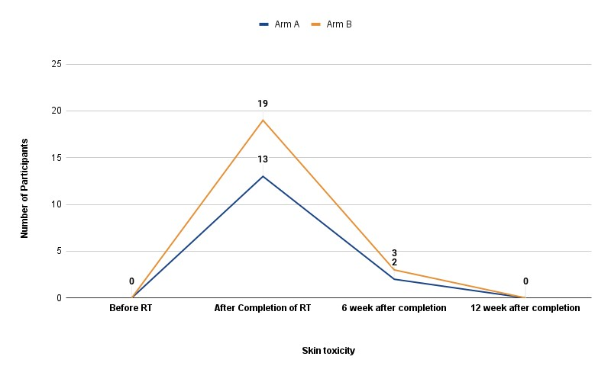

Figure 4 shows that before RT, there was no skin toxicity in any participant. After completing RT, there was 13(43.3%) skin toxicity in Arm A and 19(63.3%) in Arm B. This resolved with time, and at the end of the 6th week following RT, it was only 2 (6.7%) in Arm A and 3(10%) in Arm B.

**Discussion:**

The optimum management of HNSCC is crucial for patients’ quality of life and survival. Controlling the disease at its primary site and the nodal areas is paramount. Failure to do so can lead to significant morbidity. The treatment of choice varies depending on the staging, patient factors, and the availability of higher techniques. However, it’s important to note that the availability and access to advanced radiation therapy techniques can vary from one country to another. In some regions, like our country, hypofractionated radiation therapy may be a practical and effective alternative for achieving local disease control.

In this research, most participants fell into the age bracket of 51 to 60 years. In arm A, the average age was 52.2 ± 9.4 years, with a range spanning from 33 to 66 years. In arm B, the mean age was slightly higher at 52.6 ± 8.1 years, ranging from 36 to 67 years. There is no significant difference between arm A and arm B. The overall mean age across both arms was 52.4 ± 8.67 years, and the median age was 52.5 years. These results are consistent with the data extracted from the NICRH hospital-based cancer registry report from 2018 to 2020. This data revealed that among the 1649 participants diagnosed with head and neck cancer in 2020, the average age was 54 years, with a SD of 13.069 [13]. In a prospective quasi-experimental investigation having a similar study population conducted by Bari et al. (2018), at NICRH, BSMMU, and DMCH, it was observed that the mean ages in Arm A and Arm B were 54.7 ± 9.1 and 56.6 ± 7.9, respectively, this finding that aligns with the current study. Additionally, Agarwal et al. (2008) reported a median participant age of 55 years in their study investigating a similar cohort [13,14].

Current study’s findings also revealed that the majority of participants (53.3%) reported a total household income ranging from 15,000 to 25,000 taka, with an average total household income of 18,762 taka. However, data from the Household Income and Expenditure Survey HIES (2023) indicated that the average monthly household income at the national level was 32,422 taka, while it stood at 26,163 taka in rural areas. This income disparity can be attributed to the substantial impact of cancer on the breadwinners of these families. The financial strain associated with cancer treatment and the potential loss of income due to illness can contribute to a reduction in the overall household income [15].

This study also noted the presence of specific comorbidities in the participant population, which could potentially impact the disease progression and treatment outcomes. To be specific, we observed that 8.3% of participants had diabetes, with 6.7% in Arm A and 10% in Arm B. Hypertension was present in 10% of the participants, with 6.7% in Arm A and 13.3% in Arm B. Chronic obstructive pulmonary disease (COPD) was identified in 5% of participants, with 6.7% in Arm A and 3.3% in Arm B. Moreover, 5% of participants had multiple comorbidities, with 6.7% in Arm A and 3.3% in Arm B. It’s noteworthy that the majority of participants, specifically 71.7%, did not have any apparent comorbidities. Our study’s findings exhibit similarities to the study conducted by Srivastava et al. (2021), where 4.5% of participants had hypertension, 3.6% had COPD, 4.5% were diabetic, and the majority, comprising 83.6%, had no comorbidities [16].

Regarding the TNM stage grouping of our participants, the current study specifically included respondents classified as stage IVA and stage IVB based on our inclusion criteria. We observed that 48.3% of our participants fell into stage IVA, while 51.7% were categorized as stage IVB. In Arm A, 46.7% were in stage IVA, and 53.3% were in stage IVB, whereas in Arm B, 50% were in stage IVA, and 50% were in stage IVB. There were no significant differences in the distribution of TNM stages between the two study arms.

This study aligns with similar research in this regard. Reference studies have demonstrated variability in the distribution of cases across different TNM stages. In most of these studies, the highest number of cases was classified as stage IVA, as seen in studies by Porceddu et al. (2007)and Gautam and Shah (2020) [17,18]. Considering the study conducted by Gautam et al. (2020), roughly half, specifically 53.3% of the cases, were classified as stage IVA, a distribution closely resembling our findings. It’s essential to emphasize that the diversity in the inclusion criteria adopted in studies focused on palliative radiation therapy for head and neck squamous cell carcinoma (HNSCC) contributes to the disparities observed in patient staging across these studies.

This study evaluated the objective response after completing radiotherapy at subsequent follow-up by RECIST criteria. The findings indicate that 71.7% of participants achieved a partial response (70% in Arm A and 73.3% in Arm B), while

21.7% had stable disease (23% in Arm A and 20% in Arm B). Regrettably, 6.7% of Arm A and Arm B participants experienced progressive disease. It’s important to note that we did not observe any cases of complete response in our study. Our results align with similar studies [19].

Before LRRT, no instances of skin toxicity were evident. After RT completion (Day 22 in Arm A and Day 12 in Arm B), the occurrence of skin toxicity escalated to Grade 1, with proportions of 40% in Arm A and 56.7% in Arm B, and Grade 2, with percentages of 3.3% in Arm A and 6.7% in Arm B. This effect subsequently diminished, and by the end of the 6-week RT period, only a few cases exhibited Grade 1 skin toxicity, accounting for 6.7% in Arm A and 10% in Arm B. Importantly, no statistically significant disparities in skin toxicity were observed. The study by Bonomo et al. (2017) reported the presence of acute treatment-related skin toxicity, which was classified as Grade 1 in 27.8% of cases and Grade 2 in 27.8% of cases [20].

Pre-treatment FACT HNSI scores in arms A and B are 30.53±3.32 and 32.03±3.72, respectively. This score reduced to 25.10±2.20 and 25.7±2.27 in Arm A and Arm B, respectively. There is no significant difference in Arm A and B, but significant improvement was found from pre-treatment to post-treatment in both arms (p*<*.05). FACT HNSI score reflects the symptomatic improvement as well as improvement of quality of life. In our study, from pre-treatment condition, hypofractionated RT could significantly improve physical symptoms and quality of life [21].

**Limitation of the study:**

Conformal treatment was not given. Follow-up FOL and CT scans could not be done in all cases. Late toxicities were not evaluated properly.

**Conclusion:**

The 24 Gy in 4 fractions regimen offers clinical benefits and presents advantages in terms of reduced hospital resource utilization and lower associated costs when contrasted with the 30 Gy in 10 fractions schedule.

**Consent**

**As per international standards or university standards, Participants’ written consent has been collected and preserved by the author(s).**

Disclaimer (Artificial intelligence)

Option 1:

Author(s) hereby declare that NO generative AI technologies such as Large Language Models (ChatGPT, COPILOT, etc.) and text-to-image generators have been used during the writing or editing of this manuscript.

Option 2:

Author(s) hereby declare that generative AI technologies such as Large Language Models, etc. have been used during the writing or editing of manuscripts. This explanation will include the name, version, model, and source of the generative AI technology and as well as all input prompts provided to the generative AI technology

Details of the AI usage are given below:

1.

2.

3.

Reference:

1. DeVita Jr VT, Rosenberg SA, Lawrence TS. DeVita, Hellman, and Rosenberg's Cancer: Short Title. Lippincott Williams & Wilkins; 2022 Sep 21.
2. Pai, S. I. and Westra, W. H. (2009), ‘Molecular pathology of head and neck cancer: implications for diagnosis, prognosis, and treatment’, Annual Review of Pathology:

Mechanisms of Disease 4, 49–70.

1. Johnson DE, Burtness B, Leemans CR, Lui VW, Bauman JE, Grandis JR. Head and neck squamous cell carcinoma. Nature reviews Disease primers. 2020 Nov 26;6(1):92.
2. Nagarajan M, Banu R, Shrividhya A, Chellapandian TP, Rajkumar A, Mohanraj R. Outcomes and management of head and neck cancer at a South Indian Cancer Centre: a retrospective study. Indian Journal of Medical and Paediatric Oncology. 2022 Dec;43(06):500-6.
3. Chatterji S, Turuk A, Das P, Bhattacharya S, Mukherjee S, Ghosh PS, Chatterjee A, Mukerjee A, Kumar G, Satija A, Josten K. Insights into cancer characteristics among SARS-CoV-2 infected hospitalized patients: a comprehensive analysis from the National Clinical Registry for COVID-19. Journal of Cancer Research and Clinical Oncology. 2024 Nov 15;150(11):500.
4. Deo SV, Sharma J, Kumar S. GLOBOCAN 2020 report on global cancer burden: challenges and opportunities for surgical oncologists. Annals of surgical oncology. 2022 Oct;29(11):6497-500.
5. Barsouk A, Aluru JS, Rawla P, Saginala K, Barsouk A. Epidemiology, risk factors, and prevention of head and neck squamous cell carcinoma. Medical Sciences. 2023 Jun 13;11(2):42.
6. de Almeida JR, Truong T, Khan NM, Su JS, Irish J, Gilbert R, Goldstein D, Huang SH, O'Sullivan B, Hosni A, Hope A. Treatment implications of postoperative chemoradiotherapy for squamous cell carcinoma of the oral cavity with minor and major extranodal extension. Oral Oncology. 2020 Nov 1;110:104845.
7. Forastiere AA, Goepfert H, Maor M, Pajak TF, Weber R, Morrison W, Glisson B, Trotti A, Ridge JA, Chao C, Peters G. Concurrent chemotherapy and radiotherapy for organ preservation in advanced laryngeal cancer. New England Journal of Medicine. 2003 Nov 27;349(22):2091-8.
8. Alterio D, Marvaso G, Ferrari A, Volpe S, Orecchia R, Jereczek-Fossa BA. Modern radiotherapy for head and neck cancer. InSeminars in oncology 2019 Jun 1 (Vol. 46, No. 3, pp. 233-245). WB Saunders.
9. Grewal AS, Jones J, Lin A. Palliative radiation therapy for head and neck cancers. International Journal of Radiation Oncology* Biology* Physics. 2019 Oct 1;105(2):254-66.
10. Morris S, Roques T, Ahmad S, Loo S. Practical radiotherapy planning. CRC Press; 2023 Oct 3.
11. Agarwal JP, Nemade B, Murthy V, Ghosh-Laskar S, Budrukkar A, Gupta T, D’Cruz A, Pai P, Chaturvedi P, Dinshaw K. Hypofractionated, palliative radiotherapy for advanced head and neck cancer. Radiotherapy and Oncology. 2008 Oct 1;89(1):51-6.
12. Bari MA, Alam S, Sharmin S, Nahar S, Uddin J, Alam N. Outcome of concurrent chemoradiotherapy and radiotherapy alone following induction chemotherapy in locally advanced squamous cell carcinoma of head and neck. Bangladesh Medical Research Council Bulletin. 2018 Nov 22;44(2):93-7.
13. Nishat NJ. Household Income Dynamics and Wage Inequality In Bangladesh: Evidence From Hies 2010 And 2016. Journal of Economic Development. 2023 Sep 1;48(3):91-110.
14. Srivastava A, Adhikari N, Sonkar DR, Singh K, Rathi AK. “Christie Regimen” palliative radiotherapy in advanced head-and-neck cancer: A single-center experience. Journal of Cancer Research and Therapeutics. 2021 Jan 1;17(1):88-93.
15. Porceddu SV, Rosser B, Burmeister BH, Jones M, Hickey B, Baumann K, Gogna K, Pullar A, Poulsen M, Holt T. Hypofractionated radiotherapy for the palliation of advanced head and neck cancer in patients unsuitable for curative treatment–“Hypo Trial”. Radiotherapy and Oncology. 2007 Dec 1;85(3):456-62.
16. Gautam D, Shah A. Palliative hypofractionated radiotherapy in advanced squamous cell carcinoma of head and neck. Nepalese Journal of Cancer. 2020 Oct 4;4(1):39-44.
17. Ali MY, Alam MS, Mannan MA, Asaduzzaman AK, Khan MA, Islam SM. Short course palliative radiotherapy in locally advanced squamous cell carcinoma of head and neck. Journal of Armed Forces Medical College, Bangladesh. 2010;6(1):16-20.
18. Bonomo P, Desideri I, Loi M, Russo ML, Olmetto E, Maragna V, Francolini G, Paoli CD, Grassi R, Pezzulla D, Greto D. Elderly patients affected by head and neck squamous cell carcinoma unfit for standard curative treatment: Is de-intensified, hypofractionated radiotherapy a feasible strategy?. Oral Oncology. 2017 Nov 1;74:142-7.
19. Haddad RI, Harrington K, Tahara M, Ferris RL, Gillison M, Fayette J, Daste A, Koralewski P, Zurawski B, Taberna M, Saba NF. Nivolumab plus ipilimumab versus EXTREME regimen as first-line treatment for recurrent/metastatic squamous cell carcinoma of the head and neck: the final results of CheckMate 651. Journal of Clinical Oncology. 2023 Apr 20;41(12):2166-80.