**Characterization of bacteria that promote growth from spent mushroom compost and**

**their effectiveness on the yield and quality of white button mushrooms**

**Abstract**

Micro-organisms in the substrate and mushroom casing are essential to the start and growth of primordial. For mushroom production, the discarded mushroom compost may be a useful source of bacteria that promote development. **"Characterization of bacteria that promote growth from spent mushroom compost and their effectiveness on the yield and quality of white button mushrooms"** is the title of the current study that was conducted. Spent mushroom compost (SMC) samples were gathered from various locations in Solan, including Chambaghat (DMR), Nauni (UHF), and local farmers (Dharja). In order to isolate the bacteria, nutrient agar medium was utilized. From discarded mushroom compost, 25 bacterial isolates from SMC were chosen and refined.

Twelve of the twenty-five bacterial isolates (seven from Nauni, four from the local farmer site, and fourteen from Chambaghat) produced P-solubilizer, fifteen nitrogen fixers, nine HCN, thirteen siderophores, and ten IAA. Out of 25 bacterial isolates, only two (GPB1 and GPB2) were chosen based on different PGPR characteristics.Bacterial isolate NS2 produced the highest amounts of siderophores (96.37%) on solid CAS medium and (286.21μg/ml) in liquid assay, IAA (79.60 μg/ml), HCN, and P-solubilization both qualitatively (93.3%) and quantitatively (214.76 μg/ml).

These two bacterial isolates (GPB1, GPB2) were tested for growth of white button mushroom in field experiment. Mushrooms innoculated with Treatment 7(GPB1+ GPB2 on casing and substrate) showed significant increase in yield (75 %) and biological efficiency in all three flushes over Uninoculated control. The treatment T7 (GPB1+ GPB2 ) registered 51.3 per cent increase in antioxidant enzyme assay content,67.83 per cent increase in protein content, 74.5 percent in carbohydrate content , 87.8 per cent increase in ash content over uninoculated control (T1).This treatment also increased NPK content of compost over uninoculated control. Hence these bacterial isolates have enormous potential to be used as biofertilizers for enhanced growth and quality of white button mushroom.

**Key words:** Spent Mushroom compost, PGPR, White Button Mushroom, IAA

1. **Introduction**

The spent mushroom compost (SMC) is a valuable by-product of mushroom cultivation. It consists of partially degraded paddy or wheat straw, coconut husk, bagasse, or other agricultural waste. The bacteria within SMC are adapted to the harsh conditions of mushroom cultivation, they play a beneficial role in recycling compost nutrients. The isolation and characterization of microbial diversity with potential growth promoting traits in SMC are of prime importance for researchers and farmers.

These beneficial microbes can be utilized as efficient biofertilizers and are verified as secure and proficient methods of increasing crop yields and production, and also help to improve the soil health (Premachandra et al., 2016; Vejan et al., 2016, Martin et al., 2023). Recently numerous PGP bacterial genera such as *Azotobacter, Arthrobacter, Bacillus, Burkholderia, Klebsiella, Enterobacter, Pseudomonas, Serratia*, etc. have been used as biofertilizers due to their growth promoting traits, availability and safe handling as reported by various authors (Di Benedetto et al., 2017

Banerjee and van der Heijden, 2023).

Mushrooms have been favored as food by mankind for a long time. Mushrooms supply a rich addition to the diet in the form of protein, carbohydrates, valuable salts, minerals, and vitamins. There are 2000 edible types of mushrooms, but the white button mushroom (*Agaricus bisporus*) is the one that’s most commonly eaten worldwide. It is the most popular cultivar among artificially grown fungi, accounting for 31.8 percent of worldwide mushroom cultivation and 85 percent of total yield in India. The white button mushroom is a significant nutritional and medicinal species (Owaid et al., 2017; Khalil et al ., 2024).

In mushroom cultivation, the microorganisms present in the casing play a crucial role in the initiation and development of primordial and uniform distribution of sporophores, higher mushroom yield, and early cropping. There is a succession of microbial populations in the stages of mushroom cropping which is influenced by casing type affecting mushroom yield. However, isolates from SMC have not been reported and tested for its effect on mushroom yield which may have better potential. Keeping in view the present status of knowledge, there is a need to screen bacterial diversity associated with SMC and to study their application on the growth and yield of white button mushrooms.

1. **Materials and Methods:**

The present study “Characterization of bacteria that promote growth from spent mushroom and their effectiveness on the yield and quality of white button mushrooms” will be carried out in Laboratory of Basic sciences and also in Mushroom farm under Lab conditions of Dr YSP university of Horticulture and Forestry, Nauni Solan, HP. The studies were conducted to select best plant growth promoting rhizobacteria from spent mushroom compost and their response in the improvement of growth and yield of white button mushroom.

2.1 COLLECTION OF SAMPLE: The samples of spent mushroom compost were collected from different locations of distt Solan (HIMACHAL PRADESH). Three different sites are Chambaghat (1502 amsl), Nauni (1250 amsl), and from local farmer of district Solan. The mushroom compost was produced after 3-4 mushroom harvest. Samples were placed in plastic bags and stored in laboratory of Department of Basic Sciences for further isolation and for carrying on the analytical work.

Number of sites =

3



Local Farmer site

((

Dharja)



Nauni

(

Mushroom

farm of UHF)



Chambaghat

(

Directorate of

mushroom research)



SOLAN

**Fig 1:** Sample collection from three different site of district solan.

Replication: 3; Statistical Design: RBD

Chemical and Reagent: Analytical grade (AR) chemical and reagents procured from standard company were used for different experiments under present investigation.

**2.2 Microbiological Methods**

2.2.1 Isolation and enumeration of bacteria from organic sources of nutrients

One gram of sample (spent mushroom compost) was dissolved in 9 ml of sterilized distilled water and serial dilutions were made up to 10-8 under aseptic conditions. The serially diluted suspensions of samples were spread on pre-poured nutrient agar medium and also on the selective media: Nitrogen free medium (Jensen, 1987) for nitrogen fixing activity, Pikovskaya medium (Pikovskaya, 1948) for phosphate solubilizing 37 ability as described by Subba Rao (1999). The petri plates were incubated for 24 - 48 h at 35 ± 2˚C temperature in incubator. The microbial count appeared on the plate was expressed as colony forming unit (cfu) per gram/ml of sample (spent mushroom compost)

**2.2.2 Screening of Bacterial Isolates On The Basis Of Plant Growth Promoting Traits**

The screening of the bacterial isolates for various plant growth promoting activities

like P-solubilization, growth on N-free medium, siderophore production, HCN, and auxin

production(IAA) were performed by adopting the standard methods. The brief descriptions of

these methods are as follows:

**Phosphate solubilizing activity**

Each of purified isolate were streaked in a straight line on PVK medium as described

by Pikovskaya (1948) and was incubated for 72 h at 30 ± 2°C. Colonies showing

solubilization halos (>0.1mm diameter) were selected.

Nitrogen fixing activity

Each pure isolate was streaked in a straight line on Jensen's medium and cultured for

72 to 120 hours, with the plates that showed bacterial colony growth being chosen.

**Siderophore production**

The CAS plate assay method was used to measure siderophore production (Schwyn

and Neilands, 1987). CAS (60.5 mg/50 mL distilled water) was mixed with 10 mL iron

solution to make sterilised blue agar (1 mM FeCl3.6H2O in 10 mM HCl). The

hexadecyltrimethyl ammonium bromide (HDTMA) solution was produced by dissolving 72.9

mg HDTMA in 40 mL distilled water. As a result, 100 mL of CAS dye were made. 750 mL

of nutritional agar was combined with 30.24 g of 1, 4 piperazine diethane sulphonic acid, and

the pH was adjusted to 6.8 with 0.1N NaOH. It was autoclaved separately and then mixed

with Chrome azurol- S (100 ml) under aseptic conditions before being used in subsequent

tests. A bit of 72 h old culture of each test bacterium was placed on prepoured blue

coloured chrome-azurol-S agar (CAS) plates. Plates were incubated at 30 ± 2°C for 24 h

and observed for production of orange halo around the bit.

Percent siderophore efficiency =(Z-C )X 100/C

**HCN Production**

Bakker and Schippers (1987) approach was used to screen bacterial isolates for the

generation of hydrogen cyanide (HCN) . Bacterial cultures were streaked on King's B

medium modified with 1.4 g/l glycine on prepoured plates. Whatman No.1 filter paper strips

were soaked in 0.5 percent picric acid in 2% sodium carbonate, then inserted in the lid of

each petriplate, sealed with parafilm, and incubated for 1 to 4 days at 35°C. The findings of

the uninoculated control were compared. The colour of the filter paper on the plates was

changed from yellow to orange brown.

**Quantitative estimation of indole-3-acid**

Bacterial cultures were grown in modified Luria Bertani broth amended with 5 mM

L-tryptophan, 0.065% sodium dodecyl sulphate and 1% glycerol 72 h at 35˚C under shaking

conditions. The cultures were centrifuged at 15,000 rpm for 20 minutes and supernatants

were collected and stored at 4°C.

The method described by Gorden and Palleg (1957) was used to determine the IAA

equivalents i.e. 3 ml of supernatant was pipette out into test tube and 2 ml of Salkowski

reagent (2 ml 0.5 M FeCl3 + 98 ml 35% HCLO4) was added to it. The tubes containing the

mixture were left for 30 minutes (in dark) for colour development. Intensity of colour was

measured spectrophotometrically at 535 nm. Similarly, colour was also developed in standard

solution of IAA (10-100 μg/ml) and a standard curve was established by measuring the

intensity of this colour.

**2.2.3 Morphological and Biochemical Characterization of Selected Isolates**

The most efficient bacterial isolates selected on the basis of plant growth promoting traits and in vitro antagonistic activity were subjected to morphological, physiological and biochemical characterization as per the criteria of Bergey’s Manual of Systematic Bacteriology (Sherman and Cappuccino, 2005).

* + 1. **Molecular Characterization of Selected Rhizobial Isolates By 16s rRNA Sequencing**

Genomic DNA extraction was carried by conventional method (Sambrook et al., 1989). Bacterial isolates were incubated overnight at 28°C in YEM broth at 200 rpm. The cells were harvested and processed for DNA isolation. The isolated DNA was finally suspended in 100 µl of elution buffer and quantified on 1% (w/v) agarose gel. The electrophoresis was performed at 1-5 V/cm2 voltage until two dyes resolve and migrated the appropriate distance through the gel. After electrophoresis, the gel was observed under UV light and documented using gel documentation system (Bio-rad).

Universal primers for 16S rDNA amplification of bacterial isolates used were pA (5’-AGAGTTTGATCCTGGCTCAG-3’) and pH (5’-AAGGAGGTGATCCAG CCGCA-3’).

Agarose gel slice containing relevant DNA fragments was excised and extra agarose was removed to minimize the size of the gel slice. Representative bacterial isolates of each genotypic profile were chosen for 16S rDNA partial sequencing. The sequencing was performed from Eurofins lab, Bangalore, India, using both forward and reverse primers. The sequence alignment was done using the Clustal W (Thompson et al., 1994) and manually edited using the Bioedit package (Hall, 1999). The cladograms were constructed by neighbor-joining method (Saitou and Nei, 1987) with the Kimura-2-parameter model (Kimura, 1980) and were bootstrapped using the software programs in the MEGA 6.0 package (Tamura et al., 2013).

**2.3 Efficacy of Selected Growth Promoting Bacterial Isolates on Growth and Yield of White Button Mushroom**

The efficacy of selected bacterial isolates on white button mushroom will be carried out.

|  |  |  |
| --- | --- | --- |
| To1  To2 | =  = | Uninoculated casing  Uninoculated substrate |
| T1 | = | GPB1 on casing |
| T2 | = | GPB1 on substrate |
| T3 | = | GPB 2 on casing |
| T4 | = | GPB2 on substrate |
| T5 | = | GPB1 + GPB2 on casing |
| T6 | = | GPB1 + GPB2 on substrate |
| T7 | = | GPB1 + GPB2 on casing and substrate |

Where,

GPB1 is growth promoting bacteria isolated from Nauni, Solan

GPB2 is growth promoting bacteria isolated from Local site of Solan (Dharja).

Bacterial isolates = 2

Total treatments = 9

Replications = 3

Experimental Design = RBD

2.3.1 **Physico-Chemical Properties, Available Nutrients and Microbiological Status of Casing Mixture and Spent Mushroom Compost**

Potting mixture was analyzed before the application of treatments and after the termination of experiment for important physico-chemical properties, available nutrient and microbiological status by adopting the following standard procedures:

**2.3.2 pH and electrical conductivity**

The soil pH was determined in 1:2.5 (soil: water suspension) and the electrical conductivity of the supernatant liquid was recorded and expressed in dSm-1 (Jackson, 1973).

**2.3.3 Organic car, Available nitrogen, Available phosphorous and Available potassium**:

Organic carbon was determined by Chromic acid titration method of Walkley and Black (1934). Available nitrogen was determined by alkaline permagnate method of Subbiah and Asija (1956). 0.5 N NaHCO3 at 8.5pH was used to extract available phosphorus (Olsen’s et al., 1954) and determined spectrophotometrically. Available potassium was extracted by normal neutral ammonium acetate (Merwin and Peech, 1951) and determined on flame photometer.

**2.3.4 Total microbial count**

The compost mixture was also analyzed for total bacterial counts. 1g of compost mixture was taken in 9 ml of sterilized water blank and the soil suspension was diluted in 10 fold series, then microbial counts was determined by standard pour plate technique on different media as described by (Subba Rao, 1999). The population was expressed as colony forming units per gram of soil (cfu/g soil).

**2.3.5 OBSERVATIONS RECORDED FOR MUSHROOM PARAMETERS**

**Sporophore parameters**

1. Days taken for completion of case run
2. Days taken for first harvest post casing

After first case run, days taken for first harvesting of mushrooms was recorded.

1. Total length of mushroom

Length of mushroom will be measure with ruler scale in centimeters (cm) from the

bottom of mushroom to cap of mushroom.

1. Individual weight of fruit

The fresh weight of individual fruit bodies from each treatment was measured by cutting the above ground portion of mushroom with the help of knife and weighed with the help of weighing balance and the fresh weight was expressed in grams.

1. Length of stalk

Length of stalk of each mushroom was measured with the help of scale and it was measure in centimeters (cm)

1. Width of stalk

Width of stalk of each fruit was measured with the help of ruler scale in centimeters (cm)

1. Average diameter of mushroom cap (cm)
2. Yield (kg/100kg of compost)
3. Disease and pest if any.

**Yield parameter**

Total wt. of mushroom

Biological efficiency (B. E) % = X 100

Weight of compost

**2.4 Mushroom biochemical parameters**

**2.4.1 Antioxidant enzyme assay**

The mushroom extracts were mixed with methanol (96 %) and 63 μmol/L solution of

DPPH. After 30 min. at room temperature, the absorbance was measured at 517 nm and

converted into percentage of radical scavenging activity (Zeković et al., 2010). The

comparative analysis of samples was made by calculating DPPH scavenging activity which

stands for the relative decrease of absorbance in the samples analysed. DPPH scavenging

activity was calculated by using the following equation:

DPPH scavenging activity = 100 × (𝐴𝑐 – 𝐴𝑠)/𝐴𝑐 where:

Ac - absorbance of the control

As- absorbance of the sample

2.4.2 **Total phenolic content**

Total phenols (TP) were determined spectrophotometrically with Folin-Ciocalteu

reagent (Waterhouse, 2002). The sample (2 mL) was dissolved in ethanol and mixed with 10

mL Folin-Ciocalteau’s reagent diluted 1/10 with distilled water. After few minutes sodium

carbonate (8 mL) was added to this solution. This solution was stored in dark place for two

hours and after that, the absorbance was measured at 765 nm. A standard curve was prepared

using gallic acid as standard with a concentration range from 100 to 500 μg/mL. Results are

expressed in mg of gallic acid equivalents per gram (mg GAE g-1) of mushrooms.

2.4.3 **Total ash content:** This method was described by (Raghuramulu et al., 2003).Ten grams of moisture and fat-free sample was taken in a beaker and 200 ml of boiling 0.255 N H2SO4 was added. The mixture was boiled for 30 minutes keeping the volume constant by the addition of water at

frequent intervals. The mixture was then filtered through a muslin cloth and the residue

washed with hot water till free from acid. The material was then transferred to the same

beaker, and 200 ml of boiling 0.313 N NaOH added. After boiling for 30 minutes (keeping

the volume constant as before) the mixture was filtered through a muslin cloth and the

residue washed with hot water till free from alkali, followed by washing with some alcohol

and ether. It was then transferred to a crucible, dried overnight at 80~100℃ and weighed

(We) in an electric balance .The crucible was heated in a muffle furnace (at 600℃)for 5~6

hours, cooled and weighed again (Wa). The difference in the weights (We-Wa) represents the

weight of crude fiber.

Crude fiber (g/100 g sample) =100 - (moisture + fat) /(We-Wa)/Wt of sample

2.4.4 **Total protein content**

A mushroom sample of 0.1 gm was placed in 10 ml of cell lysis solution and allowed

to sit at room temperature for two days. The samples were then centrifuged for 10 minutes at

7000 rpm, and the preparation was used to estimate protein using Lowry's technique. (Lowry

et al.,1951)

**2.4.5 Total carbohydrates content**

The total carbohydrate content of wild edible mushrooms is estimated by the anthrone method (Hedge and Hofreiter, 1962).

**2.4.6 Estimation of** **Soil Nitrogen, Phosphorus And Potassium (NPK)**

The nitrogen was estimated in Kjaldhel apparatus. The phosphorus content was determined by Vanado molybdo-phosphoric yellow colour method. However, potassium was determined by flame-photometer (Jackson, 1973).

**2.5 STATISTICAL ANALYSIS**

The data recorded on plant, soil and microbiological properties will be statistically analyzed by using MS-Excel and OPSTAT packages (Sheoran et al., 1998). The mean values of data will be used for the analysis of variance (ANOVA) as described by Panse and Sukhatme (2000) by using Completely Randomized Design and Randomized Block Design.

The standard error of mean SE (m) and critical difference (CD) for comparing the means of any two treatments will be calculated as below:

SE(m) = ± (Me / r)1/2 SE(d) = ± (2Me / r)1/2

CD = SE (d) x t (5%) value at error degrees of freedom.

Where,

SE(m) = Standard error of mean SE(d) = Standard error of difference

CD (0.05) = Critical difference at 5% level of significance

1. **RESULTS AND DISCUSSION**

The present investigation entitled “**Characterization of growth promoting bacteria from spent mushroom compost and their efficacy on quality and yield of white button mushroom**” was conducted at the Department of Basic Sciences, Dr. Yashwant Singh Parmar University of Horticulture and Forestry, Nauni-Solan. The studies were conducted to select best growth promoting bacteria from spent mushroom substrate and to study their response in the improvement of growth and yield of white button mushroom.

**3.1 Isolation and Enumeration of Bacteria Associated with Spent Mushroom Compost**

The data pertaining to bacterial count from spent mushroom compost (SMC) in nutrient agar medium are presented in Fig 2. It is evident from the data that mushroom compost selected from different locations had significant effects on the total bacterial count. The maximum bacterial count of 6.78 ×106 cfu/g was recorded from DMR Chambaghat of district Solan. However, the minimum bacterial count 5.43 ×106 cfu/g was recorded from Local farmer site (Dharja) of district Solan. On the basis of predominant growth of bacterial isolates on nutrient agar by calculating 106cfu/g, total 25 bacterial isolates were selected. Among 25 isolates 14 isolates from Chambaghat, Solan represented as CSI14, 7 isolates from Nauni named as NSI-7 and 4 isolates from Local Farm, Dharja, Solan represented LSI-4 were selected for further studies (Table 2).

Yohalem et al. (1996) reported that the media of button mushroom are habitat for useful microorganisms. They collected different samples from different sites of mushroom compost and found variation of bacterial population in all the collected samples. This variation may be due to composition of compost used for mushroom cultivation. Similar results were reported for white button mushroom compost by Siyoum et al., 2016 reported similar results with 7.6×10 log cfu/g bacteria in SMC of white button mushroom. Rossouw and Korsten (2017) reported high cfu/g (5.2 to 2.4 log cfu/g) form spent mushroom compost.

6.78

5.47

5.43

Microbial population (10

6

cfu/g)

Chambaghat(DMR)

Nauni

Local farmer

**Fig 2: Comparative microbial population isolated from spent mushroom compost of different sites**.

**Table 1: Total number of isolates selected from spent mushroom compost**

|  |  |  |  |
| --- | --- | --- | --- |
| District | Sites | Isolates name | No. of isolates |
| Solan | Chambaghat | CSI (Chambaghat solan isolate) | 14 |
| Solan | Nauni | NSI (Nauni Solan isolate) | 7 |
| Solan | Local famer | LSI (Local Solan isolate) | 4 |

**3.2 Screening of Bacterial Isolates for Multifarious Growth Promoting Traits**

The twenty five selected isolates were screened for multifarious growth promoting traits such as IAA production, phosphate solubilization, Nitrogen fixing ability, HCN production and siderophore production.

The data presented in Fig 3 for various growth promoting traits showed that out of 25 bacterial isolates only 10 bacterial isolates were found as IAA producer (40%), 15 isolates were found as N fixer(60%), 12 were phosphate solubilizers (48%), 13 were siderophore producer (52%)and only 9 isolates were HCN producer (36%). The isolate NS2 showed the maximum growth promoting traits followed by LS4. However, bacterial isolates CS3, CS8 and CS9 have not shown any growth promotion activities. It is evident from Fig 3 that bacterial isolates from compost of local farm of Dharja and mushroom farm of Nauni had maximum growth promoting traits, whereas spent mushroom compost of Chambaghat was recorded with bacterial isolates having low growth promoting traits. The variation of traits from different sites may be due to composition of compost of different sites and the environmental conditions during mushroom cultivation and time of sampling of compost.

Carrasco and Preston (2020) and Chen et al. (2022) have also reported that composition and conditions of mushroom cultivation affect the microbial communities. In addition to the cultivation environment, biological factors can also play a pivotal part of production cycle of edible fungi & the microbial communities of compost.

0.00

%

10.00

%

%

20.00

%

30.00

40.00

%

%

50.00

%

60.00

%

70.00

%

80.00

Chambaghat

Nauni

Local site

Percentage

Sites

IAA production

P

-

solubilisation(%)

Siderophore production(%)

HCN production(%)

Nitrogen fixers

**Fig 3: Percent of isolates exhibiting growth promoting traits**

**3.3 Morphological, Physiological and Biochemical Characteristics of Selected Bacterial Isolates**

Two isolates namely NS2and LS4 were selected on the basis of maximum PGP traits. The selected 2 bacterial isolates, NS2 (Mushroom farm UHF Nauni) and LS4 (Local farmer, Dharja) characterized for morphological and biochemical characterization by using the standard procedures.

**3.4 Morphological and Biochemical characterization of selected bacterial isolates**

The data presented in Table 2 showed the morphological attributes of isolates NS2and LS4. The results revealed that bacterial isolate NS2was gram positive and the isolate LS4 was found as gram negative. The bacterial isolates, NS2 was rod shaped, white, irregular, convex elevation, entire margin, granular surface, slimy texture However bacterial isolate LS4 was rod shaped, circular, raise elevation, entire margin, smooth surface and slimy texture.

The results are supported by Tsegaye et al., (2019) reported that 84.5per cent isolates were Gram-negative and 15.5 percent were Gram-positive, and among bacterial genus *Pseudomonas Bacillus, Enterobacter, Serratia, Chryseobacter, Citrobacter, Flavobacter and Klebsiella.* Khan et al. (2018) also characterized the form, elevation, margin, opacity and colour of the selected bacterial isolates. They selected a total of 14 bacterial strains for gram staining and out of these selected isolates only 11 bacterial strains were Gram negative while the 3 strains were Gram positive.

**Table 2: Morphological characterization of selected bacterial isolates**

|  |  |  |  |  |  |  |  |  |  |  |
| --- | --- | --- | --- | --- | --- | --- | --- | --- | --- | --- |
| Bacteria Isolates | Colony color | Form | Elevation | Margin | Surface | Texture | Shape | Arrangement | Colour | Gram’s reaction |
| NS2 | White | irregular | convex | Entire | Granular | Slimy | Rods | Cluster | Pink | + |
| LS4 | White | Circular | Raised | Entire | Smooth | Slimy | Rods | Cluster | Pink | - |

**Table 3: Biochemical characterization of selected bacterial isolates.**

|  |  |  |  |  |  |  |  |  |
| --- | --- | --- | --- | --- | --- | --- | --- | --- |
| Bacterial isolates | Indole test | Methyl-  Red test | Voges  Proskauer  test | Hydrogen sulphide production | Catalase test | Citrate utilisation | Starch hydrolysis | Casein hydrolysis |
| NS2 | - | + | + | - | + | + | - | - |
| LS4 | - | + | + | - | + | - | - | - |
| Carbohydrate  test | Xylulose | Fructose | Sucrose | Galactose | Maltose | Mannitol | Lactose | Xylulose |
| NS2 | + | + | + | + | + | + | - | + |
| LS4 | + | + | + | + | + | + | - | + |

Two selected bacterial isolates namely NS2 from Mushroom farm and LS4 from local farmer were characterized by a series of biochemical test and results are presented in Table 3. Results of present study revealed that all bacterial isolates were negative for indole test and positive for methyl red test. Among the selected bacteria isolates all were positive for citrate utilization. In this experiment, all selected bacterial isolates show halos around the colonies indicating positive results. All the bacterial isolates were positive for catalase test as well as able to ferment carbohydrates. All the selected bacterial isolates were positive for Voges proskauer test and unable to hydrolyze Casein. In case of carbon utilization, both the isolates were able to ferment xylulose, sucrose, galactose, maltose, mannitol fructose except lactose.

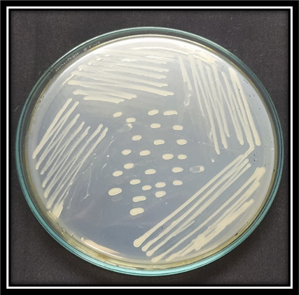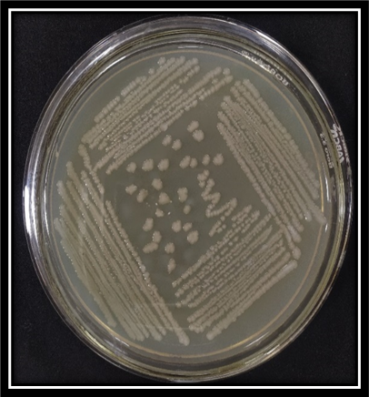

GPB1 (NS2)



GPB2 (LS4)

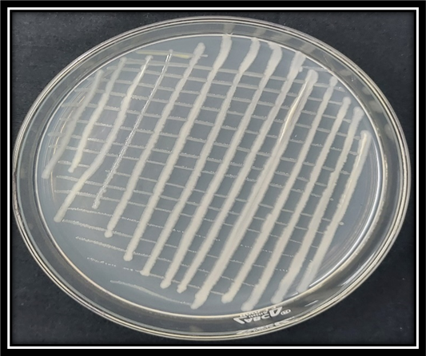

Consortia (GPB1 + GPB2

)

## Plate 1: Selected Bacterial isolates (GPB 1 + GPB 2)



The present results are in conformity with those Rathaur et al. (2012) who also observed similar morphological characteristics for Withania somnifera. Similarly, Prabhukarthikeyan et al. (2017) isolated a total of 60 bacterial isolates from the turmeric rhizosphere and out of which 15 bacterial isolates characterize biochemically. They reported that all the *Pseudomonas* isolates shows positive reaction for the following test viz., Glucose utilization, Nitrate utilization, Citrate utilization and Catalase activity.

3.5 **Molecular Characterization**

The most efficient growth promoting two bacterial isolates viz., NS2 (GBP1) and LS4 (GPB2) were selected. These bacterial isolates exhibited all mushroom growth promoting traits and were selected for identification up to species level by molecular technique based on 16S rRNA sequencing. The amplicon of expected size i.e. (1400 bp) was obtained (plate 2).

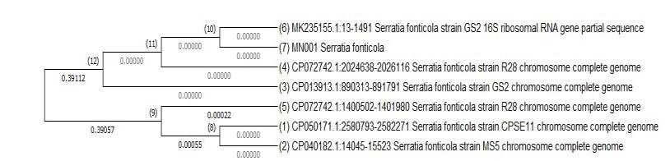

**Fig 4. Neighbour joining tree based on relationship of bacterial isolates GPB1 with the analyzed sequences**

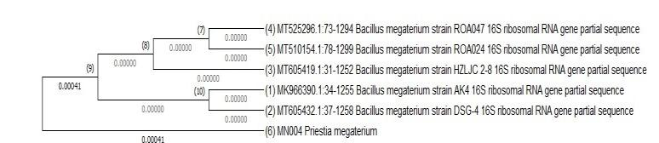

**Fig 5. Neighbour joining tree based on relationship of bacterial isolates GPB2 with the analyzed sequences**

|  |  |  |  |
| --- | --- | --- | --- |
| |  | | --- | | NS2 | | 16  S rDNA  amplificaton  1400  bp    LS4 | |
| |  | | --- | | Genomic DNA of bacterial isolates | | | |  | | --- | | Amplification of DNA | |

Plate 2: Molecular identification of bacterial isolates based on 16 S rRNA amplification.



The sequence data of the 16S rRNA of selected isolates were subjected to BLAST analysis. As 16S rRNA gene sequence provide accurate grouping of organism even at subspecies level it is considered as a powerful tool for the rapid identification of bacterial species (Jill and Clarridge, 2004). The sequence analysis of 16S rRNA revealed that strain GPB1 (Accession No. OP743914) showed maximum similarity of 99.00 per cent with *Serratia fonticola* (Fig 4) and strain GPB2 (Accession No. OP743915) showed maximum similarity of 99.00 per cent with *Priestia megaterium* (Fig 5). The phylogenetic analysis of 16S rRNA sequence of the isolates along with the sequence retrieved from the NCBI was carried out with MEGA X using the neighbor joining method with 1,000 bootstrap replicates.

**3.6 Effect of Selected Growth Promoting Bacteria Isolates on Growth and Yield of White Button Mushroom**

A persual of data presented in Table 4 revealed the effect of bacterial inoculation on the yield of white button mushroom and mushroom growth parameters. The application of selected bacterial isolates showed a significant variation for all the growth parameters of mushroom viz. total length of mushroom, length and width of stalk, diameter of cap, individual weight of mushroom, and yield of mushroom. It was found from the present investigation that all growth parameters and yield showed significant increase over uninoculated control. Plate (3a and 3b) represents the growth characters of mushroom with different treatments. Overall a total of 20-24 days were taken for case run after spawning and 19-20 days taken for first harvest after casing for all the treatments.

**Table 4: Effect of selected bacterial isolate on mushroom growth parameters.**

|  |  |  |  |  |  |  |
| --- | --- | --- | --- | --- | --- | --- |
| Treatments | Total length of  mushroom  (cm) | Individual weight of mushroom(g) | Length of stalk  (cm) | Width of  stalk  (cm) | Average diameter  of cap  (cm) | Yield  (kg/100kg compost) |
| To1(uninoculatedcontrol in casing) | 1.80 | 12.50 | 0.70 | 1.06 | 2.33 | 10.63 |
| To2(uninoculated  control in substrate) | 1.93 | 12.63 | 0.80 | 1.36 | 2.36 | 10.63 |
| T1(GPB1 on casing) | 2.56 | 14.86 | 1.53 | 2.20 | 3.30 | 11.53 |
| T2(GPB1 on substrate) | 3.10 | 13.20 | 2.06 | 2.26 | 3.40 | 12.56 |
| T3 (GPB2 on casing) | 3.36 | 14.36 | 1.60 | 2.36 | 4.16 | 13.16 |
| T4(GPB2 on substrate) | 3.13 | 16.36 | 2.00 | 1.80 | 4.43 | 14.60 |
| T5(GPB1 + GPB2  on casing) | 4.30 | 18.20 | 2.40 | 2.26 | 5.46 | 15.66 |
| T6(GPB1+GPB2  on substrate) | 4.13 | 19.20 | 2.33 | 2.50 | 5.16 | 15.60 |
| T7(GPB1+GPB2  on casing and substrate) | 4.33 | 21.10 | 2.70 | 2.66 | 6.26 | 16.53 |
| CD 0.05 | 0.31 | 0.51 | 0.21 | 0.30 | 0.48 | 0.67 |

The data presented in table 4 showed that the maximum total length of mushroom (4.33cm), individual mushroom weight (21.10g), width of stalk (2.66cm), length of stalk(2.70cm), average diameter of cap of mushroom (6.26cm) were recorded by Treatment T7 (GPB1+ GPB2) on casing and substrate whereas the minimum values total length of mushroom (1.80cm), individual weight of mushroom (12.50g) , width of stalk (1.06cm) , length of stalk (0.70cm), average diameter of cap of mushroom (2.33 cm)were recorded by Treatment To1 which was uninoculatedcontrol. The highest yield of mushroom (16.53kg) was also recorded with Treatment T7 which was statistically superior to all the treatments. It was found that with application of consortia of bacterial isolates NS2 and LS4 on casing as well as on substrate (T7) yield of mushroom increased with 55 percent over uninoculatedcontrol (Fig 6).The results showed that inoculation of mushroom growth promoting bacteria treatment had more stimulating effect on growth and yield of mushrooms. The increase in growth parameters with biofertilizers may be attributed to the improved nutrient availability specially N (nitrogen fixation), P (P- solubilization) and Fe (siderophore) to the mushroom by direct mechanism.

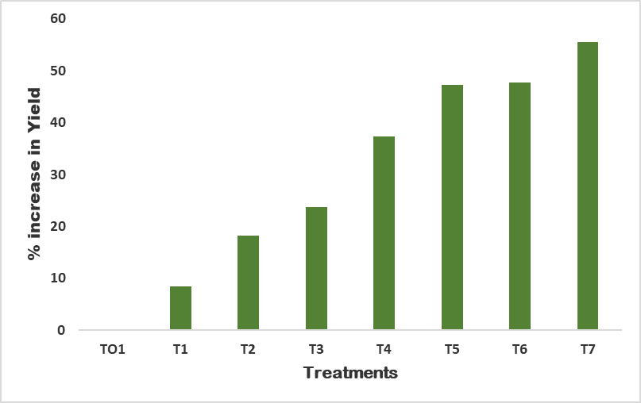

**Fig 6: Percent increase in yield of white button mushroom.**

Similar results were reported by Kim et al (2008) that *Pseudomonas* sp.P7014 enhanced the growth of edible oyster mushroom *P.eryngii* in bottle cultures. Young et al. (2013) reported a significant increase of 64 percent in yield of *Agaricus blezzi* inoculated with two bacterial isolates *Exignobacteriu*m sp. (JN03) and *Arthobacter sp.* (JN12) over uninoculated cultures. Mohammad and Sabaa (2015) also recorded a 26.6 percent increase in mushroom yield when inoculated with Pseudomonas putida in comparison with uninoculatedcontrol.

**3.7 BIOLOGICAL EFFICIENCY**

A perusal data in Table 5 showed that the biological efficiency for all the three flushes ranged between 15.32- 24.83%, 14.22- 22.76%, and 10.23- 15.56% respectively. A significant increase of biological efficiency was recorded for all the treatment in all the three flushes of mushroom in comparison to uninoculated control. The highest biological efficiency was observed by treatment T7 (24.83 percent) (GPB1+ GPB2) with inoculation of on both casing and substrate) followed by T6. The results of present investigation indicate that inoculation of GPB into casing and substrate has great impact on yield and quality of white button mushroom. It was clearly observed from Table 5 that biological efficiency increased in all the treatments over uninoculatedcontrol. It was found that treatment T7 showed 63.1 percent increase in biological efficiency in first flush, 60.2 percent increase in second flush, and 53.1 percent increase in third flush over uninoculated control.

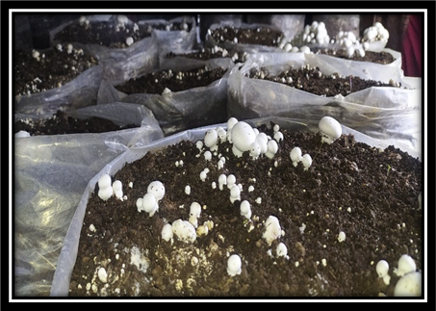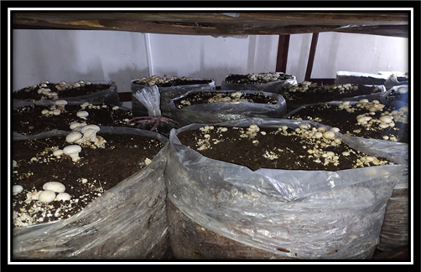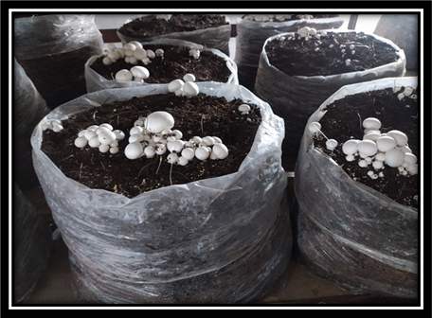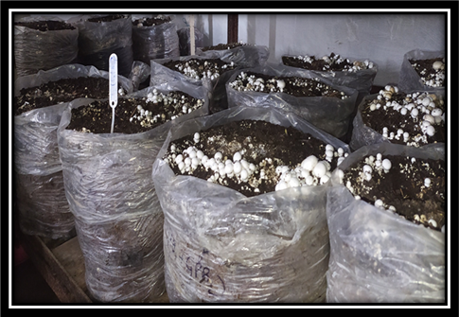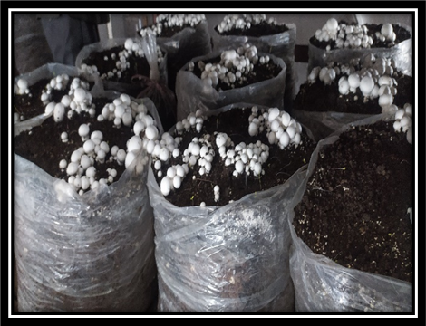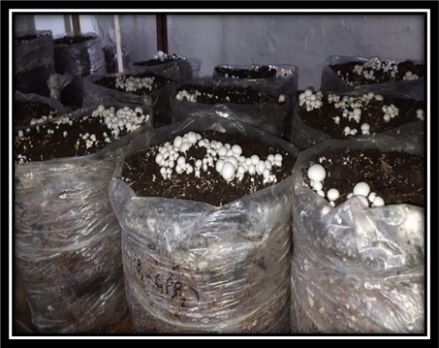

Uninoculatedcontrol TO1



Uninoculatedcontrol TO2



Treatment T1



Treatment T2



Treatment T3



Treatment T4



Plate 3a : Effect of selected bacterial isolates on quality of

mushroom

**Table 5: Effect of selected bacterial isolates on biological efficiency of mushroom.**

|  |  |  |  |
| --- | --- | --- | --- |
| Treatments | First flush (%) | Second flush (%) | Third flush (%) |
| TO1(Uninoculated casing) | 15.32 | 14.22 | 10.23 |
| TO2 (Uninoculated substrate) | 15.21 | 14.22 | 10.16 |
| T1 (GPB1 on casing) | 18.39 | 16.25 | 11.86 |
| T2 (GPB1 on substrate) | 17.90 | 17.38 | 10.93 |
| T3 (GPB2 on casing) | 19.52 | 16.44 | 12.60 |
| T4 (GPB2 on substrate) | 20.83 | 18.81 | 11.40 |
| T5 (GPB1 + GPB2 on casing) | 22.19 | 19.24 | 13.26 |
| T6 (GPB1+ GPB2 on substrate) | 22.47 | 21.34 | 13.40 |
| T7(GPB1+ GPB2 on both Casing and substrate) | 24.83 | 22.76 | 15.56 |
| CD0.05 | 0.68 | 0.24 | 0.57 |

The mushroom substrate and casing soil inoculated with MGP improved the mushroom yield and Biological efficiency significantly. This increase in growth and yield parameters may be due to availability of nutrients and metabolism and enzyme activities in the compost with the application of (MGPB) mushroom growth promoting bacteria. Bacteria were closely attached to mycelia surface and enhanced the growth. The findings of current study are similar with the study conducted by Khalili et al. (2015) who reported that biological efficiency were higher 12.1 percent and 20.64 percent and 13.43 percent and 21.08 percent of the control, respectively when substrate or both substrate and casing were inoculated with *P. putida*. This is in agreement with the findings of Iqbal et al., (2005) and Khalil et al., (2024), where they clarified that Oyster mushroom gave the maximum flushes on sawdust substrate.

3.8 **Effect of selected bacterial cultures on quality parameters of white button mushrooms:** The data on quality parameters (Antioxidant enzyme assay, total phenolic content, total ash content, total protein content, total carbohydrate content and total crude fibre content) were presented in Fig 7. A significant increase was found in all the treatments over uninoculated control. The data revealed that the maximum antioxidant activity (32.56), phenol content (12.40mg GAE/g), ash content (1.54 g/100g), protein content (4.10 g/100g), Crude fibre content (3.57g/100g) and carbohydrate content (61.60 g/100g) were recorded with treatment T7(GPB1 + GPB2 on casing and substrate) which was statistically superior to all the treatments. The increase of antioxidant activity may be due to increase of phenol contents. The increase of quality parameter in the treatments with inoculation of growth promoting bacteria may be due to enhanced availability of essential nutrients in the compost, responsible for synthesis of biochemical constituents of white button mushroom. The consortia of both the bacterial isolates had more impact (T7) than the single bacterium. The other possible reason of increase may be attributed to increase of carbohydrates in all treatment which directly affect the other quality attributes of mushroom. Similar results were reported by Prabhu et al. (2016) maximum DPPH radical scavenging activity of 37.04±0.15 and 28.04±0.41 % in *Pleurotus florida* and *Calocybe indica*. The results of phenol content are in accordance with Alispahic et al. (2015) who reported total phenolic content in white button mushroom ranged from 4.94 mg GAE/g to 7.66 mg GAE/g. Maknali et al. (2021) reported that inoculated treatment with *Pseudomonas* had 8.46 percent higher ash content than the non-inoculated treatment. The earlier reports showed varied amount of ash content in white button mushroom which may be due to variation of compost of nutrient availability. The total ash content reported by Alam et al. (2008) in *Pleurotus ostreatus, P. sajor-caju, P. florida and C. indica* were 1.1-1.3 g, 1-1.2 g, 1.1-1.2 g and 1.2-1.4 respectively. The ash content reported by Okechukwu et al., (2011) showed a range of 3.20 - 25.10 percent in *Agaricus bisporus*. Sinha et al. (2021) reported the ash content in the fresh white button mushroom was found to be 0.93±0.01 g/100g. Sinha et al. (2021) reported the protein value as 3.27±0.12/100g in fresh white button mushroom. These high carbohydrate contents are in accordance with Shin et al.,(2007), Hong et al.,(2007), Dhundar et al .,( 2008) and Kumari and Srivastava (2020).

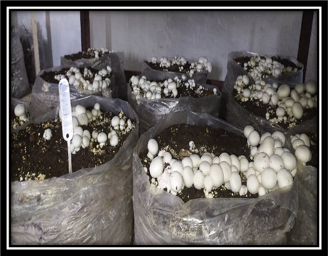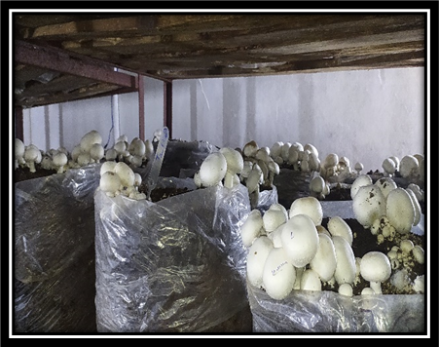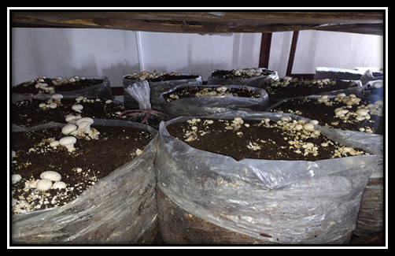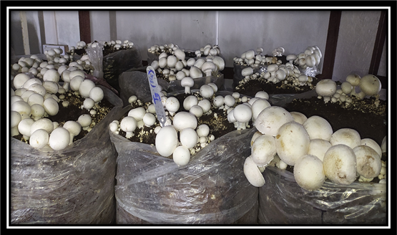

Treatment T5



Treatment T7



Treatment T6



Uninoculated control



Plate 3b: Effect of selected bacterial isolates on quality of

mushroom

0

20

40

60

80

100

TO1

T1

T2

T3

T4

T5

T6

T7

Percentage

Treatments

Phenol(%)

Antioxidant enzyme assay(%)

Ash content (%)

protein (%)

Carbohydrates(%)

**Fig 7: Percent increase in mushroom quality parameter.**

3.9 **Effect of selected bacterial isolates on nutrient uptake**

The tried treatments registered a significant increase in NPK content of mushroom. The maximum Nitrogen content (6.30 %), Phosphorus content (0.81%), and potassium content (5.00%) were recorded by Treatment T7 followed by Treatment T5 .However, the minimum was recorded by treatment TO1 and TO2 which were uninoculated control. Fig 8 indicates that with application of consortium of selected bacterial isolates T7 nitrogen increased upto 85.2 percent, P upto 72 percent and K values increased upto 80 percent over uninoculated control. The NPK content in mushroom may be due to mineralization of compost via application of biofertilizers due to phosphate solubilization, Siderophore production, and nitrogen fixation. Similar results were reported by Khalili et al. (2015) nitrogen content within range of 4.5– 5.3 % and potassium within range of 4.3 – 5.1%).

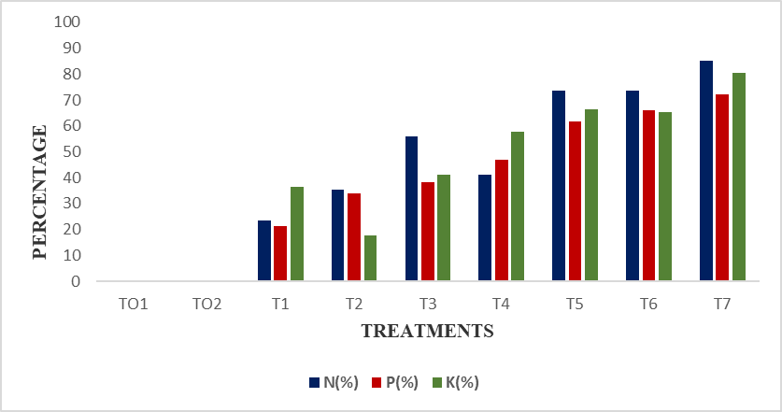

**Fig 8: Percent increase of nutrient content N P K of mushroom**

3.10 **Effect of selected bacterial isolates on physico chemical properties, nutrient availability and microbial count of compost**

The data on the physico-chemical properties of soil were recorded at the start and termination of the experiment.

3.10.1 **Physico-chemical properties, nutritional status and total microbial count of compost (initial status)**

The data pertaining to initial physico-chemical status of the soil are presented in the Table 6 A perusal of data showed that the compost was nearly neutral (pH 6.22 ), EC (1.56dSm-1) and organic carbon was 12.30 per cent. The available N (0.59 percent) and P (0.36 percent) contents were in medium range. However, available K (0.90 percent) was in high range. The total bacterial count was 6.12×106 cfu/g soil on nutrient agar medium.

**3.10.2 At the end of experiment**

The data pertaining to effect of different treatments on the physico-chemical and biological properties of compost are presented in Table 6. Data revealed that none of the treatment influenced compost pH and electrical conductivity over control. However, organic carbon significantly increased over control. All the treatments registered significant increase in available NPK content. The treatment T7 registered significant per cent increase 72.5% in nitrogen, 88 % increase in phosphorus and 75.2 % increase in potassium over uninoculated control (T1).

The solubilization of P in the rhizosphere is the most common mode of action implicated in biofertilizer that increases nutrient availability to host plants (Bhattacharya and Jha, 2012). The application of biofertilizer have enhanced the solubilization, mobilization, availability and uptake of N, P and K by the mushroom (Zahir et al., 2004).The results obtained in the present study with respect to N, P and K are in agreement with the results reported by Gupta et al. (2015) and Gopalkrishan et al.,(2017).

**Table 6. Physico-chemical and biological properties at the end of the experiment**

|  |  |  |  |  |  |  |  |
| --- | --- | --- | --- | --- | --- | --- | --- |
| Treatments | pH | EC  (dSm-1) | OC  (%) | Available N (%) | Available P (%) | Available K (%) | Microbial count (×106 cfu/g soil |
| Initial status  (compost mixture) | 6.22 | 1.54 | 12.30 | 0.59 | 0.36 | 0.90 | 6.12 |
| TO1 | 6.53 | 1.43 | 20.18 | 0.62 | 0.42 | 0.97 | 6.23 |
| TO2 | 6.14 | 1.47 | 21.31 | 0.62 | 0.43 | 0.98 | 6.25 |
| T1 | 6.45 | 1.49 | 22.30 | 0.85 | 0.52 | 1.42 | 8.10 |
| T2 | 6.40 | 1.56 | 23.12 | 0.73 | 0.56 | 1.33 | 8.30 |
| T3 | 6.88 | 1.64 | 21.62 | 0.86 | 0.60 | 1.52 | 7.30 |
| T4 | 6.61 | 1.73 | 23.25 | 0.81 | 0.56 | 1.61 | 8.70 |
| T5 | 6.65 | 1.74 | 25.44 | 0.94 | 0.64 | 1.60 | 9.16 |
| T6 | 6.55 | 1.58 | 24.55 | 0.95 | 0.72 | 1.67 | 10.56 |
| T7 | 6.36 | 1.55 | 26.15 | 1.07 | 0.79 | 1.70 | 10.83 |
| CD0.05 | N/S | N/S | 0.86 | 0.04 | 0.06 | 0.08 | 0.54 |

**3.10.3 Microbial count (at the termination of experiment)**

The data presented in Fig 9 revealed the significant variation in the microbial count over uninoculated control. The total microbial count was varied from (6.23 to 10.83 × 106 cfu/g soil) NA medium. The maximum (10.83 × 106 cfu/g soil) microbial counts on NA medium was observed in spent mushroom compost whose substrate were treated with consortia of bacterial isolates (GPB1 +GPB2 )(T7). Whereas, the minimum count (6.23× 106 cfu/g soil) was recorded with uninoculated control (TO2). Ahlawat and Manikandan (2015) reported that after inoculation of Bacillus subtilis casing treatments enhanced 1.72 and 2.73 folds higher bacterial count than control FYM + SMS based casing. Similarly, Riahi et al., (2011) concluded that the inoculation of native *P. putida* isolated from casing soil at the primordia formation stage would be very efficient for increasing mushroom yield and quality.

0

20

40

60

80

100

TO1

TO2

T1

T2

T3

T4

T5

T6

T7

Percentage increase

Treatments

N(%)

P(%)

K(%)

Fig 9: Percent increase in NPK.

The present study entitled ‘Characterization of Growth promoting bacteria from spent mushroom compost and their efficacy on yield and quality of white button mushroom’ were conducted to select best plant growth promoting rhizobacteria from spent mushroom compost and to study their response in the improvement of growth and yield of white button mushroom.

A variation was observed for bacterial count isolated from spent mushroom compost from different locations of distt Solan. The maximum bacterial population (6.73×106cfu/g) was recorded from compost collected from DMR Chambaghat Solan. A total of 25 bacterial isolates were selected on the basis of predominant growth. Among all 48 percent were P-solubilizer, 36 percent were HCN producers, 52 percent were siderophore producers and 40 isolates were IAA producers and 60 percent were nitrogen fixers.

Among the selected bacterial isolates NS2 and LS4 showed maximum P-solubilization, siderophore production, IAA and HCN production. These isolates were selected for further study. The selected isolates (NS2 and LS4) were white in color, cluster in arrangement, entire in margin, and slimy colonies with raised elevation in LS4 and convex elevation of NS2. In Gram’, NS2 bacterial isolate was gram positive rods and LS4 was negative for gram staining. On the basis molecular identification GPB1 was identified as *Serratia fonticola* and GPB2 as *Priestia megaterium*.

The application of selected bacterial isolates significantly increased the growth and yield parameters of mushroom over uninoculated control. the maximum total length of mushroom (4.33cm), individual mushroom weight (21.10g), width of stalk (2.66cm), length of stalk(2.70cm), Average diameter of cap of mushroom (6.26cm) were recorded by Treatment T7 (GPB1+ GPB2 on casing and substrate whereas the minimum values total length of mushroom (1.80cm), Individual weight of mushroom (12.50g) , width of stalk (1.06cm) , length of stalk (0.70cm), Average diameter of cap of mushroom (2.33 cm)were recorded by Treatment TO1 which was uninoculated control. The highest yield of mushroom (16.53 kg) was also recorded with Treatment T7 which was statistically superior to all the treatments.

The treatment T7 (GPB1+ GPB2 on casing and substrate) registered 55 percent increase in yield of white button mushroom over uninoculated control. The maximum antioxidant activity (32.56) , phenol content(12.40mg GAE/g), ash content (1.54 g/100g),protein content (4.10 g/100g), Crude fibre content (3.57g/100g) and carbohydrate content (61.60 g/100g) were recorded with treatment T7(GPB1 + GPB2 on casing and substrate) which was statistically superior to all the treatments.

The highest available N content (6.30 %), available P content (0.81) and available K content (5.00%) of soil was recorded with treatment T7(GPB1+ GPB2 with inoculation of on both casing and substrate).

The treatment T7 registered 85.2 % percent increase in nitrogen content, 72.3 percent increase in phosphorus content and 80.4 % increase in potassium content of white button mushroom over uninoculated control. All the treatments registered significant increase in available NPK content of compost.

1. **Conclusion**

From the present investigation, it was concluded that spent mushroom compost can be a good source of growth promoting bacterial for mushroom cultivation. On the basis of efficiency selected isolates, the consortia of two isolates NS2 and LS4 have significantly increased yield and quality characteristics of white button mushroom. The consortia of both the isolates increase available NPK content of compost which also increased the nutritional status of mushrooms. Hence, these isolates have enormous potential to be used as multifunctional biofertilizer for enhanced productivity of white button mushrooms. The developed technology may be recommended to the farmers after mutilocational trials.

**Disclaimer (Artificial intelligence)**

Author(s) hereby declare that NO generative AI technologies such as Large Language Models (ChatGPT, COPILOT, etc.) and text-to-image generators have been used during the writing or editing of this manuscript.

# **References**

Ahlawat O P, Manikandan K. 2015. Evaluation of Alispahic A, Sapcanin A, Salihovic M, Ramic E, Dedic A and Pazalja M. 2015. Phenolic content and antioxidant activity of mushroom extracts from Bosnian market. Bulletin of the Chemists and Technologists of Bosnia and Herzegovina 44:5-8.

Alam N, Amin R, Khan A, Ara I, Shim MJ, Lee MW and Lee TS.2008.Nutritional analysis of cultivated mushrooms in Bangladesh–Pleurotus ostreatus, Pleurotus sajor-caju, Pleurotus florida and Calocybe indica 36:228-32.

Alispahic A, Sapcanin A, Salihovic M, Ramic E, Dedic A and Pazalja M. 2015. Phenolic content and antioxidant activity of mushroom extracts from Bosnian market. Bulletin of the Chemists and Technologists of Bosnia and Herzegovina 44:5-8.

Bakker A W and Schipper B. 1987. Microbial cyanide production in the rhizosphere to potato yield reduction and Pseudomonas sp. mediated plant growth stimulation. Soil Biology and Biochemistry 19:451-57.

Banerjee, S., van der Heijden, M.G.A., 2023. Soil microbiomes and one health. Natur. Rev., microbiol. 21, 6–20. https://doi.org/10.1038/s41579-022-00779-

Bhattacharyya P N and Jha D K. 2012. Plant growth-promoting rhizobacteria (PGPR): emergence in agriculture. World Journal of Microbiology and Biotechnology 28:132750.

Carrasco J and Preston GM.2020.Growing edible mushrooms: a conversation between bacteria and fungi. Environmental microbiology 22:858-72.

Chen L, Yan M, Qian X, Yang Z, Xu Y, Wang T, Cao J, Sun S.2022.Bacterial Community Composition in the Growth Process of Pleurotus eryngii and Growth-Promoting Abilities of Isolated Bacteria. Frontiers in Microbiology 13:1-11

Di Benedetto N A, Corbo M R, Campaniello D, Cataldi M P, Bevilacqua A, Sinigaglia M and Flagella Z. 2017. The role of plant growth promoting bacteria in improving nitrogen use efficiency for sustainable crop production: a focus on wheat. AIMS microbiology 3:413.

Edi-Premono M A, Moawad M A and Vleck P L G. 1996. Effect of phosphate solubilizing Pseudomonas putida on the growth of maize and its survival in the rhizosphere. Indonasian Journal of Crop Science 11:13-23.

Gopalakrishnan S, Srinivas V and Samineni S. 2017. Nitrogen fixation, plant growth and yield enhancements by diazotrophic growth-promoting bacteria in two cultivars of chickpea (Cicer arietinum L.). Biocatalysis and Agricultural Biotechnology. 1:116-23.

Gorden S A and Paleg L G. 1957. Quantitative measurement of indole acetic acid. Journal of Plant Physiology 10:37-48.

Gupta S, Meena M K and Datta S. 2015. Isolation, characterization of plant growth promoting bacteria from the plant Chlorophytum borivilianum and in-vitro screening for activity of nitrogen fixation, phosphate solubilization and IAA production. International Journal of Current Microbiology and Applied Science 3:1082-90.

Hall T A. 1999. BioEdit: a user-friendly biological sequence alignment editor and analysis program for Windows 95/98/NT. Nucleic acid symposium 41:95-98.

Hedge D M, Dwivedi B S and Sudhakara Babu S S. 1999. Biofertilizers for cereal production in India-A review. Indian Journal of Agriculture Research 69:3-83.

Iqbal S M, Rauf C and Sheikh M .2005. Yield performance of oyster mushroom on different substrates. International Journal of Agriculture and Biology 7:900-03

Jackson M L. 1973. Soil chemical analysis. Prentice Hall of India Limited, New Delhi.21922p.

Jensen E S. 1987. Inoculation of pea by application of Rhizobium in planting furrow. Plant and Soil 97:63-70.

Jill E and Clarridge III. 2004. Impact of 16S rRNA gene sequence analysis for identification of bacteria on clinical microbiology and infectious disease. Journal of clinical Microbiology Reviews 17: 840-62.

Khalili H R, Olfati J A and Fallahi A. 2015. Plant growth promoting rhizobacteria affect button mushroom yield and quality. Horticulture, Biology and Environment 4:83-89.

Khalil S, Panda P, Ghadamgahi F, Barreiro A, Rosberg AK, Karlson M, Vetukuri RR. 2024. Microbial potential of spent mushroom compost and oyster substrate in horticulture: Diversity, function, and sustainable plant growth solutions. Journal of Environmental Management ;357 (2024) 120654.

Khan F M, Nimatullah I H, Tariq S, Muhammad F, Ohia C and Tauseef. 2018. Isolation, Characterization and Identification of Plant Growth Promoting Rhizobacteria from Cauliflower (*Brassica oleracea*). Archieve of Basic and Applied Medicine 6:55-60.

Kim M K, Math R K, Cho K M, Shin K J, Kim J O and Ryu J S. 2008. Effect of Pseudomonas sp. P7014 on the growth of edible mushroom *Pleurotus eryngii* in bottle culture for commercial production. Bioresource Technology 99:3306–08

Kimura M. 1980. A simple method for estimating evolutionary rate of base substitutions through comparative studies of nucleotide sequences. Journal of Molecular Evolution 16: 111-120.

Lowry O H, Rosebrough N J, Farr A L and Randall R J. 1951.Protein measurement with the Folin phenol reagent. Journal of Biological Chemistry 193:265–75.

Maknali F, Kashi A, Salehi Mohammadi R and Khalighi A. 2021. Effect of application of different levels of Fe and Soybean flour on yield and quality of edible Mushroom (*Agaricus bisporus*) inoculated with *Pseudomonas putida*. Journal of Vegetables Sciences 5:17-33.

Martín, C., Zervakis, G.I., Xiong, S., Koutrotsiosc, G., Strætkvern, K.O., 2023. Spent substrate from mushroom cultivation: exploitation potential toward various applications and value-added products. Bioengineered 14 (1), 2252138. https://doi. org/10.1080/21655979.2023.2252138.

Merwin H D and Peech M. 1951. Exchange ability of soil potassium in the sand, silt and clay fractions as influenced by the nature and complementary exchangeable cations. Soil Science American Proceedings 15:125-28.

Mohammad A and Sabaa A K. 2015. In vitro and in vivo impact of some Pseudomonas spp.

on growth and yield of cultivated mushroom (*Agaricus bisporus*). Egyptian Journal of Experimental Biology 11: 163–7.

Olsen S R, Cole C V, Watenabe D S and Dean L A. 1954. Estimation of available phosphorus in soils by extraction with sodium bicarbonate. USDS Circular. 939:1-19.

Owaid M N, Barish A and Shariati M A. 2017. Cultivation of Agaricus bisporus (button mushroom) and its usages in the biosynthesis of nanoparticles. Open Agriculture 26: 537-43

Panse V G and Sukhatme P V. 2000. Statistical Methods for Agricultural Workers. Indian Council of Agricultural Research, New Delhi. India.

Pikovskaya R I. 1948. Mobilization of phosphorus in soil in connection with the vital activity of some microbial species. Microbiologia 7:362-70.

Prabhukarthikeyan S R, Manikandan R, Durgadevi D, Keerthana U, Harish S, Karthikeyan G and Raguchander T. 2017. Bio-suppression of turmeric rhizome rot disease and understanding the molecular basis of tripartite interaction among Curcuma longa, Pythium aphanidermatum and Pseudomonas fluorescens. Biological control 111: 23-31.

Prabu M A. and Kumuthakalavallia, R. 2016. Antioxidant activity of oyster mushroom (Pleurotus florida )and milky mushroom (Calocybe indica). International Journal of Current Pharmaceutical Research 8:1-4.

Premachandra D, Hudek L and Brau L. 2016. Bacterial modes of action for enhancing of plant growth. Journal of biotechnology & biomaterials 6:1-8.

Rathaur P, Raja W, Ramteke P W and John S A. 2012. Effect of UV-B tolerant plant growth promoting rhizobacteria (PGPR) on seed germination and growth of Withania somnifera. Advances in Applied Science Research 3:1399-04.

Riahi H, Eskash A and Shariatmadari Z. 2011. Effect of bacterial and cyanobacterial culture on growth, quality and yield of Agaricus bisporus. Proceedings of the 7th International Conference on Mushroom Biology and Mushroom Products (ICMBMP7) 4–7 October 2011, Arcachon, France. 1:406-11.

Rossouw W, Korsten L.2017. Cultivable microbiome of fresh white button mushrooms. Letters in Applied Microbiology 64:164-70.

Raghuramulu, N.; Nair, K. Madhavan and Kalyanasundaram, S. 2003. A manual of laboratory techniques. National Institute of Nutrition, ICMR, Hyderabad.

Saitou N and Nei M. 1987. The neighbor-joining method: a new method for reconstructing phylogenetic trees. Molecular Biology and Evolution 4: 406-25.

Sambrook J, Fritsch E F and Maniatis T. 1989. Molecular cloning: A laboratory manual. Cold Spring Harbor: Cold Spring Harbor Laboratory Press 6-15 p.

Schwyn B and Neilands J B. 1987. Universal chemical assay for the detection and determination of siderophore. Analytical Biochemistry 28:751-59.

Sheoran O P, Tonk D S, Kaushik L S, Hasija R C and Pannu R S. 1998. Statistical software package for agricultural research workers. Recent advances in information theory, statistics and computer applications. (Eds DS Hooda, RC Hasija) 139-43pp.

Sherman N and Cappuccino J G. 2005. Microbiology: a laboratory manual. 6th ed. ISBN 8:265-67.

Sinha, S.K., Upadhyay, T.K. and Sharma, S.K., 2021. Nutritional-medicinal profile and quality categorization of fresh white button mushroom. Biointerface Res. Appl. Chem 11:8669-85.

Siyoum N A, Surridge K, Van der Linde E J and Korsten L. 2016. Microbial succession in white button mushroom production systems from compost and casing to a marketable packed product. Annals of microbiology 66:151-64.

Subba Rao N S. 1999. Soil microorganism and plant growth. Oxford & IBH publishing Company, New Delhi. 252 p.

Subbiah B V and Asija G L. 1956. A rapid procedure for the estimation of the available nitrogen in soils. Current Science 25: 259-60.

Tamura K, Stecher G, Peterson D, Filipski A and Kumar S. 2013. MEGA6: molecular evolutionary genetics analysis version 6.0. Molecular Biology and Evolution 30: 272529.

Thompson J D, Higgins D G and Gibson T J. 1994. CLUSTAL W: improving the sensitivity of progressive multiple sequence alignment through sequence weighting, positionspecific gap penalties and weight matrix choice. Nucleic acids research 22: 4673-80.

Vejan P, Abdullah R, Khadiran T, Ismail S and Nasrulhaq Boyce A. 2016. Role of plant growth promoting rhizobacteria in agricultural sustainability-a review. Molecules 21:573-74.

Walkley A and Black T A. 1934. An estimation of soil organic matter and purposed modification of chromic acid titration method. Soil Science 37:29-38.

Yohalem DS, Nordheim EV, Andrews JH.1996. The effect of water extracts of spent mushroom compost on apple scab in the field. Phytpopathology 86:914–22.

Young L S, Chu J N, Hameed A, and Young C C. 2013. Cultivable mushroom growth promoting bacteria and their impact on Agaricus blazei productivity. National Formosa University. Department of Biotechnology 48:636-44.

Zahir Z.A, Arshad M. and Frankenberger W.T. 2004. Plant Growth Promoting Rhizobacteria: Applications and Perspectives in Agriculture. Advances in Agronomy 81:97-168

Zekovic Z, Vidovic S and Mujic I. 2010. Selenium and Zinc content and radical scavenging capacity of edible mushrooms Armilaria mellea and Lycoperdon saccatum. Croatian Journal of Food Science and Technology 2:16-21.