**Assessment and Mapping of Soil Nutrient Status Using GPS and GIS Techniques for Sustainable Agriculture in Barpeta District, Assam, India**

**ABSTRACT:**

In Barpeta District of Assam, agricultural is a major livelihood activity. The region faces annual challenges from floods and erosion, depleting soil nutrients. Additionally, the mono-cropping system of rice further degrades the land. Assessing macro and micro nutrients and mapping the soil nutrient status help develop targeted strategies to replenish nutrient levels, improve farming techniques, and enhance the productivity and resilience of agriculture in Barpeta District. To address these issues and highlight the importance of soil nutrients for sustainable agriculture, soil fertility status maps were prepared using GPS and GIS techniques. For this study, 1,293 georeferenced soil samples were collected at 1 km intervals from 718 villages, covering 11 community development blocks and 9 revenue circles. These samples were analyzed for 9 (pH, OC, N, P, K, Fe, Mn, Zn and Cu) chemical parameters, and the data, along with GPS readings, were used to create soil fertility maps using GIS. The results revealed that a significant portion of the district was acidic (53.0% of TGA), with 13.0% of the area being slightly to moderately alkaline. Organic carbon (OC) levels were recorded as low, medium, and high in 7.6%, 24.1%, and 42.9% of the area, respectively. Nitrogen (N) and phosphorus (P) were found to be medium in most areas, while potassium (K) was largely low. Zinc (Zn) was predominantly deficient (47.2% of TGA), while iron (Fe), manganese (Mn), and copper (Cu) were sufficient. Overall, the major nutrient constraints in Barpeta District are soil acidity, available potassium (K), and zinc (Zn). The assessed soil nutrient status can be a valuable tool for local farmers to plan their crops and for agricultural planners to develop large-scale crop improvement strategies and recommend site-specific nutrient management practices. In the future, GIS and GPS-based nutrient management will help monitor soil nutrient status, maintain soil health, and ensure sustainable agricultural production. Also, it will assist in providing soil test crop response-based nutrient recommendations and applying corresponding micronutrients to enhance soil fertility and crop productivity.

***Key words****: GPS, GIS techniques, soil nutrient mapping, soil fertility appraisal and sustainable agricultural.*

**1. INTRODUCTION**

Sustainable agriculture is crucial to meet the increasing food demand of Assam's growing population. High crop productivity, which depends on fertile soil, is essential for food security. Evaluating the soil fertility status is vital for crop production, as it is influenced by essential nutrients like Nitrogen (N), Phosphorus (P), Potassium (K) (Singh and Mishra, 2012), and micronutrients (Bingham, 1982; Chesnin and Yien, 1950). Unfortunately, crop production in Assam remains stagnant due to imbalanced and inadequate fertilizer use, along with low efficiency of other inputs. The response efficiency of chemical fertilizers has declined significantly under intensive agriculture. Periodic characterization of soil fertility and mapping the spatial distribution of available soil nutrient status are essential for location-specific crop management and sustainable agriculture, as well as precision farming. However, such geo-coded data is lacking for in-depth studies. At the field level, farmers need time-series information to plan crops and procure fertilizers, while at district and state levels, technocrats require time-series data to identify critical areas needing different fertilizers. Barpeta district, known for its jute production, has 85% of its population engaged in agriculture. The district faces severe soil erosion, causing significant nutrient loss and agricultural destruction (Makbul Hussain Khan, 2012). Due to illiteracy, poverty, unemployment, disguised unemployment, high growth rate, and other socio-economic challenges, the people of Barpeta depend heavily on agriculture for their livelihood (Makbul Hussain Khan, 2012). To boost crop productivity, judicious use of macro and micronutrients is necessary. Soil nutrient variation is natural, with some nutrients being sufficient while others are deficient. Soil testing plays a critical role in the effective use of fertilizers and other agricultural inputs (Santhi et al., 2018). Soil test summaries and soil fertility maps are essential reference materials for scientific soil management (Bowman et al., 1999; Palm et al., 2007). Soil properties vary spatially due to intrinsic factors (parent materials and climate) and extrinsic factors (soil management practices, indigenous fertility status, crop rotation, and standing crop nature) (Cambardella and Karlen, 1999). The spatial variability of soil fertility has been challenging to describe until the advent of technologies like GPS and GIS. Collecting soil samples using GPS is crucial for preparing thematic soil fertility maps (Mishra et al., 2013). GIS is a powerful tool for easy access, retrieval, and manipulation of large volumes of natural resource data (Hussain et al., 2024), aiding farm planning (Mandal and Sharma, 2009 and 2010). Understanding soil fertility status is essential for the judicious application of fertilizers and amendments to achieve higher crop production (Barua and Bora, 1969). Since such work has not been previously conducted in Barpeta district, the current study aims to assess the status of available major and micronutrients using advanced technology to enhance sustainable agricultural production more effectively, timely, and cost-efficiently. Given all these considerations, a project was undertaken by the ICAR-National Bureau of Soil Survey and Land Use Planning, Jorhat, titled “Soil Nutrient Status Mapping of Assam for Site-Specific Nutrient Management Using Geospatial Techniques.” The project focused on 13 priority district of Assam in which Barpeta district one with the goal of creating GPS and GIS-based soil fertility maps of the district. By employing these maps to guide fertilizer application in a site-specific manner, new opportunities for managing soil health and achieving optimal fertilizer usage efficiency may arise. These maps could also serve as reference points for future surveys, providing a real-time perspective of the evolving fertility scenario at the block, village, or district level. Therefore, it is important to investigate nutrient status and map their spatial distribution to provide valuable information for agricultural development. Hence, these activities were initiated with the objective of identifying and classifying soil nutrient status in the study area and mapping soil fertility parameters.

**2. METHODS AND MATERIALS**

**2.1 Geographical Setting**

Barpeta district in Assam is located between latitudes 26º 05′ 40" N and 26º 39′ 30" N and longitudes 90º 39′ 0" E and 91º 17′ 45" E, covering an area of 2237.2 km² (as per ICAR-NBSS&LUP, ICAR, Govt. of India). Of this area, 569.2 km² (25.46% of the total geographical area) is occupied by water bodies and sandbars (Fig.1).

The district comprises two subdivisions, Barpeta and Bajali, and nine revenue circles: Barpeta, Baghbar, Sarthebari, Barnagar, Kalgachia, Chenga, Bajali, Sarupeta, and Jalah. Barpeta serves as the district headquarters. Situated in Lower Assam, Barpeta is bordered by Baksa District to the north, Nalbari District to the east, Kamrup and Goalpara Districts to the south, and Bongaigaon District to the west.

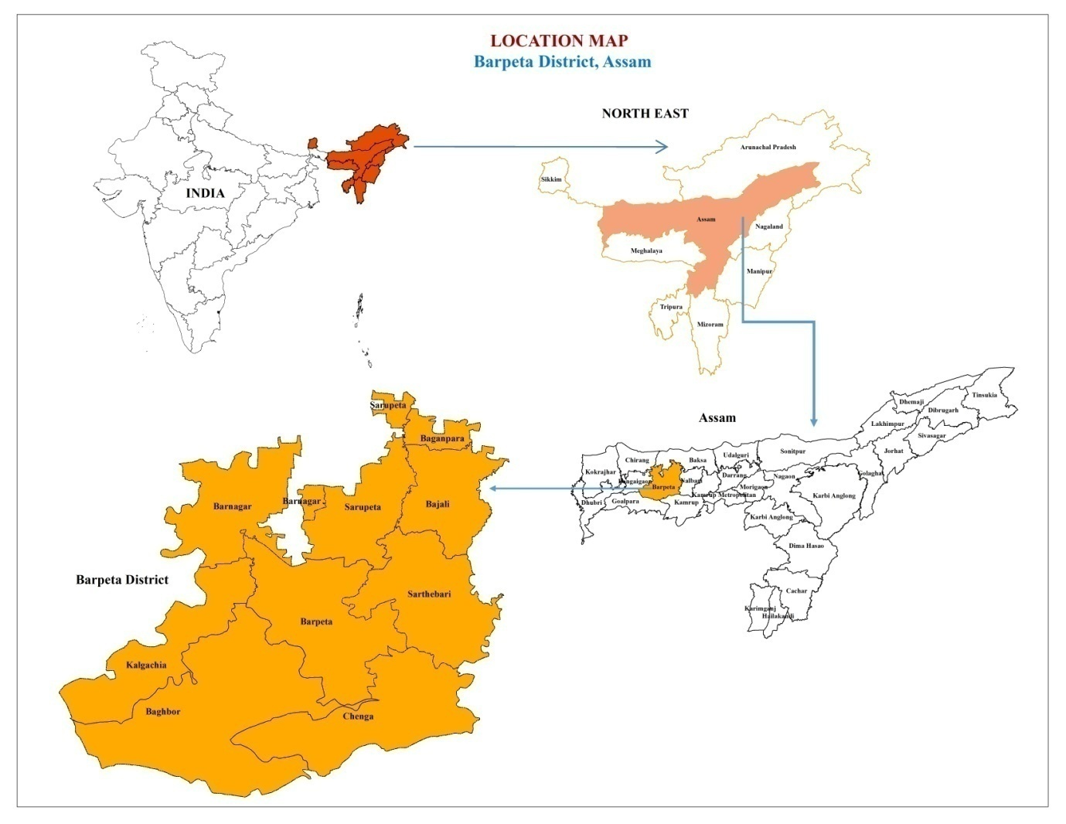

Fig.1. Location map of Barpeta district, Assam (India)

**2.2 Collection and analysis of soil samples**

` The base maps of Barpeta district were created using village boundary maps published by the Assam Survey, Government of Assam, in conjunction with Survey of India Topographical Sheets at a 1:50,000 scale (78 J / 14, 15, and 16; 78 N / 2, 3, 4, and 7). All maps were marked with grid points at 1 km intervals. A total of 1,293 grid samples were collected across the district, excluding grids in water bodies and inaccessible forest areas. Representative soil samples (0-25 cm depth) were gathered from each grid point for analysis. The soil samples were air-dried, sieved, ground, and analyzed for various parameters: pH was measured using a glass electrode in a 1:2.5 soil/water suspension, organic carbon was determined by Walkley and Black (1934), available potassium was extracted with 1 M NH4OAc and measured by flame photometer, available nitrogen was determined by Subbiah and Asija (1956), available phosphorus was measured by Bray P-1 (Bray and Kurtz 1945), and cationic micronutrients were assessed by Lindsay and Norvell (1978) using an atomic absorption spectrophotometer (Shimadzu model No. AA-6300). The soils were then classified into different fertility assessment classes as per Takkar's (2009) guidelines.

**2.2.1 Per cent sample category**

The analytical results for each soil sample were categorized into low, medium, and high categories for organic carbon and macronutrients, and as deficient, moderate, or sufficient based on the critical limits for available micronutrients in Assam. The percentage of samples in each category and nutrient index values (NIV) were computed using the provided formulae.

No. of "low (L)" or "medium (M)" or "high (H)" category

Per cent sample category = —–––––––––––––———————————————— × 100

Total no. of samples

**2.2.2 Nutrient index values and fertility rating**

The Nutrient Index Value (NIV) is calculated based on the proportion of soils falling into low, medium, and high available nutrient categories, using the formula:

[(PH×3)+(PM×2)+(PL×1)]

NIV= ––––––––––––––––––––––

100

Here, NIV represents the nutrient index value; PL, PM, and PH are the percentages of soil samples falling in the low, medium, and high nutrient status categories, respectively. These categories are given weightages of one, two, and three, respectively (Ramamoorthy and Bajaj, 1969). The index values are then rated into various categories *viz*., low (<1.67), medium (1.67-2.33) and high (>2.33) for OC and available N, P and K. For available micronutrients, the ratings are very low (<1.33), low (1.33-1.66), marginal (1.66-2.00), adequate (2.00-2.33), high (2.33-2.66) and very high (>2.66).

***2.2.3 Statistical Analysis and Generation of thematic soil fertility maps***

Descriptive statistics (mean and range) of soil parameters were computed using an Excel data sheet. The point-wise analytical database was imported into the GIS platform (ArcGIS software version 10.3.1) to create soil nutrient maps. Point data were transformed into area features using the Regular Spline method of interpolation (Collins and Bolstad, 1996: Hutchinson, 1995). Based on the available nutrient status, thematic maps were generated in GIS, ranking macro-nutrients as 'low', 'medium', and 'high', and micro-nutrients as 'deficient', 'moderate', and 'sufficient'.

**3. RESULT AND DISCUSSION**

**3.1 Soil reaction (pH)**

The pH of the surface soil (Table 1) ranged from 3.99 to 8.4, with a mean of 5.91. Approximately 53.0% of the samples were found to be acidic, likely due to the high annual rainfall (2000-2500 mm) in this region, which leads to the loss of basic cations, as reported by Chakravarty et al. (1987) and Sathish et al. (2017), resulting in low base saturation of the soil (Prasenjit Ray et al., 2018). Similar results were also reported in Assam by Barooah et al. (2020) and Bikram Borkotoki et al. (2024). In contrast, 21.5% of the samples exhibited neutral to alkaline pH, which may be attributed to a higher degree of base saturation (Waghmare et al., 2008; Sharma et al., 2008). The extensive area with low pH is also influenced by the long-term use of inorganic fertilizers instead of green manure, farmyard manure, and rice-straw residues, which has contributed to a decrease in soil pH (Tiwary et al., 2003).

**3.2 Organic carbon**

The overall organic carbon (OC) status of the soil (Table 1) ranged from 0.02% to 3.47%, with a mean value of 0.80%. The OC levels were recorded as high, medium, and low in 42.9%, 24.1%, and 7.6% of the area, respectively. About 7.6% of the soil samples were categorized as low OC status, resulting in an overall fertility rating of 'high.' This low OC status is primarily due to high temperatures leading to a higher rate of organic matter decomposition (Kameriya, 1995), and the lack of organic matter additions (Rego et al., 2003: Sathish et al., 2017). This indicates a need for rejuvenation for high crop productivity. The maximum area with high and medium OC can be attributed to the frequent addition of crop residues, higher root mass density, and organic root tissue (Patil and Ananth Narayana, 1990: Behera and Shukla, 2014).

**3.3 Available N, P and K**

The overall available nitrogen (N) status (Table 1) ranged from 91 to 685 kg ha⁻¹ with a mean value of 336 kg ha⁻¹. The results indicated that 48.2% of the district's soils had a medium availability of nitrogen (280-560 kg ha⁻¹). In Lakhimpur, Assam, 65% of the soils fall into the medium category (Bikram Borkotoki et al., 2024). Another 22.7% of the area showed low nitrogen availability (<280 kg ha⁻¹), while only 3.7% had high nitrogen availability (>560 kg ha⁻¹). The majority of soil samples (48.2%) had a medium status with an overall fertility rating of 'medium.' This could be attributed to the higher OC content in the surface, which might have aided in the mineralization of soil nitrogen, leading to a build-up of higher available nitrogen (Urkurkar et al., 2010; Sharma et al., 2007). Similar result was also reported by Verma et al., (2007) and Pandiaraj et al., (2017). The Bray-P (Table 1) ranged from 18 to 359 kg ha⁻¹ with an overall mean value of 55 kg ha⁻¹. The sample categories revealed 30.8% under medium status with an overall fertility rating of 'medium,' and 22.3% in the high status category. This high status could be due to the continuous application of single superphosphate (SSP) for crops, which would have built up soil available phosphorus, and the high rate of soil organic matter (SOM) mineralization of organic phosphorus to available phosphorus. It may also be partly due to inheritance from parent materials and the effects of continuous application of phosphate fertilizers over the past 2-3 decades (Singh et al., 2007). The low sample category status, covering 21.5% of the area, may be due to high rainfall and a higher rate of SOM decomposition, which increases the leaching of available phosphorus from surface soils (Urkurkar et al., 2010) and precipitation of phosphorus as iron and aluminium complexes due to soil acidity (Prasenjit Ray et al., 2018). In acid soil the tendency of low soil phosphorus over time reported by Dutta et al., (2008) this result confirmation with finding of Barooah et al., (2020). The available potassium (K) ranged from 40 to 479 kg ha⁻¹ with a mean of 134 kg ha⁻¹. The sample categories under low, medium, and high were 42.9%, 26.5%, and 5.2%, respectively, with an overall medium fertility rating. The 'low' available potassium in these soils may be due to the continuous drain of potassium from the soil reserve over the years with inadequate supply of chemical fertilizers to meet crop needs. Mining of potassium has started appearing in the soils, which is a matter of concern. In Assam, potassium deficiency is observed due to higher amounts of non-exchangeable potassium content in the soil than potassium in solution (Dutta and Zaman, 2013), and a negative balance of potassium has been reported by Basumatary and Talukdar (1999) and Borkakati et al. (2001). Moreover, the application of higher amounts of nitrogenous fertilizers than phosphorus-type and potassium-type fertilizers may result in decreased soil available phosphorus and exchangeable potassium (Singh et al., 2010).

**3.4 Available micronutrients**

Iron is a crucial micronutrient for plants, playing a significant role in various metabolic processes (Rout and Sahoo, 2015). The available Fe status (Table 1 and Fig. 7) ranged from 0.95 to 197.7 mg kg⁻¹, with a mean of 66.3 mg kg⁻¹. Deficient, moderate, and sufficient Fe statuses were observed in 4.2%, 47.7%, and 22.6% of the samples, respectively, with a mean fertility rating of adequate based on the nutrient index value (NIV). Fe solubility increases with a reduction in soil pH (Shukla et al., 2015), which aligns closely with the findings of Brady and Weil (2002). Soils in Barpeta with higher organic matter content may contribute to increased Fe levels, consistent with Khalifa et al. (1996) and Goldberg et al. (2002).

Manganese is another essential micronutrient involved in various plant metabolic processes, including photosynthesis and acting as an enzyme antioxidant-cofactor (Millaleo et al., 2010). The available Mn status ranged from 1.12 to 136.77 mg kg⁻¹, with a mean value of 21.14 mg kg⁻¹. About 75% of the samples had moderate Mn levels, with an overall fertility rating of "adequate." This may be due to the decomposition of organic matter releasing micronutrients and lowering the soil pH around plant roots, thus increasing the solubility of cationic micronutrients (Sharma and Chaudhary, 2007).

Copper is an essential micronutrient for plant growth and development, though it can be toxic in high amounts (Yruela, 2005). The available Cu status ranged from 0.23 to 17.31 mg kg⁻¹, with a mean of 3.31 mg kg⁻¹. About 50% of the samples showed sufficient Cu levels, with an overall fertility rating of "high." This may be due to the high organic carbon content and acidic pH of the soils, which favor Cu solubility (Prasenjit Ray et al., 2018).

Table 1. Soil fertility status of Barpeta district of Assam

|  |  |  |  |  |  |  |  |  |  |  |
| --- | --- | --- | --- | --- | --- | --- | --- | --- | --- | --- |
| Parameters/Nutrients | Range | Mean | Per cent sample category | | | NIV | Fertility rating | Per cent area based on soil fertility maps | | |
| Acidic/  Low/  Deficient | Neutral/  Medium/  Moderate | Alkaline/High/  Sufficient | D | M | S |
| pH | 3.99-8.40 | 5.91 | 68 | 24 | 8 | - | - | 53 | 9 | 13 |
| OC (%) | 0.02-3.47 | 0.80 | 15 | 34 | 51 | 2.38 | High | 8 | 24 | 43 |
| Available N (kg ha-1) | 91-685 | 336 | 34 | 64 | 2 | 1.68 | Medium | 23 | 48 | 4 |
| Available P (kg ha-1) | 18-359 | 55 | 27 | 40 | 33 | 2.07 | Medium | 21 | 31 | 22 |
| Available K (kg ha-1) | 40-479 | 134 | 61 | 38 | 1 | 1.4 | Low | 43 | 26 | 5 |
| Available Fe (mg kg-1) | 0.95-197.67 | 66.29 | 0 | 73 | 27 | 2.27 | Adequate | 4 | 48 | 23 |
| Available Mn (mg kg-1) | 1.12-136.77 | 21.14 | 0 | 75 | 25 | 2.25 | Adequate | 7 | 48 | 20 |
| Available Cu (mg kg-1) | 0.23-17.31 | 3.31 | 0 | 50 | 50 | 2.5 | High | 6 | 33 | 35 |
| Available Zn (mg kg-1) | 0.04-0.85 | 0.58 | 70 | 24 | 6 | 1.36 | Low | 47 | 21 | 7 |

*25.46% of TGA is occupied by river and sand bar; Acidic, neutral and alkaline for pH; Low, medium and high for OC and available N, P and K; Deficiency, moderate and sufficient for micronutrients.

Zinc deficiency is a significant micronutrient constraint for food production globally, and its application has shown positive responses in almost all crops (Welch, 2002). The available Zn status (Table 1 and Fig. 10) ranged from 0.04 to 0.85 mg kg⁻¹, with a mean of 0.58 mg kg⁻¹. About 70% of the soil samples were deficient in available Zn, with an overall rating of "low," consistent with findings by Bhuyan et al. (2014) in Lakhimpur district and Reza et al., (2021) in Nalbari district of Assam. Zn deficiency in Barpeta may be due to the coarse soil texture and intensified agricultural systems leading to imbalanced micronutrient use (Shukla et al., 2014). The total Zn content in soils largely depends on the parent rock materials (Kabata-Pendias and Pendias, 1992), and Zn deficiency is often more common in sandy soils than in clayey soils due to higher Zn adsorption in clay soils, controlled by cation exchange capacity (CEC) and pH (Ellis and Knezek, 1972). The lowest Zn levels were recorded in the soils of the recent alluvial high flood plain (Ray and Banik, 2016).

**3.5 Thematic Soil Fertility Maps**

The percentage area based on soil fertility maps for all nine chemical parameters is depicted in Figures 2 to 10.

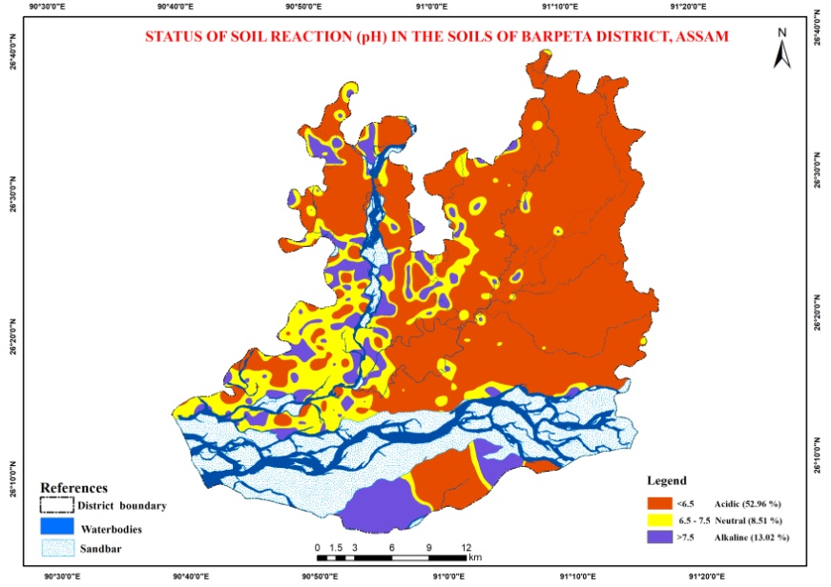

Fig.2. Status of Soil reaction (pH) in the soils of Barpeta district, Assam (India)

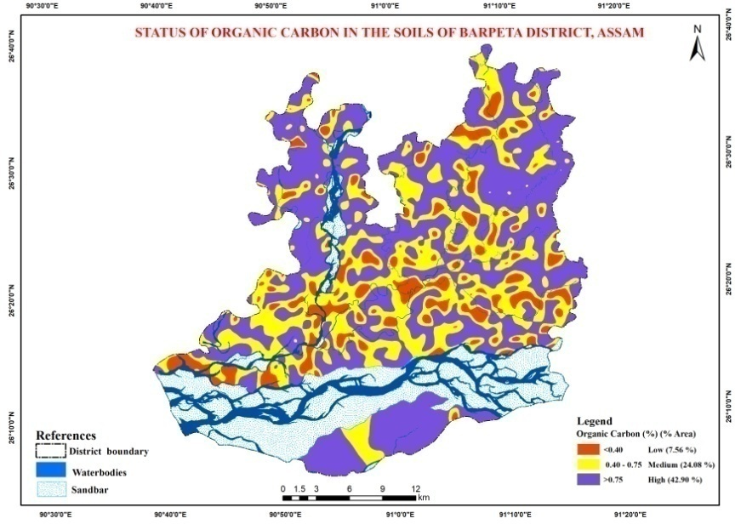

Fig. 3. Status of Organic carbon in the soils of Barpeta District, Assam (India)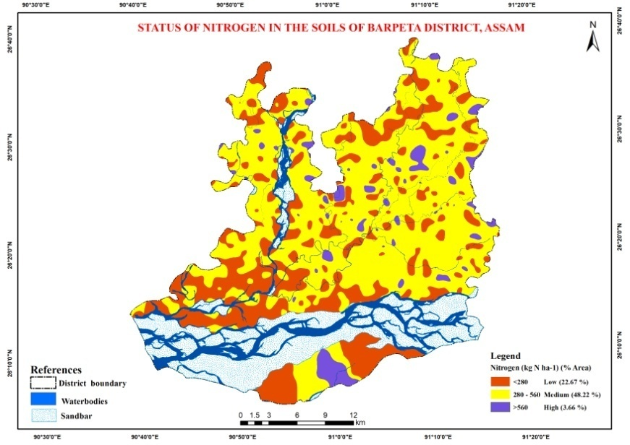

Fig. 4.Status of Available nitrogen in the soils of Barpeta District , Assam (India)

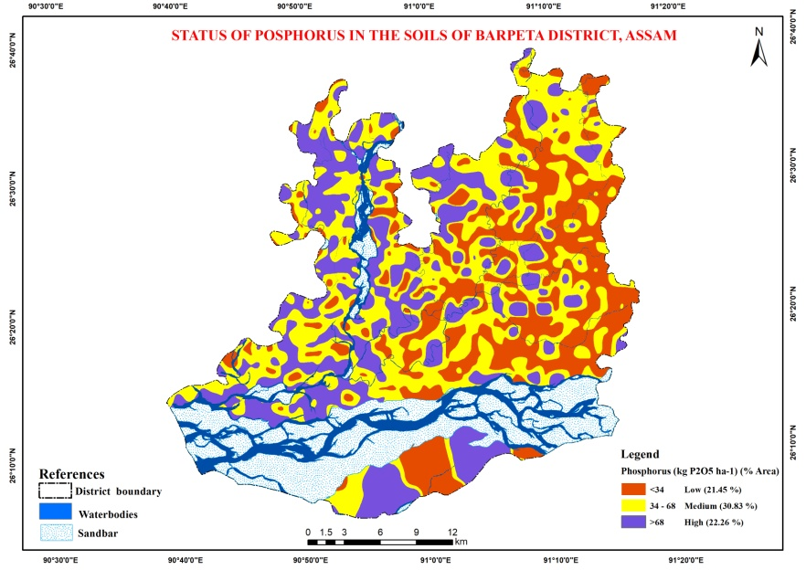

Fig. 5. Status of Available phosphorus in the soils of Barpeta District, Assam (India)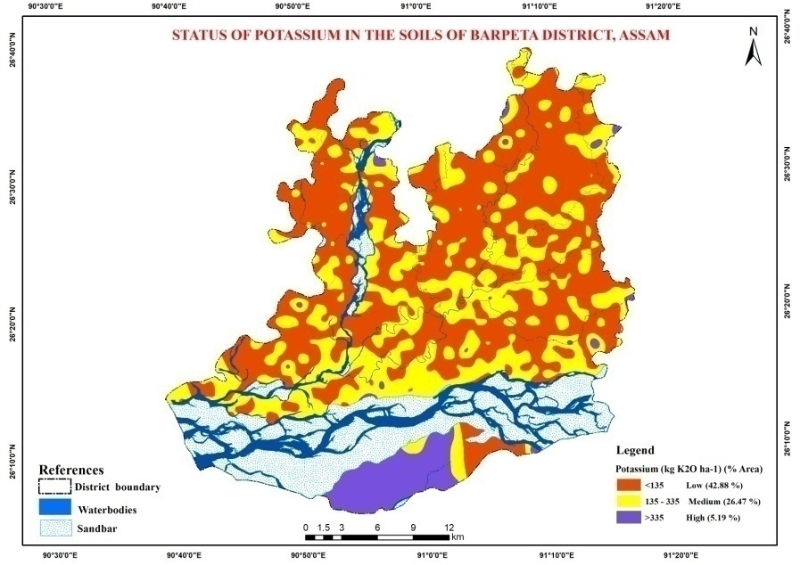

Fig. 6.Status of Available potassium in the soils of Barpeta District, Assam (India)

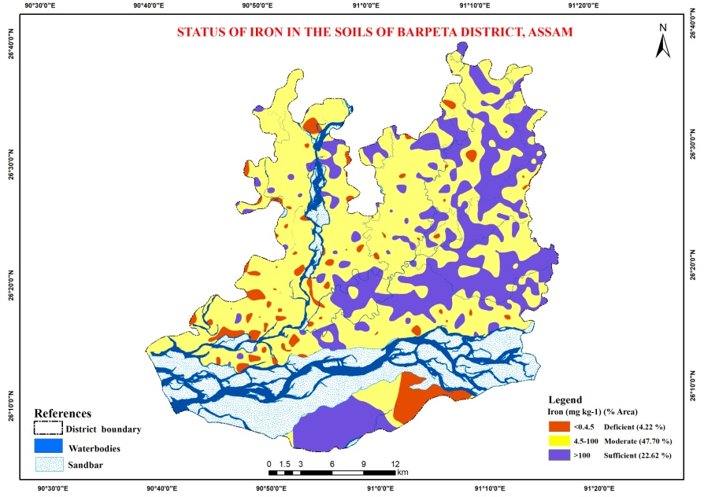

Fig. 7. Status of Available iron in the soils of Barpeta District, Assam (India)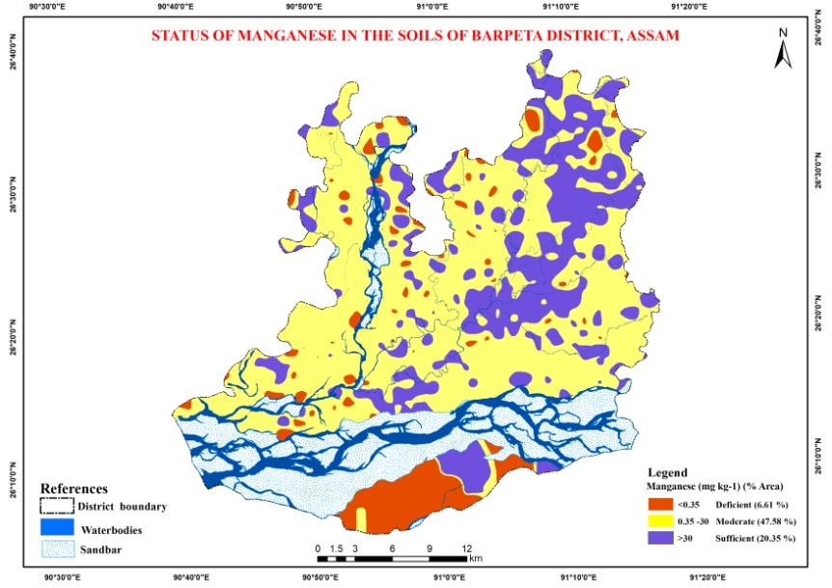

Fig. 8. Status of Available manganese in the soils of Barpeta District, Assam (India)

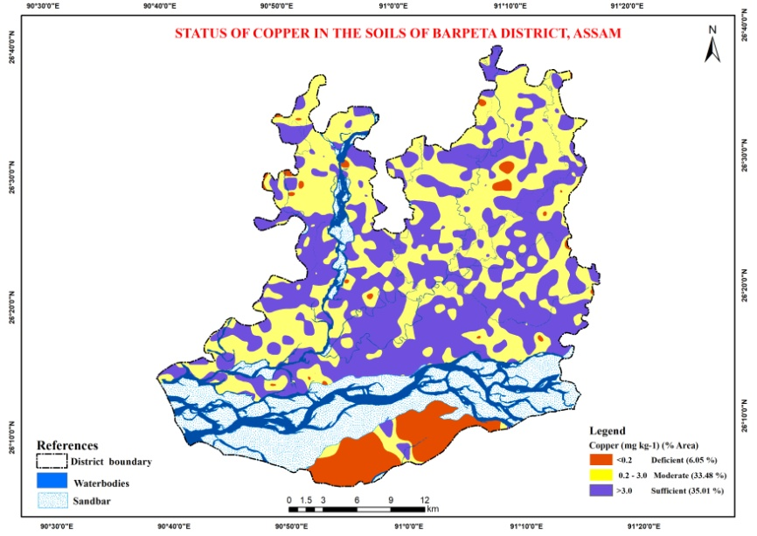

Fig. 9. Status of Available copper in the soils of Barpeta District, Assam (India)

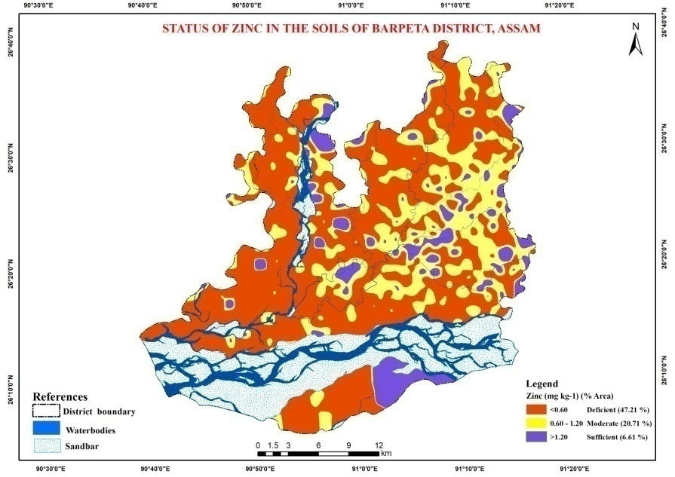

Fig. 10. Status of Available zinc in the soils of Barpeta District, Assam (India)

**3.6 Soil pH and Organic Carbon**

Regarding soil pH, the soils are primarily acidic, with 53% of the total geographical area falling under this category. Neutral and alkaline soils follow. As for organic carbon (OC) status, it is predominantly high, covering 43% of the total geographical area, followed by a medium status accounting for 24%.

**3.7 Available Nutrients**

About 48% of the area falls under the medium category for available nitrogen (N). For available phosphorus (P), approximately 31% of the area is medium, 22% is high, and 21% is low. Around 43% of the area is low in available potassium (K), 26% is medium, and only 5% is high. Regarding micronutrients, iron (Fe) status is moderate in 48% of the area, sufficient in 23%, and deficient in 5%. Manganese (Mn) is predominantly moderate in 48% of the area, sufficient in 20%, and deficient in 7%. Copper (Cu) is sufficient in 42% of the area, with 35% and 33% of the area under sufficient and moderate status, respectively. Zinc (Zn) is predominantly deficient in 47% of the area, moderate in 21%, and sufficient in only 7% of the total geographical area (TGA).

**3.8 Proposed nutrient plan for Barpeta district**

Based on the soil fertility appraisal of the district, a nutrient plan for various revenue circles/tehsils has been prepared and is presented in Table 2 for implementation.

Table 2. Proposed nutrient plan for Barpeta district

|  |  |  |
| --- | --- | --- |
| Strategies | Revenue circle/Tehsil | Remedial measures |
| Soil amendment  Acidity | Whole district except Kalgachia and Baghbor revenue circle. | Calcium carbonate @ 4 t ha-1 or 5 q/ bigha at every alternate year during land preparation  Acid tolerant crops *viz., rape seed (variety - varuna, sonmukhi), green gram (K851 and Sonmngu); vegetables: potato, sweet potato, chow-chow, yam and dioscoria sp,* cauliflower *etc.* can be grown. |
| Application of organic manures and bio-fertilizer like *Rhizobium* culture @ 150g for enhancing organic carbon status. | Whole district | Well decomposed FYM @ 5-10 t ha-1 during land preparation. organic manures *viz.,* FYM/vermicompost @ 5 t ha-1. *In-situ* crop decomposition *etc.* for residue incorporation along with *Trichoderma viride* enhancing the organic (@ 4g kg-1). |
| Recommendations for NPK | Low N status- Kalagachia and Chenga revenue circle.  Low P status - Barpeta, Sarupeta, Balaji, Sarthebari and Chenga  Low K status- Barnagar, Balaji, Sarupeta, Jelah and Sarthebari revenue circle. | http://www.stcr.gov.in and http://www.soilhealth.dac.gov.in).  25% higher than the recommended of K2O is recommended as maintenance dose. |
| Recommendations for micronutrients | Fe- sufficient in whole district | Recommended dose of FeSO4 can be applied according to crop and varieties (*e.g.* Sugarcane - FeSO4 @ 100 kg ha-1). |
| Mn- moderate in whole district except Baghbor revenue circle. | Recommended dose of MnSO4 can be applied according to crop and varieties (*e.g.* pearl millet - MnSO4 @ 12.5 kg ha-1). |
| Cu - sufficient in whole district except fringe are of Baghbor and Chenga revenue circle. | Recommended dose of CuSO4 can be applied according to crop and varieties (*e.g.* rice - CuSO4 @ 5 kg ha-1). |
| Zn - deficient in whole district except Sarthebari revenue circle. | Recommended dose of ZnSO4 can be applied according to crop and varieties (*e.g.* rice - ZnSO4 @ 25 kg ha-1). |

**4. CONCLUSION**

The study concludes that the soils in Barpeta District are generally acidic, with a high range of organic carbon. Available nitrogen is found in the medium category, while phosphorus and potassium are in the low category. The availability of micronutrients, such as iron and manganese, is in the moderate range, while copper is sufficient, and zinc is deficient. Therefore, the major nutrient constraints in Barpeta District are available potassium and zinc. To address these deficiencies and enhance crop productivity, it is important to introduce a soil test crop response-based integrated system for various crops and cropping systems. This approach will enhance soil fertility and support sustainable crop production in the area. The information developed from this study can help revisit and monitor soil fertility changes over time. The findings are crucial for guiding nutrient management strategies, improving crop productivity, and promoting sustainable agriculture in Barpeta District.

**ACKNOWLEDGEMENTS**

Authors are grateful to Agricultural Department of Assam for providing financial support through the project to carry out this study and also thankful to ICAR-NBSS&LUP, Kolkata and HQs, Nagpur for providing technical support during the course of endeavour.

**DISCLAIMER (ARTIFICIAL INTELLIGENCE)**

Author(s) hereby declare that NO generative AI technologies such as Large Language Models (ChatGPT, COPILOT, etc) and text-to-image generators have been used during writing or editing of manuscripts.

**REFERENCES**

Barooah, A., Bhattacharyya, H.K. and Chetri, K.M. (2020). Soil fertility evaluation of Dibrugarh district, India using nutrient index approach. *Academia Journal of Agricultural Research* 8(2), 059-071.

Barua P. K. and Bora. P. K. (1969). Progress of Soil Testing Works in Assam, Summary Report of the Soil Testing Laboratory (from Inception to 1969), Soil Fertility Series No.1, Department of Agriculture, Assam, India.

Basumatary, A. and Talukdar, M. C. (1999). Changes in available nutrients as affected by integrated supply system in rice-rice sequence. *New Agriculturist,* 10 (1, 2), 81-4.

Behera, S. K. And Shukla, A. K. (2015). Spatial distribution of surface soil acidity, electrical conductivity, soil organic carbon content and exchangeable potassium, calcium and magnesium in some cropped acid soils of India. *Land Degradation & Development,* 26, 71–79.

Bhupen K., Baruah, Bhanita Das, Chitrani Medhi. and Abani K. Misra (2013). Fertility Status of Soil in the Tea Garden Belts of Golaghat District, Assam, India. *Journal of Chemistry,* 1, 1- 6.

Bingham, F. T. (1982). Boron. In Methods of Soil Analysis, Part 2, 2nd Ed. A. L. Page *et al*. (eds.) Agron. Monogr. No. 9. ASA and SSSA, Madison, WI, pp. 437–447.

Borkakti, K., Bhattacharyya, H. C. and Karmakar. (2001). Nutrient mining in agroclimatic zones of Assam. *Fertilizer News,* 46(5), 61-63.

Borkotoki, B., Bhattacharyya, D., Sharma, K. K., Saikia, P., Goswami, P and Bora, B (2024). Soil nutrient mapping of the Lakhimpur district of Assam using geospatial technology. *Annals of Plant and Soil Research,* 26(1), 1-13.

Bowman, R. A., Vigil, M. F., Nielsen, D. C. and Anderson, R. L. (1999). Soil organic matter changes in intensively cropped dry land systems, *Soil Science Society of America Journal,* 63 (1), 186–191.

Brady, N.C. and Weil, R.R. (2002). The Nature and Properties of Soils, 13th Ed. Prentice- Hall Inc., New Jersey, USA, 960.

Bray, R.H. and Kurtz, L.T. (1945) Determination of total, organic and available forms of phosphorus in soils. *Soil Science,* 59, 39-45.

Cambardella, C.A. and Karlen, D.L. (1999). Spatial analysis of soil fertility parameters. *Precision Agriculture,* 1(1), 5-14.

Chakravarty, D.N., Tewari, S.N., Barthakur, B.C. (1987). Assam soils and their fertility management. Research Bulletin, Directorate of Research, Assam Agricultural University, Jorhat, Assam, p. 8.

Chesnin, L., & Yien, C. H. (1950). Turbidimetric Determination of Available Sulphates. Soil *Science Society of America Journal,* 15, 149-151.

Collins, F.C. and Bolstad, P.V. (1996). A comparison of spatial inter-polation techniques in temperature estimation. In: Proceedings ofthe 3rd international conference/workshop on integrating GIS andenvironmental modeling, Santa-Fe, NM. National Center for Geographic Information and Analysis, Santa Barbara, CA.

Dutta, J., Bhuyan, B and Misra, A.K. (2008). Chemical estimation of soil fertility status in and around the tea gardens of Gohpur sub-division, Assam*.* ***International Journal of Chemical Science,*** 6(2), 1099-1105.

Dutta, S. and Zaman, A.S.N. (2013). Potassium Indexing of summer rice grown in the shallow tube well command areas of Central Bramaputra Valley Zone of Assam, India. *Agricultural Science Digest,* 33(4), 259-263.

Ellis, B.G. and Knezek, B. D. (1972). Adsorption Reactions of Micronutrients in Soils. In Mortvedt, J., Giordano J. and Lindsay W.L. (ed), Micronutrient in Agriculture. *Soil Science Society of America*. Madison, Washington, America, pp. 59-78.

Goldberg, S., Shouse, P. J., Lesch, S. M., Grieve, M.J., Poss, C.A., Forster, H. S. and Suarez, D. L. (2002). Soil boron extractions as indicators of boron content of field grown crops. *Soil Science,* 167(11), 720-728.

Hussain, S.S., Ganie, A., Dar, W.A., Wani, T., Hadayatullah, M., Baba, J., Parrey, G., Mugloo, J and, Dar, R. (2024). The Role of Digital Soil Mapping in Soil Survey and Agricultural Planning. *International Journal of Plant and Soil Science,* 36(9), 438-49. https://journalijpss.com/index.php/IJPSS/article/view/4993

Hutchinson, M. F. (1995). Interpolating mean rainfall using thinplate smoothing splines. International *Journal of Geographical Information Science*, 9(4), 385–403.

Kabata Pendias, A. and Pendias, H. (1992). Trace elements in soils and plants. 2nd. Ed., CRC Press, Boca Raton, Florida.

Kameriya, P. R. (1995). Characterization of soils of agro climatic zone of transitional plain of inland drainage (Zone II-A) of Rajasthan, *Ph.D. Thesis*, R.A.U., Bikaner.

Khalifa, E. M., El-Desoky, M. A., Gameh M. A. and Faragallah. M. E. (1996). Status of some micronutrients and their relations to mineral composition of the Nile valley desert interference zone soils, East of Assiut city. *Assiut Journal of Agricultural Sciences,* 27(3), 107-127.

Lindsay, N.L. and Norvell, W.A. (1978). Development of DTPA soil test for zinc, iron, manganese and copper. *Soil Science Society of America,* 42, 421-428.

Makbul Hussain Khan (2012). River Erosion and Its Socio-Economic Impact in Barpeta District with Special Reference to Mandia Development Block of Assam. *The International Journal of Engineering and Science,* 1(2), *177-183.*

Mandal, A.K. and Sharma, R.C. (2009). Computerized database of salt affected soils for Peninsular India using GIS. *Geocarto International,* 24(1), 64-85.

Mandal, A. K and Sharma, R.C. (2010). Computerized Database of Salt-affected soils in Peninsular India using Geographic Information System. *Journal of the Indian Society of Soil Science,* 58(1), 105–116.

Millaleo, R., Reyes-Díaz, M.,Ivanov, A.G., Mora, M.L., Alberdi, M. (2010). Manganese as essential and toxic element for plants: transport, accumulation and resistance mechanisms. *Journal of Soil Science and Plant Nutrition,* 10(4), 470-481

Mishra, A., Das, D. and Saren, S. (2013). Preparation of GPS and GIS based soil fertility maps for Khurda district, Odisha. *Indian Agriculturist,* 57(1), 11-20.

Palm, C., Sanchez, P. Ahamed, S. and Awiti, A. (2007). Soils: a contemporary perspective, *Annual Review of Environment and Resources,* 32, 99–129.

Pandiaraj, T., Srivastava, P.P., Das, S. and Sinha, A.K. (2017). Evaluation of soil fertility status for soil health card in various Tasar growing fields of Bihar and Jharkhand states, India. *International Journal of Current Microbiology and Applied Sciences,* 6(4), 1685- 1693.

Patil, P.L and Ananthnarayana, R. (1990). Determination of lime requirement of some acid soils of Uttara kannada district, Karnataka. *Journal of Agricultural Science* , 3,161-170.

Prasenjit Ray, S. N. Gogoi, S. Bandyopadhyay, S. Padua, R. K. Jena, P. Deb Roy, S. Ramachandran, G. K. Sharma, K. D. Sah, K. Trivedy, S. K. Singh and S. K. Ray. (2018). Fertility status of mulberry (*Morus indica* L.) growing soils of upper Brahmaputra valley region of north eastern India. *Range Mgmt. & Agroforestry,* 39 (2), 147-155.

Ramamoorthy, B. and Bajaj, J.C. (1969). Available N, P and K status of Indian soils. *Fertiliser News,* 14, 24-26.

Ray, S.K. and Banik, G.C. (2016). Available micronutrient status in relation to soil properties in some villages under four agro-climatic features of West Bengal. *Journal of the Indian Society of Soil Science,*  64 (2), 169-175

Rego, T.J., Rao, V.N., Seeling, B., Pardhasaradhi, G. and Kumar Rao, J.V.D.K. (2003). Nutrient balances a guide to improving sorghum and groundnut based dry land cropping systems in semiarid tropical India. *Field* *Crops Research,* 81, 53-68.

Reza, S.K., Baruah, U., Mukhopadhyay, S., Dutta, D., Bandyopadhyay, S. and Sahoo, A.K. (2021). Quantifying spatial variability of available Zinc in Alluvial soils of Brahmaputra Plains, India. *Journal of Indian Society of Soil Science,* 69(1):28-36.

Rout, G. R. and Sahoo, S. (2015). Role of iron in plant growth and metabolism. *Reviews in Agricultural Science,* 3(1), 1-24

Santhi, R., Stalin, P., Arulmozhiselvan, K., Radhika, K., Sivagnanam, S., Sekar, J., Muralidharudu, Y., Pradip Dey and Subba Rao, A. (2018). Soil Fertility Appraisal for Villupuram District of Tamil Nadu using GPS and GIS Techniques. *Journal of the Indian Society of Soil Science,* 66(2), 158-165.

Sathish, A., Ramachandrappa, B.K., Devaraja, K., Savitha, M.S., Gowda, M.N.T., Prashanth K.M. (2017). Assessment of spatial variability in fertility status and nutrient recommendation in alanatha Cluster Villages, Ramanagara District, Karnataka using GIS. *International Journal of Current Microbiology and Applied Science,*  6(5), 211-224.

Sharma, J.C. and Chaudhary, S.K. (2007). Vertical distribution of micronutrient cations in relation to soil characteristics in lower Shiwaliks of Solan district in north-west Himalayas. *Journal of the Indian Society* *of Soil Science,* 55, 40-44.

Sharma, M., Mishra, B. and Singh, R. (2007). Long-term effects of fertilizers and manure on physical and chemical properties of a Mollisol, *Journal of the Indian Society of Soil Science,* 55(4), 523–524.

Sharma, P.K., Sood, A., Setia, R.K., Tur, N.S., Deepak Mehra and Harpinder Singh (2008). Mapping of macronutrients in soils of Amritsar District (Punjab) – A GIS approach. *Journal of the Indian Society of* *Soil Science,* 56, 34-41.

Shukla, A. K. Srivastava P.C., Tiwari, P. K., Chandra Prakash, Patra, A. K., Pooja Singh and Pachaur, S.D. (2015). Mapping Current Micronutrients Deficiencies in Soils of Uttarakhand for Precise Micronutrient Management*. Indian Journal of Fertilizer,* 11 (7), 52-63

Shukla, A.K., Tiwari, P. K. and Chandra Prakash (2014). Micronutrients Deficiencies vis-a-vis Food and Nutritional Security of India. *Indian Journal of Fertilizer,* 10(12), 94-112

Singh, R.P. and Mishra, S.K. (2012). Available macronutrient (N, P, K and S) in the soils of Chiraigaon block of District Varanasi (UP) in relation to soil characteristics, *Indian Journal of Scientific Research,* 3, 97-100.

Singh, S. R., Zargar, M. Y., Singh, U. and Ishaq, M. (2010). Influence of bio-inoculants and inorganic fertilizers on yield, nutrient balance, microbial dynamics and quality of strawberry (Fragariax ananassa) under rainfed conditions of Kashmir valley, *Indian* *Journal of Agricultural Sciences,* 80(4), 275–281.

Singh, S.K., Mahesh Kumar, Sharma, B.K. and Tarafdar, J.C. (2007). Depletion of organic carbon, phosphorus and potassium under pearl millet based cropping system in the arid region of India. *Arid Land Research* *and Management,* 21, 119-131.

Subbiah, B.V. and Asija, G.L. (1956). A rapid procedure for estimation of available nitrogen in soils. *Current.* *Science,* 25, 259-260.

Takkar, P. N. (2009). Soil fertility, fertilizer and integrated nutrient use. In *Hand Book of Agriculture* (eds Rai *et al.*), Indian Council of Agriculture, New Delhi, 2009, 6th revised edn, p. 516.

Tiwari, K. N. (2003). *Fundamental of Soil Science*, Indian Society of Soil Science, New Delhi, India

Urkurkar, J. S. Tiwari, A. Chitale, S. and Bajpai, R. K. (2010). Influence of long-term use of inorganic and organic manures on soil fertility and sustainable productivity of rice (*Oryza sativa*) and wheat (*Triticum aestivum*) in Inceptisols, *Indian Journal of* *Agricultural Sciences,* 80(3), 208–212.

Verma, L.P., Tripathi, B.R. and Sharma, D.P. (2007). Organic carbon an index to assess the nitrogen status of the soils. *Journal of Indian Society of Soil Science,*  28, 138-140.

Waghmare, M.S., Indulkar, B.S., Mali, C.V., Takankhar, V.G. and Bavalgave, V.G. (2008). Chemical properties and micronutrients status of some soils of Ausa tahsil of Latur, Maharashtra. *An Asian Journal of Soil* *Science,* 3, 236-241.

Walkley A. and Black, I.A. (1934). An examination of the Digestion method for determining soil organic matter, and a proposed modification of the chromic acid titration method. *Soil Science,* 37, 29-38.

Welch, R.M. (2002). The impact of mineral nutrients in food crops on global human health. *Plant and Soil*, 247(1), 83-90

Yruela, I. (2005). Copper in plants. *Brazilian Journal of Plant Physiology,* 17(1), 145-156.