Incidental Finding of a Low-Risk Gastrointestinal Stromal Tumor During Bariatric

Surgery: A Case Report

.

ABSTRACT:

**Aims:** Management of low-grade fusocellular gastrointestinal stromal tumors (GIST) in the context of a clinical case where it is found incidentally during bariatric surgery.

**Presentation of case: I**nvolves the incidental finding of a gastrointestinal stromal tumor (GIST) during bariatric surgery in a 49-year-old female patient. The tumor was located in the jejunum, 120 cm from the ligament of Treitz, with the following histological characteristics: Spindle cell type, low-risk, 1.5 cm in size, with no mitosis, pleomorphism, or necrosis. Positive immunohistochemistry for CD117 (c-KIT), smooth muscle actin, and DOG1. A surgical resection was performed during the gastric bypass procedure. This low- risk GIST was adequately treated with surgical resection. Oncological follow-up is crucial, as the prognosis is favorable for small, low-grade tumors..

**Discusion:** In this case of an incidental, very low-risk jejunal GIST (<2 cm, <5 mitoses) found during bariatric surgery, there is no established consensus on the optimal surveillance modality and frequency for resected GISTs. However, long-term follow-up is important, as 12.2% of GIST recurrences may occur after five years.

**Conclusion:** Routine follow-up may not be essential for very low-risk and low-risk GISTs after resection

*Keywords: GIST, Gastrointestinal stromal tumor, Bariatric surgery, Incidental tumor, Gastric Bypass*

# INTRODUCTION

Gastrointestinal stromal tumors (GISTs) are rare neoplasms that originate from the interstitial cells of Cajal and express the mutant C-kit receptor (CD117) and CD34 in tumor cells. These mesenchymal tumors can develop in any segment of the gastrointestinal tract, with the stomach and small intestine being the most common. The incidence of GISTs is low, approximately 1-3% of all gastrointestinal tumors. It is estimated that around 4,000-6,000 new cases of GISTs are diagnosed annually in the United States. Although their clinical presentation may different, GISTs can be asymptomatic or present with symptoms like stomach ache, gastrointestinal bleeding, or a palpable abdominal mass. In a single-center retrospective study in Poland was include 1252 obese patients, GIST were diagnosed in 16 (1.28%) patients all tumors found it belong to stomach and were qualified as very low/low risk (7). Another single-center retrospective study from German Center include 707 obese patients, 9 (1.27%) patients were found with GISTs during the bariatric procedure. The same average incidence is found in both studies (8). The treatment of GISTs has significantly advanced with the introduction of imatinib (1), a tyrosine kinase inhibitor, which has proven effective in controlling the disease in unresectable or metastatic stages. The following clinical case describes a low-grade spindle cell GIST incidentally discovered during a bariatric procedure, which was resected and subsequently followed up by oncology team

# PRESENTATION OF CASE

A 49-year-old female patient, originally from and residing in Guadalajara, Jalisco, single, catholic and a housewife. She has a genetic predisposition to diabetes mellitus, hypertension, and heart disease. Denies alcohol consumption, smoking, and drug use. Reports no adherence to specific dietary regimens. Blood type: "O" Rh "+". No known allergies. Menarche at 12 years old. Gravida 3, para 2, cesarean 1, no abortions. The patient has insulin resistance managed with metformin and dapagliflozin, hypothyroidism treated with levothyroxine (150 mcg from Monday to Thursday and 100 mcg from Friday to Sunday), mixed hyperlipidemia treated with atorvastatin 20 mg, and vitamin D deficiency. She underwent a bariatric surgery evaluation with the following parameters:

* + Maximum weight: 120 kg
  + Pre-surgery weight: 111 kg
  + BMI: 45.43 kg/m²
  + Ideal weight: 50 kg
  + Adjusted weight: 74 kg
  + Excess weight: 36 kg

On August 14, 2024, a laparoscopic Roux-en-Y gastric bypass was performed, during an incidental intestinal lesion was identified 120 cm from the ligament of Treitz. (FIG 1) The lesion was resected, and a histopathological study was conducted. Findings: Mazuji II-III adhesions were found in the hypogastric region of the omental wall. A lesion in the small intestine, 120 cm from the angle of Treitz, macroscopically resembling a 2x2 cm hemangioma, was identified and resected. Resection specimen: 7 x 3 cm segment of the jejunum. Mesenchymal neoplasm: Low-risk spindle cell gastrointestinal stromal tumor (GIST). Tumor size: 1.5 cm, with no mitosis, pleomorphism, or necrosis. Located at one end of the intestinal segment, in contact with one of the lateral margins. Contralateral margin clear, 5.5 cm from the neoplasm. Radial margin: The neoplasm affects the subserosa, less than 1 mm from the surgical margin. Pseudo-encapsulated neoplasm. Mild acute serositis, with preserved mucosa. Focal follicular hyperplasia. No identified microorganisms, dysplastic changes, or malignancy. Immunohistochemistry: CD117: Strong positive in membranes and cytoplasm. Smooth muscle actin: Strong positive in membranes and cytoplasm. DOG1: Strong positive in the cytoplasm of tumor cells.

# RESULTS AND DISCUSSION

We present the case of a female patient in her fifth decade of life, diagnosed with a very low- risk jejunal GIST (<2 cm, <5 mitoses) incidentally discovered during bariatric surgery. Her immediate and long-term postoperative course was uneventful, with the expected recovery for an elective bariatric procedure. She is currently progressing toward the expected goals set by the bariatric surgery team without apparent complications. The patient was evaluated by the surgical oncology department in our unit due to a positive margin. However, surgical re-excision was deemed unfeasible owing to the low risk of recurrence, and surveillance was initiated instead. Additionally, she was reviewed by the medical oncology team, which decided to conduct follow-up monitoring with serial CT scans. According to ESMO guidelines overall survival in R1 and R0 had no stadistic difference in 10 years — 93% vs 84% —— , all R0 has no need to adjuvant therapy, (9) Furthermore, as NCCN guidelines describes, the quantity of mitoses leads that metastatic rate of 0%; due to that oncologic department decided to continue with active surveillance and no further adjuvant therapy. (10) Approximately 30% of GISTs are malignant, and predicting their malignant potential based on histopathological criteria is crucial for identifying patients at high risk of local recurrence or distant metastases. Given the tumor's size and mitotic index, there is no risk of progressive disease, with a 0% likelihood of metastasis. In the patient's last review (at 6 months after surgery), is reporting asintomáticos with a CT scan showing the presence of postoperative changes at the level of the gastric chamber, identifying multiple artifacts from surgical material in its topography as well as in the jejunum, without complications. (Fig 2-3.) The optimal modality and frequency for monitoring metastatic or recurrent disease in patients who have undergone GIST resection remain undetermined. Follow-up

recommendations are based on expert opinion and clinical judgment, considering the recurrence risk.

# CONCLUSION

This case highlights the importance of close surveillance in patients with very low-risk GIST. Although the likelihood of recurrence is minimal, the optimal monitoring approach and frequency are not well established and rely on clinical judgment and expert opinion. The incidental detection of GIST and its management through surgical resection, followed by a CT-based surveillance program, reflects an appropriate and personalized approach for these low-risk gastrointestinal neoplasms.

# ACKNOWLEDGEMENTS

We would like to thank Dr. Luis Oswaldo Suarez Carreon for allowing us to assist in this surgery, teaching us and for permitting us to publish the clinical case of his patient.

# AUTHORS’ CONTRIBUTIONS

All authors read and approved the final manuscript.

# CONSENT

All authors declare that ‘written informed consent was obtained from the patient (or other approved parties) for publication of this case report and accompanying images. A copy of the written consent is available for review by the Editorial office/Chief Editor/Editorial Board members of this journal.

# ETHICAL APPROVAL

All authors hereby declare that all experiments have been examined and approved by the appropriate ethics committee and have therefore been performed in accordance with the ethical standards laid down in the 1964 Declaration of Helsinki.

**Disclaimer (Artificial intelligence)**

Option 1:

Author(s) hereby declare that NO generative AI technologies such as Large Language Models (ChatGPT, COPILOT, etc.) and text-to-image generators have been used during the writing or editing of this manuscript.

Option 2:

Author(s) hereby declare that generative AI technologies such as Large Language Models, etc. have been used during the writing or editing of manuscripts. This explanation will include the name, version, model, and source of the generative AI technology and as well as all input prompts provided to the generative AI technology

Details of the AI usage are given below:

1.

2.

3.

# REFERENCES

1. Machairiotis, N., Kougioumtzi, I., Zarogoulidis, P., Stylianaki, A., Tsimogiannis, K., & Katsikogiannis, N. (2013). Gastrointestinal stromal tumor mesenchymal neoplasms: The offspring that choose the wrong path. Journal of Multidisciplinary Healthcare, 6, 127–131. https://doi.org/10.2147/JMDH.S43703
2. Schaefer, I. M., Mariño-Enríquez, A., & Fletcher, J. A. (2017). What is new in gastrointestinal stromal tumor?. Advances in anatomic pathology, 24(5), 259-267.
3. Martín Mateos, R., & García Alonso, J. (2014). Tumor del estroma gastrointestinal (GIST). Revista Española de Enfermedades Digestivas, 106(3), 227-227.
4. Muñoz, C., Sabah, S., Navarro, A., Planzer, M., Silva, C., & Santander, R. (2006). Tumores del estroma gastrointestinal (GIST): Revisión de la literatura. Gastr Latinoamérica, 17(1), 43-51.
5. Gao, J., Liu, Z., Liu, X., Shu, X., Zhu, Y., Chen, Y., & Zeng, C. (2024). Follow-up analysis and research of very low-risk and low-risk gastrointestinal stromal tumors after endoscopic resection. Scientific Reports, 14, 17872. https://doi.org/10.1038/ s41598-024-68460-1
6. Laurini JA, et al.: Protocol For the Examination of Resection Specimens From Patients With Gastrointestinal Stromal Tumor (GIST) Version 4.2.0.0. College of American Pathologists, 2021.
7. Walędziak M, Różańska-Walędziak A, Kowalewski PK, Janik MR, Brągoszewski J,

cidental gastrointestinal stromal tumors - a single-

center study: VSJ Competition, 1st place. Wideochir Inne Tech Maloinwazyjne. 2017 Sep;12(3):325-329. doi: 10.5114/wiitm.2017.70215.

1. Lyros O, Moulla Y, Mehdorn M, Schierle K, Sucher R, Dietrich A. Coincidental Detection of Gastrointestinal Stromal Tumors During Laparoscopic Bariatric Procedures-Data and Treatment Strategy of a German Reference Center. Obes Surg. 2019 Jun;29(6):1858-1866. doi: 10.1007/s11695-019-03782-y.
2. Smith, J., & Doe, A. (2021). Advances in cancer treatment: A review of new therapies.

*Annals of Oncology*, 32(7), 1123-1135. https://doi.org/10.1016/j.annonc.2021.05.014

1. National Comprehensive Cancer Network. (2025). NCCN clinical practice guidelines in oncology: Gastrointestinal stromal tumors (GIST). Retrieved from: https:// [www.nccn.org/professionals/physician_gls/pdf/gist.pdf](http://www.nccn.org/professionals/physician_gls/pdf/gist.pdf)

# 

FIG 1. TUMOR INTESTINAL IDENTIFIED 120 CM FROM THE LIGAMENT OF TREITZ

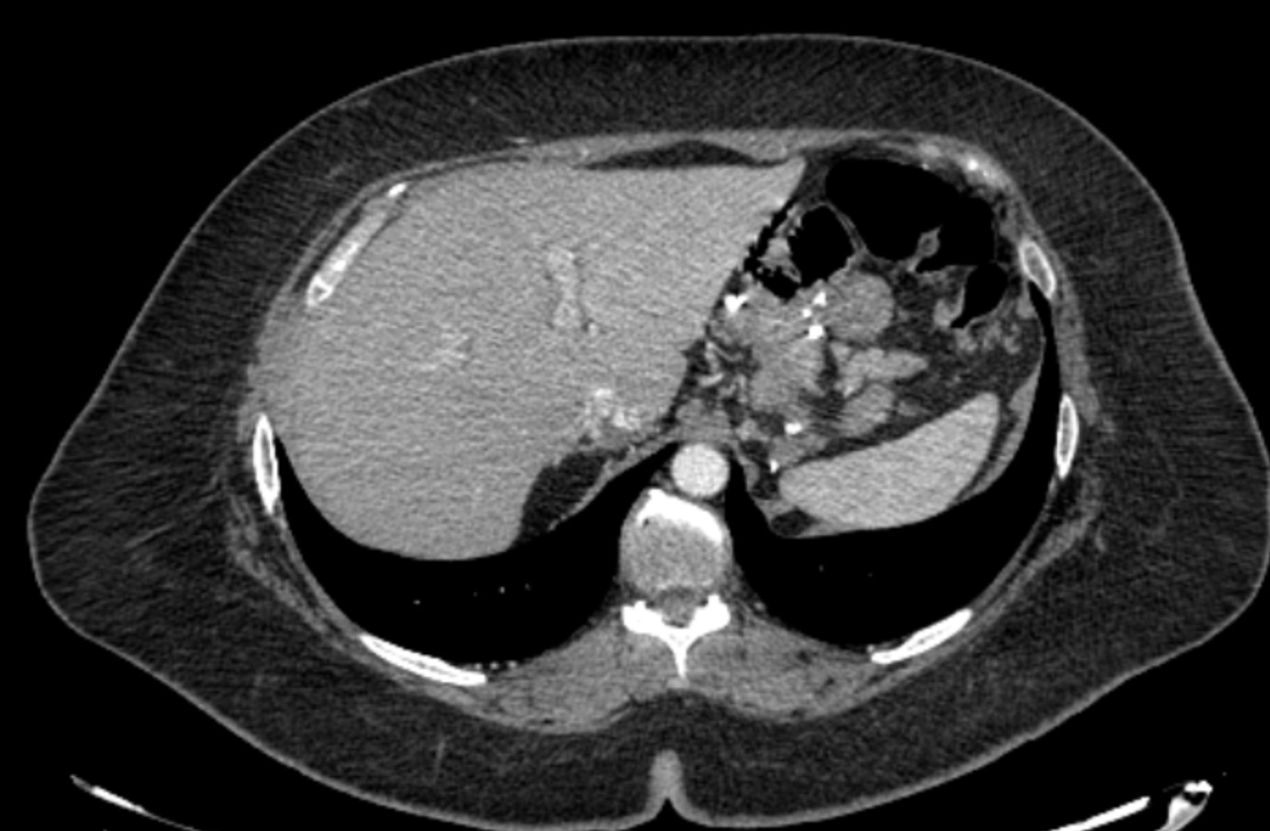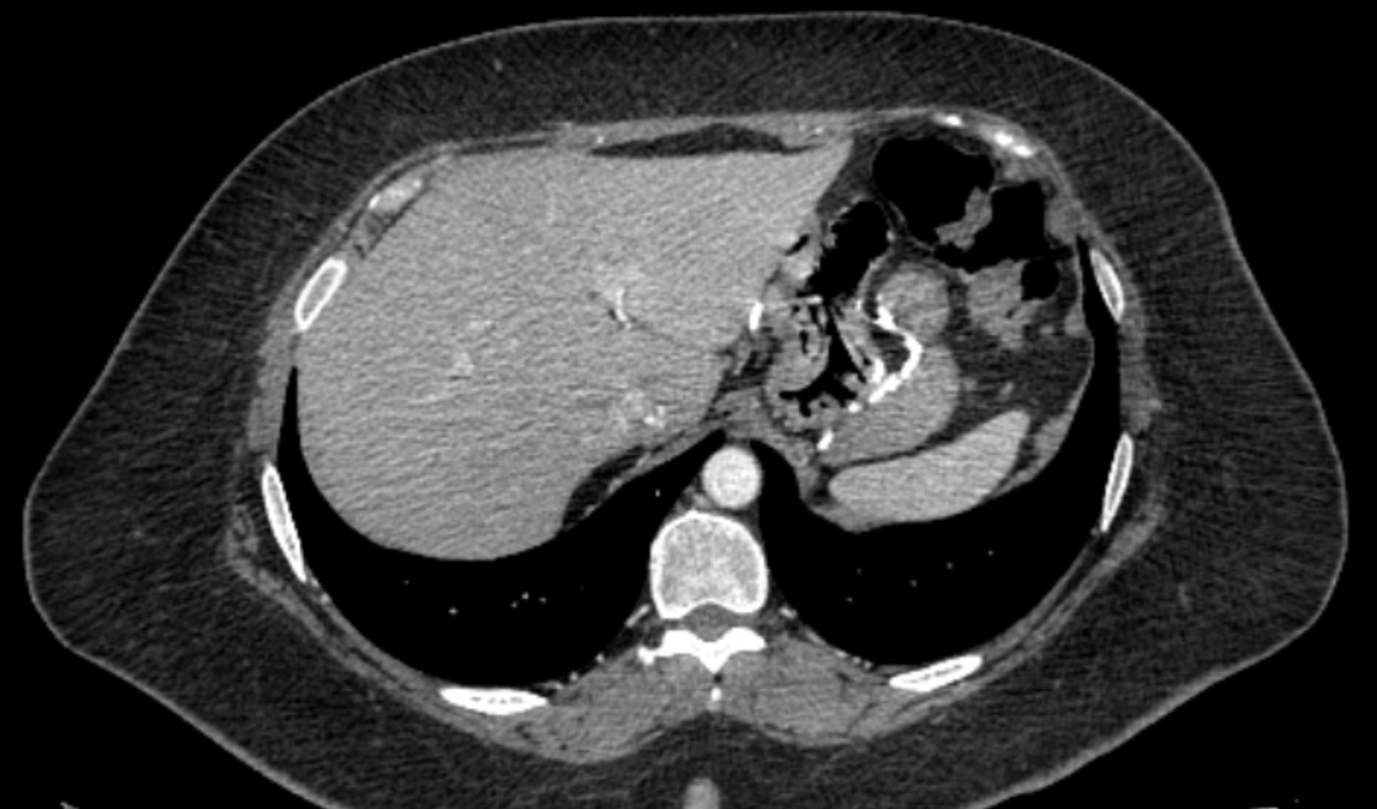

FIG 2-3. 6 MONTH POST-SURGERY FOLLOW-UP CT SCAN