***Case report***

**Anterior Ischemic Optic Neuropathy Revealing Thyroid and Lymph Node Tuberculosis : A case report**

**Abstract:**

Tuberculosis is a bacterial infection caused by the Mycobacterium tuberculosis complex, which includes five Mycobacteriums : Tuberculosis (commonly known as Koch's Bacillus), Bovis, Africanum, Microti, and Pinnipedii. This condition affects both humans and certain animal species (such as cattle). Human contamination occurs either via respiratory or digestive routes, with four possible outcomes: early-onset of the tuberculosis disease, late-onset of it, latent tuberculosis infection, or the total elimination of the bacillus. It can affect both immunocompetent and immunodeficient individuals, and when the disease manifests, it may be unifocal or multifocal, leading to clinical polymorphism that complicates the diagnostic process. We report the case of a patient, who had contact with livestock (the wife of a farmer who owns cattle), with no known immunodeficiency, vaccinated against tuberculosis, and in whom bifocal tuberculosis was diagnosed following an etiological assessment of anterior ischemic optic neuropathy. This represents a presentation undescribed previously, with the following atypical features: bifocal localization in an immunocompetent patient vaccinated against tuberculosis, the unusual thyroid involvement, the identification of Mycobacterium Bovis, and the fact that this inaugural presentation has not been previously documented in the medical literature.

**Keywords:**

Tuberculosis, Thyroid Tuberculosis, Lymph Node Tuberculosis, Anterior Ischemic Optic Neuropathy, Mycobacterium Bovis.

**Introduction:**

Tuberculosis is a bacterial infection caused by the Mycobacterium tuberculosis complex, which includes: Mycobacterium tuberculosis (Koch's Bacillus), Bovis, Africanum, Microti and Pinnipedii. The classical routes of entry are the respiratory and digestive tracts, with four potential outcomes: immediate onset of the illness, delayed onset, latent tuberculosis infection, and total elimination of the Mycobacterium [1]. When the disease manifests, it can localize to one or multiple sites, resulting in a wide variety of clinical presentations that mimic the symptomatology of different diseases.

Anterior ischemic optic neuropathy is an acute ischemic event affecting the head of the optic nerve due to occlusion of the posterior ciliary arteries or their branches, leading to a sudden loss of visual acuity that can be permanent. The two main pathophysiological mechanisms are arteritic , which corresponds to vasculitis, primarily Giant Cell Arteritis, formerly known as Horton's disease, and non-arteritic, which is caused by endovascular obstruction due to atherosclerotic overload or extravascular compression from external arterial pressure [2].

We report the case of a patient who presented with AION and whose etiological assessment led to the diagnosis of thyroid and lymph node TB secondary to MB bovis.

**Case presentation:**

The patient was a 60-year-old woman from the Mohammedia Province, married and mother of two children, a housewife and the wife of a farmer, with no significant medical, surgical, or toxicological history. The onset of her illness dated back to four months prior to her admission, marked by progressive asthenia. Two months later, she developed a weight loss of 30 kg within two months, accompanied by night sweats, but without fever. The course of her condition was further complicated by a sudden decrease in visual acuity in her right eye, prompting her to seek urgent care at the Ophthalmology Department of the 20 August Hospital in Casablanca. There, a diagnosis of AION was made, with visual acuity recorded at 7/10 in the left eye and 3/10 in the right eye. She was then urgently referred to our service for an etiological workup and therapeutic management.

On admission examination, the patient was conscious, well-oriented in time and space. Her conjunctivae were of normal color, and she exhibited excess skin on the arms and abdomen, indicative of significant and rapid weight loss. She had a blood pressure of 157/96 mmHg, slightly tachycardic at 88 beats per minute, eupneic at 19 breaths per minute, and had an oxygen saturation of 97%.

On cardiovascular examination, heart sounds were clear without murmurs or additional sounds, peripheral pulses were well felt and symmetrical, the calves were soft with no Homan's sign, and there was no lower limb edema. Temporal pulses were well felt and symmetrical, with no jaw claudication or scalp paresthesia. The pleuropulmonary examination was unremarkable.

Abdominal examination revealed white stretch marks and excess skin consistent with rapid and significant weight loss, without scars or collateral circulation. On palpation, the abdomen was soft, with no hepatomegaly or splenomegaly, but there was a pulsating mass in the peri-umbilical region and bilateral inguinal lymphadenopathy, with the largest node on the left, measuring approximately 3 cm in its longest dimension.

The ENT examination revealed an enlarged thyroid with hard nodules and a few cervical lymph nodes, the largest of which was on the right side, measuring approximately 12 mm in its longest dimension. Other lymph node areas were free of abnormalities. The remainder of the examination was unremarkable.

The patient underwent an emergency abdominal-pelvic CT angiography to explore the pulsating mass, which revealed large abdominal juxta-aortic lymphadenopathies explaining the pulsating nature, along with an epiploic infiltration and inguinal lymphadenopathy.

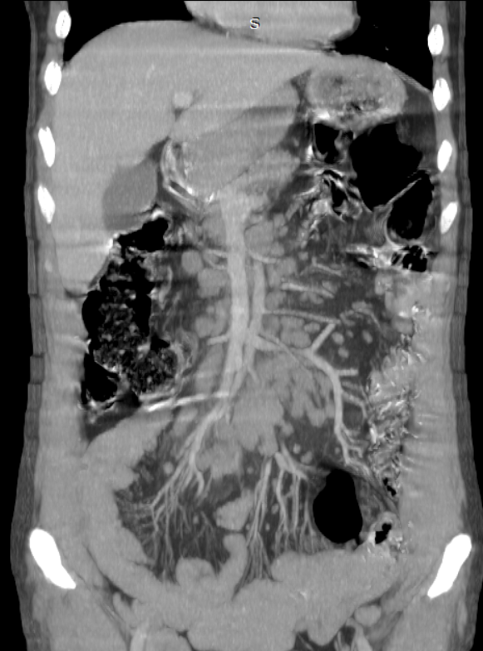 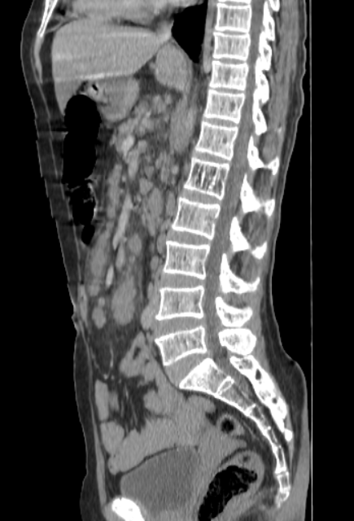

**Figure 1 (A-B) :***Coronal CT scan on the left and sagittal scan on the right with contrast agent injection during the venous phase, revealing the presence of mesenteric lymphadenopathy.*

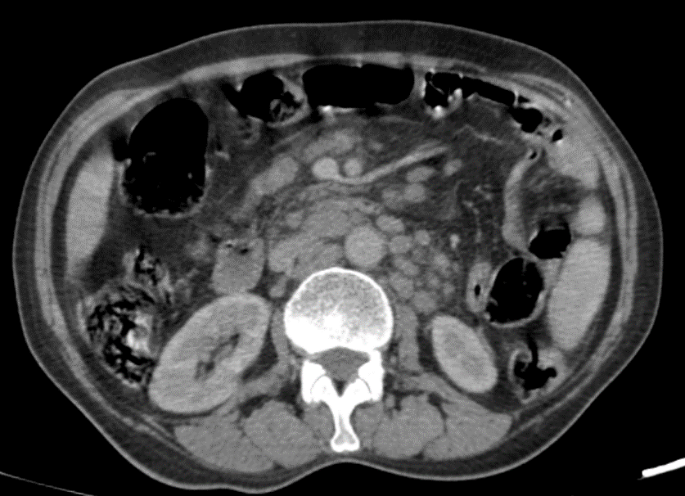

**Figure 2 :** *Axial CT scan with contrast agent injection during the venous phase, revealing the presence of left lateral aortic, inter-aortocaval, and mesenteric lymphadenopathy.*

Doppler exploration of the temporal arteries, aimed at detecting signs suggestive of giant cell arteritis, revealed no wall thickening, halo sign, calcification, or any other abnormalities.

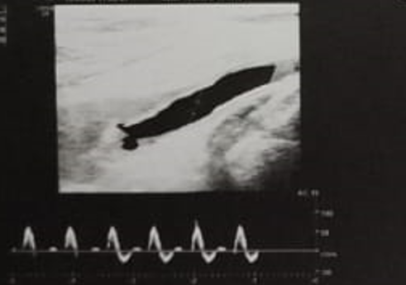 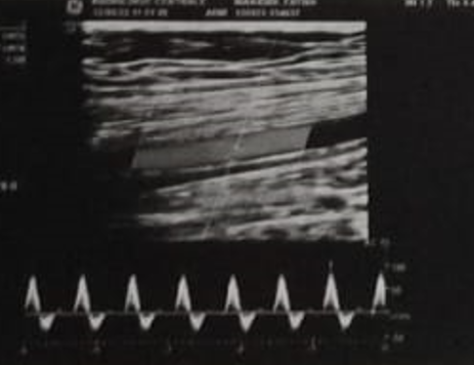

**Figure 3(A-B) :** *Doppler of the temporal arteries showing no signs of arterial wall thickening.*

Doppler exploration of the supra-aortic trunks to investigate a non-vasculitic cause showed no atherosclerotic burden but revealed decreased carotid flow secondary to compression by right-sided lymphadenopathy.

Cervical ultrasound performed to evaluate the thyroid nodules showed a thyroid nodule classified as EUTIRADS 5, along with multiple bilateral cervical lymphadenopathies compressing the vascular structures on the right side.

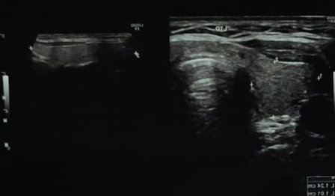 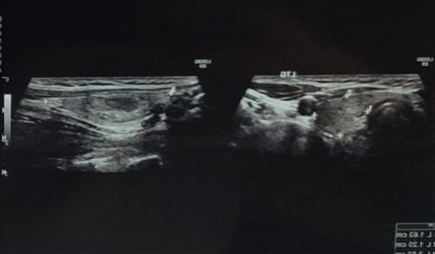

**Figure 4(A-B):** *Ultrasound of an euthyroid thyroid with a right nodule classified as EUTIRADS 5, associated with a suspicious ipsilateral cervical lymphadenopathy.*

Additional thoracic exploration via CT scan, prompted by the lymphadenopathies found in the cervical, abdominal, and pelvic regions, revealed some bilateral mediastinal and axillary lymphadenopathy.

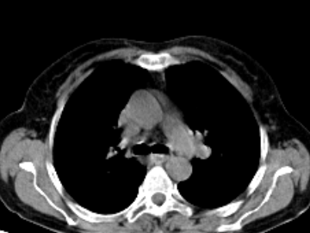 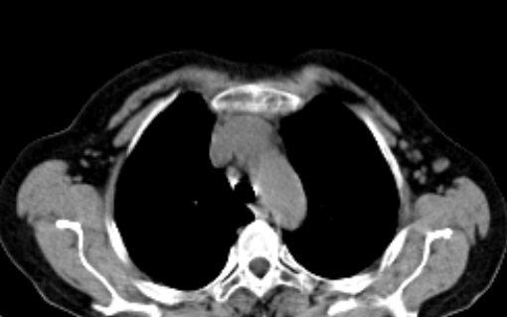

**Figure 5(A-B) :** *Transverse thoracic CT scan with contrast agent injection showing left mediastinal lymphadenopathy and right axillary lymphadenopathy.*

The PET scan revealed hypermetabolic activity in the cervical, axillary, mediastinal, abdominal, and inguinal lymphadenopathies.

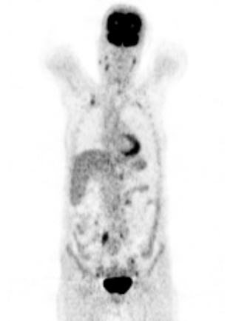

**Figure 6 :** *Coronal PET scan highlighting cervical lymphadenopathy, right axillary lymphadenopathy, and abdominal lymphadenopathy with hypermetabolic activity.*

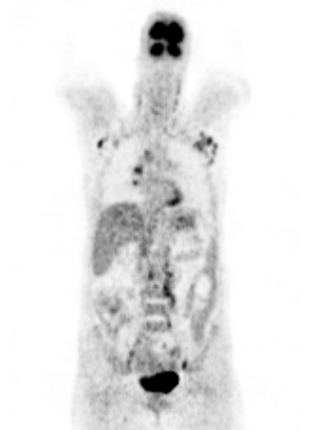 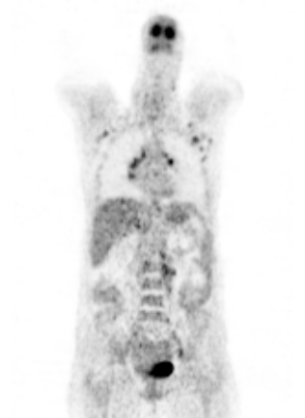

**Figure 7(A-B) :** *Coronal PET scan highlighting axillary, mediastinal, and abdominal lymphadenopathy with hypermetabolic activity.*

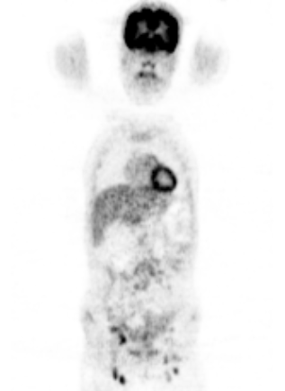

**Figure 8:** *Coronal PET scan highlighting inguinal lymphadenopathy with hypermetabolic activity.*

In the biological assessment: The patient presented with anemia with a hemoglobin level of 10 g/dL, characterized as hypochromic microcytic and non-regenerative. There was lymphopenia at 989/mm³ without thrombocytopenia or neutropenia, and ferritin was at 11 ng/mL. The LDH was slightly elevated at 284 IU/L, while haptoglobin was normal at 1.4 g/L. The direct Coombs test was negative, and C-reactive protein was mildly elevated at 25 mg/L, with fibrinogen at 6.8 g/L. Metabolically, the TSH level was normal at 4 mUI/L, fasting blood glucose was normal at 0.84 g/L, and triglycerides were slightly elevated at 2.7 g/L. HIV serology was negative, as were syphilis serology tests. The QuantiFERON test returned positive. Serum protein electrophoresis showed polyclonal hypergammaglobulinemia at 15.6 g/L. The calcium-phosphate balance in blood and urine was normal, potassium levels were normal, uric acid levels were normal, and the angiotensin-converting enzyme level was normal at 65 IU/L.

The patient underwent left inguinal adenectomy, and the pathological study revealed an epithelioid giant cell granuloma with the presence of caseating necrosis. Detection of Mycobacterium bovis genome was achieved via polymerase chain reaction.

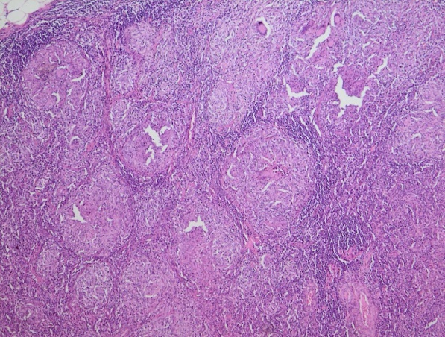 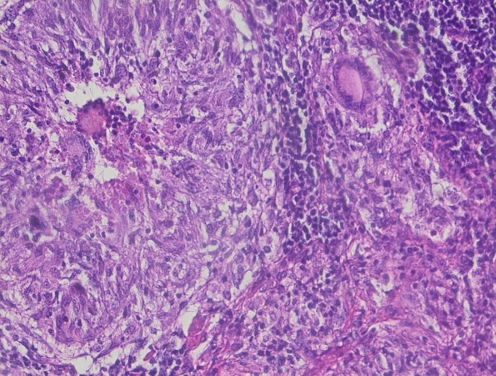

**Figure 9(A-B) :** *Histological sections stained with hematoxylin and eosin showing a lymph node pulp containing multiple epithelioid giant cell granulomas.*

The patient also underwent total thyroidectomy, and the pathological examination showed thyroid parenchyma with a vesicular architecture without tumor proliferation. The vesicles varied in size, some being cystic, with presence of fibrous and hemorrhagic changes within the nodules. However, PCR testing isolated the genome of Mycobacterium Bovis.

The patient was urgently treated with a bolus of methylprednisolone at 500 mg/day for three days, followed by oral prednisone at a dose of 1 mg/kg/day on day four, along with adjunctive treatment consisting of Calcimat (1 tablet twice daily) and Kalieff (1 tablet three times daily), leading to slight improvement in visual acuity. She was also prescribed Triatec at 5 mg/day for hypertension, resulting in normalized blood pressure readings.

Once the diagnosis of tuberculosis was established, the patient started antitubercular therapy. The decided protocol was two months of ERIPK4 at 4 tablets/day, followed by ten months of RINIAZIDE at 2 tablets/day, with monitoring for any related complications.

**Discussion :**

Tuberculosis is an ancient disease, initially described in ancient Egyptian papyrus records [3], with the earliest paleomicrobiological evidence dating back to 9000 years BC in human remains and 17,000 years BC in animal remains [4]. It’s an infection caused by the MB complex. Koch's Bacillus is the most frequently found in humans. Human contamination can occur via respiratory routes— which is the most common—or through the digestive tract. When tuberculosis manifests, it can localize to one or multiple sites, leading to clinical presentations that are as complex as they are varied, often mimicking different conditions and complicating the etiological diagnosis [1].

The case we present is characterized by a set of features that illustrate the complexity of the diagnostic process:

* An atypical inaugural clinical presentation never described in the medical literature: AION, which constitutes a therapeutic emergency given the implications for visual prognosis.
* The bifocal localization in a patient with unknown immunocompromising conditions and who has been vaccinated against tuberculosis.
* Thyroid localization.
* The isolated pathogen : Mycobacterium Bovis.

1. **Diagnostic Approach:**

Our patient presented urgently with a sudden onset AION and general health deterioration. AION is secondary to hypoperfusion of the optic nerve head due to occlusion of the posterior ciliary arteries or their branches.

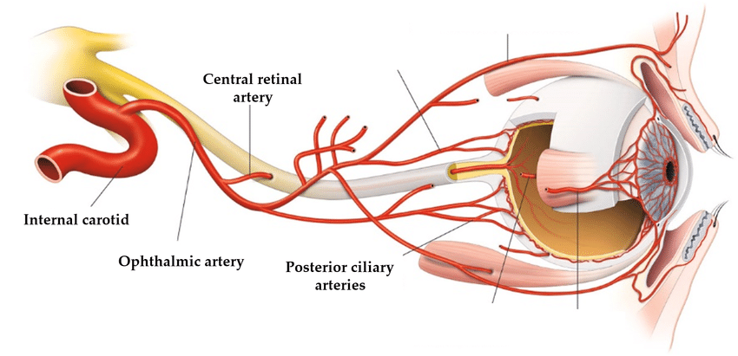

**Figure 10 :** *Illustration of orbit and eye vascularization. The internal carotid artery supplies the orbit and the eyeball through branches of the ophthalmic artery. [32]*

AION has two essential pathophysiological mechanisms:

* Vasculitic cause: secondary to endothelial inflammation of the arterial wall, with giant cell arteritis (formerly known as Horton’s disease) being the primary etiology. It can also occur in infectious conditions such as syphilis [5] or infection with the HIV [6,7].
* Non-vasculitic cause: secondary to either atherosclerotic burden or extrinsic compression of the vessels [2].

The diagnosis of giant cell arteritis was initially considered due to the gender as it predominantly affects women, the age of 60 years since it’s incidence increases after 59, the general health deterioration , often associated to it [8] and the pulsatile mass in the periumbilical region suggesting an abdominal aortic aneurysm. However, the patient did not exhibit jaw claudication, headaches, scalp paresthesias, or abnormalities in the temporal pulses.

Biologically, the patient presented an inflammatory syndrome characterized by elevated CRP and fibrinogen levels. She underwent radiological exploration with an abdominal CT angiography to confirm the presence of the aneurysm ; it revealed significant abdominal lymphadenopathy with epiploic infiltration and inguinal lymphadenopathy, but no evidence of an aneurysm. A Doppler ultrasound of the temporal arteries showed no signs supporting a diagnosis of giant cell arteritis, specifically no halo sign, thickening, or calcification of the temporal arteries.

In the context of the vasculitic mechanism, the syphilitic and HIV infection, which have been reported in the medical literature [5-7], were also considered due to the resurgence of syphilis and the lymphadenopathy found during clinical examination and abdominal CT angiography. However, the patient did not report any high-risk sexual behavior or skin lesions indicative of a syphilitic chancre or secondary syphilis. The corresponding serologies, conducted for pre-therapeutic purposes and as part of the etiological assessment, returned negative.

With the etiologies behind the vasculitic mechanism eliminated, we turned our attention to the non-vasculitic mechanism, which can be secondary to either atherosclerotic burden of the arterial wall or extrinsic compression. The patient did not report any history of obesity, diabetes, or hypertension; however, clinical examination revealed that blood pressure readings, checked multiple times during her hospitalization, were consistently elevated, indicating previously undiagnosed hypertension. The patient underwent a lipid profile assessment, which showed hypertriglyceridemia. However, ultrasound with Doppler of the supra-aortic trunks did not reveal any atherosclerotic burden, but showed compression of the right carotid artery due to cervical lymphadenopathy, resulting in decreased carotid blood flow. Once the compressive mechanism identified, the question of the etiology arose.

Clinically, the patient presented with a tumor syndrome characterized by lymphadenopathy evolving in a context of general health deterioration. Both infectious and neoplastic origins were possible, especially as the patient reported general health decline and, upon clinical examination, had excess skin indicating rapid and significant weight loss. From a neoplastic perspective, the patient clinically presented with thyroid nodules and hypertension. Could this be a case of thyroid tumor revealed by lymphadenopathy compressing the SAT, resulting in a case of AION? A retrospective Franco-Italian study conducted at ENT departments in 2011 on 167 cases identified 13 cases of papillary microcarcinoma of the thyroid revealed by lymphadenopathy [9], as well as a case identified in 2021 at the University Hospital of Rabat involving a 24-year-old patient whose diagnosis of papillary thyroid carcinoma was revealed by a lymph node. However, the thyroid function tests were normal.

Malignant hematopathy was also a possibility. Chronic lymphocytic leukemia was ruled out due to the lymphopenia of 989/mm³, but lymphoma could fit, especially that the LDH level was also elevated at 284 IU/l, with lymphadenopathy identified at all four anatomical levels: cervical lymph nodes identified by ultrasound, and thoracic, abdominal, and pelvic lymph nodes observed through imaging. However, the tumor lysis panel, consisting of serum calcium, phosphorus, potassium, and uric acid levels, was normal. The PET scan revealed the presence of hypermetabolic lymphadenopathy at all four anatomical levels, but has no specificity.

The infectious origin could not be excluded, particularly tuberculosis in its lymph node form, which can also be responsible for the same clinical presentation consisting of lymphadenopathy evolving in a context of general health deterioration, lymphopenia, and hypermetabolic uptake on PET scan [11]. Additionally, Morocco is an endemic country, and the province of Mohammedia, where our patient is from, is the most affected in the Casablanca-Settat region. Another risk factor for our patient was proximity to cattle, which could represent a source of tuberculosis transmission. In support of a tuberculosis infection, the patient underwent a Quantiferon test that was positive. Pulmonary involvement was ruled out by a chest CT scan, which showed no parenchymal lesions. The search for the genome of the Mycobacterium tuberculosis complex in the sputum was negative. Thyroid nodules could, in this context, correspond to a thyroid localization of tuberculosis. Several cases of thyroid tuberculosis have been reported in various Moroccan university hospitals, often revealed by hormonal abnormalities, with imaging showing thyroid nodules, including a case of Graves' disease with thyroidectomy, where histopathological analysis led to the diagnosis of thyroid tuberculosis [12-17]. Other cases have been reported by hospitals in Algeria and Tunisia, which demonstrates that although this localization is atypical [18-23], it is not so rare. Given that the patient did not present any signs suggestive of another localization beyond the lymph node and thyroid, histological analysis was necessary to establish the diagnosis.

1. **Diagnostic Confirmation :**

The cervical lymphadenopathies were of insignificant size and located too close to the neurovascular bundle of the neck, making their excision risky. Mediastinal and abdominal lymphadenopathies could have been sampled by mediastinoscopy or laparoscopy; however, we recommended an adenectomy of the left inguinal lymphadenopathy, which was large, showed uptake on the PET scan, and was easily accessible. The patient also underwent a total thyroidectomy since the detected nodules were classified as EUTIRADS V and were thus highly suspicious. The two samples were each divided into three parts: one formalin-fixed for conventional histopathological analysis, and two others fresh for bacterial culture and bacterial genome search via PCR. Although the Quantiferon test, tuberculin skin test, and, when possible, adenosine deaminase levels were positive, they only provide strong presumptive evidence. The confirmation of tuberculosis must be bacteriological, histological, or genetic [24]. Genome detection remains by far the best technique—highly sensitive and extremely specific, allowing identification of which bacillus of the MB complex is involved, the search for resistance genes, monitoring disease progression during treatment [25], and an epidemiological role in tracking genetic diversity due to migration, which leads to the emergence of resistant strains [26,27].

The histopathological examination of the thyroid revealed no tumor-like lesions, and bacteriological analysis did not isolate any acid-fast bacilli. However, PCR identified the genome of MB Bovis. Histopathological analysis of the inguinal lymph node sample revealed an epithelioid giant cell granuloma with tuberculoid necrosis, and PCR also detected MB Bovis at the lymph node. Thus, the diagnosis of bifocal tuberculosis was established. The extension workup did not reveal any additional focus. Given the low ferritin levels, a malabsorption workup was performed; however, total protein and albumin levels were normal, as was fasting blood glucose at 0.84 g/L. The lipid profile showed hypertriglyceridemia, fecal calprotectin was negative and the abdominal CT scan did not reveal any suspicious digestive thickening or abscessed collection.

1. **Investigation of Immunodeficiency :**

Tuberculosis has long been considered an opportunistic disease; however, it is now understood to affect both immunocompetent and immunocompromised individuals [1]. In our case, the search for immunodeficiency was necessary due to the bifocal nature of tuberculosis in a vaccinated patient, as well as the identified bacillus. Primary immunodeficiencies were not considered given the patient’s age and the absence of a history of recurrent infections. Therefore, secondary immunodeficiencies were investigated: HIV serology was negative, renal function was normal, proteinuria was absent, and serum protein levels were normal. The blood count only showed minimal lymphopenia, which could be associated with tuberculosis infection. Imaging revealed no tumors, and serum protein electrophoresis found only moderate polyclonal hypergammaglobulinemia, consistent with tuberculosis infection. The patient reported no medication use, and the metabolic workup did not reveal diabetes, with normal fasting blood glucose and a normal hemoglobin A1c level at 5.4 g/L. However, vitamin D levels were low at 18 ng/mL, contrasting with the patient’s lifestyle, as she reported sufficient sun exposure. No immunodeficiency condition was identified. An interesting article on tuberculosis vaccination, published in October 2022, highlights that although the vaccine is effective and protects vulnerable and at-risk populations, it does not provide absolute protection against the development of the disease, which remains possible in vaccinated individuals [31].

1. **Therapeutic Management :**

Due to the suspicion of Horton’s disease and the urgency of preserving visual prognosis, the patient received a bolus of 1 g/day of methylprednisolone for three days, followed by oral prednisone at 60 mg/day, along with hygiene measures and adjunctive treatment consisting of potassium and calcium supplementation.

Once the diagnosis of tuberculosis was confirmed, the pre-treatment evaluation, including liver and kidney function tests, was normal. The patient was started on antitubercular therapy with ERIPK4 (Ethambutol, Rifampicin, Isoniazid, Pyrazinamide) at a dose of 4 tablets in the morning on an empty stomach for 2 months, followed by discontinuation of oral corticosteroids. This was then followed by RINIAZIDE (Rifampicin and Isoniazid) at a dose of 2 tablets per day for 10 months.

The patient also received vitamin D supplementation, with 100.000 IU every 15 days for 6 weeks, then 100.000 IU per month for 3 months, and finally 25.000 IU per month for 6 months.

For her hypertension, after excluding endocrine and vascular causes, the patient was prescribed the angiotensin-converting enzyme inhibitor Triatec at 5 mg/day. Cardiac evaluation through echocardiography revealed homogeneous left ventricular hypertrophy, indicating hypertensive heart disease, with an ejection fraction of 65%.

For iron deficiency, oral iron supplementation was prescribed with Ferplex Fol, 1 bottle per day for 1 month, followed by Ferplex, 1 bottle three times a day for 3 months.

Following thyroidectomy, she was placed on hormone replacement therapy with Levothyrox at 125 µg/day.

Rosuvastatin at 10 mg/day was prescribed for her hypertriglyceridemia, along with lifestyle and dietary measures.

1. **Evolution :**

The patient’s evolution was marked by a general improvement, with weight gain and disappearance of asthenia starting in the second week of antitubercular treatment. Blood pressure normalized from day 5 of Triatec. Visual acuity improved one week after the bolus, reaching 9/10 in the left eye and 5/10 in the right eye, and remained stable at the follow-up ophthalmologic examination conducted one month after the start of treatment. Biologically, the blood count normalized, with hemoglobin reaching 13 g/dL after one month of treatment, compared to 10 g/dL at baseline. C-reactive protein (CRP), lactate dehydrogenase (LDH), ferritin, and vitamin D levels also normalized, and the patient did not experience any complications related to antitubercular therapy.

**Conclusion :**

Tuberculosis is a bacterial infection known since ancient Egypt and remains a significant health problem, especially in Morocco, where it is still endemic. Although the primary route of entry is respiratory or digestive, when the disease manifests, it can be localized or widespread, pulmonary or extrapulmonary, leading to complex and varied clinical presentations [28-30]. Once considered an opportunistic infection, it is now recognized that tuberculosis affects both immunocompetent and immunocompromised individuals. It can take on atypical forms due to the responsible bacillus, the site of infection, or the initial clinical presentation, posing a significant diagnostic challenge. The advent of PCR has allowed for greater accuracy and relatively early diagnosis, especially since histological proof is not always present and bacillary culture is too slow. PCR also facilitates the detection of resistant forms, which are increasingly common due to genetic diversity associated with migration.

**Abbreviations :**

* TB : Tuberculosis
* MB : Mycobacterium
* AION: Anterior ischemic optic neuropathy
* ENT : Otorhinolaryngology
* SAT : Supra-aortic trunks
* CRP : C-reactive protein
* TSH : Thyroid-stimulating hormone
* ACE : Angiotensin-converting enzyme
* PCR : Polymerase chain reaction
* HIV : Human immunodeficiency virus
* BC : Before Christ
* CLL : Chronic lymphocytic leukemia
* LDH : Lactate dehydrogenase
* PET-Scan : Positron emission tomography

**Ethical Approval:**

As per international standards or university standards written ethical approval has been collected and preserved by the author(s).

**Consent**

As per international standards or university standards, patient(s) written consent has been collected and preserved by the author(s).

**Disclaimer (Artificial intelligence)**

Author(s) hereby declare that generative AI technologies such as Large Language Models, etc. have been used during the writing or editing of manuscripts. This explanation will include the name, version, model, and source of the generative AI technology and as well as all input prompts provided to the generative AI technology

Details of the AI usage are given below:

Chat GPT 4 of Open AI has been used for the translation of the text from French to English.

**References :**

[1]- French-Speaking Pneumology Society 2 Pulmonary tuberculosis and latent tuberculosis infection, P. Fraisse, N. Veziris https://splf.fr/wp-content/uploads/2015/01/PFP02.pdf

[2]- The Review of Internal Medicine 47 (2020) A1–A89, CO132 Anterior ischemic optic neuropathies: study of the characteristics of arteritic and non-arteritic forms S. Parreau1,∗, A. Régent 2, S. Dumonteil 1, A. Fauchais 1, E. Liozon1, L. Mouthon2, D. Monnet 3, A. Brézin3, K.H. Ly 1, B. Terrier 2; https://doi.org/10.1016/j.revmed.2020.10.140

[3]- Revue des Maladies Respiratoires Volume 24, Issue 10, December 2007, Pages 1277-1283. General review, Tuberculosis in ancient Egypt Tuberculosis in ancient egypt. Author links open overlay panel : B. Ziskind 1, B. Halioua 2 ; https://doi.org/10.1016/S0761-8425(07)78506-6

[4]- Revue Francophone des Laboratoires Volume 2017, Issue 496, November 2017, Pages 40-46. Paleomicrobiology of tuberculosisTubercolisis paelomicrobiology. Author links open overlay panel : Rémi Barbiéri 1 2, Michel Drancourt 1 ; https://doi.org/10.1016/S1773-035X(17)30374-X

[5]- French Journal of Ophthalmology Volume 30, Supplement 2, April 2007, Page 2S172 ; 078 A false diagnosis of anterior ischemic optic neuropathy revealing an ocular syphilis ; Author links open overlay panel : F. Sonnenmoser, F. Mura, S. Riviere, S. Navarre, N. Pralon, B. Arnaud ; https://doi.org/10.1016/S0181-5512(07)79890-X

[6]- Neurological Review Volume 162, Issue 1, January 2006, Pages 95-97 Bilateral optic neuropathy revealing human immunodeficiency virus infectionHIV infection presenting with bilateral optic neuropathy ; Author links open overlay panel : C. Laurent-Coriat 1, C. Tilikete 1, D. Bouhour 2, J. Boulliat 3, J. Fleury 4, M. Bernard 1, A. Vighetto 1 ; https://doi.org/10.1016/S0035-3787(06)74988-8

[7]- French Journal of Ophthalmology Volume 35, Issue 4, April 2012, Pages 272-276 Recurrent unilateral optic neuropathy associated with human immunodeficiency virus (HIV); Author links open overlay panel: A. Le Corre, A. Robin, T. Maalouf, K. Angioi; https://doi.org/10.1016/j.jfo.2011.07.015

[8]- National Protocol for Diagnosis and Care; Giant Cell Arteritis (Horton) January 2024; Authors: Hubert de BOYSSON,1 Valérie DEVAUCHELLE-PENSEC,2 Christian AGARD,3 Marc ANDRÉ,4 Boris BIENVENU,5 Bernard BONNOTTE,6 Guillermo CARVAJAL,7 Olivier ESPITIA,3 Eric HACHULLA,8 Emmanuel HERON,5 Marc LAMBERT,8 Jean-Christophe LEGA,9 Kim Heang LY,10 Arsène MEKINIAN,11 Jacques MOREL,12 Alexis REGENT,13 Christophe RICHEZ,14 Laurent SAILLER,15 Raphaèle SEROR,16 Anne TOURNADRE,17 Maxime SAMSON,6 and colleagues*; https://www.has-sante.fr/upload/docs/application/pdf/2024-03/pnds_acg_vf_1.pdf

[9]- Cervical lymphadenopathy revealing thyroid microcarcinomas. Case study and literature review - 06/21/11 R. Garrel a, ⁎ , C. Tripodi b, C. Cartier a, M. Makeieff a, L. Crampette a, B. Guerrier a Department of ENT and head and neck surgery, neuroscience head and neck pole, CHRU Gui-de-Chauliac, 80, avenue Augustin-Fliche, 34280 Montpellier, France b Otorhinolaryngology Unit, University Sapienza II School of Medicine, Via di Grottarossa 1035, 00189 Rome, Italy ; Doi: 10.1016/j.aforl.2011.01.010

[10]- Annals of Endocrinology Volume 82, Issue 5, October 2021, Page 394 PB-112 Cervical adenopathy revealing papillary thyroid carcinoma in a patient followed for Hodgkin's lymphoma; Author links open overlay panel: Dr I. Abidi, Pr K. Rifai, Pr H. Iraqi, Pr M.E.H. Gharbi; https://doi.org/10.1016/j.ando.2021.08.400

[11]- International Journal of Infectious Diseases Volume 92, Supplement, March 2020, Pages S85-S90 Towards more accurate 18F-fluorodeoxyglucose positron emission tomography (18F-FDG PET) imaging in active and latent tuberculosis; Author links open overlay panel: Dimitris Priftakis a, Saima Riaz a, Alimuddin Zumla b, Jamshed Bomanji a; https://doi.org/10.1016/j.ijid.2020.02.017

[12]- Annals of Endocrinology Volume 82, Issue 5, October 2021, Page 294 PA-039, Thyroid tuberculosis: unusual location; Author links open overlay panel : Dr F. Kamel, Pr K. Rifai, Pr H. Iraqi, Pr M. Gharbi ; https://doi.org/10.1016/j.ando.2021.08.106

[13]- Annals of Surgery Volume 127, Issue 5, May 2002, Pages 385-387 ; Clinical fact: Thyroid tuberculosis. Diagnosis and treatment. Author links open overlay panel : H.O El Malki, M El Absi, R Mohsine, K Aït Taleb, M.C Chefchaouni, S Oulbacha, L Ifrine, A Belkouchi, H El Alaoui, A Maaouni, S Balafrej ; https://doi.org/10.1016/S0003-3944(02)00777-0

[14]- Annals of Endocrinology Volume 68, Issues 2–3, June 2007, Pages 196-198Annales d'Endocrinologie Clinical case Thyroid tuberculosisThyroid tuberculosis Author links open overlay panel: H. Kabiri, F. Atoini, A. Zidane; https://doi.org/10.1016/j.ando.2007.04.007

[15]- Annals of Endocrinology Volume 75, Issues 5–6, October 2014, Page 495 P631 Thyroid tuberculosis: about a case Author links open overlay panel: M.Y. Bajja Dr, S. Anajar Dr, R.L. Abada Pr, S. Rouadi Pr, M. Mahtar Pr, M. Roubal Pr; https://doi.org/10.1016/j.ando.2014.07.765

[16]- Annals of Otolaryngology and Head and Neck Surgery Volume 122, Issue 3, June 2005, Pages 150-153 Clinical cases Thyroid tuberculosisThyroid tuberculosis Author links open overlay panel : A. Oudidi, A. Cherkaoui, Z. Zaki, H. Hachimi, M.-N. https://doi.org/10.1016/S0003-438X(05)82341-2

[17]- Attifi H, Messary A. Graves' disease revealing thyroid tuberculosis. Pan Afr Med J. 2017 Mar 21;26:163. French. doi: 10.11604/pamj.2017.26.163.11562. PMID: 28533884; PMCID: PMC5429459.

[18]- Review of Respiratory Diseases Volume 34, Supplement, January 2017, Page A240 567 Endothoracic thyroid tuberculosis: a report of a very rare case Author links open overlay panel : M. Ahmed Azi, H. Khaber, N. Talbi, A. Moumeni ; https://doi.org/10.1016/j.rmr.2016.10.580

[19]- Annals of Endocrinology Volume 84, Issue 1, February 2023, Page 120 PB-086 Tuberculosis of the thyroid gland, about a case Author links open overlay panel: Dr K. Bessaid, Pr M. Mezoued, Dr L. Kaced, Pr M. Azouz; https://doi.org/10.1016/j.ando.2022.12.090

[20]- Review of Internal Medicine Volume 38, Supplement 2, December 2017, Page A240 CA257 Thyroid tuberculosis: about two cases Author links open overlay panel : A. Redissi, I. Rachdi, Z. Aydi, F. Daoud, H. Zoubeidi, B. Ben Dhaou, F. Boussema ; https://doi.org/10.1016/j.revmed.2017.10.266

[21]- Annals of Endocrinology Volume 75, Issues 5–6, October 2014, Page 513 P696 Thyroid tuberculosis: about a case Author links open overlay panel: S. Fedala Dr, D. Meskine Pr, F. Mahloul Dr, N. Madani Dr, N. Fafa Dr, L. Kedad Dr, A.E.M. Haddam Pr; https://doi.org/10.1016/j.ando.2014.07.830

[22]- Annals of Endocrinology Volume 79, Issue 4, September 2018, Page 383 P444 Thyroid tuberculosis: diagnostic and therapeutic particularities Author links open overlay panel : Dr C. Halwani, Dr I. Zoghlami, Dr C. Zgolli, Pr K. Akkakri, Pr R. Ben Mhamed ; https://doi.org/10.1016/j.ando.2018.06.595

[23]- Lahiani R, Mahfoudhi M. Multinodular thyroid goiter revealing tuberculosis. Pan Afr Med J. 2015 Nov 10;22:220. French. doi: 10.11604/pamj.2015.22.220.8118. PMID: 26955411; PMCID: PMC4760719.

[24]- Review of Pneumology Clinique Volume 72, Issue 5, October 2016, Pages 320-325 Practical teaching Diagnostic means for tuberculosis Author links open overlay panel : H. Jabri, N. Lakhdar, W. El Khattabi, H. Afif ; https://doi.org/10.1016/j.pneumo.2016.06.003

[25]- Review of Respiratory Diseases Volume 37, Issue 5, May 2020, Pages 412-416 Mini series "GREPI" Place of molecular biology in the diagnosis of tuberculosisMolecular diagnosis of tuberculosis ; Author links open overlay panel : F. Morel a, J. Jaffré a, W. Sougakoff a, A. Aubry a, N. Véziris b ; https://doi.org/10.1016/j.rmr.2019.09.004

[26]- Pathology Biology Volume 61, Issue 1, January 2013, Pages 11-16 Human genetics of tuberculosis Author links open overlay panel : J. El Baghdadi a, A.-V. Grant b c, A. Sabri a, S. El Azbaoui a, H. Zaidi a, A. Cobat d, E. Schurr d, S. Boisson-Dupuis b c e, J.-L. Casanova b c e f, L. Abel b c e; https://doi.org/10.1016/j.patbio.2013.01.004

[27]- Review of Pneumology Clinique Volume 71, Issue 4, August 2015, Pages 233-241 General review Multidrug-resistant tuberculosis: epidemiology and risk factorsMultidrug-resistant tuberculosis: Epidemiology and risk factors; Author links open overlay panel: S. Smaoui Fourati a b, H. Mzid a b, C. Marouane a b, S. Kammoun a b, F. Messadi-Akrout a b; https://doi.org/10.1016/j.pneumo.2015.03.004

[28]- Review of Respiratory Diseases Volume 35, Supplement, January 2018, Page A268 621 Unusual localizations of tuberculosis; Author links open overlay panelN. Kallel 1, S. Ben Saad 1, A. Ben Mansour 1, H. Gharsalli 2, L. El Gharbi 2, H. Daghfous 1, F. Tritar 1; https://doi.org/10.1016/j.rmr.2017.10.633

[29]- Review of Respiratory Diseases Volume 29, Issue 4, April 2012, Pages 566-578 Series “Tuberculosis and mycobacteriosis” Coordinated by F.X. Blanc, J.-P. Janssens and M. Underner. Extrapulmonary tuberculosisExtrapulmonary tuberculosis; Author links open overlay panel: J. Mazza-Stalder a, L. Nicod a, J.-P. Janssens b; https://doi.org/10.1016/j.rmr.2011.05.021

[30]- Review of Respiratory Diseases Volume 36, Supplement, January 2019, Page A162 334 Multifocal tuberculosis: about 16 cases; Author links open overlay panel: H. Janah 1, B. Rachid 2 ; https://doi.org/10.1016/j.rmr.2018.10.348

[31]- Pharmaceuticals Actualities Volume 61, Issue 619, October 2022, Pages 40-42 practice Vaccination against tuberculosisVaccination against tuberculosis Author links open overlay panel: Aurore Blin (Doctor of Pharmacy); https://doi.org/10.1016/j.actpha.2022.07.043

[32]- SFO Report 2014 - Primary open-angle glaucoma, Chapter 6 Anatomy of the head and the anterior portion of the optic nerve; https://www.em-consulte.com/em/SFO/2014/html/file_100017.html