***Cotesia ruficrus* (Hymenoptera:Braconidae) Parasitizing *Beet* Armyworm, *Spodoptera exigua* (Lepidoptera:Noctuidae) larvae in Clover Fields in Egypt**

Abstract

Clover, *Trifolium alexandrinum* L. is the key fodder winter crop, for feeding livestock in Egypt, particularly with a sharp decline in meat and dairy production. One of the important insect pests attacking clover is the beet armyworm, *Spodoptera exigua* Hübner (Lepidoptera:Noctuidae) which feeds upon clover stems and leaves, and in severe infestation, it can defoliate the plants resulting in considerable foliage reduction. The current investigation was conducted at clover fields in Rasheed district, Beheira Governorate, during the 2020/2021 and 2021/2022 seasons, to monitor the population fluctuations of *S. exigua* as well as the fluctuations of the larval end parasitoid, *Cotesia ruficrus* (Haliday) ( Hymenoptera: Braconidae) and its efficiency against *S. exigua* larvae. The first infestation by the beet armyworm was detected on November 1st with 28.00±2.00- 30.00±2.00 larvae, and the highest pest densities were recorded in April and May. The parasitism of *S. exigua* larvae was recorded started from mid-March up to mid-May. The numbers of the parasitoid،s clusters were low during January, February and March, and were notably high during April and May. This study revealed that *C. ruficrus* attacked the larvae of *S. exigua* in clover fields, particularly during April and May, with overall parasitism percentage of 14.41±1.21 - 17.86±1.00%. Thus, the parasitoid, *C. ruficrus* could be considered as an efficient control element in the integrated pest management (IPM) of the beet armyworm, *S. exigua*.

**Key words:** *Cotesia ruficrus*, *Spdoptera exigua*, *Trifolium alexandrinum*, fodder winter crop

**Introduction**

Clover, *Trifolium alexandrinum* L., is the key fodder winter crop for feeding livestock in Egypt, particularly with a sharp decline in meat and dairy production. This crop is highly significant as a multi-cut crop and an excellent soil-reclaiming crop because of its ability to fix the atmospheric nitrogen in its roots (Malaviya et al., 2005; Zayed et al., 2011; Roy *et al*., 2015). Clover cultivations is a host of diverse fauna of insect pests and natural enemies as well. Since this crop is cut almost daily for animal feeding, pesticide applications are heavily restricted. Accordingly, the populations of diversified natural enemies have become very high, and these natural enemies migrate clover moving to the following or the successive summer crops (Hervet *et al*., 2018). However, one of the most important insect pests attacking *T*. *alexandrinum* plant is the beet armyworm, *Spodoptera exigua* Hübner (Lepidoptera: Noctuidae). This insect feeds upon clover stems and leaves, and in severe infestation, it can defoliate the plants resulting in considerable foliage reduction (Mardani *et al*., 2012, Hameed *et al*. 2016 and Cabello, 1998). *S. exigua* pest poses a significant threat to early-sown clover (from late August to early September. During this period, the temperature is still relatively high in Egypt, which enhances the damage in clover plantations and may need chemical control, before offering the plants for livestock feeding. Fortunately, the parasitoid, *Cotesia ruficrus* (Haliday) (Hymenoptera: Braconidae) has proven to parasitizes several economic insect pests including *S. exigua* ( Patil *et al.* 2016 and Mansour and Abou-El Kassem 2022). It is well known that the wide host range of any parasitoid is desirable, to ensure the establishment of many natural enemies in a wide range of zones (Hervet *et al*., 2022). Patil *et al*., (2016) recorded five insect pests as hosts for the larval gregarious endoparasitoid, *C. ruficrus*. These hosts were discerningly preferred as *Helicoverpa armigera*, (Hübner), *Mythimna separata* Walker, *Agrotis ipsilon* Hufnagel, *Spodoptera litura* Fab. and *S. exigua* Hübner. Gupta *et al*. (2019) surveyed *C. ruficrus* as one of the parasitoids of *S. frugiperda* in the maize fields. The larvae of the leaf folder, *Cnaphalocrocis medinalis* that parasitized by *C. ruficrus* suffered reductions in of wet or dry weight, food consumption and fecal matter (Chen *et al.,* 2016). Mansour and Abou-ELkassem(2022) detected 21.48- 27.58 % of *S. exigua* larvae was parasitized by *C. ruficrus* in sugar beet fields, depending on the date of sowing. The female of *C. ruficrus* attacked the larvae of *S. frugiperda* infesting maize fields in India (Gupta *et al.,* 2019). The maximum number of parasitoid،s cocoons of *C. ruficrus* (65.2 cocoons )was obtained when the parasitoid was reared on the 4th larval instar of the tea looper, *Hyposidra talaca* (Walker) ( Lepidoptera: Geometridae ) with 65.2 cocoons, followed by 27.2 and 4.60 in thethird and second larval instars, respectively (Sarkara *et al.* 2020 and 2021). *S. exigua* (Patil *et al.* 2016 and Mansour and Abou-El kassem 2022). The objectives of the current study were to monitor the population fluctuations of the beet armyworm, *S. exigua* larvae, in clover fields, as well as the fluctuations of the endoparasitoid larvae, *C. ruficrus*. In addition, the status of the parasitoid, and its capability of emergence from cocoons was discussed.

**Materials and Methods**

1. **Experimental Site**

This study was conducted at clover fields at Rasheed district, Beheira Governorate. Rasheed lies at the western branch of River Nile Delta; about 50 km far of Mediterranean Sea seashore, with latitude of 31.40 N and longitude of 30.41 E. Soil at the experimental site is fertile with 7.1pH and a good source of fresh irrigation water.

# Cultural Practices

The experimental area was prepared following the recommendations of Egypt's Ministry of Agriculture. Throughout the experimental period, all-normal agricultural procedures were adopted, but without any pesticidal treatments. On September 15, clover, *T. alexandrinum* L (Leguminosae) seeds (Helaly cultivar) were sown, in the 2020/2021 and 2021/2022 seasons.

1. **Population Fluctuations of *Spodoptera exigua***

The population fluctuations of *S. exigua* were monitored throughout the experimental period from the beginning of November until the end of May in both seasons of study. Biweekly samples (4m² of cut clover plants each) were examined to count the number of *S. exigua* larvae present in the clover vegetation. The collected larvae were kept for further investigation.

1. **Population Fluctuations of the Parasitoid, *C. ruficrus* (Haliday)**

The biweekly collected larvae of *S. exigua* were examined and those with any disease symptoms were excluded. The larvae were individually kept in glass containers and provided with clover plant pieces for feeding until they completed their larval stage. By monitoring the enclosed larvae, the clusters of the parasitoid, s cocoons could be observed; otherwise, the *S. exigua* pupaeare formed. By counting the cocoons clutches attached to *S. exigua* larvae, percentage of *S*. *exigua* parasitism was computed.

4. **Parasitism Status of *C. ruficrus***

Formed clusters of the parasitoid were examined to record the number of pupae per cluster clutch. In addition, the results clusters clutches were kept individually in glass vials, and the emerging adult parasitoids were counted to calculate the percentage of *C. ruficrus* emergence throughout the period from early November up to late May.

**Statistical analysis**

Data of the present experiment indicated that of Farrell and Stufkens (1990) proved the estimates for the parasitism percentage and Costat statistical Software 2005 was used to performed statistical analysis on the data.

# Results

1. **Population Fluctuations of *S. exigua* Larvae**
   1. **Season 2020/2021**

In the first sample (Table 1) examined on November 1st, 28.00 larvae of *S. exigua* were detected in 4 m2 cut clover plants, which increased to 38.25 larvae/4 m2 two weeks later. By the beginning of December up to the beginning of February, the beet armyworm larvae decreased progressively and decreased from 26.75 to

10.50 larvae/4 m2 cut clover, respectively. However, the larval population steadily increased from 12.25 to 44.25 larvae / 4 m2 on March 15 and May 15, respectively.

# . Season 2021/2022

The population densities of *S. exigua* larvae (Table 1) ranged between

24.00 and 30.00/4 m2 cut clover through the period extending from November 1st up to January 1st. However, the highest densities were recorded in April and May, ranging between 26.00 and 43.25 larvae/4m2 cut clover plants.

1. **Population Fluctuations of *C. ruficrus***

Data presented in Table (2) shows that the parasitoid *C. ruficrus* (Fig 1) was low active from the beginning of November up to late March, except for a few individuals in some examinations. In the 2020/2021 season, the parasitism of *S. exigua* larvae was notable from mid-March (22.22±1.97%) up to mid-May (32.43±1.90 %). In addition, the parasitism was higher during April and May, ranging from 26.92±2.34 to 28.57±2.44%.

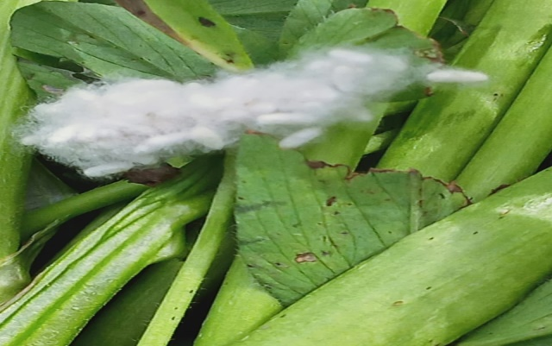

Fig (1): A cluster clutch of *Cotesia ruficrus*

Parasitoid attached to clover stems

Table (1): Population dynamics of *Spodoptera exigua* larvae in

Clover fields, at Rasheed District, Beheira governorate

|  |  |  |
| --- | --- | --- |
| Date of examination | No. larvae/4m2 | |
| 2020/2021±SE | 2021/2022±SE |
| Nov.1 | 28.00±2.00 | 30.00±2.00 |
| Nov. 15 | 38.25±2.97 | 28.75±2.01 |
| Dec. 1 | 26.75±1.89 | 28.50±2.03 |
| Dec. 15 | 16.50±1.21 | 16.00±1.11 |
| Jan. 1 | 14.00±1.11 | 24.50±1.78 |
| Jan. 15 | 12.75±1.00 | 10.00±1.06 |
| Feb.1 | 10.50±0.98 | 9.50±1.03 |
| Feb. 15 | 0.00±0.00 | 0.00±0.00 |
| Mar.1 | 0.00±0.00 | 0.00±0.00 |
| Mar. 15 | 12.25±1.09 | 0.00±0.00 |
| Apr.1 | 30.25±2.10 | 26.50±1.87 |
| Apr 15 | 34.00±2.93 | 38.75±2.98 |
| May. 1 | 42.50±3.11 | 32.00±2.23 |
| May. 15 | 44.25±3.45 | 43.25±3.21 |

# Parasitism Status

**3.1. Season 2020/2021**

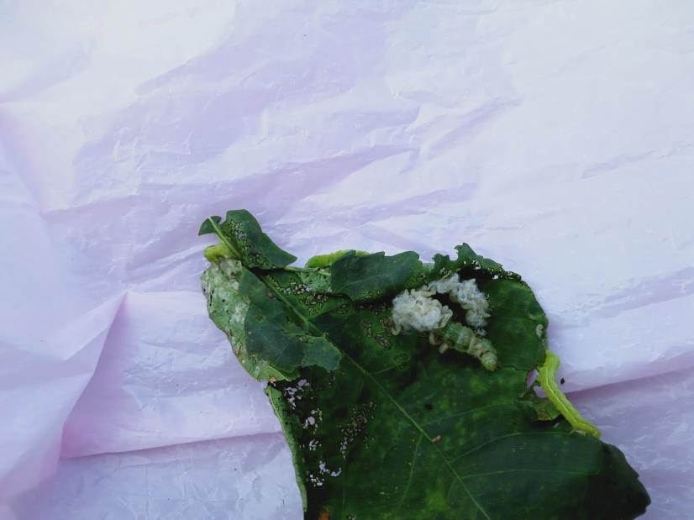Data presented in Table (3) show that the number of the parasitoid cluster was low during January, February and March (3.25±0.78 to 9.45±0.99 cluster/4 m2 cut clover plants). However, the number was notably higher during April and May with 17.25±1.50- 37.24±3.11 cluster / 4 m2.

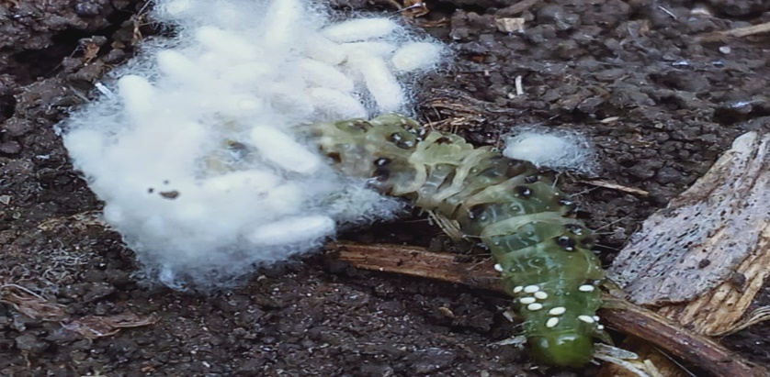

Fig (2): A clutch of *Cotesia ruficrus* parasitoid showing gregarious

pupae of the parasitoid emerging from on *Spodoptera exigua* larva

Table (2): Population dynamics of *Spodoptera exigua* parasitism by *Cotesia ruficrus* in clover fields, at Rasheed District, Beheira governorate (sample size is 4 m2 cut clover)

|  |  |  |  |  |  |  |
| --- | --- | --- | --- | --- | --- | --- |
| Date of sampling | 2020/2021  Season | | | 2021/2022  Season | | |
| No. incubated larvae | No. formed cluster | Parasitism  % | No. incubated larvae | No. formed cluster | Parasitism  % |
| Nov.1 | 25.12±2.00 | 0.00±0.00 | 0.00±0.00 | 20.11±1.81 | 0.00±0.00 | 0.00±0.00 |
| Nov.15 | 30.46±2.54 | 0.00±0.00 | 0.00±0.00 | 25.35±1.00 | 0.00±0.00 | 0.00±0.00 |
| Dec. 1 | 16.09±1.11 | 0.00±0.00 | 0.00±0.00 | 24.36±0.99 | 0.00±0.00 | 0.00±0.00 |
| Dec. 15 | 16.34±1.10 | 0.00±0.00 | 0.00±0.00 | 14.90±1.01 | 0.00±0.00 | 0.00±0.00 |
| Jan. 1 | 12.41±0.99 | 0.00±0.00 | 0.00±0.00 | 18.37±0.89 | 0.00±0.00 | 0.00±0.00 |
| Jan. 15 | 10.23±0.89 | 3.01±0.05 | 30.00±2.00 | 4.80±0.09 | 0.00±0.00 | 0.00±0.00 |
| Feb.1 | 10.56±0.99 | 2.11±0.04 | 20.00±1.23 | 2.38±0.08 | 1.34±0.08 | 50.0±0.2.99 |
| Feb 15 | 0.00±0.00 | 0.00±0.00 | 0.00±0.00 | 0.00±0.00 | 0.00±0.00 | 0.00±0.00 |
| Mar.1 | 0.00±0.00 | 0.00±0.00 | 0.00±0.00 | 0.00±0.00 | 0.00±0.00 | 0.00±0.00 |
| Mar.15 | 9.31±0.87 | 2.35±0.08 | 22.2±1.97 | 0.00±0.00 | 0.00±0.00 | 0.00±0.00 |
| Apr.1 | 21.45±1.87 | 6.23±0.56 | 28.57±1.90 | 26.32±2.11 | 7.47±0.84 | 26.92±2.34 |
| Apr.15 | 26.90±2.23 | 8.34±0.91 | 30.77±2.11 | 35.71±1.98 | 9.86±0.96 | 25.71±2.23 |
| May 1 | 40.97±2.89 | 1.45±0.09 | 30.77±2.00 | 28.52±1.92 | 8.24±0.91 | 28.57±2.44 |
| May 15 | 37.32±2.76 | 12.57±0.99 | 32.43±1.90 | 33.29±1.91 | 8.25±0.90 | 24.24±2.18 |
| Overall | 252.08±5.25 | 45.62±3.00 | 17.86±1.00 | 229.11±5.11 | 33.92±2.90 | 14.41±1.21 |

Data are present as mean ± SE

**3.2. 2021/2022 Season**

Data for the second season (Table 4) is similar to those for the first one. Numbers of *C. ruficrus* clutches were low during January and February (2.21±0.76-9.54±0.45/4m2 cut clover plants), increased to 5.36±0.76 -12.50±0.79 clutches in March. The activity of the parasitoid was higher in April and May with 12.50±0.79 to 20.68±2.92 clutches/m2. The emergences of the parasitoid wasps were lower in the second season compared to those of the first one, with the lowest value in February (81.32±0.91%), and highest in April (90.73±1.92%). It was observed that parasitoid emergence was almost the same within January, March and April (95.81±2.23, 95.04±1.21and 95.30±1.89, respectively).

Table (3): *Spodoptera exigua* parasitism status, and activity of the parasitoid *Cotesia ruficrus* at clover fields, at Rasheed District, Beheira Governorate 2020/2021

|  |  |  |  |  |  |
| --- | --- | --- | --- | --- | --- |
| Date of sampling | | No. of collected cluster | No. of parasitoid pupa | No. emerging parasitoids | Parasitoids emerging % |
| Month | Week |
| January | 1st | 4.34±0.96 | 188.11±1.91 | 180.12±1.78 | 95.74±2.00 |
| 2nd | 6.45±0.94 | 240.25±2.18 | 230.25±2.12 | 95.83±2.34 |
| Average | | 5.00±0.90 | 214.00±2.14 | 205.00±2.00 | 95.81±2.23 |
| February | 1st | 5.03±0.91 | 175.35±1.89 | 155.26±1.23 | 88.5±0.79 |
| 2nd | 7.71±0.94 | 231.25±2.43 | 210.28±2.06 | 90.91±0.97 |
| 3rd | 9.45±0.99 | 198.60±2.12 | 180.00±1.88 | 90.91±0.89 |
| 4th | 5.87±1.08 | 85.52±1.00 | 80.25±0.99 | 94.12±2.06 |
| Average | | 6.50±0.91 | 172.20±2.08 | 156.25±1.22 | 91.13±0.59 |
| March | 1st | 3.25±0.78 | 120.23±1.67 | 114.50±1.06 | 95.00±0.99 |
| 2nd | 4.50±0.97 | 112.14±1.08 | 104.45±1.02 | 92.86±0.89 |
| 3rd | 7.52±0.95 | 259.90±2.78 | 245.45±2.02 | 94.59±0.98 |
| 4th | 6.50±0.92 | 264.50±2.96 | 258.70±2.21 | 97.72±1.33 |
| Average | | 5.00±0.89 | 188.75±1.97 | 180.25±1.98 | 95.04±1.21 |
| April | 1st | 20.42±2.15 | 560.60±3.99 | 540.25±3.43 | 96.43±1.03 |
| 2nd | 17.25±1.50 | 527.41±3.96 | 510.55±3.00 | 96.77±1.12 |
| 3rd | 22.50±2.01 | 550.25±3.98 | 528.11±3.22 | 96.00±1.22 |
|  | 4th | 25.25±2.33 | 875.25±5.98 | 805.43±4.61 | 92.00±0.95 |
| Average | | 21.00±1.97 | 628.00±4.00 | 595.75±3.34 | 95.30±1.89 |
|  | 1st | 27.12±2.53 | 1700.00±6.00 | 1470.25±5.23 | 86.47±0.56 |
| May | 2nd | 30.65±2.98 | 810.60±5.90 | 750.50±4.50 | 92.59±1.00 |
|  | 3rd | 37.24±3.11 | 911.11±5.11 | 812.45±4.98 | 89.10±3.00 |
| Average | | 31.33±3.01 | 1140.33±6.90 | 1010.67±5.90 | 89.40±4.25 |

**Table (4): *Spodoptera exigua* parasitism status, and activity of the parasitoid *Cotesia ruficrus* at clover fields, at Rasheed District, Beheira Governorate 2021/2022**

|  |  |  |  |  |  |
| --- | --- | --- | --- | --- | --- |
| Date of sampling | | No. of collected cluster | No. of parasitoid,s pupa | No. emerged parasitoids | parasitoids emerged % |
| Manth | Week |
| January | 1st | 6.24±0.64 | 240.11±2.12 | 190.50±1.76 | 79.17±0.90 |
| 2nd | 9.54±0.45 | 324.35±2.09 | 300.25±2.00 | 92.59±1.05 |
| Average | | 7.50±0.78 | 282.00±1.89 | 245.00±0.98 | 85.88±0.96 |
| Febraury | 1st | 6.14±0,91 | 180.50±1.90 | 15.11±0.46 | 83.89±0.89 |
| 2nd | 4.35±0.54 | 120.35±1.00 | 100.00±0.97 | 83.33±0.89 |
| 3rd | 2.21±0.76 | 56.25±0.87 | 43.15±0.34 | 76.79±0.45 |
| 4th | 3.65±0.45 | 48.35±0.98 | 39.24±0.54 | 81.25±0.89 |
| Average | | 3.75±0.76 | 101.00±1.02 | 83.25±0.99 | 81.32±0.91 |
| March | 1st | 5.36±0.76 | 175.25±1.98 | 160.25±1.00 | 91.43±1.76 |
| 2nd | 7.50±0.45 | 210.75±1.91 | 181.25±1.08 | 86.19±1.07 |
| 3rd | 9.00±.0.95 | 270.50±2.00 | 215.50±1.50 | 79.63±0.89 |
| 4th | 12.50±0.79 | 480.00±3.01 | 360.56±2.40 | 75.00±1.00 |
| Average | | 8.25±0.54 | 283.75±2.78 | 229.00±2.23 | 83.00±1.07 |
| April | 1st | 15.15±0.98 | 420.35±3.88 | 405.45±3.02 | 96.43±1.89 |
| 2nd | 13.37±0.99 | 377.00±3.65 | 311.34±2.89 | 82.49±1.08 |
| 3rd | 16.43±1.51 | 320.10±3.10 | 291.25±2.90 | 90.94±1.15 |
| 4th | 20.68±2.92 | 720.25±4.08 | 670.15±4.24 | 93.06±1.98 |
| Average | | 16.00±1.67 | 459.25±3.99 | 419.25±3.78 | 90.73±1.92 |
|  | 1st | 17.12±1.79 | 425.25±3.98 | 399.05±3.50 | 93.88±1.90 |
| May | 2nd | 12.00±0.65 | 360.75±3.20 | 307.25±2.50 | 85.28±0.98 |
|  | 3rd | 20.25±2.90 | 400.34±3.90 | 336.75±2.98 | 84.00±0.89 |
| Overall Average | | 16.33±1.90 | 395.00±3.30 | 347.33±3.00 | 87.72±0.69 |

The

# DISCUSSION

The Egyptian clover, *T. alexandrinum* L. (Leguminosae) is the most important forage crop in Egypt, it is rich in protein, and thus, is of high nutritional value for livestock. Furthermore, atmospheric nitrogen, fixed by *Azotobacter*, enriches the soil, particularly in newly reclaimed lands. Clover sown by late August up to early September is highly infested by the beet armyworm, *Spodoptera exigua*, due to the relatively high temperature during this period. Since the insect pest has built up resistance to several insecticides, it has become important to enhance the activity of natural enemies. Among the parasitoids efficient against this insect pest, is the larval parasitoid, *Cotesia ruficrus* (Haliday) (Hymenoptera: Braconidae). In the current study, this parasitoid proved active against beet armyworm, *S. exigua*, fortunately, clover plantations are an ideal shelter for several natural enemies that move, by the end of clover season, to the neighboring summer plantation fields. For the successful establishment of the parasitoids in new geographic zones, parasitoids need to find several suitable hosts that are of economic importance on cultivable plants (Hervet *et al*., 2018). Accordingly, Hearvet *et al*. (2023) considered *Cotesia vanessae* (Hymenoptera: Braconidae) a successful parasitoid in North America, as it was reared on several noctuid pest species. Patil *et al* (2016) indicated that the main noctuid insect pests attacked by *C. ruficrus* are *H. armigera* (Hubner), *Mythimna separata* Walker, *A. ipsilon* (Hufnagel), *S. litura* Fab. and *S. exigua* (Hubner).

In the current study, *C. ruficrus* attacked the larvae of *S. exigua* in clover fields, particularly during April and May, with overall parasitism percentage of 14.41-17.86 %. In the study of Mansour and Abou-El-Kassem (2023), the parasitism of *S. exigua* in sugar beet fields by *C. ruficrus* ranged from 21.48 to 34.33 %, with significant positive correlations between the population of the pest and parasitism level. In addition, Chen *et al*. (2016) indicated the efficient parasitism of *C*. *ruficrus* on leaf folder, *Cnaphalocrocis medinalis*, and the parasitism negatively affected all biological aspects of the host.

**Conclusion**

From the obtained results in this investigation, it could be concluded the population fluctuation of *S. exigua* as well as the percentage of the larval end parasitoid, *Cotesia ruficrus* and its efficiency against *S. exigua* larvae in clover fields as an economic important crop for better controlling this armyworm, the parasitoid, *C. ruficrus* could be considered as an efficient control element in the integrated pest management (IPM) of the beet armyworm*.*

**Disclaimer (Artificial intelligence)**

Option 1:

Author(s) hereby declare that NO generative AI technologies such as Large Language Models (ChatGPT, COPILOT, etc.) and text-to-image generators have been used during the writing or editing of this manuscript.

Option 2:

Author(s) hereby declare that generative AI technologies such as Large Language Models, etc. have been used during the writing or editing of manuscripts. This explanation will include the name, version, model, and source of the generative AI technology and as well as all input prompts provided to the generative AI technology

Details of the AI usage are given below:

1.

2.

3.

# REFERENCES

Cabello, T. (1989). Natural enemies of noctuid pests in alfalfa, corn, cotton and soybean crops in southern Spain. J. Appl. Entomol, 108:80-88.

Chen, Y[Chen](javascript:;), Y.; [X. G Liu](javascript:;), [J. Wang](javascript:;); [J. Zhao](javascript:;); [Z. X. Lu](javascript:;) and [Y. H. Liu](javascript:;) (2016). *Cotesia ruficrus*(Hymenoptera:Braconidae)parasitizing *Cnaphalocrocis medinalis* (Lepidoptera:Pyralidae):Developmental Interactions and Food Utilization Efficiency of Hosts. Journal of Economic Entomology, 109 (2):588–593.

Costat Statistical Software (2005) Microcomputer program analysis version, 6. 311, CoHort Sofyware, Montery, Califomia.

Farrell, J. A. and M. W. Stufkens (1990) the impact of *Aphidius rophopalosiphi* (Hymenoptera:Aphidiidae) on population of the some grain aphid (*Metopolophiumdirhodum*) (Hymenoptera:Aphidiidae) on cereals in canKrbuty. Newzlenda Bull. Entomol. Res. 80: 377-383.

Gupta, A.,S.; R. Babu, and M. S. Kumar (2019). *Cotesia ruficrus* (Haliday, 1834) ( Hymenoptera: Braconidae) emerging as a common natural parasitoid of *S. frugiperida* (J.E.Smith) ( Lepidoptera : Noctuidae) in Indian maize fields. Journal of Biological Control,33(3): 193-196.

Hameed, A.; H. Karar, N. Muhammad and R. A. Kainth (2016). Varietal response to population fluctuation of insect pests, predators and pollinator fauna associated with berseem (*T. alexandrinum* L) crop. Pakistan J. Zool., 48(3),729-734.

Hervet, Y. A. D.; R. A. Larid and K. D. Floate (2023). Potential host range of *Cotesia vanessae* (Hymenoptera: Braconidae), a parasitoid new to North America and a possible biological control agent of noctuid pest species. Bulletin of Entomological Research, 113 (2): 145-161.

Hervet, Y. A. D.; R. A. Larid and K. D. Floate (2018). Siblicidal behavior by larvae of the gregarious parasitoid, *Cotesia vanessae*. Journal of Hymenoptera Research, 67: 55-62.

Mansour, M. R. K. and A. B. Abou-Elkassem (2022). Ecological studies on *Spodoptera exigua* (Hubner) and its biological control by the novel parasitoid, *Cotesia ruficrus* (Haliday) (Hymenoptera: Braconidae) on sugar beet. Middle East Journal of Agriculture Research, 11(4): 1193-1200.

Mardani, M.; T. G. Nouri; G. B. Naseri and M. Hassanpour (2012). Life history studies of the beet armyworm, *Spodoptera exigua* (Hübner) (Lepidoptera: Noctuidae) on 10 corn hybrids J. Entomol. Res. Soc., 14(3): 09-18.

Malaviya, D. R.; A. K Roy; P. Kaushal; B.Kumar and A. Tiwari (2005). Development and characterization of interspecific hybrids of *Trifolium alexandrinum* x *T. apertum* using embryo rescue. Plant Breed, 123: 536-542.

Patil, S. S.; C. Kamble and T. V. Sathe (2016). Biocontrol potential of *Cotesia ruficrus* Hal. (Hymenoptera : Braconidae) against different lepidopterous pests. Biolife Journal, 4(2): 343-346.

Roy, D. C.; M. Ray; N. K Tudu and C. K. Kundu (2012). Impact of phosphate solubilizing bacteria and phosphorus application on forage yield and quality of berseem in west Bengal. IJAEB, 8(2):315-321.

Sarkara, S. S.; A. Babua; K. Chakrabortyb; B. Dekaa and S. Royc (2021). Seasonal abundance of *Cotesia ruficrus* ( Hymenopera: Braconidae) and its host tea looper, *Hyposidra talaca* (Lepidoptera: Geometridae) in tea ecosystem. International Journal of Pest Management, 69 (4): 332-345.

Sarkar,S, A. Babu; K. Chakraborty and B. dcka (2020). Biology and life history of *Cotesia ruficrus* (Hymenoptera: Braconidae) a potential parasitoid of *Hyposidra talaca* (Lepidoptera: Geometridae) larvae, a major tea pest. J. Biopest, 13 (1): 79-84.

Zayed, E. M.; E. M. R. Metwali; A. F. Khafaga, and M. M. Azab (2011). Field performance of commercial Egyptian clover (*Trifolium alexandrinum* L*.*)cultivars under high temperature condition. Range Mgmt. and Agroforestry, 32(2):87-91.

# 