Systematic Review

Prevalence of COPD Exacerbation with Type-2 Diabetes Comorbidity: A Systematic Review and Meta-Analysis

.

ABSTRACT

|  |
| --- |
| Background: Type-2 Diabetes Mellitus (type-2 DM) is one of the  comorbidities in Chronic Obstructive Pulmonary Disease (COPD),  associated with the incidence of respiratory tract infections which is a risk  factor for COPD exacerbations.  Methods: Systematic review include publications from January 1st 2015 to  October 31th 2021, using data base Pubmed and Google Scholar and meta-  analysis conducted to summarize prevalence of COPD exacerbation with  type-2 DM with subgroup analysis base on geographical location, study  design, study period also characteristic population COPD exacerbation with  type-2 DM comorbidities  Result: Seven studies conducted in the meta-analysis. Pooled prevalence  of COPD exacerbations with type-2 DM comorbidity was 34.22% (95%CI:  27.49%-41.28%) and heterogeneity (I2=87.69%, Q=48.75, p=<0.001). Five  studies were based in Europe, one study in Asia and the Americas.  Prevalence of COPD exacerbations with type-2 DM comorbidity based on  WHO region subgroup analysis found European region 34.70% (95%CI:  25.88%-43.96%), America’s region 40.28% (95%CI: 39 .89%-40.79%) and  the Western Pacific region 26.01%(95%CI:0.20;0.32) with statistical  heterogeneity (I2 = 77%, Q=17.63, p=<0.001). Population age of the study  was above 60 years and more males than females (n=30,58.8% vs  n=21,41.1%). Most common other comorbidities of COPD exacerbation  were hypertension, obesity, and coronary heart disease.  Conclusion: Pooled prevalence of COPD exacerbations with comorbid  type-2 DM in this systematic review and meta-analysis was 34.22% (95%  CI: 27.49%-41.28%) |

*Keywords: COPD, Diabetes Mellitus, Comorbid disease*

1. INTRODUCTION

Chronic Obstructive Pulmonary Disease (COPD) is a common, preventable

and treatable lung disease characterized by airway and / or alveoli

abnormalities. It is usually caused by significant exposure to harmful gases

or particles and is affected by a host of factors, including abnormal lung

development. Serious comorbidities can affect morbidity and mortality.1,2

Exacerbation and comorbidity contribute to the severity of the disease. The

comorbidity that often obtains in COPD patients is cardiovascular disease,

skeletal muscle dysfunction, metabolic syndrome, osteoporosis,

depression, anxiety, lung malignancies.2,35

Exposure to cigarette smoke, harmful gases or particles for a long time

causes complex pathological changes in the airways and lung parenchyma,

resulting in worsening of respiratory function due to inflammation of the

lower airways, fibrosis of the airway walls, smooth muscle hypertrophy,

hyperplasia of goblet cells, hypersecretion of mucus and damage to the lung

parenchyma.1 This process causes a loss of lung elasticity resulting in

persistent airway obstruction. Loss of lung elasticity results in airway collapse earlier during expiration so that lung volume increases and

hyperinflation occurs as well as increased functional residual capacity.

Exposure to cigarette smoke or other harmful substances as mention

above, also causes damage to the ciliary epithelium of the airways, resulting

in impaired mucociliary clearance which results in progressive airway

obstruction. Peripheral pulmonary inflammation can cause spillover of

proinflammatory cytokines such as tumor necrosis factor-α (TNF-α), IL-1β,

and IL-6, which can increase C-reactive protein (CRP) resulting in systemic

inflammation. This proinflammatory cytokine also contributes to type II

diabetes because TNF-α and IL-6 block insulin receptors, causing insulin

resistance and an increased risk of type-2 diabetes [26].

Physical activity in COPD patients is severely restricted compared to

healthy people. COPD patients spend more time on sedentary activities

than their healthy peers.44 Respiratory symptoms in COPD patients are

exacerbated when the patient engages in excessive activity, physical

activity is restricted, and the patient tends to cease activity. Lack of exercise

leads to changes in insulin sensitivity.45,46 45

2. material and methods

The primary aims of this systematic review and meta-analysis is to determined

the prevalence of COPD exacerbations with comorbid type-2 DM. The

secondary aim was to determine prevalence of COPD exacerbations with

comorbid type-2 DM based on WHO subregion, design study, study period

and patient characteristics. This systematic review protocol using the

Preferred Reporting Items for Systematic Reviews and Meta-Analyses

(PRISMA) 2020. Assessment of the risk of bias using the Newcastle-Ottawa

Scale (NOS) criteria for a cohort study. Research question of this studi is

using Population in Question, Exposure, Comparator and Outcome (PECO)

methodes. Population is COPD exacerbation, Exposure is type-2 DM, no

comparator and outcome is prevalence of COPD exacerbation with type-2 DM

comorbidity.

Search strategy

Two independent reviewer (AD,NFW) conducted a systematic article search

using a search strategy in data base online Pubmed and Google Scholar by

using a special combination of Medical subject Heading (MeSH Term) and

a series of keywords including COPD, exacerbation, Diabetes mellitus type-

2 and prevalence. MeSH Term will be combined using Boolean logic

Operators : AND and OR.

Eligibility criteria

The study design of a cohort study (retrospective or prospective and both)

published from 2015 to 2021, containing the keywords COPD, exacerbation

and type-2 diabetes mellitus, fully accessible full paper, reports the

prevalence rate of COPD exacerbations with comorbid type-2 diabetes

mellitus. 2. If not listed, available data that allows to calculate the prevalence

rate and the study population is patients with COPD and type-2 DM. Articles

are classified as included and excluded based on the inclusion and

exclusion criteria. Complete manuscripts that have been assessed for

research quality downloaded for further review for meta-analysis according

to PRISMA 2020 is presented in Figure.1.

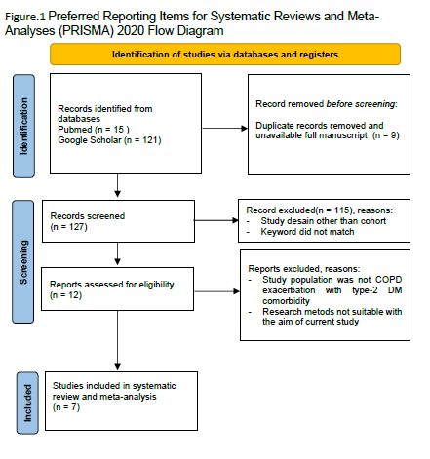

Data extraction and synthesis

Screening and data extraction were performed by two independents

reviewers (AD and NFW) and discussed with two others reviewers (MI and

FY) for any disagreements to the consensus. Data extraction using

Microsoft Excel containing general information format (first author, year and

place), total sample (COPD exacerbations and COPD exacerbations with

comorbid type-2 DM), subgroup analysis (study design, study time period

and WHO region) and patient characteristics.

Risk of bias assessment.

Articles categorized as included were included in the review and assessed

for research quality using the New Castle Ottawa Scale (NOS) for cohort

study. A good quality of articles (score 3 or 4 in selection, 2 or 1 in

comparability and 2 or 3 in outcomes) include in this study

New Castle Ottawa Scale (NOS) Quality Assessment Form For Cohort

Studies

Data analysis

Statistical analysis using MetaXL program version 5.3 (Ersatz, EpiGear

International, Sunrise Beach, Australia) was used. A p value less than 0.05

was considered to be statistically significant. Heterogeneit calculated using

the Cochrane Q‐statistic I2. All pooled estimates were provided with 95%

confidence intervals (95% CIs).

3. results and discussion

From a total of 136 articles obtained from online databases, 9 articles were

removed due to duplications and no full paper was available. One hundred

and fifteen articles were excluded because the study design was not a

cohort study, study population was not COPD patients with comorbid type-

2 DM and aim of the research not suitable for this review. Twelve articles were assessed for eligibility and total 7 articles were included in final meta-

analysis.

Study Design, COPD and type-2 DM Characteristic Population

A total of seven articles were systematically reviewed (Papathanissiou,

2021; Lin, 2021; Koskela, 2015; Annavarapu , 2018; Figueira Gonçalves,

2020; Mekov, 2015; and Mekov, 2016). Six of the 7 articles were studies

with a prospective design. Meanwhile, the exacerbation of COPD with

comorbid type-2 DM also varied in each study as many as 14-18442 cases.

Characteristics of COPD exacerbation with comorbid type-2 DM from the

seven studies are shown in Table.1.

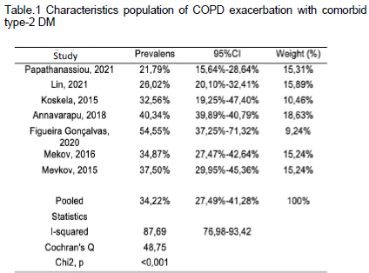

Two studies (Lin, 2021 and Mekov,2016), showed COPD exacerbation

patients with comorbid type-2 DM was above the age of 35 years old. Lin

(2021) showed that the average age of COPD exacerbation patients with

comorbid type-2 DM was 71.65 years old (mean SD±9.76). Mekov (2016)

also reported the mean age of the patients was 68 years old. Age

characteristics are shown in Table.2.

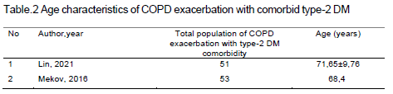

Two of the seven studies that showed the sex characteristics of COPD

exacerbation with comorbid type-2 DM. Lin (2015) reported more COPD

exacerbation with comorbid type-2 DM in males than females (n=30, 58.8%

vs. n=21, 41.1%) and Mekov (2016) (n=40, 75.4% vs n=14, 24.5%). Another

study did not show sex characteristics in the population of COPD

exacerbation with comorbid type-2 DM with comorbid type-2 DM (Table.3).

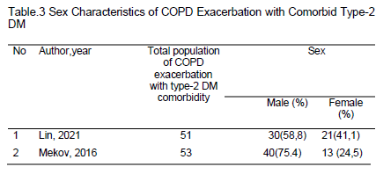

Papathanassiou (2021) reported several other comorbidities in patients with

COPD exacerbation. The most common was hypertension (42.2%, 66/156)

followed by arrhythmia (26.3%,41/156), heart failure (14.1%,22/156) and

cardiovascular disease (1.9%,156). This is in line with what was reported by

Lin (2015), hypertension 22 cases (43.13%,22/196) and chronic heart

disease 20 cases (39.22%,20/196). Mevkov (2015) reported most comorbid

was obesity (58.4%,89/152). While Annavarapu (2018) reported that the

most comorbid was coronary heart disease 42.2% (17056/45722). Other

comorbidities in COPD exacerbation are shown in Table.4.

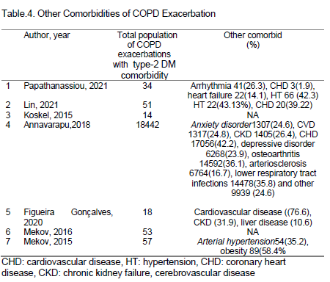

Prevalence rate

Meta-analysis in the seven studies found that the pooled prevalence of

COPD exacerbations with comorbid type-2 DM was 34.22% (95% CI:

27.49%-41.28%) with statistical heterogeneity (I2 = 87.69 % Q = 48.75, p =

<0.001). The results of the analysis are presented in Table.5 and Figure.2.

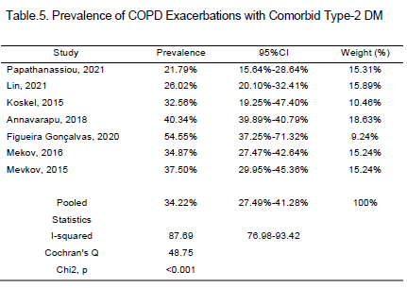

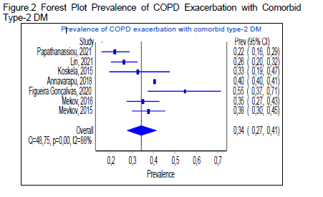

Subgroup analysis

Study period subgroup

The research time period was obtained from the seven studies obtained,

the longest research by Lin et al (±6 years). Furthermore, research by

Annavarapu et al (±5 years) and Koskela et al for ±2 years and Mekov et

al for ±1 year. Meta-analysis of subgroups based on the study period found

the prevalence of COPD exacerbations with comorbid type-2 DM study

period within 5 years was 35.76% (95%CI: 28.86%-42.97% ) and the

prevalence in the study > 5 years was 26.01% (95%CI:20.10%-32.41%).

Subgroup statistical heterogeneity (I2 = 84%, Q = 31.01, p=<0.001). The

results of the analysis and forest plots are presented in Table.6 and Figure

3.

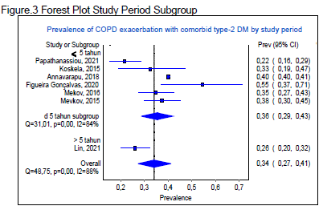

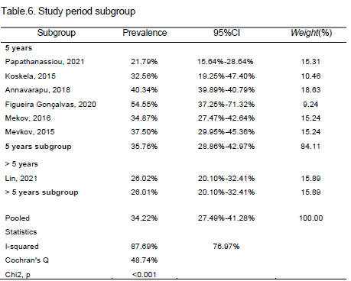

World Health Organization Region subgroup

According to the World Health Organization (WHO) Region, five of the

seven studies were conducted in Europe (Papathanassiou,

2021;Koskela,2015;Figueira Gonçalves,2020;Mekov,2015 and 2016). The

other two studies were in the Western Pacific region (Lin, 2021) and

America (Annavarapu, 2018). Meta-analysis of subgroups based on WHO

region found the prevalence of COPD exacerbations with comorbid type-2

DM was 34.70% (95%CI: 25.88%-43.96%) in subgroup Europe region,

America subgroup region 40,28%(95%CI: 39.89%-40.79%) and the

Western Pacific subgroup region 26.01%(95%CI:0.20;0.32). The results of

the analysis and forest plots are presented in Figure.4 and Table.7.

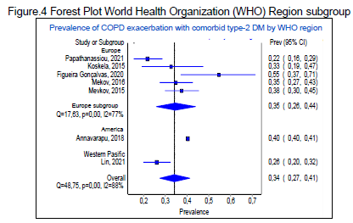

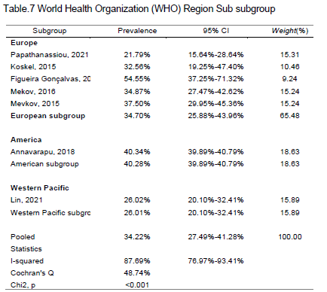

Study Desain subgroup

Six of the seven studies were prospective in design (Papathanassiou, 2021;

Lin,2021; Koskela,2015; Figueira Gonçalves, 2020; Mekov, 2015 and

2016). Study by Annavarapu (2018) with a retrospective research design.

Meta-analysis of subgroups based on study design found that the

prevalence of COPD exacerbations based on subgroup prospective cohort

study design was 32.79% (95% CI: 25.66%-40.30%) and retrospective

cohort subgroup was 40.28% (95% CI: 39.89%-40.79%). Subgroup

statistical heterogeneity (I2 = 76%, Q = 20.63, p=<0.001). The results of the

analysis and forest plots are presented in Figure.5 and Table.8.

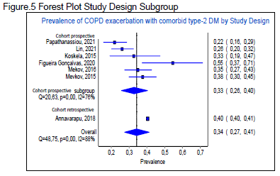

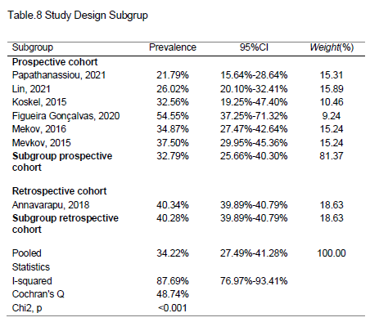

Discussion

As far as the author knows, this study is the first systematic review and

meta-analysis of the prevalence of COPD with type-2 DM comorbidity.

Pooled prevalence of COPD exacerbation with comorbid type-2 DM in this

study was 34.22% (95% CI: 27.49%-41.28%) with statistical heterogeneity

among the seven studies was significant (I2 = 87.69%, Q = 48.75, p =

<0.001). The sample size of COPD exacerbation with comorbid type-2 DM

varied in each study (14 - 18442 cases). 1-7

One of the risk factors for COPD is deficiency️-1 antitrypsin, which causes

an imbalance between proteases and antiproteases, is most commonly

found in Northern Europe and North America.2. This study shwed that the

prevalence of COPD exacerbation with comorbid type-2 DM in the American

region subgroup 40.28%(95%CI:39.89%-40.79%) and the European

subgroup 34.70%(95%CI:25.88%-43.96%) is larger than the Western

Pacific region subgroup26.01%(95%CI:0.20;0.32).1-7

Slightly different from the number of type-2 DM in each regional subgroup.

The report from the International Diabetes Federation (IDF) in 2021, the

number of people with type-2 DM in the WHO Western Pacific region was

205.6 million, which was more than the European region of 61.4 million and

the North America and Caribbean region of 50.5 million.9 The lower

prevalence of COPD and with comorbid type-2 DM in the Western Pacific

region may be due to only one study from the WHO Western Pacific region,

by Lin (2021).2

Prolonged exposure to tobacco smoke, harmful gases or particles can

cause complex pathological changes in the airways and lung parenchyma,

resulting in worsening of respiratory function due to inflammation of the

lower airways, fibrosis of the airway walls, smooth muscle hypertrophy,

goblet cell hyperplasia, mucus hypersecretion and lung parenchymal

damage. Peripheral pulmonary inflammation causes spillover of

proinflammatory cytokines such as TNF-, IL-1β, and IL-6 and CRP into the

systemic circulation. The proinflammatory cytokines TNF-α and IL-6 block insulin receptors, causing insulin resistance and an increased risk of type-2

diabetes.10

The effects of uncontrolled type-2 diabetes also affect lung function. Maan

(2021) reported that uncontrolled diabetes in this case assessed from

HbA1c showed a significant decrease in lung function, vital capacity (VC),

forced expiratory volme in one second (FEV1), forced vital capacity (FVC)

and Peak Expiratory Flow (PEF) 25-75% compared to a non-DM control

group with HbA1C. >8%. However, there was no significant difference in

FEV1/KVP. The DM group with HbA1C levels <8% showed the opposite,

there was no significant difference in lung function (VC, VEP1, FVC and PEF

25-75%) compared to the non-DM control group. But there is a significant

difference in FEV1/VC.11,12

Chronic hyperglycemia causing the formation of glycosylated proteins with

pro-inflammatory effects that cause microvascular disorders resulting in

pulmonary vascular microangiopathy. Increased vascular permeability

causes influx of mononuclear cells, cell proliferation, increased fibrosis with

interstitial thickening which then causes the collapse of the alveolar

space.11,12 Sonoda (2018) showed more features of restrictive lung function

than obstructive in a group of patients with uncontrolled blood sugar levels.13

The prevalence of COPD exacerbations with comorbid type-2 DM in the

study period > 5 years was less than the study period ⩽ 5 years because of

different number of samples, which is sample size in the study > 5 years

was smaller than the study ⩽ 5 years.

The characteristics of the COPD population with comorbid type-2 DM

reported in this study were age, sex and comorbidities other than type-2

DM. The results of a systematic review of two studies reporting age in the

population of COPD exacerbation with type-2 DM comorbidity patients were

found more over 35 years old. The study conducted by Lin (2015) had an

average age was 71.65 years old (mean SD±9.76) and Mekov (2016) also

reported a mean age was 68 years old.2-7

This is in line with Yusuf (2019) which reported that in 65 patients with

COPD exacerbations were over 60 years old (73.8%).14 Pangaribuan

(2020) also reported that the prevalence of type-2 DM in COPD patients

were over 65 years old (27.3%).15

Aging is associated with a progressive decrease in FEV1 of about 20 ml/year

and a decrease in the VEP1/FVC ratio and an increase in residual volume

with constant total lung capacity. These changes in lung function result in

decreased oxygen levels and decreased ability to eliminate carbon dioxide

(CO2) due to decreased chest wall compliance and lung recoil elasticity and

respiratory muscle strength. These changes in lung function with age are similar to those that occur in COPD. Changes in lung physiology with age

are associated with structural changes in the lungs that involve dilatation of

the alveoli, resulting in a decrease in the area available for gas exchange.

However, this alveolar dilatation does not as happens in COPD, because

there is destruction of the alveolar walls.16

Pangaribuan (2020) in their study on COPD outpatients, the highest

incidence of DM was found at the age of 70-79 years. Increasing age causes

uncontrolled hepatic gluconeogenesis, lipid lipogenesis, impaired glycogen

synthesis and decreased tissue glucose uptake. In addition, eldery also

associated with changes in fat distribution resulting in the accumulation of

visceral fat which releases inflammatory cytokines such as leptin and TNF-

⍺ which play a role in resistance.insulin.15,17

In this systematic review, it was found that the proportion of male with

diagnosed COPD exacerbations with comorbid type-2 DM was higher than

female, as reported by Lin (2021) and Mekov (2016) (n=30, 58.8% vs n=21,

41.1% and n =40, 75.4% vs. n=14, 24.5%).2,6 Men with COPD are at higher

risk for developing DM. As reported by Mannino (2008) and Yusuf (2019). It

was found that many patients with exacerbation of COPD were male

(95.4%) than female (4.6%).14,18 COPD affects more male than female,

because more male smoker than female.17,19The risk of diabetes in active

smokers is 30-40% higher than that of nonsmokers. The more number of

cigarettes smoked, the higher the risk of developing diabetes.20

However, in recent years, population of female smokers is more prevalent

so more women are diagnosed with COPD.17 Research conducted by

Hwang at 2008-2010 in Taiwan on 105.825 COPD population, the

prevalence of COPD was higher in women aged 40-49 years old. Men and

women may have different susceptibility to cigarette smoke and pollutants,

which are related by biological and hormonal mechanisms. Estrogen

hormone may influence lung damage in women aged 40-49 year.21

Some of the comorbidities other than type-2 DM in COPD that are widely

reported in this systematic review article are hypertension, obesity, and

coronary heart diseases. The prevalence of comorbidities varied in each

study.2-7

Vanfleteren (2013) in the Netherlands conducted a single-center study and

found 213 COPD patients. 97.7% of all patients had one or more

comorbidities and 53.5% had four or more comorbidities. The most common

comorbidities found were hyperglycemia (54%), followed by atherosclerosis

(53%), hypertension (48%), dyslipidemia (36%) osteoporosis (31%), and

others.22 A recent multi-center national study in Europe (Poland) by

Rubinsztajn (2019) in 444 COPD patients reported that hypertension was

the most comorbid (61.5%).23 A study describing the prevalence of comorbidities in COPD in an Asian population by Park (2015) who

conducted a retrospective cohort study based on the National Health

Database in Korea reported several comorbidities in 2108 COPD patients.

The three most comorbidities were dyslipidemia (72.7%), hypertension

(49.6%), and DM (16.8%).24

Slightly different from the research conducted by Sullivan (2018) who

reported the national and state estimates of COPD comorbidity and

mortality in the United States, the most comorbidities were asthma (46.6%),

depression (44%), cardiovascular disease (20.5%), DM (17.8%) and

coronary heart disease (11.2%). Other comorbidities are depression, kidney

disease, myocardial infarction, stroke and other cardiovascular diseases.25

As previously described, in COPD peripheral lung causes spillover of

proinflammatory cytokines such as TNF-⍺, IL-1β, and IL-6 into systemic

circulation thereby increasing the acute phase protein (CRP) resulting in

systemic inflammation that plays a role in the occurrence of comorbidities

in COPD.10

4. Conclusion

Prevalence of COPD exacerbations with comorbid type 2 diabetes was

34.22%(95%CI:27.49%-41.28%). The prevalence of COPD exacerbations

with comorbid type 2 diabetes is higher in the America population and

Europe than in Asia (Western Pacific) about 40.28%(95%CI:39.89%-

40.79%) vs 34.70%(95%CI:25.88%-43.96%) vs 26.01%(95%CI:0.20;0.32),

higher prevalenceat the age of 68-71 years old and more males than

females Comorbid other than type-2 DM were hypertension, obesity and

coronary heart disease.

DEFINITIONS, ACRONYMS, ABBREVIATIONS

List of Abbrevations

CI : Confidence interval

COPD : Chronic obstructive pulmonary disease

CRP : C-reactive protein

FEV1 : Forced expiratory volme in one second

FVC : Forced vital capacity

HbA1C : Hemoglobin A1C

I2 : Heterogenity

IDF : International diabetes federation

IL-1β : Interleukin 1β

IL-6 : Interleukin-6

NOS : New Castle Ottawa Scale

PECO : Population in question, exposure, comparator dan

outcome

PEF 25-75% : Peak expiratory flow 25-75%

PRISMA 2020 : Preferred Reporting Items for Systematic Reviews

and Meta- Analyses

SD : Standard deviation

TNF-α : Tumor necrosis factor-α

type-2 DM : type-2 diabetes mellitus

VC : Vital capacity

WHO : World Health Organization

Consent (where ever applicable)

Not applicable

Ethical approval (where ever applicable)

Not applicable. Ethical eligibility approval for this systematic review and

meta-analysis not required as it uses anonymous data which has already

been published and is available for download.

References

1. Papathanassiou, E, Papaioannou A.I, Papanikkolau, I, Antonakis E,

Makou I, Hillas G,et al. Glycated Hemoglobin (HbA1c) as a Predictor

of Outcomes during Acute Exacerbations of Chronic Obstructive

Pulmonary Disease. COPD: Journal of Chronic Obstructive Pulmonary

Disease. 2021;18:219–25.

2. Lin L, Shi J, Kang J, Wang Q. Analysis of prevalence and prognosis of

type 2 diabetes mellitus in patients with acute exacerbation of COPD.

BMC Pulm Med. 2021;21(1):7.

3. Koskela, H. O., Salonen, P. H., Romppanen, J., & Niskanen, L. A

history of diabetes but not hyperglycaemia during exacerbation of

obstructive lung disease has impact on long-term mortality: A

prospective, observational cohort study. BMJ Open 2015;5:e006794.

4. Annavarapu S, Goldfarb S, Gelb M, Moretz C, Renda A, Kaila S.

Development and validation of a predictive model to identify patients

at risk of severe COPD exacerbations using administrative claims

data. Int J Chron Obstruct Pulmon Dis 2018;13:2121-30.

5. Figueira Gonçalves, J. M., García Bello, M. Á., Golpe, R., Alonso

Jerez, J. L., & García-Talavera, .Impact of diabetes mellitus on the risk

of severe exacerbation in patients with chronic obstructive pulmonary

disease. Clinical Respiratory Journal 2020;14(12):1208-11.

6. Mekov, E. V., Slavova, Y. G., Genova, M. P., Tsakova, A. D.,

Kostadinov, D. T., Minchev, D, et al. Diabetes Mellitus Type 2 in

Hospitalized COPD Patients: Impact on Quality of Life and Lung

Function. Folia Medica. 2016;58(1):36-41.

7. Mekov, E., Slavova, Y., Tsakova, A., Genova, M., Kostadinov, D.,

Minchev, D., & Marinova, D. (2015). Metabolic syndrome in

hospitalized patients with chronic obstructive pulmonary disease.

PeerJ, 2015;7.

8. Global Strategy for the Diagnosis, Management and Prevention of

Chronic Obstructive Pulmonary Disease (2021 Reports), Global

Initiative for Chronic Obstructive Lung Disease (GOLD). 2021.

Availableat: http://goldcopd.org

9. World Health Oranization. Diabetes fact sheet 2018. Available at:

https://www.who.int/news-room/fact-sheets/detail/diabetes. Accessed

Januari 3, 2020.

10. Barnes PJ and Celli BR. Systemic manifestations and comorbidities of

COPD. Eur Respir J. 2009;33:1165-85.

11. Maan,H.B, Meo,S.A, Al Rouq F, Meo I.M.U, Gacuan M.E, Alkhalifah

J.M. Effect of Glycated Hemoglobin (HbA1c) and Duration of Disease

on Lung Functions in Type 2 Diabetic Patients. Int. J. Environ. Res.

Public Health. 2021;18:6970.

12. Klein, O.L.; Krishnan, J.A.; Glick, S.; Smith, L.J. Systematic review of

the association between lung function and Type 2 diabetes mellitus.

Diabet. Med. 2010;27:977–987.

13. Sonoda, N.; Morimoto, A.; Tatsumi, Y.; Asayama, K.; Ohkubo,T.;

Izawa, S.; Ohno, Y. The association between glycemic control and

lung function impairment in individuals with diabetes: The Saku study.

Diabetol. Int. 2019;10,:213–218.

14. Yusuf K, Ilyas M, Tabri N, Katu S, HP F, Kasim H, et all. The correlation

between bacterial colonization and interleukin-8 serum levels in acute

exacerbation of COPD. International Journal of Medical Reviews and

Case Reports. 2019; 3(11):702-706.

15. Pangaribuan M, Yunus F, Damayanti T, Rochsismandoko, R. The

Prevalence of Diabetes Mellitus in Chronic Obstructive Pulmonary

Disease Patients. Jurnal Respirologi Indonesia. 2020;40:48-57.

16. MacNee W. Is Chronic Obstructive Pulmonary Disease an Accelerated

Aging Disease? Ann Am Thorac Soc. 2016;13 Suppl 5:S429-37.

17. Barzilai N, Huffman DM, Muzumdar RH, Bartke A. The Critical Role of

Metabolic Pathways in Aging. Diabetes. 2012;61:1315-22.

18. Mannino DM, Homa DM, Akinbami LJ, Ford ES, Redd SC.

Chronicobstructive pulmonary disease surveillance—United States,

1971–2000.MMW RSurveill Summ. 2002;51:1–16.

19. Barnes PJ. Sex Differences in Chronic Obstructive Pulmonary

Disease Mechanisms. Am J Respir Crit Care Med. 2016;193(8):813-

4.

20. Klein O.L.; Krishnan, J.A.; Glick, S.; Smith, L.J. Systematic review of

the association between lung function and Type 2 diabetes mellitus.

Diabet. Med. 2010;27:977–987.

21. Hwang S. Prevalence of Chronic Obstructive Pulmonary Disease in

Southwestern Taiwan: A Population-Based Study. International

Journal of Respiratory and Pulmonary Medicine. 2016;3:048.

22. Vanfleteren LE, Spruit MA, Groenen M, Gaffron S, van Empel VP,

Bruijnzeel PL, et al. Clusters of comorbidities based on validated

objective measurements and systemic inflammation in patients with

chronic obstructive pulmonary disease. Am J Respir Crit Care Med.

2013;187(7):728-35

23. Rubinsztajn R, Przy️by️łowski T, Grabicki M, Karwat K, Maskey️-

Warzęchowska M, Batura-Gabryel H, Chazan R. Comorbidities in

chronic obstructive pulmonary disease: Results of a national

multicenter research project. Adv Clin Exp Med. 2019;28(3):319-324.

24. Park HJ, Leem AY, Lee SH, Song JH, Park MS, Kim YS, Kim SK,

Chang J, Chung KS. Comorbidities in obstructive lung disease in

Korea: data from the fourth and fifth Korean National Health and

Nutrition Examination Survey. Int J Chron Obstruct Pulmon Dis.

2015;10:1571-82.

25. Sullivan J, Pravosud V, Mannino DM, Siegel K, Choate R, Sullivan T.

National and state estimates of COPD morbidity and mortality United

States, 2014-2015. Chronic Obstr Pulm Dis. 2018; 5(4):324-333.

26. Iqbal, M. S., Al-Saikhan, F. I. and Iqbal, M. Z. (2020) “Out-of-pocket Healthcare Costs of COPD Exacerbation Episodes: A Hidden Cost and Growing Strain on Family Budgets”, Journal of Pharmaceutical Research International, 32(5), pp. 42–48. doi: 10.9734/jpri/2020/v32i530435.