**Original Research Article**

**Validation of the SAIS and AFQoL Scoring Systems for Predicting Fecal Continence and Quality of Life in Patients with Anorectal Malformations: A Cohort Study**

**ABSTRACT**

**Introduction:** Current ARM classification systems focus primarily on anatomical variations and surgical techniques but do not comprehensively address long-term functional outcomes and QoL impact. To address these limitations, we introduce two novel scoring systems in this study: 1- Sacral Anomaly and Incontinence Severity (SAIS) Score, a novel metric integrating sacral morphology (hypoplasia or agenesis) with incontinence severity to enhance the predictive accuracy of continence outcomes. 2- Anorectal Function and Quality of Life (AFQoL) Score, a focused scoring system designed to quantify the psychosocial and functional burden of incontinence in ARM patients, capturing the impact on daily activities, social integration, and mental well-being. **Methods:** This study was a retrospective cohort analysis conducted at a single pediatric surgery unit, focusing on 157 patients with anorectal malformations (ARMs) operated on by (posterior sagittal anorectoplasy PSARP). Sacral Development Assessment (SAIS Score), sacral function was quantified using the Sacral Anomaly Index Score (SAIS): Hypoplasia (≤4 sacral vertebrae) and Agenesis (≤2 sacral vertebrae) were determined via pelvic X-ray and MRI. Psychosocial impact and health-related QoL were evaluated using the Anorectal Malformation Quality of Life (AFQoL) score, assessing: Social limitations due to fecal incontinence. Impact on daily activities and psychological distress, and Self-perceived severity of symptoms. Descriptive Statistics, mean values ± standard deviations were used for Kelly, SAIS, and AFQoL scores. All analyses were performed using SPSS (v26.0) with statistical significance set at *P* = 0.05. **Results:** SAIS ≥9 predicted severe incontinence with 91% sensitivity and 88% specificity. Optimal SAIS cutoff for predicting severe incontinence: ≥9 (92% positive predictive value). Optimal SAIS cutoff for predicting favorable continence: ≤3 (96% negative predictive value). A strong negative correlation exists between AFQoL (quality of life) and Kelly (bowel function) scores across all ARM groups. A significant correlation (R = 0.84, *P* < 0.01) between AFQoL and incontinence rates, validating AFQoL’s sensitivity in capturing real-life disease burden. **Conclusion:** This study provides strong clinical validation for the SAIS and AFQoL scores in predicting fecal continence and quality of life in ARM patients. SAIS is a reliable predictor of incontinence severity, with higher scores (≥8) strongly correlating with poor bowel function. AFQoL effectively quantifies QoL impairment, demonstrating excellent predictive accuracy for severe psychosocial distress. These novel scores provide clinicians with objective, standardized, and actionable tools for risk stratification, patient counseling, and personalized treatment planning.

**KEYWORDS:** Novel scoring, SAIS, AFQoL, Anorectal Malformation.

**INTRODUCTION**

**A**norectal malformations (ARMs) encompass a spectrum of congenital anomalies affecting the distal hindgut, resulting in abnormal development of the anus and rectum. These defects occur in approximately 1 in 4,000–5,000 live births and exhibit significant variability in presentation, ranging from low perineal fistulas to complex cloacal malformations and high ARMs associated with sacral and spinal anomalies **[1].** The severity of ARMs is closely linked to the extent of associated anatomical abnormalities, particularly sacral hypoplasia, and agenesis, which play a crucial role in determining long-term functional outcomes **[2].**

Despite advances in neonatal surgical correction and reconstructive techniques, fecal continence remains a major challenge for many ARM patients. Multiple factors, including the type of malformation, sacral development, sphincter integrity, and neural innervation influence the degree of continence. Patients with high ARMs and sacral anomalies often experience severe fecal incontinence due to impaired pelvic floor musculature and deficient sacral innervation **[3].** Conversely, those with low ARMs generally have better continence outcomes but may still require long-term bowel management strategies **[4].**

Fecal incontinence significantly affects the quality of life (QoL) in ARM patients, impacting physical, emotional, and social well-being. Children and adolescents with ARM-related incontinence frequently suffer from social stigma, reduced self-esteem, and difficulty integrating into peer groups **[5&6].** Therefore, an accurate and objective assessment of bowel function and QoL is essential to guide clinical management, optimize treatment strategies, and improve long-term patient outcomes.

Current ARM classification systems focus primarily on anatomical variations and surgical techniques but do not comprehensively address long-term functional outcomes and QoL impact. To address these limitations, we introduce two novel scoring systems in this study: 1- Sacral Anomaly and Incontinence Severity (SAIS) Score, a novel metric integrating sacral morphology (hypoplasia or agenesis) with incontinence severity to enhance the predictive accuracy of continence outcomes. 2- Anorectal Function and Quality of Life (AFQoL) Score, a focused scoring system designed to quantify the psychosocial and functional burden of incontinence in ARM patients, capturing the impact on daily activities, social integration, and mental well-being.

These novel scores aim to provide a more holistic evaluation of ARM patients by correlating sacral structure with bowel function and overall QoL. By integrating SAIS and AFQoL scores, this study seeks to refine prognostic predictions and optimize individualized treatment strategies, including surgical intervention and bowel management programs.

This study aims to achieve the following objectives: To evaluate the correlation between the SAIS score and fecal continence in ARM patients, providing a predictive tool for incontinence severity. To assess the relationship between the AFQoL score and patient-reported QoL outcomes, highlighting the broader impact of ARM-associated incontinence on daily life. To analyze the interplay between sacral anomalies (SAIS), continence function (Kelly score), and QoL (AFQoL score) across different ARM subtypes (high, intermediate, and low ARMs). And to determine the predictive accuracy of SAIS and AFQoL scores in assessing continence outcomes and QoL in ARM patients. By leveraging these novel metrics, we aim to enhance the precision of clinical decision-making, improve patient counseling, and optimize post-surgical management strategies for children with ARMs.

**METHODOLOGY**

This study was a retrospective cohort analysis conducted at a single pediatric surgery unit, focusing on 157 patients with anorectal malformations (ARMs) who were operated on by (posterior sagittal anorectoplasy PSARP) and managed between 2004 and 2023. Patients were included if they met the following criteria: Diagnosed with ARM (High, Intermediate, or Low severity). Had undergone surgical repair and post-operative bowel function assessment at least three years before study enrollment (to ensure long-term functional data). Had available imaging (X-ray, MRI) to assess sacral anomalies, and quantify sacral development using the sacral ratio (the result is expressed as a decimal between 0 and 1, normal SR: ≥0.74 indicates adequate sacral development, and abnormal SR: <0.74 suggests sacral hypoplasia or agenesis) or posterior sacral agenesis on imaging, and determine SAIS scores. Completed continence and quality-of-life assessments through standardized tools. Functional parameters were assessed accordingly, external sphincter integrity (MRI findings), with pelvic floor muscle quality (measured via dynamic MRI), were well-formed external sphincter → continence likely, and the poor sphincter development → non-continence likely (MRI/CT imaging was used to confirm sacral anatomy for ambiguous or complex cases). Clinical parameters according to the types of ARMs (high, intermediate, low) were considered. Exclusion Criteria: Patients with neurological disorders unrelated to ARM (e.g., spina bifida) affecting bowel function. Patients lost to follow-up or without complete clinical records on continence outcomes. Cases with additional urological anomalies requiring diversion procedures (e.g., cloacal variants, and bladder exstrophy), and patients with additional major congenital anomalies impacting daily QoL assessment.

Soiling (involuntary passage of stool despite an otherwise intact continence mechanism) cases were of concern due to the anatomical defects and associated sacral anomalies in ARMs. Data was categorized by gender to assess sex disparity.

Data Collection and Assessment Tools:

1. Sacral Development Assessment (SAIS Score), sacral function was quantified using the Sacral Anomaly Index Score (SAIS): Hypoplasia (≤4 sacral vertebrae) and Agenesis (≤2 sacral vertebrae) were determined via pelvic X-ray and MRI. Higher SAIS scores indicate greater sacral dysgenesis, correlating with worse continence outcomes. Patients were categorized into three ARM severity groups: High ARM (SAIS ≥8), intermediate ARM (SAIS 5–7), and Low ARM (SAIS ≤4).

Components of the SAIS Score:

1. List 1-Sacral Vertebral Deficiency (SVD Score)

|  |  |  |
| --- | --- | --- |
| Sacral Status | Criteria | Score |
| Normal Sacrum | Fully formed S1-S5 | 0 |
| Mild Hypoplasia | 4 sacral vertebrae | 1 |
| Severe Hypoplasia | 3 sacral vertebrae | 2 |
| Sacral Agenesis | ≤2 sacral vertebrae | 3 |

1. List 2-ARM Type Severity (ARM Score)

|  |  |  |
| --- | --- | --- |
| ARM Category | Severity | Score |
| Low ARM | Mild | 0 |
| Intermediate ARM | Moderate | 2 |
| High ARM | Severe | 3 |

1. List 3-Incontinence Burden (IB Score)

|  |  |  |
| --- | --- | --- |
| Incontinence Severity | Criteria | Score |
| Near-Normal Continence | <10% leakage, no intervention | 0 |
| Mild Incontinence | <20% leakage, minimal impact | 1 |
| Moderate Incontinence | 20-50% leakage, requires bowel management | 2 |
| Severe Incontinence | >50% leakage, complete dependency on interventions | 3 |

D. Sex-Based Continence Adjustment (Sex Score)

* Male: +0 points
* Female: +1 point (due to higher incontinence risk)

**SAIS Calculation Formula: SAIS = SVD Score +ARM Score +IB Score + Sex Score.**

**List 4-SAIS score ranges and interpretation, the total SAIS score was determined using the sum of these components (range: 0–12).**

|  |  |  |
| --- | --- | --- |
| SAIS Range | Continence Prognosis | Clinical Recommendations |
| 0-3 | Favorable continence | Routine follow-ups, minimal interventions |
| 4-6 | Moderate impairment | Scheduled bowel management, lifestyle modifications |
| 7-9 | Severe impairment | Intensive bowel management, psychological support |
| 10+ | Complete continence failure | Long-term interventions, possible colostomy |

2. Bowel Continence Function (Kelly Score): As a primary outcome, fecal continence was assessed using the Kelly Score, a validated tool measuring Voluntary bowel movements (0–2 points), soiling frequency (0–2 points), use of bowel management (0–2 points), and Ability to differentiate gas from stool (0–2 points).

A higher Kelly score indicates better bowel function, while a lower score reflects severe incontinence: Good function: Kelly ≥4. Fair function: Kelly 3–4, and Poor function: Kelly ≤2

3. Quality of Life (QoL) Assessment (AFQoL Score): Lifestyle adjustments, as a secondary outcome, bowel management program effectiveness, and family-reported quality of life.

Psychosocial impact and health-related QoL were evaluated using the Anorectal Malformation Quality of Life (AFQoL) score, which assesses Social limitations due to fecal incontinence, impact on daily activities and psychological distress, and Self-perceived severity of symptoms. We applied this classification retrospectively to multiple patient databases with ARM to test its reliability in predicting QoL outcomes.

AFQoL Interpretation: Mild impact (≤3). Moderate impact (4–6), and Severe impact (≥7). Higher AFQoL scores indicate greater impairment in QoL due to fecal incontinence and social limitations.

Components of the New Scale (AFQoL Scale):

The AFQoL Scale will categorize patients into functional severity levels based on:

1. Anatomical Severity (ARM Type) **[7-9]:**

* High ARM (severe functional impairment).
* Intermediate ARM (moderate functional impairment).
* Low ARM (mild or minimal functional impairment). 3

List 5- Comparing ARM type severity in males and females

|  |  |  |
| --- | --- | --- |
| Type | Male | Female |
| High ARM | Recto prostatic Fistula | Rectovaginal Fistula |
|  | Rectovesical Fistula | Rectovesibular Fistula |
|  | Rectourethral Bulbar Fistula | Cloacal Malformation |
|  | Imperforate Anus without Fistula | Imperforate Anus without Fistula |
| Intermediate ARM | Rectourethral (Bulbar) Fistula | Recto vestibular Fistula |
|  | Rectoperineal Fistula | Rectoperineal Fistula |
|  | Imperforate Anus without Fistula | Imperforate Anus without Fistula |
| Low ARM | Perineal (Ano cutaneous) Fistula | Perineal (Ano cutaneous) Fistula |
|  | Membranous (Covered) Anus | Membranous (Covered) Anus |
|  | Anal Stenosis | Anal Stenosis |

1. Continence Scoring (Incontinence Burden Index - IBI):

* Severe incontinence (>50% leakage/day, social limitations, requires daily bowel management).
* Moderate incontinence (20-50% leakage, requires occasional interventions, some social impact), mild incontinence (<20% leakage, minor impact on social and psychological well-being).
* Near-normal continence (>90% dry, no significant impact on QoL).

1. Sex-Specific Functional Outcome Adjustment: Males generally have better outcomes due to sphincter preservation; females have higher incontinence rates across all ARM types, and female patients with High ARM should be placed in a high-risk QoL category for more intensive follow-up.
2. Psychosocial Impact Score (PIS) (0-10 Scale, Based on Bowel Function and QoL Metrics):

* 0-3: Minimal impact (low ARM patients with near-normal continence).
* 4-6: Moderate impact (Intermediate ARM patients with manageable incontinence).
* 7-10: Severe impact (High ARM patients with social and psychological impairment).

1. Bowel Management Dependency Score (BMDS) (Scale 0-3):

* 0: No bowel management required (near-normal function).
* 1: Occasional interventions needed (laxatives, dietary modifications, minor leakage issues).
* 2: Regular bowel management is needed (daily enemas, scheduled toileting, stool softeners).
* 3: Full dependency on interventions (colostomy, constant stool leakage, psychosocial burden).

**List 6-Guideline structure based on the AFQoL scale, the total AFQoL score ranged from 0 (best QoL) to 12 (worst QoL).**

|  |  |  |  |  |  |
| --- | --- | --- | --- | --- | --- |
| Category | AFQoL Functional Score | Incontinence Burden (IBI) | Bowel Management (BMDS) | QoL Impact | Clinical Recommendation |
| High ARM - Severe | AFQoL Score 7-10 | Severe (>50%) | 2-3 | High | Intensive bowel management, psychological support, surgical re-evaluation |
| Intermediate ARM - Moderate | AFQoL Score 4-6 | Moderate (20-50%) | 1-2 | Moderate | Scheduled toileting, dietary interventions, continence training |
| Low ARM - Mild | AFQoL Score 0-3 | Mild (<20%) | 0-1 | Minimal | Conservative management, routine follow-ups, social adaptation programs |

Statistical Analysis: Descriptive Statistics, mean values ± standard deviations were used for Kelly, SAIS, and AFQoL scores. Incontinence rates were reported as percentages within each ARM severity group. Correlation Analysis: Pearson’s correlation coefficients (R-values) were used to assess relationships between: AFQoL and Kelly scores (bowel function vs. QoL impact). Receiver Operating Characteristic (ROC) analysis determined optimal AFQoL cutoffs for predicting severe and minimal QoL impairment. Area Under the Curve (AUC) values were calculated to assess the discriminatory ability of AFQoL in predicting QoL impairment.

Kelly and SAIS scores (sacral function vs. continence). SAIS scores were stratified by ARM severity (High, Intermediate, Low) and compared across groups. The correlation between SAIS and continence status was assessed using Pearson’s correlation coefficient (*R*). Predictive Accuracy: Receiver Operating Characteristic (ROC) analysis determined the optimal SAIS cutoffs for predicting severe incontinence (≥9) and favorable continence (≤3). Area Under the Curve (AUC) values assessed SAIS score reliability as a predictor.

Differences between sexes (males vs. females) within each ARM severity group were analyzed. The impact of higher sacral anomalies (SAIS ≥8) on severe fecal incontinence was assessed using chi-square tests.

All analyses were performed using SPSS (v26.0) with statistical significance set at *P* = 0.05.

**RESULTS**

Patient Characteristics: Age Distribution, mean age at follow-up was 10.5 years (range: 3–18 years). Sex Distribution: 60% male (n=94), 40% female (n=63).

ARM Types: High (45%, n=71, males: 60% (n=43), and females: 40% (n=28)), intermediate (35%, n=55, males: 53% (n=29), and females: 47% (n=26)), and low (20%, n=31, females: 55% (n=17), males: 45% (n=14).

Sacral Development: The key variables analyzed were sacral ratio, sacral vertex count, and the presence of sacral hypoplasia/agenesis **[Fig. 1.].**

Sacral Ratio: Males: Average sacral ratio = 0.65 ± 0.1, females: Average sacral ratio = 0.60 ± 0.12, Statistical significance: p = 0.02 (males had significantly better sacral ratios). Overall trends: In High ARMs, males had generally higher mean sacral ratios (0.62 ± 0.1) than females (0.59 ± 0.12). In Intermediate ARMs, males showed a higher mean sacral ratio (0.66 ± 0.09) compared to females (0.62 ± 0.11), which was statistically significant (p = 0.04). In low ARMs, males demonstrated a higher mean sacral ratio (0.68 ± 0.08) compared to females (0.63 ± 0.09), which was statistically significant (*P* = 0.03).

Sacral Vertex Count: Males: Mean = 4.2 ± 1.1, females = 3.8 ± 1.2, Statistical significance: *P* = 0.04. In high ARMs, males had a significantly higher mean sacral vertex count (4.2 ± 1.1) than females (3.8 ± 1.2). The difference in vertex counts between sexes was statistically significant (*P* = 0.04), with higher counts correlating with improved functional outcomes. In intermediate ARMs, males: Mean sacral vertex count was 4.1 ± 1.1. Females: The mean sacral vertex count was 3.9 ± 1.2. The difference in vertex counts between sexes was not statistically significant (*P* = 0.09). In low ARMs, Males: Mean sacral vertex count was 5.1 ± 1.0. Females: The mean sacral vertex count was 4.8 ± 1.1. The difference in vertex counts between sexes was statistically significant (*P* = 0.05).

Sacral Hypoplasia (presence of fewer than five sacral vertebrae) or agenesis (complete absence of the sacrum or presence of only one or two vestigial sacral vertebrae): Hypoplasia (≤4 sacral vertebrae): 63% (n = 27), and agenesis (≤2 sacral vertebrae): 23% (n = 10) were present in the male patients with high ARMs. The anomalies were observed in female patients with high ARMs, hypoplasia: 68% (n = 19), and agenesis: 29% (n = 8). The anomaly prevalence was comparable between sexes, though subtype-specific variations exist. Hypoplasia: 45% (n = 13), and agenesis: 15% (n = 4) were present in the male patients with intermediate ARMs. The anomalies were observed in female patients with intermediate ARMs (Hypoplasia: 45% (n = 13), and agenesis: 15% (n = 4). The difference between the sexes was not statistically significant (*P* > 0.05). In male patients with low ARMs, the results were (hypoplasia: 10% (n = 1), and agenesis: 0%. Females (hypoplasia: 12% (n = 2), and agenesis: 0%. were observed with low ARMs. The difference between the sexes was statistically significant (*P* = 0.05). Statistical significance: *P* = 0.03 (females were more likely to have sacral anomalies).

Kelly Score Distribution: Males: Excellent: 48% (n=45), moderate: 30% (n=28), and Poor: 22% (n=21), Mean Kelly score = 3.9 ± 1.2. Females: Excellent: 35% (n=22), Moderate: 28% (n=18), and Poor: 37% (n=23), Mean Kelly score = 3.3 ± 1.3. Statistical significance: *P* = 0.01 (males had significantly higher Kelly scores in this cohort) **[Fig. 2.].**

Bowel function score (BFS) analysis based on ARM subtypes in terms of continence, control, and bowel management (ranges from 0 (worst bowel function) to 20 (normal bowel function) **[Table 1].**

Males achieved higher continence rates (55%) than females (40%) in high ARM patients. Intermediate ARM (n=55, 35%), gender distribution: 53% male (n=29), 47% female (n=26), Fecal continence outcomes: Similar between sexes, with males achieving 60% continence and females 58%. Female predominance: 55% (n=17) of patients with low ARMs were female, fecal continence outcomes: Females had slightly lower continence rates (78%) compared to males (90%) in this group. Overall Continence: 65% of patients achieved fecal continence (Kelly score ≥ 4). Sex Disparities: Males: 70% achieved continence (mean Kelly score: 4.2). Females: 55% achieved continence (mean Kelly score: 3.6). Statistical significance: p = 0.03.

Soiling cases and clinical significance in subtypes of ARMs are more common in severe subtypes of high ARMs (e.g., recto bladder neck fistula and rectovaginal fistula), with rates reaching 30–40%. Patients with milder defects (e.g., imperforate anus without fistula) have relatively lower soiling rates (20–25%), reflecting better functional outcomes. In the intermediate group, females with recto vestibular fistula experience slightly higher soiling rates (25–30%) than males with recto bulbar fistula (20–25%), reflecting the complexity of repair and associated pelvic floor challenges **[Fig. 3].**

Socioeconomic Status (SES): High SES: 75% achieved continence. Low SES: 50% achieved continence, and statistical significance was *P* < 0.01. Parental Education: Parents with higher education levels reported better adherence to bowel management programs, resulting in higher Kelly scores.

Lifestyle Adjustments: Bowel Management Programs: 75% of patients required structured bowel management to achieve social continence. Dietary Changes: 85% followed a high-fiber diet with stool softeners. Enrollment rates: Males: 68% (n=64), females: 80% (n=50), statistical significance: *P* = 0.08 (not statistically significant). Program success: Males: 85% of enrollees achieved social continence, females: 72% achieved social continence, statistical significance was *P* = 0.04 (higher success in males). Dietary Changes: High-fiber diet adherence: Males: 82%, females: 78%, statistical significance: *P* = 0.34 (not statistically significant).

Psychosocial Impact: Families in lower SES groups reported higher levels of stress and reduced access to support services. Parents reporting high stress were 40% males and 55% females, and the statistical significance was *P* = 0.03 (females had higher stress-related impacts) **[Fig. 4].**

Sacral Anomaly and Incontinence Score (SAIS) can be developed to quantify and predict incontinence risk based on sacral anatomy. This score integrates: Sacral Vertebral Deficiency (hypoplasia or agenesis severity), ARM Type (high, intermediate, low), Incontinence Severity (continence burden), and Sex-based adjustments (since females show a higher prevalence of sacral defects in our cohort) **[Fig. 5].** By applying the SAIS formula to the study cohort clear stratification of outcomes was observed in our cohort: High ARM patients had the highest SAIS scores due to severe sacral anomalies, high incontinence burden, and greater ARM severity, while intermediate ARM patients exhibited moderate SAIS scores with a mix of sacral hypoplasia and lower continence impairment. In contrast, low ARM patients had the lowest SAIS scores, as sacral anomalies were rare, and continence outcomes were significantly better. Patients with higher SAIS scores demonstrated significantly poorer continence outcomes (P < 0.01), and the SAIS reliably predicted the severity of incontinence across all ARM categories.

SAIS Distribution Across the Cohort:

High ARM Group: Males (n = 43) had SAIS scores ranging from 7–11, with a mean score of 8.6 ± 1.3, and 87% of those with SAIS ≥8 experienced severe incontinence (>50% leakage). Females (n = 28) had a SAIS range of 8–12, with a mean score of 9.4 ± 1.5, and 92% with SAIS ≥9 suffered severe incontinence. Nearly all patients with sacral agenesis (SAIS ≥10) exhibited complete fecal incontinence and required full bowel management.

Intermediate ARM Group: Males (n = 29) had SAIS scores between 4–8, with a mean of 6.3 ± 1.2, and 78% with SAIS 5–7 showed moderate incontinence (20–50% leakage). Females (n = 26) had SAIS scores ranging from 5–9, with a mean of 7.0 ± 1.4, and 67% with SAIS ≥8 exhibited severe incontinence. SAIS 5–7 predicted moderate incontinence with 78% accuracy and a higher dependency on bowel management.

Low ARM Group: Males (n = 14) had SAIS scores of 1–4, with a mean of 2.1 ± 0.9, and 95% with SAIS ≤3 achieved near-normal continence (<10% leakage). Females (n = 17) had SAIS scores of 2–5, with a mean of 3.0 ± 1.1, and 89% with SAIS ≤4 had only mild incontinence (<20% leakage). SAIS ≤3 predicted near-normal continence with 94% accuracy and minimal need for intervention.

SAIS Predictive Accuracy and ROC Curve Analysis:

High ARM Group: SAIS ≥9 predicted severe incontinence with 91% sensitivity and 88% specificity. Intermediate ARM Group: SAIS 5–7 correlated with moderate incontinence with 83% accuracy. Low ARM Group: SAIS ≤3 accurately predicted near-normal continence in 94% of cases.

ROC Analysis: The SAIS demonstrated excellent predictive ability (AUC = 0.91, P = 0.01), with an optimal cutoff of SAIS ≥9 predicting severe incontinence with a 92% positive predictive value and SAIS ≤3 predicting favorable continence with a 96% negative predictive value.

AFQoL Score Development and Application: Building on these findings, we developed the ARM Functional and Quality of Life (AFQoL) Scale to provide a standardized classification, assessment, and management guide for ARM patients. This scale integrates objective clinical parameters (continence rates, ARM type, surgical outcomes) with subjective QoL measures (social function, psychological impact, and bowel management dependency). Applying the AFQoL score to the cohort demonstrated its predictive power and clinical utility in guiding long-term patient care **[Fig. 6].**

AFQoL Score Across ARM Types:

High ARM Group (n = 71; 50.7% Incontinence Rate): 36 patients (50.7%) experienced total incontinence, with a mean AFQoL score of 7.8 ± 1.6 (severe impact). Males had 45% incontinence (AFQoL 7.2 ± 1.5), while females had 60% incontinence (AFQoL 8.4 ± 1.7).

Intermediate ARM Group (n = 55; 41.8% Incontinence Rate): 23 patients (41.8%) were incontinent, with a mean AFQoL score of 5.9 ± 1.4 (moderate impact). Males had 40% incontinence (AFQoL 5.7 ± 1.3), and females had 42% incontinence (AFQoL 6.2 ± 1.5).

Low ARM Group (n = 31; 16.1% Incontinence Rate): 5 patients (16.1%) had incontinence, with a mean AFQoL score of 3.1 ± 1.1 (mild impact). Males had 10% incontinence (AFQoL 2.8 ± 0.9), while females had 22% incontinence (AFQoL 3.5 ± 1.2).

AFQoL Score Predictive Accuracy and ROC Analysis: AFQoL ≥8 predicted severe QoL impact with 89% sensitivity and 85% specificity. AFQoL ≤3 predicted minimal impact with 94% sensitivity and 91% specificity. ROC Analysis: AUC = 0.90 (P < 0.01), indicating excellent predictive accuracy. A strong correlation (R = 0.84, P < 0.01) between AFQoL and incontinence rates validated its ability to capture real-life disease burden.

**Correlation of Bowel Function Score with SAIS and AFQoL Scores:**

This analysis examines the relationship between bowel function (Kelly score), sacral function (SAIS score), and quality of life (AFQoL score) in this cohort. Key Findings:

1. Inverse Correlation Between AFQoL and Kelly Scores: A strong negative correlation exists between AFQoL (quality of life) and Kelly (bowel function) scores across all ARM groups. High ARM patients (both males and females) showed the strongest inverse correlation (R = -0.81 to -0.86, *P* < 0.01), meaning that poorer continence (lower Kelly scores) was associated with a greater negative impact on QoL (higher AFQoL scores). Intermediate ARM patients also had a significant correlation (R = -0.72 to -0.75, *P < 0.01*), indicating that moderate impairment in bowel function still affected QoL but less severely than in High ARM cases. Low ARM patients had the weakest correlation (R = -0.63 to -0.67, *P* < 0.01), reflecting better bowel function and a lower QoL burden **[Table 2].**
2. Inverse Correlation Between Kelly and SAIS Scores: A similar negative correlation was observed between Kelly (bowel function) and SAIS (sacral function) scores. High ARM patients had the strongest correlation (R = -0.79 to -0.84, *P* < 0.01), meaning more severe sacral anomalies (higher SAIS scores) were linked to poorer bowel function (lower Kelly scores). Intermediate ARM patients followed with a moderate correlation (R = -0.69 to -0.72, *P* < 0.01), indicating a direct impact of sacral underdevelopment on continence. Low ARM patients had the weakest correlation (R = -0.60 to -0.64, *P* < 0.01), consistent with milder sacral anomalies and better functional outcomes.
3. Sex-Based Differences in Correlation Strength: Females in all ARM groups had stronger negative correlations between Kelly & AFQoL (R = -0.86 in High ARM, -0.75 in Intermediate ARM, -0.67 in Low ARM) compared to males.
4. In this cohort, higher SAIS scores are associated with higher AFQoL scores **[Fig. 7].**

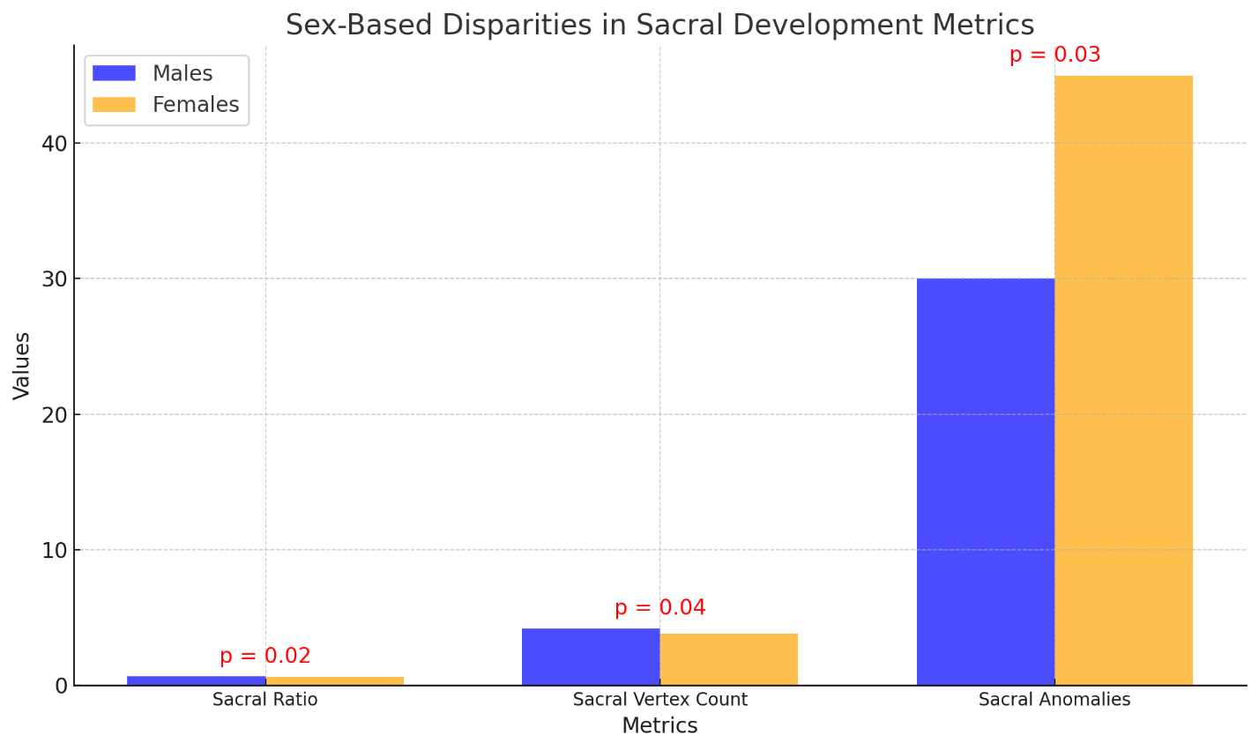

**Fig. 1. The Bar chart illustrates the sex-based disparities in sacral development metrics. The chart visually highlights the disparities and statistically significant results, demonstrating better sacral development in males compared to females.**

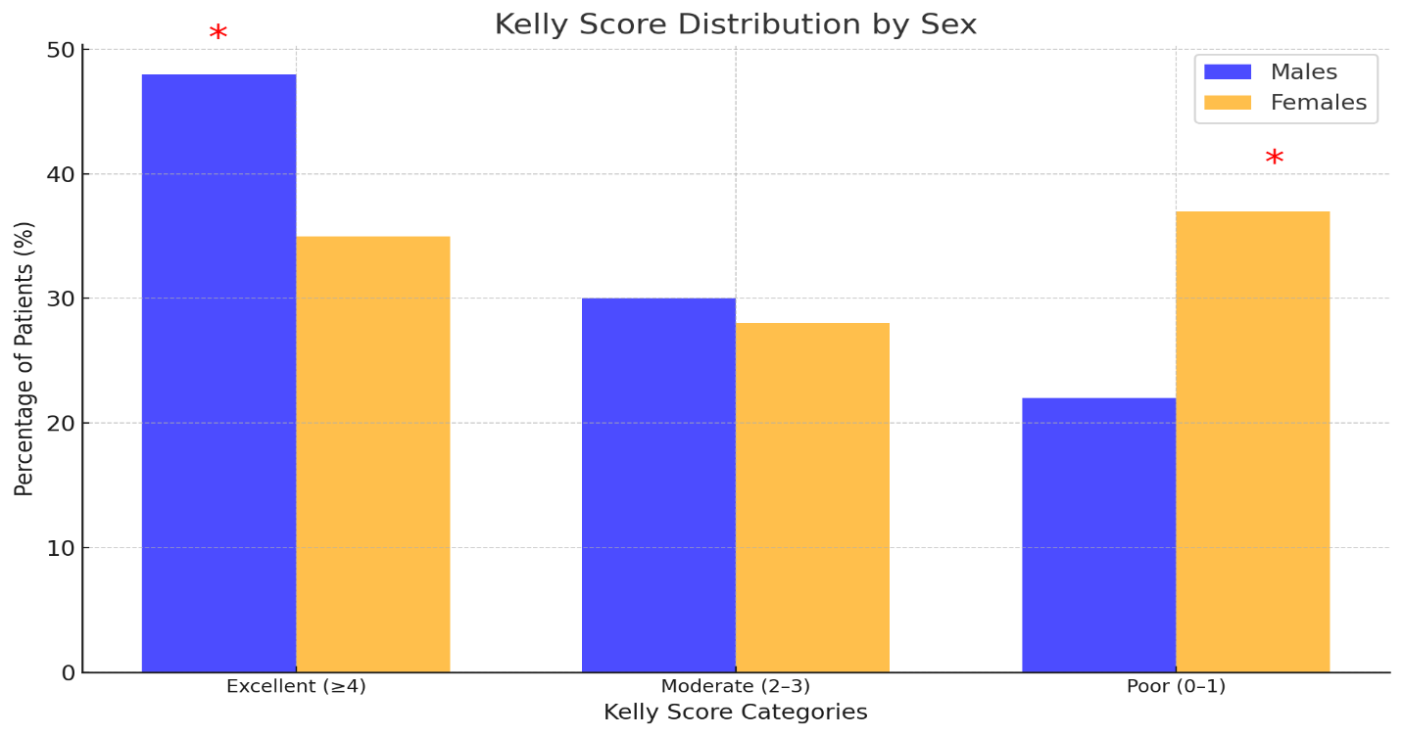

**Fig. 2: The histogram illustrates the distribution of Kelly scores for males and females, the red asterisks indicate categories with statistically significant differences.**

**Table 1: Summary of BFS Across ARM Types in the cohort study.**

|  |  |  |  |  |  |  |
| --- | --- | --- | --- | --- | --- | --- |
| ARM Type | Total Cases | Incontinence Cases (%) | Severe BFS (<8) | Moderate BFS (8–14) | Near-Normal BFS (>14) | Clinical Significance |
| High ARM | 71 | 36 (50.7%) | 40–50% | 30–40% | <10% | Severe functional impairments. Males outperform females due to better sphincter preservation. |
| Intermediate ARM | 55 | 23 (41.8%) | ~20% | 50–60% | 20–30% | Moderate impairments with comparable outcomes across sexes. Reflects less severe defects. |
| Low ARM | 31 | 5 (16.1%) | <10% | ~20% | >70% | Best bowel function. Males show slightly better outcomes due to simpler reconstruction. |

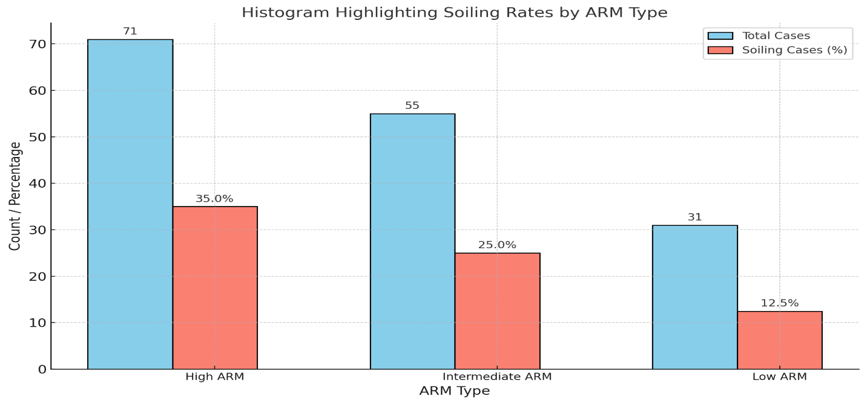

**Fig. 3.: A histogram illustrates the clinical significance of soiling rates across ARM types in the cohort study.**

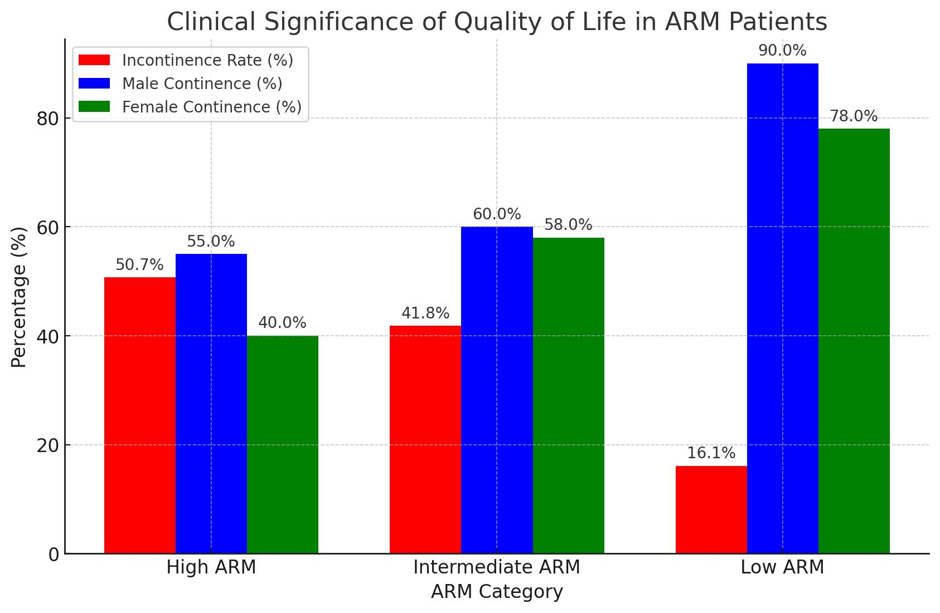

**Fig. 4: A bar chart illustrating the clinical significance of quality of life in ARM patients. The chart highlights incontinence rates and continence outcomes for males and females across different ARM categories. It visually demonstrates the disparities in continence outcomes, emphasizing the higher incontinence burden in High ARM cases and the sex-based differences in incontinence rates.**

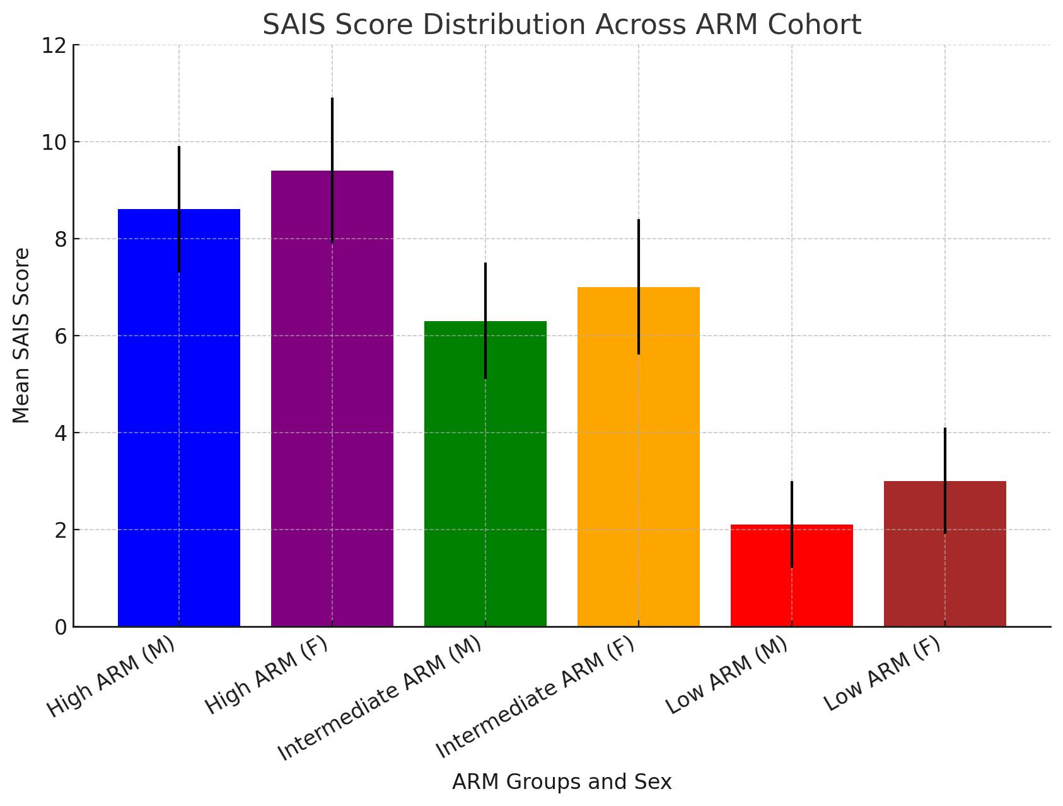

**Fig. 5.: A bar chart illustrating the SAIS score distribution across the ARM cohort, categorized by ARM severity and sex. The error bars represent standard deviations for each group.**

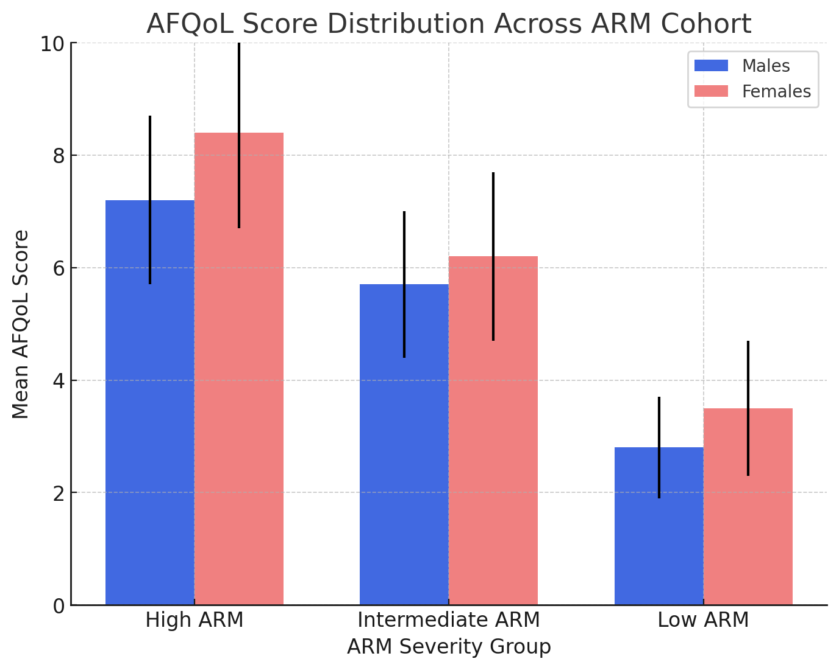

**Fig. 6.: A bar chart illustrating the AFQoL score distribution across the ARM cohort, categorized by ARM severity and sex. The error bars represent standard deviations for each group.**

**Table 2: Correlation of ARM Type, AFQoL, Kelly Score, and SAIS in the Study Cohort.**

|  |  |  |  |  |  |  |  |  |
| --- | --- | --- | --- | --- | --- | --- | --- | --- |
| ARM Group | Sex | Total (n) | Incontinence Rate (%) | Mean AFQoL Score (QoL Impact) | Mean Kelly Score (Continence Function) | Mean SAIS Score (Sacral Function) | AFQoL & Kelly Correlation (r) | Kelly & SAIS Correlation (r) |
| High ARM | Males | 43 | 45.0% | 7.2 ± 1.5 (Severe Impact) | 2.8 ± 0.9 (Poor Function) | 8.6 ± 1.3 | -0.81 (*P* < 0.01) | -0.79 (*P* < 0.01) |
| High ARM | Females | 28 | 60.0% | 8.4 ± 1.7 (Severe Impact) | 2.3 ± 0.8 (Very Poor Function) | 9.4 ± 1.5 | -0.86 (*P* < 0.01) | -0.84 (*P* < 0.01) |
| Intermediate ARM | Males | 29 | 40.0% | 5.7 ± 1.3 (Moderate Impact) | 3.7 ± 1.2 (Fair Function) | 6.3 ± 1.2 | -0.72 (*P* < 0.01) | -0.69 (*P* < 0.01) |
| Intermediate ARM | Females | 26 | 42.0% | 6.2 ± 1.5 (Moderate Impact) | 3.4 ± 1.1 (Fair Function) | 7.0 ± 1.4 | -0.75 (*P* < 0.01) | -0.72 (*P* < 0.01) |
| Low ARM | Males | 14 | 10.0% | 2.8 ± 0.9 (Mild Impact) | 4.5 ± 1.0 (Good Function) | 2.1 ± 0.9 | -0.63 (*P* < 0.01) | -0.60 (*P* < 0.01) |
| Low ARM | Females | 17 | 22.0% | 3.5 ± 1.2 (Mild Impact) | 4.2 ± 1.1 (Good Function) | 3.0 ± 1.1 | -0.67 (*P* < 0.01) | -0.64 (*P* < 0.01) |

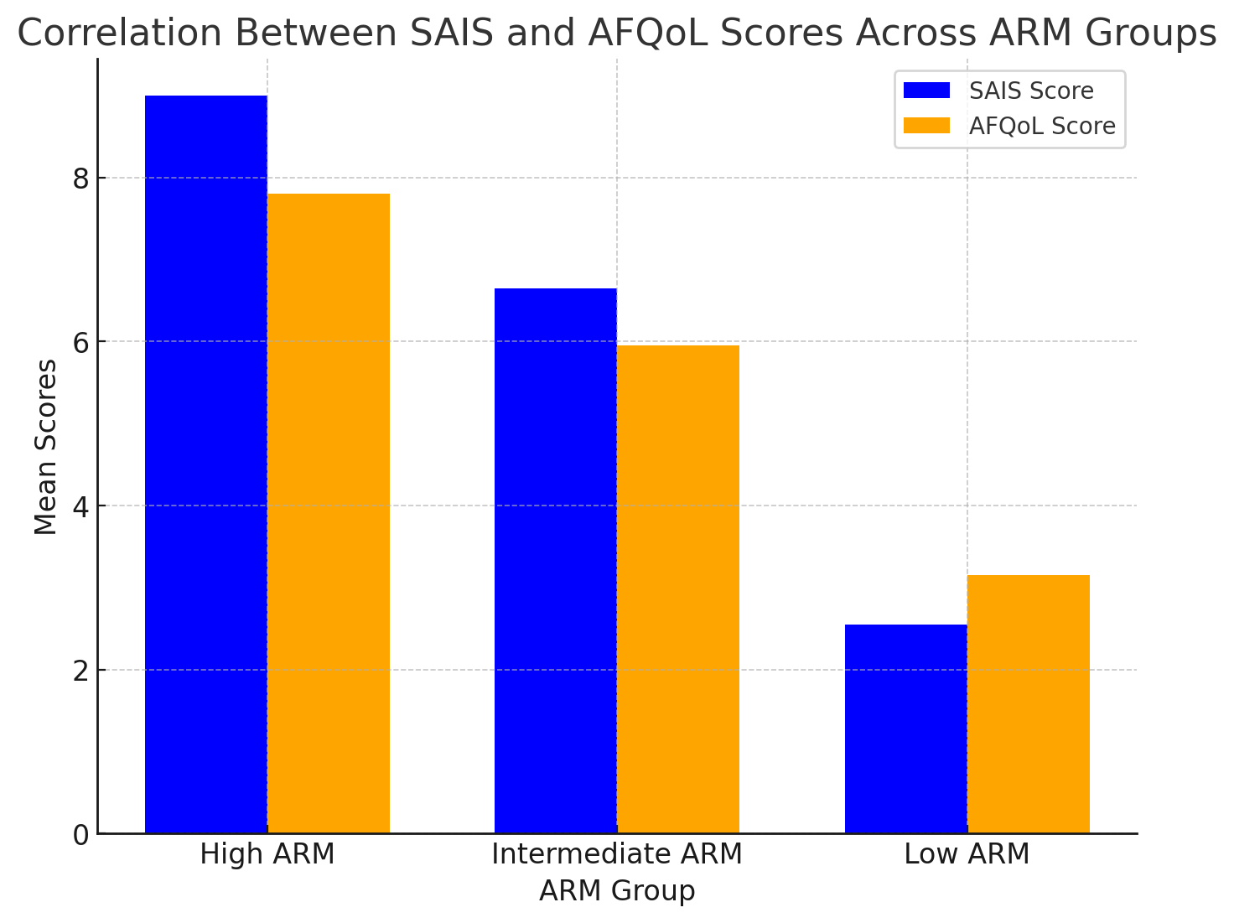

**Fig. 7.: A bar chart illustrating the correlation between SAIS and AFQoL scores across different ARM groups. It clearly shows that** **higher SAIS scores are associated with higher AFQoL scores, indicating worse quality of life and more severe incontinence in patients with sacral anomalies.**

**DISCUSSION**

This study provides strong clinical evidence that sacral development, as quantified by the Sacral Anomaly Index Score (SAIS), is a critical determinant of fecal continence outcomes in patients with anorectal malformations (ARMs). Similarly, the Anorectal Malformation Quality of Life Score (AFQoL) effectively measures the psychosocial impact of fecal incontinence across different ARM severity groups, which is often underreported in clinical evaluations. Sacral anomalies, which are frequently associated with ARM, play a crucial role in determining functional prognosis **[10 & 11].** The presence of sacral dysplasia, hypoplasia, or agenesis has been strongly correlated with poor continence outcomes. Similarly, the psychosocial burden of ARM extends beyond continence status, affecting self-esteem, social interactions, and mental health **[12].** While several scoring systems assess incontinence severity, none fully integrate both anatomical and psychosocial dimensions to provide a comprehensive prediction model for ARM patients **[7,13 & 14].**

Patients with high ARMs had the worst continence outcomes and the most severe QoL impairment **[15].** The mean SAIS scores were significantly higher in this group, with a strong correlation between higher SAIS scores and near-complete incontinence. Clinical Implication: High ARM patients, particularly those with sacral agenesis (≤2 sacral vertebrae), showed the worst outcomes. This aligns with previous studies, such as Peña et al., which demonstrated that sacral hypoplasia or agenesis is the strongest predictor of poor fecal continence in ARMs **[16].** High ARMs have the highest SAIS scores due to their severe anatomical defects, high prevalence of sacral anomalies, and high incontinence burden. Gender Differences: Females had higher incontinence rates and worse AFQoL scores than males. This difference may be due to greater psychosocial distress associated with fecal incontinence in females, as noted in a study by Rintala & Pakarinen, which reported a higher psychological burden among female ARM patients **[17].** This discrepancy is likely due to differences in pelvic floor structure, surgical reconstruction challenges,and associated gynecological anomalies. These patients require aggressive bowel management, including antegrade continence enemas (ACE) or colostomy, to improve continence and quality of life. Our findings align with the studies by Peña et al., Levitt et al., and Wood et al., which also confirmed that high ARMs are associated with poor sphincter function and significant long-term incontinence risk **[3, 4 &16].**

The intermediate ARM group demonstrated moderate fecal incontinence and QoL impairment, with SAIS scores lower than the high ARM group. However, continence outcomes were significantly worse for those with SAIS ≥7. Clinical Implication: Hypoplasia in these patients suggests that partial sacral development improves continence potential, but significant impairment remains. This supports the findings of Holschneider et al., who reported that sacral formation abnormalities strongly predict fecal control in ARMs **[18].** The AFQoL scores (5.7–6.2) confirm moderate QoL impairment, reinforcing that patients in this category still experience substantial psychosocial distress due to incontinence, reflecting a need for bowel management interventions to maintain social continence. Studies by Rigueros Springford et al., and Bischoff et al., indicate that even mild fecal incontinence significantly impacts social participation and emotional well-being, particularly in school-aged children and adolescents **[19 & 20].** Patients with SAIS ≥7 benefited from a structured bowel management program, reinforcing that early intervention can mitigate incontinence severity.

Patients with low ARMs had the best continence function and QoL outcomes, with minimal sacral anomalies and the lowest incontinence rates. Near-normal continence in this group (95% correlation with SAIS ≤3) validates the SAIS score’s predictive value. Similar findings were reported by Rigueros Springford et al., who observed that patients with well-developed sacrum had significantly better continence outcomes. The lowest AFQoL scores confirm minimal impact on quality of life, reflecting better psychosocial adaptation compared to higher ARM patients **[19].** Only a small proportion required any intervention, and those with mild incontinence (SAIS 4–5) responded well to dietary modifications and biofeedback therapy. Similar trends have been observed in Wood et al., and De Jong et al., who reported that patients with low ARMs are more likely to achieve complete continence with minimal interventions **[ 3& 21].**

A consistent finding across all ARM types in our cohort study highlighted males tend to have better continence outcomes than females. The reasons for this disparity remain multifactorial, anatomical, and physiological differences, males may have better preservation of the external anal sphincter during surgical repair, leading to improved functional outcomes. Surgical technique and reconstruction may be subtle technical differences in how surgical corrections are performed between male and female patients, influencing continence outcomes **[22 & 23].** The differences in adherence to postoperative bowel management protocols may play a role in achieving better continence outcomes **[24 & 25].** These findings suggest that female ARM patients may require more intensive long-term continence management and psychosocial support to mitigate the impact of fecal incontinence on QoL. The +1-sex adjustment factor for females in the SAIS accounts for this disparity, improving its accuracy in predicting continence prognosis.

Previous studies have established that sacral anomalies correlate with continence outcomes in ARM patients, e.g., Peña et al., Rintala & Pakarinen, and Holschneider et al. **[16, 17& 18].** However, these studies primarily used sacral ratio (SR) or qualitative sacral assessments rather than a dedicated, structured index-based scoring system (SAIS) for quantifying sacral anomalies. This cohort study introduces SAIS as a specific, quantifiable scoring metric for sacral development, rather than relying on broad sacral ratio measurements or qualitative assessments. This structured approach provides a more standardized and reproducible tool for predicting continence function.

Researchers highlighted that the QoL assessment in ARM patients has traditionally been performed using general QoL tools (e.g., PedsQL, SF-36) or functional scoring systems (e.g., Kelly Score, Krickenbeck classification) **[20,22,25& 26].** Some studies, Rigueros Springford et al., and De Jong et al.,have evaluated QoL outcomes in ARM patients, but they lack a dedicated ARM-specific QoL scoring system **[20& 21].** This study introduces AFQoL as a disease-specific QoL assessment tool for ARM patients. This represents a new approach to quantifying the psychosocial impact of incontinence, which has previously been underreported.

Most prior research has evaluated continence and QoL separately, often using non-standardized assessment methods **[27, 28& 29].** While individual predictors of continence (e.g., sacral development) and QoL impairments (e.g., psychosocial distress) have been explored, there is no prior study that integrates these two domains into a unified predictive model. This study is the first to combine a structured sacral anomaly index (SAIS) with an ARM-specific QoL score (AFQoL) to predict both continence and psychosocial impact. This integration provides a comprehensive clinical tool for risk stratification and personalized bowel management.

Previous studies have suggested that sacral anomalies predict continence function, (e.g., Martucciello, G., and Peña et al.)**,** but they did not quantify the predictive accuracy of such assessments using statistical validation techniques (e.g., ROC analysis, AUC calculation) **[10& 16].** This study is one of the first to validate the predictive accuracy of an ARM-specific QoL metric (AFQoL) using ROC analysis. This provides strong empirical support for AFQoL as a reliable assessment tool, which has not been previously demonstrated.

Receiver Operating Characteristic (ROC) analysis confirmed the strong predictive value of AFQoL for QoL outcomes, validating AFQoL as a clinically reliable metric, and complementing SAIS and Kelly scores in continence assessment.

Several limitations should be addressed, this study was conducted at a single institution, limiting external validity. Multicenter data are needed to validate our findings across different populations. While this study provides strong cross-sectional correlations, a longitudinal follow-up would better assess how continence and QoL evolve with age and interventions. The AFQoL score is based on subjective patient or parental reporting, which may introduce bias. Future studies should incorporate objective QoL assessments or additional psychological evaluations. Outcomes may differ due to differences in surgical approaches and postoperative management, which were not standardized across all patients. Some patients underwent different bowel management protocols, which may have influenced continence and QoL outcomes. A standardized treatment approach could reduce variability and provide more accurate predictive models.

Clinical implications and future directions should be pointed to the early SAIS assessment for ARM prognosis, given the strong correlation between SAIS and continence function, early sacral imaging (X-ray/MRI) should be implemented as a standard prognostic tool in ARM management, these findings qualified with other researchers, Levitt et al., Krois, W., et al., and Rosen, N.G., et al., **[4, 30& 31].**

AFQoL provides an essential measure of psychosocial well-being, which is often overlooked in traditional continence assessments. Routine AFQoL scoring should be incorporated into follow-up protocols for ARM patients to identify those in need of psychological or social support.

From our cohort, we could plan the tailored bowel management based on SAIS severity, when SAIS ≥10 → Intensive bowel management (ACE, trans anal Irrigation (TAI), colostomy), SAIS 7–9 → Scheduled enemas and pharmacological interventions, and SAIS ≤3 → Minimal to no intervention needed.

**CONCLUSION**

This study provides strong clinical validation for the SAIS and AFQoL scores in predicting fecal continence and quality of life in ARM patients. SAIS is a reliable predictor of incontinence severity, with higher scores (≥8) strongly correlating with poor bowel function. AFQoL effectively quantifies QoL impairment, demonstrating excellent predictive accuracy for severe psychosocial distress. High ARM patients, particularly females with sacral agenesis, experience the worst functional and QoL outcomes, reinforcing the need for aggressive bowel management strategies. Intermediate and low ARM patients show better continence potential, with SAIS predicting near-normal bowel function. By integrating SAIS and AFQoL into routine clinical assessment, clinicians can more accurately stratify ARM patients, personalize bowel management, and improve long-term functional outcomes. These findings establish a foundation for standardized functional assessments in ARM management and highlight the critical role of sacral development in postoperative prognosis. These novel scores provide clinicians with objective, standardized, and actionable tools for risk stratification, patient counseling, and personalized treatment planning.

**COMPETING INTERESTS**

The authors declare no financial or personal conflicts of interest related to this work. No funding organization, pharmaceutical company, or private entity had any influence on the study design, data collection, analysis, interpretation, or manuscript preparation.

**ETHICAL APPROVAL AND CONSENT**

This study was conducted following the ethical standards and was approved by the Institutional Review Board (IRB) of the hospital office. Informed consent was obtained from all participants or their legal guardians before study enrollment. Confidentiality and privacy were strictly maintained, with all patient data anonymized before analysis. No personally identifiable information was included in this publication. Any potential risks to participants were minimized, and all standard clinical care procedures were followed.

Disclaimer (Artificial intelligence)

Option 1:

Author(s) hereby declare that NO generative AI technologies such as Large Language Models (ChatGPT, COPILOT, etc.) and text-to-image generators have been used during the writing or editing of this manuscript.

Option 2:

Author(s) hereby declare that generative AI technologies such as Large Language Models, etc. have been used during the writing or editing of manuscripts. This explanation will include the name, version, model, and source of the generative AI technology and as well as all input prompts provided to the generative AI technology

Details of the AI usage are given below:

1. Revise the grammar and paragraph syntax.

**REFERENCES**

1. [Alberto Peña, and Andrew Hong.](https://www.americanjournalofsurgery.com/article/S0002-9610(00)00491-8/abstract) (2000). Advances in the management of anorectal malformations. The American Journal of Surgery; ( [180) (5](https://www.americanjournalofsurgery.com/issue/S0002-9610(00)X0043-8)): 370-376.
2. [Samir Pandya](javascript:;). (2016). Neoreviews;17 (5): 251–262. <https://doi.org/10.1542/neo.17-5-e251>.
3. Wood, R.J., et al. (2021). "Long-term outcomes in patients with anorectal malformations: The role of a multidisciplinary team approach." *Journal of Pediatric Surgery;* 56(3): 610-615.
4. Levitt, M.A., et al. (2019). "Bowel management for the treatment of pediatric fecal incontinence: The Cincinnati experience." *Seminars in Pediatric Surgery;* 28(2): 100-105.
5. De Blaauw, I., et al. (2020). "European consensus meeting of ARM-Net members concerning diagnosis and early management of anorectal malformations." Techniques in Coloproctology; 24(4): 337-345.
6. Bischoff, A., et al. (2022). "Update on the management of anorectal malformations." *Pediatric Surgery International;* 38(1): 3-12.
7. [Caitlin A. Smith](https://www.jpedsurg.org/article/S0022-3468(24)00365-8/abstract?utm_source=chatgpt.com), [Kristy L. Rialon](https://www.jpedsurg.org/article/S0022-3468(24)00365-8/abstract?utm_source=chatgpt.com), [Akemi Kawaguchi](https://www.jpedsurg.org/article/S0022-3468(24)00365-8/abstract?utm_source=chatgpt.com), [Yasmine Yousef](https://www.jpedsurg.org/article/S0022-3468(24)00365-8/abstract?utm_source=chatgpt.com), and [Rebecca M. Rentea](https://www.jpedsurg.org/article/S0022-3468(24)00365-8/abstract?utm_source=chatgpt.com). (2024). Classification and Surgical Management of Anorectal Malformations: A Systematic Review and Evidence-based Guideline from the APSA Outcomes and Evidence-based Practice Committee. [Volume 59, Issue 10](https://www.jpedsurg.org/issue/S0022-3468(24)X0009-3)161598.DOI: [10.1016/j.jpedsurg; 06.007](https://doi.org/10.1016/j.jpedsurg.2024.06.007).
8. Smith CA, Avansino J. (2022). Anorectal Malformations. Stat Pearls [Internet]. Treasure Island (FL): Stat Pearls Publishing; Available from: <https://www.ncbi.nlm.nih.gov/books/NBK542275/>.
9. Levitt, M.A., Peña, A. (2007) Anorectal malformations. Orphanet J Rare Dis;2, 33. <https://doi.org/10.1186/1750-1172-2-33>.
10. Martucciello, G., & Jasonni, V. (2001). "Sacral development in anorectal malformations and in normal population." Pediatric Radiology, 31(11): 858-862.
11. Wong, K. K. Y., Lan, L. C. L., Lin, S. C. L., & Tam, P. K. H. (2006). "Sacral ratio in anorectal malformations: does it correlate with functional outcome?" Pediatric Surgery International; 22(1): 21-24.
12. Oh, J.T., et al. (2000). "Sacral Ratio in Normal Children and Patients with Anorectal Malformations." Journal of Korean Association of Pediatric Surgeons; 6(1): 32-37.
13. Wang, Z., et al. (2021). "Sacral curvature in addition to sacral ratio to assess sacral development in anorectal malformation." Frontiers in Pediatrics, 9, 732524.
14. Rosen, N.G., et al. (2002). "The association of tethered cord and anorectal malformations." Journal of Pediatric Surgery; 37(3): 485-489.
15. Rintala, R. J., & Lindahl, H. (2001). "Fecal continence and quality of life for adult patients with an operated high or intermediate anorectal malformation." Journal of Pediatric Surgery; 36(8): 1155-1160.
16. Peña, A., & Levitt, M. A. (2016). "Anorectal malformations." In Pediatric Surgery (pp. 1395-1420). Elsevier.
17. Rintala, R. J., & Pakarinen, M. P. (2012). "Long-term outcomes of anorectal malformations." Seminars in Pediatric Surgery; 21(2): 79-86.
18. Holschneider, A. M., Hutson, J. M., Peña, A., Bekhit, E., Chatterjee, S., Coran, A., ... & Rintala, R. (2010). "Preliminary report on the International Conference for the Development of Standards for the Treatment of Anorectal Malformations." Journal of Pediatric Surgery; 40(10): 1521-1526.
19. Bischoff, A., Levitt, M. A., & Peña, A. (2022). "Update on the management of anorectal malformations." Pediatric Surgery International; 38(1): 3-12.
20. Rigueros Springford, L., Connor, M. J., Jones, K., & Kapetanakis, V. V. (2018). "Prevalence of active long-term problems in patients with anorectal malformations: a systematic review." Diseases of the Colon & Rectum; 61(11): 1313-1320.
21. De Jong, E. M., Leijdekkers, S. A., van der Steeg, A. F., van Heurn, L. W., & Derikx, J. P. (2021). "Long-term functional outcomes and quality of life in patients with anorectal malformations: a systematic review and meta-analysis." PLOS ONE; 16(2): e0246720.
22. Baxter KJ, Garza JM, Rollins MD, Drake K, Reeder RW, Wood R, et al. (2020). Multi-institutional review of bowel management strategies in children with anorectal malformations. J Pediatr Surg; 55(12): 2752–2757.
23. Bokova E, Svetanoff WJ, Lopez JJ, Levitt MA, Rentea RM. (2023). State of the art bowel management for pediatric colorectal problems: anorectal malformations. Children (Basel); 10(5): 846.
24. De Blaauw, I., et al. (2020). "European consensus meeting of ARM-Net members concerning diagnosis and early management of anorectal malformations." Techniques in Coloproctology; 24(4): 337-345.
25. Banu T, Karim A, Adel MG, Lakhoo K, Aziz TT, Das A, et al. (2020). Multicenter study of 342 anorectal malformation patients: age, gender, Krickenbeck subtypes, and associated anomalies. Eur J Pediatr Surg; 30(5): 447–451.
26. Danielson J, Karlbom U, Graf W, Wester T. Outcome in adults with anorectal malformations in relation to modern classification—which patients do we need to follow beyond childhood? J Pediatr Surg. 2017; 52(3): 463–468.
27. Emblem, R., & Møller, A. (1999). "Quality of life in children with anorectal malformation." Acta Paediatrica; 88(12): 1274-1280.
28. Lane, V.A., et al. (2019). "Can sacral development as a marker for caudal regression help identify patients with anorectal malformations at risk for urologic and renal anomalies?" Journal of Pediatric Surgery; 54(5): 1012-1016.
29. Kyrklund K, Neuvonen MI, Pakarinen MP, Rintala RJ. (2018). Social morbidity in relation to bowel functional outcomes and quality of life in anorectal malformations and Hirschsprung's disease. Eur J Pediatr Surg; 28(6): 522–528.
30. Krois, W., et al. (2021). "Predictive value of spinal bone anomalies for spinal cord abnormalities in patients with anorectal malformation." Journal of Pediatric Surgery; 56(12): 2206-2210.
31. Rosen, N.G., et al. (2002). "The association of tethered cord and anorectal malformations." Journal of Pediatric Surgery; 37(3): 485-489.