**A Review on Structures and Methods of Synthesis of ZnO NPs with a Focus on Cost-Effectiveness and Availability for Various Applications**

**Abstract**

Nanotechnology focuses on the creation and application of materials at the nanoscale, where nanoparticles exhibit unique physicochemical properties due to their high surface area-to-volume ratio. Among these, zinc oxide (ZnO) based nanomaterials have gained significant attention due to the abundance of zinc and the ease of integrating ZnO into various nanostructures. Since the advent of nanoscience, ZnO has been widely utilized in fuel cells, solar cells, water purification, and biomedical applications, existing in diverse forms such as nanoparticles, nanowires, and nanofibers. ZnO nanoparticles, in particular, have attracted extensive research interest due to their wide bandgap and exceptional exciton binding energy, which contribute to their enhanced optical, electronic, and catalytic properties. Compared to their bulk counterparts, ZnO nanoparticles offer superior performance while reducing material consumption and production costs. This review provides a comprehensive analysis of the synthesis techniques, structural characteristics, and diverse applications of ZnO nanoparticles, highlighting recent advancements and future research directions in this rapidly evolving field.

**Keywords:** ZnO, Nanoparticles, Nanotechnology, Advanced Synthesis Methods, Applications.

1. **Introduction**

Zinc oxide has been extensively studied in recent years among metal oxide nanoparticles due to its unique mechanical, optical, magnetic, and chemical properties, which significantly differ from those of its bulk counterpart[1]. Nanotechnology is currently utilized across various scientific domains. Nanoparticles (NPs) have been functionalized at the nanoscale using diverse techniques. As a broad class of materials, nanoparticles consist of particles with at least one dimension smaller than 100 nanometers[2]. ZnO nanoparticles exhibit distinct chemical and physical properties, including superior optical and chemical stability, natural abundance, paramagnetism, a broad radiation absorption range, and a high electrochemical coupling coefficient[3]. Nanostructured zinc oxide nanoparticles have attracted significant attention due to their well-established applications in photonics, optics, and electronics. Their high pyroelectric and piezoelectric properties, resulting from the absence of a center of symmetry in the wurtzite structure and their strong electromechanical coupling, make them suitable for use in piezoelectric detectors and mechanical actuators. Additionally, zinc oxide possesses a wide bandgap (3.370 eV), which is characteristic of standard compound semiconductors and enables its application in various fields. ZnO nanoparticles are employed in power generators, solar cells, ultraviolet (UV) lasers[4], gas sensors[5], photocatalysts, field emission devices, and capacitors.[6]

Additionally, ZnO can be utilized in eczema treatment, wound healing for cosmetic applications[7] , antibacterial agents, sunblock lotions, anti-hemorrhoid treatments, photo printing, electrophotography, transparent UV-resistant coatings, nanoscale electrochemical and electromechanical devices, and even in human medicine[8] .Zinc oxide powder is widely used as an additive in various materials and products, including ceramics[3] , rubber, cement, lubricants, glass, paints, adhesives, ointments, plastics, pigments, sealants, food products, ferrites, batteries, and fire retardants[4]. Furthermore, ZnO-based coatings can be applied to timber samples as a protective layer with moisture-resistant properties[9] .

The physical and chemical characteristics of zinc oxide nanoparticles can be categorized based on various factors. For instance, reducing their size alters their crystalline structure, morphology, surface area, and other properties. Several preparation techniques have been developed to achieve these modifications, including mixing[2], mechanical and chemical methods, deposition techniques[10], surfactant-assisted precipitation, sol-gel processing[11] , hydrothermal and solvothermal synthesis[12], microwave-assisted methods, microemulsion techniques[11], microwave processing, chemical vapor deposition (CVD), molecular beam epitaxy (MBE), spray techniques, laser ablation[13], and various other advanced approaches.

As far as we are aware, there are only a few review articles on zinc oxide nanoparticles, including. Given the significance of zinc oxide nanoparticles and their potential applications, the primary objective of this review article is to provide readers with a comprehensive understanding of their structure and major synthesis methods, which have not been thoroughly addressed in previous reviews. Additionally, the physical and chemical characteristics of ZnO nanoparticles are examined in greater detail. This paper further discusses key properties such as mechanical, electrochemical, electrical, and photoluminescence attributes.

* 1. **Structure of Zinc Oxide (ZnO)**

Zinc oxide nanoparticles belong to a class of materials with potential applications across various nanotechnology fields[14]. These nanoparticles exist in one-, two-, and three-dimensional structures. The one-dimensional structures include spirals, belts, combs, wires, rings, springs, needles, ribbons, nanorods, and tubes. The two-dimensional structures consist of nanoplates and nanosheets that contribute to zinc oxide formation. In contrast, the three-dimensional structures of zinc oxide encompass forms such as mushrooms, thorny flowers, conical formations, and snowflakes. Zinc oxide is a material that exhibits a remarkably diverse range of particle morphologies[15]. Additionally, Figure 1 illustrates the various forms and structures of zinc oxide.

* 1. **Crystallographic Structure of Zinc Oxide**

The two primary crystal structures of zinc oxide are the hexagonal wurtzite and the cubic zinc blende. Under ambient conditions, the wurtzite structure is the most stable and commonly observed form. As illustrated in Figure 2, zinc oxide crystallizes in the B4-type wurtzite structure at standard temperature and pressure. This structure belongs to the hexagonal crystal system and is classified under the space group P6₃mc. It consists of two interpenetrating lattices of O²⁻ and Zn²⁺ ions, where each zinc ion is tetrahedrally coordinated with oxygen ions, and vice versa. This tetrahedral coordination results in polar symmetry along the hexagonal axis, contributing to the unique physicochemical properties of ZnO[16]. This polarity is crucial for zinc oxide’s spontaneous polarization and piezoelectric properties. Additionally, it plays a subtle yet significant role in etching, defect formation, and crystal growth. The wurtzite structure of zinc oxide includes both polar and non-polar facets. The non-polar facets consist of (11,02) (a-axis) and (10,1), while the polar terminations include the Zn-terminated (0001) and oxygen-terminated (O) (000.1) surfaces. Generally, these non-polar surfaces can accommodate an equal number of oxygen and zinc atoms. However, the oxygen-terminated (O) facet exhibits a significantly altered electronic structure compared to the other three O-terminated surfaces. As a result, the polar facets possess distinct physical and chemical properties[10].

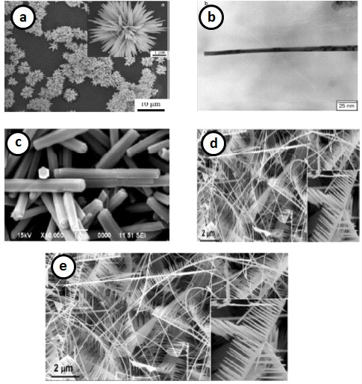

Figure 1 shows several zinc oxide forms and architectures, including (a) flowers[17], (b) wire[11], (c, d) rods and mushrooms[18], and (e) combs[19].

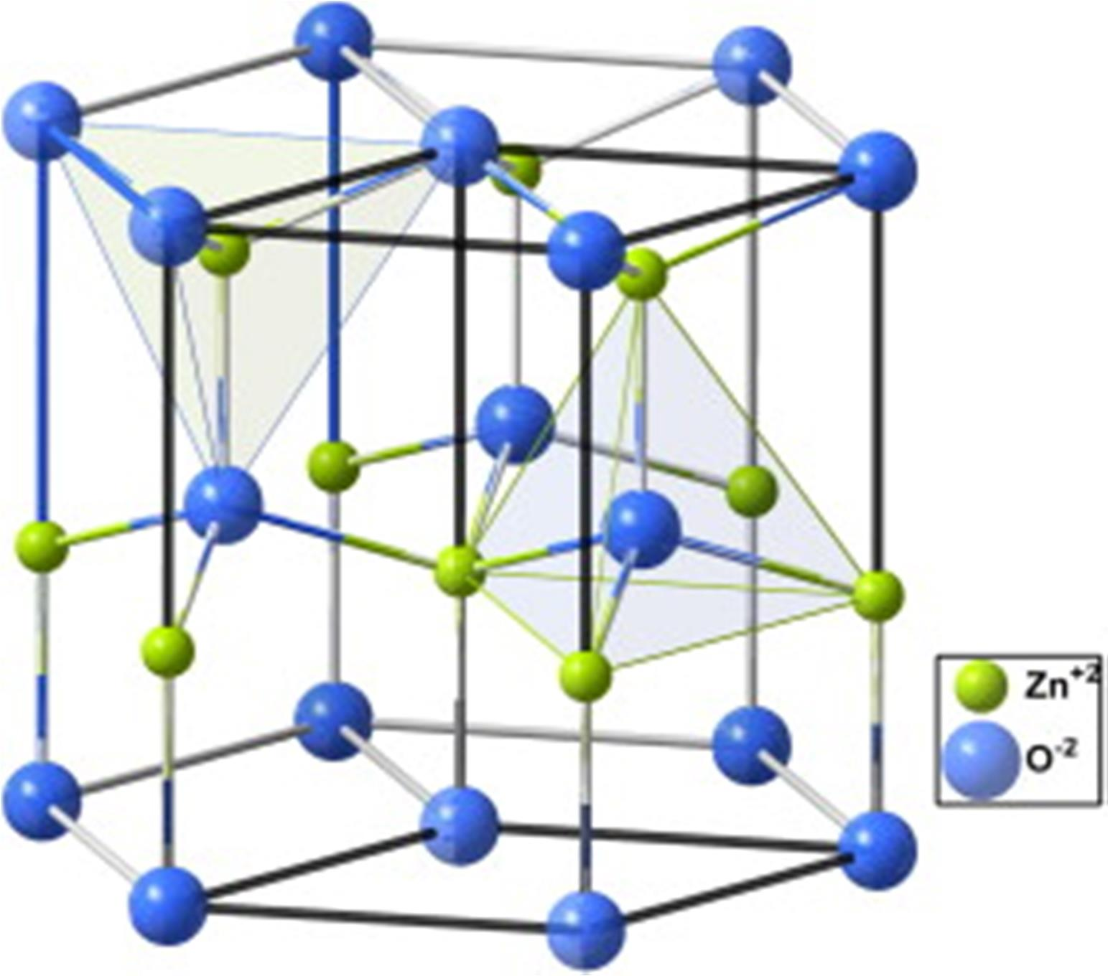

Figure 2: Zinc oxide nanoparticles' crystal structure[11].

1. **Methods for Synthesizing Zinc Oxide Nanoparticles**

To synthesize zinc oxide nanoparticles efficiently and cost-effectively, three primary methods are used: (1) Solid-phase techniques, including mechanochemical processes and mechanical milling; (2) Liquid-phase techniques, such as wire explosion, laser ablation, and solution breakdown and reduction; (3) Gas-phase techniques, including chemical bath deposition (CBD), green synthesis, wet chemical approaches [38], wire explosion, gas evaporation, spark discharge, and laser ablation[6].

* 1. **Chemical Synthesis of Zinc Oxide Nanoparticles**

Mechanochemistry is the study of heated or extremely rapid chemical reactions between solids or between solids and adjacent gaseous or liquid molecules under mechanical stress. It involves mechanical fragmentation and chemical activation of strained solids, as well as the interaction of mechanical and chemical effects at the molecular level. However, ball milling and mechanochemical synthesis are distinct processes. Traditional ball milling, conducted in an inert environment, primarily reduces particle size, leading to the formation of nano-sized grains within micro-sized particles. During mechanochemical treatment, a displacement solid-state reaction initiates during the ball milling process, leading to a reduction in nanoparticle size to approximately 5 nm, which remains stable during the large-particle manufacturing phase[20]. Ao et al. [21] predicted the synthesis of nanoparticles through mechanochemical processing. They synthesized a zinc oxide crystal with a size of 21 nanometers. During the six-hour milling process, a zinc oxide precursor was used to produce ZnCO₃. However, upon calcination at 600°C, the precursor transformed into a hexagonal zinc oxide structure. Research findings indicate that variations in milling time and calcination temperature significantly influence the crystallite size of zinc oxide nanoparticles. The crystallite size decreased from 25 to 21.5 nm as the milling duration increased from 2 to 6 hours, suggesting the presence of a critical limit. Conversely, when the calcination temperature increased from 400 to 800°C, the crystallite size expanded from 18 to 35 nm. This mechanical technique offers several advantages, including finer particle size, higher manufacturing purity, faster reaction rates, and a unique microreaction mechanism[22].

* + 1. **Sol-Gel Method**

In the sol-gel process for nanoparticle synthesis, an inorganic compound is formed through a chemical reaction in a solution. This method is significant due to its advantages, including high thermal stability, enhanced solution resistance, superior mechanical stability, and the potential for transformation simulation. Roodi and colleagues[23]. successfully synthesized zinc oxide nanoparticles using the sol-gel method followed by calcination. In this study, the crystalline structure, including particle size and morphology, was analyzed to confirm the formation of zinc oxide nanoparticles. The results indicated that the optimal conditions for nanoparticle synthesis were a pH of 10 and a sonication time of 60 minutes. The synthesized nanoparticles exhibited a purity of 87.31% and an average particle size of approximately 50 nm . The sol-gel method offers several advantages, including lower processing temperatures, exceptionally high purity levels, precise control over impurity concentrations, and the ability to produce multi-component compounds in various morphological forms[24].

* + 1. **Hydrothermal Method**

The hydrothermal method eliminates the need for organic solvents and additional steps such as calcination and grinding, making it a simple and sustainable approach. This technique requires an autoclave chamber, where the substrate mixture is gradually heated to temperatures between 100 and 300°C and maintained for an extended period. As the solution cools, crystal nuclei form and grow. The hydrothermal method offers several advantages, including its applicability at low temperatures and the ability to control crystal size and shape by adjusting the mixture composition, process temperature, and pressure. Moezzi et al.[4] successfully synthesized zinc oxide nanoparticles in the form of nanotubes using a hydrothermal method with Zn(NO₃)₂ as the precursor. The resulting zinc oxide nanotubes had an outer diameter of approximately 200 nm and a length of about 2.4 µm [44]. One significant advantage of the hydrothermal process over other nanoparticle synthesis techniques is its ability to produce crystalline phases that are unstable at their melting temperatures. Additionally, this method is highly efficient for developing materials with high vapor pressures near their melting temperatures[19].

* + 1. **Liquid-Phase Method**

Pulsed Laser Deposition (PLD) is an excellent synthesis technique for producing nanoparticles with small diameters and minimal impurity levels. The laser-based method for generating nanoparticles (NPs) from a target immersed in a liquid involves three well-established processes. Yoshitaka demonstrated how the morphological phase influences the control of zinc oxide crystals using a simple aqueous solution method. At 50°C, zinc oxide nanotubes with lengths of 50 micrometers and diameters of approximately 100 nanometers were successfully synthesized[10].

Compared to gas-phase and solid-phase synthesis methods, liquid-phase synthesis is one of the most widely used techniques for producing nanoparticles (NPs) and nanostructured materials. In addition to gas-phase synthesis, the liquid-phase approach enables precise control over the size and shape of the final nanoparticles within a short timeframe, ranging from a few minutes to several hours, and at relatively low temperatures[25].

* + 1. **Precipitation Method**

Zinc nitrate and urea serve as precursors in this process for synthesizing zinc oxide (ZnO). A typical synthesis procedure involves dissolving **0.5 M (4.735 g)** of zinc nitrate **(Zn(NO₃)₂⋅6H₂O)** in **50 mL** of distilled water under continuous stirring for **30 minutes** to ensure complete dissolution. Simultaneously, **1 M (3.002 g)** of urea is dissolved in **50 mL** of distilled water with constant stirring for **30 minutes**, acting as the precipitating agent. To facilitate the formation of ZnO nanoparticles, the urea solution is added dropwise to the zinc nitrate solution under vigorous stirring at **70°C** for **two hours**, ensuring complete nanoparticle formation.

The resulting precipitate gradually adopts an opaque, white appearance. To eliminate any potential contaminants or adsorbed ions, the white precursor product is subjected to centrifugation at **8,000 rpm for 10 minutes**, followed by thorough washing with distilled water. The purified product is then **calcined in a muffle furnace at 500°C for three hours** under an air atmosphere to enhance crystallinity and remove residual organic compounds[23]. The complete sequence of chemical reactions involved in this process is illustrated in the flowchart diagram **(Figure 3**).

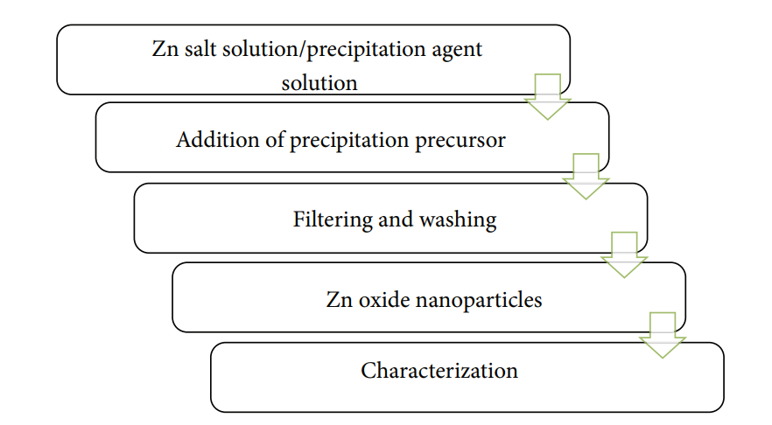

Figure 3: Precipitation method

* + 1. **Vapor Transport Method**

The vapor transfer method is a widely recognized technique for synthesizing zinc oxide nanoparticles. Based on the mechanism of nanostructure formation, it can be classified into two main categories: catalyst-assisted vapor-liquid-solid (VLS) and catalyst-free vapor-solid (VS) processes. In general, the vapor-solid method enables the large-scale fabrication of nanostructures such as nanowires, nanobelts, and nanorods. Kong et al.[11] successfully synthesized composite zinc oxide nanostructures, including nanobelts and nanohelices, using a conventional vapor-solid approach. The resulting nanostructures exhibited belt-like morphologies with widths ranging from 10 to 60 nanometers, thicknesses between 5 and 20 nanometers, and lengths extending to several hundred micrometers. Such processes involve the synthesis of zinc oxide nanoparticles (NPs) through the interaction of volatile zinc vapor with oxygen or oxygen-containing vapors. Various methods can be employed to generate zinc and oxygen vapors. The thermal decomposition of zinc oxide is a straightforward and direct approach; however, it requires high temperatures to proceed effectively[20]. In the vapor-solid method, direct condensation in the vapor phase leads to the formation of NP structures. While this technique enables the fabrication of different NP architectures, it offers limited control over the morphology, organization, and precise positioning of zinc oxide nanostructures. The T519 and W528 nanobelts exhibit geometric dimensions of 519 nm and 528 nm, respectively.

The synthesis of one-dimensional, high-purity single crystals through directed growth along the lowest energy pathway, driven by favorable orientation and low-energy surfaces, highlights the significant advantages of the vapor transport method. Consequently, low-index nanoparticles (NPs) play a crucial role in the formation of crystallographic planes.

* + 1. **Chemical Reaction of Zinc Acetate Dihydrate and NaOH**

In this procedure, **0.02 M aqueous zinc acetate dihydrate** is dissolved in **50 mL of distilled water** under vigorous stirring. A **2.0 M aqueous NaOH solution** is then added dropwise until the **pH reaches 12** at room temperature. The mixture is subsequently stirred using a magnetic stirrer for **two hours** to ensure the completion of the reaction. The resulting **white precipitate** is thoroughly washed with **distilled water and ethanol** to eliminate any residual impurities. The purified product is then **dried overnight in a hot air oven at 60°C**, facilitating the complete conversion of **Zn(OH)₂ into ZnO nanoparticles (ZnO NPs)**[25].

* + 1. **Disadvantages of Chemical Synthesis of (ZnO NPs**)

Certain harmful substances tend to adsorb onto the surface of **ZnO nanoparticles (ZnO NPs)** synthesized via chemical methods such as **chemical precipitation, hydrothermal synthesis, pyrolysis, and chemical vapor deposition**. These contaminants can pose significant risks, particularly in **medical applications**. Moreover, many of these chemical synthesis methods require **high temperatures, elevated pressures, or inert atmospheres** to proceed efficiently. Additionally, some processes involve the use of **toxic substances**, including **H₂S, hazardous templates, and metallic precursors**. The **chemicals used for nanoparticle synthesis and stabilization** can also be toxic, leading to adverse environmental and biological effects[26].

* 1. **Green Synthesis of Zinc Oxide Nanoparticles**

**Plant-based nanoparticle synthesis** is an integral part of **green synthesis approaches**, which emphasize the use of **environmentally benign** and **non-toxic chemicals** for nanostructure fabrication. These methods promote the utilization of **eco-friendly solvents**, such as **water and natural plant extracts**, reducing the reliance on hazardous reagents. By minimizing environmental pollution and ensuring biocompatibility, **green synthesis** provides a sustainable alternative for nanoparticle production[15].

Therefore, **biological approaches**, including the use of **microorganisms** and **plants or plant extracts**, have been proposed as **safe alternatives** to conventional **chemical synthesis methods** for the production of metal nanoparticles. Various **biological systems**, such as **yeast, fungi, and bacteria,** have been successfully utilized in the **biogenic synthesis** of nanoparticles. However, the use of microorganisms in nanoparticle synthesis presents **significant challenges,** as it involves a **complex process** requiring **strict cell culture maintenance, intracellular nanoparticle production, and multiple purification steps** to obtain the final product[19].

* + 1. **Advantages of Green Synthesis of Nanoparticles**

Due to the high costs and environmental hazards associated with traditional chemical procedures involving chemical compounds and organic solvents as reducing agents, there has been a significant shift towards 'green' methods for nanoparticle synthesis in recent years[27].

Green chemistry aims to prevent waste rather than manage or clean it up after production, thereby reducing contamination risks at the source. The selection of eco-friendly reagents is central to this approach. Biogenic processes offer a superior and environmentally benign alternative for nanoparticle production despite physical and chemical methods being faster and simpler[28].

* + 1. **By Using Leaf Extract of Coriandrum sativum**

The leaf extract of Coriandrum sativum can be utilized for the synthesis of ZnO nanoparticles (ZnO NPs). In this process, 0.02 M aqueous zinc acetate dihydrate is dissolved in 50 mL of distilled water under continuous stirring. After ten minutes of stirring, varying volumes of Coriandrum sativum aqueous leaf extract (0.25, 0.5, and 1 mL) are added to the solution. To adjust the pH to 12, 2.0 M NaOH is introduced, resulting in the formation of a light white aqueous solution. The mixture is then subjected to magnetic stirring for two hours to complete the reaction.

After stirring, the pale white precipitate is separated and repeatedly washed with distilled water, followed by ethanol, to remove any impurities. The purified precipitate is then dried at 60°C in a vacuum oven overnight, resulting in the formation of a pale white powder of ZnO nanoparticles[19].

* + 1. **Utilization of *Calotropis gigantea* Leaf Extract**

Zinc oxide nanoparticles (ZnO NPs) can be synthesized using Calotropis gigantea leaf extract. Initially, 50 mL of the leaf extract is heated to a temperature between 60 and 80°C using a stirrer-heater or hot plate. Once the temperature reaches 60°C, five grams of zinc nitrate are added to the solution. The mixture is then continuously heated until it reduces to a bright yellow paste. This paste is transferred to a ceramic crucible and calcined at 400°C for two hours in a furnace. The heating process yields a light-yellow powder, which is carefully collected and stored for further analysis. To achieve a finer consistency suitable for analysis, the material is ground using a mortar and pestle[28].

* + 1. **By Using Leaf Extract of Acalypha indica**

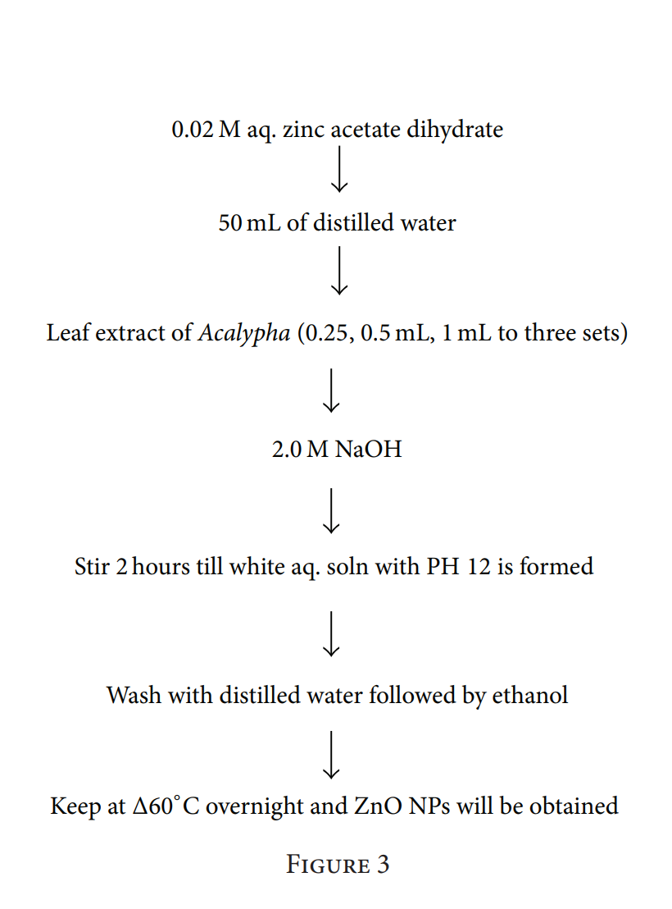First, fresh Acalypha indica leaves are collected and thoroughly washed with double-distilled water. The leaves are then ground, and the extract is filtered using Whatman filter paper. The precursor materials used in the synthesis include sodium hydroxide (pellet, 99% purity) and zinc acetate dihydrate (99% purity). Zinc acetate dihydrate is dissolved in distilled water under vigorous stirring. After ten minutes of stirring, the aqueous leaf extract of Acalypha indica is added to the solution, followed by the addition of 2.0 M aqueous NaOH. The process results in a white aqueous solution with a pH of 12, where the pH of the medium plays a crucial role in determining the size of the ZnO nanoparticles. The mixture is then subjected to magnetic stirring for two hours. To ensure the removal of any impurities, the precipitates are collected and thoroughly washed multiple times with ethanol and distilled water. Finally, the purified precipitates are dried in a vacuum oven overnight at 60°C, yielding a white powder of ZnO nanoparticles[1].

Figure 4 presents a schematic illustration of the synthesis process

* + 1. **By Using Rice as a Soft Bio-template**

Oryza sativa (rice) is an abundant and renewable bioresource with unique properties, making it a suitable bio-template for synthesizing various functional nanomaterials. ZnO particles can be synthesized using the hydrothermal bio-template approach by employing zinc acetate, sodium hydroxide, and uncooked rice flour in different ratios as precursor materials. The reaction is carried out at 120°C for 18 hours to facilitate the formation of ZnO nanoparticles[24].

1. **Zinc Oxide Nanostructures and Their Physical Properties**

The physical properties of zinc oxide nanoparticles vary significantly. It is important to note that several physical characteristics are influenced by quantum size effects, which occur when the dimensions of semiconductor materials are progressively reduced to the nanometer scale or smaller. For instance, optical absorption studies have shown that the bandgap energy of quasi-one-dimensional (Q1D) zinc oxide increases due to quantum confinement. Quantum confinement refers to the modification of electrical and optical properties that occurs when a material is reduced to nanoscale dimensions, typically below 10 nanometers. As the size of a nanostructure decreases, its bandgap energy increases due to quantum confinement effects. This phenomenon results in the spatial confinement of electrons and holes within dimensions comparable to a fundamental quantum parameter known as the exciton Bohr radius[29].

Understanding the fundamental physical properties is essential for designing functional devices. A thorough investigation is necessary to explore the potential applications of zinc oxide nanoparticles as fundamental components in nanoscale optoelectronic devices. This review aims to provide a comprehensive overview of previous studies on the mechanical, electrical, magnetic, and luminescent properties of zinc oxide nanoparticles[30].

1. **Applications of ZnO (NPs)**

Due to their unique chemical and physical properties, zinc oxide nanoparticles (NPs) have a wide range of potential applications across various fields. From medicine and agriculture to paints, chemicals, rubber, and ceramics, zinc oxide plays a crucial role in numerous industries. The global utilization of zinc oxide nanoparticles across different application areas is illustrated in Figure 5[31].

* 1. **Agricultural Applications of ZnO (NPs)**

Zinc oxide nanoparticles (NPs) have been shown to enhance the growth rate of food crops. Treatment with varying concentrations of zinc oxide nanoparticles has led to improved seed germination, increased vigor, and overall enhanced plant development. Notably, these nanoparticles have been found to effectively promote both stem and root formation [69]. Paul and Ban [70] further explored the significance of zinc oxide nanoparticles in the field of biotechnology. Paul and Ban [70] examined the impact of zinc oxide nanoparticles on biological systems. Additionally, various concentrations of zinc oxide have been utilized to combat diseases caused by pathogens such as Pseudomonas aeruginosa, Bacillus species, Streptococcus pneumoniae, and E. coli. Studies indicate that higher concentrations of zinc oxide nanoparticles significantly enhance enzymatic activity. Figure 5[32]provides an overview of the diverse sectors in which zinc oxide nanoparticles have been applied.

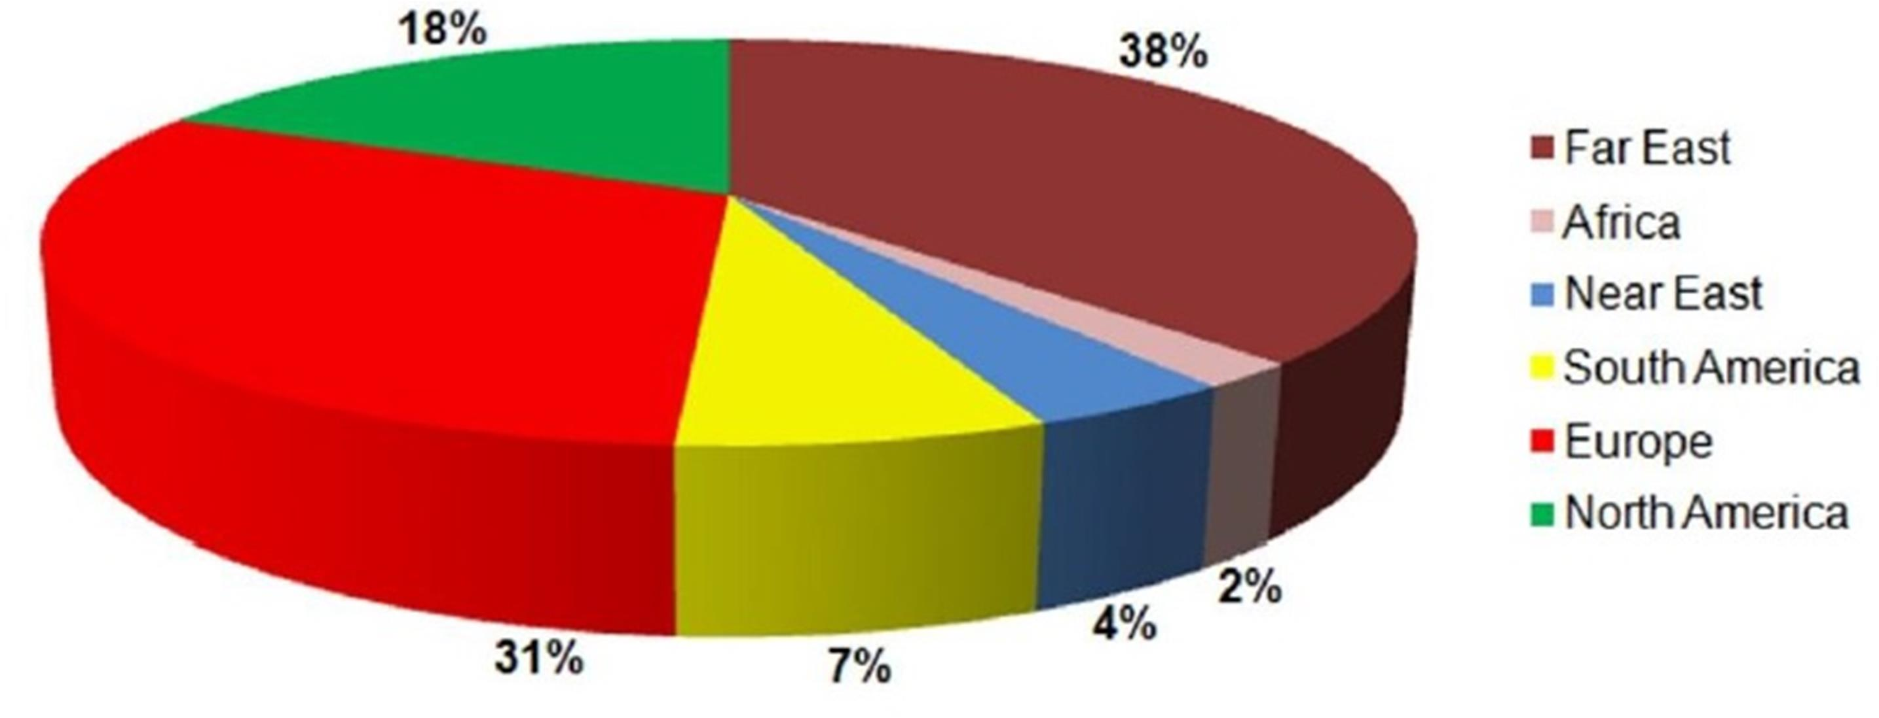

Figure 5 illustrates the global consumption of zinc oxide nanoparticles across various application areas[4].

* 1. **Medicinal Applications of ZnO (NPs)**

The unique properties of zinc oxide nanoparticles make them suitable for applications related to the central nervous system (CNS) and may contribute to disease treatment through mechanisms such as **modulating neuronal excitation** and **regulating neurotransmitter release[33]**. Several studies have demonstrated that zinc oxide not only interacts with tissues, cells, and physiological processes but also plays a role in brain tissue engineering and biocompatibility[35].

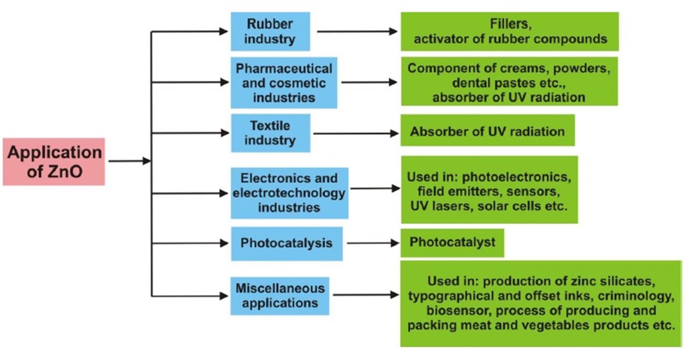

Figure 6 presents a schematic representation of the diverse applications of zinc oxide as discussed in this paper[34].

1. **Conclusion**

Zinc oxide nanoparticles (NPs) represent a highly functional and versatile material with exceptional properties, offering remarkable potential for future applications in electronic, magnetoelectronic, and optoelectronic devices. This review has comprehensively examined zinc oxide NPs from the perspectives of synthesis, structure, and applications. Based on the studies assessed, zinc oxide NPs can be synthesized through various approaches, primarily categorized into metallurgical and chemical methods. In metallurgical processes, zinc oxide NPs are obtained by burning suitable zinc ores through direct or indirect procedures.

This study highlights that zinc oxide NPs serve as fundamental building blocks for a wide range of devices and numerous applications. The findings suggest that continuous research and development efforts are essential to achieving large-scale structural designs for advanced and sustainable architectures. Consequently, the significance of zinc oxide NPs will continue to grow, driving the development of novel applications and expanding their technological relevance.

Disclaimer (Artificial intelligence)

Option 1:

Author(s) hereby declare that NO generative AI technologies such as Large Language Models (ChatGPT, COPILOT, etc.) and text-to-image generators have been used during the writing or editing of this manuscript.

Option 2:

Author(s) hereby declare that generative AI technologies such as Large Language Models, etc. have been used during the writing or editing of manuscripts. This explanation will include the name, version, model, and source of the generative AI technology and as well as all input prompts provided to the generative AI technology

Details of the AI usage are given below:

1.

2.

3.

The authors hereby declare that **NO** generative AI technologies, such as Large Language Models (ChatGPT, COPILOT, etc.), and text-to-image generators have been used during the writing or editing of this manuscript.

**References**

1. A. Król, P. Pomastowski, K. Rafińska, V. Railean-Plugaru, and B. Buszewski, Zinc oxide nanoparticles: Synthesis, antiseptic activity and toxicity mechanism, Advances in Colloid and Interface Science, vol. 249, pp. 37–52, 2017.
2. S. Fakhari, M. Jamzad, and H. Kabiri Fard, Green synthesis of zinc oxide nanoparticles: a comparison,Green Chemistry Letters and Reviews, vol. 12, no. 1, pp. 19–24, Jan. 2019. doi: 10.1080/17518253.2018.1547925.
3. E. K. Droepenu, B. S. Wee, S. F. Chin, K. Y. Kok, and M. F. Maligan, Zinc oxide nanoparticles synthesis methods and its effect on morphology: A review, Biointerface Res. Appl. Chem, vol. 12, pp. 4261–4292, 2022.
4. E. L. Irede et al., Cutting-edge developments in zinc oxide nanoparticles: synthesis and applications for enhanced antimicrobial and UV protection in healthcare solutions, RSC Advances, vol. 14, no. 29, pp. 20992–21034, 2024.
5. M. Y. Al-darwesh, S. S. Ibrahim, and M. A. Mohammed, A review on plant extract mediated green synthesis of zinc oxide nanoparticles and their biomedical applications, Results in Chemistry, p. 101368, 2024.
6. A. Badri, S. El Ghali, I. Alvarez-Serrano, K. Hemden, F. Aloui, and M. Gassoumi, Chenopodium exsuccum plant extract for green zinc oxide nanoparticles synthesis: Photocatalytic titan yellow degradation and antioxidant and antibacterial properties, Inorganic Chemistry Communications, vol. 172, p. 113724, 2025.
7. A. Kamal et al., Green Synthesis of Zinc Oxide Nanoparticles, Characterization and Its Applications in Inducing Disease Resistance Against Spot Blotch Disease in Wheat by Enhancing Its Physiological and Biochemical Parameters, Journal of Crop Health, vol. 77, no. 1, p. 5, Feb. 2025. doi: 10.1007/s10343-024-01088-3.
8. A. K. Mandal et al., Current research on zinc oxide nanoparticles: synthesis, characterization, and biomedical applications, Nanomaterials, vol. 12, no. 17, p. 3066, 2022.
9. S. Saqib et al., Catalytic potential of endophytes facilitates synthesis of biometallic zinc oxide nanoparticles for agricultural application, Biometals, vol. 35, no. 5, pp. 967–985, Oct. 2022. doi: 10.1007/s10534-022-00417-1.
10. M. Bandeira, M. Giovanela, M. Roesch-Ely, D. M. Devine, and J. da Silva Crespo, Green synthesis of zinc oxide nanoparticles: A review of the synthesis methodology and mechanism of formation,Sustainable Chemistry and Pharmacy, vol. 15, p. 100223, 2020.
11. S. G. Bekele, D. D. Ganta, and M. Endashaw, "Green synthesis and characterization of zinc oxide nanoparticles using Monoon longifolium leave extract for biological applications, Discov. Chem., vol. 1, no. 1, p. 5, Jul. 2024. doi: 10.1007/s44371-024-00007-9.
12. J. A. A. Abdullah, A. Guerrero, and A. Romero, Efficient and Sustainable Synthesis of Zinc Salt-Dependent Polycrystal Zinc Oxide Nanoparticles: Comprehensive Assessment of Physicochemical and Functional Properties, Applied Sciences, vol. 14, no. 5, p. 1815, 2024.
13. A. S. El-Gebaly, A. R. Sofy, A. A. Hmed, and A. M. Youssef, "Green synthesis, characterization and medicinal uses of silver nanoparticles (Ag-NPs), copper nanoparticles (Cu-NPs) and zinc oxide nanoparticles (ZnO-NPs) and their mechanism of action: A review, Biocatalysis and Agricultural Biotechnology, vol. 55, p. 103006, 2024.
14. M. S. Rahman, M. A. H. Suvo, M. T. Islam, N. Yeachin, and M. A. Bhuiyan, "Fast and efficient removal of metronidazole from aqueous solution using graphene oxide (GO) supported nitrogen (N) doped zinc oxide (ZnO) nanoparticles, Colloids and Surfaces A: Physicochemical and Engineering Aspects, vol. 690, p. 133660, 2024.
15. R. C. Serejo et al., An Innovative Green Eco-Friendly Method for the Synthesis of Zinc Oxide (ZnO) Nanoparticles Using Plinia cauliflora Extract, Journal of the Brazilian Chemical Society, vol. 35, no. 11, p. e-20240097, 2024.
16. M. Fakhar-e-Alam et al., Antitumor activity of zinc oxide nanoparticles fused with green extract of Nigella sativa," *Journal of Saudi Chemical Society, vol. 28, no. 2, p. 101814, 2024.
17. N. M. Shamhari, B. S. Wee, S. F. Chin, and K. Y. Kok, Synthesis and Characterization of Zinc Oxide Nanoparticles with Small Particle Size Distribution, Acta Chimica Slovenica, vol. 65, no. 3, 2018. Accessed: Feb. 07, 2025. [Online]. Available: <https://www.researchgate.net/profile/Wee-Boon-Siong/publication/326414272_Synthesis_and_Characterization_of_Zinc_Oxide_Nanoparticles_with_Small_Particle_Size_Distribution/links/5ba8ca0fa6fdccd3cb6e9f9c/Synthesis-and-Characterization-of-Zinc-Oxide-Nanoparticles-with-Small-Particle-Size-Distribution.pdf>
18. E. S. Ali, S. A. Issa, H. M. Zakaly, N. T. El-Shamy, H. A. Saudi, and D. E. Abulyazied, Exploration of optical and gamma radiation shielding characteristics of zinc oxide nanoparticles doped functionalized multi-walled carbon nanotubes nanohybrids based polyaniline ternary nanocomposites, Diamond and Related Materials, vol. 143, p. 110882, 2024.
19. M. U. Rashid et al., Green Synthesis and Characterization of Zinc Oxide Nanoparticles Using Citrus limetta Peels Extract and Their Antibacterial Activity Against Brown and Soft Rot Pathogens and Antioxidant Potential, Waste Biomass Valor, vol. 15, no. 6, pp. 3351–3366, Jun. 2024. doi: 10.1007/s12649-023-02389-w.
20. A. U. Khan, N. Malik, B. Singh, N. H. Ansari, M. Rehman, and A. Yadav, Biosynthesis, and characterization of Zinc oxide nanoparticles (ZnONPs) obtained from the extract of waste of strawberry, J.Umm Al-Qura Univ. Appll. Sci., vol. 9, no. 3, pp. 268–275, Sep. 2023. doi: 10.1007/s43994-023-00038-5.
21. Nataraj K., Murali M., Satish A., and Amruthesh K.N., "Structural characterization and biological properties of novel biosynthesized zinc oxide nanoparticles from the giant potato plant Ipomoea mauritiana Jacq., Biomass Conv. Bioref., vol. 15, no. 1, pp. 399–408, Jan. 2025. doi: 10.1007/s13399-023-05091-y.
22. A. V. Blinov et al., Synthesis and characterization of zinc oxide nanoparticles stabilized with biopolymers for application in wound-healing mixed gels, Gels, vol. 9, no. 1, p. 57, 2023.
23. S. Nazneen and S. Sultana, Green Synthesis and Characterization of Cissus quadrangularis. L stem mediated Zinc Oxide Nanoparticles, Plant Science Archives, vol. 1, no. 05, 2024. Accessed: Feb. 07, 2025. [Online]. Available: <https://plantarc.com/wp-content/uploads/2024/02/Green-Synthesis-and-Characterization-of-Cissus-quadrangularis.-L-stem-mediated-Zinc-Oxide-Nanoparticles-2.pdf>
24. A. Masood et al., Synthesis and Characterization of Cadmium Doped Zinc Oxide Nanoparticles for Visible Light Driven Catalytic Removal of MB and RhB Dye: Experimental and Computational Analysis, J Inorg Organomet Polym, vol. 33, no. 7, pp. 1841–1854, Jul. 2023. doi: 10.1007/s10904-023-02618-8.
25. A. E. Alprol, A. T. Mansour, H. S. El-Beltagi, and M. Ashour, Algal extracts for green synthesis of zinc oxide nanoparticles: promising approach for algae bioremediation, Materials, vol. 16, no. 7, p. 2819, 2023.
26. X.-Q. Zhou et al., Zinc oxide nanoparticles: synthesis, characterization, modification, and applications in food and agriculture, Processes, vol. 11, no. 4, p. 1193, 2023.
27. S. A. Akintelu and A. S. Folorunso, A Review on Green Synthesis of Zinc Oxide Nanoparticles Using Plant Extracts and Its Biomedical Applications, BioNanoSci., vol. 10, no. 4, pp. 848–863, Dec. 2020. doi: 10.1007/s12668-020-00774-6.
28. P. Vanathi, P. Rajiv, S. Narendhran, S. Rajeshwari, P. K. Rahman, and R. Venckatesh, Biosynthesis and characterization of phyto mediated zinc oxide nanoparticles: a green chemistry approach,Materials Letters, vol. 134, pp. 13–15, 2014.
29. Unlocking potential of zinc oxide nanoparticles in enhancing topical drug delivery - ScienceDirect." Accessed: Feb. 08, 2025. [Online]. Available: <https://www.sciencedirect.com/science/article/abs/pii/S2352507X24002130>
30. New insights into designing hybrid nanoparticles for lung cancer: Diagnosis and treatment - ScienceDirect." Accessed: Feb. 08, 2025. [Online]. Available: <https://www.sciencedirect.com/science/article/abs/pii/S0168365919300276>
31. In-vitro Evaluation of Talaromyces islandicus Mediated Zinc Oxide Nanoparticles for Antibacterial, Anti-inflammatory, Bio-pesticidal and Seed Growth Promoting Activities | Waste and Biomass Valorization." Accessed: Feb. 08, 2025. [Online]. Available: <https://link.springer.com/article/10.1007/s12649-023-02386-z>
32. Application of ZnO NPs, SiO2 NPs and Date Pollen Extract as Partial Substitutes to Nitrogen, Phosphorus, and Potassium Fertilizers for Sweet Basil Production. Accessed: Feb. 08, 2025. [Online]. Available: <https://www.mdpi.com/2223-7747/13/2/172>
33. Trends in green synthesis, pharmaceutical and medical applications of nano ZnO: A review - ScienceDirect. Accessed: Feb. 08, 2025. [Online]. Available: <https://www.sciencedirect.com/science/article/abs/pii/S1387700324009869>
34. S. Dey et al., A critical review on zinc oxide nanoparticles: Synthesis, properties, and biomedical applications, Intelligent Pharmacy, Aug. 2024. doi: 10.1016/j.ipha.2024.08.004.
35. M. N. Kumar, C. S. Rahale, H. Shanmugam, K. Vanitha, N. Saranya, and M. Prasanthrajan, "Eco-friendly synthesis of zinc oxide nanoparticles using *Camellia sinensis* (green tea) and its characterization," *Int. J. Plant Soil Sci.*, vol. 35, no. 20, pp. 56–61, Sep. 2023. [Online]. Available: <https://journalijpss.com/index.php/IJPSS/article/view/3785>