**Influence of *Acacia senegal* density on soil fertility in the western Sahel of Mali (Nioro)**

**ABSTRACT**

*Acacia senegal* colonizes the Western Sahel of Mali. This agroforestry species plays an important role in the socio-economic life of local populations. The density of this species has declined sharply recently because of climate change and anthropogenic factors. However, the influence of this density on soil fertility has been documented in very few studies in Mali. This study reports the influence of the density of natural *Acacia senegal* stands on soil fertility. Three municipalities of the region (Gadiaba, Nioro, and Korokodjo) were selected for the study. At each site, three plots of 2500 m2 each were marked out. The *Acacia* woody stand within each plot was measured (basal circumference, total height, and circumference total height and circumference at 1.30 m). These measurements were preceded by an exhaustive inventory of the plants. Juvenile trees with a circumference of 10 cm were systematically counted and considered as regeneration. In parallel with these measurements, soil samples were taken from the tops and undersides of four-foot trees at the ends and centers of the meshes. A 500 g composite sample was taken from these samples. These samples were sent to the Sotuba soil-water-plant laboratory for particle size and chemical analysis. Natural stands are very dense in Gadiaba, with an average of 690 plants/ha, medium density in Nioro, with 430 plants/ha, and very low density in Korokodjo, with 120 plants/ha. The natural stands in the study area are characterized by small, medium-diameter trees. At Gadiaba, the soil is sandy-loamy, while at Nioro and Korokodjo, the proportion of sand dominates at over 90%. The soils were all deficient in organic carbon, nitrogen, and assimilable phosphorus. Comparison of the magnesium content, sand, and silt proportions between the sites studied showed highly significant differences (p ˂ 0.001). The C/N ratios and phosphorus levels were not significantly different between the three sites. The C/N ratio is 4.55% at Gadiaba, 5.95% at Korokodjo and 3.36% at Nioro du Sahel. Phosphorus levels were 3.79% in Gadiaba, 1.73% in Korokodjo, and only 0.21% in Nioro du Sahel. For other mineral elements and pH, however, the differences are significant at the critical threshold of 5%. Therefore, it is important to identify suitable management methods for these resources.

**Keywords:** *Acacia senegal*, soil fertility, density, Sahel, Mali

**INTRODUCTION**

*Acacia senegal* (gum tree) is a leguminous member of the Mimosaceae family and therefore has the property of fixing atmospheric nitrogen. It thus can replenish soils both through the abundance of their biomass and their ability to mobilize atmospheric nitrogen (Diallo *et al.*, 2012; Mbayngone *et al.*, 2017). A cyclical process of decomposition of organic matter, production, and absorption of mineral elements enriches the soil near the tree, thus promoting good crop development when *Acacia* is associated with rain-fed crops (Harmand *et al.,* 1998). The region of Nioro du Sahel is a preferred area for gum trees, due to their resistance to climatic variability (Traoré *et al.,* 2022). *Acacia senegal* is enjoying considerable growth, recognized not only for the environmental benefits of natural plantations but also for protecting soils against erosion, improving soil fertility through its branched root system, stabilizing dunes and shifting sands (Dommergues *et al.*, 1994; Abaker *et al.*, 2018) and reducing the rate of deforestation. The plant is also of economic interest for its gum production (Sall, 1997; Sarr et *al.*, 2005). Under its crown, an abundant herbaceous carpet thrives, benefiting from its contribution of nitrogen and organic matter, which reinforces the anti-erosion effect of the tree’s roots. Details of the quantification of the species’ nitrogen supply and its contribution to the recycling of chemical elements (nitrification) have been extensively studied by (Dommergues, 1993; Mallet *et al.,* 2002), and studies are underway in North Cameroon and Senegal on the rhizobium symbiosis that enables this species to fix atmospheric nitrogen symbiotically.

Similar work has also been conducted in the Ferlo in Senegal (Dione, 1996), in the Guéra region for the characterization of *Acacia senegal* woody plants (Ngaryo *et al.*, 2017). This work highlighted increases in the carbon (C) content ranging from 0.11 to 0.43 in the area and the assimilable soil nitrogen (N), cations, and phosphorus (P) under the crowns and outside the trees, creating islands of fertility. It also demonstrated that the transfer of nutrients by the roots to the surrounding land, although low, can restore the soil's mineral elements. Woody vegetation is sparse due to the nature of the soil (Soumaré *et al.,* 2004). This species contributes to soil fertilization and poverty alleviation among the most vulnerable segments of the population in the Sahel, and in Nioro in particular, due to climatic deterioration (Mbayngone *et al.,* 2017; Abaker *et al.,* 2018). However, very few studies have been conducted in Mali on the determinism of *Acacia senegal* density on soil fertility. This study aimed to determine the influence of *Acacia senegal* stand density on soil fertility in Mali’s western Sahel.

**MATERIALS AND METHODS**

**Material**

The plant used in this study was *Acacia senegal* L. Willd found on site.

**Study area**

The study was conducted in the western Sahel region of Mali (region of Nioro du Sahel). Figure 1 shows the location of the study sites.

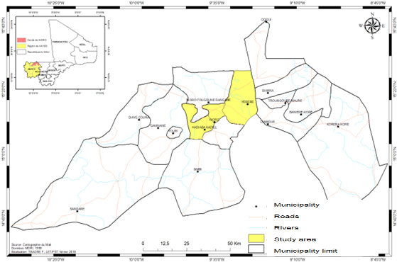

**Figure 1:** Location of the study area in Mali

**Characterization of the natural stands of *Acacia senegal***

The inventory was conducted in 2500 m2 plots (25 x 25 m) delimited in each site. In each plot, the number of *Acacia senegal* trees was counted, and dendrometric measurements were taken (basal circumference, total height, and circumference at 1.30 m). The average stem density (N) of juvenile and adult individuals was determined per hectare in each biotope. It is determined by the number of stems per hectare and is evaluated according to the formula:

**N = n/S**

where **n** is the total number inventoried in the biotope and S is the total area sampled.

**Determination of the soil physicochemical parameters**

Soil samples were taken at the ends and centers of the meshes, both outside and under the four-foot tree crowns. Three 500 g composite samples were taken from each commune. These samples were sent to the Sotuba soil-water-plant laboratory for granulometric analysis. pH was determined by the potentiometric method in a 1/:2 ratio, Thomas (1996). Soil organic C content was determined by the Walkley and Black method (Nelson and Sommers, 1982), assimilable phosphorus-BrayII as described in Olsen and Sommers (1982). Exchangeable bases (Ca, Mg, and K) were determined by extraction with ammonium acetate buffered at pH 7.0 before atomic absorption spectrometer reading for Ca and Mg, and flame spectrometer reading for K. Total nitrogen (total N) was determined by the Kjeldahl method (Bremner and Mulvaney, 1982).

**Data analysis**

Excel spreadsheet and R software (R version 4.4.2, <http://www.r-project.org>) were used for the analysis of variance (ANOVA), generated the graph, and statistical processing of the data. Bartlett's Chi2 test was used to compare variances at the 5% level of significance.

**RESULTS**

**The structure of natural *Acacia senegal* stands in the study area**

Natural stands of *Acacia senegal* are relatively dense in Gadiaba, with an average of 690 plants/ha. The average density was 430 plants/ha in the municipality of Nioro. The Korokodjo site recorded the lowest density, with 120 plants/ha. These densities are predominantly in the 50-70, 70-90, and 90-110 cm circumference classes at all three sites (Figure 2).

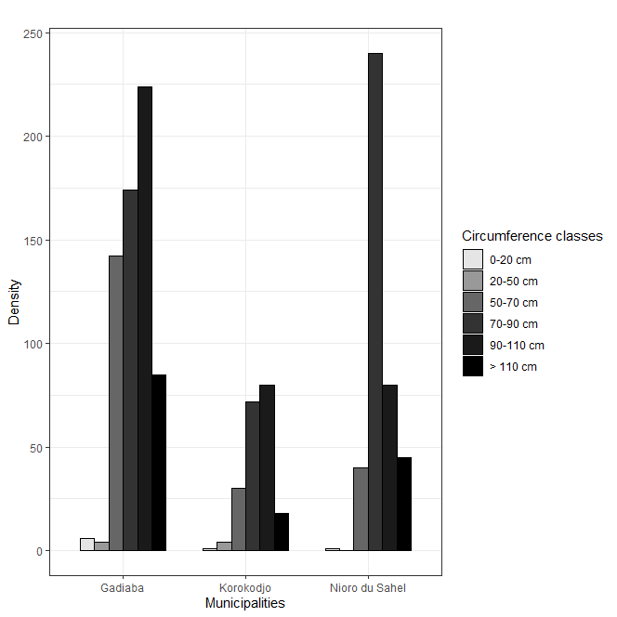

**Figure 2:** Density of *Acacia senegal* according to the circumference classes

*Acacia senegal* stands are dominated by trees with circumferences of 70-90 cm at Gadiaba (224 plants/ha) and Korokodjo (80 plants/ha). In Nioro, individuals with circumferences of 50-70 cm dominate (240 plants/ha). Stratification shows that natural stands of *Acacia senegal* are concentrated mainly in the 2-5 m height class (Figure 3).

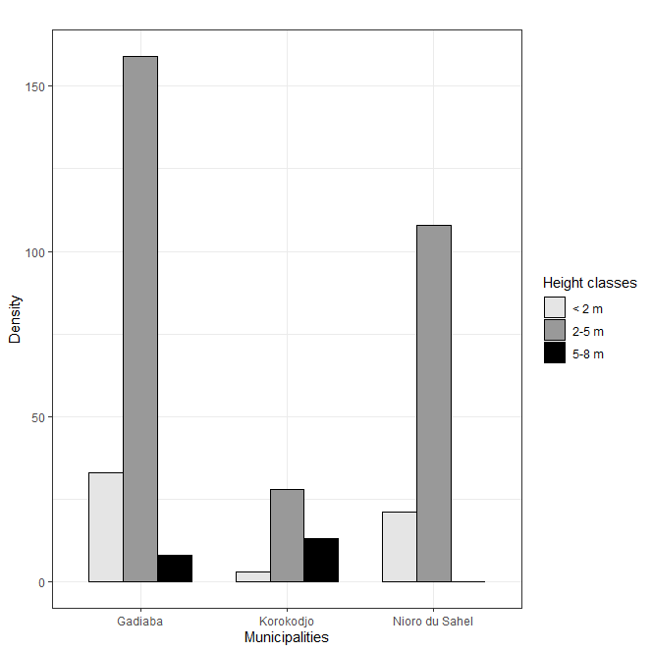

**Figure 3**: Density of the *Acacia Senegal* population according to the height classes

With 159 plants/ha, the 2-5 m height class represents the stratum with the highest density at Gadiaba, contributing 80%. The < 2 m height class contributed 17%, with a density of 33 plants/ha on the same site. The 5–8 m class is sparsely populated (only 8 plants/ha), with a contribution of 4% on the same site. The density of the woody stratum at the Nioro site was dominated by the 2–5 m height class, with 108 feet/ha for a specific contribution of 84%, compared with 21 feet/ha for the <2 m height class, with a contribution of 16%. No plants were recorded in the 5-8 m height class at Nioro. At Korokodjo, the *Acacia senegal* stand is also dominated by plants in the 2-5 m height class, with 28 plants/ha and a contribution of 64%. The other two classes, <2 m and 5-8 m, accounted for 7% and 30%, respectively.

**Physicochemical composition of the site soils**

Analysis of the variance of the physicochemical and granulometric parameters of the soil samples showed that there were three homogeneous groups at the 5% threshold (Table 1). Comparison of the magnesium content, sand, and silt proportions between the sites studied showed highly significant differences (p ˂ 0.001). At Gadiaba, the soil is sandy-loamy, while at Nioro and Korokodjo, the proportion of sand dominates at over 90%. In contrast, the C/N ratios and phosphorus levels were not significantly different between the three sites. The C/N ratio is 4.55% at Gadiaba, 5.95% at Korokodjo and 3.36% at Nioro du Sahel. Phosphorus levels were 3.79% in Gadiaba, 1.73% in Korokodjo, and only 0.21% in Nioro du Sahel. For other mineral elements and pH, however, the differences are significant at the critical threshold of 5%. The Gadiaba site has the richest soil in mineral elements, while the Nioro du Sahel site has the poorest soil. Soils at the study sites were acidic overall with an average pH value of 6.36%. They are richer in Carbone at Gadiaba avec 0.42%, moderately rich at Korokodjo, and relatively poor at Nioro.

**DISCUSSION**

The study area is dominated by species belonging to the Fabaceae family (Mimosaceae). Several authors have pointed out that the Sahelian woody flora is dominated by species belonging to the Mimosaceae, Combrétaceae, Capparidaceae and Asclepiadaceae families (Hiernaux and Le Houérou, 2006). The woody stand densities obtained at Gadiaba and Nioro of 690 and 430 feet/ha, respectively, are higher than the 376 feet/ha obtained by N'Diaye (2018) in the Ferlo region of Senegal. The density recorded at the Yèrèrè site is lower than that of N'Diaye (2018), but also than that obtained by Koné (2017), who reported 22784 feet/ha on a course at Ziguéna in the Sudanian bioclimatic.

The circumference and height class distributions of the plants at site are characteristic of natural *Acacia senegal* stands observed elsewhere in the Sahel, with small, medium-diameter individuals (Dembélé, 2009; Karembé, 2009; Traoré *et al.*, 2022).

The pH of the study sites was between 5.9 and 6.5, considered optimal for soil nutrient availability. These figures are close to those found by Hiernaux and Le Houérou (2006) and Traoré (2012) in the eastern Sahel region of Mali.

The physicochemical and granulometric parameters of the soil samples showed that there were three homogeneous groups at the 5% threshold. Significant differences in the organic matter content linked to wood density were observed between the three sites studied. These results are comparable to those obtained by Samb (2010); and Abdou *et al.* (2013) in the villages of Aité and Somo in Mali.

With a critical threshold of 0.6%, the soils in the study area were all deficient in organic carbon. Total nitrogen, ranging from 0.03% to 0.1%, is also low in the study area (Sarr *et al.*, 2005). However, the difference was not significant between the three sites. The assimilable phosphorous content in the soil samples ranged from 0 to 4.45 ppm. Referring to the critical threshold of 7 ppm, all soil samples have a proven deficiency in assimilable phosphorus (Ngaryo *et al.*, 2017). These results are in agreement with those of Abdou *et al.* (2013) in the six gum tree basins of Niger, with variations in pH, C, and N under and out of the crown, and these variations are significant between all gum trees (P<0.05). These parameters are in most cases higher under the tree crown and in other cases higher out of the crown (Abdou *et al.*, 2013).

**CONCLUSION**

In the current context of climate change, the density of *Acacia senegal*, an agroforestry species, is declining sharply in the Sahel. This study aimed to determine the influence of the density of natural stands of *Acacia Senegal* on soil fertility in the western Sahel of Mali. The natural stands in the study area are characterized by small, medium-diameter trees. The density is generally low at all three sites. The soils were all deficient in organic carbon, nitrogen, and assimilable phosphorus. Therefore, it is important to identify suitable management methods for these resources.

**DISCLAIMER (ARTIFICIAL INTELLIGENCE)**

Author(s) hereby declare that NO generative AI technologies such as Large Language Models (ChatGPT, COPILOT, etc.) and text-to-image generators were used during the writing or editing of this manuscript.

## CONSENT AND ETHICAL APPROVAL

The study protocol was approved by the institutional ethics committee of the Faculty of Science and Technology (FST). Informed, voluntary consent was obtained from all owners. All measures were taken to minimize the risks associated with participation in the study.

**REFERENCES**

Abaker Wafa, E., Berninger, F., Saiz, G., Pumpanen, J. and Starr, M. (2018). Linkages between soil carbon, soil fertility and nitrogen fixation *Acacia senegal* plantations of varying age in Sudan Peer J, DOI 10.7717/peerj.5232.

Abdou, M.M., Zoubeirou, A.M., Kadri, A., Ambouta, J.M.K., Dan Lamso, N. (2013). Effect of the Acacia senegal tree on the fertility of gum plantation soils in Niger. Int. J. Biol. Chem. Sci., 7(6): 2328-2337.

Bremner, J.M., Mulvaney, C.S. (1982). Total N. In: Methods of soil analysis part 2. Chemical and mineralogical properties, 2nd ed., Agronomy Monograph vol.9. A. L. Page, Ed. Madison Wisconsin, USA 1982, p. 595-622.

Dembélé, F., Karembé, M., Diallo, D. (2009). Influence of climate and soil on woody vegetation in the Senegal River Basin in Mali. 3rd International Conference on Multidisciplinary Analysis of the African Monsoon. Ouagadougou 2009, pp. 184p.

Diallo, A., Agbangba, E.C., Thiaw, A., Guissé, A. (2012). Structure of Acacia senegal (L.) Willd populations in the Tessékéré area (northern Ferlo), Senegal. Journal of Applied Biosciences 59: 4297– 4306. <https://hal.science/hal-01722558/document>

Dione, M. (1996). Experimental research on the gum tree Acacia senegal in the Senegalese Ferlo. Doctoral thesis, Paul Sabatier University of Toulouse, 150p.

Dommergues, Y. (1993). The workshop on Acacia symbioses. Wood and Forests of the Tropics, 238: 21-34.

Harmand, J-M., Mathieu, B., Njiti, C.F. and Ntoupka, M. (1998). Research on the possibilities of gum Arabic production by Acacia senegal (Linn.) Willd in different pedoclimatic situations of northern Cameroon. IRAD, Agricultural Export Diversification Project in Cameroon, 21 p.

Hiernaux, P. & Le Houérou, H.N. (2006). Sahel Rangelands. Drought. 17: 51–71.

Karembé, M., Dembélé, F., Maïga, M. and Lahbib, M. (2009). Study of the dynamics of desertification in the Timbuktu-Gao section (Mali). Technical Report UNESCO Chair for the Environment. ISFRA/UB, Mali, 39p.

Kone, A.K. (2017). Assessment of pastoral potential in the cotton-growing area of ​​Mali: The case of the village lands of Benguéné, Ziguéna and Nafégué. Master’s thesis, Higher Institute of Training and Applied Research, Bamako, Mali. p. 105.

Mallet, B., Besse, F., Gautier, D., Muller, D., Bouba, N. Njiti, C. (2002). What are the prospects for gum trees in the savannah zone of Central Africa? Proceedings of the conference, May 2002, Maroua, Cameroon. 249p.

Mbayngone, E., Mélom, S., Béchir, A.B. and Mapongmetsem, P.M. (2017). Structure and gum productivity of Acacia senegal (L) Willd. And Acacia seyal Del. stands for Massenya in Chad. Flora et Vegetatio Sudano-Sambesica 20, 3-11.

Nelson, D.W. and Sommers, L.E. (1996). Total carbon, organic carbon, and organic matter. In Methods of soil analysis. Part 3 – Chemical Methods. Sparks D.L., Page A.L., Helmke P.A. and Loeppert R.H. (Ed.). American Society of Agronomy, Madison, USA. SSSA Book Series 5 : 961-1010.

Ngaryo, F.T., Ngarnougber, C. Adamou, I. (2017). Characterization of woody plants in the Sahelian savannah with Acacia senegal (L.) Willd in the Guéra region, Chad. Int J Appl Research 3: 600-606.

N’Diaye, S. (2018). Impact of the adoption of climate change adaptation strategies on food security and income of pastoral households in the Ferlo area of ​​Senegal. PhD thesis, University of Thies. <https://www.inter-reseaux.org/wp-content/uploads/these_saboury_version_finale_2019.pdf>

Olsen, S.R., & Sommers, L.E. (1982). Phosphorus. In Methods of Soil Analysis, 2nd ed. Part 2, Page A.L. et al. (Eds.), Madison, WI, USA, Agronomy No 9, American Society of Agronomy, p. 403-430.

R Core Team (2021). R: A language and environment for statistical computing. R Foundation for Statistical Computing, Vienna, Austria.URL https://www.R-project.org/.

Sall, P. N. (1997). The gum tree and gum Arabic. Technical note of the RCS-Sahel-1 project 507/RAF/43. 30p.

Samb, C.O., Touré, M.A., Faye, E., (2018). Sociodemographic, structural, and agronomic characteristics of cashew plantations (Anacardium occidentale L.) in the Peanut Basin and Casamance/Senegal. Journal of Animal & Plant Sciences 38, 6307–6325.

Samb, N., (2010). Influence of Acacia senegal (L) Willd on the physical, chemical, and biological properties of soils. DEA thesis in Plant Biology, Cheikh Anta Diop University, Dakar, 60p. <https://horizon.documentation.ird.fr/exl-doc/pleins_textes/divers13-06/010058503.pdf>

Sarr, A., Faye, A., Oihabi, A., Houeibib, MAJO, Neyra, M. Lesueur, D. (2005). Inoculation in the station and the field of Acacia senegal with selected strains of Rhizobium. Wood and forest of the tropics, No. 283(1). <https://agritrop.cirad.fr/524184/1/document_524184.pdf>

Sarr, M.S. (2009). Dynamics and production of gum Arabic from a natural and trial stand of Acacia senegal provenances. Thesis 3 in Plant Biology, Cheikh Anta Diop University, Dakar. 160p.

Soumaré, M. (2004). Contribution to the prediction of the diffusion area of ​​sorghum varieties in Mali: coupling between crop growth model and geographic information system. Nanterre: University of Paris-Nanterre, 92 p. DEA thesis: Geography and development practice: University of Paris-Nanterre.

Thomas, G.W. (1996). Soil pH and soil acidity. In Methods of soil analysis. Part 3 – Chemical Methods, Bigham J. M. (Editor-in-Chief SSSA), Book Series Published by Soil Science Society of America, Inc., American Society of Agronomy, Inc. Madison, Wisconsin, USA 1996 II_41, p. 419-422.

Traoré, F. (2012). Characterization of the woody diversity of the Agoufou pond basin in the Malian Gourma. DEA thesis in Applied Biological Sciences. Faculty of Science and Technology of Bamako FST/ USTT-B, 45p.

Traoré, F.S., Karembé, M., Soumana, I., Togola, I. Mahamane, A. (2022). Characterization of natural Acacia senegal (L) Willd formations in the Western Malian Sahel, Nioro. IOSR Journal of Environmental Science Toxicology and Food Technology 16(4):20-28

**Table1**: Physical composition and contents of some mineral elements in the soils of the study sites

|  |  |  |  |  |  |  |  |  |  |
| --- | --- | --- | --- | --- | --- | --- | --- | --- | --- |
| **Sites** | **pH (%)** | **C (%)** | **C/N (%)** | **MO (%)** | **N (%)** | **P (%)** | **Mg+ (%)** | **Sand (%)** | **Silt (%)** |
| Gadiaba | 6.39±0.07a | 0.42±0.09a | 4.55±4.02a | 0.09±0.01a | 0.10±0.01a | 3.79±2.74a | 0.85±0.01a | 55.67±2.31b | 41±2a |
| Korokodjo | 6.34±0.10ab | 0.33±0,09ab | 5.95±0.54a | 0.05±0.01b | 0.05±0.01b | 1.73±1.51a | 0.55±0.03b | 90±3.46a | 6.67±2.31b |
| Nioro | 6.04±0.19b | 0.11±0.10b | 3.36±0.66a | 0.04±0.01b | 0.04±0.01b | 0.21±0.5a | 0.56±0.07b | 91±7a | 7±7b |
| ***Average*** | *6.36* | *0.29* | *4.62* | *0.06* | *0.06* | *1.91* | *0.65* | *78.89* | *18.22* |
| ***Probability*** | *0.044* | *0.021* | *0.456* | *0.012* | *0.012* | *0.133* | *0* | *0* | *0* |
| ***Significance*** | *S* | *S* | *NS* | *S* | *S* | *NS* | *THS* | *THS* | *THS* |