**A Review of Bears in Himachal Pradesh: Distribution, Conflict with Human and their Mitigation Strategies**

**Abstract**

The existence of bears in Himachal Pradesh contributes significantly to the region's biodiversity. However, rising confrontations between bears and people pose substantial concerns. In Himachal Pradesh; Himalayan brown bears are reported in 10 protected areas. The Asiatic black bear is often distributed at elevations of 70 to 3000m asl. Recorded data on the presence of Asiatic black bears in Lahaul Valley, Rupi-bhaba WLS, Daranghati wildlife sanctuaries Himachal Pradesh, and genetic analysis identifies 307 unique Black bear, with the highest numbers in Kinnaur (n=90) and Kullu (n=76). Intrinsic and extrinsic factors that influence conflict occurrence: older male brown bears often prey on younger conspecifics, particularly cubs. Younger bears and females with cubs are more likely to be near human settlements to protect themselves from older males. Extrinsic drivers like anthropogenic food sources and habitat loss from human activities. Climate change also influences the occurrence of Himalayan brown bears as they mostly prefer places with relatively low minimum and maximum surface temperatures during the hottest (7 to 12°C) and coldest (-6 to -1°C) months., The wettest quarter was most associated with brown bear incidence between 45mm and 85mm.Himalayan brown bear favors regions with little permanent snow or ice, and their probability of occurring significantly decreases when snow or ice levels exceed 5%, also Climate change may shorten hibernation, and Rapid development leads to habitat degradation and increased human-bear conflicts. The Himalayan brown bears are the most commonly recorded animal to cause livestock harm. Because of the secretive character of Himalayan brown bears and Asiatic black bears and the rough terrain, it has received little research attention. There is limited information on the species distribution ranges, with only a few range reports and short-term research on bear-human interaction leading to a lack of scientific knowledge needed for conservation and habitat management.

**Keywords:** Himalayan brown bear, Asiatic black bear, distribution ranges, human- bear conflict, Habitat degradation

**1. Introduction**

Himachal Pradesh is mostly a mountainous state located from 30° 22' to 30° 12' North latitude and 75° 47' to 79° 04' East longitude in the northwest Himalayas, is known for its rich biodiversity due to its varied topography, ranging from the plains to the high-altitude Himalayan ranges (350 to 6500 meters above mean sea level). Forest types vary from dry scrub vegetation at lower elevations to alpine meadows at higher elevations. The state includes 20 distinct vegetation zones that are largely synchronized with altitudinal stratification (Singh & Kumar, 2014). The total area of the state is 55,673 sq km and the Recorded Forest Area (RFA) in the State is 37,033sq km of which 1,898 sq km is Reserved Forests, 33,130 sq km is Protected Forests, and 2,005 sq km is Unclassed Forest. The state's protected area network includes three conservation reserves, 26wildlife sanctuaries, and five national parks, making up about 15.10 % of the state's total land area. The state is home to a wide array of flora and fauna, including many species that are endemic to the region. Its diverse ecosystems, ranging from temperate forests in the lower altitudes to alpine meadows and glaciers in the higher altitudes, provide crucial habitats for a variety of wildlife

About 20–25 million years ago, during the late Oligocene and early Miocene, Ursidae evolved from smaller, tree-climbing, predatory canid ancestors known as Miacids (Cowan, 1972). Ursid taxonomy has undergone several modifications (Mclellan, 1994). Bears are mammals of the family Ursidae that live in a wide range of environments in the Northern Hemisphere (Prater, 1971) and partially in the Southern Hemisphere. More than 60 nations in North America, South America, Europe, and Asia are inhabited by eight different species of bears (Servheen & Christopher, 1990). Asia is home to five of the eight species. In India four bear species are found that is the Sloth bear (*Melursus ursinus*), Asiatic black bear (*Ursus thibetanus*), Himalayan brown bear (*Ursus arctos isabellinus*), and Sun bear (*Helarctos malayanus*) (Sathyakumar et al., 2012). In Himachal Pradesh only two bear species are found the Himalayan brown bear (HBB) and Asiatic black bear (BB).

Human-wildlife conflicts have increased due to competition for natural resources, both directly and indirectly (Messmer, 2000). Human-animal conflict has significantly escalated in recent years. There are several causes for the growth. These include the rise in the number of wild animals, habitat fragmentation, the lack of food and water in the habitat as a result of degradation, corridor disruption from developmental operations, changes in farming patterns, and an increase in the number of people. Other factors include the capacity of some species, such as bears, nilgai, leopards, and monkeys, to adapt and live well near human settlement for crop destruction, livestock depredation, and predator assaults on humans (Mattson et al., 2011; Messmer, 2000), however Human Bear conflict (HBCs) also importantly affect bear populations and represent a major threat to bear conservation worldwide (Krofel et al., 2020a). Conflicts between humans and bears can lead to increased poaching, hinder conservation efforts, and demand for legal eliminations. Therefore, effective conflict mitigation is not only vital for human welfare but also plays a critical role in the contemporary globe bear conservation management. They dwell in many biomes and interact with various human groups. This leads to a wide range of bear-human interactions that could be classified as conflicts, such as: (1) attacks on domestic or semi-wild animals, such as bees, hunting dogs, and pet animals; (2) damage from foraging on cultivated berries, fruits, agricultural products, and tree bark in forest plantations; (3) economic loss from the destruction of beehives, fences, silos, houses, and other human property; (4) bear attacks on humans that cause mild to fatal trauma; (5) bluff charges, bear intrusions into residential areas, and other bear behavior that strongly elicit fear, anxiety, and/or defensive responses from humans (Bautista et al., 2017; Can et al., 2014a; Krofel et al., 2020b).

**2. Bear’s Habitat and Ecology**

**2.1. The Black Bear**

The BB are well recognized as umbrella species whose conservation confers protection to the other co-occurring species (Fleishman et al., 2000), particularly in the subtropical and temperate ecosystems (Yamamoto et al., 2012). BB range pattern, which is mostly restricted to temperate and subalpine environments (2,100–3,500 m), indicates its correlation with coniferous and broad-leaved forests. The BB evidence was found in temperate (67%) and subalpine habitats (31%) above 1900 m, with only one summertime photo capture from an alpine environment at 4250 m in Eastern Himalaya (Bashir et al., 2018). coniferous and broadleaved forests are the best predictors of site utilization. The quantity of acorn-producing trees in the temperate zone was shown to be the most significant factor favorably impacting the bears' percentage of site use during pre-hibernation (Izumiyama& Shiraishi, 2004; Sathyakumar, 2001; Bashir et al., 2018).

The BB range largely corresponds to the spread of forests in southern and eastern Asia and in the Shivaliks, Terai, and Arawali regions of north, central, and in southern India this species is being replaced by the sloth bear. The sun bear replaces it in southern Thailand and Malaysia, while the brown bear replaces it in the Russian Far East's north and west regions. However, the Asiatic black bear covers the territories of each of these species, particularly the sun bear across a major part of Southeast Asia.

In India, the BB lives in wooded hills ranging from 1,200m to 3,300m above mean sea level (MSL) in the Himalayas and Northeastern hill states. BB has an estimated potential habitat of around 270,000 km2 in India (Sathyakumar & Choudhry, 2007). Its range overlaps with those of the sloth bear below 1,200m and the HBB beyond 3,000m (Prater, 1971b; Rathore, 2008).

BB are found across the Himalayan regions in the northwest (Jammu and Kashmir, Himachal Pradesh), west (Himachal Pradesh and Uttarakhand), central (Sikkim and northern West Bengal), and east (Arunachal Pradesh) regions. The species may also be found in hills in other northeastern Indian states (Meghalaya, Mizoram, and Tripura). BB distribution in the Indian subcontinent is contiguous with Nepal (eastward from Uttarakhand to Sikkim) and Bhutan (Sathyakumar, 2001; Sathyakumar & Choudhry, 2007). In 1994-1995 the first author evaluated the status and distribution of BB in India and reported the presence of species in 53 protected areas (PAs) and 62 other locations; however, their population status remains unknown. Their numbers are declining due to habitat degradation, poaching, and human-bear conflicts. Again 2005 survey report indicated that BB is found in 82 protected areas and 98 other localities in India (Sathyakumar & Choudhry, 2007).

**2.2. The Himalayan brown bear**

The HBB (*Ursus arctos isabellinus*) is a subspecies of the brown bear, and its distribution is restricted to higher altitudes across the northwestern and central Himalayas, including India, Pakistan, Afghanistan, western China, Tibet, and Nepal. HBB inhabits subalpine and alpine regions (above 3,300 m). In India HBB has been reported in Jammu and Kashmir, Himachal Pradesh, and Uttaranchal (Sathyakumar, 2001; Sharief et al., 2020). HBB is present in 10 PAs in Himachal Pradesh (Rathore & Chauhan, 2014; Sathyakumar, 2001). Outside of protected areas, HBB occurs in Malana Valley, Mamta Pass, Solang Valley, Bara Bangal, Parvati Valley, Rola Valley, Kaushal, Manali, Pooh and Lingti and Ensa Valleys (Lahaul and Spiti) (Sathyakumar, 2001).

Based on the 2005 estimation, the possible HBB distribution area was approximately 36,800 km2. According to (Kumar et al., 2024a) slope, yearly precipitation, the largest patch index, and the Shannon diversity index were all positively correlated with the habitat utilization of HBB. In contrast, the driest month showed a negative correlation between precipitation and elevation. The findings underline the importance of these regions for connectivity and resources by indicating that the HBB favors larger, connected habitat patches. The subalpine and alpine regions were expected to be the primary habitats for HBB. The IUCN states that brown bears are the least concerned on the IUCN Red List, however, the Himalayan brown bear (HBB) population is listed as endangered under criterion D. It is also listed as Appendix I of CITE and on Schedule I of the Indian Wildlife Protection Act (1972) as amended in 2003. Three main concerns that are present throughout its whole area of distribution, climate change, habitat encroachment/degradation, and human-bear conflict make the HBB population susceptible (Kumar, Sharief, Dutta, Singh, et al., 2022).

According to the study, by 2050, there would be more than 70% less suitable habitats for HBB over its whole distribution range (Kumar, Sharief, Dutta, Singh, et al., 2022; Mukherjee et al., 2021). The study also noted that the effects of climate change may cause the majority of the Kanawar Wildlife Sanctuary's suitable habitats to disappear (Kumar et al., 2022a; Mukherjee et al., 2021b).

HBB likes areas with moderate to dense evergreen needle-leaf forests and grasslands. Low farmland and urban density are associated with increased HBB occurrence. HBB are mostly prefer places with relatively low minimum and maximum surface temperatures during the hottest (7 to 12°C) and coldest (-6 to -1°C) months., The wettest quarter was most associated with brown bear incidence between 45mm and 85mm. HBB favored regions with little permanent snow or ice, and their probability of occurring significantly decreased when snow or ice levels exceeded 5% (Dar et al., 2021).

The study discovered that HBB prefer bigger, contiguous habitat patches, emphasizing the importance of these regions for resource availability and connection. The HBB is expected to be found mostly in subalpine and alpine environments with elevations ranging from 2,500 to 4,500 meters. HBB prefers moderate to steep slopes, which is consistent with their den sites and habitat use patterns (Kumar et al., 2024).

**3. Distribution Patterns of Bears in Himachal Pradesh**

The BB (*Ursus thibetanus*) is found in all ten Himalayan states of India, often at elevations between 70 to 3,000 meters. However, it may reach greater elevations in northeast India (Bashir et al., 2018; Sathyakumar & Choudhry, 2007). In 1994-1995 the first author evaluated the status and distribution of BB in India and reported the presence of species in 53 protected areas (PAs) and 62 other locations; however, their population status remains unknown. Their numbers are declining due to habitat degradation, poaching, and human-bear conflicts. Again 2005 survey report indicated that BB is found in 82 protected areas and 98 other localities in India (Sathyakumar & Choudhry, 2007). In Himachal Pradesh recorded data on the presence of BB is limited to certain places. Fig.2, 3 shows the presence of BB in Lahaul Valley, Rupi-Bhabha WLS, and Daranghati wildlife sanctuaries in Himachal Pradesh. As (Bhattacharya et al., 2022) estimated a population density of 2.5 individuals/100 km2 from Daranghati WLS and 0.3 individuals/100 km2 (95% Credible Interval = 0.2–0.7 individuals/100 km2) from Rupi-Bhaba WLS. Abundance estimates produced by extrapolating these densities were 11 BB individuals (95% Credible Interval = 4–27) from Daranghati WLS and 2 BB individuals (95% Credible Interval = 1–3) from Rupi-Bhaba WLS. (Joshi, Kaur, Kumar, Thakur, Chandra, et al., 2020) reported that BB may be expanding its range to the Lahaul Valley in Himachal Pradesh's Lahaul and Spiti regions. The genetic analysis identifies 307 unique BBs, with the highest numbers in Kinnaur (n=90) and Kullu (n=76)

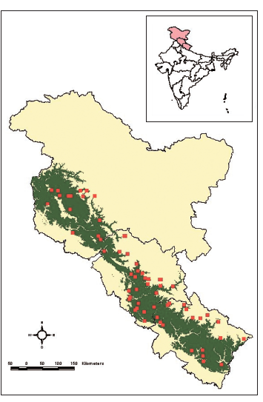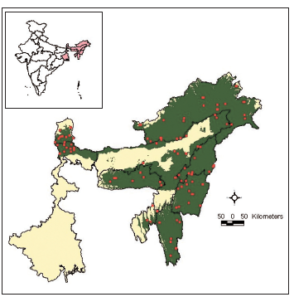

Fig.1: Distribution of Asiatic black bear in India (A -North and B -North eastern States).

Source: (Sathyakumar & Choudhry, 2007)

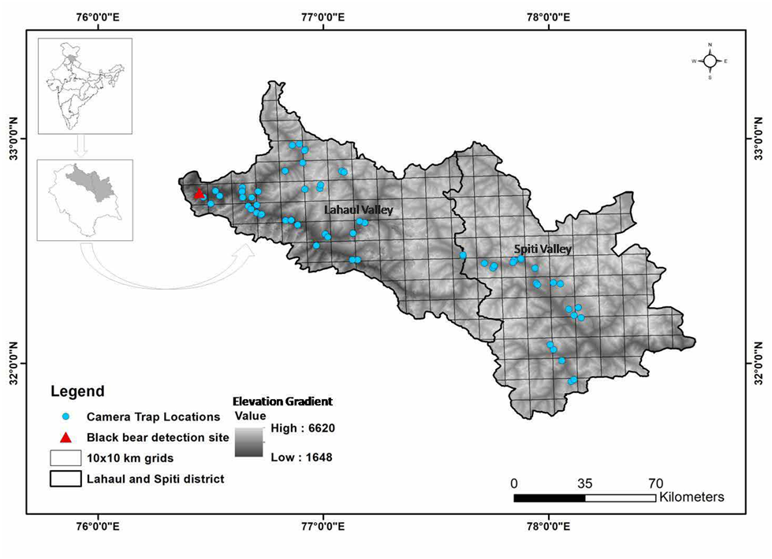

Fig.2: Camera trapping locations and site of first camera capture of an Asiatic black bear in the Lahaul Valley, Himachal Pradesh, India, August – September, 2018

Source: (Joshi, Kaur, Kumar, Thakur, Sharma, et al., 2020)

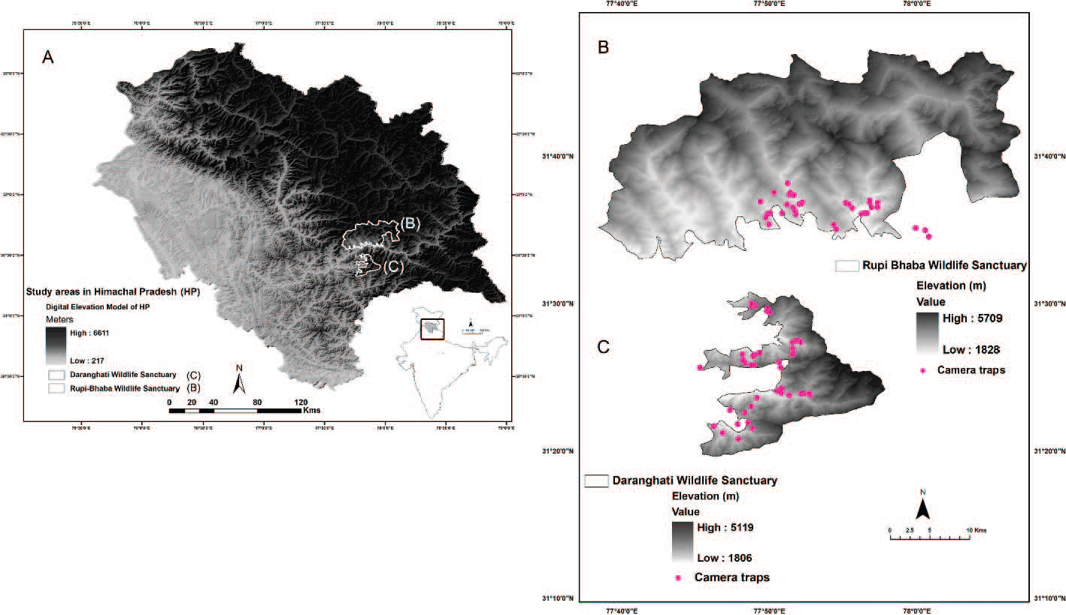

Fig.3. Map of study areas showing (A) location of study sites for estimation of Asiatic black bear in the state of Himachal Pradesh, India. (B) Rupi- Bhaba and (C) Daranghati wildlife sanctuaries. SOURCE: (Bhattacharya et al., 2022)

HBB were observed consuming winter-killed animals and growing plant material in lower-elevation habitats throughout the spring. Following the phonological benefit of vegetative foods, they migrated to higher elevations in the late spring. Bears moved to lower locations in the summer to take advantage of habitats with berry harvests that ripened early. In the early fall, they repeatedly moved altitudinally, following the maturing fruits to higher altitudes (Hamer & Herrero, 1987).

In Himachal Pradesh, HBB is reported in 10 protected areas located in the Greater Himalayan as well as the Trans-Himalayan zones, outside of protected areas HBB occurs in Malana Valley, Mamta Pass, Solang Valley, Bara Bangal, Parvati Valley, Rola Valley, Kaushal, Manali, Pooh and Lingti and Ensa Valleys (Lahaul and Spiti) (Rathore & Chauhan, 2014b; Sathyakumar, 2001) The HBB subspecies lives at high elevations in the Himalayas due to its challenging and inaccessible environment, the HBB is one of the least researched carnivore species in India (Aryal et al., 2012). The HBB was recorded in some places of Himachal Pradesh; Kanwar Wildlife Sanctuary (fig.4), Lippa-Asarang Wildlife Sanctuary at an altitude of 3,287m (Rathore & Chauhan, 2014a) Lahaul Valley.

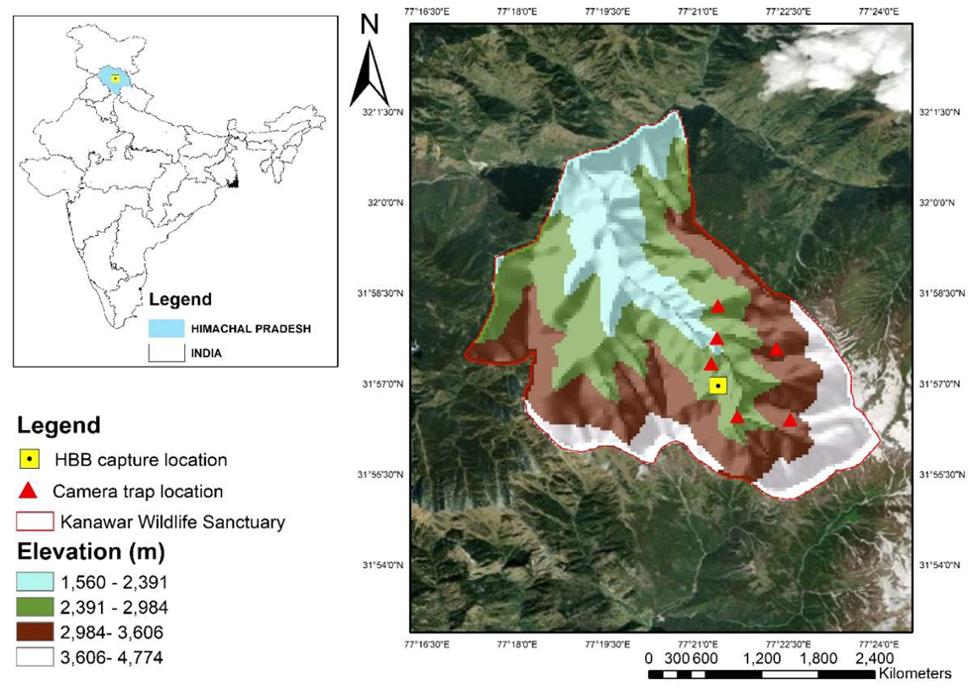

Fig.4: Captured location of Himalayan brown bear in Kanwar Wildlife Sanctuary.

Source: (Kumar, Sharief, Dutta, Singh, et al., 2022)

**5. Human-Bear Conflict**

Brown and Black bears are the species involved in most types of conflicts (Krofel et al., 2020). There have been reports of human-Asiatic black bear conflicts throughout the whole species' range in Asia, including China (Krofel et al., 2020b; Liu et al., 2011) Japan (Saito et al., 2008) Pakistan (Ahmad et al., 2016; Ali et al., 2018) Iran (Ghadirian et al., 2017) India (Chauhan, 2003a) and Bhutan (Jamtsho & Wangchuk, 2016; Sangay & Vernes, 2008) crop-raiding, particularly of corn, potatoes, and fruit trees, is the most commonly reported conflict type. This type of harm is concentrated all across the summer (Charoo et al., 2011; Scotson et al., 2014) whereas the majority of recorded livestock attacks have occurred in the autumn season (Jamtsho& Wangchuk, 2016; Li et al., 2013; Mir et al., 2015) Occasionally, BB attack beehives and fish farms (Jamtsho& Wangchuk, 2016; Liu et al., 2011).

The HBB is the most commonly recorded animal to cause livestock harm, including rabbits, poultry, and cattle. HBB often do the most harm to animals in regions with sheep husbandry. (Gunther et al., 2004; Kaczensky, 1999) HBB are known to attack pets, captive animals, and fish, in addition to cattle. HBB regularly damage beehives when looking for insect larvae, which are the primary source of HBC in certain areas of their territory (Karamanlidis et al., 2011; Naves et al., 2018) Crop fields (particularly maize), gardens, orchards, grass silage, and vineyards are among the agricultural areas that sustain damage (Krofel et al., 2020a). Brown bears in certain areas of the range inflict forestry damage, particularly to mature conifer trees (Zyśk-Gorczyńska et al., 2016). Searching for manmade food sources can bring bears near to human settlements, raising concerns about human safety and leading to the deadly eradication of trespassing bears (Gunther et al., 2004). Despite a reported increase, conflict with HBB receives little attention in India (Anand & Radhakrishna, 2017; Chauhan, 2003b; Maheshwari et al., 2012).

**6. Main Drivers and Factors That Influence Conflict Occurrence**

**6.1. Intrinsic Drivers**

Bears often exhibit human habituation and food conditioning as a result of repeated exposure to humans and their food sources (Herrero et al., 2005; McCullough, 1982). Human activities or settlements can provide a shelter for juvenile bears and females with offspring, protecting them from dominant conspecifics (Mueller et al., 2004; Steyaert et al., 2013; Wielgus & Bunnell, 1994). A prevalent pattern among brown bears in older adults, particularly males, preying on and attacking conspecific young, particularly cubs-of-the-year and yearlings (McLellan, 2005; Swenson, 1997; Swenson et al., 2001). A common pattern across Europe, North America, and Japan is that brown bears, polar bears, and American and Asiatic black bears that are found close to human settlements and activities tend to be younger, and females with their cubs are more likely than adult males or lone adult females to be found close to human settlements or humans (Elfström et al., 2014).

**6.2. Extrinsic Drivers**

There are six main extrinsic drivers of HBC: availability of anthropogenic food, natural food failures, impacts of human activities on the landscape, climatic and meteorological events, differences in conflict management, and reduced human tolerance (Krofel et al., 2020a).

At a local scale, the availability of anthropogenic food is a source of conflict and an ecological trap for bears in many parts of the world, for example; brown bears roam in agriculture fields or garbage dumps in Japan, Europe, the Middle East, and North America (Cozzi et al., 2016; Narita et al., 2011; Northrup et al., 2012; Penteriani et al., 2018). Additionally, artificial feeding can extend the time that humans and bears interact by reducing the hibernation period (Krofel et al., 2017). HBC incidence is also influenced by the amount of the human population and the effects of human activity on the environment. Globally, habitat loss brought on by agricultural growth raises the rates of HBC (Can et al., 2014b). Furthermore, human utilization of bear habitats may make human-bear encounters more likely. For instance, sloth bear assaults on people increased in India as a result of direct rivalry for crops (Dutta et al., 2015). Additionally, there is a growing desire for leisure activities like bear watching and nature tourism, which, if not properly regulated, may lead to an increase in human-bear contact and ultimately result in HBC (Penteriani et al., 2017). Various climatic and meteorological events have been associated with the increasing trend of HBC (Krofel et al., 2020). Climate change can also shorten bear hibernation, which will increase the amount of time that people can contact with bears (Johnson et al., 2018). This also impacts the availability of natural food resources across different regions (Krofel et al., 2020a). As a result, bears may shift from alpine areas to more populated areas, perhaps leading to confrontations (Penteriani et al., 2019).

The primary danger to bears in India is habitat loss, degradation, and fragmentation as a result of rapid development across the nation. This is aggravated by retaliatory deaths resulting from human-bear conflict and purposeful hunting of bears to provide a black-market trade in animal parts desired as trophies or for traditional medicine, the most prevalent bear parts discovered in the illicit trafficking were bear paws and gallbladder and their meat consumed in some regions of India and China (Sathyakumar et al., 2012; Sethy & Chauhan, 2011; Long, Shuzhi, Li, & Sheng, 2025). India reported 23 seizure events involving live bears and gallbladders during an examination of bear seizure data from Asia between 2000 and 2011 (Burgess et al., 2014). The human-bear conflict has increased in India Due to the lack of adequate habitat and escalating human intrusion into forested regions (Debata et al., 2017; Garcia et al., 2016).

**7. Encounters leading to human injuries or fatalities**:

The BB is known to attack humans, causing injuries and death. For example, in Himachal Pradesh's Chamba District, attacks on people increased from 10 in 1988-89 to 21 in 1991-92. Similarly, in the Chamoli District of Uttaranchal, such occurrences increased from one in 1990-91 to sixteen in 1992-93 (Sathyakumar, 2001). Bears often prey on livestock, causing economic loss to local communities. The number of livestock killed by black bears in Chamba District increased from 29 in 1988-89 to 45 in 1991-92 (Sathyakumar, 2001). According to the study done by (Kumar, Sharief, Dutta, Mukherjee, et al., 2022b), 64.8% of participants (398) reported having to deal with brown bears, with crop loss (30.6%) and livestock depredation (6.2%) being the most common complaints. Instances of conflict were comparatively high throughout the summer and were more common in regions between 2700 and 3000 meters above sea level and closer to the forest (<500 meters). Heavy grazing in bear habitats, particularly alpine meadows, causes habitat degradation and competition for food resources. In India's alpine meadows, brown bears cause widespread livestock depredation, and nomadic shepherds ('Gaddies' and 'Bakharwals') frequently eliminate them in retribution to prevent livestock depredation (Chauhan, 2003b). The study was done by (Chauhan, 2003b) on human casualties, livestock killing, and crop Damage by BB and HBB in Great Himalayan National Park, Himachal Pradesh (1989-98) reported 3 human casualties by black bear and 355 livestock killings by black bear and HBB.

**8. Current Measures**:

The Wildlife Division of the Ministry of Environment, Forest and Climate Change, Government mentioned that, The Centrally Sponsored Scheme "Integrated Development of Wildlife Habitats", which includes activities such as anti-poaching, habitat restoration, and eco-development. The important steps taken by the Government for the protection of wildlife and management of human-wildlife conflict are as follows: 1. Alerts and advisories were issued by Wildlife Crime Control Bureau (WCCB) on poaching and illegal trade of wildlife to the concerned State and Central agencies for preventive action.2. The Ministry has issued an advisory on 06.02.2021 to all states/UTs to deal with human-wildlife conflict situations.3.The Ministry issued Guidelines to States/UTs on June 3, 2022, on managing Human Wildlife conflict, including damage to crops.4.The Ministry has released species-specific guidelines on 21.03.2023 for mitigation of human-elephant, gaur, leopard, snake, crocodile, rhesus macaque, wild pig, bear, blue bull, and blackbuck conflict in India (Ministry of Environment, 2023). The Ministry of Environment, Forest, and Climate Change Government of India 2023 proposed some guidelines regarding human-bear conflict (Guidelines for Human–Bear Conflict Mitigation, 2023)

1. The huge number of invasive alien plant species in the area may suppress and reduce bears' native food plants, which would lower habitat quality and cause bears to move more frequently from forested areas into areas used for human purposes, which would raise HBC.

2. Reduce reliance on forest resources to enhance the livelihoods of communities living near forests through participatory management interventions, eco-development initiatives, and programs.

3. Pradhan Mantri Fasal Bima Yojana (PMFBY), under its flagship program, the Ministry of Agriculture and Farmers Welfare has included agricultural loss brought on by wild animal activity, which may be utilized as a significant HBC mitigation tool.

4. Protecting crops from wildlife-safe buildings is a very effective early warning and deterrence approach. Crop-guarding entails driving bears away by generating noise (e.g., shouting, pounding drums or tins) and employing dogs to scare them.

4. Upgrading veterinary infrastructure can help monitor disease in animal populations, protect wildlife, and prevent zoonotic infections from spreading to humans and livestock. Create a comprehensive Wildlife Health Management and Disease Surveillance Plan for each forest division/PA.

5. Encourage local NGOs, volunteers, and stakeholders to prioritize safety measures to reduce human-bear confrontations. To protect against bears, humans can be trained to recognize signals of their presence and behave appropriately.

6. A prospective bear-in-conflict is a person who is likely to enter an HBC scenario because of their movement pattern or behavior. Male bears and their cubs may develop a preference for simple food and go into human-dominated areas to find it. State forest departments (SFDs) may detect and handle high-conflict individuals while monitoring their travels in human-dominated regions.

7. Identifying conflict hotspots can help identify sources of conflict and suggest site-specific measures to lessen HBC. Geo-spatial evaluations can identify conflict hotspots in HBC using primary and secondary data, including time series.

8. Garbage dumps near woods or in villages/towns might attract bears, increasing the risk of human-bear confrontations. Unmanaged rubbish can cause bears to become used to scavenging in human-used areas, leading to increased conflict. Increase community knowledge and engagement in waste management through signs and other initiatives.

**9. Mitigation Strategies**

A number of studies indicate that agricultural and horticultural damage by bears is a crucial factor leading to the development of antagonistic behavior against the species among local communities (Can et al., 2014b; Charoo et al., 2009). Anthropogenic food is a well-known primary cause of HBC. Bears can be kept from accessing manmade food sources, such as cattle, using a variety of strategies; however, there is currently insufficient proof to support the efficacy of many of them (Van Eeden et al., 2018). Exclusion by means of bear-proof bins and electric fences restricts access to exposed resources such as waste material and cattle, respectively (Krofel et al., 2020a). Properly constructed and maintained electric fences can have a nearly 100% efficiency rate and another very successful tactic is the use of guard dogs for protection, especially when it comes to livestock (Proctor et al., 2018; Van Eeden et al., 2018). Reducing habitat degradation and avoiding retaliatory killing is essential for the HBB long-term survival (Chavan et al., 2021; Sathyakumar, 2001) Bears prefer broad-leaved and coniferous forests for their shelter, Bear managers need to consider the value of mast-producing trees as the staple food for bears and keep a check on acorn collection. There is a great need for radio-telemetry studies that could provide a fine understanding of bear movement and habitat utilization, particularly with regard to bear-human conflict. Bear crop raiding is mostly caused by a shortage of natural food sources in many areas; employing electric fences, replenishing natural food supplies, and educating the local population are all possible ways to resolve the conflict between humans and bears, additionally, there is need to examine possible pathways that permit genetic exchange in this area. A thorough molecular genetics study of the bear population in the Himachal Pradesh is needed in order to determine the population's genetic viability, gene flow, and genetic connectedness with neighboring populations.

**Conclusion and future directions:**

The IUCN Red List lists the Asiatic black bear (BB) as vulnerable and the Himalayan brown bear (HBB) as Critically Endangered, mostly because of habitat loss, human conflict, and climate change. According to the study, more than 70% of HBB-suitable ecosystems would disappear by 2050, underscoring the critical need for conservation measures. The primary concern is the rise in confrontations between humans and bears, which is fueled by resource rivalry, habitat fragmentation, and changes in farming methods. Conservation efforts are hampered by these disputes because they not only endanger and less in numbers but also boost poaching and revenge killings. The study underlines the significance of bigger, attached habitat patches for Himalayan brown bears and Asiatic black bears. The subalpine and alpine regions are vital for their habitat, and the findings indicate that conserving these habitats is essential for the bears' long-term existence. The study advocates for thorough molecular genetics research to ensure bear populations' genetic survival and connectivity. Understanding gene flow and population dynamics is critical for developing successful conservation efforts. Effective dispute resolution solutions are critical to both human wellbeing and bear conservation. This review paper concluded that bear-proof bins, electric fences, and guard dogs may be used to safeguard cattle. Furthermore, teaching local populations about bear behavior and the need of protecting natural food sources can aid in conflict resolution. The study emphasizes the possible impact of climate change on bear habitats, which might worsen human-bear interactions. Addressing climate-related issues is critical for the preservation of both bears and their habitats. A plea for integrated conservation strategies that take ecological, social, and economic concerns into account is made in this paper. To guarantee the survival of bear populations in Himachal Pradesh, cooperation between wildlife officials, local communities, conservation groups and continues population study is required.

**Disclaimer (Artificial intelligence)**

Authors hereby declare that NO generative AI technologies such as Large Language Models (ChatGPT, COPILOT, etc.) and text-to-image generators have been used during the writing or editing of this manuscript.

**References:**

1. Ahmad, S., Hameed, S., Ali, H., Khan, T. U., Mehmood, T., & Nawaz, M. A. (2016). Carnivores’ diversity and conflicts with humans in Musk deer national Park, azad Jammu and Kashmir, Pakistan. *European Journal of Wildlife Research*, *62*, 565–576.
2. Ali, A., Waseem, M., Teng, M., Ali, S., Ishaq, M., Haseeb, A., Aryal, A., & Zhou, Z. (2018). Human–Asiatic black bear (Ursus thibetanus) interactions in the Kaghan Valley, Pakistan. *Ethology Ecology & Evolution*, *30*(5), 399–415.
3. Anand, S., & Radhakrishna, S. (2017). Investigating trends in human-wildlife conflict: is conflict escalation real or imagined? *Journal of Asia-Pacific Biodiversity*, *10*(2), 154–161.
4. Aryal, A., Hopkins, J. B., Raubenheimer, D., Ji, W., & Brunton, D. (2012). Distribution and diet of brown bears in the upper Mustang Region, Nepal. *Ursus*, *23*(2), 231–236.
5. Bashir, T., Bhattacharya, T., Poudyal, K., Qureshi, Q., & Sathyakumar, S. (2018). Understanding patterns of distribution and space-use by Ursus thibetanus in Khangchendzonga, India: Initiative towards conservation. *Mammalian Biology*, *92*, 11–20. https://doi.org/https://doi.org/10.1016/j.mambio.2018.04.004
6. Bautista, C., Naves, J., Revilla, E., Fernández, N., Albrecht, J., Scharf, A. K., Rigg, R., Karamanlidis, A. A., Jerina, K., & Huber, D. (2017). Patterns and correlates of claims for brown bear damage on a continental scale. *Journal of Applied Ecology*, *54*(1), 282–292.
7. Bhattacharya, A., Chatterjee, N., Angrish, K., Meena, D., Sinha, B. C., & Habib, B. (2022). Population estimation of Asiatic black bear in the Himalayan Region of India using camera traps. *Ursus*, *2022*(33e8). https://doi.org/10.2192/URSUS-D-21-00002.2
8. Burgess, E., Stoner, S., & Foley, K.-E. (2014). *Brought to Bear: An analysis of seizures across Asia (2000-2011)(PDF, 1.3 MB*.
9. Can, Ö. E., D’Cruze, N., Garshelis, D. L., Beecham, J., & Macdonald, D. W. (2014a). Resolving human‐bear conflict: A global survey of countries, experts, and key factors. *Conservation Letters*, *7*(6), 501–513.
10. Can, Ö. E., D’Cruze, N., Garshelis, D. L., Beecham, J., & Macdonald, D. W. (2014b). Resolving human‐bear conflict: A global survey of countries, experts, and key factors. *Conservation Letters*, *7*(6), 501–513.
11. Charoo, S. A., Sharma, L. K., & Sathyakumar, S. (2009). *Asiatic black bear–human conflicts around Dachigam National Park*. by: Wildlife Institute of India PO Box 18, Chandrabani Dehradun 248 001 ….
12. Charoo, S. A., Sharma, L. K., & Sathyakumar, S. (2011). Asiatic black bear–human interactions around Dachigam National Park, Kashmir, India. *Ursus*, *22*(2), 106–113.
13. Chauhan, N. P. S. (2003a). Human casualties and livestock depredation by black and brown bears in the Indian Himalaya, 1989-98. *Ursus*, 84–87.
14. Chauhan, N. P. S. (2003b). Human casualties and livestock depredation by black and brown bears in the Indian Himalaya, 1989-98. *Ursus*, 84–87.
15. Chavan, K., Watts, S. M., &Namgail, T. (2021). Human-bear conflict and community perceptions of risk in the Zanskar region, northern India. *Human–Wildlife Interactions*, *15*(1), 24.
16. Cowan, I. M. (1972). The status and conservation of Bears (Ursidae) of the world: 1970. *Bears: Their Biology and Management*, *2*, 343–367.
17. Cozzi, G., Chynoweth, M., Kusak, J., Coban, E., Çoban, A., Ozgul, A., &Şekercioğlu, Ç. H. (2016). Anthropogenic food resources foster the coexistence of distinct life history strategies: year‐round sedentary and migratory brown bears. *Journal of Zoology*, *300*(2), 142–150.
18. Dar, S. A., Singh, S. K., Wan, H. Y., Kumar, V., Cushman, S. A., & Sathyakumar, S. (2021). Projected climate change threatens Himalayan brown bear habitat more than human land use. *Animal Conservation*, *24*(4). https://doi.org/10.1111/acv.12671
19. Debata, S., Swain, K. K., Sahu, H. K., & Palei, H. S. (2017). Human–sloth bear conflict in a human-dominated landscape of northern Odisha, India. *Ursus*, *27*(2), 90–98.
20. Dutta, T., Sharma, S., Maldonado, J. E., Panwar, H. S., & Seidensticker, J. (2015). Genetic variation, structure, and gene flow in a sloth bear (Melursus ursinus) meta-population in the Satpura-Maikal landscape of Central India. *PLoS One*, *10*(5), e0123384.
21. Elfström, M., Zedrosser, A., Støen, O., & Swenson, J. E. (2014). Ultimate and proximate mechanisms underlying the occurrence of bears close to human settlements: review and management implications. *Mammal Review*, *44*(1), 5–18.
22. Fleishman, E., Murphy, D. D., & Brussard, P. F. (2000). A new method for selection of umbrella species for conservation planning. *Ecological Applications*, *10*(2), 569–579.
23. Garcia, K. C., Joshi, H. M., &Dharaiya, N. (2016). Assessment of human–sloth bear conflicts in North Gujarat, India. *Ursus*, *27*(1), 5–10.
24. Ghadirian, T., Qashqaei, A. T., Soofi, M., Abolghasemi, H., &Ghoddousi, A. (2017). Diet of Asiatic black bear in its westernmost distribution range, southern Iran. *Ursus*, *28*(1), 15–19.
25. Gunther, K. A., Haroldson, M. A., Frey, K., Cain, S. L., Copeland, J., & Schwartz, C. C. (2004). Grizzly bear–human conflicts in the Greater Yellowstone ecosystem, 1992–2000. *Ursus*, *15*(1), 10–22.
26. Hamer, D., & Herrero, S. (1987). Grizzly Bear Food and Habitat in the Front Ranges of Banff National Park, Alberta. *Bears: Their Biology and Management*, *7*. https://doi.org/10.2307/3872626
27. Herrero, S., Smith, T., DeBruyn, T. D., Gunther, K., & Matt, C. A. (2005). *From the field: brown bear habituation to people—safety, risks, and benefits*. Wiley Online Library.
28. Izumiyama, S., & Shiraishi, T. (2004). Seasonal changes in elevation and habitat use of the Asiatic black bear (Ursus thibetanus) in the Northern Japan Alps. *Mammal Study*, *29*(1), 1–8.
29. Jamtsho, Y., & Wangchuk, S. (2016). Assessing patterns of human–Asiatic black bear interaction in and around Wangchuck Centennial National Park, Bhutan. *Global Ecology and Conservation*, *8*, 183–189.
30. Johnson, H. E., Lewis, D. L., Verzuh, T. L., Wallace, C. F., Much, R. M., Willmarth, L. K., & Breck, S. W. (2018). Human development and climate affect hibernation in a large carnivore with implications for human–carnivore conflicts. *Journal of Applied Ecology*, *55*(2), 663–672.
31. Joshi, B. D., Kaur, H., Kumar, M., Thakur, M., Chandra, K., & Sharma, L. K. (2020). Is climate change allowing the Asiatic Black Bear to inhabit a trans-Himalayan valley of Himachal Pradesh (India). *Int. Bear News*, *29*, 26–28.
32. Joshi, B. D., Kaur, H., Kumar, M., Thakur, M., Sharma, K., Chandra, K., & Sharma, L. (2020). Biological Research Is Climate Change Allowing the Asiatic Black Bear to Inhabit a Trans- Himalayan Valley of Himachal Pradesh (India)?
33. Kaczensky, P. (1999). Large carnivore depredation on livestock in Europe. *Ursus*, 59–71.
34. Karamanlidis, A. A., Sanopoulos, A., Georgiadis, L., &Zedrosser, A. (2011). Structural and economic aspects of human–bear conflicts in Greece. *Ursus*, *22*(2), 141–151.
35. Krofel, M., Elfström, M., Ambarlı, H., Bombieri, G., González-Bernardo, E., Jerina, K., Laguna, A., Penteriani, V., Phillips, J. P., & Selva, N. (2020a). Human–bear conflicts at the beginning of the twenty-first century: patterns, determinants, and mitigation measures.
36. Krofel, M., Elfström, M., Ambarlı, H., Bombieri, G., González-Bernardo, E., Jerina, K., Laguna, A., Penteriani, V., Phillips, J. P., & Selva, N. (2020b). Human–bear conflicts at the beginning of the twenty-first century: patterns, determinants, and mitigation measures.
37. Krofel, M., Špacapan, M., & Jerina, K. (2017). Winter sleep with room service: denning behaviour of brown bears with access to anthropogenic food. *Journal of Zoology*, *302*(1), 8–14.
38. Kumar, V., Sharief, A., Dutta, R., Mukherjee, T., Joshi, B. D., Thakur, M., Chandra, K., Adhikari, B. S., & Sharma, L. K. (2022a). Living with a large predator: Assessing the root causes of Human–brown bear conflict and their spatial patterns in Lahaul valley, Himachal Pradesh. *Ecology and Evolution*, *12*(7). https://doi.org/10.1002/ece3.9120
39. Kumar, V., Sharief, A., Dutta, R., Mukherjee, T., Joshi, B. D., Thakur, M., Chandra, K., Adhikari, B. S., & Sharma, L. K. (2022b). Living with a large predator: Assessing the root causes of Human–brown bear conflict and their spatial patterns in Lahaul valley, Himachal Pradesh. *Ecology and Evolution*, *12*(7). https://doi.org/10.1002/ece3.9120
40. Kumar, V., Sharief, A., Dutta, R., Singh, H., Bhattacharjee, S., Mukherjee, T., Sharma, L. K., & Joshi, B. D. (2022). First photographic record of Himalayan brown bear from Kanawar wildlife sanctuary, Himachal Pradesh, India. *Indian Journal of Ecology*, *49*(4), 1494–1496.
41. Kumar, V., Sharief, A., Singh, H., Dutta, R., Joshi, B. D., Thakur, M., Adhikari, B. S., & Sharma, L. K. (2024a). Habitat selection by the Himalayan brown bear in the multiuse landscape of Lahaul Valley, India. *Ursus*, *2024*(35e23). https://doi.org/10.2192/URSUS-D-24-00004.1
42. Kumar, V., Sharief, A., Singh, H., Dutta, R., Joshi, B. D., Thakur, M., Adhikari, B. S., & Sharma, L. K. (2024b). Habitat selection by the Himalayan brown bear in the multiuse landscape of Lahaul Valley, India. *Ursus*, *2024*(35e23), 1–10. https://doi.org/10.2192/URSUS-D-24-00004.1
43. Li, X., Buzzard, P., Chen, Y., & Jiang, X. (2013). Patterns of livestock predation by carnivores: human–wildlife conflict in Northwest Yunnan, China. *Environmental Management*, *52*, 1334–1340.
44. Liu, F., McShea, W. J., Garshelis, D. L., Zhu, X., Wang, D., & Shao, L. (2011). Human-wildlife conflicts influence attitudes but not necessarily behaviors: Factors driving the poaching of bears in China. *Biological Conservation*, *144*(1), 538–547.
45. Maheshwari, A., Takpa, J., Angchok, T., Rauf, A., & Ali, M. (2012). Living with large carnivores: mitigating large carnivore-human conflicts in Kargil, Ladakh, India. *Final Report Submitted to Rufford Small Grant, London, United Kingdom*.
46. Mattson, D., Logan, K., &Sweanor, L. (2011). Factors governing risk of cougar attacks on humans. *Human-Wildlife Interactions*, *5*(1), 135–158.
47. McCullough, D. R. (1982). Behavior, bears, and humans. *Wildlife Society Bulletin*, 27–33.
48. Mclellan, B. (1994). Density-dependent population regulation of brown bears. *Ursus Monograph*, *3*, 15–24.
49. McLellan, B. N. (2005). Sexually selected infanticide in grizzly bears: the effects of hunting on cub survival. *Ursus*, *16*(2), 141–156.
50. Messmer, T. A. (2000). The emergence of human–wildlife conflict management: turning challenges into opportunities. *International Biodeterioration & Biodegradation*, *45*(3–4), 97–102.
51. Ministry of Environment, F. and C. C. (2023). Steps taken for protection of wildlife and management of human-wildlife conflict. In *https://pib.gov.in/PressReleaseIframePage.aspx?PRID=1985042#:~:text=The%20Wild%20Life%20(Protection)%20Act,of%20human%2Dwildlife%20conflict%20situations.*
52. *Guidelines for Human–Bear Conflict Mitigation*. (2023). https://indo-germanbiodiversity.com/pdf/publication/publication25-04-2023-1682406931.pdf
53. Mir, Z. R., Noor, A., Habib, B., &Veeraswami, G. G. (2015). Attitudes of local people toward wildlife conservation: A case study from the Kashmir Valley. *Mountain Research and Development*, *35*(4), 392–400.
54. Mueller, C., Herrero, S., & Gibeau, M. L. (2004). Distribution of subadult grizzly bears in relation to human development in the Bow River Watershed, Alberta. *Ursus*, *15*(1), 35–47.
55. Mukherjee, T., Sharma, L. K., Kumar, V., Sharief, A., Dutta, R., Kumar, M., Joshi, B. D., Thakur, M., Venkatraman, C., & Chandra, K. (2021a). Adaptive spatial planning of protected area network for conserving the Himalayan brown bear. Science of the Total Environment, *754*, 142416.
56. Mukherjee, T., Sharma, L. K., Kumar, V., Sharief, A., Dutta, R., Kumar, M., Joshi, B. D., Thakur, M., Venkatraman, C., & Chandra, K. (2021b). Adaptive spatial planning of protected area network for conserving the Himalayan brown bear. *Science of the Total Environment*, *754*, 142416.
57. Narita, R., Mano, T., Yokoyama, R., & Takayanagi, A. (2011). Variation in Maize Consumption by Brown Bears (*Ursus arctos*) in Two Coastal Areas of Hokkaido, Japan. *Mammal Study*, *36*(1), 33–39. https://doi.org/10.3106/041.036.0104
58. Naves, J., Ordiz, A., Fernández-Gil, A., Penteriani, V., Delgado, M. del M., López-Bao, J. V., Revilla, E., & Delibes, M. (2018). Patterns of brown bear damages on apiaries and management recommendations in the Cantabrian Mountains, Spain. *PloS One*, *13*(11), e0206733.
59. Northrup, J. M., Stenhouse, G. B., & Boyce, M. S. (2012). Agricultural lands as ecological traps for grizzly bears. *Animal Conservation*, *15*(4), 369–377.
60. Penteriani, V., Delgado, M. D. M., Krofel, M., Jerina, K., Ordiz, A., Dalerum, F., Zarzo‐Arias, A., & Bombieri, G. (2018). Evolutionary and ecological traps for brown bears Ursus arctos in human‐modified landscapes. Mammal Review, *48*(3), 180–193.
61. Penteriani, V., López-Bao, J. V., Bettega, C., Dalerum, F., del Mar Delgado, M., Jerina, K., Kojola, I., Krofel, M., &Ordiz, A. (2017). Consequences of brown bear viewing tourism: A review. *Biological Conservation*, *206*, 169–180.
62. Penteriani, V., Zarzo‐Arias, A., Novo‐Fernández, A., Bombieri, G., & López‐Sánchez, C. A. (2019). Responses of an endangered brown bear population to climate change based on predictable food resource and shelter alterations. *Global Change Biology*, *25*(3), 1133–1151.
63. Prater, S. H. (1971a). The book of Indian animals.
64. Prater, S. H. (1971b). The book of Indian animals.
65. Proctor, M. F., Kasworm, W. F., Annis, K. M., MacHutchon, A. G., Radandt, T. G., & Servheen, C. (2018). Conservation of threatened Canada-USA trans-border grizzly bears linked to comprehensive conflict reduction. Human-Wildlife Interactions, *12*(3), 348–372.
66. Rathore, B. C. (2008). Ecology of brown bear *(Ursus arctos)* with special reference to assessment of human-brown bear conflicts in Kugti Wildlife Sanctuary, Himachal Pradesh and mitigation strategies. http://etheses.saurashtrauniversity.edu/id/eprint/597
67. Rathore, B. C., & Chauhan, N. P. S. (2014a). The food habits of the Himalayan Brown bear Ursus arctos (Mammalia: Carnivora: Ursidae) in Kugti wildlife sanctuary, Himachal Pradesh, India. *Journal of Threatened Taxa*, *6*(14), 6649–6658.
68. Rathore, B. C., & Chauhan, N. P. S. (2014b). The food habits of the Himalayan Brown bear Ursus arctos (Mammalia: Carnivora: Ursidae) in Kugti wildlife sanctuary, Himachal Pradesh, India. *Journal of Threatened Taxa*, *6*(14), 6649–6658.
69. Saito, M., Yamauchi, K., & Aoi, T. (2008). Individual identification of Asiatic black bears using extracted DNA from damaged crops. *Ursus*, *19*(2), 162–167.
70. Sangay, T., & Vernes, K. (2008). Human–wildlife conflict in the Kingdom of Bhutan: patterns of livestock predation by large mammalian carnivores. *Biological Conservation*, *141*(5), 1272–1282.
71. Sathyakumar, S. (2001). Status and management of Asiatic black bear and Himalayan brown bear in India. *Ursus*, 21–29.
72. Sathyakumar, S. (2006). Status and distribution of Himalayan Brown Bear (Ursus arctos isabellinus) in India: an assessment of changes over ten years.
73. Sathyakumar, S., & Choudhry, A. (2007). Distribution and status of the Asiatic black bear Ursus thibetanus in India. *J. Bombay Nat. Hist. Soc*, *104*(3), 316–323.
74. Sathyakumar, S., Kaul, R., Ashraf, N. V. K., Mookerjee, A., & Menon, V. (2012). *National bear conservation and welfare action plan 2012*. Ministry of Enviroment and Forest, Government of India.
75. Scotson, L., Vannachomchan, K., & Sharp, T. (2014). More valuable dead than deterred? Crop‐raiding bears in Lao PDR. *Wildlife Society Bulletin*, *38*(4), 783–790.
76. Servheen, & Christopher. (1990, February). The status and conservation of the bears of the world. A paper presented at a plenary session of the eighth International conference on bear research and management.
77. Sethy, J., & Chauhan, N. P. S. (2011). Use and trade of bear body parts: impact and conservation in Arunachal Pradesh State of India. *International Journal of Bio-Resource and Stress Management*, *2*(4), 409–415.
78. Sharief, A., Joshi, B. D., Kumar, V., Kumar, M., Dutta, R., Sharma, C. M., Thapa, A., Rana, H. S., Mukherjee, T., & Singh, A. (2020). Identifying Himalayan brown bear (Ursus arctos isabellinus) conservation areas in Lahaul Valley, Himachal Pradesh. *Global Ecology and Conservation*, *21*, e00900–e00900.
79. Singh, R. B., & Kumar, P. (2014). *Geographic and Socio-Economic Realities of Himachal Pradesh, Northwestern Himalaya*. https://doi.org/10.1007/978-4-431-54868-3_2
80. Steyaert, S. M. J. G., Kindberg, J., Swenson, J. E., &Zedrosser, A. (2013). Male reproductive strategy explains spatiotemporal segregation in brown bears. *Journal of Animal Ecology*, *82*(4), 836–845.
81. Swenson, J. E. (1997). Infanticide caused by hunting of male bears. *Nature*, *386*(6624), 450–451.
82. Swenson, J. E., Dahle, B., & Sandegren, F. (2001). Intraspecific predation in Scandinavian brown bears older than cubs-of-the-year. *Ursus*, 81–91.
83. Van Eeden, L. M., Eklund, A., Miller, J. R. B., López-Bao, J. V., Chapron, G., Cejtin, M. R., Crowther, M. S., Dickman, C. R., Frank, J., & Krofel, M. (2018). Carnivore conservation needs evidence-based livestock protection. *PLoS Biology*, *16*(9), e2005577.
84. Wielgus, R. B., & Bunnell, F. L. (1994). Sexual segregation and female grizzly bear avoidance of males. *The Journal of Wildlife Management*, 405–413.
85. Yamamoto, T., Tamatani, H., Tanaka, J., Yokoyama, S., Kamiike, K., Koyama, M., Seki, K., Kakefuda, S., Kato, Y., & Izawa, N. (2012). Annual and seasonal home range characteristics of female Asiatic black bears in Karuizawa, Nagano Prefecture, Japan. *Ursus*, *23*(2), 218–225.
86. Zyśk-Gorczyńska, E., Jakubiec, Z., Wertz, B., &Wuczyński, A. (2016). Long-term study of damage to trees by brown bears Ursus arctos in Poland: increasing trends with insignificant effects on forest management. *Forest Ecology and Management*, *366*, 53–64.