**HELPRESIDENT Structured Framework :A Systematic review Supporting Struggling Family Medicine Residents**

**Abstract**

Struggling residents in family medicine programs present significant challenges for both the residents themselves and the programs. The main objective is to address these challenges effectively which requires a greater focus on strategies to manage and support these residents.A comprehensive literature review was conducted using databases like PubMed, Scopus, and Google Scholar, focusing on articles published in the last 10 years on managing struggling residents in family medicine programs.The HELPRESIDENT framework was found to provide a clear, structured approach to supporting struggling residents, improving their performance and well-being.Implementing structured frameworks like HELPRESIDENT and SOAP supports struggling residents through comprehensive assessments, targeted interventions, and ongoing monitoring, fostering a positive learning environment.

**Key Words**

**Family Medicine - HELPRESIDENT - Stuggling Resident**

**Introduction:**

Struggling residents can be conceptualized demonstrating gap in academic growth as defined by program outcomes or they can demonstrate misconduct or professional gap, they have a gap between observed and expected performance .(1) .There was Labeling for challenging learners such as : Troublesome ,disruptive student ,non engaged trainee ,resident in difficulty ,problem resident and Impaired Physician .(2) .Struggling residents are those whose academic or professional performance fails to meet expected milestones, often due to gaps in medical knowledge, clinical skills, communication, professionalism, or personal well-being.Terms like 'troublesome' or 'problematic' should be avoided, as they can perpetuate stigma and hinder the appropriate support and development of struggling residents.

**Methodology :** A comprehensive literature review was conducted using databases like PubMed, Scopus, and Google Scholar, focusing on articles published in the last 10 years on managing struggling residents in family medicine programs.

**Prevalence of struggling residents among education programs:**

Over a 25-year period, 230 residents entered the family medicine program, with 209 graduating. Of these, 9.1% were identified as struggling residents. Most issues were related to personal challenges, psychiatric illnesses, substance abuse, and gaps in knowledge. A variety of remediation approaches were used, and 90% of the residents in trouble graduated.43% identified during PGY-1 year and 91% by the end of PGY-2 year.(3). The reported prevalence of struggling residents in medical programs varies, with estimates ranging from 6% to 15% of residents facing significant difficulties during training. Family medicine programs often reflect similar rates, though specific data may vary by region or institution. The true prevalence can be under-reported due to stigma or lack of consistent assessment methods.(4).One significant barrier to identifying struggling residents is the 'failure to fail' mindset, where educators are hesitant to fail under-performing students, often due to compassion or fear of conflict. This can lead to under-performance being overlooked.(5).

**Objectives and Rationale:**

Struggling residents are challenging to the residency program directors, attending physicians, and often their fellow trainees. They can threaten the integrity of a training program and can negatively influence the residency training experience for other trainees. (6) .This review may help to provide a better understanding of the issues related to problem residents, thereby supporting residency program directors, medical educators, and residents themselves. In the same time why are learner struggling and determine appropriate intervention requires accurate assessment of the learner .

**Risk factors and causes of struggling residents:**

Academic performance in the form of [Gaps in medical knowledge or clinical skills, and inadequate preparation or foundational training can significantly impact residents](https://bmcmededuc.biomedcentral.com/articles/10.1186/s12909-022-03422-7). (7). Personal and Emotional Factors such as : [Burnout, stress, and mental health issues such as anxiety and depression are common among medical students and residents](https://bmcpublichealth.biomedcentral.com/articles/10.1186/s12889-022-13943-x) . [Personal life challenges, including family or financial issues, also play a role](https://bmcpublichealth.biomedcentral.com/articles/10.1186/s12889-022-13943-x) . (8).Professional and Interpersonal Factors: [Poor communication skills or interpersonal conflicts with peers and staff, as well as struggles with professionalism, are notable factors](https://bmcnurs.biomedcentral.com/articles/10.1186/s12912-024-01962-5). (9).Systemic and Environmental Factors: High workload, long hours, and lack of support in the training environment contribute to resident difficulties. Inadequate supervision or mentor-ship further exacerbates these issues [18-20]. Learning Styles and Adapting to Training: Difficulty adapting to the learning style and expectations of a residency program can hinder a resident’s progress. Differential Diagnosis:Depression or Anxiety ,Distraction- personal/life,Deprivation-exercise, rest, recreation Substance Use Disorders ,Medical Disease,Learning Disability,and Disordered personality.(10). Summary of difficulties and its causes will be detailed in Figure 1 .(11) . and Figure 2 .(10).

**Approach to Management of struggling residents :**

**Early Identification**: Regular performance reviews and feedback sessions are crucial for detecting early signs of struggle. [Multi-source feedback (360-degree evaluations) and self-assessment are effective tools](https://www.aihr.com/blog/performance-management-approaches/).program directors stated that problem residents half the time or more frequently had insufficient medical knowledge (48%), poor clinical judgment (44%), and inefficient use of time (44%). The most frequent processes by which struggling residents were discovered included direct observation (82%) and critical incidents (59%). Chief residents and program directors most frequently identified the struggling residents (84% and 74%); struggling residents rarely come forward themselves (2%).(12). **Individualized Assessment**: Conducting thorough evaluations of residents’ strengths, weaknesses, and contributing factors is essential. [Tools such as direct observation, simulation assessments, and structured interviews can be utilized](https://www.qualtrics.com/experience-management/employee/performance-appraisal/). Assessment narrative comments predicting struggling include but not limited to the following : Gaps in attention to detail,Communication deficits with patients ,Difficulty recognizing the “big picture” of patient care ,Feedback as deficiency rather than an opportunity to improve,Normative comparison that identifies the resident as behind their peers, and Warning of possible risk to patient care .(13). **Creating an Improvement Plan**: [Developing a personalized learning and remediation plan with clear goals and timelines, and incorporating additional educational support like workshops and targeted supervision, is beneficial](https://factorialhr.com/blog/performance-management-cycle/).**Support Systems**:Providing mentor-ship or coaching by assigning experienced faculty or peer mentors, and ensuring access to mental health resources, including counseling and stress management programs, are important support measures.M**onitoring Progress**:Regular follow-ups to monitor progress and adjusting the intervention plan as needed based on periodic assessments are key steps.**Documentation**:Maintaining detailed records of evaluations, interventions, and outcomes ensures transparency and fairness. Other strategies could be beneficial collected in Figure 3 .(17).

**SOAP Framework:**

The SOAP framework (Subjective, Objective, Assessment, Plan) can guide the structured approach to managing struggling residents: Subjective: ( Collect anecdotal reports from faculty, peers, and the resident themselves and gather the resident’s perspective on their performance and challenges). Objective: (Document performance metrics (e.g., rotation evaluations, exam scores and Use structured observation tools and feedback from multiple sources).Assessment:(Identify specific areas where the resident is struggling and review patterns and underlying causes of performance issues using a comprehensive assessment tool). Plan: (Create an individualized remediation plan with defined goals and timelines and Implement mentor-ship and provide educational resources for targeted support) as shown in Table (1). (14). One of the important aspects of plan is to set SMARTER Objectives: specific ,M- measurable,A- achievable.,R-relevant ,T- time bound,E- engaging,R- re-assessed periodically .(15).

For interventions: A Learner-Centered Approach which center interventions on well-being of the learner and safety of patients and their families with individualized Learning Plan based on learner strengths and areas for growth .(16)."The SOAP framework helps structure the approach, focusing on gathering subjective and objective data, assessing performance, and creating an actionable plan."

**HELPRESIDENT structured framework** :

1. **E.L.P.** : Steps to start (Holistic assessment, Engage mentors, Learning plan, Provide feedback). **R.E.S.I.D.E.N.T.** : Additional strategies (Reduce workload, Emotional support, Supervised remediation, Involve team, Document, Escalate, New learning opportunities, Terminate or transition if needed).For more detailed explanation will be in Table ( 2 ).This model has been generated and developed after several trials from inputs and interactions with CHAT GPT .

**Results and discussions: Reflection from Family Medicine Residency Program Qatar:**

Review of struggling residents in the program in the last 10 years revealed total number of residents is139 residents ,18 of them were struggling with prevalence of 17.26% .

6 out of 18 stragglers representing 33.3% leave the program because they suffer from poor medical knowledge ,because of poor preparation in medical college ,learning disability ,and patient safety issues.

8 out of remaining 18 stragglers representing 44.44 % showed constant improvement by early detection ,individualized learning plan ad mentor-ship program however there is still another 4 out of 18 stragglers 2.22 in remediation process .

**Fig 1: summary of the causes and difficulties struggling residents face**

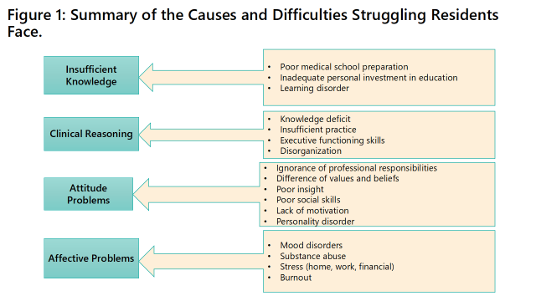

Fig 2: program related causes 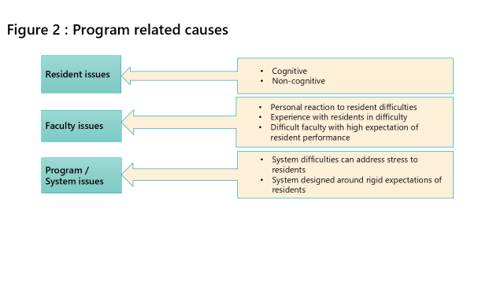

Fig 3: Potential strategies to manage struggling resident

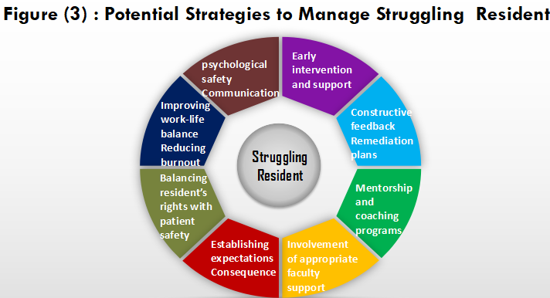

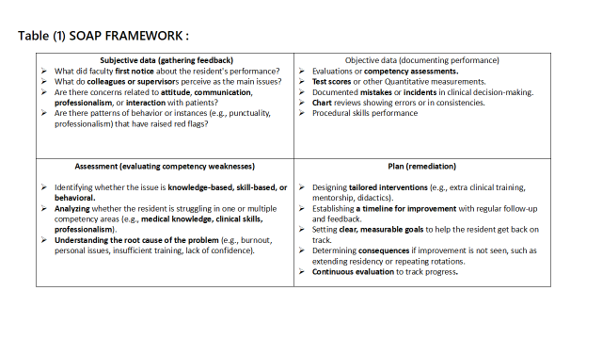

Table 1: Soap framework

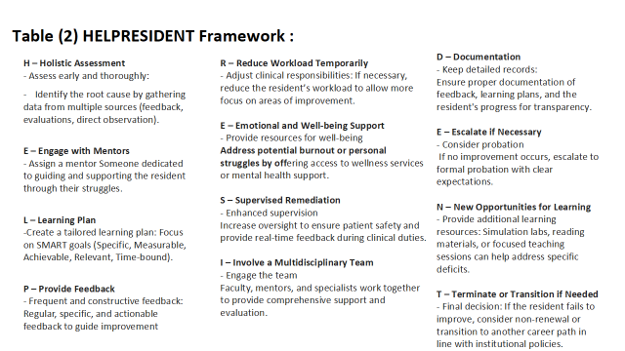

Table 2: Helpresident frame work

**Recommendations:**

Faculty Development: Train faculty members to recognize signs of a struggling resident and provide constructive feedback with clear policies to ensure residency programs have clear guidelines for remediation and remediation exit criteria.

Foster a culture of support where struggling is part of the learning process. Implement wellness and resilience programs to prevent burnout and support mental health.

**Conclusion:**

The use of structured frameworks like HELPRESIDENT and SOAP allows residency programs to systematically support struggling residents, ensuring comprehensive assessment, targeted intervention, and effective monitoring. This approach promotes a supportive learning environment that benefits both residents and training programs.

Limitations:

The proposed framework need to be applied tested and validated before generalization which will be good area of improvement in this field.

Disclaimer (Artificial intelligence)

Author(s) hereby declare that generative AI technologies such as Large Language Models, etc. have been used during the writing or editing of manuscripts. This explanation will include the name, version, model, and source of the generative AI technology and as well as all input prompts provided to the generative AI technology

Details of the AI usage are given below:

CHAT GPT4

**References:**

1. William Lobst , MD FACP ,Karen M Warburton, MD FACP,FSSN: Programmatic Approach to Identifying and Supporting the Struggling Learner .book chapter 2024
2. Yao DC, Wright SM. The challenge of problem residents. J Gen Intern Med. 2001 Jul;16(7):486-92. doi: 10.1046/j.1525-1497.2001.016007486.x. PMID: 11520388; PMCID: PMC1495245.
3. Reamy BV, Harman JH. Residents in trouble: an in-depth assessment of the 25-year experience of a single family medicine residency. Family Medicine. 2006 Apr; 38(4):252-257. PMID: 16586171.
4. Pirie, J., St. Amant, L. & Glover Takahashi, S. Managing residents in difficulty within CBME residency educational systems: a scoping review. BMC Med Educ 20, 235 (2020). <https://doi.org/10.1186/s12909-020-02150-0>

(5) Finch, J., & Tedam, P. (2023). Failure to fail or fast tracking to failure: a critical exploration of social work placements. Social Work Education, 1–16. <https://doi.org/10.1080/02615479.2023.2236153>

1. Holmboe, Eric S., and Durning, Steven James. Practical Guide to the Assessment of Clinical Competence. United Kingdom, Elsevier Health Sciences, 2024.
2. Hwang, E., Kim, J. Factors affecting academic burnout of nursing students according to clinical practice experience. *BMC Med Educ* **22**, 346 (2022). <https://doi.org/10.1186/s12909-022-03422-7>
3. Campbell, F., Blank, L., Cantrell, A. *et al.* Factors that influence mental health of university and college students in the UK: a systematic review. *BMC Public Health* **22**, 1778 (2022). <https://doi.org/10.1186/s12889-022-13943-x>
4. Dias, J.M., Subu, M.A., Al-Yateem, N. *et al.* Nursing students’ stressors and coping strategies during their first clinical training: a qualitative study in the United Arab Emirates. *BMC Nurs* **23**, 322 (2024). <https://doi.org/10.1186/s12912-024-01962-5>
5. Steinert Y. The "problem" learner: whose problem is it? AMEE Guide No. 76. Med Teach. 2013;35(4):e1035-e1045. doi:10.3109/0142159X.2013.774082
6. Boileau E, St-Onge C, Audétat MC. Is there a way for clinical teachers to assist struggling learners? A synthetic review of the literature. Adv Med Educ Pract. 2017 Jan 18;8:89-97
7. Yao DC, Wright SM. National survey of internal medicine residency program directors regarding problem residents. *JAMA*. 2000;284(9):1099-1104. doi:10.1001/jama.284.9.1099
8. Kelleher M, Kinnear B, Sall DR, et al. Warnings in early narrative assessment that might predict performance in residency: signal from an internal medicine residency program. *Perspect Med Educ*. 2021;10(6):334-340. doi:10.1007/s40037-021-00681-w
9. Langlois JP, Thach S. Managing the difficult learning situation. *Fam Med*. 2000;32(5):307-309.

(15) MacLeod L. Making SMART goals smarter. Physician Exec. 2012 Mar-Apr;38(2):68-70, 72

(16) Robin, O, Winter., Bruce, A, Birnberg. (2002). Working with impaired residents: trials, tribulations, and successes.. Family Medicine, 34(3):190-196.

(17) Shrivastava, Saurabh RamBihariLal; Shrivastava, Prateek Saurabh1. Moving from Struggle to Success: Strategies for Addressing and Cultivating Competence among Problem Residents in Medical Education. Indian Journal of Medical Specialities 15(1):p 58-62, Jan–Mar 2024. | DOI: 10.4103/injms.injms_116_23

18. Davis C, Krishnasamy M, Morgan Z, Bazemore A, Peterson L. Academic achievement, professionalism, and burnout in family medicine residents. Family medicine. 2021;53(6):423-32.

19. Jensen RL, Kestle JR, Brockmeyer DL, Couldwell WT. Principles of remediation for the struggling neurosurgery resident. World Neurosurgery. 2021 Feb 1;146:e1118-25.

20. Conforti LN, Yaghmour NA, Hamstra SJ, Holmboe ES, Kennedy B, Liu JJ, Waldo H, Selden NR. The effect and use of milestones in the assessment of neurological surgery residents and residency programs. Journal of Surgical Education. 2018 Jan 1;75(1):147-55.