**Youth Preferences of Fortified Products in Lucknow City in India: Exploring Consumption Pattern and Barriers**

**ABSTRACT**

**Background information:** Food fortification brings forth an inexpensive and scalable solution that can reach vast demographics including those residing in remote or deprived sections.

**Methodology:** A cross-sectional survey was conducted in Lucknow city using convenience sampling to select 170 participants. Data was collected using paper-based questionnaire.

**Major findings:** 67% of participants had easy access to fortified foods, with fortified milk being the most consumed. Daily consumption was reported by 40% of participants. 69% had no safety concerns and holds a positive perception of fortified foods, though a majority still preferred regular food.

**Conclusion:** While fortified foods are accessible and widely accepted, consumer preference for regular food indicates the need for further awareness efforts.

**KEY WORDS:** **food fortification**, **fortified foods**, **micronutrient deficiency**, **fortified milk**

**INTRODUCTION**

The infusion of micro-nutrients to foods is segment of the approach for enhancing food via fortification to boost nutritional value **(Horton, S. et al., 2008)**. Micronutrient deficiency is a leading contributor to disorders and death among both children and women in India **(Bailey R. L. et al., 2015) (Han X. et al., 2022)**. The processing of grains often strips flour of its nutritional content hence fortified flour has iron, vitamin B complex reinstated. On the other hand, different fortified foods receive added micronutrients that is not inherently present in those substances. Food fortification brings forth an inexpensive and scalable solution that can reach vast demographics including those residing in remote or deprived sections **(Olson R. et al.,2021).** Food fortification acts as a supplementary way to achieve a varied diet providing vital nutrients through regularly consumed foods. This approach works to bridge the gap between dietary intake and nutritional requirements eventually promoting improved overall nutrition **(Ramachandran P. et al., 2018)**. The most popular fortified foods are cereal grains and cereal-based product, including fortified breakfast cereals that are supplied with important nutrients like iron vitamin D and vitamin B9, milk and dairy products, fortified with vitamin D, calcium and sometimes vitamin A,  Salt, fortified with iron and iodine, fats and oils, edible oils such as soya bean, sunflower, rice bran, groundnut etc. are fortified with vitamin A and D,fortified juices, fortified with extra vitamins and minerals such as vitamin C and calcium to provide boosted nutritional content. Vitamin and mineral deficiency are widespread in India due to various interconnected factors firstly a significant share of the population relies heavily on staple grains like rice and wheat while their intake of nutrient-packed fruits and vegetables and animal-source foods remains limited this lack of dietary diversity contributes to an inadequate intake of essential micronutrients. Secondly poverty coupled with socioeconomic disparities exacerbate the issue as individuals with lower socioeconomic status often face food insecurity and lack access to nutrient-rich food **(Pingali P et al.,2019)**. Additionally, there is meagre awareness across the population generally acknowledging the importance of consuming a balanced diet to meet nutritional needs. Furthermore, India’s healthcare infrastructure especially in rural areas may not fully provide nutrition education preventive healthcare services or availability of indispensable nutrients via fortification schemes. The food safety and standards authority of India (FSSAI) play a pivotal role in directing and upholding food fortification efforts countrywide. The government of India has undertaken different food fortification endeavours to fight malnutrition and advance health outcomes it has long been engaged in iodizing salt to address iodine deficiency disorders IDDS through the universal salt iodization USI program ensuring sufficient iodine intake among the masses **(Tiwari BK et al., 2006)**. Along with that, the food safety and standards authority of India FSSAI has made flour fortification obligatory with iron folic acid and other essential micronutrients to combat iron deficiency anaemia especially among women and children **(FSSAI ,2018).** In 2020 plans were announced to fortify rice with vitamin B12 targeting vitamin B12 deficiency prevalent among vegetarians. Furthermore, suggested directives deliberate on enforcing fortification of edible oils with vitamin A and D to counteract deficiencies of these fat-soluble vitamins in the population. The surge in global consumer interest in the direction of wellness has fuelled a heightened interest in fortified products believed to provide health advantages leveraging these health and wellness trends presents an effective approach to foster consumer uptake of fortified foods. This study aims to determine the consumption patterns of fortified foods and identify barriers to their acceptance.

**MATERIALS AND METHODS**

The research was conducted among youth in Lucknow city to achieve the research objectives using a quantitative methodology with a cross-sectional survey approach. The study targeted college students and the participants were selected using convenience sampling. A sample of 170 participants was chosen based on time limitations and resource availability. Participants were between 18 to 28 years, including 91 females and 79 males. Data collection was done through paper based questionnaire. The questionnaire contained questions exploring consumption pattern and barrier to fortified foods consumption, including preferences, affordability, availability, media influence and choices between fortified and regular foods, with 30 participants used for pretesting. Data analysis was performed using Microsoft Excel to carefully process the collected information.

**RESULTS AND DISCUSSION**

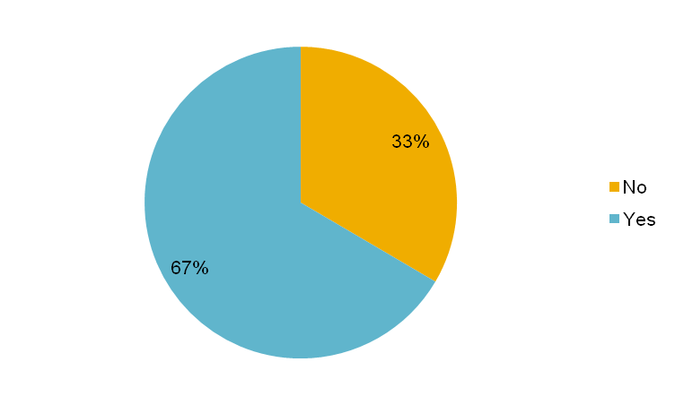

**Figure 1. Distribution of participants according to availability of fortified food around residences**

Figure 1 presents the survey findings on participants access to fortified foods in their residential area. The results indicate that a majority 67% (n=114) reported that fortified foods were readily available in their vicinity making access convenient. In contrast 33% (n=56) stated that they have faced difficulty in obtaining fortified foods in their local area.

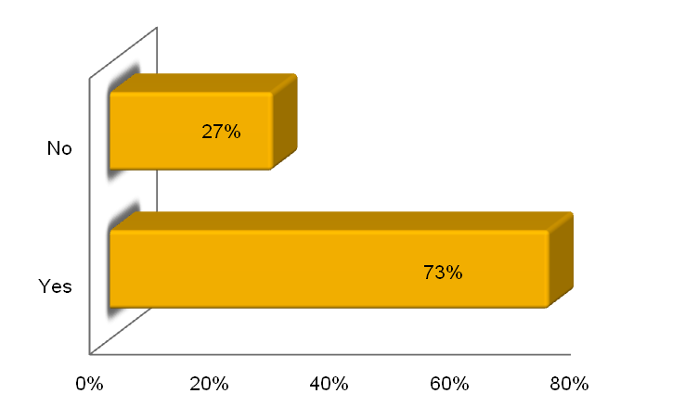

**Figure 2. Distribution of participants according to affordability of fortified food**

Figure 2 highlights the distribution of participant based on their ability to afford fortified foods. Majority of the surveyed youth totalling 75% (n=128) consider fortified food to be within their financial means. Furthermore, 27% (n= 46) of the participants considered them less affordable indicating financial constants in assessing these products.

**Table 1. Distribution of participants according to consumption of variety of fortified food**

|  |  |
| --- | --- |
| Fortified food | % of consumption[1] |
| +F milk | 46% |
| +F salt | 39% |
| +F rice | 23% |
| +F oil | 18% |
| +F wheat flour | 15% |

Table 1 demonstrates distribution of participants based on their consumption of different types of fortified food. The findings reveal that fortified milk is the most commonly consumed, accounting for 46% of total consumption, followed by fortified salt at 39%. Fortified milk popularity among participants may be due to its accessibility cost effectiveness and its common role in daily nutrition. In contrast, fortified wheat has the lowest consumption rate among all fortified foods reported by participants.

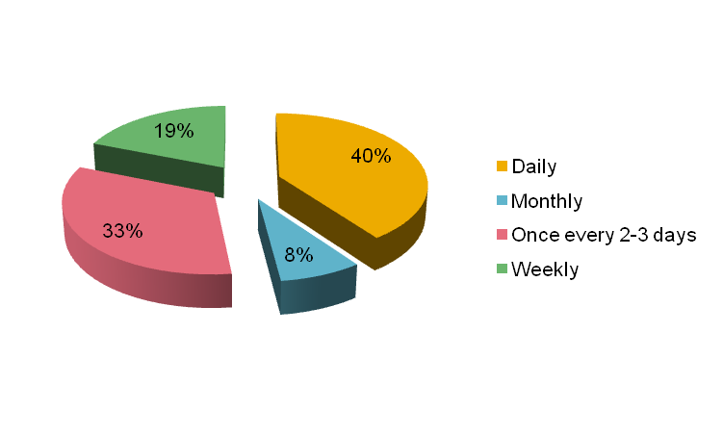

**Figure 3. Distribution of participants according to consumption pattern of fortified food**

Figure 3 illustrates the frequency all fortified food consumption among participants the data shows that 40% consume fortified food daily, 33% every two to three days, 19% weekly and 8% monthly. These findings indicate that the majority of the participants incorporate fortified foods into their diet on a daily basis and the high daily consumption of fortified foods among participants may be influenced by nutritional awareness, easier availability and affordability.

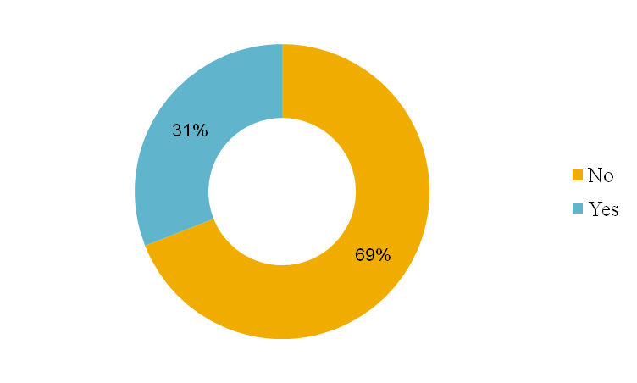

**Figure 4. Distribution of participants according to concerns impacting fortified food acceptance**

Figure 4 depicts participants’ awareness of food fortification and their perceptions of its safety. The data reveal that although 69% of participants aware of food fortification had no doubts about its safety, notable 31% still had misconceptions emphasizing the need for clear information and public awareness campaigns.

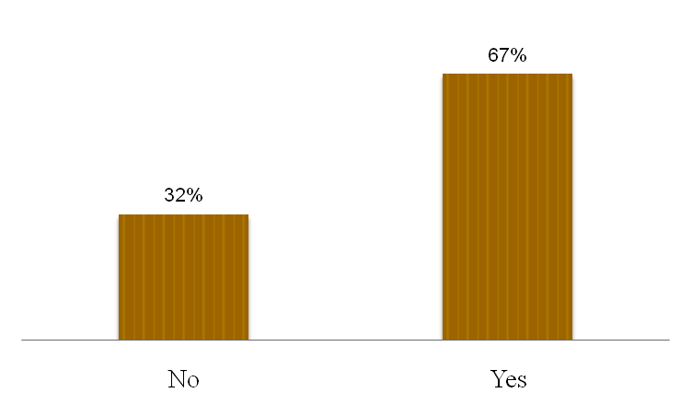

**Figure 5. Distribution of participants according to influence of media on fortified food choices**

Figure 5 illustrates the influence of media on participants choices regarding fortified foods. The data shows that 67% of participants perceived media as a key factor in their decision-making, while, 32% do not believe media plays a role in their consumption choices. This underscores the media's influence in raising awareness while also emphasizing the need for diverse approaches to reach those who are less influenced by it.

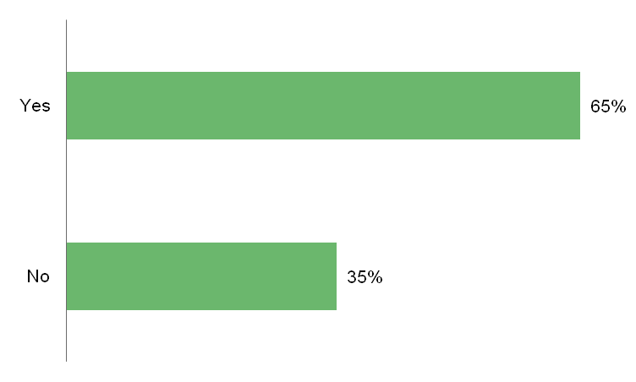

**Figure 6. Distribution of participants according to perceived taste difference of fortified vs. regular food**

Figure 6 illustrates the distribution of participants based on their perceived taste differences between fortified and regular food. The data shows that 65% of participants perceived a difference in taste between fortified and regular food, indicating that fortified foods may have distinct taste characteristics compared to regular food.

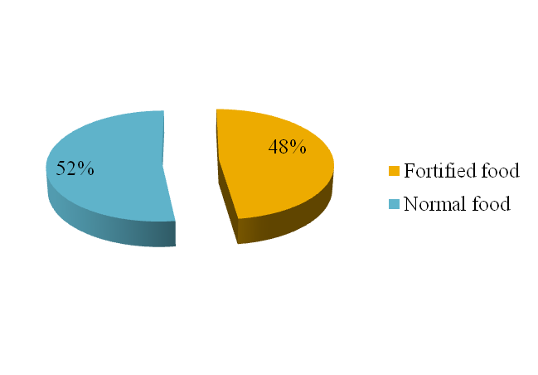

**Figure 7. Distribution of participants according to preferences: fortified food vs. regular food**

Figure 7 presents the distribution of participants based on their preference for fortified versus regular food. The data shows that 48% of participants favours fortified foods, while, 52% prefer regular foods. the nearly even split in preference between fortified and regular food may be influenced by factors such as taste difference, availability, media influence and different misconceptions about fortified food.

**CONCLUSION**

The study found that most participants have easy access to fortified foods, with fortified milk being the most consumed, followed by salt, rice, oil, and wheat flour. Fortified foods are commonly included in daily diets. Most participants aware of fortified foods have no safety concerns and hold a positive perception, influenced mainly by media. Taste plays a crucial role, with many noticing a difference between fortified and regular foods. Although a significant number prefer fortified foods, more participants favour regular foods. These findings highlight the need to address concerns, improve taste, and communicate the benefits of fortified foods to increase acceptance and adoption. The use of convenience sampling in this study may limit its generalizability. Future research should consider random sampling and a more diverse sample for greater validity.

**Disclaimer (Artificial intelligence)**

Option 2:

Author(s) hereby declare that generative AI technologies such as Large Language Models, etc. have been used during the writing or editing of manuscripts. This explanation will include the name, version, model, and source of the generative AI technology and as well as all input prompts provided to the generative AI technology

Details of the AI usage are given below:

1. ChatGPT-4 was used in (4–5 places) to enhance the clarity of language in this manuscript. However, all intellectual content remains original and is solely authored by the listed authors.

2.

3.

**REFERENCES**

Horton, S., Mannar, V., & Wesley, A. (2008). Best practice paper: food fortification with iron and iodine. Copenhagen Consensus Center, Copenhagen Business School, Denmark.

Bailey, R. L., West, K. P., Jr, & Black, R. E. (2015). The epidemiology of global micronutrient deficiencies. Annals of nutrition & metabolism, 66 Suppl 2, 22–33. <https://doi.org/10.1159/000371618>

Han, X., Ding, S., Lu, J., & Li, Y. (2022). Global, regional, and national burdens of common micronutrient deficiencies from 1990 to 2019: A secondary trend analysis based on the Global Burden of Disease 2019 study. EClinicalMedicine, 44, 101299. <https://doi.org/10.1016/j.eclinm.2022.101299>

Olson, R., Gavin-Smith, B., Ferraboschi, C., & Kraemer, K. (2021). Food Fortification: The Advantages, Disadvantages and Lessons from Sight and Life Programs. Nutrients, 13(4), 1118. <https://doi.org/10.3390/nu13041118>

Ramachandran, P.. (2018). Food Fortification: Public Health Approach to Bridge the Gaps Between Requirement and Intake of Micronutrients. Proceedings of the Indian National Science Academy. 84. 10.16943/ptinsa/2018/49448.

Pingali, P, Aiyar, A., Abraham, M and Rahman, A (2019). Transforming Food Systems for a Rising India. Palgrave Studies in Agricultural Economics and Food Policy, ISBN 978-3-030-14408-1 ISBN 978-3-030-14409-8 (eBook). https://doi.org/10.1007/978-3-030-14409-8

Tiwari BK, Ray I, Malhotra RL. New Delhi: 2006. Policy Guidelines on National Iodine Deficiency Disorders Control Programme-Nutrition and IDD Cell.Directorate of Health Services, Ministry of Health and Family Welfare; pp. 1–22. Government of India.

Food Safety and Standards (Fortification of Foods) Regulations, 2018, published in the Gazette of India, Extraordinary, Part III, Section 4 vide notification number, F. No. 11/03/Reg/Fortification/2014, dated – 21/08/2018,retrievedfrom:<https://www.fssai.gov.in/upload/uploadfiles/files/Compendium_Food_Fortification_Regulations_30_09_2021.pdf>.

Purohit N, Mehta S, Bakhshi P. Positioning of Fortified Products for Behavior Change: Research Insights from India. Eur. J. Nutr. Food. Saf. [Internet]. 2015 Aug. 14 [cited 2025 Feb. 5];5(5):1079-80. Available from: https://journalejnfs.com/index.php/EJNFS/article/view/1092

Pambo KO, Otieno DJ, Okello JJ. Analysis of consumer preference for Vitamin A-fortified sugar in Kenya. The European Journal of Development Research. 2017 Aug;29:745-68.

Geicu-Cristea M, Popa EE, Tenagashaw MW. Consumers Perceptions of Fortified Foods. InConsumer Perceptions and Food 2024 Oct 24 (pp. 589-604). Singapore: Springer Nature Singapore.

1. Data based on participant responses (N=170); multiple selections allowed.