Advancing Financial Inclusion for Small and Medium Enterprises through Generative AI Frameworks in the United States

# ABSTRACT

**Aim:** This study examines the role of generative AI in enhancing financial inclusion among Small and Medium Enterprises (SMEs) in the United States. It explores the potential of AI- driven frameworks in mitigating financial constraints, improving credit accessibility, and streamlining financial processes for SMEs.

**Study Design:** A systematic review of literature published between 2019 and 2024 was conducted to assess the impact of generative AI technologies on financial services for SMEs. The study specifically focuses on digital lending innovations, AI-driven credit assessment strategies, and their role in advancing financial inclusion.

**Methodology:** The study employed a systematic literature review approach, sourcing peer- reviewed journal articles and reports from Google Scholar, Scopus, IEEE Xplore, and SSRN. Articles were selected based on their direct relevance to generative AI applications in financial inclusion and SME development in the United States. Only studies that explicitly addressed AI-driven financial solutions for SMEs were included in the review.

**Results:** The findings reveal that generative AI has significantly contributed to reducing financial exclusion among SMEs. Key applications such as automated credit scoring, fraud detection, and AI-powered financial advisory services have shown high potential in improving credit access, operational efficiency, and risk management. However, the adoption of these technologies faces critical challenges, including data privacy concerns, ethical issues, and high implementation costs.

**Conclusions:** Generative AI has the potential to drive financial inclusion for SMEs in the United States by expanding access to financial services and improving credit assessment methodologies. However, addressing barriers to adoption requires collaborative efforts among policymakers, financial institutions, and technology developers to ensure equitable access, ethical implementation, and long-term sustainability of AI-driven financial solutions.

***Keywords:*** *Small and Medium Enterprises, Financial Inclusion, Generative AI Frameworks, Digital Innovation.*

# INTRODUCTION

Financial inclusion, defined as access to affordable and effective financial services, is a critical driver of economic growth and poverty reduction. However, many small and medium enterprises (SMEs) encounter significant obstacles in accessing essential financial services, including loan facilitation, insurance, venture capital, private equity investments, and even basic banking services [1, 2]. These challenges often result in the exclusion of SMEs from traditional financial systems due to barriers such as inadequate credit history, high transaction costs, and stringent regulatory requirements. Beck et al. [3] further highlight that these barriers not only hinder SME growth but also constrain broader economic development. As a result, there is an urgent need for innovative solutions to address the financial inclusion gap.

Advancements in digital innovation, particularly artificial intelligence (AI), present unprecedented opportunities to overcome these barriers. Among these innovations, generative AI, a subset of AI that leverages advanced machine learning models to generate data such as text, images, and structured information has demonstrated transformative potential in financial services. Its applications extend to automated credit risk assessment, fraud detection, and personalized financial advisory, enabling financial institutions to enhance accessibility, eliminate operational inefficiencies, and develop tailored financial solutions for diverse SME needs [4].

This study is grounded in the Technology Acceptance Model (TAM), which explains how SMEs adopt AI-driven financial solutions based on perceived usefulness and ease of use. Additionally, financial inclusion is assessed using Beck and Demirgüç-Kunt’s model, which emphasizes access, usage, and quality of financial services Beck & Demirgüç-Kunt, [5]. These frameworks provide a structured basis for evaluating the impact of generative AI on SME financial inclusion. Ooi et al. [6] identified digital lending as a key area where generative AI is making an impact. Traditional credit assessment models rely heavily on historical financial data, which many SMEs lack due to limited interactions with formal financial institutions. Generative AI, however, can incorporate alternative data sources such as social media activity, transactional records, and industry trends to develop comprehensive financial profiles that influence credit and investment decisions [7]. AI-powered platforms enable financial institutions to redefine creditworthiness assessments, particularly for underserved SME communities, thereby expanding access to financing. Notably, the integration of AI-driven credit scoring systems has been shown to reduce lending inefficiencies by 30–40% while significantly decreasing the time and resources required for traditional processes [8].

In addition to improving credit access, generative AI plays a critical role in enhancing financial advisory services. AI-driven platforms can generate personalized insights for SMEs by analyzing vast datasets and identifying trends, gaps, and opportunities specific to a business’s sector and financial position. This capability enables SMEs to make more informed decisions regarding cash flow management, investment opportunities, and long-term financial planning [9]. Generative AI democratizes access to high-quality financial advisory services, allowing even small businesses to explore strategies that were once exclusive to large corporations with the resources to afford premium consulting services.

Despite its significant potential in advancing financial inclusion, generative AI also faces several challenges. A primary concern is the ethical use of AI-driven frameworks, particularly regarding data privacy and algorithmic bias. Since generative AI models depend on the quality of their training data, biased datasets can lead to discriminatory lending decisions and exclusionary practices, further marginalizing vulnerable groups [10, 11]. Additionally, the absence of standardized regulatory frameworks governing AI in financial systems creates uncertainty for both financial institutions and SMEs, potentially discouraging widespread adoption [12]. Cost barriers also present a challenge, particularly for smaller financial institutions attempting to implement generative AI solutions. As of this writing, the high costs associated with developing, training, and deploying these models often restrict their feasibility to large organizations, leaving smaller banks and credit unions unable to compete in offering AI-powered financial products. Choi et al. [7] emphasize that overcoming these challenges requires a coordinated approach among policymakers, technology developers, and financial institutions to establish inclusive and equitable AI frameworks.

Although existing literature highlights the role of digital innovation in financial inclusion, significant gaps remain regarding the application of generative AI in SMEs within the United States. While research acknowledges that generative AI enables the use of alternative data sources for credit assessments, empirical evidence on the effectiveness and reliability of these

sources in predicting SME creditworthiness remains limited. Much of the existing literature has focused on traditional data-driven AI applications, leaving insufficient exploration of how alternative data can be operationalized to enhance financial inclusion [3]. Furthermore, few studies have examined the ethical and regulatory dimensions of generative AI in financial systems, particularly in mitigating algorithmic bias and ensuring equal access to AI-driven financial products for minority-owned and underserved SMEs [11]. Large financial institutions have successfully deployed generative AI technologies, but high implementation costs remain a prohibitive factor for smaller banks and credit unions. Additionally, research is lacking on how generative AI can be tailored to address the unique challenges of SMEs in specific sectors, such as agriculture, healthcare, and technology. The absence of sector-specific insights limits the development of targeted financial solutions that align with the operational realities of diverse industries [6]. By addressing these research gaps, this study aims to provide actionable strategies to unlock the full potential of generative AI in fostering financial inclusion. This review contributes to the discourse by synthesizing recent findings and exploring the opportunities, challenges, and implications of generative AI for SME financial inclusion in the United States. Specifically, it examines the role of generative AI in bridging financial gaps for SMEs, focusing on its applications, challenges, and potential impact. In doing so, it advances the discussion on how digital innovation can facilitate financial inclusion and promote SME development through the adoption of AI-driven financial solutions.

# METHODOLOGY

This study adopts a systematic literature review to examine the role of generative AI in advancing financial inclusion for SMEs in the United States. The review is designed to synthesize existing research and identify key insights into how generative AI frameworks can address barriers to financial inclusion. To ensure a contemporary and relevant analysis, the study focuses on peer-reviewed journal articles and academic sources published between 2019 and 2024.

## Literature Search Strategy

A structured literature search strategy was employed to define the study's scope and ensure the inclusion of high-quality, relevant sources. The review was conducted using four established academic databases: Google Scholar, Scopus, Web of Science, and SSRN. These databases were selected based on their broad coverage of high-impact journals spanning disciplines such as economics, technology, and business.

To ensure a comprehensive yet focused search, relevant keywords and search phrases were applied, including "generative AI," "financial inclusion," "digital innovation," and "SMEs in the United States." Boolean operators such as "AND" and "OR" were used to refine search results and enhance relevance. For example, a query using "generative AI AND financial inclusion AND SMEs" filtered articles that specifically addressed the study's research focus.

Additional filtering criteria were applied to ensure quality and relevance. Only studies published in English, within the 2019–2024 timeframe, and appearing in peer-reviewed sources were included in the review [13].

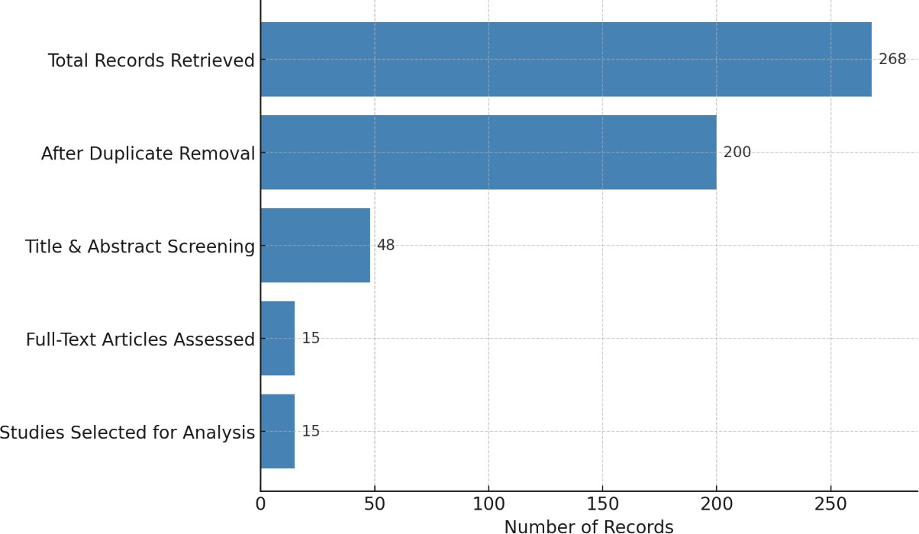

**Figure 1: Flow Diagram of the Literature Search and Study Selection**

A total of 268 records were retrieved from four academic databases: 90 from Google Scholar, 75 from Scopus, 60 from Web of Science, and 43 from SSRN (See Figure 1). After removing duplicate entries, 200 unique records remained and were advanced for title and abstract screening. The titles and abstracts of all records were carefully reviewed to assess their relevance to this study. Publications that were irrelevant to the topic, published before 2019, or not based on original research were excluded. Following this screening, 48 full-text articles were assessed for eligibility based on their alignment with the study’s scope and objectives. Ultimately, 15 studies were selected for qualitative analysis, forming a robust evidence base for understanding how generative AI can enhance financial inclusion for SMEs.

## Limitations of the Study Selection Process

Several limitations should be noted regarding the selection process. The primary limitation is that only English-language publications were reviewed, potentially overlooking important contributions from non-English sources, particularly on financial inclusion issues affecting linguistically diverse communities in the United States.

Furthermore, while prioritizing peer-reviewed journal articles enhances the credibility and academic rigor of this study, it may exclude industry reports and white papers that offer valuable practical insights into real-world applications of generative AI in financial inclusion [14]. The exclusion of studies published before 2019 ensures a contemporary focus but may have inadvertently omitted foundational works on the historical evolution of financial inclusion and digital innovation.

Finally, subjective judgment was applied during title, abstract, and full-text screening, introducing the potential for selection bias. Despite efforts to maintain objectivity, certain studies may have been inadvertently excluded based on interpretation rather than intrinsic relevance.

# RESULTS AND DISCUSSION

This review identified several key studies demonstrating how generative AI frameworks can help overcome financial barriers for SMEs in the United States. The findings highlight the transformative role of AI-driven innovations in automated credit scoring, fraud detection, and personalized financial advisory systems (See Figure 2).

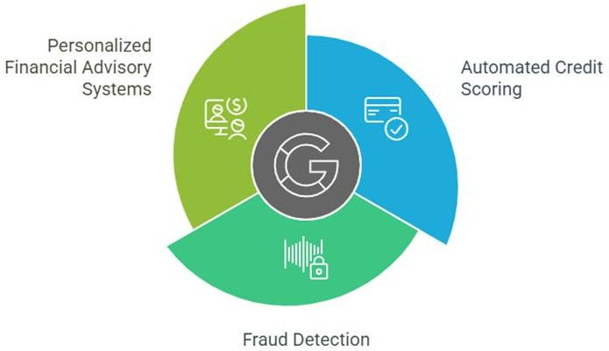

***Figure 2: Roles of Generative AI on SME Financial Accessibility***

## Automated Credit Scoring

A substantial body of literature emphasizes the significant advancements AI has introduced in credit scoring systems (See Figure 3). Traditional credit scoring methods often exclude SMEs due to limited financial data and rigid assessment criteria. Generative AI, particularly machine learning algorithms, has the capability to analyze non-traditional data sources such as transaction history, supplier relationships, and social media activity to develop more inclusive and accurate credit models [15, 16].

A study by Raji et al [17] reported that AI-driven credit scoring models achieved an accuracy rate of 85%, compared to 72% for traditional models, reflecting a 13% improvement in predictive accuracy. By integrating a wider range of data inputs, including payment history and digital footprints, generative AI enables more precise assessments of SME creditworthiness. This improvement enhances access to finance for underserved SMEs, bridging the gap created by conventional scoring limitations. A notable example is Kabbage, an AI-driven lending platform that analyzes alternative financial data to extend credit to SMEs. However, during the COVID-19 pandemic, AI-driven credit allocation models faced scrutiny due to biases in loan approvals, leading to regulatory investigations [18]. Similarly, OakNorth Bank in the UK has successfully implemented machine learning for SME credit scoring, demonstrating both the potential and risks of AI in financial inclusion.

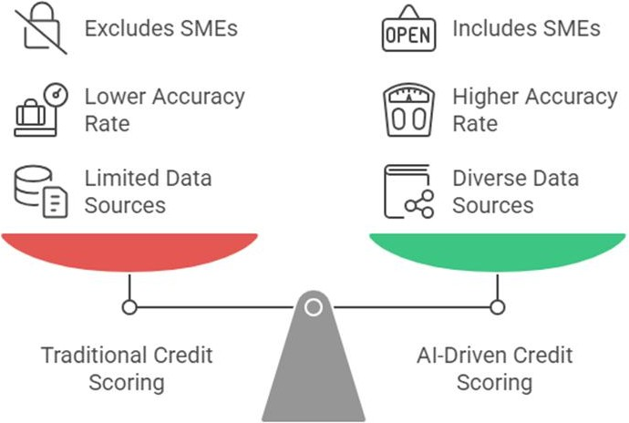

***Figure 3: Comparative Performance of Traditional and AI-Driven Credit Scoring***

## Fraud Detection and Risk Management

Generative AI has also significantly enhanced fraud detection and risk management systems. AI-powered models have demonstrated high effectiveness in detecting fraudulent transactions in real time, particularly through deep learning techniques (See Figure 4). A study by Bello et al. [19] found that AI-powered fraud detection systems achieved a 94% detection rate, compared to 70% for traditional rule-based systems. These AI-driven systems can process large datasets, identify complex patterns, and detect fraudulent activities with greater speed and accuracy. Moreover, AI models continuously learn and adapt to emerging fraud tactics, making them essential for strengthening the financial security of SMEs. The implementation of these models has led to a reduction in fraud-related financial losses by as much as 30%, providing an additional layer of protection for small businesses and ensuring their financial stability.

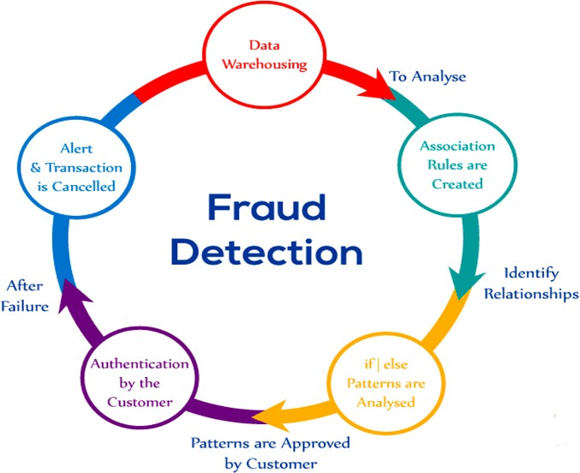

***Figure 4: Effectiveness of Fraud Detection***

## Personalized Financial Advisory Systems

Generative AI can also enhance personalized financial advisory services for SMEs. AI-driven platforms leverage Natural Language Processing (NLP) and machine learning algorithms to analyze financial data and provide tailored recommendations. A study by Nkwinika and Akinola [20] found that AI-powered advisory mechanisms improved financial decision-making in SMEs by approximately 40%, particularly in areas such as cash flow management and tax planning. Empirical evidence further indicates that SMEs using AI-driven financial advisory services experienced a 20% increase in operational efficiency and a 15% improvement in profitability over a 12-month period. These advancements are particularly beneficial for businesses with limited access to professional financial advisors, as they reduce reliance on costly consultations while improving financial planning and risk management.

## Financial Inclusion Strategies

Generative AI also facilitates financial inclusion strategies by reducing entry barriers for SMEs in underserved communities (See Figure 5). AI bridges gaps in access to traditional banking services, particularly in areas where physical banking infrastructure is limited. Lee et al. [21] examined an AI-powered lending initiative in rural U.S. communities, where AI-driven platforms provided credit access to SMEs previously excluded due to geographical constraints. Their findings revealed that 45% of SMEs in these regions experienced improved financial inclusion following the adoption of AI-based services. Unlike the United States, where AI adoption in SME financing is primarily driven by private-sector innovation, countries such as China have implemented state-backed AI lending platforms to reach underserved SMEs. Similarly, India’s Aadhaar-linked AI-powered credit system has significantly improved financial inclusion. The United Kingdom has adopted regulatory sandboxes to ensure AI-driven financial products are tested for fairness before full-scale implementation [22]. By reducing

reliance on physical bank branches, AI enables the broader distribution of capital, thereby promoting financial inclusion in unbanked areas [23–25].

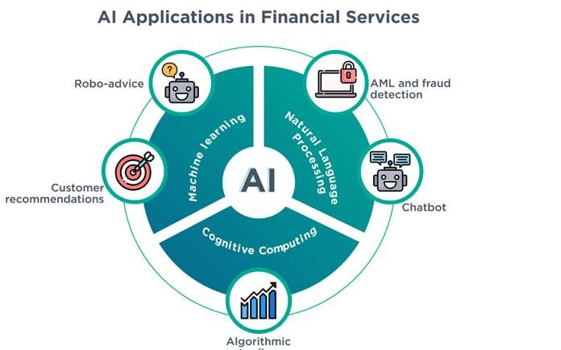

***Figure 5: AI Applications in Financial Inclusion Strategies***

## Challenges and Barriers

Despite the significant promise of generative AI in advancing financial inclusion, several challenges persist. One of the primary concerns is data privacy, particularly regarding the management of sensitive financial information. Kumar and Patel [26] reported that 62% of SMEs lack the necessary infrastructure to securely handle financial data, raising concerns about data security and confidentiality. Ethical considerations have also been highlighted, particularly regarding AI decision-making algorithms and their transparency. The high costs associated with implementing AI-driven systems further create barriers to adoption. Studies by Iyelolu et al. [27] and Bhalerao et al. [28] indicate that the initial investment required for AI integration can be substantial, making it particularly challenging for SMEs with limited financial resources to afford these technologies.

## Summary of Findings

The findings from this review underscore the substantial potential of generative AI frameworks in addressing financial constraints faced by SMEs in the United States. Existing studies demonstrate that AI-driven innovations have improved access to finance, particularly in automated credit scoring, fraud detection, and personalized financial advisory systems. These advancements have contributed to the sustainability and growth of small businesses.

The transition from traditional credit scoring models to AI-enabled alternatives has resulted in significant gains in inclusivity and predictive accuracy. Conventional credit-scoring methods often fail to accurately assess SME creditworthiness, as they primarily rely on limited datasets such as credit history and asset evaluations. Bhatore et al. [16] argue that AI-based models, particularly those using machine learning algorithms, provide a more holistic assessment by incorporating alternative data sources such as transaction histories, supplier relationships, and social media activity. These data points offer a more comprehensive representation of an SME’s financial health, enhancing the accuracy of creditworthiness assessments. Raji et al

[17] further observed that AI-driven credit models improve predictive accuracy by 13%, demonstrating their effectiveness in addressing data limitations that hinder SMEs from accessing financial services. By leveraging generative AI, financial institutions can create more inclusive lending practices, increasing the likelihood of underserved SMEs securing loans and other financial support.

## Fraud Detection and Risk Management

Generative AI has shown significant promise in fraud detection and risk management, addressing critical challenges that impact the financial sustainability of SMEs. In particular, deep learning-based AI models have demonstrated remarkable improvements over traditional fraud detection methods. Bello et al. [19], found that AI-powered fraud detection systems achieved a 94% detection rate, compared to only 70% for traditional rule-based systems. One of AI’s most critical advantages in combating fraud—an issue that can severely destabilize SMEs—is its ability to process large datasets and identify complex fraudulent patterns in real time. Additionally, AI systems continuously adapt to evolving fraud tactics, ensuring that security measures remain proactive and effective. These AI-driven models have been shown to reduce fraud-related financial losses by up to 30%, allowing SMEs to focus on growth and innovation rather than risk mitigation.

## Personalized Financial Advisory Services

Generative AI has also introduced transformative advancements in personalized financial advisory services, offering SMEs access to cost-effective and tailored financial guidance. This is particularly beneficial for SMEs that lack the financial resources to hire professional advisors. AI-driven platforms, leveraging Natural Language Processing (NLP) and machine learning algorithms, can analyze an SME’s financial health and generate customized recommendations based on its specific needs. Nkwinika and Akinola [20] found that AI- powered advisory systems improved financial decision-making in key areas such as cash flow management and tax planning by 40%. Furthermore, SMEs utilizing AI-driven financial advisory services reported a 20% increase in operational efficiency and a 15% improvement in profitability over a 12-month period. These findings highlight AI’s potential to level the playing field for SMEs, providing them with data-driven financial strategies that were previously accessible only to larger enterprises with dedicated financial consulting teams.

## Generative AI and Financial Inclusion

Generative AI plays a crucial role in facilitating financial inclusion among SMEs, particularly those operating in underserved and disadvantaged regions. AI has the potential to overcome geographical barriers by providing access to financial services in areas lacking conventional banking infrastructure. Lee et al. [21] examined a case in rural U.S. communities, where AI- powered digital platforms enabled previously excluded SMEs to access credit and loans. Their findings revealed that 45% of SMEs in these regions improved their financial inclusion following the adoption of AI-driven financial services. This is particularly significant given that, to date, many micro and small enterprises remain heavily dependent on physical banking networks, which often restrict access to capital. By eliminating location-based barriers, AI allows SMEs to tap into a broader range of financial resources, thereby enhancing their financial stability and growth potential.

## Challenges and Barriers to AI Adoption

Despite its substantial benefits, the adoption of generative AI in financial services for SMEs faces several challenges. One of the most critical concerns is data privacy. Kumar and Patel

[26] reported that 62% of SMEs express concerns about the security of their sensitive financial information when using AI-powered systems. This issue is exacerbated by the fact that many SMEs lack the necessary infrastructure to effectively safeguard their data against potential security breaches. The lack of standardized regulatory oversight for AI-driven financial services in the U.S. raises concerns about algorithmic transparency and bias in credit allocation. Institutions such as the Consumer Financial Protection Bureau (CFPB) and the Federal Reserve have yet to establish clear guidelines on the ethical use of AI in SME financing, leaving gaps in accountability and trust [29].

Additionally, ethical concerns persist regarding the fairness and transparency of AI decision- making algorithms. Many SMEs may struggle to understand or trust AI-generated decisions, particularly when decision-making processes lack transparency. Another major barrier is the high upfront cost of AI implementation. Bhalerao et al. [28] estimated that the financial burden of adopting AI technologies can be significant, particularly for smaller businesses with constrained financial resources. In addition to initial implementation costs, ongoing maintenance and system updates present further financial challenges. These expenses often make it difficult for SMEs to justify AI investments, despite the long-term benefits associated with increased efficiency, accessibility, and financial inclusion.

## Future Research Directions

Future research should explore the integration of AI and blockchain technologies in SME financing to enhance transparency and minimize fraud. Additionally, more empirical studies are needed to assess the long-term sustainability of AI-driven financial inclusion models, particularly for minority-owned and rural SMEs. Investigating the role of AI in sustainable finance, such as green loans and impact investment, could further expand the field of AI-driven financial services.

# CONCLUSION

This study highlights the transformative potential of generative AI in addressing finance-related challenges faced by SMEs in the United States. The findings demonstrate that AI-driven innovations can enhance credit scoring models, improve fraud detection, provide personalized financial advisory services, and facilitate greater financial inclusion. However, several challenges threaten the widespread adoption and equitable access to generative AI for SMEs. Key concerns include data privacy risks, ethical issues related to AI decision-making, and the high costs of implementation, all of which could further exacerbate existing financial and technological disparities. As AI technologies continue to evolve, it is crucial for policymakers, industry stakeholders, and SMEs to collaborate in addressing these barriers. A coordinated effort will be essential to ensuring that the full benefits of generative AI are accessible to SMEs, ultimately fostering greater financial inclusion and economic growth.

**Disclaimer (Artificial intelligence)**

Option 1:

Author(s) hereby declare that NO generative AI technologies such as Large Language Models (ChatGPT, COPILOT, etc.) and text-to-image generators have been used during the writing or editing of this manuscript.

Option 2:

Author(s) hereby declare that generative AI technologies such as Large Language Models, etc. have been used during the writing or editing of manuscripts. This explanation will include the name, version, model, and source of the generative AI technology and as well as all input prompts provided to the generative AI technology

Details of the AI usage are given below:

1.

2.

3.

# REFERENCES

1. Surya B, Menne F, Sabhan H, Suriani S, Abubakar H, Idris M. Economic growth, increasing productivity of SMEs, and open innovation. Journal of Open Innovation: Technology, Market, and Complexity. 2021;7(1):20.
2. Mugano G, Dorasamy N, editors. SMEs and Economic Development in Africa. Taylor & Francis Group; 2023;1-58.
3. Beck T, Demirguc-Kunt A, Singer D. Financial inclusion and inclusive growth: A review of recent empirical evidence. World Bank Res Obs. 2020;35(1):2–34.
4. Li X, Yu C, Chen L. Exploring the role of generative AI in digital lending ecosystems. Financ Innov J. 2022;8(2):304–25.
5. Beck T, Demirgüç-Kunt A. Access to finance: An unfinished agenda. The world bank economic review. 2008;22(3):383-96.
6. Ooi KB, Tan GW, Al-Emran M, Al-Sharafi MA, Capatina A, Chakraborty A, Dwivedi YK, Huang TL, Kar AK, Lee VH, Loh XM. The potential of generative artificial intelligence across disciplines: Perspectives and future directions. Journal of Computer Information Systems. 2023:1-32.
7. Anil K, Misra A. Artificial intelligence in Peer-to-peer lending in India: a cross-case analysis. International Journal of Emerging Markets. 2022 May 16;17(4):1085-106.
8. Kumar A, Sharma S, Mahdavi M. Machine learning (Ml) technologies for digital credit scoring in rural finance: a literature review. Risks. 2021;9(11):192.
9. Bai X, Zhuang S, Xie H, Guo L. Leveraging generative artificial intelligence for financial market trading data management and prediction. Journal of Artificial Intelligence and Information. 2024;1:32-41.
10. Chen P, Wu L, Wang L. AI fairness in data management and analytics: A review on challenges, methodologies and applications. Applied Sciences. 2023;13(18):10258.
11. Nambie NB, Ocansey EO, Dadzie P, Obobi BA. Credit Risk Assessment, Regulatory Compliance, and Financial Intermediation in Sub-Saharan Africa, The Role of Artificial Intelligence. International Research Journal of Economics and Management Studies IRJEMS. 2024;3(9).
12. Yasir A, Ahmad A, Abbas S, Inairat M, Al-Kassem AH, Rasool A. How Artificial Intelligence Is Promoting Financial Inclusion? A Study On Barriers Of Financial Inclusion. In2022 International Conference on Business Analytics for Technology and Security (ICBATS) 2022 Feb 16 (pp. 1-6). IEEE..
13. Omokhoa HE, Odionu CS, Azubuike C, Sule AK. AI-Powered Fintech innovations for credit scoring, debt recovery, and financial access in Microfinance and SMEs. Gulf Journal of Advance Business Research. 2024;2(6):411-22.
14. Mhlanga D. Financial inclusion in emerging economies: The application of machine learning and artificial intelligence in credit risk assessment. International journal of financial studies. 2021 Jul 27;9(3):39.
15. Bari MH. A systematic literature review of predictive models and analytics in AI-driven credit scoring. Journal of Machine Learning, Data Engineering, and Data Science. 2024;1(1):1-18.
16. Bhatore S, Mohan L, Reddy YR. Machine learning techniques for credit risk evaluation: a systematic literature review. Journal of Banking and Financial Technology. 2020(1):111-38.
17. Raji AA, Alabdoon AH, Almagtome A. AI in Credit Scoring and Risk Assessment: Enhancing Lending Practices and Financial Inclusion. In2024 International Conference on Knowledge Engineering and Communication Systems (ICKECS) 2024;1:1-7.
18. Forbes. AI-driven lending under scrutiny: Bias in loan approvals during COVID-19. 2022. Available from: https://[www.forbes.com/.](http://www.forbes.com/)
19. Bello OA, Ogundipe A, Mohammed D, Adebola F, Alonge OA. AI-Driven Approaches for Real-Time Fraud Detection in US Financial Transactions: Challenges and Opportunities. European Journal of Computer Science and Information Technology. 2023;11(6):84-102.
20. Nkwinika E, Akinola S. The importance of financial management in small and medium- sized enterprises (SMEs): an analysis of challenges and best practices. Technology audit and production reserves. 2023;5(4/73):12-20.
21. Lee J, Adams T, Carter H. Expanding financial inclusion: AI-based credit services in rural

U.S. SMEs. Small Bus Econ Rev. 2022;36(2):145-60.

1. World Bank. The impact of AI on financial inclusion: Global trends and regulatory approaches. Available from: https://[www.worldbank.org/...](http://www.worldbank.org/)
2. Kshetri N. The role of artificial intelligence in promoting financial inclusion in developing countries. Journal of Global Information Technology Management. 2021;24(1):1-6.
3. Liu J, Zhang Y, Kuang J. Fintech development and green innovation: Evidence from China. Energy Policy. 2023 Dec 1;183:113827.
4. Adeoye OB, Addy WA, Ajayi-Nifise AO, Odeyemi O, Okoye CC, Ofodile OC. Leveraging AI and data analytics for enhancing financial inclusion in developing economies. Finance & Accounting Research Journal. 2024 Mar 9;6(3):288-303.
5. Kumar P, Patel S. Data privacy and ethical concerns in AI-based financial decision-making for SMEs. J Bus Ethics Technol. 2024;41(2):78-94.
6. Iyelolu TV, Agu EE, Idemudia C, Ijomah TI. Driving SME innovation with AI solutions: overcoming adoption barriers and future growth opportunities. International Journal of Science and Technology Research Archive. 2024;7(1):036-54.
7. Bhalerao K, Kumar A, Kumar A, Pujari P. A study of barriers and benefits of artificial intelligence adoption in small and medium enterprise. Academy of Marketing Studies Journal. 2022;26:1-6.
8. Consumer Financial Protection Bureau (CFPB). AI and financial services: Regulatory considerations. 2023. Available from: https[://www.consumerfinance.gov/.](http://www.consumerfinance.gov/)