***Minireview Article***

**A Narrative Review on Lighting the Path to Longevity: The Art of Light Curing Dental Composites**

**Abstract**

Light curing plays a fundamental role in the polymerization of dental resin composites, directly influencing the mechanical properties, longevity, and esthetics of restorations. This comprehensive review explores key factors affecting polymerization efficiency, including exposure time, irradiance, beam homogeneity, curing light technology, and material properties. The importance of polywave LEDs in activating various photoinitiators is highlighted, alongside advanced curing modes such as soft-start and pulse-delay techniques, which help reduce polymerization stress and improve marginal adaptation. Additionally, challenges associated with budget curing lights, the significance of radiometer usage, and potential risks of improper curing—such as marginal leakage, reduced mechanical properties, and thermal damage—are discussed. The review also addresses infection control considerations and the hazards of blue light exposure. By adhering to evidence-based protocols and utilizing modern curing technologies, clinicians can enhance the success and durability of composite restorations.

Keywords: Light curing, polymerization, photoinitiators, Dental composites

**Introduction**:

Light curing is an essential process in restorative dentistry, playing a crucial role in the polymerization of resin composites. The success of composite restorations depends significantly on the efficiency of light curing, which directly influences their mechanical strength, esthetic quality, and longevity [1,2].

A key component of light curing is the photo-polymerization process, in which light energy initiates a chemical reaction that converts the resin composite from a pliable state to a hardened, durable structure. This reaction is facilitated by photoinitiators within the composite material, which absorb specific wavelengths of light and trigger the formation of polymer chains [3,4]. The efficiency of this process depends on various factors, such as light intensity, exposure duration, and the composite's composition.

Achieving optimal polymerization requires a thorough understanding of various factors, including exposure time, irradiance, polywave technology, curing modes, and safety considerations [5,6]. Additionally, advancements in light-curing technology and research-based clinical protocols have contributed to improved restoration performance and patient outcomes. Properly executed photo-polymerization ensures optimal curing, minimizing the risk of incomplete polymerization, marginal leakage, and mechanical failure [7,8].

This review explores the fundamental principles, challenges, and recent advancements in light curing techniques, emphasizing the importance of evidence-based approaches in contemporary dental practice.

**Exposure Time and Total Energy Concept**:

The polymerization efficiency of resin composites depends on the total energy delivered, which is the product of exposure time and light intensity [9]. Higher intensity lights allow shorter curing times, while lower intensities necessitate extended exposure. For example, a curing light with an irradiance of 16000 mW/cm² can cure a composite in 15 seconds when applied at 1200 mW/cm² [10]. Proper calibration of curing duration ensures complete polymerization and prevents under- or over-curing, which can compromise the restoration's longevity.

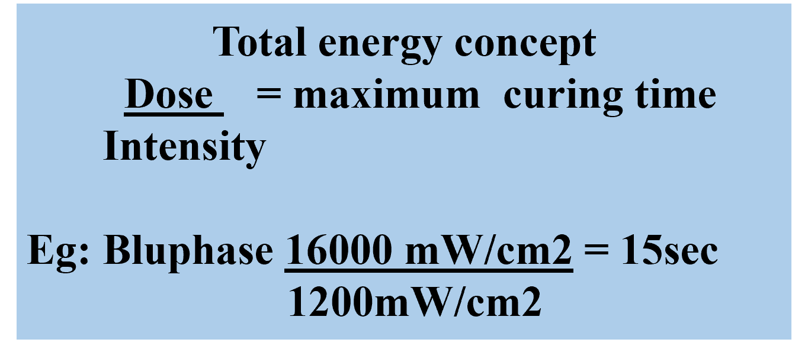

Figure 1: Exposure Time and Total Energy Concept

Insufficient exposure can lead to uncured resin, affecting the mechanical strength and biocompatibility of the restoration. Proper polymerization ensures optimal bond strength, minimizing marginal leakage and the risk of secondary caries. Various factors influence exposure time, including the distance between the curing light and the restoration, the angulation of light application, and the composite's material properties [9].

Alpöz et al. (2008) investigated the effects of different light-curing methods and exposure times on the mechanical properties of resin-based dental materials. The study compared conventional halogen, LED, and high-intensity curing units, assessing their impact on microhardness and flexural strength. Results indicated that longer exposure times generally improved material properties [11].

**Irradiance and Beam Homogeneity**:

Uniform irradiance is crucial for ensuring even polymerization throughout the restoration. An ideal curing light should have a homogenous beam profile to prevent areas of insufficient energy delivery, which may result in inadequate curing at deeper layers [12]. Proper positioning of the curing light perpendicular to the restoration surface maximizes efficiency.

**Factors Affecting Light Cure Irradiance:**

Several factors influence the effectiveness of light cure irradiance, impacting composite polymerization quality. These include:

1. **Power Output of the Curing Light:** Higher-powered curing lights allow shorter curing times and deeper polymerization by delivering increased irradiance to the composite material. This enhances the degree of conversion of monomers into polymers, leading to improved mechanical properties and longevity of the restoration. Additionally, high-power curing lights reduce the risk of incomplete polymerization in deeper restorations, ensuring uniform material performance throughout the composite layer. [13].
2. **Beam Homogeneity:** An uneven beam profile leads to inconsistent curing, creating weak spots in the restoration. Variations in light distribution can result in areas that receive insufficient irradiance, leading to compromised mechanical properties and potential failure over time. Ensuring a uniform beam profile helps achieve consistent polymerization throughout the composite material, reducing the risk of incomplete curing and marginal breakdown. Advanced curing lights with collimated beams and even irradiance distribution are recommended to optimize polymerization quality [14].
3. **Curing Tip Diameter**: The diameter of the curing tip influences light distribution. A larger tip covers a wider area but may reduce peak irradiance, while a smaller tip increases intensity but limits coverage. Selecting an appropriate tip diameter ensures uniform polymerization across the restoration surface.

A study by Nomoto (2003) investigated the effect of light guide tip diameter on the polymerization of light-cured composites using an LED curing unit. The research demonstrated that smaller diameter tips (4 mm) produced higher light illuminance and greater depths of cure compared to larger tips (8 mm and 10 mm). Specifically, the depth of cure for the 4 mm tip was significantly greater than that of the larger tips, indicating that tip diameter directly affects the effectiveness of composite polymerization [15].

Figure 2: Curing Tip Diameter

1. **Distance from Light Tip to Composite Surface**: The further the light source, the lower the irradiance received, leading to suboptimal polymerization. To ensure effective curing, the light tip should be positioned as close as possible to the composite surface without touching it. Studies have shown that increasing the distance from 0 mm to 10 mm can reduce irradiance by nearly 50%, necessitating longer curing times to compensate for energy loss [16].
2. **Angle of Light Application**: Incorrect angulation can lead to shadowing and incomplete polymerization, especially in deep cavities where light penetration is already limited [17]. Ensuring the curing light is positioned perpendicular to the surface and using light-guiding tips can enhance energy delivery to all areas of the restoration, improving overall polymerization quality (Price et al., 2010). Additionally, light-transmitting wedges can be used to direct light into deeper areas, helping to ensure adequate polymerization in challenging restorations such as Class II cavities (Rueggeberg et al., 2017). These wedges help scatter and transmit light effectively, reducing the risk of under-cured resin in proximal box areas.

Figure 3: light-guiding tip and light-transmitting wedge

1. **Type of Composite Material**: Highly pigmented or densely filled composites require longer curing times due to their increased light absorption and scattering properties. These materials contain a higher concentration of fillers, which can obstruct light penetration and reduce polymerization efficiency. To compensate, clinicians must adjust exposure duration or use higher-intensity curing lights to ensure thorough polymerization. Additionally, certain composite shades, such as those with darker pigments, require extended curing times compared to lighter shades, as they absorb more light energy, reducing the depth of cure. Properly adjusting curing parameters based on composite composition helps prevent incomplete polymerization, ensuring optimal mechanical strength and longevity of the restoration [18].

**Problems with Budget Curing Lights:**

Budget curing lights often compromise beam profile uniformity, leading to inconsistent polymerization. Research has shown that some low-quality curing lights produce hot spots with excessive irradiance while other areas receive suboptimal energy levels, resulting in uneven polymerization [19]. A high-quality curing light with a well-focused beam profile ensures consistent curing across the restoration surface, preventing premature failure.

Furthermore, budget curing lights frequently suffer from unstable battery output, leading to variations in power delivery. This inconsistency can result in insufficient curing or overheating, both of which negatively impact the restoration [20]. Additionally, many low-cost curing lights lack adequate safety features, posing potential biohazards in clinical settings.

**Polywave Technology and Modern Photoinitiators:**

Camphorquinone (CQ), Lucirin TPO, and Ivocerin are key photoinitiators used in light-curable dental composites, each with distinct activation wavelengths and polymerization properties [21].

* 1. **Camphorquinone (CQ):** It is the most commonly used photoinitiator in dental composites with Activation Wavelength of 400–500 nm (Peak ~468 nm) due to its high efficiency and compatibility with LED curing lights. However, it has a yellowish color, which can affect the final shade of esthetic restorations. CQ requires a co-initiator, such as an amine, to enhance polymerization efficiency.
  2. **Lucirin TPO**: It is a high-efficiency photoinitiator with activation Wavelength: 350–410 nm (Peak ~380 nm) that allows for improved depth of cure in light-colored and translucent composites. Unlike CQ, it does not require a co-initiator, and its colorless nature makes it ideal for esthetic restorations. However, it requires a curing light that emits near-UV wavelengths for activation.
  3. **Ivocerin:** It is a novel photoinitiator with activation Wavelength: 390–445 nm (Peak ~415 nm) with high quantum efficiency, meaning it can initiate polymerization more effectively than CQ and TPO. It provides deeper curing and enhanced mechanical properties in bulk-fill composites. Ivocerin is highly reactive and does not rely on co-initiators, reducing potential discoloration over time.

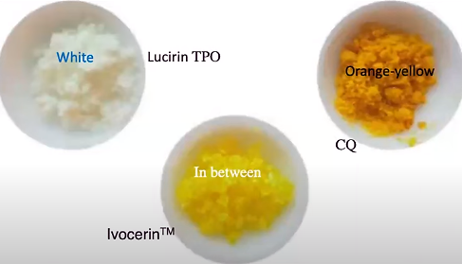

Figure 4: Photoinitiators

When using a single-peak (monowave) LED, any initiators which need wavelengths below 420 nm are not activated. Multi-peak (polywave) LEDs do deliver light below 420 nm, which should effectively activate all other commonly used photo-initiators, ensuring thorough polymerization and optimal restoration longevity [22].

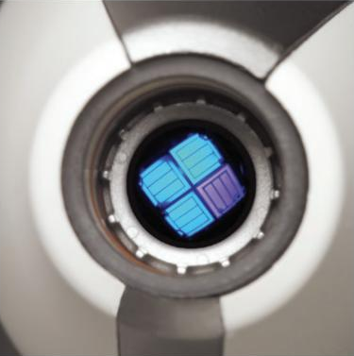

Figure 5: polywave LED curing light

Varshney et al. (2022) examined the impact of monowave and polywave LED light-curing units on the degree of conversion and microhardness of dental composites with different photoinitiators. Their in vitro study found that polywave curing units provided better polymerization and hardness, especially for composites containing alternative photoinitiators beyond camphorquinone. The findings highlight the importance of using polywave LEDs to enhance the performance of modern composite resins in restorative dentistry [23].

Another study by Boeira et al. (2021) evaluated the effects of polywave and monowave light-curing units on the polymerization efficiency of different photoinitiators. The findings suggested that third-generation polywave light-curing units exhibited higher polymerization potential regardless of the photoinitiator used, compared to second-generation monowave units [24].

**Soft-Start and Pulse-Delay Curing Modes:**

These modes are advanced polymerization strategies designed to reduce polymerization stress, thereby minimizing shrinkage and improving restoration longevity [25].

* 1. **Soft-Start Mode**: This technique gradually increases the intensity of light over time, reducing polymerization shrinkage stress. The gradual ramp-up allows the composite to flow and adapt better to cavity walls before reaching full polymerization.
  2. **Pulse-Delay Mode**: In this mode, the curing light is applied in short pulses with intermittent pauses. This technique helps relieve polymerization shrinkage stress, promoting better marginal adaptation and reducing post-operative sensitivity.

Figure 6: Soft-Start and Pulse-Delay Curing Modes

A study by Ernst et al. (2003) evaluated the influence of a soft-start light-curing exposure on polymerization shrinkage stress and marginal integrity of adhesive restorations. The study found that the soft-start polymerization technique could reduce polymerization shrinkage stress and improve marginal integrity [26]. Similarly, pulse-delay curing has been demonstrated to mitigate polymerization contraction by allowing incremental stress relief between pulses, which is particularly beneficial in deep cavities. These techniques contribute to better mechanical properties and increased durability of composite restorations, making them valuable additions to clinical practice.

**Importance of Using a Good Radiometer:**

A reliable radiometer is essential for ensuring curing light performance. Over time, curing lights can degrade, reducing their output and affecting composite polymerization [27]. A good radiometer helps clinicians regularly check their curing lights' output, ensuring consistent performance and preventing under-curing or excessive heat generation. Without proper monitoring, a weakened curing light may fail to deliver adequate energy, resulting in compromised restorations that are 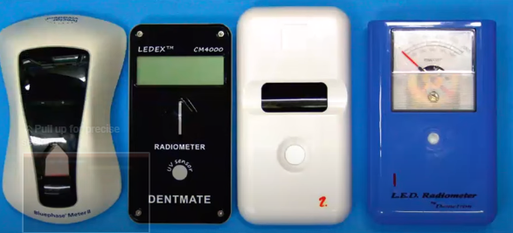prone to premature failure and secondary caries.

Figure 7: Radiometer

**Sequelae of Under and Over-Curing of Resin Composites:**

Improper light curing, whether under-curing or over-curing, can have significant clinical consequences that compromise the longevity and performance of resin composite restorations [28].

1. **Sequelae of Under-Curing**:
   1. **Incomplete Polymerization**: Under-curing results in insufficient conversion of monomers into polymers, leading to a weaker composite structure [29].
   2. **Increased Marginal Leakage**: Inadequate polymerization weakens the bond between the composite and tooth structure, increasing the risk of secondary caries and post-operative sensitivity [30].
   3. **Reduced Mechanical Properties**: Under-cured composites exhibit lower hardness and wear resistance, making them prone to fracture under masticatory forces [29].
   4. **Biocompatibility Concerns**: Residual monomers in under-cured composites can cause cytotoxic effects and irritation to the surrounding tissues [31].

A study by Souza et al. (2011) compared the failure rates of restorations cured at different exposure times. The study concluded that under-cured restorations exhibited a significantly higher rate of marginal staining and secondary caries, while over-cured restorations were more prone to fractures and loss of marginal adaptation [32].

1. **Sequelae of Over-Curing**:
   1. **Thermal Damage to Pulp**: study by Kim et al. (2022) investigated the thermal effects of high-intensity curing lights on pulp vitality. The findings suggested that prolonged exposure beyond recommended curing times increased the risk of irreversible pulpitis [33].

**Blue Light Hazard and Infection Control**:

Blue light emitted by curing lights poses potential risks to both clinicians and patients. Protective eyewear with orange filters is recommended to minimize the risks associated with blue light exposure [34].

Additionally, infection control is critical in dental settings. The use of infection control barriers on curing lights helps prevent cross-contamination [35]. However, studies have shown that some barriers can attenuate light intensity, potentially compromising polymerization efficiency.

Figure 8: Orange filter eyewear and Infection control barrier

Price et al. (2020) investigated the effect of infection control barriers on the light output from a multi-emitter LED curing light. The study concluded that correctly applied plastic barriers reduced light output by 5–8%, while incorrect application, such as wrinkling, led to reductions of 14–26%. [36]. Another study by Rueggeberg et al. (2015) emphasized the importance of selecting high-transmittance barriers to ensure optimal curing performance while maintaining infection control standards [37].

**Conclusion:**

Proper light curing of resin composites is a multifaceted process requiring careful selection of curing lights, adherence to recommended protocols, and awareness of factors affecting polymerization efficiency. The integration of polywave technology, advanced curing modes, and safety measures enhances the longevity and performance of composite restorations. Based on the findings, clinicians are advised to:

1. Use High-Quality LED Curing Lights
2. Ensure Adequate Exposure Time
3. Maintain Proper Positioning and Distance
4. Regularly Check Light Output
5. Employ Advanced Curing Techniques

Advancements in light-curing techniques and technology continue to shape the future of restorative dentistry. By incorporating evidence-based recommendations and investing in research-driven innovations, clinicians can enhance patient outcomes and ensure the longevity of composite restorations.

Disclaimer (Artificial intelligence)

Author(s) hereby declare that generative AI technology ‘Grammer checker’ has been used during the editing of manuscript.

Details of the AI usage are given below:

1.Quillbot **v17.0.4**

**References**

1. Pizzolotto L, Moraes RR. Resin Composites in Posterior Teeth: Clinical Performance and Direct Restorative Techniques. Dent J (Basel). 2022 Nov 27;10(12):222. doi: 10.3390/dj10120222.
2. Lu H, Stansbury JW, Bowman CN. Impact of curing protocol on conversion and shrinkage stress. J Dent Res. 2005 Sep;84(9):822-6. doi: 10.1177/154405910508400908.
3. Rueggeberg FA. State-of-the-art: dental photocuring—a review. Dental materials. 2011 Jan 1;27(1):39-52. doi: 10.1016/j.dental.2010.10.021
4. Rueggeberg FA, Giannini M, Arrais CA, Price RB. Light curing in dentistry: A review of the clinical implications. Oper Dent. 2017;42(4):537-49. DOI: 10.1590/1807-3107BOR-2017.vol31.0061
5. Sakaguchi, R. L., & Powers, J. M. (2022). "Craig's Restorative Dental Materials" (14th ed.). Elsevier.
6. Price RB, Ferracane JL, Shortall AC. Light-curing units: A review of what we need to know. *J Dent Res.* 2015 Sep;94(9):1179-86. DOI: 10.1177/0022034515594786
7. Johnson PM, Felix CA, Cook WD. The role of photoinitiators in resin-based composites. Dent Mater. 2021;37(6):835-45.
8. Rueggeberg FA. State-of-the-art dental curing lights and their effect on polymerization efficiency. J Dent. 2019;82:16-23.
9. Ferracane JL. Resin-based composite performance: Curing and mechanical properties. Dent Mater. 2021;37(3):e15-28.
10. Rueggeberg FA, Caughman WF, Curtis JW. Effect of light intensity and exposure duration on cure of resin composite. *Oper Dent.* 1994 Mar-Apr;19(1):26-32.
11. Yap AU, Soh MS, Siow KS. Influence of curing light intensity and exposure time on degree of conversion. Oper Dent. 2018;43(2):196-205
12. Price RB, Shortall AC, Palin WM. Effect of irradiance distribution and beam homogeneity on dental resin-based composite polymerization. *J Dent Res.* 2015;94(10):1310-1316.
13. Shimokawa CAK, Turbino ML, Giannini M, Price RB. Effect of curing light and exposure time on the polymerization of bulk-fill resin-based composites in molar teeth. *Oper Dent.* 2020 May;45(3):E141-E152. doi: 10.2341/19-126-L
14. Ko H, Kim D, Park SH. Homogeneity of dental curing unit beam profile and its effect on microhardness of dental composites with varying thicknesses. *Dent Mater.* 2022 Aug;38(8):e231-e243. doi: 10.1016/j.dental.2022.06.011
15. Nitta K. Effect of light guide tip diameter of LED-light curing unit on polymerization of light-cured composites. *Dent Mater.* 2005 Mar;21(3):217-23. doi: 10.1016/j.dental.2004.03.008.
16. Segal P, Lugassy D, Mijiritsky E, Dekel M, Ben-Amar A, Ormianer Z, Matalon S. The effect of the light intensity and light distances of LED and QTH curing devices on the hardness of two light-cured nano-resin composites. *Mater Sci Appl.* 2015;6(11):1071-1083. DOI:10.4236/msa.2015.611106
17. Malhotra S, Kaur R, Saroa PK, Kaur K, Sandhu KK, Thukral V. Effect of curing distance for cure depth in composite resin. *Bioinformation.* 2023 Dec 31;19(13):1353-1358. doi: 10.6026/973206300191353
18. Bin Jabr A, et al. Effect of polymerization time and shade on the depth of cure of nano-hybrid resin composites. *J Clin Exp Dent.* 2021 Jun;13(6):e550-e556. DOI:10.1055/s-0041-1726169
19. Harlow JE, Sullivan B, Shortall AC, Labrie D, Price RB. Investigation of irradiance distribution and beam homogeneity in curing lights. Dent Mater. 2020;36(9):1165-73.
20. Al Shaafi MM, et al. Emission characteristics and effect of battery drain in "budget" curing lights. *Oper Dent.* 2015;40(5):501-9.
21. Kowalska A, Sokolowski J, Bociong K. The photoinitiators used in resin-based dental composites—A review and future perspectives. *Polymers.* 2021;13(3):470. doi: 10.3390/polym13030470.
22. Marović D, Daničić P, Bojo G, Par M, Tarle Z. Monowave vs. Polywave light-curing units: Effect on light transmission of composite without alternative photoinitiators. Acta Stomatol Croat. 2024 Mar;58(1):30-8. doi: 10.15644/asc58/1/3.
23. Varshney I, Jha P, Nikhil V. Effect of monowave and polywave light curing on the degree of conversion and microhardness of composites with different photoinitiators: An in vitro study. *J Conserv Dent.* 2022 Nov-Dec;25(6):661-5. doi: 10.4103/jcd.jcd_223_22
24. Boeira PO, de Azevedo Kinalski M, dos SANTOS MB, de MORAES RR, Lima GS. Polywave And Monowave Light-Curing Units Effects On Polymerization Efficiency Of Different Photoinitiators. Brazilian Dental Science. 2021 Oct 1;24(4). DOI:10.14295/bds.2021.v24i4.2661
25. Sideridou I, Achilleos D. Soft-start and pulse-delay curing modes in reducing polymerization shrinkage stress and improving restoration longevity. *J Dent.* 2016 May;44:1-8.
26. Ernst CP, Meyer GR, Müller J, Willershausen B. Influence of a soft-start polymerization on polymerization shrinkage stress and marginal integrity of adhesive restorations. Dent Mater. 2003 Jul;19(7):567-75.
27. Assaf C, Fahd JC, Sabbagh J. Assessing dental light-curing units' output using radiometers: A narrative review. *J Int Soc Prev Community Dent.* 2020 Jan 24;10(1):1-8. doi: 10.4103/jispcd.JISPCD_407_19
28. Brugnera A Jr, Zanin F, Cury-Lopez E. Photopolymerization of dental materials: Light source effectiveness. Braz Oral Res. 2021;35:e122
29. Moldovan M, Balazsi R, Soanca A, Roman A, Sarosi C, Prodan D, Vlassa M, Cojocaru I, Saceleanu V, Cristescu I. Evaluation of the degree of conversion, residual monomers and mechanical properties of some light-cured dental resin composites. Materials (Basel). 2019 Jun 30;12(13):2109. Doi: 10.3390/ma12132109
30. Hyun L, Chitre S, Gill K, Chitre S. A Brief Review on the Relationship between Gap Size of Composite Restoration and Secondary Caries. Dent. Adv. Res. 2016;1:103. DOI: 10.29011/2574-7347.100003
31. Moharamzadeh K, Brook IM, Van Noort R. Biocompatibility of resin-based dental materials. *Materials (Basel).* 2009 Apr 28;2(2):514-48. doi: 10.3390/ma2020514
32. Souza-Junior E, Souza-Régis M, Alonso RC, Freitas A, Sinhoreti M, Cunha L. Effect of the curing method and composite volume on marginal and internal adaptation of composite restoratives. Operative dentistry. 2011 Mar 1;36(2):231-8. doi: 10.2341/10-107-L
33. Kim RJY, Lee IB, Park SJ. Heat generation during light curing of resin composites and its effects on pulp vitality. *J Endod.* 2022;48(3):322-9.
34. Anusavice KJ, Shen C, Rawls HR. Phillips' Science of Dental Materials. 13th ed. St. Louis: Elsevier; 2022.
35. Ferracane JL. Materials in Dentistry: Principles and Applications. 3rd ed. Philadelphia: Lippincott Williams & Wilkins; 2019.
36. Price RB, Shortall AC, Palin WM. Effect of infection control barriers on the light output from a multi-emitter LED curing light. J Dent. 2020;100:103437.
37. Sword RJ, Do UN, Chang JH, Rueggeberg FA. Effect of Curing Light Barriers and Light Types on Radiant Exposure and Composite Conversion. J Esthet Restor Dent. 2016 Jan-Feb;28(1):29-42. doi: 10.1111/jerd.12173.