**Assessment of the Comparative Effect of Sodium Benzoate, Ascorbic Acid, and their Combination on Glucose Levels, Lipid Profile, and Some Cardiovascular Risk Markers in Albino Rats**

**ABSTRACT**

The widespread use of preservatives like sodium benzoate (SB) and ascorbic acid (vitamin C) in processed foods and beverages necessitates assessing their potential health risks. This study examined the effects of sodium benzoate, vitamin C, and their combination on glucose levels, lipid profile, and cardiovascular markers in albino rats. A total of thirty-six rats were divided into six groups: a control group (Group I), two groups receiving sodium benzoate at 120 mg/kg (Group II; low-dose SB) and 240 mg/kg (Group III; high-dose SB), a vitamin C group receiving 100 mg/kg (Group IV), and two combination groups administered low-dose SB + vitamin C (Group V) and high-dose SB + vitamin C (Group VI); treatments were given orally for 28 days. At the end of the study, the rats were allowed to fast overnight, and anesthetized in a closed jar containing chloroform-soaked cotton wool. This was followed by the collection of fasting blood specimens via cardiac puncture for glucose and lipid profile analysis. The results showed FBG and total cholesterol showed no significant differences among groups (p > 0.05). Compared to the control, triglycerides and LDL-c were higher in Group VI (p < 0.05), while HDL-c was lower in Groups V and VI (p < 0.05). The LDL/HDL ratio increased in Group VI (p < 0.05), and non-HDL-c was elevated in Groups II, III, V, and VI. These findings indicate that sodium benzoate, particularly at higher doses and when combined with vitamin C, disrupts lipid metabolism by elevating triglycerides, LDL-c, LDL/HDL ratio, and non-HDL-c while reducing HDL-c in rats. Since these alterations are key cardiovascular risk factors, frequent consumption of such preservatives in processed foods may contribute to cardiovascular disease. Further studies are needed to assess the long-term health effects of these food additives in humans.

**Keywords:** *Sodium benzoate, Ascorbic acid, Lipid metabolism, Cardiovascular risk,*

**1.0 INTRODUCTION**

The growing need to preserve food and beverages for extended shelf life has resulted in the extensive use of preservatives, which play a crucial role in regulating enzymatic activities and microbial growth throughout packaging, storage, distribution, retail, and consumption to prevent spoilage [1]. Food preservatives are primarily classified into two categories: antioxidants and antimicrobials [2]. While antioxidants slow down or prevent oxidative degradation, preserving both the quality and nutritional value of food, antimicrobial agents inhibit the proliferation of spoilage-causing and pathogenic microorganisms, thereby enhancing food safety and longevity [3]. Among the widely used preservatives are sodium benzoate and ascorbic acid.

Sodium benzoate (SB), a commonly utilized preservative, effectively restricts microbial growth even at minimal concentrations and is recognized as safe for food preservation [4]. In Europe, it is labeled as E211 and is a water-soluble, odorless, and tasteless salt known for its antifungal and antibacterial properties [5]. The FDA has approved its use, categorizing it as generally recognized as safe (GRAS) at levels up to 0.1%, making it a frequent ingredient in carbonated beverages, sauces, and jams [6]. On the other hand, ascorbic acid (vitamin C) is a natural preservative with antioxidant properties, preventing oxidative spoilage by limiting oxygen-related reactions in food, thereby maintaining its quality [7]. It extends shelf life by minimizing the formation of harmful compounds and is particularly effective in preserving fruits, vegetables, and meats. Additionally, ascorbic acid is essential for collagen synthesis, immune function, and neutralizing reactive oxygen species (ROS), which helps mitigate oxidative stress [8].

Despite its widespread use, sodium benzoate in processed foods and beverages has been subject to scrutiny due to potential health risks. Upon metabolism, sodium benzoate is converted into benzoic acid, which undergoes glycine conjugation in the liver to form hippuric acid, later excreted through the kidneys. This metabolic process can impose a significant burden on renal excretion, particularly with prolonged or excessive intake. Moreover, studies have reported its association with cancer and genotoxic effects [9]. Such adverse outcomes are especially concerning when sodium benzoate is consumed in large quantities or in combination with other substances.

Certain food and beverage products contain both sodium benzoate and ascorbic acid as preservatives (as depicted in Figure 1), and their interaction has raised concerns regarding the possible formation of benzene, a known carcinogen, when exposed to light or high temperatures [10]. Benzene is a known carcinogen and pro-oxidant that contributes to oxidative stress by generating reactive oxygen species (ROS), leading to cellular damage. This oxidative damage can initiate inflammatory responses, potentially increasing the risk of metabolic and cardiovascular disorders [11]. Oxidative stress occurs when the balance between ROS production and antioxidant defenses is disrupted, resulting in lipid peroxidation, protein oxidation, and DNA damage [12]. Sodium benzoate alone has been shown to induce oxidative damage in various tissues, including the liver and brain, by depleting glutathione (GSH) and impairing antioxidant enzyme activity [6]. When combined with ascorbic acid, the formation of benzene further worsens oxidative stress by promoting lipid peroxidation and mitochondrial dysfunction [6].

Inflammation is closely linked to oxidative stress, as increased ROS levels can activate nuclear factor kappa B (NF-κB), a key transcription factor involved in the upregulation of pro-inflammatory cytokines such as tumor necrosis factor-alpha (TNF-α) and interleukins (IL-6, IL-1β) [11]. Experimental studies suggest that sodium benzoate exposure enhances inflammatory signaling pathways, leading to systemic inflammation and potential organ toxicity [6]. This inflammatory response may be further intensified by the oxidative stress triggered by benzene formation, highlighting the potential risks associated with the combined consumption of sodium benzoate and ascorbic acid in processed foods.

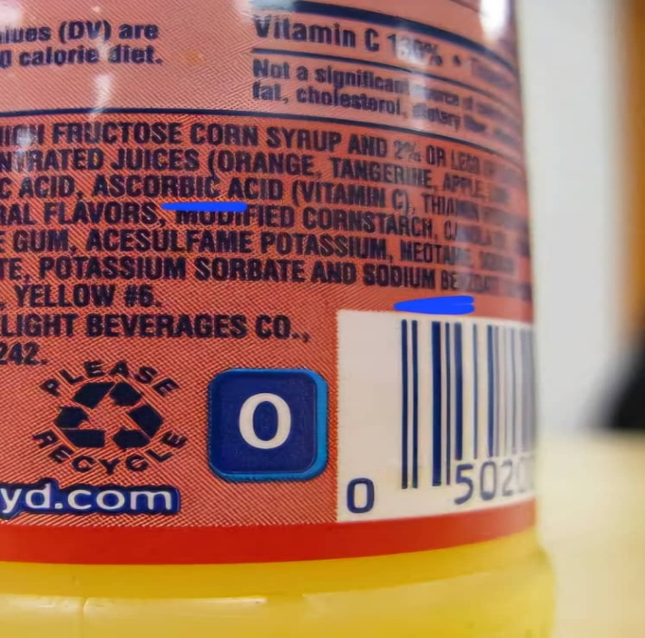 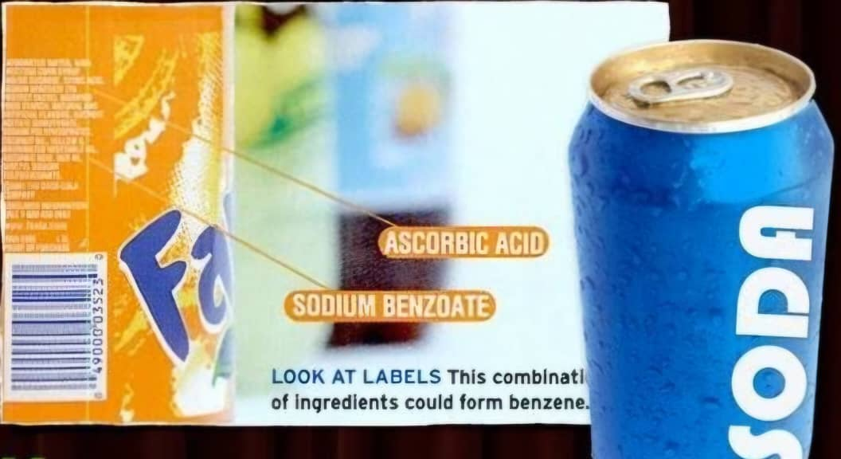

**A B**

**Figure 1A and 1B: Labels on Carbonated Beverages Indicating the Presence of Sodium Benzoate and Ascorbic Acid.** Adapted from Ibama et al. [13]

Research on the individual and combined effects of sodium benzoate and ascorbic acid (vitamin C) on the glucose levels, lipid profile and lipid ratio markers in albino rats is limited but crucial, given the widespread use of these compounds in the food industry. While the antioxidant properties of vitamin C are believed to counteract oxidative stress, its interaction with sodium benzoate may lead to conflicting outcomes depending on dose, duration of exposure, and underlying physiological conditions. Hence, this study aimed to evaluate the comparative effects of sodium benzoate, ascorbic acid, and their combination on glucose levels, lipid profile, and some cardiovascular markers in albino rats.

**2.0 MATERIALS AND METHODS**

**2.1 Procurement of Materials**

Sodium benzoate, sterile bottles, lithium heparin, plain bottles, and filter paper were procured from Nexidon Nigeria Limited reagent store, while syringes, hand gloves, and cotton wool were obtained from Lloyd’s Pharmacy in Port Harcourt.

**2.2 Ethical Considerations**

The internationally accepted National Institutes of Health (NIH) Guide for Care and Use of Laboratory Animals were observed.

**2.2 Experimental Animals**

A total of 36 albino rats, weighing between 140 and 250 g, were randomly chosen for the study. The animals were obtained from the Department of Anatomy, College of Medical Sciences, Rivers State University, and transported in a well-ventilated wire cage to the animal house at the Department of Animal and Environmental Sciences, Rivers State University, Port Harcourt. They were housed under a 12-hour light/dark cycle with unrestricted access to solid poultry chow and water. Before the commencement of the study, the rats were acclimatized for two weeks under standard laboratory conditions and subsequently assigned to six groups.

**2.3 Acute Toxicity Study**

The study utilized the Fixed Dose Procedure [14] and was carried out in two phases. In the initial phase, three rats were orally administered sodium benzoate at a dosage of 700 mg/kg body weight via gavage and observed for toxicity symptoms over a 14-day period. In the subsequent phase, a different set of three rats received a reduced dose of 300 mg/kg body weight through oral gavage, with toxicity assessments conducted over the same 14-day duration.

**2.4 Dose Determination**

Following the results of the acute toxicity study, two doses of sodium benzoate were selected: a low dose (120 mg/kg) and a high dose (240 mg/kg). Both doses were below the threshold that caused observable acute toxicity.

**2.4.1 Low Dose of Sodium Benzoate**

To determine the low dose of sodium benzoate, a dosage of 120 mg/kg body weight was calculated. For instance, for a rat weighing 234 g, the calculation proceeded as follows:

Since 120 mg of sodium benzoate is required for a 1 kg (1000 g) rat, the dose for a 234 g rat was calculated using the formula:

Dose = $\frac{120mg}{1000g}x 234g$ = **28.08 mg**

Following the Organization for Economic Co-operation and Development (OECD) guidelines for volume selection [13], this 28.08 mg of sodium benzoate was dissolved in 2.34 ml of distilled water, ensuring accurate administration.

**2.4.2 High Dose of Sodium Benzoate**

To determine the low dose of sodium benzoate, a dosage of 240 mg/kg body weight was calculated. For instance, for a rat weighing 234 g, the calculation proceeded as follows:

Dose = $\frac{240mg}{1000g}x 234g$ = **56.16 mg**

Following the OECD guidelines for volume selection [14], this 56.16 mg of sodium benzoate was dissolved in 2.34 ml of distilled water, ensuring accurate administration.

**2.4.3 Dose Calculation for Ascorbic Acid (Vitamin C)**

The dosage of vitamin C used in this study was 100 mg/kg, as adopted from the methodology of Kumar et al. [15]. For a rat weighing 234 g, the dosage was calculated as follows:

Since 100 mg of vitamin C is required for a 1 kg (1000 g) rat, the dose for a 234 g rat was determined using the formula:

**Dose** = $\frac{100mg}{1000g}x 234g$ = **23.4 mg**

Following the OECD guidelines for volume selection [14], this 23.4 mg of vitamin C was dissolved in 2.34 ml of distilled water, ensuring accurate administration.

**2.5 Experimental Study Design**

Following a 14-day acclimatization period, 36 rats were categorized into six groups of six rats each based on their body weight. Group 1 served as the control, receiving standard food, water, and 1.8 ml of distilled water orally once per day for 28 days. Group 2 was administered a low dose of sodium benzoate (120 mg/kg body weight) orally each day for 28 days, while Group 3 received a higher dose of sodium benzoate (240 mg/kg body weight) under identical conditions. Group 4 was given vitamin C at a dose of 100 mg/kg body weight via oral administration once daily for 28 days. Group 5 received a combination of the low dose of sodium benzoate (120 mg/kg) and vitamin C (100 mg/kg) daily for 28 days, whereas Group 6 was treated with the high dose of sodium benzoate (240 mg/kg) alongside vitamin C (100 mg/kg) following the same daily regimen.

**2.6 Specimen Collection, Preparation, and Analysis**

After the 28-day experimental period, the rats were fasted overnight and anesthetized in a jar containing chloroform-soaked cotton wool. Whole blood samples (5 mL) were aseptically collected via cardiac puncture using sterile syringes and needles. A 2 mL portion was placed in a fluoride oxalate bottle, while the remaining 3 mL was transferred into a plain bottle and allowed to clot. The sample in the fluoride oxalate bottle was centrifuged at 3000 rpm for 5 minutes to obtain plasma, which was analyzed for fasting glucose concentration using the glucose oxidase method. Meanwhile, the clotted blood in the plain bottle was centrifuged under the same conditions to obtain serum, which was used for fasting lipid profile analysis. Additionally, lipid ratio markers, such as the LDL/HDL ratio and non-HDL cholesterol, were calculated based on the lipid parameters.

**2.7 Statistical Analysis**

The data generated from the analysis were expressed as Mean ± standard deviation, and analysed using the Statistical Package for Social Science (SPSS) version 24. Comparison of the mean and standard deviation values were made for the various parameters for the various groups using the one-way ANOVA and Tukey test. Results were considered statistically significant at 95% confidence interval (p≤0.05).

**3.0 RESULTS**

**3.1 Acute Toxicity Study of Sodium Benzoate**

The acute toxicity study results for sodium benzoate are shown in Tables 1a and 1b. Table 1a demonstrates that administering 700 mg/kg of sodium benzoate to rats led to visible signs of toxicity, such as wounds, lesions, and decreased activity, although no fatalities were observed. In contrast, Table 1b reveals that treatment with 300 mg/kg of sodium benzoate showed no signs of toxicity or mortality in the rats.

**Table 1: Results of Acute Toxicity Study**

**1a. Phase I**

|  |  |
| --- | --- |
| **Dose (mg/kg)** | **Observation** |
| 700 | Presence of signs of toxicity such as wounds and lesions, and reduced activity. No mortality |

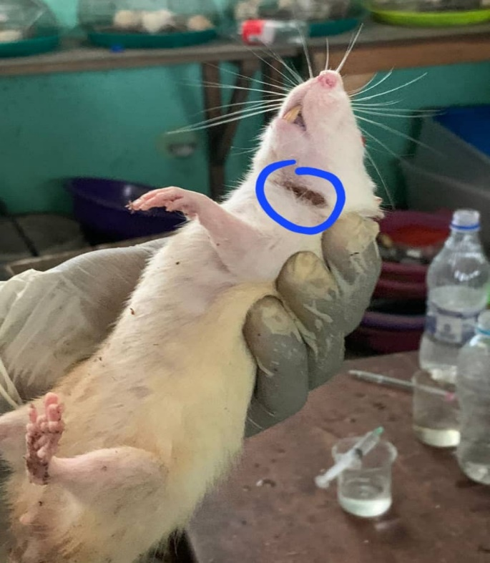 

**Figure 2: Photographs Showing Wounds and Lesions on the Skin of Rats Administered 700 mg/kg of Sodium Benzoate During Phase I of the Acute Toxicity Study**

**1b. Phase II**

|  |  |
| --- | --- |
| **Dose (mg/kg)** | **Observation** |
| 300 | No signs of toxicity. No mortality |

**3.2 Comparison of the Levels of Fasting Lipid Profile and Glucose of the Control and Test Groups**

Table 2 presents the glucose and lipid profile values across six experimental groups. Glucose levels showed no significant differences among the groups (p=0.308). Total cholesterol also did not differ significantly (p=0.143). However, triglyceride levels were significantly higher in Group II (1.15 ± 0.27 mmol/L) and Group VI (1.33 ± 0.07 mmol/L) compared to other groups (p=0.000). Finally, HDL levels were significantly lower in Group V (1.17 ± 0.29 mmol/L) and Group VI (1.05 ± 0.21 mmol/L) than in other groups (p=0.029). LDL levels were significantly elevated in Group VI (2.87 ± 0.94 mmol/L) compared to the other groups (p=0.002).

**Table 2: Plasma Glucose Levels and Lipid Profile in Control and Treatment Groups**

|  |  |  |  |  |  |
| --- | --- | --- | --- | --- | --- |
| **(n=6 per**  **Groups)** | **FBG**  **(mmol/L)** | **T. Chol (mmol/L)** | **TG**  **(mmol/L)** | **HDL**  **(mmol/L)** | **LDL (mmol/L)** |
| **Control** | 4.6 ± 0.77329 | 3.92 ± 1.17 | 0.88 ± 0.24a | 1.40 ± 0.14a | 1.12 ± 0.76a |
| **Low-dose SB** | 4.7 ± 0.71 | 3.39 ± 0.94 | 1.15 ± 0.27b | 1.38 ± 0.14 | 1.70 ± 0.71 |
| **High-dose SB** | 4.3 ± 0.32 | 3.00 ± 0.34 | 0.81 ± 0.13a | 1.29 ± 0.12a | 1.53 ± 0.46 |
| **Vit. C** | 11.3 ± 13.13 | 2.47 ± 0.18 | 0.81 ± 0.09c | 1.11 ± 0.17 | 0.81 ± 0.08a |
| **Low-dose SB + Vit. C** | 4.3 ± 1.25 | 3.20 ± 0.79 | 1.08 ± 0.12 | 1.17 ± 0.29b | 1.32 ± 0.82 |
| **High dose SB + Vit. C** | 5.1140 ± 0.87 | 3.12 ± 0.83 | 1.33 ± 0.07b | 1.05 ± 0.21b | 2.87 ± 0.94b |
| **F-value** | 1.271 | 1.842 | 7.550 | 3.037 | 5.341 |
| ***P*-value** | 0.308 | 0.143 | 0.000 | 0.029 | 0.002 |
| **Remark** | NS | NS | **S** | **S** | **S** |

*Key: NS = not significant, S = significant, FBG = fasting blood glucose, T. Chol = total cholesterol, TG = triglyceride, HDL = high density lipoprotein, LDL = low density lipoprotein. Values with different superscripts are significantly different (p<0.05), Sodium Benzoate = SB, Vitamin C = Vit. C*

*Group I = Control, Group II = low-dose SB, Group III = high-dose SB, Group IV = Vit. C, Group V = low-dose SB + Vit. C, Group VI = high dose SB + Vit. C*

**3.3 Comparison of the Mean LDL/HDL Ratio and Non-HDL Cholesterol of the Control and Test Groups**

Table 3 presents the LDL/HDL ratio and non-HDL cholesterol levels across six experimental groups. The LDL/HDL ratio was significantly higher in Group VI (2.73 ± 0.2) compared to all other groups (p=0.03). Additionally, Groups II, III, V, and VI had significantly higher non-HDL cholesterol levels compared to Group I and Group IV (p=0.001).

**Table 3: Mean LDL/HDL Ratio and Non-HDL Cholesterol Levels in Control and Treatment Groups**

|  |  |  |  |
| --- | --- | --- | --- |
| **(n=6 per Groups)** |  | **LDL/HDL Ratio** | **Non-HDL Chol (mmol/L)** |
| **Control** |  | 0.8 ± 0.1a | 1.71 ± 0.14a |
| **Low-dose SB** |  | 1.23 ± 0.15b | 2.01 ± 0.18b |
| **High-dose SB** |  | 1.19 ± 0.12b | 2.03 ± 0.19b |
| **Vit. C** |  | 0.73 ± 0.08a | 1.36 ± 0.12a |
| **Low-dose SB + Vit. C** |  | 1.13 ± 0.11b | 2.07 ± 0.22b |
| **High dose SB + Vit. C** |  | 2.73 ± 0.2c | 2.52 ± 0.2c |
| **F-value** |  | 8.492 | 10.129 |
| ***P*-value** |  | 0.03 | 0.001 |
| **Remark** |  | **S** | **S** |

***Key:*** *Group I = Control, Group II = low-dose SB, Group III = high-dose SB, Group IV = Vit. C, Group V = low-dose SB + Vit. C, Group VI = high dose SB + Vit. C*

**4.0 DISCUSSION**

This study aimed to assess the comparative effects of sodium benzoate, ascorbic acid (vitamin C), and their combination on glucose levels, lipid profile, some cardiovascular markers in albino rats. The acute toxicity findings highlight the effects of sodium benzoate on rat health across different dosage levels. At a dose of 700 mg/kg, noticeable signs of toxicity were observed, including wounds, lesions, and reduced activity, although no fatalities occurred. In contrast, the 300 mg/kg dose did not produce any visible signs of toxicity or death. The presence of lesions and decreased activity at the higher dose suggests that sodium benzoate may trigger a stress response or cause specific organ damage, particularly affecting the skin and muscles. However, the absence of fatalities indicates that overall survival was not compromised at this dosage.

The fasting blood glucose levels did not show significant differences among the various treatment groups compared to the control group, indicating that sodium benzoate, vitamin C, and their combination did not substantially affect glucose metabolism in this study. One possible explanation is that the administered doses were insufficient to provoke significant alterations in glucose levels, or that these compounds do not directly influence glucose homeostasis within the context of this experimental model.

Regarding total cholesterol levels, no significant variations were observed across the groups, suggesting that neither sodium benzoate nor vitamin C, alone or in combination, had a considerable impact on cholesterol metabolism. This could be due to the relatively low doses used or the absence of pre-existing lipid disturbances in the experimental animals. In contrast, a similar study by Olofinnade et al. [16] found that mice fed a diet containing sodium benzoate experienced a significant reduction in total cholesterol levels compared to the control group that did not receive sodium benzoate. The discrepancy between their findings and those of this study may be due to differences in sodium benzoate dosage or the animal model used, as they conducted their research on mice, whereas this study was performed on rats.

Triglyceride levels were significantly elevated in Group II (low-dose SB) and Group VI (high-dose SB + Vit. C), suggesting that sodium benzoate, both independently and in combination with vitamin C, may influence triglyceride metabolism. This could be due to its interference with lipid synthesis or liver function, leading to an accumulation of triglycerides. Elevated triglyceride levels are a well-established risk factor for cardiovascular diseases (CVDs), as they contribute to atherogenesis and increase the risk of pancreatitis [17]. High triglycerides have also been associated with metabolic syndrome, insulin resistance, and hepatic steatosis [18]. This finding is consistent with the study by Olofinnade et al. [16], which reported a significant increase in triglyceride levels in mice fed a sodium benzoate-containing diet compared to the control group that did not receive sodium benzoate.

Similarly, LDL cholesterol levels were significantly higher in Group VI (high-dose SB + Vit. C), indicating that this combination may contribute to an increase in LDL cholesterol. The significantly higher LDL cholesterol levels indicate that the combination of high-dose sodium benzoate with vitamin C may have pro-atherogenic effects. LDL cholesterol is a primary contributor to atherosclerosis, as oxidized LDL particles accumulate in arterial walls, promoting inflammation and plaque formation [19]. This observation does not align with findings from Olofinnade et al. [16] who reported decreased LDL levels in mice fed a sodium benzoate-containing diet compared to the control group that did not receive sodium benzoate. The differences in these results may be due to species variations (mice vs. rats), dosage and exposure differences, dietary factors, metabolic differences, or the presence of vitamin C, which could modulate the effect of sodium benzoate on lipid metabolism.

HDL cholesterol levels were significantly lower in Group V (low-dose SB + Vit. C) and Group VI (high-dose SB + Vit. C), indicating a potential adverse effect of these treatments on HDL levels. The reduction in HDL cholesterol suggests a potential impairment in reverse cholesterol transport, which is a protective mechanism against atherosclerosis. HDL cholesterol plays a crucial role in removing excess cholesterol from peripheral tissues and transporting it to the liver for excretion [20]. A decrease in HDL levels is associated with an increased risk of cardiovascular events, as lower HDL levels reduce the ability of the body to counteract LDL oxidation and arterial plaque formation [21]. The adverse impact of sodium benzoate on HDL levels aligns with findings from Olofinnade et al. [16], which reported reduced HDL levels in mice fed a sodium benzoate-containing diet compared to the control group that did not receive sodium benzoate.

The LDL/HDL ratio was significantly higher in Group VI (high-dose SB + Vit. C), suggests an imbalance in cholesterol transport, favoring LDL accumulation and reducing HDL-mediated cholesterol clearance. A high LDL/HDL ratio is strongly associated with atherosclerosis, as it reflects an increased presence of pro-atherogenic LDL cholesterol relative to protective HDL cholesterol [19]. This imbalance may promote endothelial dysfunction, oxidative stress, and arterial plaque formation, thereby increasing the risk of coronary heart disease [22]

Lastly, significantly elevated non-HDL cholesterol levels in Groups II (low-dose SB), III (high-dose SB), V (low-dose SB + Vit. C), and VI (high dose SB + Vit. C) compared to Groups I (Control) and IV (Vit. C) suggest that sodium benzoate exposure, particularly when combined with vitamin C, may contribute to an increase in non-HDL cholesterol. This is concerning, as non-HDL cholesterol is a known risk factor for cardiovascular diseases. One possible explanation is that sodium benzoate disrupts lipid metabolism, leading to increased accumulation of non-HDL cholesterol. Non-HDL cholesterol encompasses all atherogenic lipoproteins, including LDL, VLDL, and remnant lipoproteins, making it a strong predictor of CVD risk [23][24]. Elevated non-HDL cholesterol is particularly concerning as it reflects an increased burden of cholesterol-rich lipoproteins that contribute to arterial plaque formation and cardiovascular complications.

**5.0 CONCLUSION**

This study highlights the potential impact of sodium benzoate and ascorbic acid (vitamin C), commonly used preservatives in processed foods and beverages, on glucose levels, lipid profile, and some cardiovascular markers in albino rats. While glucose levels and total cholesterol remained unaffected, sodium benzoate significantly elevated triglycerides, LDL cholesterol, LDL/HDL ratio, and non-HDL cholesterol while reducing HDL cholesterol, particularly at higher doses and in combination with vitamin C. These changes suggest a possible pro-atherogenic effect, increasing the risk of cardiovascular diseases. Given the widespread use of these preservatives to extend shelf life, their long-term health implications in humans warrant further investigation, particularly regarding cardiovascular risk.

Disclaimer (Artificial intelligence)

Option 1:

Author(s) hereby declare that NO generative AI technologies such as Large Language Models (ChatGPT, COPILOT, etc.) and text-to-image generators have been used during the writing or editing of this manuscript.

Option 2:

Author(s) hereby declare that generative AI technologies such as Large Language Models, etc. have been used during the writing or editing of manuscripts. This explanation will include the name, version, model, and source of the generative AI technology and as well as all input prompts provided to the generative AI technology

Details of the AI usage are given below:

1.

2.

3.

**REFERENCES**

1. Femi-Oloye OP, Olatunji-Ojo AM, Owoloye A, Adewumi B, Ibitoye O, Oloye FF, et al. Studies on the effects of carbonated soft drink additives and simultaneous consumption of carbonated soft drink with ascorbic acid on histological parameters of male mice. Int J Biochem Res Rev. 2019;1(1):1–9.
2. Himani N, Mahawer SK, Arya S, Kumar R, Prakash O. Essential oil: Source of antioxidants and role in food preservation. Switzerland: Springer Nature; 2022.
3. Bacak A. Acidity regulators, preservatives, and antioxidants. In: Advances in Dairy Products. New Jersey: Wiley; 2017. p. 117–31.
4. Heydaryinia A, Veissi M, Sadadi A. A comparative study of the effects of the two preservatives, sodium benzoate and potassium sorbate, on *Aspergillus niger* and Penicillium notatum. Jundishapur J Microbiol. 2011;4(4):301–7.
5. Davidson PM, Taylor TM, David JR. Antimicrobials in food. Florida: CRC Press; 2021.
6. Walczak-Nowicka ŁJ, Herbet M. Sodium benzoate—harmfulness and potential use in therapies for disorders related to the nervous system: a review. Nutrients. 2022;14(7):1497–500.
7. Franco R, Navarro G, Martínez-Pinilla E. Antioxidants versus food antioxidant additives and food preservatives. Antioxidants (Basel). 2019;8(11):1–13.
8. Yadav A, Kumar A, Das M, Tripathi A. Sodium benzoate, a food preservative, affects the functional and activation status of splenocytes at non-cytotoxic dose. Food Chem Toxicol. 2015;88:40–7.
9. Khan IS, Dar KB, Ganie SA, Ali MN. Toxicological impact of sodium benzoate on inflammatory cytokines, oxidative stress, and biochemical markers in male Wistar rats. Drug Chem Toxicol. 2020;45(3):1345–50.
10. Piper JD, Piper PW. Benzoate and sorbate salts: a systematic review of the potential hazards of these invaluable preservatives and the expanding spectrum of clinical uses for sodium benzoate. Compr Rev Food Sci Food Saf. 2017;16(1):868–80.
11. Zeliger H. I. (2013). Lipophilic chemical exposure as a cause of cardiovascular disease. Interdisciplinary toxicology, 6(2), 55–62.
12. Jakubczyk K, Dec K, Kałduńska J, Kawczuga D, Kochman J, Janda K. Reactive oxygen species - sources, functions, oxidative damage. Pol Merkuriusz Lek. 2020;48(284):124–127.
13. Ibama O, Brisibe N, Lemoha FO. Assessment of the nephrotoxic effect of sodium benzoate, ascorbic acid, and their combined administration in albino rats. Int J Adv Nephrol Res. 2025;8(1):22–33.
14. Organisation for Economic Co-operation and Development (OECD) (2001). *OECD Guideline for Testing of Chemicals Acute Oral Toxicity – Acute Toxic Class Method*. Available from: <https://ntp.niehs.nih.gov/sites/default/files/iccvam/suppdocs/feddocs/oecd/oecd_gl423.pdf>
15. Kumar R, Narayanan SN, Nayak S. Ascorbic acid protects against restraint stress-induced memory deficits in Wistar rats. Clinics. 2009;64(12):1211–7.
16. Olofinnade AT, Onaolapo AY, Onaolapo OJ, Olowe OA. The potential toxicity of food-added sodium benzoate in mice is concentration-dependent. Toxicology Research. 2021;10(3):561–9.
17. Harchaoui KE, Visser ME, Kastelein JJ, Stroes ES, Dallinga-Thie GM. Triglycerides and cardiovascular risk. Curr Cardiol Rev. 2009;5(3):216–22.
18. Miller M, Stone NJ, Ballantyne C, Bittner V, Criqui MH, Ginsberg HN, et al. Triglycerides and cardiovascular disease: a scientific statement from the American Heart Association. Circulation. 2011;123(20):2292–333.
19. Ference BA, Ginsberg HN, Graham I, Ray KK, Packard CJ, Bruckert E, et al. Low-density lipoproteins cause atherosclerotic cardiovascular disease. 1. Evidence from genetic, epidemiologic, and clinical studies. A consensus statement from the European Atherosclerosis Society Consensus Panel. Eur Heart J. 2017;38(32):2459–72.
20. Bandeali S, Farmer J. High-density lipoprotein and atherosclerosis: the role of antioxidant activity. Curr Atheroscler Rep. 2012;14(2):101–7.
21. Assmann G, Gotto AM Jr. HDL cholesterol and protective factors in atherosclerosis. Circulation. 2004;109(23 Suppl 1):III8–III14.
22. Higashi Y, Maruhashi T, Noma K, Kihara Y. Oxidative stress and endothelial dysfunction: clinical evidence and therapeutic implications. Trends Cardiovasc Med. 2014;24(4):165–9.
23. Aggarwal DJ, Kathariya MG, Verma DPK. LDL-C, NON-HDL-C and APO-B for cardiovascular risk assessment: Looking for the ideal marker. Indian Heart J. 2021;73(5):544–8.
24. **Oladapo-Akinfolarin TT, Akinfolarin OM, Ken-Ezihuo SU, Bartimaeus E-AS.** Evaluation of cardiovascular risk markers in hypertensive pregnant women. J Adv Med Med Res. 2022;34(14):57–63.