***Case report***

**Mucosal prolapse mimicking a prolapsed stoma:An unusual case**

**Abstract**

Stoma creation is frequently performed for conditions like malignancies and bowel obstructions, with potential complications such as prolapse and hernias. Stoma prolapse involves bowel protrusion through the stoma, causing discomfort and cosmetic concerns. This report describes an unusual case of mucosal prolapse from the proximal bowel loop mimicking stoma prolapse. A 16-year-old male with a loop ileostomy presented with protrusion, later identified intraoperatively as mucosa emerging through a serosal defect. Surgical resection and anastomosis led to complete recovery. This case highlights the importance of accurate diagnosis, timely surgical management, and patient education to prevent complications effectively.

**Keywords**

Stoma prolapse, mucosal prolapse, loop ileostomy, surgical complications, ileal perforation

**Introduction**

Stoma creation is a common surgical procedure performed for various gastrointestinal conditions, including malignancies, inflammatory bowel diseases, and bowel obstructions[1]. While stomas significantly improve the quality of life for patients, complications such as prolapse, retraction, and parastomal hernias can arise. Stoma prolapse, defined as the protrusion of the bowel segment through the stoma, may lead to patient discomfort, cosmetic concerns, and functional impairment[2]. Understanding the aetiology, risk factors, and management options is critical for optimal patient care. However, we report a case of an unusual complication of a stoma where mucosal prolapse from the proximal bowel loop mimicked stoma prolapse. This complication may be the first such complication reported to date. The case report enhances our understanding of stoma-related complications, which, while often well-documented, rarely include such a presentation. By offering insight into the accurate diagnostic and surgical strategies for managing this rare condition, this report enriches the existing body of knowledge on stoma care. The emphasis on patient education and timely intervention further underscores its importance for improving clinical outcomes, ultimately advancing the quality of care for patients undergoing stoma creation.

**Case Presentation**

A 16-year-old male underwent exploratory laparotomy for ileal perforation two months prior, with a loop ileostomy created during the procedure. Loop ileostomy was preferred in this case over resection and anastomosis due to unfavourable bowel conditions in the emergency situation. The postoperative period was uneventful, and the patient was discharged on postoperative day five. He presented to the surgical outpatient department with complaints of something protruding from the stoma (Figure 1). The stoma remained functional, and there were no obstructive symptoms. The patient was vitally stable.

On examination, bowel mucosa was protruding from the side of the proximal bowel loop, measuring approximately 12 cm in length, dusky in colour, and oedematous. The exact site of mucosal prolapse could not be ascertained on clinical examination. The patient expressed concerns about discomfort, difficulty managing the stoma, and embarrassment due to the visible protrusion. Stoma reversal was planned after confirming the patency of the distal bowel segment via a distal loopogram. Ultrasound abdomen was done which was unremarkable. Given the emergency situation, a CECT abdomen was not done.

Intraoperatively, mucosa was found protruding through a serosal defect in the proximal bowel just above the rectus sheath (Figure 2). Since the condition of bowel was healthy, the diseased ileal segment was resected, and a stapled side-to-side ileo-ileal anastomosis was performed. Minimally invasive techniques like laparoscopic resection and anastomosis could be another option. The postoperative period was uneventful, and the patient was discharged on the seventh postoperative day.

Figure 1 – Showing mucosal prolapse

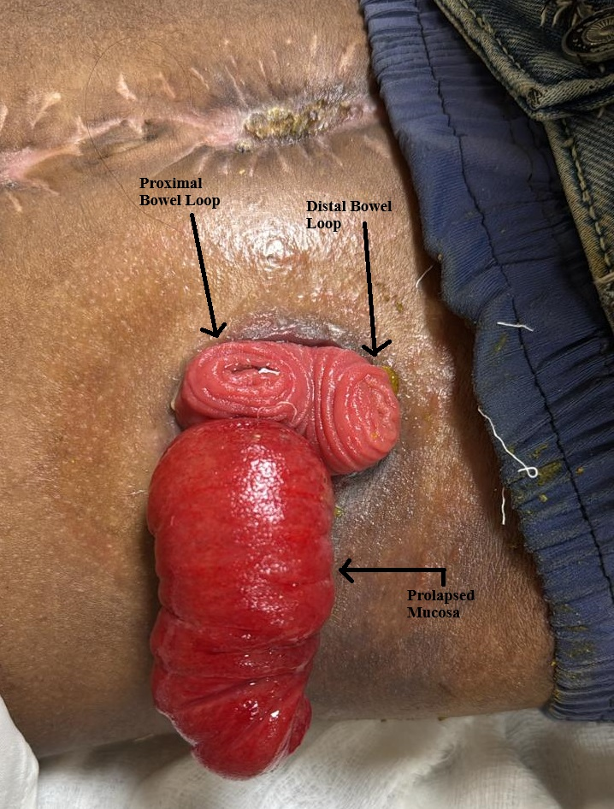

Figure 2 – Showing Intraoperative depiction of mucosal prolapse

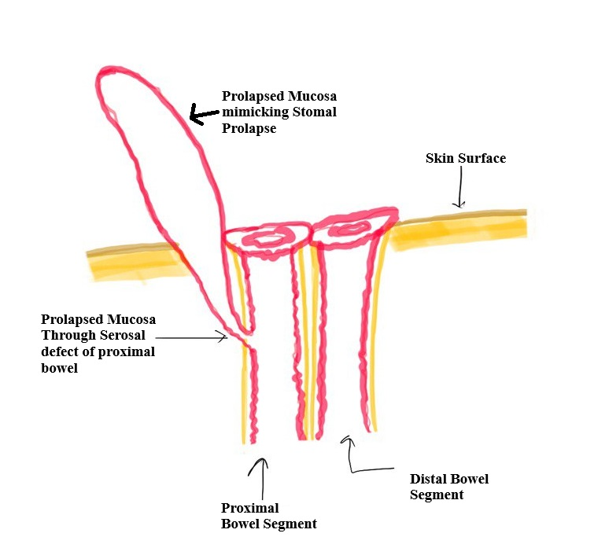

**Discussion**

Stoma prolapse is more common in loop colostomies than in end colostomies, occurring in 2-10% of stoma patients[3]. Risk factors include obesity, chronic cough, increased intra-abdominal pressure, and poor stoma site selection. Loop stomas are prone to prolapse due to their structural design. Prolapse results from weakening of the fascial support around the stoma site, allowing the bowel to telescope outward[4]. Increased intra-abdominal pressure and inadequate fixation of the bowel loop exacerbate the condition. Patients with stoma prolapse may present with visible bowel protrusion, discomfort, bleeding, or difficulty in fitting stoma appliances. Rarely, complications such as ischemia, ulceration, or obstruction may occur[5].

Management of stoma prolapse depends on severity and patient symptoms. Conservative measures include gentle reduction of the prolapsed bowel, use of belts or binders, and dietary modifications to optimize stool consistency[6]. Surgical intervention is indicated for recurrent prolapse, ischemia, or significant patient distress. Options include local stoma revision, resection of the prolapsed segment, or stoma relocation. Laparoscopic approaches have shown favourable outcomes[7].

In cases of suspected stoma prolapse or mucosal prolapse through a serosal defect, a thorough differential diagnosis is crucial to avoid misdiagnosis and ensure appropriate management. The following differentials should be considered - Stoma Prolapse, Parastomal Hernia, Ileal Perforation or Diverticulitis.To differentiate these conditions, clinicians often rely on imaging techniques such as ultrasonography, CT scans, or endoscopy, which can help in visualizing the bowel, identifying the exact site of the prolapse, ruling out hernias or obstructions, and assessing the integrity of the bowel wall. In cases where prolapse is suspected but the exact nature remains unclear, these imaging methods can guide appropriate surgical decisions [8].

This case showcases an unusual mucosal prolapse mimicking stoma prolapse, with the site of prolapse only ascertainable intraoperatively. It highlights the importance of patient education, early recognition, and timely intervention.

**Conclusion**

This case report presents an unusual occurrence of mucosal prolapse through a serosal defect, mimicking stoma prolapse. While stoma prolapse is a known complication in loop ileostomies, this rare presentation required careful differentiation to ensure accurate diagnosis and appropriate surgical management. Timely intervention through resection and anastomosis resulted in a successful outcome. This case emphasizes the importance of considering atypical complications in stoma patients, particularly when clinical signs suggest prolapse but are not consistent with typical findings. The report also highlights the critical role of intraoperative evaluation in confirming the diagnosis, as well as the need for comprehensive patient education and follow-up to prevent future complications. Moreover, it underscores the value of early recognition and proper management to avoid unnecessary procedures and reduce patient morbidity. Future research should focus on improving diagnostic approaches, including advanced imaging techniques, to facilitate early detection and precise treatment in similar cases, ultimately enhancing patient outcomes.

Ethical Approval:

As per international standards or university standards written ethical approval has been collected and preserved by the author(s).

Consent

As per international standards, parental written consent has been collected and preserved by the author(s).

**Disclaimer (Artificial intelligence)**

Author(s) hereby declares that NO generative AI technologies such as Large Language Models (ChatGPT, COPILOT, etc.) and text-to-image generators have been used during the writing or editing of this manuscript.

**References**

1. Maeda K, Maruta M, Utsumi T, Sato H, Masumori K, Aoyama H. Pathophysiology and prevention of loop stomal prolapse in the transverse colon. Tech Coloproctol. 2003 Jul;7(2):108–11.

2. Maeda K. Prolapse of intestinal stoma. Ann Coloproctol. 2022 Oct;38(5):335–42.

3. Tsujinaka S, Tan KY, Miyakura Y, Fukano R, Oshima M, Konishi F, et al. Current Management of Intestinal Stomas and Their Complications. J Anus Rectum Colon. 2020;4(1):25–33.

4. Aubert M, Buscail E, Duchalais E, Cazelles A, Collard M, Charleux-Muller D, et al. Management of adult intestinal stomas: The 2023 French guidelines. J Visc Surg. 2024 Apr;161(2):106–28.

5. Pellegrin A, Pasinato G, Sabbagh C. Stoma prolapse management: Stapler repair. J Visc Surg. 2024 Oct;161(5):317–9.

6. Parini D, Bondurri A, Ferrara F, Rizzo G, Pata F, Veltri M, et al. Surgical management of ostomy complications: a MISSTO-WSES mapping review. World J Emerg Surg. 2023 Oct 10;18(1):48.

7. Murken DR, Bleier JI. Ostomy-related complications. Clinics in colon and rectal surgery. 2019 May;32(03):176-82.

8. Krishnamurty DM, Blatnik J, Mutch M. Stoma Complications. Clin Colon Rectal Surg. 2017 Jul;30(3):193-200. doi: 10.1055/s-0037-1598160. Epub 2017 May 22. PMID: 28684937; PMCID: PMC5498161.