**Case report**

**A Radiological Challenge of Littre Hernia Complicated by Perforated Meckel's Diverticulum: A Rare Case Report and Review of the Literature**

**Abstract**

**Background:** Littre's hernia, characterized by the presence of Meckel's diverticulum within the hernial sac, is an uncommon condition. The combination of an incarcerated Littre's hernia and perforation of Meckel's diverticulum is exceptionally rare, adding to the novelty and clinical interest of this case.

**Case Presentation:** We report the case of a 76-year-old female who presented with painful paraumbilical swelling and signs of inflammation. The patient, with a past medical history including diabetes, dyslipidemia, and hypertension, was initially diagnosed with an incarcerated paraumbilical Littre's hernia based on clinical examination and radiological findings. During open hernia repair, the hernial sac was found to contain omentum, ileum, and a perforated Meckel's diverticulum caused by a fish bone. The patient subsequently underwent a segmental bowel resection and primary repair of the hernial defect. She had an uneventful postoperative hospital course and was appropriately discharged.

**Conclusions:** This case report highlights a very rare and complicated presentation of Littre's hernia associated with a perforated Meckel's diverticulum, emphasizing the critical importance of clinical vigilance. Timely surgical intervention is essential for effectively managing such complex cases. This case underscores the need for increased awareness among healthcare professionals regarding potential complications of Littre's hernia. Further documentation and study of similar cases could significantly enhance our understanding of this condition and inform future treatment strategies, ultimately improving patient outcomes.

**Keywords**

Littre's hernia, Meckel's diverticulum, perforation, case report, surgery, abdominal pain

**Introduction**

Meckel's diverticulum (MD) is a common congenital malformation of the gastrointestinal tract, typically found in 2%-4% of the population. It occurs due to the persistence of the vitello-intestinal duct, which connects the yolk sac to the fetal circulation during early embryonic development. Normally, this connection should disappear as the fetal intestine separates from the yolk sac around the 5th-6th weeks of embryonic development. When this connection persists abnormally, it can lead to various vitteline abnormalities, with MD being the most prevalent [1][2].

While MD is the most common gastrointestinal congenital malformation, it is usually asymptomatic in adults. Symptoms may only arise when complications occur, such as intestinal obstruction, gastrointestinal bleeding, inflammation, perforation, or malignant degeneration. One rare complication, occurring in only 1% of cases, is Littre’s hernia (LH), which results from an MD protruding through an abdominal opening due to its location on the antimesenteric border of the ileum [3]. This condition was first described in 1700 by French surgeon Alexis Littre (1658–1726), who reported three cases of incarcerated femoral hernia containing a small bowel diverticulum [4].

Diagnosing symptomatic MD can be challenging, especially in adults. Common symptoms include unexplained abdominal complaints, nausea, vomiting, or intestinal bleeding. In cases where the hernia is attached to the abdominal wall, cellulitis may also be present [5]. Additionally, symptomatic MD usually presents in an emergency setting. Plain radiographs are not sufficient for diagnosis, and arteriography may not always be conclusive due to variations in arterial supply. Technetium-99m pertechnetate scanning is considered the most effective method for detecting MD [3][6].

Treatment for symptomatic MD typically involves surgical resection. However, managing incidentally discovered MD remains a topic of debate in the medical community[1].

Patients undergoing bowel resection experienced significantly worse outcomes, with a mortality rate of 8.7%, compared to no recorded mortality in those who underwent MD resection alone. The higher mortality appears to be linked not to the resection technique itself but to the severity of the acute presentation, as mortality reached 28% in patients with bowel obstruction. Since the need for bowel resection is dictated by the extent of the lesions, patients requiring this procedure may inherently face a higher risk of poor outcomes [5].

This case study present a 76-year-old female patient presenting with a painful swelling in the umbilical region revealed an incarcerated paraumbilical hernia containing a perforated MD. Surgeons successfully performed a segmental resection of the bowel to manage the condition.

**Case presentation**

A 76-year-old middle eastern female presented to the Emergency Department at Adan Hospital with a 24-hour evolution of abdominal pain over a 2 years old protrusion in the umbilical region. The pain had an insidious onset and increasing severity. It was associated with fluctuating fever, nausea, dysuria and decreased oral intake. No defecation disorders or vomiting were mentioned.

Upon further history, the patient underwent right paraumbilical hernia repair in 2021. She developed an abscess at the site of surgery and was treated conservatively, however further details about the operation couldn’t be obtained as the patient was following with a different hospital. According to the family she had had the protrusion since then. In 2019, she underwent surgery for a right femur fracture which led to her being bedridden. Additionally, her past medical history included controlled hypertension, type 2 diabetes, and dyslipidemia.

During physical examination, her abdomen was found to be soft with a paraumbilical irreducible firm swelling, measuring about ~ 4x3 cm. The skin above was warm, red, tender and slightly stretched. An old transverse right paraumbilical incision scar was also noticed. There were no signs of hepatomegaly or ascites. Inguinal and femoral orifices were normal.

She was vitally stable, afebrile, and initial investigations including complete blood count (CBC), liver function test (LFT) and urine routine were all within normal. She only had slightly elevated urea of 15 mmol/L and creatinine of 104 mmol/L. Ultrasonography of the abdomen was performed and showed the presence of umbilical hernia with omental fat and bowel loops content. In addition to a suspected curvilinear echogenic foreign body seen intraluminal in the herniated bowel loop, extending to the extra luminal region and surrounded with subcutaneous extra luminal air locules (Figure 1). CT scan of the abdomen revealed a large para-umbilical hernia containing small bowel and showing subcutaneous mixed fluid/fat strandings measuring 5x3 cm with no signs of bowel obstruction (Figure 2).

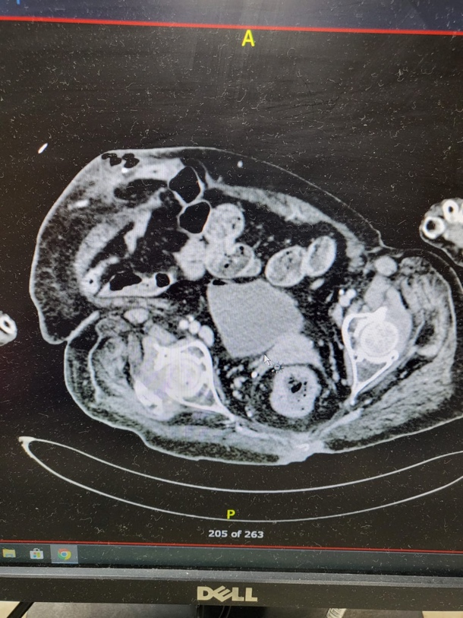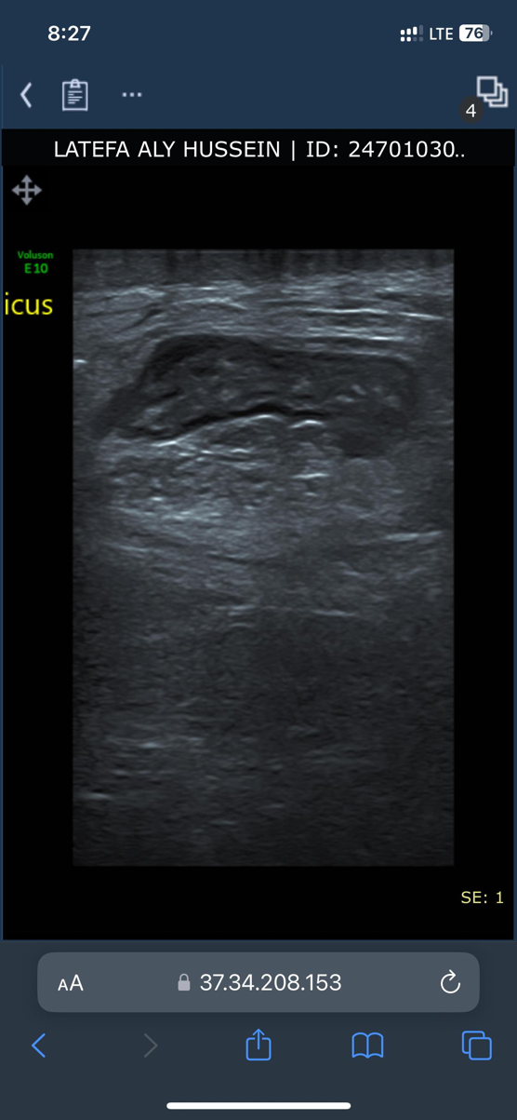

**Figure 1 - ultrasound umbilicus showed (arrow) Figure 2 - CT scan of the abdomen showed large para umbilical hernia (arrow)**

A presumed diagnosis of incarcerated paraumbilical hernia with a bowel perforation was then established and she was submitted to open repair. The patient underwent exploration under general anesthesia. She was found to have incarcerated paraumbilical LH containing: omentum, part of the small bowel loop and MD which were both perforated. The foreign body was identified as an intact fish bone (Figure 3).

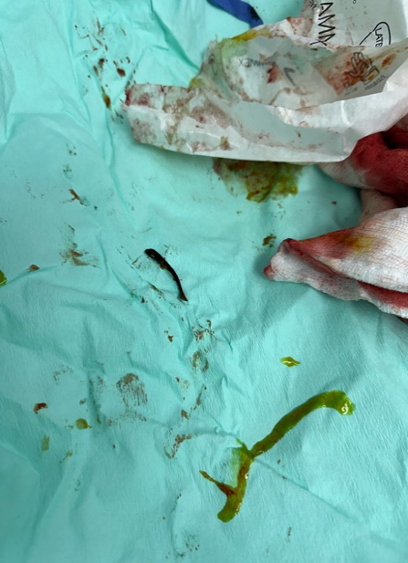

**Figure 3-Foreign body identified as a fish bone (arrow)**

Segmental resection was done to the ileum about 40 cm from the ileocecal valve (Figure 4). After the segmental resection surgeons did end-to-end anastomosis. Then hemostasis was donemeticulously and 2 drains were inserted.

The post-operative course was uneventful, and the patient was discharged on the 10th postoperative day after drains removal. She followed up in the outpatient clinic and there were no symptoms of recurrence of the swelling.

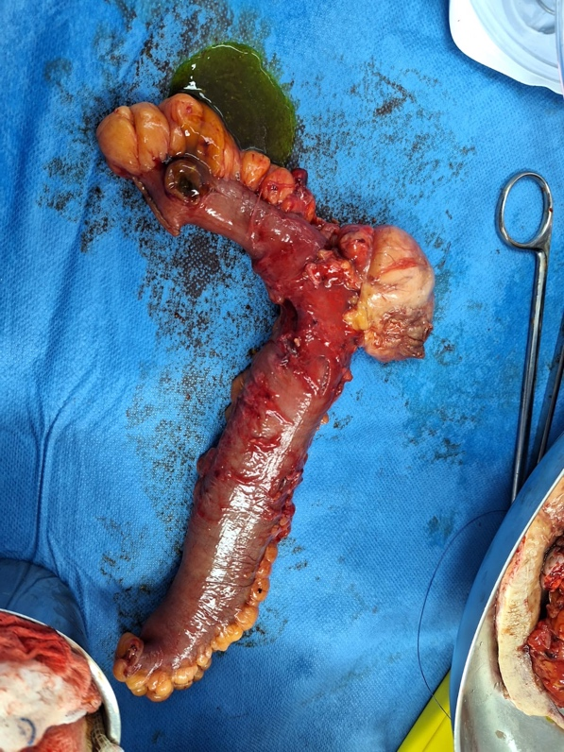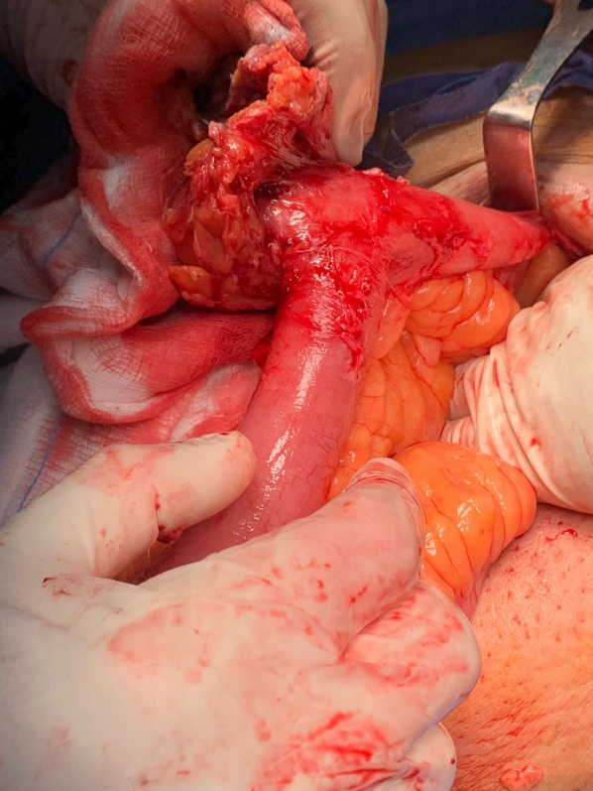

**A B**

**Figure 4 - (A)Intraoperative image and (B) resected small bowel loop**

Histopathology report released on day 5 post operation with the following impression: PUH shows extensive ischemic necrosis with superadded suppurative inflammation. No evidence of atypia consistent with clinical history of incarceration. Mucosa shows hemorrhage and superficial epithelial necrosis consistent with early ischemic changes. Both resection margins are viable and free of inflammation

**Discussion**

Approximately 50% of Littre’s hernia (LH) cases occur in the inguinal region, with 20% in the femoral region, 20% in the umbilical region, and the remaining 10% in other locations. The incidence of LH presenting in complicated abdominal hernias is reported to be 0.6%. LH can develop through a primary defect in the abdominal wall or as a ventral hernia following previous surgery [3].

Our patient had a paraumbilical incarcerated LH. In cases of LH, there are two classifications: those containing only a Meckel’s diverticulum (MD) are classified as true LH, while the presence of small bowel and other abdominal viscera within the hernia sac defines a mixed LH [7]. In our case report, the patient presented with a mixed LH, and intraoperative findings revealed the presence of an MD, omentum, and an ileal loop.

Meckel’s diverticulum (MD) is a common yet intriguing congenital gastrointestinal malformation. Despite its prevalence, this condition remains rare and typically asymptomatic in adults. MD is often discovered incidentally during surgery or imaging. However, in a small percentage of cases (4–7%), MD is diagnosed due to complications such as intestinal obstruction, gastrointestinal bleeding, inflammation, perforation, or even malignant transformation [8]. LH, an exceptionally rare complication of MD, adds another layer of complexity to this condition. Due to its origin from the antimesenteric border of the ileum, MD can protrude through various abdominal openings [3]. The majority of patients experiencing MD-related complications are male. Extensive retrospective analyses involving over 100 patients in each series have reported a male-to-female ratio ranging from 1.5:1 to 4:1 [9] [10].

In our remarkable case, a female patient with a paraumbilical LH was found to have a perforated MD caused by an unexpected fishbone. This rare combination—LH with a perforated MD—represents an unusual and compelling occurrence in medical literature.

The enigmatic nature of LH poses a diagnostic challenge, as preoperative identification remains difficult due to its rarity and the lack of distinct radiological and clinical features. Despite advances in radiological imaging, accurately diagnosing LH and distinguishing it from other hernias remains challenging. While various imaging modalities can assist in diagnosing MD, their sensitivity and specificity in detecting this anomaly are notably limited [3]. In our patient’s case, two radiological studies were diligently performed, yet both failed to reveal any evidence of MD. Ultimately, the definitive diagnosis was made intraoperatively, highlighting the complexity of diagnosing LH and its elusive nature in medical imaging.

For hernia repair, the use of mesh is considered the gold standard for treating LH in adults. However, in cases of ischemia or small bowel perforation, mesh should be avoided to mitigate the risk of infection [11]. If the MD shows no edema or inflammation at its base, resection with transverse closure of the ileum is recommended to prevent postoperative ileal stenosis. Conversely, if signs of ischemia, inflammation, perforation, or macroscopic ectopic tissue are present at the base of the MD, a segmental resection of the small intestine with anastomosis is warranted [12].

In our patient’s case, an emergency open hernia repair was performed, along with a segmental enterectomy and primary side-to-side anastomosis. As of the present date, the patient continues to recover without any postoperative complications. Notably, bowel resection carries a mortality rate of 8.7%, highlighting the potential risks associated with this procedure [5].

**Conclusion**

In conclusion, Littre’s hernia (LH) is a rare complication of Meckel’s diverticulum (MD) that presents significant diagnostic challenges due to its nonspecific clinical and radiological findings. Given its potential for serious complications, surgeons must maintain a high level of awareness to ensure timely diagnosis and management.

This case report illustrates an exceptionally rare and complex presentation of LH with a perforated MD, highlighting the importance of clinical vigilance. Prompt surgical intervention is crucial in effectively managing such cases. Raising awareness among healthcare professionals about the possible complications of LH is essential. Further documentation and research on similar cases could enhance our understanding of this condition and contribute to improved treatment strategies and patient outcomes.

**Declarations**

**Ethical Approval**

This case report was conducted in accordance with the ethical standards of Research Ethical Committee, Ministry Of Health, Kuwait, and the Helsinki Declaration of 1975, as revised in 2008.

**Patient Consent**

Written informed consent was obtained from the patient involved in this case report for the publication of this report and any accompanying images. A copy of the written consent is available for review by the Editor-in-Chief of the Journal of Medical Case Reports.

**Data Availability**

Data sharing is not applicable to this article as no datasets were generated or analyzed during the current study.

**Originality**

This case report has not been published elsewhere and is not under consideration by any other publication.

**Disclaimer (Artificial intelligence)**

Authors hereby declare that they utilized artificial intelligence (AI) tools to assist in checking the grammar and formatting of the sentences in this case report. The AI was used to ensure clarity, coherence, and adherence to standard writing conventions, thereby enhancing the overall quality of the manuscript.​

**References**

1. Fusco, J. C., Achey, M. A., & Upperman, J. S. (2022). Meckel’s diverticulum: Evaluation and management. Seminars in Pediatric Surgery, 31(1), 151142. https://doi.org/10.1016/j.sempedsurg.2022.151142
2. Sagar J, Kumar V, Shah DK. Meckel's diverticulum: a systematic review. J R Soc Med. 2006 Oct;99(10):501-5. doi: 10.1177/014107680609901011. Erratum in: J R Soc Med. 2007 Feb;100(2):69. PMID: 17021300; PMCID: PMC1592061.
3. Evola, G., Piazzese, E., Bonanno, S., Di Stefano, C., Di Fede, G. F., & Piazza, L. (2021). Complicated Littre’s umbilical hernia with normal Meckel’s diverticulum: A case report and review of the literature. International Journal of Surgery Case Reports, 84, 106126. <https://doi.org/10.1016/j.ijscr.2021.106126>
4. Mirza MS. Incarcerated Littre’s femoral hernia: case report and review of the literature. J Ayub Med Coll Abbottabad. 2007;19(2):60–61.
5. Răcăreanu M, Preda SD, Preda A, Strâmbu VDE, Radu PA, Bratiloveanu TC, Pătrașcu Ș, Marinescu D, Sapalidis K, Șurlin V. Management of Littre Hernia-Case Report and Systematic Review of Case Reports. J Clin Med. 2023 May 29;12(11):3743. doi: 10.3390/jcm12113743. PMID: 37297940; PMCID: PMC10253297.
6. Martin, J. P., Connor, P. D., & Charles, K. (2000). Meckel's diverticulum. American family physician, 61(4), 1037–1044.
7. Matias, M. R. A., Kronberga, M., & Aghahoseini, A. (2021). Complicated Littre hernias. International Journal of Abdominal Wall and Hernia Surgery, 4(3), 83. https://doi.org/10.4103/ijawhs.ijawhs_26_21
8. Lequet, J., Menahem, B., Alves, A., Fohlen, A., & Mulliri, A. (2017). Meckel’s diverticulum in the adult. Journal of Visceral Surgery, 154(4), 253–259. <https://doi.org/10.1016/j.jviscsurg.2017.06.006>
9. Erol V, Yoldaş T, Cin S, Çalışkan C, Akgün E, Korkut M. Complicated Meckel's diverticulum and therapeutic management. Ulus Cerrahi Derg. 2013 Jun 1;29(2):63-6. doi: 10.5152/UCD.2013.36. PMID: 25931848; PMCID: PMC4379835.
10. Hansen, C., & Søreide, K. (2018). Systematic review of epidemiology, presentation, and management of Meckel’s diverticulum in the 21st century. Medicine, 97(35), e12154. <https://doi.org/10.1097/md.0000000000012154>
11. Johnson GGRJ, Holden J, Helewa RM, Hochman D, Hyun E. A Strangulated Meckel's Diverticulum in an Inguinal Hernia: A Case Report and Literature Review. Int Med Case Rep J. 2021 Sep 2;14:605-609. doi: 10.2147/IMCRJ.S325390. PMID: 34512042; PMCID: PMC8421327.
12. Khalifa, M. B., Belaid, A. B., Ghannouchi, M., Nacef, K., Fodha, M., & Boudokhane, M. (2024). Umbilical Littre hernia: A rare case report of an acute abdomen. International Journal of Surgery Case Reports, 114, 109182. <https://doi.org/10.1016/j.ijscr.2023.109182>