A rare case presentation of Pleomorphic adenoma of the infratemporal fossa

Abstract :

Pleomorphic adenoma is a common benign tumor found in the major salivary glands and can also originate from accessory salivary glands. Here, we present an exceptionally rare case of pleomorphic adenoma arising from the infratemporal space, confirmed by histological analysis. Treatment primarily involved complete resection using a cervical approach. This case prompts a review of the diagnosis, clinical characteristics, and treatment strategies for pleomorphic adenoma originating in the infratemporal space, drawing insights from existing literature.

Keywords : diagnosis, Pleomorphic adenoma, salivary glands , Treatment,

Introduction :

" Salivary gland tumors account for 3% of all head and neck tumors. Pleomorphic adenomas predominantly arise from the salivary glands, with 85 to 90% occurring in the major salivary glands and 6% in the minor salivary glands, particularly in the oral cavity, notably on the palatal mucosa" [1]. "Rarely, pleomorphic adenomas are found in locations such as the nasal cavity, pharynx, larynx, trachea, and lacrimal glands" [2]. "Pleomorphic adenoma originating from the infratemporal space is exceptionally rare, with only two cases reported in the English literature to date" [3, 4].

Case report:

A 54-year-old woman, without significant medical history, presented with a swelling in her cheek that had been evolving for 5 years, gradually increasing in size. She also reported odynophagia (painful swallowing) and incidentally noticed a mass in the left tonsillar area, which had worsened over time

On intraoral examination, a firm and nodular swelling of the left tonsillar area was observed, pushing the anterior pillar and narrowing the oropharyngeal space. Nasofibroscopy revealed filling of the left nasopharynx extending downward into the oropharynx, reaching up to the homolateral vallecula, without signs of infiltration.

The examination of the major salivary glands was unremarkable. No cervical lymphadenopathy was found, and the rest of the physical examination was within normal limits.

A contrast-enhanced CT scan revealed a roughly oval-shaped tissue mass in the left parapharyngeal space. The mass appeared well-defined, hypodense, with some peripheral rounded calcifications, and showed enhancement in some areas after contrast injection. It measures 56 x 38 x 53 mm. The mass displaces the oropharynx medially, reducing its lumen. Anteriorly, it displaces the base of the tongue and surrounds the corresponding palatine tonsil. Laterally, it contacts the left mandible without evidence of bone destruction. Posteriorly, it contacts the prevertebral muscle and the jugulo-carotid axis. Inferiorly, it contacts the left submandibular gland with loss of the separation border.

Figure 1 :

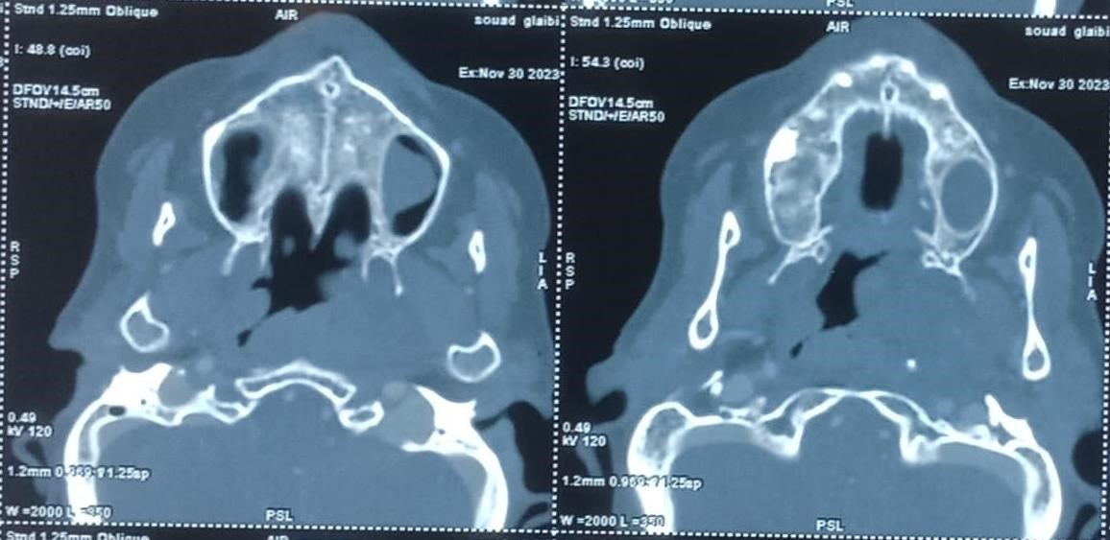

Figure2 :

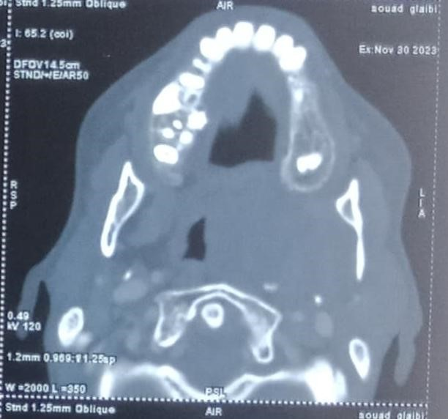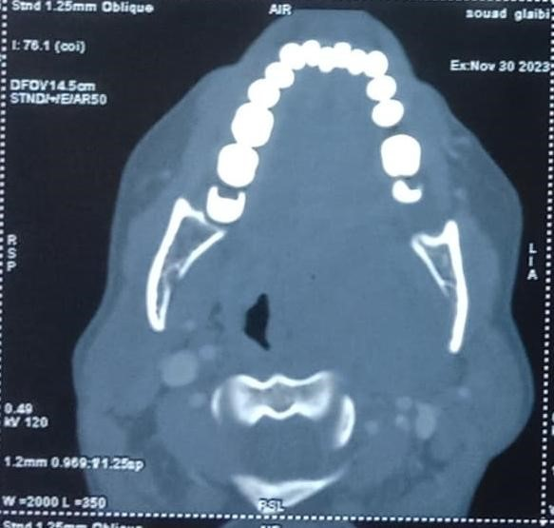

# Figure 1 and 2 : Axial slice CT scan showing a huge tumor in the left infra-temporal fossa

MRI revealed a well-defined oval-shaped tissue mass with regular and lobulated contours, iso-intense on T1-weighted imaging, heterogeneous hyperintensity on T2weighted imaging, and intense enhancement after gadolinium injection. The mass measures 51 x 31.5 x 55 mm. It shows hyperintensity on diffusion-weighted imaging with an apparent diffusion coefficient (ADC) ratio of 1. Perfusion sequence demonstrates a type A enhancement curve. Based on these findings, MRI suggests a pleomorphic adenoma as the likely diagnosis.

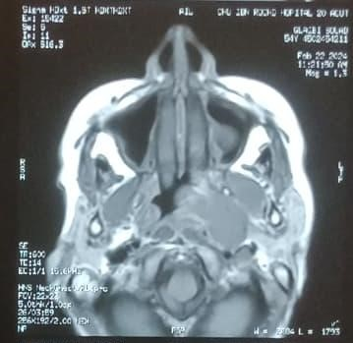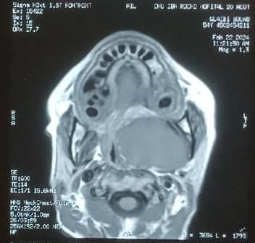

# Figure 3: MRI axial section, T1 sequence, without gadolinium injection

( a ) (b)

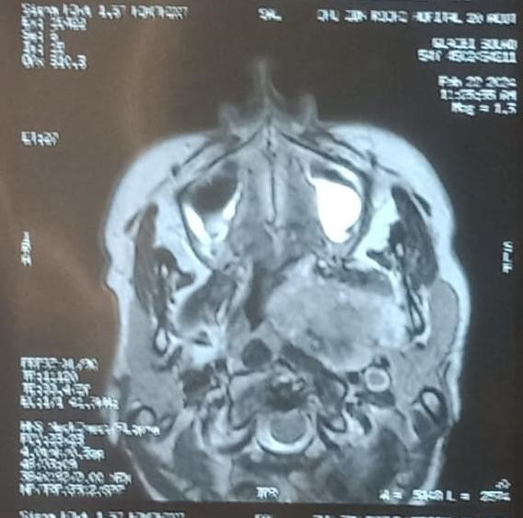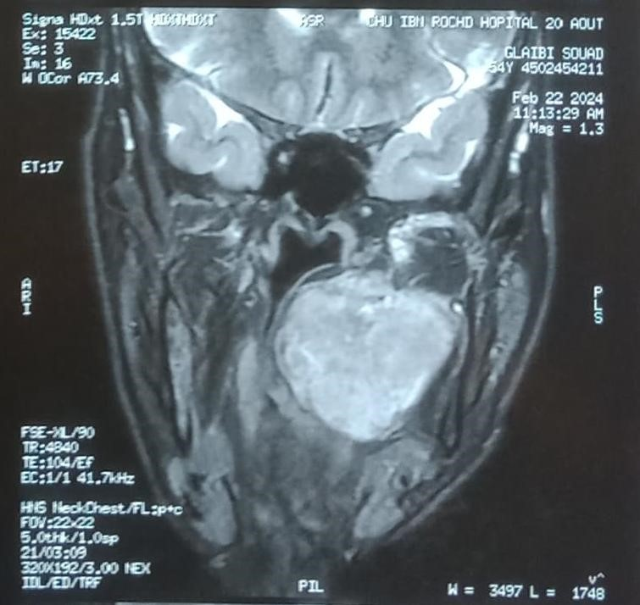

# Figure 4: MRI, axial section (a), and coronal section (b) , T2 sequence, without gadolinium injection

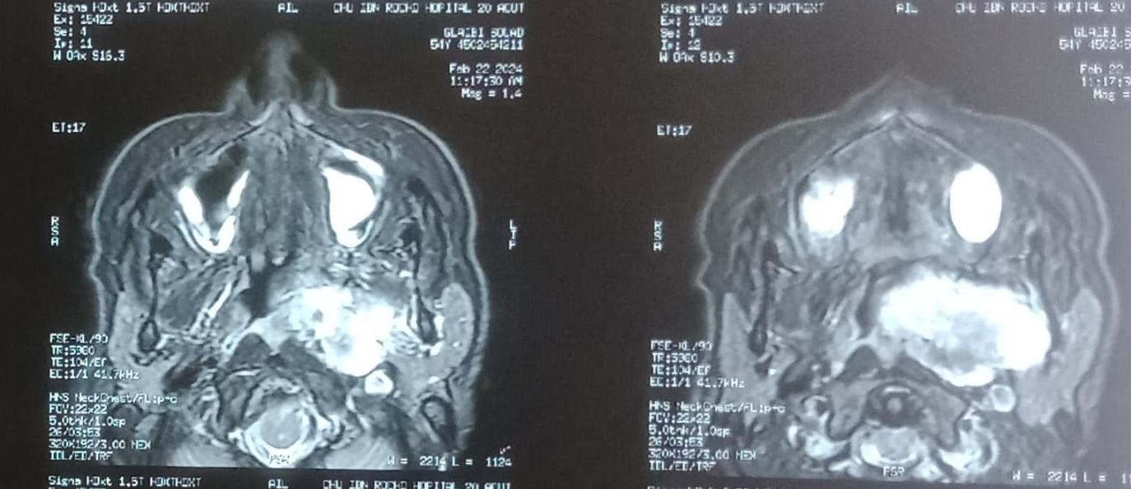

# Figure 5 : MRI axial section, T1 sequence, with gadolinium injection

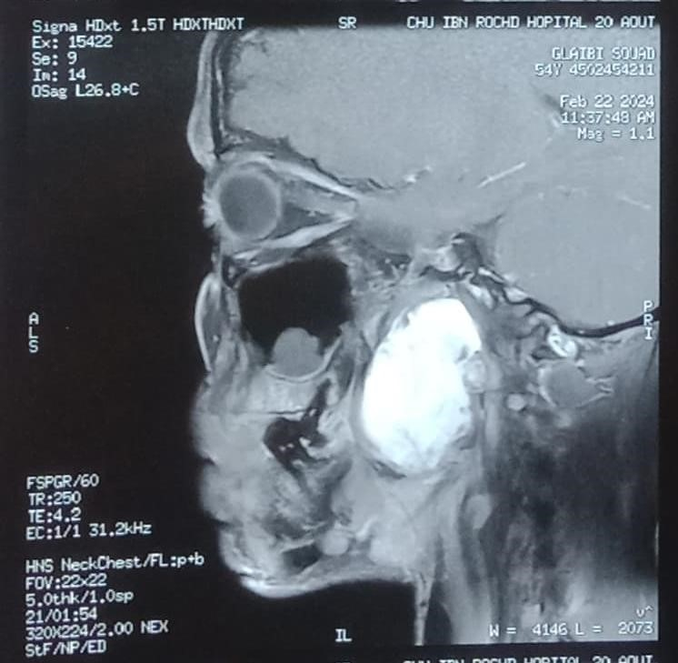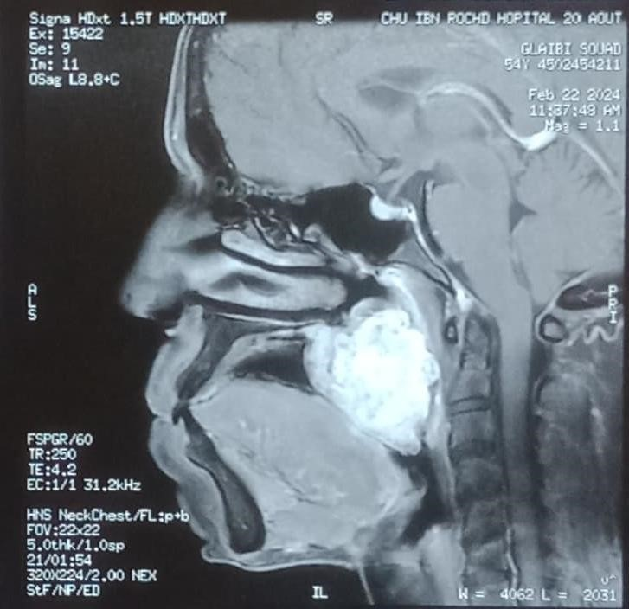

# Figure 6 : MRI sagittal section, T1 sequence, with gadolinium injection

An endobuccal biopsy of the left tonsillar area confirmed the histological nature suggested by the MRI: a pleomorphic adenoma.

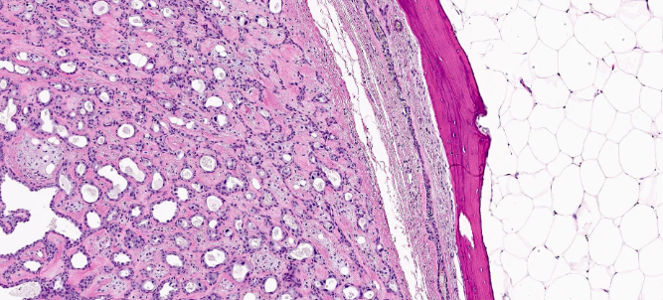

# Figure 7 : histopathological examination of the biopsy

The surgical procedure was conducted via a cervical approach using a Sébilleau incision. Sectioning of the digastric muscle and ligation of the external carotid artery were necessary to access the infratemporal fossa (FIT). The tumor was meticulously dissected and completely removed in one piece, without any damage to adjacent structures. The excised tumor was sent for histopathological examination, confirming a pleomorphic adenoma. Twelve months post-operation, the patient remained free of disease.

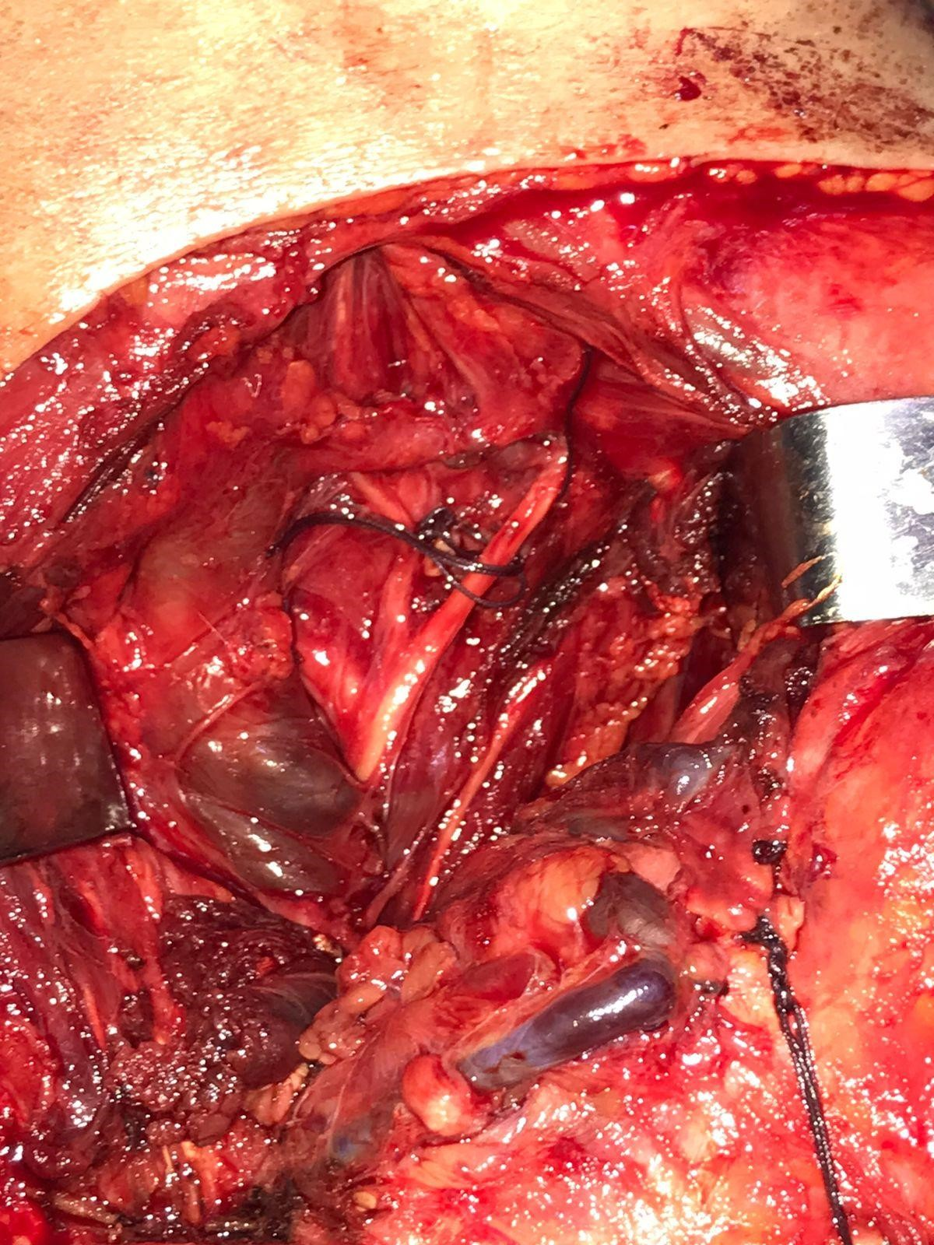

# Figure 8 : cervical approach to the mass with ligation of the external carotid artery and section of the posterior belly of the digastric muscle

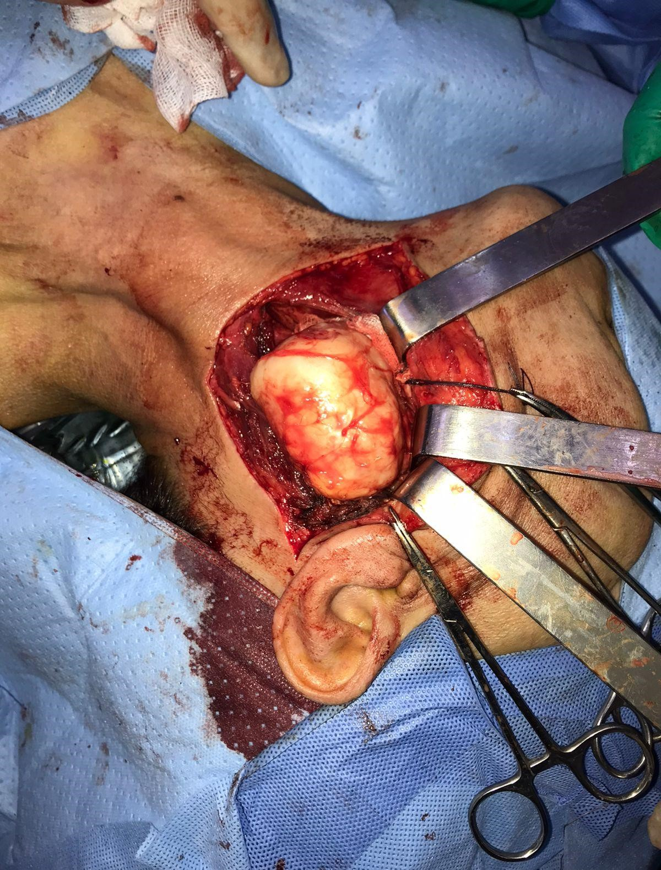

# Figure 9 : exposure of the mass by cervical approach

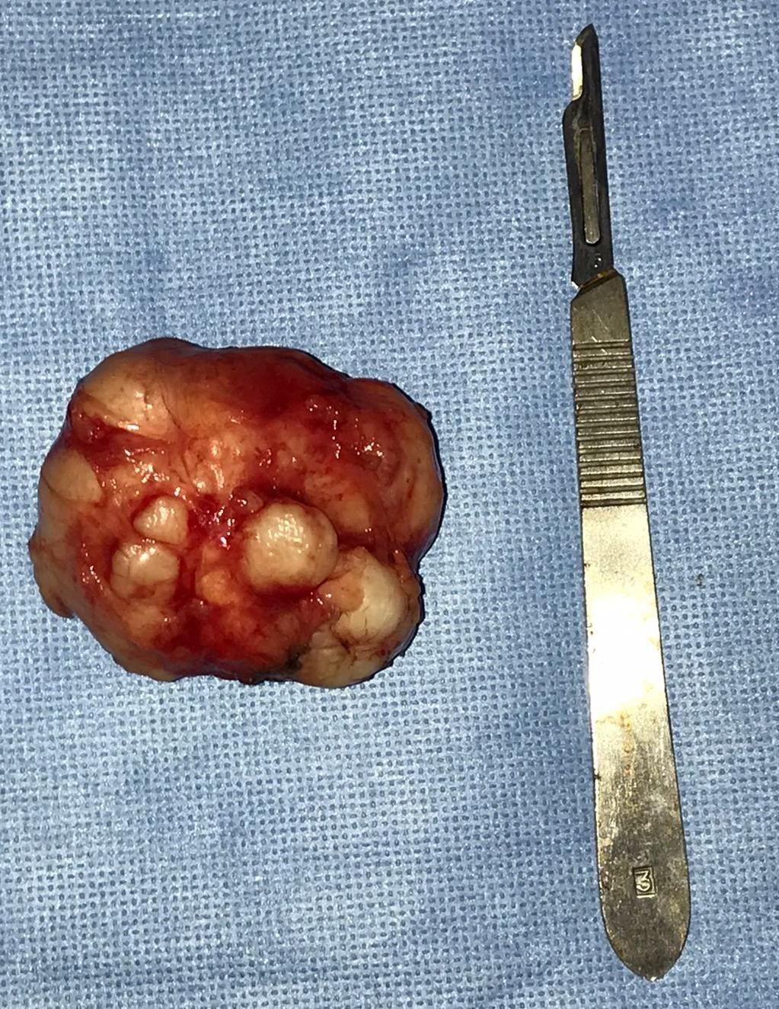

# Figure10 : image of the surgical specimen after complete excision

Discussion :

The infratemporal fossa typically becomes involved by tumors that extend from surrounding regions like the paranasal sinuses, middle cranial fossa, nasopharynx, parotid gland, and external auditory canal. Primary tumors originating within the infratemporal fossa itself are less common, and metastasis to this area is exceedingly rare.

Approximately 90% of pleomorphic adenomas arise in the major salivary glands, while 6% occur in the minor salivary glands [1]. They are rarely found in other sites within the upper aerodigestive tract, such as the nasal cavity, pharynx, larynx, trachea, and lacrimal glands [2].

Unique cases of pleomorphic adenoma occurring in cutaneous locations of the head and neck have been documented in the literature. These include sites such as the scalp, eyelids, nose, cheek, upper lip, external ear, and external auditory canal [5].

It is important to note that this case report involves a pleomorphic adenoma originating from the infratemporal space, a condition that has been reported only three times in the English literature [3, 4].

The first documented case was published in 2000 in the European Archives of Otorhinolaryngology, detailing a 52-year-old woman who presented with a swelling in the left buccal area. A CT scan revealed a localized, moderate-sized tumor in the left pterygopalatine fossa. Surgical resection was performed using a transmaxillary approach.[6]

The second case, published in 2007 in Head and Neck Pathology, described a 45-yearold woman with swelling on the right cheek and a nodular mass filling the superior ipsilateral oral vestibule. A CT scan showed a moderate-sized lesion in the right retromaxillary space, with anterior bowing of the posterolateral wall of the maxillary sinus. Surgical resection was carried out via a transzygomatic approach [7].

The 3rd case published in 2010, at the Albany Medical Center, described the case of a 42-year-old man presenting with a mass in the left infra-temporal fossa, discovered by chance on a CT scan of the face, performed in the context of a facial trauma. Surgery was performed using a caldwell luc approach followed by an approach through the posterolateral wall of the maxillary sinus. Surgical resection was complete.[8]

The three cases were histopathologically confirmed as typical pleomorphic adenomas.

Typically, benign tumors located in the infratemporal space often do not cause symptoms for an extended period. They are typically identified by a swelling on the face, and within the mouth, they appear as a nodular mass that fills the upper buccal vestibule. It's crucial to conduct endoscopic examinations of the nasal cavities because they can detect any tumor-induced displacement of the lateral nasal wall.

A CT scan is crucial for diagnosing tumors in the infratemporal fossa as it provides insights into the disease's extent, local spread, and can offer some clues about the tumor type. Vascular and neurogenic tumors typically show contrast enhancement on CT scans. For suspected vascular tumors, MRI angiography or conventional arteriography is recommended. If a vascular lesion is excluded, histologic examination becomes necessary [9]. In our case, histopathological analysis confirmed the presence of a pleomorphic adenoma.

While there is an anatomical connection between the deep lobe of the parotid gland and the infratemporal fossa, the likelihood of tumors from the deep lobe spreading to the infratemporal fossa appears to be uncommon. Tumors extending from the deep lobe of the parotid gland can be distinguished from those originating de novo in the infratemporal region by a fine lucent line. This line corresponds to the compressed layer of fibroadipose tissue that acts as a boundary between the tumor and the deep lobe of the parotid gland.[10] [11]

Surgery is the preferred treatment for a pleomorphic adenoma. There are several surgical approaches available, chosen based on the complexity of access, which is further complicated by communications with neighboring regions; cervical approach, transmaxillary and lateral facial approach [12].

While many authors assert that complete surgical resection is the definitive treatment for pleomorphic adenoma, some reports have indicated favorable outcomes with adjuvant radiotherapy for tumors that are inoperable or after incomplete resection [13] . However, the role of adjuvant radiotherapy in these cases remains controversial.

Despite being benign, pleomorphic adenoma is associated with a high potential for local recurrence, ranging from 2.4% to 10% [8]. It also carries a risk of malignant transformation, which varies between 6% and 10% [14], and a potential for distant metastasis [15].

Regular long-term monitoring is therefore essential, to detect any recurrence, malignant transformation or distant metastases.

Conclusion :

The pleomorphic adenoma of the infratemporal fossa is a very rare benign tumor, with very few cases reported in the literature. Its slow progression makes diagnosis challenging. CT scan is key for diagnosis. MRI remains essential if there is suspicion of a vascular nature of the mass. Biopsy confirms the diagnosis, and treatment is surgical. Long-term regular surveillance is necessary to monitor for recurrence or distant metastasis.

Ethical Approval:

As per international standards or university standards written ethical approval has been collected and preserved by the author(s).

Consent

As per international standards or university standards, patient(s) written consent has been collected and preserved by the author(s).

Disclaimer (Artificial intelligence)

Option 1:

Author(s) hereby declare that NO generative AI technologies such as Large Language Models (ChatGPT, COPILOT, etc.) and text-to-image generators have been used during the writing or editing of this manuscript.

Option 2:

Author(s) hereby declare that generative AI technologies such as Large Language Models, etc. have been used during the writing or editing of manuscripts. This explanation will include the name, version, model, and source of the generative AI technology and as well as all input prompts provided to the generative AI technology

Details of the AI usage are given below:

1.

2.

3.

Références:

1. H. H. Unlu, O. Celik, M. A. Demir, and G. Eskiizmir, “Pleomorphic adenoma originated from the inferior nasal turbinate,” Auris Nasus Larynx, vol. 30, no. 4, pp. 417–420, 2003.
2. K. Suzuki, K.Moribe, and S. Baba, “A rare case of pleomorphic adenoma of lateral wall of nasal cavity—with special reference of statistical observation of pleomorphic adenoma of nasal cavity in Japan,” Journal of Otolaryngology of Japan, vol. 93, no. 5, pp. 740–745, 1990.
3. K. Jeyanthi, R. Karthikeyan, H. J. Sherlin, et al., “Pleomorphic adenoma in the infra-temporal space: the first case report,” Head and Neck Pathology, vol. 1, no. 2, pp. 173–177, 2007.
4. T. Kanazawa, H. Nishino, and K. Ichimura, “Pleomorphic adenoma of the pterygopalatine fossa: a case report,” European Archives of Oto-Rhino-Laryngology, vol. 257, no. 8, pp. 433– 435, 2000.
5. S. Nishimura, T. Murofushi, and M. Sugasawa, “Pleomorphic

adenoma of the auricle,” European Archives of Oto-RhinoLaryngology, vol. 256, no. 1, pp. 22–24, 1999.

1. Pleomorphic Adenoma in the Infra-temporal Space:

The First Case Report

K. Jeyanthi Æ Ramalingam Karthikeyan Æ Herald J. Sherlin Æ N. Anuja Æ

Pratibha Ramani Æ Premkumar Priya Æ T. Chandrasekar Æ Naushad Khan Æ

Vinod Narayanan

Head and Neck Pathol (2007) 1:173–177

7. Case Report; Plemorphic Adenoma of the Infratemporal Space:

A New Case Report

Tarik El-Hadi, A. Oujilal,M. Boulaich, L. Sqalli, and M. Kzadri

Service ORL, Hˆopital des Sp´ecialit´es, Rabat-Instituts, Rabat 6220, Morocco

International Journal of Otolaryngology Volume 2009, Article ID 529350, 3 pages doi:10.1155/2009/529350

1. Pleomorphic Adenoma of the Infratemporal Fossa:

Case Report and Literature Review

Lowell E. Gurey, MD; Christopher D. Brook, BS; Steven M. Parnes, MD

Division of Otolaryngology- Head & Neck Surgery

Department of Surgery

Albany Medical Center; Albany, NY

1. Heeneman H. Parapharyngeal space tumours. In: Kerr AG, editor.

Scott Brown’s otolaryngology. Butterworth & Co Ltd.; 1987. p. 380–391.

1. Eveson JW, Cawson RA. Tumour of the minor (Oropharyngeal) salivary glands: demographic study of 336 cases. J Oral Pathol 1985;14:500–9.
2. Batsakis JG, Sneige N. Pathology consultation: parapharyngeal and retropharyngeal space diseases. Ann Otol Rhinol Laryngol 1989;98:320–4.
3. Guinto G, Abello J, Molina A, Gallegos F, Oviedo A, Nettel B,

Lopez R. Zygomatic-transmandibular approach for giant tumors of the infratemporal fossa and parapharyngeal space. Neurosugery 1999;45:1385–98.

1. S. A. Kamal, “Pleomorphic adenoma of the nose: a clinical case and historical review,” Journal of Laryngology and Otology, vol. 98, no. 9, pp. 917–923, 1984.
2. O. H. Shaheen, “Benign salivary gland tumors,” in Scott Brown’s Otolaryngology, A. G. Kerr, Ed., Butter-Worth Heinemann, London, UK, 6th edition, 1997.
3. S. B. Freeman, K. S. Kennedy, G. S. Parker, and S. A. Tatum,

“Metastasizing pleomorphic adenoma of the nasal septum,” Archives of Otolaryngology, vol. 116, no. 11, pp. 1331–1333, 1990.